Name
Student number
E-portfolio report
Learning in the Digital Era – BMPL4007/BMPS4009

Table of Contents

TASK 2
1) Written summary on the topic of “Preparing for Higher Education 2
2) Mind map on the topic of “Becoming a Digital Learner” 3
3) Presentation 5
4) Reflection using Borton’s reflective tool 7
REFERENCES 9

TASK

1) Written summary on the topic of "Preparing for Higher Education
One student may find their ideal college to be one that offers everything but what they're looking for in terms of location, climate, academic specialisations, extracurricular opportunities, and campus culture. Graduation from high school is something many kids fear since they have no idea what they want to do after they graduate. Despite the fact that this is the time of year when most people celebrate their child's accomplishment of completing elementary school, graduation has become increasingly more of a sombre occasion (Murtagh, 2012). Developing a plan for how the goals are to be achieved even before starting the pursuit of higher education is essential. It's probable that the university will have a very different organisational structure for your coursework than your previous educational experiences. One will have to rely on themselves more and be able to keep themselves motivated (UCAS, 2023). The best time to start getting ready is throughout the summer.
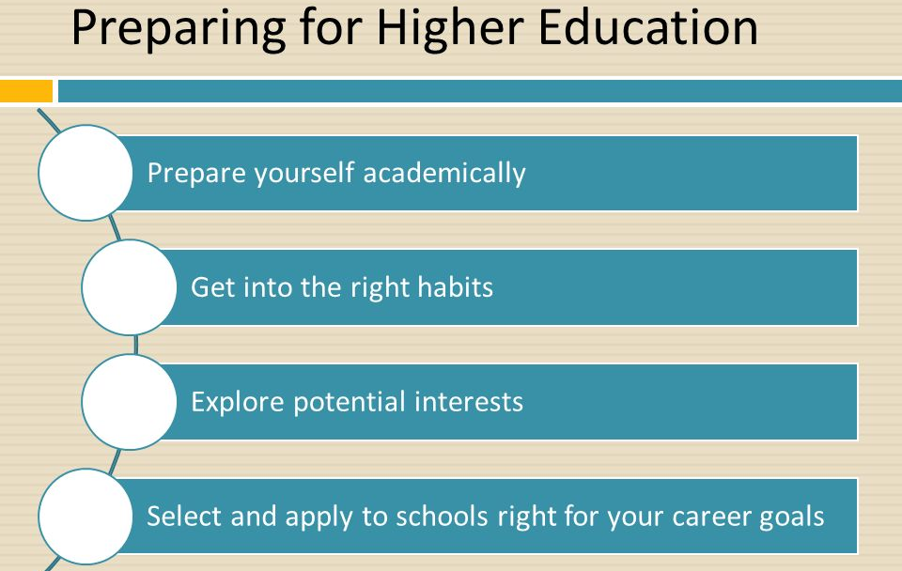
Figure 1: Preparation for higher education
[Source: Slide Player, 2023]
One student may find their ideal college to be one that offers everything but what they're looking for in terms of location, climate, academic specialisations, extracurricular opportunities, and campus culture (Lowe and Cook, 2003). As a result, it is crucial to consider factors other than a college or university's name or reputation while making a final decision on your education. It's important to take the initiative when researching possible options for acquiring financial aid. Doing proper research early on and figuring out which course of action is best can minimise wasted time and effort and maximise potential financial savings (Crimson, 2023). Most students will need financial assistance at some point during their time in school. Loans, scholarships, grants from other organisations, and government aid are just some of the options available to students looking to cover the costs of attending college.

2) Mind map on the topic of "Becoming a Digital Learner."

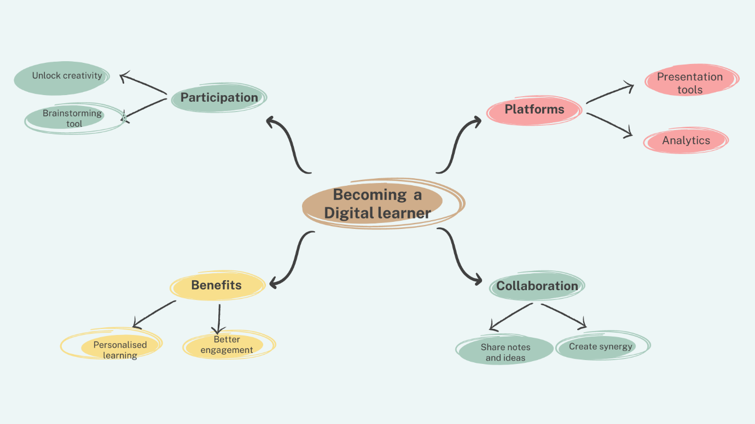
Figure 2: Mind map of "Becoming a Digital Learner"
(Source: Self-developed)
Digital learners are using technology actively to learn on several devices, engaging and appreciating the high-value online course support and interactive sessions anywhere and anytime. The digital learner learns how to perform in a team. In the context of digital learning, students can access recorded classes easily and consider them as a reference (Leyden, 2023). It helps the students to understand the subject in a better way and speed up the whole learning process. It is convenient for the students to access the extra learning materials and sources. In regards to the mentioned mind map on Becoming a Digital Learner, there are some concepts and themes that are interrelated. To become a digital learner, students need different digital platforms, such as presentation tools and analytics. Both are platforms of digital learning beneficial for the students to make better presentations and do the analysis of the information. In collaboration, online mind-mapping software is an effective learning tool. Notes and ideas can be shared among the same areas and in a better position to work together to develop a valuable and reliable library of authentic information. Digital learning provides benefits to students in enhancing their personalized learning and engaging them in learning activities. In participation, a mind map can be considered an interactive resource that can effectively transform the classroom (Leyden, 2023). As mentioned above, a mind map can be practiced as a brainstorming tool for groups and individuals by sharing new thoughts that can ignite possibilities spark. It enhances the digital learning experience of the students through giving them better resources to improve their creativity and express their ideas and thoughts quickly.

3) Presentation
Slide 1:
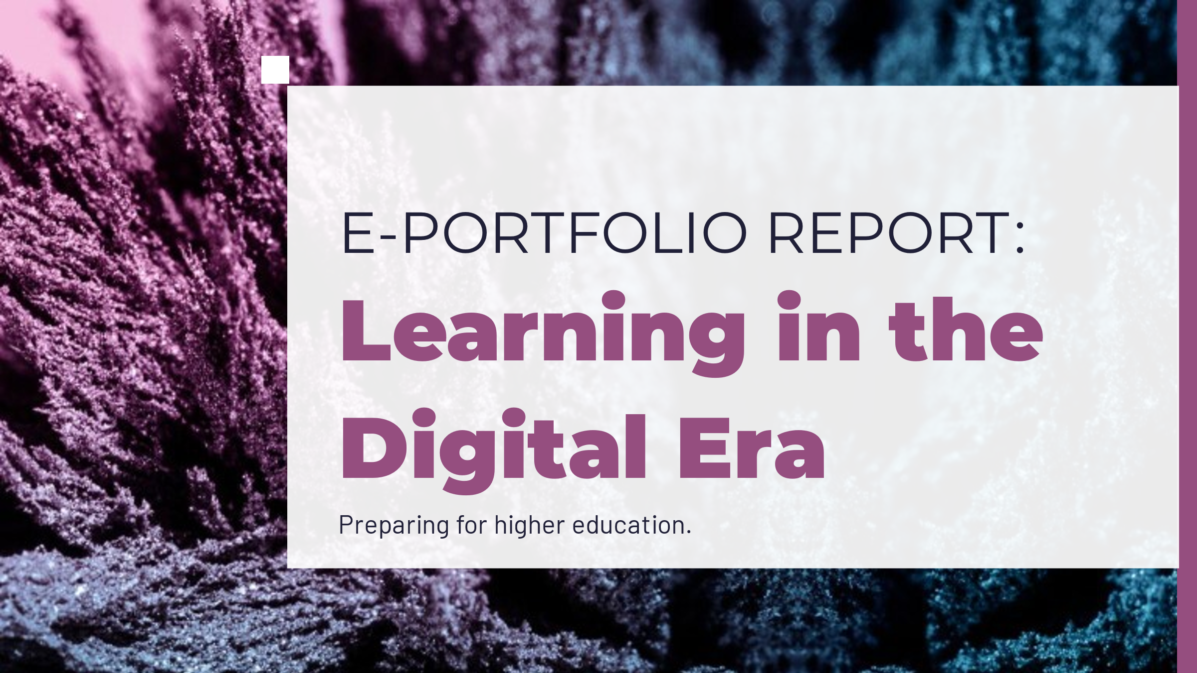
Slide 2:
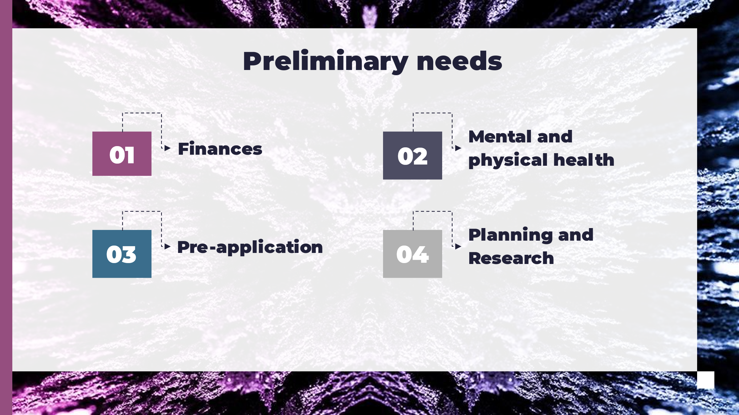
Speaker notes:
Slide 3:
To prepare for is higher education it is extremely important for a student to develop a better understanding of financial undertakings. Students have to survive in a very under pressure environment and have to manage their expenses specially in case of international studies. In addition, students also have to be aware about their physical and mental health to survive in the difficult environment they are exposed to. Furthermore, preapplication to multiple universities and equipping themselves with planning and research is also a substantial tool.
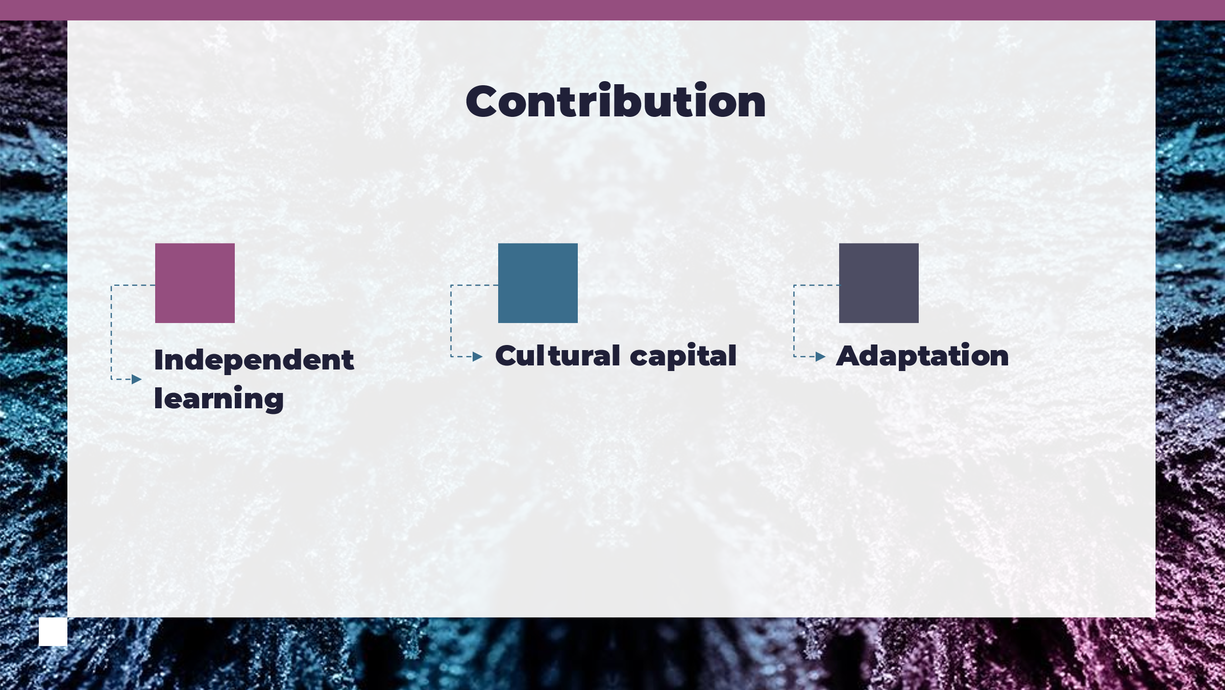
Speaker notes: there are three different elements having contribution towards a student's chance at a prestigious and well-established institution of learning. Having independent learning as a skill is extraordinarily useful as critical examination and active listening along with aptitude is pause substantial capability. In addition, students have to be aware about the cultural diversity specially in the case of international education. Flexibility and adaptability per the exposed situation are a must have skill in such time overcoming both the obstacles of educational ecosystem and other issues.
Slide 4:
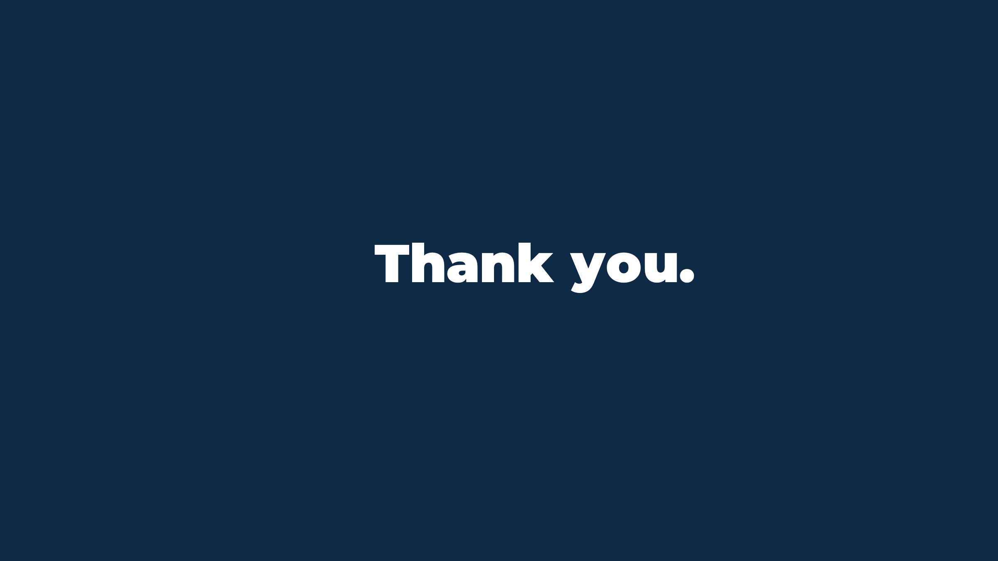

4) Reflection using Borton's reflective tool
The high school years are a crucial time to put in the work required to build genuine relationships with a wide range of teachers. In the end, kids applying to college will need to ask anywhere from two to four separate teachers to individually submit a recommendation letter on their behalf. If the instructor is very familiar with the student, this process will go more smoothly. Institutions will have a better impression of me if a recommendation letter is detailed and full of enthusiasm. With this approach in mind, I plan on using the tools and techniques available for my graduation year to their best potential.
What
Throughout the process, I plan on getting past my initial apprehensions about various courses, applications and become familiar with the system's many useful tools and processes. A variety of difficulties and concerns have been investigated despite my use of shortcuts and methods within my schooling years which I plan on resolving now (Iatsyshyn, et. al., 2020). The potentially I hold as a candidate relies on the active working I show in the upcoming time which I plan on grabbing through optimal use of online resource and learning. For the first assignment, my primal focus has to be brainstorming and recreating my essence of the past with the new assignments for developing a good impression.
So What
Those who have acquired the ability to pursue others with creative working, a versatile instrument that may be utilised for a variety of objectives during my years of higher education, stand to benefit from a wide variety of opportunities. Former teachers, advisors, or superiors at work can also provide strong recommendations. They may also comment on my daily work ethic, character, and interactions with co-workers and others in the workplace. Not only are these as powerful as letters from teachers, but they are also equivalent in terms of cost. Before applying for the job, make a list of five to ten people who could be willing to write a letter of recommendation (García-Morales, et. al., 2021).
Now What
Every school has its own set of requirements and benchmarks for admission, including but not limited to grades, test scores, and work history. It is important to research which standardised tests colleges I are interested in will actually accept before I sit for any of them. The SAT may be the only criterion for admission at some colleges, while other universities may consider additional factors. I may also be required to have a specified minimum score on a standardised test. Even if the institution has the ability to be flexible in its standards, I should always make sure to question about my eligibility if my results do not fit what is published by the school.

REFERENCES
Crimson, 2023. 6 Ways High School Students Can Start Preparing For College. [Online]. Available through: <https://www.crimsoneducation.org/in/blog/campus-life-more/prepare-for-college/> [Accessed 8 Mar. 2023].
García-Morales, V.J., Garrido-Moreno, A. and Martín-Rojas, R., 2021. The transformation of higher education after the COVID disruption: Emerging challenges in an online learning scenario. Frontiers in psychology, 12, p.616059.
Iatsyshyn, A.V., Kovach, V.O., Lyubchak, V.O., Zuban, Y.O., Piven, A.G., Sokolyuk, O.M., Iatsyshyn, A.V., Popov, O.O., Artemchuk, V.O. and Shyshkina, M.P., 2020, March. Application of augmented reality technologies for education projects preparation. In CTE Workshop Proceedings (Vol. 7, pp. 134-160).
Leyden, A., 2023. Top 5 Ways to Use Mind Maps for E-Learning. [Online]. Available through: <https://elearningindustry.com/top-5-ways-to-use-mind-maps-for-e-learning>.
Lowe, H. and Cook, A., 2003. Mind the gap: are students prepared for higher education?. Journal of further and higher education, 27(1), pp.53-76.
Murtagh, L., 2012. Enhancing preparation for higher education. Practitioner Research in Higher Education, 6(1), pp.31-39.
Slide Player. 2023. Preparing for Higher Education Advanced Level - ppt download. [online] Available at: <https://slideplayer.com/slide/9201978/> [Accessed 8 Mar. 2023].
UCAS, 2023. GETTING READY FOR HIGHER EDUCATION. [Online]. Available through: <https://www.ucas.com/undergraduate/results-confirmation-and-clearing/getting-ready-higher-education> [Accessed 8 Mar. 2023].

‌

