

SAMPLE TITLE PAGE

ACS report

Student Name:
Student ID:
Module Code: LCLM4001
Module: Academic Skills
Lecturer:

Table of Contents
1 Introduction 3
2 Description of Experiences 3
3 Personal Reflection 3
3.1 Evaluation 3
3.2 Analysis 4
4 Conclusion 4
5 References 5

Please note: these are just suggested headings/titles of the sections; you can amend them according to what each section is about

1 Introduction (~100 words)
For university students, important process , important process for university(Moon 2004). I will discuss my learning from this module in this report, focusing on three academic skills: paraphrasing, diagram notes, and finding information. These skills are important for doing well in school, and thinking about them will help me figure out how I can get better. I'm going to think about what I've learned about each skill and how it has helped me learn more in general. Last, I'll talk about what I'm going to do to get better at these skills in the future.

2 Description of Experiences
(~200 words, 2-3 paragraphs)
In this module, I focused on three academic skills: paraphrasing, diagram notes, and finding information. Rephrasing text in your own words without changing its meaning is called paraphrasing (University of Leeds, 2020). It is an important skill to have if you want to avoid copying and show that you understand what was said. This skill was very helpful for me when I had to summarize study papers for school.
Diagram notes (Appendix -1 )were also a key skill that I developed. This means making pictures of data to help people understand complicated subjects better. I used diagrams to break down the different types of research approaches when I was studying a topic on research methods, for example. This helped me remember important ideas during class talks.
Finally, finding information(Appendix -2) is very important for finishing projects and tasks. I looked for school sources online and in the library for a long time. Having this skill helped me when I had to quickly find good information for things like writing reports. As an example, for Task 2, I searched through several databases to find peer-reviewed articles that backed up my points.

3 Personal Reflection

3.1 Evaluation
(~200 words, 1-2 paragraphs)
Generally, I had both good and bad situations with these school skills. Sometimes paraphrasing(Apppendix-3) worked well for me, especially when I was summarizing pieces that I already knew a lot about. But sometimes it was hard for me to find the right words. This made my paraphrase sound too much like the original, which cost me points because it was too close to the source. As an example, I had trouble paraphrasing an article about tourist trends for Task 1, and my teacher told me I needed to change the structure more.
The diagram notes helped me understand things that were hard to grasp. I learned how to connect thoughts better when I drew shapes in class. I could have been more organized with my notes, though, because some sketches were missing parts or weren't clear when I looked at them again later.
Lastly ,finding information was a skill that could be made better with practice. At first, it was hard for me to find the best sources for my work. For instance, in Task 2, I took too long looking for articles that weren't exactly about my topic, which slowed me down. But my teacher told me to focus on more specific keywords and academic sources, which I did.

3.2 Analysis

One of the things that made rewriting hard for me was that I didn't trust my own words. Brown (2018) says that students often have trouble rewriting because they are afraid of changing the meaning of the original text. This happened to me in Task 1 when I wasn't sure if my paraphrases were too close to the source or too far away from it. I think my lack of confidence made me either copy directly or change the meaning without trying to. I need to do more paraphrasing practice, especially with hard books, and work on using different sentence structures (University of Leeds, 2020). With diagram notes, I did better in some classes because the pictures in the diagrams helped me understand vague ideas better. According to Buzan (2010), mind maps and diagrams help you remember things and understand them better by putting them in a visible way. This helped me a lot in my study methods class, where I made diagrams that explained complicated ideas. But I wasn't always organized in how I linked thoughts together. I learned that models work best when they are organized in a way that makes sense. I'm going to make this better by making sure that every diagram I make has clear titles and an idea flow that makes sense.
When it came to getting information, I mostly had trouble with how to search well. Richards (2017) says that one big problem is that people aren't using the right keywords or search tactics. I used general search engines too much at first, which got me a lot of results that weren't useful. I learned later how to use academic libraries and narrow my searches, which helped me find better sources faster. This was a very helpful lesson on how to find accurate and useful knowledge for schoolwork.
I've learned that paraphrasing takes more practice before you feel confident, that diagram notes need to be organized for clarity's sake, and that it's easier to find information when you have the right tools and techniques.

4 Conclusion
(~100 words)
In the end, this subject has had a big effect on my academic skills. I've learned more about the challenges and techniques involved in paraphrasing, taking diagram notes, and finding information by thinking back on the times I had to do these things. I've seen some things I can do better, like gaining more confidence when copying and getting my notes in order. I will keep practicing these skills and use the comments I've gotten to improve my learning going forward. I've become more aware of how these skills will help me do well in college thanks to this process of reflection.

5 References

Brown, H. D. (2018) Principles of Language Learning and Teaching. 6th ed. Pearson Education.
Buzan, T. (2010) The Mind Map Book: Unlock your creativity, boost your memory, change your life. BBC Active.
University of Leeds (2020) ‘Academic writing: How to incorporate evidence’. Available at: https://library.leeds.ac.uk/info/14011/writing/106/academic_writing/4 (Accessed: 18 April 2025).
Moon, J. (2004) Reflection and Employability. University of Exeter.
Richards, J. C. (2017) The Focus on Academic Skills: Practical Applications. Cambridge University Press.
Appendix -1 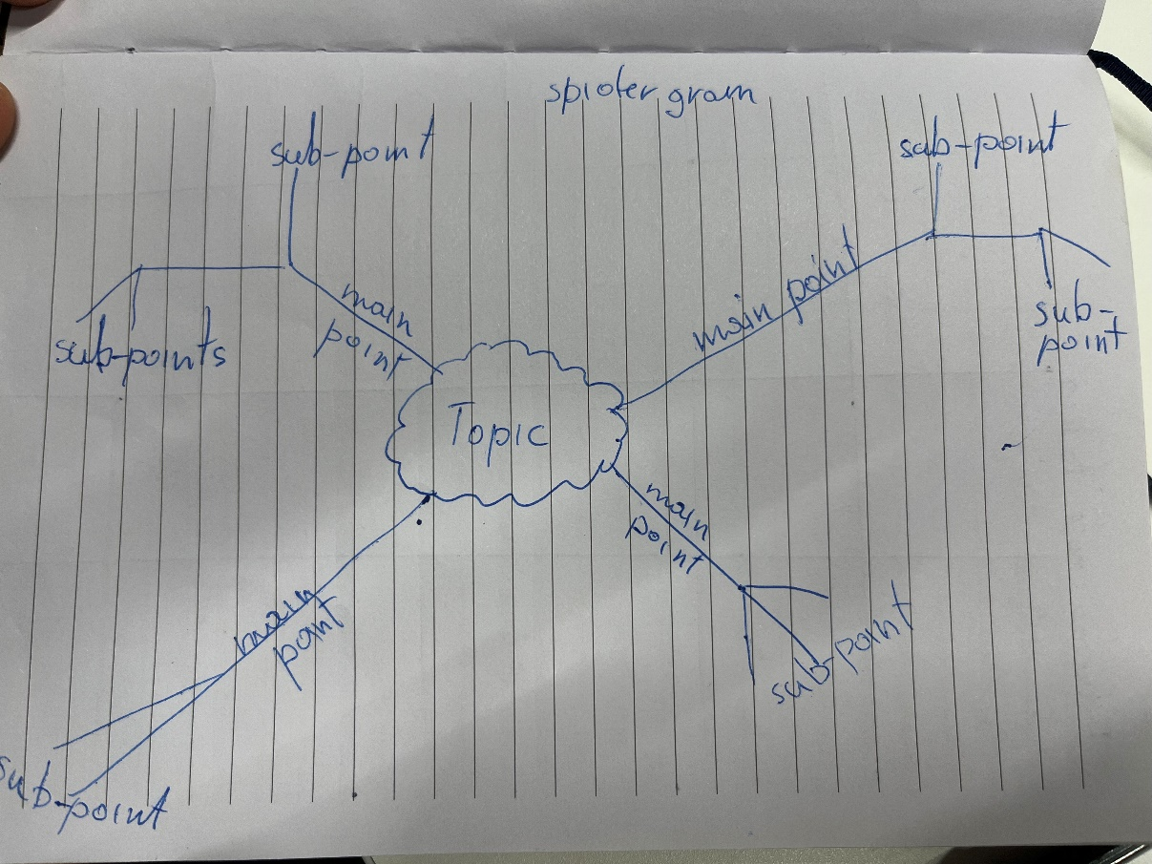
Appendix -2 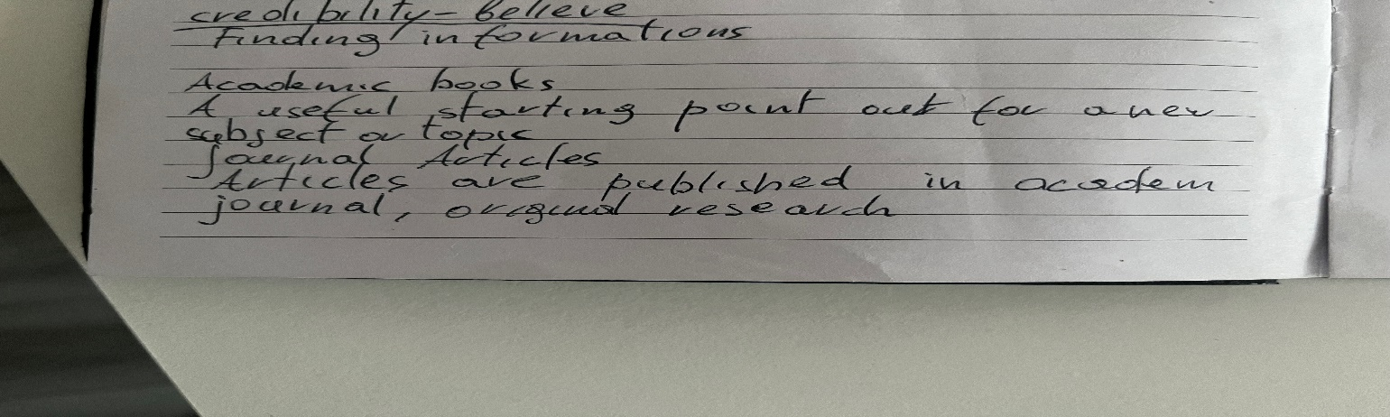
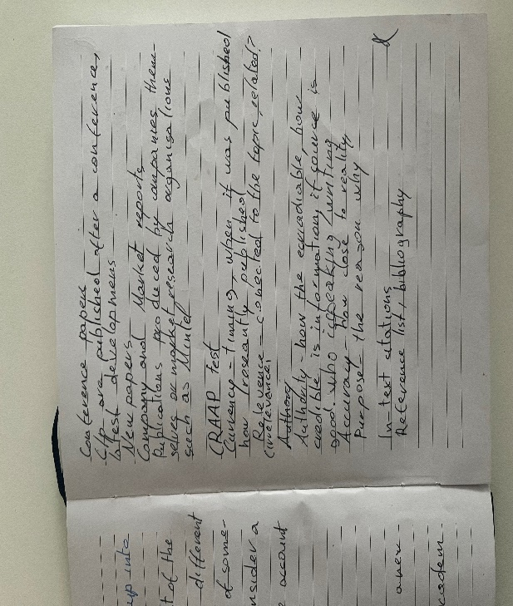
Appendix-3

