Shader Development

Student name : Teifion Gibson
Student number : 2304294

Task 1 - code created 3
Task 2 35
Practical applications of an edge detection shader 35
Practical applications of a colour inversion shader 37
Shader Utilised within written code 38
Bibliography 42
Appendix 46
1 Link to Google drive containing code 46
2 Link to video demo of code 46
3 Copy and paste of assignment code 46

Task 1 - code created
This section outlines the code for the renderer and the main cpp file, for the shader code, it is located at the end of task 2.
Fullscreen quad.cpp
The fullscreen quad function when called calls to functions that generates indices and vertices and creates a unique object that contains the generated indices and vertices. This creates a unique object that is the fullscreen quad.
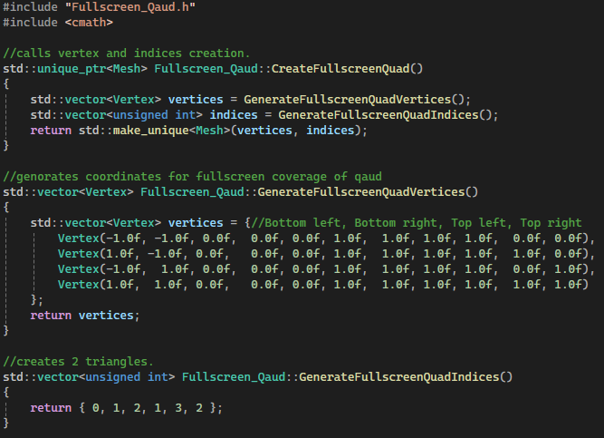Figure 1
Text 1: Fullscreen qaud cpp
Fullscreen quad.h
Contains the functions used within the program, the objects values are called using the vertex class for the vertices and creates the indices via an unsigned int.
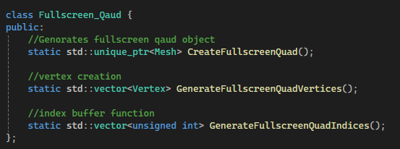Figure 2: Fullscreen qaud header

Mesh.cpp
The First Function within the mesh file calls the setup mesh and takes input and makes references to the indices and vertices, the next function is the mesh destructor and unbinds the VAO, VBO, and EBO buffers
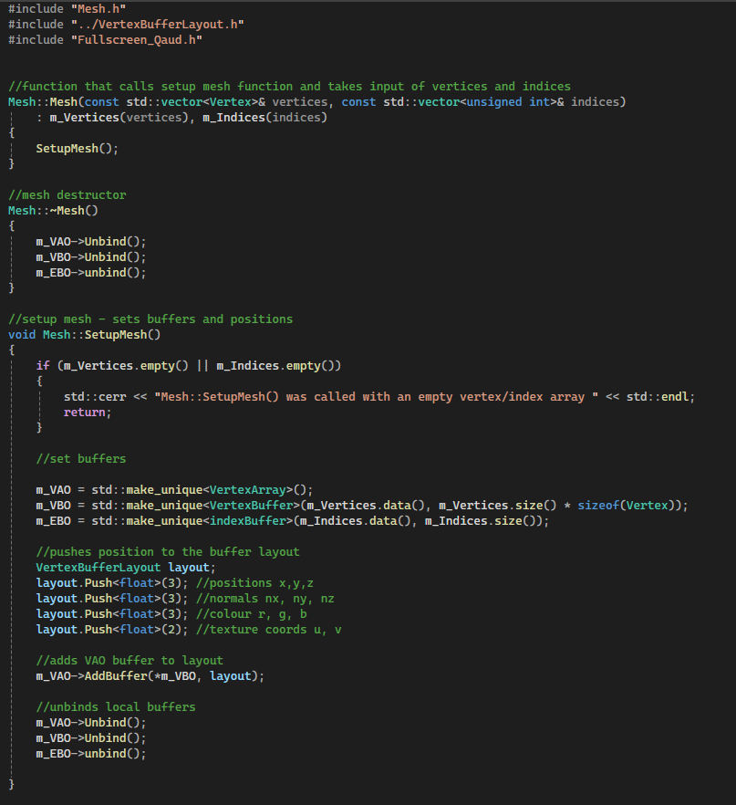Figure 3: Setup Mesh
Figure 4: Mesh Destructor
Next the cpp calls a setup mesh function which first checks that the mesh has vertices and indices, then it makes unique variables for the VAO, VBO and EBO. Next space is allocated to the vertex buffer for the mesh object. Finally the buffer is added to the layout and then the local buffers are unbinded allowing the mesh setup function to be used again for the creation of additional objects.
Figure 5: Setup Mesh Function
The Draw function calls the renderer and draws the object from the VAO and EBO buffers.
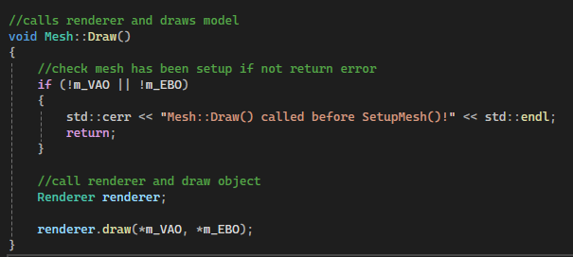Figure 6: Draw Model Function
Mesh.h
This header file contains the declarations for buffer and vertices within the mesh class, additionally creates pointers to the EBO VBO and VAO buffers. And matrices for the model vectors. The functions are constructors and destructors setup and draw functions and a function for setting the models position. Which sets the model position to the inputted vectors position
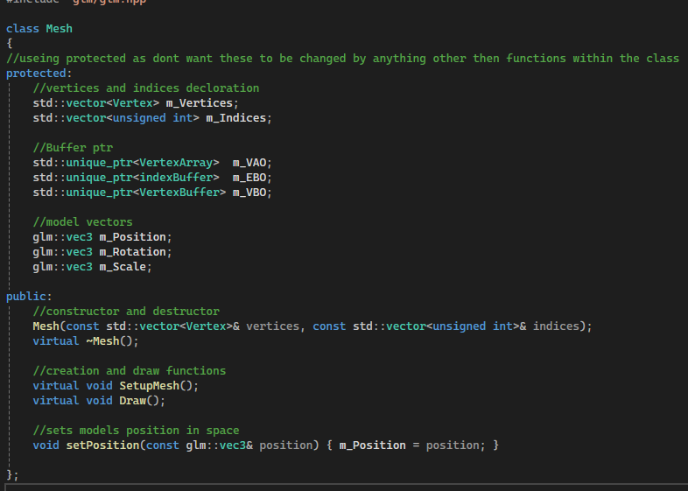Figure 7: Mesh Header
Model mesh cpp
The draw function first checks that the VAO and EBO buffers exist, next the function creates a count that contains the size of the textures array, then it sends the texture to the shader and binds it, then it calls the texture and draws it on the object and renders within the renderer. Finally the draw function unbinds the texture.
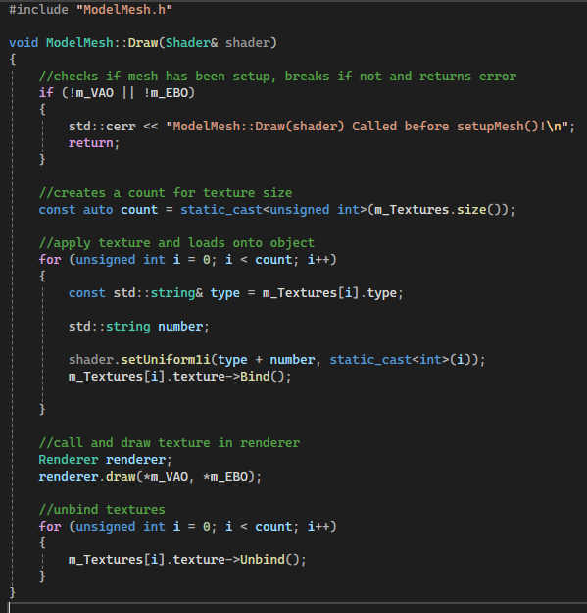Figure 8: Model Mesh cpp
Model mesh header
This header contains a struct called meshtexture containing a pointer to the texture from texture cpp, and two strings for the file type and filepath. Additionally contains a class called model mesh for a function that is used for drawing the shader and a texture vector that is private to avoid overwriting the texture data
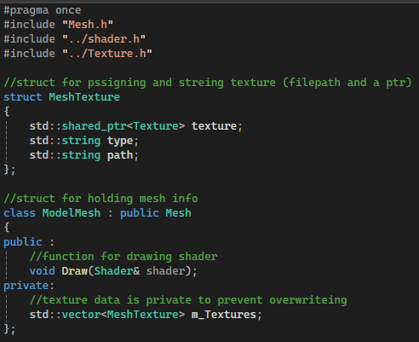Figure 9: Model Mesh Header
Vertex.h
This header contains a struct that defines the vertex float values and a function that names and writes the full vertex values.
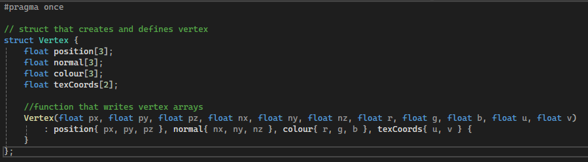Figure 10: Vertex header
Test effects cpp
This function contains the test effect function which creates the a unique reference to the shader file, a unique quad object, and a texture reference, then the shader is binded to the GPU, the the texture effect is passed to the shader as U_texture and the texel is passed as U_texel within the shader. Additionally we will pass the effect to the shader which We then pass the opacity to the shader. allows us to create a selector in imgui, finally the program unbinds the texture and shader
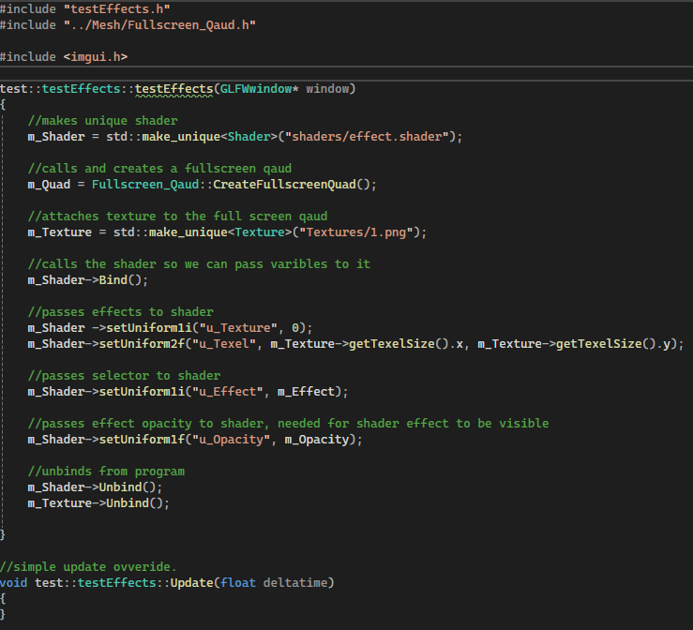Figure 11: Test Effects Render model And apply texture
Additionally there is an update function.
Figure 12: Test effects Update Function
The render function creates and calls the renderer and clears the old frame, it then binds the shader and texture, it then checks and sets U_effect within the shader to the selected shader, then calls the draw function to render the object and unbinds the object and texture.
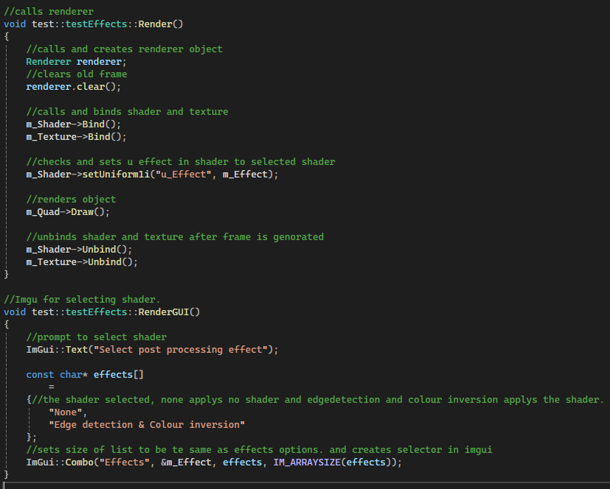Figure 13: Test effects render function

The render gui sets the imgui menu with 2 options, these are no shader effect and edge detection and colour inversion, these are then placed within the list in the imgui menu.
Figure 14: Test Effects render gui
Shader.h
The shader file contains a class called testeffects, this class exists within the test namespace, first it declares the testeffects constructor function, then an override for the update render and render gui functions.
The class also stores pointers to the window, quad object, the shader, and the texture/ additionally it declares and sets a local value of effect to 0 and opacity to 1, the opacity is used to make the shader visible.
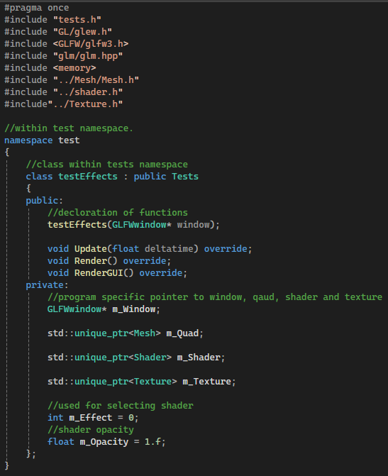Figure 15: Shader header
Tests cpp
Tests cpp contains a blank test menu function, this can be overridden to apply program specific functions
The render GUI function creates a button within the test menu to exit the program and return to the test selector menu
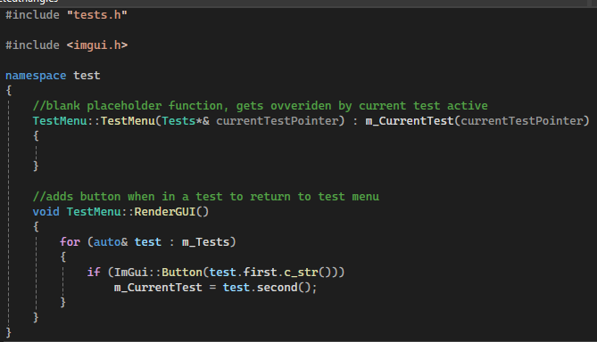Figure 16: Tests cpp

Tests Header file
Within the namespace of test we create a test class, first there is a constructor and destructor, then we create blank functions that will be overridden by the test effects program
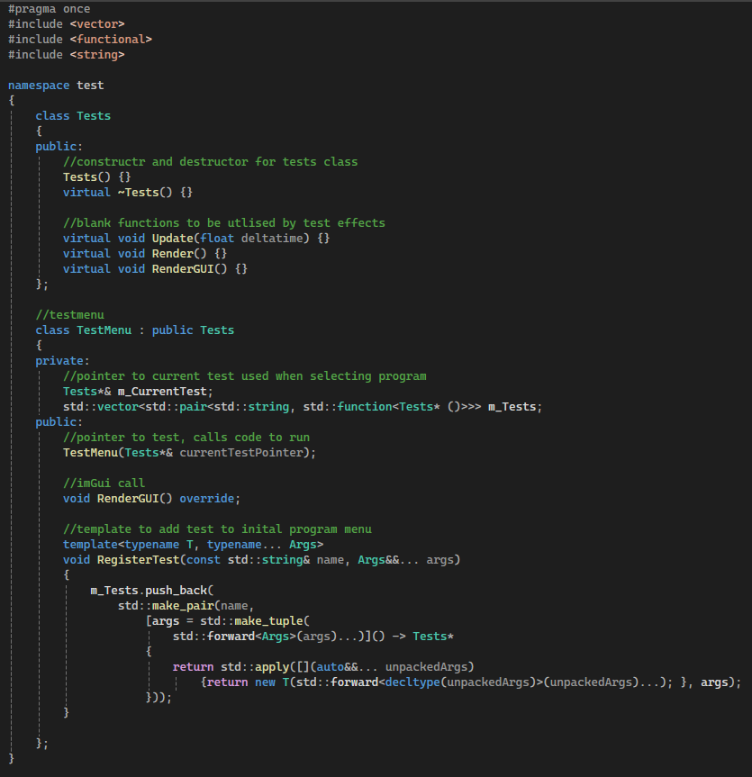Figure 17: Tests header
The next class is the testmenu, this class is a part of the tests class and contains a pointer to the current testmenu, a pointer to a test that calls what code to run (this is the cpp file test effects. Finally we create a template with a function to add an test to the test menu (called register test)
Figure 18: Tests header 2 - test menu class
Main cpp file
After the includes for the programs utilized by the program we defines the opengl and the glew Library
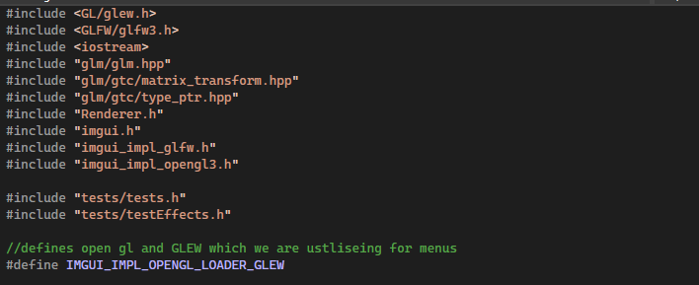Figure 19: Main cpp includes
Next the program enables vsync and creates the renderer object. Then it creates a imgui menu within the window and checks if the menu is initialized.
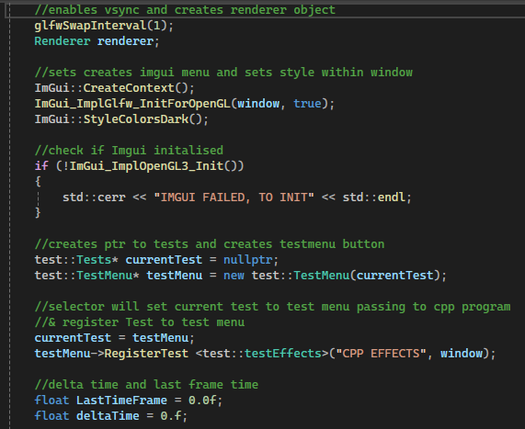Figure 20: Main cpp enable vsync and initalise imgui
Next the code creates a pointer and creates a button for the test menu. Then it creates a selector that allows us to run the cpp effects in the window, additionally the current test is the same as the test menu. This code creates a selector within the test menu. Additionally we store the delta time and last frame time.
Figure 21: Test Menu and register Program to test menu
Within the renderloop we fetch the current frame time and update the current frame time with the last frame time, to get the change in time, then the code clears the frame, and updates imguis menu to be in the new frame.
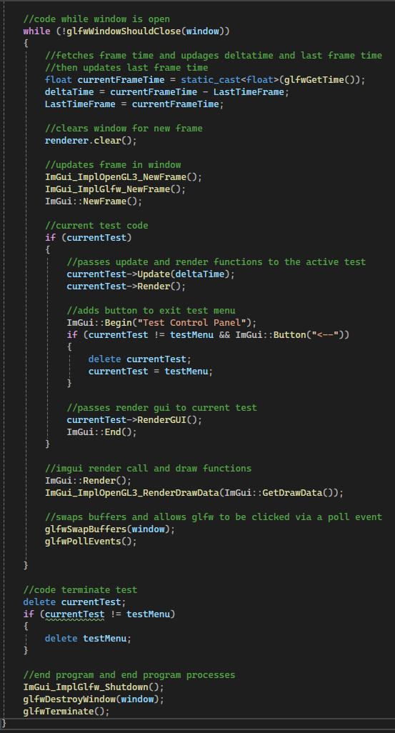Figure 22: Start of render loop - frame updates and imgui update
Checks current test and uses render and update function within the currently applied test. Adds a button to the test menu to return out of the test program then passes render gui to current test to add program specific test functions
Figure 23: Sets active code to selected test from menu
Now the code renders and draws imgui menu and swaps the window buffers. Finally after the update loop the code ends the current test and deletes the active testmenu, then it ends imgui, closes the window and terminates the program.
Figure 24: End of render loop and close program processes
Indexbuffer cpp
This cpp file contains functions to create and bind the index buffer, and a function to delete the index buffer. Additionally there are quick bind and unbind functions.
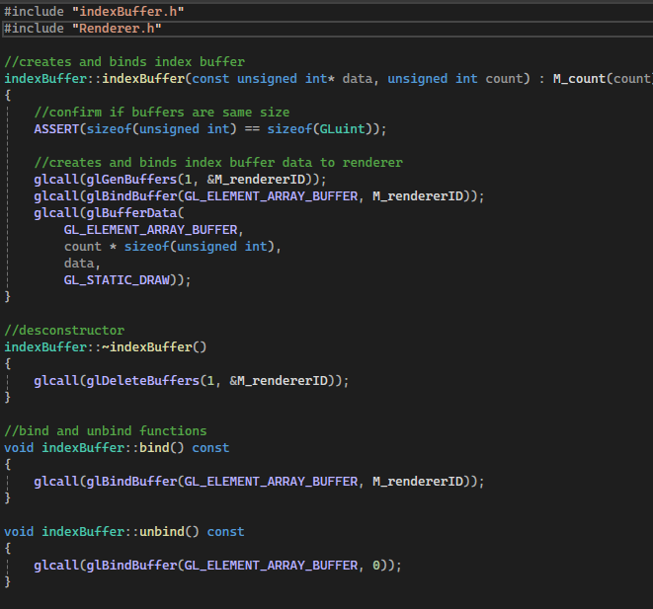Figure 25: Index buffer cpp
indexbuffer header
contains declaration of class the renderer id and count which is used for updating buffers additionally constructors, destructors, bind and unbind functions. Additionally a get count function used for retrieving the size of the index buffer.
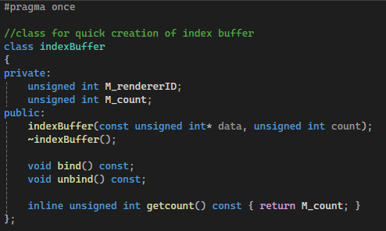Figure 26: Index buffer header
Vertexbuffer cpp
Functions to create a buffer and assign it to renderer, destructor to delete buffer, bind and unbind functions for vertex buffer
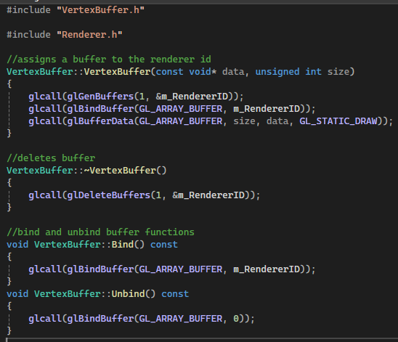Figure 27: Vertex buffer cpp
Vertexbuffer header
Header that contains a renderer id reference and constructor/destructor for vertex buffer and bind and unbind functions.
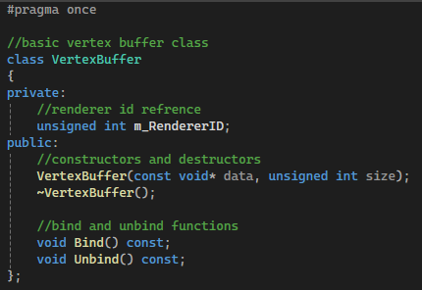Figure 28: Vertex buffer header
Renderer cpp
The renderers first uses 2 functions utlised by a macro. This macro will print error within the shader and print the location of the error. This is utlised to assist with debugging the shader.
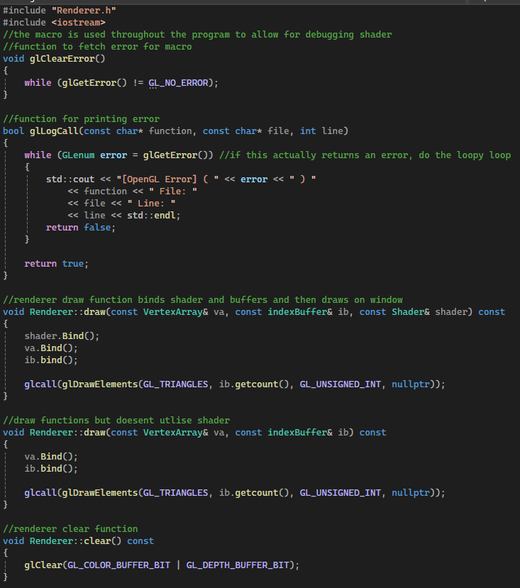Figure 29: Renderer cpp glclear error and gllogcall functions
First function within the renderer object is the draw function this binds the shader vertex and index buffers rendering the object. The second draw function dosent utilize the shader and is used to render the quad model. Finally the clear function clears the renderer for the next frame.
Figure 30: Renderer draw and clear functions
Renderer header
The header begins with a macro that exists to assist with debuggin the shader if there is an error the macro will print where the error occurred within the code. This has been done as an error in the shader will not return where the error is.
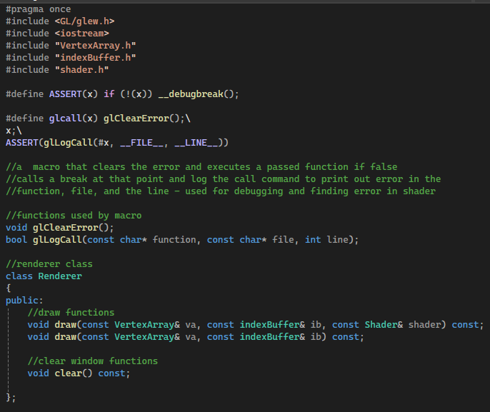Figure 31: Renderer Macro
The class within the file creates two draw functions that render the object and shader and another function which does not draw the shader. Additionally there is a quick function to clear the renderer.
Figure 32: Renderer Class
Shader cpp
Code loads a shader from a specified filepath and turns it into a vertex and fragment shader and assigns them to the RendererID. Second function just creates the shader reference utilizing pointers to the source code of the shaders.
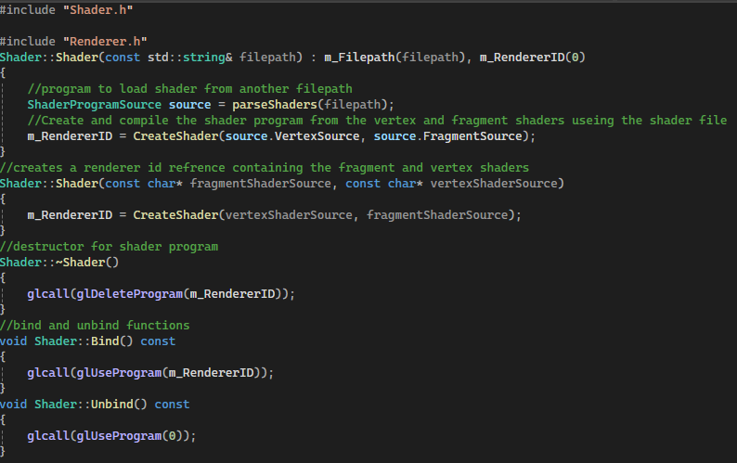Figure 33: Shader constructors
Figure 34: Shader deconstructors and unbind functions
Set of uniforms that creates arrays and matrix within the shader
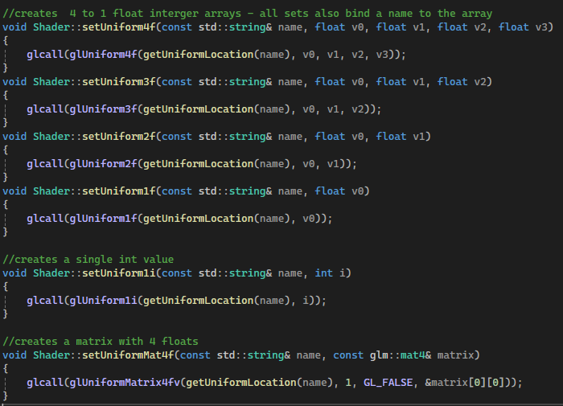Figure 35: Uniform arrays
This function gets the uniform location and returns it if it is found.
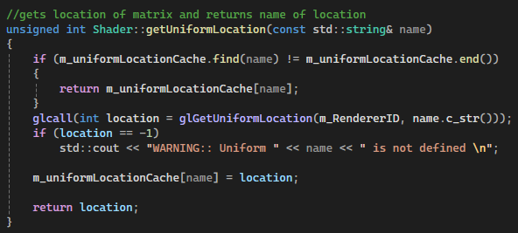Figure 36: Get uniform loaction function
The shader program function parses the shaders and ensures they load correctly within the gpu. First it checks if the specified filepath is valid. If it is it allocate space for the filepath and then creates a class to store shader information and a shadertype object
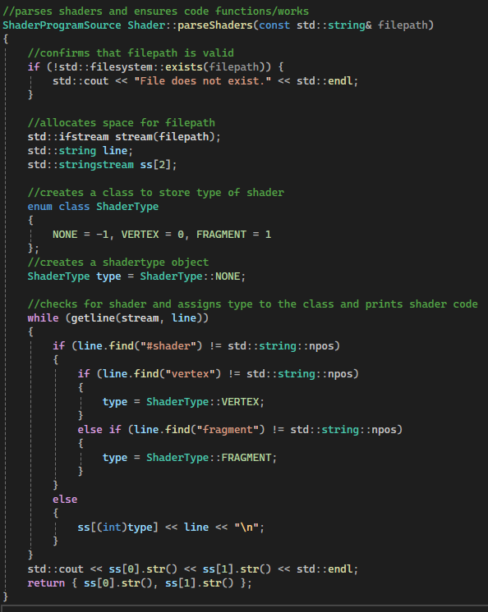Figure 37: Parse shaders function 1
Then the code checks for the types of shaders present and then assigns the shader the type of shader Vertex and fragment. Otherwise it prints no shader. Finally it prints the shader code to the terminal.
Figure 38: parse shaders function 2
Next the compile shader function starts by fetching the shader if aand assigning it an id. Then the shader converts the shader code to c_String so that the shader can be read by the gpu. Then the shader associates the shader source code that was converted to cstring and sends it to the shader, then the code compiles the shader.
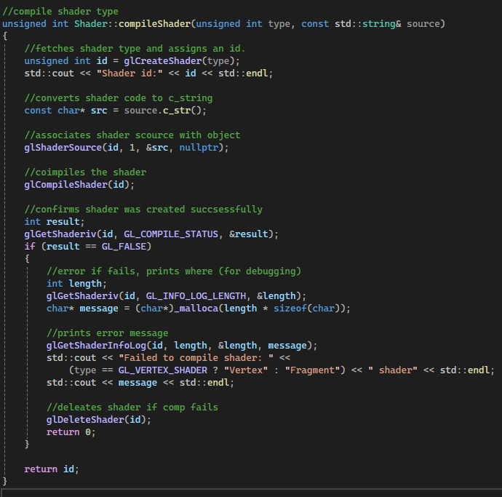Figure 39: Compile shaders function 1
This part of the shader compilation checks if the shader has successfully loaded. If it does no error is returned if the shader fails an error is printed specifying it failed to compile the shader and which shader the error is within then the shader object is deleted, and 0 is returned. Otherwise the shader id is returned.
Figure 40: Compile shaders function 2
The last function creates and attaches the vertex and fragment shader to a shader program and returns the shader program.
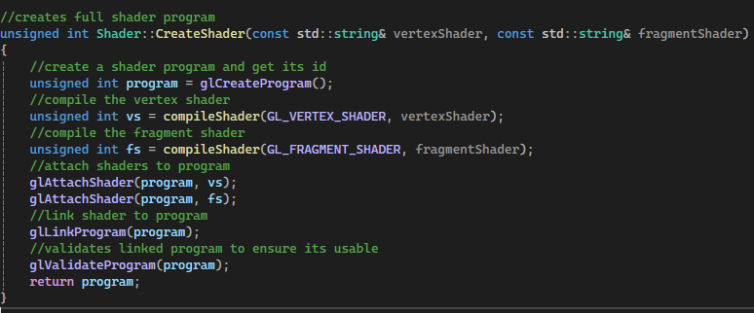Figure 41: Create shader function
Shader header file
The shader header file contains a struct containing the vertex and fragment shader source code.
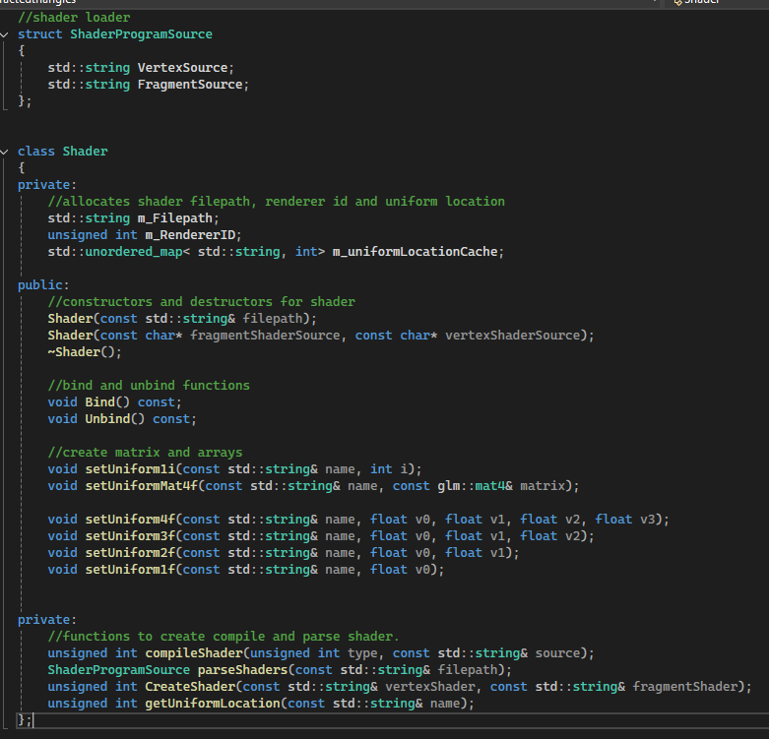Figure 42: Shader struct

The shader class first allocates space to store the shader filepath the rendererID and the uniform cache as private variables.
Figure 43: Shader Class private varibles
Within the public functions there are constructors for the shader and destructor, bind and unbind functions, functions to create matrix and arrays within the shader.
Figure 44: Shader class public functions

Figure 45: Shader class private functions

Texture cpp
Within the texture cpp file we utlised the Stb_image implementation in order to utlise and load textures within the program [1]
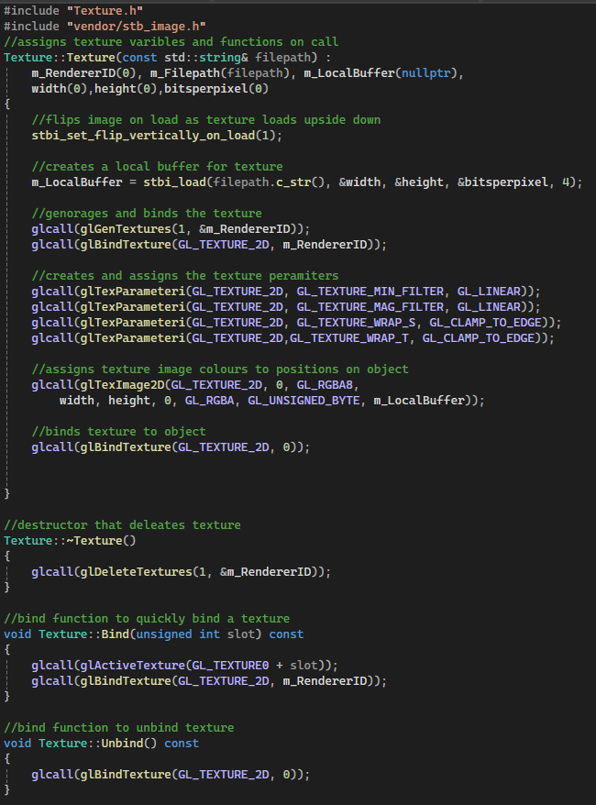Figure 46: Stb image.h include
Within the cpp file we have the constructor that loads the image from an external file. First the image is flipped vertically as it loads upside down otherwise, next we assign a local buffer for the texture.
Figure 47: Texture loader 1
Next we bind the texture to the renderer, then we assign the texture parameters within the shader, load the image colours to the texture positions on the object then finally we bind the texture data to the object.
Figure 48: Texture loader 2

Next functions are a destructor that deletes the texture, and bind and unbind functions to quickly bind and unbind a texture to an object.
Figure 49: Texture Destructor, bind and unbind functions
Texture Header
The header contains integers for storing filepath and image information aswell as a pointer to a local buffer and the renderer id. Within the public functions we have the constructors and destructors bind and unbind function and a function that gets the texel size on the image.
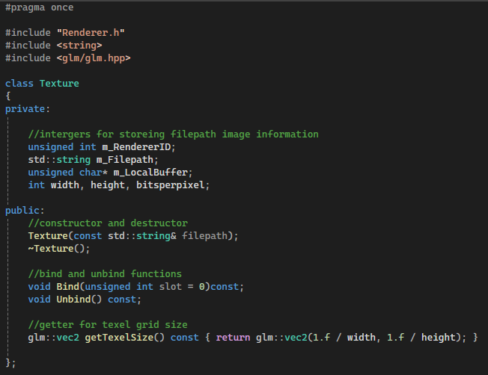Figure 50: Texture header
Vertex array Cpp
Functions for quickly creating and binding / unbinding the vertex array to the renderer.
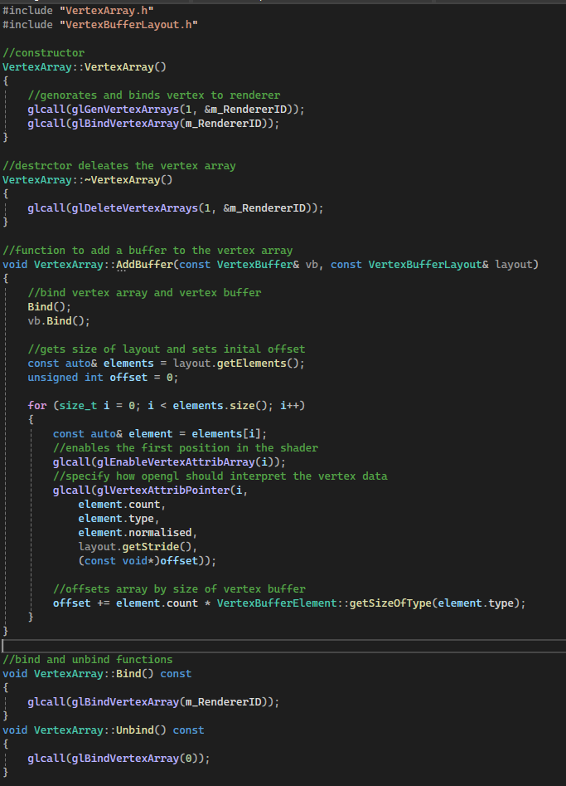Figure 51: Vertex array constructor and destructor

A function to add a vertex array buffer, and adds it to the array within the shader, and the array is offset by the size of the vertex buffer. Additionally quick bind and unbind functions are here

Figure 52: Add buffer and bind/unbind functions
Vertex array header
Header file within the vertex buffer contains a forward declare, then the vertex array buffer contains the renderer id, constructors and destructors a function to add the vertex buffer to the programs buffers and bind and unbind functions.
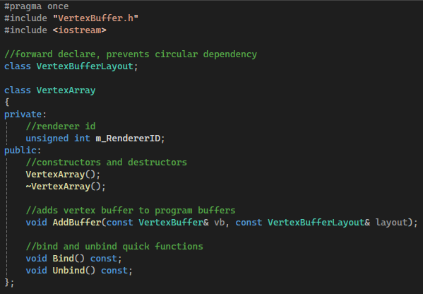Figure 53: Vertex array header
Vertex buffer Cpp
Code to add vertex buffer to the renderer, deconstructor function and bind and unbind functions.
Vertex buffer header
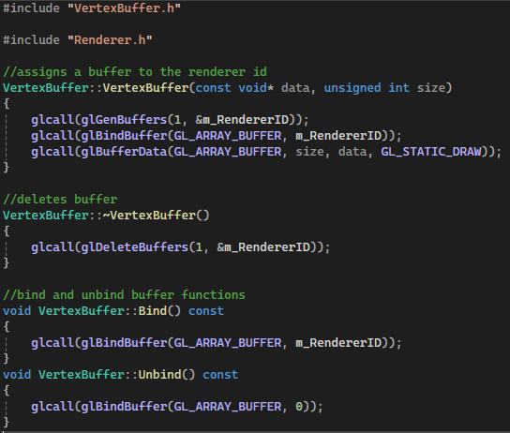Figure 54: Vertex buffer cpp
Header contains class that has a reference to renderer id, and constructor/destructor functions, and bind and unbind functions
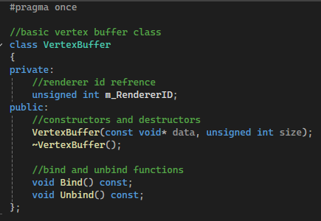Figure 55: Vertex buffer header
Vertex buffer layout Cpp
Blank cpp as all is handled within header
Vertex buffer Header
Header contain a struct for the buffer element containing the type cound and normalised values. Within the struct there is a get size of type function which returns the type of vertex buffer. Additionally there is a vertex buffer element acting as a constructor for the struct.
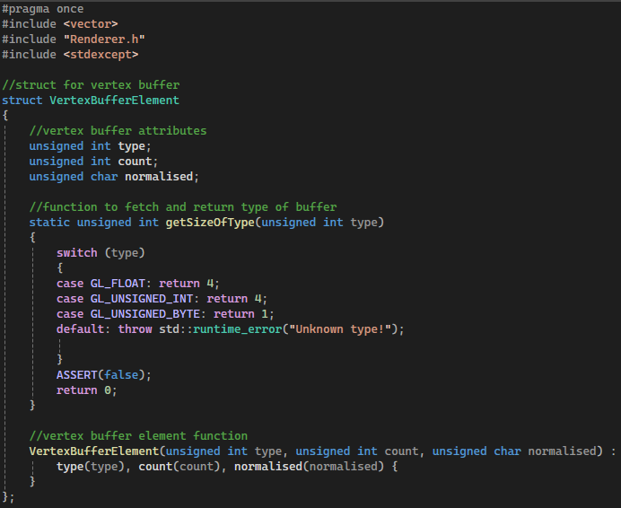Figure 56: Vertex buffer layout struct
Within the vertex buffer layout class there are two values stored the elements and stride. Additionally there is a constructor and destructor within the functions, there are also push functions to push space for each type of vertex buffer utlised within the program. Finally there are two functions to get the number of elements within the buffer and the stride.
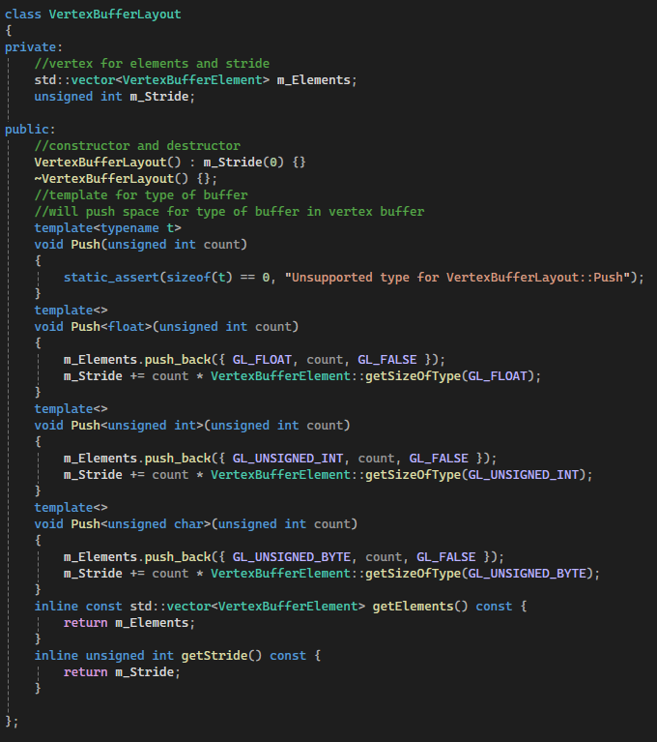Figure 57: Vertex buffer layout class

Task 2

Practical applications of an edge detection shader
Edge detection shaders are used to locate the boundaries of objects in an image [3]. Applications include medical imaging, computer vision and photography, and are utilized to improve abilities for automated systems to understand their environment [3].
Within edge detection systems there are three kinds of visible edges that can occur, these are steep edges, ramp edges and line edges [4]. Outlined below are two common edge detection methods and applications for them [4].
Sobel edge detection
Sobel operator is a simple edge detection method that works by applying 3x3 convolution kernels to an image, one for detecting vertical edges and one for horizontal edges [4]. Then the filter finds the gradient and how fast the gradient changes in these two directions, a large change signifies an possible edge [5], the two values are then combined to determine the edge strength at each pixel [5]. Pixels with a high gradient are marked, these edges assist in finding the visual boundaries within images [5]
Prewitt operator
The perewitt operator is similar to the sobel operator but it uses a slightly different calculation, additionally it is less computationally intensive as the sobel operator [4]
Examples of edge detection
Edge detection is utilized heavily with facial recognition technology and motion technology as it helps machines interpret and understand visual data [6] in a paper by J.García-Ramírez et al, the outline that edge detection technology is utilized within the first stage of facial recognition systems to clearly define boundaries and outlines of an individual's facial features [7].
Within game applications game engines such as unity have built in effects that allow for the application of an edge detection filter for visual effects within games, such as in the image below [7]
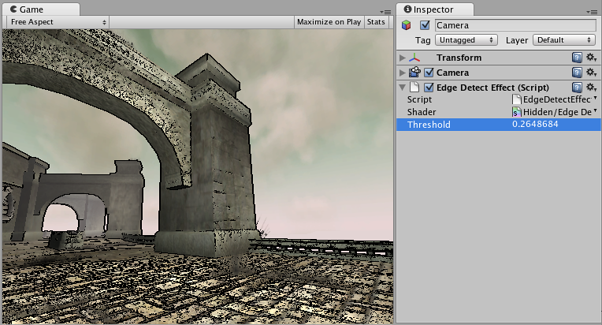Figure 58: Edge detection filter applyed in game [7]
Within medical applications edge detection has been applied to identify medical issues such as edges of tumors. Allowing doctors to identify the potentially harmful tumors and the size of these tumors. A downside of edge detection is that it can be effected by noise within images, if an image has high noise, it can be harder for the algorithm to clearly find the visible edges as it highlights areas with high gradients[8].
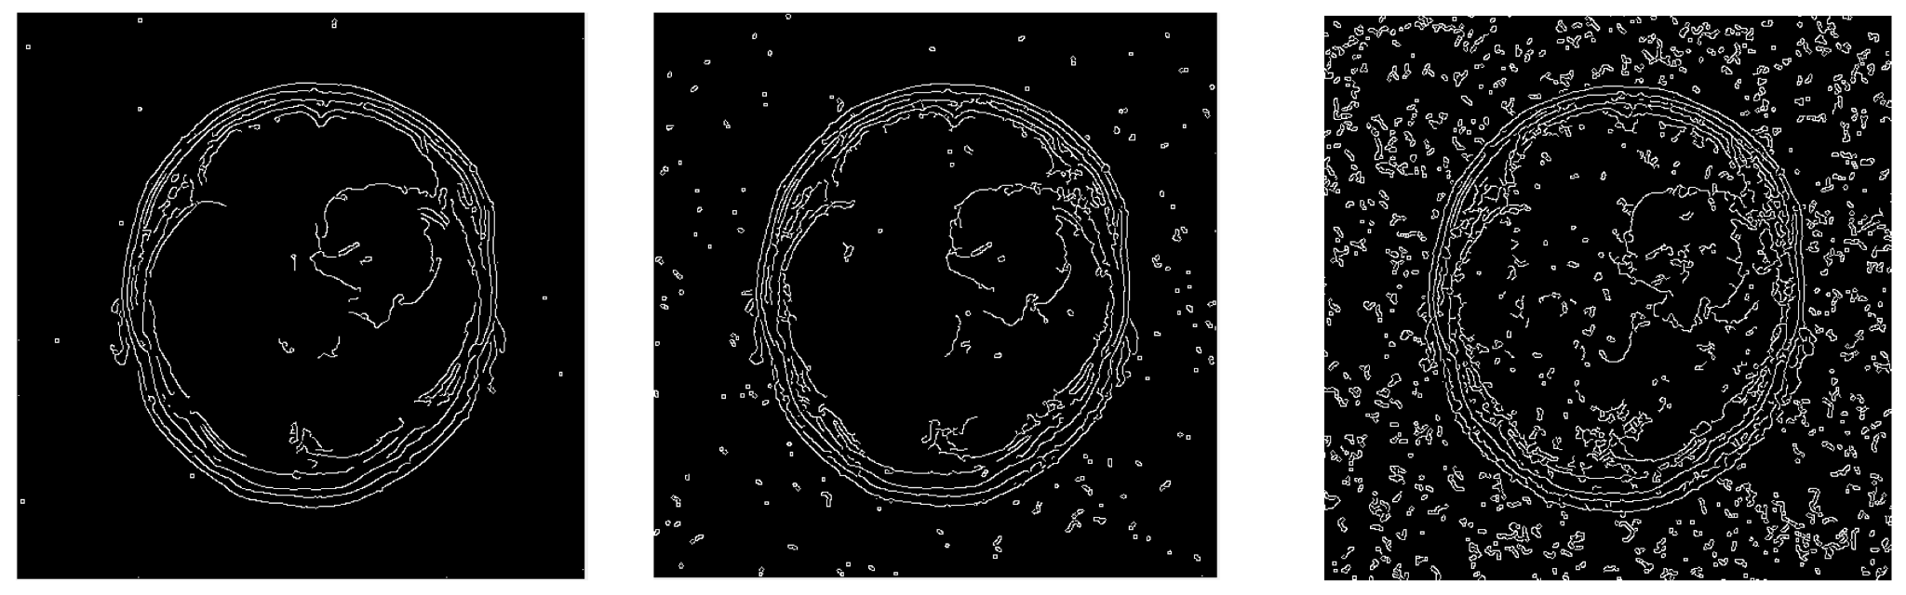Figure 59: Edge detection utlised to show outline of a tumor as more visual noise is present

Practical applications of a colour inversion shader
Colour inversion shaders work by taking the displayed pixels colour value and then subtracting the rgb values by 1.0 this inverts the colours of a displayed image [11], further more by subtracting a singular colour value you can create a shader that removes certain colours from an image such as the images shown below [11]
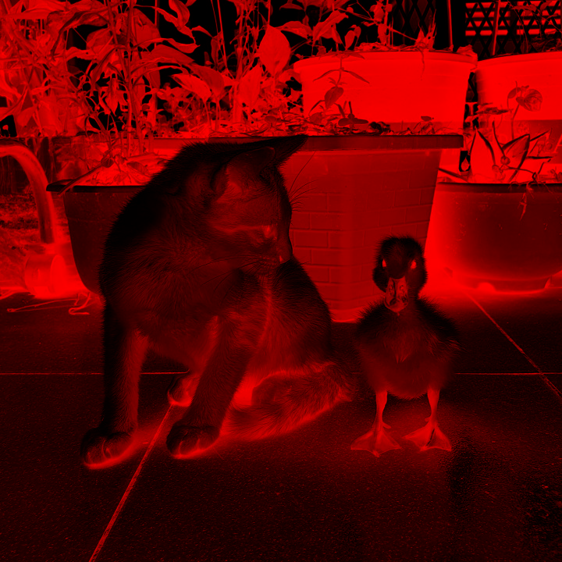Figure 60: Colour inversion shader applyed to image - removes all values exccept for red [11]

By applying colour inversion shaders within game applications we can create effects to visually tell the player they are under conditions such as a poison effect or bleeding effect. Within game engines such as godot and unity there are built in shaders for applying colour inversion to the project [12], [13] these shader functions allow for the game to invert colours on a single colour value or the entire displayed texture
Another application of colour inversion is for accessibility to make elements visually more distinct or to reduce eye strain, this is intended to be utilized to assist individuals with visual impairment by increasing contrast between colours, additionally it can darken a visual as the colours are less bright [9].
An additional usage for colour inversion is to apply effects to create images such as photos to create a unique aesthetic [10] as colour inversion utilizes opposites in the colour spectrum it creates a “negative” effect similar to traditional analog photographs [10]
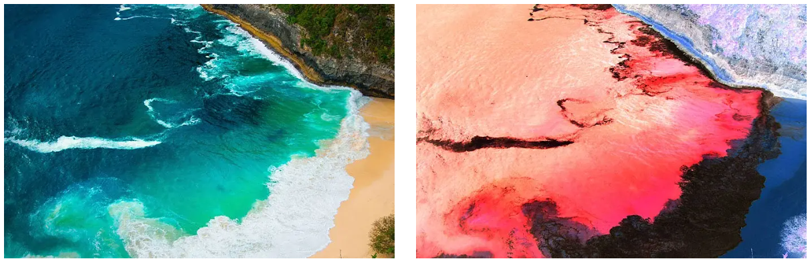Figure 61: eample of colour inversion on a photo from adobe showing no colour inversion and colour inversion [10]

Shader Utilised within written code
For the image we are applying post processing effects to im using SMPTE Colour [2] bars as they will show the effects applied clearly the first image shows the original image we are applying the post processing effects to.
Figure 62: SMPTE colour bars [2]
Within the second image we have applied postprocessing effects to the image. And as can be seen the white lines on the left of the image are where the edge detection shader found a high gradient and the colours on the left of the image are inverted to their opposite rgb values.
Shader effects applied to image (Edge detection left, colour inversion right)
Figure 63: Shader effects applyed to image
First the vertex shader Specifies the shader and defines the vertex position normal and texture coordinates. Then it outputs to the frag shader the texture coordinates as a different named value. The function then applies the texture coordinates to the outputted variable, this is done to prevent the fragment shader from overwriting the displayed textures values as the vertex shader is loaded first.
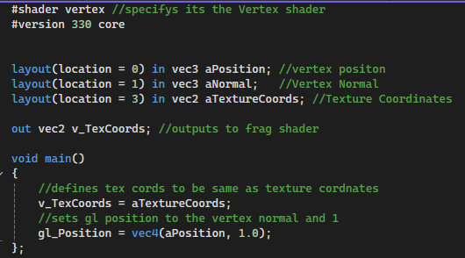Figure 64: Vertex shader

The Fragment shader is where the post processing effects are being applied, it takes in the Texture coordinates from the vertex shader and outlines some modifiable effects. Additionally it outlines variables for the texture, texel an effect selector and shader opacity
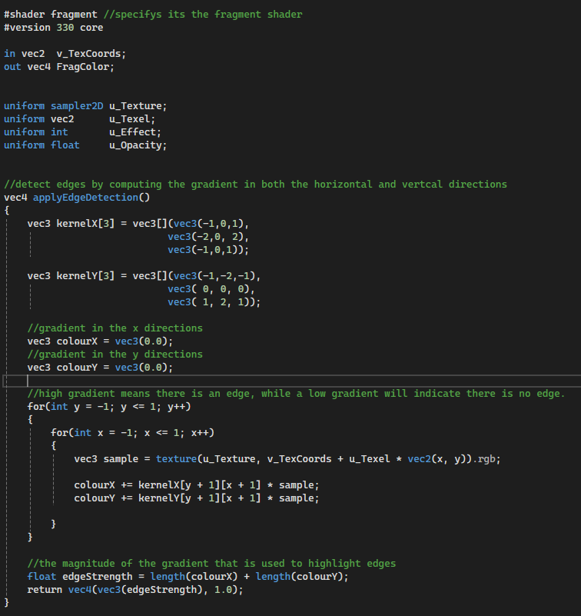Figure 65: Fragment shader values
The edge detection algorithm utilizes Sobel edge detection to clearly mark and define where a High gradient is present. The shader does this by taking a gradient in x and y positions in the image and searches for a high gradient. The greater the difference in the 3 by 3 matrix means there is an edge Finally the code sets the magnitude of the gradient used to highlight edges. Within the shader this visually appears as a white line marking the High Gradients.
Figure 66: Edge detection shader code

This function is the colour inversion shader, It first takes the colour of the texture of the texture and saves it as vec 4, then it takes 1 away from the colour within the rgb values of the image, this gives us the inverted colours and returns this modified colour value. This causes the colours to be inverted on all three colour channels on the effected pixels.
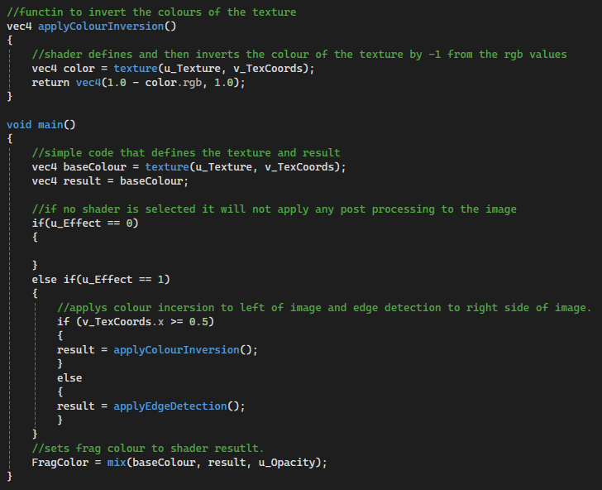Figure 67: Colour inversion shader code

Within main function of the shader we set the base colour value within a vec 4 and set the result to the base colour. Then if u_effect is 0 no shaders are applied to the image, then if u_effect is equal to 1 we apply colour inversion to the right side of the image and edge detection to the left. We use the result for this as it is a reference pointer to the base colour of the image. Finally the frag colour of the shader is set to the result of the shader basecolour, result and opacity.
Figure 68: Main Fragment shader code

Bibliography
[1]
nothings, “nothings/stb,” GitHub, 2020. https://github.com/nothings/stb/blob/master/stb_image.h
[2]
MediaCollege.com, “SMPTE Color Bars,” Mediacollege.com, 2025. https://www.mediacollege.com/video/test-patterns/colour-bars-smpte.html
[3]
GeeksforGeeks, “What is Edge Detection in Image Processing?,” GeeksforGeeks, Jul. 22, 2024. https://www.geeksforgeeks.org/computer-vision/what-is-edge-detection-in-image-processing/
[4]
M. Ettorre, “Edge Detection: A Key Technique in Image Processing,” International Journal of Advancements in Technology, vol. 15, no. 5, pp. 1–2, Oct. 2024, doi: https://doi.org/10.35841/0976-4860.24.15.305.
[5]
A. Vina, “Edge Detection in Image Processing: Explained,” Ultralytics.com, 2025. https://www.ultralytics.com/blog/edge-detection-in-image-processing-explained
[6]
M. hakimi, “Edge Detection - What Is Edge Detection?,” Ioriver.io, 2024. https://www.ioriver.io/terms/edge-detection
[7]
Unity, “Edge Detection - Unity Documantation,” https://docs.unity3d.com, Jul. 2016. https://docs.unity3d.com/540/Documentation/Manual/script-EdgeDetectEffect.html
[8]
V. Maksimovic, B. Jaksic, M. Milosevic, J. Todorovic, and Lazar Mosurovic, “Comparative Analysis of Edge Detection Operators Using a Threshold Estimation Approach on Medical Noisy Images with Different Complexities,” Sensors, vol. 25, no. 1, pp. 87–87, Dec. 2024, doi: https://doi.org/10.3390/s25010087.
[9]
Q. O’Reilly, “Finding it difficult to look at your screen? Why not invert its colours,” TheJournal.ie, May 20, 2015. https://www.thejournal.ie/invert-colours-pc-mac-smarthphone-2113329-May2015/ (accessed Apr. 06, 2026).
[10]
Adobe, “How to invert colors in Photoshop - Adobe,” Adobe.com, 2025. https://www.adobe.com/products/photoshop/invert-colors.html
[11]
Agate Dragon, “How to invert an image in a shader,” Agate DRAGON Games, Jan. 13, 2024. https://agatedragon.blog/2024/01/13/invert-image-shader/ (accessed Apr. 06, 2026).
[12]
GodotShaders, “Invert color - Godot Shaders,” Godot Shaders, Dec. 06, 2021. https://godotshaders.com/shader/invert-color/ (accessed Apr. 06, 2026).
[13]
Unity, “https://docs.unity3d.com/Packages/com.unity.shadergraph@6.9/manual/Invert-Colors-Node.html,” https://docs.unity3d.com, Oct. 04, 2019. https://docs.unity3d.com/Packages/com.unity.shadergraph@6.9/manual/Invert-Colors-Node.html
Table of Figures
Figure 1 3
Figure 2: Fullscreen qaud header 4
Figure 3: Setup Mesh 4
Figure 4: Mesh Destructor 4
Figure 5: Setup Mesh Function 5
Figure 6: Draw Model Function 5
Figure 7: Mesh Header 6
Figure 8: Model Mesh cpp 7
Figure 9: Model Mesh Header 8
Figure 10: Vertex header 8
Figure 11: Test Effects Render model And apply texture 9
Figure 12: Test effects Update Function 9
Figure 13: Test effects render function 10
Figure 14: Test Effects render gui 10
Figure 15: Shader header 11
Figure 16: Tests cpp 12
Figure 17: Tests header 12
Figure 18: Tests header 2 - test menu class 13
Figure 19: Main cpp includes 13
Figure 20: Main cpp enable vsync and initalise imgui 14
Figure 21: Test Menu and register Program to test menu 14
Figure 22: Start of render loop - frame updates and imgui update 15
Figure 23: Sets active code to selected test from menu 15
Figure 24: End of render loop and close program processes 16
Figure 25: Index buffer cpp 17
Figure 26: Index buffer header 18
Figure 27: Vertex buffer cpp 18
Figure 28: Vertex buffer header 19
Figure 29: Renderer cpp glclear error and gllogcall functions 19
Figure 30: Renderer draw and clear functions 20
Figure 31: Renderer Macro 20
Figure 32: Renderer Class 21
Figure 33: Shader constructors 21
Figure 34: Shader deconstructors and unbind functions 22
Figure 35: Uniform arrays 22
Figure 36: Get uniform loaction function 23
Figure 37: Parse shaders function 1 23
Figure 38: parse shaders function 2 24
Figure 39: Compile shaders function 1 24
Figure 40: Compile shaders function 2 25
Figure 41: Create shader function 25
Figure 42: Shader struct 26
Figure 43: Shader Class private varibles 26
Figure 44: Shader class public functions 26
Figure 45: Shader class private functions 27
Figure 46: Stb image.h include 27
Figure 47: Texture loader 1 27
Figure 48: Texture loader 2 28
Figure 49: Texture Destructor, bind and unbind functions 28
Figure 50: Texture header 29
Figure 51: Vertex array constructor and destructor 29
Figure 52: Add buffer and bind/unbind functions 30
Figure 53: Vertex array header 31
Figure 54: Vertex buffer cpp 32
Figure 55: Vertex buffer header 32
Figure 56: Vertex buffer layout struct 33
Figure 57: Vertex buffer layout class 34
Figure 58: Edge detection filter applyed in game [7] 36
Figure 59: Edge detection utlised to show outline of a tumor as more visual noise is present 36
Figure 60: Colour inversion shader applyed to image - removes all values exccept for red [11] 37
Figure 61: eample of colour inversion on a photo from adobe showing no colour inversion and colour inversion [10] 38
Figure 62: SMPTE colour bars [2] 38
Figure 63: Shader effects applyed to image 39
Figure 64: Vertex shader 39
Figure 65: Fragment shader values 40
Figure 66: Edge detection shader code 40
Figure 67: Colour inversion shader code 41
Figure 68: Main Fragment shader code 41

Appendix

1 Link to Google drive containing code
https://drive.google.com/drive/folders/1goG0z-4gbZ6CxCSp_UyS1hYZOFcevR-c?usp=sharing

2 Link to video demo of code
https://youtu.be/zs-WhGJmXDA

3 Copy and paste of assignment code
Fullscreen quad.cpp
#include "Fullscreen_Qaud.h"
#include <cmath>

//calls vertex and indices creation.
std::unique_ptr<Mesh> Fullscreen_Qaud::CreateFullscreenQuad()
{
std::vector<Vertex> vertices = GenerateFullscreenQuadVertices();
std::vector<unsigned int> indices = GenerateFullscreenQuadIndices();
return std::make_unique<Mesh>(vertices, indices);
}

//genorates coordinates for fullscreen coverage of qaud
std::vector<Vertex> Fullscreen_Qaud::GenerateFullscreenQuadVertices()
{
std::vector<Vertex> vertices = {//Bottom left, Bottom right, Top left, Top right
Vertex(-1.0f, -1.0f, 0.0f, 0.0f, 0.0f, 1.0f, 1.0f, 1.0f, 1.0f, 0.0f, 0.0f),
Vertex(1.0f, -1.0f, 0.0f, 0.0f, 0.0f, 1.0f, 1.0f, 1.0f, 1.0f, 1.0f, 0.0f),
Vertex(-1.0f, 1.0f, 0.0f, 0.0f, 0.0f, 1.0f, 1.0f, 1.0f, 1.0f, 0.0f, 1.0f),
Vertex(1.0f, 1.0f, 0.0f, 0.0f, 0.0f, 1.0f, 1.0f, 1.0f, 1.0f, 1.0f, 1.0f)
};
return vertices;
}

//creates 2 triangles.
std::vector<unsigned int> Fullscreen_Qaud::GenerateFullscreenQuadIndices()
{
return { 0, 1, 2, 1, 3, 2 };
}

Fullscreen quad.h
#pragma once

#include "Mesh.h"
#include <vector>

class Fullscreen_Qaud {
public:
//Genorates fullscreen qaud object
static std::unique_ptr<Mesh> CreateFullscreenQuad();

//vertex creation
static std::vector<Vertex> GenerateFullscreenQuadVertices();

//index buffer function
static std::vector<unsigned int> GenerateFullscreenQuadIndices();
};

Mesh.cpp
#include "Mesh.h"
#include "../VertexBufferLayout.h"
#include "Fullscreen_Qaud.h"

//function that calls setup mesh function and takes input of vertices and indices
Mesh::Mesh(const std::vector<Vertex>& vertices, const std::vector<unsigned int>& indices)
: m_Vertices(vertices), m_Indices(indices)
{
SetupMesh();
}

//mesh destructor
Mesh::~Mesh()
{
m_VAO->Unbind();
m_VBO->Unbind();
m_EBO->unbind();
}

//setup mesh - sets buffers and positions
void Mesh::SetupMesh()
{
if (m_Vertices.empty() || m_Indices.empty())
{
std::cerr << "Mesh::SetupMesh() was called with an empty vertex/index array " << std::endl;
return;
}

//set buffers

m_VAO = std::make_unique<VertexArray>();
m_VBO = std::make_unique<VertexBuffer>(m_Vertices.data(), m_Vertices.size() * sizeof(Vertex));
m_EBO = std::make_unique<indexBuffer>(m_Indices.data(), m_Indices.size());

//pushes position to the buffer layout
VertexBufferLayout layout;
layout.Push<float>(3); //positions x,y,z
layout.Push<float>(3); //normals nx, ny, nz
layout.Push<float>(3); //colour r, g, b
layout.Push<float>(2); //texture coords u, v

//adds VAO buffer to layout
m_VAO->AddBuffer(*m_VBO, layout);

//unbinds local buffers
m_VAO->Unbind();
m_VBO->Unbind();
m_EBO->unbind();

}

//calls renderer and draws model
void Mesh::Draw()
{
//check mesh has been setup if not return error
if (!m_VAO || !m_EBO)
{
std::cerr << "Mesh::Draw() called before SetupMesh()!" << std::endl;
return;
}

//call renderer and draw object
Renderer renderer;

renderer.draw(*m_VAO, *m_EBO);
}

Mesh.h
#pragma once
#include <vector>
#include <memory>
#include <string>

#include "../VertexArray.h"
#include "../IndexBuffer.h"
#include "../VertexBuffer.h"
#include "Vertex.h"

#include "glm/glm.hpp"

class Mesh
{
//useing protected as dont want these to be changed by anything other then functions within the class
protected:
//vertices and indices decloration
std::vector<Vertex> m_Vertices;
std::vector<unsigned int> m_Indices;

//Buffer ptr
std::unique_ptr<VertexArray> m_VAO;
std::unique_ptr<indexBuffer> m_EBO;
std::unique_ptr<VertexBuffer> m_VBO;

//model vectors
glm::vec3 m_Position;
glm::vec3 m_Rotation;
glm::vec3 m_Scale;

public:
//constructor and destructor
Mesh(const std::vector<Vertex>& vertices, const std::vector<unsigned int>& indices);
virtual ~Mesh();

//creation and draw functions
virtual void SetupMesh();
virtual void Draw();

//sets models position in space
void setPosition(const glm::vec3& position) { m_Position = position; }

};

Model mesh cpp - handles texture
#include "ModelMesh.h"

void ModelMesh::Draw(Shader& shader)
{
//checks if mesh has been setup, breaks if not and returns error
if (!m_VAO || !m_EBO)
{
std::cerr << "ModelMesh::Draw(shader) Called before setupMesh()!\n";
return;
}

//creates a count for texture size
const auto count = static_cast<unsigned int>(m_Textures.size());

//apply texture and loads onto object
for (unsigned int i = 0; i < count; i++)
{
const std::string& type = m_Textures[i].type;

std::string number;

shader.setUniform1i(type + number, static_cast<int>(i));
m_Textures[i].texture->Bind();

}

//call and draw texture in renderer
Renderer renderer;
renderer.draw(*m_VAO, *m_EBO);

//unbind textures
for (unsigned int i = 0; i < count; i++)
{
m_Textures[i].texture->Unbind();
}
}

Model mesh header
#pragma once
#include "Mesh.h"
#include "../shader.h"
#include "../Texture.h"

//struct for pssigning and streing texture (filepath and a ptr)
struct MeshTexture
{
std::shared_ptr<Texture> texture;
std::string type;
std::string path;
};

//struct for holding mesh info
class ModelMesh : public Mesh
{
public :
//function for drawing shader
void Draw(Shader& shader);
private:
//texture data is private to prevent overwriteing
std::vector<MeshTexture> m_Textures;
};

Vertex.h
#pragma once

// struct that creates and defines vertex
struct Vertex {
float position[3];
float normal[3];
float colour[3];
float texCoords[2];

//function that writes vertex arrays
Vertex(float px, float py, float pz, float nx, float ny, float nz, float r, float g, float b, float u, float v)
: position{ px, py, pz }, normal{ nx, ny, nz }, colour{ r, g, b }, texCoords{ u, v } {
}
};

Test effects cpp
#include "testEffects.h"
#include "../Mesh/Fullscreen_Qaud.h"

#include <imgui.h>

test::testEffects::testEffects(GLFWwindow* window)
{
//makes unique shader
m_Shader = std::make_unique<Shader>("shaders/effect.shader");

//calls and creates a fullscreen qaud
m_Quad = Fullscreen_Qaud::CreateFullscreenQuad();

//attaches texture to the full screen qaud
m_Texture = std::make_unique<Texture>("Textures/1.png");

//calls the shader so we can pass varibles to it
m_Shader->Bind();

//passes effects to shader
m_Shader ->setUniform1i("u_Texture", 0);
m_Shader->setUniform2f("u_Texel", m_Texture->getTexelSize().x, m_Texture->getTexelSize().y);

//passes selector to shader
m_Shader->setUniform1i("u_Effect", m_Effect);

//passes effect opacity to shader, needed for shader effect to be visible
m_Shader->setUniform1f("u_Opacity", m_Opacity);

//unbinds from program
m_Shader->Unbind();
m_Texture->Unbind();

}

//simple update ovveride.
void test::testEffects::Update(float deltatime)
{
}

//calls renderer
void test::testEffects::Render()
{
//calls and creates renderer object
Renderer renderer;
//clears old frame
renderer.clear();

//calls and binds shader and texture
m_Shader->Bind();
m_Texture->Bind();

//checks and sets u effect in shader to selected shader
m_Shader->setUniform1i("u_Effect", m_Effect);

//renders object
m_Quad->Draw();

//unbinds shader and texture after frame is genorated
m_Shader->Unbind();
m_Texture->Unbind();
}

//Imgu for selecting shader.
void test::testEffects::RenderGUI()
{
//prompt to select shader
ImGui::Text("Select post processing effect");

const char* effects[]
=
{//the shader selected, none applys no shader and edgedetection and colour inversion applys the shader.
"None",
"Edge detection & Colour inversion"
};
//sets size of list to be te same as effects options. and creates selector in imgui
ImGui::Combo("Effects", &m_Effect, effects, IM_ARRAYSIZE(effects));
}

Test Effects header
#pragma once
#include "tests.h"
#include "GL/glew.h"
#include <GLFW/glfw3.h>
#include "glm/glm.hpp"
#include <memory>
#include "../Mesh/Mesh.h"
#include "../shader.h"
#include"../Texture.h"

//within test namespace.
namespace test
{
//class within tests namespace
class testEffects : public Tests
{
public:
//decloration of functions
testEffects(GLFWwindow* window);

void Update(float deltatime) override;
void Render() override;
void RenderGUI() override;
private:
//program specific pointer to window, qaud, shader and texture
GLFWwindow* m_Window;

std::unique_ptr<Mesh> m_Quad;

std::unique_ptr<Shader> m_Shader;

std::unique_ptr<Texture> m_Texture;

//used for selecting shader
int m_Effect = 0;
//shader opacity
float m_Opacity = 1.f;
};
}

Tests cpp
#include "tests.h"

#include <imgui.h>

namespace test
{
//blank placeholder function, gets ovveriden by current test active
TestMenu::TestMenu(Tests*& currentTestPointer) : m_CurrentTest(currentTestPointer)
{

}

//adds button when in a test to return to test menu
void TestMenu::RenderGUI()
{
for (auto& test : m_Tests)
{
if (ImGui::Button(test.first.c_str()))
m_CurrentTest = test.second();
}
}
}

Tests Header file
#pragma once
#include <vector>
#include <functional>
#include <string>

namespace test
{
class Tests
{
public:
//constructr and destructor for tests class
Tests() {}
virtual ~Tests() {}

//blank functions to be utlised by test effects
virtual void Update(float deltatime) {}
virtual void Render() {}
virtual void RenderGUI() {}
};

//testmenu
class TestMenu : public Tests
{
private:
//pointer to current test used when selecting program
Tests*& m_CurrentTest;
std::vector<std::pair<std::string, std::function<Tests* ()>>> m_Tests;
public:
//pointer to test, calls code to run
TestMenu(Tests*& currentTestPointer);

//imGui call
void RenderGUI() override;

//template to add test to inital program menu
template<typename T, typename... Args>
void RegisterTest(const std::string& name, Args&&... args)
{
m_Tests.push_back(
std::make_pair(name,
[args = std::make_tuple(
std::forward<Args>(args)...)]() -> Tests*
{
return std::apply([](auto&&... unpackedArgs)
{return new T(std::forward<decltype(unpackedArgs)>(unpackedArgs)...); }, args);
}));
}

};
}

Main cpp file.
#include <GL/glew.h>
#include <GLFW/glfw3.h>
#include <iostream>
#include "glm/glm.hpp"
#include "glm/gtc/matrix_transform.hpp"
#include "glm/gtc/type_ptr.hpp"
#include "Renderer.h"
#include "imgui.h"
#include "imgui_impl_glfw.h"
#include "imgui_impl_opengl3.h"

#include "tests/tests.h"
#include "tests/testEffects.h"

//defines open gl and GLEW which we are ustliseing for menus
#define IMGUI_IMPL_OPENGL_LOADER_GLEW

int main()
{
//checks if GLFW loads if so ends program
if (!glfwInit())
{
std::cerr << "Failed to init GLFW" << std::endl;
return -1;
}

//Assigning open gl version
glfwWindowHint(GLFW_CONTEXT_VERSION_MAJOR, 3);
glfwWindowHint(GLFW_CONTEXT_VERSION_MINOR, 3);
//call what version being used
glfwWindowHint(GLFW_OPENGL_PROFILE, GLFW_OPENGL_CORE_PROFILE);

// Create a window (in windowed mode) and its OpenGL context.
GLFWwindow* window = nullptr;
window = glfwCreateWindow(960, 540, "Triangle Time", NULL, NULL);

//returns error if window fails to load and ends program
if (!window)
{
std::cerr << "Failed to create a GLFW window" << std::endl;
glfwTerminate();
return -1;
}

//making window currunt context.
glfwMakeContextCurrent(window);

// Initialize GLEW
glewExperimental = GL_TRUE;
GLenum err = glewInit();
//if GLEW fails to initalise will return error and close window.
if (err != GLEW_OK)
{
std::cerr << "Failed to initialise GLEW: " << glewGetErrorString(err) << std::endl;
glfwDestroyWindow(window);
glfwTerminate();
return -1;
}

//enables vsync and creates renderer object
glfwSwapInterval(1);
Renderer renderer;

//sets creates imgui menu and sets style within window
ImGui::CreateContext();
ImGui_ImplGlfw_InitForOpenGL(window, true);
ImGui::StyleColorsDark();

//check if Imgui initalised
if (!ImGui_ImplOpenGL3_Init())
{
std::cerr << "IMGUI FAILED, TO INIT" << std::endl;
}

//creates ptr to tests and creates testmenu button
test::Tests* currentTest = nullptr;
test::TestMenu* testMenu = new test::TestMenu(currentTest);

//selector will set current test to test menu passing to cpp program
//& register Test to test menu
currentTest = testMenu;
testMenu->RegisterTest <test::testEffects>("CPP EFFECTS", window);

//delta time and last frame time
float LastTimeFrame = 0.0f;
float deltaTime = 0.f;

//code while window is open
while (!glfwWindowShouldClose(window))
{
//fetches frame time and updages deltatime and last frame time
//then updates last frame time
float currentFrameTime = static_cast<float>(glfwGetTime());
deltaTime = currentFrameTime - LastTimeFrame;
LastTimeFrame = currentFrameTime;

//clears window for new frame
renderer.clear();

//updates frame in window
ImGui_ImplOpenGL3_NewFrame();
ImGui_ImplGlfw_NewFrame();
ImGui::NewFrame();

//current test code
if (currentTest)
{
//passes update and render functions to the active test
currentTest->Update(deltaTime);
currentTest->Render();

//adds button to exit test menu
ImGui::Begin("Test Control Panel");
if (currentTest != testMenu && ImGui::Button("<--"))
{
delete currentTest;
currentTest = testMenu;
}

//passes render gui to current test
currentTest->RenderGUI();
ImGui::End();
}

//imgui render call and draw functions
ImGui::Render();
ImGui_ImplOpenGL3_RenderDrawData(ImGui::GetDrawData());

//swaps buffers and allows glfw to be clicked via a poll event
glfwSwapBuffers(window);
glfwPollEvents();

}

//code terminate test
delete currentTest;
if (currentTest != testMenu)
{
delete testMenu;
}

//end program and end program processes
ImGui_ImplGlfw_Shutdown();
glfwDestroyWindow(window);
glfwTerminate();
}

Indexbuffer cpp
#include "indexBuffer.h"
#include "Renderer.h"

//creates and binds index buffer
indexBuffer::indexBuffer(const unsigned int* data, unsigned int count) : M_count(count)
{
//confirm if buffers are same size
ASSERT(sizeof(unsigned int) == sizeof(GLuint));

//creates and binds index buffer data to renderer
glcall(glGenBuffers(1, &M_rendererID));
glcall(glBindBuffer(GL_ELEMENT_ARRAY_BUFFER, M_rendererID));
glcall(glBufferData(
GL_ELEMENT_ARRAY_BUFFER,
count * sizeof(unsigned int),
data,
GL_STATIC_DRAW));
}

//desconstructor
indexBuffer::~indexBuffer()
{
glcall(glDeleteBuffers(1, &M_rendererID));
}

//bind and unbind functions
void indexBuffer::bind() const
{
glcall(glBindBuffer(GL_ELEMENT_ARRAY_BUFFER, M_rendererID));
}

void indexBuffer::unbind() const
{
glcall(glBindBuffer(GL_ELEMENT_ARRAY_BUFFER, 0));
}

indexbuffer header
#pragma once

//class for quick creation of index buffer
class indexBuffer
{
private:
unsigned int M_rendererID;
unsigned int M_count;
public:
indexBuffer(const unsigned int* data, unsigned int count);
~indexBuffer();

void bind() const;
void unbind() const;

inline unsigned int getcount() const { return M_count; }
};

Vertexbuffer cpp
#include "VertexBuffer.h"

#include "Renderer.h"

//assigns a buffer to the renderer id
VertexBuffer::VertexBuffer(const void* data, unsigned int size)
{
glcall(glGenBuffers(1, &m_RendererID));
glcall(glBindBuffer(GL_ARRAY_BUFFER, m_RendererID));
glcall(glBufferData(GL_ARRAY_BUFFER, size, data, GL_STATIC_DRAW));
}

//deletes buffer
VertexBuffer::~VertexBuffer()
{
glcall(glDeleteBuffers(1, &m_RendererID));
}

//bind and unbind buffer functions
void VertexBuffer::Bind() const
{
glcall(glBindBuffer(GL_ARRAY_BUFFER, m_RendererID));
}
void VertexBuffer::Unbind() const
{
glcall(glBindBuffer(GL_ARRAY_BUFFER, 0));
}

Vertexbuffer header
#pragma once

//basic vertex buffer class
class VertexBuffer
{
private:
//renderer id refrence
unsigned int m_RendererID;
public:
//constructors and destructors
VertexBuffer(const void* data, unsigned int size);
~VertexBuffer();

//bind and unbind functions
void Bind() const;
void Unbind() const;
};

Renderer cpp
#include "Renderer.h"
#include <iostream>
//the macro is used throughout the program to allow for debugging shader
//function to fetch error for macro
void glClearError()
{
while (glGetError() != GL_NO_ERROR);
}

//function for printing error
bool glLogCall(const char* function, const char* file, int line)
{
while (GLenum error = glGetError()) //if this actually returns an error, do the loopy loop
{
std::cout << "[OpenGL Error] ( " << error << " ) "
<< function << " File: "
<< file << " Line: "
<< line << std::endl;
return false;
}

return true;
}

//renderer draw function binds shader and buffers and then draws on window
void Renderer::draw(const VertexArray& va, const indexBuffer& ib, const Shader& shader) const
{
shader.Bind();
va.Bind();
ib.bind();

glcall(glDrawElements(GL_TRIANGLES, ib.getcount(), GL_UNSIGNED_INT, nullptr));
}

//draw functions but doesent utlise shader
void Renderer::draw(const VertexArray& va, const indexBuffer& ib) const
{
va.Bind();
ib.bind();

glcall(glDrawElements(GL_TRIANGLES, ib.getcount(), GL_UNSIGNED_INT, nullptr));
}

//renderer clear function
void Renderer::clear() const
{
glClear(GL_COLOR_BUFFER_BIT | GL_DEPTH_BUFFER_BIT);
}

Renderer header
#pragma once
#include <GL/glew.h>
#include <iostream>
#include "VertexArray.h"
#include "indexBuffer.h"
#include "shader.h"

#define ASSERT(x) if (!(x)) __debugbreak();

#define glcall(x) glClearError();\
x;\
ASSERT(glLogCall(#x, __FILE__, __LINE__))

//a macro that clears the error and executes a passed function if false
//calls a break at that point and log the call command to print out error in the
//function, file, and the line - used for debugging and finding error in shader

//functions used by macro
void glClearError();
bool glLogCall(const char* function, const char* file, int line);

//renderer class
class Renderer
{
public:
//draw functions
void draw(const VertexArray& va, const indexBuffer& ib, const Shader& shader) const;
void draw(const VertexArray& va, const indexBuffer& ib) const;

//clear window functions
void clear() const;

};

Shader cpp
#include "Shader.h"

#include "Renderer.h"
Shader::Shader(const std::string& filepath) : m_Filepath(filepath), m_RendererID(0)
{
//program to load shader from another filepath
ShaderProgramSource source = parseShaders(filepath);
//Create and compile the shader program from the vertex and fragment shaders useing the shader file
m_RendererID = CreateShader(source.VertexSource, source.FragmentSource);
}
//creates a renderer id refrence containing the fragment and vertex shaders
Shader::Shader(const char* fragmentShaderSource, const char* vertexShaderSource)
{
m_RendererID = CreateShader(vertexShaderSource, fragmentShaderSource);
}
//destructor for shader program
Shader::~Shader()
{
glcall(glDeleteProgram(m_RendererID));
}
//bind and unbind functions
void Shader::Bind() const
{
glcall(glUseProgram(m_RendererID));
}
void Shader::Unbind() const
{
glcall(glUseProgram(0));
}

//creates 4 to 1 float interger arrays - all sets also bind a name to the array
void Shader::setUniform4f(const std::string& name, float v0, float v1, float v2, float v3)
{
glcall(glUniform4f(getUniformLocation(name), v0, v1, v2, v3));
}
void Shader::setUniform3f(const std::string& name, float v0, float v1, float v2)
{
glcall(glUniform3f(getUniformLocation(name), v0, v1, v2));
}
void Shader::setUniform2f(const std::string& name, float v0, float v1)
{
glcall(glUniform2f(getUniformLocation(name), v0, v1));
}
void Shader::setUniform1f(const std::string& name, float v0)
{
glcall(glUniform1f(getUniformLocation(name), v0));
}

//creates a single int value
void Shader::setUniform1i(const std::string& name, int i)
{
glcall(glUniform1i(getUniformLocation(name), i));
}

//creates a matrix with 4 floats
void Shader::setUniformMat4f(const std::string& name, const glm::mat4& matrix)
{
glcall(glUniformMatrix4fv(getUniformLocation(name), 1, GL_FALSE, &matrix[0][0]));
}

//gets location of matrix and returns name of location
unsigned int Shader::getUniformLocation(const std::string& name)
{
if (m_uniformLocationCache.find(name) != m_uniformLocationCache.end())
{
return m_uniformLocationCache[name];
}
glcall(int location = glGetUniformLocation(m_RendererID, name.c_str()));
if (location == -1)
std::cout << "WARNING:: Uniform " << name << " is not defined \n";

m_uniformLocationCache[name] = location;

return location;
}

//parses shaders and ensures code functions/works
ShaderProgramSource Shader::parseShaders(const std::string& filepath)
{
//confirms that filepath is valid
if (!std::filesystem::exists(filepath)) {
std::cout << "File does not exist." << std::endl;
}

//allocates space for filepath
std::ifstream stream(filepath);
std::string line;
std::stringstream ss[2];

//creates a class to store type of shader
enum class ShaderType
{
NONE = -1, VERTEX = 0, FRAGMENT = 1
};
//creates a shadertype object
ShaderType type = ShaderType::NONE;

//checks for shader and assigns type to the class and prints shader code
while (getline(stream, line))
{
if (line.find("#shader") != std::string::npos)
{
if (line.find("vertex") != std::string::npos)
{
type = ShaderType::VERTEX;
}
else if (line.find("fragment") != std::string::npos)
{
type = ShaderType::FRAGMENT;
}
}
else
{
ss[(int)type] << line << "\n";
}
}
std::cout << ss[0].str() << ss[1].str() << std::endl;
return { ss[0].str(), ss[1].str() };
}

//compile shader type
unsigned int Shader::compileShader(unsigned int type, const std::string& source)
{
//fetches shader type and assigns an id.
unsigned int id = glCreateShader(type);
std::cout << "Shader id:" << id << std::endl;

//converts shader code to c_string
const char* src = source.c_str();

//associates shader scource with object
glShaderSource(id, 1, &src, nullptr);

//coimpiles the shader
glCompileShader(id);

//confirms shader was created succsessfully
int result;
glGetShaderiv(id, GL_COMPILE_STATUS, &result);
if (result == GL_FALSE)
{
//error if fails, prints where (for debugging)
int length;
glGetShaderiv(id, GL_INFO_LOG_LENGTH, &length);
char* message = (char*)_malloca(length * sizeof(char));

//prints error message
glGetShaderInfoLog(id, length, &length, message);
std::cout << "Failed to compile shader: " <<
(type == GL_VERTEX_SHADER ? "Vertex" : "Fragment") << " shader" << std::endl;
std::cout << message << std::endl;

//deleates shader if comp fails
glDeleteShader(id);
return 0;
}

return id;
}

//creates full shader program
unsigned int Shader::CreateShader(const std::string& vertexShader, const std::string& fragmentShader)
{
//create a shader program and get its id
unsigned int program = glCreateProgram();
//compile the vertex shader
unsigned int vs = compileShader(GL_VERTEX_SHADER, vertexShader);
//compile the fragment shader
unsigned int fs = compileShader(GL_FRAGMENT_SHADER, fragmentShader);
//attach shaders to program
glAttachShader(program, vs);
glAttachShader(program, fs);
//link shader to program
glLinkProgram(program);
//validates linked program to ensure its usable
glValidateProgram(program);
return program;
}

Shader header file
#pragma once

#include <iostream>
#include <string>
#include <fstream>
#include <sstream>
#include <filesystem>

#include <unordered_map>
#include "glm/glm.hpp"
#include "glm/gtc/matrix_transform.hpp"

//shader loader
struct ShaderProgramSource
{
std::string VertexSource;
std::string FragmentSource;
};

class Shader
{
private:
//allocates shader filepath, renderer id and uniform location
std::string m_Filepath;
unsigned int m_RendererID;
std::unordered_map< std::string, int> m_uniformLocationCache;

public:
//constructors and destructors for shader
Shader(const std::string& filepath);
Shader(const char* fragmentShaderSource, const char* vertexShaderSource);
~Shader();

//bind and unbind functions
void Bind() const;
void Unbind() const;

//create matrix and arrays
void setUniform1i(const std::string& name, int i);
void setUniformMat4f(const std::string& name, const glm::mat4& matrix);

void setUniform4f(const std::string& name, float v0, float v1, float v2, float v3);
void setUniform3f(const std::string& name, float v0, float v1, float v2);
void setUniform2f(const std::string& name, float v0, float v1);
void setUniform1f(const std::string& name, float v0);

private:
//functions to create compile and parse shader.
unsigned int compileShader(unsigned int type, const std::string& source);
ShaderProgramSource parseShaders(const std::string& filepath);
unsigned int CreateShader(const std::string& vertexShader, const std::string& fragmentShader);
unsigned int getUniformLocation(const std::string& name);
};

Texture cpp
#include "Texture.h"
#include "vendor/stb_image.h"
//assigns texture varibles and functions on call
Texture::Texture(const std::string& filepath) :
m_RendererID(0), m_Filepath(filepath), m_LocalBuffer(nullptr),
width(0),height(0),bitsperpixel(0)
{
//flips image on load as texture loads upside down
stbi_set_flip_vertically_on_load(1);

//creates a local buffer for texture
m_LocalBuffer = stbi_load(filepath.c_str(), &width, &height, &bitsperpixel, 4);

//genorages and binds the texture
glcall(glGenTextures(1, &m_RendererID));
glcall(glBindTexture(GL_TEXTURE_2D, m_RendererID));

//creates and assigns the texture peramiters
glcall(glTexParameteri(GL_TEXTURE_2D, GL_TEXTURE_MIN_FILTER, GL_LINEAR));
glcall(glTexParameteri(GL_TEXTURE_2D, GL_TEXTURE_MAG_FILTER, GL_LINEAR));
glcall(glTexParameteri(GL_TEXTURE_2D, GL_TEXTURE_WRAP_S, GL_CLAMP_TO_EDGE));
glcall(glTexParameteri(GL_TEXTURE_2D,GL_TEXTURE_WRAP_T, GL_CLAMP_TO_EDGE));

//assigns texture image colours to positions on object
glcall(glTexImage2D(GL_TEXTURE_2D, 0, GL_RGBA8,
width, height, 0, GL_RGBA, GL_UNSIGNED_BYTE, m_LocalBuffer));

//binds texture to object
glcall(glBindTexture(GL_TEXTURE_2D, 0));

}

//destructor that deleates texture
Texture::~Texture()
{
glcall(glDeleteTextures(1, &m_RendererID));
}

//bind function to quickly bind a texture
void Texture::Bind(unsigned int slot) const
{
glcall(glActiveTexture(GL_TEXTURE0 + slot));
glcall(glBindTexture(GL_TEXTURE_2D, m_RendererID));
}

//bind function to unbind texture
void Texture::Unbind() const
{
glcall(glBindTexture(GL_TEXTURE_2D, 0));
}

Texture Header
#pragma once

#include "Renderer.h"
#include <string>
#include <glm/glm.hpp>

class Texture
{
private:

//intergers for storeing filepath image information
unsigned int m_RendererID;
std::string m_Filepath;
unsigned char* m_LocalBuffer;
int width, height, bitsperpixel;

public:
//constructor and destructor
Texture(const std::string& filepath);
~Texture();

//bind and unbind functions
void Bind(unsigned int slot = 0)const;
void Unbind() const;

//getter for texel grid size
glm::vec2 getTexelSize() const { return glm::vec2(1.f / width, 1.f / height); }

};

Vertex array
Cpp
#include "VertexArray.h"
#include "VertexBufferLayout.h"

//constructor
VertexArray::VertexArray()
{
//genorates and binds vertex to renderer
glcall(glGenVertexArrays(1, &m_RendererID));
glcall(glBindVertexArray(m_RendererID));
}

//destrctor deleates the vertex array
VertexArray::~VertexArray()
{
glcall(glDeleteVertexArrays(1, &m_RendererID));
}

//function to add a buffer to the vertex array
void VertexArray::AddBuffer(const VertexBuffer& vb, const VertexBufferLayout& layout)
{
//bind vertex array and vertex buffer
Bind();
vb.Bind();

//gets size of layout and sets inital offset
const auto& elements = layout.getElements();
unsigned int offset = 0;

for (size_t i = 0; i < elements.size(); i++)
{
const auto& element = elements[i];
//enables the first position in the shader
glcall(glEnableVertexAttribArray(i));
//specify how opengl should interpret the vertex data
glcall(glVertexAttribPointer(i,
element.count,
element.type,
element.normalised,
layout.getStride(),
(const void*)offset));

//offsets array by size of vertex buffer
offset += element.count * VertexBufferElement::getSizeOfType(element.type);
}
}

//bind and unbind functions
void VertexArray::Bind() const
{
glcall(glBindVertexArray(m_RendererID));
}
void VertexArray::Unbind() const
{
glcall(glBindVertexArray(0));
}

Header
#pragma once
#include "VertexBuffer.h"
#include <iostream>

//forward declare, prevents circular dependency
class VertexBufferLayout;

class VertexArray
{
private:
//renderer id
unsigned int m_RendererID;
public:
//constructors and destructors
VertexArray();
~VertexArray();

//adds vertex buffer to program buffers
void AddBuffer(const VertexBuffer& vb, const VertexBufferLayout& layout);

//bind and unbind quick functions
void Bind() const;
void Unbind() const;
};

Vertex buffer

Cpp
#include "VertexBuffer.h"

#include "Renderer.h"

//assigns a buffer to the renderer id
VertexBuffer::VertexBuffer(const void* data, unsigned int size)
{
glcall(glGenBuffers(1, &m_RendererID));
glcall(glBindBuffer(GL_ARRAY_BUFFER, m_RendererID));
glcall(glBufferData(GL_ARRAY_BUFFER, size, data, GL_STATIC_DRAW));
}

//deletes buffer
VertexBuffer::~VertexBuffer()
{
glcall(glDeleteBuffers(1, &m_RendererID));
}

//bind and unbind buffer functions
void VertexBuffer::Bind() const
{
glcall(glBindBuffer(GL_ARRAY_BUFFER, m_RendererID));
}
void VertexBuffer::Unbind() const
{
glcall(glBindBuffer(GL_ARRAY_BUFFER, 0));
}

Header
#pragma once

//basic vertex buffer class
class VertexBuffer
{
private:
//renderer id refrence
unsigned int m_RendererID;
public:
//constructors and destructors
VertexBuffer(const void* data, unsigned int size);
~VertexBuffer();

//bind and unbind functions
void Bind() const;
void Unbind() const;
};

Vertex buffer layout.
Cpp
#include "VertexBufferLayout.h"
Header
#pragma once
#include <vector>
#include "Renderer.h"
#include <stdexcept>

//struct for vertex buffer
struct VertexBufferElement
{
//vertex buffer attributes
unsigned int type;
unsigned int count;
unsigned char normalised;

//function to fetch and return type of buffer
static unsigned int getSizeOfType(unsigned int type)
{
switch (type)
{
case GL_FLOAT: return 4;
case GL_UNSIGNED_INT: return 4;
case GL_UNSIGNED_BYTE: return 1;
default: throw std::runtime_error("Unknown type!");

}
ASSERT(false);
return 0;
}

//vertex buffer element function
VertexBufferElement(unsigned int type, unsigned int count, unsigned char normalised) :
type(type), count(count), normalised(normalised) {
}
};

class VertexBufferLayout
{
private:
//vertex for elements and stride
std::vector<VertexBufferElement> m_Elements;
unsigned int m_Stride;

public:
//constructor and destructor
VertexBufferLayout() : m_Stride(0) {}
~VertexBufferLayout() {};
//template for type of buffer
//will push space for type of buffer in vertex buffer
template<typename t>
void Push(unsigned int count)
{
static_assert(sizeof(t) == 0, "Unsupported type for VertexBufferLayout::Push");
}
template<>
void Push<float>(unsigned int count)
{
m_Elements.push_back({ GL_FLOAT, count, GL_FALSE });
m_Stride += count * VertexBufferElement::getSizeOfType(GL_FLOAT);
}
template<>
void Push<unsigned int>(unsigned int count)
{
m_Elements.push_back({ GL_UNSIGNED_INT, count, GL_FALSE });
m_Stride += count * VertexBufferElement::getSizeOfType(GL_UNSIGNED_INT);
}
template<>
void Push<unsigned char>(unsigned int count)
{
m_Elements.push_back({ GL_UNSIGNED_BYTE, count, GL_FALSE });
m_Stride += count * VertexBufferElement::getSizeOfType(GL_UNSIGNED_BYTE);
}
inline const std::vector<VertexBufferElement> getElements() const {
return m_Elements;
}
inline unsigned int getStride() const {
return m_Stride;
}

};

Shader header
#pragma once

#include <iostream>
#include <string>
#include <fstream>
#include <sstream>
#include <filesystem>

#include <unordered_map>
#include "glm/glm.hpp"
#include "glm/gtc/matrix_transform.hpp"

//shader loader
struct ShaderProgramSource
{
std::string VertexSource;
std::string FragmentSource;
};

class Shader
{
private:
//allocates shader filepath, renderer id and uniform location
std::string m_Filepath;
unsigned int m_RendererID;
std::unordered_map< std::string, int> m_uniformLocationCache;

public:
//constructors and destructors for shader
Shader(const std::string& filepath);
Shader(const char* fragmentShaderSource, const char* vertexShaderSource);
~Shader();

//bind and unbind functions
void Bind() const;
void Unbind() const;

//create matrix and arrays
void setUniform1i(const std::string& name, int i);
void setUniformMat4f(const std::string& name, const glm::mat4& matrix);

void setUniform4f(const std::string& name, float v0, float v1, float v2, float v3);
void setUniform3f(const std::string& name, float v0, float v1, float v2);
void setUniform2f(const std::string& name, float v0, float v1);
void setUniform1f(const std::string& name, float v0);

private:
//functions to create compile and parse shader.
unsigned int compileShader(unsigned int type, const std::string& source);
ShaderProgramSource parseShaders(const std::string& filepath);
unsigned int CreateShader(const std::string& vertexShader, const std::string& fragmentShader);
unsigned int getUniformLocation(const std::string& name);
};

Shader cpp
#include "Shader.h"

#include "Renderer.h"
Shader::Shader(const std::string& filepath) : m_Filepath(filepath), m_RendererID(0)
{
//program to load shader from another filepath
ShaderProgramSource source = parseShaders(filepath);
//Create and compile the shader program from the vertex and fragment shaders useing the shader file
m_RendererID = CreateShader(source.VertexSource, source.FragmentSource);
}
//creates a renderer id refrence containing the fragment and vertex shaders
Shader::Shader(const char* fragmentShaderSource, const char* vertexShaderSource)
{
m_RendererID = CreateShader(vertexShaderSource, fragmentShaderSource);
}
//destructor for shader program
Shader::~Shader()
{
glcall(glDeleteProgram(m_RendererID));
}
//bind and unbind functions
void Shader::Bind() const
{
glcall(glUseProgram(m_RendererID));
}
void Shader::Unbind() const
{
glcall(glUseProgram(0));
}

//creates 4 to 1 float interger arrays - all sets also bind a name to the array
void Shader::setUniform4f(const std::string& name, float v0, float v1, float v2, float v3)
{
glcall(glUniform4f(getUniformLocation(name), v0, v1, v2, v3));
}
void Shader::setUniform3f(const std::string& name, float v0, float v1, float v2)
{
glcall(glUniform3f(getUniformLocation(name), v0, v1, v2));
}
void Shader::setUniform2f(const std::string& name, float v0, float v1)
{
glcall(glUniform2f(getUniformLocation(name), v0, v1));
}
void Shader::setUniform1f(const std::string& name, float v0)
{
glcall(glUniform1f(getUniformLocation(name), v0));
}

//creates a single int value
void Shader::setUniform1i(const std::string& name, int i)
{
glcall(glUniform1i(getUniformLocation(name), i));
}

//creates a matrix with 4 floats
void Shader::setUniformMat4f(const std::string& name, const glm::mat4& matrix)
{
glcall(glUniformMatrix4fv(getUniformLocation(name), 1, GL_FALSE, &matrix[0][0]));
}

//gets location of matrix and returns name of location
unsigned int Shader::getUniformLocation(const std::string& name)
{
if (m_uniformLocationCache.find(name) != m_uniformLocationCache.end())
{
return m_uniformLocationCache[name];
}
glcall(int location = glGetUniformLocation(m_RendererID, name.c_str()));
if (location == -1)
std::cout << "WARNING:: Uniform " << name << " is not defined \n";

m_uniformLocationCache[name] = location;

return location;
}

//parses shaders and ensures code functions/works
ShaderProgramSource Shader::parseShaders(const std::string& filepath)
{
//confirms that filepath is valid
if (!std::filesystem::exists(filepath)) {
std::cout << "File does not exist." << std::endl;
}

//allocates space for filepath
std::ifstream stream(filepath);
std::string line;
std::stringstream ss[2];

//creates a class to store type of shader
enum class ShaderType
{
NONE = -1, VERTEX = 0, FRAGMENT = 1
};
//creates a shadertype object
ShaderType type = ShaderType::NONE;

//checks for shader and assigns type to the class and prints shader code
while (getline(stream, line))
{
if (line.find("#shader") != std::string::npos)
{
if (line.find("vertex") != std::string::npos)
{
type = ShaderType::VERTEX;
}
else if (line.find("fragment") != std::string::npos)
{
type = ShaderType::FRAGMENT;
}
}
else
{
ss[(int)type] << line << "\n";
}
}
std::cout << ss[0].str() << ss[1].str() << std::endl;
return { ss[0].str(), ss[1].str() };
}

//compile shader type
unsigned int Shader::compileShader(unsigned int type, const std::string& source)
{
//fetches shader type and assigns an id.
unsigned int id = glCreateShader(type);
std::cout << "Shader id:" << id << std::endl;

//converts shader code to c_string
const char* src = source.c_str();

//associates shader scource with object
glShaderSource(id, 1, &src, nullptr);

//coimpiles the shader
glCompileShader(id);

//confirms shader was created succsessfully
int result;
glGetShaderiv(id, GL_COMPILE_STATUS, &result);
if (result == GL_FALSE)
{
//error if fails, prints where (for debugging)
int length;
glGetShaderiv(id, GL_INFO_LOG_LENGTH, &length);
char* message = (char*)_malloca(length * sizeof(char));

//prints error message
glGetShaderInfoLog(id, length, &length, message);
std::cout << "Failed to compile shader: " <<
(type == GL_VERTEX_SHADER ? "Vertex" : "Fragment") << " shader" << std::endl;
std::cout << message << std::endl;

//deleates shader if comp fails
glDeleteShader(id);
return 0;
}

return id;
}

//creates full shader program
unsigned int Shader::CreateShader(const std::string& vertexShader, const std::string& fragmentShader)
{
//create a shader program and get its id
unsigned int program = glCreateProgram();
//compile the vertex shader
unsigned int vs = compileShader(GL_VERTEX_SHADER, vertexShader);
//compile the fragment shader
unsigned int fs = compileShader(GL_FRAGMENT_SHADER, fragmentShader);
//attach shaders to program
glAttachShader(program, vs);
glAttachShader(program, fs);
//link shader to program
glLinkProgram(program);
//validates linked program to ensure its usable
glValidateProgram(program);
return program;
}

Shader code - vertex shader
#shader vertex //specifys its the Vertex shader
#version 330 core

layout(location = 0) in vec3 aPosition; //vertex positon
layout(location = 1) in vec3 aNormal; //Vertex Normal
layout(location = 3) in vec2 aTextureCoords; //Texture Coordinates

out vec2 v_TexCoords; //outputs to frag shader

void main()
{
//defines tex cords to be same as texture cordnates
v_TexCoords = aTextureCoords;
//sets gl position to the vertex normal and 1
gl_Position = vec4(aPosition, 1.0);
};

Shader code Fragment shader
#shader fragment //specifys its the fragment shader
#version 330 core

in vec2 v_TexCoords;
out vec4 FragColor;

uniform sampler2D u_Texture;
uniform vec2 u_Texel;
uniform int u_Effect;
uniform float u_Opacity;

//detect edges by computing the gradient in both the horizontal and vertcal directions
vec4 applyEdgeDetection()
{
vec3 kernelX[3] = vec3[](vec3(-1,0,1),
vec3(-2,0, 2),
vec3(-1,0,1));

vec3 kernelY[3] = vec3[](vec3(-1,-2,-1),
vec3( 0, 0, 0),
vec3( 1, 2, 1));

//gradient in the x directions
vec3 colourX = vec3(0.0);
//gradient in the y directions
vec3 colourY = vec3(0.0);

//high gradient means there is an edge, while a low gradient will indicate there is no edge.
for(int y = -1; y <= 1; y++)
{
for(int x = -1; x <= 1; x++)
{
vec3 sample = texture(u_Texture, v_TexCoords + u_Texel * vec2(x, y)).rgb;

colourX += kernelX[y + 1][x + 1] * sample;
colourY += kernelY[y + 1][x + 1] * sample;

}
}

//the magnitude of the gradient that is used to highlight edges
float edgeStrength = length(colourX) + length(colourY);
return vec4(vec3(edgeStrength), 1.0);
}

//functin to invert the colours of the texture
vec4 applyColourInversion()
{
//shader defines and then inverts the colour of the texture by -1 from the rgb values
vec4 color = texture(u_Texture, v_TexCoords);
return vec4(1.0 - color.rgb, 1.0);
}

void main()
{
//simple code that defines the texture and result
vec4 baseColour = texture(u_Texture, v_TexCoords);
vec4 result = baseColour;

//if no shader is selected it will not apply any post processing to the image
if(u_Effect == 0)
{

}
else if(u_Effect == 1)
{
//applys colour incersion to left of image and edge detection to right side of image.
if (v_TexCoords.x >= 0.5)
{
result = applyColourInversion();
}
else
{
result = applyEdgeDetection();
}
}
//sets frag colour to shader resutlt.
FragColor = mix(baseColour, result, u_Opacity);
}

