University of Wales Trinity Saint David
(London Campus)

Student Name: Noemi Putz
Student Number: 2336726
Module Code and Title: Changemakers: Building Your Personal Brand for Sustainable Employment (BMHP5015_LON)
Assignment Title: Online Portfolio
Lecturer Name: Christopher Mafuva
Submission Date: 14.04.2026

Table of Contents
Introduction 2
Task 1: Reflection on Unit 1 – Brand You 3
Task 2: Reflection on Unit 2 – It is a Small World 3
Task 3: Reflection on Unit 3 – Opportunity Knocks 4
Task 4: Reflection on Unit 4 – The Pursuit of Happiness 5
Conclusion 6
References (Harvard Style) 7

Introduction
This portfolio presents a comprehensive reflection on my learning throughout this module, focusing on the development of my personal brand and professional identity within the health and social care sector. The assignment is structured around four key units: Brand You, It is a Small World, Opportunity Knocks, and The Pursuit of Happiness. Each unit has contributed to enhancing my understanding of employability, self-development, and the skills required for professional practice in a complex and evolving care environment (Yorke, 2020).
The purpose of this portfolio is to critically analyse my engagement with module content and online activities, confirming how theoretical concepts can be applied to real-life professional contexts. In health and social care, professionals are expected to prove not only academic knowledge but also emotional intelligence, adaptability, resilience, and persuasive communication skills (Health Education England, 2021). Therefore, reflecting on my personal development is essential in preparing for future employment.
My long-term career goal is to become a qualified social worker and eventually progress into a management role within the sector. I am motivated by a strong desire to support vulnerable individuals and families who may be experiencing challenges such as mental health issues, poverty, abuse, or social exclusion. This career aligns with my personal values of empathy, fairness, and making a meaningful difference in people’s lives (Banks, 2021).
Throughout this module, I have developed a greater awareness of the importance of personal branding, networking, and recognising opportunities for growth. I have also learned how to reflect critically on my own strengths and areas for improvement. The online activities on the Virtual Learning Environment (VLE) allowed me to actively engage with these concepts and apply them to my career aspirations (Moon, 2020).
This portfolio will explore key theories such as self-determination, emotional intelligence, networking, resilience, and social learning, supported by relevant academic literature. It will also include evidence of my engagement through screenshots of completed activities. Overall, this assignment shows my progression towards becoming a reflective, skilled, and employable professional in the field of health and social care (Kolb, 2021).

Task 1: Reflection on Unit 1 – Brand You
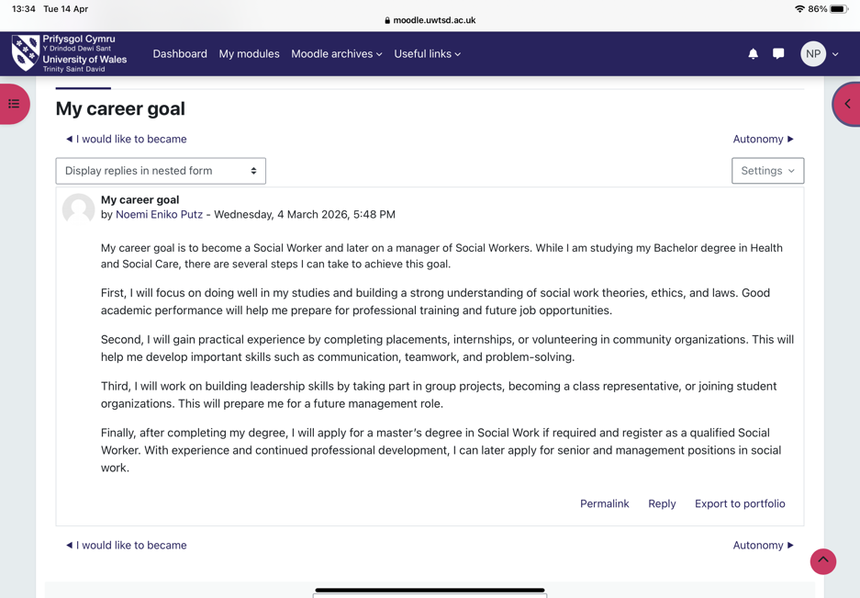
Unit 1 focused on developing a personal brand and understanding how individual identity, skills, and values influence employability. One of the key theories explored in this unit was self-determination theory, which explains that motivation is driven by autonomy, competence, and relatedness (Ryan and Deci, 2020). This theory helped me reflect on my personal motivation to pursue a career in social work, as my decision is based on personal values and a genuine desire to help others.
Another important concept introduced was the boundary-less career, which emphasises flexibility and continuous learning across different roles and organisations (Sullivan and Al Ariss, 2021). In health and social care, professionals often move between roles and settings, requiring adaptability and transferable skills. This has encouraged me to focus on developing skills that can be applied in different environments.
The gig economy was also discussed, highlighting the increasing use of temporary and flexible work arrangements within health and social care. While this can provide valuable experience, it may also lead to job insecurity and lack of stability (Wood et al., 2019). This made me critically reflect on my preference for a stable and progressive career path.
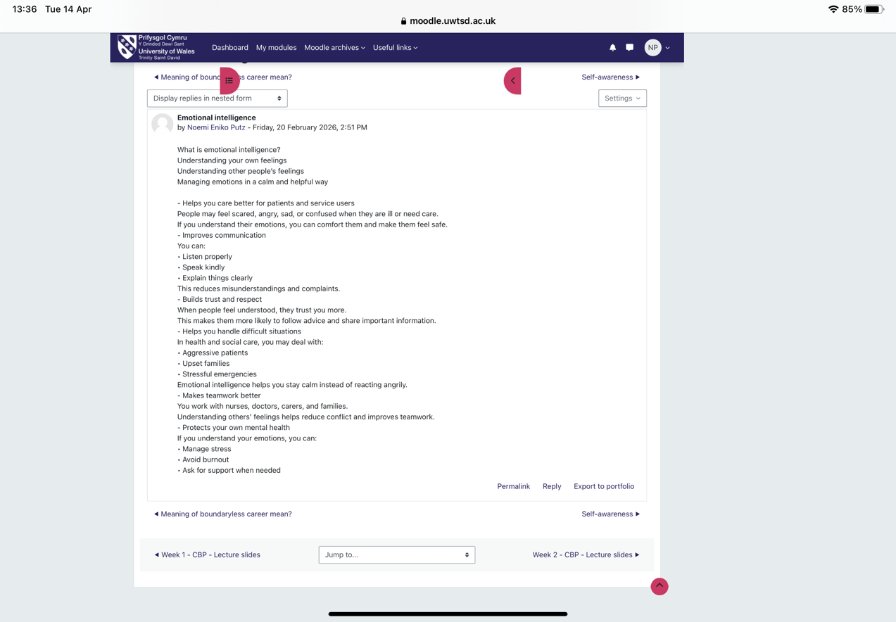
A key area of learning was the importance of soft skills, including communication, empathy, teamwork, and emotional intelligence. These skills are essential for building trust and supporting individuals effectively. Emotional intelligence enables professionals to manage their own emotions and respond appropriately to others, especially in stressful situations (Goleman, 2021).
Research highlights that soft skills are crucial for employability and professional success in health and social care (Andrews and Higson, 2020). Reflecting on this, I recognise the importance of continuously developing these skills alongside my academic studies.
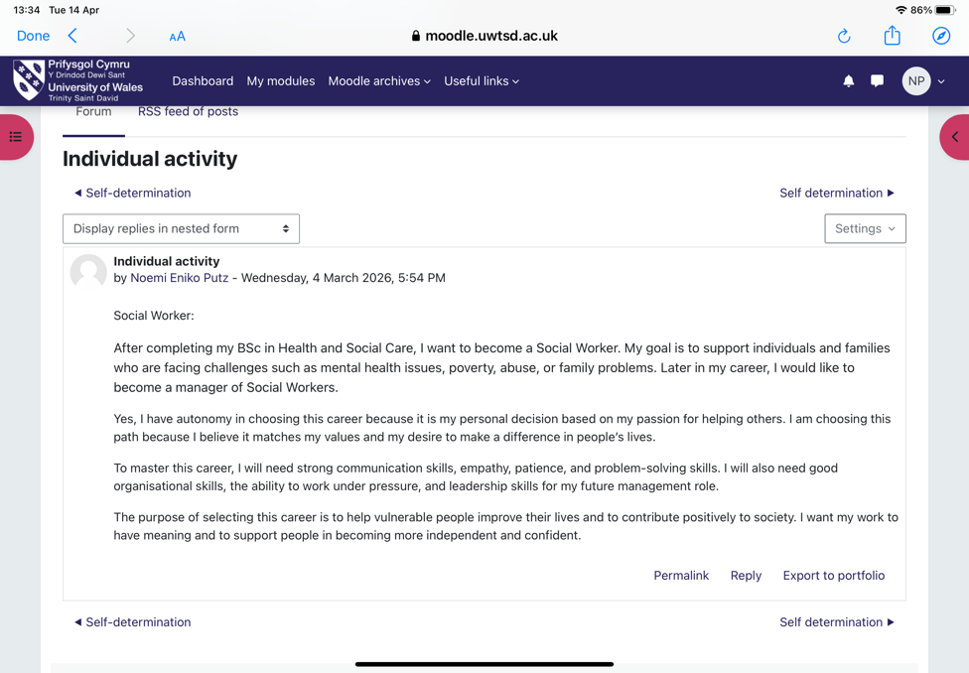
Overall, this unit helped me understand that personal branding is an ongoing process that involves self-awareness, skill development, and professional behaviour.

Task 2: Reflection on Unit 2 – It is a Small World
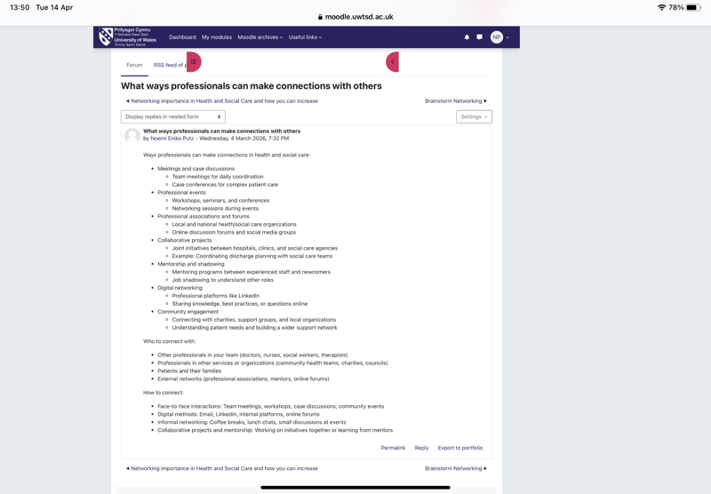
Unit 2 focused on networking and the interconnected nature of health and social care systems. One key activity was creating a networking map, which helped me identify and visualise my professional connections. This allowed me to recognise the importance of building relationships with individuals who can support my career development (Burt, 2020).
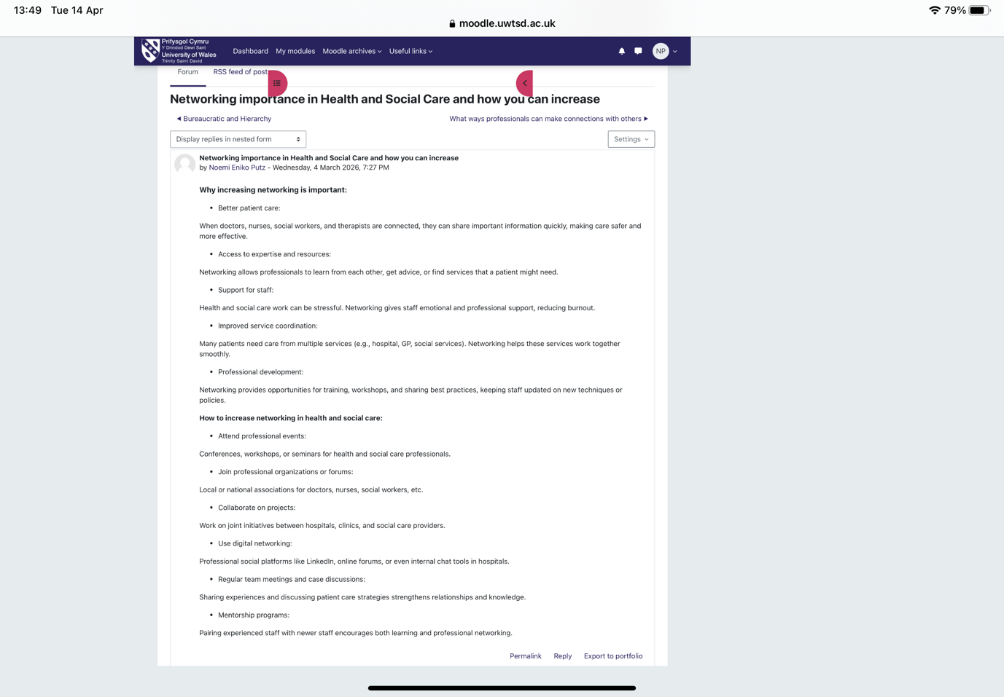
The unit also explored bureaucratic and hierarchical structures within organisations, which define roles, responsibilities, and decision-making processes (Walshe and Smith, 2020). While these structures provide organisation and accountability, they can sometimes limit communication. This highlighted the importance of networking to improve collaboration.
Another key concept was the network of influence, which refers to connections that provide support, knowledge, and opportunities. In social work, this includes professionals such as nurses, teachers, and community organisations. Strong networks enable better coordination of care and improved outcomes for service users (Greenwood and Suddaby, 2021).
There are many ways professionals can build connections, including attending events, participating in meetings, collaborating on projects, and using digital platforms such as LinkedIn. Digital networking has become increasingly important in maintaining professional relationships (Brown and Kelleher, 2022).
Research suggests that effective networking improves teamwork, reduces stress, and enhances service delivery (WHO, 2020). Reflecting on this, I understand that networking is essential not only for career development but also for improving the quality of care.

Task 3: Reflection on Unit 3 – Opportunity Knocks
Unit 3 focused on recognising and making use of opportunities. One key concept was changing perspectives, which is essential for providing person-centred care and reducing bias (Thompson, 2021). Understanding different viewpoints allows professionals to respond effectively to diverse needs.
The unit also explored the relationship between success and luck, highlighting that opportunities often arise unexpectedly. The concept of planned happenstance suggests that being open to new experiences can lead to positive outcomes (Mitchell et al., 2020). This encouraged me to adopt a proactive approach.
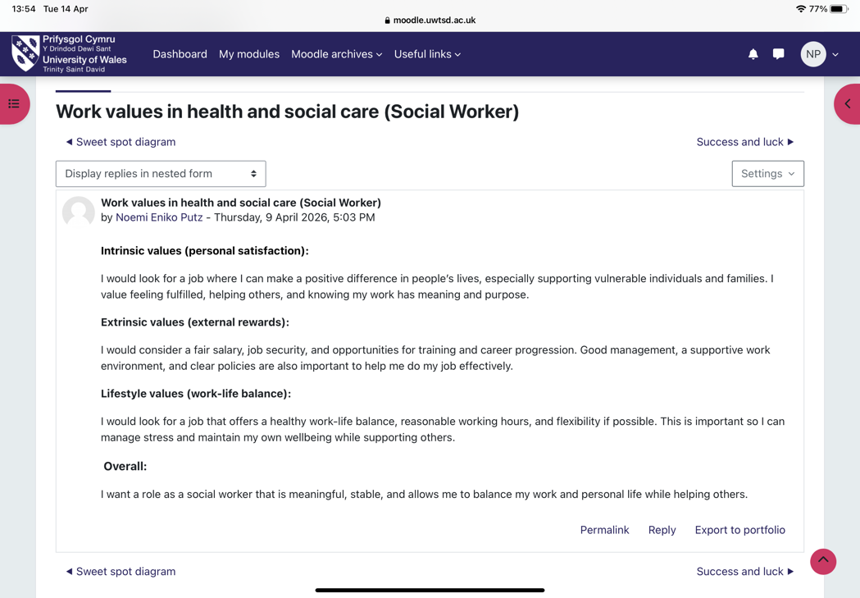
I reflected on my work values, including intrinsic motivation (helping others), extrinsic rewards (salary and stability), and lifestyle factors (work-life balance). These values guide my career decisions and ensure alignment with my goals (Super, 2020).
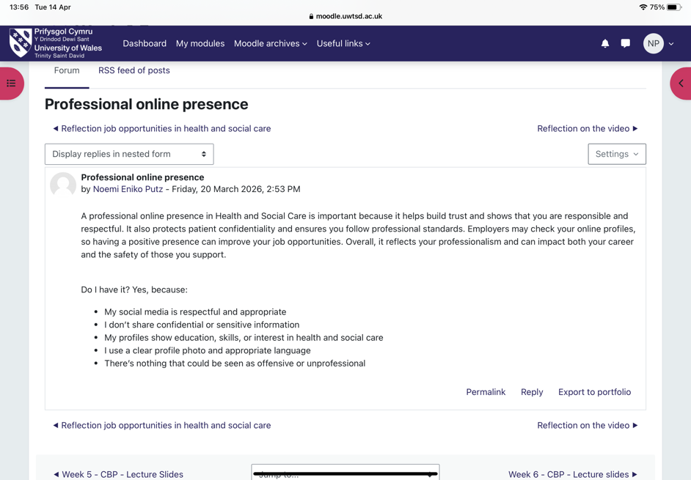
The unit also highlighted various job opportunities in health and social care, including roles in local authorities, charities, and community organisations. This demonstrated the wide range of career pathways available.
Maintaining a professional online presence is essential, as employers often review digital profiles (Brown and Kelleher, 2022). Blogging can also support professional development by encouraging reflection and knowledge sharing (Kaplan and Haenlein, 2021).
Overall, this unit helped me recognise opportunities and take responsibility for my development.

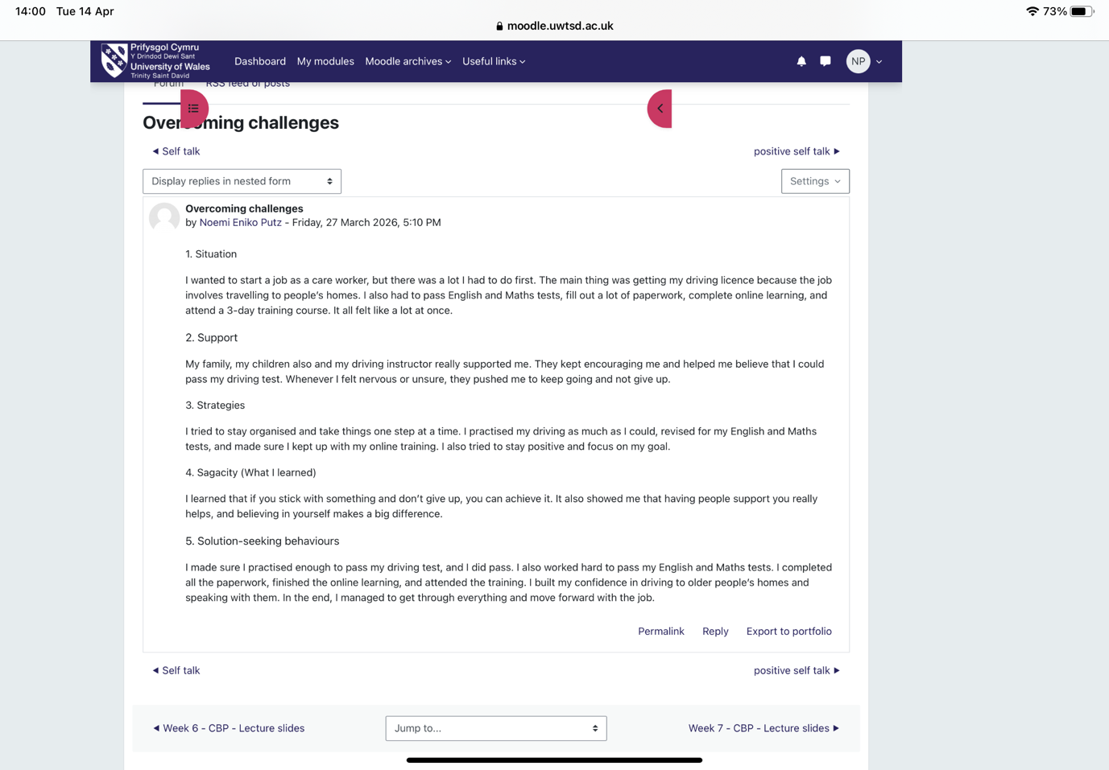
Task 4: Reflection on Unit 4 – The Pursuit of Happiness
Unit 4 focused on personal development, resilience, and the ability to adapt to challenges within health and social care. One key concept explored was limiting beliefs, which are negative thoughts or assumptions that can prevent individuals from achieving their goals. These beliefs are often shaped by past experiences or fear of failure and can reduce confidence and motivation (Dweck, 2021). Reflecting on my own experiences, I recognised that thoughts such as “I am not good enough” or “I don’t have enough experience” could hold me back. However, by challenging these beliefs and replacing them with positive and realistic thinking, I can develop a growth mindset and improve my performance.

Another important concept introduced in this unit was the 4S resilience model, which includes Situation, Support, Strategies, and Sagacity. This model provides a structured approach to managing challenges and building resilience (Jackson et al., 2021). I applied this model to my personal experience of becoming a care worker. Initially, I faced several challenges, including passing my driving test, completing training, and managing multiple responsibilities. However, by identifying the situation, seeking support from my family and instructor, applying effective strategies such as practice and organisation, and reflecting on what I learned, I was able to overcome these challenges successfully. This experience demonstrated the importance of resilience and perseverance.

The unit also highlighted the impact of technological changes in health and social care. Digital systems such as electronic health records, telehealth services, and online communication tools are increasingly used to improve efficiency and patient care (Topol, 2019). However, this also requires professionals to continuously update their skills and adapt to new ways of working. I have realised that developing digital literacy is essential for my future role as a social worker.

At the same time, technology can be fragile, meaning that systems may fail or become outdated. In such situations, professionals must rely on critical thinking and problem-solving skills to maintain effective service delivery. This links to the concept of antifragility, introduced by Nassim Nicholas Taleb, which suggests that individuals can grow stronger through challenges rather than simply resisting them. Adopting this mindset will help me view difficulties as opportunities for learning and improvement.

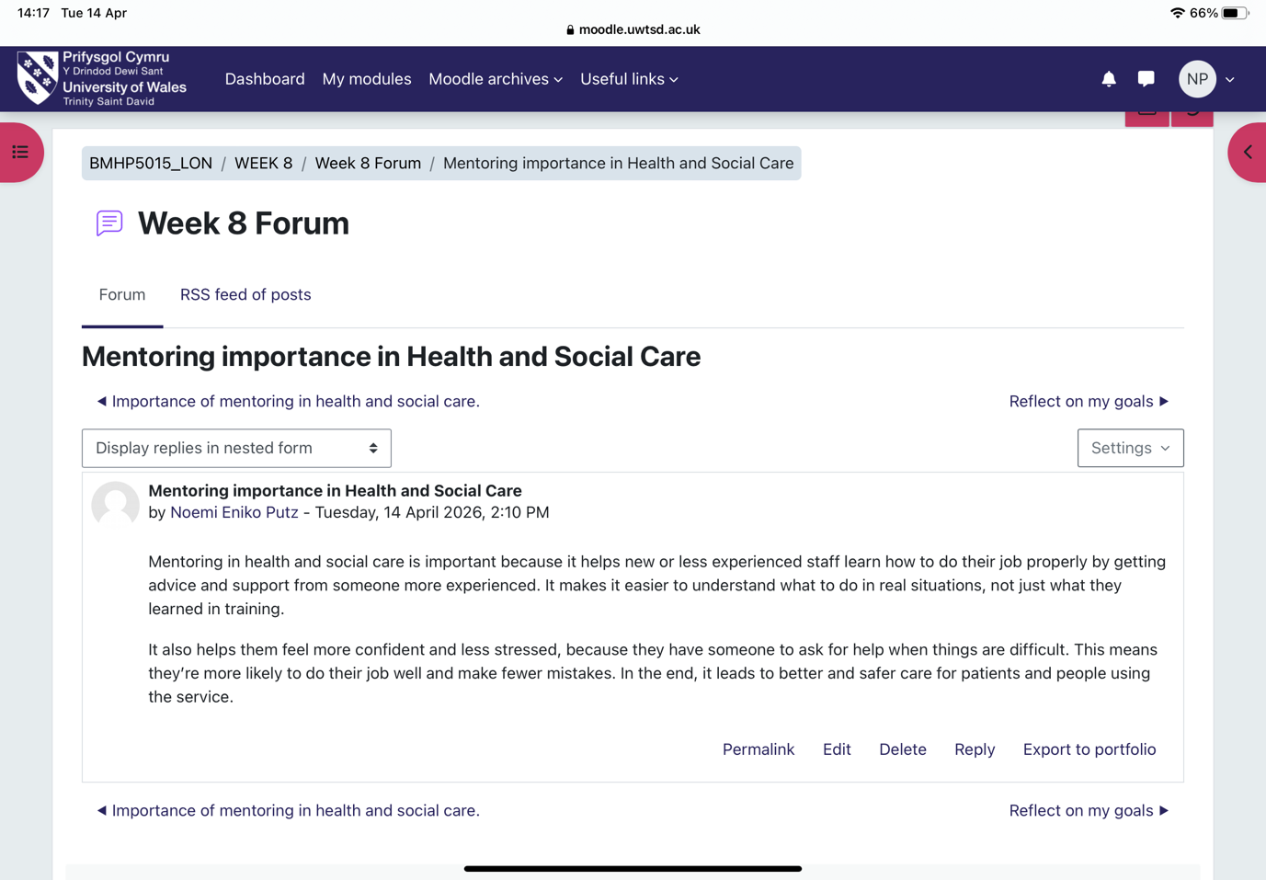
Another key theory explored was Social Learning Theory, developed by Albert Bandura, which explains that individuals learn by observing, modelling, and imitating others (Bandura, 2021). This is particularly relevant in health and social care, where mentoring and role modelling play a crucial role in professional development. For example, seeing how experienced professionals communicate with service users can help me develop my own skills, confidence, and professional behaviour.

Furthermore, mentoring relationships provide valuable guidance, feedback, and emotional support, which are essential for building competence in complex care environments (Clutterbuck, 2020). This is especially important for individuals entering the profession, as it helps them navigate challenges and develop confidence in their abilities.

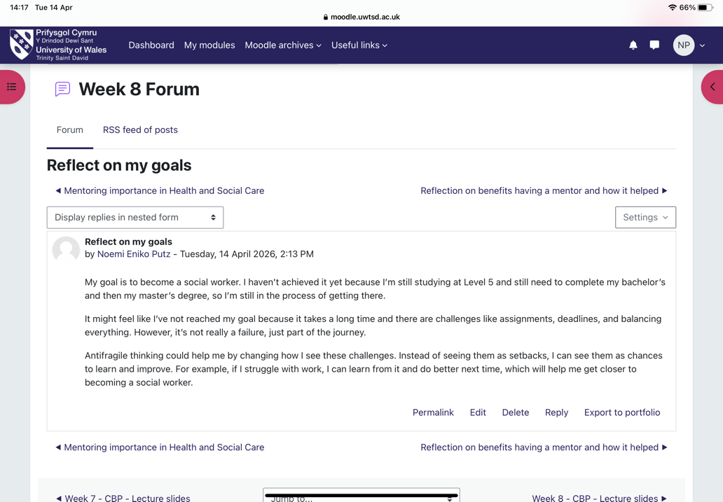
Overall, this unit has helped me understand that resilience is not only about coping with challenges but also about growing from them. By developing a positive mindset, improving my adaptability, and learning from others, I feel more prepared to face the demands of a career in health and social care. These skills will be essential in supporting individuals effectively and maintaining my own wellbeing in a challenging professional environment.

Conclusion
In conclusion, this module has significantly enhanced my understanding of personal and professional development within health and social care. I have developed key skills such as self-awareness, communication, and critical reflection, which are essential for my future career (Kolb, 2021).
The module has also highlighted the importance of networking, resilience, and recognising opportunities. These skills will support my progression into social work and future leadership roles (Yorke, 2020).
Furthermore, this module has encouraged me to take greater responsibility for my own learning and professional development, which is essential for continuous improvement within health and social care (Moon, 2020). I have also developed a clearer understanding of how theory can be applied in practice, particularly in supporting vulnerable individuals and working effectively within multidisciplinary teams (Health Education England, 2021).
In addition, the skills and knowledge gained from this module will not only support my academic progression but also prepare me for real-world challenges in a demanding professional environment. I am now better equipped to adapt to change, reflect on my experiences, and continue developing throughout my career (Kolb, 2021)
Overall, I feel more confident, prepared, and motivated to achieve my career goals.

References (Harvard Style)
Andrews, J. and Higson, H. (2020) ‘Graduate employability skills’, Business and Management Education Journal.
Bandura, A. (2021) Social Learning Theory Revisited.
Banks, S. (2021) Ethics in Social Work Practice.
Brown, D. and Kelleher, C. (2022) ‘Digital professionalism in healthcare’, Health Education Journal.
Burt, R. (2020) Network Theory in Practice.
Dweck, C. (2021) Mindset.
Greenwood, R. and Suddaby, R. (2021) ‘Professional networks’, Journal of Management Studies.
Health Education England (2021) Skills Framework.
Jackson, D. et al. (2021) ‘Resilience in healthcare’, Journal of Nursing.
Kaplan, A. and Haenlein, M. (2021) ‘Digital communication’, Business Horizons.
Kolb, D. (2021) Experiential Learning.
Mitchell, K. et al. (2020) ‘Planned happenstance theory’, Career Development Quarterly.
Moon, J. (2020) Reflection in Learning.
Ryan, R. and Deci, E. (2020) Self-Determination Theory.
Sullivan, S. and Al Ariss, A. (2021) ‘Boundaryless careers’, Human Relations.
Thompson, N. (2021) Anti-Discriminatory Practice.
Topol, E. (2019) The Future of Healthcare.
WHO (2020) Interprofessional Collaboration Framework.
Wood, A. et al. (2019) ‘Gig economy’, Work, Employment and Society.
Yorke, M. (2020) Employability in Higher Education.

