Representing the Body: Portable Art in Non-Urban Communities

A few things to think about:
- What need/urge prompts humans to represent themselves in a variety of media?
- What choices in the production/creation of the miniature humans affects the type of image created?
- Is gender important?
- Why earthy matter? What link, if any, is there between the many myths, legends and stories of humans being created from earth/clay/dust by the gods and the many early anthropomorphic representations worldwide in this medium?
- How useful are the theories we looked at last week for interpreting these objects?
- What about Bailey’s cheirotic approach and/or discussions of miniaturisation?

And now to meet some miniature (or at least smaller than lifesize) people in different media!

Not from the Near East: but interesting early representations/images....
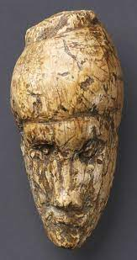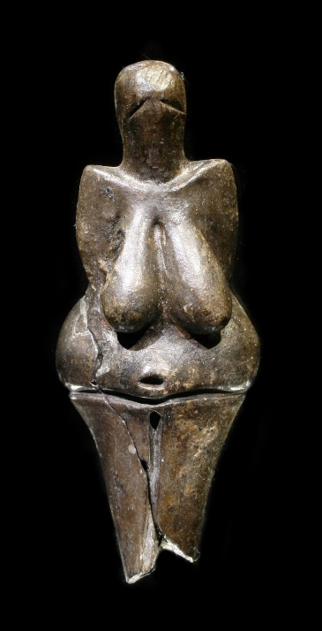
Dolní Věstonice: Upper Palaeolithic ivory Dolní Věstonice: fired clay

And over to Predynastic Egypt:
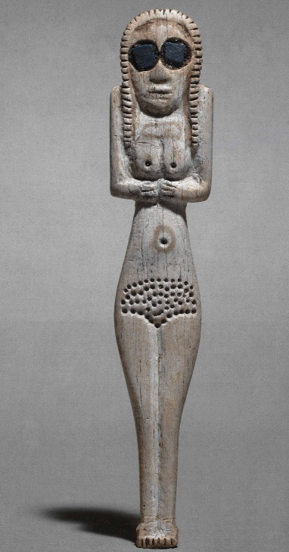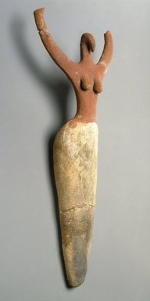
Ivory and lapis baked clay

A few figures from the Near East:

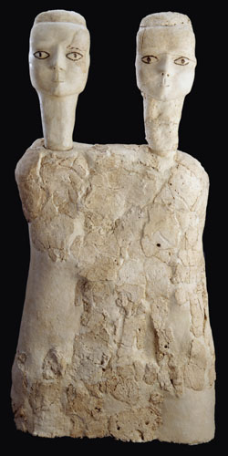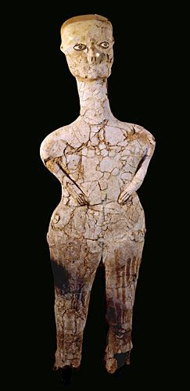
‘Ain Ghazal: plaster
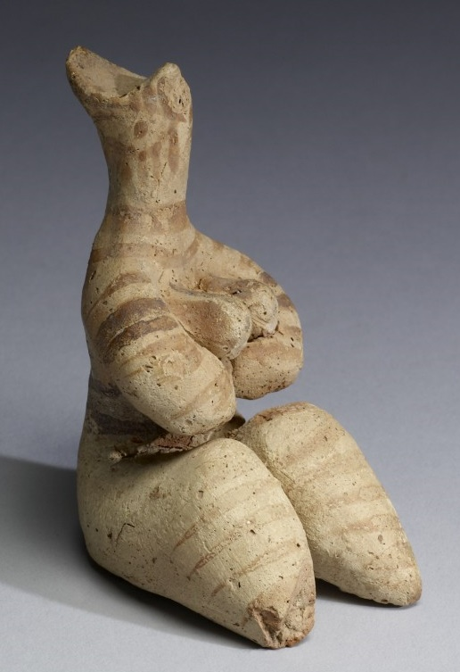
Halaf: baked clay Souskiou (Cyprus): clay pot

