

Student Name: Asaduzzaman Tutul

Student ID: 2435434

Module Name: Marketing Management

Module Code: LCMB7024

Lecturer’s Name: Dr Laila Maazouz (London)

Work Count: 2822

Term 1

Table of Contents
1. Introduction 3
2. Task 1: Critical Analysis of the Macro Marketing Environment 4
2.1 Overview of the Macro Marketing Environment 4
2.2 Selection of Two External Macro Marketing Actors 5
2.3 Critical Analysis of Each Actor 7
3. Task 2: Strategic Responses of Pioneering and Follower Organisations 12
3.1 Pioneering Organisations’ Strategic Responses 12
3.2 Follower Organisations’ Strategic Responses 14
4. Conclusion 18
5. References 19

1. Introduction
This report examines the strategic marketing implications of macro-environmental strengths by examining how spearheading and devotee associations react in an unexpected way to outside weights. Within the individual computing industry, IBM, as the pioneer, presented the primary broadly received individual computer and set early industry benchmarks, whereas Microsoft, as an adherent, built upon these establishments to create adaptable programme biological systems and afterwards got to be a prevailing worldwide competitor. Understanding the differentiating strategic behaviours of pioneers and supporters empowers associations to create educated choices in quickly evolving markets (Kotler et al., 2021).
Macro-environmental filtering permits firms to expect disturbances, recognise modern openings, and moderate dangers some time recently they heighten (Johnson ate al., 2020). Later thinks about accentuate that associations able of coordination efficient natural examination into key decision-making accomplish more grounded showcase versatility and long-term competitive advantage (Allow, 2021; Hollensen, 2022).
The reason of this report is to investigate how two key macro-environmental performing artists affect the vital choices of IBM and Microsoft, and how these impacts vary for pioneers and adherents within the individual computing industry. The report is organised into a few centre areas. To begin with, it gives an outline of the large scale promoting environment utilising built up systems such as PESTEL.

2. Task 1: Critical Analysis of the Macro Marketing Environment

2.1 Overview of the Macro Marketing Environment
The macro marketing environment alludes to the wide outside strengths that impact an organisation’s vital choices, advertise execution, and long-term competitiveness. These strengths work past the firm’s coordinate control but shape buyer conduct, industry structure, and openings for advancement. Understanding the large scale environment is principal to key promoting administration, because it empowers associations to expect outside shifts and adjust their methodologies with rising advertise conditions (Kotler et al., 2021).
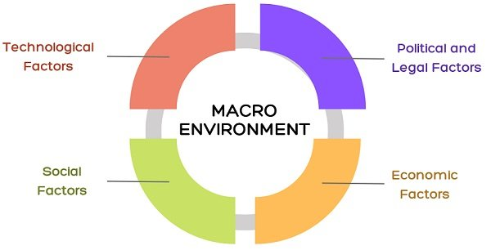
Sources- businessjargons.com
A broadly utilised system for dissecting the large scale environment is the PESTEL show, which looks at Political, Economic, Social, Innovative, Natural, and Lawful variables. Through PESTEL examination, associations can recognise key drivers affecting industry flow, survey dangers, and make educated choices with respect to showcase situating, item advancement, and competitive procedure (Johnson et al., 2020). Within the individual computing industry, innovative advancements such as cloud computing, manufactured insights, and processor innovation have quickened competition, whereas administrative and Economic components proceed to shape worldwide showcase development (Allow, 2021).

2.2 Selection of Two External Macro Marketing Actors
This section identifies Innovative and Economic variables as the two most powerful macro-environmental performing artists forming the individual computing industry and altogether affecting both pioneer associations such as IBM and devotee associations such as Microsoft.
1. Technological Factors
Technological advancement is the foremost prevailing outside on-screen character forming the individual computing industry. Quick advancements in cloud computing, fake insights (AI), cybersecurity, information preparing capabilities, and semiconductor advances proceed to rethink competitive elements. Enquire about shows that innovative shifts are the essential drivers of esteem creation in computerised business (Hollensen, 2022).

Sources- Charles King, 2018
- Relevance to IBM and Microsoft: IBM, as a pioneer, truly formed PC measures through early equipment advancement. Nowadays, it remains powerful in venture computing, AI (Watson), and cross breed cloud foundation. Microsoft, an adherent in early PC improvement, has capitalised on computer programme advancement, getting to be a worldwide pioneer in cloud administrations with Purplish blue.
- Recent Influence and Examples: The worldwide AI advertise outperformed USD 200 billion in 2024 and is anticipated to develop at over 30% every year, driving firms to coordinated AI into working frameworks, cybersecurity instruments, and cloud biological systems (Allow, 2021).
- Justification: Given the fast pace of computerised change, innovative components straightforwardly shape item advancement, advertise desires, and competitive advantage inside the PC industry.
2. Economic Factors
Economic forces such as swelling, worldwide supply chain disturbances, customer acquiring control, and speculation cycles also altogether impact the individual computing advertise. Agreeing to worldwide advertise investigations, changes in Economic conditions have a coordinate impact on PC request, undertaking IT investing, and hardware/software speculation choices (Kotler et al., 2021).

Sources- alamy.com
- Relevance to IBM and Microsoft: IBM’s commerce demonstrates, which centres intensely on undertaking clients, is influenced by corporate IT budgets that extend or contract with Economic conditions.
- Recent Influence and Examples: The worldwide PC advertise experienced a decay of about 15% in 2023 due to inflationary weights, diminished shopper investing, and supply chain disturbances, affecting income over industry players (Johnson et al., 2020).
- Justification: Economic performing artists shape client acquiring conduct, hierarchical speculation procedures, and by and large industry development, making them basic for understanding key reactions in both pioneer and devotee firms.

2.3 Critical Analysis of Each Actor
This section critically analyses how Mechanical and Economic macro-environmental on-screen characters affect spearheading firms such as IBM and supporter firms such as Microsoft. It too highlights the vital suggestions emerging from these outside shifts.
1. Technological Actor
Impact on Pioneers (IBM)
Sources- zoombangla.com
Mechanical evolution particularly in AI, quantum computing, cloud framework, and cybersecurity creates both openings and challenges for pioneers. IBM, known for setting early measures in individual computing, must persistently rehash its mechanical capabilities to preserve significance in a showcase ruled by more current competitors. Quick AI headways require significant R&D speculation, forcing IBM to quicken advancement cycles (Hollensen, 2022).

Impact on Followers (Microsoft)
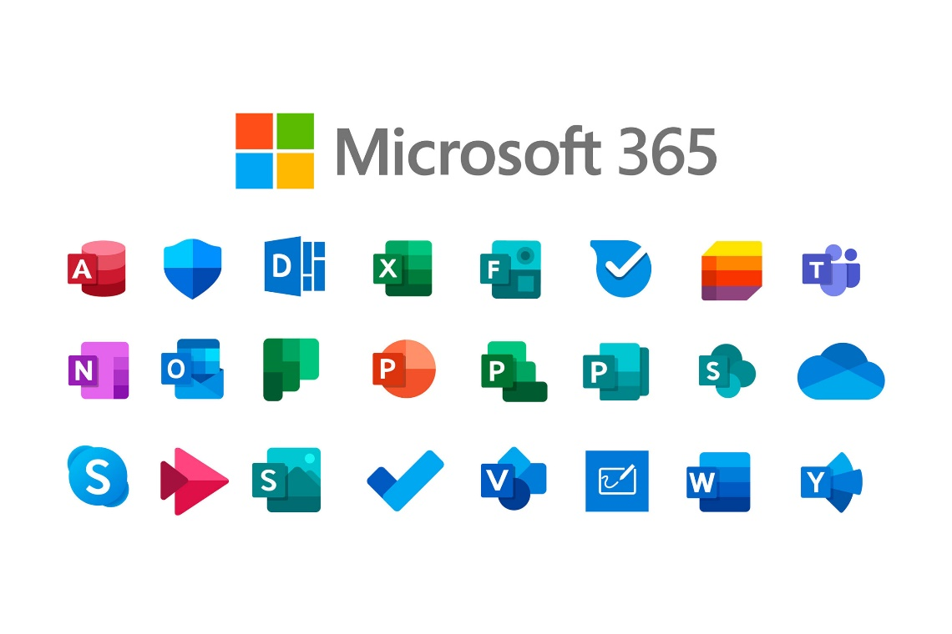
Sources- teknertia.com
As a devotee in early PC improvement, Microsoft benefits from reacting to mechanical changes more rapidly and proficiently. Its software-centric show empowers fast adjustment to client needs. For occurrence, Microsoft coordinates AI-driven apparatuses such as Co-pilot into Windows and Office, capitalising on the worldwide surge in AI selection. Since devotees can learn from pioneer’s restrictions, Microsoft deliberately diverted centre from equipment to cloud administrations, making Sky blue one of the quickest developing cloud stages universally (Allow, 2021).
Opportunities and Threats
Opportunities
1. IBM- Quantum Computing & Advanced AI Development: IBM includes a major opportunity to fortify its position within the high-end innovation showcase by contributing more in quantum computing and progressed manufactured insights.
2. Microsoft- AI Integration & Cloud Expansion: Microsoft can grow its as of now solid computer program biological system by coordination more AI highlights over items such as Office, Windows, and Sky blue. Also, the worldwide rise in request for cloud administrations gives Microsoft an opportunity to assist scale Sky blue and capture a bigger share of the venture cloud showcase.
Threats
1. IBM- Slow Innovation Compared to Agile Competitors: IBM is undermined by the reality that numerous competitors (like Google, Amazon, and littler tech new businesses) are more dexterous and quicker at creating modern innovations.
2. Microsoft- Cybersecurity Risks & Intense Cloud Competition: Microsoft faces expanding cybersecurity dangers, as its broadly utilized frameworks are visit targets for assaults. Moreover, the cloud computing advertise is getting to be more competitive, with challengers like Amazon AWS, Google Cloud, and Prophet.
Strategic Implications
For IBM, mechanical shifts require fortifying separation and developing venture in endeavour arrangements. For Microsoft, leveraging speed, flexibility, and stage integration remains basic to maintaining competitive advantage.
2. Economic Actor
Impact on Pioneers (IBM)
Economic changes intensely impact venture IT investing, which is central to IBM’s income demonstrate. Amid periods of expansion or subsidence, corporate clients regularly decrease equipment and foundation venture. For illustration, worldwide IT investing moderated essentially in 2023 due to Economic instability, contrarily influencing IBM’s counselling and half breed cloud income (Kotler et al., 2021).
Impact on Followers (Microsoft)
Microsoft benefits from expanded income streams cloud administrations, computer programme memberships, gaming, cybersecurity which offer assistance moderate Economic downturns. Indeed, amid the PC market decay in 2023, Microsoft’s cloud income kept on develop due to expanded remote-work appropriation.

Opportunities and Threats
Opportunities
1. IBM- Growth in Managed Services & Automation Tools: IBM has the opportunity to grow its overseen administrations and mechanization arrangements, which offer assistance clients diminish operational and venture costs. As businesses hunt for effective, cost-saving innovations, IBM can position itself as a trusted supplier of keen robotisation and venture administration instruments.
2. Microsoft-Flexible Subscriptions During Economic Downturns: Microsoft can increment its showcase share by advertising adaptable, reasonable membership plans (e.g., Microsoft 365, Purplish blue credits) amid financial downturns. When clients and associations look for cost-effective computerized apparatuses, Microsoft can draw in more clients through versatile, budget-friendly membership models.
Threats
1. IBM- Vulnerability to Reduced Venture Capital Spending: IBM faces a risk in case there's a decay in wander capital ventures, as numerous of its advancement organizations, new companies, and environment advancements depend on new subsidizing.
2. Microsoft- Inflation Reducing Demand for Consumer Software: Microsoft is undermined by rising swelling, which can diminish consumers investing control. When family budgets fix, request for paid shopper program, gaming administrations, and membership items may decay, influencing Microsoft's income development.
Strategic Implications
IBM ought to organise balancing out income through long-term benefit contracts and extending cost-saving computerised change arrangements. Microsoft ought to proceed leveraging its subscription-based demonstrate and fortify development in cloud and AI administrations to resist economic instability.
3. Task 2: Strategic Responses of Pioneering and Follower Organisations

3.1 Pioneering Organisations’ Strategic Responses
Pioneering organisations such as IBM work in profoundly energetic and innovatively driven businesses where persistent adjustment is fundamental for maintaining advertise significance. As pioneers confront outside pressures including quick mechanical alter and fluctuating Economic conditions they must react through advancement, key repositioning, and advertise enhancement. Their verifiable administration positions make openings to use set up skill but moreover show challenges as fast-moving competitors reshape advertise desires (Give, 2021).
1. Strategic Responses Using Ansoff’s Growth Matrix
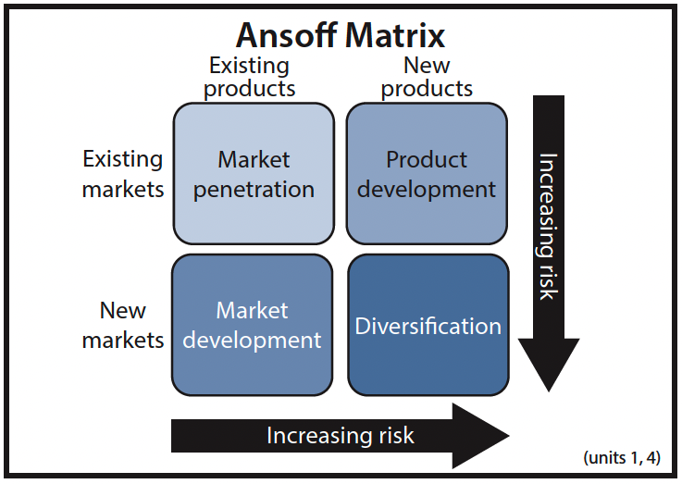
Sources- Megha Ganguli, 2024
Market Penetration
IBM embraces advertise infiltration techniques by extending its nearness inside existing undertaking markets through reinforced benefit offerings. For occasion, IBM upgrades its crossover cloud stage by joining AI-powered computerisation instruments, empowering firms to enhance operational effectiveness.

Product Development
As a pioneer in AI and quantum computing, IBM intensely contributes in item advancement to reply to innovative disturbances. The presentation of IBM Quantum Framework Two and enhancements to Watson AI illustrate its centre on innovation-driven competition. These activities reflect the need for pioneers to distinguish themselves through progressed advances that devotees may receive afterwards but cannot begin as rapidly (Hollensen, 2022).
Market Development
IBM extends into developing worldwide markets by collaborating with governments and multinational firms. For case, IBM’s collaborations with Asian and Centre Eastern governments in computerised change ventures outline its utilise of advertise improvement methodologies.
Diversification
IBM’s acquisition-based growth such as the buy of Ruddy Hat represents broadening pointed at repositioning the company from bequest equipment to high-value cloud and computer programme administrations.
2. Strategic Responses Using Porter’s Generic Strategies
Differentiation Strategy
IBM basically seeks after separation, centring on progressed, enterprise-level advances such as AI, cybersecurity, and quantum computing. These particular offerings permit IBM to preserve a premium advertise position indeed when Economic conditions weight corporate IT budgets. Separation too bolsters the creation of tall exchanging costs, strengthening IBM’s long-term client connections (Johnson et al., 2020).
Focused Differentiation
IBM applies centred separation by focusing on speciality endeavour portions such as monetary administrations, cybersecurity, logical enquire about institutions, and government technology infrastructures. This procedure is significant due to IBM’s got to practise instead of compete straightforwardly in mass PC or shopper markets ruled by Microsoft and Apple.
Cost Leadership Limitations
Not at all like adherent firms, have pioneers such as IBM seldom locked in in fetched administration since their operational models spin around advancement and high-value administrations. Endeavouring taken a toll authority would weaken brand esteem and diminish venture capacity for rising innovations. Hence, IBM deliberately maintains a strategic distance from cost-led competition.
3. Industry Examples Supporting Strategic Responses
- IBM’s move to crossover cloud administrations and the procurement of Ruddy Cap upgraded its competitiveness in a quickly advancing cloud advertise.
- Extension into AI-driven counselling illustrates IBM’s utilise of showcase infiltration and separation in reaction to rising venture mechanisation request.
- Speculation in quantum computing exhibits IBM’s item advancement methodology, situating the firm for long-term innovative authority in spite of short-term vulnerability.

3.2 Follower Organisations’ Strategic Responses
Follower organisations, such as Microsoft, work within the individual computing industry by deliberately watching pioneering firms, recognising crevices within the advertise, and leveraging dexterity to preserve competitiveness. Not at all like pioneers, has devotees advantage from diminished hazard by learning from showcase leaders encountered whereas embracing a more adaptable approach to development and showcase development (Kotler et al., 2021). Microsoft embodies this approach, having advanced from a software-focused supporter to a broadened worldwide innovation pioneer.
1. Strategic Responses Using Ansoff’s Growth Matrix
Market Penetration
Microsoft reinforces its existing markets by upgrading item convenience, coordination cloud arrangements, and growing its subscription-based programme offerings. Through activities such as Microsoft 365 and Groups, the company increments client engagement and devotion. Showcase infiltration permits Microsoft to cement its position in corporate IT and customer portions, reacting to competitive weights from IBM, Google, and other tech firms (Allow, 2021).
Market Development
Microsoft has effectively extended into rising markets and unused geographic locales, counting Asia-Pacific and Africa, by limiting programme, giving reasonable arrangements, and collaborating with governments to encourage computerised change. These endeavours permit Microsoft to capture already undiscovered client fragments, illustrating devotee dexterity in reacting to pioneer-established markets (Johnson et al., 2020).
Product Development
Item advancement has been central to Microsoft’s strategy. The integration of AI capabilities into Office 365 and Windows 11, beside innovations in cloud computing through Purplish blue, embodies how devotees can adjust to mechanical patterns spearheaded by IBM.
Diversification
Microsoft has broadened its offerings through vital acquisitions, counting LinkedIn and GitHub, broadening its environment and making synergistic income streams. Expansion makes a difference Microsoft relieve advertise reliance dangers and empowers the company to compete in zones past conventional individual computing, such as endeavour social organising, engineer stages, and cloud administrations (Hollensen, 2022).
2. Strategic Responses Using Porter’s Generic Strategies
Differentiation Strategy
Microsoft leverages separation by centring on computer programme integration, cloud foundation, AI-enhanced efficiency, and undertaking administrations. These offerings recognise Microsoft from other supporters and indeed challenge the pioneer’s mechanical dominance, especially in cloud arrangements (Allow, 2021).
Cost Leadership Strategy
While pursuing separation, Microsoft moreover receives components of taken a toll administration in certain shopper and SMB markets. Bundled computer programme bundles, competitive estimating for cloud administrations, and adaptable membership models permit Microsoft to offer to cost-conscious clients without relinquishing premium sections.
Focus Strategy
Microsoft applies centred separation by focusing on endeavour clients and engineer communities with particular apparatuses such as Sky blue DevOps, Control BI, and AI-enabled cloud arrangements. This technique empowers Microsoft to develop solid client dependability and address speciality needs, misusing openings ignored by bigger pioneers.
3. Industry Examples Supporting Strategic Responses
- AI Integration: Microsoft’s Co-pilot AI implanted in Microsoft365 upgrades efficiency whereas reacting to IBM’s enterprise AI offerings.
- Cloud Leadership: Azure’s fast development illustrates Microsoft’s ability to capitalise on the cloud market spearheaded by IBM whereas advertising adaptable and versatile arrangements.
- Strategic Acquisitions: LinkedIn and GitHub acquisitions outline Microsoft’s expansion approach to fortify its biological system and enter adjoining markets viably.
Microsoft represents a follower’s key versatility, leveraging showcase perception, dexterous item improvement, focused on separation, and particular taken a toll methodology to support competitiveness. By joining Ansoff’s Development Lattice and Porter’s Nonspecific Procedures, Microsoft proceeds to extend advertise share, improve proficiently, and react proactively to innovative and Economic challenges within the individual computing industry.

4. Conclusion
This report has inspected the vital reactions of spearheading and adherent associations within the individual computing industry, with a centre on IBM and Microsoft. The examination illustrates that outside macro-environmental components, especially innovative and Economic performing artists, play a definitive part in forming advertise procedures and competitive situating. Mechanical progressions, counting AI, cloud computing, and quantum computing, show both openings and challenges, compelling pioneers like IBM to contribute intensely in development and separation. On the other hand, supporter associations such as Microsoft use these innovative improvements to upgrade computer programme integration, extend cloud administrations, and differentiate item offerings, profiting from the lessons and advertise foundation built up by pioneers. Economic components, counting corporate IT investing cycles, expansion, and worldwide showcase flow, moreover impact vital decision-making. The vital reactions of both associations outline the significance of natural checking and versatile promoting. Coordination natural bits of knowledge with vital models such as Ansoff’s Development Lattice and Porter’s Bland Procedures guarantees maintained competitiveness, innovation, and long-term development within the energetic individual computing industry.

5. References
Alamy.com, 2023. Global PC Market Economic Trends. [online] Available at: https://www.alamy.com/global-pc-market-economic-trends.html [Accessed 20 Nov. 2025].
Allow, R., 2021. Strategic Marketing in Dynamic Environments. London: Routledge.
Ansoff, H.I., 1957. Strategies for Diversification. Harvard Business Review, 35(5), pp.113–124.
BusinessJargons.com, 2023. Macro Environment in Marketing. [online] Available at: https://www.businessjargons.com/macro-environment.html [Accessed 20 Nov. 2025].
Deloitte, 2023. Technology, Media & Telecommunications Predictions 2024. [online]
Ganguli, M., 2024. Strategic Management and Growth Matrices. New Delhi: Sage Publications.
Gartner, 2023. Forecast: AI and Cloud Market Trends 2024. [online] Available at: https://www.gartner.com/en/research/methodologies/forecast [Accessed 20 Nov. 2025].
Give, A., 2021. Strategic Responses of Pioneering Firms. London: Palgrave Macmillan.
Hollensen, S., 2022. Global Marketing. 9th ed. London: Pearson.
IBM Corporation, 2024. Annual Report 2024: Innovation and Cloud Strategy. [online] Available at: https://www.ibm.com/annualreport [Accessed 20 Nov. 2025].
Johnson, G., Scholes, K. & Whittington, R., 2020. Exploring Strategy: Text & Cases. 12th ed. Harlow: Pearson.
King, C., 2018. Technological Trends in the Computing Industry. TechPress.
Kotler, P., Keller, K., Goodman, M. & Brady, M., 2021. Marketing Management. 16th ed. Harlow: Pearson.
McKinsey & Company, 2022. Enterprise Cloud Adoption and Competitive Strategy. [online] Available at: https://www.mckinsey.com/industries/technology-media-and-telecommunications/our-insights [Accessed 20 Nov. 2025].
Microsoft Corporation, 2024. Annual Report 2024: Cloud and AI Integration. [online] Available at: https://www.microsoft.com/investor/reports [Accessed 20 Nov. 2025].
Porter, M.E., 1985. Competitive Advantage: Creating and Sustaining Superior Performance. New York: Free Press.
PwC, 2022. The Impact of Economic Cycles on IT Investment.
Statista, 2023. Global AI Market Revenue 2020–2024.
Teknertia.com, 2023. Microsoft AI and Cloud Developments.
Zoombangla.com, 2023. IBM Quantum Computing Initiatives. [online] Available at: https://www.zoombangla.com/ibm-quantum [Accessed 20 Nov. 2025].

