

Master of Business Administration
LCMB7020
Jesica Mora Mera 201029

Jesica Mora Mera
Evaluating the impact of training and development on manager in the retail sector.
(Case study of HR systems in London Reiss stores)
Page 42, 1 appendix
Master of Business Administration

This study aims to evaluate the effect of employee performance on training and development initiatives. There are three primary components to this research. A review of prior studies is presented in the first section, emphasising the importance of training and development initiatives. It also describes the main research aims, the research methods, and the study's scope. The study's main aim is to assess how training and development affect managers in the retail industry. Specifically, it looks at the HR systems used by Reiss stores in London.
The second section examines the several training frameworks and models that are employed across the world for training and development initiatives. To set up a knowledge of the training process, from defining training requirements to implementation and outcomes, it goes deeply into the research topics.
An empirical case study of the topic organisation, where data was gathered and examined, is presented in the last part. The data collected via surveys were analysed using percentage distribution and correlation.
The results show how important training and development are, especially for less experienced and unskilled workers. The company's training strategies and resources have shown to be successful in improving employee work performance as well as their abilities and productivity. To further boost the efficacy of its training initiatives, the organisation is also always enhancing them.

Contents
1 Introduction 5
1.1 Reiss the company history 5
1.2 The Goal 6
1.3 HR Systems 6
1.4 Report Objective 6
1.5 Surveys 6
1.5 Method 7
2.1 Knowledge of Human Resources 10
2.2 System of Human Resources 12
3 Training effectiveness models based on HR Cycle and Human 15
3 Models of training efficacy 18
4 Case Study 20
How many years have you been employed by the company? 20
Expanded Analysis 20
Conclusion 21
Recommendations 22
2 How often do you receive training? 23
Breakdown of percentages and interpretation 23
Conclusion 25
Recommendations 25
3 What is your assessment of the training program's quality in which you have taken part? 26
Percentage interpretation 26
Summary 27
Conclusion 27
Recommendations 27
4 Do you think that programs for training development are supported by your workplace? 30
Overview 30
Recommendations 32
Considerations for Future Training Programs 32
Conclusion 33
5 Would further training motivate you to enhance your performance so that you could help contribute to higher production? 35
Implications 37
Recommendations 37
Conclusion 38
Conclusion part 2 39
Reference 41
Appendix 43

Evaluating the impact of training and development on manager in the retail sector.
(case study of HR systems in London Reiss stores).

1 Introduction
The purpose of this study is to evaluate how HR systems affect management effectiveness at the London Reiss stores, with a focus on manager training. The retail sector in London is renowned for its vibrant and competitive environment, which presents both unique opportunities and challenges. The effectiveness, efficiency, and general success of a company's leadership teams are decided in large part by its HR systems. In the retail industry, where operational efficiency and customer satisfaction are crucial, effective HR practices might be the difference between a company's success and stagnation. Due to the high staff turnover, diverse consumer, and constantly evolving retail landscape, HR procedures must be adaptable and consistent. This research will look at any external influences on these findings as well as the direct effects of HR systems on management performance to provide a thorough analysis. The research will meticulously strategies its approach to ensure superior data collection, comprehensive analysis, and adherence to the most elevated ethical norms. By using this approach, the results will be dependable and relevant and will offer valuable information on how HR systems might increase management effectiveness in the retail sector.

1.1 Reiss the company history
Founded in 1971, Reiss is a well-known British fashion brand. The company is well known for its dedication to creating stylish, well-made clothing that suits every gender. Over the years, Reiss has earned a reputation for meticulous diligence and commitment to high-calibre design.
Among its fundamental qualities are sincerity, simplicity, and honesty; these traits have allowed the company to grow and thrive in a range of market conditions.
The company has many branches in London, a city renowned for its diverse clientele and booming retail sector. Managing many sites requires a strong and effective HR system that can manage the difficulties of personnel management, customer service, and operational efficiency. In the past, Reiss has placed a high priority on keeping ambitious standards of customer service, fostering a positive work environment, and investing in staff training. It is possible to further enhance operational effectiveness and employee satisfaction by gaining understanding of how various HR practices impact management performance.
Furthermore, the brand's enduring market presence and flexible approach have allowed it to successfully weather economic downturns and competitive challenges. Analysing the contribution HR systems have had to promoting this resilience will be a critical part of this research. This research will investigate the historical backdrop of Reiss's HR practices and decide how well they have held up over time. We intend to take lessons from this and apply them to future HR efforts to make sure the brand endures in a rapidly evolving retail industry.

1.2 The Goal
The goal of this study is to understand the role HR systems have in enhancing management performance in a retail setting. Effective HR systems are necessary for the recruitment, training, and retention of talented individuals who can drive company success. In the context of Reiss stores in London, where the retail landscape is always shifting, evaluating the effect of current HR rules on management performance is essential. This study aims to find the essential HR elements of good training to management performance and provide evidence-based recommendations for improvement. The study will help Reiss keep its competitive edge and ensure its long-term survival in the retail sector in this way.
Moreover, by focussing on the needs and challenges that the retail sector faces. Although HR systems have been the focus of several studies in a wide range of industries, particularly in a congested city like London, little is known about their implications in the retail sector. The purpose of this study is to further our understanding of how managers may be trained through bespoke HR processes to increase management effectiveness and improve financial outcomes for the retail sector.

1.3 HR Systems
With an emphasis on the HR systems put in place at Reiss stores in London, this research aims to assess the impact of management training and development on performance within the retail industry. This study examines the risk factors related to HR practices that change the efficacy of managers and employees as well as the success of the shop.

1.4 Report Objective
The goal of the current study is to find the key HR procedures that influence management effectiveness in Reiss stores. Analyse the relationship between HR systems and management effectiveness using both qualitative and quantitative data. provide data-backed suggestions for HR system optimisation that will increase operational effectiveness and management efficacy. Draft a comprehensive report that explains the findings and makes suggestions for practical improvements for Reiss stores. Analyse the HR procedures and training programs that Reiss presently has in place. Examine the extent to which different HR strategies enhance managerial effectiveness. list the challenges managers face while using HR systems. Provide ideas for improving HR training programs to increase management efficacy.

1.5 Surveys
An instrument for surveys will be created to collect data from employees on their experiences and opinions regarding HR systems. This survey will include 5 questions to get data that is both qualitative and quantitative. We will discuss a variety of HR-related topics, including recruiting, training, performance management, employee engagement, and satisfaction.

The primary focus of this study is the evaluation of training. The aim is to name the factors influencing the example firm's management's performance.

1.5 Method
In this study, a quantitative research technique was used to investigate the research subjects. The study's primary focus should be on employee training participation, performance comparisons before and after training, and career progression options from an HR (human resources) perspective. Frequency distribution and histogram trend are the approaches used in the study to assess the outcomes. When undertaking rudimentary questionnaire research analysis, these strategies are highly beneficial. The frequency distribution displays the occurrence of a factor (Hill 2012). The SPSS software package is used to conduct the quantitative analysis. Impact areas include skill development for managers in inventory management, sales forecasting, communication, and dispute resolution.
Performance Improvement:
Improved management abilities can lead to demonstrable gains in store performance, such as greater sales and higher customer satisfaction rates.
Employee Retention: Well-trained managers often create a supportive atmosphere that enhances work satisfaction and employee loyalty, resulting in lower turnover rates and recruiting expenses.
Adaptability to Change: Continuous training equips managers to adapt successfully to the ever-changing retail environment by keeping them up to date on trends, consumer behaviours, and technology improvements.
Participants
Managers and workers of London-based Reiss stores will take part in the study. There may also be industry experts and consultants who are familiar with HR systems used in the retail sector. This diverse group of participants will provide an extensive viewpoint on how HR systems impact management success.
Methods
Using a mixed-methodologies approach, the study will combine quantitative and qualitative methods to offer a thorough understanding of the impacts of HR systems.
Surveys: to collect numerical data about various HR practices and perceived levels of success.
Case Studies: in-depth examinations of Reiss shops' HR policies to understand their real-world applications and ramifications.
Data Collection
The data collection procedure will make use of several instruments designed to get comprehensive information, such as:
Surveys: Managers and employees will get organised surveys to provide their thoughts on HR practices, management effectiveness, and job satisfaction. Structured questionnaires of HR practices, their effectiveness, and their impact on job satisfaction and management performance will be distributed to managers and employees.
Document Analysis: To contextualise survey and interview results, evaluate internal HR documents, training materials, performance reports, and company rules.
Sample Size: To ensure that the data are representative, the study strives to include many participants. A sample size of 50 participants (workers and managers) would be judged enough for both substantial qualitative insights and correct statistical analysis. It is decided that this sample size is sufficient to produce relevant qualitative insights and reliable statistical analysis.
Type of Sample: To provide a diverse representation of professional and demographic traits, participants will be selected using the following criteria:
Role: A variety of retail roles, including managers, supervisors, and sales reps.
Tenure: Workers having different tenures at Reiss to gather a variety of perspectives based on experience.
Ethical considerations will be critical throughout the research process. Important moral conduct will include:
The privacy and security of all participant information is our top priority.
Informed permission is obtained prior to each participant's participation in the study and ensures that they are fully informed of the study's purpose and their rights.
Transparency: Providing each participant with comprehensive information about the goals, methods, and implications of the study.
Respect: Showing attention for everyone engaged and ensuring that their participation is fully voluntary and free of coercion.
Results of the Case Study
The study might show a substantial positive relationship between the amount of training hours completed by managers and their teams' performance measures, such as sales statistics and customer service evaluations. Qualitative evidence may show that team members feel more encouraged and motivated when they collaborate with well-trained supervisors. Furthermore, the study is expected to highlight excellent practices in training, such as developing leadership development programs with mentoring opportunities and collaborative learning settings.
Conclusion part 1
In conclusion, the purpose of this study is to provide a full understanding of how HR systems influence management success in London-based Reiss stores. The study's research of the viewpoints and experiences of both male and female workers will give significant other information on how well the HR department is currently performing. The findings are designed to name important risk factors and provide actionable solutions to enhance management effectiveness and, as a result, Reiss store performance. The goal of this study is to provide a comprehensive examination of how manager training influences management performance in the retail business, with a focus on the HR systems used by London's Reiss stores. Mixed-methods research, which combines qualitative and quantitative methodologies, is likely to offer important insights into the effectiveness of HR training efforts and their practical implications for management performance.
The study is expected to suggest that regular investment in training and development is essential for long-term business success, particularly in the highly competitive retail industry. Recommendations may include developing bespoke training programs to meet the individual needs of each Reiss shop. Developing an ongoing assessment framework to measure training performance is critical for aligning training activities with the organization's changing goals.
The study intends to contribute to the current body of knowledge by examining Reiss' HR systems and training programs, evaluating their impact on management performance, and finding the challenges managers face. It also provides actionable recommendations. The goal of these proposals is to strengthen training programs and HR systems to increase overall store performance and management effectiveness.
Implications for the Retail Industry
This case study's conclusions might be valuable for other stores wanting to improve their management training practices. Key implications include creating a culture of continuous learning, utilising technology for training (such as virtual reality simulations), and implementing succession plans to promote future leadership potential inside the organisation.
literature Review HR systems
The literature evaluation will encompass significant writers and studies on HR systems, management efficacy, and the retail industry. This section will provide a list of studies as well as a theoretical framework.

2. Knowledge of Human Resources
The word "human resource" refers to any individual who is employed by a firm or organisation and is included in the entire workforce (Stewart & Brown, 2020). Human resources are people in the complete workforce of the firm who supply talent, skills, time, thoughts, and energy in exchange for payment in the form of salaries, wages and allowances with a quantity or amount of money dependent on the contribution provided.
Within a business or organisation, the department chosen to manage human resources is the human resources department. The department in charge of human resources oversees hiring, inspiring, developing, training, and keeping the company's human resources.
Within an organisation or firm, human resource management has the power to develop personnel, including talent management. The development of human resources, including capital held by workers or internal resources inside the organisation or corporation and their oversight, is the duty and authority of human resource management.

The process of employing people, providing them with training and compensation, creating policies for them, and fostering their growth and retention is known as human resource governance.

The purpose of human resource management is to enable employees to do their jobs well. At the very least, the Human Resources Division oversees the following:
1. Benefits and payment for employees

2. Find and engage workers

3. Structure and personnel focus
4. Management of employee performance
5. Training for employees

6. Culture and organisational development

2.1 Management performance
Managing performance should not be restricted to addressing underperformance or resolving difficulties when someone falls short of their responsibilities. Effective performance management is a continuous process including all team members, regardless of their present performance level. It is critical to keeping the whole team engaged, ensuring that everyone is aligned with the company's goals, and encouraging continual improvement. By focussing on performance management as a comprehensive, initiative-taking process, you can aid your team members in reaching their maximum potential, closing any skill gaps, and supporting elevated levels of productivity and engagement.
Performance management is also about encouraging open communication and developing a culture of feedback. Regular check-ins and one-on-one interactions are critical for not just tracking success but also understanding individual team members' goals, obstacles, and development requirements. This guarantees that the management and employee are on the same page, avoiding misunderstandings and misplaced expectations. Furthermore, recognising successes and delivering constructive criticism in real time enables employees to make quick adjustments, hence improving overall performance and job happiness.
One of the most important aspects of effective performance management is approaching difficult talks with confidence and sensitivity. Addressing underperformance or behavioural concerns can be difficult, but it is critical to approach these conversations with a solution-oriented perspective. Instead, then focussing simply on the problem, the aim should be to discover the core causes and work together to develop solutions. By framing the discourse around growth and improvement, you create a supportive atmosphere in which workers are encouraged to learn from their errors and take responsibility for their progress.
Furthermore, performance management helps discover and develop outstanding performers. High-performing individuals sometimes want more than simply praise for their efforts; they wish opportunities for growth, leadership, and increasing responsibility. Managers may find high-potential workers and provide them with the resources and coaching they need to flourish in the future by conducting frequent performance assessments. By creating a personalised growth plan for top talent, you not only keep key team members but also nurture future leaders who will contribute to the organization's long-term success.
In addition to inspiring individuals, superior performance management improves the whole team dynamic. It promotes teamwork, responsibility, and alignment of individual goals with team goals. Consequently, you create a high-performing team that meets or exceeds goals. By addressing performance gaps early on and encouraging both individual and team growth, you guarantee that your team are adaptive, resilient, and ready to face new challenges in a quickly changing business environment.
2.1 Building a high performance.
Building a high-performance team is a complicated process that needs careful consideration of several factors, including team makeup, leadership, communication, and continual improvement. The integration of these variables is critical to the success of any high-performance team, as it creates an atmosphere in which team members feel motivated, engaged, and committed to the organization's goals.
Clear Vision and Goals:
Any high-performance team is built on a clear and compelling vision. It is critical to communicate the team's mission, vision, and goals in a way that connects with all members. Each team member should have a clear grasp of how their own efforts contribute to the overall aims of the organisation. When team members understand their roles and responsibilities in conducting these goals.
Effective leadership is vital for creating a high-performing team. A successful leader gives guidance, support, and inspiration while creating an inclusive and collaborative workplace in which all team members feel appreciated. Effective leaders set a good example by committing to the team's success and fostering a culture of trust, responsibility, and mutual respect. This guarantees that the team stay cohesive and focused, especially during difficult circumstances.
Appropriate Team Composition:
A high-performing team thrives when it has a broad set of talents, strengths, and experiences. It is not just about having the most skilled people, but also about finding the proper mix of personalities, work styles, and experience to form a balanced team. Diversity boosts creativity and critical thinking skills, allowing the team to tackle difficulties from different angles. A well-rounded team is better able to manage complexity while producing high-quality solutions.
High-performing teams prioritise open and honest communication. Creating a culture in which team members feel free to voice their ideas, concerns, and criticism promotes cooperation and creativity. When communication flows easily, misconceptions are reduced, and trust is increased. Leaders should promote constant communication, both formal and informal, to ensure that team members are on the same page and that any potential difficulties are handled swiftly.
Clearly finding roles and duties prevents confusion and ensures team members understand what is expected of them. This clarity enables team members to stay focused and work more effectively by understanding how their contributions match with the team's and organization's goals. Aligning individual duties with team goals promotes a sense of responsibility and accountability among all team members.
High-performing teams prioritise effective collaboration. Encourage teamwork, information exchange, and cross-functional cooperation to ensure that team members work fluidly and use each other's skills. A collaborative workplace fosters more creativity and invention since team members are more inclined to build on one other's ideas and create more effective solutions to challenges.
Maintaining a high-performing team requires continuous learning and development. Supporting skill development via training, seminars, and mentorship programs allows employees to stay current and adapt to new circumstances. When team members believe their personal development is recognised, they are more likely to stay motivated and dedicated to the team's success.
High-performing teams prioritise recognition and rewards. Recognising and celebrating individual and team accomplishments is critical for preserving morale and inspiring continuous success. Implementing a fair and transparent reward system, whether through monetary incentives or public recognition, promotes excellent behaviour and encourages team members to continuously perform to their full potential.
Giving team members liberty to make decisions within their responsibilities promotes trust and ownership. When employees are given the flexibility to take the initiative and lead in their areas of expertise, they become more engaged and accountable for their contributions, which improves overall team performance.
Consistent, constructive feedback is necessary for continual progress. Performance evaluations and real-time feedback enable team members to reflect on their strengths and find areas for development. This fosters a culture of continual development, encouraging individuals to learn from their experiences and strive for greatness.
Adaptation and Resilience: In today's fast-paced and ever-changing corporate climate, flexibility and resilience are essential characteristics for high-performing teams. Encouraging a resilient mentality encourages team members to view difficulties and failures as chances for development. An adaptive team can swiftly pivot in reaction to changes, guaranteeing excellent performance even under uncertain situations.
Trust is the foundation of all successful teams. Establishing trust among team members allows them to work more successfully and keep one another accountable. Accountability guarantees that everyone honours their obligations and contributes equally to the team's success. This joint accountability creates a strong, cohesive organisation capable of regularly reaching high performance levels.
Conflict is unavoidable in any workplace, but high-performing teams understand how to handle it constructively. Creating effective conflict resolution procedures ensures that differences are addressed quickly and constructively, keeping them from escalating and disrupting team relationships. Encouraging open conversation and mediation leads to a more peaceful work environment.
Providing proper technology and tools is vital for effective cooperation and productivity. High-performing teams use innovative tools to improve communication, manage projects, and measure success. Staying current on important technology allows the team to function efficiently and preserve a competitive advantage.
Improving employee well-being and work-life balance is crucial for keeping satisfactory performance. Recognising the indications of burnout and giving the necessary aid to keep a good work-life balance helps people stay motivated, engaged, and productive over time.

Regular team-building activities help develop connections and promote a healthy company culture. Team-building activities, such as social gatherings, workshops, and joint projects, serve to prove trust, increase communication, and create a more pleasurable working environment. Developing a high-performance team is an ongoing, dynamic process that needs commitment, communication, and constant progress. Leaders may build a resilient, flexible, and high-achieving team that achieves long-term success by routinely analysing team performance, modifying plans, and focussing on development and cooperation.
Conclusion
Finally, effective performance management and the creation of high-performing teams are critical to long-term organisational success. Performance management should not be considered only as a technique for correcting underperformance, but rather as a continual, all-encompassing activity that involves all team members. Managers may assist staff eliminate skill gaps, maintain high levels of productivity, and feel more committed to the company's goals by encouraging open communication, providing regular feedback, and recognising successes in real time. This method also boosts staff morale and work satisfaction, resulting in improved overall organisational performance. Equally crucial is the process of developing and nurturing a high-performance team. Clear vision and well-defined goals, reinforced by good leadership, are the foundations of such teams. Leaders must foster an environment of trust, accountability, and mutual respect, making all team members feel appreciated and driven. A well-balanced team composition, which includes a variety of abilities, experiences, and work styles, encourages innovation and problem solving, making the team more adaptive to complicated issues. Open and honest communication among team members promotes innovation and eliminates misunderstandings, while clearly defined roles and duties match individual contributions with team goals, improving both personal accountability and team cohesiveness.
Furthermore, ongoing learning and growth are essential for sustaining a high-performance culture. Giving team members opportunity to grow through training, mentorship, and skill development programs helps them stay motivated and capable of adjusting to new problems in a fast-paced corporate environment. Recognising and recognising individual and team successes is essential for maintaining motivation and promoting an excellence culture.
Empowering workers to make decisions and take responsibility of their duties builds trust and accountability, which improves overall team performance. Consistently providing constructive criticism to team members helps them find areas for improvement and advances their professional development. Furthermore, high-performing teams demonstrate resilience and flexibility, which are essential characteristics in today's dynamic and uncertain business world. They see obstacles as chances for progress and can adapt swiftly to changing situations, providing consistent high performance even in the face of uncertainty. Finally, ensuring that the team has the necessary tools, technology, and resources is critical for effective cooperation and production. Furthermore, establishing work-life balance and focussing on employee well-being helps to reduce burnout, resulting in increased engagement and long-term performance. Regular team-building exercises boost interpersonal connections, improve workplace culture, and promote team togetherness.
In the end, by incorporating these ideas into everyday operations—performance management, teamwork, continuous growth, and resilience—organizations can build a strong, flexible, and high-performing staff that consistently delivers outcomes and supports long-term success.
2.2 System of Human Resources

When it comes to contributing to the organisation or corporation, human resources have their own method. Human aspects that contribute to the system's operation are inextricably linked to it (Banfield & Kay, 2012). Humans are made up of two aspects in general: physical and non-physical. physical components of the body and physical well-being. Non-physical aspects are connected to the soul or psyche, knowledge, skill, invention, creativity, and interactions with other humans (relationships). It is impossible to have a human resource system without these two components.

One must first understand the components of human resources to understand human resource systems. Beginning with the components of physical health, a manual stand for a human's physical shape and conducts physical tasks. It is difficult to correctly construct a cage product in the absence of a physical or human body.
It will be difficult to work or contribute to the firm while one is ill. Thus, it is crucial for human resource management to take physical health into account.
The effectiveness of human resources is significantly influenced by their physical well-being. Physical activity is affected by physical health, which means that when one's physical health is compromised, physical activity is also changed, which affects human resource performance. Maintaining good physical health is crucial for keeping human or social interactions as well as emotional or mental well-being. Neglecting physical health can have deadly consequences.
One is directly affecting emotions and degree of physical activity physical state, or health. A person's ability to keep their daily routines is influenced by their physical health. When physical health is damaged, daily tasks will be hindered.
The most obvious form of health is physical health. Maintaining and promoting physical health is necessary to lower the risk of being sick and shorten the time it takes to recover from disease. Physical health may be supported by a regular diet, a healthy lifestyle, regular exercise, and proper and quality sleep.
Physical well-being is formed of several elements or determinants. A few key elements that change an individual's physical health are as follows:
Sports and hobbies that require a lot of physical exertion, like riding a bike or walking to work, are considered forms of physical exercise. A healthy diet consists of eating a sufficient and well-balanced diet. Use of Alcohol and Drugs: Unless prescribed by a physician, do not use alcohol or drugs, or use them less.
Self-care is looking after oneself, which includes keeping personal hygiene, tending to minor cuts that may be bandaged on your own, and engaging in stress-relieving hobbies.
Relaxation is necessary to support both physical and mental health, which includes getting enough good sleep. Sleep demands rest.
Physical activity.
Daily activities like riding a bicycle to work, walking, cleaning, playing outside with the family, taking part in measured and organised sports, and so forth can all count as physical activity. Engaging in regular physical activity is particularly crucial for keeping good health. Exercise.
Daily activities like walking, riding to work, cleaning the home, playing outside with the family, taking part in measured and organised sports, and so in May all count as physical activity. Engaging in regular physical activity is particularly crucial for keeping good health.
Healthy Diet: A nutritious diet that is balanced is necessary to keep physical health. Since these nutrients are received through food and drink, supporting physical health requires eating a balanced diet and drinking enough water to meet bodily fluid requirements.

Self-care: Keeping your health requires self-care, which includes safeguarding the environment, supporting good personal cleanliness, and avoiding prominent levels of stress. The physical and emotional well-being of employees is crucial for enhancing their ability to work better and make a positive impact on the company.
The human resource system's auxiliary components—knowledge, skills, inventiveness, and creativity—cannot be divided.

Human knowledge that enables people to perform tasks or finish a job with the aid of technology, tools, and interpersonal connections in addition to physical help.
The foundation of human resources is knowledge, which enables people to do tasks using their bodies, interpersonal connections, current technology, and work support equipment.
Increasing knowledge through education is one approach for people to be able to use their physical selves, abilities, emotions, inventiveness, technology, accessible tools for the job, and interpersonal relationships to do tasks quickly and effectively. The ability to organise and manage sports, technology, and work equipment to finish tasks based on their ability is known as a talent. Skills are different from knowledge since skills lead to acts or actions depending on the knowledge they have.
Practice is necessary for skills to advance. The same information does not always translate into the same talents. Appropriate training is needed to advance abilities.
In the arts, like in every discipline that requires a hint of the creative, emotions play a crucial role. The creative worth of the work might be enhanced by taste talents. Thus, one of the key components of human resources is that sentiment.
Another element that improves the worth of job quality and adds selling point is creativity. Combining one's sense of style, knowledge, experience, and ability to create something novel or unusual with one's products is what makes one creative. The cost of creativity in human resources is quite high. Sometimes organisational bureaucracy—which keeps the organisation functioning properly—becomes a barrier to innovation and creativity. Re-examining bureaucratic issues that stifle innovation and creativity is necessary, as is reforming organisational bureaucracy to make it more adaptable and agile. It may be challenging for organisations to grow and advance effectively if bureaucracy stifles innovation and creativity. However, bureaucracy is also essential in terms of organizational monitoring and control.

Creativity and innovation merge to make something similar but distinct. Sometimes, individuals do not grasp the concepts of creativity and innovation. To put it plainly, creativity is more of an original concept that never or never occurs. On the other hand, innovation focusses more on how the concept is put into practice. Let us say a business is not online yet. Then an employee offers the building of the company website. The employee's originality is reflected in the suggestion. The implementation of website development is considered innovative even when it already exists outside the firm or is owned by many companies. This is because the website is not proprietary to the company.
New products are typically the result of innovation, although innovation is not just Innovation might take the form of new techniques, business plans, alliances, access points to markets, or advertising strategies. Innovation can be extreme or gradual. An added innovation is any enhancement made to an item or service.
The most inventive and creative businesses are those who have given it their all. These groups do not mimic the actions of others. Alternatively, they could generate or create novel goods and marketing breakthroughs using imaginative and distinctive concepts. To thrive in times of fierce rivalry, a company's competitive power is boosted by innovation and originality. Every individual and business can be highly creative and innovative to produce superior goods and make commercial breakthroughs in the face of swiftly changing market conditions. Imagination is linked to creativity, but execution is linked to innovation.

Goods or services may help a firm remain ahead of the competition and a changing market if they use creativity and innovation in every part of the business. Combining experience, imagination, and knowledge to create novel breakthroughs in a range of areas, such as marketing, new product development, and other potential fields, is what it means to be creative. These novel breakthroughs then form new, creative patterns that boost organisational competitiveness. However, the mere possession of information does not ensure the creation of novel patterns.

3 Training effectiveness models based on HR Cycle and Human
The role in an organisation that helps managers in recruiting, choosing, onboarding, and developing staff members is known as human resource management (HRM). Sverdrup and colleagues, 2010a, p. 5. The management function oversees handling matters of employment, payment, performance management, growth of the organisation, safety, wellness, benefits, employee incentives, administration, communication, and training. HRM is a sophisticated method of managing personnel as well as the environment and culture of the company. Effective HRM helps employees fulfil their responsibilities in a way that advances the organization's aims and contributes to the direction of the business.
In the current competitive world, an organization's success or failure is figured out by the skills, knowledge, and talents of its personnel. There are a lot of high achievers, such Glaxo Smith Kline, Beecham, Ranbaxy, Infosys, and so on, and low achievers, like Lamps, NGEF, Mysuru, and so on. The calibre of an organization's human resources decides whether it performs exceptionally well or poorly.
Recruitment
Recruitment is the first stage of any HR management process. To use workforce for your organisational purposes, you must first hire it. Once you have human capital, you can develop and train it to meet the needs of the company.
The following variables predict labour planning requirements:
Estimated turnover. The calibre and character of your workforce. What you perceive to be your organization's evolving needs the amount of money your organisation has available Two fundamental methods that are applied globally to figure out how many recruits an organisation needs
Trend analysis: Examining a company's historical hiring requirements over time to forecast future requirements.
Ratio analysis: A forecasting method that uses ratios between personnel count and turnover to estimate future staffing needs.
Businesses employ a variety of sources for hiring, based on their comfort level and the amount of funding at their disposal. Advertisements, newspapers, online job portals, college recruiting, and recruitment agencies are a few popular sources for hiring.

Retention
The focus of this study, which addresses employee training and development, is retention, which is the second building block in the HR cycle. While HR development focusses on broad information and insights that may be needed for future adaptation to environmental demands, training concentrates on work knowledge and abilities that must be implemented at once.
A thorough understanding of the phenomena of employee training and development may be reached by examining the modifications that occur during the learning process. Human resource management's larger strategic framework includes employee training and development. Retention is constantly needed to stay up with the always evolving and expanding environments in which businesses and organisations run. Instead of using the current information, techniques, and abilities, they must develop new ones. (Vemic, 2007) The overall notion of staff training has been wonderfully summed up by Denis Diderot, a French philosopher from the age enlightenment "Education should not be finished when an individual leaves school, it should encompass all the ages of life, which provide them the possibility to maintain their knowledge" (Vemic 2007).
Training Process
The three to four building elements of a typical training process are training needs analysis, training goals, conducting training, and training assessment. To find the training needs of an individual or a particular profession, training need analysis is needed. What are the real requirements, and why does someone require training? Knowledge should be applied to needs, not only for the sake of knowledge acquisition. This will lead to innovation and a competitive edge that can be used in real-world situations. The needs analysis serves as the foundation for all training. Enhancing performance on an individual and organisational level is the main goal of all training. The first phase in the training process is, and should always be, doing a requirements analysis. (Infande, 2015).
Developing and delivering training
This phase of the training process focusses on the strategies and procedures used to conduct training. Training goals, period, and money are communicated, and training is provided using stated methodologies and a road map (Infande, 2015).
Training Evaluation
This is the most important stage of the training process, since it focusses on the results gained after training. The primary aim is to examine the results of training and find whether the needed or established goals were met. It assesses the reaction, participant feedback, educator feedback, learning behaviour, and training outcomes. (Infande 2015.)
Methods of Training
In business, several training approaches are employed. Even within the same organisation, different strategies are used to teach different employees. These strategies can be divided into cognitive and behavioural categories. Cognitive techniques of training are employed to provide theoretical information. It teaches trainees how to perform something, the principles behind something, and textual material. These strategies are ideal for knowledge building. (Zhan 2005)

3 Models of training efficacy

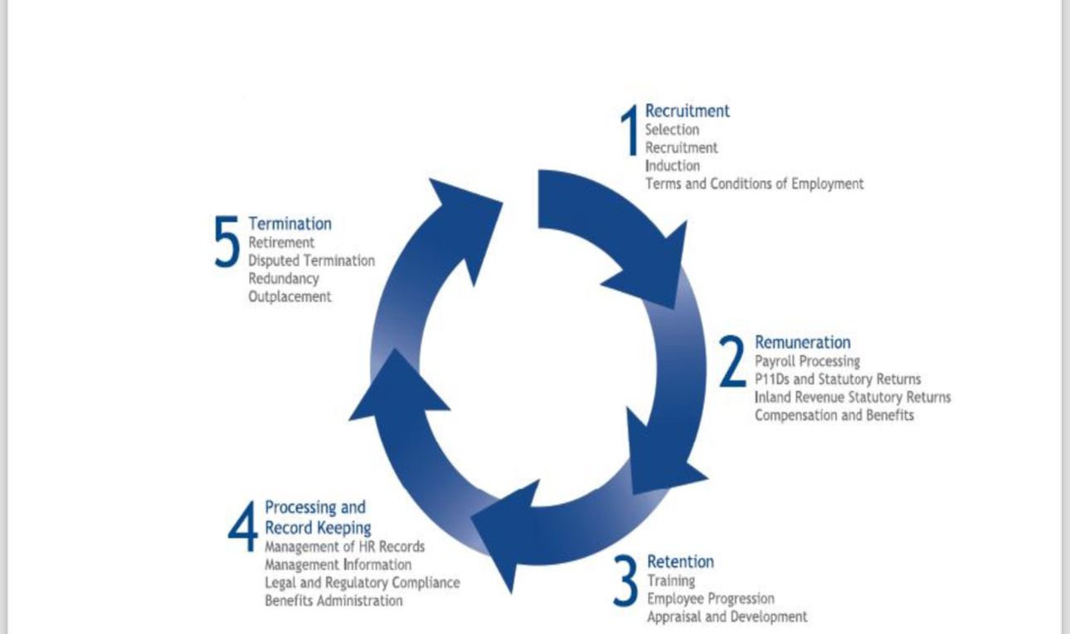

Examining the standard HR cycle is the most effective method of understanding how HRM operates (Figure 1). Recruiting is the cornerstone of every successful HR cycle.
Figure 1. HR Cycle (Videsi 2012)
Training effectiveness refers to the consequences of training. It is difficult to assess the efficiency of certain types of training. Kirkpatrick created the first training evaluation model (Kirkpatrick 1976). The first method is to use response criteria, which refer to employees' attitudes towards a given training program. The second model is learning criteria, which evaluate learners' levels obtained throughout training. This is the real measurement of the impact of a training program on personnel. The third level of evaluation is behaviour criteria, which assess the amount to which training is applied in learner behaviour and performance after completing a training program.
The fourth model is outcomes analysis, which measures how far an organisation has succeeded in meeting its pre-training goals, such as sales or profit (Noe 1986).
Noe also suggests a training motivation model. Trainees will be more motivated during a training program if they believe that putting in more effort will result in better training results. Higher performance translates to higher work performance. Higher job performance is the key to achieving targeted job results. This model focusses on motivation since it is a significant part that influences training performance and results. (Noe 1986.)
Training-related factors.
A variety of elements influence the training process, including the environment, supervisors and instructors, training material, and how it is delivered. These elements may be explored and clearly understood by telling their advantages and disadvantages.
Personal Factors
Personal variables surround those who are training. When humans engage in any type of exercise or practice, they always have an impact on the environment or process they are experiencing. The same is true for staff training. It is a process of transferring skills and technology from skilled trainers to new employees who are learning them.
The two key parties are, of course, the employees who want training and the trainer or staff person who gives the training. Officials who plan and supply resources for training can be classified as a third party, as they control the pre-arrangement and post-training quality evaluation (Birdi 2005).
Human Resource Policy
Haywood showed this part, which is based on the HR policy developed for a training program. According to him, too many training programs hinder the core goal of training, which is skill development and behaviour modification (Haywood 1992).
Organisational Factors
Everything is changed by its surroundings and environment, including the training programs. Birdi suggested that a lack of managerial support may hinder the effectiveness of creativity training. Unfavourable settings influence training efficacy (Birdi 2005).
Other factors:
Fischer and Ronald propose that open-mindedness is an important aspect in training success. Training has been said to be as successful as trainees and trainers are open-minded (Fischer 2011). According to Driskell, the kind of training, training material, and learner competence all have an impact on training results. Success depends on how the educator conducts training and the material (Driskell 2011).

4 Case Study
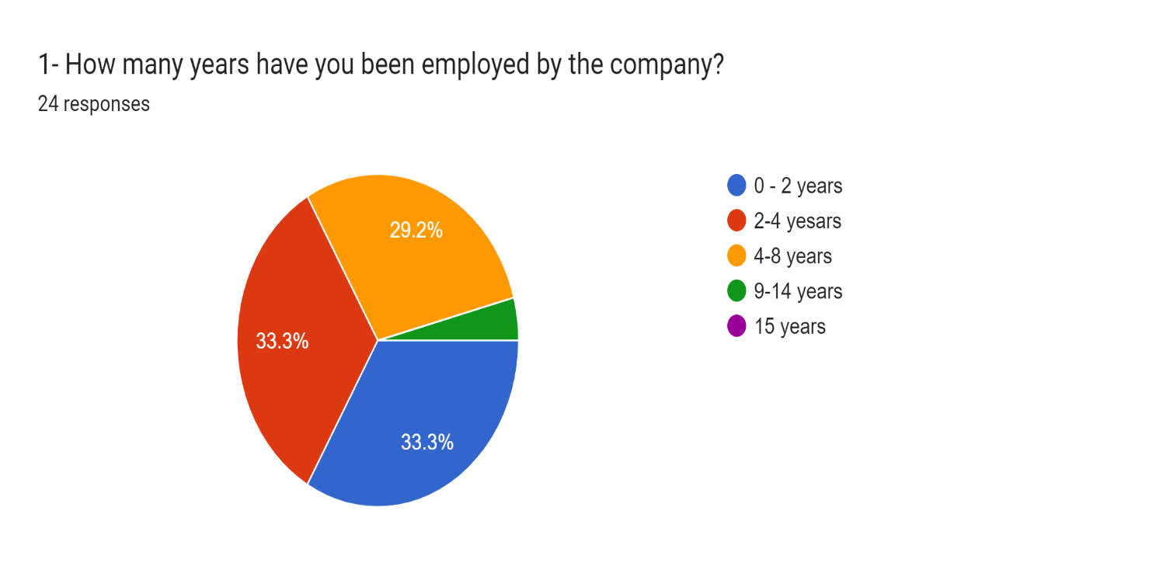

1

How many years have you been employed by the company?

Expanded Analysis

A survey of 24 respondents gives valuable information into workforce makeup and trends within the organisation.
1. 0–2 years (33.3%): This group has 8 people, showing that a large fraction of the workforce (one-third) has only been with the organisation for a short amount of time. This might show recent employment activity, either owing to expansion, high turnover, or both. Companies experiencing rapid development often have a sizeable proportion of newer employees, but high turnover can be a red indicator if retention is a concern.
2. 2 - 4 years (33.3%): 8 more employees have worked for the organisation for two to four years. When this group is added to the prior one, the total number of workers with four years or fewer at the firm is **66.6%**. A recent period of fast expansion or a high concentration of employees within their first few years might be the cause of this high concentration. It may also be the result of recent hires getting used to the work environment, which could influence engagement and productivity levels overall.
3. 4 - 8 years (29.2%): - 7 people fall into this category, making up a smaller but still considerable share of the workforce. This group proves a level of stability, since these individuals have spent a significant length of time with the organisation. However, the percentage is still below one-third of responses, implying that fewer employees advance beyond this mid-range tenure. If many employees do not stay beyond this point, it may say discontent, a lack of professional advancement prospects, or other causes that contribute to departures after many years.
4. 9 - 14 years (4.2%): Only 1 employee has been with the organisation for 9 to 14 years, writing down a significant reduction in long-term retention. This low proportion writes down that long-term staff retention may be difficult. One probable cause is that career progression or job evolution may be insufficient for long-term employees, prompting them to explore chances elsewhere.
5. Over 15 years (0%): - No employees reported being with the firm for 15 years or longer. The absence of any long-term workers after this stage might write down several things, including that the organisation is new or that it is having difficulty proving long-term loyalty among employees. It may also stand for business culture or organisational changes that have made it less desirable for employees to stay for extended periods of time.

Conclusion

The study results highlight many major themes about the company's workforce:
A large share of new hires: With 66.6% of employees having a term of four years or less, a significant majority of the workforce is new. This might be due to recent growth or high turnover rates, but it could also show difficulties in supporting staff after this short-term time.
Decline in long-term retention: The findings prove a significant decrease in staff retention after four years. Few employees stay with the firm for more than eight years, and none for fifteen years or more. This might say concerns with employee happiness, career growth, or the work environment, all of which deserve more investigation.
Lack of long-tenured personnel: The absence of employees with 15 or more years of service suggests that the organisation is young or that there are little opportunities for long-term career advancement. Ensuring that long-term workers feel appreciated and have possibilities for promotion is critical for developing organisational memory and internal leadership.

Recommendations

Investigate employee turnover and retention: Conduct departure interviews and get input from existing workers to figure out why so few individuals are still with the organisation for more than eight years. Naming the primary causes of turnover can help the organisation to address issues that may be driving people away, such as work culture, salary, or growth prospects.
Professional Development and Progression Plans: Create clear paths for professional progression, particularly for individuals who have been with the organisation for four to eight years. Structured development programs might persuade staff to still be longer and work towards long-term organisational goals.
Staff Engagement Programs: To prevent turnover in the early years, prioritise staff engagement through mentoring programs, frequent feedback, and performance rewards. Creating a supportive work environment can aid new employees integrate more easily and feel more connected to the company's goal and vision.
Focus on Long-Term Employee Satisfaction Prioritise keeping individuals with 4-8 years of tenure by improving work-life balance, offering leadership chances, and cultivating a culture that rewards loyalty. Conduct regular satisfaction surveys to discover any areas for improvement that may be causing mid-career employees to leave.

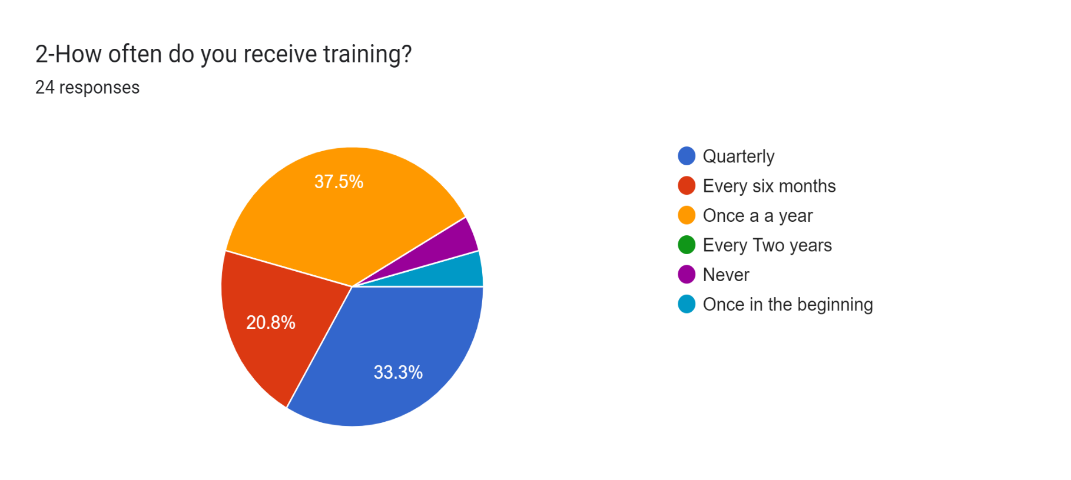

2 How often do you receive training?

How often do you receive training? is based on 24 responses and depicts how often employees receive training at the organisation. The pie chart is broken into distinct portions based on the results, which are colour-coded as follows:
Breakdown of percentages and interpretation
1. Once a year (Orange) – 37.5% Most respondents (37.5%, or 9 workers) report receiving training once a year. This says that yearly training sessions are the most widespread practice in the firm.
2.Quarterly (Blue) – 33.3% A sizable proportion of the workforce, 33.3% or 8 workers, report receiving training quarterly, suggesting that these employees are given regular, more frequent training.
3. Every six months (Red) – 20.8% Another group of 20.8%, or 5 employees, reported getting to train every six months, writing down that some employees follow a planned but less regular training program.
4. Once at the beginning (Light Blue) - 4.22% A tiny fraction of workers, 4.2% or 1 employee, reported receiving training once at the start of their job. This shows that for at least one participant, no more training beyond the first session was offered.
5. Every two years (green) – 0% None of the respondents reported receiving training every two years, writing down that this is not a typical training plan at the firm.
6. Never (purple) - 4.2 percent Another 4.2%, or 1 employee, said that they never received any training, writing down a deficit in training provisions for this person.
Summary of findings:
Most workers (about 71%) get regular training, either quarterly or once a year, showing that training is a key part of the company's continuous employee development plan. A lower percentage of workers (about 21%) receive training every six months; while this is less frequent than the quarterly group, it proves a strong commitment to employee skill development.
However, the fact that 4.2% of workers never receive training and another 4.2% only receive training once at the beginning suggests that there may be anomalies in the training program or that positions are neglected for continual training.
This data reveals that, while most employees receive frequent training, the organisation may need to address training gaps for individuals who receive little to no continuous growth opportunities. Furthermore, the fact that no employees are trained every two years may indicate that such lengthy periods are not seen useful or required in the company's training strategy.
While many employees benefit from frequent training, the data suggests that the organisation should focus on several important areas for improvement to guarantee that all employees have equal access to growth opportunities. Specifically, 71% of employees receive consistent training on a quarterly (33.3%) or annual (37.5%) basis.
This reflects a strong commitment to continued staff development, with three-quarters of respondents taking part in formal training programs. The large amount of annual training (37.5%) shows that this frequency may be a typical practice within the organisation, ensuring that personnel are still current with corporate rules, technology, or industry standards on a yearly basis. Furthermore, 21% of employees reported getting to train every six months, which, while less frequent than quarterly, shows a consistent training routine.
This technique may be proper for specific departments or tasks that require biannual skill refreshers or upgrades. Together, the quarterly and semi-annual training plans provide a solid basis for skill development and professional progression inside the organisation. However, the fact that 4.2% of workers never receive training and another 4.2% only receive training once at the start of their employment writes down that the company's training framework may have gaps. The lack of continual training may limit these employees' prospects for growth, adaption to new systems, and the development of skills needed for long-term success. These findings may show variations in how training is delivered across separate roles or departments, suggesting that some sectors of the business may not be receiving right attention when it comes to learning and development.
Furthermore, no employees reported receiving training every two years, implying that the company may not consider this interval an effective period for training, or that such long gaps between training sessions are unsuitable for supporting relevant skills in today's fast-paced work environments.

Conclusion

While many employees receive help from regular training, there are noticeable gaps in access to consistent development opportunities. The company's current training policies may not be fully inclusive, as some employees report limited or no access to training sessions. This uneven distribution of training resources could hinder employee growth and overall productivity. To foster a more skilled and adaptable workforce, it is essential for the company to re-evaluate its approach to employee development.

Recommendations

Address training gaps: Implement regular check-ins and mandated refresher courses to guarantee that all workers, particularly those who have had only one or no training, have continuous growth opportunities.
Role-specific training Consider the need for role-specific training to ensure that even employees in jobs with less obvious training needs have access to knowledge refreshers and skill development.
Customised Training Schedules: Implement bespoke training schedules to meet the unique needs of employees, ensuring that everyone, regardless of function, is up to speed on industry standards and internal processes.
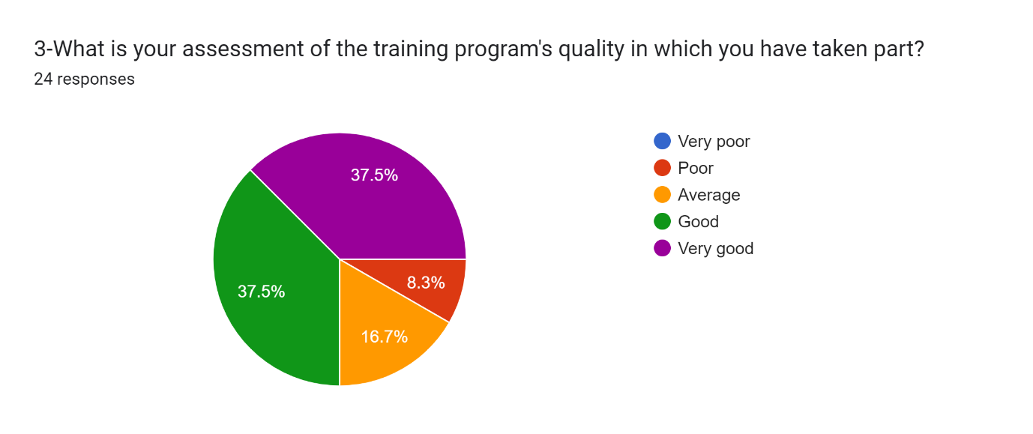

3 What is your assessment of the training program's quality in which you have taken part?

Percentage interpretation

1. Particularly good (purple) - 37.5%. Most responders (37.5% or 9 workers) evaluated the training program as exceptionally good. This writes down that a sizable number of employees are extremely pleased with the quality of the training offered.
2. Good (Green) – 37.5% Another 37.5% of employees, or 9 employees, evaluated the training as good, showing that a significant percentage of respondents are favourable about the training programs, if not completely satisfied.
3. Average (Orange) - 16.7%. A smaller percentage, 16.7% or 4 employees, rated the training as average. This suggests that some employees believe there is room for improvement in the quality of the training programs offered.
4. Poor (Red) – 8.3% A tiny group of 8.3% of respondents (2 workers) assessed the training programs as poor, suggesting dissatisfaction with the training's content, delivery, and overall efficacy.
5. Unbelievably bad (Blue) – 0% No respondents assessed the training as extremely poor, showing that no employee had a particularly negative opinion of the program's quality.

Summary

Most workers, 75%, assess the training as good or particularly good, showing that the company's training programs are well-received. The fact that no workers evaluated the training as extremely poor suggests that many employees were satisfied.
However, 16.7% of employees rate the training as average, meaning that while it satisfies certain fundamental expectations, improvements may be done in specific areas to raise it to a higher standard. 8.3% of respondents (2 workers) are dissatisfied with the training, rating it as poor, writing down the presence of problems or unmet requirements about the training program.

Conclusion

The overall assessment of the company's training program reveals a high degree of employee satisfaction. With 75% of workers evaluating the program as good or particularly good, most employees are satisfied with the company's training activities. These personnel are likely to believe that the training programs help them grow personally and perform well in their jobs. The fact that there are no extremely poor evaluations confirm the idea that the organisation normally provides high-quality training sessions.
However,16.7% of employees assessed the training as average, while 8.3% rated it as poor, writing down areas that need to be addressed. These personnel may believe that the training they get lacks relevance, depth, or effective delivery. Given that one-quarter of respondents did not rank the program as above-average, there are chances to improve the training programs so that all employees benefit equitably. A consistent and high-quality training experience across all departments and positions is critical for long-term employee development and retention.

Recommendations

It is critical to better understand why 24% of employees assessed the training as average or poor. The firm should do follow-up surveys or one-on-one interviews to delve deeper into these problems. These interactions can aid find whether the discontent is due to the training program's content, delivery style, frequency, or accessibility. Collecting thorough feedback will offer the firm with useful information to improve the training process.
The same training topic may not be right for all roles within the firm. By tailoring training to the individual demands of different departments or job functions, the organisation can ensure that each employee receives information that is directly relevant to their tasks. Employees in technical professions may require more sophisticated and firsthand training, whilst administrative workers may receive help from process-oriented or customer service training. Offering both role-specific and advanced training options may help engage people who believe present training is too broad or basic.
The method in which training is given can have a substantial impact on its efficacy. Traditional lecture-based training may not be suitable for everyone. The organisation might think about implementing blended learning approaches, which integrate in-person training, interactive digital courses, and group workshops. Adding more interactive and practical elements, such as simulations, case studies, or firsthand practice, may increase engagement. Furthermore, proving e-learning platforms that provide on-demand training might provide employees the freedom to study at their own speed, making it simpler for them to absorb and apply the information.
Effective training programs should go beyond a single session and result in real-world gains in work performance. To guarantee this, the organisation should set up procedures to check the long-term impact of training. Managers might follow up with staff following training sessions to see how successfully they applied what they had learnt. Furthermore, doing post-training assessments or evaluations can help prove how effectively the information was recalled and whether it resulted in any demonstrable improvements in the workers' performance.
To increase motivation and engagement with training programs, the organisation might implement a system of recognition and rewards for workers who actively pursue and excel at their training. Recognising workers' dedication to learning and using new abilities, whether through certifications, incentives, or career progression chances, may result in more enthusiastic engagement in training programs. A formal recognition system may also build a competitive, growth-oriented culture in which people strive for continuous improvement.
Final Thoughts
While the company's training program has a solid base, added enhancements can guarantee that it is both globally successful and deeply meaningful for all workers. The organisation may prove a more dynamic learning environment by addressing the problems highlighted by individuals who gave the training a lower rating and using more customised, engaging, and continual training tactics. This, in turn, will boost employee happiness while also contributing to improved performance, retention, and long-term corporate success.
Focussing on these areas for improvement allows the organisation to guarantee that the training program satisfies the requirements of all employees, promotes happiness, and adds to the workforce's overall growth and development.

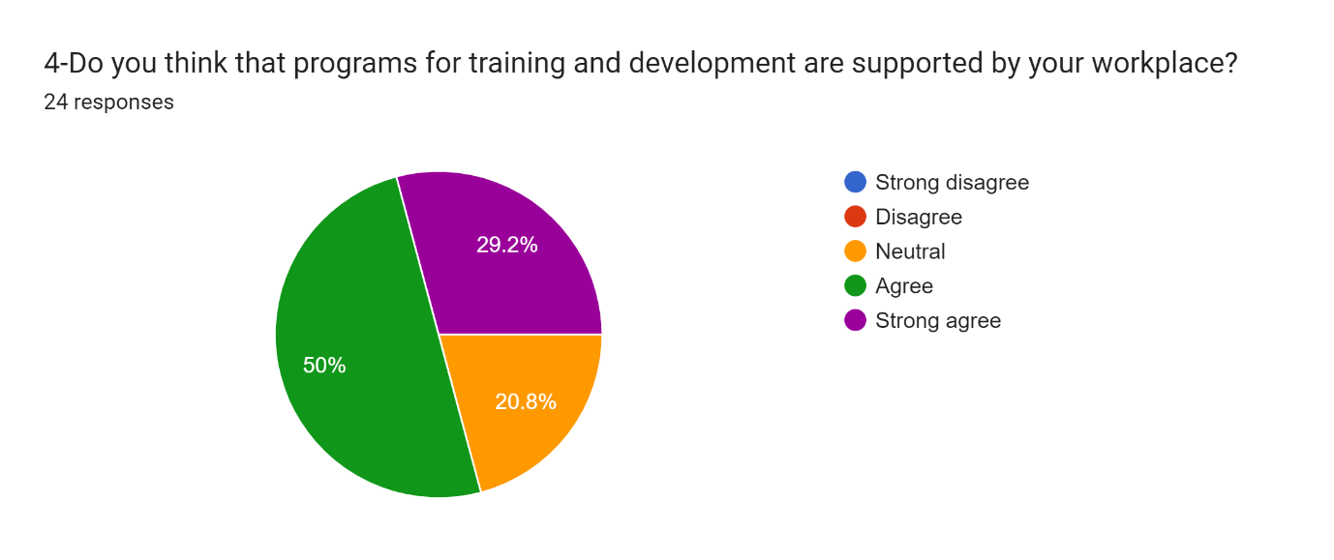

4 Do you think that programs for training development are supported by your workplace?

Overview

The poll received responses from 24 individuals, giving information about employees' feelings of their organization's commitment to training and development. Responses are categorised as follows:
Agree (50% - Green):12 responses.
Strongly Agree (29.9%, Purple): 7 replies
Neutral (20.8% - Orange): 5 individuals

Responses
1.Agree (50%, Green) A 50% agreement rate shows a strong basis of support among employees. Those who agree may enjoy the availability of training materials and their importance in professional growth.

Factors influencing this unobstructed view may include.
Access to Resources: The availability of online courses, workshops, mentoring programs, and seminars.
Supportive Culture: Leadership fosters a culture of learning and development.
Skill Enhancement: Opportunities to develop both hard and soft skills related to their roles.
2. Strongly Agree (29.9% – Purple): With 30% of respondents strongly agreeing, this sector displays a firm conviction in the usefulness and importance of training programs. This group may regard training not just as a benefit, but as a vital part of their job experience, resulting in increased Job Satisfaction: Employees who believe their growth is valued are more engaged and content with their jobs. Performance Improvement: Strongly supported personnel may be more productive and efficient, which helps the organisation.
Career Advancement. This group may regard training to advance their careers.
3. Neutral (20.8%, Orange) Approximately 21% of respondents reported neutrality towards training support, showing gaps in knowledge or efficacy.
Reasons for this neutral posture might include:
Lack of Information: Employees may be unaware of all available training alternatives or how to obtain them.
Program Relevance: Training possibilities may not correspond to their unique professional aims or skill sets.
Perceived Efficacy: Some workers may have engaged in training that they believed was ineffective or did not provide demonstrable results.
Addressing these concerns is crucial for making all employees feel supported and engaged.
Implications
Strengths
Employee Engagement: A prominent level of agreement says a supportive atmosphere for professional development, leading to increased morale and retention rates.
Investment in Development: The organisation looks to be devoted to investing in its employees, which can help it build a reputation as a desirable employer.
Retention and Loyalty: Employees who feel valued through training opportunities are more likely to stay with the organisation for the long run, lowering turnover costs.
Areas for Improvement:
Increase Awareness: With 21% of workers expressing neutrality, improved communication and marketing of training opportunities may be necessary.
Relevance of Programs: It is critical to ensure that training courses are not just available but also relevant to the changing demands of the workforce and the organization's goals.
Employees have a variety of learning styles and preferences. Offering a combination of in-person, online, and firsthand training options helps accommodate these disparities.

Recommendations

Conduct Focus Groups to get qualitative data on employee training requirements and preferences. This can give more insight beyond the survey data.
Regular Training Needs Assessment**: Periodically evaluate the training programs to ensure they are still relevant and effective. This might incorporate questionnaires or feedback tools following training sessions.
Mentorship Programs: Implementing mentorship or coaching programs may give workers with personalised direction and support as they pursue their professional goals.
Celebrate Successes: Publicly recognising workers who complete training or certificates might inspire others to pursue professional development.

Considerations for Future Training Programs

Integration with Performance Management: Coordinate training and development programs with performance evaluations and goal-setting procedures. This can help employees see the direct link between training and job advancement.
Emphasise Soft Skills: In addition to technical training, emphasising the value of soft skills like communication, leadership, and teamwork may result in a more well-rounded staff.
Feedback Loop: Prove a comprehensive feedback loop in which employees may share their opinions about training programs, helping continual development and adaptability to changing demands.

Conclusion

The survey findings give useful information about employees' impressions of training and development support inside the organisation. While a considerable majority of employees are pleased with the resources offered, there is still room to engage the neutral group and improve the overall efficacy of training programs. The findings show a good foundation of support for training efforts, with half of respondents saying that their company prioritise their professional growth.
This statement shows the organization's dedication to creating a learning environment, which is critical for recruiting and keeping top personnel. However, the presence of a sizable indifferent response group suggests that there may be underlying concerns about awareness, accessibility, or perceived significance of these training opportunities.
To solve these problems, the organisation must actively involve workers in talks about their training requirements and preferences. This may be done through frequent surveys, focus groups, and informal feedback systems. By actively asking for feedback from employees, the organisation may adjust training programs to better match their requirements, improving engagement and satisfaction.
Furthermore, fostering a culture of continual learning may be game-changing. This includes not just giving access to training tools, but also encouraging people to take initiative-taking steps towards personal and professional growth. Recognising and rewarding workers who take part in training efforts can inspire others to follow suit, resulting in a shared commitment to progress throughout the organisation.
Additionally, the organisation should consider employing a variety of training methods to accommodate different learning styles. For example, combining traditional classroom instruction with online modules, seminars, and mentoring programs might result in a more thorough and interesting learning experience. This method can also increase the training's relevance and application, making it more interesting to a wider spectrum of personnel.
Finally, creating an atmosphere that values ongoing learning, and growth may boost the workforce. This dedication leads to enhanced job satisfaction, higher performance levels, and more organisational loyalty.
Employees who feel encouraged in their development are more likely to be engaged, motivated, and involved in their jobs, which may lead to better outcomes for the organisation. By meeting the needs of all employees, particularly those in the neutral group, the organisation may foster a culture of growth that helps both individuals and the organisation. This comprehensive approach to training and development not only improves the workforce's skills and abilities, but it also positions the organisation as a leader in employee happiness and engagement. As the organisation invests in its people, it can create a robust, adaptable workforce that is prepared to face future challenges, driving innovation and success in an ever-changing marketplace.

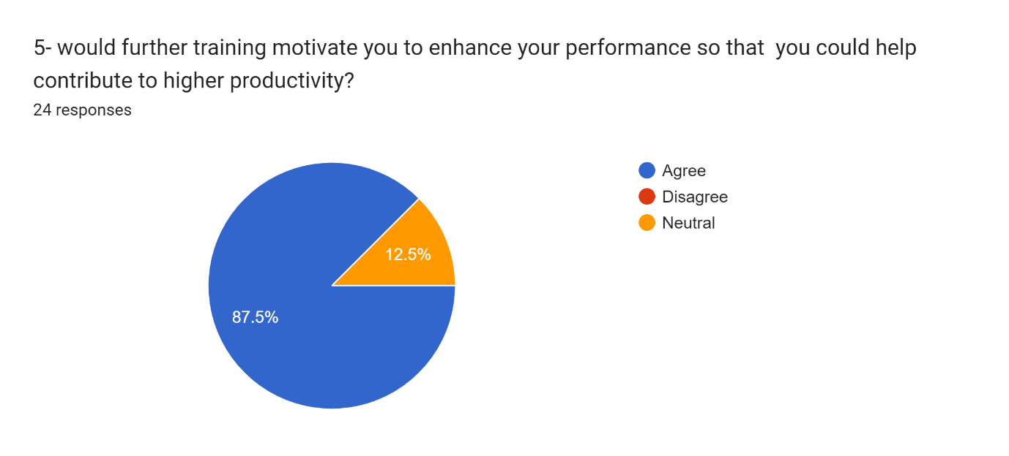

5 Would further training motivate you to enhance your performance so that you could help contribute to higher production?

The survey findings on whether more training would drive employees to improve their performance and lead to increased productivity:
The survey findings from 24 respondents prove a strong confidence that further training may improve employee performance and lead to increased productivity.
The findings are distributed as follows:
Agree (87%, blue): 21 replies!
Neutral (12.5% - Orange): three responses
These findings prove a wide consensus that greater training is seen as an effective technique for increasing individual and organisational performance. However, the limited number of indifferent replies may show areas where training programs might be targeted more successfully.
Agree (87% - Blue)
Most respondents (87%) think that further training would drive them to enhance their performance, resulting in increased productivity. This response offers a few key insights. Training for Performance Drivers: Employees see training as a key part that may help them refine their abilities, widen their knowledge, and improve their performance in their professions. This emotion is important because it shows that employees believe they have space for improvement and are looking for ways to better.
Link to Productivity: The high agreement rate says that employees consider expanded training as a direct path to increased productivity, because it allows them to become more knowledgeable, successful, and confident in their job.
Motivational Impact: Employees who believe their employer is invested in their professional growth are more likely to still be motivated and engaged. This can result in higher job satisfaction and morale, as well as a stronger commitment to meeting organisational goals.
Retention and Loyalty: Providing further training improves employee performance while also increasing loyalty. Employees who are constantly improving their abilities are less inclined to seek out other chances because they feel encouraged in their professional development.
Neutral (12.5%, Orange)
A tiny minority of responses (12.5%, or three people) are indifferent, writing down no agreement or disagreement regarding whether further training will improve their performance or productivity. This neutrality might result from a few factors:
Ambiguity About Training Relevance: Some employees may believe that the training programs provided do not correspond to their specific positions or long-term career aspirations, creating ambiguity about the influence on their performance.
Experienced Employees: This category may also include persons who think they are already very skilled in their positions and hence do not consider more training as essential to increase performance. Employees in this group may be unaware of the potential benefits of focused training programs, or they may not have previously been exposed to successful training, leading them to adopt a wait-and-see approach.

Implications
Strengths
General Motivation for Training: The overwhelming consensus that more training will improve performance reflects a workforce eager to learn and progress. This is an important positive for the organisation since it shows that staff are receptive to growth and understand the need of honing their abilities.
Direct Link to Productivity: Employees clearly see a link between skill development via training and greater productivity, which is consistent with the organization's overall aim of boosting efficiency and output.
Areas for Improvement
Involving the Neutral Group
The 12.5% neutral response writes down that there is still a tiny part of the workforce that may not completely grasp or recognise the advantages of more training. It is critical to communicate with these personnel to understand their reasons for neutrality and find solutions to their issues.
Tailoring Training for Different Needs
Different employees may require different sorts of training to understand its usefulness. For example, some may receive help from leadership development, whilst others require technical skills or job-related training. Offering a more personalised approach may help engage people who are unsure about the benefits.

Recommendations

Targeted Training Programs: To ensure training is relevant and valuable to all employees, consider personalising programs to certain departments, positions, or people. A more personalised approach may enhance participation, particularly among individuals who are neutral. Promote Success Stories: Sharing instances of how further training has helped other staff improve their performance and increase productivity may be an excellent method to drive others. This might involve incorporating real-life examples into newsletters, meetings, and internal communications.
Continuous Feedback Loop
Including employee feedback in the creation of training programs may aid ensure that the training delivered fulfils their requirements and expectations. Regular surveys, focus groups, or one-on-one interactions may offer valuable insights about how to increase training relevance and effect.
Mentoring and Coaching
Implementing mentoring or coaching programs that provide employees with direction on how to implement their training in real-world situations can improve the practical advantages of training. This might be especially beneficial for individuals who are neutral because it offers a more firsthand approach to growth.
Considerations for Future Training Programs
Focus on Practicality: Employees are more likely to appreciate the benefit of training if it is directly relevant to their roles. Programs that focus on improving job-specific abilities or addressing current issues may lead to a stronger conviction in training as a tool for performance enhancement.
Incentive Participation: Providing incentives for completing training programs, such as certificates, bonuses, or recognition, can help to increase participation and promote a culture of continuous development.
Technology Integration: As technology advances, including digital tools and platforms into training may improve learner engagement and accessibility. E-learning, virtual workshops, and on-demand materials may fit a variety of learning styles and schedules.
Conclusion
According to the survey results, employees strongly believe that further training will drive them to enhance their performance and help to increased production. 87% of respondents agreed, showing that the workforce is excited about possibilities to learn and progress. This offers an excellent chance for the organisation to use this drive to build a culture of continual improvement and innovation.
However, the 12.5% neutral responses show that there is still space for development, especially in making training more relevant and interesting for all employees. Addressing this group with personalised training programs and improved information about the benefits of skill development may convert neutral responders into active participants in their own development.
By investing in varied and personalised training efforts, sharing success stories, and keeping open feedback channels, the organisation can guarantee that all workers feel empowered to improve their performance. This, in turn, will result in enhanced productivity, greater work satisfaction, and improved overall organisational success. Fostering an atmosphere in which training is viewed as a crucial path to success can benefit not just individual employees, but also the organization's long-term viability.

Conclusion part 2

To summarise, this study offers useful insights not only for Reiss, but also for the larger HR and management sectors, particularly in the highly competitive retail market. By digging into crucial labour concerns such as employee tenure, retention, satisfaction, and professional development, the findings provide a road map for managing workforce challenges and improving management performance. These insights may help Reiss support its record of excellence by implementing data-driven tactics that reinforce its organisational culture, increase staff retention, and create long-term operational success.
One critical result is that Reiss must address its deteriorating long-term retention rates, since most of its workers have been with the company for four years or fewer, with few remaining for more than eight years. This raises issues about employee happiness, career advancement, and workplace culture, writing down that initiative-taking actions are needed to address the root reasons of high turnover. Reiss can prove a more stable staff with a strong organisational memory and internal leadership by increasing career progression chances and recognising long-term workers' achievements.
Furthermore, the report names major gaps in Reiss' present training and development initiatives, with a sizable proportion of workers believing they have inconsistent access to professional development opportunities. While most employees are happy with their training, 25% believe the programs may be improved. To solve this, Reiss must guarantee that training resources are spread more fairly across departments and that programs are tailored to the specific requirements of all workers. Personalised training courses, leadership development programs, and ongoing learning opportunities can help to create a workforce that is both highly trained and adaptive to changing industry demands.
Furthermore, the report emphasises the necessity of cultivating a culture of continual professional growth, with 87% believing that more training will improve their performance. Reiss may tap into this excitement by introducing more dynamic and diversified training techniques, such as combining traditional classroom instruction with digital learning modules, mentorship programs, and firsthand workshops. Offering refresher courses and leadership development programs will help to encourage staff and keep them engaged and committed to their professional development.
These training programs, in addition to enhancing employee happiness and engagement, have the potential to increase organisational performance. Employees who feel encouraged and have access to career advancement chances are more likely to be productive, motivated, and loyal to their employer. Addressing the problems of neutral respondents—who make up 12.5% of the workforce—via personalised, relevant training may transform passive employees into active contributors to the company's success. This will not only increase individual performance but will also encourage innovation and provide Reiss with a competitive edge.
Reiss can make its personnel more adaptive, inventive, and future-ready by investing in extensive training and development efforts. This dedication to staff development and happiness will help Reiss preserve its competitive advantage, manage market difficulties, and position itself as a leader in both employee engagement and customer service in the fashion retail sector. Overall, these initiatives will improve Reiss' ability to recruit, keep, and develop elite personnel, assuring long-term success in an ever-changing economy.

Reference

Becker, B E and Gerhart, S (1996) The impact of human resource management on organizational performance: progress and prospects, Academy of Management Journal, 39 (4), 779–801

Boxall, P F (2007) The goals of HRM, in (eds) P Boxall, J Purcell and P Wright, Oxford Handbook of Human Resource Management, Oxford, Oxford University Press, pp 48–67.

Citation: Mello, J. A. (2015). Strategic Human Resource Management. Cengage Learning

Haasen, A,’ (1996) ‘Opel Eisenach GmbH – Creating a High-productivity Workplace’, Organisational Dynamics, Spring 1996.

A practical at: https://www.reiss.com/carrers/ (accessed:24 June 2024)

A practical at: https://reiss.storiq.net/org_units/294 (accessed:24 June 2024)

A practical at: https://themuseretail.learn.link/ (accessed:24 June 2024)

Leading HR, Basingstoke, Palgrave Macmillan, 68-89 dd Tyson, S (1985) Is this the very model of a modern personnel manager? Personnel Management, May, Pp 22-25.

Lunenburg, F.C., 2011. Goal-setting theory of motivation. International journal of management, business, and administration, 15(1), pp.1-6.

Ulrich, D (1998) A new mandate for human resources, Harvard Business Review, January- February, pp 124–34.

Armstrong, M, Taylor, S. (2020). Armstrong's Handbook of Human Resource Management Practice. London: Kogan Page

Banfield, P., Kay, R. (2012). Introduction to Human Resource Management. Oxford: Oxford University Press

Denisi, A., Griffin. R. (2018). HR. Boston Cengage Learning.

Gandhi, P. (2020). Business Studies. New Delhi: VK Global Publications

Appendix

Questionnaire

How many years have you been employed with the company?
- 0-2 years
- 2-4 years
- 4- 6 years
- 6 – 10 years
- 10 – 15 years
- 15 or more years
How often do you receive training?

- Quarterly
- Every six months
- Once a year
- Every two years
- No specific schedule

What is your assessment of the training program's quality in which you have taken part?

- Extremely poor
- Poor
- Average
- Good
- Particularly good
Do you believe that programs for training and development are supported by your workplace?

- 1)Strong disagree
- Disagree
- Neutral
- Agree
- Strongly agree.

Would you need further training to be motivated to enhance your performance so you could help contribute to higher productivity?

- Strongly
- Disagree
- Neutral
- Agree
- Strongly Agree

