Assessment Component 1
Individual report
Student Name: Mariana Acris
Student Number: 2239619
Lecturer Name: Samson Oladejo
Module Name: LCBB6003_BIRM
Leadership and Management Theory and Practice

Table of Contents
1. Introduction 3
2. Managerial Functions 3
3. Why Controlling is Essential in Organizations? 5
3.1. Key Features of Controlling 6
4. Challenges Associated with Controlling 7
5. How Managers Can Mitigate Challenges in Controlling? 8
6. Conclusion 10
References 11

Introduction
Management is a fundamental process in contemporary organizations, providing direction, coordination, and oversight to ensure that goals are effectively achieved. It is often described as a set of functions-planning, organizing, leading, and controlling-that together guide organizations in navigating increasingly complex and competitive environments (Fayol, 1949; Robbins and Coulter, 2018). These functions are interdependent, forming a cycle that enables managers to translate vision into results. In today’s dynamic global economy, where uncertainty, technological change, and cultural diversity dominate, the importance of effective management has never been greater (Drucker, 1999).
Among these functions, controlling is critical but frequently underestimated. It involves monitoring performance, comparing actual results with planned objectives, and implementing corrective measures where necessary (Griffin, 2017). Without effective control, organizations risk inefficiency, misalignment, and exposure to external threats. For example, in industries such as aviation and pharmaceuticals, control mechanisms such as compliance audits and quality checks are essential for safety and regulatory adherence (Hill et al., 2017). Furthermore, Hofstede’s (2001) model of national cultures highlights how control systems may be perceived differently across cultural contexts, making the function even more complex in multinational organizations.

Managerial Functions
The four functions of management-planning, organizing, leading, and controlling-form the core framework guiding managerial practice. These functions were first articulated by Henri Fayol in the early 20th century, who described management as a universal process comprising interrelated responsibilities (Fayol, 1949). Although initially conceived as separate tasks, modern scholarship emphasizes their interdependence and cyclical nature in achieving organizational effectiveness (Robbins & Coulter, 2018).

Function | Historical Perspective | Contemporary Perspective
  Business Example
Planning | Introduced by Fayol (1949) as the foundation of management; initially a top-down process where executives dictated strategies. | Now a collaborative and adaptive process involving employees at multiple levels; emphasizes flexibility and continuous updating (Mintzberg, 1994). | Microsoft involves cross-functional teams in strategic planning to adapt to rapid tech changes (Drucker, 1999).
Organizing | Originally seen as mechanistic, focusing on hierarchical structures, rules, and formal authority (Weber, 1947). | Emphasizes agility, team-based structures, decentralization, and collaboration across functions (Daft, 2020). | Toyota’s lean production model uses team structures and efficient workflows to minimize waste.
Leading | Early theories assumed leadership was an innate trait possessed by a select few (trait-based theories). | Modern approaches recognize leadership as relational, adaptive, and shared across organizational levels (Northouse, 2021). | Google promotes transformational leadership, empowering employees and fostering innovation.
Controlling | Traditionally focused on discipline, compliance, and strict monitoring to ensure adherence to rules. | Now focused on continuous improvement, learning, and feedback using performance metrics and analytics (Griffin, 2017). | Amazon employs real-time performance monitoring in logistics and supply chains to maintain efficiency.

Tab. 1.: Managerial Functions

Together, these four functions create a continuous cycle: planning establishes the direction, organizing arranges resources, leading motivates people, and controlling keeps everything aligned with objectives. When integrated, they offer a comprehensive framework for managing the complexities of today’s business environment.

Why Controlling is Essential in Organizations?
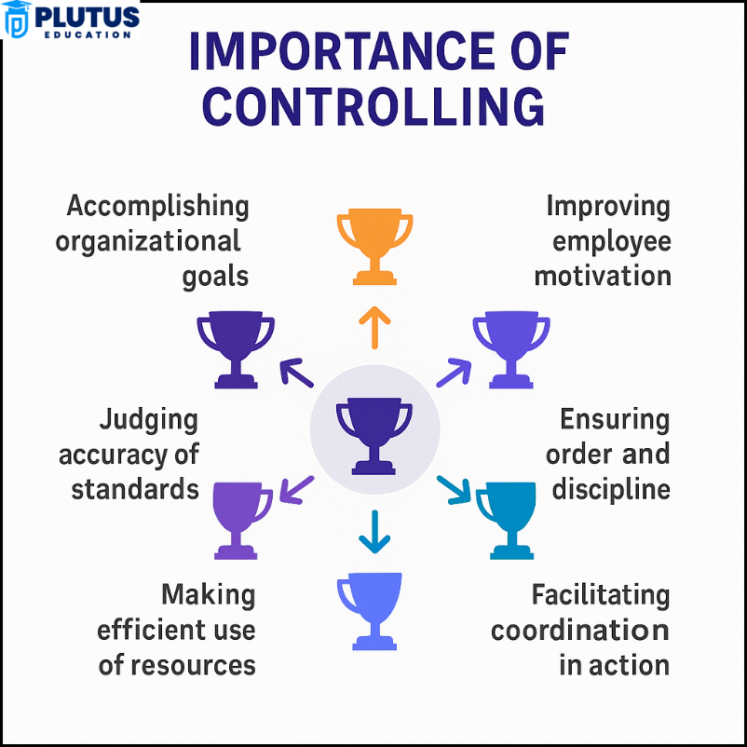
Controlling is a vital managerial function because it ensures that the activities of an organization remain aligned with its objectives. While planning, organizing, and leading establish the framework for action, it is through controlling that manager can verify whether those actions are producing the intended results. Without control mechanisms, even the most carefully designed strategies may fail due to inefficiencies, deviations, or lack of accountability (Griffin, 2017).
One key reason controlling is essential is that it helps maintain alignment with objectives. Managers use control systems to measure actual performance against planned goals, identifying deviations and implementing corrective action where necessary. For instance, airlines such as Emirates rely on strict safety audits and compliance checks to ensure that their operations consistently reflect their brand promise of high service
Fig. 1. Source of: https://plutuseducation.com/blog/importance-of-controlling/
quality. In the absence of such controls, misalignment could undermine customer trust and organizational reputation.
Another important role of controlling lies in efficiency and productivity. By identifying wastage and bottlenecks, control systems enable organizations to optimize resources. Tesla, for example, monitors its production lines in real time to reduce downtime and streamline manufacturing processes. Such systems not only cut costs but also enhance overall performance (Robbins & Coulter, 2018).
Controlling also promotes accountability and transparency. Mechanisms such as performance appraisals, budgets, and compliance audits reinforce responsibility and provide stakeholders with sureness that resources are actuality used efficiently. Financial institutions such as HSBC employ rigorous internal control systems to prevent fraud, demonstrating how accountability mechanisms underpin organizational legitimacy and sustainability (Drucker, 1999).
In addition, controlling supports adaptability in dynamic environments. Modern organizations face rapid technological advances and volatile markets. Control systems provide timely data that enables managers to respond effectively to change. Netflix, for example, uses analytics to monitor customer preferences and quickly adjust its content strategy, thereby maintaining competitive advantage.
Finally, controlling is essential for risk management and continuous improvement. In industries such as pharmaceuticals, quality control safeguards against defective products that could lead to recalls or reputational damage. Toyota exemplifies the use of continuous improvement (“Kaizen”), where control processes provide ongoing feedback to refine operations and maintain high standards of quality (Daft, 2020).
Overall, controlling is not merely about enforcing discipline or restricting employee behaviour, as earlier perspectives suggested. Instead, it provides feedback loops, fosters learning, and ensures adaptability in uncertain environments. Moreover, cultural differences influence the design of control systems. As Hofstede (2001) notes, while strict hierarchical controls may be accepted in high power distance cultures, they may be resisted in individualistic and low power distance contexts. This underlines that while controlling is universally important, its application must be context-sensitive.

Key Features of Controlling
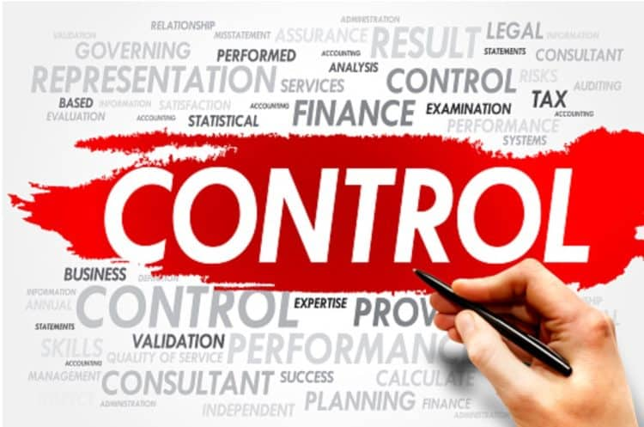
Fig.2. Source of: https://www.linkedin.com/pulse/crucial-role-control-functions-organizational-success-al-khoshiban--xgqlf/

Controlling is a fundamental management function that ensures efficiency, accountability, and alignment across all organisational levels and industries. It is inherently goal-oriented, with all control activities directed towards achieving specific organisational objectives. By keeping goals at the centre of the process, managers can allocate scarce resources effectively, focus on priority areas, and enhance overall productivity and strategic direction (Robbins & Coulter, 2018).
The function of controlling is also a continuous process, operating as an ongoing cycle of measurement, evaluation, and corrective action. This continuous feedback system enables organisations to remain agile, respond quickly to changes, and refine operations in line with evolving conditions (Drucker, 2007).
Its universal applicability means it is equally relevant in large multinational corporations and small enterprises, and across functions such as finance, operations, and human resources. This makes controlling a cornerstone of effective management practice in any organisational setting (Hill & Jones, 2012).
A key characteristic of controlling is that it is action-oriented. When performance deviates from set standards, control mechanisms prompt corrective measures, which may involve revising strategies, retraining employees, or reallocating resources. Without this action-oriented nature, control would merely be passive monitoring and lose its effectiveness (Griffin, 2017). Additionally, control systems must be flexible and adaptive. In a dynamic environment shaped by market fluctuations, technological change, and shifting customer expectations, rigid systems become obsolete, whereas adaptive ones sustain organisational competitiveness and resilience (Bateman & Snell, 2013).
Overall, controlling combines goal alignment, continuous feedback, universal application, proactive action, and adaptability, creating a responsive system that ensures organisational objectives are met while supporting long-term growth and sustainability (Koontz & Weihrich, 2010).

Challenges Associated with Controlling
Controlling is a important management function that confirms structural activities align with fixed plans and objectives. However, its implementation is not without significant challenges.
One of the foremost issues is resistance from employees. Control mechanisms are sometimes perceived as restrictive or punitive, which may reduce morale and foster opposition. Employees may interpret strict monitoring as a lack of trust, thereby undermining motivation and cooperation (Simons, 1995).

Another difficulty lies in measuring performance effectively. While financial performance is relatively straightforward to monitor, non-financial factors such as innovation, customer satisfaction, or employee engagement are more difficult to quantify. The traditional reliance on accounting-based controls (Anthony, 1965) is increasingly inadequate for capturing the multidimensional nature of organizational performance (Otley, 1999).
A further challenge arises from environmental dynamism and complexity. The pace of technological innovation, globalization, and shifting consumer preferences means that performance standards and benchmarks can quickly become outdated. Control systems designed for stable environments are often unable to cope with such volatility (Chenhall, 2003).
There are also concerns regarding the cost and bureaucratic nature of control systems. Establishing and monitoring control processes requires substantial time and resources. Overly complex systems may stifle innovation and slow decision-making, leading to inefficiency (Kaplan & Norton, 1992).
Information quality and overload further complicate control. Managers depend on accurate and timely information to make corrective decisions. However, information may be incomplete, inaccurate, or excessive, leading to poor judgments (Otley, 1994) . Inaccurate reporting, sometimes stemming from human manipulation of data to meet targets, exacerbates this problem.
Finally, behavioural and cultural factors create additional obstacles. Organizational politics, managerial bias, or employees’ attempts to manipulate performance outcomes can distort the effectiveness of control systems (Merchant & Van der Stede, 2017). In culturally diverse organizations, varying attitudes toward authority and compliance may also hinder consistent implementation of control mechanisms.

How Managers Can Mitigate Challenges in Controlling?
To address the difficulties involved in controlling, managers should embrace adaptable, collaborative, and technology-driven methods. One of the most effective strategies is enhancing transparency and communication. When employees understand the purpose of control mechanisms and see them as supportive rather than punitive, resistance can be reduced. Involving employees in setting performance standards fosters ownership and cooperation (Kaplan & Norton, 1996).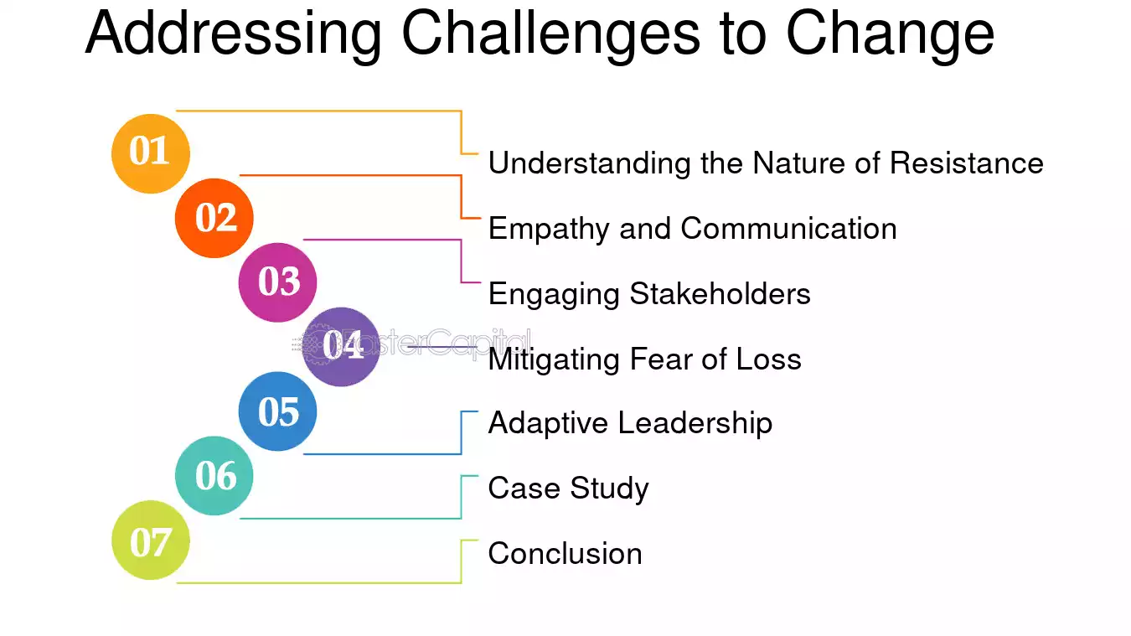
Fig.3. Source of: https://fastercapital.com/topics/the-challenges-of-change-management.html/1
Managers can also address measurement challenges by implementing multi-dimensional performance frameworks. Tools such as the Balanced Scorecard incorporate both financial and non-financial indicators, capturing innovation, customer focus, and learning alongside traditional financial outcomes (Kaplan & Norton, 1992). This approach ensures a more comprehensive evaluation of organizational performance.
Flexibility and adaptability are equally important. Control systems should be designed to respond quickly to changes in the external environment. Digital dashboards and real-time data analytics enable managers to monitor performance dynamically and adjust strategies accordingly (Chenhall, 2003). This adaptability ensures relevance in volatile environments.
To address concerns about cost and bureaucracy, managers can leverage technology to streamline controls. Automation, artificial intelligence, and data analytics can reduce administrative workload, improve accuracy, and provide timely insights (Merchant & Van der Stede, 2017). This allows managers to focus on strategic oversight rather than operational minutiae.
Ensuring the accuracy and reliability of information is also crucial. Managers can achieve this by implementing data verification processes, training employees in ethical reporting, and cultivating a culture of honesty and accountability (Simons, 1995). Such practices reduce the risk of data manipulation and enhance decision-making.
Behavioural challenges can be mitigated by fostering a culture of trust and empowerment. Supportive controls that guide employees, rather than punish them, are more effective in achieving sustainable performance. Reward and recognition systems tied to transparent and fair evaluations encourage positive behaviour while discouraging manipulation (Otley, 1999).
Finally, continuous training and development for both managers and employees ensure that control systems are used constructively. Training improves understanding of performance data, enabling staff to focus on problem-solving and innovation rather than compliance alone (Chenhall, 2003).
In conclusion, managers can mitigate the challenges of controlling through transparent communication, adoption of multidimensional metrics, flexible and technology-driven systems, and by nurturing a culture of accountability and trust. These strategies align control systems with the complex demands of contemporary organizations, ensuring that control supports-not hinders-long-term effectiveness.

Conclusion
The four managerial functions-planning, organizing, leading, and controlling-form the foundation of effective management, but it is controlling that ensures the other functions achieve their intended outcomes. Controlling enables organizations to align activities with objectives, improve efficiency, promote accountability, adapt to change, manage risks, and foster continuous improvement. Without control, even the best strategies and organizational structures can falter, leaving companies vulnerable to inefficiency, misalignment, and external threats (Griffin, 2017; Robbins and Coulter, 2018).
However, controlling is not without its challenges. Issues such as employee resistance, the high cost and complexity of systems, information overload, outdated measures, ethical dilemmas, and cultural differences all complicate its application. Case studies from Amazon, Wells Fargo, and Kodak highlight the risks of poorly designed control systems. These examples show that while control is necessary, it must be applied thoughtfully to avoid unintended negative consequences.
To mitigate these challenges, managers must design control systems that are adaptive, ethical, cost-effective, and culturally sensitive. Tools such as balanced scorecards, feedback mechanisms, and qualitative assessments can ensure that control supports learning and improvement rather than stifling innovation. Ultimately, controlling should be viewed not as a restrictive mechanism but as a dynamic process that safeguards organizational performance and sustainability in an ever-changing global environment (Kaplan and Norton, 1992; Hofstede, 2001).

References
Anthony, R., 1965. Planning and control systems: A framework for analysis., Boston: Harvard Business School Press..
Bateman, T. & Snell, S., 2013. Management: Leading & Collaborating in a Competitive World. 10th edn., New York: McGraw-Hill..
Chenhall, R., 2003. ‘Management control systems design within its organizational context: Findings from contingency-based research and directions for the future.. Accounting, Organizations and Society, 2-3(28), p. 127–168..
Drucker, P., 1999. Management Challenges for the 21st Century., New York: Harper Business..
Drucker, P., 2007. The Practice of Management., New York: Harper Business..
Fayol, H., 1949. General and Industrial Management. London: Pitman., London: Pitman..
Griffin, R., 2017. Management. 12th edn., Boston: Cengage Learning..
Griffin, R. W., 2017. Management., s.l.: 12th edn. Boston: Cengage..
Hill, C. & Jones, G., 2012. Strategic Management Theory: An Integrated Approach. 10th edn., Boston: Cengage Learning..
Kaplan, R. & Norton, D., 1992. ‘The Balanced Scorecard: Measures that drive performance’. Harvard Business Review, 70(1), p. 71–79..
Kaplan, R. & Norton, D., 1996. The Balanced Scorecard: Translating strategy into action, Boston: Harvard Business School Press..
Koontz, H. & Weihrich, H., 2010. Essentials of Management. 8th edn., New Delhi: Tata McGraw-Hill..
Merchant, K. & Van der Stede, W., 2017. Management control systems: Performance measurement, evaluation and incentives., s.l.: 4th edn. Harlow: Pearson Education..
Mintzberg, H., 1994. The Rise and Fall of Strategic Planning., New York: Free Press..
Northouse, P. G., 2021. Leadership: Theory and Practice., s.l.: 9th edn. Thousand Oaks: Sage..
Otley, D., 1994. ‘Management control in contemporary organizations: Towards a wider framework’,. Management Accounting Research, 3-4(5), p. 289–299..
Otley, D., 1999. ‘Performance management: A framework for management control systems research’, Management Accounting Research. 4(10), p. 363–382..
Robbins, S. & Coulter, M., 2018. Management.14th edn., Harlow: Pearson Education..
Robbins, S. P. & Coulter, M., 2018. Management., Harlow: 14th edn. Pearson..
Simons, R., 1995. Levers of control: How managers use innovative control systems to drive strategic renewal., Boston: Harvard Business School Press..
Weber, M., 1947. The Theory of Social and Economic Organization., s.l.: New York: Free Press..

