Changemakers: Creativity and Value Creation
Assignment 1: Innovation & Research

University Of Wales Trinity Saint David (London Campus)
Module Name: Changemakers: Creativity and Value Creation

Module Code: ACCA5033

Student Name: Tatiana Zaneva

Student ID: 2436814

Group: 1

Lector’s Name: Dr. Fahad Ahmed

Table of Contents
Introduction 2
Task 1: Ideation and Mind Map 2
1.2 Mind Map 2
1.3 Reflection on the Ideation Process 3
1.4 Selected Project Idea 3
Task 2: Aim and Objectives 4
2.1 Project Aim 4
2.2 Project Objectives 4
2.3 Research Philosophy 5
2.4 Search Tools and Research Databases 5
Task 3: Research Methods and Ethics 6
3.1 Research Methodology 6
3.2 Data Collection Method 6
3.3 Validity, Reliability and Generalizability 6
3.4 Ethical Considerations 7
3.5 Pilot Study 7
3.6 Quantitative Data Analysis 7
3.7 Qualitative Data Analysis 7
Conclusion 8
References 8
Appendix 9

Introduction

Artificial Intelligence (AI) is changing the way modern healthcare works [1]. It supports approaches that are more personalised, predictive and preventive, rather than focused only on treating illness after it appears. At the same time, populations are ageing and chronic diseases are becoming more common, which puts growing pressure on healthcare systems. This situation has created a strong demand for digital technologies that encourage early action and healthier daily habits [2] [3].
This proposal presents VAIA Longevity, an AI-powered platform that brings together health monitoring, lifestyle assessment and evidence-based recommendations in one place, with the goal of supporting preventive healthcare. The proposal sets out the research aim and SMART objectives, explains the choice of research philosophy, identifies suitable academic search tools and databases, and describes the planned research methods. Ethical, privacy and data protection issues are also considered. Together, these parts form a clear framework for exploring how AI can contribute to personalised preventive healthcare.

Task 1: Ideation and Mind Map

Innovation turns creative ideas into practical solutions for real problems in society. In Computing, progress in Artificial Intelligence (AI), digital health and biotechnology has led to intelligent systems that support decision-making, automation and more personalised care [2].
These technologies allow continuous health monitoring and interventions based on data, but they also raise concerns about privacy, algorithmic bias and user trust. For this reason, AI works best as a decision-support tool that helps healthcare professionals rather than replacing them [4].
These ideas shaped the ideation process shown in Figure 1. The mind map connected emerging technologies, preventive healthcare and personalised medicine, and helped compare several concepts before VAIA Longevity was chosen as the final project.

1.2 Mind Map

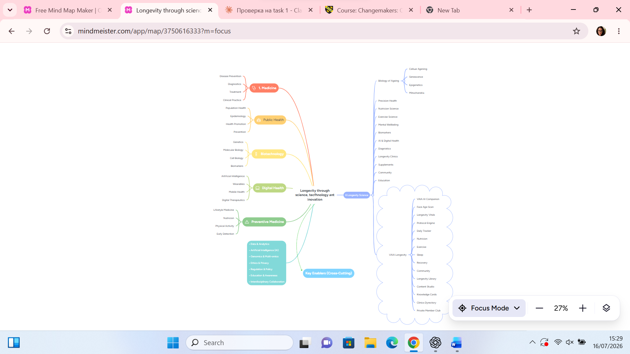
Figure 1. Mind map illustrating the ideation process for the proposed AI-powered longevity platform.

https://mm.tt/map/3750616333?t=s1NfyMPNY3

1.3 Reflection on the Ideation Process

Mind mapping was chosen as the main ideation technique because it helps organise ideas, show the links between concepts and support creative problem-solving. It is widely used in the early stages of innovation, as it makes complex information easier to visualise and explore [5]. In this project, the technique was used to compare several research directions before choosing the final concept.
The brainstorming covered emerging technologies and healthcare themes, including AI, personalised medicine, digital health, wearable devices and healthy ageing. Mapping the connections between these areas revealed an opportunity to combine them into one digital healthcare ecosystem instead of treating each one separately.
AI stood out as the core technology because of its ability to analyse health data and produce personalised recommendations. Personalised medicine and prevention proved just as important: combining AI with individual health data makes it possible to give tailored advice, support lasting behaviour change and promote healthier ageing [4].
After evaluating the generated concepts, VAIA Longevity was selected because it brings AI, digital health and evidence-based prevention together in a single platform, addressing a real societal challenge within the field of Computing.

1.4 Selected Project Idea

Following the ideation process, VAIA Longevity was selected as the proposed project. It is an AI-powered personalised longevity platform that supports preventive healthcare through evidence-based digital interventions, promoting healthy ageing through prevention rather than treatment.
Unlike most digital health applications, which focus on a single aspect of wellbeing such as nutrition or sleep, VAIA Longevity combines health monitoring, wearable data, behavioural science and evidence-based recommendations. This allows the platform to give personalised guidance based on each user's health data, habits and goals. In this way, the project shows how AI can be applied as a practical decision-support solution to a real healthcare problem [2].
The proposal also lays the groundwork for future development, as the findings will guide the design, implementation and evaluation of a working version of the platform [6].

Figure 2. Overview of the proposed VAIA Longevity platform architecture.

Task 2: Aim and Objectives

2.1 Project Aim

The aim of this research is to investigate how an AI-powered personalised longevity platform can support preventive healthcare by providing evidence-based recommendations that promote healthy ageing, lasting behaviour change and stronger user engagement. The study will also examine the ethical, privacy, data protection and user adoption challenges linked to this type of technology.

2.2 Project Objectives

To achieve the research aim, the following SMART objectives have been established:
- To critically examine the role of Artificial Intelligence in personalised preventive healthcare and healthy ageing.
- To investigate AI-powered digital health technologies, including wearable devices and mobile health applications, and evaluate their contribution to personalised healthcare.
- To evaluate how AI-generated recommendations influence user engagement, behaviour change and long-term adherence to healthy lifestyle practices.
- To examine the ethical, privacy and data protection challenges associated with AI-powered healthcare platforms.
- To develop an evidence-based conceptual framework for the future design and evaluation of the VAIA Longevity platform.
These objectives are Specific, as each one targets a clearly defined aspect of AI in preventive healthcare. They are Measurable through the literature review and the questionnaire data, Achievable within the scope of this proposal, Relevant to the Computing programme and the proposed platform, and Time-bound as they will be completed within the timeframe of this study.

2.3 Research Philosophy

Research philosophy describes the assumptions that shape how knowledge is generated and interpreted in a study, and it guides the choice of research design and data collection methods [7]. For this research, Pragmatism was selected because the goal is to investigate a practical solution to a real healthcare problem, rather than to build abstract theory.
The main strength of pragmatism is its flexibility: it allows quantitative and qualitative methods to be combined depending on what the research question needs. In this study, that means joining a structured literature review with primary data from an online questionnaire. This flexibility also makes pragmatism a natural fit for Computing research, which is centred on real-world application, user needs and problem solving.

2.4 Search Tools and Research Databases

A systematic search strategy will be used to find relevant, high-quality and current literature that addresses the research aim and objectives. A structured search helps reduce bias, improves transparency and makes sure the research is built on credible academic evidence (Saunders et al., 2023 [7]). The review will focus on peer-reviewed journal articles, conference proceedings, academic books and publications from recognised organisations in AI, Computing, digital health and preventive healthcare.
The selected databases provide access to authoritative and discipline-specific research:
- UWTSD Library for academic books, journals and subscription databases.
- Google Scholar for highly cited and interdisciplinary research, supported by citation tracking.
- PubMed for biomedical and clinical research on preventive healthcare and healthy ageing.
- IEEE Xplore for Computing, machine learning and intelligent healthcare systems.
- ACM Digital Library for software engineering, human-computer interaction and intelligent systems.
- ScienceDirect for interdisciplinary research linking Computing, healthcare and behavioural science.
To improve accuracy, Boolean operators (AND, OR, NOT), phrase searching and truncation will be applied where the databases support them. Example combinations include "Artificial Intelligence" AND Healthcare, "Personalised Medicine" AND Longevity, and "Wearable Technology" AND Health Monitoring; the full search strategy is shown in Table 1 and Appendix D.
Only peer-reviewed publications in English will be included, with priority given to studies from the last five years. Earlier landmark works will be kept where they provide an important theoretical foundation.

Table 1. Literature Search Strategy

Database | Purpose | Example Search Terms
UWTSD Library | Academic books, journals and subscription databases | "Artificial Intelligence" AND Preventive Healthcare
Google Scholar | Highly cited multidisciplinary research | "Personalised Medicine" AND Longevity
PubMed | Biomedical and clinical research | "Artificial Intelligence" AND Healthy Ageing
IEEE Xplore | Computing, Artificial Intelligence and Engineering | "Machine Learning" AND Healthcare
ACM-Digital Library | Human-computer interaction and intelligent systems | "Artificial Intelligence" AND User Engagement
ScienceDirect | Interdisciplinary Computing and Healthcare research | "Digital Health" AND Behaviour Change

Task 3: Research Methods and Ethics

3.1 Research Methodology

Research methodology provides the framework for investigating the research aim and objectives, guiding the choice of methods, data collection and analysis [7]. As this study looks at both the technology itself and how users perceive AI-powered preventive healthcare, a mixed methods approach has been selected.
Mixed methods research combines quantitative and qualitative evidence, producing both measurable results and a deeper understanding of participants' views [8]. Here, the quantitative part will be an online questionnaire measuring participants' awareness of AI and digital health, and their willingness to use an AI-powered longevity platform. The qualitative part will use open-ended questions to explore opinions, expectations and concerns in more depth.
This choice follows naturally from the pragmatic philosophy adopted earlier, which supports combining whichever methods best fit the problem [7]. Using both types of evidence also allows methodological triangulation, which strengthens the credibility of the findings.

3.2 Data Collection Method

Primary data will be collected through an online questionnaire built in Microsoft Forms. This method was chosen because it allows data to be gathered efficiently from a larger group of participants in a consistent, standardised way. The questionnaire will combine closed questions, which produce quantitative data, with open-ended questions that give qualitative insight into participants' opinions and experiences.
The study will use convenience sampling, inviting adults who use digital technologies or have an interest in health and wellbeing to take part voluntarily. Participants will see an information sheet explaining the purpose of the research before giving informed consent. All responses will be anonymous, and no personally identifiable information will be recorded.
Before the main data collection, the questionnaire will be tested in a pilot study with a small group of participants. Their feedback will be used to improve the wording, structure and clarity of the final version.

3.3 Validity, Reliability and Generalizability

The quality and trustworthiness of research findings depend on three criteria: validity, reliability and generalisability [7].
Validity refers to whether the research measures what it intends to measure. To improve validity, each questionnaire item will be linked to a specific research objective and written in clear, unbiased language. The pilot study will also help identify unclear questions before the main data collection.
Reliability concerns the consistency of the findings if the study were repeated. All participants will complete the same standardised questionnaire in Microsoft Forms, with identical wording and question order, which reduces measurement errors.
Generalisability describes how far the findings can be applied beyond the study sample. Because the research uses convenience sampling and a relatively small number of participants, the results will be exploratory rather than representative of the wider population. Even so, they should offer useful insight into how users view AI-powered preventive healthcare and inform the next stage of the platform's development.

Ethical considerations are essential in any research involving human participants. This study will follow the University's research ethics guidance, the UK General Data Protection Regulation (UK GDPR) and the Data Protection Act 2018 to protect participants' rights, privacy and wellbeing [7] [9].
Participation will be voluntary. Before starting the questionnaire, participants will see an information sheet explaining the purpose of the study, the expected completion time, how the data will be used and their rights. Informed consent will be obtained first, and participants may withdraw at any point before submitting their responses, without giving a reason.
The questionnaire will not collect personally identifiable information, and all responses will stay anonymous. Data will be stored on a password-protected device, accessed only by the researcher and permanently deleted once the study is complete. Questions will focus on opinions about AI, preventive healthcare and digital health, avoiding sensitive personal or medical topics. The participant information sheet and consent section are included in Appendix B.

3.5 Pilot Study

Before the questionnaire is distributed to the full sample, a pilot study will be carried out with 5 to 10 participants who represent the target population. The pilot will test the clarity, relevance and structure of the questionnaire and reveal any issues that could affect data quality [7].
Participants will comment on the wording, the order of the questions, the completion time and any difficulties they experience. Based on this feedback, ambiguous questions will be revised and the overall design improved. The pilot questionnaire and a summary of the feedback received are provided in Appendix B and Appendix C.

3.6 Quantitative Data Analysis

Quantitative data from the questionnaire will be analysed using descriptive statistics to identify patterns and trends in participants' responses. Descriptive statistics suit this study because it is exploratory and based on a small sample, so the goal is to summarise the data clearly rather than test for statistical significance [8].
Responses will be exported from Microsoft Forms to Microsoft Excel, where frequencies, percentages and summary tables will show participants' awareness of AI, attitudes towards preventive healthcare and willingness to use the platform. Results will be presented in tables, bar charts and pie charts, and cross-tabulation will be used where appropriate to compare responses across participant groups [10]. Examples of the planned output formats are provided in Appendix G.

3.7 Qualitative Data Analysis

Qualitative data from the open-ended responses will be analysed using thematic analysis, a widely used method for identifying and interpreting patterns in qualitative data [11]. This approach fits the study because it allows participants' views on AI and preventive healthcare to be explored in more depth than numbers alone can show.
The analysis will follow the six phases described by [11]: responses will be read several times, systematically coded and then grouped into broader themes. Likely themes include trust in AI, privacy concerns, perceived usefulness and barriers to adoption. A structured coding approach will keep the analysis consistent and reduce subjective interpretation.

Conclusion

This proposal has set out a framework for investigating VAIA Longevity, an AI-powered platform designed to support preventive healthcare through evidence-based digital technology. It defined a single research aim and SMART objectives, justified pragmatism as the research philosophy, and described a mixed methods design supported by a clear search strategy, ethical safeguards and appropriate methods of data collection and analysis.
Although exploratory, the study should offer useful insight into how users perceive AI-powered preventive healthcare and which factors influence the adoption of personalised digital health platforms. These findings will directly inform the future design and evaluation of the platform.
More broadly, the project shows how Computing can address real healthcare challenges through user-centred innovation. The next step is to develop and evaluate a working prototype as part of the final year project.

References

[1] | N. England, "The NHS Long Term Plan," NHS England, London, 2019.
[2] | E. Topol, Deep Medicine: How Artificial Intelligence Can Make Healthcare Human Again, New York: Basic Books, 2019.
[3] | W. H. Organization, Ethics and Governance of Artificial Intelligence for Health, Geneva: World Health Organization, 2021.
[4] | W. H. Organization, World Health Statistics 2022: Monitoring Health for the SDGs, Geneva: World Health Organization, 2022.
[5] | T. Buzan, The Mind Map Book, London: BBC Active, 2010.
[6] | V. M. M. G. M. M. G. F. D. Venkatesh, "User acceptance of information technology: Toward a unified view," MIS Quarterly, vol. 27, no. 3, pp. 425-478, 2003.
[7] | P. L. A. T. Mark Saunders, Research Methods for Business Students, Harlow: Pearson, 2023.
[8] | J. D. C. Creswell John W, Research Design: Qualitative, Quantitative and Mixed Methods Approaches, Thousand Oaks: SAGE Publications, 2023.
[9] | E. Commission, "Ethics Guidelines for Trustworthy Artificial Intelligence," European Commission, Brussels, 2019.
[10] | F. D. Davis, "Perceived usefulness, perceived ease of use, and user acceptance of information technology," MIS Quarterly, vol. 13, no. 3, pp. 319-340, 1989.
[11] | V. C. Virginia Braun, Using Thematic Analysis in Psychology, Using Thematic Analysis in Psychology, Qualitative Research in Psychology, vol. 3, 2006, pp. 77-101.

Appendix

Appendix A. Mind Map
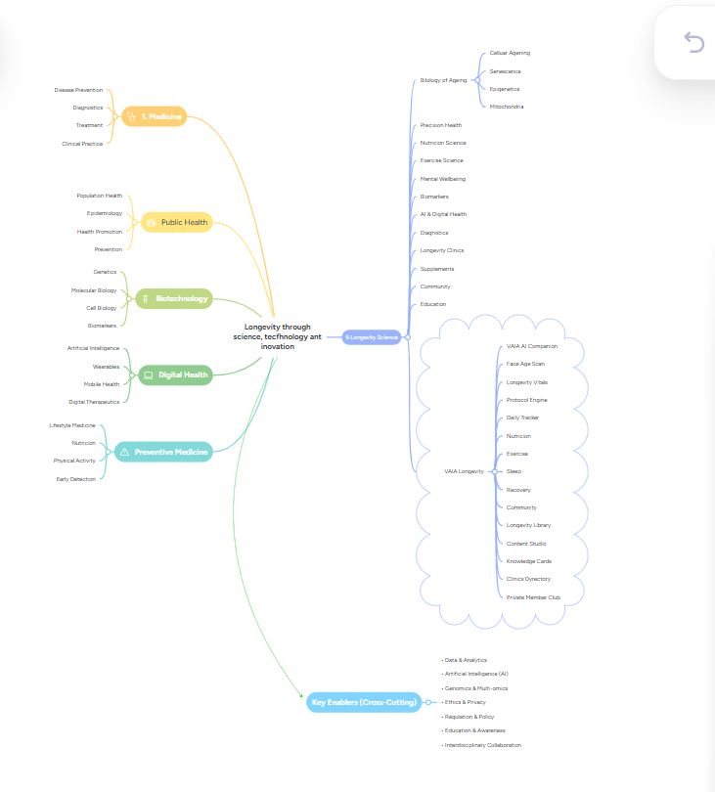

Appendix A. Initial Mind Map used during the ideation process.

Appendix B. Pilot Questionnaire

Participant Information and Consent

This questionnaire is part of a student research project at UWTSD investigating attitudes towards an AI-powered preventive healthcare platform. Completing it takes around 5 minutes. Participation is voluntary, all responses are anonymous, and no personal information that could identify you will be collected. You may stop at any point before submitting your answers. The data will be used only for academic purposes and deleted after the project is completed.
□ I confirm that I have read the information above and agree to take part.

Section 1: Demographic Information

- Age
- 18–24
- 25–34
- 35–44
- 45–54
- 55+
- Gender

- Female
- Male
- Prefer not to say

- Have you previously used a digital health application?
  - Yes
  - No

Section 2: Artificial Intelligence and Digital Health

- How familiar are you with the use of Artificial Intelligence in healthcare?
- Very unfamiliar
- Unfamiliar
- Moderately familiar
- Familiar
- Very familiar

- I would trust health recommendations generated by AI.

- Strongly disagree
- Disagree
- Neutral
- Agree
- Strongly agree

- Which features of an AI-powered longevity platform would you consider most valuable? (Select all that apply.)
- Personalised recommendations
- Face Scan (an AI feature that estimates visual age from a photo)
- Biomarker tracking
- Nutrition guidance
- Exercise tracking
- Sleep monitoring
- Community support
Section 3: Open-Ended Questions

- What concerns would you have about using an AI-powered longevity platform?
- Which features would encourage you to use the platform regularly?
- Do you have any additional comments or suggestions?

Appendix C. Pilot Study Feedback

Participant | Main Feedback | Action Taken
P1 | Some questions were unclear | Wording simplified
P2 | Questionnaire slightly long | Removed repetitive items
P3 | Face Scan needed explanation | Added brief description
P4 | Improve question order | Reorganised sections
P5 | Completion time acceptable | No change required

The pilot’s study demonstrated that the questionnaire was generally clear and relevant. Minor revisions were made to improve clarity, logical flow and readability before the main data collection phase.

Appendix D. Literature Search Examples

Database | Search Query | Results
Google Scholar | "Artificial Intelligence" AND Preventive Healthcare | 18,300
PubMed | "Artificial Intelligence" AND Healthy Ageing | 462
IEEE Xplore | "Machine Learning" AND Healthcare | 2,814
ACM Digital Library | "Artificial Intelligence" AND User Engagement | 1,127
ScienceDirect | "Digital Health" AND Behaviour Change | 3,056

Appendix E. Research Workflow

Figure 3. research workflow for the proposed study

Appendix F. Conceptual Framework

The framework below shows how user data flows through the platform to support behaviour change and healthy ageing.

Figure F1. Conceptual framework of the VAIA Longevity platform.

Appendix G. Sample Output Formats

The table and chart formats below illustrate how the quantitative findings will be presented. The values shown are examples only.
Table G1. Sample presentation of questionnaire results (illustrative data).

Response | Frequency | Percentage
Strongly agree | 6 | 20%
Agree | 12 | 40%
Neutral | 7 | 23%
Disagree | 4 | 13%
Strongly disagree | 1 | 4%

