
HTML & CSS Web Development
Connor Stock - 1801401

May 3, 2019
COMPUTER NETWORKS AND CYBER SECURITY
INTERNET TECHNOLOGY AND SECURITY

Table of Contents:
Contents
Table of Contents: 1
1. Introduction: 1
2. Requirements: 1
3. Implementation: 2
3.1. Screenshots of the Website Pages 2
3.1.1. Home Page: 2
3.1.2. Geography Page: 2
3.1.3. Sport Page: 3
3.1.4. Education Page: 3
3.1.5. Celebrities Page: 4
3.2. Validation: 4
3.2.1. HTML Validation: 5
3.2.2. CSS Validation: 5
4. Evaluation: 5
4.1. Design: 5
4.1.1. Colour/Readability: 5
4.2. Usability: 6
4.2.1. Navigation Bar: 6
4.2.2. Form: 6
4.3. Content: 6
4.3.1. Detail: 6
4.3.2. Readability: 6
5. Appendices: 6

Introduction:
This report will cover the design, coding and documentation for a hand-coded website made using HTML and CSS. This will include a brief description of the website and its purpose, screenshots of all of the website’s pages, validation of the HTML and CSS code, a discussion of the accessibility of the website, and finally an evaluation of the final website. The aim of this report is to show a competent knowledge of HTML and CSS, along with showing the ability to properly document the process.

Requirements:
The website that will be created for this assignment will be about the City and County of Swansea, which is a coastal city in south wales. A website will be created with pages relating to Swansea geography, presence in sport, education and celebrities. The purpose of this website will be to create an example of a functional website that could be used to provide people will information about Swansea. Additionally, the target audience of this website will be people of all ages who want to learn more about Swansea.

Implementation:
For this section of the report, screenshots of all five pages of the author’s website will be shown. Some screenshots may not have the entire contents of the page, as the page is too long, but most of the content will be shown in each screenshot. Along with this, the HTML and CSS code of the website will be validated to check for errors. If any errors do come up during validation, efforts will be made to either fix these errors, or at the very least describe the error

Screenshots of the Website Pages
Firstly, the screenshots of the pages of the completed website will be shown. There are five pages total, respectively titled ‘Home’, ‘Geography’, ‘Sport’, ‘Education’ and ‘Celebrities’

Home Page:
The below screenshot is of the home page of the completed website. This page has some writing explaining the topic of the website, along with an image of Swansea. It also contains the basic header, title, navigation bar and footer which belong to all pages of the website.
This is the screenshot of the home page:
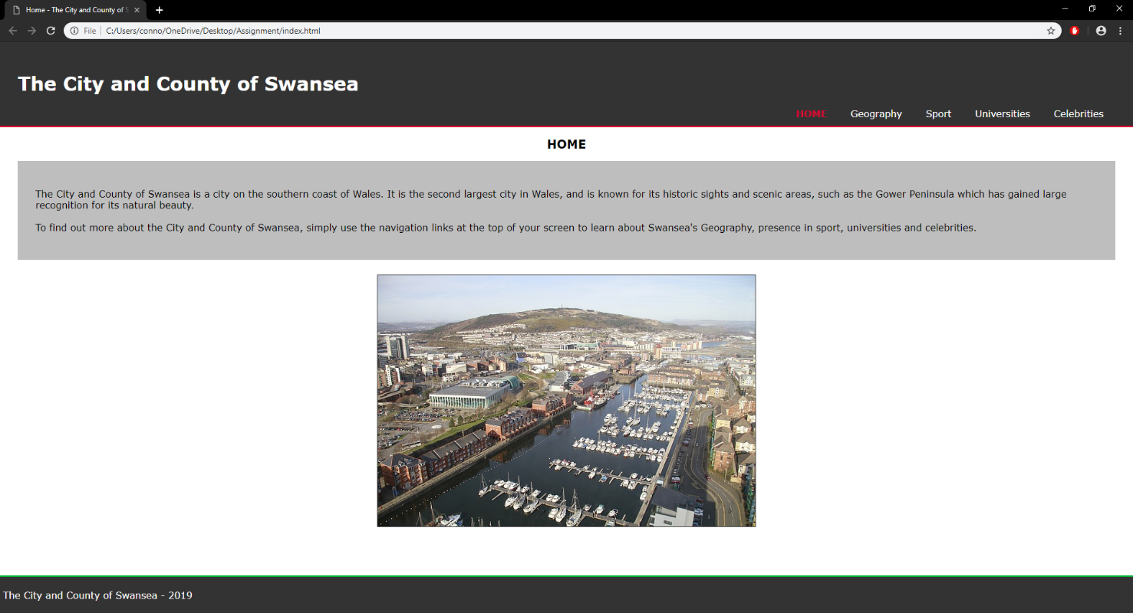

Geography Page:
The below screenshot is of the geography page of the completed website. This page describes some of the most commonly known areas in the City and County of Swansea. It describes the Gower Peninsula, Three Cliffs Bay, Swansea Bay and the Mumbles along with providing images of these areas. Some of the content of this page has not been shown, due to its size.
This is the screenshot of the geography page:
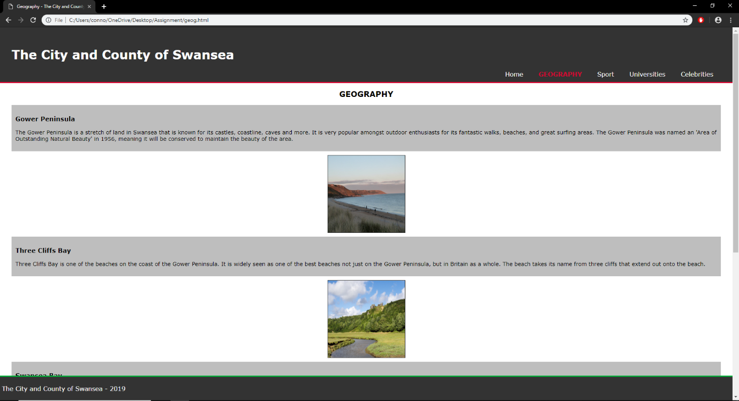

Sport Page:
The below screenshot is of the sport page of the completed website. This page describes some of the largest sports teams and stadiums/grounds in the City and County of Swansea. It describes Swansea City AFC, The Ospreys, The Liberty Stadium and St Helen’s Rugby and Cricket Ground.
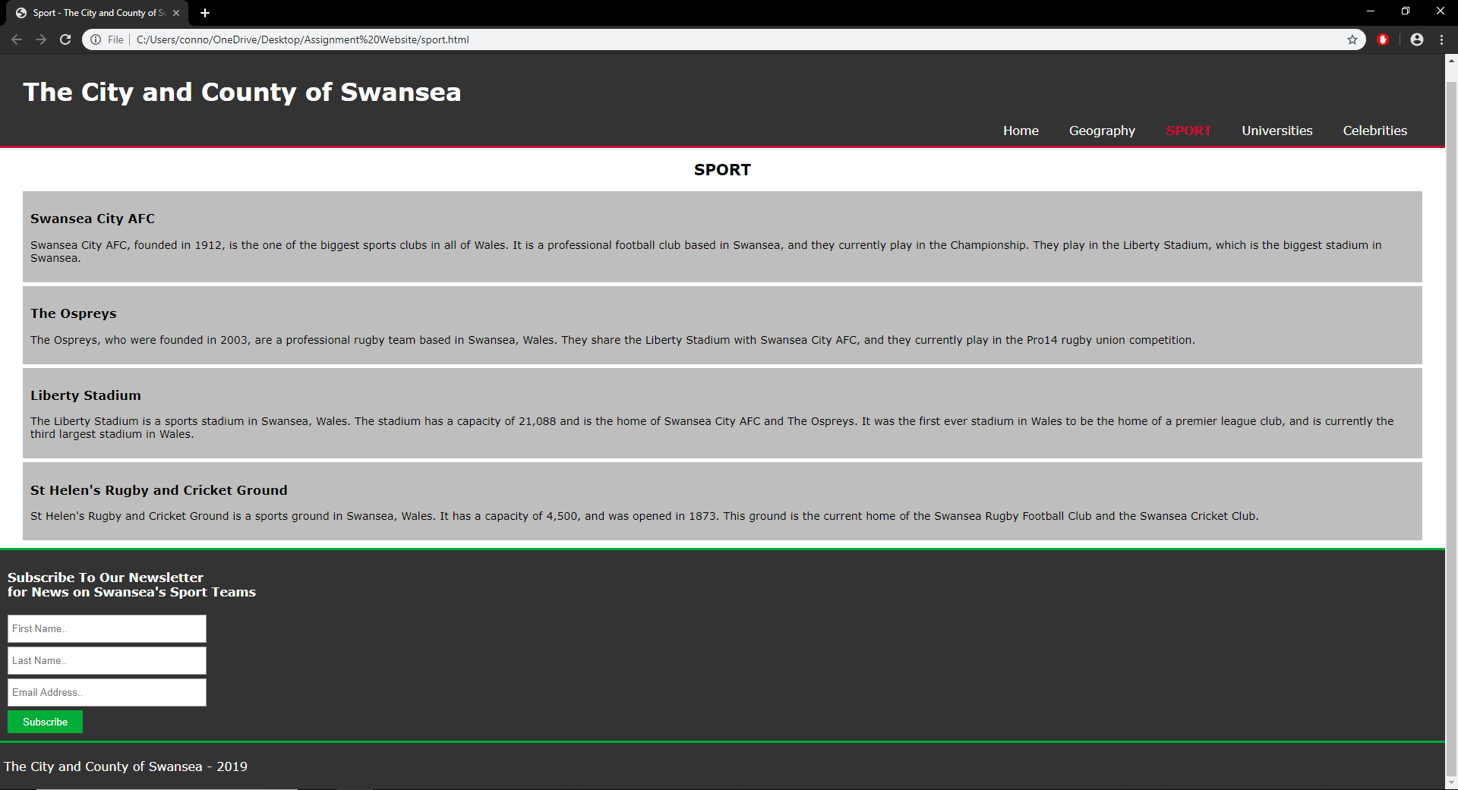
This is the screenshot of the sport page:

Education Page:
The below screenshot is of the education page of the completed website. This page describes some of the main universities and schools in the City and County of Swansea. It describes Swansea University, University of Wales Trinity Saint David, Olchfa School and Bishop Gore School.
This is the screenshot of the education page:
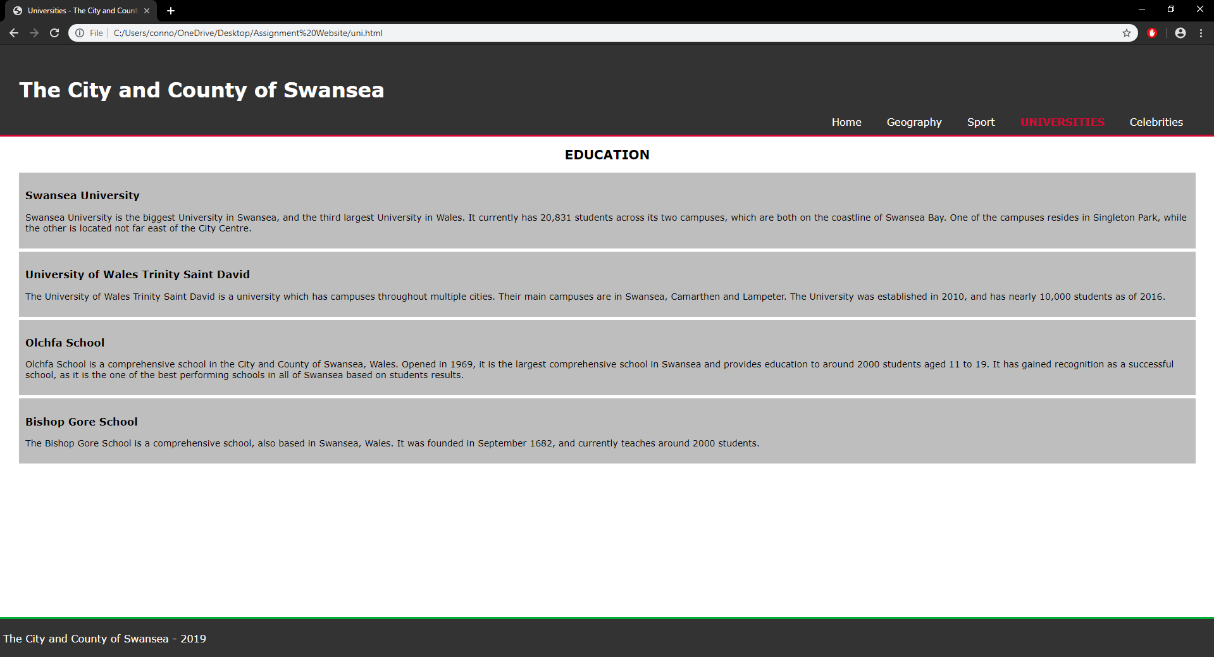

Celebrities Page:
The below screenshot is of the celebrities page of the completed website. This page describes some of the biggest celebrities born in the City and County of Swansea. It talks about Dylan Thomas, Russel T Davies, Catherine Zeta-Jones and Matt Ryan.
This is the screenshot of the celebrities page:
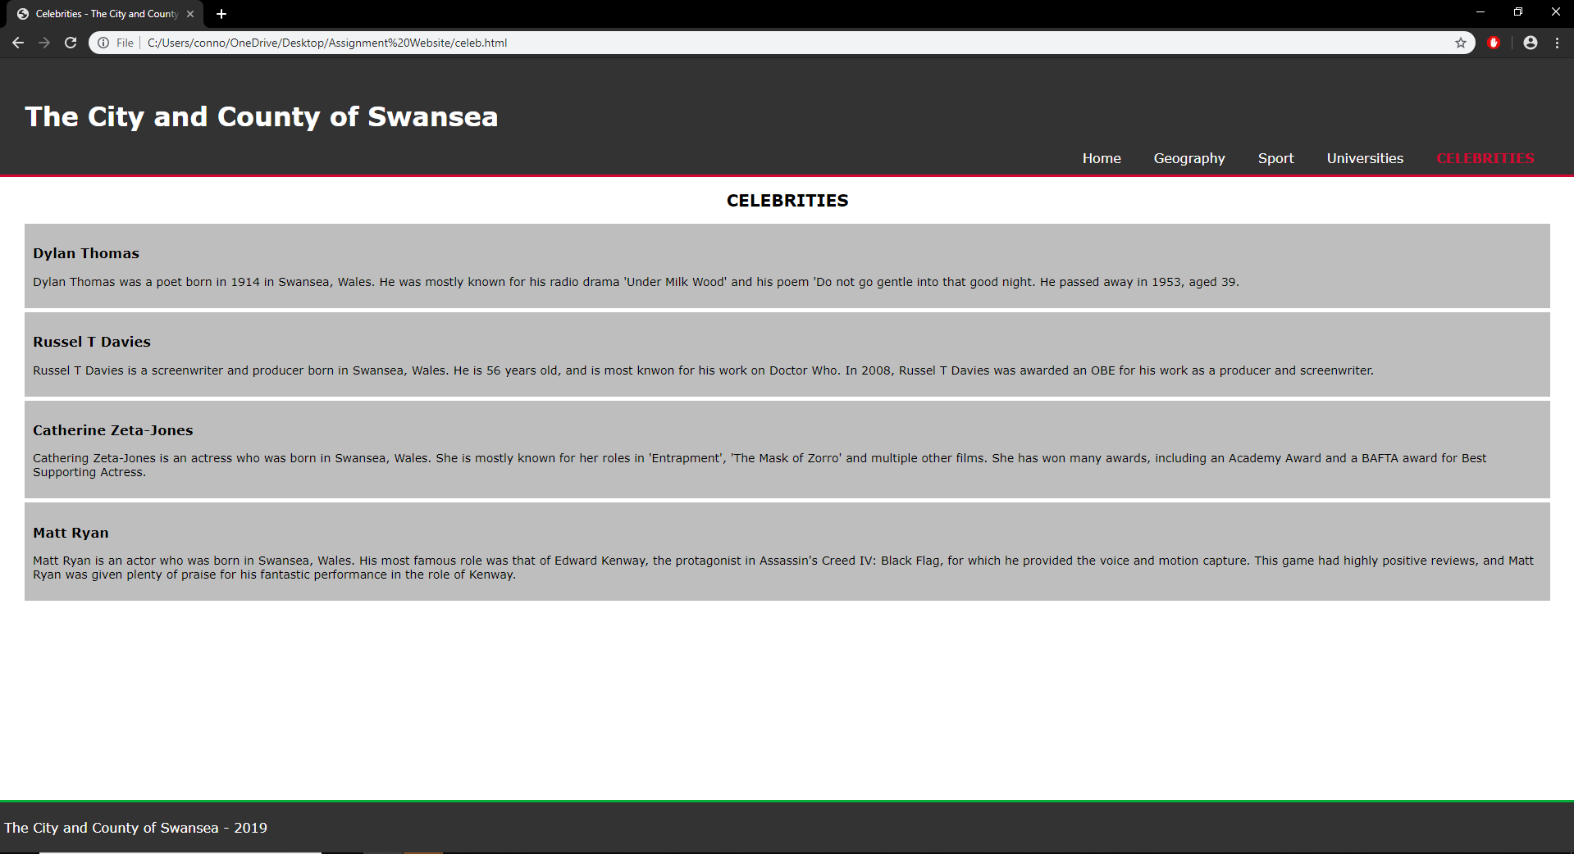

Validation:
Next, the validation results of the HTML and CSS code will be shown. Two websites will be used for this validation, one for the HTML and one for the CSS. For the HTML, the website ‘Markup Validation Service’ [A1] will be used. For the CSS, the website ‘CSS Validation Service’ [A2] will be used.

HTML Validation:
When the HTML code of the home page of the authors completed website was validated, only one warning appeared. The website recommended simply adding a ‘lang’ attribute to the ‘html’ start tag. This is a very simple addition and allows for the language of the document to be set.

CSS Validation:
When the CSS code of the authors completed website was validated, no errors appeared. Due to this, no changes were needed to be made to the website’s CSS.

Evaluation:
This section of the report will focus on evaluating the completed website. This evaluation will go in-depth into the websites design, usability, content and improvements that could be made. This will allow for the strengths and weaknesses of the website to be determined, along with recognising how the website could be improved.

Design:
Firstly, the design of the website will be evaluated. This will include evaluating the websites colour scheme and readability.

Colour/Readability:
In order to evaluate the colours used for the website, the website ‘Contrast Checker’ [A3] will be used. This website allows two colours to be entered, and it will test these colours using the Web Content Accessibility Guidelines (WCAG) to see if they work well together and would be suitable to be used in tandem for websites or any other design purposes.
The main colours used for the authors website were white, black and red for the text, and a mix of white and two shades of grey for the background. Firstly, the dark grey background and white text of the header and footer were tested. This came back as passing all of the tests, meaning the colours match well. Secondly, the black test on the white and light grey backgrounds were tested, and these tests also passed. Lastly, the red text was tested with the dark grey background. These tests all failed, with the website saying the colours did not match.
Overall, this meant most of the text was perfectly readable even if the reader is colour-blind, as long as the font size is reasonable, which it was. However, the red text used for the navigation bar did not match well with the dark grey background of the footer, so changing this would be important for improving the websites design and readability.

Usability:
Secondly, the functionality of the website will be evaluated. This will include evaluating the usability of the navigation bar, the form and the ability to view the website on multiple resolutions.

Navigation Bar:
The navigation bar works mostly as intended. Clicking the link once simply brings you to the desired page and navigating from page to page comes with no issue. However, at a certain point of lowering the resolution, the navigation bar does not present neatly in a line. Half of the navigation bar is cut off as the size of the header does not expand to fit the navigation links. The links can still be clicked, but this should still be fixed to make the functionality and design of the website better on all devices and resolutions.

Form:
The completed website contains one form, which is on the ‘Sport’ page. This form is a very simple fictitious ‘newsletter’ which allows users to enter their first and last name and their email address. When entering an email address, the user is prompted to enter their email using a correct format. However, one letter names and impossible email addresses can still be entered. Also, when clicking the ‘subscribe’ button to submit their details and subscribe for the newsletter, an error simply occurs saying the file was not found. Code could be added for these details to actually go somewhere and for the user to be notified that they have ‘subscribed’. In terms of the readability and functionality of the form on multiple resolutions, the form does appear to be perfectly usable on all resolutions.

Content:
Lastly, the content of the website will be evaluated. This will simply involve determining if the content of the website is detailed enough to explain the point, but also not too overwhelming in detail. Also, the readability of the content will be evaluated.

Detail:
The author believes that the website has a fair amount of detail on most points, but if changes were to be made, more detail could potentially be added. Although the key points for each header are there, more detail could be desired by users reading the website.

Readability:
In terms of the readability of the websites content, the colours used, and the font size are suitable for all types of people, as proven by the testing done earlier in the report. Also, the content does scale with resolution and should be readable on all types of devices.

Appendices:
Appendix List:
A1 - Markup Validation Service (http://validator.w3.org/)
A2 - CSS Validation Service (http://jigsaw.w3.org/css-validator/)
A3 – Contrast Checker (https://contrastchecker.com/)

