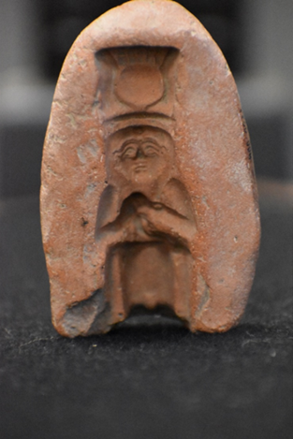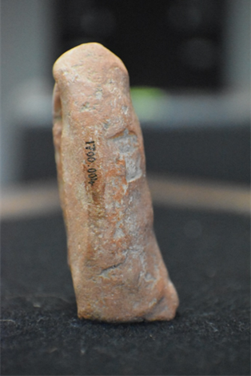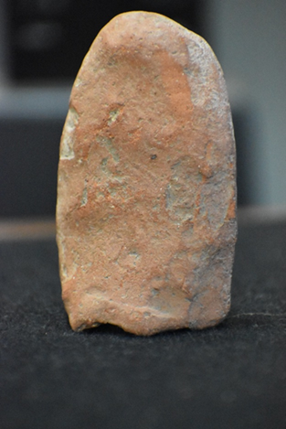
Figure 3: back view of the amulet mould Zinn, K. (2021)

Figure 1: front view of the amulet mould Zinn, K. (2021)
Figure 2: side view of the amulet mould Zinn, K. (2021)

Amulet mould
Object: Mould for an amulet of Isis suckling Horus
Cyfarthfa Castle, Merthyr Tydfil – CCM 1700.004
Object Type: Amulet mould
Material: Nile silt/ clay
Period: Late Period – Ptolemaic period?
Provenance: Egypt, Thebes?
Condition: Good. Some signs of wear and damage to the external surface. The impression surface remains in good condition.
Dimensions:
- Hight: 8 cm
- Width:
• Top: 3.7 cm
• Middle: 4.7 cm
• Bottom: 4.5 cm
- Depth: 1.5 cm
An amulet mould made from clay (Nile silt). This red/brown mould, possibly one half of a pair of moulds, was used to produce a three-dimensional amulet. This would have been worn for individual protection or as a household shrine ornament for the protection of the home.
Other examples of amulet moulds can be seen throughout Egyptian history as well as their usage for the construction of amulets for religious and magical protection – known as ‘heka’ (Andrews, 1994). Its size suggests that this mould would most likely have produced a household shrine or funerary ornament. It is likely that this mould would have been used to produce a faience amulet. As Bart Van Thuyne’s study of the amulet moulds of Amarna makes clear, faience objects were often used for grave ornamentation as a popular replacement for more expensive materials such as silver or gold.
The inverse image impressed into the mould indicates the figure of Isis. The impressed image displays characteristics of another divinity (Hathor). This can be seen in the sun-disk (Isis or Hathor), horns (Hathor) and a Modus (crown) (Isis or Hathor). Hathor is the goddess of joy, cows, and like Isis, motherhood. Figure 4, displaying both divinities in relief illustrates the similarity of their depiction. However, the suckling image is strongly associated with Isis, as the mother of Horus with strong theological connotations. Figure 5, which displays an amulet depiction of Isis holding Horus in faience, illustrates the goddess’s strong association with motherhood. This has been observed in many similar images, amulets and temple carvings often accompanied with inscriptions of her name in hieroglyphic text. The amulets, this mould formed, are most likely from the late period (525 - 332 BCE) to the Ptolemaic period (332 - 30 BCE). Both at this time and during the Ptolemaic period Isis was popular across Egypt and the Mediterranean.
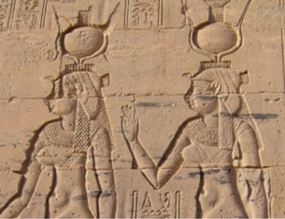
This particular mould depicts Isis wearing a dress or skirt. This is shown by the lack of a clear partitioning between the legs. Her arms are folded and within her hands lays the suckling Horus pressed to her breast. Her face is human with larger ears than would be anatomically correct. This feature suggests the mould was made during the Late Period as this was a preferred sculptural motif of the time. Here, Isis displays eye makeup and on her forehead a serpent-like impression. On the top her head is a sun disk, framed by ox horns seated on a Modus.
Figure 4: Isis and Hathor standing next to each other inscribed on a temple, (Tut, K. 2017)

This inverse image shows no signs of damage or extensive wear. However, there is some indication that there was more detail on the crown and also on the figure of the baby. This could be attributed to wear following repeated use in crafting, which is regularly seen in other examples of amulet moulds from all over Egypt (unsurprising given their role in the mass production of amulet-figures in this period). There is no ornamentation on the external surfaces. There is some evidence of damage on the exterior. This damage includes a chipped small section of the front face and a small number of indentations in the external surface which can be attributed to wear over time and use.
This type of mould would typically be made by placing Nile river silt or clay onto a master impression. This would be left to set, with subsequent finer details added by carving, before a final firing in a kiln which would leave a clear inverse image on inner surface, ready for use (Nicholson, P. 2000). This inverse image would have been used to produce multiple amulets. The back of the amulet would either be hand-carved, or more likely produced from a secondary mould.
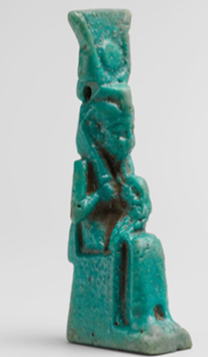
This form of moulding and amulet creation can be seen throughout Egyptian history from the predynastic (4400 BCE) to Ptolemaic periods (332 - 30 BCE). This particular artefact’s main function was as a crafting tool, most likely for the production of Faience amulets. Faience being a combination of crushed quartz and Nile river silt that is glazed and fired, becoming a green/blue colour (Nicholson, 1998). The amulet creation process is described as follows:
‘Damp faience paste was pushed into the moistened mould, and the resulting form, such as a bead or amulet, was removed immediately so it would not stick. The faience was then hardened by baking’ (Brooklyn Museum, 2013).
A similar amulet to that which would have been formed in this mould (see figure 5), has been found in Asasif, Thebes, within the Ptolemaic vaulted graves of Birabi (Hall, 1922). Amulets like this have connections to both the living and in the funerary sphere and can be found within domestic context as well as tombs themselves. The amulet found in Thebes was discovered within the wrappings of a mummy, most likely placed there for the purpose of familial protection in the afterlife. This is exemplified by Stünkel who states ‘amulets worn by the living were generally used for the dead as well, since their benefit also applied to the afterlife. Amulets representing a goddess or god for example, occur in both spheres, as they were meant to invoke the deity’s specific powers.’ (Stünkel, 2019).
Figure 5: Faience amulet of Isis and Horus Zanker, P, (2019)

The presence of amulets within tombs is significant. Their presence is a demonstration of belief in the protection offered through the invocation of an image through heka. This presence of the divine facilitates the journey and the next life as well as provide comfort, the journey is beset by demons and dangers (Isabel Stünkel. 2019). The application of divine images can provide protection against these ‘evils’. This placement of amulets within tombs suggests this may have been a popular aspect of funerary practice as demonstrated by the inundation of amulets within tombs of the era. The amulet mould itself would not typically be found in a tomb but images it would be used to form would be.
Throughout Egyptian history, Isis is portrayed as a protector, life-giver, and sorceress. Invoking her associations make this an especially powerful amulet. As Newberry states:
‘[I]n the funerary realm, Isis was extremely important as she cared for and revived her husband Osiris. She is often described as ‘The Great One of Magic,’ and this amulet was presumably supposed to invoke her protection and versatile powers for the benefit of its wearer’ (Newberry, 1922).
It was believed that protection arose from the invoked images of Isis and Horus. Horus’s theological association with new life, rebirth and protection sits at the heart of Egyptian funerary beliefs. The baby Horus is the son of Osiris who is the god of the afterlife. Isis was the wife of Osiris, who, Ancient Egyptian theology associated with the protection of children and mothers, both in life and the afterlife.
Bibliography
Alvar, J. (2020) ‘Worship of this Egyptian goddess spread from Egypt to England’ Available at: https://www.nationalgeographic.com/history/magazine/2020/03-04/isis-egyptian-goddess-worship-spread-egypt-england/ [Accessed 27/02/2021]
Andrews, C. (1994) ‘Amulets of Ancient Egypt’. Texas: University of Texas Press. pp48-9.
Brooklyn Museum, (2013) ’Mold for Amulet of Seated Goddess Holding Papyrus Sceptre’. Available at: https://www.brooklynmuseum.org/opencollection/objects/4326 [Accessed 25/01/2021]
Isabel Stünkel. (2019) “Ancient Egyptian Amulets.” In Heilbrunn Timeline of Art History. New York: The Metropolitan Museum of Art, 2000–. http://www.metmuseum.org/toah/hd/egam/hd_egam.htm
Newberry, P.E. & Hall, H.R. (1922) ‘Catalogue of an Exhibition of Ancient Egyptian Art’. London: Burlington Fine Arts Club, p67 no. 13.
Nicholson, P. (1998) ‘Materials and technology, in: Gifts of the Nile, Ancient Egyptian fiancé’ Ed. F Dunn Friedman, London pp50-64 [Accessed 21/01/2021]
Nicholson, Paul & Peltenburg, Edgar. (2000). Egyptian Faience. Ancient Egyptian materials and technology. pp177-94.
Stünkel. I (2019) “Ancient Egyptian Amulets.” In Heilbrunn Timeline of Art History. New York: The Metropolitan Museum of Art, 2000, available at: http://www.metmuseum.org/toah/hd/egam/hd_egam.htm accessed [02/02/2021]
Vanthuyne, B. (2012). ‘armarna factories, workshops, Faïence moulds and their produce. Ägypten Und Levante / Egypt and the Levant, 22/23, 395-429. Available from http://www.jstor.org/stable/43552828 [accessed 7/2/2021]
Fig 1 &3: Zinn, K. (2021) ‘Object images of amulet mould’ Available at: https://moodle.uwtsd.ac.uk/course/view.php?id=1663 [Accessed 23/01/2021]
Fig 4: Tut, K. (2017) ‘Isis and Hathor’ Available at: https://famouspharaohs.blogspot.com/2017/07/isis-and-hathor.html [Accessed 27/01/2021]
Fig.5: Zanker, P., Hemingway, S., Lightfoot, C.L., & Mertens, J.R. (2019) ‘Roman Art : A Guide through the Metropolitan Museum of Art's Collection’. pp250–51, fig. 124, New York: Scala Publishers., Faience amulet of Isis and Horus , Available at: https://www.metmuseum.org/art/collection/search/243744> [Accessed 20/01/2021]

