University of Wales Trinity Saint David
School of Engineering

Reflective Project Report
Group Project ACMA5009

Heather Came
2208198
01/03/2024

Abstract

This report presents a reflective analysis of IQE's implementation of hybrid working, a strategy adopted by the semiconductor manufacturer. The COVID-19 pandemic pushed change onto organisations. As people were forced into lockdown, workers had to promptly learn new ways of operating from home, adapting to new daily routines that became increasingly digital. IQE seeing the success of this, along with many other companies, decided to implement a model that meant working both remotely and on site.
IQE identified twenty-five employees, currently working solely remotely or from home, suitable for transitioning to a hybrid work model. The primary objective of this analysis is to evaluate the management of the hybrid working initiative and gauge employee satisfaction, serving as a determinant for potential company-wide adoption. Additionally, it aims to address employee concerns, as several employees had become accustomed to remote work during the pandemic and expressed uncertainty about returning to the office. Conversely, others preferred to continue working on-site, citing a lack of space at home and a desire to maintain their accustomed routines. IQE had not accounted for or foreseen any concerns arising.
The analysis employs management-based methodologies, incorporating a Gantt chart and project plan to depict the project's timeline and time management strategies. It encompasses a thorough review of project planning, execution, and feedback, facilitated by employee surveys among the selected twenty-five employees. Through this reflective analysis, IQE's approach to project management is scrutinised, offering insights into successful strategies for employee engagement and a seamless transition.
The implementation of hybrid working at IQE achieved its primary objective of increasing employee engagement whilst also providing valuable insights into change management within a corporate setting, due to the project managements downfalls. This reflective analysis underscores the pivotal role of motivation and communication in project management, presenting lessons applicable to future endeavours. Despite accomplishing primary objectives, challenges in addressing employee concerns were evident, underscoring the importance of selecting the correct management tools and better understanding the project’s needs.
Limitations include the scope of available feedback. Nonetheless, this report provides a comprehensive exploration of project management practices, offering valuable lessons for organisations who wish to make a transition.

Contents

1 Abstract ii
2 Introduction 1
3 Aims and Expectations 2
4 Methodologies 3
5 Time management 4
6 Hybrid Working 6
6.1 Effect of COVID-19 6
6.2 Advantages and Disadvantages 6
6.3 Survey of results 8
7 Change Management 14
7.1 The importance of change management 14
7.2 Surveys 14
7.3 Strengths and Weaknesses 17
7.4 Change Management Models 20
7.4.1 Lewin’s Change Model 20
7.4.2 McKinsey’s 7-S approach 21
7.4.3 Kotter’s 8-Step Model 23
7.5 Leadership 25
7.6 Motivation 26
8 Improvements 30
8.1 Kotter’s 8-Step Model 30
8.2 Leadership 31
8.3 Motivation Model 31
9 Key Takeaways 34
10 Recommendations 35
11 Conclusion 36
12 References 37
13 Appendix A 46
13.1 Results of the Engagement Survey 2023, (before transition) 46
13.2 Results of the Engagement Survey 2024 (following transition) 51
14 Appendix B 56
14.1 Results of project management survey 56

Figure 1 - Hybrid Working Gantt Chart 4
Figure 2 - Project Plan for transition. 4
Figure 3 - Group Project Gantt Chart 5
Figure 4- Project Plan for group project 5
Figure 5 - Advantages of hybrid work (Wigert and White, 2022) 7
Figure 6 - Challenges of hybrid work (Wigert and White, 2022) 7
Figure 7 - Page 1 of Employee Engagement Survey. 9
Figure 8 - Page 2 of Employee Engagement Ssurvey. 10
Figure 9 - Results of Employee Engagement Survey 2023. 11
Figure 10 - Results of Employee Engagement Survey 2024. 12
Figure 11 - Project Management Survey 15
Figure 12 - Results of Project Management Survey. 16
Figure 13 - Question 3 results of Project Management Survey. 18
Figure 14 - Question 4 results of Project Management Survey. 19
Figure 15 - SWOT analysis of IQE's project management. 19
Figure 16 - The three stages of Lewin's change model (Mulder, 2012) 20
Figure 17 - Example of Lewin's change model (9m Consulting, 2018) 20
Figure 18 - Lewin's change model applied to the transition to hybrid working at IQE. 21
Figure 19 - Structure of Mckinsley's 7S model (Jurevicius, 2023) 22
Figure 20 - Mckinsley's 7S model applied to the transition to hybrid working at IQE. 22
Figure 21 - Structure of Kotter's 8 step model (Main, 2023) 24
Figure 22 - Kotter's 8 step model applied to the transition to hybrid working at IQE (Visual Paradigm, 2024) 24
Figure 23 - Lewin's 3 change styles (Lindberg, 2022) 26
Figure 24 - Comparison of motivation theories (Klepetouna, 2019) 27
Figure 25 - Herzberg's Theory of Motivation (Gorin, 2024) 28
Figure 26 - Maslow's Hierarchy of Needs Framework (Bitesize Learning, 2024) 28
Figure 27 - McCelland's 3 Needs Theory (Management Works, 2022) 29
Figure 28 - Maslow's Hierarchy of Needs Pyramid (Bamford, 2019) 32
Figure 29 - Question 1 results of Engagement Survey 2023. 46
Figure 30 - Question 2 results of Engagement Survey 2023. 46
Figure 31 - Question 3 results of Engagement Survey 2023. 47
Figure 32 - Question 4 results of Engagement Survey 2023. 47
Figure 33 - Question 5 results of Engagement Survey 2023. 48
Figure 34 - Question 6 results of Engagement Survey 2023. 48
Figure 35 - Question 7 results of Engagement Survey 2023. 49
Figure 36 - Question 8 results of Engagement Survey 2023. 49
Figure 37 - Question 9 results of Engagement Survey 2023. 50
Figure 38 - Question 10 results of Engagement Survey 2023. 50
Figure 39 - Question 1 results of Engagement Survey 2024. 51
Figure 40 - Question 2 results of Engagement Survey 2024. 51
Figure 41 - Question 3 results of Engagement Survey 2024. 52
Figure 42 - Question 4 results of Engagement Survey 2024. 52
Figure 43 - Question 5 results of Engagement Survey 2024. 53
Figure 44 - Question 6 results of Engagement Survey 2024. 53
Figure 45 - Question 7 results of Engagement Survey 2024. 54
Figure 46 - Question 8 results of Engagement Survey 2024. 54
Figure 47 - Question 9 results of Engagement Survey 2024. 55
Figure 48 - Question 10 results of Engagement Survey 2024. 55
Figure 49 - Question 1 results of project management survey. 56
Figure 50 - Question 2 results of project management survey. 56
Figure 51 - Question 5 results of project management survey. 57
Figure 52 - Question 6 results of project management survey. 57
Figure 53 - Question 7 results of project management survey. 58

Table 1 - Comparison of change models 30

Introduction

In response to the evolving workplace dynamics and the long-term impacts of the COVID-19 pandemic, many organisations have shifted towards hybrid working models (McKinsey Global Institute, 2023). IQE, a leading semiconductor manufacturer established 1988 in Cardiff (IQE, n.d.), initiated a project involving twenty-five employees selected for their suitability for hybrid working. The goal was to evaluate the impact of this transition on job satisfaction before implementing it across the entire company.
This reflective analysis delves into the project's management, examining strategies employed and outcomes achieved. It provides a comprehensive case study of IQE's approach, offering valuable insights into effective project management practices that lead to employee engagement and therefore a smooth transition.
Through this examination, IQE aims to gain insights into improving their project management skills by identifying effective tools and strategies, ensuring future transitions are seamless and well-received by employees. Additionally, IQE seeks to determine if the transition to hybrid working is suitable for the company, as a whole.

Aims and Expectations

The aim of this project was to find evidence to support that hybrid working would increase employees job satisfaction and make IQE a more desirable employer to outside talent. It was hoped the transition to hybrid working would improve employees’ wellbeing by permitting a balanced work-life schedule, therefore reducing stress and helping the company operate more efficiently as a result. Given the numerous benefits associated with hybrid working in organisations, IQE’s project is expected to provide evidence of these outcomes.
The report intends to offer a comprehensive overview of the hybrid working model’s inception, implementation, and impact on employee engagement within IQE. Through this reflective analysis, the report seeks to identify key strengths and weaknesses of the project’s management, highlighting areas for improvement and identifying aspects that were overlooked. It also aims to demonstrate the author’s ability to manage time effectively by creating and adhering to a realistic project plan.
It is also expected to capture valuable lessons that can be applied to future projects within IQE, by utilising management tools. By examining employee feedback, the report aspires to contribute to the broader understanding of transitions, supporting IQE's continuous improvement and innovation in workplace management practices. To summarise, the report’s objective is to offer insights, and recommendations based on reflective analysis, enriching the understanding of project management practices. This includes analysing the objectives, challenges, and outcomes of the transition.

Methodologies

To achieve these aims, the report will employ several methodological approaches. First, a thorough literature review will be conducted to contextualise the inception of organisational transitions, drawing on existing research and applicable management practices. This review will provide a foundational understanding of the theoretical and practical aspects of such transitions.
Second, employee responses to surveys will be collected to capture qualitative insights into the impact on employee development. These responses will be analysed and presented in graphical form to facilitate easy assessment and comparison.
Third, the report will include a reflective component, where aspects such as time management skills will be evaluated through a review of the project plan and its execution. This reflection will offer insights into the effectiveness of the project management strategies employed.
Finally, the report will compare the management strategies used by IQE with alternative methods. This comparative analysis will explore the implementation of different management strategies to determine which best achieves the desired outcomes. By examining various approaches, the report aims to identify the most effective methods for organisational transition and employee development.

Time management

Effective time management is crucial for project management, as it helps set realistic expectations for the pace of change and ensures deadlines are adhered to (Monday Blog, 2022).

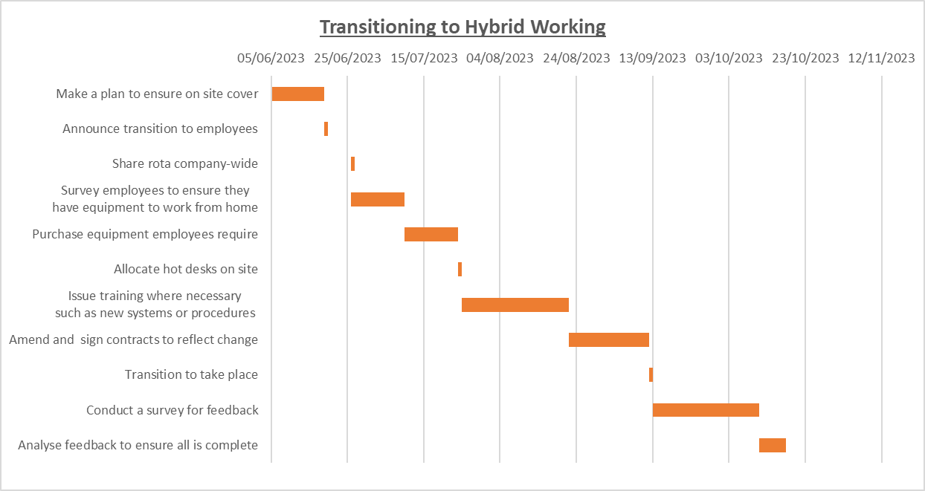
Figure 1 - Hybrid Working Gantt Chart

The Gantt chart displayed in Figure 1, was created by the team managing the transition to hybrid working. The dates shown were met. However, they decided to postpone the feedback survey until January 2024, to ensure employees had settled into their new way of working and therefore could accurately review their new structure.

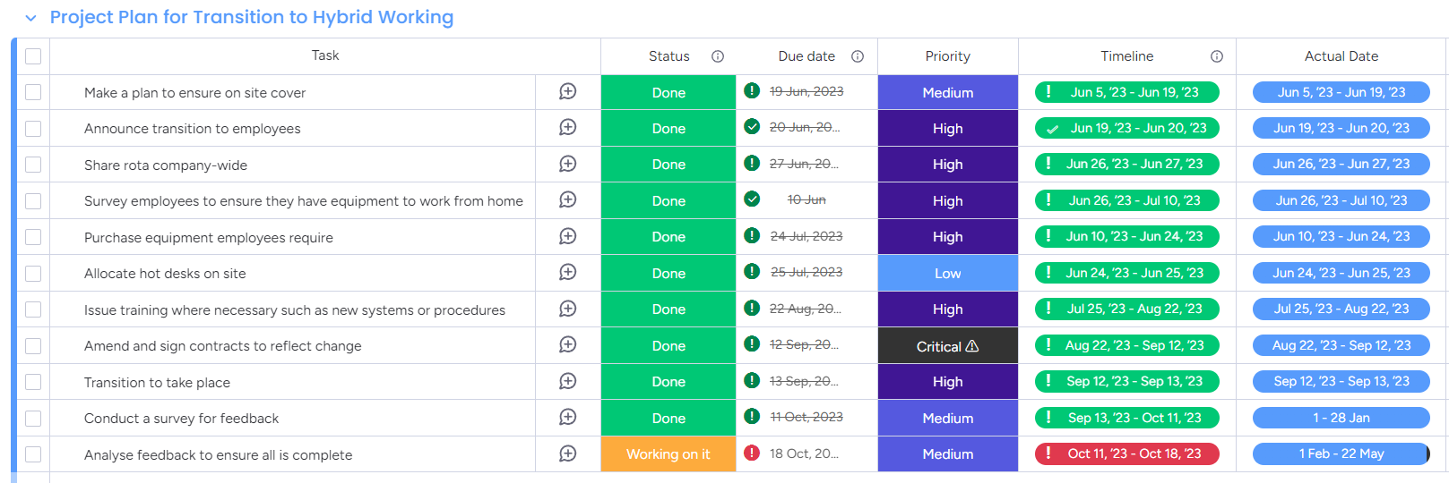
Figure 2 - Project Plan for transition.
Similarly, a Gantt chart was developed for the report to ensure steady, continuous progress and adherence to the final deadline. The chart's creation immediately demonstrated the feasibility of completing the report within the proposed timeframe.

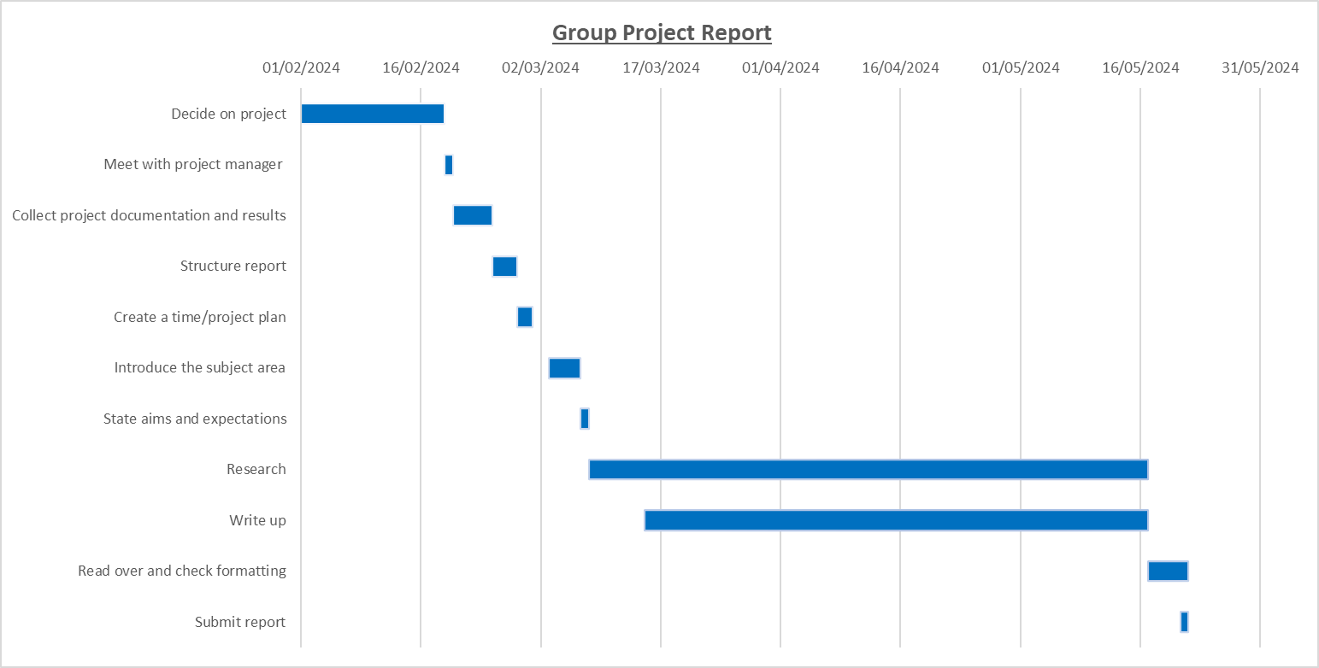
Figure 3 - Group Project Gantt Chart

A project plan was also created to facilitate progress tracking. This plan was essential for effective time management, providing clear visibility into remaining tasks and maintaining motivation to advance to the next stage.

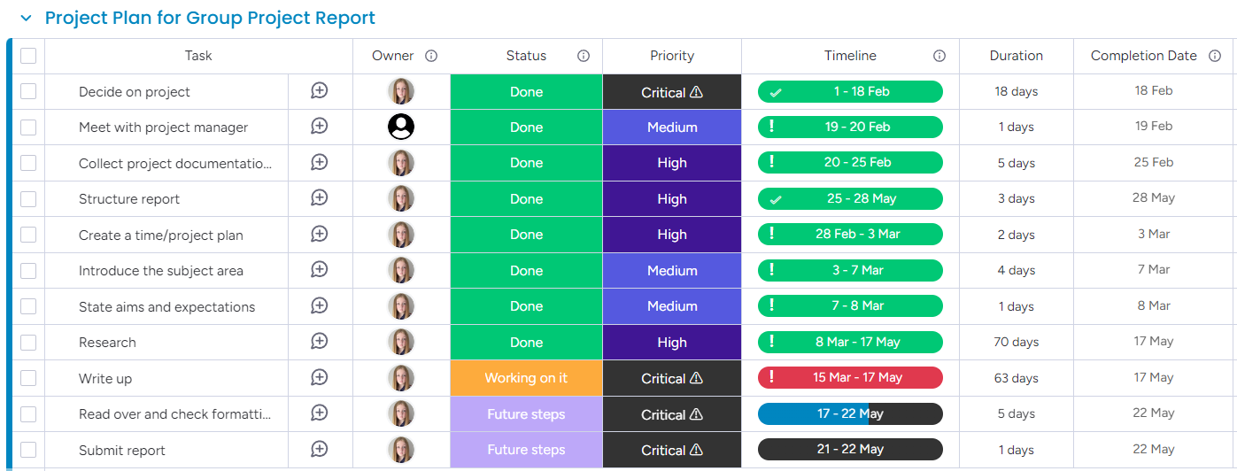
Figure 4- Project Plan for group project

Hybrid Working

Effect of COVID-19

According to UK statistics, employees between the ages of 16-34 working in a hybrid pattern, more than doubled during the pandemic (Ginger Recruitment, 2024). Prior to the pandemic, remote and hybrid working had been gradually on the rise. Between January and December 2019, about 12% of the UK workforce worked at least one day from home in the previous week, and around 5% primarily worked from home (Mutebi and Hobbs, 2022).
This trend escalated significantly during the pandemic, peaking in June 2020 when approximately 49% of workers worked at least one day from home, with 38% reporting to work exclusively from home. As pandemic restrictions lifted, these numbers gradually decreased but remained higher than pre-pandemic levels. By September 2022, about 22% of the GB workforce had worked at least one day from home in the previous week, and around 13% worked exclusively from home (Mutebi and Hobbs, 2022).
Before the COVID-19 pandemic, individuals who primarily worked remotely were less likely to be promoted and had fewer training opportunities (Morgan, 2021). Limited data exists on whether this trend persisted throughout the pandemic, and it may shift if a larger proportion of people continue working from home more frequently. Research from before and during the lockdowns indicates a biased attitude towards remote workers, though there is evidence that the COVID-19 lockdowns have mitigated this stigma (Nicks et al., 2021).

Advantages and Disadvantages

Research shows that organisations recognise both advantages and disadvantages to flexible working arrangements. Benefits of remote and hybrid working for organisations include increased staff wellbeing, reduced overhead costs, productivity gains, lower sickness absence rates, and more efficient labour allocation ultimately boosting productivity and retention rates while decreasing absences (Chowaniec, 2023). Additionally, it reduces facility costs and creates more workspace as some employees work from home. A hybrid model also attracts a wider range of talent by promoting inclusivity for individuals such as those with disabilities and by reducing geographical constraints (Tsipursky, 2023). One study found that 71% of respondents consider flexible working patterns important, and 53% of employees view flexible and remote working as an asset when job searching (CIPD, 2023). Furthermore, the flexibility offered by hybrid working models improves resilience against unforeseen disruptions, such as public health emergencies, ensuring business continuity without compromising productivity (Aleem et al., 2023).

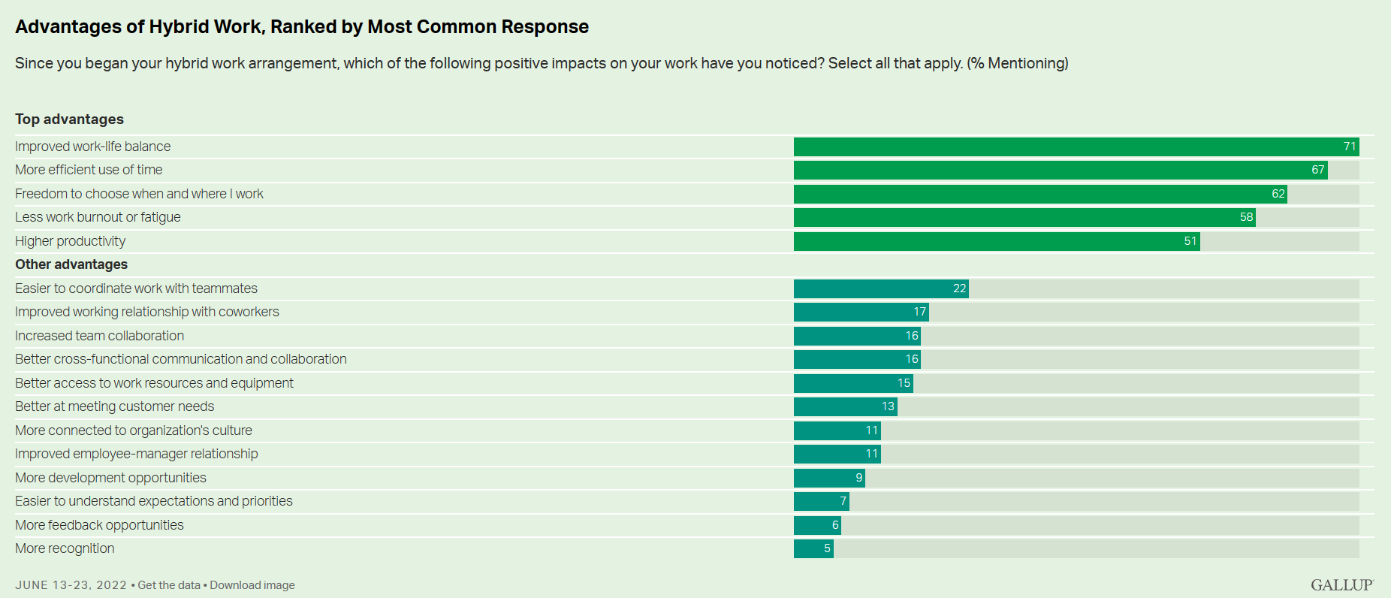
Figure 5 - Advantages of hybrid work (Wigert and White, 2022)

Employees transitioning to hybrid working report numerous benefits. These include a better work-life balance, decreased commuting costs, and saved time. Employees feel more motivated and engaged as remote work provides a conducive environment for focused tasks, minimising workplace distractions and interruptions. Hybrid working fosters a culture of trust and autonomy, where employees are empowered to manage their own schedules and workload effectively (CIPD, 2023). However, hybrid work can present several significant challenges, including increased work intensity, longer working hours, distractions, decreased social interactions, diminished mental wellbeing, fewer learning opportunities, and an inability to disconnect from work (Xiao et al., 2021).

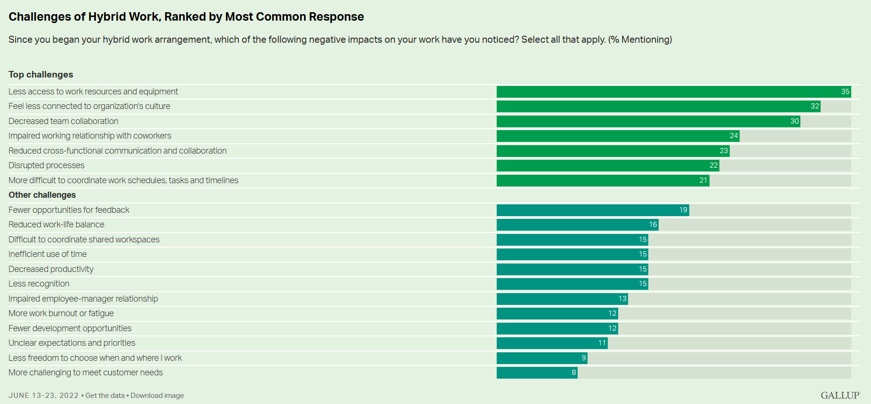
Figure 6 - Challenges of hybrid work (Wigert and White, 2022)
Organisations can face challenges such as resource coordination: home offices must be fully functional to maximise productivity, while on-site offices and conference rooms need to support remote collaboration to ensure inclusivity. Maintaining organisational culture is difficult in a fully remote setting, as teamwork and relationships are tested (Wigert and White, 2022). Despite these challenges, the advantages of hybrid working significantly outweigh the drawbacks, indicating its benefits are more substantial than the issues it presents.

Survey of results

To analyse the impact of hybrid working on employees, IQE developed an Engagement Survey. This survey was administered to the twenty-five selected employees twice: once before the transition and once after, allowing time for employees to adjust to their new working routines. The survey questions focused on employees' attitudes towards their jobs.

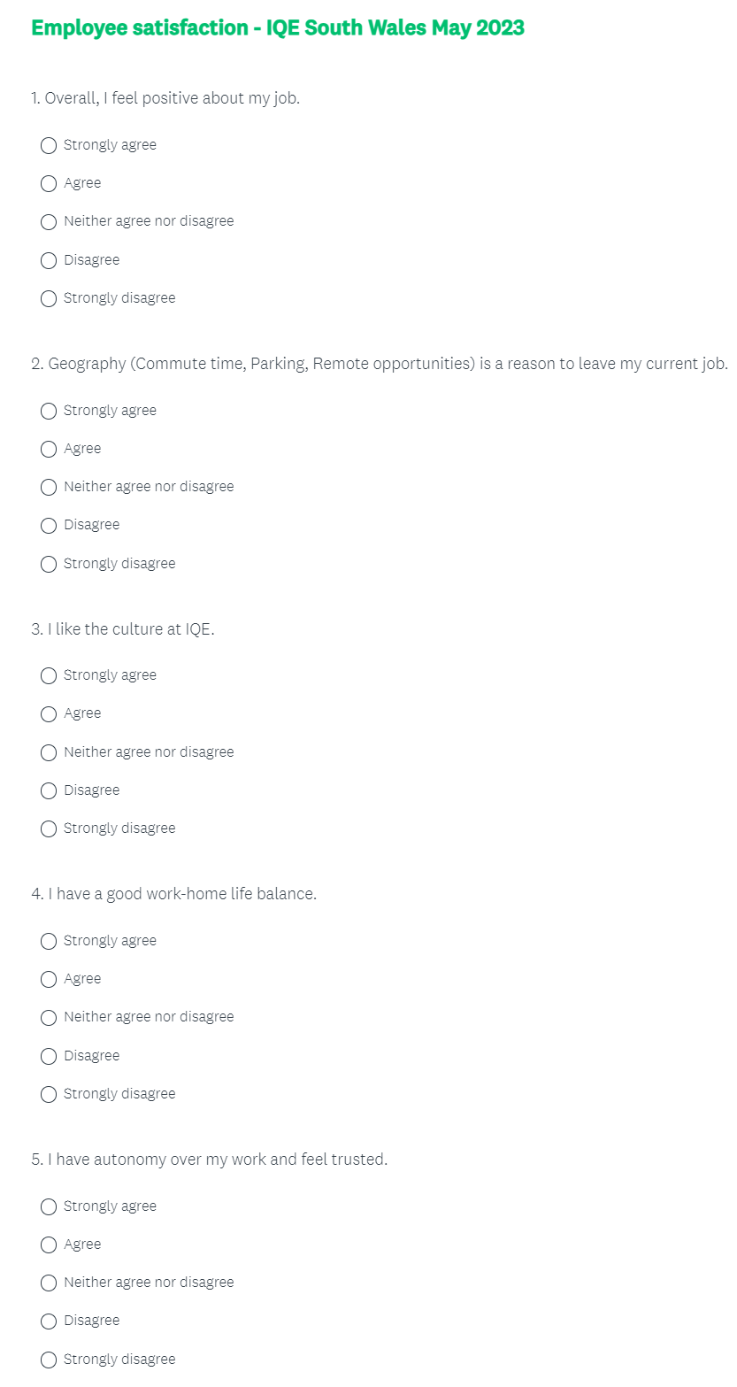
Figure 7 - Page 1 of Employee Engagement Survey.
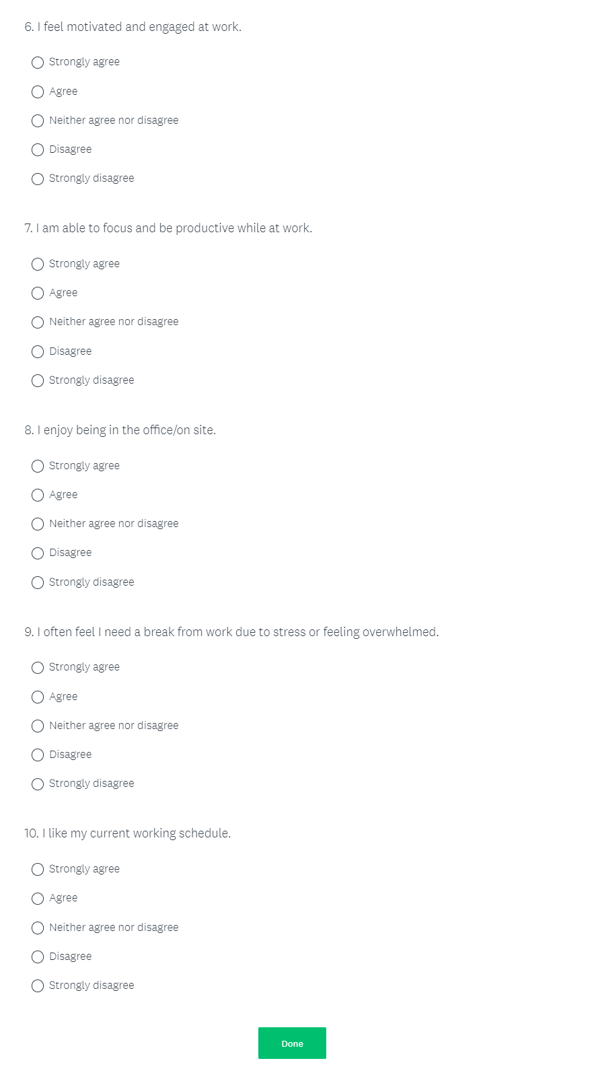
Figure 8 - Page 2 of Employee Engagement Ssurvey.
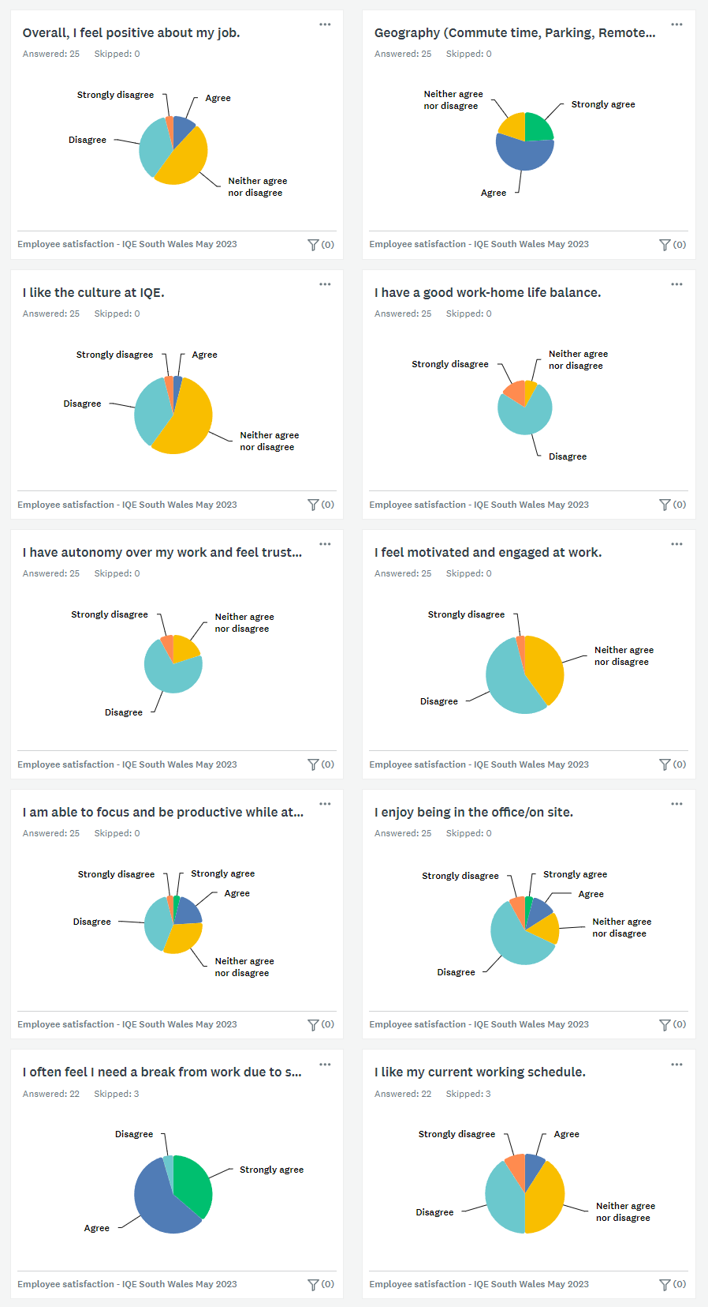
Figure 9 - Results of Employee Engagement Survey 2023.
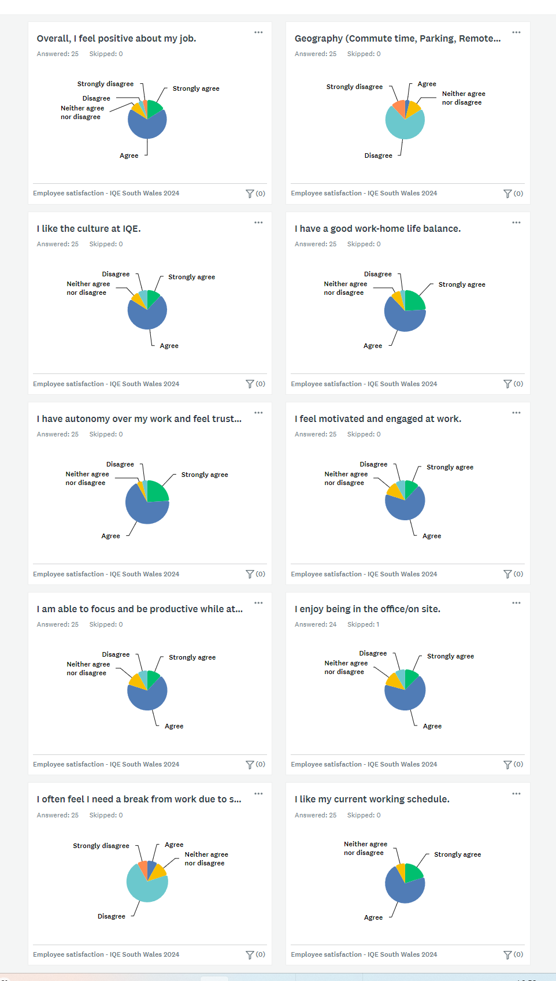
Figure 10 - Results of Employee Engagement Survey 2024.
When surveyed in 2023, the vast majority of respondents felt negatively or indifferent about their job, with only three out of twenty-five expressing positive sentiments. However, in the 2024 survey following the organisational transition, twenty-one out of twenty-five respondents reported feeling positively about their job. These results clearly demonstrate a significant improvement in employee attitudes and job satisfaction. Every response, when compared pre and post-transition, indicates that employees strongly prefer the new working structure. See Appendix A for more detailed results.

Change Management

The importance of change management

Previously, business success was determined by stability and a permanent working structure. However, significant strides in understanding the link between mental health and employees' needs and desires have highlighted the necessity for organisational changes, such as adopting hybrid working models, to ensure a happy and motivated workforce (Dawson, 2023). This flexibility allows the company to meet evolving employee needs, foster a more dynamic work environment, and maintain elevated levels of job satisfaction. Embracing hybrid working enables IQE to stay competitive in the semiconductor industry by attracting and retaining top talent, which is crucial for innovation and sustained success (Mezzacappa, 2023). To remain competitive, IQE must swiftly integrate innovative methodologies and flexible working arrangements to meet evolving market needs, foster innovation to outpace rivals, comply with changing regulations, and mitigate supply chain risks (IQE, n.d.).
Companies restructure to increase efficiency, retain staff, keep up productivity, stay competitive and accommodate growth (Twin, 2023). During critical events like the Covid-19 pandemic, it becomes imperative for organisations to establish an effective framework to navigate change seamlessly. It is crucial for them to comprehend the key aspects of change, including leadership and employee motivation, to adapt swiftly and ensure resilience. (Santoso, Sulistyaningtyas and Pratama, 2022).
Reports indicate that 70% of change initiatives end in failure, often because those impacted resist change due to their comfortability with existing routines and fear of the unknown (Bodell, 2022). This underscores the critical importance of effective change management for successful transitions. Managing change requires a strategic approach to garner support, addressing concerns, and articulating a compelling vision. Beyond facilitating acceptance of change, adept change management cultivates a culture of trust and appreciation within the organisation when executed effectively (Duck, 1993). Furthermore, research indicates that proficient change management can spur innovation within an organisation (Kumarasinghe, 2021).

Surveys

Throughout the transition to hybrid working, IQE faced resistance and pushback from employees, particularly regarding the adoption of new systems and practices. Consequently, IQE conducted a post-transition survey to evaluate whether the lack of acceptance was linked to a deficiency in understanding or motivation, and to identify whether it could have been mitigated with other or additional change management strategies. See Appendix B for detailed results.

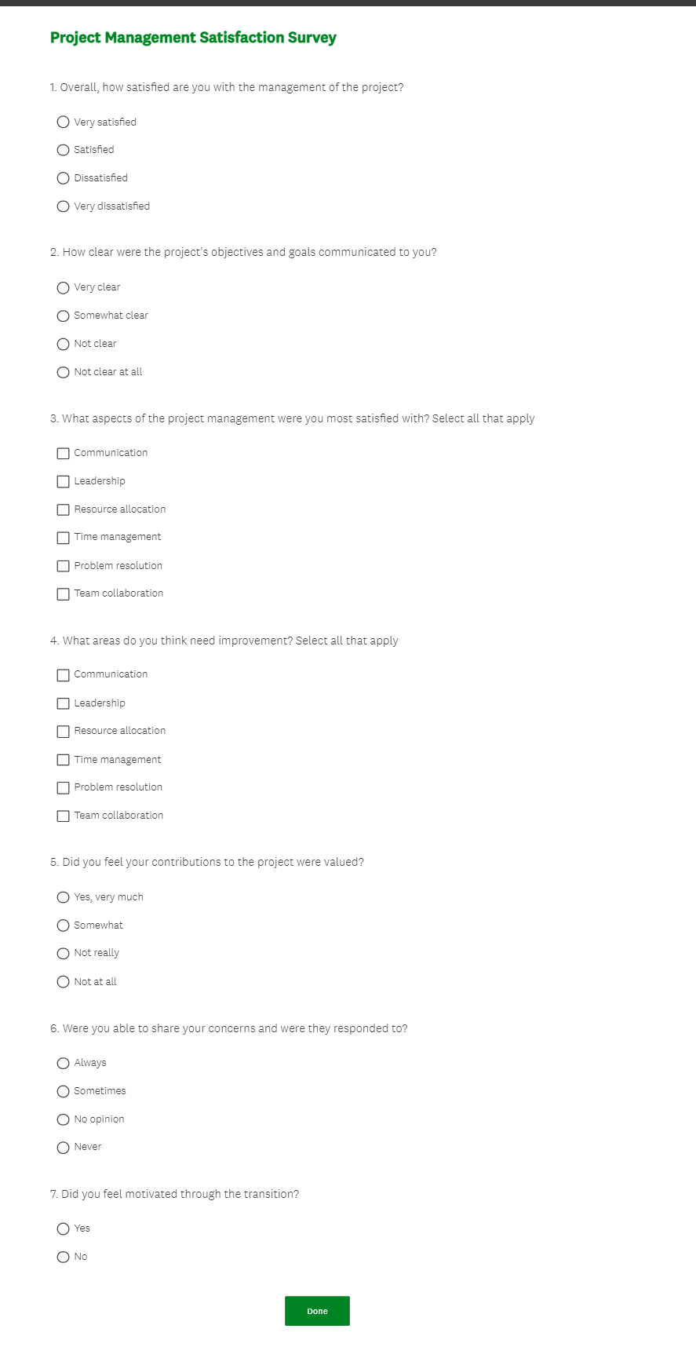
Figure 11 - Project Management Survey
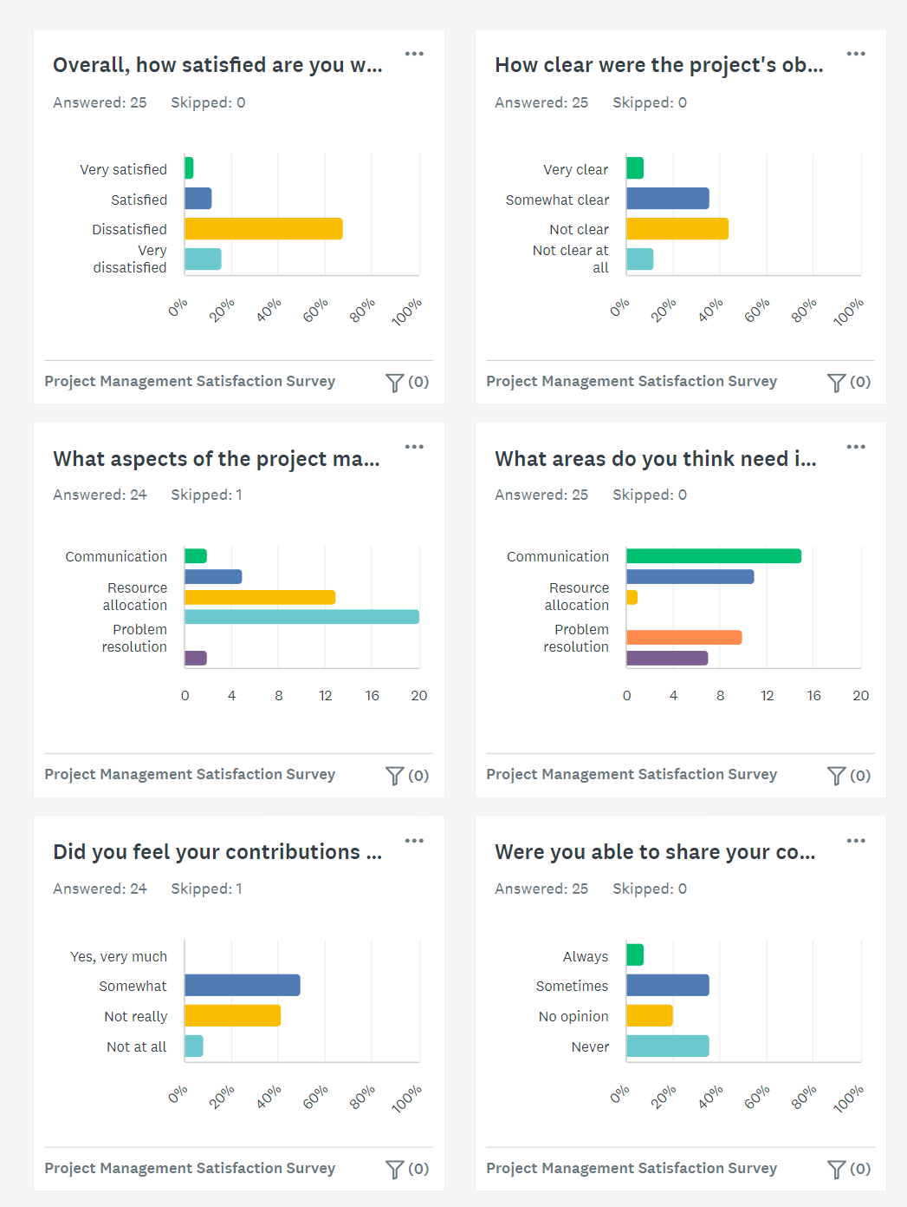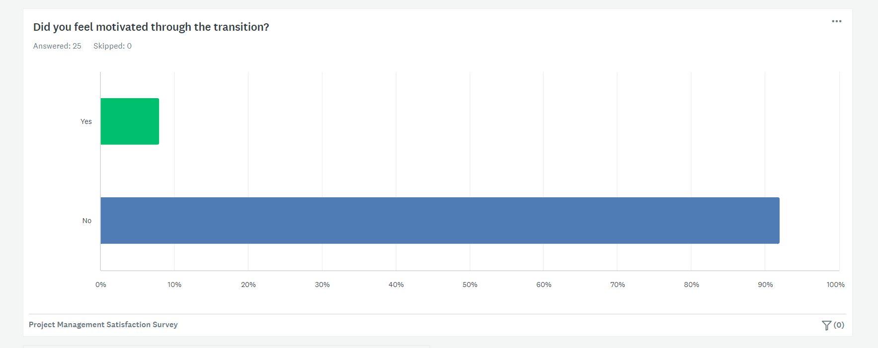
Figure 12 - Results of Project Management Survey.
The Project Management Survey revealed significant dissatisfaction among participants, with 84% answering they were dissatisfied or very dissatisfied with the management. Communication of project objectives was largely unclear, as 56% found them not clear or not clear at all. Time management received the most satisfaction (83.33%), while other aspects like problem resolution and team collaboration were less favoured. Major areas needing improvement included communication (60%) and leadership (44%). Despite some feeling their contributions were somewhat valued (50%), a considerable portion (41.67%) felt undervalued. Sharing concerns was problematic, with only 8% always feeling heard. Motivation was notably low, with 92% not feeling motivated through the transition. Overall, the survey highlighted critical areas for improvement in communication, leadership, and team collaboration to enhance project satisfaction and engagement.

Strengths and Weaknesses

Reflecting upon the results, respondents were satisfied with the time management of the project. This is likely due to IQE’s preparation using a Gantt chart, as shown in Figure 1. When creating the chart, IQE allowed ample time for tasks such as 28 days for the training stage. This ensured tasks were not rushed and employees were able to adapt slowly. This displays effectiveness organisation and planning skills.
Furthermore, over half of respondents believed that resource allocation was adequate. In the context of this project, resource allocation was most applicable to ensuring employees had adequate equipment needed to work remotely and on-site. During the pandemic, these issues were addressed but in a hurried manner with IQE focused on ensuring employees had what they needed and no more. As displayed in Figure 1, IQE determined what employees were lacking and allocated equipment in the following two weeks. Furthermore, they allocated hot desks to hybrid working employees. This shows proactiveness and awareness from management.

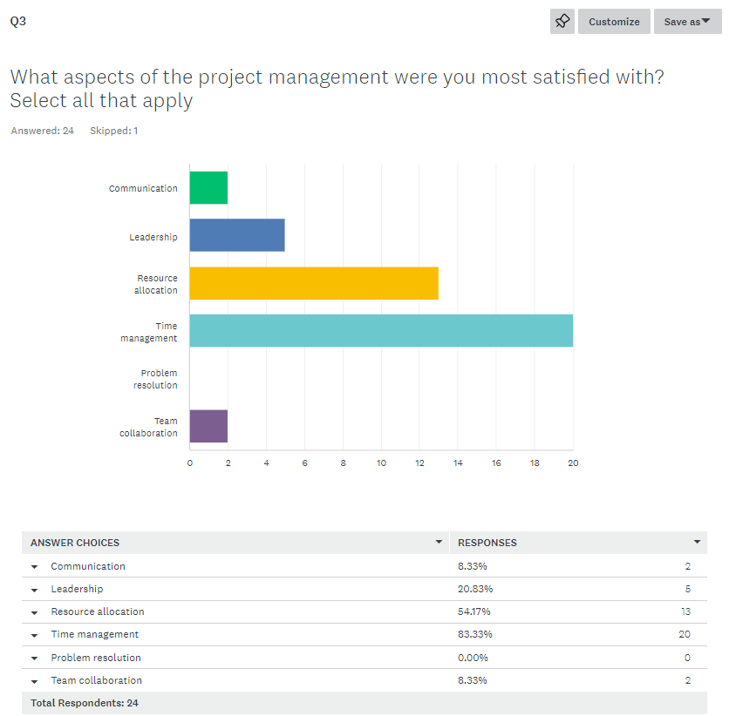
Figure 13 - Question 3 results of Project Management Survey.

Overall, employees negatively perceived the project’s management. Significant weaknesses were highlighted in communication, understanding and lack of appreciation. Specifically, 80% of employees did not understand the vision, which highlights a lack of communication and successful engagement crucial for motivation and acceptance of change. Moreover, 36% of employees felt they could sometimes share their concerns and receive consideration, while another 36% felt they could not raise concerns or these were disregarded when they did. This evidences a lack of approachability and consideration. Additionally, no respondents answered yes to feeling valued, indicating IQE failed to praise employees or show appreciation. The survey indicates they failed to listen, address concerns and share information throughout this transition. All these issues are symptomatic of insufficient communication and feedback channels, resulting in low morale which can result in decreased productivity.
The findings of Question 4, seen in Figure 14, indicates that employees felt there was ineffective leadership, problem resolution, and team collaboration. These results evidence a lack of strategy and a failure to predict problems/resistance and adequately prepare leaders. IQE did not implement a purposeful leadership style to engage the workforce and bring them together as a team, negatively impacting employee motivation throughout the change also reflected in the answers provided for Question 7, shown in Figure 12, which revealed a lack of motivation among employees throughout the transition with 92% of respondents answering they did not feel motivated.

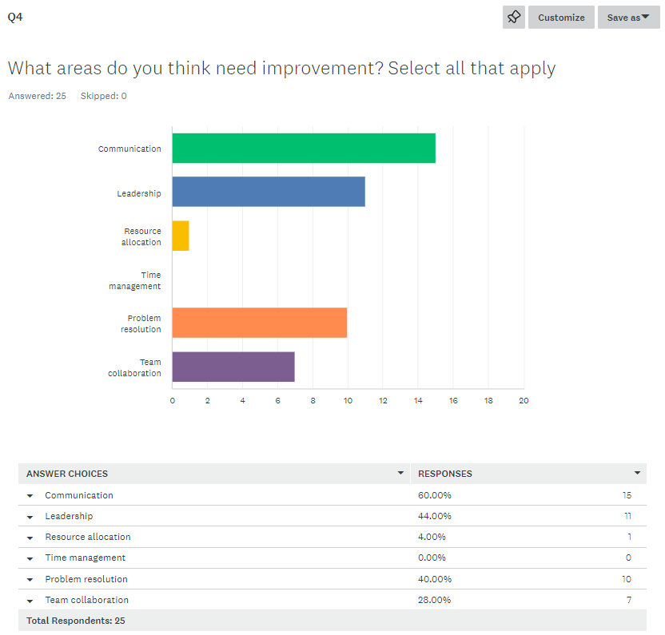
Figure 14 - Question 4 results of Project Management Survey.

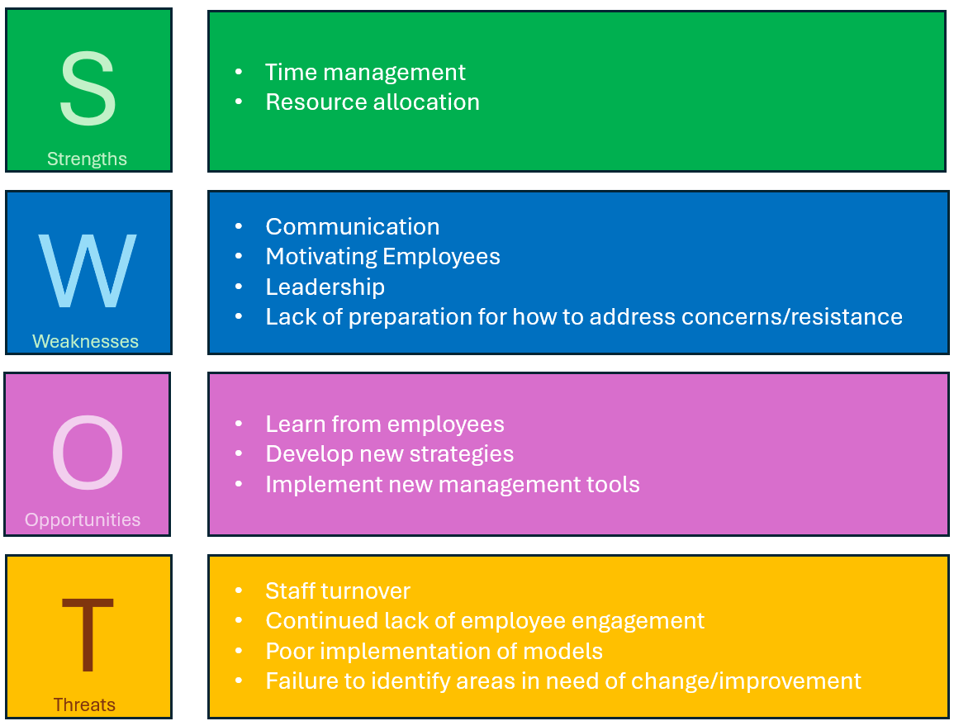
Figure 15 - SWOT analysis of IQE's project management.

Change Management Models

Lewin’s Change Model

Kurt Lewin was a German American physicist as well as a social scientist. He is well known for his change model, developed in the 1940s. The model is a theoretical framework developed to understand and facilitate the organisational change processes (Mind Tools Content Team, 2022a). This model consists of three key stages to guide leaders and managers through a change (Came, 2024a),

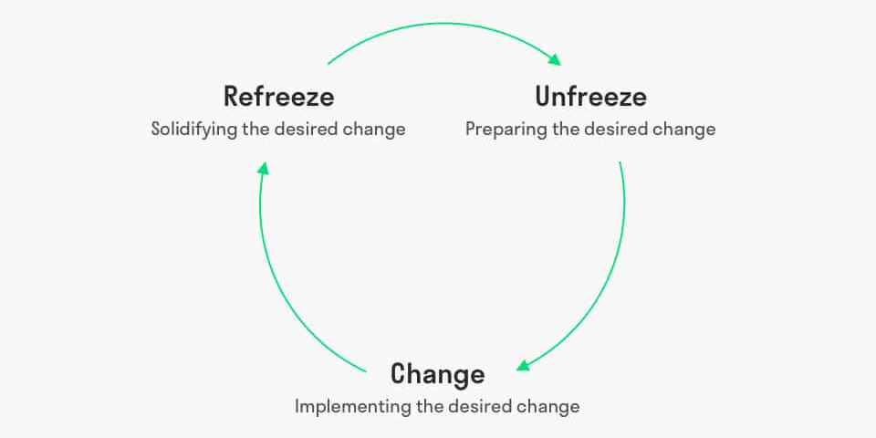
Figure 16 - The three stages of Lewin's change model (Mulder, 2012)

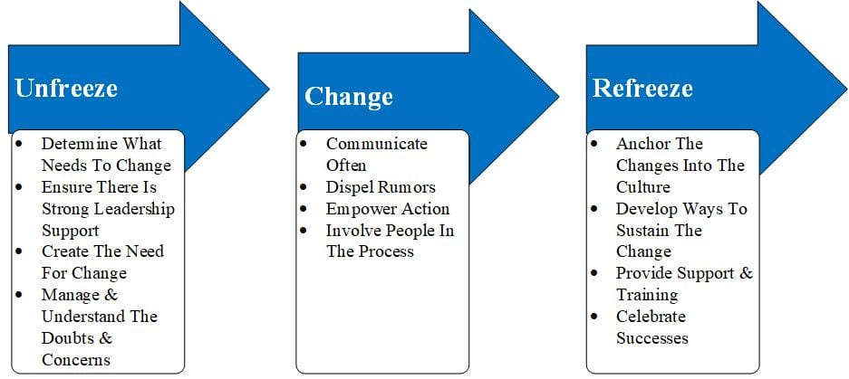
Figure 17 - Example of Lewin's change model (9m Consulting, 2018)
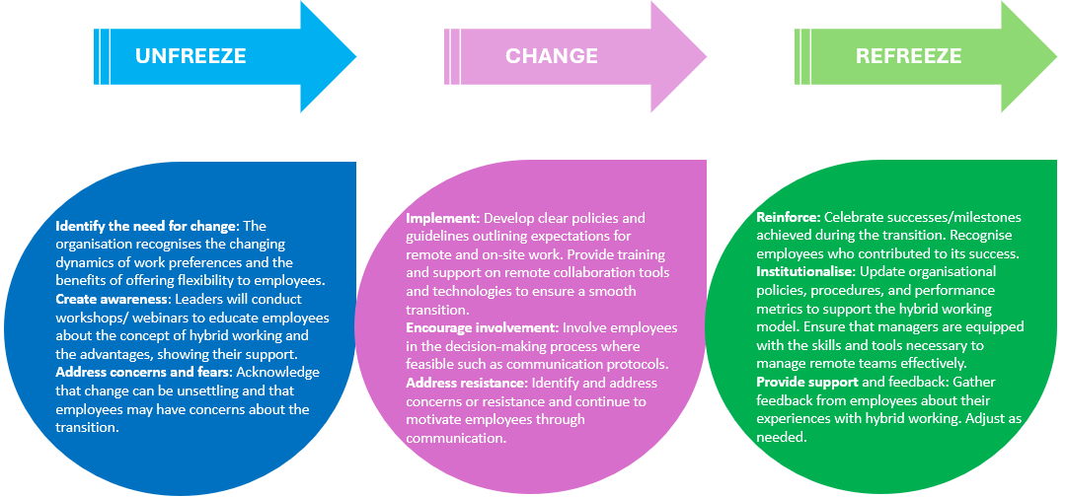
Figure 18 - Lewin's change model applied to the transition to hybrid working at IQE.

Lewin’s change model is favourable due to its simplicity and easily understandable actions. The three stages offer practical steps that guide leaders through the process of change, from preparation to implementation to stabilisation. One significant limitation of the model is its insufficient guidance on managing resistance to change. It assumes minimal resistance and does not provide specific strategies for engaging and involving employees in the change process, which are critical factors in successful change management and so the model is suitable only for small-scale projects in stable environments (Malik, 2022).
IQE chose to use this model as they incorrectly labelled the transition as minor. The project leaders felt that the major adaptation challenges had already been addressed during the pandemic, as many on site workers had learnt to work remotely. Hence, project leaders deemed a detailed plan unnecessary, considering the groundwork already laid. However, they underestimated employees' apprehension about the permanence of the new structure, initially introduced as a temporary measure. Lewin’s model does not provide guidance on addressing such resistance, focusing instead on the assumption that understanding concerns will be sufficient. Thus, this theoretical approach may not always be effective in practical, real-world scenarios (Status Net, 2019).

McKinsey’s 7-S approach

In the 1980s, McKinsey consultants Tom Peters and co. created the 7S model (Jurevicius, 2023). McKinsey’s 7S model is a tool that analyses an organisation’s structure and design by looking internally at key elements (Came, 2024a). This model identifies whether these elements are efficiently aligned and emphasises the interconnected nature of these areas. Any change in one area necessitates changes in the others to ensure the organisation functions effectively (Malik, 2022).
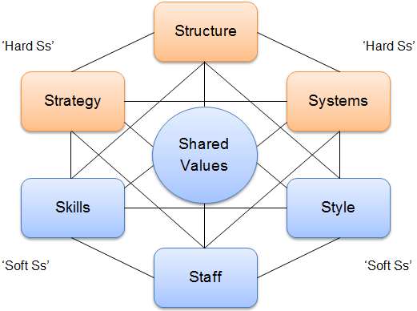
Figure 19 - Structure of Mckinsley's 7S model (Jurevicius, 2023)

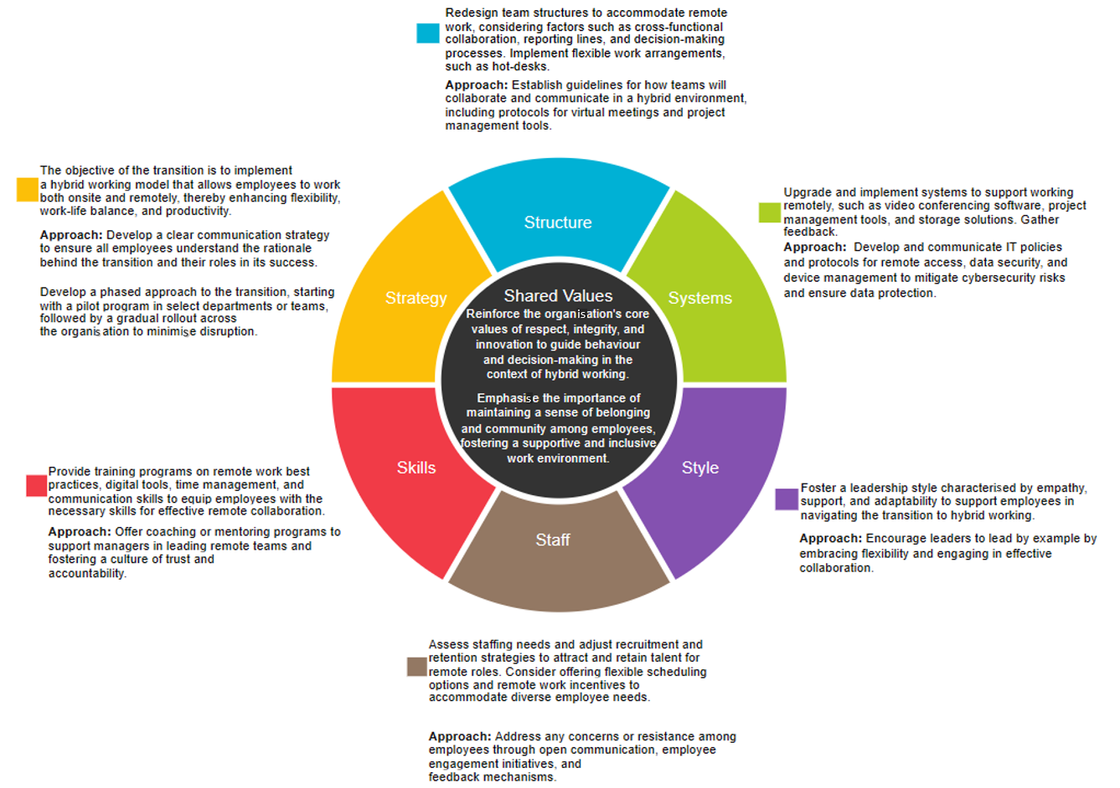
Figure 20 - Mckinsley's 7S model applied to the transition to hybrid working at IQE.

McKinsey’s approach conducts an in-depth investigation, ensuring no part of the organisation is overlooked. This holistic perspective helps identify areas of alignment or misalignment. The model examines the seven factors independently but harmonises them with one another. By assessing each category, leaders can pinpoint areas needing attention, develop targeted strategies for improvement, and anticipate how changes in one area will impact others (Freeman-Gray, 2023). This forward planning contributes to sustained organisational success. While not explicitly a change management model like Kotter's, McKinsey's framework provides valuable insights for managing change initiatives (Came, 2024a).
However, although this model identifies areas for improvement, it does not offer a clear roadmap to implement or sustain the change. While this framework touches on strategy, it does not explicitly address the emotional aspect of change or the need to build a compelling case for the change and to support employees through it (Came, 2024a). Furthermore, it overlooks external factors such as competitive pressures, which are particularly important when assessing change (Mind Tools Content Team, 2022c). Lastly, this model does not emphasise the importance of communication and motivating employees.

Kotter’s 8-Step Model

John Kotter, a professor at Harvard Business School, introduced Kotter’s 8 Step Model in his book ‘Leading Change’. His model is a widely utilised strategic approach designed to facilitate effective organisational change (Kotter, 2021). It provides a structured framework comprising eight steps aimed at guiding organisations through the process to understand, analyse, and implement change (Came, 2024a).

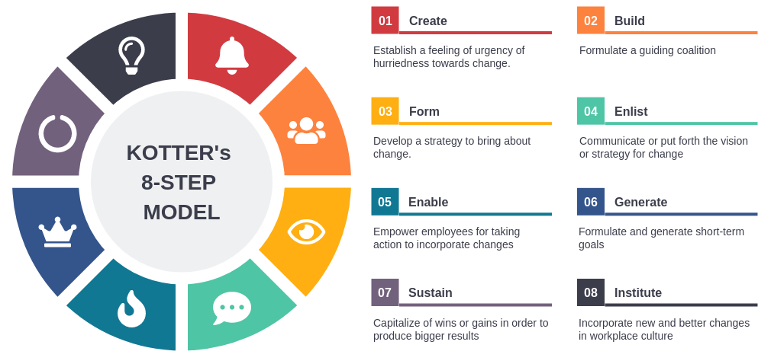
Figure 21 - Structure of Kotter's 8 step model (Main, 2023)

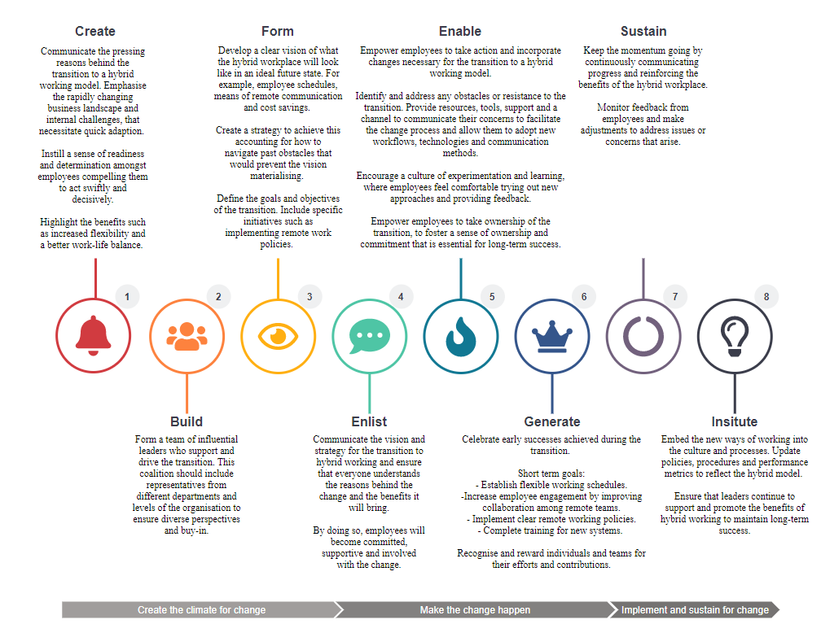
Figure 22 - Kotter's 8 step model applied to the transition to hybrid working at IQE (Visual Paradigm, 2024)

Kotter suggests forming a coalition of influential leaders to promote the change effort and drive alignment across the organisation. This step enhances the "Staff" and "Style" elements of the McKinsey framework by emphasising the importance of leadership engagement, collaboration, and communication, in leading change effectively (Came, 2024a).
Kotter's model advocates forming a coalition of influential leaders to promote the change effort and drive alignment across the organisation, enriching leadership involvement, collaboration, and communication. Its structured framework offers a clear and organised eight-step process, simplifying implementation (Kotter, 2014). The emphasis on influential leadership ensures committed engagement. Moreover, it fosters effective communication and collaboration, aligning the organisation around the change effort. Additionally, the model promotes identifying and celebrating short-term wins to sustain momentum. The model covers various aspects of change, from creating a sense of urgency to consolidating gains and embedding innovative approaches in the culture (Mind Tools Content Team, 2022a).
However, Kotter’s model also comes with drawbacks. The model can oversimplify the complexities of organisational change, presenting it as a linear process when, in reality, change is often more complex and iterative (Status Net, 2019). Its linear structure may not accommodate the need for adjustments and iterations required in real-world change initiatives. While short-term wins are important for maintaining momentum, an overemphasis on them can lead to neglecting long-term sustainability and cultural transformation (Kotter, 2014).

Leadership

In 1939 psychologist Kurt Lewin conducted a study, investigating the distinct types of leadership styles and their impacts. Using his findings, he created a framework that centred around three broad classifications of leadership styles (Lindberg, 2022). Each style carries its unique set of advantages and disadvantages however Lewin advocated that the democratic style was the most effective (Leadership & Performance Partners, 2022).

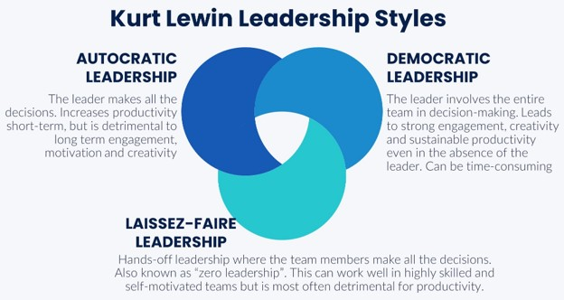
Figure 23 - Lewin's 3 change styles (Lindberg, 2022)

The autocratic style, also known as the authoritarian style, entails making and enforcing decisions without consulting others. While this approach is known for its quick and efficient nature, it often leads to demoralisation and demotivation among team members. The autocratic style can breed resentment and resistance within the team (Leadership & Performance Partners, 2022). On the other hand, the laissez-faire style adopts a hands-off, delegative approach. It thrives in environments where employees are already motivated and supportive of change. However, it quickly falters when met with resistance, lack of skills, or insufficient knowledge among team members. Contrastingly, the democratic style fosters a fully participative environment, cultivating trust and positive professional relationships while empowering and engaging team members. Although this style may prolong decision-making processes due to the consideration of multiple opinions, it is often essential for reaching sustainable solutions (Lindberg, 2022).

Motivation
Motivating is a recurring theme in change management. For individuals to support change, they need to understand the need for growth, feel motivated, and accept the reasons for the change (Tiefensee, 2022). Motivation serves as the catalyst that inspires both individuals and organisations to embrace and implement new strategies, processes, and behaviours. In the face of change, motivation fuels the commitment and perseverance needed to overcome obstacles and achieve desired outcomes (Souders, 2019). By fostering a motivated environment, leaders can enhance engagement, reduce resistance, and ensure a smoother transition, leading to successful and sustainable change. Numerous theories, such as Herzberg's Two-Factor Theory and McClelland's Theory of Needs, offer insights into what motivates individuals and can be instrumental in developing effective motivation models (Main, 2023b).

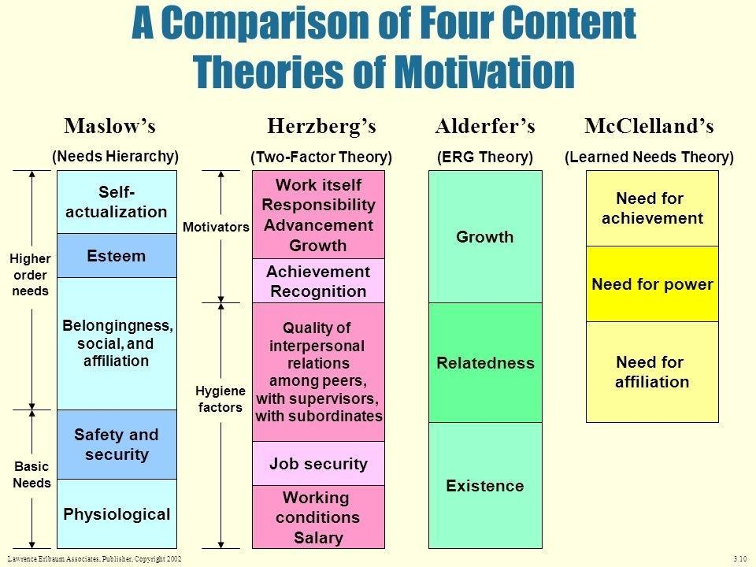
Figure 24 - Comparison of motivation theories (Klepetouna, 2019)

Herzberg was an influential American psychologist who introduced his renowned Two-Factor Theory in 1959. This theory posits that human motivation at work is driven by two distinct sets of factors: motivators and hygiene factors. Motivators, such as recognition, achievement, and opportunities for personal growth, foster job satisfaction and encourage employees to excel. On the other hand, hygiene factors, which include salary, company policies, and working conditions, are essential to prevent job dissatisfaction (Nickerson, 2024). While hygiene factors are necessary for maintaining basic job satisfaction, they do not necessarily motivate employees to perform better. In essence, Herzberg's theory distinguishes between the factors that contribute to job satisfaction and those that are fundamental for avoiding dissatisfaction, emphasising the importance of addressing both to effectively manage and motivate a workforce (Kurt, 2021).

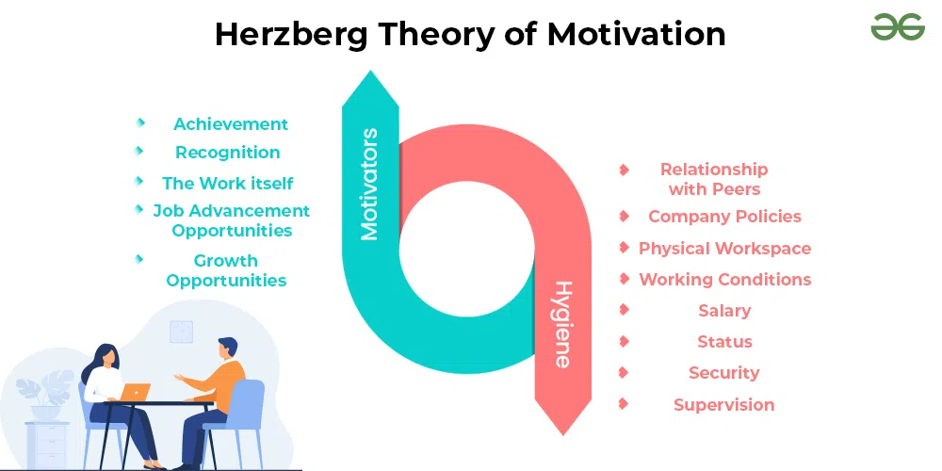
Figure 25 - Herzberg's Theory of Motivation (Gorin, 2024)

The most widely accepted and well-known theory of motivation is Maslow's Hierarchy of Needs. Abraham Maslow, an influential American psychologist of the 20th century, introduced this theory in a seminal 1943 paper, which quickly gained respect in the field of behavioural science. Maslow's theory provides a structured approach for leaders to motivate employees during transitions (Maslow, 1943, pp.370). His model outlines a five-tier hierarchy of human needs, typically represented as levels within a pyramid. The fundamental premise is that individuals must satisfy their basic needs at the lower levels before they can address higher-level needs. These needs are ordered from the most basic at the pyramid's base to the most advanced at the top (Maslow, 1943). By understanding and addressing these needs, leaders can create environments that facilitate motivation and support personal and professional growth during periods of change.

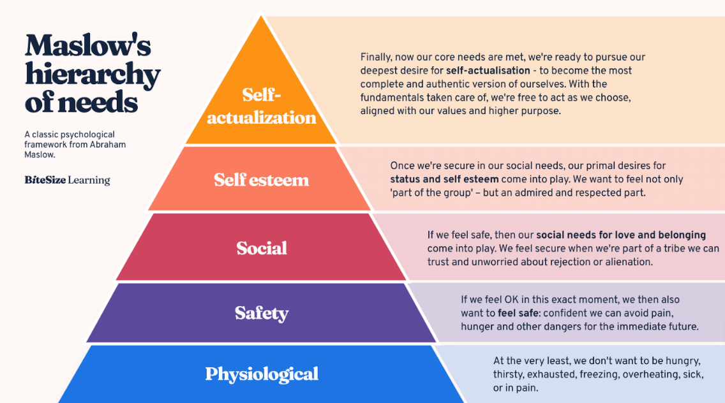
Figure 26 - Maslow's Hierarchy of Needs Framework (Bitesize Learning, 2024)

Another significant motivation model is McClelland's theory, developed by American psychologist David McClelland in the 1960s. This theory focuses on individual motivation, asserting that people are driven by one of three primary needs: achievement, affiliation, or power (Kurt, 2022). Unlike Maslow's hierarchy of needs, McClelland's model suggests that these motivators are learned rather than innate. According to McClelland, at any given time, one of these needs is dominant in an individual. However, this dominant motivator is not fixed and can change through experiences such as training, mentoring, and exposure to new situations (Mind Tools Content Team, 2022b). For instance, an individual's dominant need could shift from a focus on achievement to a desire for power. This flexibility highlights the dynamic nature of motivation and the potential for personal development and change.

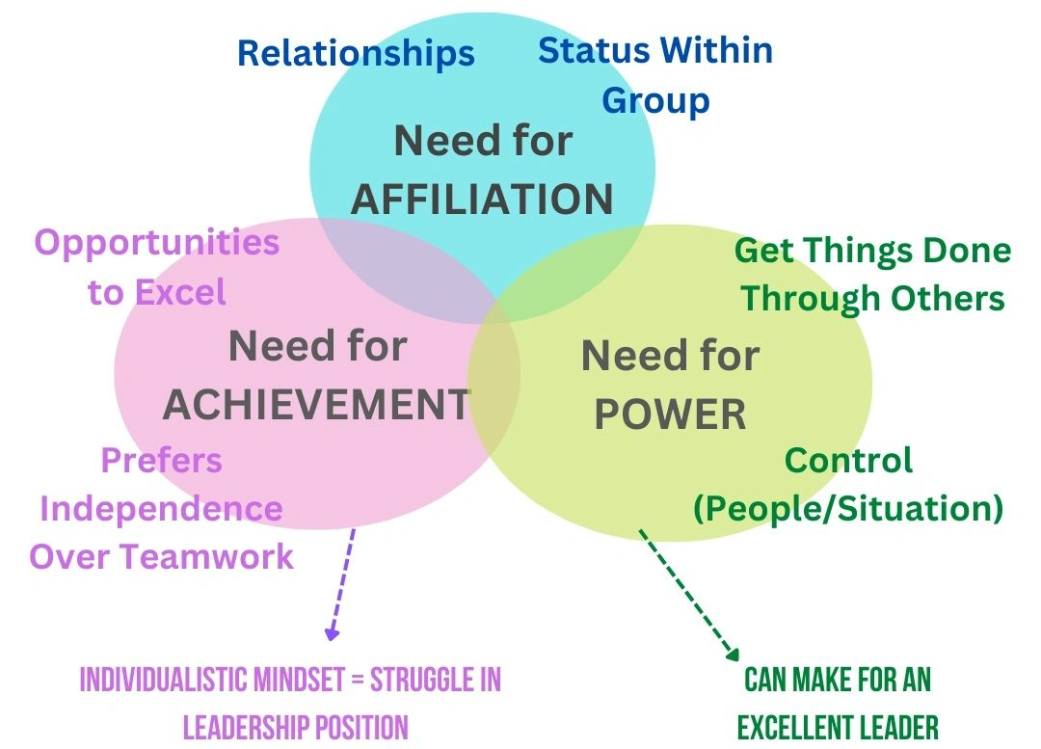
Figure 27 - McCelland's 3 Needs Theory (Management Works, 2022)

While all three theories have merit as well as studies to evidence their validity. Maslow's theory is often considered more comprehensive and universally applicable for motivating employees during organisational change. Maslow’s Hierarchy of Needs offers a detailed, sequential framework for understanding and addressing employee motivation. Its holistic approach to well-being, emphasis on personal growth, and adaptability to diverse employee needs make it particularly effective in the context of organisational change (Bamford, 2019). By focusing on fulfilling needs from basic physiological requirements to higher-level self-actualisation, leaders can use Maslow’s theory to foster a motivated and resilient workforce during periods of transformation. This makes Maslow’s theory an invaluable tool for leaders aiming to guide their teams through change successfully.

Improvements

Kotter’s 8-Step Model

For the transition to hybrid working, the survey results clearly indicated that communication and motivation were not managed effectively. IQE could have improved this by adopting a different management model in place of Lewin’s. A more detailed plan, such as Kotter’s 8-Step approach, which focuses on employee engagement and responsiveness to concerns (Kotter, 2014), would have been more beneficial. See Figures 18 and 22 to see both models applied.

Table 1 - Comparison of change models
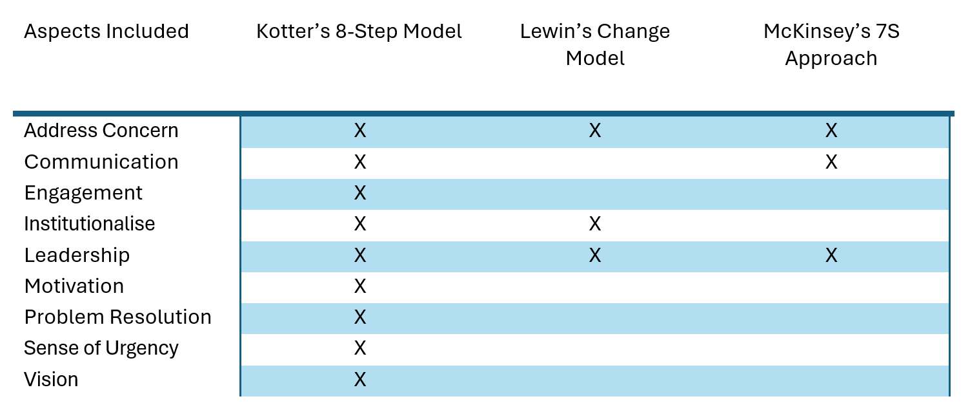

Unlike Lewin’s model, Kotter’s approach emphasises motivation and communication, ensuring that the vision is embraced and understood by employees. This focus would have significantly increased employees’ motivation towards the change. Through Kotter’s emphasis on transparency, employees would have recognised and understood the benefits of hybrid working. The model also encourages strong leadership and a compelling vision, areas where employees indicated there was a lack. Additionally, Kotter’s approach ensures that feedback is gathered from employees during the transition, facilitating two-way communication (Ramasamy, 2017).
The clear, step-by-step process of Kotter’s model would have provided leaders with a structured approach, leading to a smoother transition. In contrast, Lewin’s model was basic and left much for managers to improvise along the way. Overall, Kotter’s 8-Step Approach would have better addressed the challenges of the hybrid working transition by fostering employee motivation, enhancing communication, creating a sense of urgency, and providing a comprehensive framework for resolving concerns and managing change. See Figures 18 and 22.

Leadership

IQE did not adopt a specific leadership style during the project transition. The management approach most closely resembled an autocratic style, as IQE was non-communicative with employees and did not consider their input. A democratic style would have been more appropriate for IQE's transition. Unlike the autocratic approach, a democratic style involves leaders engaging employees in decision-making, valuing their opinions, and gathering feedback and diverse perspectives to make informed decisions. This approach empowers employees to find solutions to concerns and work towards the best outcome for everyone (Humaans, 2024). See Figure 23.
This transition required guidance, vision, and encouragement from a leader who could advocate for the change and clearly communicate its benefits to employees. Excluding employees from decision-making can lead to low morale and opposition. In contrast, a democratic style fosters motivated workers who feel valued (Forbes, 2022). The open communication channels and transparency inherent in a democratic style help build trust and understanding, which are crucial for a smooth and harmonious transition (Cherry, 2023). Collective decision-making, adaptable to evolving needs, leads to effective organisational responses to challenges (Stobierski, 2020).
The democratic leadership style aligns with IQE's values and the nature of the project. It promotes inclusivity, collaboration, and empowerment, which are essential for a successful transition (The Economic Times, 2023). By adopting a democratic leadership style, IQE could have facilitated a more inclusive and effective transition, leading to a more motivated and cohesive workforce.

Motivation Model

The final graph shown in Figure 12, revealed a significant lack of motivation among employees during the transition, with 92% of respondents indicating they did not feel motivated. IQE could have addressed this issue by employing a motivation model such as Maslow’s Hierarchy of Needs. IQE already meets employees' physiological and safety needs, as the company has a duty of care to fulfil these essential requirements, which are unaffected by the organisational change. The focus, therefore, should be on fulfilling employees' needs for love and belonging, esteem, and self-actualisation.
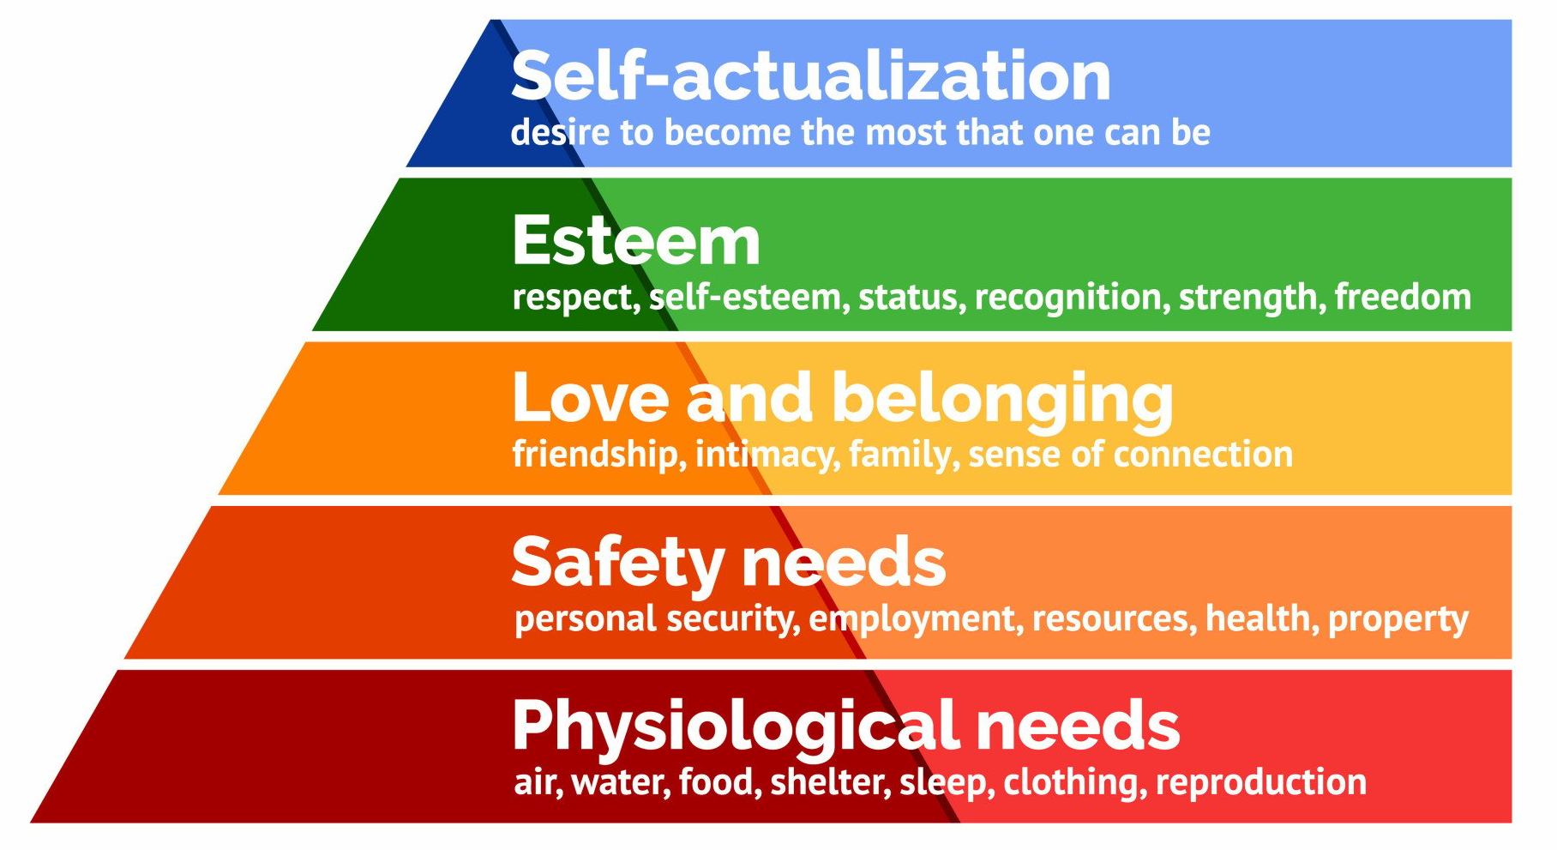
Figure 28 - Maslow's Hierarchy of Needs Pyramid (Bamford, 2019)

- Love and Belonging
Hybrid working can lead to feelings of disconnection and isolation among employees, as the absence of on-site interactions decreases their sense of community (Petitta and Ghezzi, 2023). To combat this, IQE could implement social online activities such as virtual team meetings and remote coffee catchups. Regular check-ins by management and ensuring employees find them approachable would also satisfy their need for connection and friendship.

- Esteem Needs
Esteem needs are crucial during project management and transitions. Employees need to feel respected and autonomous to stay motivated. Recognition plays a key role in this (Souders, 2019). “There is no stronger motivation for employees than an understanding that their work matters and is relevant to someone or something, other than a financial statement” (Lai, 2017). IQE could publicly reward employees for embracing change, acknowledging hard work and accomplishments through internal and external broadcasts.
The transition to hybrid working presents a unique opportunity for increased autonomy. The flexibility of working from home empowers employees to effectively manage their day and accommodate appointments and breaks (IMA New York, 2023). This potential could have been highlighted by IQE, fostering a stronger sense of ownership and enhancing productivity. Another way to address esteem needs, would be to allow employees to establish personal targets and take ownership of their new schedules post transition.

- Self-Actualisation
Self-actualisation addresses the human desire for continuous progress and achievement. When employees perceive a 'glass ceiling' to their professional growth, their motivation diminishes. To ensure sustained motivation, employees need to identify opportunities for personal development (Fletcher, 2016). During the transition, IQE could have clearly communicated their vision, emphasising how employees could thrive and reach their full potential with the new flexibility of their schedules. Post-transition, IQE could encourage employees to use the extra time saved from commuting to take online training courses offered through an IQE system, supporting their pursuit of personal growth.
In summary, by incorporating Maslow’s motivation model, IQE could have established a more structured approach to motivating their workforce during the transition to hybrid working. This would have ensured that employees felt connected, respected, autonomous, and overall motivated, leading to a more successful transition.

Key Takeaways

Through conducting this analysis and working on the project, valuable knowledge was gained. It became evident that there is a lack of employee engagement at IQE regarding change management. The report teaches that engaged employees are more likely to understand the reasons behind the change and contribute valuable insights. Employee engagement fosters a positive culture and ensures that changes are implemented effectively and sustainably (Fletcher, 2016). The report emphasises the need to motivate, communicate, and effectively lead employees to achieve such engagement.
The report highlights the usefulness of various tools in change management, such as time management plans, motivation models, and project management models. It underscores the importance of having an appropriate and structured plan with the necessary details.
Additionally, the report teaches the importance of correctly assessing the impact and size of a transition to choose the appropriate management model. Incorrectly labelling a transition as minor and choosing an unsuitable model led to a lack of strategy and preparation by IQE to address problems and resistance during the transition. The absence of democratic leadership and problem resolution in the model negatively impacted employee motivation and team cohesion, leading to low morale throughout the transition period. The lack of approachability and consideration from management resulted in employees feeling unheard or ignored when raising concerns.
Research indicates that hybrid working will continue to gain popularity as it offers a range of benefits to both employees and employers that outweigh its drawbacks. IQE’s project and the satisfaction surveys conducted show that employees at IQE favour the hybrid structure, which they believe improves their efficiency, wellbeing, and contentment.
Overall, the key takeaways include the importance of effective time management, clear communication, inclusive leadership, and fostering a collaborative work environment to ensure successful project management and employee satisfaction. These lessons learned through the analysis can greatly impact IQE’s success when navigating future changes.

Recommendations

In order to enhance the depth of insights gathered, IQE could have expanded the scope of the surveys by incorporating additional questions that would facilitate a more comprehensive understanding of the underlying reasons behind employees' answers, such as written responses instead of multiple choice. By delving deeper into the factors influencing their perceptions, IQE could pinpoint areas for improvement with greater accuracy. Moreover, to improve the accuracy of their findings, it could be beneficial to increase the sample size of employees. Putting thought into selecting employees from diverse segments of the business to provide a more nuanced perspective and yield fairer results.
Lastly, IQE could have used different metrics to assess the success of the transition to hybrid working such as productivity, financial performance, and employee performance. It is beneficial for organisations to investigate these aspects because they provide valuable insights into the overall effectiveness and impact of the change. By examining these aspects comprehensively, organisations can make well informed decisions and drive sustainable growth and success (Network, 2023).

Conclusion

In summary, the analysis of employee sentiments before and after the organisational transition at IQE reveals a significant improvement in job satisfaction and attitudes. This shift clearly demonstrates the new working structure's positive impact on employee morale. Despite this improvement, several areas require attention.
The project management aspect of the transition was perceived negatively, with significant weaknesses in communication, understanding, and appreciation. Specifically, 80% of employees did not understand the vision, and no respondents felt valued, indicating a critical need for better communication and engagement strategies. Furthermore, resource allocation was deemed adequate by only half of the respondents, suggesting there are areas where logistical support could be enhanced.
The lack of leadership during the transition also faced criticism. The approach was similar to an autocratic style which led to a lack of inclusivity and low morale among employees. A more democratic leadership style, which involves engaging employees in decision-making and valuing their input, would have fostered a more motivated and cohesive workforce (Padmavati, 2023). Similarly, adopting Kotter’s 8-Step Approach to change management, rather than Lewin’s model, could have provided a more structured and engaging framework for the transition, emphasising the importance of communication, motivation, and employee feedback.
Moreover, the motivation of employees during the transition was notably low, with 92% indicating a lack of motivation. Implementing Maslow’s Hierarchy of Needs could have addressed this issue by ensuring that employees’ needs for connection, esteem, and self-actualisation were met. Initiatives such as virtual social activities, recognition of achievements, and opportunities for personal development could have significantly enhanced employee motivation and engagement.
In conclusion, while the organisational transition itself led to improved job satisfaction, the findings highlight critical areas for improvement in communication, leadership, and employee motivation in managing the change. By adopting a more inclusive leadership style and a comprehensive change management model, and by addressing employees' motivational needs, IQE can ensure a smoother transition and foster a more motivated and productive workforce in the future.

References

9m Consulting (2018). Lewin’s Change Model. [online] 9m Consulting. Available at: https://9mconsulting.com/newsletter/lewins-change-model [Accessed 20 Mar. 2024].
Aleem, M., Sufyan, M., Ameer, I. and Mustak, M. (2023). Remote Work and the COVID-19 pandemic: an Artificial intelligence-based Topic Modeling and a Future Agenda. Journal of Business Research, [online] 154(154), p.113303. doi:https://doi.org/10.1016/j.jbusres.2022.113303.
Ammeter, A.P. and Dukerich, J.M. (2002). Leadership, Team Building, and Team Member Characteristics in High Performance Project Teams. Engineering Management Journal, 14(4), pp.3–10. doi:https://doi.org/10.1080/10429247.2002.11415178.
Bamford, R. (2019). A Theory of Human Motivation A. H. Maslow (1943) Originally Published in Psychological Review, 50, 370-396. [online] Richard Bamford Therapy. Available at: https://www.richardbamfordtherapy.co.uk/blog/a-theory-of-human-motivation-a-h-maslow-1943-originally-published-in-psychological-review-50-370-396 [Accessed 24 Mar. 2024].
Bitesize Learning (2024). Maslow’s hierarchy of needs explained [inc. pyramid diagram]. [online] BiteSize Learning. Available at: https://www.bitesizelearning.co.uk/resources/maslows-hierarchy-of-needs-theory [Accessed 4 May 2024].
Bodell, L. (2022). Most Change Initiatives Fail - Here’s How to Beat the Odds. [online] Forbes. Available at: https://www.forbes.com/sites/lisabodell/2022/03/28/most-change-initiatives-fail---heres-how-to-beat-the-odds/#:~:text=From%20employee%20resistance%20to%20a [Accessed 14 May 2024].
Cakir, F.S. and Adiguzel, Z. (2020). Analysis of leader effectiveness in organization and knowledge sharing behavior on employees and organization. SAGE Open, [online] 9(4), pp.1–14. doi:https://doi.org/10.1177/2158244020914634.
Came, H (2024a) Title: Innovation and Organisational Change ACMA5007: Management Innovation and Sustainability. University of Trinity St Davids. Draft Unpublished Report.
Came, H (2024b) Title: Innovation and Organisational Change ACMA5007: Management Innovation and Sustainability. University of Trinity St Davids. Unpublished Report.
Cassidy, C. (2012). Management. 12th ed. Mason, Ohio: South-Western Cengage.
Cherry, K. (2023). Is Democratic Leadership the Best Style of leadership? [online] Verywell Mind. Available at: https://www.verywellmind.com/what-is-democratic-leadership-2795315 [Accessed 5 May 2024].
Chowaniec, E. (2023). The Hybrid Working Model: Weighing Pros and Cons. [online] flexwhere.co.uk. Available at: https://flexwhere.co.uk/blog/the-hybrid-working-model-weighing-pros-and-cons/ [Accessed 3 May 2024].
Christenson, D. and Walker, D.H.T. (2004). Understanding the Role of ‘Vision’ in Project Success. Project Management Journal, 35(3), pp.39–52. doi:https://doi.org/10.1177/875697280403500306.
CIPD (2023). Flexible and Hybrid Working Practices in 2023. [online] CIPD. Available at: https://www.cipd.org/uk/knowledge/reports/flexible-hybrid-working-2023 [Accessed 22 Apr. 2024].
Clarke, J. (2010). TEDxPerth - Jason Clarke - Embracing Change. [online] YouTube. Available at: https://youtu.be/vPhM8lxibSU [Accessed 30 Mar. 2024].
Dawson, J. (2023). Mental Health in the Workplace: World Mental Health Day 2023. [online] HR:4UK. Available at: https://hr4uk.com/blogs/mental-health-in-the-workplace-world-mental-health-day-2023/ [Accessed 18 May 2024].
Duck, J. (1993). Managing Change: The Art of Balancing. [online] Harvard Business Review. Available at: https://hbr.org/1993/11/managing-change-the-art-of-balancing [Accessed 16 Mar. 2024].
Eccles, D.W. and Tran, K.B. (2012). Getting Them on the Same Page: Strategies for Enhancing Coordination and Communication in Sports Teams. Journal of Sport Psychology in Action, 3(1), pp.30–40. doi:https://doi.org/10.1080/21520704.2011.649229.
Elzinga, D. (2023). How to Create a Sense of Belonging across Remote Teams. [online] Culture Amp. Available at: https://www.cultureamp.com/blog/how-to-create-sense-of-belonging [Accessed 6 May 2024].
Fletcher, L. (2016). How can personal development lead to increased engagement? The roles of meaningfulness and perceived line manager relations. The International Journal of Human Resource Management, 30(7), pp.1203–1226. doi:https://doi.org/10.1080/09585192.2016.1184177.
Forbes (2022). How Democratic Leadership Can Impact Your Company. [online] councils.forbes.com. Available at: https://councils.forbes.com/blog/how-democratic-leadership-can-impact-your-company [Accessed 29 Apr. 2024].
Franklin, K. (2022). 7 Ways to Encourage Employees to Take Ownership of Their Work. [online] Insperity. Available at: https://www.insperity.com/blog/7-ways-to-encourage-employees-to-take-ownership-of-their-work/ [Accessed 7 May 2024].
Freeman-Gray, J. (2023). McKinsey 7-S Model - Mutomorro. [online] mutomorro.com. Available at: https://mutomorro.com/mckinsey-7-s-model/ [Accessed 21 Feb. 2024].
Ginger Recruitment (2024). Remote working statistics UK. [online] Ginger Recruitment. Available at: https://www.ginger-recruitment.co.uk/remote-working-statistics-uk/ [Accessed 15 May 2024].
Gleeson, B. (2016). 8 Steps for Helping Your Employees Accept Change. [online] Forbes. Available at: https://www.forbes.com/sites/brentgleeson/2016/10/17/8-steps-for-helping-your-employees-accept-change/?sh=8d708729f2a0 [Accessed 2 Apr. 2024].
Goleman, D., Boyatzis, R.E. and Mckee, A. (2002). Primal Leadership: Learning to Lead with Emotional Intelligence. Boston, Mass.: Harvard Business School Press.
Gorin, M. (2024). Unlocking Team Potential: The Transformative Power of Delegation. [online] Medium. Available at: https://maxim-gorin.medium.com/unlocking-team-potential-the-transformative-power-of-delegation-2927f4d31081 [Accessed 9 May 2024].
Gosling, J. and Mintzberg, H. (2003). The Five Minds of a Manager. Harvard Business Review. Available at: https://hbr.org/2003/11/the-five-minds-of-a-manager [Accessed 15 Mar. 2024].
Habaibeh, A.A., Watkins, M., Waried, K. and Javareshk, M.B. (2021). Challenges and Opportunities of Remotely Working from Home during Covid-19 Pandemic. Global Transitions, [online] 3(1), pp.99–108. doi:https://doi.org/10.1016/j.glt.2021.11.001.
Hubbart, J. (2023). Organizational Change: The Challenge of Change Aversion. Administrative Sciences, [online] 13(7), pp.162–162. doi:https://doi.org/10.3390/admsci13070162.
Humaans (2024). Participative Leadership: Meaning and Best Practices - Humaans. [online] humaans-landing. Available at: https://humaans.io/participative-leadership [Accessed 7 Feb. 2024].
IMA New York (2023). Workplace Flexibility Means More than WFH. [online] www.linkedin.com. Available at: https://www.linkedin.com/pulse/workplace-flexibility-means-more-than-wfh [Accessed 3 May 2024].
IQE (n.d.). Home | IQE Corporate. [online] www.iqep.com. Available at: https://www.iqep.com [Accessed 25 Apr. 2024].
IQE (n.d.). Innovation | IQE Corporate. [online] www.iqep.com. Available at: https://www.iqep.com/innovation [Accessed 25 Mar. 2024].
Kamath, N. (2021). Leaders’ Lessons: How to Nurture Positive Change. [online] www.ft.com. Available at: https://www.ft.com/content/6c2f5513-cbbd-4e84-9a3f-c88c6efcf9c9 [Accessed 3 Apr. 2024].
Klepetouna, D. (2019). Dorina Klepetouna on LinkedIn: 4 Theories on Motivation Compared. [online] www.linkedin.com. Available at: https://www.linkedin.com/posts/dorinaklepetouna_4-theories-on-motivation-compared-activity-6481198724637818880-1iZ2 [Accessed 19 May 2024].
Kotter, J. (2014). The 8 Steps for Leading Change. [online] Kotter International Inc. Available at: https://www.kotterinc.com/methodology/8-steps/ [Accessed 14 Mar. 2024].
Krakoff, S. (2022). The 10 Best Organizational Change Management Strategies. [online] Champlain College Online. Available at: https://online.champlain.edu/blog/best-organizational-change-management-strategies [Accessed 7 Apr. 2024].
Kumarasinghe, H.P.N.I. (2021). Organizational Change and Change Management. [online] ResearchGate. Available at: https://www.researchgate.net/publication_Change_Management [Accessed 3 May 2024].
Kurt, S. (2021). Herzberg’s Motivation-Hygiene Theory: Two-Factor. [online] Education Library. Available at: https://educationlibrary.org/herzbergs-motivation-hygiene-theory-two-factor/ [Accessed 5 May 2024].
Kurt, S. (2022). McClelland’s Three Needs Theory: Power, Achievement, and Affiliation. [online] Education Library. Available at: https://educationlibrary.org/mcclellands-three-needs-theory-power-achievement-and-affiliation/ [Accessed 1 May 2024].
Lai, L. (2017). Motivating Employees Is Not about Carrots or Sticks. Harvard Business Review. Available at: https://hbr.org/2017/06/motivating-employees-is-not-about-carrots-or-sticks [Accessed 26 Apr. 2024].
Leadership & Performance Partners (2022). Lewin’s Leadership Theory Explained - Leadership and Performance. [online] Leadership and Performance. Available at: https://l/leadership-development/lewins-theory-explained/ [Accessed 28 Jan. 2024].
Lindberg, C. (2022). Kurt Lewin Leadership Styles. [online] Leadership Ahoy! Available at: https://www.leadershipahoy.com/kurt-lewin-leadership-styles [Accessed 26 Apr. 2024].
Main, P. (2023a). Change Theories. [online] www.structural-learning.com. Available at: https://www.structural-learning.com/post/change-theories [Accessed 20 Mar. 2024].
Main, P. (2023b). Theories of Motivation. [online] www.structural-learning.com. Available at: https://www.structural-learning.com/post/theories-of-motivation [Accessed 22 Apr. 2024].
Malik, P. (2022). Lewin’s 3-Stage Model of Change Theory: Overview. [online] WhatFix. Available at: https://whatfix.com/blog/lewins-change-model/ [Accessed 4 May 2024].
Management Works (2022). The Three Needs Theory of Motivation. [online] Management Works. Available at: https://managementworksmedia.com/blog/f/the-three-needs-theory-of-motivation [Accessed 22 Apr. 2024].
Maslow, A. (1943). A Theory of Human Motivation. Psychological Review, pp.370–396.
Maylor, H. (2010). Project Management. 4th ed. London; New York: Financial Times/Prentice Hall.
Maylor, H. and Turner, N. (2022). Project Management. 5th ed. Pearson Education, Limited.
McKinsey Global Institute (2023). Chapter 1: How Hybrid Work Has Changed the Way People work, live, and Shop | McKinsey. [online] www.mckinsey.com. Available at: https://www.research/empty-spaces-and-hybrid-places [Accessed 2 Apr. 2024].
McLeod, S. (2018). Maslow’s Hierarchy of Needs. [online] Canada College. Simply Psychology. Available at: https://canadacollege.edu/dreamers/docs/Maslows-Hierarchy-of-Needs.pdf [Accessed 15 May 2024].
Mezzacappa, S. (2023). The Era of Hybrid Work: Optimizing the Hybrid Work Model for Your Organization. [online] www.applauz.me. Available at: https://www.applauz.me/resources/hybrid-work [Accessed 21 Mar. 2024].
Miller, K. (2020). 5 Critical Steps in the Change Management Process. [online] Harvard Business School. Available at: https://online.hbs.edu/blog/post/change-management-process [Accessed 19 Mar. 2024].
Mind Tools Content Team (2022a). Kotter’s 8-Step Change Model. [online] www.mindtools.com. Available at: https://www.mindtools.com/a8nu5v5/kotters-8-step-change-model. [Accessed 2024].
Mind Tools Content Team (2022b). McClelland’s Human Motivation Theory. [online] www.mindtools.com. Available at: https://www.mindtools.com/aznjntj/mcclellands-human-motivation-theory [Accessed 14 May 2024].
Mind Tools Content Team (2022c). McKinsey 7-S Framework. [online] www.mindtools.com. Available at: https://www.mindtools.com/aicks4s/the-mckinsey-7-s-framework [Accessed 7 May 2024].
Mind Tools Content Team (2024). MindTools | Home. [online] www.mindtools.com. Available at: https://www.mindtools.com/a7m23wp/leadership-styles. [Accessed 12 Mar. 2024].
Mind Tools Content Team (2022). Lewin’s Change Management Model. [online] www.mindtools.com. Available at: https://www.mindtools.com/ajm9l1e/lewins-change-management-model. [Accessed 12 Mar. 2024].
Monday Blog (2022). Time Management in Project Management. Monday Blog. Available at: https://monday.com/blog/project-management/time-management-in-project-management/ [Accessed 15 Apr. 2024].
Morgan, K. (2021). Why in-person Workers May Be More Likely to Get Promoted. BBC. [online] 8 Mar. Available at: https://www.bbc.com/worklife/article/20210305-why-in-person-workers-may-be-more-likely-to-get-promoted [Accessed 6 May 2024].
Mulder, P. (2012). Lewin Change Model Explained. [online] Toolshero. Available at: https://www.toolshero.com/change-management/lewin-change-model. [Accessed 5 Apr. 2024].
Mullins, L.J. (2019). Organisational Behaviour in the Workplace. 12th ed. Harlow: Pearson.
Mutebi, N. and Hobbs, A. (2022). The Impact of Remote and Hybrid Working on Workers and Organisations. [online] Available at: https://post.parliament.uk/research-briefings/post-pb-0049/ [Accessed 12 May 2024].
Network, F. (2023). Startup Metrics 101: What to Track and Why It Matters. [online] Founders Network. Available at: https://foundersnetwork.com/blog/startup-metrics/ [Accessed 25 Apr. 2024].
Nickerson, C. (2024). Maslow’s Hierarchy of Needs. [online] Simply Psychology. Available at: https://www.simplypsychology.org/maslow.html. [Accessed 22 Apr. 2024].
Nicks, L., Gesiarz, F., Likki, T., Baynham-Herd, Z. and Lohmann, J. (2021). Impact of changes in flexible working during lockdown on gender equality in the workplace Research report. [online] Available at: https://www.bi.team/wp-content/uploads/2021/05/Covid-flexible-working-report-for-upload.pdf [Accessed 4 May 2024].
Olson, A.B. (2023). Getting Employee Buy-In for Organizational Change. [online] Harvard Business Review. Available at: https://hbr.org/2023/02/getting-employee-buy-in-for-organizational-change [Accessed 4 May 2024].
Padmavati (2023). Democratic Leadership: Path to Team Success. [online] Northwest Executive Education. Available at: https://what-is-democratic-leadership-style [Accessed 18 Apr. 2024].
Petitta, L. and Ghezzi, V. (2023). Remote, Disconnected, or Detached? Examining the Effects of Psychological Disconnectedness and Cynicism on Employee Performance, Wellbeing, and Work–Family Interface. International Journal of Environmental Research and Public Health, [online] 20(13), p.6318. doi:https://doi.org/10.3390/ijerph20136318.
Ramasamy, R. (2017). A Critical Analysis of John P. Kotter’s Change Management Framework. [online] ResearchGate. Available at: https://www.researchgate.net/publication/318481875 [Accessed 21 Mar. 2024].
Rosing, F., Boer, D. and Buengeler, C. (2022). When timing is key: How autocratic and democratic leadership relate to follower trust in emergency contexts. Frontiers in Psychology, [online] 13(904605), pp.1–18. doi:https://doi.org/10.3389/fpsyg.2022.904605.
Sales Training International (2023). 7 Top Motivation Models to Use as a Leader. [online] www.linkedin.com. Available at: https://www.linkedin.com/pulse/7-top-motivation-models-use-leader- [Accessed 16 Apr. 2024].
Santoso, N.R., Sulistyaningtyas, I.D. and Pratama, B.P. (2022). Transformational Leadership during the COVID-19 Pandemic: Strengthening Employee Engagement through Internal Communication. Journal of Communication Inquiry, [online] 1(1). doi:https://doi.org/10.1177/01968599221095182.
Sarran, P., Clark, D. and Mendonca, K. (2015). Change Management Toolkit. [online] Available at: https://hr.berkeley.edu/sites/default/files/change_management_toolkit.pdf [Accessed 4 May 2024].
Sinek, S. (2011). Start with Why: How Great Leaders Inspire Everyone to Take Action. New York: Portfolio/Penguin.
Skepe, S. (2012). Evaluation of the Applicability of Lewin’s Force Field Analysis in the Implementation of the Financial Sector Charter at Standard Bank Supervised by: Professor Owen Skae. [online] Available at: https://core.ac.uk/download/pdf/145055852.pdf [Accessed 4 May 2024].
Smith, I. (2011). Organisational Quality and Organisational Change. Library Management, 32(1/2), pp.111–128. doi:https://doi.org/10.1108/01435121111102629.
Souders, B. (2019). The Vital Importance and Benefits of Motivation. [online] PositivePsychology.com. Available at: https://positivepsychology.com/benefits-motivation/ [Accessed 4 Mar. 2024].
Status Net (2019). 5 Main Change Management Models: ADKAR Vs Kubler Ross Vs McKinsey 7S Vs Lewin Vs Kotter’s 8 Step. [online] Status Articles. Available at: https://status.net/articles/change-management-models-lewin-mckinsey-7s-kotter-8-step-kubler-ross-change-curve-adkar-model [Accessed 7 Apr. 2024].
Stobierski, T. (2020). 5 Tips for Managing Change in the Workplace. [online] Harvard Business School Online. Available at: https://online.hbs.edu/blog/post/managing-change-in-the-workplace [Accessed 15 Apr. 2024].
Strebel, P. (2009). Why Do Employees Resist change? IEEE Engineering Management Review, 37(3), pp.60–66. doi:https://doi.org/10.1109/emr.2009.5235497.
Tenney, M. (2022). The 5 Leadership Styles Most Commonly Utilized - Business Leadership Today. [online] Business Leadership Today. Available at: https://businessleadershiptoday.com/what-are-the-5-leadership-styles/ [Accessed 4 May 2024].
The Economic Times (2023). Democratic Leadership: Fostering Collaboration and Inclusivity. The Economic Times. [online] 26 Oct. Available at: https://economictimes.indiatimes.com/jobs/c-suite/democratic-leadership-fostering-collaboration-and-inclusivity/articleshow/104731724.cms?from=mdr [Accessed 4 May 2024].
Tiefensee, N. (2022). 10 Reasons Why Change Management Is Important | Runn. [online] Runn. Available at: https://www.runn.io/blog/why-change-management-is-important [Accessed 3 May 2024].
Todnem, R. (2005). Organizational Change Management: A Critical Review. ResearchGate. Available at: https://www.researchgate.net/publication/233604011_Organizational_Change_Management_A_Critical_Review [Accessed 11 May 2024].
Tsipursky, G. (2023). Embrace Hybrid Work or Lose Talent: The New Workforce Reality. Forbes. [online] Available at: https://www.forbes.com/sites/glebtsipursky/2023/03/31/embrace-hybrid-work-or-lose-talent-the-new-workforce-reality/ [Accessed 4 May 2024].
Twin, A. (2023). Restructuring: Definition, Meaning, Process, and Example. [online] Investopedia. Available at: https://www.investopedia.com/terms/r/restructuring [Accessed 13 Apr. 2024].
Visagie, C. and Steyn, C. (2011). Organisational Commitment and Response to Planned Organisational change: an Exploratory Study. pp.98–121. doi:https://www.researchgate
Visual Paradigm (2024). Kotter’s 8 Step Change Model Templates. [online] online.visual-paradigm.com. Available at: https://online.visual-paradigm.com/diagrams/templates/kotters-8-step-change-model [Accessed 21 Mar. 2024].
Wang, Q., Hou, H. and Li, Z. (2022). Participative Leadership: A Literature Review and Prospects for Future Research. Frontiers in Psychology, doi:https://doi.org/10.3389/fpsyg.2022.924357.
Wigert, B. and White, J. (2022). The Advantages and Challenges of Hybrid Work. [online] Gallup. Available at: https://www.gallup.com/workplace/398135/advantages-challenges-hybrid-work.aspx [Accessed 3 Apr. 2024].
Xiao, Y., Becerik-Gerber, B., Lucas, G. and Roll, S.C. (2021). Impacts of Working from Home during COVID-19 Pandemic on Physical and Mental Well-Being of Office Workstation Users. Journal of Occupational & Environmental Medicine, [online] 63(3), pp.181–190. doi:https://doi.org/10.1097/jom.0000000000002097.

Appendix A

Results of the Engagement Survey 2023, (before transition)

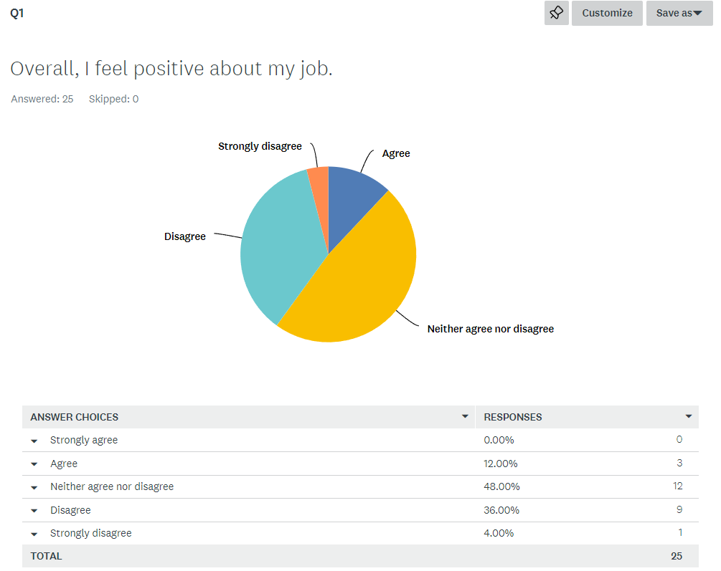
Figure 29 - Question 1 results of Engagement Survey 2023.

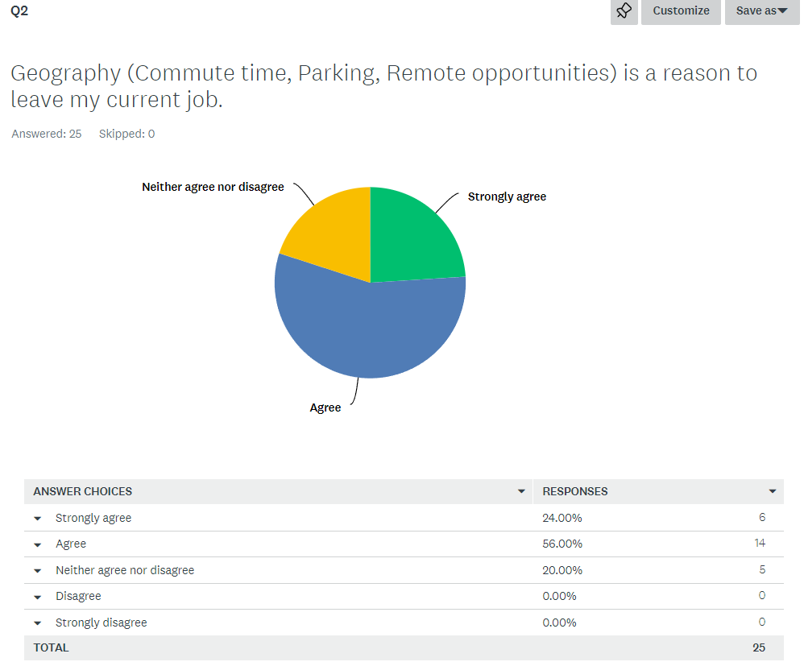
Figure 30 - Question 2 results of Engagement Survey 2023.
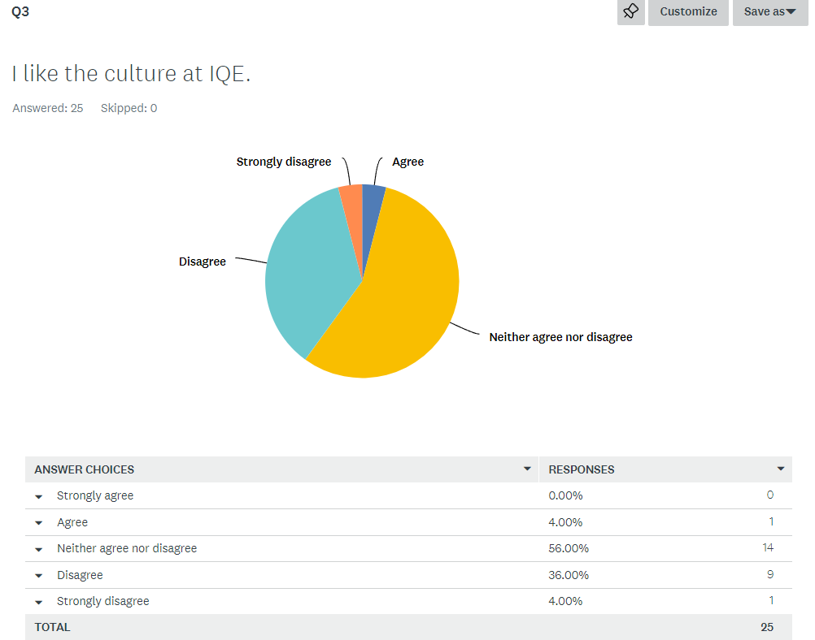
Figure 31 - Question 3 results of Engagement Survey 2023.

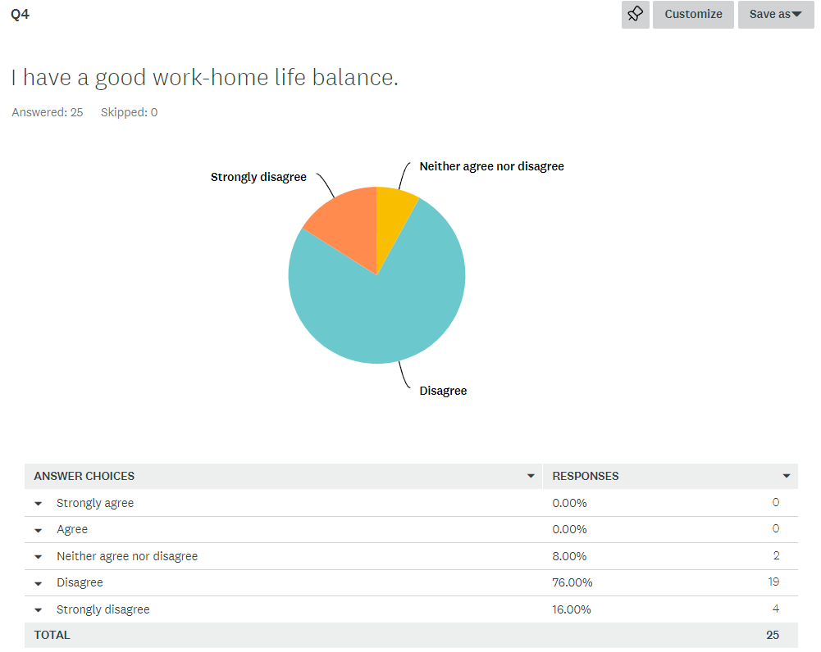
Figure 32 - Question 4 results of Engagement Survey 2023.
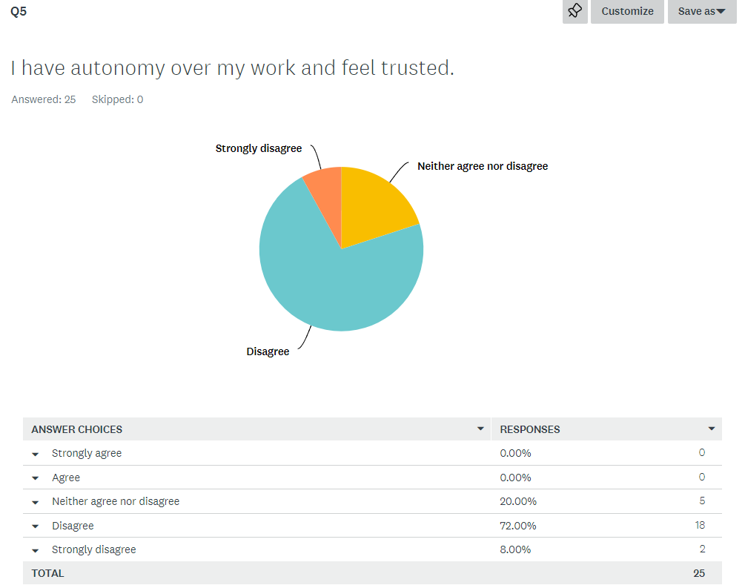
Figure 33 - Question 5 results of Engagement Survey 2023.

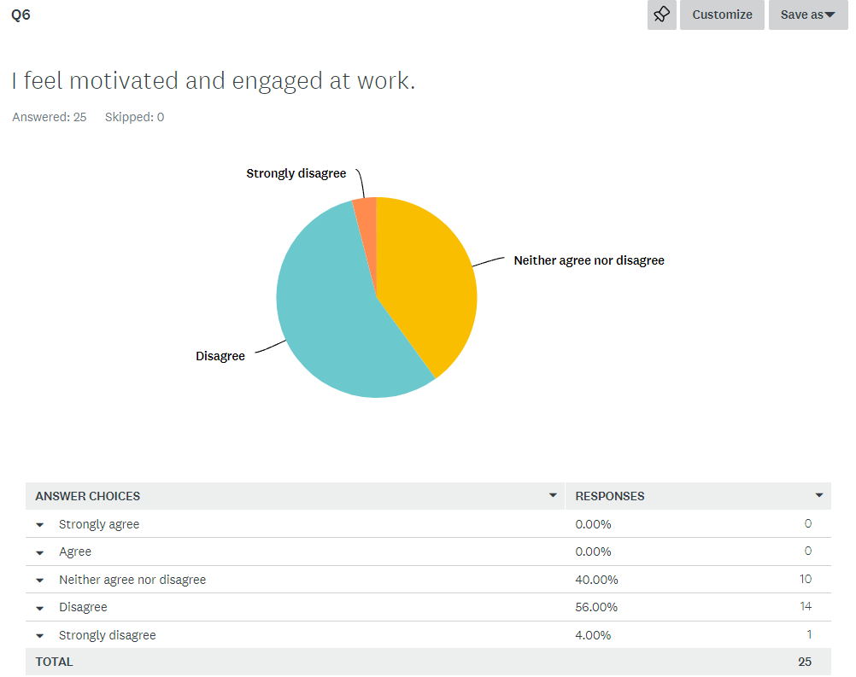
Figure 34 - Question 6 results of Engagement Survey 2023.
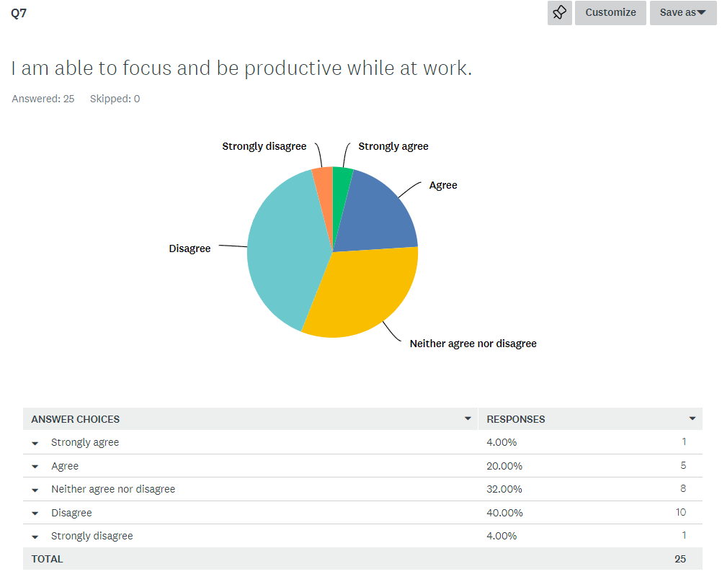
Figure 35 - Question 7 results of Engagement Survey 2023.

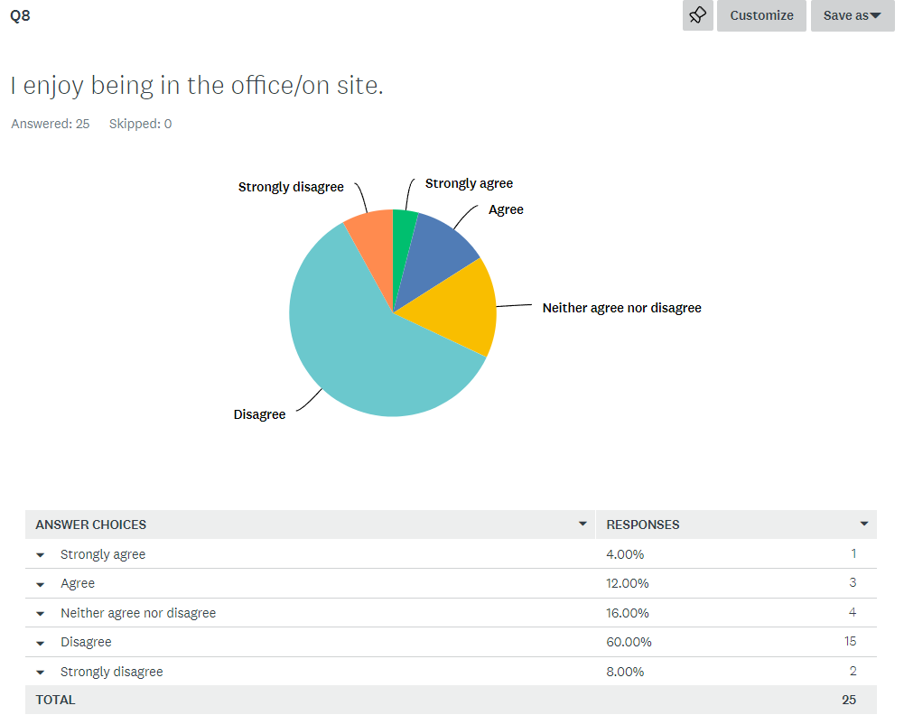
Figure 36 - Question 8 results of Engagement Survey 2023.
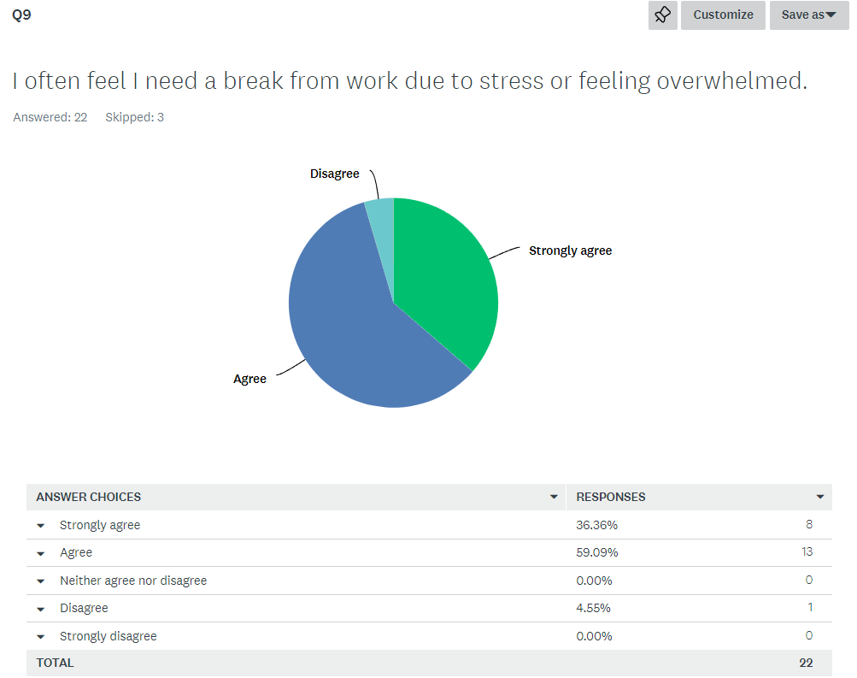
Figure 37 - Question 9 results of Engagement Survey 2023.

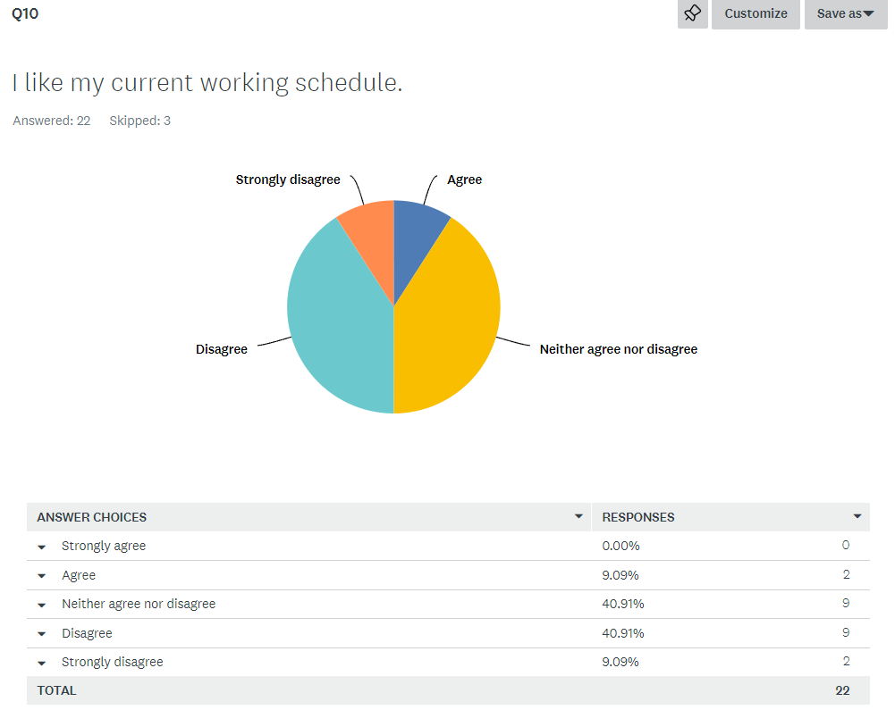
Figure 38 - Question 10 results of Engagement Survey 2023.

Results of the Engagement Survey 2024 (following transition)

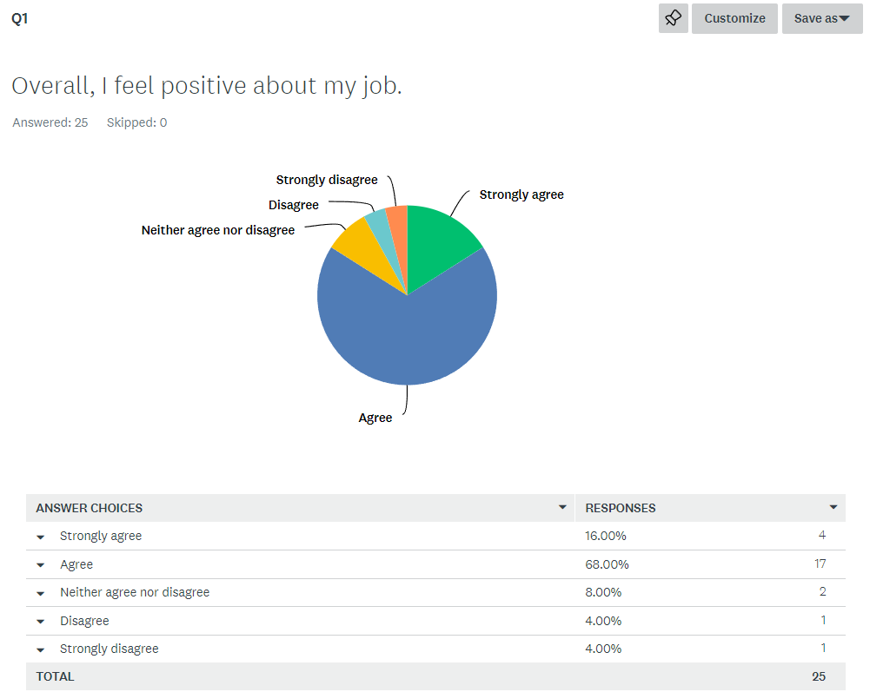
Figure 39 - Question 1 results of Engagement Survey 2024.

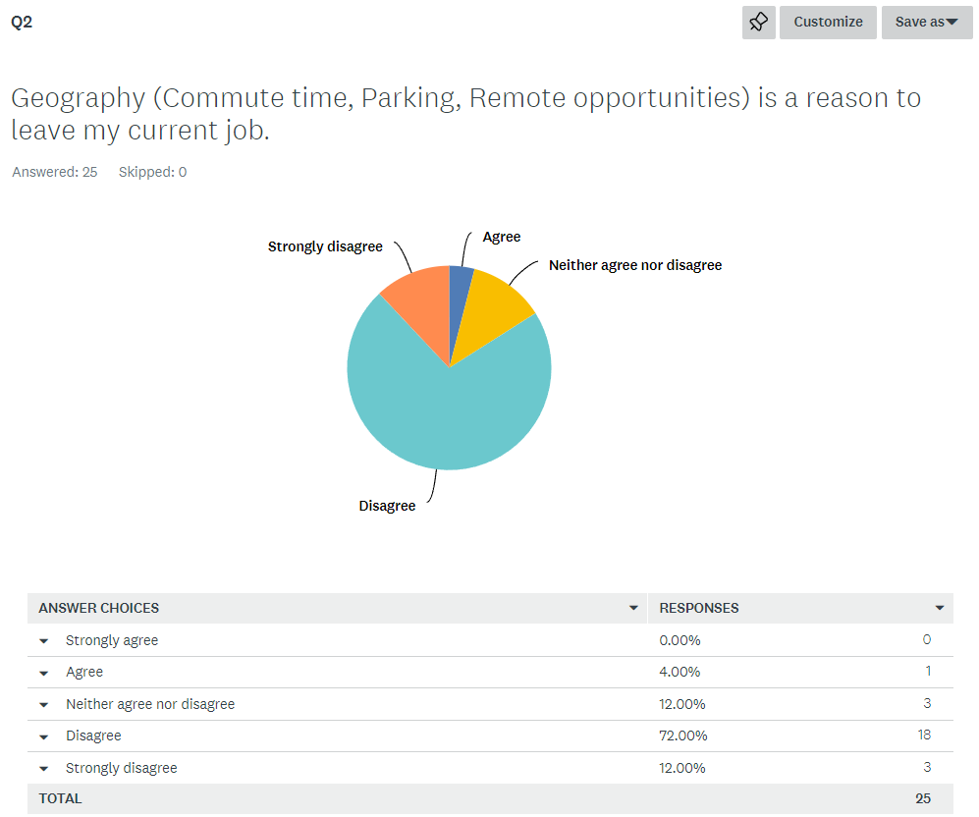
Figure 40 - Question 2 results of Engagement Survey 2024.
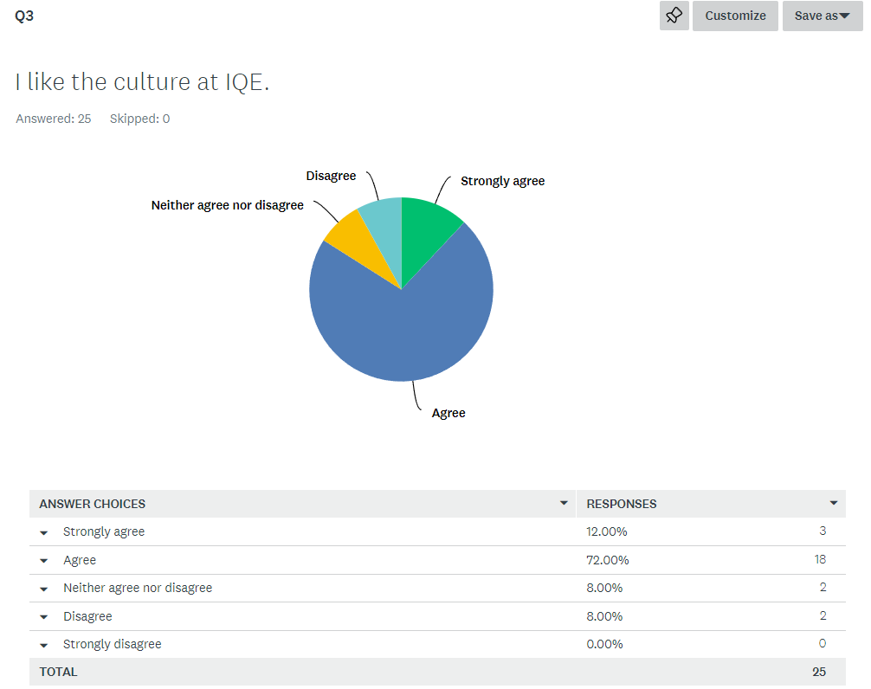
Figure 41 - Question 3 results of Engagement Survey 2024.

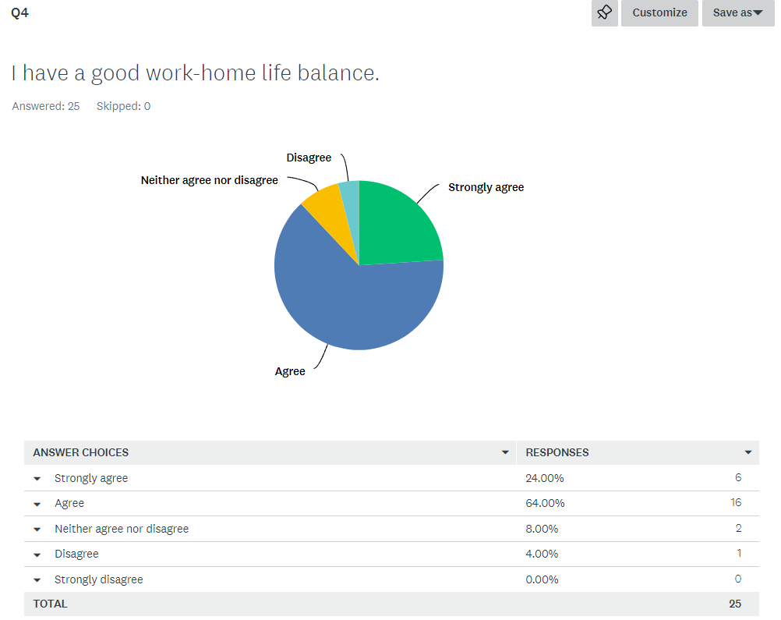
Figure 42 - Question 4 results of Engagement Survey 2024.
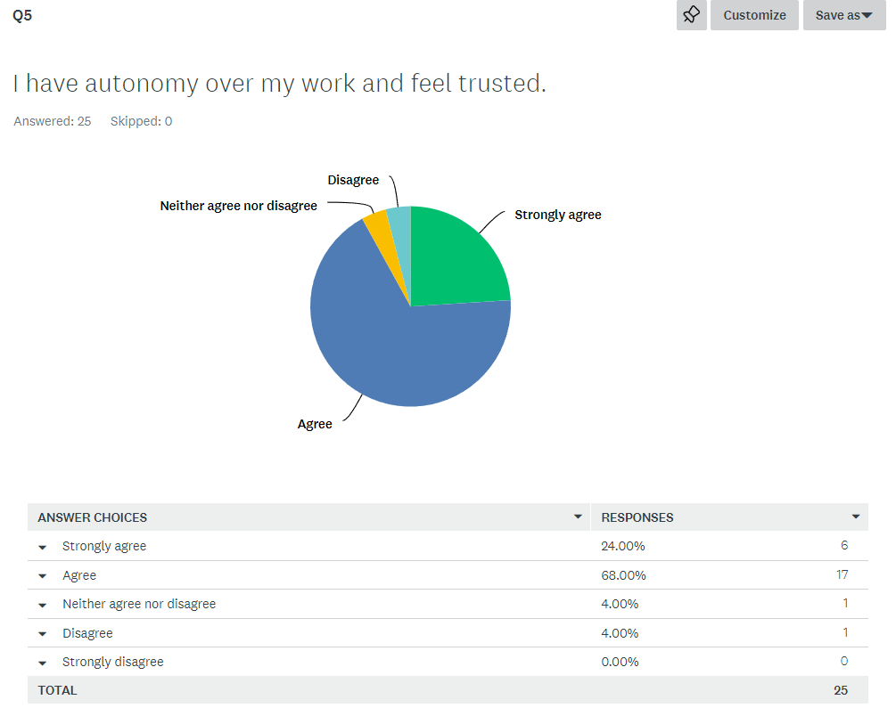
Figure 43 - Question 5 results of Engagement Survey 2024.

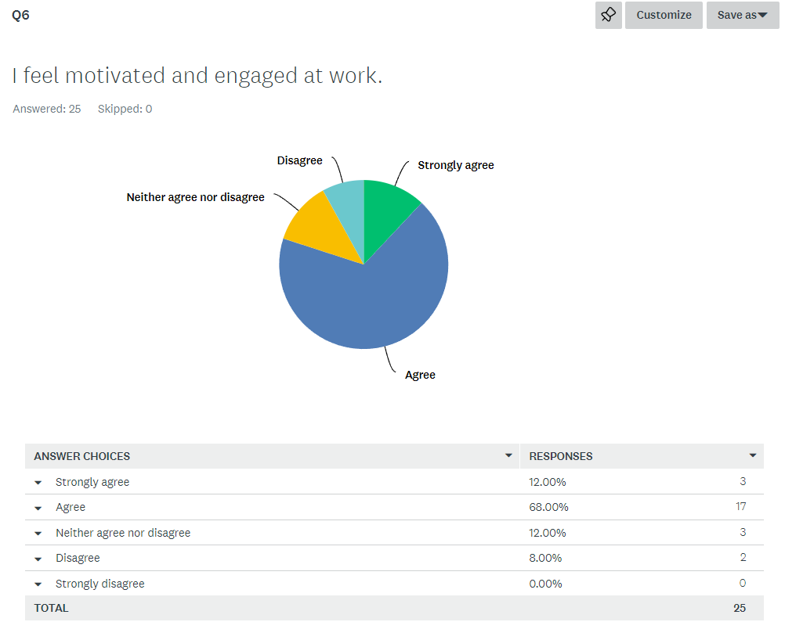
Figure 44 - Question 6 results of Engagement Survey 2024.
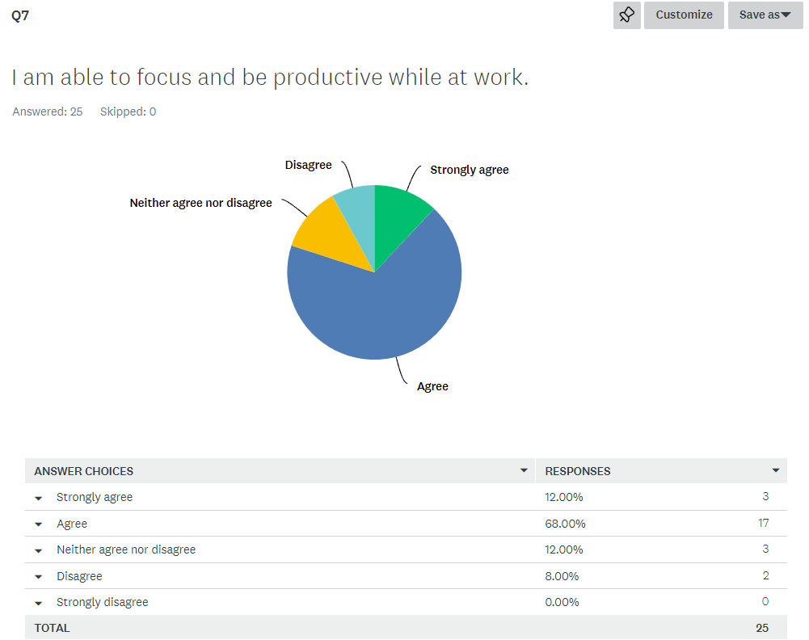
Figure 45 - Question 7 results of Engagement Survey 2024.

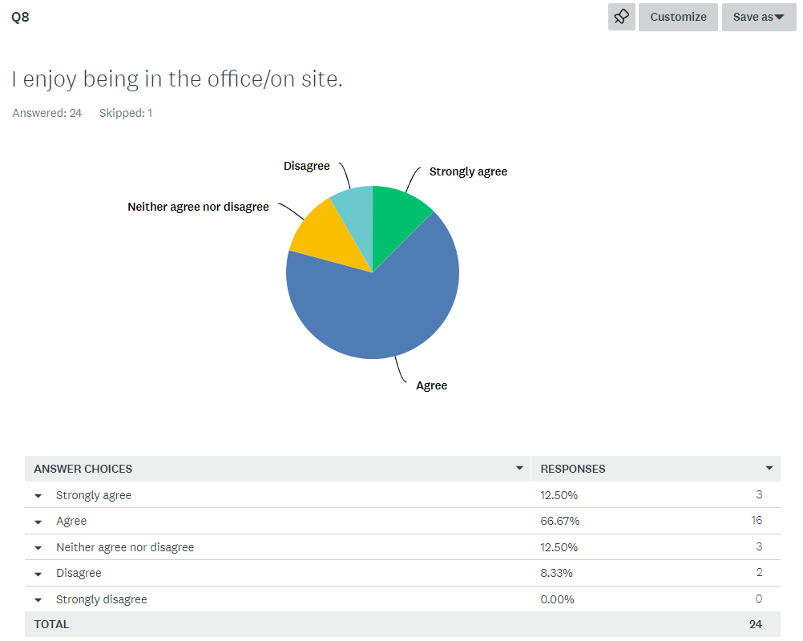
Figure 46 - Question 8 results of Engagement Survey 2024.
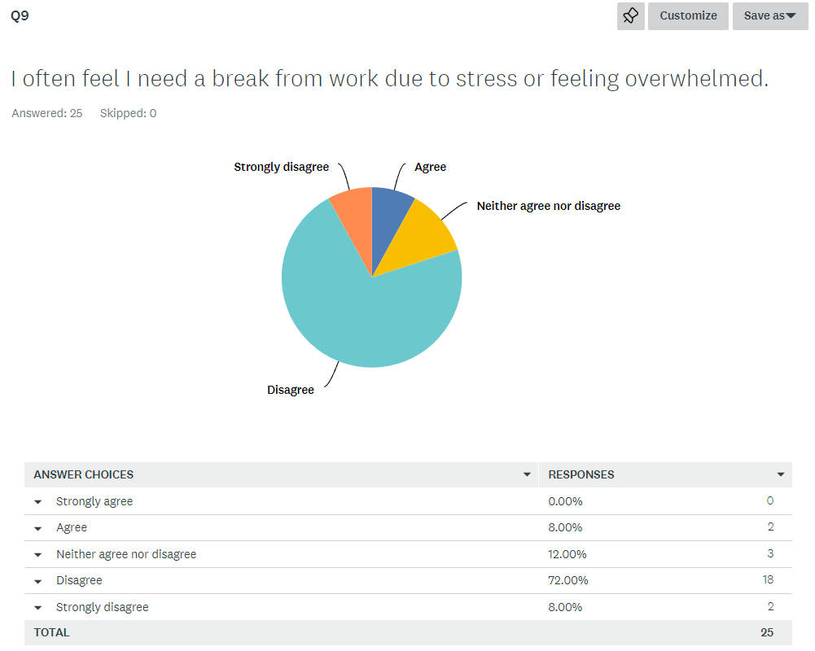
Figure 47 - Question 9 results of Engagement Survey 2024.

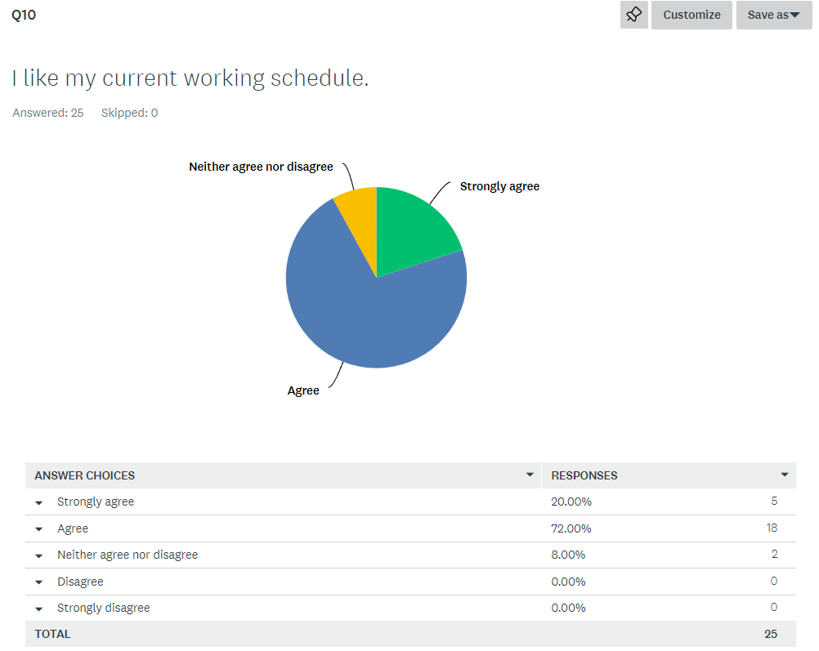
Figure 48 - Question 10 results of Engagement Survey 2024.

Appendix B

Results of project management survey
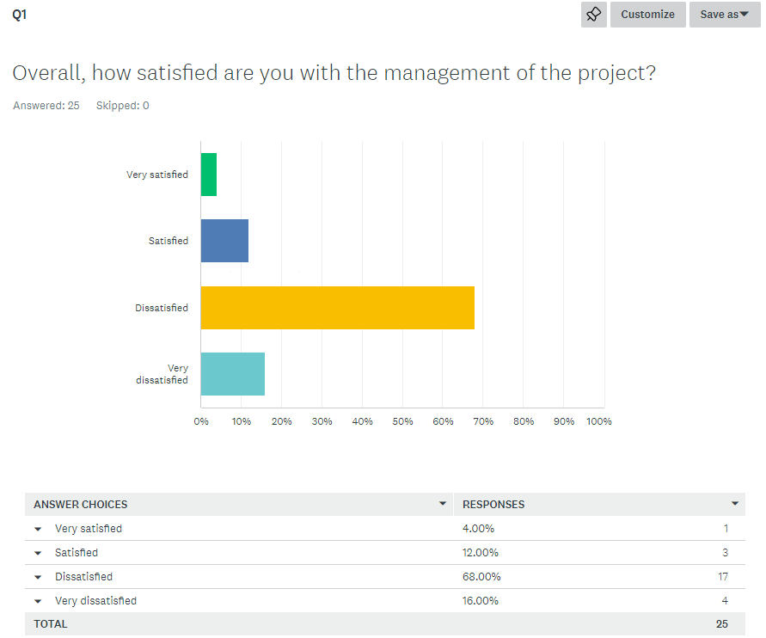
Figure 49 - Question 1 results of project management survey.

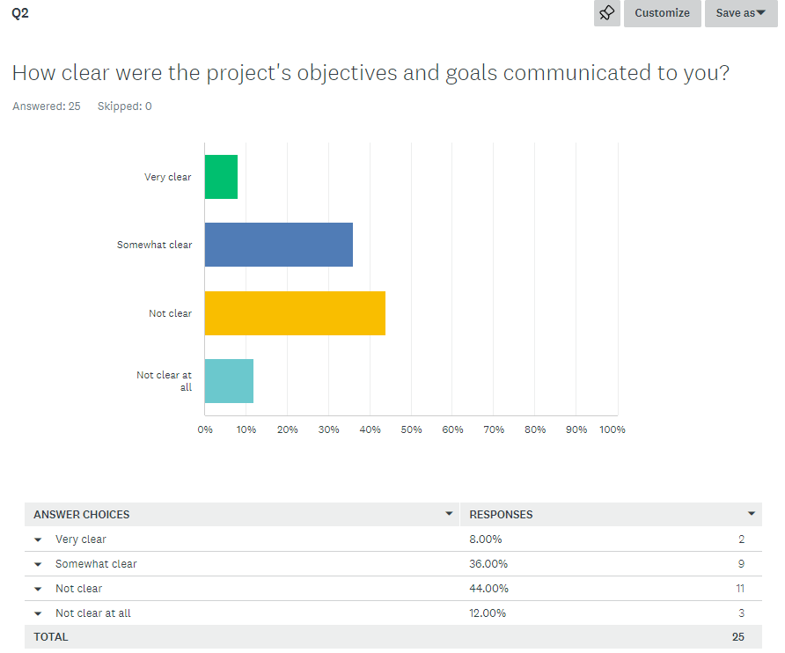
Figure 50 - Question 2 results of project management survey.
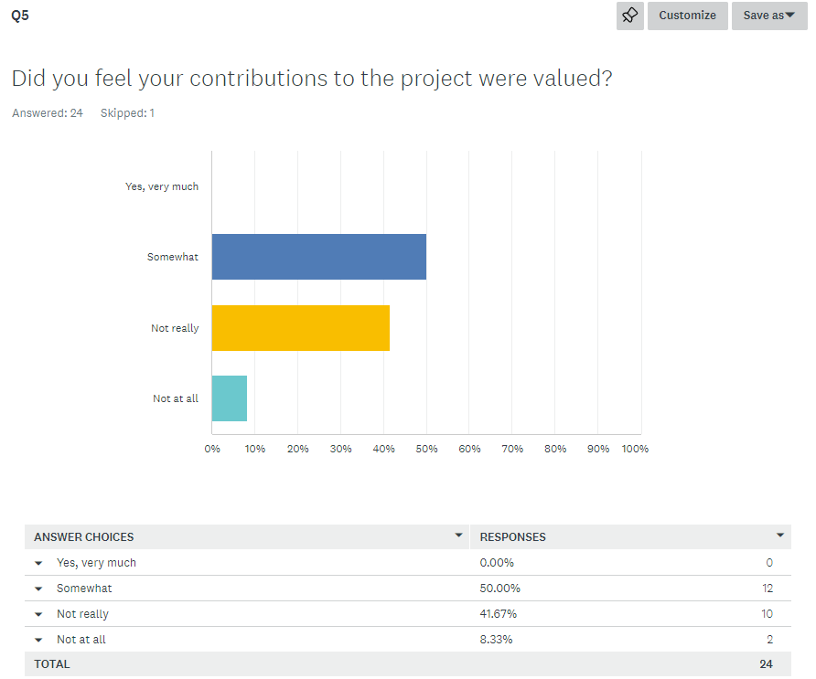
Figure 51 - Question 5 results of project management survey.

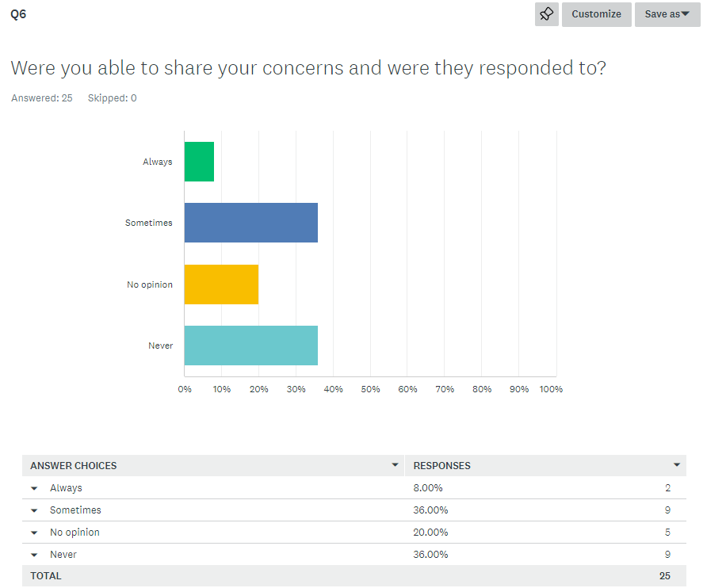
Figure 52 - Question 6 results of project management survey.
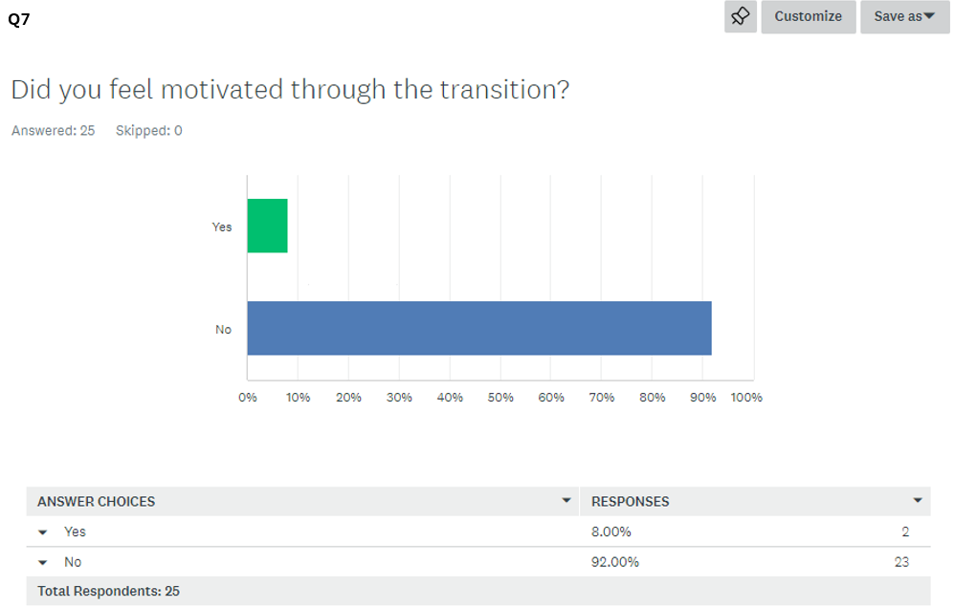
Figure 53 - Question 7 results of project management survey.

