Name: mavish IYSHIA
Student id:2236706
Lecturer: Abdullah usman
assignment title: (ACCA4019) Component 2: Written Assessment: Problem Analysis and Solution Development
Submission Date: 23:07:2026

Contents
Introduction 2
Problem Deconstruction 2
Overview of the problem 2
Prime Requirements (MoSCoW Analysis) 3
1.3 Variables 3
1.4 The Constraints 4
1.5 Systems Thinking 5
Proposed Solution and Explanation 6
Methodology and Evaluation 8
3: Reflection and Justification 9
Conclusion 9
References 11

Introduction

Group-based projects are common in computing courses and offer many advantages, such as improving team building, collaboration, problem-solving, enhancing leadership, and developing creativity and innovation. However, many barriers reduce opportunities to reap the benefits, significantly undermining overall performance in completing tasks to the best of one's ability. A solution to the implication has been produced to help eliminate collaboration complications. I have adopted theories and methods to reinforce the solution, using the MoSCoW method, System Thinking, and Operations to do so more efficiently.

Findings indicate collaborative learning challenges in arranging meetings, which serve as structural constraints that shape team interaction, influence the quality of communication, and impact overall performance in completing tasks/projects on time. Unfortunately, when coordination does not go smoothly, workloads are not shared fairly, tasks become disjointed, miscommunication occurs, and overall team performance weakens. Therefore, to build a solution that is both theoretically sound and practically effective, it is essential to examine scheduling complexities using computational thinking and systems-oriented techniques.

Problem Deconstruction

Overview of the problem
Within today's higher education environments, students balance several responsibilities while pursuing their education. Responsibilities that may contribute include part-time employment, personal commitments/obligations, family commitments and personal circumstances. This increases the complexity of facilitating and aligning with everyone to coordinate meetings where each member can be present at the same time. Unfortunately, due to the difficulties in doing so, it creates undesirable implications for development, causing strain on overall productivity and performance in completing assigned projects. The lack of communication creates significant barriers to performing tasks well and meeting required deadlines.
Computational thinking involves decomposition and abstraction. Decomposition is the process of breaking down complex problems into smaller components, making them easier to understand and then produce a solution [1].
- Collection of student availability.
- Timetable conflicts.
- Meeting deadlines
- Confirmation of attendance
- Standard of communication
- Selecting the most suitable date and time
To develop a deeper understanding of the challenge, decomposition has been applied to break the issue into smaller, more manageable components

Prime Requirements (MoSCoW Analysis)
The MoSCoW method promotes the prioritisation and recognition of requirements. This method supports individuals to acknowledge factors and differences, such as the availability of students being more important than personal preferences. Dividing requirements into the categories Must Have, Should Have, Could Have, and Won’t Have [2] promotes clarity and helps create a more efficient, focused solution to the scheduling problem.
PRIORITY | REQUIREMENT | JUSTIFICATION
Must Have | Detect mutual meeting slots | Vital for coordination of meetings/gatherings
Must Have | Arrange meetings prior to deadlines | Ensures project progress remains aligned
Should Have | Fair distribution of meeting slots | Promotes scheduling fairly
Could Have | Deliver updates and notifications | Enhances attendance rates
Won’t Have | Provided with the most preferred meeting time | Boosts user convenience

The evaluation shows that the most important requirements are locating common availability and securing meeting times prior to deadlines. Additional features, such as reminders, offer usability benefits but do not contribute to solving the fundamental scheduling problem.

1.3 Variables

The scheduling procedure is driven by variables which have a huge impact on the overall arrangement of team meetings. The factors that must be considered are the following: student availability, personal commitments, part-time work, academic timetables and deadlines. Taking all this into account can help determine whether a suitable meeting date and time can be organised and successfully carried out. When going through the scheduling process, it is essential to recognise what variables are more significant than others when making decisions and how they will impact the process.
There are several constraints when it comes to timetabling complications; it is vital to acknowledge which constraints should be ranked based on their importance to conduct and attain positive scheduling outcomes.[3]

Project and task deadlines must be given precedence, as this is the fixed constraint that shapes the overall process, enabling positive project outcomes. In contrast, features such as the length of meetings can be altered to meet commitments of individuals within the group. Clarifying the distinction between fixed constraints and adaptable variables promotes a systematic scheduling approach, it promotes both when it comes to making decisions as well as involvement, and aiding in completing projects and tasks.

Variable | Description
availabilityStatus | Times when students are available
timetable | Academic scheduled commitments
workTiming | Part-time job hours
deadlineOfTheProject | Submission date
lengthOfMeeting | The time duration of the meeting
quantitySize | The number of people attending
typeOfMeeting | Virtual or Face-to-face

The scheduling system uses the variables indicated as input to verify the most compatible times for meetings.

1.4 The Constraints

There are various factors that restrict the systematic arrangement of meetings.
- Part-time work commitments
- Students may only be available to attend meetings online
- Each student follows a different academic timetable
- Changes in availability- may not stay the same
- Group meetings must take place before assigned deadlines

Schedule conflicts become significantly more challenging when the constraints intensify, reinforcing a systemic approach to implement when arranging meetings to obtain positive results.[4]

Constraint | Type | The Effect
Academic Table | Fixed | Decreases available meeting slots
Employment | Fixed | Reduces availability
Project Deadline | Fixed | Team meeting must be arranged before the deadline.
Length of Meeting | Flexible | Duration can be modified to enhance attendance
Change of Availability | Dynamic | Rescheduling is required

1.5 Systems Thinking

The use of systems thinking can help one gain a deeper understanding of scheduling implications. This approach not only deepens insight into the problem but also enables a broader perspective on the issue. By carefully analysing how each part of the system affects the others, it becomes easier to determine the root causes of scheduling meetings rather than treating them as separate factors. An example of this is that the complications of arranging team meetings may lead to reduced communication with other team members, resulting in misunderstandings, reduced productivity, delays in completing tasks and projects, limited coordination and uneven workload distribution. This shows that changes in one part of the system have a huge influence on the consequences which occur. Moreover, feedback loops display how an issue can lead to further complications. An example of this is not attending team gatherings; several problems increase, such as the following: misunderstandings, performance level decreases, communication issues and many other problems which could have been avoided. This is a reinforcing loop. Whereas regular reminders can help improve attendance, this is producing a balancing loop. Feedback loops emphasise that the scheduling process is not just a step-by-step procedure but a system where every modification has an immense impact on the overall group.

Furthermore, Systems thinking boosts the scheduling approach by helping us visualise how everyone’s behaviour affects the rest of the group. If someone’s availability changes, it does not just play a role in that meeting, it also effects communication, how tasks are shared and delays in future team meetings.
Recognising patterns in delays helps develop schedules that prevent issues rather than simply respond to them.

Proposed Solution and Explanation

2:1

The flowchart outlines an organised way to find the best possible meeting time by simply checking when students are free. Following a step-by-step method which minimises possible conflicts when organising team meetings. Obtaining and using all the information supports this, helping avoid confusion or other complications during the scheduling process. [5]

The flowchart which I have created aligns with the Constraint Satisfaction Theory (CPS). This theory simply solves complex problems by using information like students' availability, timetables, hours of work, personal commitments and project deadlines to do so. The step: Is a similar time slot found? This performs the main CPS duty: checking whether there is a time that meets every individual's requirement. However, if there isn’t one, the flowchart goes back and asks for updated availability; then, using the new data, it undergoes another check. By connecting the flowchart to the CPS, it indicates the scheduling process is more than just following a step-by-step process; it is aided by a computational strategy that supports teams in making positive decisions when planning and arranging team meetings/gathering.

Scheduling issues are recognised as computationally complex and are NP-hard in operations research. As more constraints are added, the number of possible combinations increases rapidly, making it much more difficult to find an ideal solution effectively. It is important to implement well-constructed strategies, such as constraint-based and algorithmic search; these approaches handle the problem in a practical manner. Additionally, this perspective shows that the solution is not only logically produced but also grounded in and reinforced by optimisation theory.

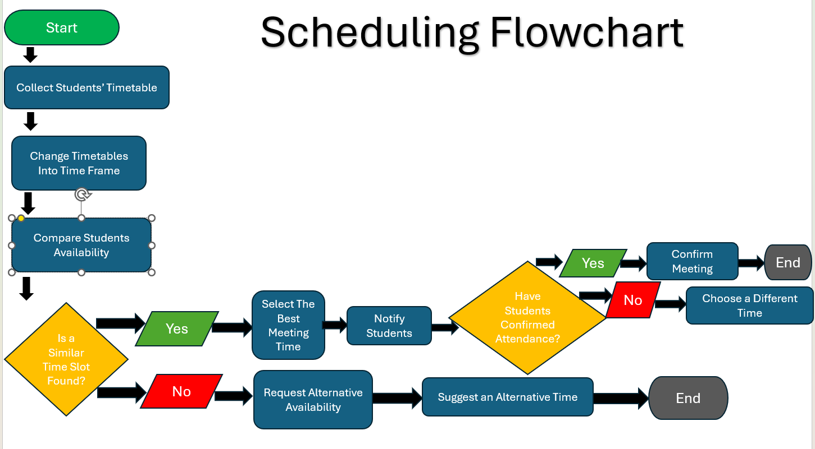
2:2
Stage 1: Collection of availability
This step consists of gathering the required information, such as the following: academic timetable, timing of work, personal commitment and preference. This step is core to obtaining accurate data and using it effectively to increase the likelihood of resolving schedule constraints.

Step 2: Change Timetables into Time
Using and applying information to clear time slots can make the process much easier.

Step 3: Comparing Students' Availability
This step consists of timetables being compared.

Step 4: Is a similar time slot found?
As for now, the system undergoes a check to identify if there are any available suitable time which is suitable for everyone.

If the answer is YES

Step 5: Select the best meeting time
Pick the most appropriate common time slot.

Step 6: Notify Students
Apprise students about the proposed time of the meeting.

Step 7: Have students confirmed attendance?
Wait for students reply.

If YES:

Step 8: Confirm the meeting
Confirm details of the meeting.

Step 9: END
Scheduling the meeting is now concluded.

If NO

Step 10: Change the timing.
Come up with a different available time and redo the confirmation procedure.

If NO from step 5:

Step 11: Request an alternative availability
Ask students to share further times that they are available.

Step 12: Suggest an alternative time
Propose a different meeting time, using the additional data provided.

Step 13: END

Methodology and Evaluation
Implementing a simple prototype that asks members within the group for their availability and uses the proposed constraint propagation alongside heuristic search. Test it with up to 12 groups across one academic term, then compare its performance with the usual way of arranging team meetings. Assess the following: attendance rate, fairness of scheduling and the completion of tasks, to help you gain an understanding of how effective the strategy is and find out the weak areas which need further improvement before real-world deployment. It is essential to compare results by evaluating proportions, averages and feedback on the usability and fairness.

3: Reflection and Justification

There are several problem-solving techniques to develop a solution. Subdividing the problem into smaller, manageable components. Using Abstract thinking eliminates less relevant content and focuses on the key points such as availability, deadlines and conflicts.[6] The actions I took contributed to the development of a versatile solution that extends its usefulness beyond one student group.

This approach is appropriate because it integrates key principles of prioritisation, optimisation, and systems thinking. MoSCoW analysis supports in distinguishing critical stakeholder needs from the least important requirements, while constraint-based logic enabled the efficient selection of feasible meeting schedules.

A major benefit of the proposed solution is how simple the process is; individuals are only required to provide their availability information, while the scheduling process is conducted according to clear logical rules. In addition, it is highly scalable, allowing the same method to be used either manually or through software.

Despite this, limitations may still arise. Changes in availability can have a drastic impact on the overall quality once the meetings have been arranged and confirmed.
Additionally, the algorithm assumes all individuals are equally willing to attend scheduled meetings/sessions; however, human behaviour is unpredictable.

Reflecting on my own personal experience working on group projects, I gained firsthand insights into the challenges we faced in arranging team meetings. Most students in my group had part-time jobs and family commitments, which limited collaboration, as not everyone could attend team meetings. Causing several conflicts, an uneven workload share and a reduced level of overall performance. This led to the necessity of developing a proposed solution to aid in
Using systems thinking and decomposition helped break down the complex issue into simple and manageable components. This promoted a better understanding of which actions to take to improve the chances of conducting team meetings successfully and meeting project objectives.

Conclusion
Throughout this report, I examined the problem of coordinating group meetings, identifying the key reasons such as academic timetables, employment commitments and personal responsibilities, all of which can hinder scheduling meetings. A structured analysis of the implications was utilised by implementing computational skills, decomposition, abstraction, MoSCoW, and systems thinking. This approach assisted in identifying and evaluating the important factors, such as the constraints and variables that all affect the difficulty in scheduling.

I approached the scheduling implications by designing a clear, logical solution in a step-by-step flowchart, as indicated within this report. The goal was to reduce conflicts and make it easier for groups to arrange meetings. Through this process, I have gained an understanding of how important combining optimisation principles with a consistent decision-making process, which positively impacts teamwork in both academic and professional environments.

References
- [1] J. M. Wing, “Computational Thinking,” ResearchGate, vol. 49, no. 3, pp. 33–35, Mar. 2006, Accessed: July 17, 2026. [Online]. Available: https://www.researchgate.net/publication/274377900_Computational_Thinking
- [2]E. Miranda, “Moscow Rules: A Quantitative Exposé,” Lecture Notes in Business Information Processing, vol. 445, pp. 19–34, 2022, doi: 10.1007/978-3-031-08169-9_2. Moscow Rules: A Quantitative Exposé | Springer Nature Link
- [3]E. K. Burke and S. Petrovic, “Recent research directions in automated timetabling,” European Journal of Operational Research, vol. 140, no. 2, pp. 266–280, July 2002, doi: 10.1016/s0377-2217(02)00069-3. Recent research directions in automated timetabling - ScienceDirect
- [4] R. Qu, E. K. Burke, B. McCollum, L. T. G. Merlot, and S. Y. Lee, “A survey of search methodologies and automated system development for examination timetabling,” Journal of Scheduling, vol. 12, no. 1, pp. 55–89, Oct. 2008, doi: 10.1007/s10951-008-0077-5. A survey of search methodologies and automated system development for examination timetabling | Journal of Scheduling | Springer Nature Link
- [5] J. Song, Z. Ashktorab, and T. W. Malone, “Togedule: Scheduling Meetings with Large Language Models and Adaptive Representations of Group Availability,” Proceedings of the ACM on Human-Computer Interaction, vol. 9, no. 7, pp. 1–24, Oct. 2025, doi: 10.1145/3757513. Togedule: Scheduling Meetings with Large Language Models and Adaptive Representations of Group Availability | Proceedings of the ACM on Human-Computer Interaction
- [6] T.-T. Wu, Andik Asmara, Y.-M. Huang, and Intan Permata Hapsari, “Identification of Problem-Solving Techniques in Computational Thinking Studies: Systematic Literature Review,” SAGE open, vol. 14, no. 2, Apr. 2024, doi: 10.1177/21582440241249897. Identification of Problem-Solving Techniques in Computational Thinking Studies: Systematic Literature Review - Ting-Ting Wu, Andik Asmara, Yueh-Min Huang, Intan Permata Hapsari, 2024

