Stage 3 Written Report

BA (Hons) Music Performance and Production
2018

Contents Page

Page 1 – Front Cover
Page 2 – Contents Page
Page 3 – Abstract/ Introduction
Page 4 – Introduction
Page 5 – Background Research/ The definition of teaching/ The Role of a teacher
Page 6 – The role of a teacher/ How to become a teacher
Page 7 – Annual salaries of teaching occupations/ Lesson observation
Page 8 – Lesson Observation/Methodology/Questionnaire
Page 9 – Lesson Design
Page 10 – Schemes of work/ Teaching techniques applied
Page 11 – Teaching techniques applied
Page 12 - Analysis of design and the result of final design/ Teaching Pedagogy Development
Page 13 – Teaching Pedagogy development/ Lesson plan development/ Personal Development
Page 14 – Conclusion/ Future Work and study limitations
Page 15 – Future work and study limitations
Page 16 – References
Page 17 – 39 – Appendices
Abstract
The primary purpose of this project is to conduct research within a personal area of interest to develop an artefact that has progressed over the course of sixteen weeks. In this case, the personal area of interest was to show progression in the field of a music teacher delivering weekly lessons in a primary school. The main factor behind this choice of project was to create a stepping stone into the field of teaching, and this project provided the relevant experience that will lead onto studying a teaching qualification in future. The major project unit is an asset to this course as it provides students with the opportunity to experiment, experience and make mistakes within the process of learning which assists them into creating a career path as university ends. The following report will demonstrate the process of this major project within a critical analysis, that will clearly display the stages on how the project was a success.

Introduction
Music is a powerful subject that can influence anyone of any age. As an aspiring teacher this major project was tailored towards becoming a versatile music teacher that can teach a variety of age groups. Throughout this process, the main goal was to develop the relevant skills as a teacher to enable the chance of delivering effective lessons that could be tailored to suit educational platforms such as primary schools, secondary schools, colleges, and universities. The key inspiration for this project originated from the ‘Community Music’ unit of the second year FDA course. The main task of that unit was to deliver a community music session at a school, a community centre, a hospice, or an out of education club. The FDA class decided to tackle a 1-hour lesson at Creunant primary school and were assessed on their teaching skills which covered classroom control, behaviour management, and lesson presentation. Having enjoyed that unit and being inspired by it, this project became a swift decision into targeting the teaching sector and developing within it. Teaching is a very rewarding occupation as you can witness your own personal growth and development and that of the people you teach.
To begin this process, an investigation took place that was set out with the intention on finding what different age groups would be the most suitable to educate. The findings presented that pupils in primary schools range from ages 5 to 11, secondary schools range from ages 11 to 16, colleges range from ages 16 to 18 and universities comprise the age group of 18 plus. As a rapport with Creunant primary school had already been built the previous year, they were contacted a second time as a level of trust was already in place. Being comfortable with teaching the age group of 5 – 11 and knowing that Creunant are a school that lacks in depth of music provision, this was an easy choice to make over all other options. Due to Creunant lacking in-depth music lessons, this project would benefit them as they have a music specialist delivering music lessons over the course of sixteen weeks free of charge, which works in their favour financially and provides the pupils with a free 16-week music experience. This is also a two-way relationship as personal teaching skills have developed because they have facilitated the practical element to this project. The nature of this project moulded into becoming an amazing precursor into teaching as it gave the experience of a working music teacher that targeted all angles such as weekly lesson planning, classroom control, behaviour management, teaching techniques and self-confidence, and all of these are very important skills to nurture as a developing teacher.

Background Research
The Definition of Teaching
Before stepping into the shoes of a teacher it was important to understand what ‘teaching’ is and how it works. The function of a teacher is to deliver information to an individual or a group by using language and terms that pupils with mixed abilities can understand, and (Heick 2015) heightens the meaning of teaching within its function by stating “teaching means to help another person understand why something is worth understanding”. (Walker 2008 pp. 9 – 11) provides a backbone to give a further understanding of the teaching definition with stating that teachers play an extensive role in the development of a pupil. Understanding a pupil’s needs and knowing their strengths and weaknesses opens the window to give effective and progressive lessons that can impact an individual student or groups of students.
The Role of A Teacher
In general, the basic role of a teacher is to plan lessons and execute them while assisting the growth and development of the pupils in the class. However (Cox 2018) governs that teaching is far more than this by stating “teachers often carry the roles of a surrogate parent, class disciplinarian, mentor, counsellor, book-keeper, role model, and planner”. By understanding the statement from Cox, it proves that the role of a teacher is also orientated around the factor of building relationships by being a role model to the class. The duties within a formal teaching profession have wide variety of tasks and challenges that must be undertaken over the course of an academic year. (Kelly 2017) presents these challenges by expressing that “planning, developing and organizing instruction, house-keeping and record-keeping, managing student conduct, presenting subject material, assessing student learning, and meeting professional obligations”. By analysing these findings, it shows that teaching is a very diverse profession that requires dedication, discipline and personal organization.
How to Become a Teacher
The paths into becoming a teacher are all different and can depend on what subject you want to teach and where you want to teach. Many routes into this require the candidate to have prior teaching experience or academic qualifications as entry requirements. The requirements for teaching in primary or secondary schools are very similar as you must have GCSE qualifications, an A level or a national diploma and a degree. As they are entry requirements that lead you onto studying a PGCE (post graduate certificate in education), a PDGE (postgraduate diploma in education) or to gain the QTS (qualified teacher status) qualification. The qualification requirements to teach in a college or university are diverse as you need a degree, a PGCE or a PCET (post compulsory education and training), and you can also teach in a university if you have a Master’s Degree qualification. Achieving a teaching qualification can give a job seeking teacher an advantage over unqualified applicants as the teaching qualification has many attributes that schools, colleges, universities or teaching agencies favour. Unqualified teachers can teach in many circumstances but are normally directed in the role of a teaching assistant, that can vary from different duties such as leading a class or assisting one, and, in many cases, the annual salary can differ.

Annual Salaries of Teaching Occupations
Teaching is a personally rewarding profession that can also be financially rewarding and salaries can depend on where you teach and at what level. The average salary of a qualified primary school teacher is £24,787 and a salary increase can be determined by the years of teaching experience and teacher status, see appendix (4). The average salary of a secondary school teacher is £29,094 and it can increase on an annual scale through experience and gaining a higher teaching status in the school by delivering extracurricular activities or taking on additional duties, see appendix (5). The average salary of a college or university lecturer are similar as they are both calculated at a median of £27, 197 and pay rises can increase annually depending on teacher status and experience in the occupation and can also increase by delivering extracurricular activities or taking on additional duties, see appendix (6) for an example. The salaries above have been calculated from (PayScale 2018) and the purpose of the PayScale calculator is to find out the average annual salary of almost any occupation based in the UK or US. Examining the salaries of various teaching occupations gave a clear idea of the potential earnings that could be gained when qualified as teacher.
Thursday 16th November 2017 Lesson observation
The first visit to Creunant primary school played an important part in defining the project as it investigated the characteristics of two contrasting classes to find out which class would be the most suitable to teach. Within the first ten minutes of each lesson, observations were made on how the main tutors of each class delivered their sessions, as it gave an idea into the requirements of controlling each session comfortably. This was achieved by listening to the way the class tutor spoke to the pupils and delivered the content within the lesson, the negative side to this is that every individual teacher has their own approach to the delivery of content, by using different methods of teaching. The positive aspect to witnessing their main tutor deliver a session, was to gave a clear idea on how to adapt teaching methods to suit that particular class. The first observation monitored a year 3 class that consisted of 19 pupils with ages from 7,8 and 9. This class had a variety of mixed abilities which varied from highly academic pupils, to pupils who struggled with numeracy and literacy. The second observation monitored a class called the ‘Nurture Group’ which are a mix between year 2 and year 4 pupils. The nurture group are made up from pupils who are servilely autistic and encounter daily social impairments and are supervised by two LSA teachers who specialise in the field of special needs teaching.

Methodology
Questionnaire
The next step in the process was to provide the pupils with a questionnaire that consisted of elementary questions on what they enjoy about music, and the prime purpose of this was to build a relationship with them and learn about them. As there was a restriction of 1 hour many of the pupils did not get the opportunity to answer everything, the questionnaire can be found in appendix (1). The questionnaire produced the relevant results that were put into characteristic profiles which displayed what each pupil answered, and example of this can be seen in appendix (2) and (3). By understanding the individual’s characteristics and knowing their interests it made it easier to establish what music topics to deliver and how it could be adapted to suit them individually. By analysing the characteristic profiles of each class, it concluded that both classes would love more music lessons and that all pupils could benefit from them. The final choice resulted in choosing class one as it would be a challenge due to the number of pupils and this provided the opportunity to deliver academic music lessons to a class that has a mixture of abilities.
Lesson design
By finding out that the music lessons in Creunant school were built around topics such as ‘impersonating an animal to music’ and ‘making music that demonstrates ‘rainfall and water’ the lesson design to this practical element of the project became an instant decision in setting fun academic activities that demonstrate the fundamentals of music and initially progressing on what topics they have already covered. All information on all set compulsory lessons were gathered by conversating with the original tutor. To begin the lesson design a lesson plan had to be created to give every session a structure that meets the timescale of 1 hour, and (Singh 2008 pp. 28-29) has provided an in detail view on the purpose of a lesson plan that stated “lesson plan is the title given to a statement of the achievements to be realized and the specific meaning by which these are to be attained as a result of the activities engaged during the period”. Singh’s statement means that a lesson plan is a document that includes a topic that has stages or tasks to be undertaken within a timescale with a premeditated achievement in mind.

Schemes of work
Understanding now what a lesson plan is and how it works, the lesson plans were created for the following topics that were decided upon to aid the progress of the pupils in each session. After each session the pupils were given options of different topics they could choose from and class votes took place to determine what to study next. By the class deciding on what they wanted to learn each lesson, this aspect gave the pupils an opportunity to lead their own education and to learn what they are interested in. An example of the first lesson plan can be seen in appendix (7).
The topics covered throughout this process were instrument types instrument components, the names of notes, the rhythmic value of notes, major and minor tonality, key signatures, studio components, what is rhythm, and writing and performing a rhythmic graphic score. Within each topic there were a variety of worksheets that the pupils had to undertake to demonstrate their knowledge of the subject and each worksheet was designed in a simple format that prevented any confusion within the class. A display that contains a variety of different worksheets that were undertaken can be seen in appendix (8), and a full timeline of every session can be seen in appendix (9).
Teaching Techniques Applied
To progress as an aspiring teacher, it was very important to research and experiment with different teaching techniques as they can be used to enhance the education of an individual student or an entire class, and this section presents the main techniques that have been researched and applied. The main class tutor provided feedback on each session which was used to personally reflect and to progress from one session to the next, and many of these feedback sheets entailed techniques to use or to try, see appendix (10) for a display of feedback sheets. The class tutor recommended using a technique called ‘freeze time’ which is used to get the attention of the entire class by shouting “freeze” and within this process all the pupils would remain quiet and still while the tutor would assist each table or group equally. The ‘freeze time’ technique worked well as it provides a tutor with the opportunity to check everyone’s work equally with no interruptions. The class tutor also recommended adapting ‘Freeze time’ to a different situation. For example: when a pupil is stuck on something shout “freeze” to the whole class and ask a volunteer to help the pupil. By using and adapting the ‘Freeze time’ technique it provided a positive result as it helps the pupils learn from each other in a quiet environment. In this case the pupil began to understand the topic at a deeper level and this technique was predominantly used in the session on key signatures.
An additional technique that was used was a ‘Heuristic’ teaching method, (Davar 2012 pp. 163-165) expresses that “Minimum guidance is given by the teacher in setting up and carrying out the experiments. Therefore, any student-centred method which places students in the position of a discoverer and generates an attitude of discovery in them is called heuristic method”. The ‘Heuristic’ teaching method was applied during the rhythmic graphic score sessions, as three different groups had to compose and perform a rhythmic extract. Within this process the pupils had to make appropriate musical decisions within their composition and work as a team. At the end of every graphic score session each group were required to perform the extract in front of the class, and the benefit of this was it gives the pupils a chance to promote what they have created to their peers. By the groups knowing they have a performance at the end of this session all the pupils had to remain engaged throughout this process to complete the end task. By only assisting the behaviour of each group the heuristic aspect was that all groups had the freedom to compose what they wanted and experiment with what works musically and what doesn’t, if the pupils got themselves in a major situation where they couldn’t find a solution, further assistance would be given on solving the issue. The heuristic approach within the three graphic sessions went on to assist the pupils in the skills of aural perception, composition and music performance.
By the class learning through the repetition within a heuristic method resulted in a positive as it was set to develop a deeper understanding of musical notation, note value, dynamics and tempo. Many pupils developed a greater sense of self-worth and confidence within the graphic score session as they had to compose and perform in front of their peers in the class, whilst in the process of learning and discovering independently.

Analysis of Design Developments and Results of Final Design
Teaching Pedagogy development
Teaching pedagogy is a term that is used to explain the strategies and attitude of a teacher in the process of undertaking a lesson and a mixture of different pedagogies are seen to affect the education of students in many ways (Kincheloe 2005 pp. 53-54). The progression of pedagogies within this process was continuous and consisted of many strategies such as productive group activities, the development of language, contextualization, independent challenges and teaching through conversation.
The most important aspect of teaching pedagogy, which developed throughout this process was contextualization. (Colwell and Richardson 2002 p. 686) express that “Contextualizing refers to the beginning of a process of self-exploration in which interns examine their own beliefs and actions in light of instructional social realities.” To elaborate on Colwell and Richardson’s definition, the contextualization in this case progressed in the sessions that covered major key signatures and major scales. The contextualization was proven by the pupils understanding different major scales. By means of the pupil maintaining this knowledge they can now apply them to everyday scenarios in composing music and apply these scales to almost any instrument.
Lesson Plan Development
Throughout this process the lesson plan was a developing document that was altered on a weekly basis. The first lesson plan was mostly bullet pointed with subheadings that were listed with numerous tasks. The final lesson plan was far more sophisticated as it provides key vocabulary, key questions, a number of concepts or tasks to undertake in each session and a detailed report on the possible outcomes of each session. The positive aspect for this development was to prevent any confusion within each task and to allow stability and precision within the delivery of each session. See an example of many lesson plans with this format in appendix (11).
Personal Development
The final design of this project was to personally develop in the shoes of a music teacher over a sixteen-week period. By deciding to tailor the major project towards teaching it resulted in the development of many personal skills such as self-confidence, punctuality, teaching skill, behaviour management, public speaking, organisation and controlling a class. The overall outcome of this process resulted with being able to deliver effective music lessons. By nurturing these important personal skills over a weekly interval period made the goal of delivering effective music lessons a reality.

Conclusion
In conclusion, by fully committing myself to the research and application of teaching and teaching techniques within the teaching role, I now have the skill to control a large class and provide equal assistance to all pupils. This experience provided me with a clear idea of what it is like to be a music teacher in a primary school, and it was a very rewarding process as all pupils enjoyed and benefitted from all sessions. The pupils were disappointed that I was leaving and all pupils would have continued to do more music lessons if they had the opportunity.

Future Work and Study limitations
The next step to progress from here is to either study a PGCE or a PCET as I have a very keen interest in pursuing a career in that field of college or university lecturing. Leading forward into my career I have learned that being a teacher is not all about the subjects you teach, it is about how you teach them. By supporting and assisting all pupils through fun and academic activities, you can almost get all pupils to learn any subject if the delivery of it is precise. The weakness of this project was that it was only set in a primary school, and it was limiting as there was only one age group.
By tackling this project, a second time around I would design a music programme that could be offered to schools, colleges, and universities as there would be multiple year groups. This would be challenging as all the topics would have to be delivered in different depths and stages. By undertaking this project, I have developed an important skill-set that I can eventually turn into a profession through the passion for teaching and the education of others.

References

Colwell, R. Richardson, C (2002) The new handbook of research on music teaching and learning: A project of the music educators national conference. Oxford University Publishing. USA. [Accessed 26/04/2018]
Cox, J (2018) What is the role of a teacher? [Online] Available from: https://www.thoughtco.com/what-is-the-role-of-a-teacher-208151 [Accessed 19/04/2018]
Davar, M (2012) Teaching of science. PHI learning Pvt. New Delhi. [Accessed 25/04/2018]
Heick, T (2015) What it means to teach [Online] Available from: https://www.teachthought.com/pedagogy/what-teaching-means/ [Accessed 19/04/2018]
Kelly, M (2017) Six daily tasks all teachers should do [Online] Available From: https://www.thoughtco.com/top-teacher-tasks-8422 [Accessed 19/04/2018]
Kincheloe, L, J (2005) Classroom teaching: An introduction. Peter Lang Publishing. New York, Washington D.C. [Accessed 26/04/2018]
Payscale (2018) Salary data & career research centre United Kingdom. [Online] Available From: https://www.payscale.com/research/UK/Country=United_Kingdom/Salary [Accessed 25/04/2018]
Singh, Y, K (2008) Teaching Practice: Lesson Planning. APH Publishing, Ansari Road, Darya, Ganji, New Delhi. [Accessed 19/04/2018]
Walker, J, R (2008) 12 Characteristics of an effective teacher. Lulu Publishing, 860 Aviation Parkway, Suite 300, Morrisville, NC. [Accessed 19/04/2018]

Appendices

Appendix (1)

Questionnaire

- What is your favourite thing about music?
- What is your favourite band or artist?
- What is your favourite musical instrument?
- As a pupil, would you enjoy more music lesson in your school?

Appendix (2)
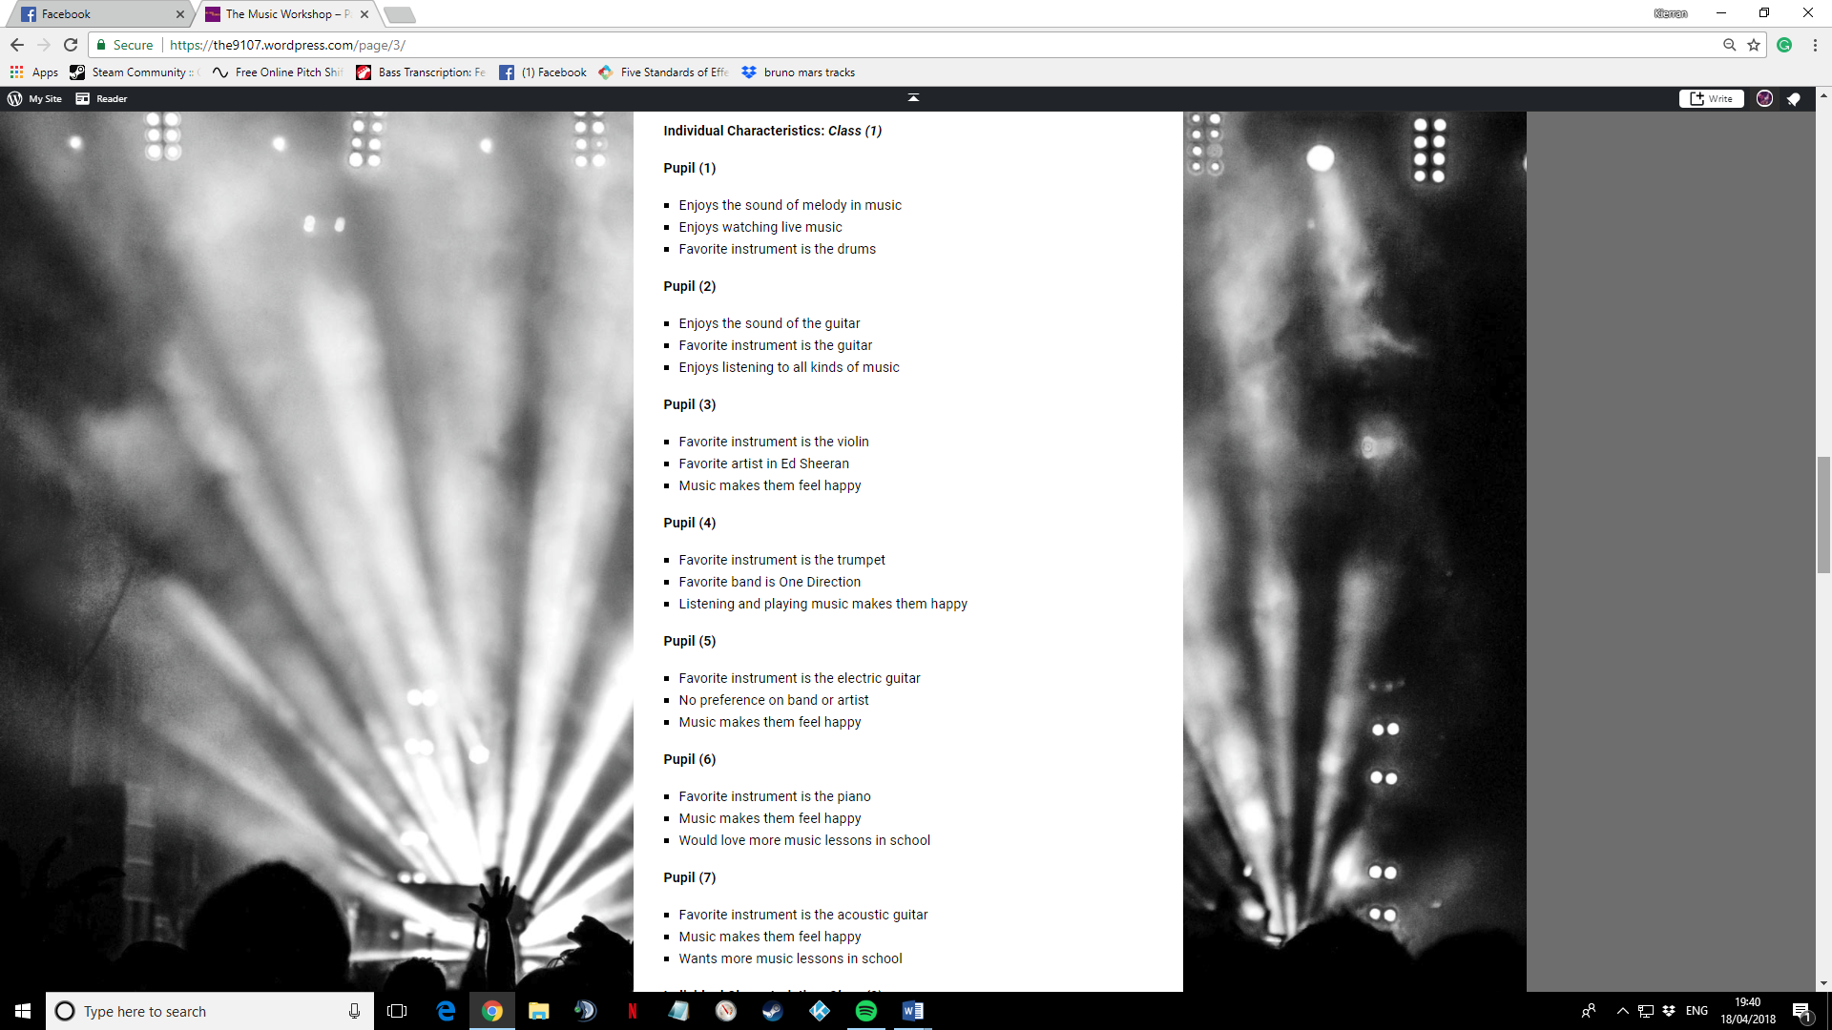

Appendix (3)
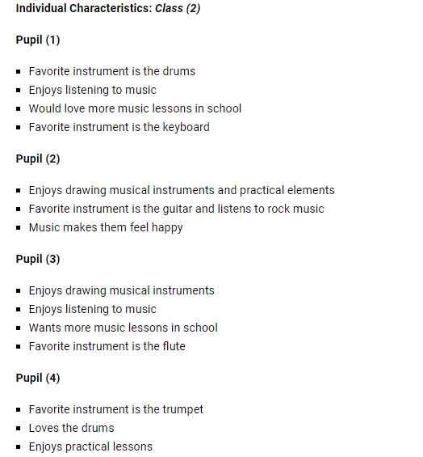

Appendix (4)


Appendix (5)


Appendix (6)


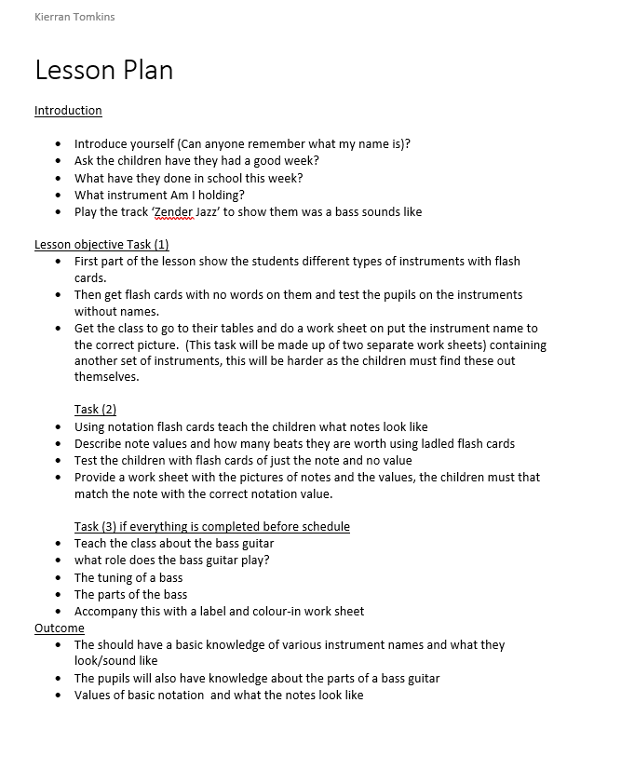
Appendix (7)

Appendix (8)

8.1

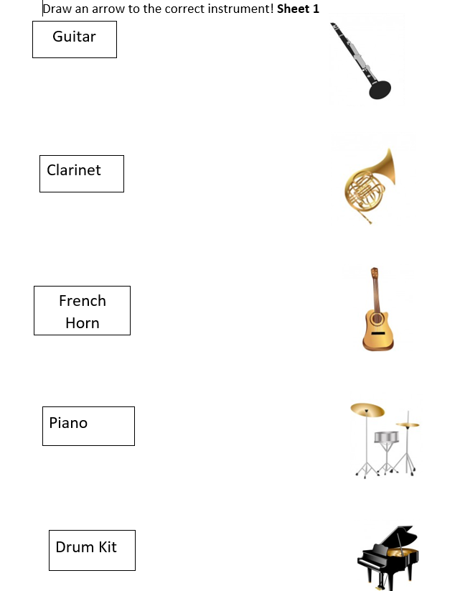

8.2
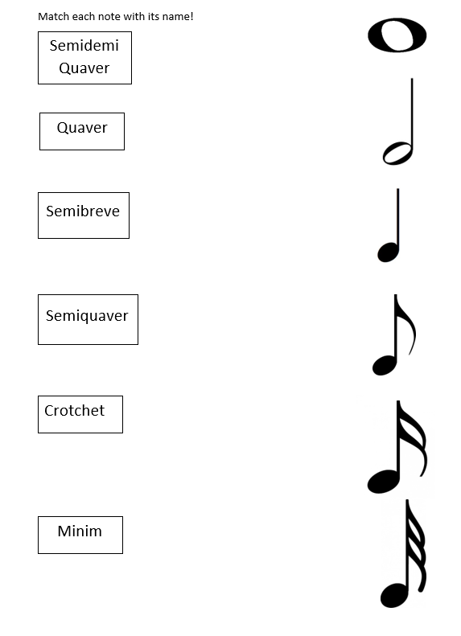

8.3
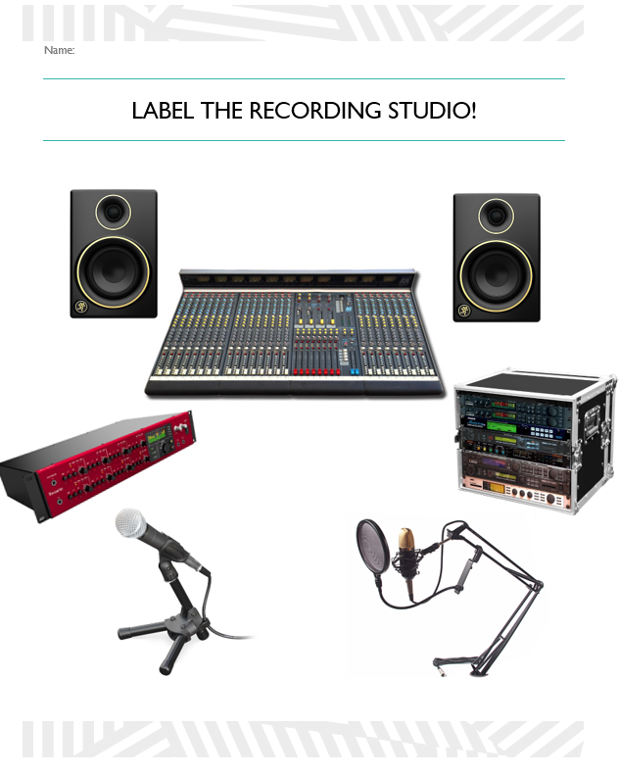

8.4
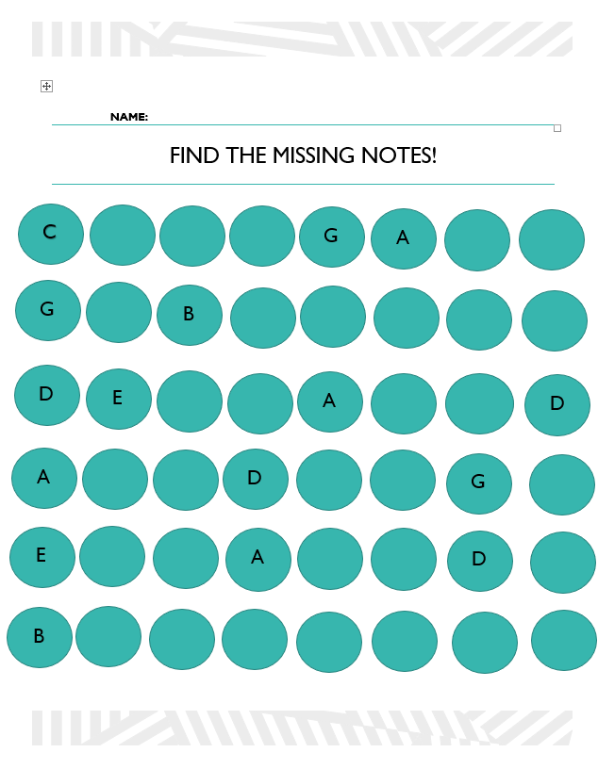

8.5
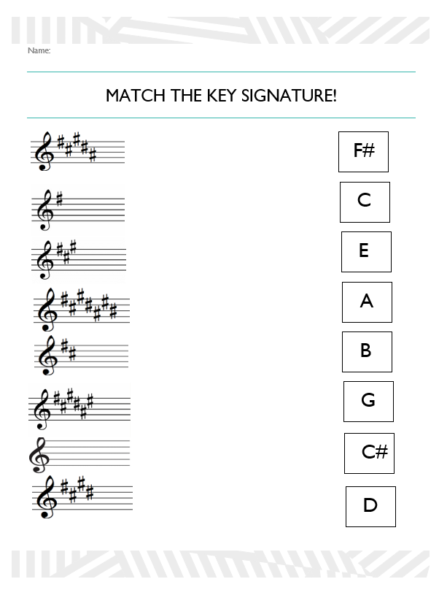

Appendix (9)
Lesson timeline
Thursday 16th November – Lesson Observation
Thursday 23rd November – Introduction Lesson/Instrument Investigation
Thursday 30th November – Notation Lesson
Thursday 7th December – Parts of the bass guitar
Christmas Break
Thursday 11th January – Parts of the drum kit/Major and Minor tonality
Thursday 18th January – Sharp key signatures
Thursday 25th January – Key signatures/ F# to C#
Thursday 1st February – All sharp key signatures and F major scale
Thursday 8th February – Introduction to the recording studio
Thursday 15th February – What is Rhythm/The definition of rhythm
Weather Interruption (Lesson cancelled due to snow)
Thursday 8th March – Graphic Score
Thursday 15th March – Graphic Score with use of dynamics
Thursday 22nd March – Graphic Score with use of different tempos
Thursday 28th March – Recording the graphic score

Appendix (10)

10.01

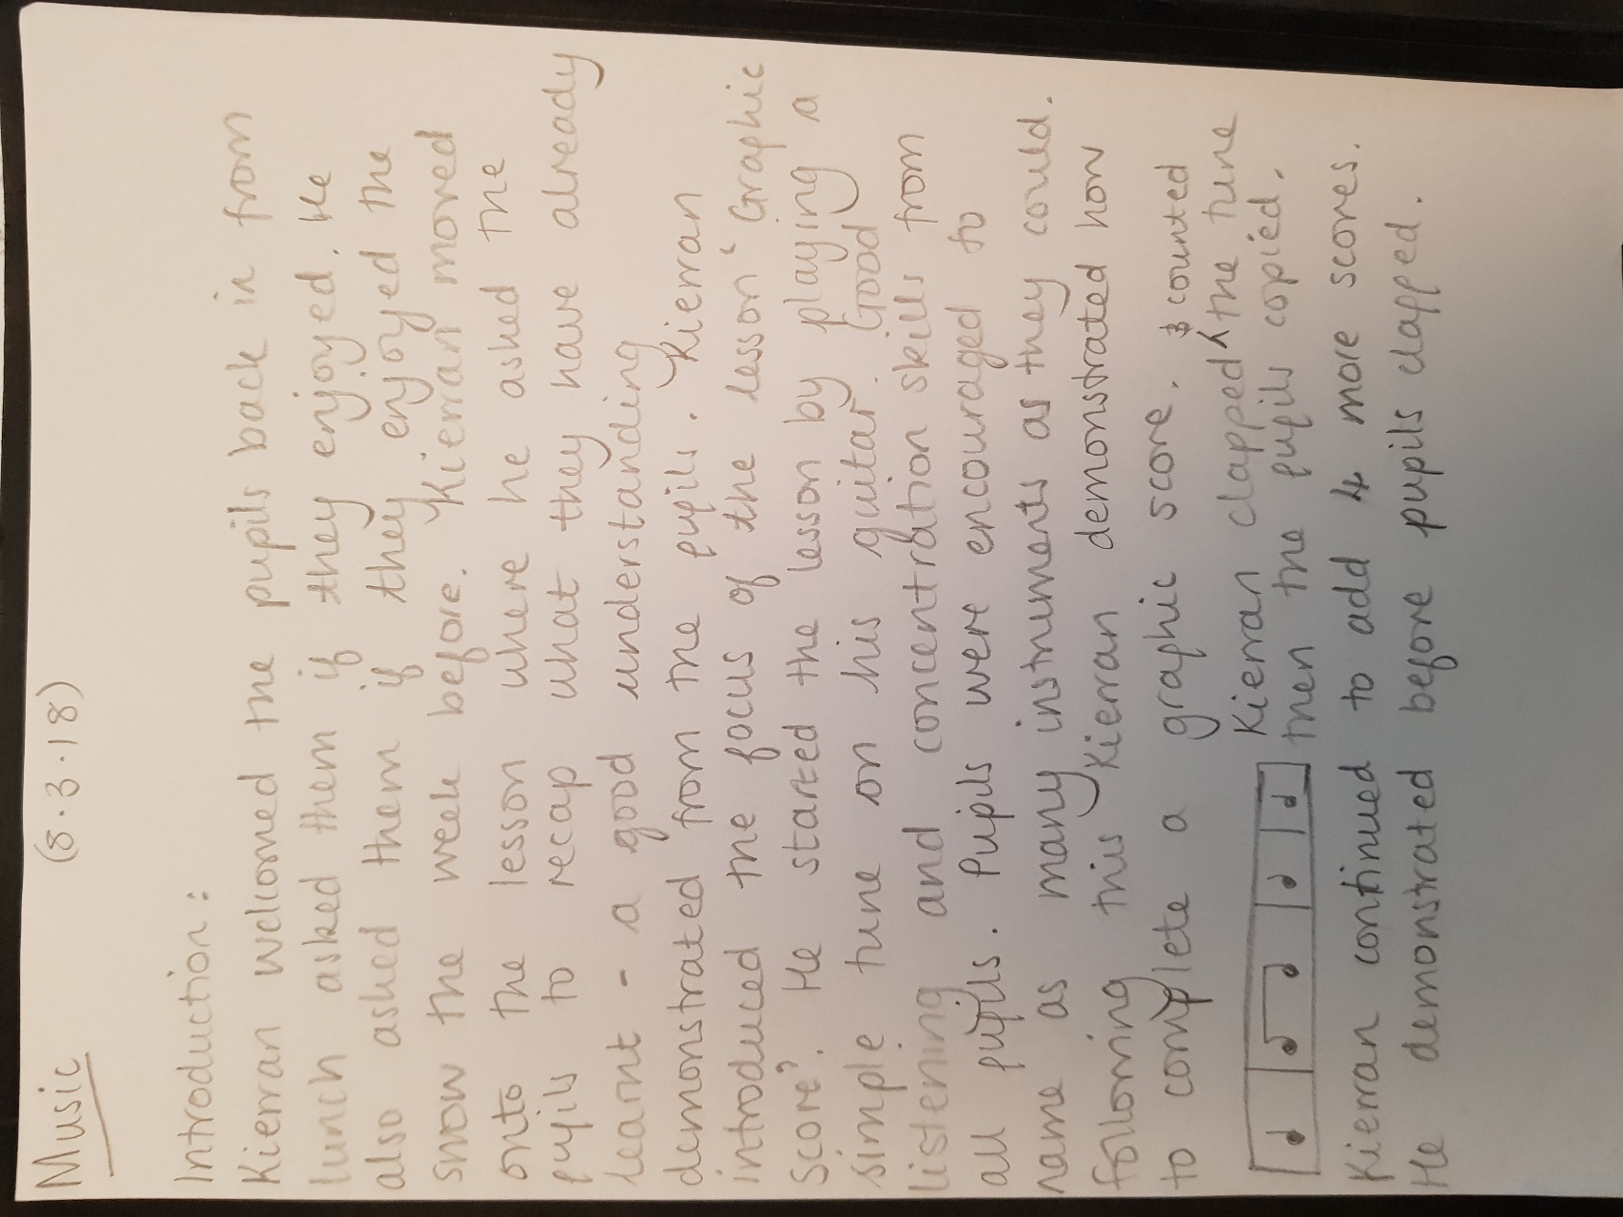

10.02
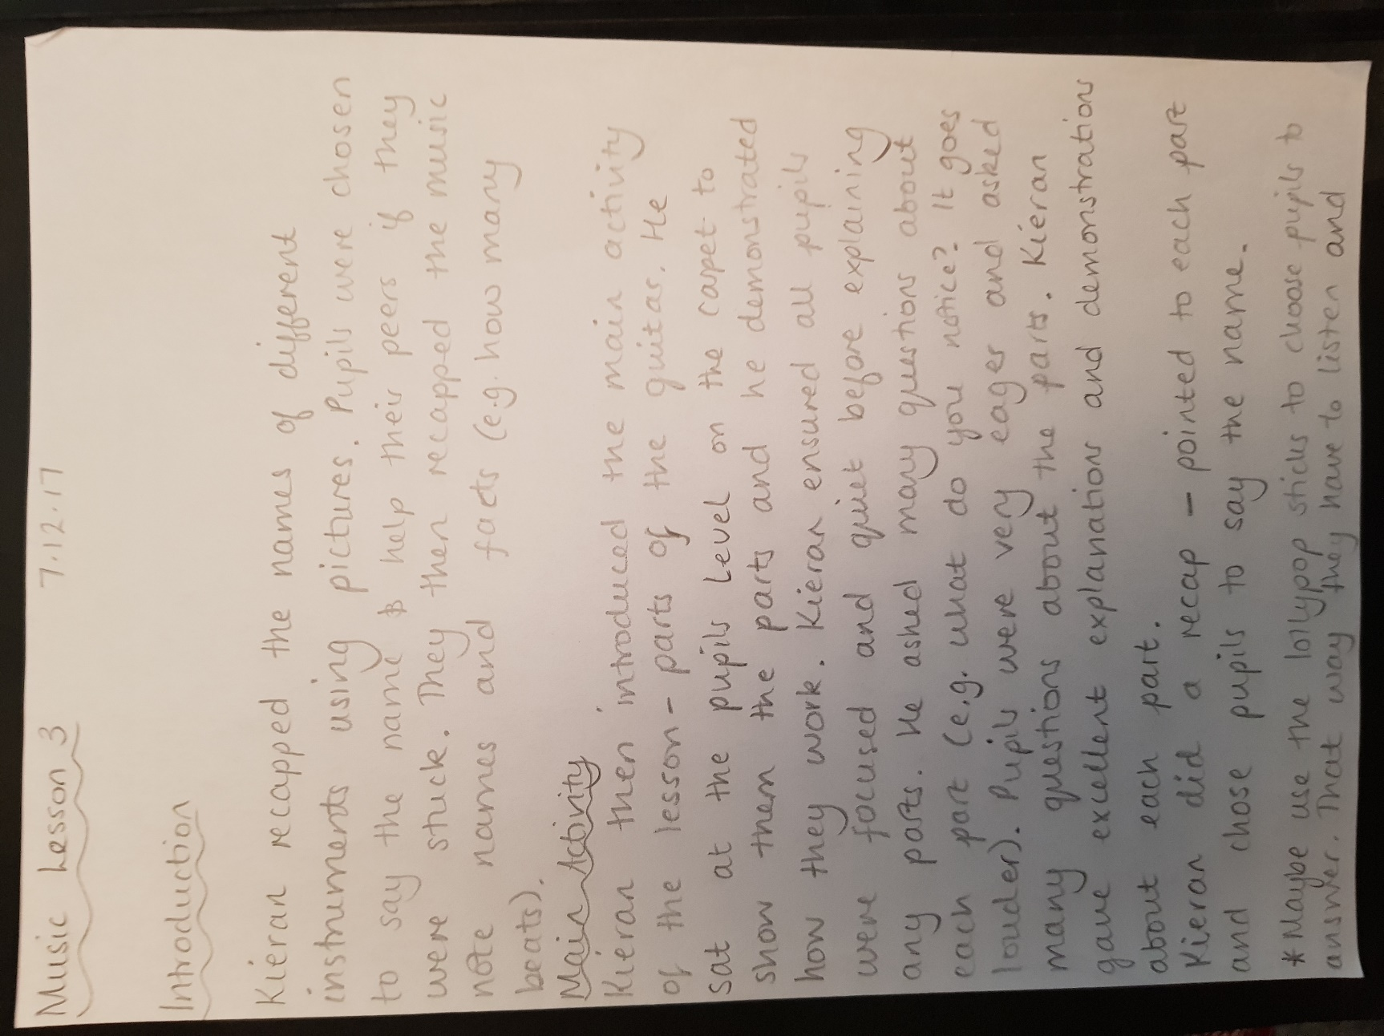

10.03
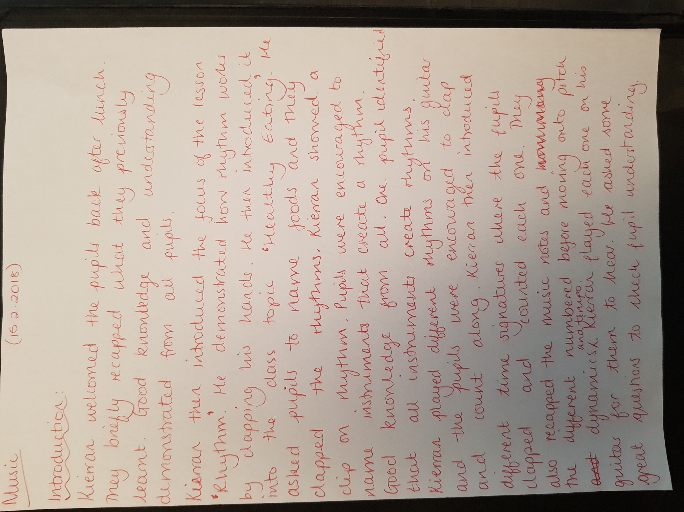

10.04
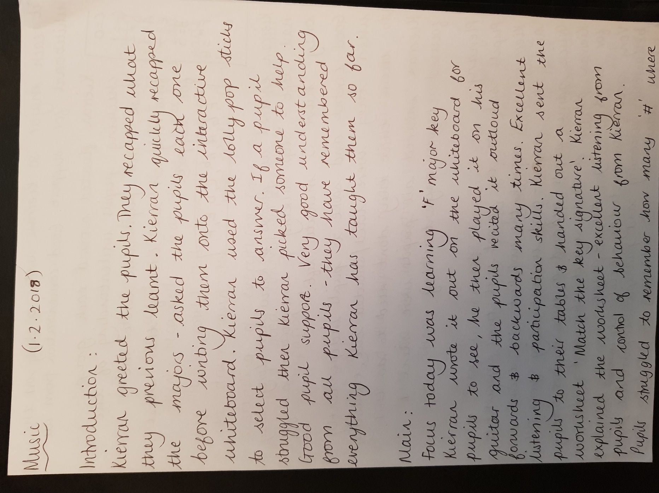
10.05
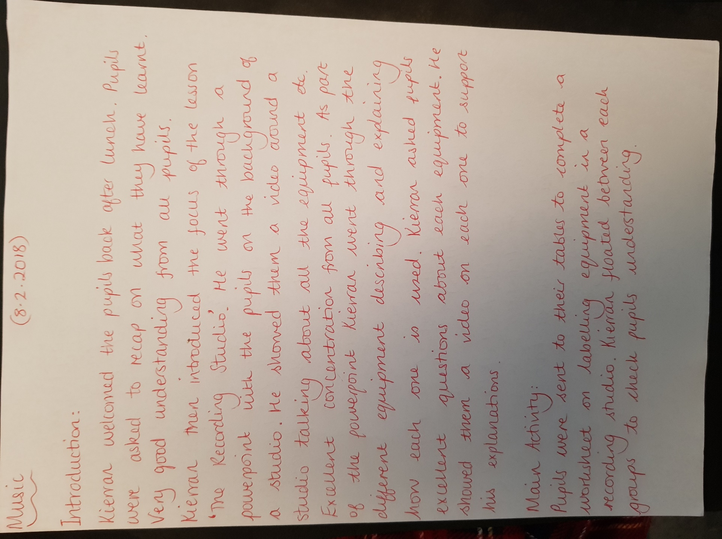

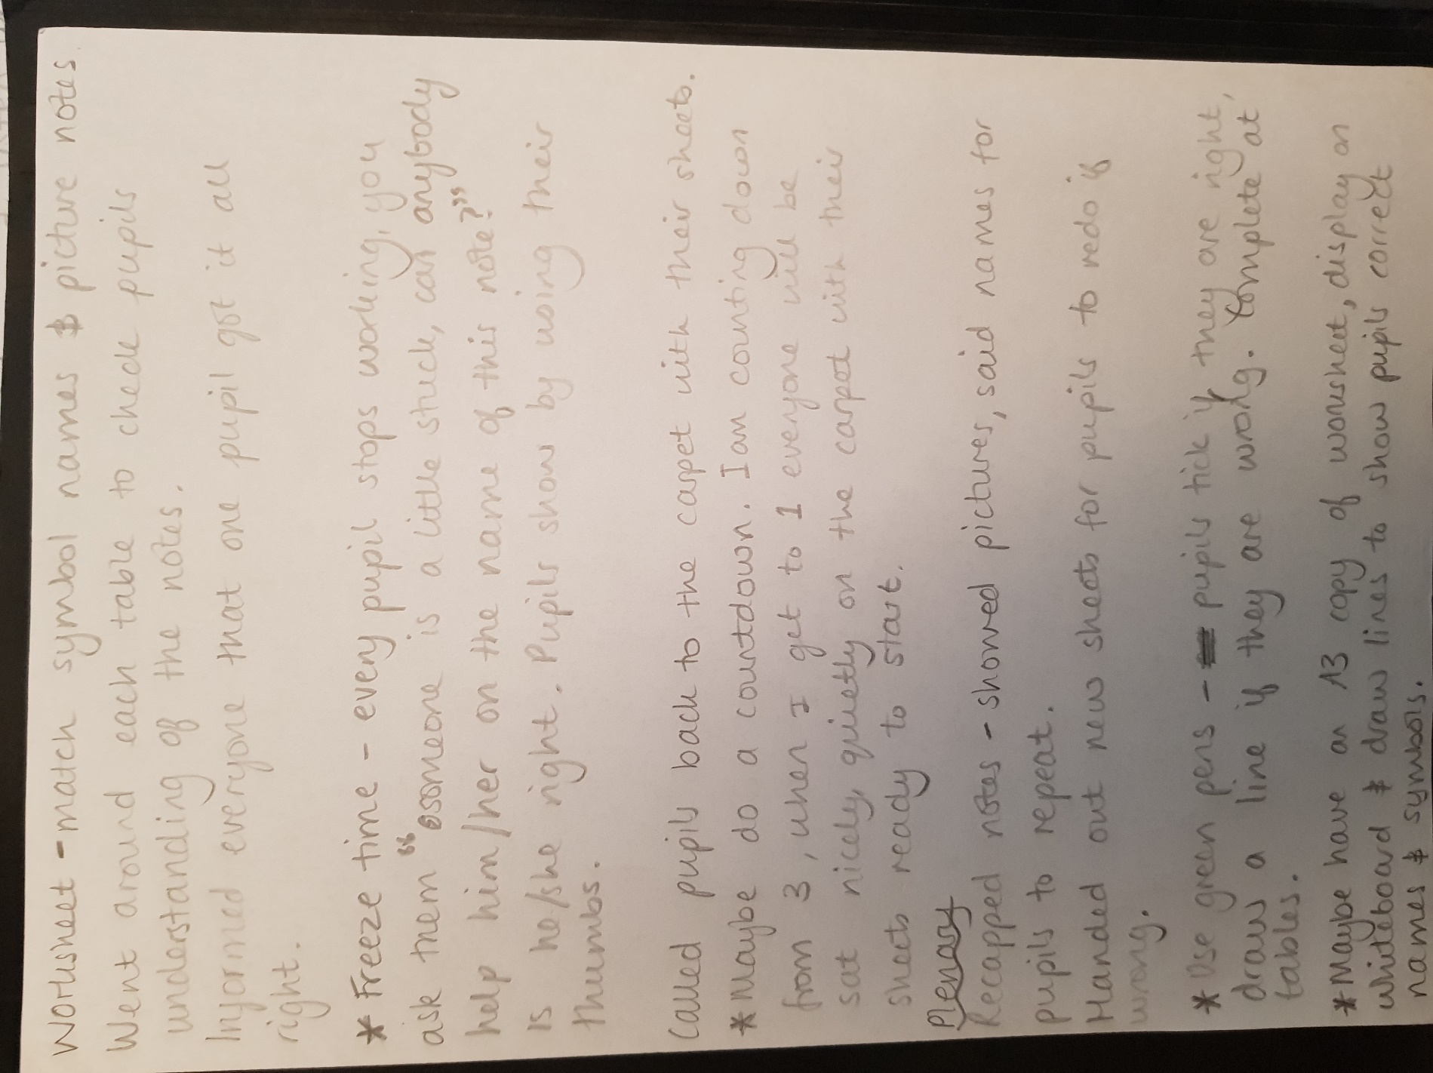
10.06

Appendix (11)

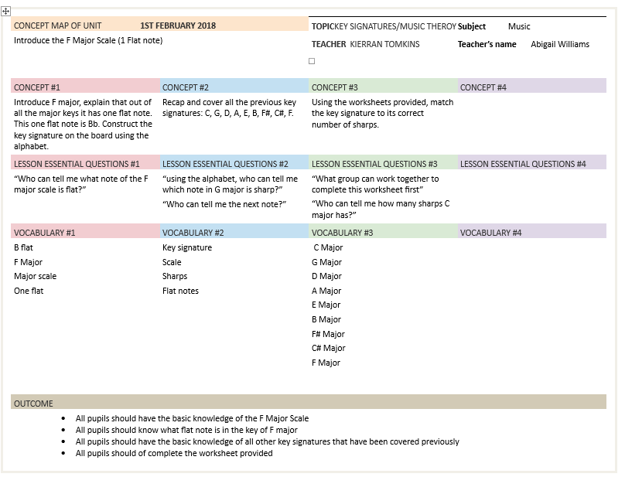
11.01

11.02

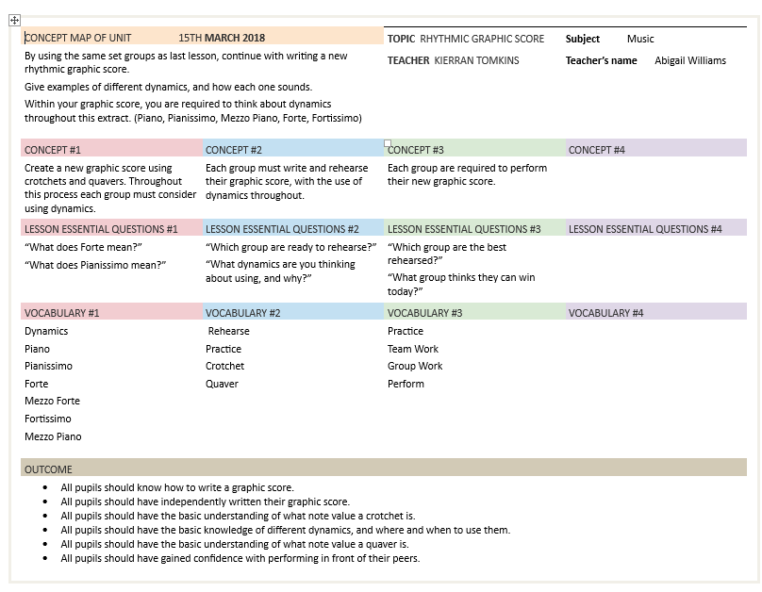

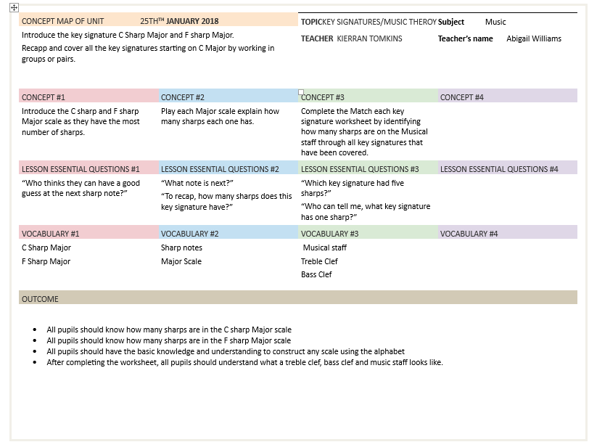
11.03

