

Student name: Kate Omoruyi Monday
Student ID: 2531937

Module name: Health and social care
Module code: LCHS4003
Lecturer name : Muhammad Aliyu

Table of Contents
Task 1 Poster: Pharmacy Services in the UK 3
Task 2: Residential Care Home Services 4
1. Introduction 4
2. Origins and Historical Context 4
3. Current Functioning of Residential Care Homes 4
4. Significance for Quality of Life 5
5. Conclusion 5
References 6

Pharmacy Development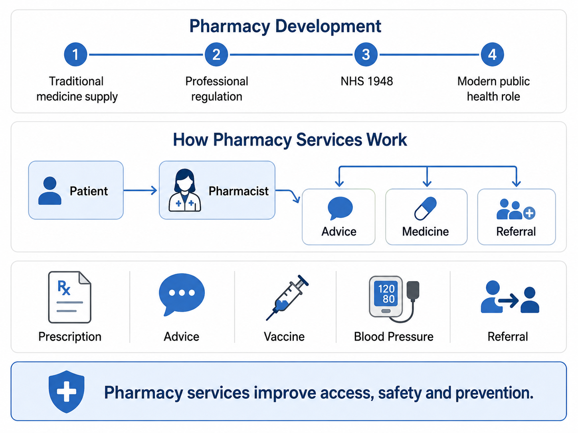

Challenge 2 - Public Awareness and Inequality
- A key challenge for pharmacy services is that some people still see pharmacies mainly as places to collect prescriptions. They may not realise that pharmacists can also support minor illness, prevention, medicine safety, health advice and long-term condition management.

- This lack of public awareness can reduce the effective use of pharmacy services. If patients do not know when to visit a pharmacy instead of a GP, urgent care or hospital, the wider healthcare system may remain under unnecessary pressure.

- Inequality is also an important concern. People in rural areas, deprived communities, disabled patients and those with language barriers may find it harder to access or understand pharmacy support. Therefore, pharmacy services must be clearly promoted, inclusive and accessible so that all groups can benefit fairly (Thomson et al., 2019).

Challenge 1 Workforce and Service Pressure
- One major challenge faced by pharmacy services is increasing demand. Many patients use pharmacies for quick healthcare advice, especially when GP appointments are difficult to access. This increases the workload of pharmacists and pharmacy staff.
- Staff shortages and workload pressure can affect waiting times, service quality and patient experience. Pharmacists must balance dispensing medicines, giving clinical advice, managing services and completing safety checks. When pressure is high, there may be less time for detailed patient conversations.
- Medicine shortages can also make it difficult for pharmacists to supply treatment on time. When a medicine is unavailable, pharmacists may need to contact prescribers, suggest alternatives or explain delays to patients. This can create frustration for patients, particularly when they need regular medicines for long-term conditions.
- This challenge matters because delays in pharmacy services can affect treatment, trust and patient satisfaction. If patients cannot access medicines or advice quickly, they may delay treatment or seek help from already pressured GP and hospital services.

Current Functioning of Pharmacy Services
- In the present-day medicines are dispensed safely in the pharmacy and the meaning of how medicines are used is explained. Pharmacists analyse prescriptions, determine potential drug interactions and counsel patients about proper medication use. This helps increase the security of medicines and prevents unnecessary errors.
- Pharmacies can offer advice on minor ailments like coughs, colds, pain, allergies and skin problems. This is helpful as patients may be able to obtain help quickly without having to wait for a GP appointment. For many, community pharmacy is therefore a first contact service, which can be used easily. But there is a need for proper communication between the pharmacy and GP services, ensuring safe and consistent care for patients (Hindi et al., 2019).
- Some pharmacies will also have vaccination programs, blood pressure checks, contraception advice and smoking cessation. The services illustrate the public health function of the pharmacy: the ability of the pharmacist to prevent disease and promote better health. While public health interventions in community pharmacy can have an impact on population health, the impact will be influenced by service design, access and patient engagement (Thomson et al., 2019).

History of Pharmacy Services
- Pharmacy has evolved from the manufacture, storage and distribution of medicines to becoming a regulated profession in healthcare. Pharmacy was initially mainly oriented towards medicines provision, but with the increasing scientific nature of healthcare, the pharmacist role in medicines safety, patient advice and medicines responsible use became more evident.
- In the UK, the professionalization of pharmacy occurred via professional regulation, the development of the NHS, and medicines legislation. Since the establishment of the NHS in 1948, community pharmacies have been associated with access to public healthcare systems as people could pick up their NHS prescriptions and consult their pharmacists for advice in the local area.
- It's no longer about dispensing in modern pharmacy. Pharmacists are now responsible for prevention, medicine reviews, public health advice and long-term condition management. This change, which is driven by the needs of a population that has a longer lifespan and uses medicines more frequently, has to be supported. Community pharmacy has been acknowledged to be a component of an integrated health care system, beyond simply picking up prescriptions (Hindi et al., 2019).

Task 1 Poster: Pharmacy Services in the UK
Student Name, Course Name, Email Details Go Here

Explanation of Pharmacy Services:
- The role of the Pharmacy service in the UK health and social care system is important in delivering safe access to medicines, health advice, support for minor ill health and public health information. Community pharmacies are typically located in the community and are easily accessible to patients compared to GP surgeries and hospitals.
- Community pharmacists help patients take their medicines as prescribed, they explain how to use the medicines and they check for risks to patients, such as side effects and interactions with other medicines. This enables patients to take medicines safely and helps to prevent unnecessary harm, particularly for those with long-term conditions and multiple prescriptions.
- Medicine reviews & over the counter advice and prevention services are also offered in the pharmacy. Pharmacists will be able to give advice on coughs, colds, allergies, pain and skin conditions. Community pharmacies are appreciated by patients for their accessibility, familiarity and professional advice given without any appointment (Hindi et al., 2018).

Task 2: Residential Care Home Services

1. Introduction
Residential care homes are social care services where people who are not able to live safely on their own are accommodated, and receive personal care and daily support. They are usually used for older people, individuals with frailty, dementia, disabilities or long-term care requirements. The priority of residential care homes is to ensure the safety, dignity and wellbeing of residents. This essay explores the history of residential care homes, their role today and the benefits of good quality of life.

2. Origins and Historical Context
Residential care homes grew out of various institutional care facilities, as well as charitable assistance and local authority welfare. In the old days, the poor, the elderly, the disabled and the incapable to care for themselves were supported by workhouses, religious charities, or local community arrangements. The services provided were primarily focussed on shelter/survival and not on emotional wellbeing and/or choice.
The function of care has evolved over time as a result of the evolution of the welfare state. Social care was increasingly structured and residential care began to be regulated, safeguarded and professionalised. Modern care homes are expected to offer more than housing, they need to offer dignity, independence, safety and person-centred care. This historic change is significant as care has come to be assessed not only in terms of the physical help provided, but also in terms of how well their lives are enhanced (Towers et al., 2016).

3. Current Functioning of Residential Care Homes
Residential care homes today offer accommodation, meals, care and support with personal care, support with medications, safeguarding, and social activities. Residents might require assistance in washing, dressing, feeding, moving, bladder/bowel control and taking medications. Care homes also offer routines and supervision for individuals that could become at risk living alone.
Care staff can range from care assistants/senior carers to nurses, managers and visiting professionals (GPs, district nurses, social workers, therapists). The needs, risks, preferences, medication, communication needs and support needs of each resident are recorded on a care plan. This assists staff to give consistent care and to identify when a person's health or well-being changes.
Residential Care Homes also liaise with families and local authorities to ensure residents are cared for in an appropriate manner. The quality of care can, however, vary. The capacity for services to meet residents' needs can be impacted by staffing pressures, funding constraints or inspection results. Towers et al. (2021) demonstrate that the workforce challenge and quality of care are closely connected, and that good care quality and safe staffing levels are crucial to the quality of residents' lives.

4. Significance for Quality of Life
Residential care homes can improve quality of life by keeping frail, isolated or vulnerable people safe. They reduce risks such as falls, missed medication, poor nutrition and neglect, while also providing regular contact with staff and other residents. Good care homes support dignity through respectful personal care, privacy, routine, nutrition and emotional support. Person-centred care is important because residents should be treated as individuals with choices, preferences and personal histories. Ballard et al. (2018) show that person-centred care and meaningful activities can improve quality of life. However, poor staffing or weak communication can reduce wellbeing.

5. Conclusion
Residential care homes have developed from basic institutional support into regulated social care services. They remain important because they support vulnerable people who cannot live safely alone. Their value depends on good staffing, person-centred care, safeguarding, communication and respect for residents’ dignity and wellbeing.

References
Ballard, C., Corbett, A., Orrell, M., Williams, G., Moniz-Cook, E., Romeo, R., Woods, B., Garrod, L., Testad, I., Woodward-Carlton, B. and Wenborn, J., 2018. Impact of person-centred care training and person-centred activities on quality of life, agitation, and antipsychotic use in people with dementia living in nursing homes: A cluster-randomised controlled trial. PLoS medicine, 15(2), p.e1002500.
Hindi, A.M., Jacobs, S. and Schafheutle, E.I., 2019. Solidarity or dissonance? A systematic review of pharmacist and GP views on community pharmacy services in the UK. Health & social care in the community, 27(3), pp.565-598.
Hindi, A.M., Schafheutle, E.I. and Jacobs, S., 2018. Patient and public perspectives of community pharmacies in the United Kingdom: a systematic review. Health Expectations, 21(2), pp.409-428.
Thomson, K., Hillier-Brown, F., Walton, N., Bilaj, M., Bambra, C. and Todd, A., 2019. The effects of community pharmacy-delivered public health interventions on population health and health inequalities: A review of reviews. Preventive Medicine, 124, pp.98-109.
Towers, A.M., Smith, N., Allan, S., Vadean, F., Collins, G., Rand, S., Bostock, J., Ramsbottom, H., Forder, J., Lanza, S. and Cassell, J., 2021. Care home residents' quality of life and its association with CQC ratings and workforce issues: the MiCareHQ mixed-methods study. Health and Social Care Delivery Research, 9(19), pp.1-188.
Towers, A.M., Smith, N., Palmer, S., Welch, E. and Netten, A., 2016. The acceptability and feasibility of using the Adult Social Care Outcomes Toolkit (ASCOT) to inform practice in care homes. BMC Health Services Research, 16(1), p.523.

