ACDA5025 Engineering and Project Management Assignment

Smart Energy Monitoring and Load Control System for Residential Use – Business Proposal

Charlie Rainey

2414414

14/07/2025

Total Word Count: 2,489

Table of Contents
Table of Figures 2
Abstract 3
Introduction 4
Aims and Objectives 5
Background Research 6
Project Design 7
Resources 9
Planning 10
Expected Outcomes and Deliverables 14
Risk and Ethical 15
Conclusion 18
References 19

Table of Figures

Figure 1 - Block Diagram of Design 7
Figure 2 - Critical Path Analysis 8
Figure 3 - Smart Energy Monitoring Control System Gantt Chart 10
Figure 4 - Gantt Chart Breakdown 11
Figure 5 - Gantt Chart Breakdown 12
Figure 6 - Equality and Diversity certificate 16
Figure 7 - Prevent certificate 17

Abstract

This project proposes the design and build of an IoT-based smart energy monitoring system that tracks and controls the power usage of home appliances in real-time. It includes automatic load balancing and disconnecting non-essential appliances during peak times or high tariffs, helping reduce electricity bills and energy waste. Throughout the design there has been consideration to environmental, societal and ethical impacts which has had a big effect on the proposal and helped shape the final project. Numerous different techniques have been used through out the proposal to help plan the project, prevent any risks from occurring and even to helping design the project. A training course on prevent has been completed as well as a training course on equality, diversity and inclusion.

Introduction

Electrical energy is becoming more and more essential to modern cultures, especially in homes where the number of power-hungry gadgets keeps growing. Consequently, there is an increasing demand for more intelligent and effective ways to control residential power use. In order to help households, monitor, assess, and improve their energy usage in real time, this project suggests creating a smart energy monitoring and load control system. In order to automate load management and provide feedback, the system will combine wireless connectivity, microcontrollers, and sensors, thereby fostering sustainability and cost savings. This proposal aims to address the urgent need for better household energy management by designing and building a Smart Energy Monitoring and Load Control System for residential use.
This system will allow users to monitor real-time energy usage at the appliance level, receive actionable insights through a user interface, and automatically control or prioritise loads based on defined thresholds. Through the use of microcontrollers, current sensors, and IoT connectivity, the system will not only provide transparency but also enable automation to reduce unnecessary consumption and improve energy efficiency. All while assessing ethical considerations for the project and making sure that equality and diversity is included throughout to make the project user friendly.

Aims and Objectives

There are 5 key objectives of the proposed project, and these are:
- To develop a real time energy monitoring system that tracks household energy consumption at the appliance level
- To provide users with a mobile or web interface to visualise energy usage and receive actionable insights
- To implement load control features that allow users to automate and prioritise energy consumption
- To ensure the system is scalable, low cost and user friendly for widespread domestic application
- To assess the environment, societal and ethical implications of deploying such system whilst including equality and diversity

Background Research

Households across the world use energy for multiple purposes, the most common being lighting, heating, cooking, water heating and cooling and that is only naming a few [1]. Over 14 million Brits have admitted to leaving lights on in the house when they leave for work. This daily average cost per user is £0.77. Although this doesn’t seem like much this equates to a yearly average of £184.80 [2]. It is believed that anywhere between 10% to 30% usage is being wasted. Looking at the total wasted light energy from British households, the total estimated energy could power over 125,000 homes [3].
There are many different tips to help prevent energy loss in households. Some of these tips are unplugging device when not in use, making sure lights are off when leaving a room, using energy efficient appliances and reducing water consumption [4]. Some of these tips may sound simple but how is the average home user meant to know if a device is energy efficient or what consumes plenty of water or even just forgetting to switch devices or lights off. The best way to help with this is by using the smart energy monitoring and load control system. This device will pinpoint where energy is being wasted and what can be done to prevent this allowing the user to save hundreds or thousands of pounds per year. If a light has been left on, then the app can notify you to switch it off or if an appliance is using up a lot of energy it can suggest different appliances to use that are more efficient.
The energy-saving features that smart home automation offers are among its biggest advantages; they can save you money and the environment. Our smart home solutions may learn from your lifestyle and automatically modify your energy use by heating your lights and controlling your blinds or curtains as they are becoming more occupant aware. Your lights will be turned on by room occupancy sensors when you enter a room, adjusted to the appropriate lighting settings for the time of day, and turned off when you leave. Your smart home system will turn off all of your lights and heating when you leave [5].

Project Design

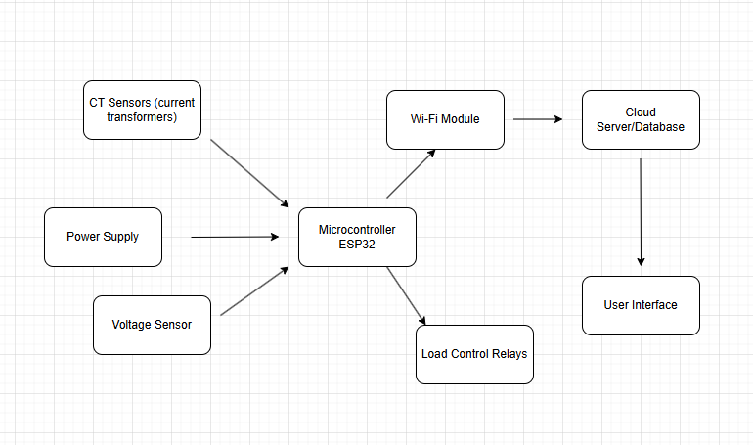
Figure 1 - Block Diagram of Design
Figure 1 displays a block diagram for the smart energy monitoring and load control system project proposal. The block diagram provides a high-level system wide view of the architecture. It helps engineers, stakeholders, assessors, and customers quickly understand what components are involved, how data flows through the system and where key processing and decisions occur. The power supply is powering the entire system, which in turn allows the CT sensor and voltage sensor to feed data to the microcontroller, the CT sensor and voltage sensor provide the microcontroller with energy usage and power consumption. The microcontroller then manages the load control relays. Finally, the Wi-Fi module is sending data to the cloud server database and then the user interface can run by retrieving data from the cloud server.
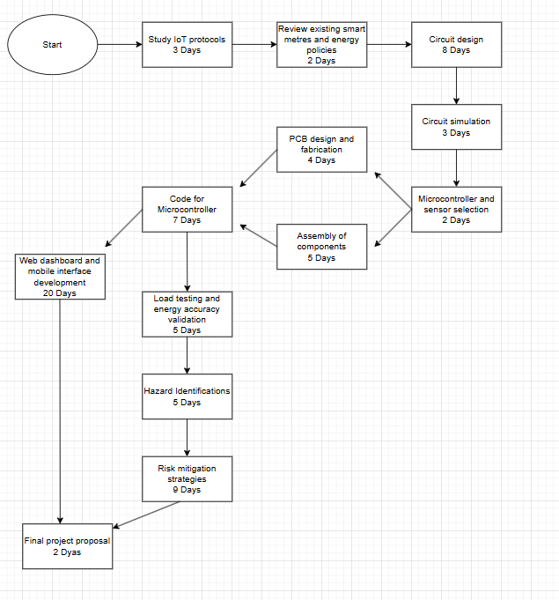
Figure 2 - Critical Path Analysis
Figure 2 is a critical path analysis that was designed to outline each step of the process and an expected duration each task should take and what tasks can be carried out simultaneously and which tasks cannot be delayed without affecting the overall timeline. The critical path plays a vital role in ensuring the project is designed properly, delivered efficiently and on time.
When designing the project there is legal regulations that must be followed to ensure the product is safe, works correctly and conforms to government standards. The first regulation that will be followed is BS 7671 which are the wiring regulations. Another regulation that the proposal will adhere to is the UK GDPR and data protection act. The final regulation to be adhered to is the ethical and professional standards by the engineering council UK.

Resources

To be able to bring the proposal to life and create the device then there will be a certain specification followed, resources included and a total cost of designing and creating the project. Without these the proposal could easily become a total failure not achieving its desired goal and end up wasting hundreds or even thousands of pounds trying to achieve this. The specification to be followed is listed below:
- ESP32 microcontroller
- Current transformer sensors for non-intrusive load monitoring
- 5V DC power supply for controller and 230V mains input for appliance monitoring
- ±1% accuracy for current and voltage measurement
- A mobile application and web dashboard for user interfaces
- Overcurrent protection and surge suppression for additional safety
- Extra features like an analytics dashboard
To help turn the proposal to a finished product, a budget of £4000 will be allocated and a timescale of three months to create a working prototype. With this budget and time frame it allows to cover sufficient research and planning into the project and covering the full cost of any necessary materials. With this plan there is additional money and time just in case any unexpected problems occur so hopefully part of the budget may be left over. With the allocated overall budget of £4000, £1500 of that is allocated to the manufacturing cost and the other £2500 is allocated to the nonrecurring engineering cost.

Planning

One of the most widely used and practical tools for displaying activities (tasks or events) against time is a Gantt chart, which is frequently used in project management. A proper time scale runs along the top of the chart, while a list of the activities appears on the left. Every action is represented by a bar, whose length and location indicate the activity's beginning, middle, and ending dates [6].

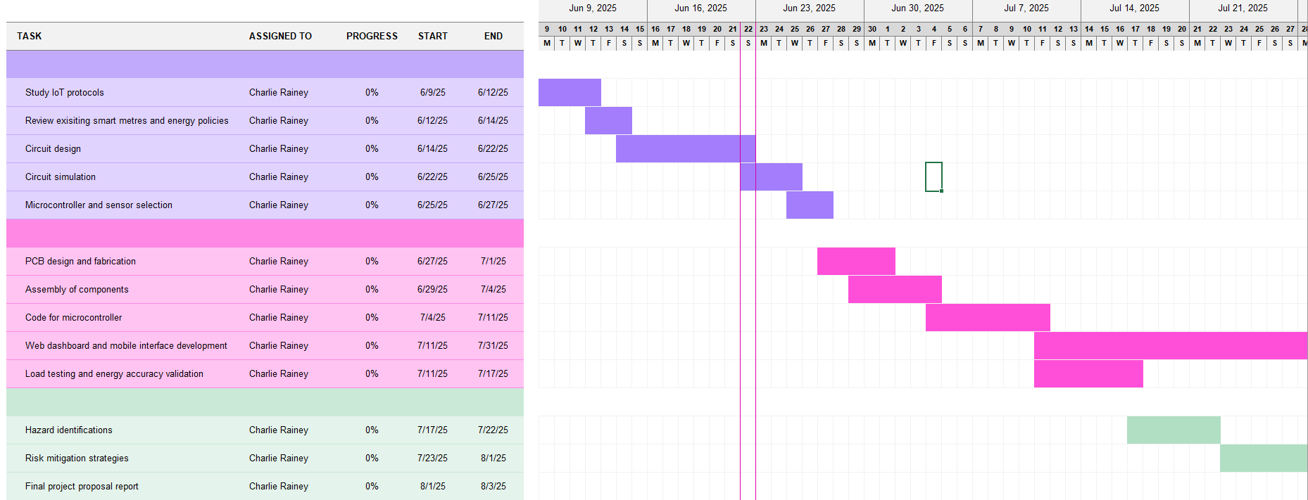
Figure 3 - Smart Energy Monitoring Control System Gantt Chart
Figure 1 displays the completed Gantt chart detailing all the specific steps that would be carried out to create the smart energy monitoring control system as well as giving a date that the task will start and finish and then representing this with the bars on the right-hand side.

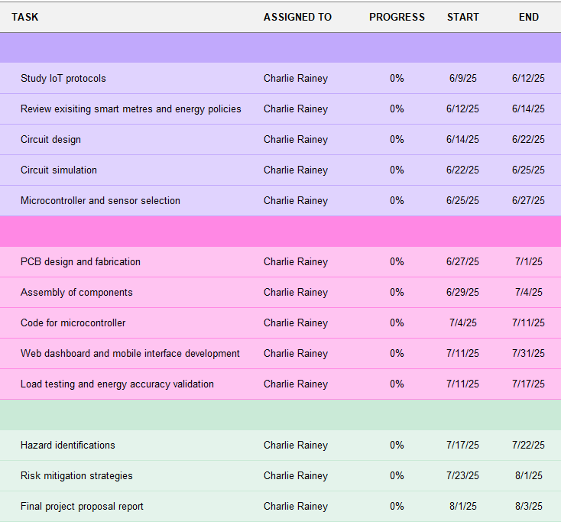
Figure 4 - Gantt Chart Breakdown
Figure 2 shows a close up of the Gantt chart in figure 1 but just the left-hand side to accurately show all the different tasks and the dates of when they would be started and expected to be completed.
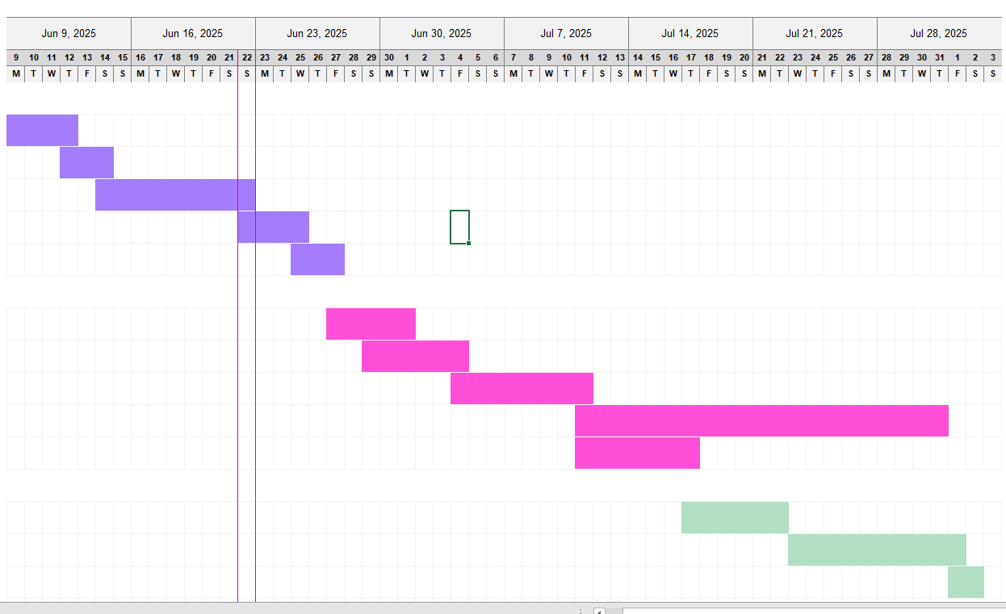
Figure 5 - Gantt Chart Breakdown
Figure 3 shows a close up of figure 1 but the right-hand side of the Gantt chart where the start and end dates of each task are displayed as bars with the dates above them. This gives a representation of what tasks are taking place and when as some tasks will take place the same time.

A strategic planning tool called BOSCARD is used to establish the parameters of new initiatives. Prior to the project's commencement, all stakeholders must reach a comprehensive agreement over its goals [7]. Expectations are nearly always not fulfilled when formal agreement is not obtained. The benefit of the BOSCARD is that it offers a rapid method of providing stakeholders with all the information they require about the project without requiring them to finish a comprehensive project start document. For busy stakeholders who might not have the time to read through a lengthy project initiation document in need of a concise yet comprehensive summary of the proposed project, it is much easier to understand [7].
Background:
Too much energy is being wasted in households across the globe resulting in an extreme amount of money going to waste and causing irreversible damage towards the planet. Knowing how to prevent wasting energy isn’t as simple as it seems which is why this product is being developed to help, save and prevent energy being wasted.

Objectives:
- To develop a real time energy monitoring system that tracks household energy consumption at the appliance level.
- To implement load control features that allow users to automate and prioritise energy consumption.
- To ensure the system is scalable, low cost and user friendly for widespread domestic application
Scope:
To provide a service for households to help them save energy and money by using an app or website where they can monitor their own house in real time and check different things such as if any lights have been left on or if an appliance is using a large amount of energy.
Constraints:
- The service must be accurate
- User friendly as some people struggle with technology
- Limited budget
Assumptions:
There is a considerable demand for the product. A decrease in energy wasted would be seen in households whilst users will be saving themselves money at the same time.
Risks:
- Competitors in the market
- Going over budget
- Website or app crashing
Deliverables:
Product must save energy and money in households. Have a working app or website where you can track your energy usage. Send alerts for abnormal power usage. Product must be ethically reasonable and include equality and diversity to allow the product to be user friendly.

Expected Outcomes and Deliverables

To see if the project works and saves money and energy for the consumer then an investigation can take place to see how the project proposal effects the domestic household. For the investigation there must be two independent variables and one dependant variable.
Independent Variables:
- Appliance Priority Setting:
- High priority only (critical loads like fridge, lights)
- Medium priority (add washing machine, microwave)
- All loads (no restrictions)
- Real Time Alert Status
- Enabled (user receives alerts via app)
- Disabled (no notifications)
Dependant variable:
- Total Energy Consumption (kWh) over a 24-hour period
From carrying out an investigation like this a null hypothesis and alterative hypothesis can be made. The null hypothesis for this scenario is that any changes in total energy consumption are not due to the appliance priority setting or real time alert status but rather to random variability. The alterative hypothesis for this scenario is that any changes in the dependant variable are due to the different appliance priority settings and if the real time alert status used in the experiment.

Risk and Ethical

Risk | Likelihood | Severity | Prevention | Severity after prevention
Sensor failures | Unlikely | Critical | Frequent sensor calibration and ensure there is a backup sensor | Marginal
Wi-Fi dropouts | Possible | Marginal | Offline fallback logic would be included | Negligible
Power surges | Rare | Catastrophic | Surge protectors and fuses included where possible | Critical
User misuse | Unlikely | Marginal | User lockouts and warnings will be added to the app | Negligible
Table 1 - Risk Matrix
The above table is a risk matrix which includes different risks that may occur and shows the severity of the risk before and after putting some sort of prevention in place.
There are many ethical considerations for the project proposal that reflect the best practises in engineering ethics, social responsibility and data protection. Issue – The system collects and transmits detailed household energy usage data, which can indirectly reveal user habits or even when a home is unoccupied. The ethical consideration is to implement an end-to-end encryption, secure user authentication and data anonymisation. Another issue could be that users may not fully understand what data is being collected or how it is used. The ethical consideration is to provide clear, user friendly consent forms and privacy policies that outline data usage. A different issue that may occur is the system may unintentionally exclude users with disabilities, language barriers or low digital literacy. The ethical consideration is to design the interface to be inclusive and accessible, including features like text to speech, high contrast modes and multilingual options. A product should be ethical since it builds consumer trust, improves brand reputation, lowers reputational and legal risks, and eventually helps society become more sustainable and beneficial. Consumer expectations for ethical corporate practices are rising, and ethical methods guarantee that the product doesn't hurt people, the environment, or reinforce prejudices [8].

Figure 6 - Equality and Diversity certificate
Figure 4 is a certificate to show that a training course was completed on the topic of equality and diversity.


Figure 7 - Prevent certificate
Figure 5 is a certificate to show that a training course has been completed on prevent, which is all to do about radicalisation.

Conclusion

The smart energy monitoring and load control system proposed in this project addresses a timely and significant challenge within modern residential energy management. With electricity usage continuing to rise due to the increasing number of household devices, the need for intelligent and user-friendly solutions has become critical. This system offers a practical response by combining real time energy monitoring, user-friendly analytics, and automated load control, all integrated through an IoT-enabled microcontroller platform. The project not only meets the technical goals but also aligns with broader sustainability and ethical standards. The proposed device empowers users to make informed energy decisions, potentially reducing consumption and lowering utility bills. It also promotes environmental responsibility by encouraging more sustainable household behaviour. The project has been planned using effective project management tools, including a Gantt chart and critical path analysis, ensuring timely delivery and clear milestones. A full risk matrix was conducted, identifying technical, operational, and user-related challenges, with mitigation strategies proposed accordingly. Ethical considerations such as data privacy, user autonomy, and accessibility have been thoughtfully incorporated into the system’s design and implementation strategy. In conclusion, this project offers both engineering innovation and societal value. It is feasible, scalable, and adaptable to various residential settings. With a focus on inclusivity, sustainability, and responsible design, the Smart Energy Monitoring and Load Control System stands as a strong example of how electrical engineering solutions can directly benefit both individuals and the wider community.

References

[1]
Eurostat, “Energy Consumption in Households,” ec.europa.eu, Jun. 2023. https://ec.europa.eu/eurostat/statistics-explained/index.php?title=Energy_consumption_in_households

[2]

Utility Design, “Leaving the Lights on | a Study from Utility Design,” Contemporary Furniture & Lighting Blog, Jul. 12, 2018. https://www.utilitydesign.co.uk/blog/leaving-lights-on/

[3]
S. Manning, “How much light energy waste are UK households responsible for?,” 100Green, Sep. 14, 2023. https://greenenergyuk.com/blog/news/uk-light-energy-waste/

[4]
V. Vishnubhotla, “Top Energy Saving Ways for Your Home,” www.greenmatch.co.uk, Feb. 16, 2022. https://www.greenmatch.co.uk/blog/2020/03/how-to-save-energy-at-home

[5]
Intelligent Abodes, “What is smart home automation and how does it work? Watch our video,” Intelligent Abodes. https://www.intelligentabodes.co.uk/smart-home-automation/

[6]
Gantt, “What is a Gantt Chart? Gantt Chart Software, Information, and History,” Gantt.com, 2023. https://www.gantt.com/

[7]
D. Haughey, “BOSCARD (Terms of Reference),” Project Smart, Oct. 21, 2021. https://www.projectsmart.co.uk/tools/boscard.php

[8]

R. Pichler, “Product Ethics,” Roman Pichler, May 01, 2019. https://www.romanpichler.com/blog/product-ethics/

