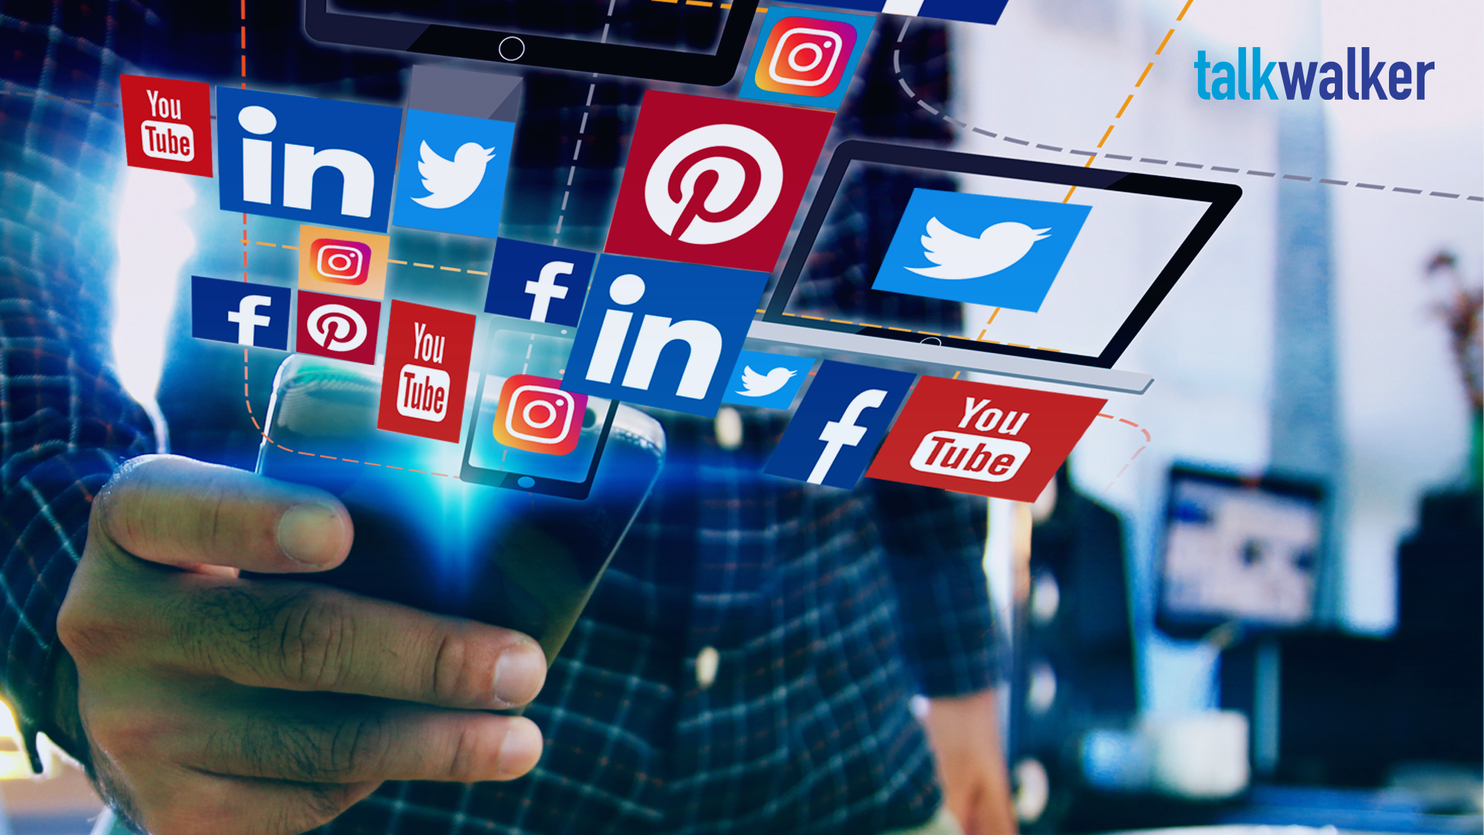  HOW SOCIAL AND DIGITAL MEDIA CAN BE USED TO REACH A WIDER CUSTOMER BASE. | Module Name: Digital Skills  Module Code: LCLM 4002  Student’s Name: Grigoras Ovtavian Paul  Student’s ID:2414391  Group: 6  Lecturer’s Name: Koushik Modak  University of Wales Trinity Saint David (London Campus)  SUBMISSION DEADLINE: 20th December 2024

Introduction 2
Social media overview 3
What marketing is and methods of it 3
Social media’s ……………………………………………………………………………………………………………………………………5
Social Media advantages 5
Social Media disadvantages 5
Conclusion ……………………………………………………………………………………………………………………………………6

Introduction
It is impossible to overstate the significance of social media marketing in the current digital environment. Social media sites like Facebook, YouTube, X (previously Twitter), TikTok, Instagram, and LinkedIn have developed into essential resources for companies looking to successfully draw in and interact with clients. In addition to offering a wide audience reach, these platforms enable tailored advertising, enabling businesses to modify their messaging according to demographics, interests, and behaviours. Businesses can produce engaging content that connects with their target audiences by utilising the distinctive qualities of each platform, whether it is through educational articles on LinkedIn, eye-catching photos on

Instagram, or intriguing films on TikTok. Social media allows businesses to gather customer feedback, enabling real-time improvements in products and services. This open communication fosters a sense of community and belonging, leading to the development of enduring relationships, client loyalty, and improved brand presence in a competitive market. (Inmoment, 2024).

Social Media Overview. The way individuals interact, communicate, and consume information has changed dramatically in recent years due to social media. Social media, which first appeared in the early 2000s with sites like Friendster and Myspace, has developed into a complex environment with industry titans like Facebook, Instagram, TikTok, Snapchat, and Twitter. Social media now plays a crucial role in our daily lives, impacting our interactions with companies, communication, and content consumption. Its function in society is still being shaped by its quick development and ability to adjust to user wants.

What marketing is and methods of it. The process of advertising, selling, and distributing a good or service is known as marketing. It includes a range of actions meant to comprehend client requirements, add value, and cultivate enduring client connections. Attracting and keeping consumers is the ultimate objective of marketing as it eventually boosts revenue and business expansion.

Methods of Marketing

Traditional Marketing Methods

Print Advertising:
-Newspaper and magazines
-Brochures and flyers
-Posters and billboards

Broadcast Advertising:
-Television commercial
-Radio spots

Direct mail:
-catalogs, postcards, and promotional letters sent directly to consumers.

Telemarketing:
-Outbound calls to potential customers to promote products or services.

Event Marketing:
-sponsoring or participating in trade shows, conferences, or community events to engage potential customers.

Public Relations:
-Managing a brand’s image through press releases, media relations, and community involvement.

Modern Marketing Methods:

Digital marketing:

Social Media Marketing:

-Utilizing platforms like Facebook, Instagram, Twitter, and LinkedIn to engage with customers and promote products.
Content Marketing:
-Creating and sharing valuable content (blogs, videos, infographics) to attract and retain customers.
Email Marketing:
-Sending targeted emails to nurture leads, inform customers, and promote products or services.

Influencer Marketing:
-Collaborating with influencers to reach their followers and promote products in an authentic way.

Mobile Marketing:
-Targeting users on mobile devices through apps, SMS, and mobile ads.

Video Marketing:
-Creating promotional videos for platforms like YouTube, TikTok, and Instagram to engage viewers and promote products.

Difference between traditional marketing and modern marketing:
The differences between modern and traditional marketing may be seen in their efficacy, channels, and methods. Even if conventional approaches have advantages, contemporary marketing provides unmatched chances for engagement, cost-effectiveness, precise targeting, and measurability. Keeping ahead of the curve and connecting with today's tech-savvy customers requires putting current methods into practice. (fabercre8tive,2024).

Social media's large user base and direct engagement capabilities have made it a vital tool for marketing and customer acquisition. Through targeted strategies and interesting content, social media helps businesses build relationships, connect with new customers, and increase brand visibility. Businesses are able to successfully connect with and engage their target audience by utilising the distinctive qualities of each platform.

  - Social Media advantages: There are several benefits to using social media as a strategy for customer acquisition, such as a large audience reach and affordable marketing options. Companies can improve engagement and contact with potential customers by connecting with particular demographics through tailored advertising. Regular content sharing on social media increases brand recognition, and real-time feedback enables prompt product or service modifications. Furthermore, thorough analytics give firms insights into audience behaviour, allowing them to improve their strategy. Social media is a crucial part of contemporary marketing initiatives since working with influencers can increase reach and establish trust.

Social Media disadvantages: Social media has a lot to offer in terms of attracting new clients, but it also has some drawbacks. Negative reviews and public criticism are a big worry since they can spread fast and damage a brand's reputation. Social media networks' algorithms can also restrict organic reach, so companies must spend money on paid advertising to be visible. Social media is a fast-paced platform, so it can be difficult to keep material relevant when trends shift quickly. Additionally, it may take a lot of time and specialised personnel to manage several platforms. Finally, preserving client trust is a major difficulty for firms due to the danger of data privacy issues and security breaches.

  - Five strategies for more effective social media use:
1. Plan your social media workflow as efficiently as possible.
2. Set up social media reporting automatically Technically, social metrics and insights can be collected by hand.
3. Distribute social media tools and resources the entire company The impact of social media on your business expands and changes along with your brand's social media presence.
4. Connect social media platforms to your entire tech stack.
5. Make managing influencers easier. (sproutsocial,2024)
You need to know who your target audience is before you start producing content for social media. Who are they? What requirements and interests do they have? You can produce content that connects with and grabs the attention of your audience by having a thorough understanding of them.(prconsultacy,2024)

List of References
Inmoment(2024) Understanding the importance of Social Media Marketing. Available at: https://inmoment.com/blog/importance-of-social-media-marketing/ (Accessed: 10/12/2024).

Sproutsocial(2024) 5 ways to improve social media efficiently. Available at: https://sproutsocial.com/insights/social-media-efficiency/#:~:text=5%20ways%20to%20use%20social%20media%20more%20efficiently,stack%20...%205%205.%20Simplify%20influencer%20management%20 ( Accessed: 10/12/2024).

Prconsultancy(2024) Define your target audience. Available at:https://prconsultancy.org/social-media-marketing-reach-new-customers/#:~:text=How%20to%20Use%20Social%20Media%20to%20Reach%20New,Your%20Results%20...%207%20Consistency%20is%20Key%20 ( Accessed: 10/12/2024)

