

LEVEL 6

SEMESTER 2

MODULE CODE: SHSS6078
Assessment in Physical Education
aSSESSMENT TYPE: aSSIGNMENT
Assessment/Component: 1
COMPONENT WEIGHTING: 50%
WORD COUNT: 3000 WORDS
MODULE TUTOR: Dylan Blain

Assessment portfolio:
You are a Physical Education teacher and have been tasked with preparing a report for a pupil who is moving on from your school. As part of the process you are required to create and use an assessment rubric which is firmly based in the literature surrounding the valued outcomes for physical education. Once the assessment is complete and report written, you are required to reflect upon the effectiveness of the assessment process undertaken.
The portfolio should contain four parts:
- A detailed rationale underpinning the creation of the rubric. This should be firmly based on high quality and relevant literature form the field.
- An assessment rubric to assess outcomes within a physical education lesson (please include a copy of the completed assessment).
- Having used the rubric to assess a pupil, a report detailing the pupil’s current levels and their next stages of learning.
- A critical reflection on the effectiveness of the assessment process undertaken. Use relevant literature to support this.

SUBMISSION DETAILS: 13th April 2018

School of Sport, Health & Outdoor Education

Assessment Feedback Sheet

Student No./Name: 1500681/ Daniel Richards
Module: Assessment in Physical Education
Module Code: SHSS6078.

Personal Evaluation – to support your academic progress please complete the section below BEFORE submitting your work.
What do you consider to be the best aspects of this work? |  |  | I consider the literature that underpins my rubric to be the best aspect because it shows wider knowledge of where my ideas have come from.
Which aspects do you consider could have been improved in this piece of work? |  |  | The section of this work that could be improved upon is the rubric, this is because it is to broad of what I’m assessing in PE.
What have you found most satisfying whilst undertaking this submission? |  |  | I have found learning about the difference in how to assess pupils the most satisfying aspect of the assignment.
ASSESSMENT CRITERIA | Learning  Outcomes |  | GRADE
ASSESSMENT CRITERIA |  |  | Poor  0-25% | Unsatisfactory  26-39% | Satisfactory  40 – 49% |  | Good  50 – 59% | Very Good  60 – 69% | Excellent  70 – 85% |  | Exceptional  86– 100% | %
Detailed assessment rubric | 1, 2, 3 |  |  |  |  |  |  |  |  |  |  | 35%
Quality of rationale underpinning assessment rubric | 1 |  |  |  |  |  |  |  |  |  |  | 15%
Pupil report | 2 |  |  |  |  |  |  |  |  |  |  | 25%
Reflections on the assessment process | 1, 2, 3 |  |  |  |  |  |  |  |  |  |  | 25%
It is expected that students will present work that is proof read, correctly referenced and adheres to the Assessment Checklist. Therefore a range of 0 – 10 marks will be deducted for non-completion of any of the points on the checklist below.
TUTOR COMMENTS:

Submission date:  via Turnitin |  | Return date:  (at least within 4 weeks) |  |  |  | Tutor: |  |  |  | Mark:

Assignment Checklist

- Please complete the Personal Evaluation section of the Assessment Feedback sheet, add your name and details, and paste the whole of this assignment document into the front of your assignment

- Submission is a single word file, clearly labelled with your name and module code
- Font style - Times New Roman, size -12 for text and 14 for headings
- Ink colour – black only
- Line spacing – 1.5line spacing and 2cm- 2.5cm page margins
- Quotations more than three lines to be indented 1line spacing
- One line space between paragraphs, paragraphs must be left aligned
- Pagination (your assignment should have page numbers)
- All tables and figures are internally referenced and have a title
- Word count checked and written at end of text (before references and any appendix)
- Assignment is within 10% of the word limit (excluding references and any appendices)
- All references in the text are included in the reference list
- Correct referencing following the Harvard style, as described in the Palgrave study skills book ‘Cite them Right’.
- Correct spelling using UK English
- Correct use of punctuation
- Grammar and syntax correct- double check anything that has a green line under it
- I have read my assignment out loud to myself and it makes sense and is easy to read
- Somebody else has read my work and it makes sense to him or her!
- I have checked and I have not plagiarised
Failure to follow these guidelines will cost you marks!
In this portfolio assignment, there will be a detailed rationale that gives underpinning reasons on why I have created the rubric assessment as a progress ladder in each of the four domains of learning. These are cognitive, social, affective and physical domains of learning. The rationale will include literature of what is assessment and how it relates to my rubric. The portfolio will also have a detailed pupil report that will be refereed to a boy in year 6 heading to secondary school, will be named as child A or he. The report will discuss where the pupil is at in his learning in each of the domains of learning in Physical Education (PE) and will give analysis on how the child is to progress in the future. The assignment will have a critical reflection on the rubric progress making some critical observations on what was good about the rubric and what perhaps could be included next time. The reflections made will be supporting literature. The assignment will have a copy of each of the 4 rubrics that have been created in the appendices to refer to.
Assessment is vitally important in PE as it gives knowledge and understanding of where pupils are, what are their current needs and where do they need to go next. Bowler and Newton (2013) suggest that “to recognise where the pupils are in their learning, communicate strengths and areas for development and identify the steps required to improve further.” That being said, the idea of assessment is retrieving knowledge and from either observing or either a written test to follow a reflective process. Hay (2006) explains that assessment involves the collection of information. An important feature to make clear is the purpose of the assessment. Why are we assessing and what is the outcomes going to be used for? Broadfoot and Black (2004) suggest that “acknowledge assessment purposes are certificates, feedback, reporting, selection, accountability and national comparison.” This gives an insight on what the information that is gathered through assessment and can then be interpreted to offer a wide range of purposes, which leads on to suggest that teachers need to be clear on what they are assessing and why they are doing it.
In terms of how we assess there are two types a formative assessment and a summative assessment. Formative assessment is designed to help pupils progress their learning Newton and Bowler (2013). Fisette and Franck (2012) also support this by suggesting that “Formative assessments inform teachers whether students are learning and give them an indication of how to plan upcoming lessons to achieve the unit goals.” This assessment is more for learning and provides the pupil information so they understand what they need to demonstrate in order to progress their level for example Hay (2006) explains that “formative assessment is understood as providing information for feedback, and in which the task itself becomes a learning experience that challenges the students.” The idea of of this type of assessment is to build upon facilitating a rich, authentic experience in PE for young people and using assessment as a tool to achieve that. The wide range of examples of formative assessment can all be used in different ways to support learning. Fisette and Franck (2012) provide examples of formative assessment such as “Performance-based assessments include observations, checklists, rubrics, journals, portfolios (print or electronic), essays, role-plays, projects, and game performance.”
The other type of assessment is summative assessment. This provides information at the end of a lesson or unit of work concerning what pupils have achieved Newton and Bowler (2013). Summative assessment is also seen as reflecting on teaching to see whether pupils have understood a topic or a particular skill that has been taught over a period of time. According to Bowler and Newton (2013) Summative assessment records learning. Summative assessments also appear in pupils reports and is used to display a pupil’s grade. This type of assessment is known as assessment of learning. Borghouts et al (2017) explains summative assessment by stating that “this function of assessment is in line with a prominent discourse of educational accountability. From this, the initial idea of summative assessment carries some sort of status which is why it is heavily used on people’s report as a conclusion of a child’s learning at the end of a school year.
The rubric is a criterion referenced form of assessment. This means that you are making a diagnosis of pupils needs and strengths you need criteria for determining their level of competence Newton and Bowler (2013). Therefore, the criteria on each level descriptor will have to be met in order for a child to achieve that level.
The rubric created is a form of an assessment that involves the four domains of learning. These are cognitive, social, physical and affective domains of learning. Birky (2012) implies that “Developing rubrics that work for your situation should be based on learning objectives, skill levels, and assignments in all three domains of physical education.” Which suggests when producing the rubric it was important to revolve it around the domains of learning to get the best analysis of where the child is at in terms of their learning. Grineski (1993) supports this by claiming that “psychomotor, cognitive and affective domains of learning frame the elementary school physical education program.”
The rubric is set out in level descriptors given specific criteria for the child to demonstrate in order to meet that level. Birky (2012) supports this by stating that,
“make levels of attainment with clear descriptions. Sometimes it’s easier to start at the highest level of skill and work backwards. Each level can be listed highest to lowest or vice versa. This listing of skills required will eliminate subjectivity, but only by having specific, clear, understandable descriptions of the skill or task.”

The four domains of learning by Bailey et al (2009) are present through the rubric. The social domain looks closely at the pupil ability to work with others by communicating and cooperating. Bailey et al (2009) suggests that through this domain cooperation, teamwork, empathy and sense of responsibility should all be accessed. This is clear that if affiliation is a learning outcome of the rubric then the sense of belonging would achieve Bailey et al (2009) social goal, therefore the child would hit the level 4 on the rubric by demonstrating the criteria stated. The cognitive domain expresses the process of problem solving and decision making. Metzler (2011) state that competition type activities should be used as a platform to facilitate an environment for children to make decisions in. This suggests that Bailey et al (2009) cognitive domain gets assessed through the rubric. This is because the rubric gives specific criteria where the child needs to make decisions under pressure to achieve the highest level of the rubric.
Furthermore, the physical domain gets experienced by the child through the range of experiences they have in PE. Students will naturally form feelings, emotions and attitudes towards PE and its important that it gets measured to provide a result on how they control their feelings. Bailey et al (2009) supports this thinking by inferring that “components of the affective domain also include dimensions such as emotion, preference, choice, feelings, beliefs and attitudes.” The physical domain is included in the rubric as it one of the leading aims of PE, being that children should participate in some sort of physical activity. The rubric criteria for a level 4 illustrates that performers have to have a competent level of fitness in order to sustain activity over long periods. Evidence from Siedentop (1994) states in his objectives that participants develop skill and physical fitness specific to relevant sports. The idea that is important here that physical fitness needs to be assessed in a broader concept, therefore the rubric underpins more of an all round fitness not just if you can do well in a bleep test. Evidence from Birky (2012) suggesting that “Physical fitness tests and other skills tests are often employed in an attempt to give a semblance of objectivity to physical education grades. These tests do not accurately assess learning in physical education.”
The pupil that I have drawn up a report for is Child A. Child A is currently in KS2 in a year 6 class at a local primary school. He is a boy with no additional learning needs. The reason for the report is to portray the current child’s level of learning before he heads into KS3 which would be year 7 in a secondary school. The report will give the secondary PE teacher a detailed analysis on where the child is at in terms of their learning within PE and where they need to progress to next. This report will be beneficial to the PE teacher as they can then plan and prepare lessons to help this child improve their performance in PE.
The report will come from Child A being assessed through the rubric created. The rubric can be used by a teacher to assess or it can be used through peer assessment. The child will be assessed through the 4 domains of learning. The report will give a clear understanding where this child is currently at in these domains of learning within PE.
Firstly, through the social ladder of progress, Child A demonstrates ability to be at a level 3. This is because the child participates with clear engagement when working in a pair or in groups tasks of 4. Clear identification of this was when Child A completed numerous striking and fielding tasks where the group had to come up with different ways to send the ball to the other side of the court but not by bouncing the ball. The child understood that there was a problem to be solved and knew that working in a team would solve it quicker. What I liked about the child was that he listened and respected other group member’s thoughts and ideas before he decided which idea to pursue. The child demonstrates good communication skills and values being part of a team which is shows evidence of working towards a level 4.
However, the child cannot be a level 4 as he lacks confidence to work as part of a team on a consistent basis. Child A does not show enough confidence to work within a team as a level 4 would need to show. For the future child A needs to be put into more team base situations where he can gain positive experiences within a team and feel affiliated to gain confidence. A strategy to combat this is Sport Education. Sport Education was founded by Siedentop in the early 1990s. The model has been used as a vehicle to deliver good physical education to children and young people. The model when taught properly, seeks to achieve rich positive experiences both physically and mentally through the use of authentic PE (Siedentop, 1994). Evidence to suggest that this would help the child gain confidence when in a team is from Hastie et al (2011) as they express that affiliation is provided only through persisting teams and the amount of enjoyment the pupil gets through formal competition.
In addition, the next domain of learning the child was measured on was through their physical fitness in PE. On the rubric ladder of progress, I levelled the child at a level 4. The reason I gave this level was because the child shows his full potential by achieving the success criteria for a level 4. He can demonstrate a wide range of movement skills, by this I’m implying clear definition in their body shape if it’s is in a gymnastics activity, or whether its showing clear fluency in movement when participating in a running activity. During competitive activities the child can demonstrate clear physical fitness and sustain being active for extended periods of time without getting tired. The child is also very good at performing skills with very little mistakes which also shows further fluency. The child has the ability to transfer skills into a pressured game situation showing great execution. For the future, for the child to progress further I would advise in KS3 that the child develops more skills in a wider activity base for example adventurous activities. This will allow the child to gain more physical control outside of his comfort zone.
Furthermore, through assessing the child through cognitive domain of learning. I can report that the child is at a level 4 in this domain. The reason why I have given this level is because the child can demonstrate a detailed understanding of a wide range of activities throughout the curriculum. Through competitive activities, the child shows that they can apply clear thinking to come up with tactics and strategies into a game situation, for example the performer portrays the tactic in football as he as quick pace he plays up the field on the last man because he knows he can run in behind and score goals because he is really fast. In addition, the child can demonstrate to me his understanding if asked to evaluate a peer’s performance. In more detail, the child can use complex vocabulary to give good points on a friend’s performance and can also tell me what they need to improve. To progress in the future, I suggest for this child to develop a further understanding in the knowledge behind fair play, rules and code of conduct in different activities. In addition to this it would be in the best interest for the child to be guided to take more responsibility for his own learning to enhance his cognitive thinking. Evidence to support my point here from Bailey and Kirk (2009) as they suggest that young children need to choose and take responsibility to participate in physical activity because of the pleasures and understanding of why it can be beneficial and enhance their bodily health.
The last domain the child got assessed in for his report is the affective domain. In particular, this domain of learning is about the child’s behaviour, feelings and emotions within PE. From my criterion reference I have given the child a level 3. The reasons for this is that the child has shown throughout lessons that he can show a level of respect to others in PE lessons. When questioned the child can give simple sentences why it is important to avoid smoking and drugs. He can also explain why regular exercise is good for him and can also describe to a certain extend how exercise makes him look and feel. The child demonstrates a sound level of knowledge of healthy living. The rubric deliberately sets out to promote health and wellbeing as it is an important area of PE and should be considered a priority when assessing the child capabilities. Evidence to support this from Cale et al, (2012) implying to the reader that differences and relationships of health such as diet, mental health, physical activity and physical fitness and how they can be monitored for grading. However, the child doesn’t show any further signs of progression at this current moment in time to push towards a level 4. My reasons for this here is because, the child lacks confidence to demonstrate a good level of control of his emotions when in game situations. This hinders him as he looses his cool and affects other people not just himself. Also the child needs to show more commitment to the subject PE. In detail, the child needs to engage with the subject more to redeem the full benefits that PE can offer him, for example having better attendance and not forgetting kit will allow him to adopt a positive attitude to the subject by experiencing more activities during lessons. For the future for the child to progress, I recommend that regular formative assessments that keep track of how the child’s emotions are and to support him with simple strategies to keep his cool if his emotions get the better of him. For example, a simple strategy would be to count to 10 every time he feels angry or annoyed in an activity.
Reflecting on the assessment rubric, I believe using the four domains of learning was the best approach to assess a pupil to the wide range of aims PE has to offer. In particular, the curriculum today in Wales has a huge focus on health and wellbeing and it being a holistic approach to health not just the area in PE of health, fitness and wellbeing. From the (NC) for Physical Education (NCPE) (WAG, 2008) portrays a learner focus of health, fitness and wellbeing for PE teachers to produce lessons from. With that being said, it was crucial to assess the child in the affective domain of learning to provide a clear analysis of where the child is at. This is why assessment for learning(AFL) should include health related criteria to achieve in PE. Evidence from Tolgfors (2018) stating that “the fifth key strategy of AFL stresses that the student is supposed to be the owner of his or her learning, there are plenty of opportunities to choose and take responsibility for training methods as well as lifestyle and health issues in PE practice.” This supports the idea of health, feelings and emotion being an important issue to measure in PE as we are responsible as teachers that children are educated about their bodies to sustain them after school.
Furthermore, another reflection on the assessment process is that although the assessment rubric was used from a teacher’s perspective, the criteria in each level descriptor deliberately allows the rubric to be used as a peer assessment tool for children to peer assess in lessons to support student achievement. This is a strength of the created rubric as it gives children a facilitated environment to engage in their learning. Supporting literature from Williams (2011) suggests that “student achievement is elicited, interpreted, and used by teachers, learners, or their peers, to make decisions about the next steps in instruction that are likely to be better.” This idea that its not just the teacher who can help student achievement when assessing, the children can be just as effective also through peer assessment. Desrosiers et al. (1997) also believed that “authentic assessment values both the learning process and outcome and provides a chance to share the responsibility of assessment with the students.” One condition that is crucial is that the assessment has to be suitable and accurate for the children to use so they understand it completely. In contrast to the rubric created, a critical reflection would be to perhaps alter the vocabulary used that it would be more child friendly for this specific age group, especially for children that are less able to make it easier for when they are assessing.
Being critical of the assessment rubric one thing it doesn’t heavily promote is the relationship between teacher and learner in terms of working with each other over the assessment to enhance student learning. Evidence to support why this would be an important thing to consider next time is from Lopez-Pastor et al (2013) as they imply that “authentic assessment has typical features, the assessment procedure is shared with the students and shared assessment attaches most importance to formative assessment.” This literature emphasis on the potential that incorporating children more in the assessment process can improve results significantly. Furthermore, when carrying out the assessment rubric again, it would be important to consider how much of a factor a relationship between a child and teacher is in terms of assessment. More literature from Mintah (2003) arguing that authentic assessment generates a greater interconnection among teaching, assessment, student and learning.
Word count- 3287.

Reference list;
Alfrey, L., Cale, L., and Webb, L. (2012) ‘Physical Education Teachers’ Continuing Professional Development in Health-Related Exercise’, Physical Education and Sport Pedagogy, 17(5), pp. 477-491. doi: 10.1080/17408989.2011.594429.
Bailey, R., Armour, K., Kirk, D., Jess, M., Pickup, I., Sandford, R. & BERA Physical Education and Sport Pedagogy Special Interest Group (2009) ‘The educational benefits claimed for physical education and school sport: an academic review’, Research Papers in Education, 24 (1), pp. 1-27.
Bailey, R. and Kirk, D. (2009) The Routledge Physical Education Reader. Oxon: Routledge.
Birky, B. (2012) ‘Rubrics: A good solution for assessment’, Strategies: A Journal for Physical and Sport Educators, 25 (7), pp. 19-21.
Borghouts, L., Slingerland, M. & Haerens, L. (2017) ‘Asessment quality and practices in secondary PE in the Netherlands’, Physical Education and Sport Pedagogy, 22 (5), pp. 473-489.
Broadfoot, P. & Black, P. (2004) ‘Redefining assessment? The first ten years of assessment in education’, Assessment in Education: Principles, Policy & Practice, 11 (1), pp. 7-26.
Desrosiers, P., Genet-Volet, Y. & Godbout, P. (1997) ‘Teachers assessment practices viewed through the instruments used in physical education classes’, Journal of Teaching in Physical Education, 16(2), pp. 211-228.
Fisette, J. & Franck, M. (2012) ‘How Teachers Can Use PE Metrics for Formative Assessment’, Journal of Physical Education, Recreation & Dance, 83 (5), pp. 23-34.

Grineski, S. (1993) ‘Achieving educational goals in physical education-A Missing Ingredient’, Journal of Physical Education, Recreation & Dance, 64 (5), pp. 32.
Hastie, P., Martinez de Ojeda, D. and Calderón Luquin, A. (2011) ‘A review of research on Sport Education: 2004 to the present’, Physical Education and Sport Pedagogy, 16 (2), pp. 10
Hay, P. J. (2006). ‘Assessment for learning in physical education’ in Kirk, D. Macdonald, D. & O’Sullivan, M. (Eds.) The Handbook of Physical Education. Thousand Oaks, Ca: Sage. pp. 312- 325.
López-Pastor, V., Kirk, D., Lorente-Catalán, E., MacPhail, A. & Macdonald, D. (2013) ‘Alternative assessment in physical education: a review of international literature’, Sport, Education and Society, 18:1, pp. 57-76, DOI: 10.1080/13573322.2012.713860.
Metzler, M.W. (2011) Instructional models for physical education. 3rd edn. Scottsdale, AZ: Holcomb Hathaway, Publishers.
Mintah, J. K. (2003) ‘Authentic assessment in physical education: prevalence of use and perceived impact on student’s self-concept, motivation, and skill achievement’, Measurement in Physical Education and Exercise Science, 7(3), pp. 161-174.
Newton, A. & Bowler, M. (2013) ‘Assessment for and of learning’ in Capel, S. & Whitehead, M (Eds). Learning to teach physical education in the secondary school. London: Routledge.
Siedentop, D. (1994) Sport education: Quality PE through positive sport experiences. Champaign, IL: Human Kinetics Publishers.
Tolgfors, B. (2018) ‘Different versions of assessment for learning in the subject of Physical Education’, Physical Education and Sport Pedagogy, 23 (3), pp. 311-327.

Welsh Assembly Government, Department for Children, Education, Lifelong Learning Skills (2008) Physical Education in the National Curriculum for Wales. Cardiff: Welsh Assembly Government.

William, D. (2011) ‘What is assessment for learning?’ Studies in Educational Evaluation, 37, pp. 3-14.

Appendix A;
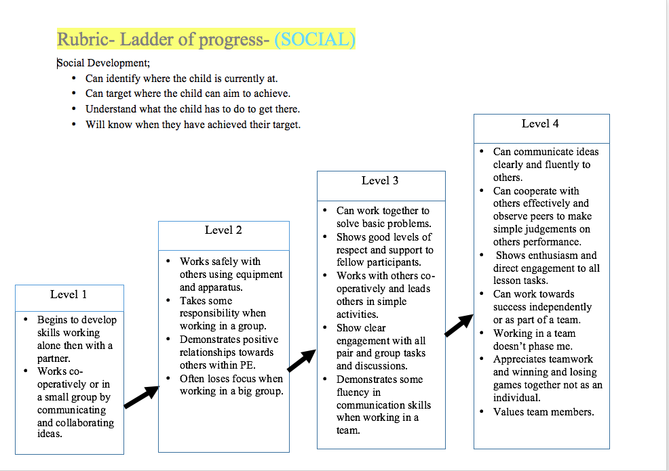

Appendix B;
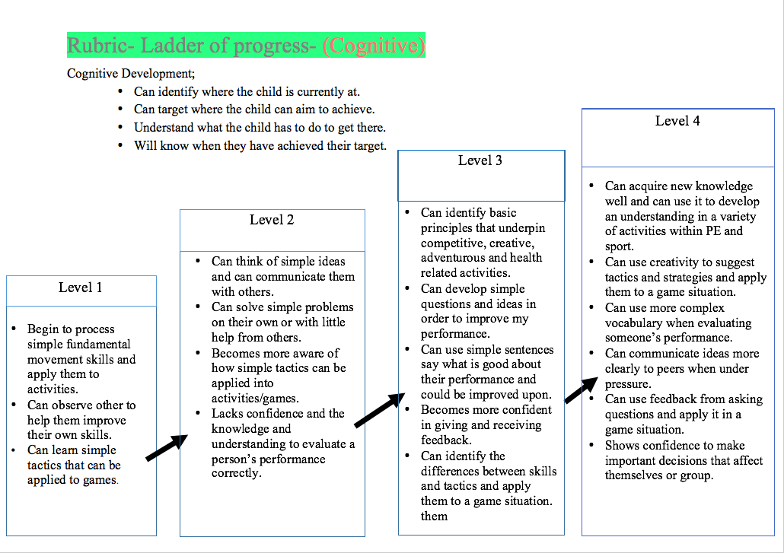

Appendix C;
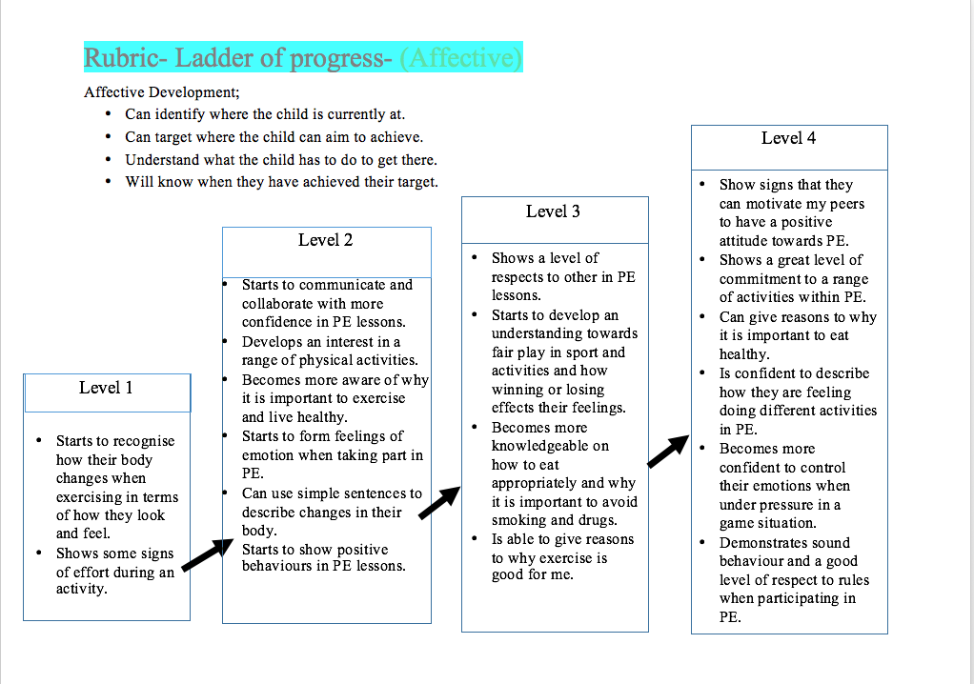

Appendix D;


