- (A.) Spanning Tree Protocol (STP) is a network protocol that create a logical topology for networks.

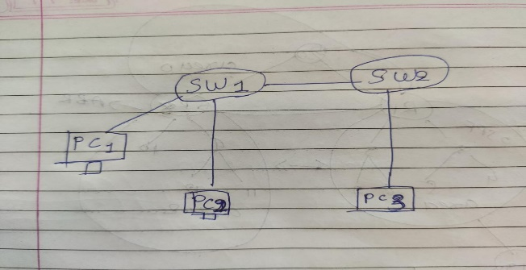
When the topology allows. For multiple active path between two or more devices the importance of the STP protection mechanician is to default and eliminate the logical loops in a networks by selecting blocking some data ports is not working.
Static Route: Static Route routes have a very low administrative distance of 1, this means that your router will a static route over any routes that were learned through a dynamic routing protocol.
Static Null Route: The Static null route directs traffic to a non- existent interface. The static null route is useful for removing packets that cannot make it out of the network.

- (A) Route Summarization is a method of representing multiple networks with a single summary address.
It is often used in large networks with many subnets.
It reduces the number of routes and all routes maintain and minimizes routing updates.
Route Summarization is a method of representing multiple networks with single summary address.
Two Type of Summarization.
- Automatic Summarization
- Manual Summarization
- Automatic Summarization:
- Automatic Summarization is a work to automatic. it’s enabled or disable by default.
- Any time Automatic Summarization is enable at a time routes are Summarization to the classful boundary in the routing update.

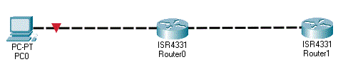

- Manual Summarization:
- One of the advantages of EIGRP over some other routing protocols is that manual summarization can be done on any router within a network.
- And single route used to represent multiple route .Which reduces the size of routing table in a network.

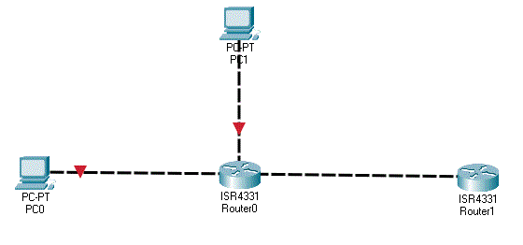

2) (C) OSPF stand for The Open Shortest Path first Protocol The Open Shortest path first protocol is a nonproprietary interior gatway protocol (IGP). That over comes the deficiencies of other distance vector routing protocols.
- In the LAS six type for IPv4 routing
- Router LSA
- Networks LSA
- Summary LSA
- ASBR Summary LSA
- ASBR External LSA
- NSSA External LSA
- Router LSA: Router LSA packets are sent between routers within the same area of origin and do not leave the area. An OSPF router uses LSA Type 1 packets to describe its own interfaces but also carries information about its neighbors to adjacent routers in the same area.
- Networks LSA: A Type 2 LSA represents a muti acess network segment that uses a DR.
The DR always advertises the type advertises the type 2 LSA and identifies all the routers attached to that network segment.
3. Summary LSA: Summary LSA Type 3 Stand for networks from other areas.
4. ASBR Summary LSA: Autonomous System Border Router (ASBR) to other areas.
2) (B) OSPF Stand for The Open Shortest Path first.
- To Find Shortest Path first, know full topology.
- All data routes are stored/ shared using link state data base(LS-DB)
- Main routes sends hell packets and every connection reply (Link State Advertisement)
- Main routes selected so that every router does not communicate with everyone and make a mess using (0-255)
- Backbone router , aveas to name connection and communication between areas in OSPF.
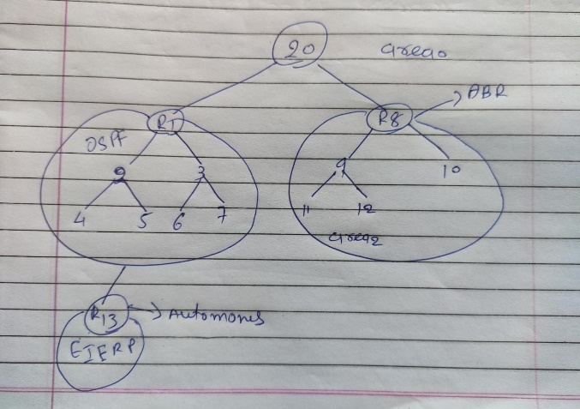
- OPSFV2-IPV4
- OPSFV-IPV6

