

LEVEL 5

SEMESTER 1 & 2

MODULE CODE: SHSS5084
Expedition Skills

aSSESSMENT TYPE: Project
Assessment/Component: 2
COMPONENT WEIGHTING: 70%
WORD COUNT: 5,000 WORDS
MODULE TUTOR: DENISE LEONARD

Expedition Portfolio

Produce a detailed log of the planning for your expedition. This will include comprehensive risk assessments, route plans, emergency procedures, transport arrangements, medical forms, pre-expedition training/ preparation and any other relevant details. Further information related to this assessment can be found on Moodle under Expedition Portfolio Resources as well as on-going tutorial support.

SUBMISSION DETAILS:

Deadline:
Date: 7th February 2020
Time: 3.00pm
Portal: Turnitin

School of Sport, Health & Outdoor Education

Assessment Feedback Sheet

Student No./Name:1803017/ Erin Smith
Module: SHSS5084
Module Code: Expedition Skills

Personal Evaluation – to support your academic progress please complete the section below BEFORE submitting your work.
What do you consider to be the best aspects of this work? |  |  | Trying to include a much detail as I can.
Which aspects do you consider could have been improved in this piece of work? |  |  | Planned better, really understand what I want to get out of this expedition on how to execute this expedition safely and effectively.
What have you found most satisfying whilst undertaking this submission? |  |  | Learning about the amount of information you need to know before executing an expedition.
ASSESSMENT CRITERIA | Learning  Outcomes |  | GRADE
ASSESSMENT CRITERIA |  |  | Poor  0 – 25% | Unsatisfactory  26-39% |  | Satisfactory  40 – 49% | Good  50 – 59% | Very Good  60 – 69% | Excellent  70 – 85% |  | Exceptional  86– 100% | %
Produce a well presented and comprehensive expedition planning log with logical format and clarity of purpose | 1,2,4,6 |  |  |  |  |  |  |  |  |  |  | 80%
Use of appropriate reference material | 6 |  |  |  |  |  |  |  |  |  |  | 20%
It is expected that students will present work that is proof read, correctly referenced and adheres to the Assessment Checklist. Therefore a range of 0 – 10 marks will be deducted for non-completion of any of the points on the checklist below.
TUTOR COMMENTS:

Submission date:  via Turnitin |  | Return date:  (at least within 4 weeks) |  |  | Tutor: Denise Leonard |  |  |  |  | Mark:

Assignment Checklist

- Please complete the Personal Evaluation section of the Assessment Feedback sheet, add your name and details, and paste the whole of this assignment document into the front of your assignment

- Submission is a single word file, clearly labelled with your name and module code
- Font style - Times New Roman, size -12 for text and 14 for headings
- Ink colour – black only
- Line spacing – 1.5 line spacing and 2cm- 2.5cm page margins
- Quotations more than three lines to be indented 1 line spacing
- One line space between paragraphs, paragraphs must be left aligned
- Pagination (your assignment should have page numbers)
- All tables and figures are internally referenced and have a title
- Word count checked and written at end of text (before references and any appendix)
- Assignment is within 10% of the word limit (excluding references and any appendices)
- All references in the text are included in the reference list
- Correct referencing following the Harvard style, as described in the Palgrave study skills book ‘Cite them Right’.
- Correct spelling using UK English
- Correct use of punctuation
- Grammar and syntax correct- double check anything that has a green line under it
- I have read my assignment out loud to myself and it makes sense and is easy to read
- Somebody else has read my work and it makes sense to him or her!
- I have checked and I have not plagiarised
Failure to follow these guidelines will cost you marks!

Expedition skills
Expedition Contract

I Erin Smith will be leading a group of people on a mountain in the Brecon Beacons. I will run my expedition between the dates of Tuesday 5th May- Thursday 7th May.

I will at all times, conduct myself as professionally as possible, adhering to the University’s Code of Conduct, and only operate within the agreed parameters of my signed-off expedition, as outlined below.

I will be running my expedition by foot.

The aims and objectives of my expedition are:
- Does being outdoors help with mental health.
- Does someone’s behaviour change when being outside if it is faced with stress, tiredness, hunger or happiness.
In order to prove whether the aims and objectives worked I will have to make a mood sheet, one for when the individual is inside and one for when the individual is outside and see if there is a difference in their mood or mental state. Whilst we are on the expedition, we have plenty of time to test someone’s behaviour by putting them in a situation where they may not be used to and see how they react, I could pretend that I have forgotten a tent or the food and see how they react, I can get someone to have a go at doing a leg and seeing how the cope. This is a great way to get to know someone, it is also I great way to get someone out of their comfort zone.

Mood sheet
This mood sheet is here to prove whether or not the outdoors helps with mood and mental health, what I would like you to do is answer a few questions as truthful as you can so we can compare the differences or similarities in mood.

Mood when inside
How do you feel when you are sat in your room, in the kitchen or in the living room on your own doing nothing? E.g. Being on your phone.

How do you feel when you are sat in your room, in the kitchen or in the living room on your own whilst doing a task? E.g. Doing work, making dinner.

How do you feel when you are with friends doing nothing? E.g. Sat down on your phones.

How do you feel when you are with your friends doing something? Making dinner, playing games, getting ready to go out.

What is your mood like in the morning compared to the evening?

Mood when outside
How do you feel when sat around the campfire or in your tent on your own doing nothing? E.g. laying down trying to sleep.

How do you feel when sat around the campfire or in your tent on your own doing a task? Eg cooking dinner, playing a card game.

How do you feel when you are with friends doing nothing? E.g. sat around the campfire.

How do you feel when you are with your friends doing something? E.g. having a skimming stone competition, helping each other build the tents, helping each other cook dinner, or playing some games.

What is your mood like in the morning compared to the evening?

Route
Day 1: We will be starting at Pont Nant-y-Moch (SN865191) where we will walk to Llyn Y Fan Fach (SN831220) where we will set up for camp.
Day 2: would be at Usk reservoir (SN819281) where we would also set up for camp.
Day 3: we are planning on doing a much longer leg on the last day, but we will spend all day outside exploring the area and have a couple of hours at the disused quarry before we make our way back to the car to come home.
I am planning on walking between 15-25 km over the 3 days on the Brecon Beacons.

On the first day we will drive to the Brecon beacons, where we will begin our expedition, it should take about an hour and a half to get to camp if you were walking at a constant speed, but we will probably take it slow as it’s not a race, we will get the opportunity to take pictures and enjoy the view, when we get to camp we will set up the tents before it gets dark then sit around a camp fire and play games like a card game or skimming stones competition and then cook up some food. We can also reflect during this time and ask people if they would specifically want to get something out of this expedition.

On the second day it should take around an hour and 10 minutes to get to the reservoir, while we are walking we can give everyone a chance to have a go at doing a leg so they can challenge themselves and let them enjoy it a bit more because walking can get repetitive. We can also spend a couple of hours in the forest, exploring the area where we can make some art out of leaves and twigs and see who’s was the best, we can learn about the different types of trees that are in the forest, or make a fort out of twigs. When we’ve had enough in the forest we will make our way to the reservoir and set up for camp, they can have the opportunity to jump and play in the water if they would like. We will have dinner and then reflect on the day and ask the group what they enjoyed the most.

The third and last day will be the longest journey where it should take about 2 hours 10 minutes but we will decide to stop at the quarry and explore the area making sure we are safe of where we go, have a little rest and then carry on the journey until we reach the car and go home. We are also going through several forests so we can explore them too.

My appointed assistant leader:
I would like my appointed assistant leader to be someone who is just as familiar with the area and in a situation where they have enough knowledge on mountain and hill skills.
I would like at least three members to take part in my expedition.

The members of my expedition group are:
I would like at least three members to take part in my expedition, I don’t mind if they have a lot of knowledge of expedition skills already or none at all, it a great opportunity to go out and have a great time where we can get to know each other and learn new things.
I will check the abilities of all expedition group members and deem them able to partake in the expedition.

I will collected relevant and up-to-date medical details from each expedition group member and am aware of any condition that may affect their ability during the expedition.

In signing this document, I agree to everything listed overleaf. I understand that I must adhere to all the documents and risk assessments I have submitted for which my expedition has been signed off.

Expedition Leader Module Staff

Name: Erin Smith Name: Tom Moore

Signed: Signed:

Date: Date:

Whilst carrying out my expedition I will help everyone as much as I can, making sure I respect them and be understanding if a task gets too much, I will also stop the expedition if myself or someone else doesn’t feel safe. I will be always thinking ahead and dynamically risk assessing as we go, I will use all three of the leadership styles throughout the expedition. Which are autocratic, democratic and lazzie-faire. It is important to be able to have the ability to have a combination of multiple styles that make them successful in guiding and inspiring people. Successful leaders are capable of driving creativity and productivity, while also getting the task done (Lazzari, 2018). Many leaders are ineffective and use leadership styles that do not correlate well with their industry or with the people they are attempting to lead (Lazzari, 2018). That is why it is important to know what each leadership style roles are, so you can be the best leader you can.
An autocratic leader is someone who gives orders and expects prompt execution, with little-to-no feedback or input from the group. This role can be effective when it is needed, because you’re getting everyone’s attention and letting them know that they need to really listen and focus on this section of the journey because it could be the difference between a life or death situation, but should only be used in small amounts because being too demanding can be too much for someone to the point they wouldn’t want to listen to the orders you are giving them. I would use this leadership style at the beginning of the journey to let the group know what we are planning to do on a certain day or where we are aiming to get to, that way they know exactly what is needed to be done. Another time I would use this leader style would be when we come across a river, rivers can be very dangerous especially when the water levels are high and fast flowing so in order to get the group across safely I would need to tell them the safest way to get across and what steps they need to take in order to do so.
A democratic leader is someone who involves a team, guided by a leader where all individuals are involved in the decision-making process to determine what needs to be done and how it should be done (BusinessDictionary.com, n.d.). I would use this when we are navigating our way through the mountains, this leadership style is a great way to involve everyone and to listen to their ideas and opinions, I think this is a great leadership style because sometimes a task can be hard work when you feel like you are doing it on your own. However, when you are working as a team it is easier. Which is crucial especially when you are walking on a mountain with loads of kit on your back in different weather extremes. So, involving the group is a great way to distract them away from the hard tasks and letting them focus on something else.
A lazzie-faire leader is someone who provides the tools and resources that are required to complete the job and then leave the group to complete it. (Sandling, 2014) An example of this leadership style is when we are setting up for camp, the group should have the resources and knowledge to be able to do it themselves.

I would also like the people going on the expedition to come prepared and to also respect the areas that we are in, I would also like it if they respect myself and others whilst being on the expedition.

TITLE | INITIAL | DATE
Expedition Overview
Aim & Objectives
Expedition Leader Profile
Competencies / Qualifications
Expedition Assistant Leader Profile
Expedition Team Profiles
Expedition Support Person
First Aid Provisions
Medical Declaration Forms
Assumption of Risk Forms
Behavioural Expectations
Individual Kit List
Group Kit List
Equipment Request Form
Preparatory Training Undertaken
Reconnaissance of Expedition Route
Campsites
Route Cards
Escape Routes
Contingency Planning
Weather Forecast Sources
Contact with Landowners
Generic Risk Assessments
Site Specific Risk Assessment
Roadworthiness of Vehicles
Drivers Licences
Drivers Insurance
Important Contact Details
Accident Emergency Procedures
Expedition Contact Details

Expedition Log Sign-Off Form

Name of Expedition Leader: Erin Smith

Your Expedition Planning Log is not just a series of lists related to routes, dates and equipment etc. but instead, is a detailed account of your planning process which identifies the range of choices you have considered, as well as the rationales that have informed your decision making.

The titles overleaf form a fundamental matrix on which to base your log. In order for your expedition to be signed off, each title needs to be addressed to a satisfactory level, as deemed by a member of module staff.

Failure to address all of the titles overleaf to a satisfactory level will result in the expedition being cancelled or deferred until the appropriate planning and preparation has been undertaken.

Expedition Approval
To the best of my knowledge all the necessary safety checks noted overleaf have been completed and the expedition is ready to proceed.

Specific safety conditions governing the undertaking of the expedition are noted below:

1.

2.

3.

4.

5.

Module Staff Signature: Date:

Statement of Expedition Readiness

I agree that all the titles noted overleaf have been completed and that my expedition is ready to proceed. I also agree to undertake my expedition in accordance with any specific safety conditions noted above, by module staff.

Expedition Leader Signature: ERIN SMITH Date:

Expedition leader profile

Name:

Insert photo
Role:
Qualifications:
About myself:
Contact details:
Email address:

Competencies and qualifications

I have been doing mountain walking once a week for 3 months, where I was taught pacing, how to use a compass, how to read a map, how to navigate, everything you need to know about contour lines and how to work out a distance by pacing and timing yourself, I’ve done night navigation, I’ve independently done a leg, I’ve also led a group of people to a destination with my class mates, I have learnt a lot about mountains over the three months and how dangerous by awarding it can be, I’ve also learnt to find atleast three things around you that makes you certain that you are in the right place. I have also been to North Wales for 5 days where we climbed Cadair Idris, Tryfan in the dark and Snowdon in 70mph winds and rain. I currently don’t have any qualifications in mountain or hill walking, but this is something that I can work towards in the future.

Expedition Assistant Leader Profile

Name:

Insert photo
Role:
Qualifications:
About myself:
Contact details:
Email address:

Expedition Team Profiles
Name:

Insert photo
X3
About yourself:
Contact details:

Expedition support person
I have decided to use Tom Moore as an expedition support person because he has a lot of experience on the mountains and is someone that I would rely on or turn to for help, because of how much he knows and how well he executes a task.

First aid provisions (see appendix 1)
It is very important to have a first aid kit when going on an expedition because you never know when you might need it. The first aid kit doesn’t need to be big; it just needs the essential items that can make an injured person a little more comfortable.

Medical form (see appendix 2)
The reason why you need to give everyone a medical form is because if something was to happen you know their emergency contacts and their local doctors so you can warn them that someone is injured and needs medical attention. You also need to know about any medication or medical conditions that could affect someone whilst on the mountain. The medical form is there to prepare yourself if there was something to happen and it’s also there to be aware of who you need to keep an eye on every now and then.

Assumption of risk form (see appendix 3)
The three day expedition will be full of fun but also challenging activities such as walking up hills, walking though moorland, carrying all you kit on your back and staying outside in a remote area in all weather conditions for 3 days often without easy access to advanced medical or other facilities. It is important to give people a risk form because it lets them know what they are getting themselves into and to understand that things do come at a risk. The form is also there for legal reason if someone decides to go to court because they injured themselves and wants to gain compensation because they didn’t know the risks, this form will prove that the victim knew what might happen.

Behavioural expectations
I expect the group to conduct themselves in a professional manner, respecting myself, peers and strangers. I would also expect everyone to respect the area that we choose to stay at or walk on. As we will still be representing our university.

The three main points to consider when following the countryside code, respect- protect-enjoy.

Respect other people:
Consider the local community and other people enjoying the outdoors. For example, don’t block gateways, driveways or other paths with your vehicle. Drive slowly when you come across horses, walkers and farm animals. Leave gates and property as you find them and follow footpaths unless wider access is available (GOV.UK, 2016).

Protect the natural environment:
Leave no trace of your visit and take your litter home, we all have responsibility to protect the countryside now for future generations, so make sure you don’t harm animals, birds, plants or trees. Keep dogs under effective control (GOV.UK, 2016). (We will not be bringing dogs, but something to remember in the future).

Enjoy the outdoors:
Plan ahead and be prepared and follow advice and local signs, its best to get the latest information about where and when you can go because some areas of open access land may be restricted in particular places at particular times. (GOV.UK, 2016).

Individual kit list

Essentials
- Food and water
- Map
- Map case
- Compass
- Head torch
- Survival bags
- Whistle
- Electrical device for emergencies
- Watch
- First aid kit
- Rucksack
- Sunglasses
- Lighter or matches
- Sleeping bag
- Roll mat
Precautions
- Group shelter
- Spare clothes
- Foil blanket
- Flask
Sensible additions
- Pad and pencil
- Mat to sit on
- Walking poles
- Tick removal kit
What to wear
- Outer layer
- Base layer
- Gloves
- Hats
- Waterproof trousers
- Leg wear
- Mid layers
- Boots
- Socks
- Neck scarf

Group kit list
- A tent between two.
- A group shelter.
- Some form of gas
- Trangia
- Gas burner
- Pegs
- flare

Equipment request form (see appendix 3)
Sign in and sign out sheets are a great way to keep track of how much kit each individual has, one section for what kit the individual already has and one section for what kit he individuals borrowed from the stores, so if anything goes missing you know who to blame for not looking after the kit properly. It is also I great way to see if the individuals are missing any important kit that would be useful when on the mountain.

Training to prepare for the expedition
The training started three months ago when we started this hill walking module, everything we have learnt up until this point should have prepared everyone. However, someone people might have forgotten so I will briefly go over some key points such as essential equipment to use or how to navigate a certain leg or what to do in a situation where you get separated from the group. The expedition won’t be so hard that they have to train in order to physically be able to cope with the amount of work I give them, it should be relatively easy. The only other thing we could do is go to the destination before the expedition, so we familiarise ourselves of the area.

Reconnaissance of expedition route
I have been to Llyn Y Fan Fach before so I’m familiar with the area, I haven’t been to the other places yet but I will plan on going there closer to the time of the expedition because I fell I would forget certain aspects to the area so its better to go closer to the time so its fresh in your mind. Also, things can change over time, something that wasn’t there before might not be there again or something that wasn’t there before might be there on the day which could have an impact on where we can and can’t go.

Camping location
The locations I have chosen for camping are beautiful and tranquil areas, with plenty of drinking water and enough shelter from the wind. They are going to test out the aims and objectives of my expedition and see if being outside really does help with mood or mental health.

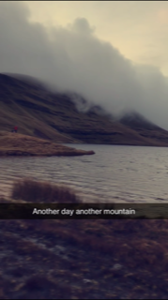
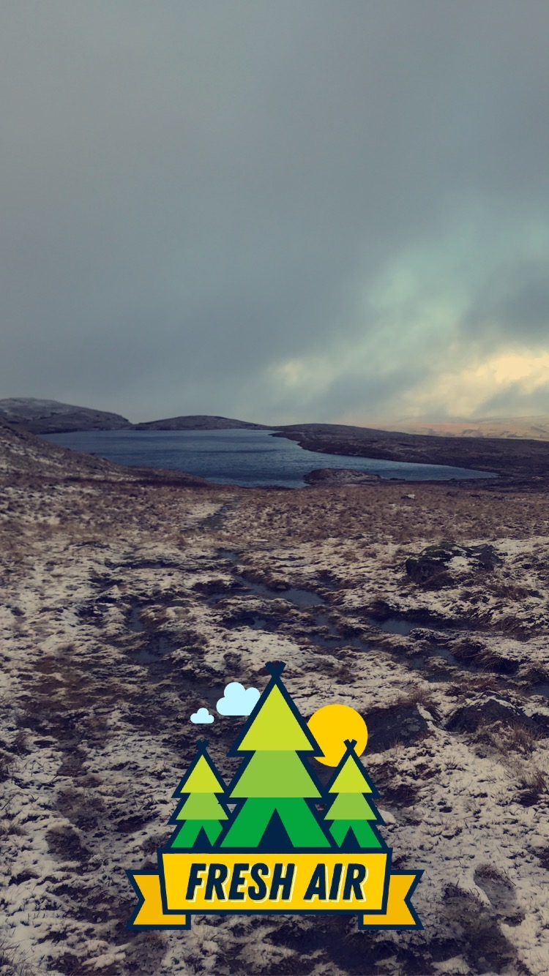

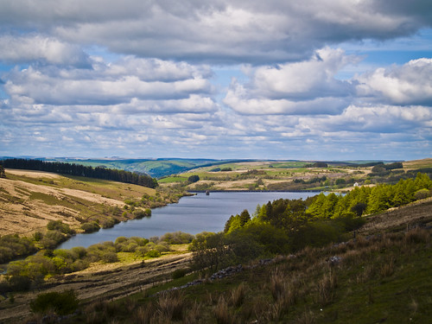
(Flickr, 2012)

Route cards
Route cards are a great way to split up your journeys and a great way to get your surroundings, if you have your route already on your map and your in a situation where the visibility is poor you find your bearing and follow that until you reach your next leg, or if you are in a situation where you don’t know where you are you, can look at your route card and see if you have passed certain obstacles. Also it’s a great way for the group to challenge themselves by looking at the route card to find out where they are or where they are expecting to end up, it not only helps them improve on their navigational skills it also gets the group to work together and bounce off each other’s ideas.

Escape routes
Escape routes are the most important things to have on an expedition because if you are in a situation where you need to get off the mountain as quick as possible you will choose the quickest routes, it also important to have a backup route if you ever need to use it, the mountains can be a very dangerous place if you’re not fully prepared, so if you ever need to get off a mountain quickly and safely a escape route can help massively.

Contingency planning
If there are high winds or poor visibility, we would have to take action and decided what is the safest option. Stay on the mountain sheltering ourselves by putting up tents or finding lower ground or getting off the mountain the quickest and safest way, however this is something that would have to be decided on the day. If there is lightning, we will have to find somewhere where we aren’t so exposed, anywhere that isn’t near water or trees. If someone is injured, we would have to get a group shelter and get help and stay together until the emergency services come. If someone in the group is unwell or not comfortable to carry on we will as a group have to exit off the mountain or turn back to camp and stay there until they are okay to carry on. If someone gets separated from the group and it is dark stay still and blow your whistle every minute or continuously until we can find you.

Weather forecast sources
The weather sources listed below are my personal preferences because they are great for seeing what the wind speed and direction is, the precipitation and air temperature. The met office has surface pressure charts which are really good for seeing what types of weather fronts you are going to get, which can predict if you are going to be stuck in a precipitation for a long period of time or whether it will come and go pretty quickly. It can also show you high and low pressure and the direction of which the weather fronts are travelling.

https://www.metoffice.gov.uk/
https://www.bbc.co.uk/weather
https://embed.windy.com/

Contact with landowners
It is important to contact landowners because a few people don’t like it when they walk on their land, you don’t want to be in a situation where you are somewhere you shouldn’t be and is forced to walk back and not know what route to take instead. It is also respectful and polite to ask if it is okay to camp on someone’s land.

Generic risk assessments (see appendix 5)
Generic risk assessments are risk assessments that are filled in but have not been adapted to a specific site or project (Haspod.com, 2018).They are hazards that are obvious to the task that you are completing, generic risk assessments are something that could happen whilst taking part in a certain activity.

Site specific risk assessment (see appendix 6)
Site specific risk assessments are risk assessments that are specifically at the site. They are hazards and risks in the area that could cause injury if not assessed beforehand. It is important to go to the site before the expedition, so you are aware of the potential risks in that area. Site specific risk assessments take into account the actual site conditions (Haspod.com, 2018).

Drivers Licence
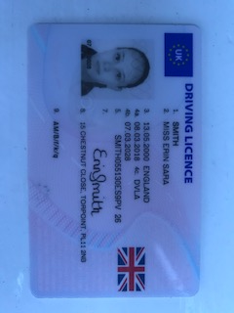
Drivers Insurance
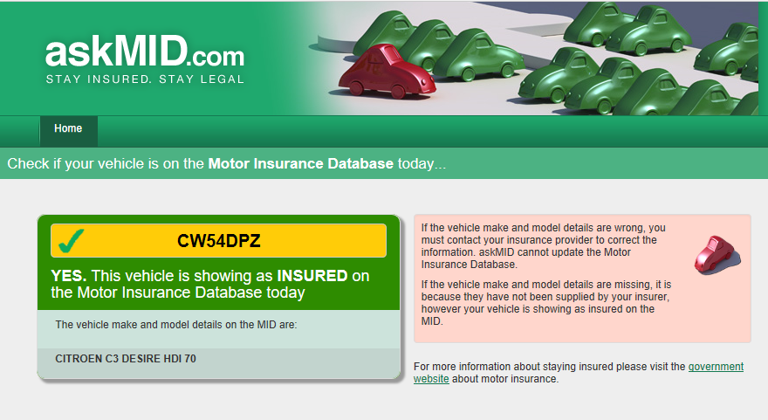

Road Worthiness of Vehicle

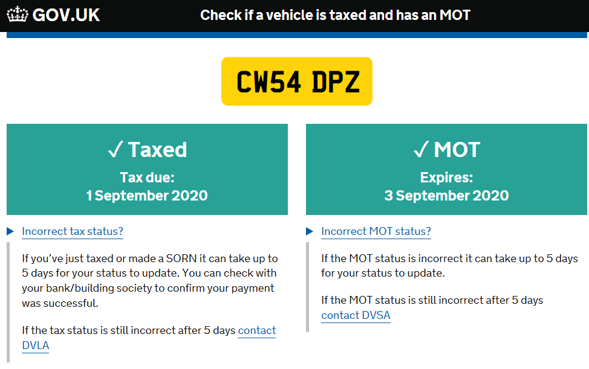

Important contact details
Expedition Leader:
Name: Erin Smith Number: 07789860866

Expedition Assistant Leader:
Name: Number:

Expedition Support Person:
Name: Tom Moore Number: 07794445535

Expedition Team Member:
Name: Number:

Expedition Team Member:
Name: Number:

Expedition Team Member:
Name: Number:

Expedition Date: Tuesday 5th May – Thursday 7th May

Venue: Beacon Beacons/ Black mountain

Campsite 1 Date: Tuesday 5th May
Location: Llyn Y Fan Fach (SN803220)

Campsite 2 Date: Wednesday 6th May
Location: Usk reservoir (SN817279)

Campsite 3 Date: Thursday 7th May
Location: Heol Lan (SN87425)

Accident Emergency Procedures
Accident and Emergency Procedures relate to the need to deal with any event throughout the duration of your expedition, in which a physical injury occurs to any expedition team member.

You are expected to deal with accidents, to the best of your abilities, and within the recommendations and remit of your first aid qualification. Where recruitment of further assistance (Emergency Services) is essential, you are required to inform a member of module staff, as soon as possible.

If it is necessary to send an expedition member to hospital, you must ensure that at least one other member accompanies the injured party.

To facilitate the processes outlined above, it is essential you complete the following, specific to your expedition:

Emergency Information:

Local Hospital:
Name: Prince Charles hospital
Address: Gurnos road, Merthyr Tydfil CF47 9DT
Tel: 01685 721721
A&E: Yes / No
Duration: 1 hour 1 minute

Local GP Service:
Name: Llanfair surgery
Address: Llanfair road, llandovery SA20 0HY
Tel: 01550 720648
Duration: 42 minutes

Local Dentist:
Name: Brynteg dental surgery
Address: upper brynamman, Ammanford SA18 1SF
Tel: 01269 825418
Duration: 35 minutes

Media Guidance
If at any point during your expedition, the media approaches you, please adopt a “No Comment” response and refer them to a member of module staff.

Accident and emergency procedures

It is always important to have an emergency point on contact; this is the most important person should the emergency services be called to look or rescue you. That’s why its important to equip them with necessary information and advice.
- Leave a note of who is in the group
- Brief description of equipment carried
- Intended route and route card
- Car make/model/registration and where you intend to park it
- Expected return time
- Emergency procedure activation time
Leave your route- route card with grid references, bearings, estimated times and various locations along the route.

Emergency communications
- Mobile voice or text
- Personal locator beacon
- Satellite phone
- Satellite messenger
- Whistle or torch
- Distress flares
- Distress strobe light
- Walk on foot and then find a phone
- VHF radio
When an incident takes place the emergency services will need to know what has happened, the nature of the injuries and the position of the incident (Thebmc.co.uk, 2010). While you wait for the emergency services you can give the victim basic first aid treatment.
Make sure you, your group and the casualty is safe from further danger, if you’re not try moving yourselves.

Things to consider when you are in an accident situation
- Is the casualty responsive?
- Is the casualty’s airways open?
- Is the casualty breathing?
- Is the circulation inadequate?
- Is the casualty disabled due to damage to head or spine?
- Prevent exposure.
- Check for fractures.
Further points to consider

Large, organised groups should bear in mind that the Mountain Rescue Teams are a finite resource and it is wrong to assume their availability. (Thebmc.co.uk, 2010). A helicopter may arrive before the mountain rescue team, to attract the attention of the helicopter stand facing it with both arms up in the air making a Y shape. (Thebmc.co.uk, 2010). Be aware that the downdraught can knock you over, only approach the helicopter when being signalled to do so by the pilot. Most injuries are lower leg sprains and fractures (Thebmc.co.uk, 2010). In order to prevent this happening, appropriate footwear is important. GPS are useful but are not a substitute for carrying a map and compass. A suitable head torch would save many needless call-outs and mobile phones can be useful if they are only for emergencies. If you are not sure whether it is an emergency or not, please investigate a little yourself first before reaching for
your phone (Thebmc.co.uk, 2010).
Word count: 4,793

References

BBC Weather. (n.d.). BBC Weather. [online] Available at: https://www.bbc.co.uk/weather [Accessed 25 Jan. 2020].

BusinessDictionary.com. (n.d.). When was the last time you said this?. [online] Available at: http://www.businessdictionary.com/definition/democratic-leadership.html [Accessed 3 Feb. 2020].

Churchill, N. (2016). RISK ASSESSMENT – Hill & Mountain Walking. [ebook] Denbigh, pp.1-4. Available at: https://www.myddeltoncollege.com/wp-content/uploads/2017/04/MOUNTAIN-WALKING-RISK-ASSESSMENT.pdf [Accessed 25 Jan. 2020].

Embed.windy.com. (n.d.). Windy: Wind map & weather forecast. [online] Available at: https://embed.windy.com/ [Accessed 25 Jan. 2020].

Flickr (2012). Cray Reservoir. [image] Available at: https://www.flickr.com/photos/decisive-moment-photography/8067601098 [Accessed 3 Feb. 2020].

GOV.UK. (2016). The Countryside Code - online version. [online] Available at: https://www.gov.uk/government/publications/the-countryside-code/the-countryside-code [Accessed 5 Feb. 2020].

Haspod.com. (2018). The Difference Between Site Specific And Generic Risk Assessments. [online] Available at: https://www.haspod.com/blog/paperwork/the-difference-between-site-specific-generic-risk-assessments [Accessed 4 Feb. 2020].
Lazzari, Z. (2018). 5 Different Types of Leadership Styles. [online] Smallbusiness.chron.com. Available at: https://smallbusiness.chron.com/5-different-types-leadership-styles-17584.html [Accessed 3 Feb. 2020].

Luke, A. (2012). Mountain & Hill Walking Safety Emergency Procedures. [online] Mountainsafety.co.uk. Available at: http://www.mountainsafety.co.uk/Emergency-Procedures.aspx/ [Accessed 29 Jan. 2020].

Met Office. (n.d.). Weather and climate change - Met Office. [online] Available at: https://www.metoffice.gov.uk/ [Accessed 25 Jan. 2020].

Protect Life (2020). Survival First Aid Kit for Car, Home, Camping, Hiking | 150 pieces. [image] Available at: https://firstaidkitsurvival.com/products/first-aid-kit-for-car-home-outdoors-camping-hiking-or-office-150-pieces-red-case-w-reflective-cross [Accessed 23 Jan. 2020].

Sandling, J. (2014). What is Laissez Faire Leadership?. [online] JONATHAN SANDLING. Available at: https://jonathansandling.com/laissez-faire-leadership/ [Accessed 3 Feb. 2020].

Thebmc.co.uk. (2010). Mountain incidents: what to do?. [online] Available at: https://www.thebmc.co.uk/mountain-incidents-what-to-do [Accessed 29 Jan. 2020].

Appendices

(Appendix 1) 5,000 Words\First aid provisions.docx
(Appendix 2) 5,000 Words\MEDICAL DECLARATION 2016-2 (5).docx
(Appendix 3) 5,000 Words\Assumption of Risk Form-2 (7).docx
(Appendix 4) 5,000 Words\SHSS5084 Equipment Request Form-2 (3).docx
(Appendix 5) 5,000 Words\Route Cards.docx
(Appendix 6) 5,000 Words\Generic risk assessment .docx
(Appendix 7) 5,000 Words\Site specific risk assessment.docx

