

FINANCIAL MANAGEMENT – ASSESSMENT 01

LCMB 7002

FINANCIAL MANAGEMENT ON WALT DISNEY COMPANY

Student Name: Medolina Jenipan
Student ID: 2246470
Lecturer Name: David Coker
Submission Date: 24-04-2024

1.0 Part A: Company History and Events

1.1 Brief history of the company
The Walt Disney Company aspires to be a 90-year-old entity that has carved out a reputable and storied history. In 1923, Walt and Roy Disney started a small-scale animation studio in Hollywood, a district in Los Angeles. The company is called Disney. Company with a history from NYSE in the 40s.When starting, the company was only a cartoon production house. From its humble beginnings, the company has subsequently grown to become a diversified global media and entertainment conglomerate, operating in fields such as film, television, publishing, theme parks, and merchandise licensing. Disney is all about the production and circulation of excellent content, all aimed at the whole family. The corporation's main competencies are in storytelling, character development, and their skills to provide the audience with a great immersion. Be it movies, television shows, or theme parks, Disney has risen to the status of cultural icon; the lure of Disney themes is felt far and wide around the globe.
It was operating in a competitive market waiting for everyone since our harshest rivals are NBCUniversal, Warner Bros, and Netflix. These companies allow corporations to make and distribute entertainment material as well, which is the reason for competition between them and consumers. Yet, the undeniable Disney's powerful brand identity, giant intellectual property collection, and ability to unify the division of enterprise have made sure that Disney keeps its dominant stand in the market. Disney's theme park, particularly, can be pinpointed as being one of the catalysts of the company's success. The Walt Disney World Resort and the Disneyland Resort which are in Florida and California respectively are two theme park destinations visited by the highest number of visitors in the world. A distinct aspect, thereby, of Disney's success may be credited to its art of developing captivating, extravagantly themed environments. Through this Disney centralized and heterogenized the business to preserve its outstanding position in the market.

1.2 Major events over the past five years
The year 2020, the pandemic with COVID-19 was featured as one of the major changes that happened to the companies of Disney’s business specifically in theme parks and live-action film production. The coronavirus era brought complicated times to companies’ business-like Disney, to shut its theme parks and postpone major movie releases, which led to a massive decline in profits and revenue. Consequently, Disney instituted cost reduction steps, which consisted of layoffs and reorganization of media and entertainment territories. The year 2021 saw the appointment of Bob Chapek as the new CEO to replace Bob Iger who had served for fifteen years before that. However, this leadership relocation was seen as a crucial strategic move, since Chapek, who was with the company even during the pandemic, was on duty to manage it during the ongoing pandemic and to drive its transition to the direct-to-consumer-focused model.
Through this period, the Disney company also bought a couple of prestigious portfolios at a very high price, the most prominent is a deal completed in 2019 on a $71 billion budget for the 21. Century Fox's entertainment assets added a unique content library to the Disney company. Besides that, Disney launched Netflix’s rival, the Disney+ service, which entered the market and became a success in 2019 and became a top contender in the streaming arena. These events, alongside the continuous challenges in the legal and regulatory domain, have also resulted in the formulation of a New Disney Strategy primarily to tackle the complexities that are encountered in the fast-moving media and entertainment industry.

2.0 Part B: Financial Performance Review

2.1 Calculation of financial ratios

2.1.1 Profitability Ratio Analysis
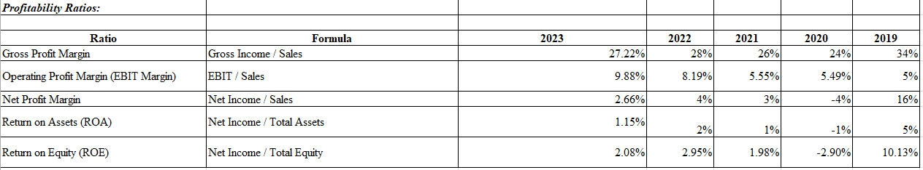
Figure 1: Calculation of Profitability Ratios
(Source: Excel)
- Gross Profit Margin: The gross profit margin has ranged from 24% to 34% in the last five years, suggesting that the company has relatively stable gross profitability from operations (Luiten, 2020). Nevertheless, the figure shows that from 34% in 2019 to 27.22% in 2023, hence a cause for concern when the trend becomes a norm.
- Operating Profit Margin: Profit margin on operations has progressed from 5% in 2019 to a higher of 9.88% in the year 2023, implying that Disney took more control in controlling their operating expenses against revenue generation.
- Net Profit Margin: Net profit margin has shown a dramatic fall from 16% recorded in 2019 to 2.66 in 2023 exhibiting that the company is vulnerable to some Operation and Non-Operational factors that have directly affected its Bottom-Line profitability.
- ROA: This means that ROA has fallen from 5% in 2019 to 1.35% in 2023, highlighting a loss in the company's effectiveness in generating profits from its assets over time (Husain, et al. 2020).
- ROE: ROE share has fallen from 10.13% in 2019 to 2.08% in 2023, which implies that returns for investors had been lower in 2023.
However, despite the improvement of its operating profitability, Disney’s net profitability, efficiency of assets, and finally, returns to shareholders, have dipped sharply in the last five years. This issue might affect investors’ decisions, and the company has to find a solution on its own because of non-operating expenses, asset utilization, and capital structure problems to improve the financial situation.

2.1.2 Liquidity Ratio Analysis
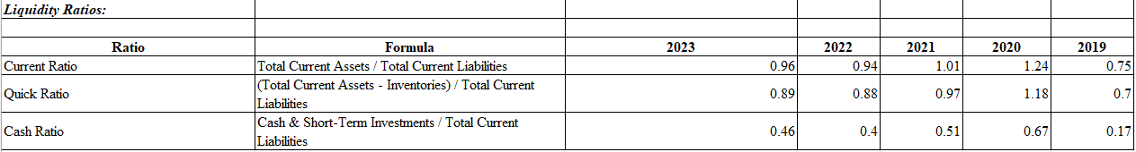
Figure 2: Calculation of Liquidity Ratios
(Source: Excel)
- Current Ratio: The current ratio is the indicator that shows how current assets compare with current liabilities. It demonstrates the company's capacity to pay off short-term obligations. As investigated by Walt Disney, the current ratio has varied through the years, ranging from 0.75 to 1.24 in 2019 and 2020 respectively (Zukin, 2020). Now, the current ratio is at the level of 0.96 for 2023 and it suffers from a deficiency within the optimal range of 1.2 to 2.0. This may imply that the firm is experiencing difficulties in satisfying its short-term creditors with its cash flows.
- Quick Ratio: The quick ratio is also a conservative measure of liquidity because it does not include the inventories from the asset side. The speedy ratio of Walt Disney also moves in line with the current ratio, having a value of 0.89 in 2023 (Arsyad, et al. 2021). This trend suggests that the business may require a stronger inventory position compared to its liquid assets to meet its short-term financial needs.
- Cash Ratio: The cash ratio is a measure that shows how much a company can meet its current liabilities with only cash or cash items. The cash ratio of Walter Disney increased to 0.46 in 2023 from 0.17, which was the number for 2019. Nevertheless, this ratio is stated as very low, maybe the company can also use other sources of liquidity such as accounts receivable and inventories as well to manage its short-term obligations.
Ultimately, although Walt Disney's liquidity ratios have varied throughout those years, the current levels display a moderate amount of liquidity. The firm could be forced to follow up on its Cash flows and working capital management to avoid situations where it fails to meet its obligations that are due on time.

2.1.3 Gearing Ratio Analysis
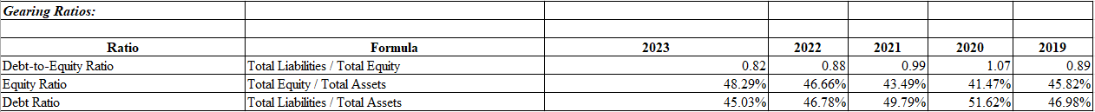
Figure 3: Calculation of Gearing Ratios
(Source: Excel)
- Debt-to-Equity Ratio: The Debt-to-Equity ratio indicates the gradual decline in 2020-2023, showing that the debt analysis of Walt Disney becomes lower than equity (Sutherland, et al. 2024). A lower Debt-to-Equity ratio usually indicates a stronger financial position with less risk for the creditors and investors, as well.
- Equity Ratio: The Equity Ratio, a ratio representing the proportion of assets sourced from shareholders' equity, has been in an upward trend and up from 41.47% in 2020 to 48.29% in 2023 (Zhou, 2024). Therefore, this may be an indication of Walt Disney turning to equity finance rather than debt, which is often perceived as a positive sign of stability.
- Debt Ratio: Conversely, the Debt Ratio, reflecting the share of total assets that are financed by debt has been on the decline from 51.62% in 2020 to 45.03% in 2023. This decrease is consistent with the decreasing Debt-to-Equity ratio and increasing Equity Ratio, which moreover means that Walt Disney Company is increasingly avoiding debt financing.
These gearing ratios compare the ability of the Company’s management to lower its debt dependence and finance the Company’s activities through equity (stocks) (Mensi, et al. 2022). This strategy may strengthen the company's financial position, reduce the risk, and if it works properly increase its creditability and the confidence of its investors in the company.

2.1.4 Efficiency Ratio Analysis
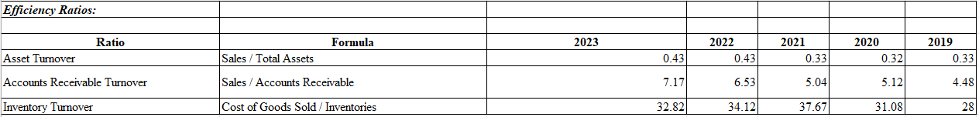
Figure 4: Calculation of Efficiency Ratios
(Source: Excel)
- Asset Turnover Ratio: It reflects a company’s ability to turn its assets into revenue during a certain period. As a result, Walt Disney's asset turnover ratio remained almost equal to and in the range of 0.33 to 0.43 over the last five years. In general, a higher ratio refers to a consistent company in terms of their assets although they can generate income through their operations.
- Accounts Receivable Turnover Ratio: This rate expresses the efficiency with which a company has collected account receivables from its customers (Steinhauser, et al. 2021). Walt Disney's Accounts Receivable Turnover Ratio increased from 4.48 in the Year 2019 to 7.17 in 2023, a sign that the organization is more adept in the collection of its outstanding receivables.
- Inventory Turnover Ratio: This ratio shows how quickly a company sells off and replaces its inventory defined by a specified timeframe. The Inventory Turnover Ratio of The Walt Disney Company fluctuated between 28 and 37.67 in the last five years. A higher ratio, of 37.67, was observed in 2021. It is the larger ratio that usually sings about better utilization of inventory.
In general, these efficiency ratios exhibit that Disney has been fairly steady and effective with its use of assets, collections for accounts receivable, and inventory control. The positive development of the accounts receivables turnover rate and the high inventory turnover rate of 2021 witnessed by the company, is a positive sign among the financial attributes (Kariyawasam, 2029). Nevertheless, these ratios should be considered in conjunction with other financial metrics and industry benchmarks to arrive at an overall conclusion about Walt Disney's performance and position.

2.2 Critical evaluation of calculated ratios using academic references
The values calculated reveal critical points about the company's financial performance and situation. Through the comparison of the ratios with those of the industry's similar standards, benchmarks, and historical trends, here can thus evaluate the financial position of the firm, identify its strong aspects, and point out any possible concerns.
Profitability Ratios: In Vogel's opinion, in 2020, the average gross profit margin for the entertainment industry has been about 30% in recent years. Disney's huge gross profit margin of 27.22% in 2023 is negligibly lower compared to the industry average as a testament to the company’s problem with either cost of goods sold (COGS) or revenue generation (Tlemsani, et al. 2020). Nonetheless, the ups and downs that The Walt Disney Company experienced in its gross profit margin recently are consistent with the cyclical nature of the industry. The downward movement in the net profit margin of Disney (from 16% in 2019 to 2.66% in 2023) is puzzling as it moves deeper into a negative direction than the industry average of around 10-12%. This possibly signals poor performance, higher costs, or other reasons explaining changes in profitability that the company is experiencing. The company needs to identify and correct the main reasons of this fall, so it will be able to become more profitable.
Liquidity Ratios: Barnes 2019, explained that the current ratio between 1.2 and 2.0 is typically good. In 2023, Disney will have a CCR of 0.96 which is a little bit under the range, which means that Disney might need to work on improving its short-term liquidity position. On the other hand, the rising cash ratio, which was 0.17 in 2019 but stood at 0.46 in 2023, indicates a better ability of the company to meet its short-term liabilities with cash and cash equivalents.
Gearing Ratios: A healthy debt-to-equity ratio and debt ratio trend, with equity ratio increasing, is favorable since it shows debt repayment capability and equity holders' finance. As Taj et al., 2022, state a lower debt-to-equity ratio is preferable because it means less financial risk and proof of a stronger financial position of a firm. The strategy of Walt Disney includes enhancing equity financing, and in this way, they can create a position of creditworthiness.
Efficiency Ratios: In contrast with the standard industry ratio of around 0.4 for a similar period, Disney's stable asset turnover ratio showing a trend from 0.33 to 0.43 during the last five years, indicates efficient asset utilization (Chen, 2022). Improvement of the accounts receivable turnover ratio which measures the efficiency of credit management and collections indicates better management of credit and collections, a crucial parameter in the entertainment industry (Damodaran, 2019). Interestingly, the relatively higher inventory turnover ratio in 2021 (37.67) is a sign of good inventory management infrastructure built around a major merchandise and retail business.
However, on the one hand, Disney's profitability and liquidity ratios send out a few alarm signals while on the other hand, the company's gearing and efficiency ratios prove sufficiently robust in this financial position. Through the evaluation of the underlying causes that affect the profitability of the company and the liquidity of the firm, and maintaining the upper hand in efficient asset utilization as well as debt management the company may reach the goal of improving the overall financial performance of the company.

2.3 Comparison to a major competitor based on calculated ratios

2.3.1 Financial Analysis of Universal Studios
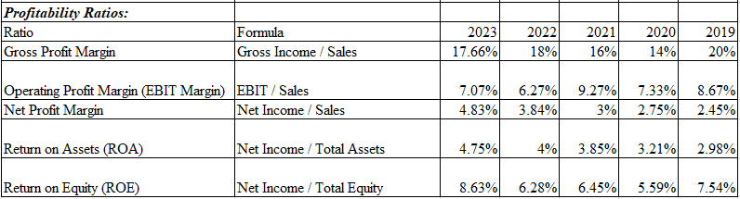
Figure 5: Calculation of Profitability Ratios
(Source: Excel)
- Gross Profit Margin: The gross profit margin has moved in the range of 14% to 20%, which indicates a comparatively pedant gross profitability. Nevertheless, these have decreased from 20% in 2019 to 17.660% in 2023, indicating a possible loss in pricing power or an upshot in the cost of goods sold.
- Operating Profit Margin: The operating profit margin has changed dramatically between 6.27% in 2022 to 9.27% in 2021 (Liu, et al. 2022). As of 2023, it is 7.07%, which is lower than the 2019 level of 8.67%, which implies a possible issue of handling operational expenses or continuing with the quality operational productivity.
- Net Profit Margin: The growing trend of net profit margin from 2.45% in 2019 to 4.83% in 2023 shows positive progress in profitability and cost attachment over the years.
- ROA and ROE: The rise in both ROA and ROE from 2019 to 2023 suggests higher productivity of assets and consequently giving the shareholders higher gains. On the other hand, in the next year, the ROE is predicted to be 8.63%, but some investors may consider it too low.
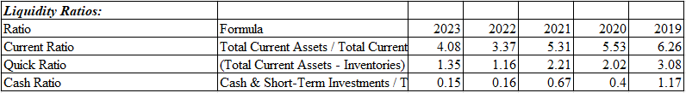
Figure 6: Calculation of Liquidity Ratios
(Source: Excel)
- Current Ratio: The decreasing current ratio, dropping from 6.26 in 2019 to 4.08 in 2023 is still a good sign which means that the company has enough current assets to cover its current liabilities.
- Quick Ratio: The current ratio has fallen from 3.08 in the year 2019 to a low 1.35 in the present day, creating the possibility of an excess of inventory or an inability to repay debts without the help of sales revenue (Hua, et al. 2021).
- Cash Ratio: The cash ratio is about 1.17 at the start of 2019 but 0.15 at the end of 2023, indicating liquidity and investing risk or cash is used for the operating needs.
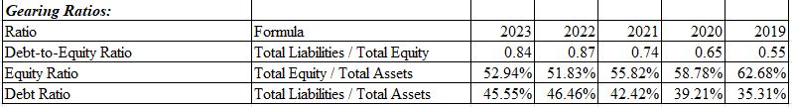
Figure 7: Calculation of Gearing Ratios
(Source: Excel)
- Debt-to-Equity Ratio: In contrast to the debt-to-equity ratio of 0.55 in 2019, It now stands at 0.84 in 2023. This clearly shows an increased reliance on debt-based financing over the years.
- Equity Ratio: The company's equity ratio drops from 62.68% in 2019 to 52.94% in 2023, which indicates a decrement in equity equity financing amount and an increase in the debt financing amount.
- Debt Ratio: The ratio of debt has progressed from 35.31% in 2019 to 45.55% in 2023. This is an assurance that the company is reliant more on debt financing.
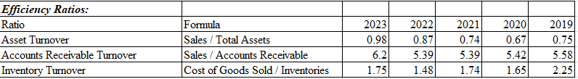
Figure 8: Calculation of Efficiency Ratios
(Source: Excel)
- Asset Turnover: The asset turnover ratio has shown an improving trend from 0.75 in 2019 to 0.98 in 2023, revealing efficient asset utilization in the generation of sales.
- Accounts Receivable Turnover: Currently, the accounts receivable turnover ratio fluctuates between 5.39 and 6.2, which shows a steady state and collecting receivables effectiveness.
- Inventory Turnover: The inventory turnover ratio drops from 2.25 in 2028 to 1.75 in 2033, leading towards an accentuation of inventories or slower sales of inventory products.
On the whole, the financial ratios depict that Universal Studios Company recorded an overall positive standpoint during the period from 2010 to 2014 relative to the three preceding periods. On the positive side, operational efficiency and return on assets have seen substantial increases. However, liquidity ratios and gearing have declined, as the company seems to focus more on liquidity management and have more of its debt financing. The company may have to handle these matters to sustain the financial stability of the business and improve its financial position.

2.3.2 Comparison of Companies Based on Ratios
Disney and Universal Studios are very dynamic and when compared based on financial ratios show considerable differences in their financial performance and position. Regarding profitability, Walt CompDisney seems to perform much better compared to Universal Studios, as its gross margin for the last five years has been 27-34% in contrast to the latter's 14-20%. Nevertheless, Universal Studios has displayed a slow process of return through marginal growth in its net profit margin, including an increase from 2.45% in 2019 to 4.83% in 2023, while Disney's net profit margin has decreased significantly from 16% in 2019 to 2.66% in 2023. This means that although Universal Studios has been able to consistently generate higher net income and make higher profits, Disney has a greater gross profit margin. Moreover, Universal Studios has demonstrated better performance in ROA and ROE as compared to Disney, indicating that it has made better use of its assets and distributed returns to shareholders. On the other hand, Disney has seen declining ROA and ROE through the same period.
While Walt Disney Company for the liquidity looks to be in better shape than Universal Studios since it is presenting a current ratio of 0.96 in 2023 but compared to Universal Studios' current ratio of 4.08. Although Universal Studios’ total assets have been attributed to their high amounts in recent years, from 1.35 to 3.08, they still seem to be more stable in meeting their short-term obligations without having to rely on sales of inventory. The cash ratio of Disney has improved from 0.17 to 0.46 between 2019 and 2023, while that of Universal Studios, declined drastically from 1.17 to 0.15 between the same years, reflecting potential liquidity problems or credit stretchedness. From the debt-to-equity and debt ratio perspectives, the Walt Disney Company has exhibited a positive trend, with a decrease in debt-to-equity ratio as well as in debt ratio together with an increase in equity ratio, which indicates the company's debt reduction strategy and its plans to access equity financing (Raimo et al. 2021). Rather, Universal Studios has been factoring in debt-to-equity ratios at a higher rate -- from 0.55 in 2019 to 0.84 in 2023, and their equity ratio has been going down from 62.68% in 2019 to 52.94% in 2023, showing increased dependence on debt over
As for productivity, The Walt Disney Company has managed to maintain a fairly stable asset turnover ratio between 0.33 to 0.43, which indicates that they have been able to make the most out of their assets. Meanwhile, Universal Studios has seen perfect improvement in its asset turnover ratio from 0.75 in 2019 to 0.98 in 2023. Disney's accounts receivable turnover ratio has increased greatly in comparison to prior performance, showing that credit and collections are being managed better, while Universal Studios has achieved a nearly consistent accounts receivable turnover. On the contrary, although the same inventory turnover ratios, (Universal Subtitles 2.25 in 2019 and 1.75 in 2023 as well as Disney's relatively high ratios), were not observed for Disney and Universal Studios, a build-inventory and a slowness in the sales of specific items were detected.
Through the use of financial ratios, it would appear that although Walt Disney Company exhibits more robust gross profitability and liquidity, Universal Studios Company has some indications that they perform better where net profitability, assets turnover, and shareholder return are concerned. Consequently, though Disney espouses a more conservative debt management approach, Universal Studios' debt financing has increased its borrowing significantly. Both companies have their attributes, as well as their drawbacks. These ratios need to be examined in context with other important variables such as other market indicators and industry-specific standards.

2.4 Recommendations for improving financial management

2.4.1 Recommendation for Part A
Based on the primary events in Part A mentioned above, it is suggested that Disney's financial management should embrace the trend of investing in its direct-to-consumer streaming platform, Disney+. The year 2019 saw the successful move of the Disney+ launch that gave Disney an entry into the ever-increasing market for streaming services and let the company stand toe to toe with giants like Netflix. During the time of the COVID-19 pandemic severely affecting their primary revenue mechanisms, such as theme parks and movie theaters, Disney's move toward a direct-to-consumer means of distribution through Disney+ was some sort of a rescue operation for them. Through increasing investments in original content, advances in technology, and international progress with Disney+, the company can increase its financial assets and decrease the dependence on more volatile income streams which are influenced by unknown factors such as pandemics and economic recessions.

2.4.2 Recommendation for Part B
From the review of financial ratios, it is recommended that Walt Disney Company should concentrate on the improvement of its net profitability and dividend yield to the shareholders. The falling net profit margin, ROA, and ROE over the recent five years indicate that the company should work on those aspects that negatively affect its bottom-line profitability, asset efficiency, and capital structure. One possible solution could be to develop Disney+ and other streaming services alongside its acquisition and investment. The management of the content costs and monetization strategies will help to optimize the revenue streams and productivity for the shareholders.

3.1 Project Evaluation 750

3.1.1 Payback Period calculation and interpretation
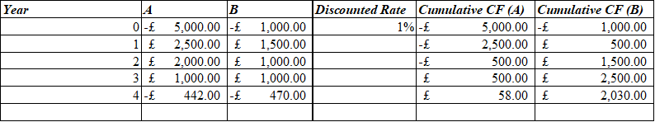

Payback Period (Years) | 4.13 | 8.32

Figure 9: Calculation of Payback Period
(Source: Excel)
The payback period is a financial metric that investors in business use to measure the time frame needed to recover their original investment in the project. With respect to the analysis of payback periods, this is a relevant instrument that is used to evaluate the liquidity and risk bank in relation to a specific project. This is because projects which have a shorter duration symbolize lower risk level and an elevated level of attractiveness for public listed companies Walt Disney. The payback period of Project A is 4.13 years in contrast with the payback period of Project B which is twice as much at 8.32 years. Such could be indicative of the fact that the option of Project A compared to the option of Project B offers a better payback period measure. The faster recovery time for the investment in Project A represents the priority of investors and managers who often take less time to make back their initial investments. This holds true especially in cases facing an uncertain future or limited access to capital resources. Shorter payback periods contribute to reducing the risk of investments, meaning that implementation of these projects is guaranteed. In the lighter side, the amount of time it would take Project B to pay off its initial costs is a significant number compared to Project A. Other investment options or expensive capital cost could be complex for the firm, as the extended payback period might not be rather attractive compared to the alternative uses of capital. Project A has a shorter payback period which gives the investors a safer side.

3.1.2 Accounting Rate of Return calculation and interpretation
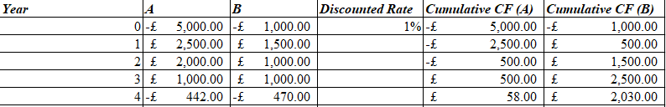
Figure 10: Calculation of Accounting Rate of Return (ARR)
(Source: Excel)
The Accounting Rate of Return (ARR) is a standard measure of the financial performance that translates the average annual earnings produced by an investment into one or other financial metrics. The ARR for project A is -25% against -76% for the ARR for Project B. The information provided shows that both projects are either yielding a negative return or are written off due to the initial negative investment (Warren et al. 2020). However, for the given decision between the two utilities projects, Project A, which has an ARR more than that of Project B, would be the more profitable one for Walt Disney. The less negative ARR of Project A indicates that the loss is less but the company gets profit in a faster way compared to Project B. In the view, according to the ARR and evaluation, Walt Disney would choose the most reasonable investment, even though two projects give negative returns.

3.1.3 Net Present Value calculation and interpretation
Figure 11: Calculation of Net Present Value (NPV)
(Source: Excel)
The net present value (NPV) technique is a management tool widely used to estimate the breakeven point of an investment. At the end of the year the NPV of project A is £0.57, while the NPV of project B is £1,980.82 (Illés, 2020). The positive NPV estimates indicate that the company should make both projects for Disney and the projects are the possible profit reaching investments. Nonetheless, major Net Present Value (NPV) of Project B means that it can make the company more adequate as it can generate more revenues which means more value to the business during the term of the investment. NPV results bring up a definite suggestion for Walt Disney to fulfill project B, since it is the one which has a more financial success projection.

3.1.4 Project recommendation based on all three calculations
Based on the evaluation of the payback period, ARR, and net present value for Project B, we suggest Walt Disney Company to take the project ahead. Project A has 4.13 years for payback period compared to Project B which is 8.32 years. Nevertheless, the two indicators, the ARR and NPV, which are used for the study, present a different picture (Siziba and Hall, 2021). Given a relatively higher NPV of £1,980.82 in Project B, its benefits to the company appear more significant compared to just about £0.57 for Project A, which is very low considering its nature. Further, given the fact that Project B's ARR is -76% which is less drastic than -25% in Project A, project B would be recommended as the most worthwhile and potentially beneficial investment. Overall, this financial assessment indicates that the better option for Walt Disney would be Project B.

3.2 Sensitivity analysis
Sensitivity analysis is a powerful tool which is used to analyze the impact of phenomena associated with parameter sway on financial returns of a project. Using sensitivity estimation on the outlined projects for The Walt Disney Company, you should compute sensitivity of the indicators such as NPV to adjustments in the factors that impact these projects most. One important point that might be put under sensitivity analysis is the discount rate used for NPV calculation. This is the rate of interest that implicitly includes risks and the minimum return, which the investors expect from such a project. When the discount rate becomes larger, NPV decreases and becomes lower; on the other hand, the NPV jumps up with the decrease of the discount rate. Through doing a sensitivity analysis on discounting rate, Walt Disney figured out the influence caused by the changing cost of capital, or the desired return on the commercial profitability of projects.
Along with that, the cash flows should be addressed too as this is another significant issue to scrutinize. That the cash flow forecasts for each year be used as inputs in the calculations of both the NPV as well as the payback period is imperative. They can develop a sensitivity analysis by assessing the cash flow and updating the television operating expenses rates or the revenue estimates. Which probably facilitates the investor understanding the risk in the project's performance due to the high variations of cash flows. Furthermore, the sensitivity of such projects to the major input cost as the initial investment would be explored. Financial ability in the start with its important role in determining the at the end success or otherwise being of the ventures. Through the analysis of the effect of updates of the initial investment to the NPV and payback period, Disney can assure the financial soundness of projects and find the point after which the work is not profitable anymore.
Furthermore, Walt Disney could analyze the sensitivity of these projects to changes in ending terms value or ending terminal value expected after the lifetime of the projects ends. The calculation of the terminal value indicates how much is the value of the assets estimated to be at the end of the useful life of the project and it can greatly affect the overall NPV. A sensitivity analysis could be performed to determine how dependent on the terminal value the projects were, which could, in turn, enable the company to understand the long-term financial implications of investing in the projects. All the factors that are critical in shaping the success of a project might come out strongly by doing a full sensitivity analysis, so Disney would have a better knowledge of the endangered sectors (Florence and Budiman, 2023). Ultimately, the generated data may be applied in the form of making smarter investment decisions, early warnings on potential threats, and eventual development of mitigation measures for project efficiency.
Sensitivity analysis results would be shown in different forms, e.g. sensitivity tables or charts that reflect the changes in a project’s NPV, payback time, and other significant parameters when key factors are varied. Through such a visual display, it enables managers to gauge the level of financial exposure that can arise from the projects and enables more robust decision-making processes. In essence, this type of sensitivity analysis provides Walt Disney with an advanced decision-making tool as well as the required powerful analytical capabilities to identify the viability and longevity of their investment projects, which helps them make wiser and more strategic financial decisions correctly aligning with the company's goals and corporate risk level.

3.3 Critical discussion of PBP, ARR, and NPV techniques

3.3.1 Advantages of each technique
Payback Period (PBP)
- The PBP serves as a clear and easy metric which lets the investor know the length of time required for the initial investment cost to rebound.
- The payback time is especially improved for achievements, which necessarily must be very budget-intensive or paid out after a long period of time.
- PBP helps to assess the risk of the project and shorter payback periods, indicating lower risk, facilitate its evaluation.

Accounting Rate of Return (ARR)
- The ARR is a primary profitability indicator that shows how the annual earnings of a project are linked to the initial investment made on it.
- It is easy to compute and may be useful to be included in other capital budgeting techniques.
- ARR is an initial stage to calculate the absolute percentage of investment profitability comparing all the investment options.
Net Present Value (NPV)
- NPV is a vernacular method that impacts the present value of cash flow by applying a discount rate to future cash flow.
- It gives a complete specific and impartial insight as to what profit a project would process throughout its lifetime, taking into account the entirety of the project.
- NPV is normally the best since it shows the length of life it would be wasteful from these projects.

3.3.2 Shortcomings of each technique
Payback Period (PBP)
- PBP fails to consider compound interest as such they do not take into account the difference between the time value cash flow collected at the early stage and that of the final stage of the projects (Eferakeya et al., 2022).
- It is not the best in bringing the point that the project is not necessarily profitable, because just the restoration of initial investment is dealt with, rather than the whole value generated.
- PBP does not differentiate between projects having identical payback periods, yet cash flow patterns, and risk assessment differ.
Accounting Rate of Return (ARR)
- ARR disregards the time value of money, which could contribute to misjudging the profitability of a given project.
- The earnings used are account earnings, however, they may be affected by different accounting rules and methods which ultimately give a fake report about the project's true financial performance.
- ARR that misses the evaluation of the scope, or the duration fails to provide the essential tips that our decision process requires.
Net Present Value (NPV)
- Accuracy of NPV on the contrary is directly dependent on the reliability of cash flow forecasts and correctness of the discount rate applied.
- NPV might need more time since there would be some complex financial modelling and forecasts.
- The amount of net present value performs only a short function of whether the project is going to receive or sends some value.

3.4 Discussion of non-financial factors to consider.
Accounting for the financial analysis of the investment projects conducted using the payback time, accounting rate of return, and net present value, Walt Disney Company should keep in mind and consider several non-financial variables as well. This can be a significant factor that determines the long-term success and actual application of the projects as well as other projects. A few essential non-monetary elements that Disney could pay attention to include how the two projects tie in with the company's long-term mission, the chances of the business reputation being affected positively or negatively, the accessibility of the necessary resources and skills, legal and regulatory challenges, as well as the projects' environmental consequences and public opinion. This extended investigation of non-financial factors together with financials can provide a greater depth picture and help in the taking of a wise investment decision of an organization.

Reference List
Journals
Arsyad, M., Haeruddin, S.H., Muslim, M. and Pelu, M.F.A., 2021. The effect of activity ratios, liquidity, and profitability on the dividend payout ratio. Indonesia Accounting Journal, 3(1), pp.36-44. https://ejournal.unsrat.ac.id/index.php/iaj/article/download/30119/31656
Barnes, P., 2019. The analysis and use of financial ratios. Journal of Business Finance dan Accounting, 14(4), p.449. https://www.superbessaywriters.com/wp-content/uploads/2016/12/week_5_discussion_1_information_0.pdf
Chen, Y., 2022, April. COVID-19 and the Dynamics of Disney’s Stock Price. In 2022 7th International Conference on Social Sciences and Economic Development (ICSSED 2022) (pp. 1425-1431). Atlantis Press. https://www.atlantis-press.com/article/125973915.pdf
Damodaran, A., 2019. Applied corporate finance. John Wiley & Sons. https://www.academia.edu/download/58200057/Damodara-applied_corporate_finance.pdf
Eferakeya, I., Enakirerhi, L.I. and Erhijakpor, A.E., 2022. Do SMEs Engage in Capital Budgeting Practices and Risk Analysis Techniques in Nigeria? Exploring the Evidence. Telematique, pp.5766-5783. https://www.researchgate.net/profile/Eferakeya-Idowu/publication/364323723_Do_SMEs_Engage_in_Capital_Budgeting_Practices_and_Risk_Analysis_Techniques_in_Nigeria_Exploring_the_Evidence/links/63482c0576e39959d6be476c/Do-SMEs-Engage-in-Capital-Budgeting-Practices-and-Risk-Analysis-Techniques-in-Nigeria-Exploring-the-Evidence.pdf

Florence, I.H. and Budiman, R.U., 2023, August. Investment Feasibility Analysis On The Addition Of Fixed Assets At PT X Using Scenario Analysis. In Proceeding of International E-Conference On Management & Small Medium Enterprise (pp. 322-337). https://prosiding.uika-bogor.ac.id/index.php/ICMSME/article/download/444/303

Hua, Z., Song, H. and Zou, K., 2021, December. Research on Disney’s Possible Expansion Strategy in Asian Market. In 2021 3rd International Conference on Economic Management and Cultural Industry (ICEMCI 2021) (pp. 2618-2625). Atlantis Press. https://www.atlantis-press.com/article/125966128.pdf
Husain, T. and Sunardi, N., 2020. Firm's Value Prediction Based on Profitability Ratios and Dividend Policy. Finance & Economics Review, 2(2), pp.13-26. http://www.riiopenjournals.com/index.php/finance-economics-review/article/download/102/53
Illés, M., 2020. Scientific problems of modern approach of net present value. https://midra.lib.uni-miskolc.hu/bitstream/handle/20.500.12795/373/4839.pdf?sequence=1&isAllowed=y
Kariyawasam, A.H.N., 2019. Analysing the impact of financial ratios on a company’s financial performance. http://dr.lib.sjp.ac.lk/bitstream/handle/123456789/11904/FMSC%20-%20Analysing%20the%20Impact%20of%20Financial%20Ratios%20on%20a%20Company%20s.pdf?sequence=1
Liu, F., Luo, B., Zhu, Y. and Wang, Y., 2022. Under COVID-19 the Transformation of Enterprise Strategy—A Case Study of Disney. International Journal of Innovation, Management and Technology, 13(3). https://www.ijimt.org/vol13/923-EM4075.pdf
Luiten, S.C., 2020. Corporate social responsibility and consumerism: case examples from Hyatt, Scandic and Walt Disney. Worldwide Hospitality and Tourism Themes, 12(5), pp.547-562. https://www.emerald.com/insight/content/doi/10.1108/WHATT-06-2020-0045/full/html
Mensi, W., Sensoy, A., Vo, X.V. and Kang, S.H., 2022. Pricing efficiency and asymmetric multifractality of major asset classes before and during COVID-19 crisis. The North American Journal of Economics and Finance, 62, p.101773. https://www.ncbi.nlm.nih.gov/pmc/articles/PMC9293880/

Raimo, N., Caragnano, A., Zito, M., Vitolla, F. and Mariani, M., 2021. Extending the benefits of ESG disclosure: The effect on the cost of debt financing. Corporate Social Responsibility and Environmental Management, 28(4), pp.1412-1421. https://onlinelibrary.wiley.com/doi/abs/10.1002/csr.2134
Siziba, S. and Hall, J.H., 2021. The evolution of the application of capital budgeting techniques in enterprises. Global finance journal, 47, p.100504. https://wjarr.com/sites/default/files/WJARR-2023-1483.pdf
Steinhauser, V., Botsis, G.S. and Singh, R.R., 2021. Walt Disney's acquisition of 21st Century fox. In Managing Negotiations (pp. 70-91). Routledge. https://api.taylorfrancis.com/content/chapters/edit/download?identifierName=doi&identifierValue=10.4324/9781003105428-5&type=chapterpdf
Sutherland, J. and Canwell, D., 2024. Gearing ratios. https://link.springer.com/chapter/10.1007/978-0-230-20472-0_7
Taj, R. and Shah, S., 2022. Financial Management: Making Sound Financial Decisions. COSMIC BULLETIN OF BUSINESS MANAGEMENT, 1(02), pp.16-19. https://journals.cosmic.edu.pk/CBBM/article/download/149/145
Tlemsani, I., Alghamdi, M., Alomair, M., Alsaleh, F., Balhareth, S. and Alqutaim, M., 2020. The impact of coronavirus (COVID-19) on New York stock exchange. Asian J Financ Account, 12(10.5296). https://www.researchgate.net/profile/Issam-Tlemsani-3/publication/345905538_The_Impact_of_Coronavirus_COVID-19_on_New_York_Stock_Exchange/links/61ca147cd4500608166fb180/The-Impact-of-Coronavirus-COVID-19-on-New-York-Stock-Exchange.pdf?_sg%5B0%5D=started_experiment_milestone&origin=journalDetail
Vogel, H.L., 2020. Entertainment industry economics: A guide for financial analysis. Cambridge University Press. https://www.academia.edu/download/67955212/bf0210861820210709-360-c1fenb.pdf
Waren, C.S., Jones, J.P. and Tayler, W.B.,2020. Financial and managerial accounting. Cengage Learning, Inc.
Zhou, R., 2024. Analysis and Prospect of capital management of Listed Companies in the United States--Taking Walt Disney Company as an example. Highlights in Business, Economics and Management, 24, pp.2559-2566. https://drpress.org/ojs/index.php/HBEM/article/download/16858/16361
Zukin, S., 2020. Disney World: The power of facade/the facade of power. In Undoing Place? (pp. 284-294). Routledge. https://www.taylorfrancis.com/chapters/edit/10.4324/9781003058885-26/disney-world-power-facade-facade-power-sharon-zukin

