Final Report

I. Introduction

In this Major project, I was in charge of a number of tasks. First of all, In the supervisor part, I think that I can act as the supervisor of the original painting part, the post-production part and the scene integration part. Because I have many previous experiences with this project. And after my discussion with the team leader, he also thinks that I am more suitable as a supervisor in this regard. So, after discussed with team leader, I will response on the post-production part. Including but not limited to color correction, editing, subtitles, sound effects. As a supervisor, I also hope to see more excellent ideas and ideas from other members, develop more excellent ideas and ideas for myself, and become more diversified.
I am mainly responsible for the entire process of main character props, firearms, weapons, bombs and other character props, from original painting to texture.
First of all, I am very confident in my prop design, and I will also communicate the whole process and requirements with the team members and team leaders during the design process.
Secondly, after the communication, I will also design multiple versions for other members to discuss and choose, get better design results, and then go to the next step.
I think I can learn how to make props, scene design and production faster in this whole process. I would love to learn these related knowledges, which will be very helpful for my future career path.
On the secondary character side, I chose to help with post production as well as rendering. In these respects, I think I can assist other members to do their work better, and I can also help them quickly when they ask for it. In the same way, if you encounter difficulties in secondary aspects during the main work, I can also gain more from my studies and absorb the strengths of other members. If other members get stuck or lose motivation at work, it is also important to be a secondary role and to help them out. Doing a better, more complete, and more quality work is my most important goal at the moment.
I added these jobs to not only reduce the process time of the entire project, but also improve the quality of the work. This is a very important and critical task for us now
I benched for animation and post production. I did a lot of related work in the early stage, and I felt that I could help other members when they needed help and take over their work. During the course of the project, I will also try to make time to help other team members while ensuring that my main work is completed. Of course, this job also gives me more opportunities to get in touch with more jobs, which allows me to adapt to the project process faster in my future work.

II. Processes

In the whole project, I have participated in many processes. There are tasks set for me by the team leader at the beginning, and tasks selected in the work division table. Of course, there are also some tasks that other teams are far from complete, and I am here to remedy. Next, I will describe my production process according to the classification.

2.1. Design part
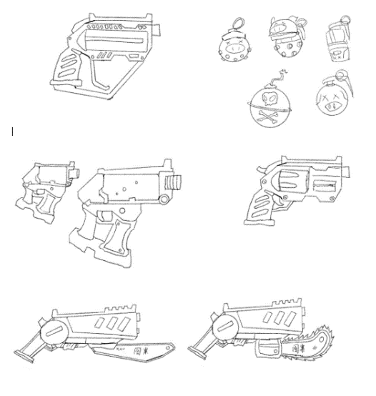
The first part I made was the design of the weapon props, including sketches, colors, shapes and functions.
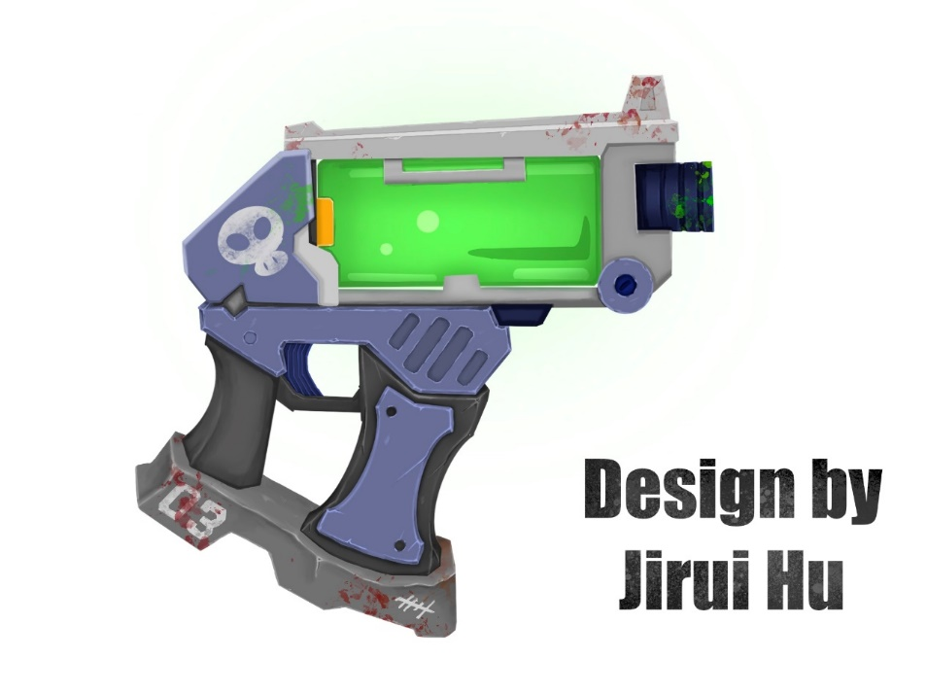
At the beginning I drew different sketches for the props. In my opinion, the style of painting and the sense of design are the most critical and necessary parts, so I drew a lot of preliminary sketches in the communication with the team members, for the team members to discuss, and choose the best one for further drawing.
The first one completed is a pistol. According to the character's needs, this is a weapon that can spray chemical liquids, so in terms of design, I referred to some mechanical design materials, and also designed the linkage mechanism of the firearm. , At the front end of the firearm, there is also a joint that can quickly change the magazine.
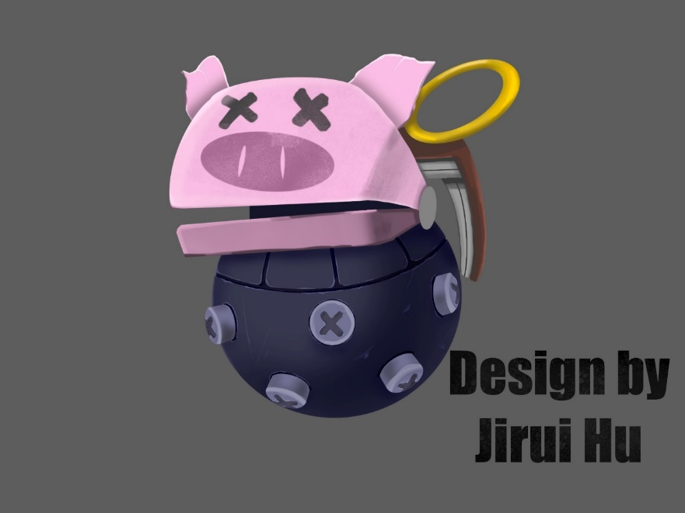
There will also be signs of wear and tear from prolonged use, as well as blood and stains on the pistol. In order to match the pirate setting, a lot of pirate-style graffiti was also added to it.

The second completed is the bomb. Of course, this is also a more important prop in the animation. In terms of setting, it is a weapon belonging to a pig, so I designed it to match the pig character more. The bomb will appear as a pig, funny image.
When exploding, the pig head bomb will detonate the gunpowder in the body and the fragments generated by the explosion will cause damage to the enemy or building.
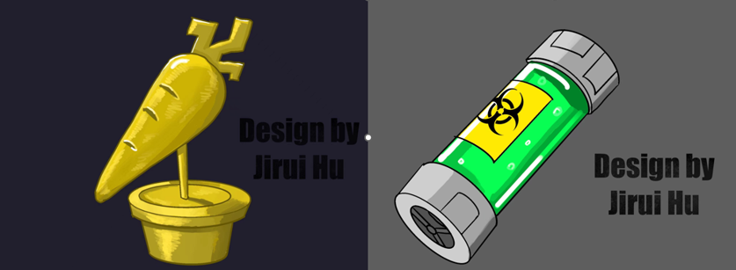
Next, in the original art section, I also made the carrot trophy and the chemical potion that makes the carrot monster stronger.

From my point of view, making the original painting is one of the necessary steps to make the whole work smoother and more efficient, so I also put a lot of effort into the original painting and communicate with the team about the production. After the production of the original painting, the modeling work also began to be produced simultaneously.

2.2. Modeling part

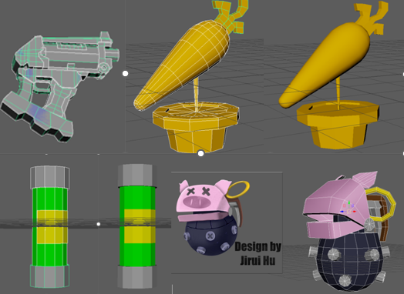
For the modeling part, according to the needs of the team, the software I use is Maya, and the original painting effect of the current model is restored through Maya. First of all, I made low poly models of these models in maya.

According to the prototype I designed, I first made a low-poly model in Maya, after making sure the lines and normals were correct, I continued to the next step, making the model into a high-poly model and UV unfolding.
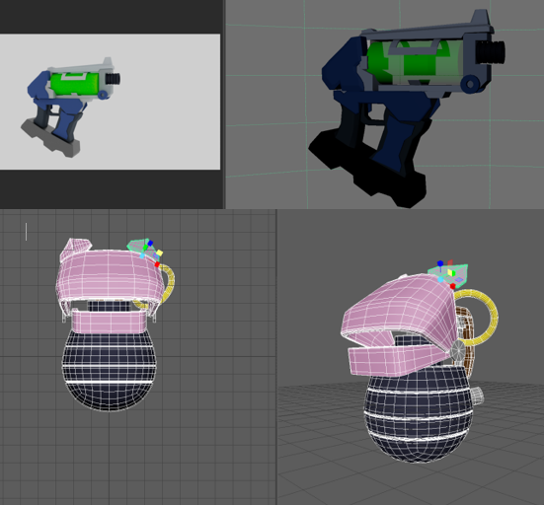

In the high-poly part, in order to restore the original painting design, I tried many times, and finally got a model with relatively fine lines and models. After making the model, I will use the software substance 3D painter to draw the texture. Before this, the UVs of the model must be unfolded to facilitate the later materials.

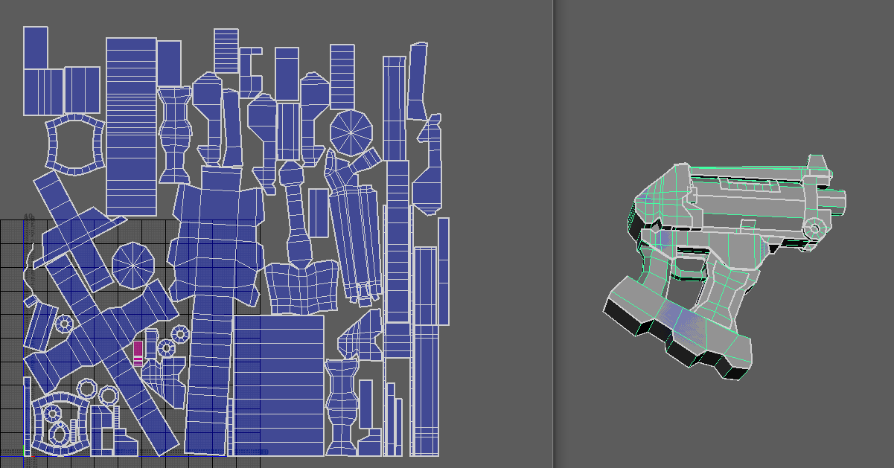
I learned the reasonable unwrapping of UVs in my exploration, and successfully unwrapped the model's UVs.

2.3. Texture part
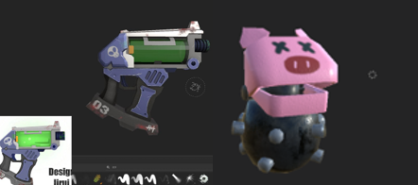

In terms of materials, in order to better meet the needs of animation, it cannot be too simulated, and there needs to be some stylized things, so the texture drawing is more cartoon-like.
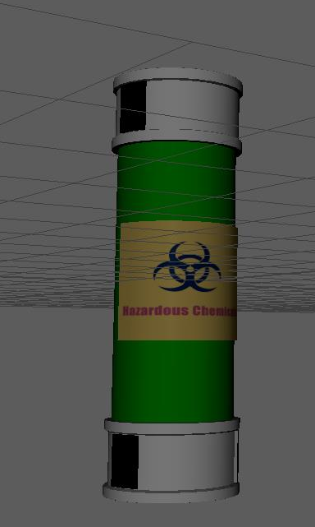
The effect of the material is basically the same as the original painting. The textures of the key props of the characters were obtained by drawing, and they were sent to the team folder as soon as they were completed, so that the team members could proceed to the next step.

Although there were a lot of problems, I was able to complete the production and materialization of these models on time. After talking to the team. They decided to make liquid flow and glow effects in gun magazines and chemicals. I reworked and textured the chemical potion model again to complete a new model.
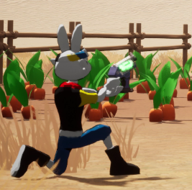

Put the character and weapon together to test the size ratio. After the test is completed, you can also proceed to the next part of the production.

2.4. Rendering part

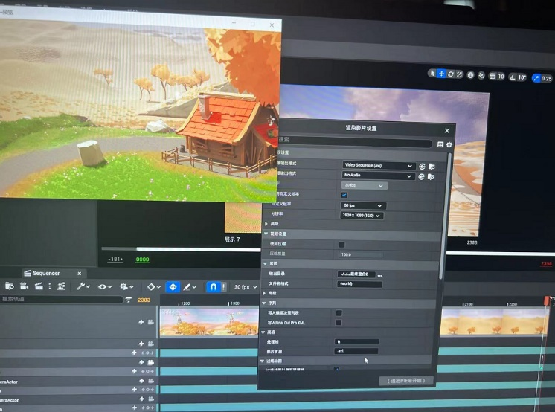
In terms of rendering, I assisted JX in rendering. The scene layout is in ue5, which is not the same as maya, so we have done a lot of work.

I rendered four empty shots, I took the composition of the four key buildings and made four empty shots. And a shot of a fight scene.
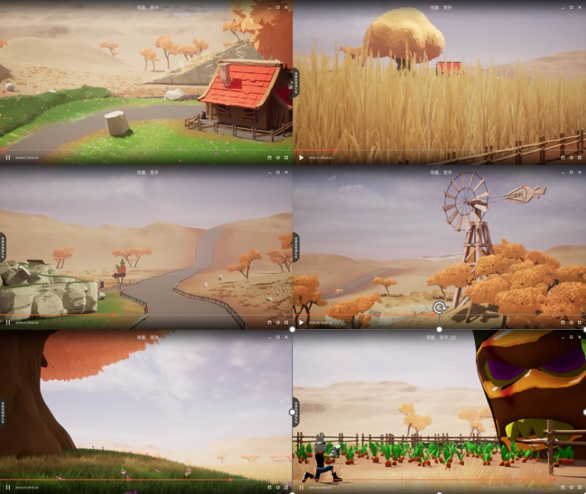
In the empty shots, I set different focal lengths such as 18 35 55 to render according to the content that different shots need to show, so that the scene is more diverse, and the things that can be shown to the audience are also different.

In terms of frame rate, I chose 60FPS, which has a higher upper limit. Even if other team members use 30 or 24, they can still match. 60FPS is relatively better for the later stage. There won't be too many technical issues.
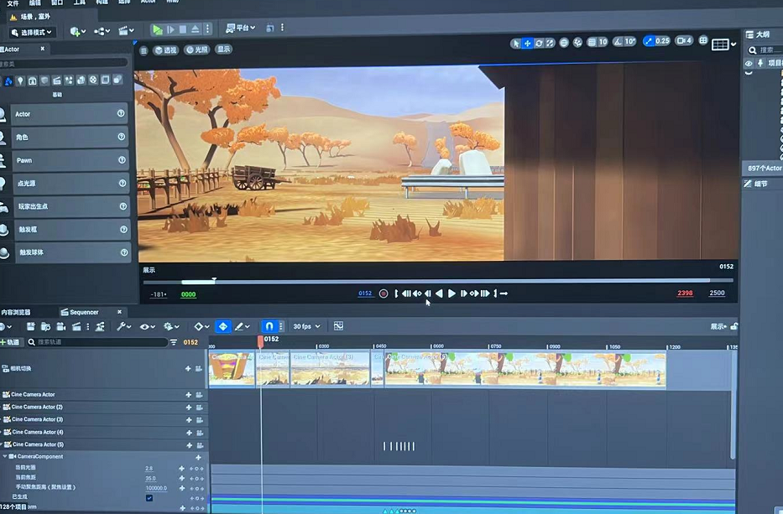
In the fight scene I rendered, I set up 6 shots, 2 fixed shots, a panorama shot, and a tracked motion shot. These shots make the whole battle more impactful, sporty, and better match the storyboards. After the rendering was completed, I also discussed with the team members and finalized the shot.
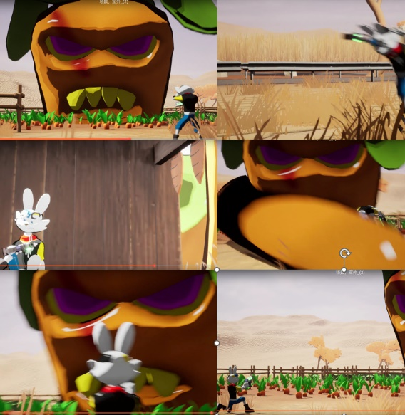

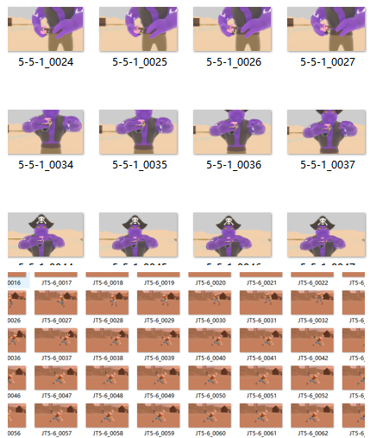
I also help teammates who rendering in Maya. I rendered three shots in Maya, a pig running, a rabbit shooting a gun, and a pig using a grenade. In keeping with teammates, the Arnold renderer was used. The materials and shots were set by teammates, and I used the computer to help render them.

Some of these lens project files lack textures, some lack lights, and some are very rigid. I debug them one by one, and export the sequence diagram after the debugging is normal. But after re-exporting, I found some problems, for example, the color is not consistent with others, and even some people's material channels have problems. So I communicated with the crew again and these renders were done.

2.5 Editing part

At the last part, I contracted post editing and sound effects. I used PR and AE for post editing. I tried my best to edit the animation based on the storyboard, but according to the upload of the file, there were many scenes that did not appear. I also communicated with the team members and got more shots before editing the entire video.
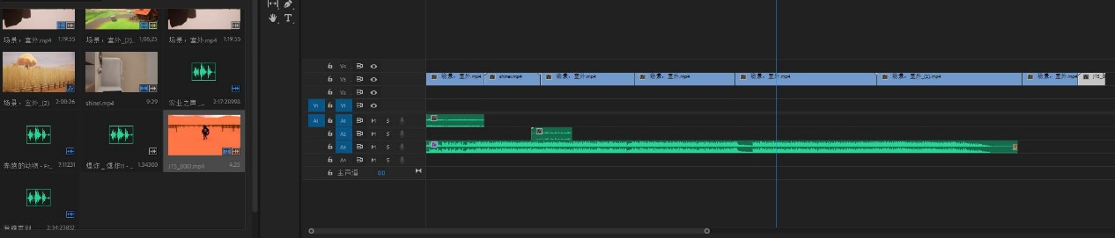
In terms of sound effects, I also tried a lot of methods, and even wanted to make it myself, but unfortunately, my own musical literacy was not enough, and the music I produced was not very good, so I finally chose to use music with open copyrights on the website to make it.
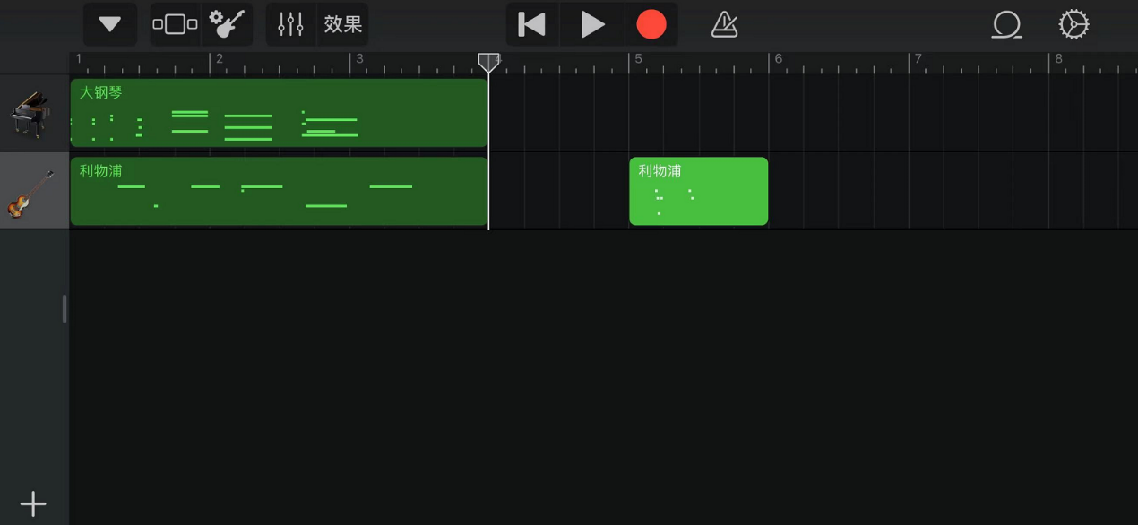

In terms of editing, I chose a lot of moving shots, and some shots chose the sound effect to appear in front of the screen, so that the whole animation will be more coherent. Of course, the environmental sound effect is also a very important part. If there is no environmental sound effect, the whole animation will not be so realistic.

The rhythm of the music is also very important. Before the fight, I chose lighter and more relaxed music. During the fight, the music started to get intense until the fight was over.

2.6. supervisor part

As a supervisor, I am responsible for supervising the team members to make rendering and post-production work. I directed LY, HY, JX, ZY to carry out rendering and post-production work. They have a good working attitude, and the quality of animation and rendering is very high. . While supervising them, I am also working and discussing with them. Because some people had problems in the early stage, our workload became larger in the later stage, and these problems were very difficult to solve. My team and I also spent a lot of time dealing with these issues. The final result is quite satisfactory.
I set up these people in a discussion group, each shot was given a different label, and each person was assigned to modify and render. They all completed these indicators on time, and sent the rendered film to me in the form of an email. As soon as I received the email, I went to pr to make adjustments. This is relatively efficient. Don't waste the time of the team members and me.
As a supervisor, I feel like I've helped my teammates, demanded quality, and managed schedules. This has benefited me a lot. The workload of the team members has also been more evenly distributed. Errors that occur during the modeling phase will not occur. The lessons I learned this time also made me realize the production line that a complete animation needs to go through. I learned a lot from it, not only from animation technology, but also from the experience of teamwork and teamwork communication.

III. Methodology

I made these models and used the software by looking up tutorials online and in books. It's important to me to have a good base for these props that are important in animation.

3.1. hard surface model
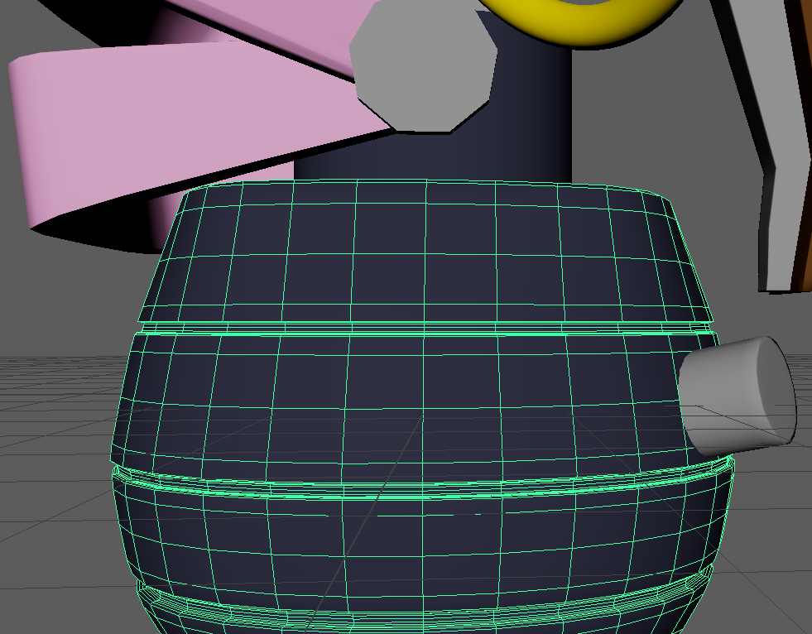

In order to express the texture of the props, excessive smoothness will cause the silhouette of the model to change, so it is very important to do a good spline for a good model. Therefore, in the production of hard surface models, the standard of lines and shapes are necessary conditions for making a qualified model. On the parts of the props, the parts that can be made separately should be made separately as much as possible, and finally merged together to make UV and textures, which will be more convenient and space-saving. At the same time, the model needs to keep the four-sided surface as far as possible, and do not have the five-sided surface and the reversed surface, which will have a great impact on the texture, and even need to remake the model.

3.2. UV unfolding
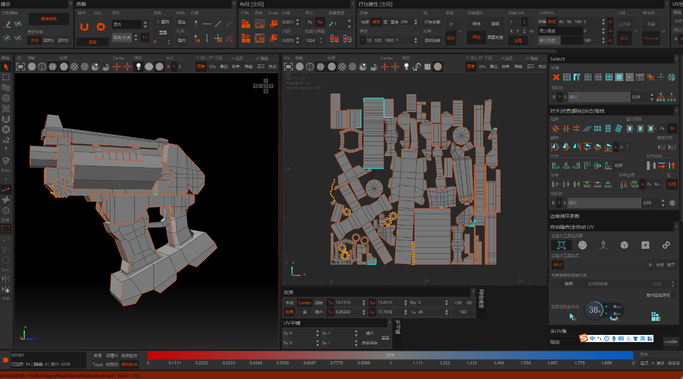

After the model is made, the first step is to unfold the UV. There are many ways to unfold the UV. I prefer to use unfold 3D, which is a smart and convenient software. After unfolding the parts one by one, enlarge the parts with more details, shrink the parts that do not need details, and then straighten them to save more space and make drawing more convenient.

3.3. Texture

I use Substance 3D painter to make the textures, there are many ways to make textures. The reason I choose this software is because it is more convenient.

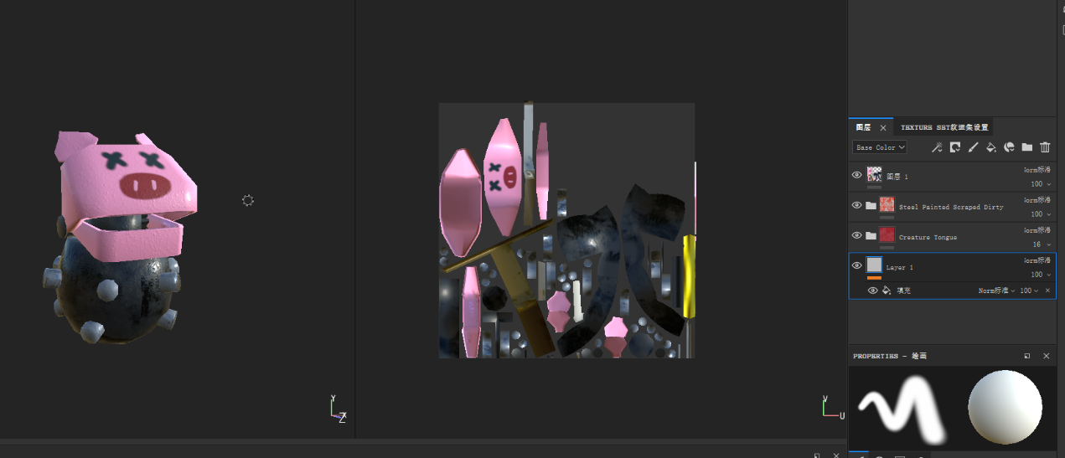
This model uses multiple layers to bring out material details, wear, elevation, and color. I try to make the texture on a model, so that teammates can more easily extract the material to the props.
To make different materials on the same map, you need to use masking technology to mask a part of the material and only make another part of the map. In this way, the material presents a different effect for each part.

3.4. Rendering
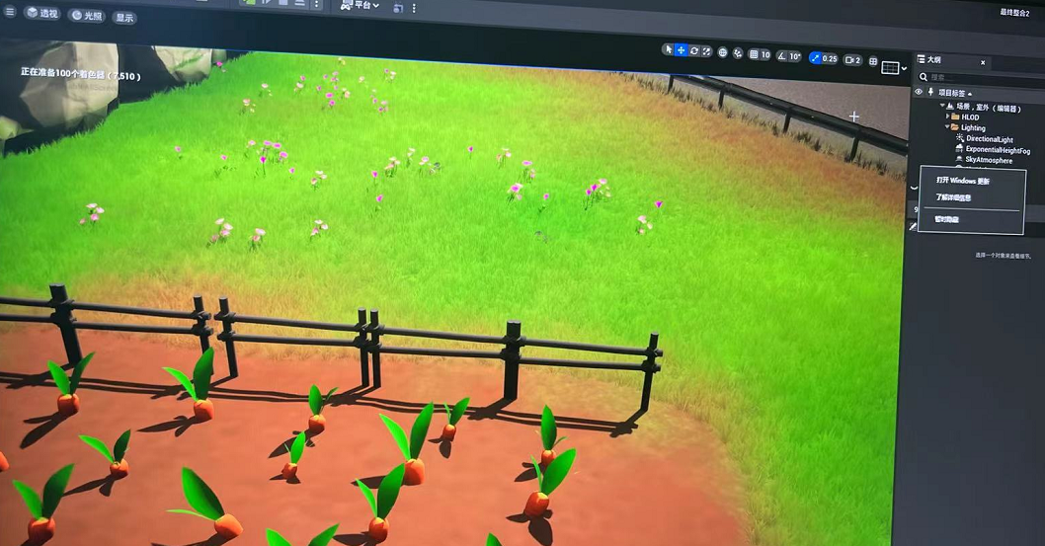
The rendering uses UE5, which is the latest updated software. Although the general operation is no different from ue4, I know nothing about rendering, and I have to relearn it all. First of all, in terms of shots, unlike maya, I need to drive the camera around the scene and set keyframes to fix the shot. And set the blueprint of the character and import the animation of the character into this shot, so that the animation can be completely rendered. Compared with Maya, this software rendering is faster, and the rendering of multiple lenses is more convenient. In the process of learning to use, my teammates also gave me a lot of help, allowing me to learn the operation of this software faster.
Maya rendering uses the Arnold renderer. This is a relatively easy-to-use renderer, but I have learned a lot about textures, including the path method of materials. Textures made in SP need to be uploaded to the correct path to get the correct effect. Properly make textures to get better results.

3.5. editing

I learned editing techniques from previous courses, books, and online videos. The editing of PR is relatively simple, import the video into PR, and use the progress bar to make and edit the video. The more important point is that the editing animation needs to be logical, produced through montage techniques and contrasting storyboards. Among them, some small special effects in the software will also be used, so that the animation looks fuller and more flexible.
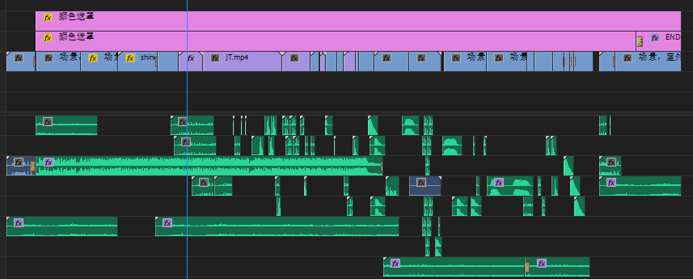

Everyone gave me different colors in the video, I used the color matching technique in PR to unify the colors. Compare the two videos in the software, adjust the color in the LUT, and finally make the color similar.
The combination of two different BGMs brings a sense of rhythm to this animation. The joy in the early stage and the tension in the later stage are also an indispensable part of adding fun to the animation. I took inspiration from a lot of movies and animation to place this music.

IV. Conclusion

Through this major project, I have gained a lot of experience and learned a lot of things, which not only exist at the technical level, but also include teamwork and cooperation.
At the technical level, I learned how to better the whole process of making models, and also learned how to unwrap UVs, use materials, and restore the design and production of original paintings. In terms of rendering, including lens language, lens dynamics, and even empty shots, all have their own importance, as well as lighting rhythms, which all need to be controlled or even set in advance. In terms of the final cut and the sound, I think I did a good job, editing is not just about throwing everything together, first to make sure the story, second, the rhythm, and the sequence of the shots are important, in this major project, I also gained a lot of experience that I didn't have before.
In terms of the team, I also earnestly completed the tasks assigned by the team leader, and even helped other team members in other aspects. I think I have done all my personal tasks. At the same time, I also learned a lot about team communication, and when making these things, a team leader is very important. Everyone's division of labor also needs to be reasonably customized, otherwise it will be a mess.
In this team work, the team members played a great role, and of course there were also team members who were not officers. Difficulties such as jet lag, communication, and file transfer did affect our production, but we still tried our best to overcome these difficulties and complete this animation. This assignment will also provide me with a lot of useful knowledge and experience in the future. I am very grateful for this opportunity. I will also use these experiences in my work and life to make better works.

