
Health and Social Care
Task 3: Midwifery Report

Word Count: 1381
Klaudie Balazova

Contents
Midwifery 2
Introduction: 2
What is midwifery? 2
Responsibilities of a Midwife 2
During pregnancy and delivery 2
During Postnatal Care 3
Skills needed in Midwifery 3
Strategies for skill improvement 3
How would these strategies help? 4
Conclusion 4
Reference List: 4

Midwifery


Introduction:
This report will include information related to what is midwifery? what is the role of Midwifery? And what are their responsibilities, ending with strategies and skills you will need to adapt in order to become a great midwife.
Figure 1. What is Midwifery (MedStar Health, 2026).

What is midwifery?
Midwifery is a health science profession, solely focused and dedicated to providing healthcare towards the women’s reproductive system and sexual health (NHS, 2026). By providing personalised care to women during their pregnancy, labour and post-partum, women are able to have a better and successful pregnancy and delivery (Cleaveland Clinic,2026) because of the support and care given by midwives, there are less health problems that may occur during pregnancy or after delivery which could be life threatening, for instance, If pregnancy is not regularly monitored, there are multiple health risks that can lead to preeclampsia, premature birth or in some severe cases, foetal distress (Zampieri, et al, 2025).

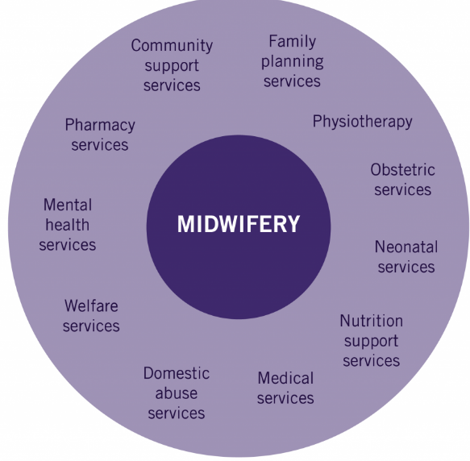
Responsibilities of a Midwife

During pregnancy and delivery
Midwives have a variety of vital responsibilities such as, providing antenatal care, this consists of carrying out consistent checks throughout the pregnancy to ensure the health and safety of the foetus, by conducting examinations, for example, ultrasounds or blood screenings, midwives are responsible for carrying out these examinations and ensuring they are being done regularly (Guzewicz, et al. 2022).
Figure 2. Roles of a Midwife (Open Library, 2017).
Another necessary responsibility as a midwife is to identify certain pregnancies with complex needs, for example, a woman who suffers with diabetes may have risks within her pregnancy, if it is overlooked, not identified or treated, then it may affect the overall growth of the foetus, potentially affecting the style of birth desired and health after birth (Bradford, et al, 2022). Midwives are required to monitor and support pregnancies regularly, by doing so, it allows accurate and important details to be taken into consideration to meet the specific needs of individuals during their pregnancy, which is vital as it allows the healthcare system to identify what needs to be taken into action, for example, women with obesity, once a midwife has identified the health issue and the risks, she is able to refer the woman to a dietitian or physiotherapy to provide extra support within her pregnancy journey (Richens, et al, 2012). Midwives are also responsible for providing helpful information to engage parents in different styles of parenting skills, this is important as it allows new parents understand different tasks/skills needed to provide the best possible life for a newborn as well as guiding them throughout their pregnancy (NHS, 2026).

During Postnatal Care
One of the many duties as a midwife is to create and develop a connection that feels safe for the woman during her pregnancy journey, by creating a safe space for women to feel comfortable enough to communicate any uncertainties or distress, being able to show support in postnatal care, by providing clinical and emotional care for the mother and child, midwives are also responsible for monitoring the health and growth of the baby, lastly one of their duties during postnatal care is to examine and carry out health checks such as, blood pressure, healing process and screenings to examine if there are any signs infections, blood clots or preeclampsia (Gidaszewski, et al, 2025).

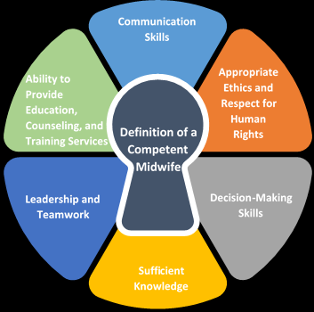
Skills needed in Midwifery
Being highly observant is a crucial skill as a midwife because through observations, it allows clear understanding of what signs are showing, what could be caused and how to prevent further health issues developing, being observant is a highly useful skill to apply within a clinic as it promotes effective and precise support (NHS, 2026). Emotional resilience is a vital skill to have because as a midwife, you will be experiencing moments where there is highly stressful and upsetting events with newborns, by being emotionally resilient, it allows you to stay focused on the support you provide as well as staying calm while making highly stressful decisions in a fast and distressing environment (Midwifing the Midwives, 2025). Another essential skill to retain is compassionate communication, this is simply done by communicating with women in a clear and kind manner, showing compassion by a number of different techniques such as facial expressions or hand gestures which shows compassion and care when the female is in distress, this is a very important skill to have as a midwife because it allows the relationship between the woman and midwife to express honesty, worries and health issues with confidence and trust, building a better and safe bond. For instance, if there was no compassion shown from the midwife, the pregnant woman would feel less confident expressing her true feelings to her, which could result in miscommunication and missed signs of potential risks that could have been dealt with if there was a safer bond created by the midwife through showing compassion (Careers Wales, 2026).
Figure 3. Competent Midwife, (Research Gate, 2026).

Strategies for skill improvement
To make improvements in these skills, the specific type of strategies includes, educating yourself with ‘trauma informed practices’ this is known to be a specific and personalised framework of care that is used to create a trustworthy and healthy relationship between midwife and patient. Rather than labelling or questioning the patient’s behaviour (which suggests a negative history), the midwife would actually ask what really happened in their past for them to speak or act in certain ways, such as avoiding communication or fear of not being safe (Wonder Foundation, 2026). This will facilitate a better understanding of real-life scenarios that can be highly distressing, learning to manage emotions and thoughts will support you by staying focused and have a clear mind, to make effective decisions when there is a highly stressful environment. To improve your skills, it is very important you have a mentor, to guide you, support you and observe your successes and mistakes which are all essential, as it allows you to see where you need to focus more on improving (Arundell, et al, 2024). To improve compassionate communication, using the PREP method is highly effective because it allows you to learn to establish your point, reason, examples and reinform your topic of discussion (Spark Studio, 2026), it is important you assess yourself daily, on your ability to actively listen, by responding, asking questions and engaging will improve clear and effective communication. Additionally, to improve your observation skills, It is important to learn how and when to observe early signs during pregnancy to reduce complications from occurring, to improve this skill it is crucial to continuously complete physical/written work which focuses on observation, for instance watching real life scenarios and being able to observe and acknowledge issues, will improve your ability to deeply analyse a situation within pregnancy, this is important and will help you in the future when dealing with situations where there is a pregnancy that has high risks of health problems (World Health Organisation, 2026).

How would these strategies help?
These strategies will support and have a high influence on the progress of your skills, as each of them focus on observing, communicating and emotionally resilient, as well as having a mentor to further support you in improving these vital skills. These are also immensely helpful strategies because they apply to real life scenarios which you will experience as a midwife, for instance, communicating with women compassionately, building trust, observing important details and dealing with a highly stressful environment within pregnancy.

Conclusion
In conclusion, this report has answered, what is a midwife, their responsibilities and different strategies used to become a successful midwife, for instance, you must educate yourself in many areas relating to personal skills that are used in the day-to-day life of a midwife such as, communication and resilience. Understanding the wide range of responsibilities and learning to adapt necessary skills you can apply into the role of a midwife Is vital and needed to become an effective and supportive midwife.

Reference List:
Arundell, F.A, Sheehan, A.S, Peters, K.P, (2024). “Strategies used by midwives to enhance knowledge and skill”. BMC Nursing. Volume 1, pp. 137.
Brandford, B.B, Wilson, A.W, Portela, A.P, McConville, F.M, Turienzo, C.T, Homer, C.H, (2022). Midwifery continuity of care. Volume 2, issue 10, Pp. 137.
Careers Wales, (2026). “Skills and Qualities”. Available at: https://careerswales.gov.wales/job-information/midwife/skills-and-qualities (Accessed on: 30/05/26).
Cleaveland Clinic, (2026). “What do midwives do?” Available at: https://my.clevelandclinic.org/health/articles/22648-midwife (Accessed on: 28/05/26).
Gidaszewski, B.G, Tan, L.T, King, J.K, Chua, S.C, Pasupathy, D.P, Steen, M.S, Khajehei, M.K, (2025). “The role of midwives in shaping postnatal care after perineal trauma”, volume 150, pp. 104-135.
Guzewicz, P.G, Sierakowska. M.S, (2022). “The Role of Midwives in the Course of Natural Childbirth”. Journal of Environmental research and Public Health. Volume 19, issue 23, Pp. 158.
MedStar Health, (2026). What is Midwifery? Available at: https://www.medstarhealth.org/blog/what-is-a-midwife-truth-about-midwifery-myths (Accessed on: 28/05/26).
Midwifing the Midwives, (2025). “Emotional Intelligence and Compassion”. Available at: https://midwifingthemidwives.com/f/essential-skills-every-midwife-needs-a-comprehensive-guide (Accessed on: 04/06/26).
NHS, (2026). “Midwife”. Available at: https://www.healthcareers.nhs.uk/explore-roles/midwifery/roles-midwifery/midwife (Accessed on: 28/05/26).
NHS, (2026). “Neonatal Nurse”. Available at: https://www.healthcareers.nhs.uk/explore-roles/nursing/roles-nursing/neonatal-nurse (Accessed on: 04/06/26).
NHS, (2026). “What are the responsibilities of midwives”. Available at: https://www.healthcareers.nhs.uk/explore-roles/midwifery/roles-midwifery/midwife (Accessed on: 30/05/26).
Open Library, (2017). “Roles of a Midwife”. Available at: https://ecampusontario.pressbooks.pub/cmroleofmidwifery/chapter/health-policy-analysis-in-midwifery/ (Accessed on: 28/05/26).
Research Gate, (2026). “Competent Midwife”. Available at: https://www.researchgate.net/figure/Midwife-skills-Source-ICM-2024_fig1_393802795 (Accessed on: 30/05/26).
Richens, Y.R, Smith, D.M, Lavender, T.L, (2012). “A Ticking Bomb for Reproductive Health”. 1st Edition, London. Elsevier BV Publishing.
Spark Studio, (2026). “Using PREP method”. Available at: https://sparkstudio.co/articles/public-speaking/using-prep-method-impromptu-speaking-quick-thinking/ (Accessed on: 27/06/26).
Wonder Foundation, (2026). “Trauma Informed Practices”. Available at: https://wonderfoundation.org.uk/trauma-informed-practice-what-it-is-and-why-it-matters/?gad_source=1&gad_campaignid=22166330394&gbraid=0AAAAADcHFO18b3CwtdmFtVaNLwLow8t6d&gclid=CjwKCAjw6f3RBhApEiwAMaCqWYndNrssANTPwrg-HZJ2167JhQ_1ZqmrxY13DYnvx3N5Gva8LK7dIRoCqNwQAvD_BwE (Accessed on: 27/06/26).
World Health Organisation, (2026). “Strengthening the skills of future midwives”. Available at: https://www.who.int/europe/news/item/03-05-2024-strengthening-the-skills-of-future-midwives (Accessed on: 30/05/26).
Zampieri, G.Z, Lonescu, C.A.L, (2025). “The impact of inadequate prenatal care on maternal anaemia and pregnancy outcomes in Romania”. Journal of Medicine and Life. Volume 4, issue 18. Pp. 306-314.

