Programme: DipHE
Nursing Studies and Health
Module: Public Health Promotion

Tuberculosis

Student Name: Cristiana I., Roman
Student ID: 1920096
Module Code: (BMN5006)
Executive Summary
This paper is based on an analysis of a communicable disease from a global, UK, and Welsh perspective. Communicable diseases are those that can spread from one person or animal to another. Tuberculosis has been selected as the contiguous illness for this article. One of the common symptoms of tuberculosis is a cough that lasts for three weeks. Individuals may cough up mucus or even blood. Approximately one million people are affected by tuberculosis annually, while the disease affects 10 million people globally. Data indicates that there are 4718 cases in the United Kingdom. WHO, a global organisation, has taken a number of public health initiatives to reduce the number of TB patients globally. 67 worldwide health assemblies accepted and endorsed the "End TB strategy," which this group proposed in 2014. In England, a coordinated TB strategy was put into place between 2015 and 2020.

Table of Contents
Part 2: Report 3
2.1 Introduction 3
2.2 Chosen disease 3
2.2.1 Define communicable diseases 3
2.2.2 Give an overview of the disease, its symptomatology and treatments 3
2.3 Trends in Communicable Disease 3
2.4 Public Health Response 3
2.5 Impacts on Society 3
2.6 Conclusion 3
Reference list 3

Part 2: Report

2.1 Introduction
This report is based on analysing the aspect of a communicable disease from global, UK and Wales perspectives. It will include all sorts of symptoms, trends, and public interventions for this disease. Communicable diseases are accounted to get spread from individuals or animals to others and this spreading can be dangerous to break the streak and has an enormous impact on society, analysis of such perspectives will be taken into consideration within this report (Kandola, 2020). The communicable disease which will be taken into consideration within this report is Tuberculosis it is a bacteria-caused disease which gets spread when an infected person coughs, sneezes or sings. In order to avoid the spread of this bacteria, the UK, Wales, and global bodies such as the World Health Organisation have taken various initiatives, and such interventions have been covered completely within this report.

2.2 Chosen disease

2.2.1 Define communicable diseases.
As mentioned by Tulchinsky and Varavikova (2014), a communicable disease is an illness which is caused due to a specific infection agent or sorts of toxic products which arise with the transmission of that agent. In case of a communicable disease product from an infected person, animal or an inanimate reservoir is speeded to a susceptible host. People sometimes refer to communicable diseases as transmissible or infectious.
Tuberculosis is the communicable disease which has been selected for this report and it is a contiguous disease which is caused in an individual by the infection of Mycobacterium Tuberculosis bacteria also known as (MTB) bacteria (NIAID, 2019). This bacterium gets spread through air when an affected individual coughs, speaks, or sings around. People nearby breathing to an infected person have the chance of getting affected.

2.2.2 Give an overview of the disease, its symptomatology, and treatments.
Overview
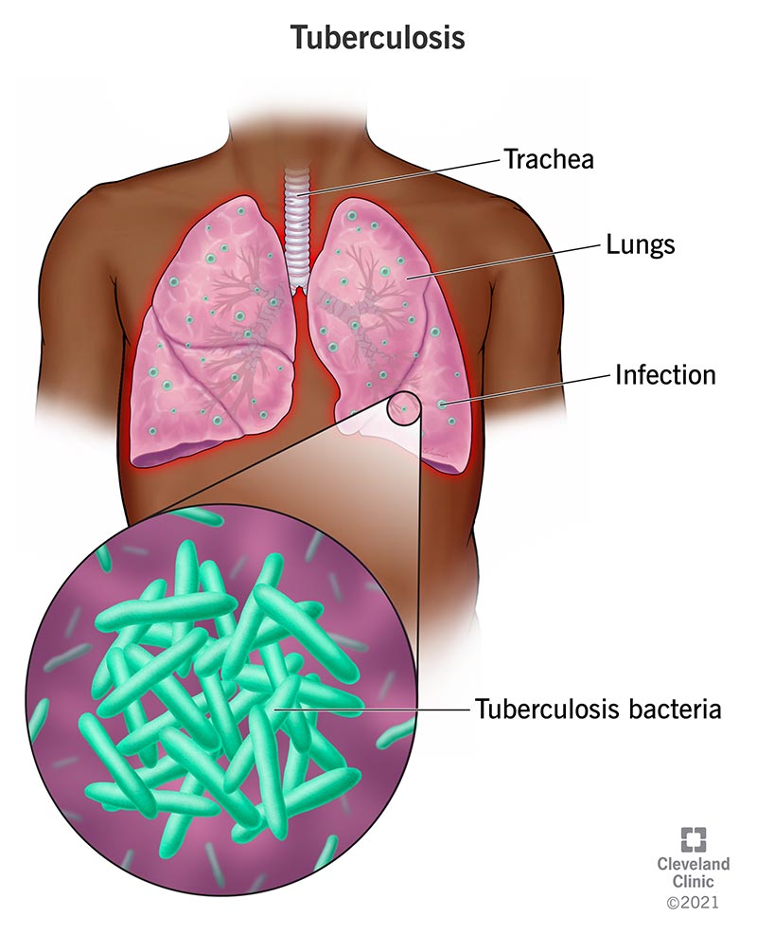
Figure 1: Area of occurrence for Tuberculosis
(Source: Cleveland Clinic, 2022)
Pulmonary tuberculosis is considered as an infectious disease which can cause infection in lungs and various other issues. This bacterium affects individual lungs however in some cases it has been detect that medical condition affects brain, spine, and kidney (Cleveland Clinic, 2022). If an individual gets stuck to this illness and falls sick that individual needs to be treated on time. Sometimes there can be no symptoms in the individual body outside or can received, however inside it remains completely active. As per activeness, they find three stages of sickness are Primary Action, this is a latent infection along Active disorder. There can be various kinds of affecting pulmonary lungs and even outside the lungs causing extrapulmonary. There is another type of this pathology which spread from the body known as Systemic Miliary tuberculosis.
Symptomatology
Common symptoms of this chronic respiratory illness include a cough which lasts for three weeks. Individuals can cough up the mucus or it can even include blood. Individuals can even feel tired with this bacterium in their bodies. They can experience elevated temperatures and night sweats which disrupt their sleep. In several situations’ loss of appetite, loss of weight and unwell feelings are, also observed as per the symptoms concern. In cases of Active tuberculosis among of children, they may experience the symptoms of gaining weight and growing (National Health Service, 2023). Airborne bacterial infection also has spread in various other parts such as glands, bones, and brains. This includes symptoms of swollen glands, body pains and aches, swollen joints, pelvic pain, constipation, and dark pee. Other than these symptoms individuals tend to experience headaches, sickness, stiff neck, confusion and even rashes on legs and face.
Treatment
For diagnosis, the presence of this disease patients has to have two types of screening tests “Mantoux tuberculin skin test” and a blood test known as "Interferon-gamma release assay" (IGRA). Further tests for assisting lung infection, include lab tests of lung fluid, X-rays, and CT scans. In the present instance, the disorder its treated with various drugs as per the symptoms. Isoniazid, Rifampin, Ethambutol, Pyrazinamide and Rifapentine are the common types of drugs, for treating individuals affected (National Health Service, 2023). However, treating individuals with all these sorts of drugs can create various side effects such as skin rashes, nausea, stomach upset, jaundice, itchy skin, and dark pee. For this along with drugs various medical treatments are required if an individual gets affected with side effects caused due to the medicine.

2.3 Trends in Communicable Diseases
In the global aspect, there are a vast number of the population affected with the problem of tuberculosis. Globally ten million peoples are affected with by this bacterium and approximately one million people experience the impact of Tuberculosis every year (Selvaraju et al., 2023). India accounts for 25% of cases around the globe with 2.77 million cases, however, India has aimed to end by 2025. As of 2023, globally 10.8 million peoples are impacted, among them six million are men, 3.6 million people are women and the rest 1.3 million are children. This year the world has experienced 1.25 million deaths due to TB. Global efforts in order to combat life have saved the lives of seventy-nine million people since the year 2000 (World Health Organization, 2024). Prevalence of this has been continuously reducing globally for the past two decades. The number of cases has also been lowered by 8.7% from the year 2015 to 2022 and this is due to active vaccination strategies (World Health Organization, 2023). However, the progress of relief is accounted for slow in comparison with the progress of medical science in the growing world.
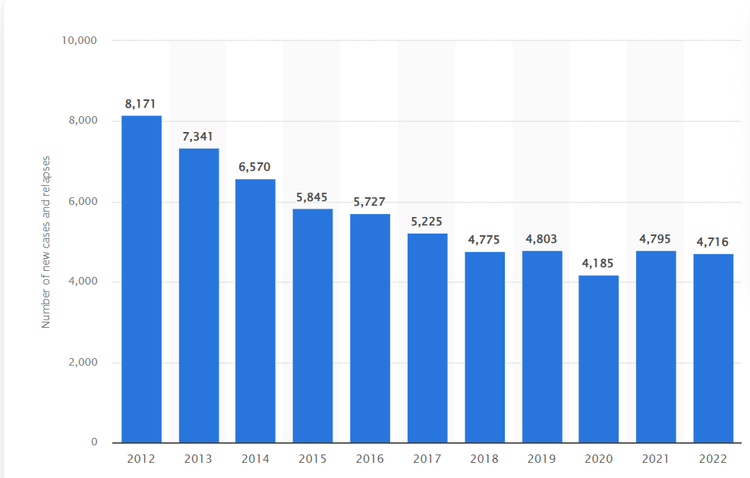
Figure 2: New Tuberculosis relapse in UK
(Source: Gagliardi, 2024)
This figure indicates the relapse scenario of new tuberculosis in the UK as it was in its final state; from 2012 this new case has emerged over a mass population of 8,171 (Gagliardi, 2024). However, the government of the UK has taken various initiatives in treating and reducing these new cases and it was prevalent up to 4718 cases as of 2022. In the UK, the majority of the cases are in various urban centres such as the Northwest, West Midlands, and London (UK Health Security Agency, 2024). However, recently it has been also rising in the Southwest and Northeast regions where incidence is comparatively lower in the UK.
As of 2023, 84 newly diagnosed cases of TB have been identified and reported in Wales, an 18% increase has been reported compared to previous year with seventy-one cases. Prevalence is identified to be increasing in Wales however this region has the lowest incidence of cases in the complete UK with a rate of 2.3 per 100,000 as of 2022 (NHS Wales, 2024). In comparison, the UK's other region has a case of seven per 100,000 in 2022. Thus, it can be concluded that prevalence of Wales is far more effective compared to that of the UK as the number of cases is much lower compared to all other greater parts of the UK.

2.4 Public Health Response
As a global organisation (WHO) has taken various public health initiatives in order to reduce the number of patients all around the globe. This organisation has introduced an "End TB strategy" which was accepted and endorsed by 67 World Health Organisation in 2014 (WHO, 2020). This strategy envisioned free TB, zero diseases and deaths along with less suffering in case of illness problems. This strategy inclusion aims to reduce the global spread, death, and impact all around the globe by the end of 2035. WHO has also included a strategy of establishing a Global Tuberculosis report which indicates the incidence and prevalence of the cases all over indicating the effectiveness of the treatment introduced globally. As per National Institute of Health, BCG (Bacillus Calmette Guerin) is the vaccine which are introduced globally for this infection and it is the only effective vaccine which reduces the rate of deaths and spread of this (Pooransingh and Sakhamuri, 2021). Overall efficiency of BCG vaccine is cost-effective in treating the patients.
The UK government has also adopted a vaccination strategy and collaborative program in order to reduce the spread and death rate. In England, a collaborative Tuberculosis strategy was introduced from 2015 to 2020 (Government of UK, 2023). This strategy collectively aims to reduce the number of aces and remove all sorts of social inequalities in the case of treating. Main goal of this particular strategy program includes elimination of infection as a part of public health problems. BCG vaccine is a routine vaccine for treating cases in the UK and as a part of this factor, the UK government has introduced a (BCG) vaccination program in order to reduce the prevalence of this pathology (NHS, 2024). However, this is not a scheduled vaccination; it is given to some babies or children who have been subjected to major risk due to TB-causing bacteria.
Wales has very few cases, however they also include an Eradication Program delivery plan for treating Tuberculosis. This particular strategy aims to make the region TB-free by the period of 2041 (Government of Wales, 2023). Measures taken as a part of this program include Annual testing of the cases, enhancing control and promotion of suitable biosecurity.

2.5 Impacts on Society
Tuberculosis affects an individual in their most productive age which is from 15 to 45 and this can reduce the all-over workforce participation of the individual. As a result, the household income can be reduced, and the family has to experience an economic burden. Even after all the free facilities for treating disorder, treatment of typical TB costs around 5000 GBP however in case of MDR tuberculosis it is 50,000 GBP (Lancet, 2013). Thus, the economic impact of this public problem can cause economic burdens over the society. TB is majorly caused by social inequalities experienced by the individual this problem is quite common among the homeless, migrants and populations with poverty. Due to this reason the death number is quite an incidence as people in poverty fail to treat individuals with TB. This problem is quite prevalent among school children, and this disrupts their educational progress affecting their mental state for the long term.
Health professionals treating TB are at elevated risk of occurrence as it is communicable, and this can lead to stress and burnout. Health workers need to be under continuous professional development so that evolving challenges such as MDR TB and modern technologies can be accounted for effectively. This problem affects the health care service of the region, treatment of TB takes a longer period for this reason it demands resources, free beds, medication, and facilities for the long term. Programs for TB controls require an elevated level of infrastructure for tracking and screening the all-over treatment process.

2.6 Conclusion
The analysis of a communicable disease from a worldwide, UK and Welsh perspective forms the basis of this report. Diseases that are passed from one person or animal to another are considered communicable. The contiguous disease that has been chosen for this article is tuberculosis, which is brought on by an infection with Mycobacterium tuberculosis bacteria, referred to as MTB bacteria. A cough that lasts for three weeks is one of the typical signs of tuberculosis. Mucus or even blood may be coughed up by individuals. Around TB impacts one million people each year, and ten million people worldwide are afflicted with the disease. According to data, there are 4718 cases in the UK. As a worldwide institution, WHO has implemented several public health measures to lower the number of TB patients worldwide. In 2014, this association presented the "End TB strategy," which was approved and supported by sixty-seven international health assemblies. From 2015 to 2020, a coordinated TB strategy was implemented in England.

Reference list:
Cleveland Clinic (2022). Tuberculosis: Symptoms, Causes, Treatments. [online] Cleveland Clinic. Available at: https://my.clevelandclinic.org/health/diseases/11301-tuberculosis .
Gagliardi, J. (2024). New tuberculosis cases and relapses in the UK 2012-2020. [online] Statista. Available at: https://www.statista.com/statistics/918290/new-tuberculosis-cases-and-relapses-in-uk/.
Goverment of UK (2023). Collaborative TB Strategy for England, 2015 to 2020 End of programme report Collaborative TB Strategy -End of Programme Report 2. [online] Available at: https://assets.publishing.service.gov.uk/media/6058cb01d3bf7f2f12377283/Collaborative_TB_Strategy_for_England_2015-2020_End_of_Programme_Report.pdf .
Government of Wales (2023). Wales TB Eradication Programme Delivery Plan. [online] Available at: https://www.gov.wales/sites/default/files/publications/2023-03/wales-bovine-tb-eradication-programme-delivery-plan-2023_0.pdf .
Kandola, A. (2020). Communicable Diseases: Definition, Symptoms, Prevention. [online] Medical News Today. Available at: https://www.medicalnewstoday.com/articles/communicable-diseases .
Lancet, T. (2013). The ongoing problem of tuberculosis in the UK. The Lancet, [online] 381(9876), p.1431. doi:https://doi.org/10.1016/S0140-6736(13)60910-1 .
NHS (2023). Overview - Tuberculosis (TB). [online] NHS. Available at: https://www.nhs.uk/conditions/tuberculosis-tb/ .
NHS (2024). BCG vaccine for tuberculosis (TB). [online] nhs. Uk. Available at: https://www.nhs.uk/vaccinations/bcg-vaccine-for-tuberculosis-tb/ .
NHS Wales (2024). Tuberculosis in Wales Annual Report Data to the end of 2023. [online] Available at: https://phw.nhs.wales/publications/publications1/tb-in-wales-annual-report-data-to-end-2023/ .
NIAID (2019). Tuberculosis | NIH: National Institute of Allergy and Infectious Diseases. [online] Nih.gov. Available at: https://www.niaid.nih.gov/diseases-conditions/tuberculosis .
Pooransingh, S. and Sakhamuri, S. (2021). Need for BCG Vaccination to Prevent TB in High-Incidence Countries and Populations - Volume 26, Number 3—March 2020 - Emerging Infectious Diseases journal - CDC. wwwnc.cdc.gov. [online] doi:https://doi.org/10.3201/eid2603.191232 .
Selvaraju, S., Velayutham, B., Rao, R., Rade, K., Thiruvengadam, K., Asthana, S., Balachandar, R., Bangar, S.D., Bansal, A.K., Bhat, J., Chopra, V., Das, D., Dutta, S., Devi, K.R., Dwivedi, G.R., Kalliath, A., Laxmaiah, A., Madhukar, M., Mahapatra, A. and Mohanty, S.S. (2023). Prevalence and factors associated with tuberculosis infection in India. Journal of Infection and Public Health, [online] 16(12). doi:https://doi.org/10.1016/j.jiph.2023.10.009 .
Tulchinsky, T.H. and Varavikova, E.A. (2014). Communicable Diseases. The New Public Health, [online] pp.149–236. doi https://doi.org/10.1016/b978-0-12-415766-8.00004-5 .
UK Health Security Agency (2024). TB cases rise in England. [online] GOV.UK. Available at: https://www.gov.uk/government/news/tb-cases-rise-in-england .
WHO (2020). Implementing the End TB Strategy. [online] www.who.int. Available at: https://www.who.int/westernpacific/activities/implementing-the-end-tb-strategy .
World Health Organization (2023). TB incidence. [online] World Health Organization. Available at: https://www.who.int/teams/global-tuberculosis-programme/tb-reports/global-tuberculosis-report-2023/tb-disease-burden/1-1-tb-incidence .
World Health Organization (2024). Tuberculosis. [online] World Health Organization. Available at: https://www.who.int/news-room/fact-sheets/detail/tuberculosis .

