University of Wales Trinity Saint David

Wales Institute of Science & Art

Project Planning

Engineering Management (ACHA5012)

Jacob Ling
220427
November 2024
Contents
1 Introduction 2
2 Team Member Roles and Responsibilities 3
2.1 Belbin’s Model Score 3
2.2 Category Explanations 3
2.3 Team Member Roles and Responsibilities 5
3 Group Tasks 6
4 My Tasks 7
4.1 Personal Gantt Chart 7
4.2 Bill of materials (Ideal Budget): 8
4.3 Bill of materials (Realistic Budget): 8
4.4 Specialist Equipment: 8
5 Significant Milestones 9
5.1 Gateway Objective: 9
5.2 Development 9
5.3 Architecture 9
5.4 Logic methods 9
5.5 Processing 9
5.6 Testing 9
5.7 Algorithms 9
5.8 Summary 9
6 Risk Assessment 10
7 Summary 11
7.1 Group Gantt Chart 11
7.2 Conclusion 12
8 References 13

Introduction

In this assignment, I will cover how to showcase my expertise in accounting methods, project planning and costing, as well as my ability to monitor projects, motivate the workforce, and manage team dynamics. This will integrate well into the group project as it will link to my personal involvement with the project which is the system programming of the control system.

Team Member Roles and Responsibilities

Belbin’s Model Score
Belbin’s Category | Implementer | Co-ordinator | Shaper | Plant | Resource Investigator | Monitor Evaluator | Team Worker | Completer Finisher
Score | 13 | 5 | 11 | 6 | 9 | 7 | 11 | 8

According to Belbin’s Model my score is highly associated with the implementer role, this relates to my role in the team as I need to plan how to create an efficient SIMULINK program that will not malfunction and execute it correctly.
Other possible traits that apply to my role include team worker which works well in my role as I will need to be cooperative with other departments to ensure that the code I create can replicate exactly what is required and designed by others within the team.

Category Explanations
Implementer:
This person is essential for planning and executing efficient strategies. They are practical, reliable, and efficient, excelling at turning ideas into actions and organizing the necessary work. However, they might be somewhat inflexible and slow to adapt to new possibilities. (Belbin, 2010)

Co-ordinator:
This person focuses on the team's objectives, encourages team members to contribute, and delegates tasks effectively. They're mature and confident, good at identifying talent and clarifying goals. However, they might be perceived as manipulative and could try to offload their own tasks onto others. (Belbin, 2010)

Shaper:
This individual ensures the team stays focused and maintains momentum. They're challenging, dynamic, and thrive under pressure, with the drive and courage to overcome obstacles. However, they may provoke others and occasionally offend people's feelings. (Belbin, 2010)

Plant:
This person is highly creative and excels at solving problems in unique ways. They are imaginative, free-thinking, and capable of generating innovative ideas and solutions to difficult problems. However, they might overlook minor details and may sometimes be too absorbed in their thoughts to communicate effectively. (Belbin, 2010)

Resource Investigator:
This person uses their natural curiosity to discover and bring new ideas to the team. They're outgoing and enthusiastic, thriving on exploring opportunities and building connections. However, they can sometimes be overly optimistic and might lose interest once the initial excitement fades. (Belbin, 2010)
Monitor Evaluator:
This individual brings a logical perspective, impartially judging and evaluating the team's options. They are sober, strategic, and discerning, with a keen eye for all available options and accurate judgment. However, they may lack the drive to inspire others and can sometimes be overly critical. (Belbin, 2010)

Team Worker:
This individual helps the team to bond, using their flexibility to identify and complete necessary tasks. They are cooperative, perceptive, and diplomatic, effectively listening and preventing conflicts. However, they may be indecisive during critical moments and tend to avoid confrontation. (Belbin, 2010)

Complete Finisher:
This person is best utilized at the end of tasks to polish and scrutinize the work for errors, ensuring the highest standards of quality control. They are painstaking, conscientious, and anxious, excelling at finding errors and perfecting the final output. However, they may worry excessively and be reluctant to delegate tasks. (Belbin, 2010)

Team Member Roles and Responsibilities
Names | Roles | Task Assigned | Responsibilities
Jacob Ling | Control System Design | System Programming | Developing the necessary software to operate the control systems.
Jacob Gough | Structural Design | Design | Carrying out the structural design and specifications recommended by the Aero part of the team using SOLIDWORKS.
Nevin Jyothis | Structural Design | Design | Carrying out the structural design and specifications recommended by the Aero part of the team using SOLIDWORKS.
James Evans | Control System Design | Mechatronic Components | Researching and designing the mechatronics system to adjust the wing angle according to the software specifications.
Alex Griffths | Aerodynamic Design / project leader | Coordinator / CFD | Leading the project ensuring that team meetings occur, and members carry out there tasks accordingly. Also responsible for using CFD to optimize the aerodynamic efficiency.
Mohammed Mahmood | Aerodynamic Design | Wind Tunnel | Carrying out wind tunnel tests to contribute to optimizing the aerodynamic capabilities of the wing.
Emily Dawes | Vehicle Performance Assessment | Simulation | Running simulations to analyse the optimal wing position for different corners on track to understand the best way to set it up.
Angel Stanley | Vehicle Performance Assessment | Simulation | Running simulations to analyse the optimal wing position for different corners on track to understand the best way to set it up.

Group Tasks

My Tasks

For the group project my assigned area is control units, this subject involves learning programming language to adapt for MATLAB and how to use Simulink. It also requires being able to build circuits and learning how to integrate the 2 to work together to adjust the wing of the car.

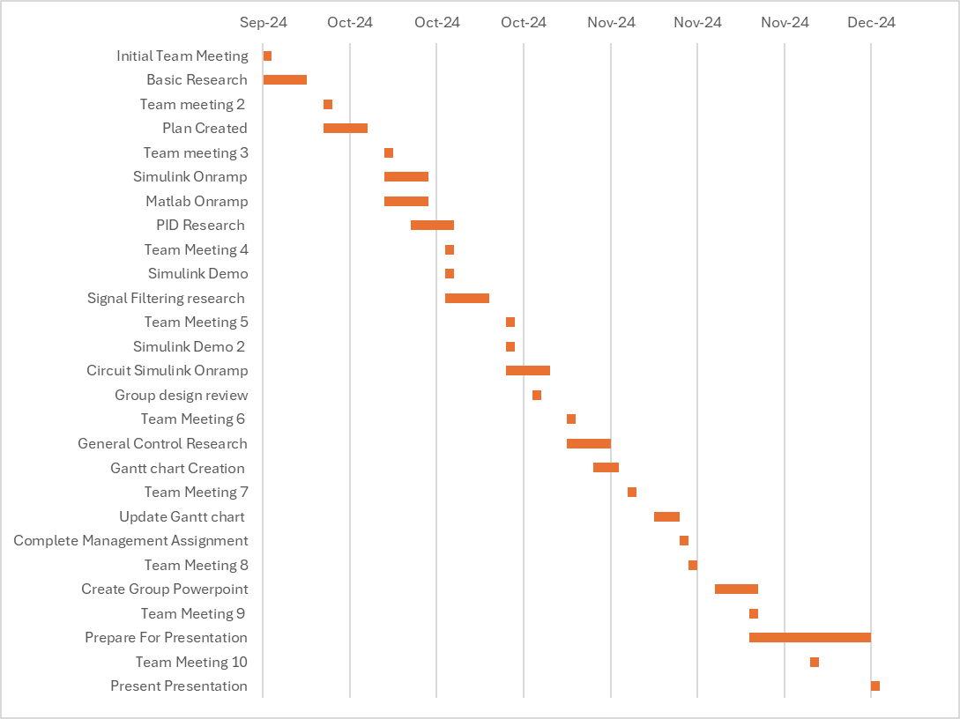
Personal Gantt Chart

Bill of materials (Ideal Budget):
Item | Approximate Cost | Estimated Lead Time
3D Printer | £10,000 (can vary depending on quality and size) | 4-6 weeks
CAD Software | £5,823 (Standard Solidworks) | Immediate
Simulation Software (MATLAB/Simulink) | £800 | Immediate
Wind Tunnel (Large scale size) | £200,000 | 6-12 months
Prototyping Materials | £5,000 | 2-4 weeks
Mechanical Testing Equipment | £10,000 | 4-6 weeks
Structural Analysis Software (FEA) | Included with SOLIDWORKS | Immediate

Bill of materials (Realistic Budget):
Item | Approximate Cost | Estimated Lead Time
3D Printer | Provided by Uni | Immediate
CAD Software | Provided by Uni | Immediate
Simulation Software (MATLAB/Simulink) | Provided by Uni | Immediate
Wind Tunnel (Small scale) | Provided by Uni | Immediate
Prototyping Materials | N/A (£1000) | 2-4 weeks

Specialist Equipment:
- Access to MATLAB software
- Access to Simulink
- Breadboard circuit
- Arduinos

Significant Milestones

Gateway Objective:
My gateway objective is to establish software structure and logic methods.

Development
Developing software to enhance the efficiency and accuracy of an active rear wing's movement involves several key structure and logic methods. The primary goal is to ensure the wing adjusts its angle swiftly and precisely, responding to dynamic driving conditions in real-time.

Architecture
The software architecture needs to be modular, enabling easy updates and scalability. At its core, the system integrates sensors, actuators, and control algorithms. The sensors gather real-time data such as speed, acceleration, and aerodynamic forces. This data is then fed into the control algorithms, which are designed to process and respond to these inputs instantly.

Logic methods
A key aspect of the control logic is the use of feedback loops. These loops continuously monitor the current position of the rear wing and compare it to the desired angle. Any deviation triggers a corrective action, ensuring the wing maintains optimal positioning. This process is similar to how a thermostat maintains room temperature—constant adjustments to achieve a set target.

Processing
To handle complex calculations and ensure quick response times, the software employs real-time processing techniques. This involves prioritizing critical tasks, such as sensor data processing and actuator control, to run at higher frequencies. Non-critical tasks are scheduled at lower frequencies, ensuring that the system remains responsive without overloading the processor.

Testing
Simulation and testing play a vital role in refining the software. Using tools like MATLAB and Simulink, engineers can simulate various driving scenarios and test the control algorithms under different conditions. This helps identify and rectify potential issues before the software is deployed in real-world applications.

Algorithms
Additionally, the software incorporates adaptive algorithms that learn from historical data to improve performance over time. These algorithms can adjust the control parameters based on past experiences, ensuring the system becomes more efficient and accurate with continued use.

Summary
In summary, the software structure and logic methods established for an active rear wing system focus on modularity, real-time processing, feedback control, simulation, and adaptive learning. These elements work together to ensure precise and efficient adjustments, enhancing the overall aerodynamic performance of the vehicle.

Risk Assessment

The first potential problem to overcome is the complexity of models. When using MATLAB and Simulink, models can get incredibly complex, which makes debugging and testing a real challenge. A complex model is harder to maintain. Over time, as new features are added or existing ones modified, the model's complexity can grow even further, increasing the likelihood of introducing new errors. The more components you have, the more interactions you need to consider, and this increases the risk of errors. The Simulink model needs to be fully operational to adjust the wing angle to all of its positions when instructed. This is important for the final design to get correct as a wing being at the incorrect angle in a corner could cause the car to crash due to a lack of downforce.
To combat this issue and tame model complexity, you could modularize your design. This means breaking down the complex model into smaller, more manageable subsystems. This way, each module can be developed and tested independently before integrating them into the larger system leading to less mistakes.

Another potential risk/issue is real-time performance. If your program has strict timing requirements, ensuring that your Simulink models can execute in real-time can be tricky. This can impact applications where precise timing and synchronization are crucial, such as control systems or simulations of dynamic systems. This would affect the speed of movement when trying to adjust the angle of the rear wing which needs to be quick and precise as possible, to ensure the best track performance achievable.
There are multiple ways of combating this issue, for example you could, select an appropriate solver. Simulink offers different solvers with varying levels of precision and performance. For real-time applications, you can use solvers designed for fixed-step or real-time simulations, such as the ode1 (Euler) or ode4 (Runge-Kutta) solvers, which can reduce computation time per step. Another alternative is to use Real-Time blocks. Simulink offers blocks specifically designed for real-time applications, such as the Real-Time Workshop blocks and Simulink Real-Time toolbox. These blocks are optimized to run on real-time hardware and can improve the responsiveness of the system.

Summary

Group Gantt Chart

Conclusion
In conclusion, this assignment demonstrates the integration of key skills such as project planning, costing, and team management with technical expertise in system programming and control system design. The use of Belbin's model has provided insights into team dynamics, helping to clarify roles and responsibilities and aligning personal strengths with the project’s needs. My role as an Implementer focuses on creating a robust and efficient SIMULINK program to control the active rear wing system, ensuring precise adjustments for optimal aerodynamic performance.

The project’s milestones highlight the importance of modular software architecture, real-time processing, and adaptive algorithms in achieving precise control over the wing’s movement. The careful selection of solvers and real-time blocks within SIMULINK will be essential for ensuring that the control system can operate within strict timing constraints, particularly under dynamic racing conditions. However, potential risks such as model complexity and real-time performance must be managed through effective modularization, testing, and optimization.

References

Belbin (2010). The Nine Belbin Team Roles. [online] Belbin. Available at: https://www.belbin.com/about/belbin-team-roles

