A Report Focussing On:

Site Investigation Case Study

Module Code – ACBA4001

Word Count Required – 2500 Words
Word Count: 2500

Prepared for:
A. Nantel

Created By:
E. Evans (2211009)

Submission Deadline – 15th December 2022

Table of Contents
No. | Content | Page
 | Figure List | 3
1.0  1.1  1.2  1.3  1.4  1.5  1.6  1.7 | Historical Appraisal  Original Site use & OS Map  Historic uses, Structures & Events  Extensions to the Dock  World War 2 brief  Effects of World War 2 to the site  Removal of structures & backfill  Brief present day changes to the site | 4-10
2.0  2.1  2.2  2.3  2.4  2.5 | Site Details  Location & current use  Walkover Survey  Boundaries  Infrastructure  Utility Information | 11-16
3.0  3.1  3.2  3.3  3.4 | Geological Appraisal  Brief information of strata  Borehole findings  Mine workings  Subsidence Risk | 17-20
4.0  4.1  4.2  4.3  4.4 | Environmental Appraisal  Contaminants  Past site uses, potential contamination  Flood Risks  Sites of Special Interest | 20-22
5.0  5.1 | Archaeological Appraisal  Brief Findings | 23
6.0  6.1  6.2  6.3 | Conceptual Ground Model  Potential Contamination Sources  Potential Receptors  Potential Pathways | 24
7.0 | Preliminary Risk Assessment | 25
8.0  8.1 | Conclusion  Site Summary of greatest Risk | 26
9.0  9.1 | Foundation Recommendations  Pile foundation findings | 27
10.0 | Pile Foundation Drawing | 28-29
11.0 | References | 30-32

Figure List
Fig No. | Content | Source  (Full ref in references) | Page
1 | Ordnance Survey map of the Fabian Way area, dated 1879 | Andrew Dulley, County Archives, Swansea | 4
2 | Aerial view Ordnance Survey map dated 1899 | Andrew Dulley, County Archives, Swansea | 5
3 | Aerial view Ordnance Survey dated 1919 | Andrew Dulley, County Archives, Swansea | 6
4 | Aerial view of the docks dated 1940 | Andrew Dulley, County Archives, Swansea | 7
5 | Bomb census describing bomb sizes | Andrew Dulley, County Archives, Swansea | 7
6 | Aerial plan Ordnance Survey dated 1948 | Andrew Dulley, County Archives, Swansea | 8
7 | Ordnance Survey map dated 1971 | Andrew Dulley, County Archives, Swansea | 9
8 | Google Earth aerial view of proposed site | https://earth.google.co.uk/ | 10
9 | Aerial view of proposed building | Taken from assignment plans | 11
10 | Google Earth Current site aerial view | https://earth.google.co.uk/ | 11
11 | Boundaries site Plan | Taken from assignment plans | 12
12 | HM Land registry ownership Plan | https://eservices.landregistry.gov.uk | 12
13 | Welsh Water asset Plans | https://gisportal.dwrcymru.com/ | 13
14 | BT Openreach asset Plans | https://www.swns.bt.com | 14
15 | National Grid asset Plans | https://onecall.linesearchbeforeudig.co.uk | 15
16 | Wales & West Utilities asset plans | https://onecall.linesearchbeforeudig.co.uk | 16
17 | Borehole logs and Plan | https://mapapps2.bgs.ac.uk/geoindex | 18
18 | Borehole logs and Plan | https://mapapps2.bgs.ac.uk/geoindex/ | 19
19 | The Coal Authority Mine Plan | https://mapapps2.bgs.ac.uk/coalauthority | 20
20 | Historic Dock photos | http://www.swanseadocks.co.uk/docksnewsite/ | 21
21 | Historic Dock photos | http://www.swanseadocks.co.uk/docksnewsite/ | 21
22 | SSSI Map plan | https://naturalresources.wales/guidance-and-advice | 22
23 | Nearest Archaeological site | http://www.swanseadocks.co.uk | 23
24 | Risk Assessment within a table | Ethan Evans | 24
25 | Hand Drawn Pile foundations | Ethan Evans | 28
26 | Borehole Logs | https://www.bgs.ac.uk/map-viewers/ | 29

- Historical Appraisal

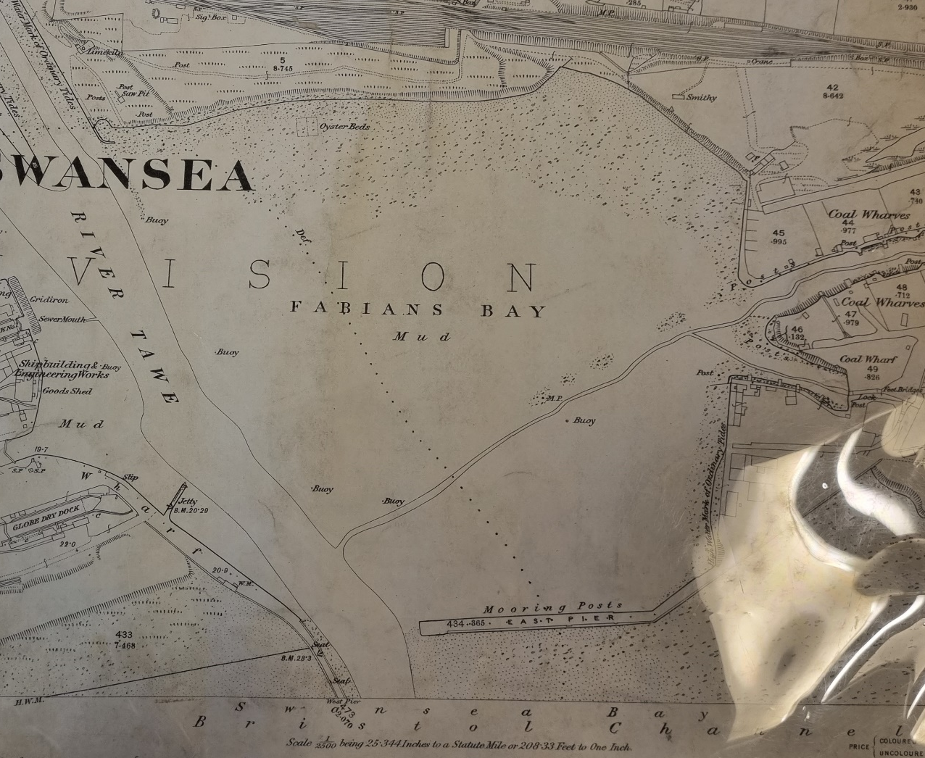
  - Before the docks were constructed, the Fabian Way area and surrounding was made up of mudflats as outlined in the ordinance survey map dated 1879.
(County Archives, 2022) Figure 1: Ordnance Survey map of the Fabian Way area, dated 1879

  - Historic Uses, Structures and Events –
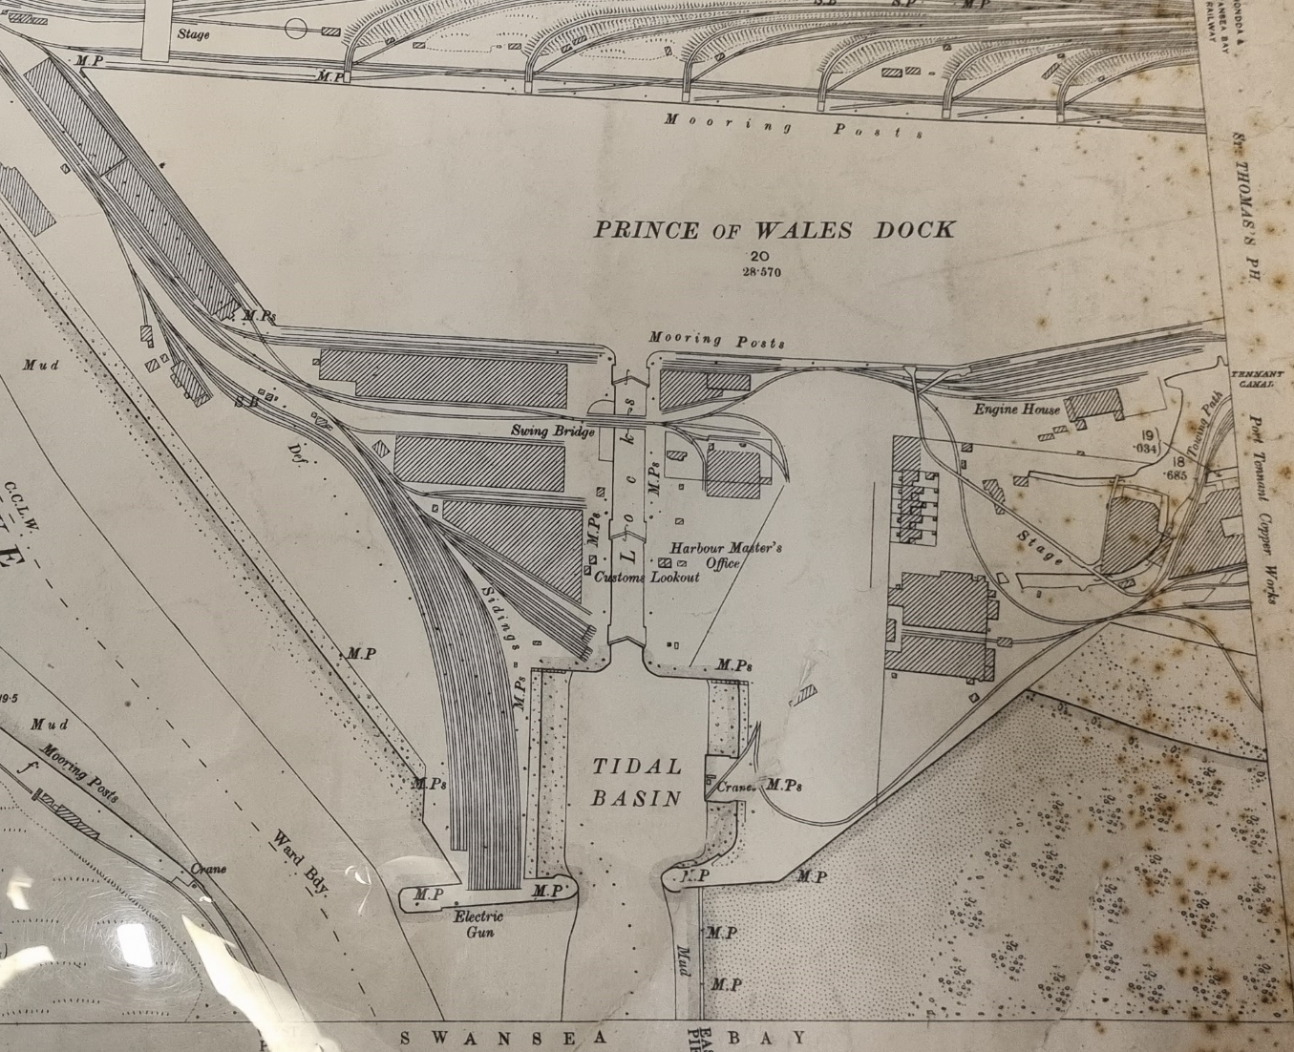
In just 20 years the docks were constructed which featured railway lines branching from areas like the mumbles, where cargo would load and unload from the dock to travel to various destinations such as refineries and mills along the mumbles etc. As outlined in the map, the tracks spanned across the site to the loading cranes. Ordnance Map (1899)
(County Archives, 2022) Figure 2: Aerial view Ordnance Survey map dated 1899

  - Extensions to the dock on the east side and more railway linkages to handle more cargo as well as a dry dock to repair ships. With the extension came more tin plate storage sheds and more railway routes and linkages, as well as mooring points and cranes for cargo loading. The dock also featured hydraulic power stations to utilise the tidal power to operate the equipment on site such as the lock gates and cranes.
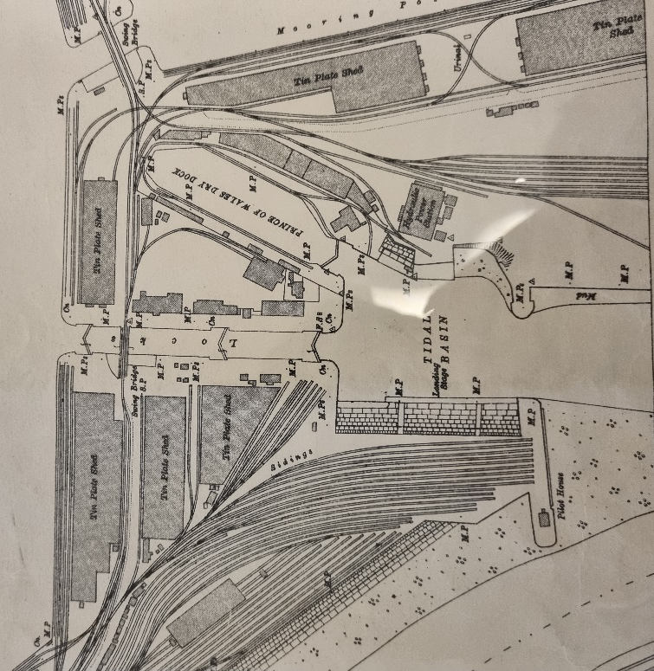

(County Archives, 2022) Figure 3: Aerial view Ordnance Survey dated 1919

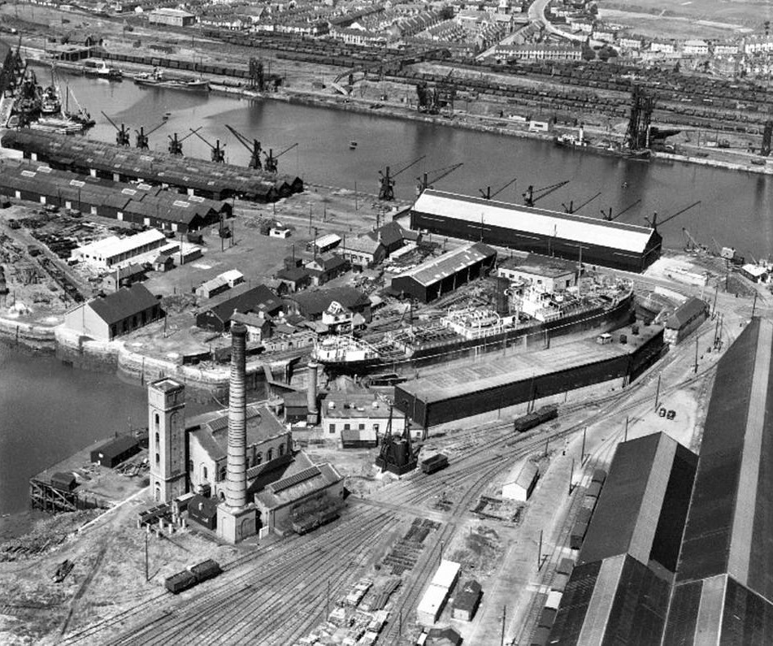

(Swansea and Port Talbot port History , 2022) Figure 4: Aerial view of the docks dated 1940
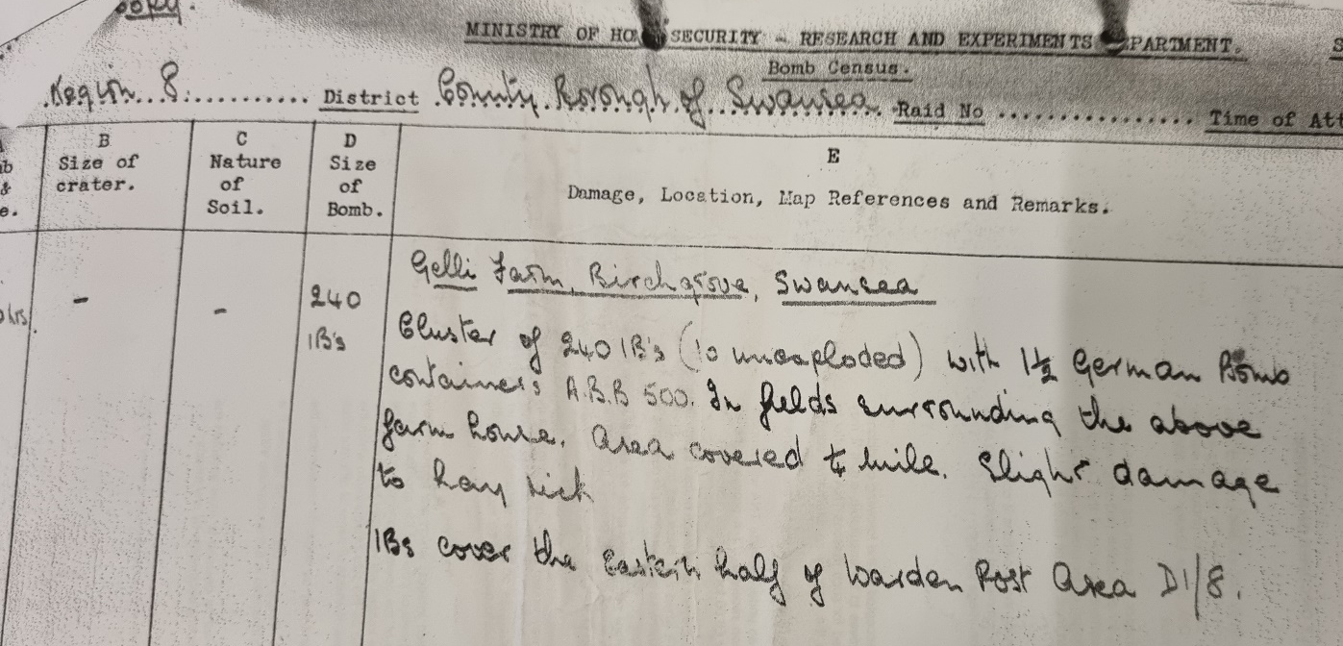
  - During World War 2, the docks and surrounding areas became a target for aerial barrage which obliterated a lot of facilities and ships around the docks, which in turn resulted in scattered materials and pollutants entering the soil, air and sea. These contaminants could be materials such as chemical substances, oils, asbestos and explosives. While it would be highly unlikely that an unexploded bomb would be buried and forgotten it could happen so extreme caution is necessary. As found from archived information there were very sizable bombs dropped on the docks which destroyed the goods sheds, workshops, ships and railway lines.
(County Archives, 2022) Figure 5: Bomb census describing bomb sizes
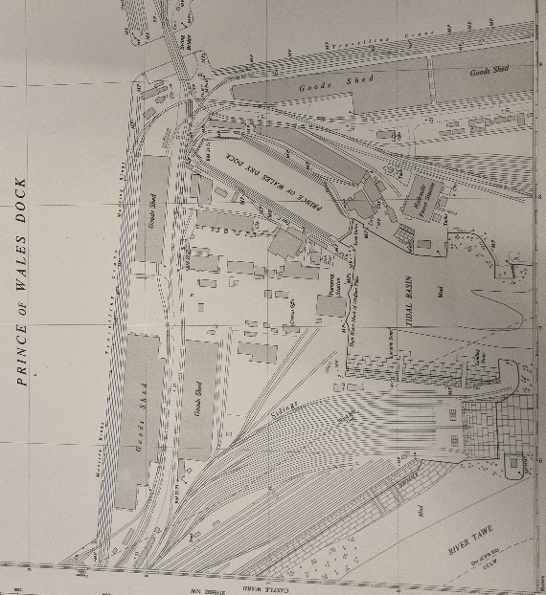
  - After World War 2 damage the site altered. The lock gates were known to have been backfilled with various materials. At the base of the old lock gates will lay a pumping station in 1948 and at the Prince of Wales Dock side it allowed for tracks to be places from one side of the dock to the other for a movable crane.

(County Archives, 2022) Figure 6: Aerial plan Ordnance Survey dated 1948

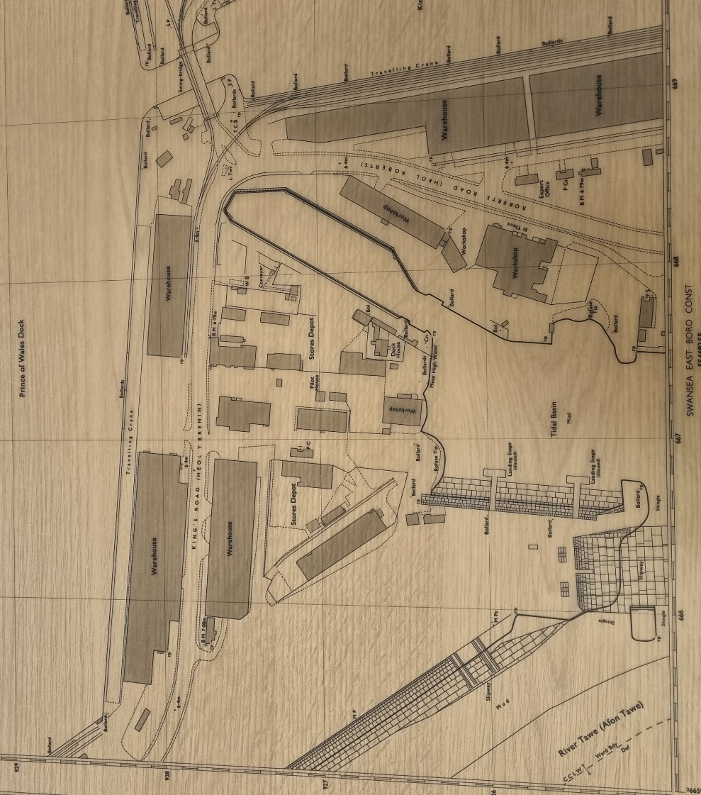
  - In 1971 the railway lines were removed likely due to deterioration and to develop an access road named Kings Road and Roberts Road which are present today and follow the old railway line. This would have been a major upgrade for the site as Lorries were able to carry cargo and improve shipment and accessibility. Structures on site were warehouses, workshops and store depots, it is recorded that throughout the docks history there were many materials that could have been housed in the docks for shipment. There was also a refuse tip on site which could have been used to backfill any areas on site further contaminating the area.
(County Archives, 2022) Figure 7: Ordnance Survey map dated 1971

  - At the present day there are a vast amount of changes to the area,
- Moving crane removed
- Storage sheds removed
- Dry dock used as a tidal basin
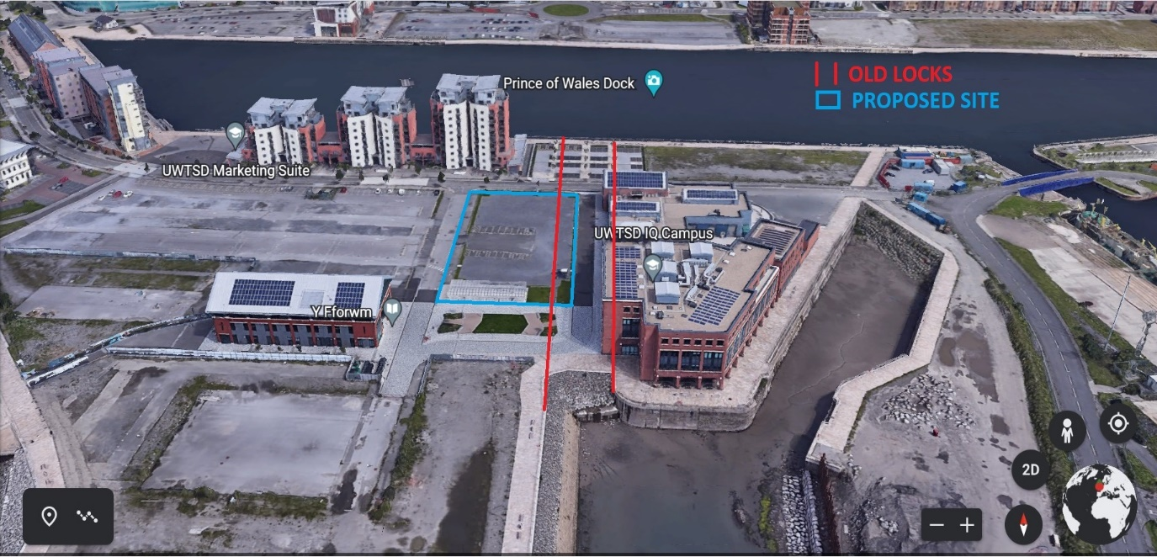
(County Archives, 2022) Figure 8: Google Earth map of the proposed site and old lock gates

- Site Details 

The ‘Innovation Matrix’ will be a two storey steel framed building with approximately 3200m$²$ of floor space.

Figure 9: Taken from assignment plans

  - Location and current use –
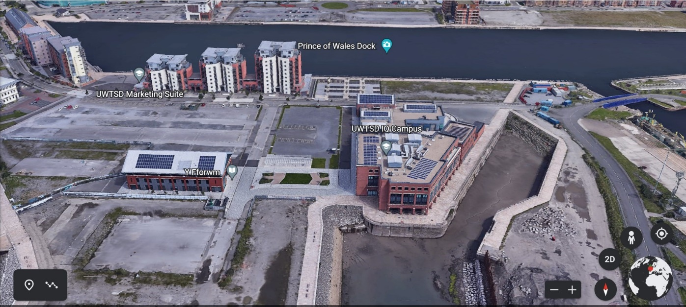
The new proposed ‘Innovation Matrix’ building will be situated on;
Plot C1, Adjacent to IQ building, Kings Road, Swansea, SA1 8EW.
OS Grid Ref: SS 66692 92728
This will be part of the SA1 university campus itself. The C1 plot is located on a spit of land between the River Tawe, the Prince of Wales Dock and the Kings Dock. The area in which the Innovation building will be constructed is currently used as a staff car park and a bike shed. This means that the current use will need to be situated elsewhere.
(Google, 2022) Figure 10: Aerial view of the current site.
  - Walkover survey -

A lot of footfall from university to the library and car park. Car parking will suffer. Lack of vegetation. A lot of surface water when raining. Can be very windy.

  - Boundaries -

The boundaries are currently outlined using the SA1 site plan, using the land registry search I have determined the land is registered by The National Assembly for Wales as per the register view screenshot below. There is a mix of land usage in the vicinity of the site, this includes residential, café/restaurants and special use such as the current University facilities.
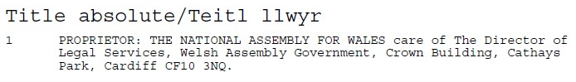
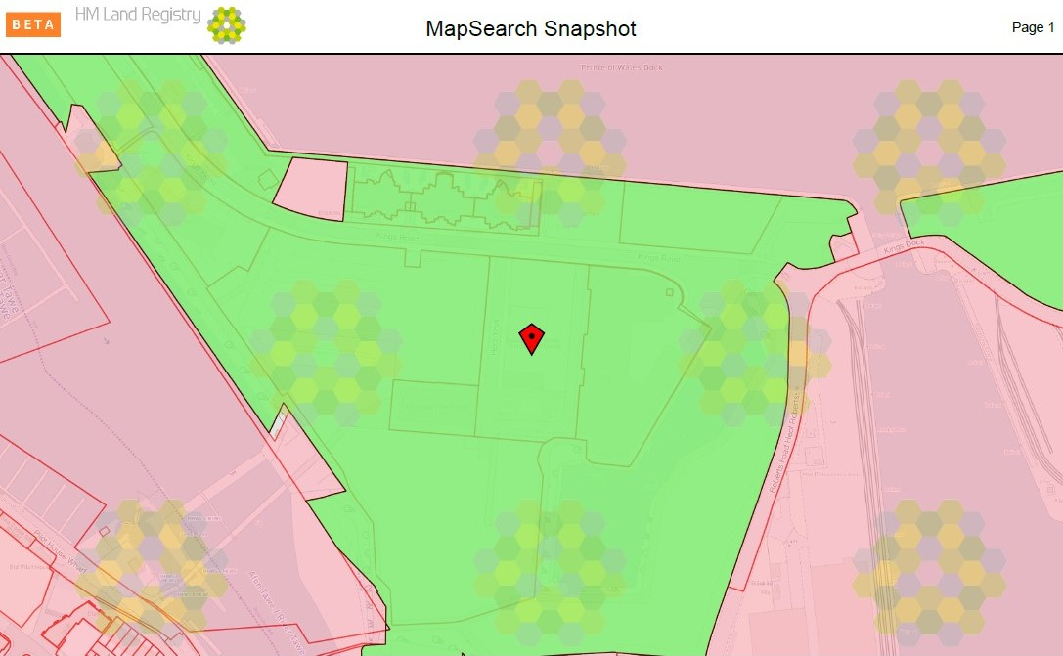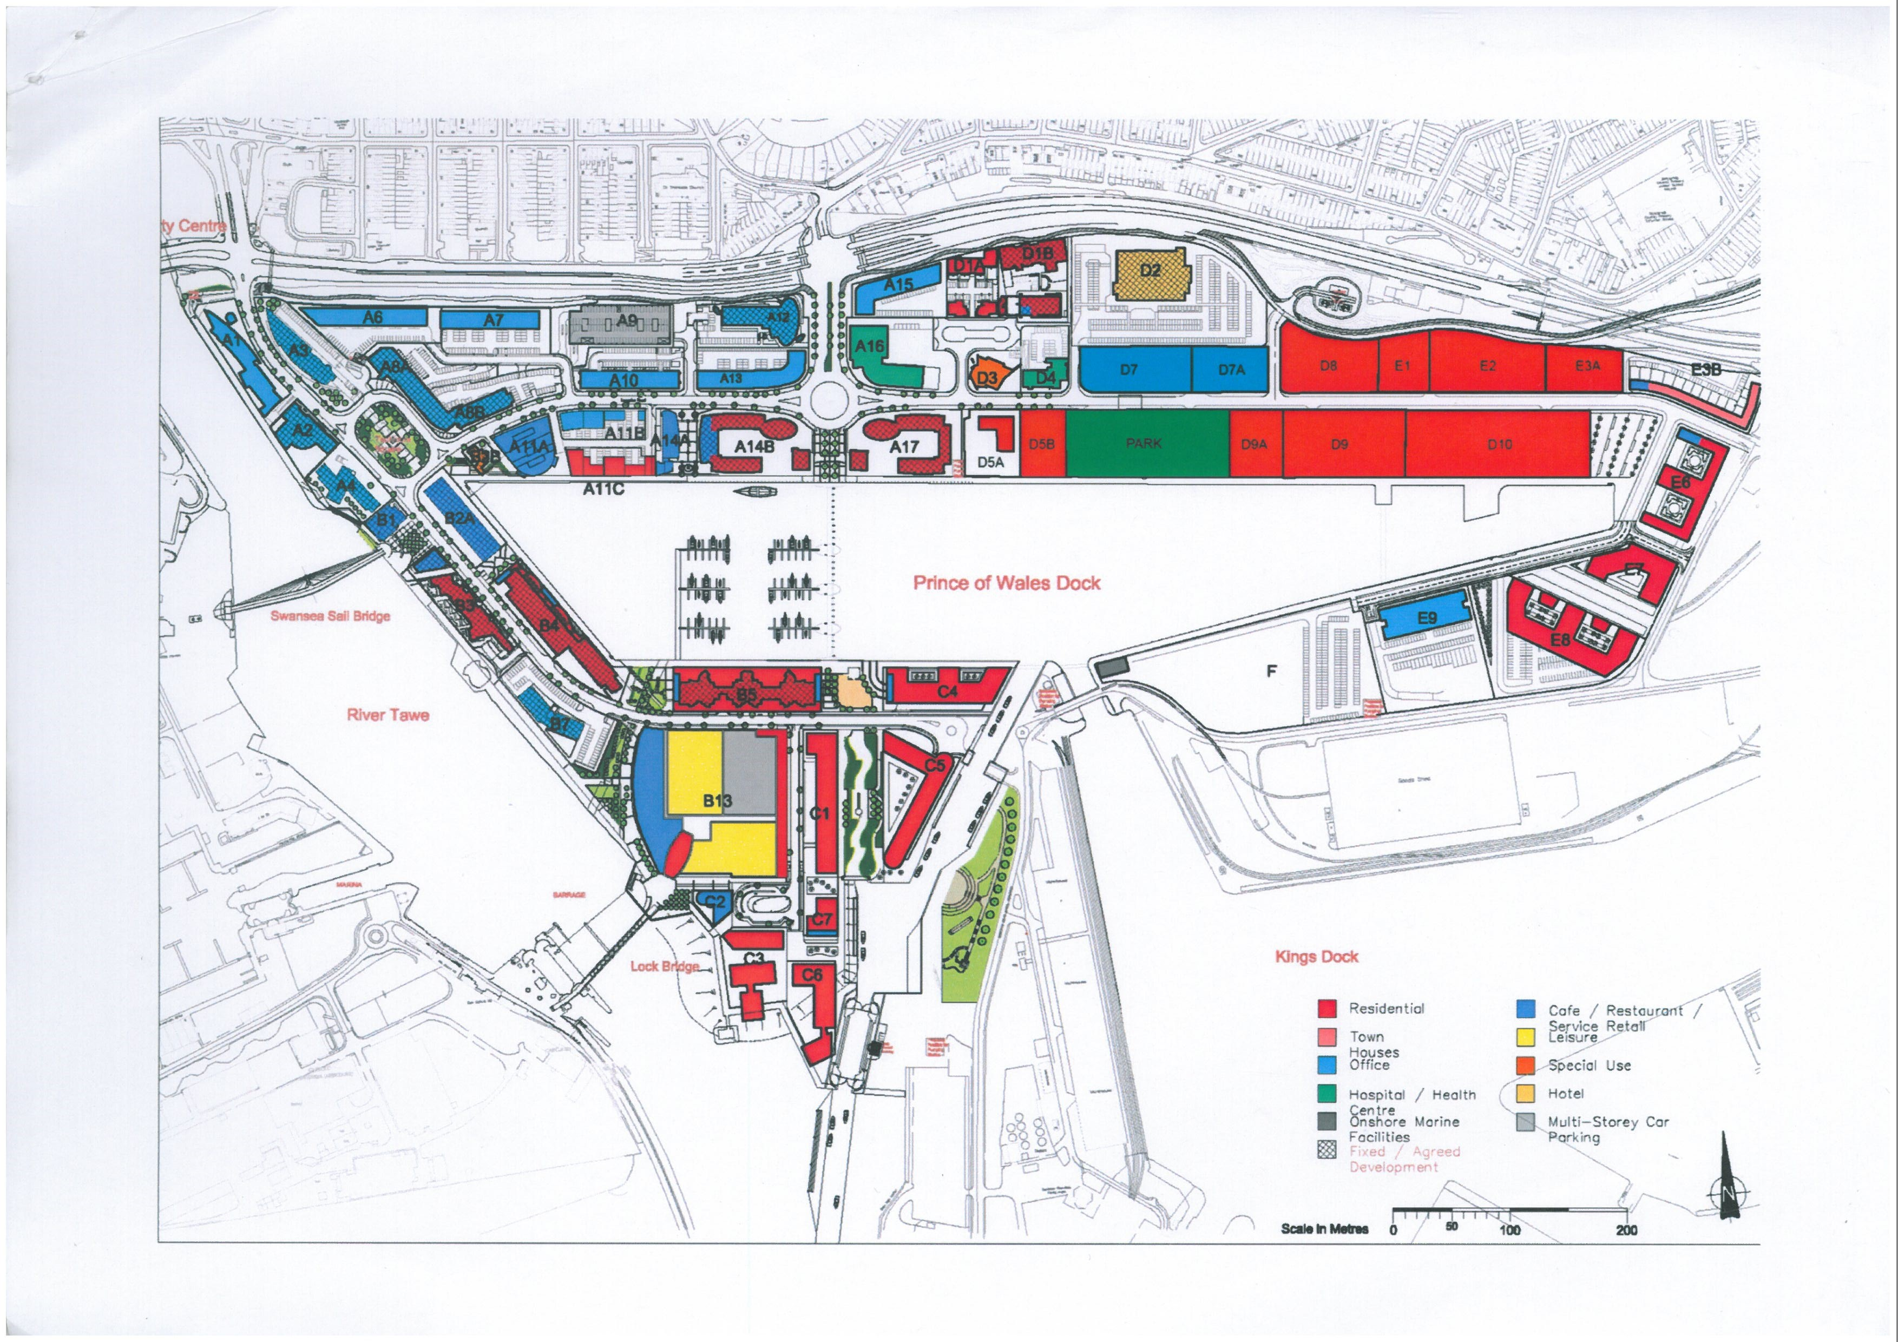Figure 11: Taken from assignment plans
(HM Land Registry, 2022) Figure 12: HM Land Registry ownership plan

  - Infrastructure –

There is sufficient access on site and surrounding, the main route into the area is a one way three lane carriageway onto a single lane carriageway, the road going through to the site is wide and gives plenty of room for big machinery, cranes etc. The road is owned by National Assembly could potentially need traffic management when removing materials and installing the structure to ensure safety for pedestrians and traffic. Railway lines will not be affected and the nearest lines are to the west on the other side of the River Tawe. Access for materials via boat would be sufficient as the Kings Dock which is situated right next to the site is still active and could be taken advantage of. Material storage and refuse tip could be placed to the south of the site as there is area free to store until utilised or taken away.

  - Utility Information –

All services are available on or in close proximity to the site for connections. I have carried out utility searches for Water, Telecoms, power and gas. Plans below.

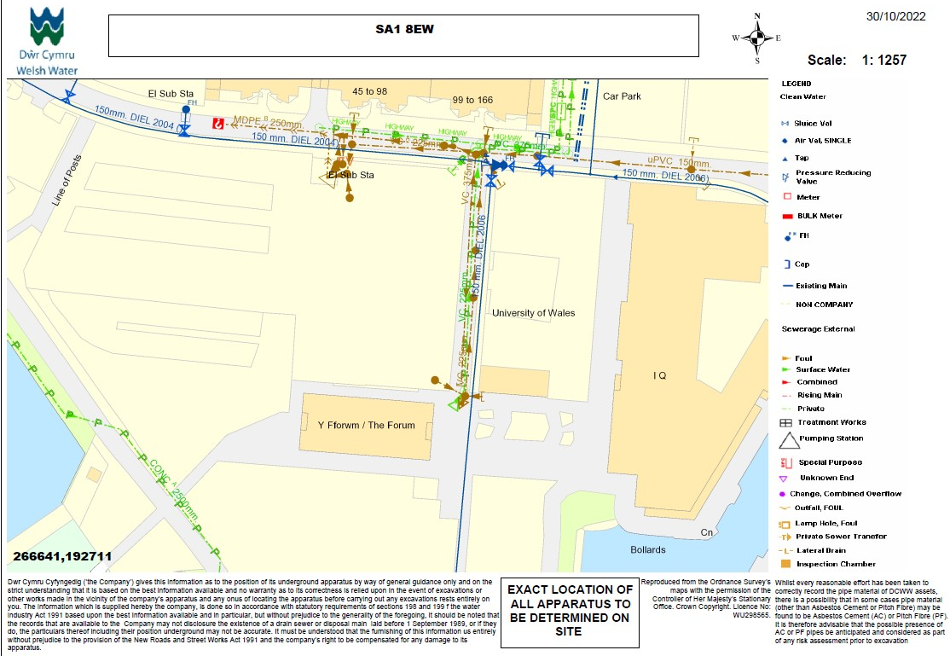
Water –
Welsh Water have assets along Kings Road and Island Road which are situated right next to the proposed site, assets include fire hydrants, clean and foul water. Actual site not affected.
(DWR Cymru Welsh Water, 2022) Figure 13: Welsh Water asset plan.

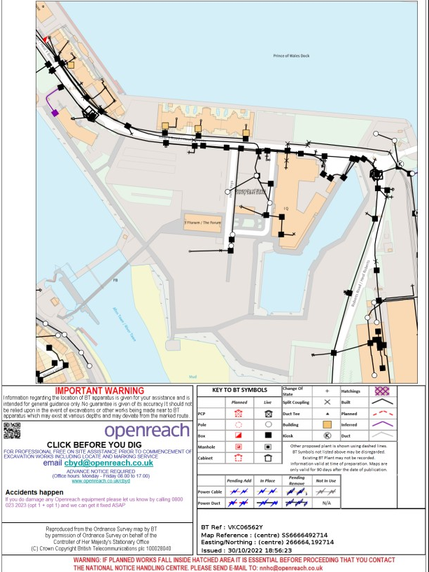
Telecoms –
BT have assets directly affecting the area of the new IM building, any boxes or poles will need to be relocated. The contractors for the IM project will need to liaise with BT to remove and replace for excavation purposes.

(British Telecom Openreach, 2022) Figure 14: BT Openreach asset plan

Power –
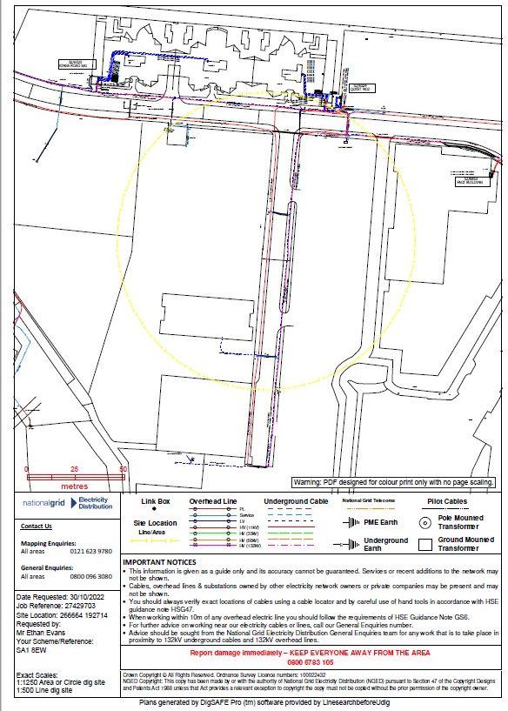
National Grid has Low voltage and High Voltages assets underground along the Kings Road and Island Road.
(Linesearch before U dig, 2022) Figure 15: National Grid asset plan

Gas –
Wales & West Utilities have low pressure lines along the Kings Road and Island Road but not directly on the site.
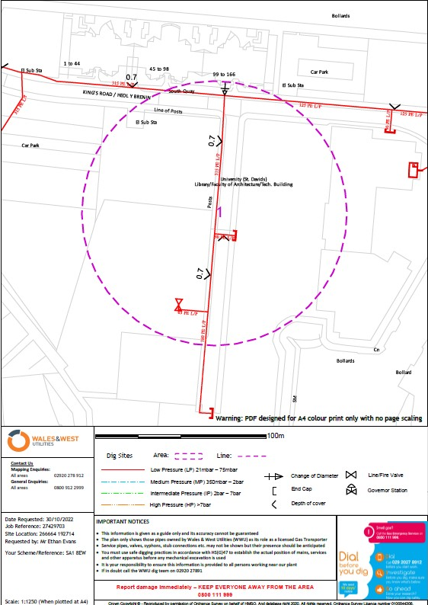

(Linesearch before U dig, 2022) Figure 16: Wales & West Utilities asset plans

- Geological Appraisal

  - I have carried out investigations using online geology viewers for the area and produced plans, as well as examined borehole logs.
- Bedrock geology is made of Mudstone, siltstone and sandstone. Sedimentary bedrock formed during the Carboniferous period.
- Superficial deposits are blown sand, Sedimentary superficial deposit formed between 2.5 million years ago and the present during the Quaternary period.
- The Soil scape viewer shows that the area of the proposed site is a loamy and clayey floodplain soils with naturally high groundwater. The fertility of the site is mainly moderate but viewing the site there is not much growth.
- The hydrogeology of the area is displayed on the map viewer which shows the rock unit is ‘Pennine middle coal measures formation and South Wales middle coal measures formation. The character is moderately productive aquifer and is multi layered with moderate yields from sandstones and many springs.
- Mine water quality is poor but can extract in all cases.

  - Multiple boreholes have been taken on the site and can be viewed online, there are 2 boreholes of special interest (No.7 & 8) that measure from ground level to 30ft and are taken directly on the old lock gates and displays clay, gravel and sand at various levels and thickness of the borehole. Clay and sand is recorded as having the most geological footprint in the borehole log, in some places there is 10ft thickness of each. Although there are records of mud, clay, gravel and sand at various levels of each borehole. The permeability of each of these soil types will affect drainage capabilities and will need to be tested.
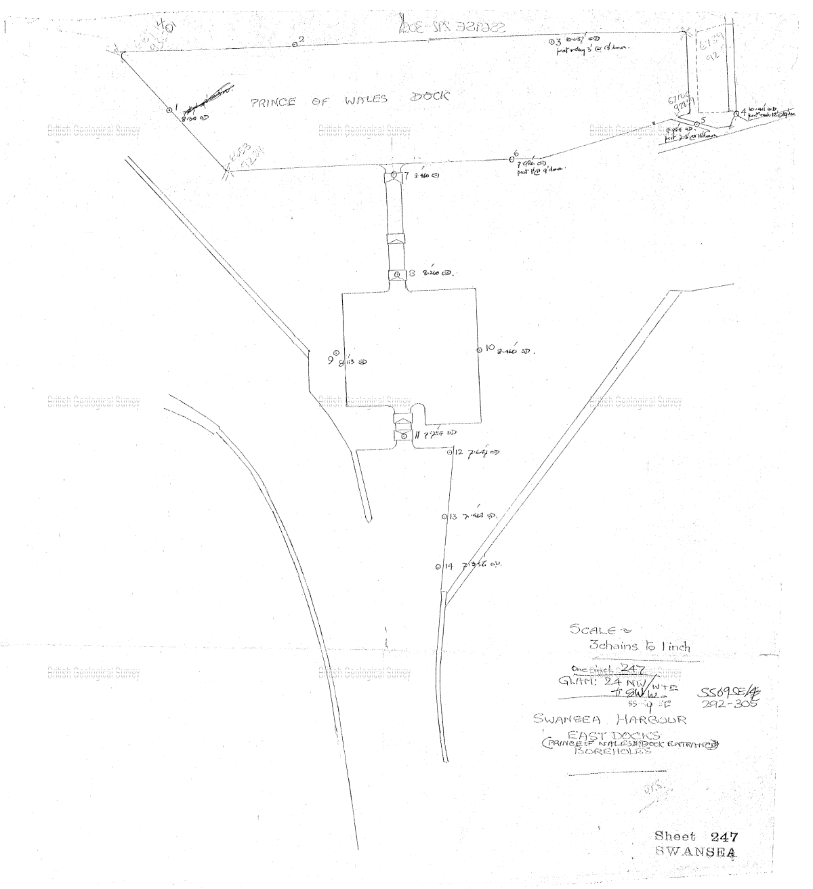
(British Geological Survey, 2022) Figure 17: Borehole map location identifying old lock gates

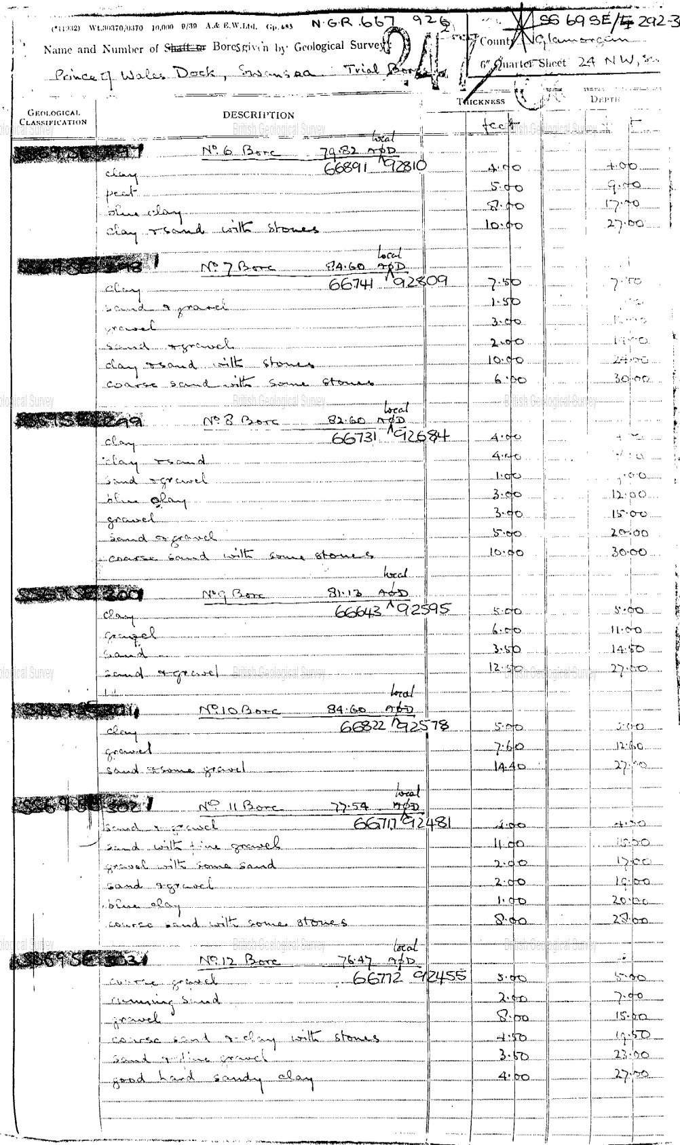
(British Geological Survey, 2022) Figure 18: Borehole log.
  - 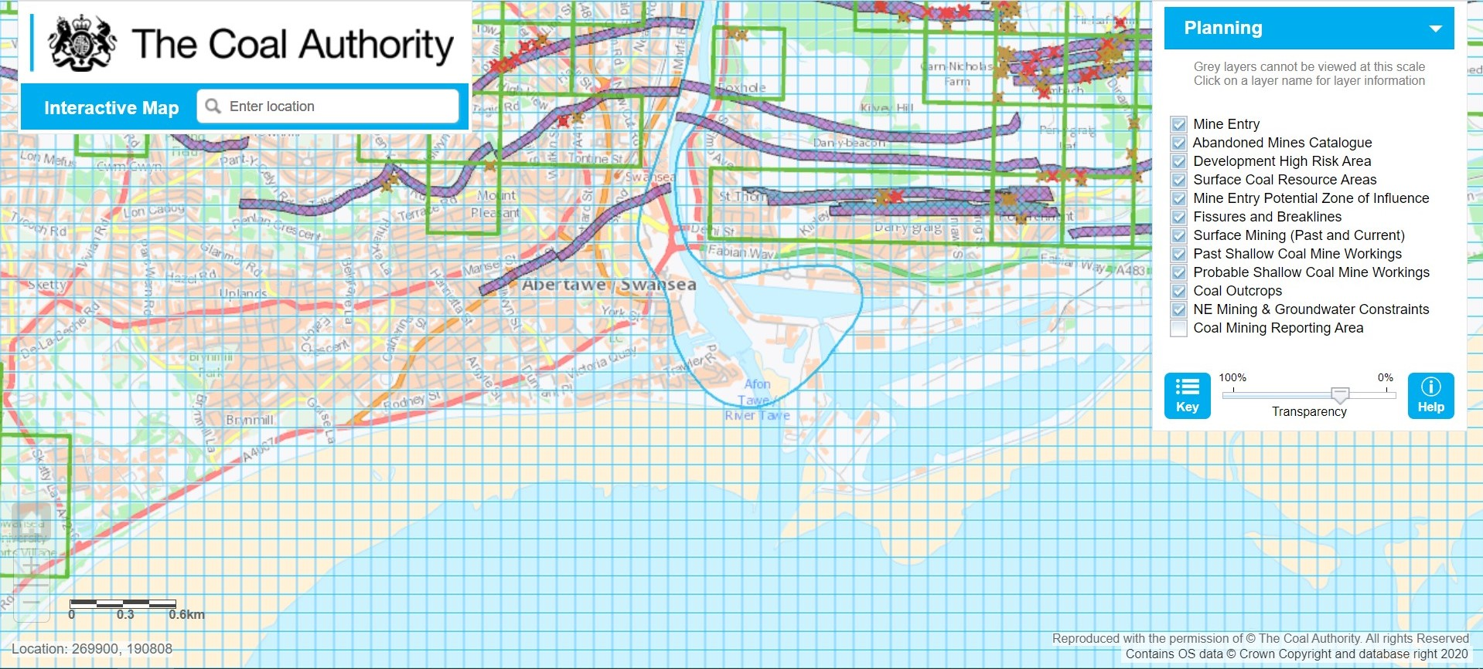Mine Workings –

There are no records of any mine workings on or in close proximity to the proposed site, although there is evidence to the far north and North West of the site which should not pose an issue. I have recovered this information using the Coal Authorities map layer of all sites.
(BGS The Coal Authority, 2022) Figure 19: The Coal Authority map viewer
  - Subsidence Risk –

Due to the varying soil types at different levels which include, gravel, sand, clay and silt which all are known to pose a risk of subsidence. Clay and silt are known as ‘cohesive’ soils which swell when wet and contract when dry. Gravels and sand are ‘non cohesive’ but are susceptible to being washed away by water flow.

- Environmental Appraisal

  - Contaminants –
Large quantities of PM₁₀ due to use of materials on site such as concrete and silica. As well as use of diesel powered vehicles and plant. This will also be affected when excavating which will cause dust and may contaminate the site, air and workers with any chemicals or hazardous debris under the surface which will be likely for this site.
High risk of noise pollution when plant and machinery are in use, excavation and foundation installation will play a big part.
Air pollution may be affected with dust and plant use, some operations will affect human and residential.
Water pollution unlikely but very close to main River Tawe, exercise caution for drainage also.

  - 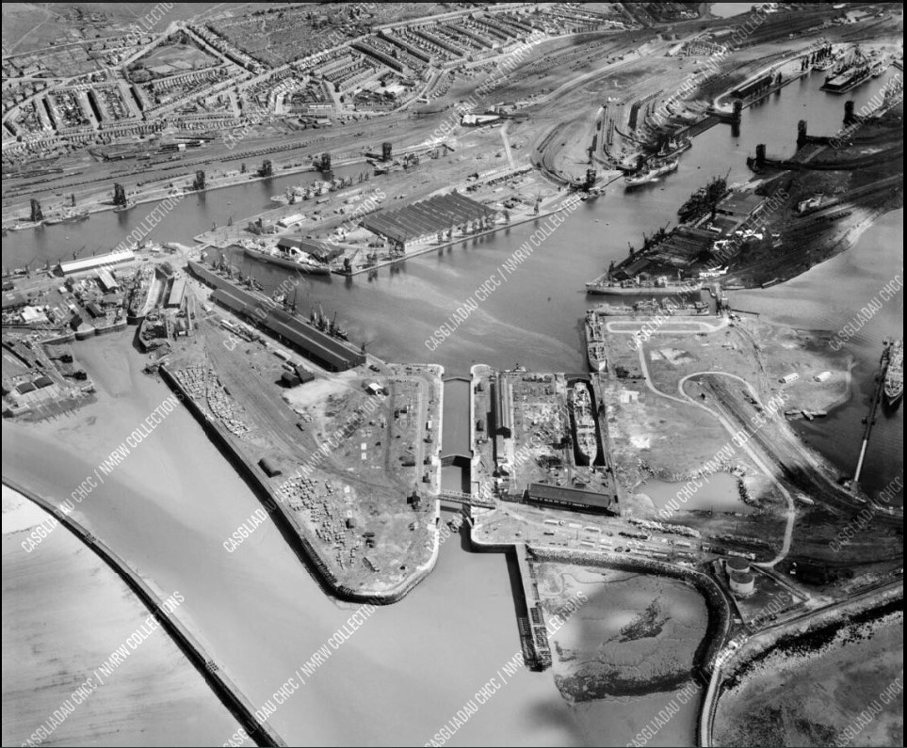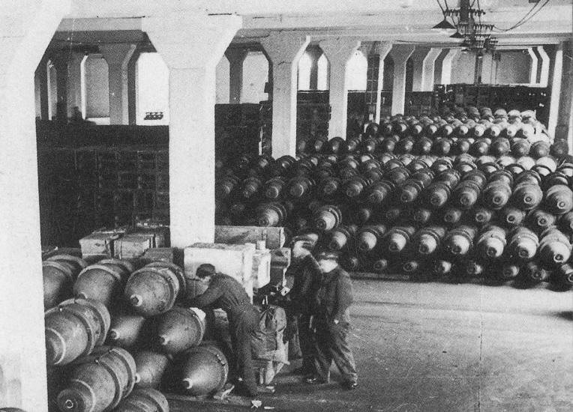Given that the land was previously used for industrial purposes, it would be considered to be a ‘brownfield site’. Possible contaminants from past use of the docks including transportation of various materials such as steel, zinc, coal, aluminium, and in the later year’s, cars. The area had its own refuse tip which would feature any waste that the site produced and could have been possibly utilised in the backfilling of the old lock gates running through the site. This could include any cargo, workshop material and general waste found on the site. The docks were also used as a dry dock and featured multiple cargo stations and stores that housed all of the materials and were utilised in World War 2 to store and ship bombs as well as repair war ships and test out tank equipment.
(Swansea and Port Talbot port history, 2022) Figure 20: Photo of a bomb shed on the docks
(Swansea and Port Talbot port History , 2022) Figure 21: Aerial photo of the docklands
  - Flood Risks –
Using National Resource Wales website I have carried out flood risk reports which states that there is a high risk of flooding from the sea and does not benefit from flood defences but has no records of flooding. There is very low risk from flooding from rivers and most importantly surface water and small watercourses. There is a tidal basin on site which can be prevented from overfilling by closing the sluice gates.
  - Sites of special interest –

Using the Natural Resources Wales website I have identified the following sites of special interest within the area of the site.
Cors Crymlyn / Crymlyn Bog / Crymlyn Burrows & Blackpill, Swansea
(National Resources Wales, 2022)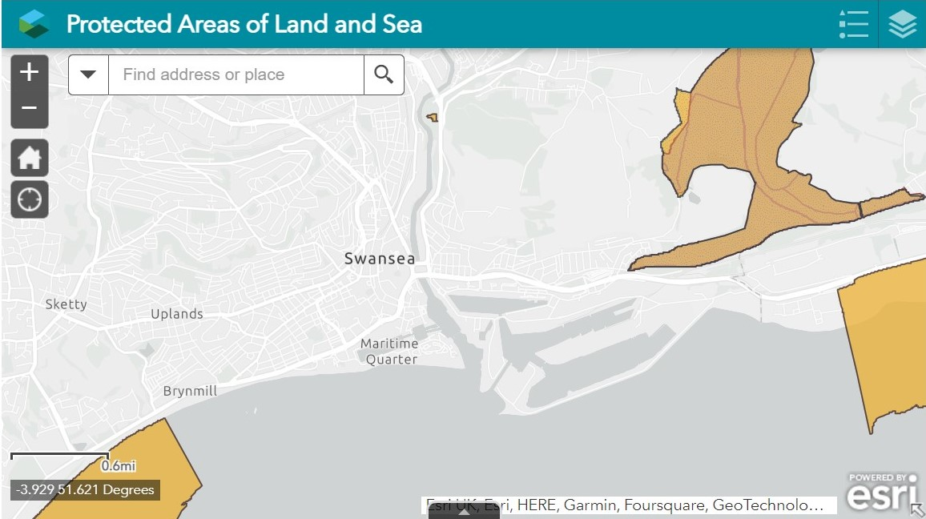 Figure 22: National Resources Wales SSSI map viewer

- Archaeological Appraisal

  - The risk of uncovering an archaeological site could be catastrophic for a project, this could put it on hold from weeks to years and could deem a project unfeasible.
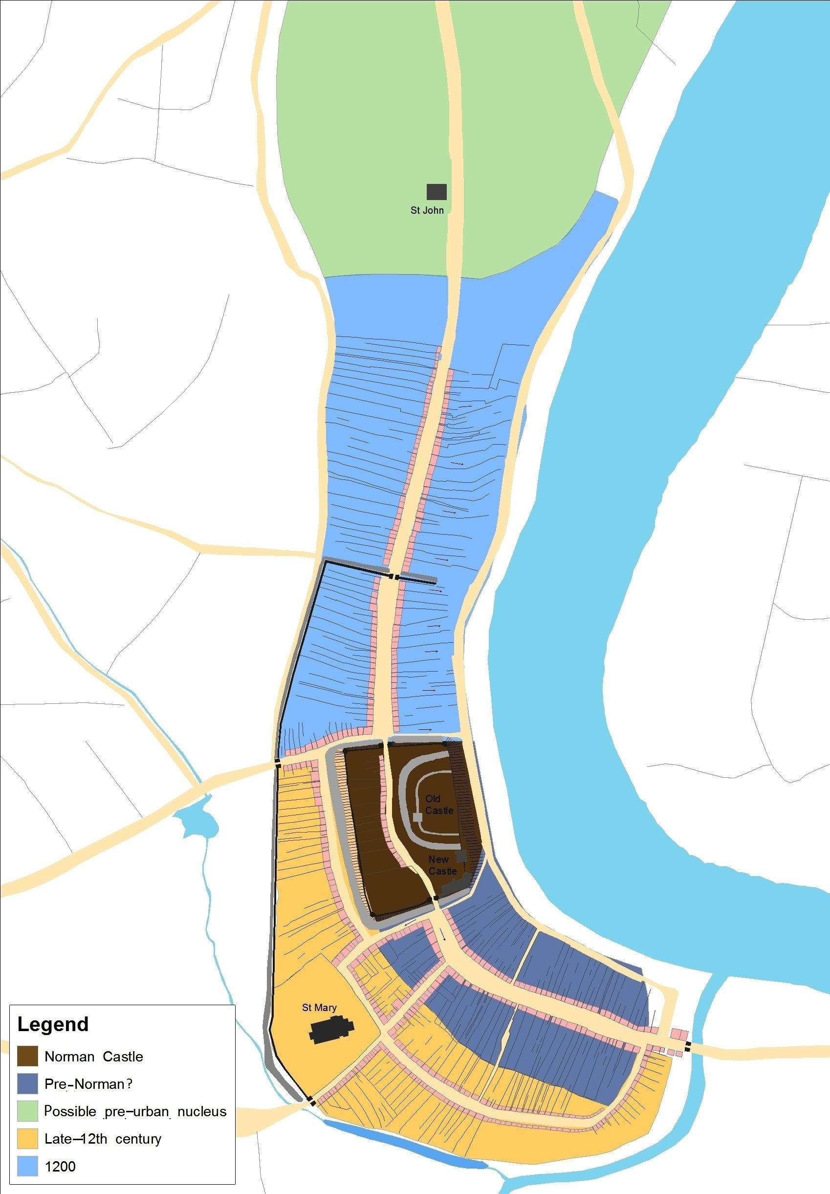There is no known evidence and particular suggestion to say that there is an archaeologist interest in the proposed site of the IM building due to the nature of the site as being industrial and less likely to be used as a burial ground or any other interest. There is evidence of an archaeologist site to the west of the site along the River Tawe.
As outlined in the BSI code of practice you can use the following methods to determine any archaeological remains; Magnetic electromagnetic resistivity and radar.

(Lilley, Unk) Figure 23: Map of nearest archaeological site.

- Conceptual ground model

  - Potential Contamination Sources
The following potential historical contamination sources on or in close proximity to the site have been identified and summarised below;
- Historical phases of industrial site usage including transport, storage, workshops and partly refuse tip.
- Historical use of the wider area has potential for residual soil or groundwater contamination from various industrial activities.
- Made ground associated with various materials being backfilled from previous uses and potentially former buildings made from hazardous materials such as asbestos.
- Ground gases associated with made ground Alluvial soils beneath the site although Radon levels are marginally low.
- Site received aerial attack in World War 2, while unlikely it is possible for explosive ordnance remains.
The current site could be considered a moderate risk of contamination with the combination of these factors.
  - Potential Receptors
Potential targets or recipients of contamination associated with the site could include;
- Construction workers
- Site end-users
- Residents in vicinity
- Groundwater (Secondary B Aquifers) underlying the site
- Proposed building structures and or services from ground gases or contaminants in soils/groundwater

  - Potential Pathways
Mechanisms or routes which potential contaminants identified may be brought into contact with the potential receptors may include;
- Construction workers and future site users – Dermal contact/ingestion/inhalation of dusts, vapours or liquids.
- Leaching of soil contamination and migration of aqueous contamination via made ground and natural strata.
- Chemical attack on foundations or water supply pipes via contact with soils/groundwater with chemicals such as sulphate and pH levels above the permissible limit.

- Preliminary Risk Assessment
Source | Pathway | Receptor | Risk | Comments
Potentially contaminated soils on site associated with previous site use. | Ingestion and skin contact with soils, inhalation of dust | Future site users, construction workers | Low | Based on site history it is possible there will be residual soil contamination that could pose a human health risk. Risk assumed to be limited for workers due to PPE and end use will limit exposure to soils for future site users.
 | Inhalation of ground/gas vapours | Future site users, construction workers | Low | Low radon levels in the area although various uses and contaminants could be a risk.
 | Direct contact with migration of ground gases/vapours into confined spaces | Structures, utilities | Low to moderate | Made ground from past uses present on site therefore could be a potential hazard for utility supplies or concrete foundations. Natural strata not considered a specific risk to structures or services.
 | Leaching to groundwater and groundwater migration | Secondary B moderately productive aquifer | Low | Presence of soil contamination currently unknown, although made ground on site could present a potential source of leachate.  Groundwater levels unknown although possible receptor.
 | Leaching to groundwater and groundwater migration | Surface water | Low | In close vicinity to River Tawe and tidal basin but not immediate.
Made ground voids | Ground subsidence | Site users, residential | Moderate | Made ground backfilled with various materials potential voids. Potential for asbestos etc. to be in made ground.
Unexploded ordnance | Contamination & explosion | Site users & surrounding areas | Moderate to high | Given site history of bombings the risk of unexploded ordnance is unlikely but not ruled out.
Figure 24: Preliminary risk assessment table.

- Conclusions

  - Site summary of greatest risk
Using the information gathered from the desk study which is required in the BSI Standards code of practice for ground investigations. I will summarise my suggestions for the geotechnical contractor to focus on where the greatest risks lies, these include;
Unexploded ordnance – Potential for unexploded ordnance and shrapnel due to World War 2 bombings.
Engineered fill and made ground – Unknown backfill materials of made ground. Determine exact depth for foundations to avoid voids due to made ground. Main interest in the old lock gates area as most recently backfilled. Whole area investigation needed to rule out obstructions for utility connections. Mechanical properties such as strength and compressibility of the different rock and soil strata in order to determine sustainability of the structure.
Groundwater – Identify depths of groundwater and ground permeability properties due to mix of soils and made ground for drainage and subsidence risk analysis.
Contamination – Identify levels of contamination from previous site workings and potential pathways.
Ground gas – Sufficiently identify ground gas levels due to previous site contamination.
Chemical analysis – Analyse any chemical contamination found from previous site use and backfill such as explosive shrapnel and asbestos from structures. This will help identify if utilities and such will need special insulation.
Any samples should be taken In accordance with BS EN ISO 22475-1, techniques for obtaining soil samples. A detailed consideration of investigations on potentially contaminated sites is given in В 5 10175.
(British Standars Institution, 2015)

- Foundation recommendations
Based on the preliminary observations, archival data, geotechnical data and the information on the type and size of the structure while also taking into account neighbouring structures and residential effects, I suggest the following foundation type;
  - Pile foundation
Friction piles – Pile bearing capacity developed by shear stresses alongside the pile and is suitable when hard layers are too deep. This will transmit loads to surrounding soil by friction between structure of pile and the soil, which will lower the bulb of pressure.
Essential for the site as the soil may not be suitable to prevent excessive settlement with gravels, sands and made ground present.
I would also recommend the piles to be ‘bored’ which are augured and concrete poured in situ, this consists of a replacement pile forming a hole in the ground and filling with concrete. The concrete will also be reinforced by steel throughout. A few advantages of this at the proposed site would be;
- Variable lengths can be extended through soft or swelling soils into suitable bearing material
- Less disruption to residents and site users
- Large excavations and backfill minimized
- Less disruption to adjacent soil occurs
- Less vibration to adjacent soils
The last two points are a big advantage as the proposed site is in close proximity to the larger IQ university building.
Ground investigation should conform to BS EN 1997-2 as well as BS EN 1536 for specifically bored piled foundations.
The pile foundations should conform to the BSI Code of practice for foundations
“4.1.3.1 The design of pile foundations should conform to 4.1.1.1 and Clause 6.

NOTE Pile foundations are generally suitable in, but not limited to, the following design situations:

On compressible strata overlying bedrock;
On compressible strata overlying coarse soils of adequate density, there being no other beds of greater compressibility below the coarse soils;
Where the strata consist of fine soils of great thickness capable of supporting the piles by friction;
Where there is a need to minimize movements of a structure owing to swelling or shrinkage of surface soils; and
Where the addition of a foundation load would cause instability of the existing ground (e.g. at the crest of an existing slope).”
(British Standards Institution, 2015)

- Pile foundation example drawing
Please note; exact location, length, depth and number of piles yet to be decided. Plan derived from borehole log BGS Reference: SS69SE345

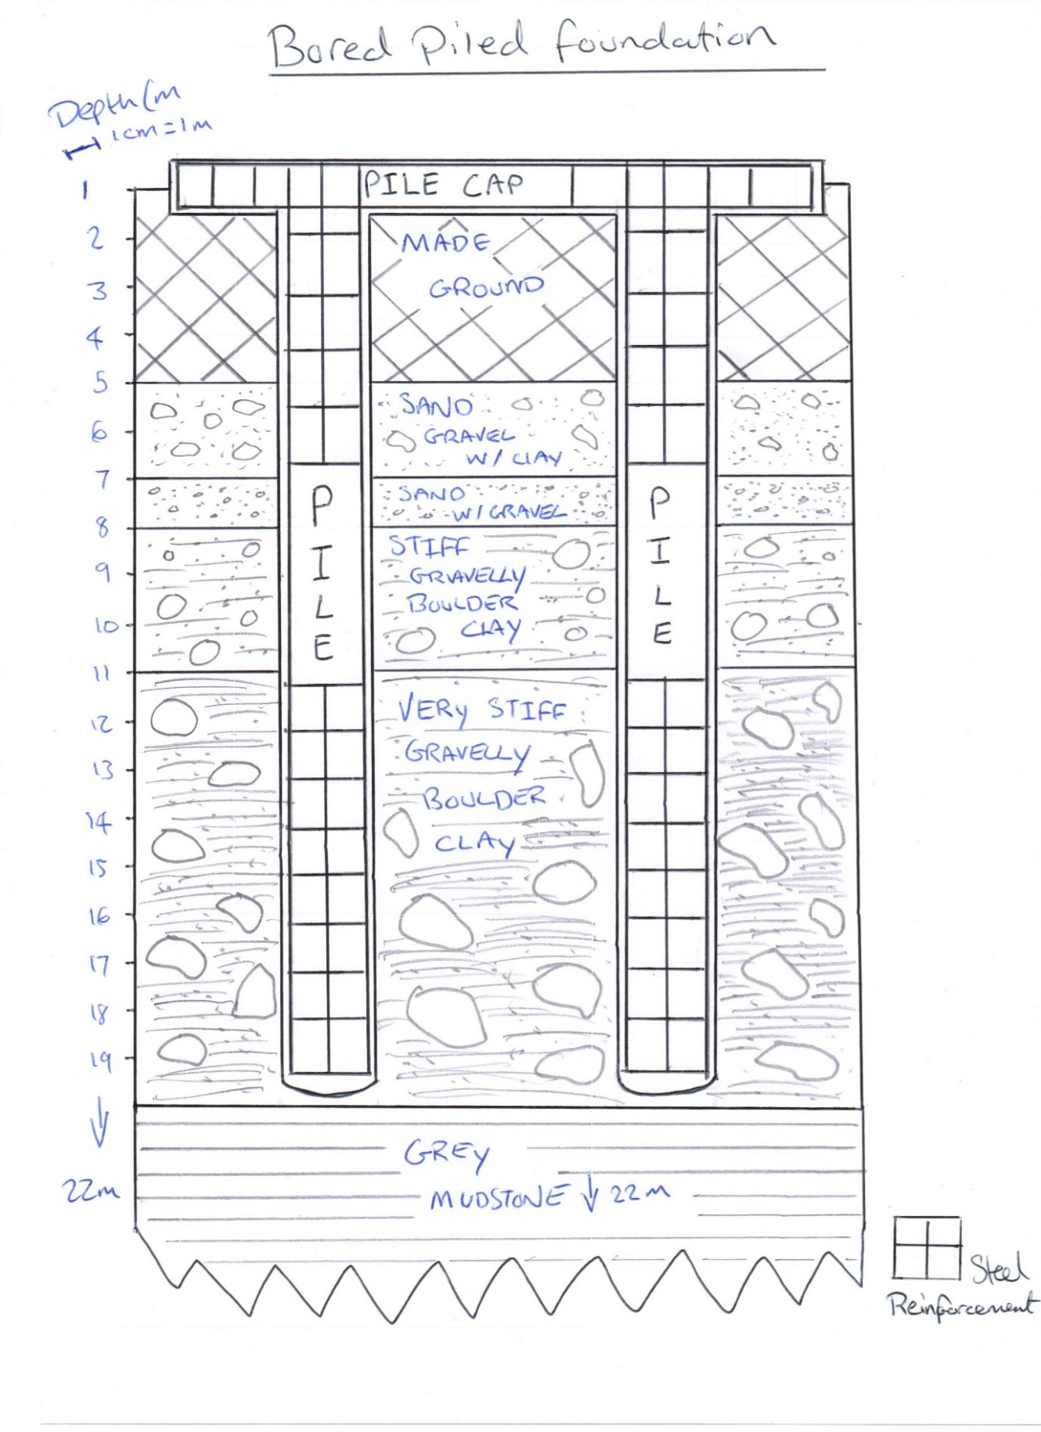
Figure 25: Hand drawn pile foundation.
Borehole log BGS Reference: SS69SE345
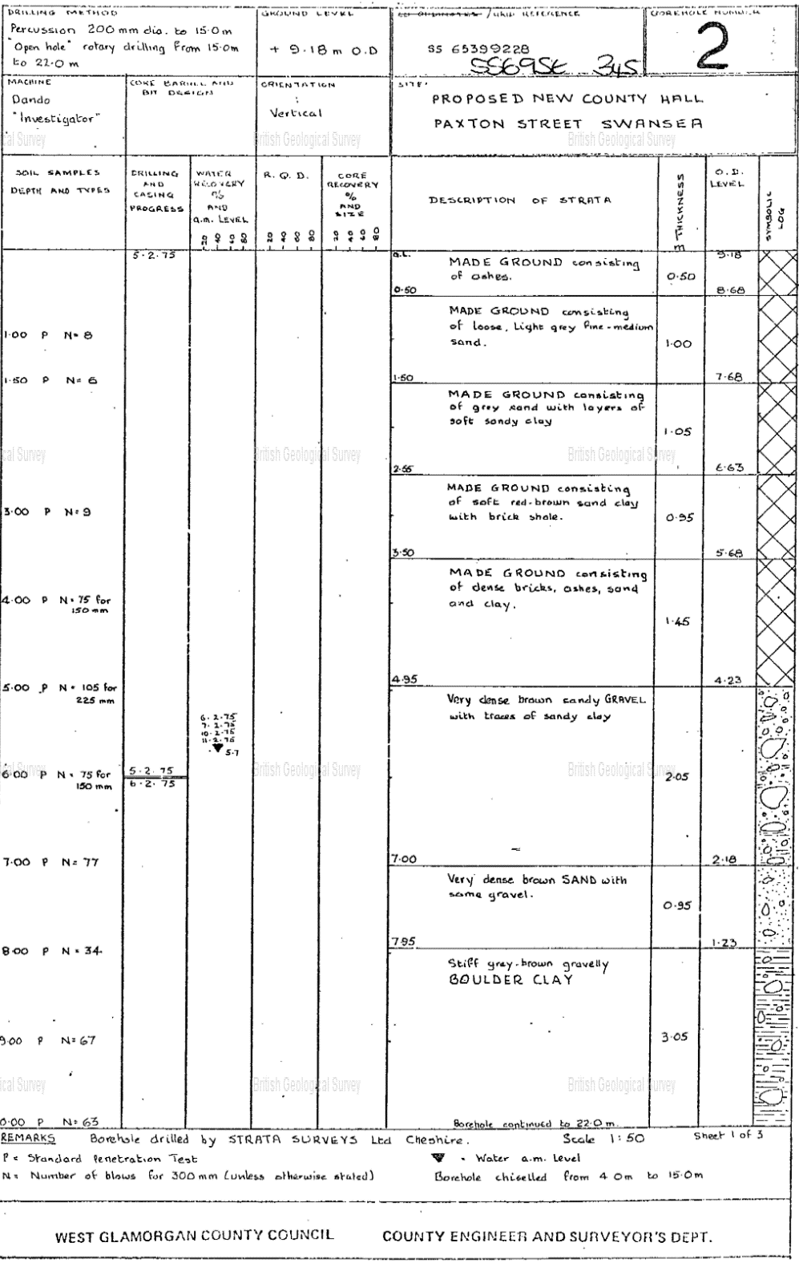

Figure 26: Borehole log from nearby project

References
BGS The Coal Authority, 2022. BGS The Coal Authority. [Online]
Available at: https://mapapps2.bgs.ac.uk/coalauthority/home.html
[Accessed 06 11 2022].
British Geological Survey, 2022. BGS Biology Viewers. [Online]
Available at: https://www.bgs.ac.uk/map-viewers/bgs-geology-viewer/
[Accessed 21 10 2022].
British Geological Survey, 2022. BGS Borehole map viewer. [Online]
Available at: https://mapapps2.bgs.ac.uk/geoindex/home.html?layer=BGSBoreholes&_ga=2.205586835.1607276193.1667567150-1737649347.1667567150
[Accessed 26 10 2022].
British Geological Survey, 2022. BGS Borehole record viewer. [Online]
Available at: http://scans.bgs.ac.uk/sobi_scans/boreholes/370200/images/10677848.html
[Accessed 24 10 2022].
British Standards Institution, 2015. Code of Practice for foundations. [Online]
Available at: https://geotechnicaldesign.info/bs8004-2015/g4-1.html
[Accessed 09 12 2022].
British Standars Institution, 2015. Codes of Practice for ground investigation. [Online]
Available at: https://geotechnicaldesign.info/download/bs5930-2015.pdf
[Accessed 09 12 2022].
British Telecom Openreach, 2022. BT Openreach asset plans. [Online]
Available at: https://www.swns.bt.com/pls/mbe/welcome.home
[Accessed 23 10 2022].
Centrum, 2017. Difference between bored piles and driven piles. [Online]
Available at: https://www.centrumpile.co.uk/what-are-the-differences-between-bored-piles-and-driven-piles/#:~:text=The%20main%20advantages%20of%20bored,and%20subsequent%20backfill%20are%20minimized.
[Accessed 09 12 2022].
County Archives, S., 2022. Discussion of Swansea Dock history, maps provided [Interview] (10 11 2022).
Dulley, A., 2022. County Hall Archives, Swansea. Maps provided. Swansea: s.n.
DWR Cymru Welsh Water, 2022. DWR Welsh Water asset plans. [Online]
Available at: https://gisportal.dwrcymru.com/Html5Viewer/index.html?viewer=Web_External_Viewer#
[Accessed 23 10 2022].
Google, 2022. Google Earth. [Online]
Available at: https://earth.google.co.uk/
[Accessed 23 10 2022].
Guzder, K., 2019. Polution from construction. [Online]
Available at: https://www.highspeedtraining.co.uk/hub/pollution-from-construction/
[Accessed 06 12 2022].
HM Land Registry, 2022. HM Land Registry. [Online]
Available at: https://eservices.landregistry.gov.uk/eservices/ECHOM_HomepageServices/#
[Accessed 23 10 2022].
LABC Warranty, 2019. Brownfield land contamination. [Online]
Available at: https://www.labcwarranty.co.uk/news-blog/contamination-risks-when-building-on-brownfield-land/
[Accessed 21 10 2022].
Leandra Smollin, A. L., 2019. What is a brownfield site. [Online]
Available at: https://www.sciencedirect.com/topics/earth-and-planetary-sciences/brownfield-site
[Accessed 21 10 2022].
Lilley, G. D. a. K., Unk. Mapping medieval Swansea. [Online]
Available at: http://www.swanseadocks.co.uk/docksnewsite/cargoes.html
[Accessed 14 11 2022].
Linesearch before U dig, 2022. Linesearch before U dig. [Online]
Available at: https://onecall.linesearchbeforeudig.co.uk/uk-b4-en/Account/Login
[Accessed 23 10 2022].
National Resources Wales, 2022. NRW Conservation Areas. [Online]
Available at: https://naturalresources.wales/guidance-and-advice/environmental-topics/wildlife-and-biodiversity/protected-areas-of-land-and-seas/find-protected-areas-of-land-and-sea/?lang=en
[Accessed 06 12 2022].
Research Gate, 2014. Chemical attack on concrete foundations. [Online]
Available at: https://www.researchgate.net/publication/273038086_Potential_Chemical_attack_on_Concrete_Foundations_due_to_Groundwater_Chemistry
[Accessed 07 12 2022].
Soil Scape, 2022. Landis Soilscape viewer. [Online]
Available at: https://www.landis.org.uk/soilscapes/
[Accessed 26 10 2022].
Swansea and Port Talbot port History , 2022. Aerial photos of Swansea Docks. [Online]
Available at: http://www.swanseadocks.co.uk/docksnewsite/aerial3.html
[Accessed 28 10 2022].
Swansea and Port Talbot port history, 2022. Swansea Docks cargo images. [Online]
Available at: http://www.swanseadocks.co.uk/docksnewsite/cargoes.html
[Accessed 28 10 2022].
Swansea and Port Talbot port history, 2022. Swansea Docks war damage. [Online]
Available at: http://www.swanseadocks.co.uk/docksnewsite/wardamage.html
[Accessed 28 10 2022].
Swanseadocks.co.uk, Unk. Swansea and Port Talbot docks history. [Online]
Available at: http://www.swanseadocks.co.uk/docksnewsite/buildingkings.html
[Accessed 21 10 2022].

