 | Student No: | Dan Covaciu  2317400
 | Module Title: | Business Skills for the International Hotel Industry
 | Module Code: | BMIH4007
 | Lecturer: | Daniel Payne

Component One: Reflective Journal 1000 words
Experience and Reflection Journal
In the first week I learned to recognize my strengths, weaknesses, opportunities, and my threats. Reflection for me is to know which strengths and weaknesses to consider the most relevant for my dream hospitality job?
My most relevant strengths for me are.
- I have good understanding of leadership
- I have a good understanding of teamwork
- I can adapt depending on the opportunities
- I am a good organizer depending on the strengths and weaknesses of my workers
My most relevant weaknesses are.
- I need to improve my knowledge of different language so I can communicate with different customer
- I need to improve my courage and believe more in myself
But also, I will need to consider the opportunities and the threats of my job?
The threats of my job could be about me my employers of even my customers, they could be an employer that is specifically weak at something so I would need to help them, so the threats then turn into strengths. My customer threat could be that they do not like something about the hotel and they would keep it for themselves and not be able to tell us so we should try and give them the best experience that we can.
Then after we went to visit the Marriot hotel, we went in a tour around the hotel with the manager he showed us the fire exits after that he showed us the different rooms, he made us recognize the different safety objects like the smoke detectors and the protected windows. We also went over to the restaurant and then into the kitchen where there were a lot of smoke detectors and fire extinguishers.
We had a visit from UWTSD careers which showed us how to sign in with our email and make an appointment with the library. They also asked us some key questions like, what is a CV? What is a Cv used for? They showed us how to build our CV.
The Marriot manager came over to explain what job he had. He said he was working the day but someone else was working during the night, and they shared information with each other. He told us about when someone brought a lizard and it escaped so they had to look for it all around the hotel.
We also learnt how to use Canva and make presentations, the different tools that we needed.

Component Two: Action Plan

Action plan

Gain some experience. Hotel managers need at least a few years of experience in the hospitality industry and extensive management experience to obtain this leadership role.
A lot of effort goes into making a hotel successful, and much of that responsibility falls in the lap of the hotel manager. Regardless of the size or location of a hotel, the hotel manager needs to get the job done.
If you manage a hotel, you are always seeking advice on ways that you can improve your skills and become a better manager.
A hotel manager is often known as a hotel general manager or guest house manager. They work in the hospitality industry and are responsible for managing staff and the day-to-day operations of a hotel. They plan, organize, and direct all the services offered by the hotel.
Hotel managers can work in diverse types of hotels, such as chains, resorts, inns, motels, luxury, and others. They can work in various-sized establishments, from large castles to small townhouses. They can manage one or many hotels regionally or nationally and specialize in specific hotel services. Therefore, what they do will depend on where they work and their specialisms.
A hotel manager’s main aim is to ensure guests receive exceptional service and leave the hotel satisfied. They also have an essential role in keeping staff safe and happy, managing the finances of a hotel, and keeping within budget. They are overall responsible for happy guests and ensuring the hotel is profitable.
Hotel managers can carry out many tasks, including setting sales targets, recruiting staff, training staff, organizing, and supervising staff, meeting and greeting guests, ensuring guests are satisfied, setting budgets, dealing with customer complaints, marketing and promoting, ensuring legal compliance, overseeing maintenance/other operations, managing events, etc. The role may also encompass administrative tasks/computer work, such as keeping records and drafting reports

How to become a better hotel manager: Tips, tricks, and advice
By Anon Year: 2018 Container: SiteMinder URL: https://www.siteminder.com/r/trends-advice/hotel-management/become-better-hotel-manager/
make an action plan to become a hotel manager - Search (bing.com)
How to Become a Hotel Manager | Hours, qualifications & earnings (cpdonline.co.uk)

Component Three: Professional development: build a personal brand and promote a professional identity. (700 words)

Canva Document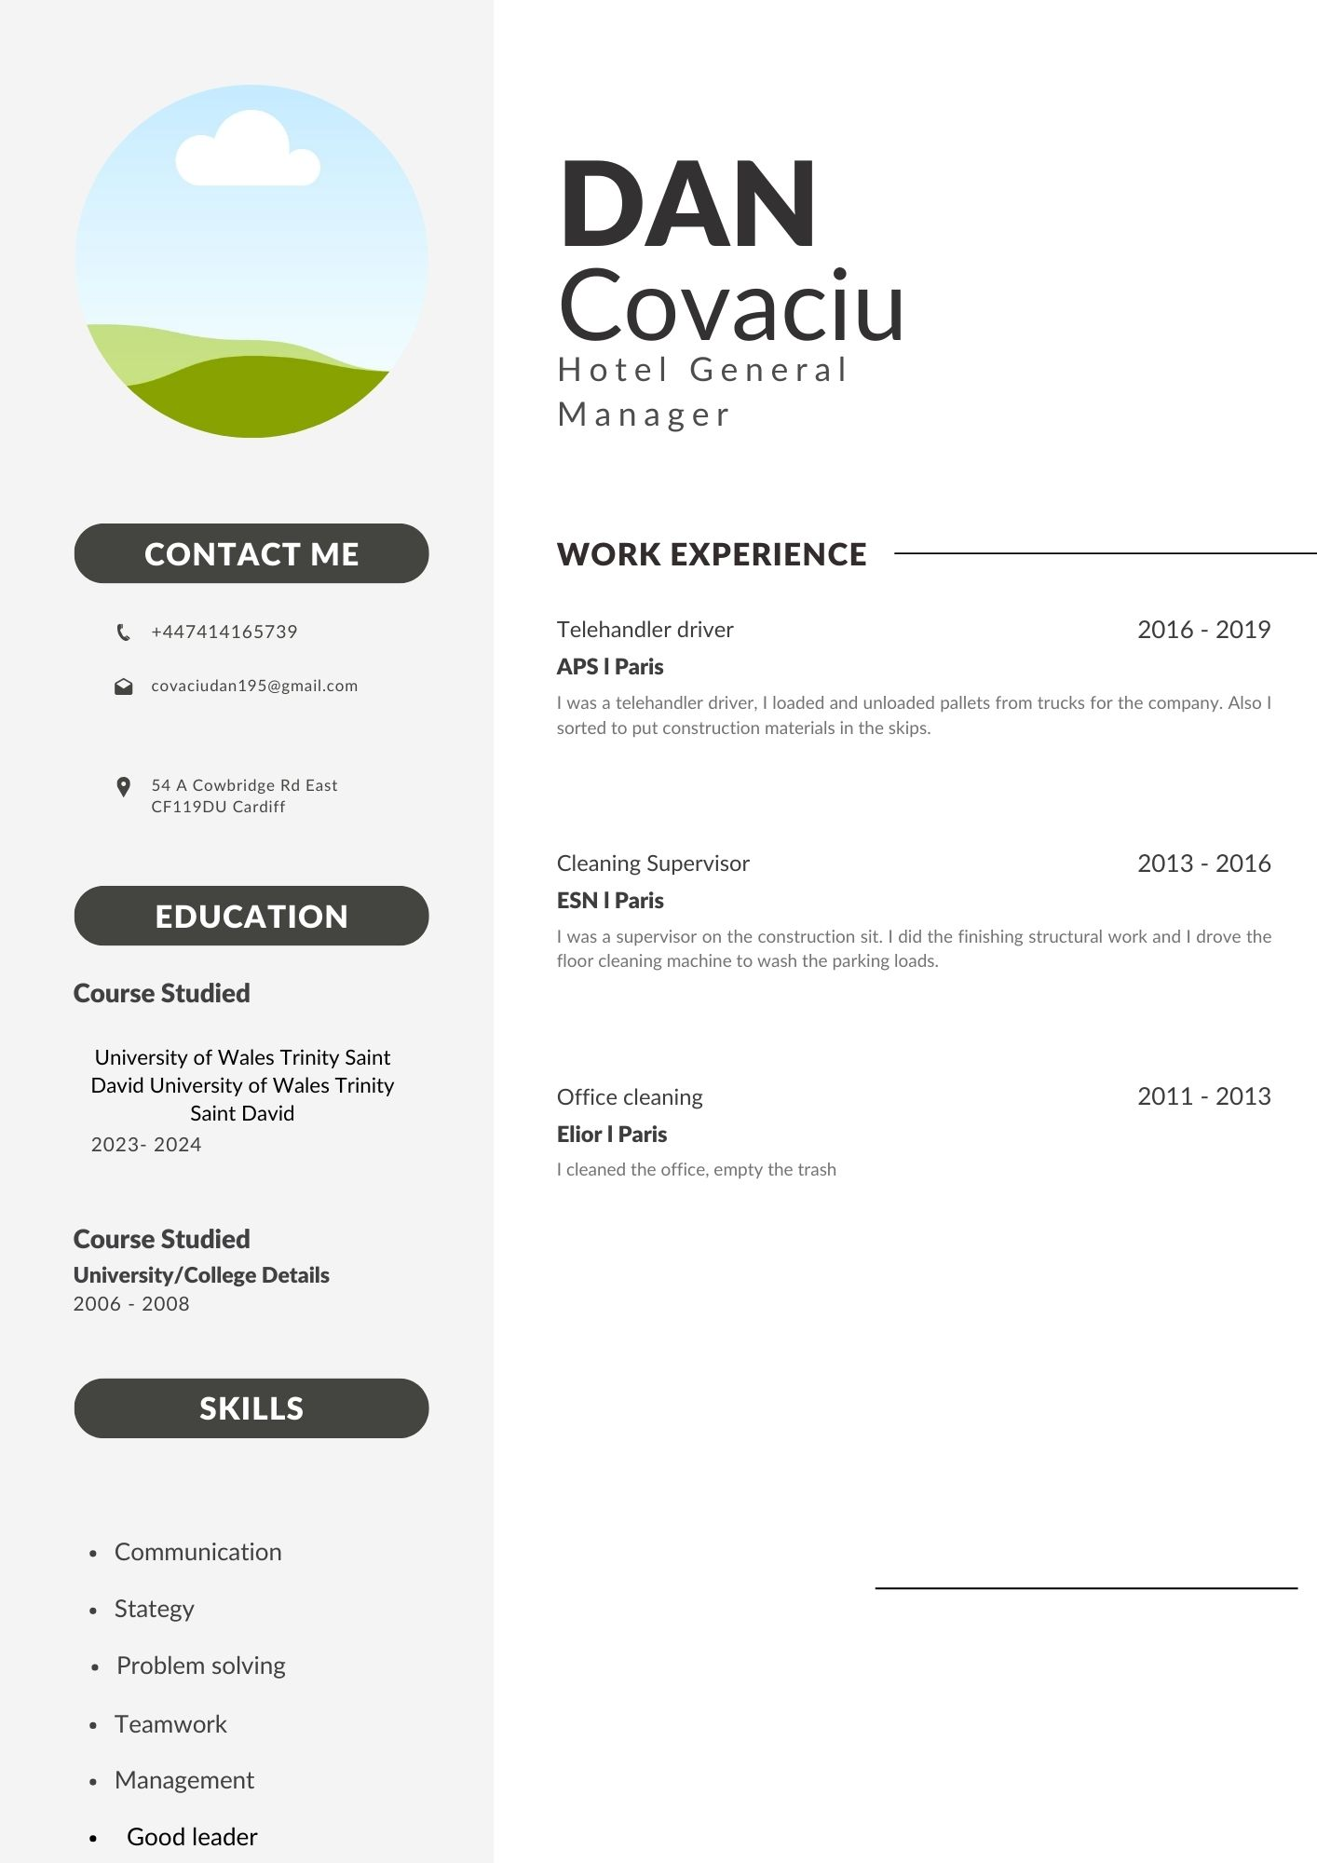

Linkedin Screenshot www.linkedin.com/in/dan-covaciu-950864299
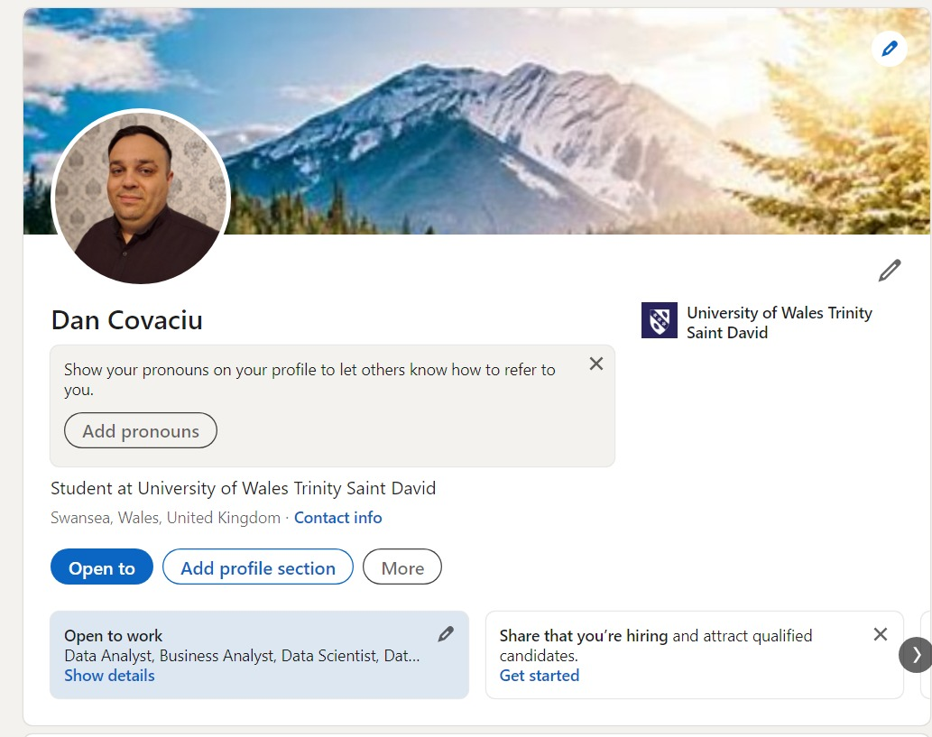
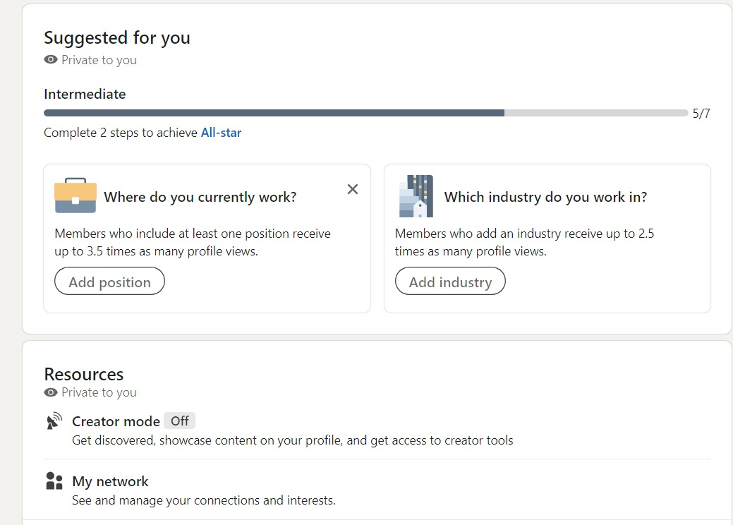
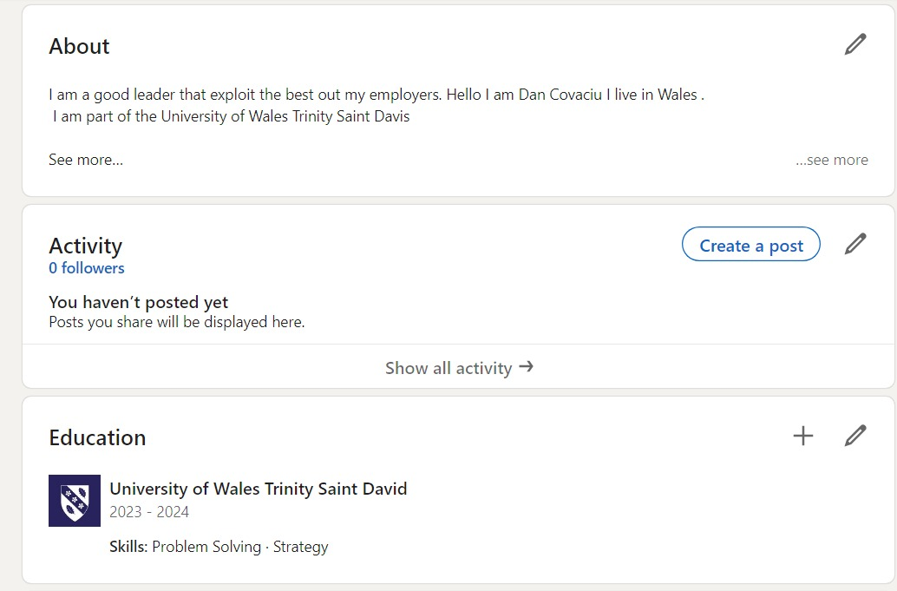

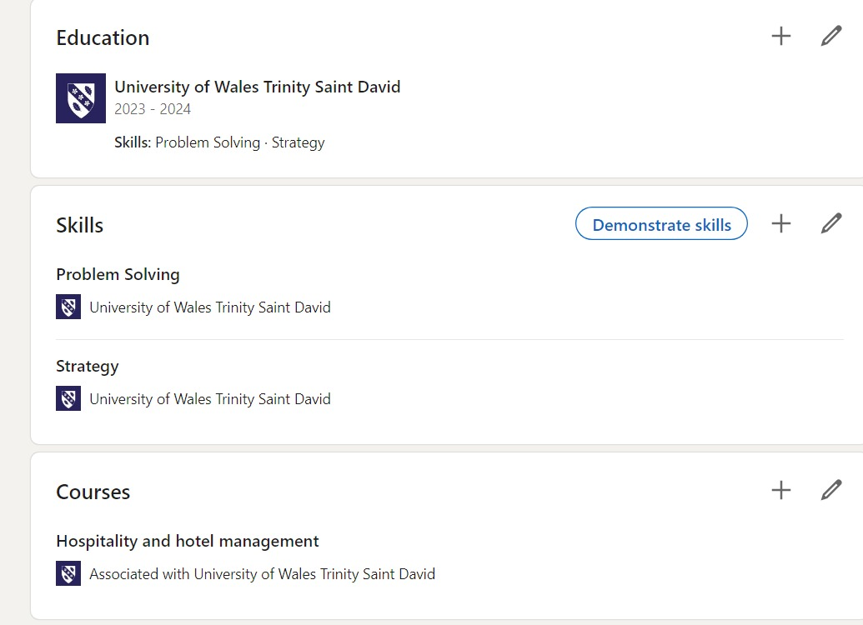
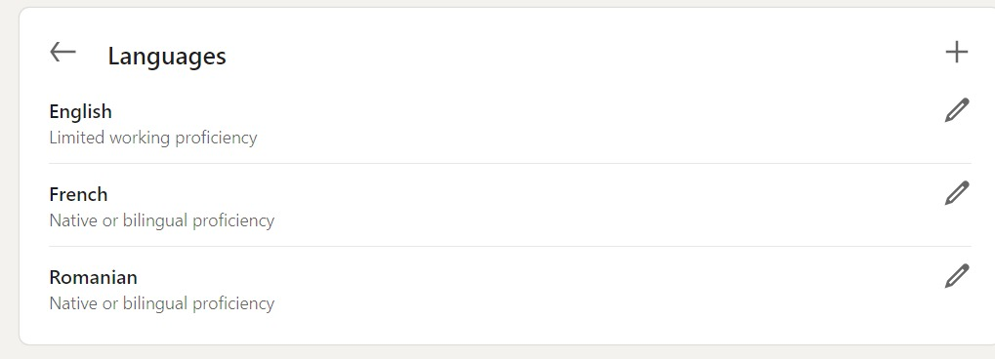

Component Four: Using the information prepared for your CV, present a 5 minute spoken CV

This Presentation will be completed in person on site at Delta by Marriott.
Place your presentation time below.

Timeslot: 10:15

