

Usability testing of a SPA using React

by
Joshua David Ford

Supervisor: Kemi Ademoye
Second Marker: Michael Dacey

Project submitted as part of the requirements for the award of ….
BSc (Hons) Web Development

April 2020

DECLARATION

I, Joshua David Ford declare that I am the sole author of this Project; that all references cited have been consulted; that I have conducted all work of which this is a record, and that the finished work lies within the prescribed word limits.

This work has not previously been accepted as part of any other degree submission.

Signed : J D Ford

Date : 27/04/2020

FORM OF CONSENT

I Joshua David Ford hereby consent that my Project, submitted in candidature for the B.Sc.(Hons) Computing & Information Systems degree, if successful, may be made available for inter-library loan or photocopying (subject to the law of copyright), and that the title and abstract may be made available to outside organisations.

Signed : J D Ford

Date : 27/04/2020

Abstract
The aims and objectives of this project will be to firstly look at current single page application frameworks to select a framework to use and investigate usability testing methods suitable for testing the usability of a website. To conduct a usability study of an existing website to evaluate the user interface design and possible challenges it may pose to users. Then, to implement a SPA website interface and conduct a usability study on the implemented website to evaluate its UI design.

The methods that will be used will firstly be a literature review of single page applications, what they are, how they work and the different types of single page applications. It will then look at usability testing methods and the best method to be used to test a website on its usability. Using one of the usability methods looked at, the most suitable method will be used and will test the website wordery.com for its usability. The usability technique system usability scale will test the website and give the author a good understanding of where the usability is at.

The findings of the project are that certain techniques used can help with the usability including the use of a single page application and other techniques. Also, looking at what features, techniques and methods worked or did not work, why did or did not work.

The conclusions would be that the creation of a single page application will improve the usability of an application, not only that it will help with the ease of use of the application. Also, usability testing is an integral part of creating an application because it will give the creator a good understanding of if users can easily navigate around the application.

Contents
Abstract 3
Figures 6
1 Introduction 7
2 Literature review 8
2.1 What are single page applications? 8
2.2 The Components of a Single page Application 8
2.2.1 The shell 9
2.2.2 Views 9
2.3 Single Page JavaScript Frameworks 10
2.4 Popular frameworks 10
2.4.1 Ember.js 10
2.4.2 Vue.js 10
2.4.3 Angular.js 10
2.4.4 React 11
2.5 Usability testing 11
2.5.1 What is usability? 12
2.6 Usability Testing Methods 12
2.6.1 User actions 12
2.6.2 A/B Testing 13
2.6.3 Hallway testing 13
2.6.4 System Usability Scale 14
2.7 Conclusion 14
3 Research Methodology 16
3.1 Research Methodology 16
3.1.1 Philosophy 16
3.1.2 Strategy 16
3.1.3 Approaches 17
3.1.4 Risks & Limitations 19
3.1.5 Validity, Reliability & Generalisability 20
3.1.6 Data Evaluation Methods 21
3.2 Development Methodology 22
3.2.1 Software Development Methodology 22
3.3 Resources 23
3.3.1 Hardware Resources 23
3.3.2 Software Resources 23
3.4 Conclusion 23
4 Design and implementation 24
4.1 Pre-Study 24
4.1.1 System usability scale tasks 24
4.1.2 System Usability Scale 25
4.1.3 Questionnaire based on tasks 26
4.1.4 User opinions 27
4.1.5 Additional findings 28
4.2 Evaluating the data collected 28
4.2.1 Design process (User Stories) 28
4.2.2 Requirements 30
4.2.3 Prototype design 30
4.3 Implementation 31
4.3.1 Deciding on requirements 31
4.3.2 Issues and problems encountered 32
4.4 Cognitive walk-through 32
4.4.1 Users 33
4.4.2 Tasks 33
4.5 Conclusion 35
5 Evaluation 36
6 Conclusion 38
7 Reflection 39
8 References 40
9 Bibliography 44
10 Appendices 45
10.1 Appendix A 45
10.2 Appendix B 48
10.3 Appendix C 50
10.4 Appendix D 52
10.5 Appendix E 60
10.6 Appendix F 65
10.7 Appendix G 66

Figures
Figure 1: Views[3] 9
Figure 2 Test Users [24] 12
Figure 3: A/B Testing [29] 13
Figure 4 SUS Scale [34] 14
Figure 5: SUS Likert Scale [43] 17
Figure 6: system usability scale questionnaire being used 18
Figure 7: Time for each SUS task 25
Figure 8: Average score from each SUS question 26
Figure 9:Questionnaire on website features 26
Figure 10:questionnaire average 27
Figure 19: Issue 1 32
Figure 20: Issues 1 example 2 32
Figure 21:Issue 2 32
Figure 22:task 1 dropdown 34
Figure 23:task 1 books 34
Figure 24:SUS Questionnaire (1/2) 45
Figure 25:SUS Questionnaire (2/2) 46
Figure 11:User story, search Book 47
Figure 12: User story, categories 47
Figure 13:User story, choosing books 47
Figure 14:User story, viewing books 48
Figure 15:user story, Information 48
Figure 16:Prototype 1 49
Figure 17:Prototype 2 49
Figure 18: Prototype 3 50

Introduction

This project is investigating the usability of a single page application (SPA). It will start by looking at single page applications, what they are and what they do. The components of a single page application will be discussed and how they are made, and how they are put together. It will then look at single page JavaScript frameworks and particularly the React framework which will be used for this project

The overall research topic will be Usability testing of a SPA developed using React. Usability testing methods will be used to test a React web application to test the usability and other factors such as Responsiveness and suitability of a single page application.

The aims and objectives will be to investigate single page applications what they are and how they work. Then to look at how they are created using frameworks and the types of frameworks used. Also, to look at usability testing and the different methods involved. To then choose a method and use it on a website, then to take the results of the usability test and create a single page application based on the results and how they can be improved. Finally, to then look at how it has been improved using testing and the use of a single page application.

The first part of the project will look at single page applications, what they are and how they are created, aswell as the types of single page applications. it then follows on to look at usability testing.

Literature review

What are single page applications?
A single page application is an application that is based on a single page that does not need to request the next page from the server because it requires just the one load which is when you first load up the page. The main bulk of the web page is loaded up just the once but that is the only refresh that happens. The bulk that is loaded will include the elements, as stated by the authors in [1], includes content, images, CSS and JavaScript. Deshmukh et al [2] states that ‘it is a web application or website that does not reload the page always from the server’, this backs up that there is only one request from the server for the shell. It also states that interaction done by the user is changed by changing the page [2], this will be done by adding views when the user interacts with the page.

Smaller parts of the page are loaded when needed but they are not the large pages that load and take time. Scott [3] explains that when a single page application (SPA) is created it is designed so that a single html page is loaded and then other portions of the page are loaded when needed. This means that the use of the server is not as much as it would be as to a website that has lots of pages [4]. This makes navigating through websites much more efficient and quicker because the user will not have to wait for the sever for the next page which has been selected.

The Components of a Single page Application
A single page application consists of many components such as the shell and views. They both work with each other to make the single page application navigate quickly. The shell is the main frame of the application in which everything is based on and the views are the different content which is shown when the user interacts with the application and selects another piece of content [5].

One of the most important thing about SPA’s is that they have a significantly less waiting time. With most old school websites, most of the waiting time is done waiting for the next page to load from the server [6], as stated, SPA’s load one page and seamlessly load different views.

Some examples of companies using SPA’s are Gmail, Twitter. These all use SPA’s to display their website. This is because when you look at the menu bar on the top and down the side on the Gmail website, they never change, only the content changes[7]. As talked about in 2.2.2, views are used throughout Gmail, when you open the inbox folder, spam folder or any email, it is just replacing one view with the other and everything else on the page is staying the same. It is the same with the twitter website[8], it has a banner on the top and a static menu on the side. It always stays the same and the content on the page itself are replaced with different views when the user clicks on something on the page.

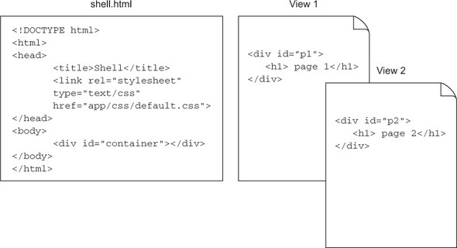
Figure 1: Views[3]
An example of this is shown in Figure 1. The example displays how a single page application works. In the Shell.html file, that would be the code for the banner, side bar and possibly another menu. The two views would then be the content, in the Gmail sake, it would be emails and every time the user clicks on a new email, it will display a different view. The fetching of views are done asynchronously when a new view is ready, Scott [3] explains that the views are fetched independently and when they are needed, they are loaded on request.

The shell
When SPA sites are loaded, it loads the shell of the site or the html file, this is the only html file that needs to be loaded on start-up. The shell is the main structure for the application and creates a structure for all the content that will be loaded into the application later. Mikowski and Powell [3] backs up the point made by stating that ‘The shell provides shape and structure to our application’. This is because everything that is built into the SPA must be built into the shell, because it is one of the most important pieces of the SPA. The shell consists of the static parts of the page such as the headers and menus and this is the first thing loaded. The static parts of the page include the header, footer, menus, scripts and the CSS [1]. The first initial load up only loads up ‘those that rarely change’.

Views
The site is changed using Views, the views are loaded for when a new piece of content is needed after a click to a heading or link, each one has different content. Using a SPA is a more efficient way of doing it because as explained in [3], it explains that views can be displayed effortlessly, and it uses a lot less strain than loading a html file every time the user navigates to a new page. Each view acts as a new page, ‘When the user navigates to what appears to be a new page, the framework is swapping view 1 for view 2’[3], As Scott explains in [3] the views act as pages but are just singular views that are loaded with different content which can be loaded onto the shell quicker because it is just simply content.

Single Page JavaScript Frameworks
A single page application is ‘composed of individual components that can be replaced/updated independently’ states Sawant and Deshmukh in [9], by using JavaScript Frameworks, it can make the application easy to maintain. The authors state that using JavaScript can be very hard to understand but using a framework makes it easier because each function is separate, so that you can fix or edit a feature without changing anything else. There are several frameworks that can be used to help build a single page application including React and Angular. These two are the most popular frameworks for creating single page applications.

Popular frameworks
There are many frameworks that can be used to create single page applications, but the following ones are the most used by developers.

Ember.js
Ember.JS uses an object-oriented pattern of class inheritance using getters and setters[10], this means that if the user is not too familiar with the framework, the user still has an understanding of how the framework looks and how it is written. Ember is one of the most complex frameworks and is used for building complex applications. It started as a version of an old framework called SpoutCore 2.0, but then changed into Ember because the creators wanted to make it an easy to use framework and it was not going in the right direction [11]. Ember has some big clients including Netflix, Microsoft, LinkedIn and many more. This backs up the point made about Ember helping develop complex applications [12].

Vue.js
Vue Is a framework which was created using concepts from Angular and React. It is built with HTML, CSS and JavaScript, It does not need any specialist knowledge[13]. It is a very lightweight framework which is useful when creating web applications. Hanchett [13] also talks about how the user can also carry on using other tools and you can just drop Vue in whenever the user needs it, this is very useful if the user needs to solve one particular problem, it can then be dropped in to solve the problem and then the user can carry on. It is also SPA friendly meaning that on Vue 2, it can seamlessly pull in views and other content when needed or called for. Vue is very well used so that if the user encounters any issues or problems, there is a wide community full of solutions and developers that can help with Vue.

Angular.js
Angular is useful when creating a single page application because it reduces it to three parts. Model-View-View Model but uses the basic principles that are MVC (Model-View-Controller). The application data is managed by the model[14]. The View is to present the model visually to the user and to get responses[14]. This is similar to what the views do inside of a single page application, which is to display content onto the web application. Only that this view is displaying the application data that is being managed by the model. The controller ‘is the core part acting between model and view’[14]. It does the job of interpreting the requests which could be to display a new view and then tells the view and model to get the data for the next view to be displayed.

Angular uses tags which are called directives [9], the directives are referred to as ‘ng’, it ‘binds the data to the view/templates through controller’[9]. There are many directives that can be used, such as ng-click which customise behaviour when the element that is linked is clicked [15]. It can use many directives such as ng-click and many others to make an application interactive so that views can be requested and displayed on request. Angular was created by two google employees and it now seen over by google itself [16]. Angular helps developers by using its syntax to save efficiency by reducing code. Angular supports all major browsers which include all of the ‘class A Browsers’[17] which is vital when creating a web application when many users will be using many different browsers depending on where they are using the application from.

React
React is a library that is used for creating user interfaces, it is used for creating applications such as Facebook and Instagram and many others. Instagram is a good example of a react application which is a single page application, as it uses the banner at the bottom and the newsfeed is the view that changes when the user interacts with the website. React had the 2nd highest number of contributors in GitHub [18]. This shows that it is a highly used library and there are lots of project’s out there created using React and many ways of completing tasks with ease and with efficiency.

React is used with companies like Facebook, Netflix and other companies with large amounts of data. A blog posted by Netflix developers [19] talks about how they needed something that could handle the amount of data that they needed to handle. The developer also talks about how they need to load the recommendations on films and programs, load films and programs, while personalising the user’s experience[19]. By using react each page can be used as a view which helps with the quickness of the app and with an app the size of Netflix, this will be very useful. The developer states that by using react they were able to ‘improve initial load times, runtime performance and overall scalability[19]’.

React uses a virtual DOM which keeps a virtual representation of the object in memory, then when it is needed it is then synced with the real DOM [20]. Objects can be stored in the DOM using react syntax such as createElement and updateElement. If the user wanted to update the page and had other objects stored in the DOM, the user could use the updateElement and it uses other syntax like new node and old node and it will replace the old elements with the ones stored in the DOM.

Usability testing
Usability testing is a vital is software design, because it can ‘enhance the usability through testing and improving the present interface’ states the author in [21]. Usability testing is usually used to find problems that exist in a website, they can help solve and improve things such as ‘ease of use’ and ‘better user experience’ quotes the author in [22]. It also helps how users use and understand a system to complete a task [23], by understanding how users use and understand the system, it allows more efficient ways being created to complete tasks and making web applications easier and more efficient.
There are many ways to test usability that are designed for helping and improving many aspects of a website.

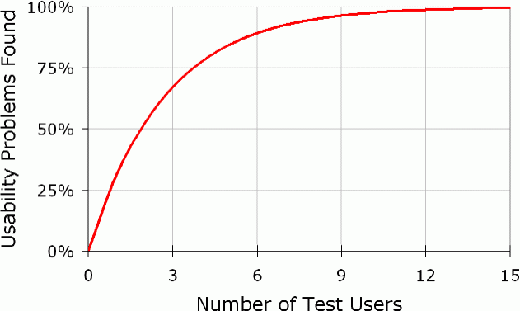
Figure 2 Test Users [24]

As shown in the figure above, it shows the correlation between the number of users and the percentage of the problems, the more test users used, the more problems that are found. This proves that the more users and more testing that is conducted means that there is a good chance that more problems and issues will be found.

What is usability?
Usability is a ‘Quality attribute that assesses how easy user interfaces are to use’[25]. It also helps with improving ‘ease of use during the design process’[26]. Usability is defined by 5 components:
- learnability, how easy it is to use the website [26].
- Efficiency, how quickly they can perform tasks[26].
- Memorability, how much they can remember tasks and functions [26].
- Errors, how many errors do they make and what errors are they [26].
- Satisfaction, what is it like to use the design [26].

Usability Testing Methods
There are many ways to test usability and test certain parts and aspects of the website. This section will look at the different methods that can be used to test usability methods. These methods can then be sorted and organised into ways to display the data that has been collected, such as graphs, charts and questionnaires to finish off.

User actions
The first usability testing method is user actions. This involves analysing the user’s actions, such as tracking the mouse actions [27], this involves tracking the movement of the user and the directions that they move the mouse and navigate around the web application. The authors in [28], state that mouse tracking can help gather user behavioural data that can be used to evaluate and improve areas. This can help developers find what paths users take to get to certain pages, this then helps them with the design of the interface of a website so that it is easier for a user to navigate to page on the site.

A/B Testing
Another method is A/B testing, this is when two different versions or two variants of a web application are tested and compared[29]. As shown in the picture below, half of the users are used to test one alternative and half the other alternative. Then the two results of the users are analysed and compared to see which version performed better. Revesz and Pataki [30] talk about how A/B testing is a ‘powerful method because it is based on the behaviour of the end user’. This is a good method because by testing two different versions the tester then has a good insight to what is efficient and what isn’t on the two versions.

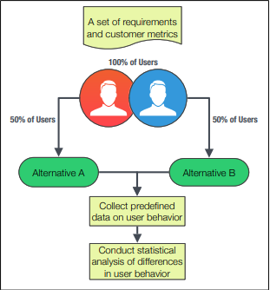

Figure 3: A/B Testing [29]

Hallway testing
Another method is hallway testing, is getting random people to test something and getting them to complete tasks. Scenario based tasks are the important ones [31], you are then testing real life situations and seeing if it works well.

System Usability Scale
System usability scale is a ten-item scale giving a global view of subjective assessments of usability [32]. It is a type of questionnaire that can be used to get feedback off users on what their opinion of something is. It is measured using the Likert scale, the Likert scale being a scale usually from one to five. Reiser et all [33], states that it measures the degree of certainty in this statement on a scale (Likert scale). After the user has answered all the questions, the scores have to be added up. The way they are being added up is that the odd numbered questions rating out of five will have one subtracted from it [34]. The even numbered questions rating will be subtracted from five [34]. Then the even numbers that have been worked out will be added up and the same for the odd numbers. Next the total of the odd numbers and the even numbers will be added up to a total, you then multiply the total by 2.5 and then you have an overall total. The overall total is then compared on a table.

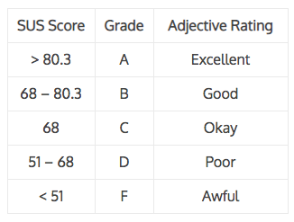
Figure 4 SUS Scale [34]
As shown in figure 4 shown above, the total score is then compared in the table and is worked out to see if it is an excellent score or a bad score.

Conclusion
To conclude the literature review, the most important points found out are the most important components of a single page application (SPA), which are the shell and views. These are the main parts of a SPA, as pointed out in chapter 2.2.1 it makes the point that the shell is the only html file that is loaded. It has also been pointed out that ‘The shell provides shape and structure to our application’[35]. Views are also one of the most important parts of a SPA. Also mentioned in Chapter 2.2.2 it states that ‘the framework is swapping view 1 for view 2’[3]. This means that the views are swapping with each one that is requested by the user.
Also talked about are the different frameworks and libraries used with creating single page applications and how each one works and how it works with a SPA. It talks about how using JavaScript frameworks and JavaScript itself can be easier when making SPA’s because they are designed to do this. This means that using frameworks are a lot easier when building applications because there are shortcuts and easier ways in the code to complete tasks. The author also looked at the different types of frameworks on hand to build SPA’s, and examples of these discussed were Angular, React, Ember and Vue. Also looked at was usability testing, what they were and what they do. They are used to test the usability and efficiency of a website and the tests are designed to improve web applications and websites.

After looking at all the different techniques and features that can be used in app development the author will now look at when they will be used and how. These will be the different approaches that will be taken to collect the correct data.

Research Methodology

Research Methodology
For the research part of the project the author will be investigating the usability of a website by using certain techniques.

Philosophy
The philosophy that will be used will be the positivist philosophy. This is because this philosophy main focuses on the View that factual knowledge gained through observation is trustworthy [36]. This goes with the plan of what the author plans to do in this project, which is to Implement a single page application based on the usability study composed on a website that doesn’t use a SPA. This also proves that the implemented react web app will be relied on the findings of the first usability study to see what types and where the usability of the website can be improved, the implemented website is being improved on the findings rather than opinion or not factual information. This is backup on the point made by the author in [36], who says that ‘the researcher needs to concentrate on facts’. The author will use the ways that the positivism approach to their advantage because positivism desires to find out how people think and do a specific thing, or have a specific problem [37]. The author will then use this because they will find out the usability of a website which will find out how the users will use the website which is similar to how it is explained to find information using this philosophy. The positivism approach means that it can be taken very widely and flexible and could mean a variety which could mean methods could be a number of things [38]. To get around this the author will make the methods and collection methods more exact by making the tasks that the users will complete simpler, so that they will focus on gathering data and information on one problem at a time.

Strategy
There are two different types of strategies being deductive and inductive. The two being similar but different in the way that they work. According to an article by Daniel Miessler, ‘Deduction moves from idea to observation, while induction moves from observation to idea’ [39]. The strategy that will be used in this project would be both inductive and deductive this means that the two methods will be use throughout the project. This will be done because at the start of the project when the first research is being done, the author wants to find out about SPA’s using react and if they are faster than a normal website. After doing research about it and collecting data further on in the project, the author can then conclude that using a react SPA can be faster than a normal website, which is deductive. Also, after the user has completed the research and has collected data from users using a questionnaire and the ‘System Usability Scale’ test on a normal website and has had opinions on a normal website. The author can then come to certain conclusions than according to data collected, react SPA’s can be faster.

Deduction’s advantages will be used because deduction ‘Gets you a perfect conclusion- but only if your premises are one hundred percent correct’ [39]. The premises ‘includes the reasons and evidence behind a conclusion’ [40]. This tells us that the premises in this case is the evidence that will be found, which would be the research and data collected by the author, meaning that our premises will be really good reliable data that has been collect properly [39]. Inductive advantages can also be used because it is useful for coming up with multiple conclusions because with the data that the author already has, it can be made into multiple conclusions [39].

Approaches
The approaches that the author will take to conduct research and what types of approaches the author will use to collect data. There are many different types of approaches that the author can take to conduct the research and this section will explain what they chose and why.

Literature Review
The literature review was the first major part of the project because the author research information about the chosen topic and writes about them using sources and information from academical sources and other sources. A literature review is an important part of a report because it gives shows ‘knowledge and understanding’ [41] and gives a ‘critical evaluation of the material [41]. It also gives the reader information about the topic if they do not have much of an understanding about the topic. The Literature review covers the information about the topic and in this case, information about Single page applications, single page JavaScript applications and information about the usability testing methods.

System usability scale

The system usability scale is a type of usability test that tests the usability of a website. It is done by getting the user to complete tasks, then complete a questionnaire. The tasks being used are designed to test the usability of each feature of the website and how they work with different users. The tasks will be simple tasks that will need to be competed on the chosen website and after that the user will complete the SUS questionnaire, then giving their feedback using the system usability scale questionnaire.

The answers will be calculated into a number and the number will then be compared to a range of scores. Once they have done that, the author can calculate the answers of what the users have chosen, shown in Figure 5: SUS Questionnaire, [40]. After being calculated a certain way, which the questionnaire having 10 questions, the even numbers will be calculated and added together, then the odd numbers will be calculated then added together. The odd and even totals will then be added together and multiplied by 2.5 to give an overall total. Then the overall total can be compared to ranges of numbers which are shown in Figure 4 SUS Scale [31] and depending on the total will be good or not. This was done because it is a good way to find the usability of a website because it lets a number of users test key features of a website and the results being in figures that can see how good the usability is depending on the score from each questionnaire.


Figure 5: SUS Likert Scale [43]

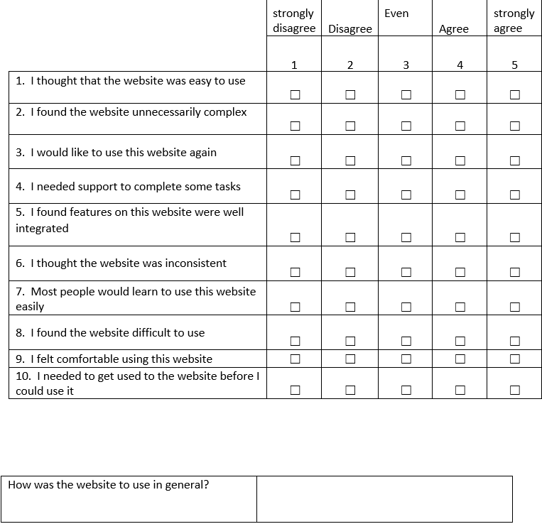
Figure 6: system usability scale questionnaire being used

Another approach that was taken was a small set of questions on the system usability questionnaire sheet which asked the user five questions about the website, which can be found when explained further on in 4.1.3 and shown in Figure 9:Questionnaire on website features. The questions will be answered after the tasks have been completed so that they can give their feedback about how they found the tasks and the website. This is being used so that it gives another form of communication with the user, also, the user will answer in the comment box which will give the author another form of feedback.

Cognitive Walkthrough
A cognitive walk-through is a usability technique that is used for looking at the learnability of a website, it can focus on how easy a website is to learn [44]. When completing a cognitive walkthrough it looks at aspects such as, it is easy to learn, is it confusing and what the user must know to make the next step[44].

This will be used after the web application has been implemented to look at the usability of the web application. It will look at, is the application easy to use, is it easy to navigate, is it efficient to use and if the user’s actions while navigating around the application are matched by what happens. The outcome of this technique will be to see if the user will expect the application to do what they expect it to do, these could be actions on the website in which include preforming tasks and finding certain features. This will be useful because it will look at if the website has been well designed and if the user can easily navigate and not get confused with certain features.

Software development
The software development part is one of the most important parts because its where the findings of the system usability scale questionnaire lays the foundations for the software development. After finding out the usability of the website in the previous section, the author will now use the findings and the parts of the website that show poor usability to design and implement their own version of the website which will have improved usability. It will be created using React and will use a lot of the features talked about throughout the report. The website should cover all the issues found and covered in the usability tests so that when the implemented website is tested for usability, it does not have similar usability issues coming up.

Risks & Limitations
There are many external factors that could hinder the success of the project and some of those could be losing work or data. The loss of data is a serious factor when writing something or storing something in general. In terms of data loss, it could be human causes which include accidental deletion or overwriting of files [45]. Other causes could be viruses, bugs and physical data loss such as power loss or surge and damage to hardware [45]. Although a very simple cause of data loss can have very high consequences. The ways this can be prevented is having an external backup such as external or portable USB/Hard drive, a very possibly cheap and easy way to prevent data loss. Another option would be to store data on the cloud, also a very cheap and mostly free ways of storing data e.g. Dropbox [46] and OneDrive [47]. If something like this was to happen, the author would simply retrieve the data from one of the places mentioned, which would be simply downloading it from the cloud or copying from storage device back onto pc.

Another option would to just to turn autosave on which is now implemented into a lot of word processing programs. Another risk could be when collecting data using the System usability scale and then the questionnaire, a user could input data incorrectly causing an anomaly in the data. This could be done by the user misunderstanding the questions and inputting a number on the wrong end of the scale. To attempt this from happening the author could put instructions or even more clear instructions in the questionnaire and task sheet, so that the user clearly knows what must be done. If this was to happen, the author could ask the user to retry both the tasks and questionnaire because the questionnaire records their names. Also, the author could remove that score and questionnaire and either leave it or ask another person to complete it.

There are many limitations that could have an effect, one of the main limitations is time. Time is a major limitation in any project, it can have major consequences. There is an easy way to handle this limitation which is to plan the project and have dates in which each task must be completed by. The author has planned for each task that has already been completed and what still needs to be completed. It has been made in the form of a Gantt chart, it gives users a visual view of tasks scheduled overtime [48].

Validity, Reliability & Generalisability

Validity
The way that has been chosen to investigate the task in hand is a good way because of several reasons. Firstly, the way the data is being collected using the system usability scale will give the user a number and a good idea on how good the usability is according where on the range of numbers the users total number will fit in. It gives the user an indication on if it has good usability, poor, or very good. The validity will be good because the questions being used in the SUS questionnaire will be standard system usability scale questions, meaning that if another project was being done and using the system usability scale method, the same or very similar questions will be used when asking the users. This shows that the questions are focused on finding the usability of the website, each question is focused on one aspect of the website and if the usability was good. Also, the second set of separate questions ask the users how they found each task and other important features of the website.

Reliability
The reliability of the investigation is good because the user is using the system usability scale method which uses the standard questions that are asked. This means that the questions that are being asked are reliable questions because they were not created especially for this investigation, they are used in general for system usability scale tests. Also, the reliability will be good because questions used could be used by another researcher for another investigation but due to the type of investigation, the findings will be different because the investigation is based on opinion and will be different for each investigation. The results being opinion based could be used for other usability type problems.

Generalisability
The results that will be found in the tests could be used for similar problems, these problems would have to be usability based because the tasks and system usability scale techniques were specific for finding out about the usability of a website. Which means that the results could not be used for a vast number of situations because of the topic on which they are based on. Although they could be used for problems which are looking for a similar answer such as looking to find out something about a website or application. The method being used to find the usability could be used in another investigation because the questions asked will be investigating usability and the questions will be asking the users for their opinion on the chosen website. As talked about in the 3.1.5.1, it talks about how the questions being used are the standard questions for a system usability scale test, meaning that the methods could be used for other problems but the results which would be the opinion of the users on the website could be used on another project if it was about usability but would be limited for any other projects.

Data Evaluation Methods

Data Collection
The type of data that is planned on being collected is the results of the SUS questionnaire which the user would complete the tasks and answer the questions resulting is a number depending on what they thought of the website. The types of data will be data in the form of numbers and data in the form of written feedback from the users. The numbers being between 0 -5, will be calculated into an overall total and stored as that overall total number. The other type of data that is being collected is the responses of the user when completing the questionnaire. The written feedback from the user can also give the author anything that they encountered while completing the tasks, which will be done at the in the five questions at the top of the questionnaire, this gives the author written feedback. The Number of respondents that will be needed to collect a safe and reliable amount of data will be fifteen plus people. These people that will be answering the questionnaire will have to give their name on the top of the survey and to have even more information.

The minimum amount of data that is needed would be fifteen people to complete the questionnaire, this is the minimum amount that will be set. The minimum amount of data that will be recorded is a suitable number and it was set because it is not too high and not too low and this will help with the risk that not enough people will answer the questionnaire. This was a measure taken to stop this kind of problem, this means that anything over fifteen questionnaires will just make it more reliable. If for some reason the minimum amount of data is not hit, the number of questionnaires completed would still need to be at a suitable number. The people who will complete the usability study will be chosen randomly, they will be student from the university and will be random on who does it. They will be classmates and other students from the university of the author.

For the cognitive walk-through, the data being collected will be conclusions based on if the tasks being completed were successful or not. The results would be in written conclusions on how the web application was used and if it is easy to navigate. The questions that will be looked at in the walkthrough will be will the actions that the user would be completing be realistic and usable, another one will be for the main features of the website, are they clear and obvious.

Data Evaluation
The data will be evaluated by looking at the results of the usability study and looking at where the usability was good and where it was poor, this could then be backed up by looking at the results for each task completed and looking at how the users found each task and how good the usability is and if it was improved by the use of a SPA and the use of React. Also, by using the first set of questions on the questionnaire, the author could use the responses of the users on the Likert scale on what they think of the website and features. They can also look at the problems and how it can be improved by looking at the comments box at the bottom of the questionnaire on what they thought of the questionnaire overall. When the users are completing the tasks for the website, it will also be recorded and as well as the time it takes for them to complete it. This could be looked at for the first website and it will give the author a good idea of how long the users take for each question. This will then give them a good idea on what parts of the website were people getting confused and could not find certain objects. After creating the web application, it can then be evaluated on whether certain features and navigating from page to page or similar is any easier.

The way that the data will be analysed will be done in several ways, firstly being calculated using mean. The mean being the average number of all the results collected. This could be used when analysing the results from each individual result from the SUS test, this could then be calculated into the average results from the usability study from the first website. This will be an effective way to see what standard the usability is of the website wordery.com. this will then give us a good understanding on how certain features are good in terms of usability and how others are not

For the results of the system usability scale, the results of the SUS test can be evaluated firstly looking at the average scores from each question and looking at how each task got on. This will give a good reference for what the users thought of the tasks. Another method is to look at the time taken for each task so that they can all be displayed in a chart; this will clearly show how long each task took compared to others. This will give a good indication compared to others. Another way is that with the second questionnaire asked to the users, the average score of what they thought about the website rather than specifically. Out of the four questions, an average can be rounded up and displayed and show which feature was good and was efficient, this could also be displayed and compared to the other questions.

Development Methodology
This section will look at the development methodology that will be used in the project. It will explain how it will be used in this project.

Software Development Methodology
The software development method that will be used in the implementation stage of the project will be User stories. User stories are commonly used to help think of the requirements needed when writing a software program in agile development [49]. As stated in the last point, user stories help with the requirements because it is a vital part in the designing of a software program. It helps the user think of the features needed for the program or website by thinking what is needed for both the user and the programmer. This is done by creating stories for tasks that will be completed, e.g. a user can search for a book and a user can view the details of a book. These stories could be created for a certain task. If the user wanted to create a set of requirements for the website, one user task could be to search for a book, that task would then have lots of user stories which would include ones such as, as a user, I want to be able to search for a book in a price range so that I can see the ones that suit the requirements set [50]. An example for the programmer side of the user stories could be, as a programmer, I want to be able to add new books to the website when new ones come out. Also, as a programmer, I want to be able to control the website so that nothing inappropriate or incorrect makes its way onto the website. The reason that this method is being chosen is because it gives the creator a good idea of what requirements are needed from every aspect.

Resources
This section will explain what resources will be used throughout the project and how they will be used.

Hardware Resources
The hardware resources that will be used in the project would be a laptop, which would be used to gather results from users when carrying out the usability study. They will be used when going around and asking students to answer the SUS questionnaire and tasks.

Software Resources
The software resources that will be used are firstly Microsoft word, this is what the questionnaires will be composed and answered in. After answered, the completed questionnaires will be saved in a Microsoft word file format as well. Also, Microsoft excel will be used to store the results. After the users have completed the SUS questionnaires, the results will be written into an excel spreadsheet, this is so that the author can use a calculation formula to calculate the overall SUS total so compare to other results. Rather than individually calculating each result, the spreadsheet will calculate it for the author. Also used will be Visual studio code, this will be used to create the implemented website itself. It is because of the use of its ability to run commands, when using react a lot of features packages can be installed and created by running commands in the terminal.

Conclusion
Each method in each section mentioned will be used to create the implemented web application and each method will play an important part in the planning and making sure each part and technique is correct in the creation of a single page application. The techniques will play an important part in the next step in the project which is the design phase of the project and each technique will be a guide for how each method of designing a web application will eventually look.

Design and implementation

Pre-Study
A pre-study was carried out to investigate the usability of a website that is similar to the one being developed in this project. The aim was to understand the usability of the website using techniques such as the System usability scale and a small standard questionnaire. These techniques were used to decide and look at how the usability was on the website being looked at. These techniques were designed for testing the usability of the website by testing certain features which construct the core of every website and then to use questions that will get the opinion of the user on what they have just completed. The first technique that was used was the tasks asked to be completed by the author.

System usability scale tasks
The tasks the users were asked to complete were done on wordery.com. Asking the users to complete tasks on the website such as finding certain products, navigating around the website, and finding key information were suitable ways of finding the usability of the website. This is because it makes the users preform basic tasks on the website and see if the tasks are easy to complete or if the features on the website are poorly designed. The tasks that were completed were a good way to test basic tasks on the website, and many other features because the users will also come across other pages and features along the way. The users were asked to complete five tasks, these tasks were as followed.

- For the first task, the user had to ‘Find a sports autobiography between £20 and £25’. This was a good way to test the navigation bar and finding a book between price ranges.
- Task 2 was to try and find the book ‘Elon Musk’. This task was focused on testing the navigation bar again, the placement of books on the website. This was important because if it is hard to find a book in a certain category, the user will go elsewhere.
- Task three was to find the cheapest book in the computer programming section. This tasks were to test the navigation bar and the categories on each section such as the computer programming section, is the programming section where the users think it would be? Also finding the cheapest in the section would test finding books in certain price ranges again but more to do with the highest and lowest.
- The fourth task was to add a children’s book and a true crime book to the basket and then to remove one book from the basket. This was to test purely the usability of the shopping basket, by asking the users to simply add products to the basket and then remove one.
- The final task was to find the delivery time and price for Royal mail first class. This was to test the placement of important information about the website, orders and products.

the completed tasks with screenshots can be found in Appendix E, with a screenshots of the full results sheet found in Appendix F. The first way to measure how the usability was on the website is the timings. Each task was timed to see the average time taken to complete the task and to compare to see if anything has been improved when the implemented one is completed.

- For the first task of finding a sports autobiography book between £20 -£25, the average time taken to complete this task was 61 seconds, with the quickest being 31 seconds and the slowest being 147 seconds.
- For the next task which was to find the book ‘Elon Musk’, the average time for this task to be completed was 59 seconds, with the fastest being 13 seconds and the slowest being 173 seconds.
- The third task, finding the cheapest book in the computer programming section, the average time taken to complete this was 66 seconds with the slowest fastest being 26 seconds and the slowest being 132 seconds.
- The fourth task to add two books to the basket and remove one of them, the average time to complete this was 72 seconds, with the fastest being 17 seconds and the slowest being 169 seconds.
- The final task, which was to find the price and time taken to deliver in royal mail first class, the average time to complete this was 76 seconds, with the fastest being 23 seconds and slowest being 147 seconds.

By looking at Figure 7, it shows that the average time taken for the tasks to be completed were all quite similar and around the same time frame, this tells the author that with the averages being around the minute mark, there are lots of room for improvements.

Figure 7: Time for each SUS task

System Usability Scale
The system usability scale (SUS) was a successful way of finding the usability of the website by using the standard usability questions, as shown in Figure 11 and Figure 12 of Appendix A. After completing the questionnaires, the author had a suitable set of results. After completing the SUS tests, the average score was 57, the highest score was 83 and the lowest was 30. The results did vary a lot, but the point of the test was to see what people thought of the website. As shown in Figure 8, it shows the average result for each question which was answered for each question on the SUS test (a good score being high and a bad score being low). With the results that have been collected here, the author can now use this data by looking at the questions to create the requirements. An example of this would be the questions that ask the user about the ease of use and how easy the website was to use.

Figure 8: Average score from each SUS question

Questionnaire based on tasks
The questionnaire that was given to the users was aimed to get their opinion on the tasks they completed rather than usability questions. The questions were aimed at sorting and filtering, using the navigation bar, using the shopping basket, and navigating around the website. The results on this will give the user a good idea on how to improve certain parts of the implemented website because of the feedback of these questions.

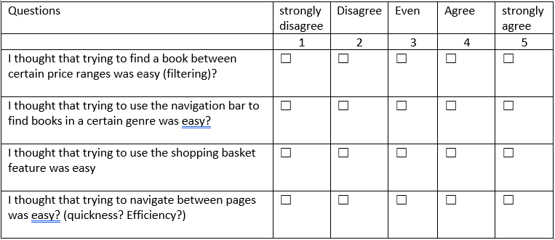
Figure 9:Questionnaire on website features

The results of this questionnaire can be looked at firstly by the average response by the users for each question. By looking at the results of the first question, the average for the first question was 2. This tells the user that the filtering and sorting was poor and was difficult to find certain products by using filtering.
Question two, which was using the navigation bar had an average of 3.7. The users found the navigation bar okay to use by looking at the results, but also many who did not agree.
Question three, which was using the shopping basket had a good score, which was an average of 4.4, this tells us that most people found it good and easy to use.
Question four which was navigating, quickness and efficiency of the website scored an average of 3.8. this tells the author that this could be improved during the implementation phase.

Figure 10:questionnaire average
By looking at Figure 10, it shows that the sorting and filtering was poor compared to everything else. The shopping basket had the best score out of the four, with not too many complaints from users and question two and four having a few concerns from users, which can be found in the next section.

User opinions
After completing the questionnaires, the users were asked to fill in an opinions box on what they thought of the website, which can be found in Appendix A. After looking at what the user said about the website and its features, ten people out of the fifteen users who completed the questionnaire said that the filtering and finding products in price ranges was poor. This means that this could be something that could be worked into the web app that will be built by the author.

Only two people thought the genre names were confusing and could be worked on. Five people thought that the information about the delivery was badly places and was hard to find.

Additional findings
After watching the users complete the questionnaires, the author has noticed the patterns that the user has been taking when completing the tasks. This will help when designing the website because knowing where most users thought certain features would be is useful. An example of this would be, when looking for the delivery price and time, most people thought it would be in the basket area. Although can be found by navigating through numerous pages, the direct link was in the footer at the bottom of the page. Another example is that users sometimes found that books could be in two sections at once, this was sometimes confusing for users because they did not know the best path to find the book they were looking for.

Evaluating the data collected
After looking at the findings from the last section it is now clearer to what needs to be looked at for the web site that is to be created. The results that have been collected show that several aspects need to be looked at when creating the requirements which will be an integral part of creating a web application.

After firstly looking at the time taken to complete the tasks, tasks three, four and five were the ones that took the longest. These tasks included finding the cheapest books in the computer programming section, adding two different books into the basket then removing one of them, then finally finding the price and time taken to deliver for royal mail first class. The other two tasks included finding a book, one specifically and the other in a price range, were in a similar time frame but were slightly slower. When looking at the questionnaire based on the tasks, questions two, three and four were higher than question one (higher scores being better). Question one asked the user if they found the use of filtering easy and with an average score of 2.3 which is disagree, this tells the author that this needs to be looked at when creating the requirements and the application its self.

After looking at the results stated and in the previous section, it gives the author more of an understanding on what needs to be focused on and also what can be added to the user stories when coming up with requirements for the application.

Another major factor that will need focused on is the use of efficient and quick navigation between pages. This will be done by using the power of React. This will allow the users to select a category or page and it will be displayed instantly rather than waiting for the server to load the page.

Design process (User Stories)
When it comes to designing an application, it is important to use a design process. With the many design processes that exist, each one is different in which it helps which different techniques in designing applications. The design process that was chosen for this project are User stories. User stories are a good way of coming up with requirements for an application that look at what is required. They are being used in this project because it is a very useful and efficient way of finding the many requirements needed on a website. User stories helps with the purpose of the software that is being created[50]. A full list of screenshots of the user stories can be found in Appendix B, the explanations for each screenshot figure can be found below.
As shown in Figure 11, it shows the user story that was created for searching for a book. The first card tells us that the user will want to search for a book depending on a filter that can be chosen by the user, so that they can find books in certain ranges of price and order. This will also help in terms of the design for the filtering, the requirements are to be able to filter between the price, which will be from low to high order and high to low order. Another filter will be sorting in alphabetical order, this is so they can find a book in a certain letter. This now helps the author because it is now known what is needed for the design. The filter and sorting as mentioned will be located at the top of each of the category pages so that the users can clearly see them.

Figure 12 shows us that on the first card, it says that the user will want to be able to navigate quickly between pages and genres so that there is no wait between loading pages. The next card tells us that the user will want to see all categories and subcategories so that they can see all the options available. This can be done by using the single page application, so that the only page that is loaded on a refresh is the homepage, each other page will be loaded in seamlessly. For the categories, there will be main categories with more specific subcategories for books. After looking at what is needed for the categories for the web application, the categories that will be shown as stated previous in the project will be Most Popular, Fiction, Non-Fiction, Children’s, and education. These were chosen because they were the most popular and use categories in terms of book categories. Also, because each category in different and none are similar, so they boast a wide range of variety.

In Figure 13, it shows the card showing that the user want to be able to choose a book that they like and to easily be able to add it to the basket. This requirement can be used by when the user is browsing through books, there will always be an option to add the book to the basket and view the books itself. The basket button will be at the bottom of the book card underneath the information about the book. When pressed it will add the book to the basket. The location of the basket itself will be located in the top right hand corner where the majority of baskets on product websites are located, this will help with the usability so that the users would already have an idea of the default locations of features.

Figure 14 shows us that as a user, they will want to be able to clearly see a book so that they can view the full details on the book. The second card tells us that the user will want to view all the books when browsing so that they can see the main details of the book such as the name, author, and price. With these two cards, this would mean that when the user is viewing books, if they would like to view a specific book, the user can click on the book itself and view more information like its description etc. The information about the book will be displayed clearly with all its information on display so the user can see the full details of the book.

Figure 15 tells us that the users will want important information about the website and other factors to be displayed and located in locations that are easily locatable. With this card this would require important information to be located in places that can be easily found and not hidden such as the delivery information as found out in the system usability scale tasks found in section 4.1.1. Important information will be displayed appropriately in the top left of the application so that the users will easily be able to find it when needed and not have to look for the information.

Requirements
After looking at the user stories in Appendix B, it is now clearer to what are the main requirements. The main requirements would be that of which would need improving after looking at the results on what needs improving. The requirements would be as followed.

- Searching and filtering, to have a filter for the price, ordering with different options.
- Quick and efficient page loading, for each page to be displayed seamlessly using a single page application that can be created using react router. Also, for the categories, there will be the main categories such as fiction, nonfiction, children’s books, and education. These categories would then have subcategories which would be the more specific such as biographies, history, true crime etc.
- Choosing books, for each book, it will give the user the option to view the books details.
- Viewing the books, for when each book is clicked on, its full details will be displayed such as its name, author, price, and description. Also, each book when being shown with the other books in its category will have the full information for the books which gives the user a good amount of information for that book.
- Displaying information, for information that will be needed by the user, it will be displayed at the top of the page so that the user can easily see it when they first open the page, also because users are most likely to be at the top of the page most of the time.

After coming up with a set of requirements, it is now clear to what needs to successfully be implemented. The requirements such as creating an application that was an efficient and quick single page application is obviously a priority because of the nature of the project but other features are also very important such as viewing multiple books in different categories, having suitable categories so that user do not get confused while looking for certain books.

To conclude this section, now that the requirements have been created accordingly by the results of the last section it is now clear on what needs to be done and if followed, a good application will be created.

Prototype design
Prototypes are a very useful way of creating a brief and first look to what something might look like. The reason in which they were used for this project is because when creating an application, it is vital to know what the developer is creating rather than just creating it as it goes along. The designs that are going to be created in this section will be for the important parts of the website that will need the most looking into. These will be the, navigation bar, the category pages with the books, filters and how they will be fitted in together, the homepage, and the location of the information pages. As talked about in section 4.2.1, it is briefly talked about how they would look, but this section will illustrate how they will look. With prototypes, they tend to focus on the design rather than detail, and the illustrations show the design and placement of features that will be implemented in the finished web application.

The prototypes that were created to aid the design of the application were created for each main feature such as the navigation bar, homepage and the design of the book card and design of the page in which the books will be displayed on. The screenshots for each illustration can be found in Appendix C, with explanations found below.

The first illustration in Figure 16 shows a design of what the header will look like. The logo placed at the centre of the top header. The shopping basket is placed on the right-hand side of the header and the information page placed on the left. This is so there is a minimal design, this is because after the feedback from the SUS tests previous, a few people mentioned that the website was cluttered. This then led to the design of this prototype based on the feedback. Underneath that, the categories will be displayed and all suitable separated to avoid confusion. Once hovered over a category, it will dropdown to show the sub categories which will be clickable and each individual page will then display the books.

Figure 17 shows the design for the main body of the website, this will be filled with information and links to certain categories. It will display a secondary header followed by 3 cards in a banner style, each card will have a category which will have a small icon or something to help indicate which category is being shown, with also a header for the card. Below that will have a section which will have information about both the website and the books that will be on offer on the website.

Figure 18 shows how the categories individual page will look when one has been chosen. It firstly chose a brief illustration on what the filter and sort section will look like. Then, it shows the card for each book that will be displayed, it will have the picture of the book with the title, author, and price underneath. Then, leaving slightly more room for the description under that.

After designing both the visual design and the requirements side of the design, it is now clearer to what every section will look like. This means that when designing, it will be easier more efficient when creating the web application.

The reason that the navigation bar, home page and the pages for each category that will display the books were chosen were, because these were the pages that the users would use the most frequently and they would use these pages to find information. Also, they were vital parts of completing tasks such as finding books on the application.

Implementation
This section will look at the creation of the web application, it will be based on the design work that was done in the last section. This will show the different stages of creation that went into creating the application and problems the author encountered.

Deciding on requirements
The requirements that were decided on in the previous section were discovered after looking at the results from the previous tests. They were also created by looking at the user stories and how each action in the user stories had multiple cards in which that action had to complete.

Issues and problems encountered
When creating the application, several issues were encountered. The first issue was about the category pages. Each category has its own page with its books that belong in that category. The author first made a page for each of the categories, but for the books to be displayed, the code belonged in a separate class. So, a way of making the category display on a page of its own without having many pages for each category. The fix for this was to create a function that used the URL parameter from the navigation menu route shown in Figure 19, which turned the parameter for the category clicked on in the navigation bar and then displays a header using the string which is returned by the function. This then means that when a category is clicked on, it takes them to the same page every time with the title changing depending on the category clicked on rather than a different page for every category, as shown in Figure 20.

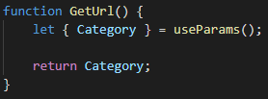
Figure 19: Issue 1
Figure 20: Issues 1 example 2

The second issue was similar the first, it involved displaying the books depending on the category that had been chosen in the navigation bar. The fetch URL which was fetching the data using the API was depending on a category that was in the database being on the end of the URL. When a category was put on the end of the URL it would display the books from that category successfully. But the aim was for this to change depending on the category chosen. The author fixed this by using state and props components that are built into react to get the category from the parameter of the category selected and call it a similar way that the data from the database is being called as shown in Figure 21.

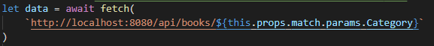
Figure 21:Issue 2

Cognitive walk-through
a cognitive walk through is a usability technique that is used for evaluating the design for the ease of learning [51]. As talked about briefly in 3.1.3.3, a cognitive walkthrough is used for looking at the usability of a website by completing specific tasks and documenting the process. The first step that will take place is the users.

Users
The users that will use this application are people of various ages. According to an article of people who read books in the united kingdom, it states that 51% of adults in the UK have read a book in the last year and 15-24 year olds are 32% less likely than the average reader to be heavy readers[52]. This then means that most users that would buy books and use the website would be adults, but a small percentage of the users being younger people. This means that the website would have to cater to all users meaning that it must be easy to use with some adults not being as computer-literate.

Tasks
The tasks that will be used in this walk-through will be ones that will be used most. These will include finding books in a category, finding information, and navigating around the application.

The first task would be to find a book in a category, specifically, to find a maths book. The task will have to start on the home page, find the category and find a book in that category. the path in which the average user will take will be the easiest route and the route in which they would take to complete the task will be as follows:
- From the homepage, hover over the categories.
- Hover over the education category because that is where the maths category is located.
- Select maths from the dropdown (Figure 22).
- Choose a book from the maths section (Figure 23).

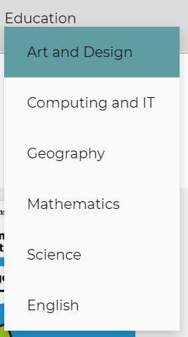
Figure 22:task 1 dropdown

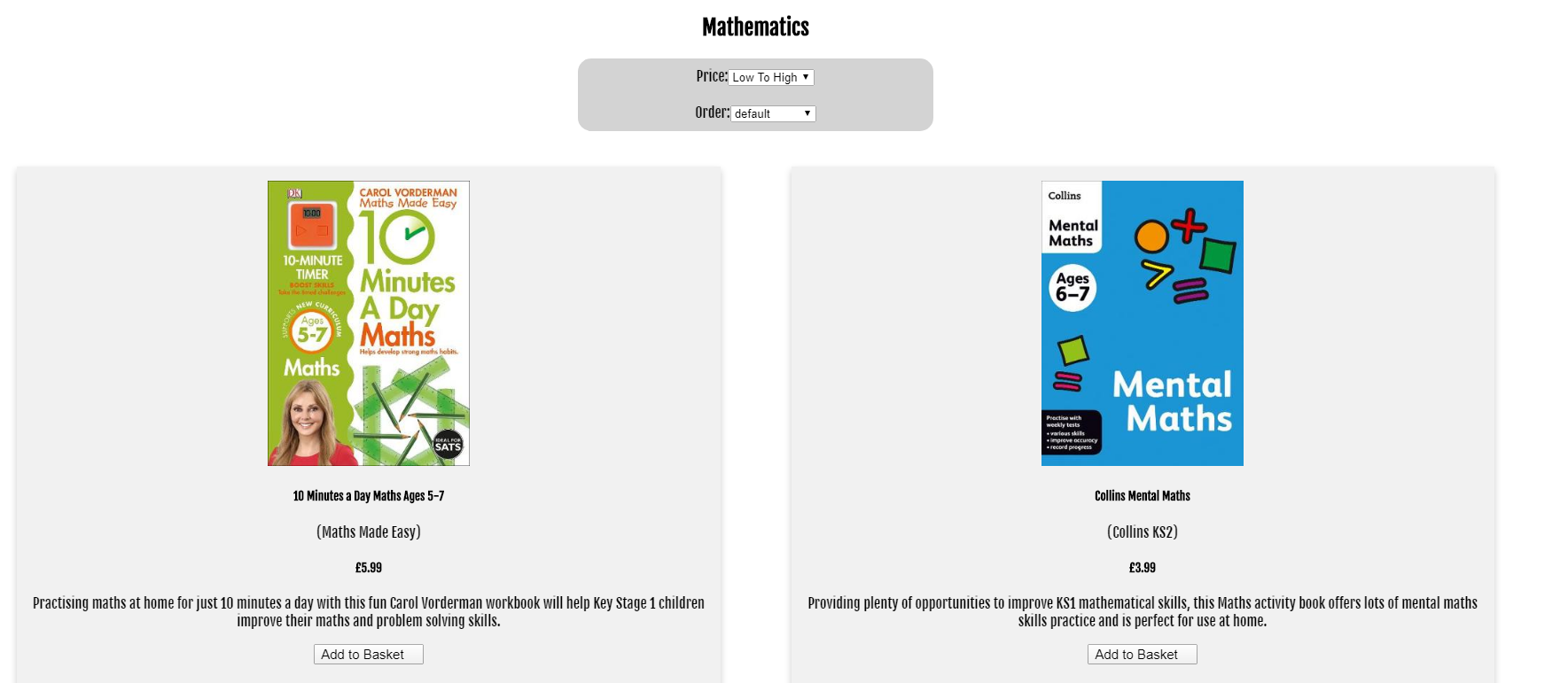
Figure 23:task 1 books
The users that would be completing these tasks when using the application would understand how to use the task because when looking for a book, the first instinct is to think or look for what category it is in. When the users completing sub tasks such as selecting a category, they would know that they were completing it because when a category is selected it will be highlighted and it will instantly display the categories page.

The next task will be finding the price of the book ‘Ben Stokes: On fire’. This task will test the usability of the website by seeing if users can find what category the chosen book is in, then finding the book and seeing if the price and title are well located on the card. The route in which the user would take would by as follows:
- The book is in the biography section, meaning that the user would go to the non-fiction section.
- Find the biography category on the dropdown and select.
- Locate the book in the biography section.
- When looking at the book card, find the price which will be located under the title and author.
The users that would be completing the tasks would understand how to start the task by firstly knowing that they would have to find the category itself. They would do this by knowing that a biography is a nonfiction book, if a user would not know this, they will be able to go through each category until they find the biography option. When the users are looking at the price for the book they are looking for, they will know the price is the correct one for that book because each book is in a card which has a different colour to the background colour of the page.

Additional information and features that would let the users know that something has been pressed or selected is that when an option or page has been chosen, because of the use of react router in the application, each page is displayed instantly, meaning that there is no wait between pages. This will help the use know that they have pressed an option rather than them not being not sure in what they have pressed.

Conclusion
To conclude this section, the use of the cognitive walkthrough was a success because it successfully looked at how the tasks that were used which included finding a category and finding a price of a book. These were successful because it helped the author look at the usability and the steps that had to be taken to complete the tasks. Also, it helped compare to if the usability had been improved, this was done by looking at if the completion of tasks similar to ones done in the SUS tests had been made easier, it can be said that after walking through and looking at the steps that have to be made, it can be said that a user would find it easier navigating and finding books.

Evaluation
The conclusions that can be drawn from the results from the data is that after completing the application, it is now more understood the techniques that help with improving usability. This is from looking at the tests that were taken place on the first website and looking at the results and feedback from people that took the tests. This would be the location and use of items on a website such as pages to information, the locations of certain categories and the overall layout of websites. After looking at the walkthrough of the implemented application it is now in terms of usability, clearer and more laid out and certain features and pages will always be in places in which users would expect. An example of this would be from the SUS test on wordery.com, majority of people complained about the location of important information such as delivery. This was solved by locating it on the top of the navigation bar in the header and aswell as its own section in the footer.
The data that was collected from both tests did back up from what was collected from the literature review because the literature review talked about how usability methods were used and how each method was useful for testing certain types of websites. When looking at the system usability scale test that took place, this backs up the point made because the research agrees with the tests taken place because the data that was collected was successful and it gave the author a good idea of what aspects of the website had good usability and what didn’t, and it also gave the author a figure on what level the usability was at, as shown in Figure 4 in which the overall score can be compared to what level of usability the website was at.
Also, the research that was done of single page applications backed up the results because it talked about how each framework was different and could help websites. By choosing React and looking at the research in the literature review it helped the author decide that its techniques were going to be an advantage. The research that was done about react in the literature review looked at how it could be used to enhance interfaces and by using built in features this helped with the usability and quickness of the application, explained in 4.4.2.
The objectives that were set in the Abstract were met because a framework was chosen and used. The framework that was used benefited the application because of its features and flexibility which allows different pages, functions, and classes to be integrated into each other. Also, a usability test was conducted and played a big part in investigating its issues that might not be good for its usability. An example of this were issues that were not know to the author but after testing the website using the system usability scale method, it quickly highlighted the issue. The final objective was to implement a single page application based on the results on the usability test. After doing the usability test, it was much clearer on what aspects of the first website needed more focus. This also led to the results of the test helping in the creation of the requirements which led to the overall completion of the objective.
The results that were expected from the first usability test was unexpected because after creating the tests for user to complete on wordery.com, the issues that were brought up by users were not expected and this was the point of usability test because it helps identify the issues that the author might not identify. With the cognitive walkthrough on the implemented application, it helped identify the different options that could be put in place to help users’ complete tasks based on previous tests.
If the project were to be done again, there would be some aspects that could be improved. Firstly, the implementation on filtering and sorting of books, this would mean to maybe have a better set up of the database so that data could be in different tables rather than one individual table, this could help with data then being sorted and filtered in many ways depending on the users preference. Also, more variety of categories with more books so that users would have a better selection of books to go through. This also ties in with the tables in the database and a better layout maybe being needed.

Conclusion
The work that was completed all contributed to completing the objectives of the project that were set at the beginning. An example of this is using and looking at many features of React that helped with the creation and the usability of the application. This was by using features of React such as React Router helping to create single page applications, and using parameters to determine the category of the page being displayed, this was to help with not only the usability and helping with the ease of use of the application but also with the development of the application and using React to its fullest.

Key points from the review that helped with the development was the research done on single page applications and React which helped with the development of the application because designing a basic website is different to designing a website using a framework.

Further work that can be undertaken to expand on the work that has been done is to improve the way in which users find books depending on books that they have viewed and books they are interested in. This could be done with books that might be like ones interested in. Another part that could be expanded on is the used of views in a SPA and this could be from giving more options to swap content on click and giving the user more options and content using such.

A benefit of this project was when creating the application, because of the many aspects of building a single page application and getting to know new syntax, the more the application was worked on, less errors and issues were happening because of the increased use of the code and learning the framework.

Reflection
During the completion of this project a lot of useful information was learned, the first example would be the use of a single page application and how the author now has a better understanding of how to implement SPA’s and when building web applications in the future, SPA’s would be used because of what was learned and how they can be beneficial to the author in a way that code can be used in more efficient ways, also being beneficial to the users that will be using the application because of the speed and efficiency of the application.

It helped the author because it taught how to use a single page application and how it can be used in the future. This will be beneficial to the author because it will be very useful for when it comes to creating applications in the future and using transferable skills such as using frameworks such as React and being able to know how to use the framework to improve applications efficiency and design.

Also, with the use usability testing, it has given the author a better understanding when it comes to designing applications. This would be because when designing applications in the future, usability will be a very important skill that will be use in future projects and other developments. This would be because usability is a very important part of a website and before the completion of this project is was not made aware of the impact it has on a website and the big benefits it has for not just the creator but especially the users.

The creation of this project has also made the author aware of what can be improved. This is because after using many features such as usability testing and using frameworks, this will help the author when it comes to creating an application again because, there is now knowledge to what was done and what benefitted the application, what did not and how more steps could be taken to improve on the application again. An example of this would be to include more steps to testing the application, this could be done by adding more tasks to be completed on the website to get more of an understanding of the website and if it is useful and being used to its fullest. Another way could be to explore more usability testing methods that could investigate other issues within a website that have not been discovered in this project.

Overall, this project has been successful because it looked at the types of usability and how to amend them. After looking at how to fix the usability, a lot of different methods and techniques were not only used but learned and that it was helped the usability and the use of single page applications.

References

[1] N. Abdelwahed, A. Ben Letaifa, and S. El Asmi, ‘Ameliorating the web QoE using SPA’, in Proceedings - 32nd IEEE International Conference on Advanced Information Networking and Applications Workshops, WAINA 2018, 2018, vol. 2018-January, pp. 164–169.
[2] S. Deshmukh, D. Mane, and A. Retawade, ‘Building a Single Page Application Web Front-end for E-Learning site’, 2019, pp. 985–987.
[3] ‘About this Book - SPA Design and Architecture: Understanding single-page web applications’. [Online]. Available: https://livebook.manning.com/book/spa-design-and-architecture/about-this-book/. [Accessed: 09-Nov-2019].
[4] M. S. Mikowski, J. C. Powell, and G. D. Benson, Single Page Web Aplications. Manning, 2014.
[5] E. Scott, ‘Chapter 1. What is a single-page application? - SPA Design and Architecture: Understanding single-page web applications’, Manning.
[6] ‘Single Page Applications vs Multiple Page Applications — Do You Really Need an SPA?’ [Online]. Available: https://medium.com/@goldybenedict/single-page-applications-vs-multiple-page-applications-do-you-really-need-an-spa-cf60825232a3. [Accessed: 15-Jan-2020].
[7] ‘Gmail.com’. [Online]. Available: mail.google.com. [Accessed: 14-Oct-2019].
[8] ‘Twitter.com’. [Online]. Available: https://twitter.com/home. [Accessed: 14-Oct-2019].
[9] M. A. J. #1, B. R. Sawant, and A. Deshmukh, ‘Single Page Application using AngularJS’.
[10] J. Cravens and T. Q. Brady, ‘Building Web Apps with Ember.js: Write Ambitious JavaScript - Jesse Cravens, Thomas Q Brady - Google Books’. [Online]. Available: https://books.google.co.uk/books?hl=en&lr=&id=dNr-AwAAQBAJ&oi=fnd&pg=PP1&dq=ember.js+&ots=y71MmGaWW3&sig=0_ojIjOhWi7d8U63UCxDsr32rhA&redir_esc=y#v=onepage&q=single page applications&f=false. [Accessed: 22-Oct-2019].
[11] ‘Chapter 1. Powering your next ambitious web application - Ember.js in Action’. [Online]. Available: https://livebook.manning.com/book/ember-js-in-action/chapter-1/40. [Accessed: 22-Oct-2019].
[12] ‘Who’s Using Ember.js - Ember.js’. [Online]. Available: https://emberjs.com/ember-users/. [Accessed: 22-Oct-2019].
[13] E. Hanchett, ‘Chapter 1. Introducing Vue.js - Vue.js in Action’. [Online]. Available: https://livebook.manning.com/book/vue-js-in-action/chapter-1/71. [Accessed: 22-Oct-2019].
[14] A. Singh, P. Chawla, K. Singh, and A. K. Singh, ‘Formulating an MVC Framework for Web Development in Java’, in Proceedings of the 2nd International Conference on Trends in Electronics and Informatics, ICOEI 2018, 2018, pp. 926–929.
[15] ‘AngularJS: API: ngClick’. [Online]. Available: https://docs.angularjs.org/api/ng/directive/ngClick. [Accessed: 15-Oct-2019].
[16] K. Elchuk, ‘JavaScript: Web page based apps - ProQuest’, pp. 88–91, 2016.
[17] Andrew Austin, ‘An Overview of AngularJS for Managers - Andrew Austin’. [Online]. Available: https://andrewaustin.com/an-overview-of-angularjs-for-managers/. [Accessed: 15-Oct-2019].
[18] ‘React Native · A framework for building native apps using React’. [Online]. Available: https://facebook.github.io/react-native/. [Accessed: 15-Oct-2019].
[19] ‘Netflix Likes React - Netflix TechBlog - Medium’. [Online]. Available: https://medium.com/netflix-techblog/netflix-likes-react-509675426db. [Accessed: 28-Oct-2019].
[20] ‘Virtual DOM and Internals – React’. [Online]. Available: https://reactjs.org/docs/faq-internals.html. [Accessed: 29-Oct-2019].
[21] C. Gong, ‘Human-computer interaction: The usability test methods and design principles in the human-computer interface design’, in Proceedings - 2009 2nd IEEE International Conference on Computer Science and Information Technology, ICCSIT 2009, 2009, pp. 283–285.
[22] M. Lv, K. Yuan, and X. Tian, ‘The research of affect computing use in users’ satisfaction measurement in usability testing’, in 9th International Conference on Computer-Aided Industrial Design and Conceptual Design: Multicultural Creation and Design - CAIDCD 2008, 2008, pp. 17–20.
[23] W. A. R. W. M. Isa, A. M. Lokman, E. S. A. Wahid, and R. Sulaiman, ‘Usability testing research framework: Case of handicraft web-based system’, in 2014 2nd International Conference on Information and Communication Technology, ICoICT 2014, 2014, pp. 199–204.
[24] ‘Why You Only Need to Test with 5 Users’. [Online]. Available: https://www.nngroup.com/articles/why-you-only-need-to-test-with-5-users/. [Accessed: 29-Nov-2019].
[25] ‘Usability 101: Introduction to Usability’. [Online]. Available: https://www.nngroup.com/articles/usability-101-introduction-to-usability/. [Accessed: 28-Nov-2019].
[26] A. Lodhi, ‘Usability heuristics as an assessment parameter: For performing usability testing’, in ICSTE 2010 - 2010 2nd International Conference on Software Technology and Engineering, Proceedings, 2010, vol. 2, pp. 256–259.
[27] F. Dias and A. C. R. Paiva, ‘Pattern-Based Usability Testing’, in Proceedings - 10th IEEE International Conference on Software Testing, Verification and Validation Workshops, ICSTW 2017, 2017, pp. 366–371.
[28] L. Cegan and P. Filip, ‘Advanced web analytics tool for mouse tracking and real-time data processing’, in 2017 IEEE 14th International Scientific Conference on Informatics, INFORMATICS 2017 - Proceedings, 2018, vol. 2018-January, pp. 431–435.
[29] P. Hynninen and M. Kauppinen, ‘A/B testing: A promising tool for customer value evaluation’, in 2014 IEEE 1st International Workshop on Requirements Engineering and Testing, RET 2014 - Proceedings, 2014, pp. 16–17.
[30] Á. Révész and N. Pataki, ‘Continuous A/B testing in containers’, in ACM International Conference Proceeding Series, 2019, vol. Part F148261, pp. 11–14.
[31] ‘Hallway usability testing for beginners - Mo Kerwin - Medium’. [Online]. Available: https://medium.com/@maureenkerwin/note-this-post-was-originally-published-on-my-internal-company-blog-at-work-5a3ee7b496ae. [Accessed: 15-Nov-2019].
[32] J. Brooke, ‘SUS: A quickdirty usability scale.’, in Usability Evaluation In Industry, P. Jordan, B. Thomas, and B. Weerdmeester, Eds. London, UK: Taylor & Francis, 1996, p. 252.
[33] R. H. S. Reiser, A. Maron, L. Visintin, A. M. Abeijon, and V. Kreinovich, ‘Relation between polling and Likert-scale approaches to eliciting membership degrees clarified by quantum computing’, in IEEE International Conference on Fuzzy Systems, 2013.
[34] ‘How to Measure Product Usability with the System Usability Scale (SUS) Score’. [Online]. Available: https://uxplanet.org/how-to-measure-product-usability-with-the-system-usability-scale-sus-score-69f3875b858f. [Accessed: 02-Dec-2019].
[35] Michael S. Mikowski and Josh C. Powell, ‘Chapter 3. Develop the Shell - Single Page Web Applications: JavaScript end-to-end’. [Online]. Available: https://livebook.manning.com/book/single-page-web-applications/chapter-3/7. [Accessed: 21-Oct-2019].
[36] ‘Positivism - Research Methodology’. [Online]. Available: https://research-methodology.net/research-philosophy/positivism/. [Accessed: 20-Jan-2020].
[37] ‘Interpretivism (interpretivist) Research Philosophy - Research-Methodology’. [Online]. Available: https://research-methodology.net/research-philosophy/interpretivism/. [Accessed: 20-Jan-2020].
[38] ‘Phenomenology - Research Methodology’. [Online]. Available: https://research-methodology.net/research-philosophy/phenomenology/. [Accessed: 20-Jan-2020].
[39] ‘The Difference Between Deductive and Inductive Reasoning | Daniel Miessler’. [Online]. Available: https://danielmiessler.com/blog/the-difference-between-deductive-and-inductive-reasoning/. [Accessed: 13-Jan-2020].
[40] ‘How to Identify and Use Premise and Conclusion Indicator Words - Video & Lesson Transcript | Study.com’. [Online]. Available: https://study.com/academy/lesson/how-to-identify-and-use-premise-and-conclusion-indicator-words.html. [Accessed: 13-Jan-2020].
[41] ‘Literature review | The University of Edinburgh’. [Online]. Available: https://www.ed.ac.uk/institute-academic-development/study-hub/learning-resources/literature-review. [Accessed: 13-Jan-2020].
[42] ‘Task Analysis | Usability.gov’. [Online]. Available: https://www.usability.gov/how-to-and-tools/methods/task-analysis.html. [Accessed: 17-Dec-2019].
[43] ‘How To Use The System Usability Scale (SUS) To Evaluate The Usability Of Your Website - Usability Geek’. [Online]. Available: https://usabilitygeek.com/how-to-use-the-system-usability-scale-sus-to-evaluate-the-usability-of-your-website/. [Accessed: 14-Jan-2020].
[44] D. Fichter, ‘Heuristic and Cognitive Walk-Through Evaluations - ProQuest’, 3rd ed., vol. 28, Medford: Information Today, Inc., 2004, pp. 53–56.
[45] ‘Data Loss and Recovery Solutions | Seagate UK’. [Online]. Available: https://www.seagate.com/gb/en/tech-insights/data-loss-and-recovery-solutions-master-ti/#. [Accessed: 14-Jan-2020].
[46] ‘Dropbox - Dropbox Business’. [Online]. Available: https://www.dropbox.com/business/landing-t61fl?_tk=sem_b_goog&_camp=1033325405&_kw=dropbox%7Ce&_ad=389595848299%7C1t1%7Cc&gclid=EAIaIQobChMIstPspYWD5wIVibPtCh0lxgIFEAAYASAAEgKvKvD_BwE. [Accessed: 14-Jan-2020].
[47] ‘Personal cloud storage - Microsoft OneDrive’. [Online]. Available: https://onedrive.live.com/about/en-US/. [Accessed: 14-Jan-2020].
[48] ‘The Ultimate Guide to Gantt Charts - ProjectManager.com’. [Online]. Available: https://www.projectmanager.com/gantt-chart. [Accessed: 20-Jan-2020].
[49] R. Noel et al., ‘Exploring collaborative writing of user stories with multimodal learning analytics: A case study on a software engineering course’, IEEE Access, vol. 6, pp. 67783–67798, 2018.
[50] M. Cohn, User Stories Applied: For Agile Software Development (Addison Wesley Signature Series), vol. 1, no. 0. Addison-Wesley Professional, 2004.
[51] C. Wharton, J. Rieman, C. Lewis, and P. Polson, ‘The cognitive walk through method: a Practitioner’s Guide’, 1994.
[52] ‘51% of UK adults read a book in the last year - Kantar’. [Online]. Available: https://uk.kantar.com/consumer/leisure/2019/51-of-uk-adults-read-a-book-in-the-last-year/. [Accessed: 25-Apr-2020].
[53] ‘Hypothesis Testing - Significance levels and rejecting or accepting the null hypothesis’. [Online]. Available: https://statistics.laerd.com/statistical-guides/hypothesis-testing-3.php. [Accessed: 03-Feb-2020].

Bibliography

Statistical significance
Statistical significance is a level that can be shown using the p-value. The p-value can be used to show the difference in two results, in this case if the p-value was 0.05, there is a 5% chance of a difference in the mean score from the system usability scale. A significance level of 0.05 could be set so that there is a 5% chance of a difference in mean score results from the first test to the second test. Depending on the difference between the two results, if the second set of results from the implemented website were more that 5%, giving it a more successful number on the scale, it means that it was a success. This could be used to display the difference in significance using a chart. [53]

Appendices

Appendix A
Screenshots of both pages of the questionnaire given to users when completing the tasks and then completing the questionnaire.

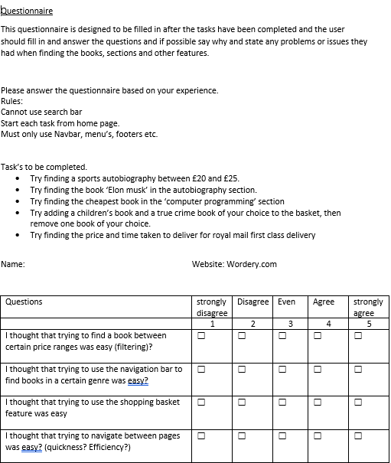
Figure 24:SUS Questionnaire (1/2)

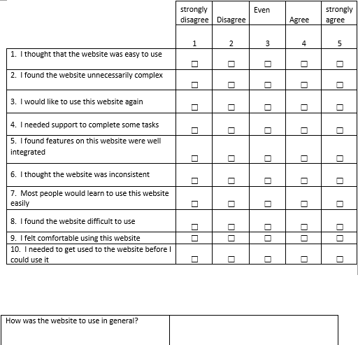
Figure 25:SUS Questionnaire (2/2)

Appendix B
The user stories that have been created are focused on the user and the different activities that the user will have to do when using the website.

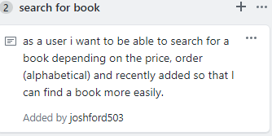
Figure 11:User story, search Book

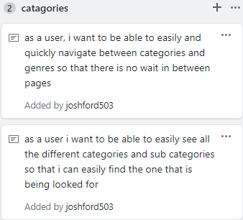
Figure 12: User story, categories

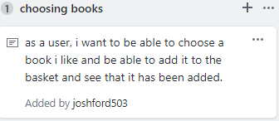
Figure 13:User story, choosing books

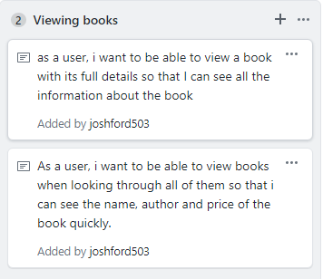
Figure 14:User story, viewing books

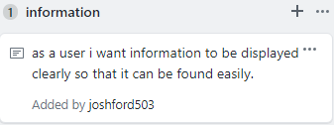
Figure 15:user story, Information

Appendix C

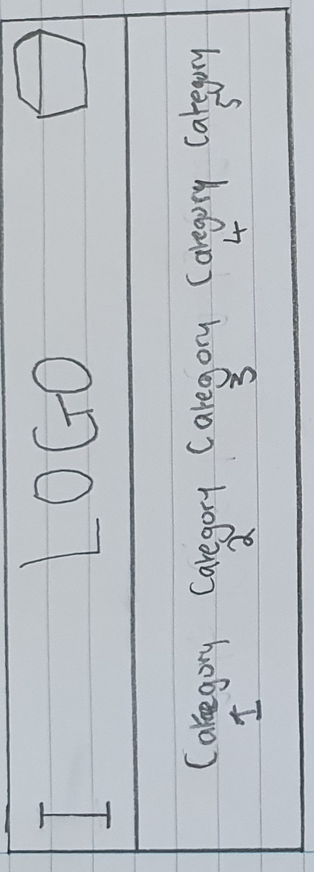
Figure 16:Prototype 1

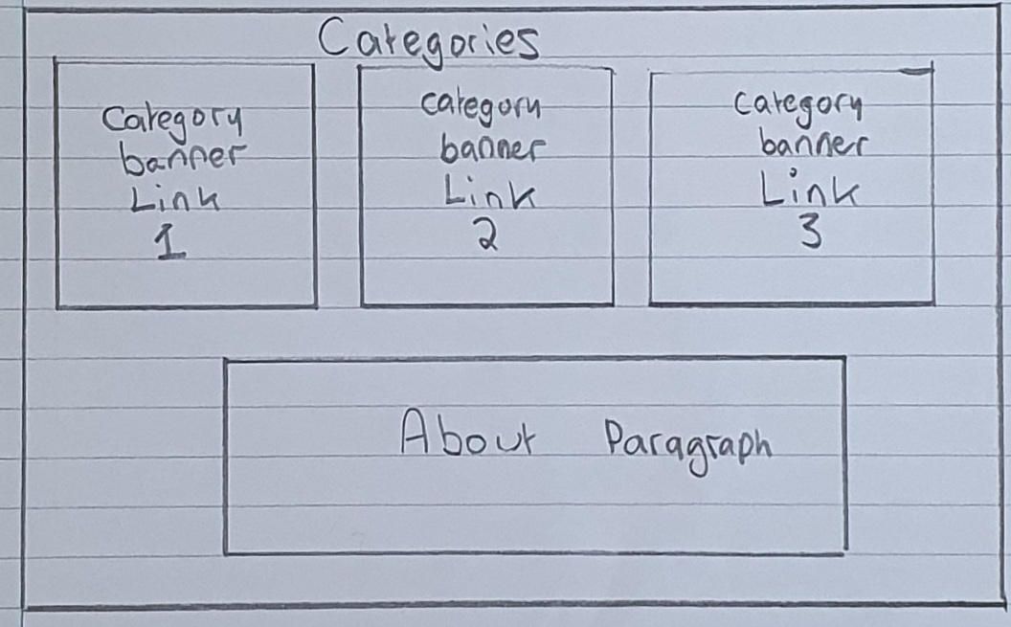
Figure 17:Prototype 2

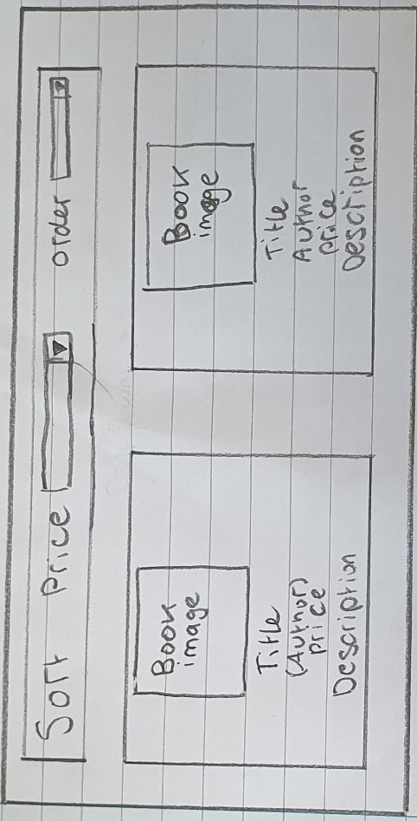
Figure 18: Prototype 3

Appendix D
Completed Questionnaires

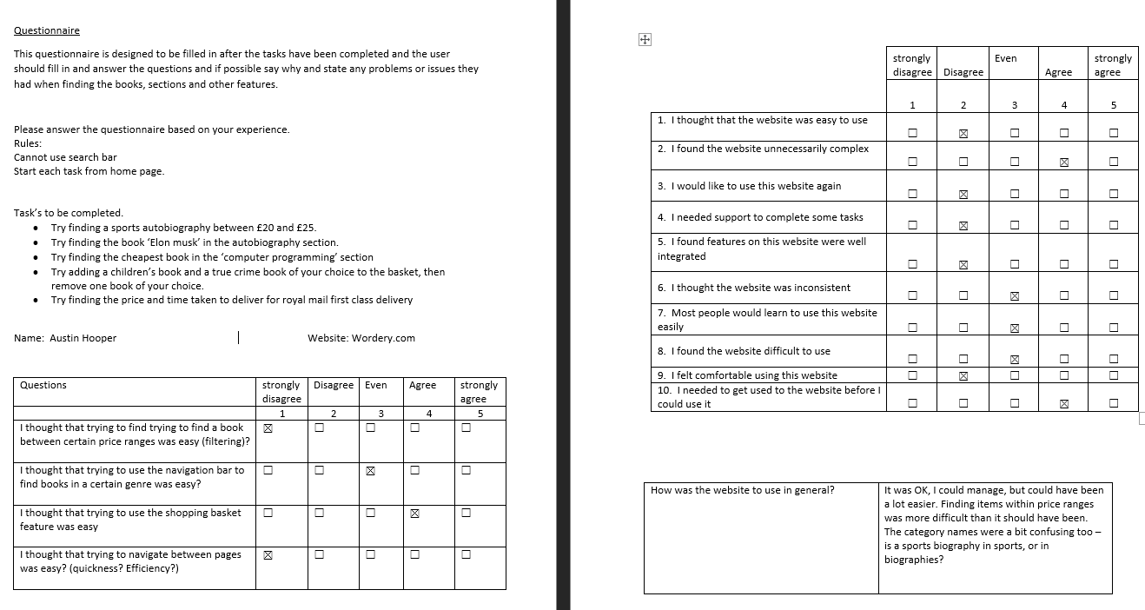

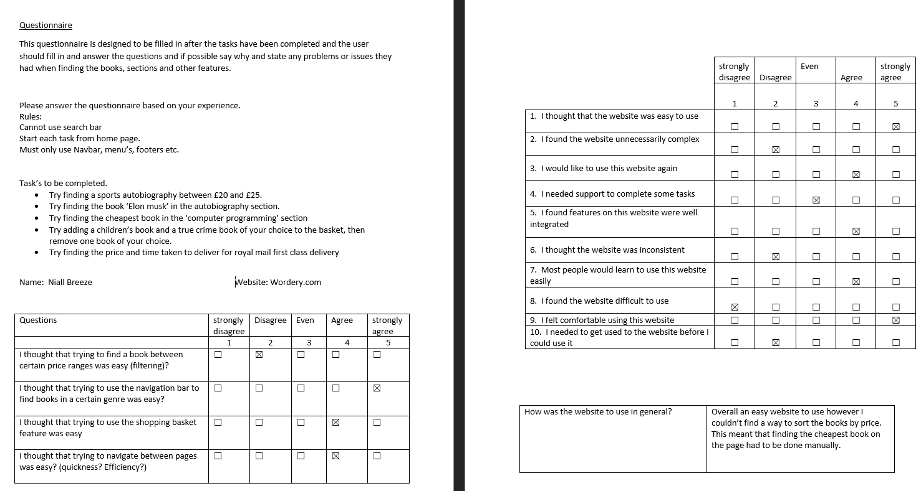

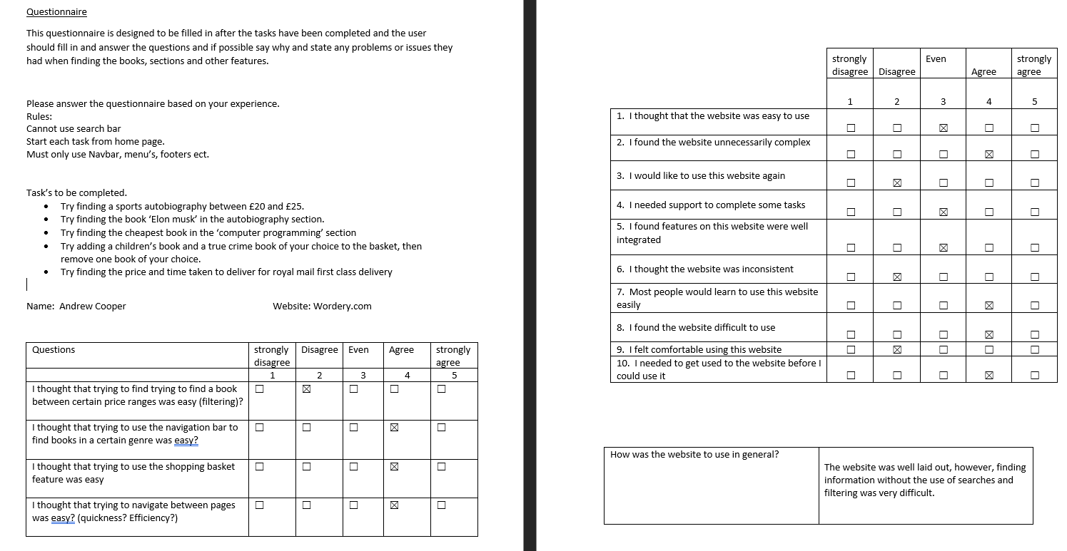

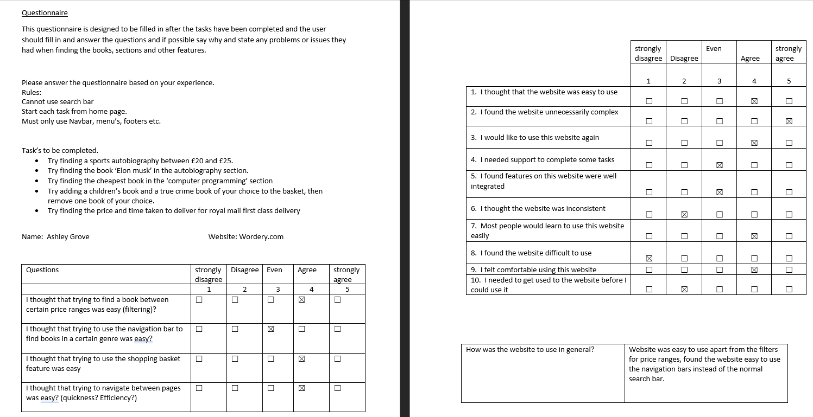

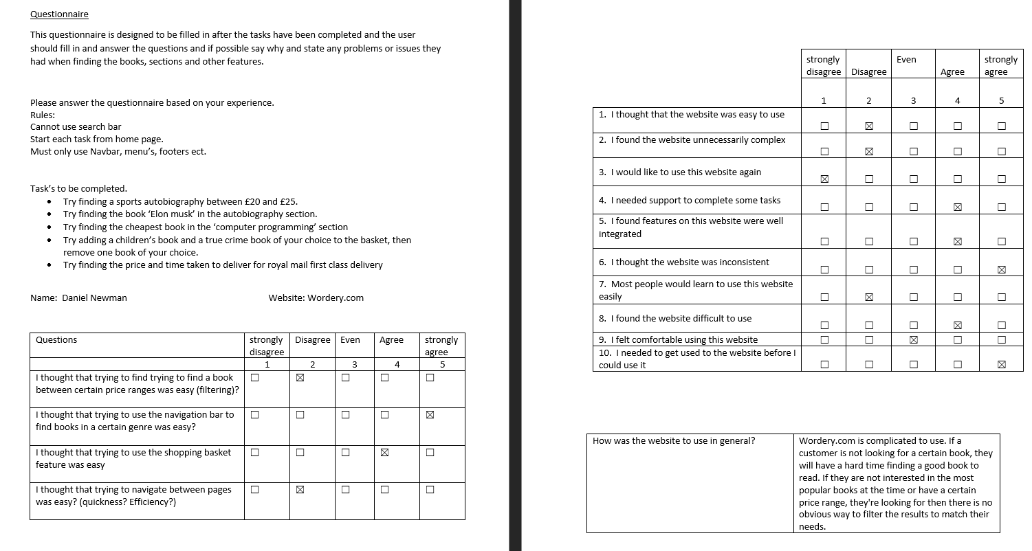

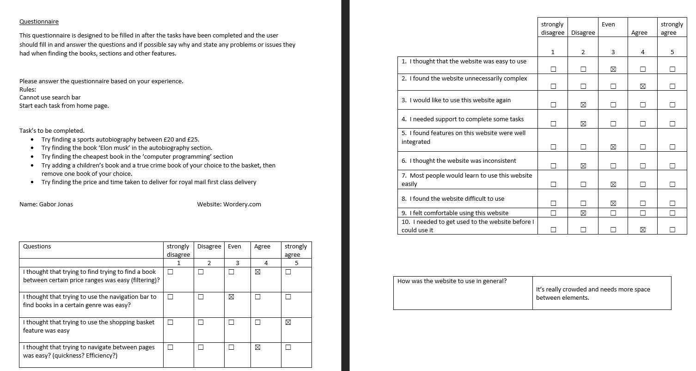

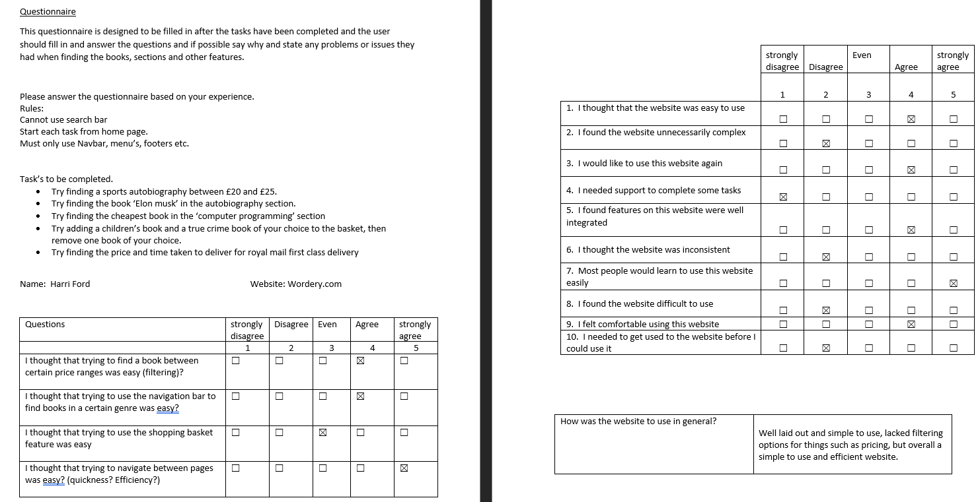

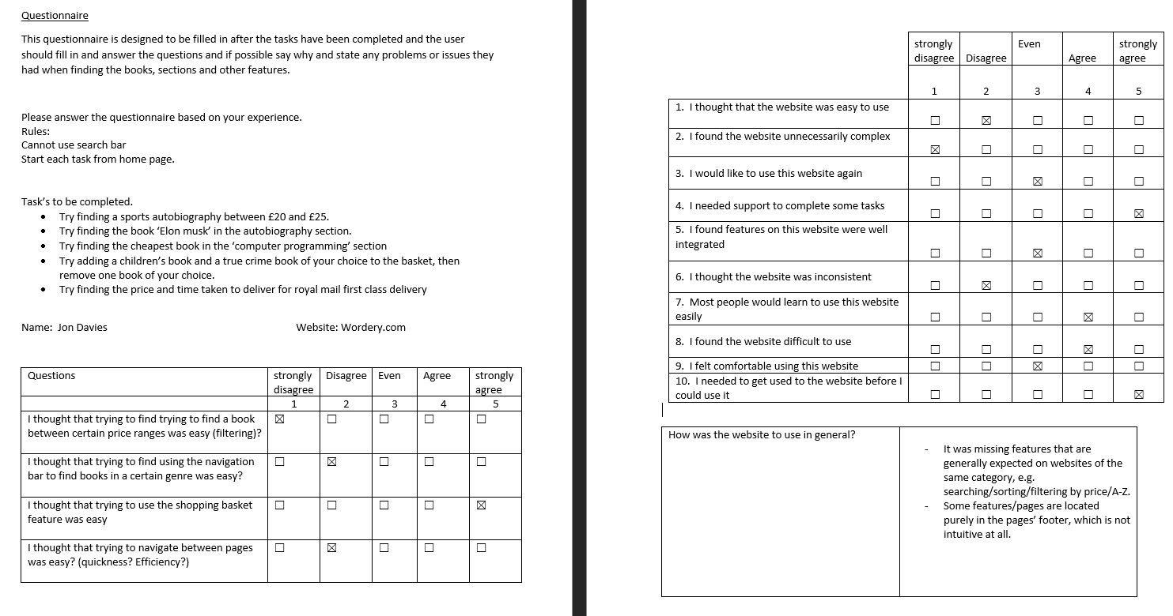

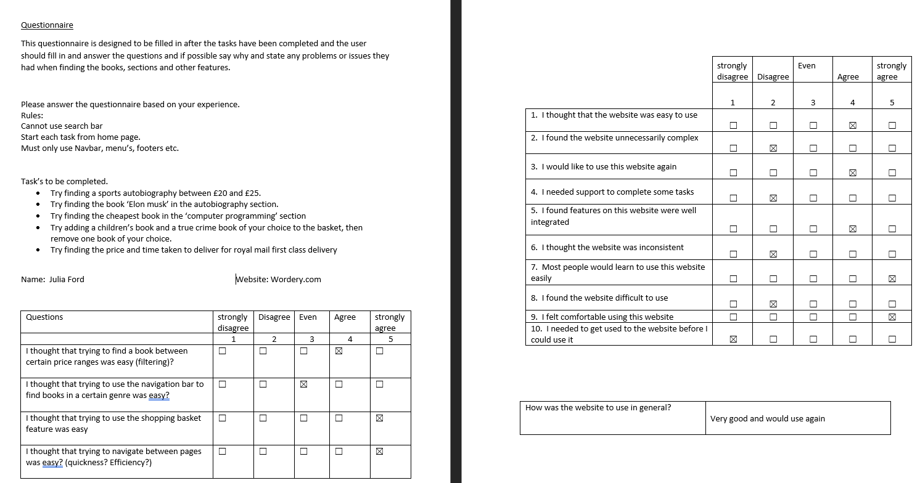

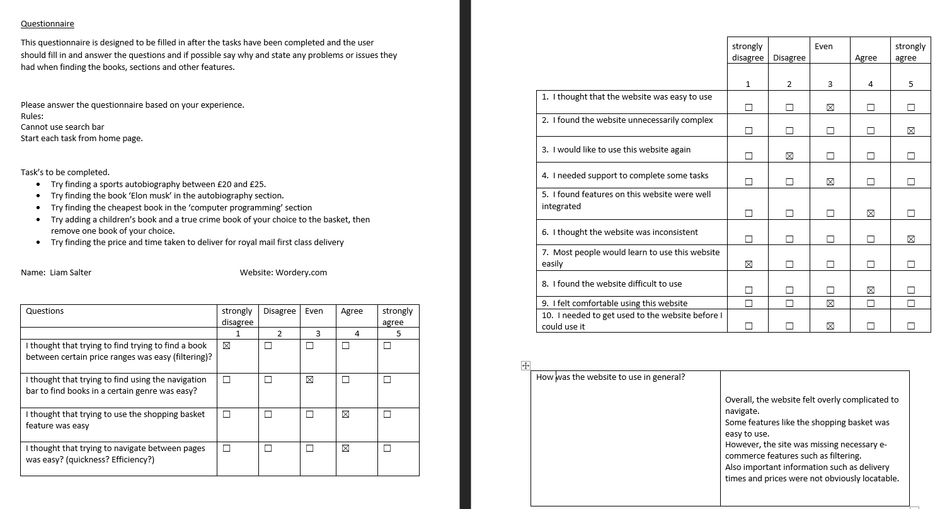

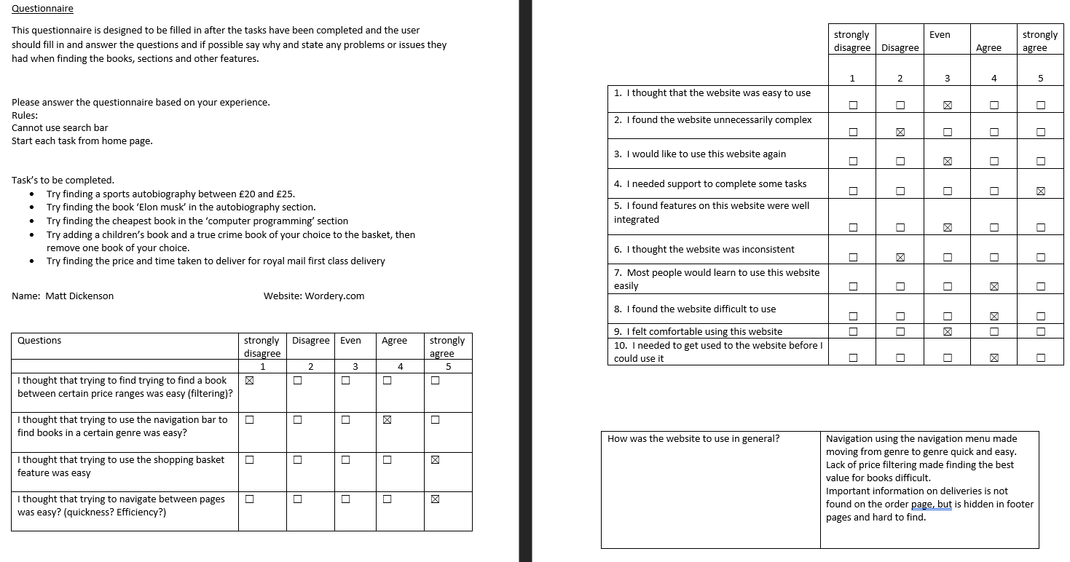

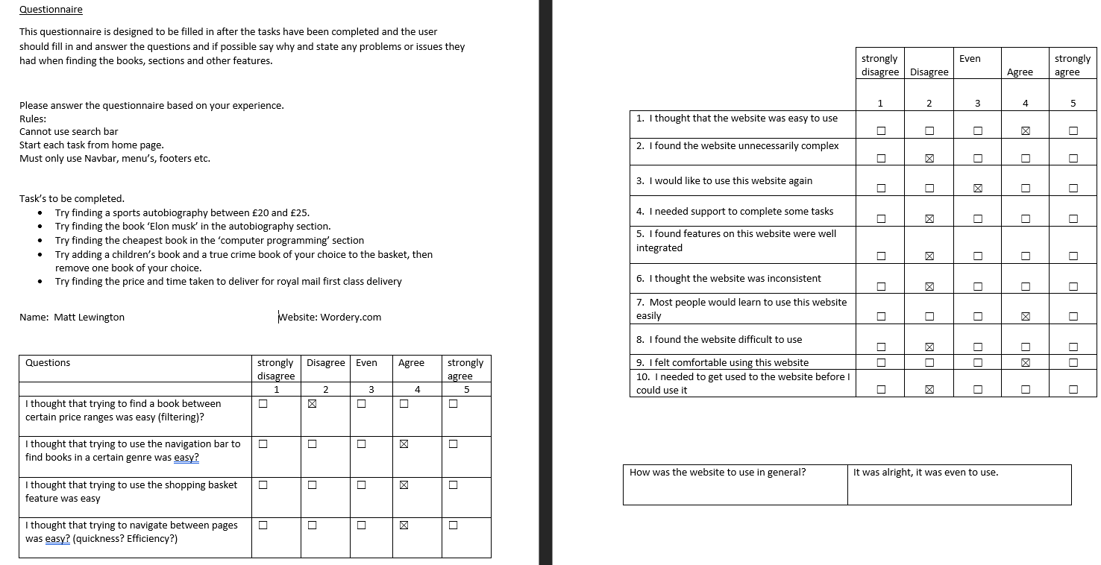

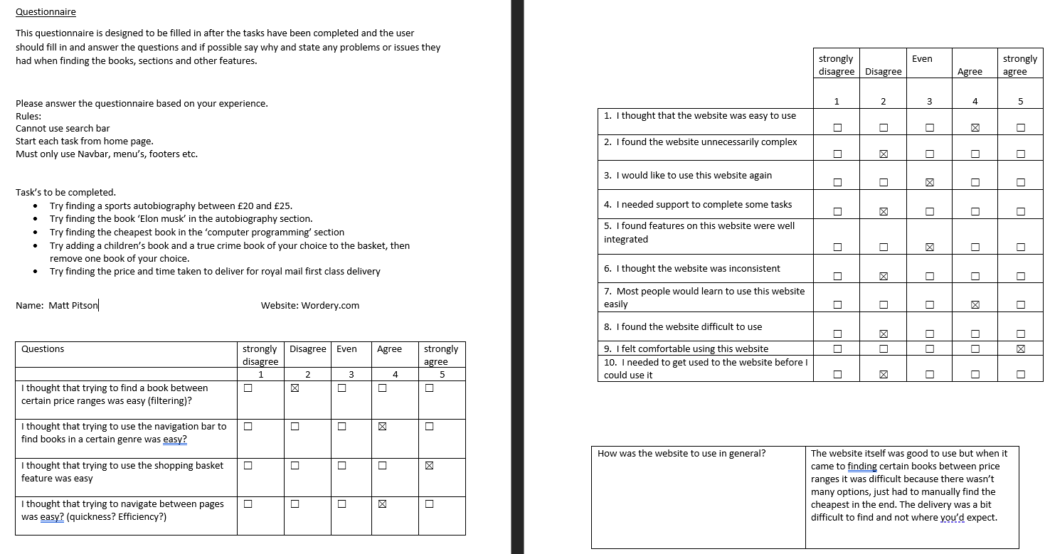

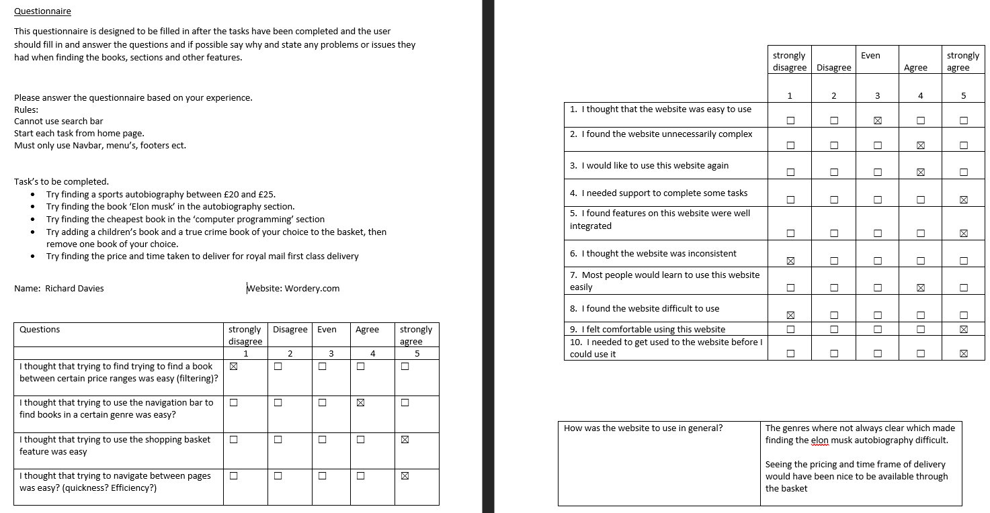

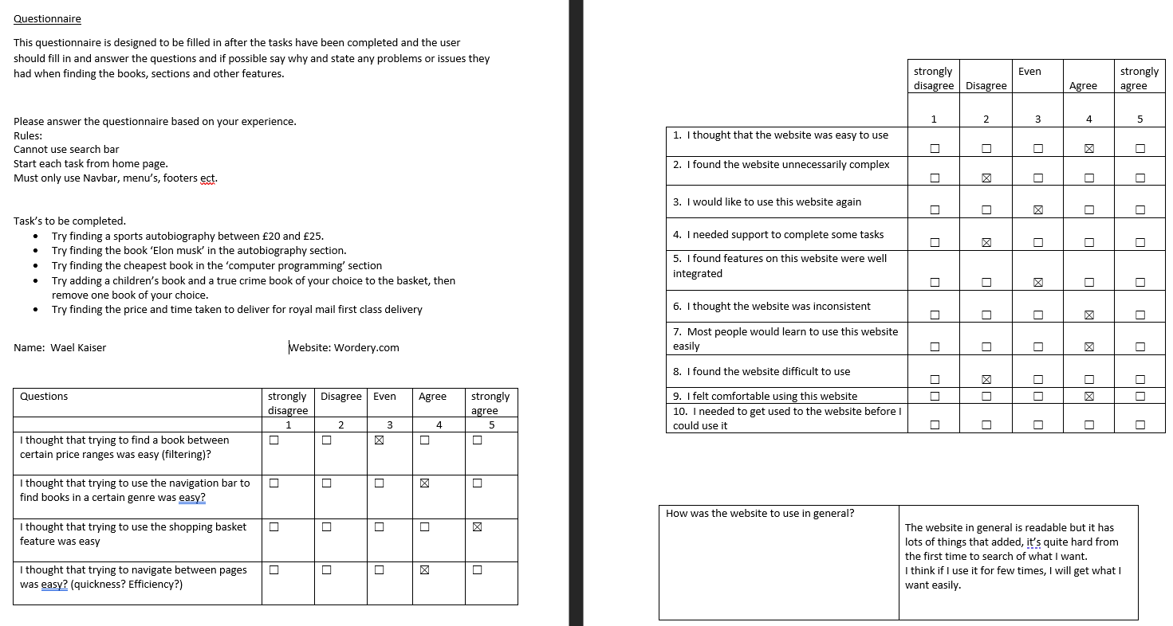

Appendix E
Selected screenshots of SUS tasks being completed.

Screenshots will show at least one screenshot for each task

Task 1
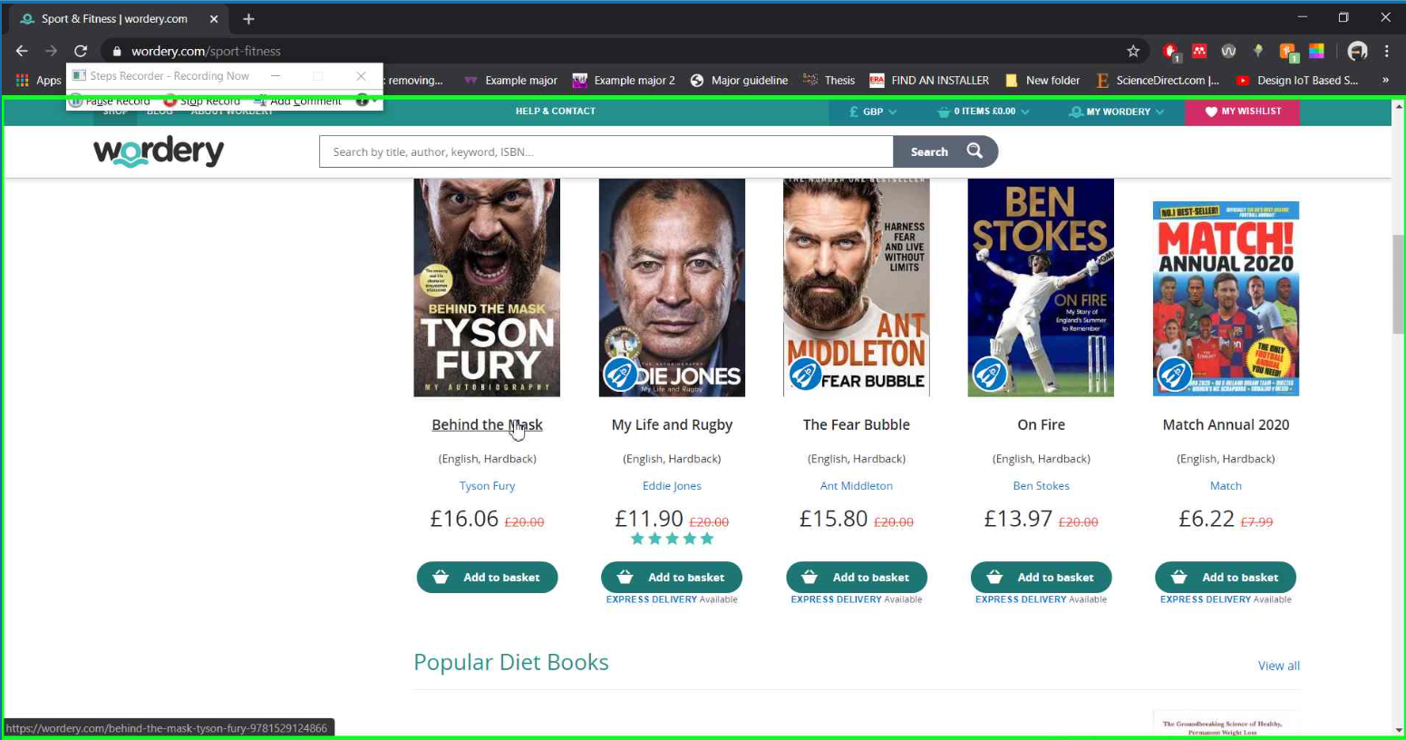

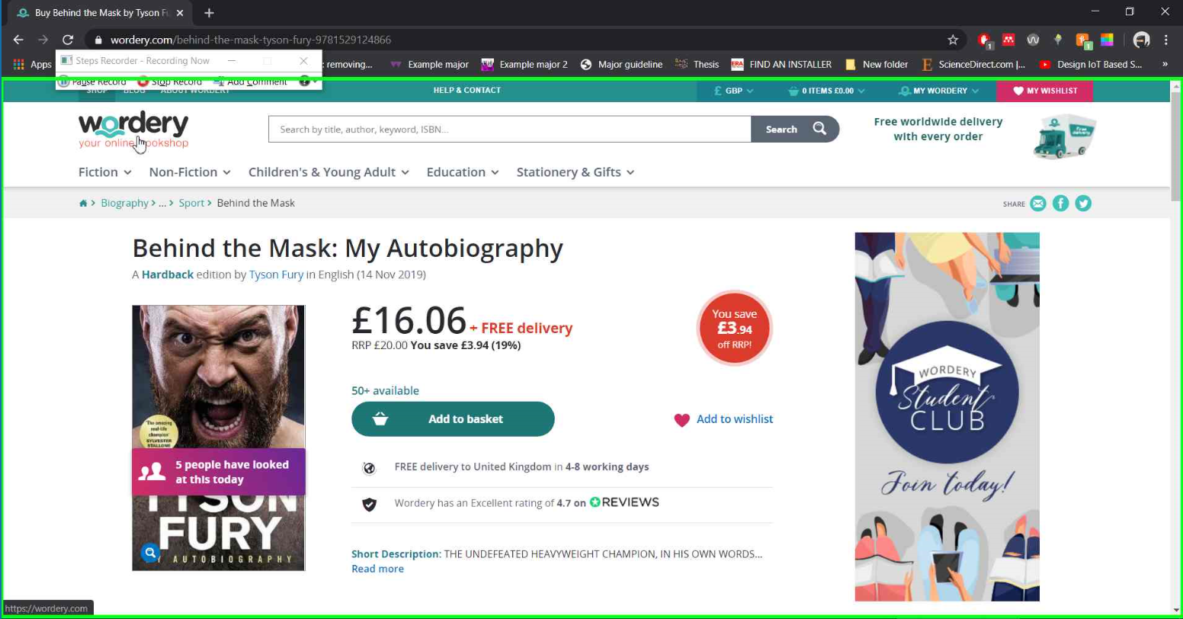

Task 2
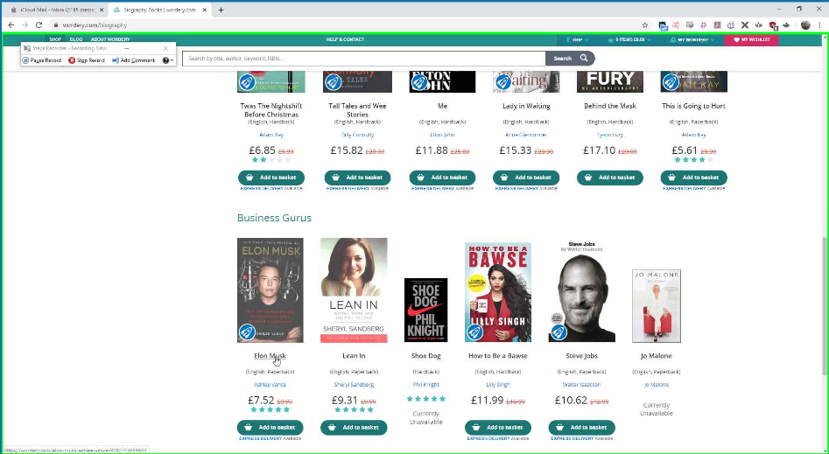

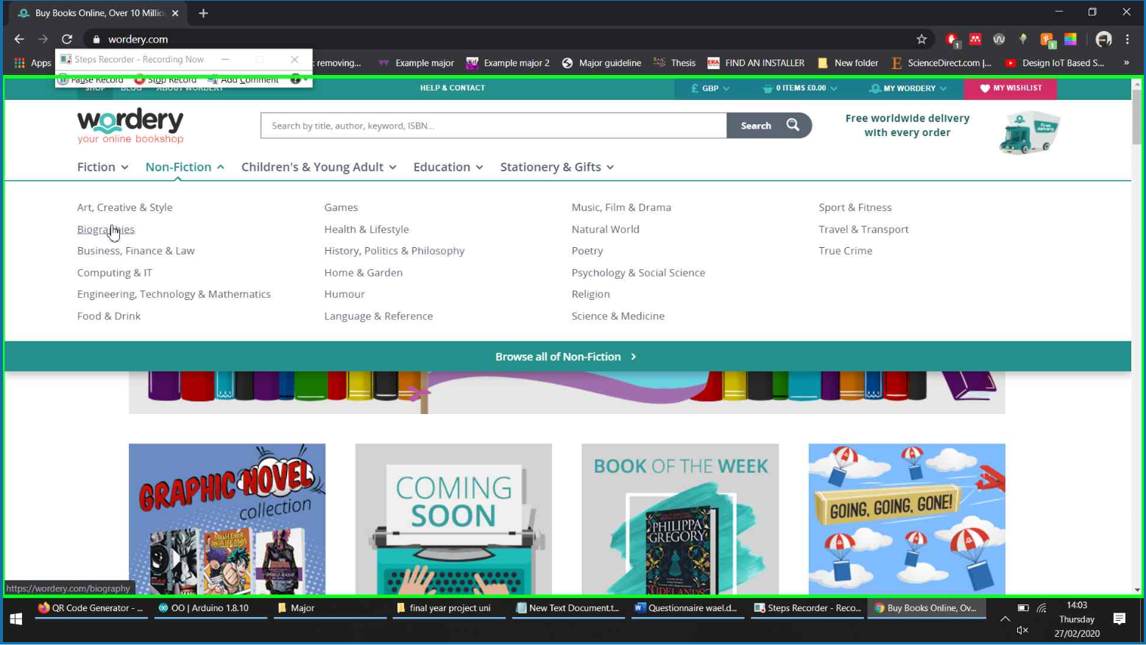

Task 3
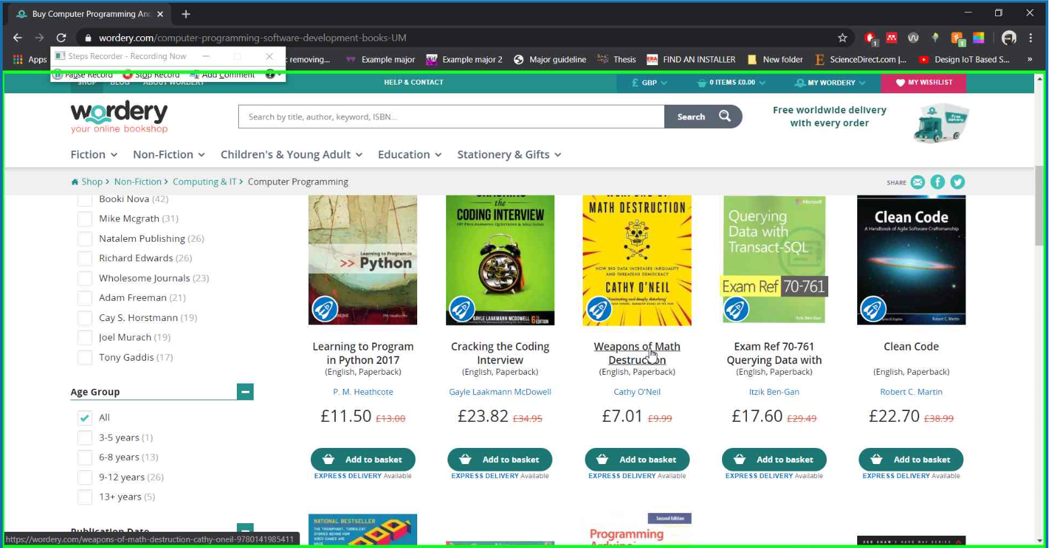

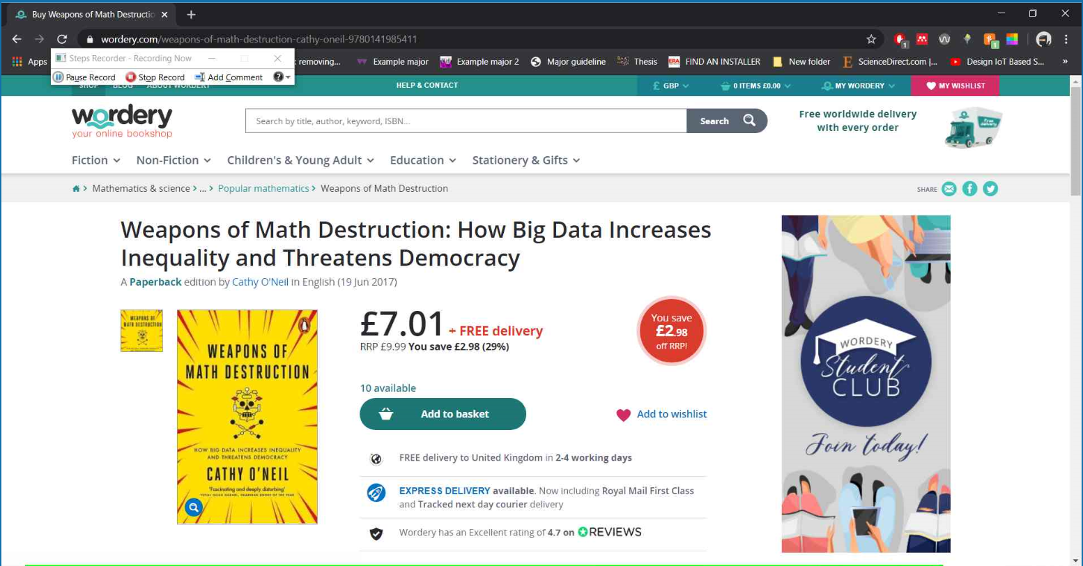

Task 4
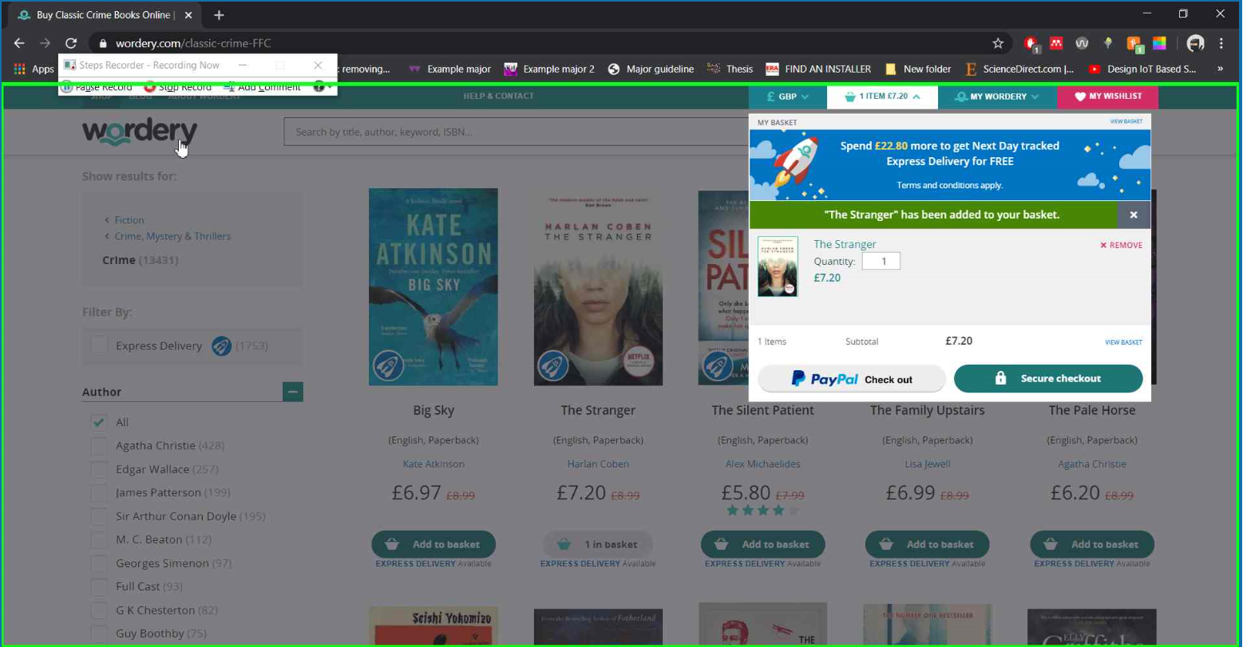

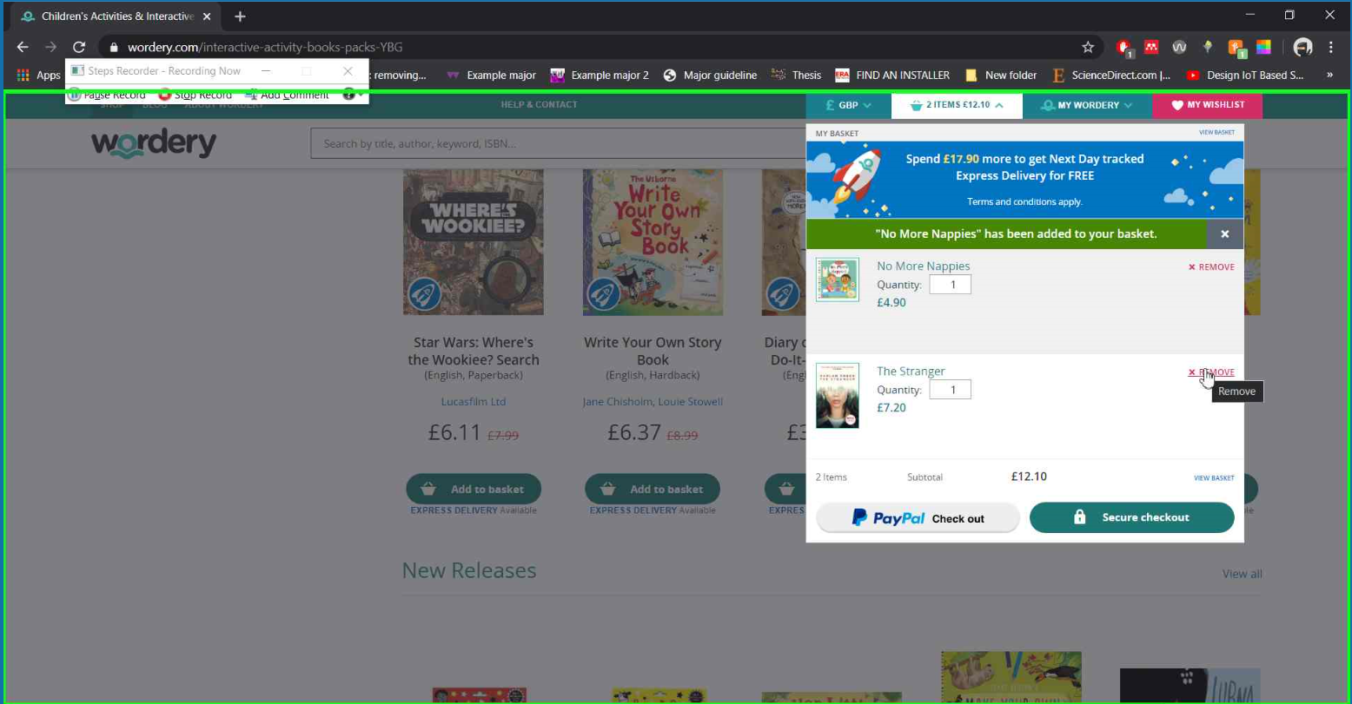

Task 5
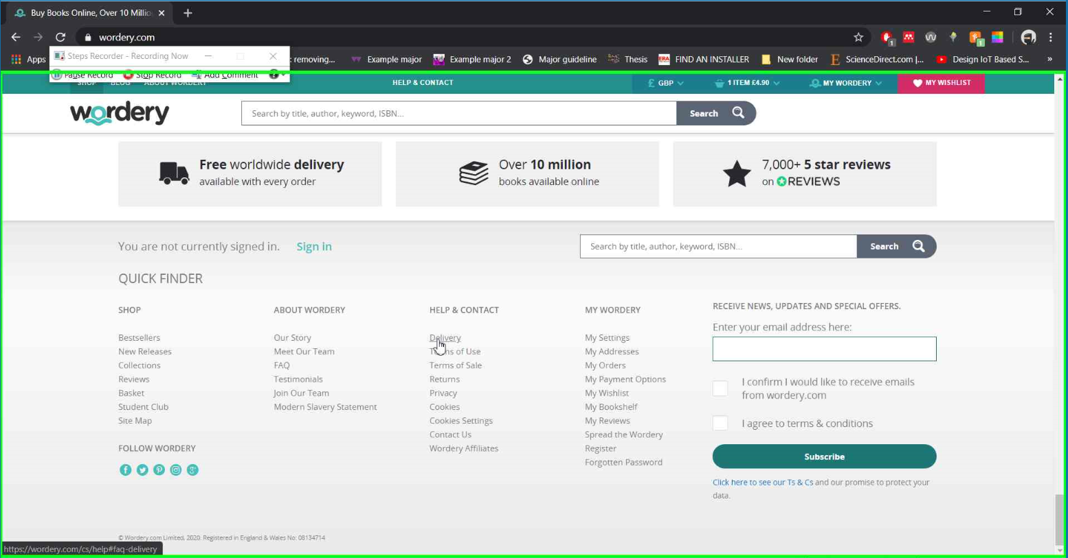

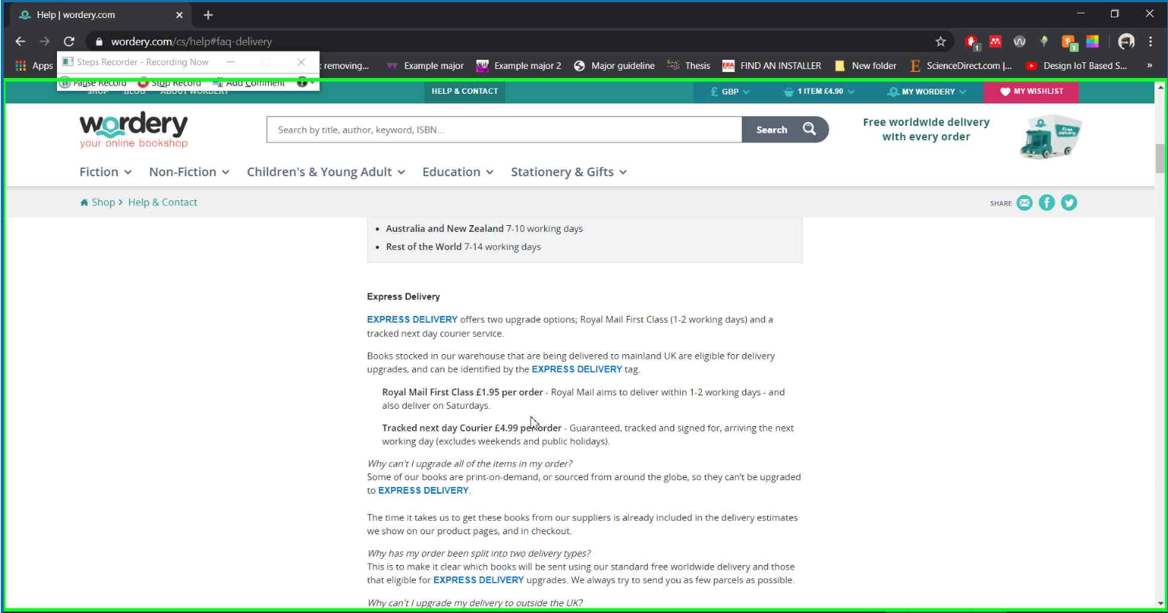

Appendix F
This will show the screenshots of the data that has been collected in full.

Timings for each task.

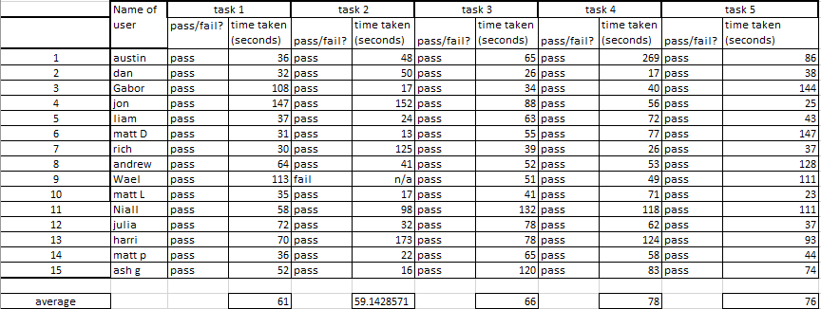

Score for each task aswell as average.

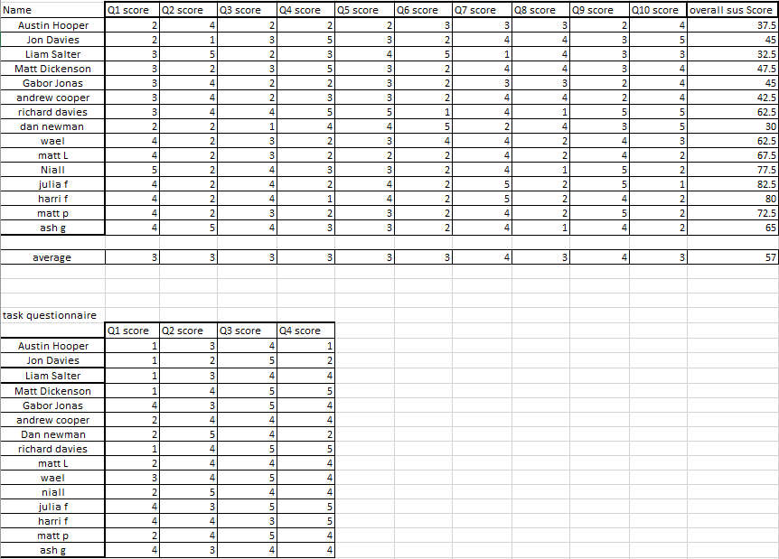
Scores for the additional questionnaire.

Appendix G
Code listings

App.js
import React from 'react';
import './App.css';
import Nav from './nav';
import {
BrowserRouter as Router,
Switch,
Route,
useParams,
} from 'react-router-dom';

import HomePage from './Home';
import BookPage from './pages/BookPage';
import Header from './Header';
import Basket from './Basket/Basket';
import ShoppingBasket from './ShoppingBasket';
import InfoPage from './InfoPage';
import { Link } from 'react-router-dom';
import BooksDisplay from './pages/Books';
import Footer from './Footer';

function App() {
return (
<div className="App">
<Router>
<Header />
<Nav />
<Switch>
{/* Routes for all pages needing links */}
<Route path="/" exact component={Home} />
<Route path="/Basket" component={ShoppingBasket} />
<Route path="/info" component={InfoPage} />
<Route path="/:Category" component={BooksDisplay} />
</Switch>
<Footer />
</Router>
</div>
);
}

function Home() {
return (
<div id="HomePage1">
{/* Title of homepage links */}
<div id="title">
<h1>Welcome to Books.com</h1>
<h4>The very latest and best books available</h4>
</div>
<br />

{/* container containing categories links */}
<div className="container">
<h3 id="title">Popular Categories</h3>
<p>
Just some of our most popular categories that our readers most enjoy!
</p>

<div className="row" id="homeRow">
<div className="column" id="homeCol">
<div class="card" id="HomeCard">
<Link to="/Biography">
<i class="gg-readme"></i>
<a id="iconText">Biographies</a>
</Link>
</div>
</div>
<div className="column" id="homeCol">
<div class="card" id="HomeCard">
<Link to="/Crime">
<i class="gg-search"></i>
<a id="iconText">Crime</a>
</Link>
</div>
</div>

<div className="column" id="homeCol">
<div class="card" id="HomeCard">
<Link to="/Mathematics">
<i class="gg-calculator"></i>
<a id="iconText">Mathematics</a>
</Link>
</div>
</div>
<br />
<br />
<br />
<br />
<br />
<br />
<br />
</div>
</div>
<br />
<br />
<br />
<br />
<br />
<div className="container">
<h1>Our Books</h1>
<p>
Books.com is a completely online bookshop that retails all the latest
books and all your favourite books.
</p>
<br />
<p>
Not sure what book to read?
<br /> Take a look at our most popular books at the moment!
</p>
</div>
<br />
</div>
);
}

export default App;

Nav.js
import React from 'react';
// import './App.css';
import { Link } from 'react-router-dom';

function Nav() {
return (
<nav>
{/* Nav bar */}
<div className="topnav-centered">
<div id="header"></div>

<ul className="nav-links">
{/* most popular tab */}
<Link to="/Crime">
<li id="dropdownlink">
<a>Most Popular</a>
</li>
</Link>
<li id="dropdownlink">
{/* Fiction tab */}
<a>Fiction</a>
<ul className="dropdown">
<Link to="/Childrens fiction">
<a>All fiction</a>
</Link>
<Link to="/Crime">
<a>Crime</a>
</Link>
<Link to="/Mystery">
<a>Mystery</a>
</Link>
<Link to="/Superhero">
<a>Super hero</a>
</Link>
<Link to="/Romance">
<a>Romance</a>
</Link>
</ul>
</li>
<li id="dropdownlink">
{/* non fiction tab */}
<a>Non Fiction</a>
<ul className="dropdown">
<Link to="/Biography">
<a>Biographies</a>
</Link>
<Link to="/Food and drink">
<a>Food and drink</a>
</Link>
<Link to="/Music and drama">
<a>Music and drama</a>
</Link>
<Link to="/Health and fitness">
<a>Health and fitness</a>
</Link>
<Link to="/True Crime">
<a>True Crime</a>
</Link>
<Link to="/History">
<a>History</a>
</Link>
</ul>
</li>
<li id="dropdownlink">
{/* childrens tab */}
<a>Children's</a>
<ul className="dropdown">
<Link to="/Childrens fiction">
<a>Children's fiction</a>
</Link>
<Link to="/Childrens Non-Fiction">
<a>Children's Non-Fiction</a>
</Link>
<Link to="/Early Learning">
<a>Early learning</a>
</Link>
<Link to="/Activity Books">
<a>Activity Books</a>
</Link>
<Link to="/Young Adult">
<a>Young Adult</a>
</Link>
</ul>
</li>
<li id="dropdownlink">
{/* education tab */}
<a>Education</a>
<ul className="dropdown">
<Link to="/Art and Design">
<a>Art and Design</a>
</Link>
<Link to="/Computing and IT">
<a>Computing and IT</a>
</Link>
<Link to="/Geography">
<a>Geography</a>
</Link>
<Link to="/Mathematics">
<a>Mathematics</a>
</Link>
<Link to="/Science">
<a>Science</a>
</Link>
<Link to="/English">
<a>English</a>
</Link>
</ul>
</li>
</ul>
</div>
</nav>
);
}
export default Nav;

Books.js
import '../App.css';
import React, { Component } from 'react';
import { useParams, Router } from 'react-router';
import { Link } from 'react-router-dom';
import BookPage from './BookPage';
import { connect } from 'react-redux';
import { addToBasket } from '../Basket/BasketOptions';
// import { imagePath } from '../db_pics';

function GetUrl() {
let { Category } = useParams();

return Category;
}

// function GetID() {
// let { ID } = useParams();

// return ID;
// }

class BooksDisplay extends Component {
constructor(props) {
super(props);
// this.state = { books };
this.sortByPriceAsc = this.sortByPriceAsc.bind(this);
this.sortByPriceDesc = this.sortByPriceDesc.bind(this);
this.state = {
Books: [],
loading: true,
Category: this.props.match.params.Category,
};
}

sortByPriceAsc() {
this.setState((prevState) => {
this.state.Books.sort((a, b) => a.Price - b.Price);
console.log('asscending');
});
}

sortByPriceDesc() {
this.setState((prevState) => {
this.state.Books.sort((a, b) => b.Price - a.Price);
console.log('descending');
});
}

componentDidMount() {
// this.setState({Category: this.props.match.params.Category})
this.GetBooks();
}

componentDidUpdate() {
console.log('DidUpdate', this.props.match.params.Category);
console.log(this.state.Category);
console.log();
if (this.props.match.params.Category !== this.state.Category) {
this.GetBooks();
}
}

handleClick() {
console.log('test');
}

static showData(Books) {
const BasketButton = {
fontSize: '15px',
};
this.state = {
BookName: '',
Author: '',
Price: '',
};

return (
<div>
{Books.map((book) => (
<div className="card" key={book.BookID}>
<img
alt="Book-Image"
src={require(`../db_pics/${book.BookPic}`)}
></img>
<h5 className="card-title">{book.BookName}</h5>
<a>({book.Author})</a>
<h5 className="card-price">£{book.Price}</h5>
<p>{book.Description}</p>
<button onClick={this.handleClick} style={BasketButton} to="/">
Add to Basket
</button>
<br />
<br />
<br />
</div>
))}
</div>
);
}

render() {
let contents = this.state.loading ? (
<p>Loading Books...</p>
) : (
BooksDisplay.showData(this.state.Books)
);

return (
<div id="title">
<h2>{<GetUrl />}</h2>
<div id="SortFilter">
<div className="container" id="BookContainer">
<div className="row">
<div classname="column">
<form>
<label>Price:</label>
<select>
<option onClick={this.sortByPriceAsc} value="LowToHigh">
Low To High
</option>
<option onClick={this.sortByPriceDesc} value="HighToLow">
High To Low
</option>
</select>
</form>
</div>
<br />
<div classname="column">
<form>
<label>Order:</label>
<select>
<option onClick={this.sortByPriceAsc} value="LowToHigh">
default
</option>
<option onClick={this.sortByPriceDesc} value="HighToLow">
Alphabetical
</option>
</select>
</form>
</div>
</div>
</div>
</div>
<div>{contents}</div>
</div>
);
}

async GetBooks() {
let data = await fetch(
`http://localhost:8080/api/books/${this.props.match.params.Category}`
)
.then((response) => {
return response.json();
})
.catch((error) => {
return 'Request failed with error: ' + error;
});

console.log(data);
this.setState({
Books: data.recordsets[0],
loading: false,
Category: this.props.match.params.Category,
});
}
}

export default BooksDisplay;

Server code

Server.js
//Initiallising node modules
var express = require('express');
var bodyParser = require('body-parser');
var sql = require('mssql');
var app = express();

app.use(bodyParser.json());

app.use(function (req, res, next) {
//Enabling CORS
res.header('Access-Control-Allow-Origin', '*');
res.header('Access-Control-Allow-Methods', 'GET,HEAD,OPTIONS,POST,PUT');
res.header(
'Access-Control-Allow-Headers',
'Origin, X-Requested-With, contentType,Content-Type, Accept, Authorization'
);
next();
});

//Setting up server
var server = app.listen(process.env.PORT || 8080, function () {
var port = server.address().port;
console.log('App now running on port', port);
});

//connection string to connect to database
var dbConfig = {
user: 'admin1',
password: 'admin1',
database: 'bookDB',
server: 'localhost',
pool: {
max: 10,
min: 0,
idleTimeoutMillis: 30000,
},
};

//connection pool
var executeQuery = async function (res, query) {
sql.on('error', (err) => {});

sql
.connect(dbConfig)
.then((pool) => {
return pool.request().query(query);
})
.then((result) => {
console.dir(result);
res.send(result);
})
.catch((err) => {
console.log(err);
});
};

//Get request for books
app.get('/api/books', function (req, res) {
var query = 'select * from BookShop';
executeQuery(res, query, null);
});

//Get request for books with selected category
app.get('/api/books/:Category', function (req, res) {
var query =
"select * from BookShop WHERE Category = '" + req.params.Category + "'";

executeQuery(res, query);
});

