EMAIL SPAM DETECTION USING MACHINE LEARNING
ABSTRACT
The email phishing and spam attack is one of the most unstoppable cybersecurity threats as it has led to people and organizations losing money, identity theft, and disruption of business. The conventional rule-based and signature-based email filters find it difficult to cope up with the changing linguistic and structural trends that attackers employ. This study has attempted to design, implement and evaluate a machine learning-based scheme to successful phishing and spam email detection by using a set of publicly available CEAS_08 dataset.
This paper has aimed at comparing the performance of three supervised machine-learning algorithms “Logistic Regression”, “Random Forest” as well as “Support Vector Machine (SVM)”. The model has implemented an elaborate preprocessing pipeline to clean text data, manipulate missing data, duplicate data and normalize email data. The “Term Frequency-Inverse Document Frequency (TF-IDF)” has been employed to extract features that can convert raw text of emails to numerical values that can be classified. Python is used to train and evaluate models in the Google Colab platform, and the performance is measured in accuracy, precision, recall, F1-score, confusion matrices, and ROC-AUC measures.
The experimental evidence shows that all the three models obtained high classification accuracy of above 99%. The “Support Vector Machine” has been able to outperform the rest with the best ability to be accurate, generalize and possess the lowest misclassification rate. The results demonstrate the usefulness of classical machine learning models with the combination of power preprocessing and feature engineering strategies.
The study has added a reproducible and implementable phishing detection framework, which has provided practical implementation in terms of improving email security systems. The findings suggest the possibilities of applying machine learning-oriented solutions to real-life email filtering systems as well as outline a background of the upcoming activities with the deep learning, progressive learning methods, and explainable artificial intelligence.

Table of Contents
1.0 INTRODUCTION 8
1.1 Background 8
1.2 Problem Statement 9
1.3 Aim and Objectives 9
1.4 Research Questions 10
1.5 Scope and Limitations 10
1.6 Dissertation Structure 12
2.0 LITERATURE REVIEW 13
2.1 Introduction 13
2.2 Conceptual Framework 14
2.3 Theoretical Discussion 14
2.3.1 Natural Language Processing Theory 14
2.3.2 Supervised Machine Learning Theory 15
2.3.3 Ensemble and Margin-Based Learning Theory 16
2.3.4 Performance Evaluation and Decision Theory 18
2.4 Thematic Discussion 19
2.4.1 Theme 1: Evolution of Email Threat Techniques 19
2.4.2 Theme 2: Preprocessing and Feature Engineering in NLP 20
2.4.3 Theme 3: Model Performance in Prior Studies 21
2.4.4 Theme 4: Manage Concept Drift in Phishing Detection 22
2.5 Literature Gap 22
2.6 Summary 23
3.0 METHODOLOGY 25
3.1 Introduction 25
3.2 Research Philosophy 25
3.3 Research Approach 26
3.4 Research Significance 26
3.5 Research Design 27
3.5.1 Justification of the Research Design 27
3.5.2 Alignment with Research Objectives 28
3.6 System Development or Experimental Approach 28
3.6.1 Rationale for Choosing a Prototyping Approach 28
3.6.2 Stages of the Development and Experimental Workflow 29
3.6.3 Experimental Structure and Iterative Refinement 29
3.6.4 Contribution of the Approach to System Effectiveness 29
3.7 Tools, Technologies, and Datasets 30
3.7.1 Software Tools and Programming Environment 30
3.7.2 Justification for Tool and Framework Selection 30
3.7.3 Dataset Description and Source 31
3.8 System Requirements and Design 31
3.8.1 Functional Requirements 31
3.8.2 Non-Functional Requirements 31
3.8.3 System Architecture 32
3.8.4 Design Rationale 33
3.9 Data Collection & Processing 33
3.9.1 Dataset Acquisition 33
3.9.2 Structure and Characteristics of the Dataset 33
3.9.3 Pre-processing Procedures 34
3.10 Ethical Consideration 34
3.11 Summary 35
4.0 IMPLEMENTATION & DEVELOPMENT 36
4.1 Introduction 36
4.2 Implementation 36
4.3 Summary 42
5.0 TESTING & EVALUATION 43
5.1 Testing and Validation 43
5.2 Experimental Results and Performance Evaluation 48
5.3 Discussion and Critical Analysis 57
6.0 CONCLUSION AND FUTURE WORK 60
6.1 Introduction 60
6.2 Summary of Findings 60
6.2.1 Achievement of Research Aim 60
6.2.2 Comparative Performance of Machine Learning Models 60
6.2.3 Identification of the Best-Performing Model 61
6.2.4 Impact of Preprocessing and Feature Extraction 61
6.2.5 Validation Through Real-World Testing 61
6.2.6 Overall Findings and Research Significance 62
6.3 Research Contributions 62
6.4 Evaluation Against Research Objectives 64
6.5 Limitations of the Study 65
6.6 Recommendations and Future Work 66
6.6.1 Recommendations for System Enhancement 66
6.6.2 Future Work 67
6.7 Summary 68
REFERENCES 69
APPENDICES 76

Table of Figures
Figure 1.6.1: Dissertation Structure 12
Figure 2.2.1: Conceptual Framework 14
Figure 2.3.1.1: Malware to infiltrate a system 15
Figure 2.3.2.1: Email classification systems 16
Figure 2.3.3.1: Margin-based imbalanced ensemble classification 17
Figure 2.4.2.1: Architecture of the spam detection model 20
Figure 3.8.3.1: System Architecture 32
Figure 4.2.1: Dataset loading 36
Figure 4.2.2: Checking data information 37
Figure 4.2.3: Checking missing values 37
Figure 4.2.4: Checking the removed value after removing the unnamed columns 38
Figure 4.2.5: Checking missing values after handling missing values 38
Figure 4.2.6 Checking duplicate rows after handling 39
Figure 4.2.7: Data preprocessing for training models 39
Figure 4.2.8: Implementation of the Logistic Regression 40
Figure 4.2.9: Support Vector Machine Model 40
Figure 4.2.10: Implementation of the Random Forest 41
Figure 4.2.11: Prediction using the best model 42
Figure 5.2.1: Descriptive Statistics 48
Figure 5.2.2: Top 10 Most Frequent Senders 49
Figure 5.2.3: Distribution of Emails Containing URLs 49
Figure 5.2.4: Average Feature Values across Emails 50
Figure 5.2.5: Correlation Matrix 51
Figure 5.2.6: Most Frequent Words in Legitimate vs. Phishing Emails 51
Figure 5.2.7: Classification report of the Logistic regressions 52
Figure 5.2.8: Confusion Matrix of the Logistic Regression 52
Figure 5.2.9: ROC Curve of the Logistic Regression 53
Figure 5.2.10: Support Vector Machine 53
Figure 5.2.11: Confusion Matrix of the SVM 54
Figure 5.2.12: ROC Curve of the SVM Model 55
Figure 5.2.13: Classification Report of the Random Forest 55
Figure 5.2.14: Confusion Matrix of the Random Forest 56
Figure 5.2.15: ROC Curve of the Random Forest 57
Figure 5.2.16: Model Comparison and showing the best model 57

1.0 INTRODUCTION

1.1 Background
Email is commonly considered one of the universal digital communications in the personal and work environment. It has been a strong and effective medium of sharing information in the world at reasonable costs. Hackers have increasingly advanced attacks on these email systems in the process of launching unlawful activities such as phishing, spamming and sending emails that are laden with malware. Phishing emails and spam emails have been evolving prolifically and intricately during the past decade, which has cost organizations money, identity theft, and lost reputation. Email security has been a primary subject of study in the field of computer science and has been targeted by computer security and data analytics (Ghosh and Senthilrajan, 2023).
Protecting digital communications has been on the agenda of researchers in enhancing email filters. The strategies of addressing the threats carried by emails are the old rule-based filters and blacklist technology. Such systems also rely on preprogrammed rules, keywords or are guided by the history of senders to classify received e-mails as either ham or spam. Such techniques are too rigid to be able to learn new tricks used in phishing that evolve quickly. Hackers have advanced methods of obfuscation to bypass rule-based systems in its proper identification of malicious content.
The process of machine learning has allowed the identification of patterns and associations within large data sets without having to be programmed with any rules. This capability is what has rendered the ML methods initially applicable in the situation with phishing, since the content of e-mail becomes dynamic and has to be learned continuously. Researchers use several algorithms, such as the Logistic Regression, Network Forest, and Support Vector Machine (SVM), to identify phishing attacks using email headers, features based on body-text, and URL. These models can adapt to threats posed by learning from past data and evolve with new, unknown cases (Bansal and Sidhu, 2021).
The analysis has been inflated by the convergence of cybersecurity, natural language processing (NLP), and machine learning in the computer science research community. It has not only focused on improving the security but also attempted to enable real-time information processing and decision-making with the help of automated auxiliary of different images (Madhavan et al. 2021). The study seeks to determine the best-performing machine-learning model for phishing email detection based on the “CEAS_08 datasets” procured from Kaggle. The study has contributed to building a model capable of recognizing phishing attempts based on textual and structural cues present in emails, through preprocessing, feature extraction, and classification.

1.2 Problem Statement
E-mail phishing has become one of the most persistent and harmful forms of cybercrime. Although significant progress has been made in mail filtering systems, many malicious emails still manage to evade traditional filters. The difficulty mainly results from the fact that rule-based and signature-based detection systems are capable of finding known attack patterns only. The high quantity of emails exchanged every day means that manual-based or static systems are unable to address new types of attack vectors (AbdulNabi and Yaseen, 2021).
The main gap in research has been the absence of adaptive models that can generalize and perform well on a variety of phishing-type techniques with high accuracy and low false-positive rates. Prior research generally has been limited to detecting phishing with a combination of isolated features (such as URLs or subject lines), while failing to leverage multiple attributes such as body text and sender profile. Several studies are based on small or old data sources, which restricts the generalization of their findings (Akinyelu, 2021).
The main objective of this research has been the requirement for a reliable machine learning model, which is flexible and efficient to detect phishing-spam email accurately through diverse email characteristics. The objective of this study has been to address the limitations in conventional filter-based approaches through incorporating machine learning techniques that can learn sophisticated, hidden patterns within email, which allows for improved performance when conducting classification.

1.3 Aim and Objectives
Aim:
The primary goal of the study is to examine and determine the best machine learning model for the detection of phishing and spam email using the “CEAS_08 datasets”, with the deployment being achieved in Python with the help of Google Colab.
Objective:
- To preprocess the dataset by performing noise removal, dealing with missing information, and irrelevant information to improve data quality, including the results
- To extract relevant features from the data, including subject line text, email body, and URLs, using natural language processing and features engineered, including TF-IDF
- To train and test more than one supervised ML algorithm, including Logistic Regression (LR), Random Forest (RF), and SVM for spam/phishing detection
- To compare and evaluate the constructs based on accuracy, precision, recall, F1-score, and ROC-AUC, among others, by using Google Colab
- To derive the optimal performing model percentage results based on the accuracy and computational efficiency suitable for deployment in email security
- To offer recommendations based on input for future work and future real-world use of ML-based phishing detection systems

1.4 Research Questions
- How successful have various machine learning methods been in identifying phishing and spam emails using the CEAS_08 datasets?
- Which possible combination of email features (subject, body text, URLs, or metadata) has the most positive influence on classification accuracy?
- Which model out of Logistic Regression, Random Forest, and SVM produced the most stable generalizable performance?
- What effect have preprocessing and feature engineering actions have on the overall performance of phishing detection models?
- What information have the experiments yielded about the structure and linguistic features of phishing scams?

1.5 Scope and Limitations
Scope
This research included the design, implementation, and evaluation of machine learning-based models to detect phishing and spam emails using the CEAS_08 dataset found on Kaggle. This research focused on classical supervised learning algorithms to find patterns in the features which can distinguish between benign and malignant emails: Logistic Regression, Random Forest, and Support Vector Machine (SVM). These classic supervised learning algorithms are selected based on their interpretability, robustness, and efficiency with text-based classification challenges (Saepudin et al. 2024). This research completed all parts of the machine learning workflow, starting with data pre-processing, which consisted of cleaning, normalization, and removal of inconsistencies. Feature extraction and transformation occurred via Term Frequency–Inverse Document Frequency (TF-IDF) so that textual data is converted to a numerical format. Implementation of the models occurred in Python while utilizing the Google Colab environment for reproducibility and accessibility for all experiments (Dinesh et al. 2024). Textual and structural components are analyzed in the emails, including subject line, body, and embedded URLs, while capturing phishing indicators. Evaluation metrics are computed for each model to compare model performance this including accuracy, precision, recall, F1-score, and ROC-AUC.
Limitation
The limitations of the research revolved around data preprocessing and the machine learning models utilized. The CEAS_08 datasets has contained inconsistencies associated with data preprocessing, including missing values, duplicate entries, and noisy text data. Although cleaning procedures and normalization are conducted before processing, certain irregularities and ambiguity of meaning or semantics of the emails’ content may have remained in the data, possibly affecting the process of feature extraction. The primary method of transforming the textual data is through TF-IDF vectorization, which did not capture the deeper contextual or semantic meaning of words. This restriction probably influenced the models in interpreting more complicated linguistic aspects that are usually presented in phishing emails.
There are some limitations to the machine learning models applied in the study, which influenced their functionality and dexterity. The results of Logistic Regression, Random forest, and Support vector machine (SVM) are far off. The models are limited to certain factors, which influenced their ability to adapt to the ambiguities and peculiarities of the phishing email dataset. Linearity has added an advantage to the use of the logistic regression model, which reduces poor performance in nonlinear associations between the textual and structural nature of email characteristics. Even though logistic regression worked quite well in the case where interpretation has focus, the logistic regression failed at complex semantic structures or feature interactions.
The random forest classifier is proven to be quite predictive, although it has a computational implication that takes more time to complete the model training and especially when modelling large sets of data with large dimensions. Random forest is an ensemble model, repeated complexity using an interpretability perspective is hard, due to the multiple decision paths made in the modelling. The support vector machine model performed strongly and achieved high precision, but has limited predictive capacity on high-dimensional data due to high computational expense for finding optimal kernel parameters. Support vector machine models also has consistency challenges based on parameter tuning or feature scaling during multiple runs; these outcomes are also difficult because it is quantitative modelling process.

1.6 Dissertation Structure
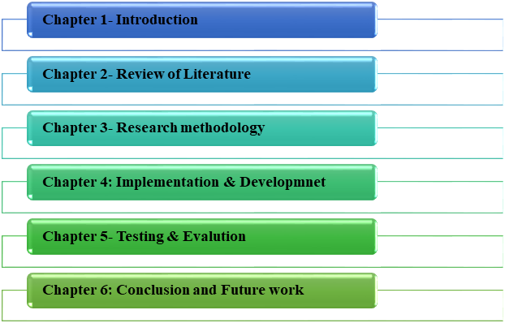

Figure 1.6.1: Dissertation Structure

2.0 LITERATURE REVIEW

2.1 Introduction
The Literature review chapter provides to in-depth analysis of academic and technical studies related to email spam and phishing detection based on machine learning techniques. The rise in the reliance on the use of emails has also been coupled with an increased number of malicious activities that are aimed at stealing personal information, interrupting systems, and defrauding users. Traditional rule-based filtering methods are no longer effective in safeguarding email users and organizations against emerging threats, as hackers constantly create more advanced methods to compromise them. It has created a growing interest in machine learning and natural language processing, which helps to create automated systems that can process message content, find unstable behavioral patterns, and understand when intent is malicious.
The review examines the concept and theoretical underpinnings of email-based cyber threats, the theoretical basis of classification algorithms, and the recent thematic advances in preprocessing, feature engineering, and performance of models. Through the comparison of existing models, datasets, and evaluation methods, the given chapter finds limitations, inconsistencies, and research gaps that do not allow the description of these strategies as applicable in real-world settings (Ahammad et al. 2022). The information gathered here can be used to build a conceptual framework and bring explicit reasons to the objectives and research methods utilized in the present research. The results will be used to provide a comprehensive assessment of the performance measures, such as accuracy, precision, recall, and F1-score, to provide useful insights on more resilient, scalable, and intelligent email security solutions.

2.2 Conceptual Framework
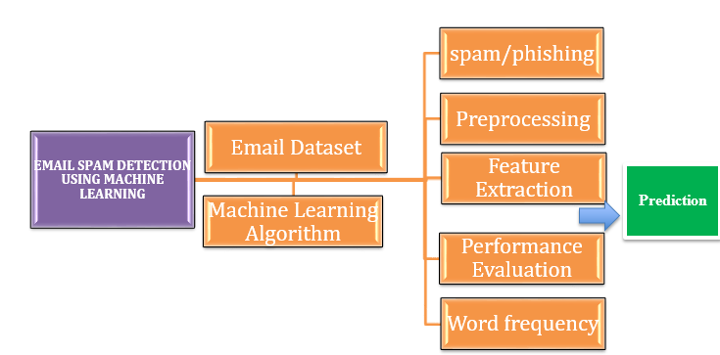

Figure 2.2.1: Conceptual Framework

2.3 Theoretical Discussion

2.3.1 Natural Language Processing Theory
Natural Language Processing (NLP) provided the theoretical basis for the analysis and classifications of the textual content in emails. It allows machines to analyses language patterns by transforming unstructured language data into structured numerical features that can be processed by machine learning algorithms. The NLP models, including tokenization, stop-word elimination, stemming, lemmatization, and TF-IDF vectorization, are commonly used in email security studies as they assist in deriving words with meaningful textual information in messages (Bacanin et al. 2022). The theory of NLP requires that the number of times, the order, and situational use of particular words are vastly dissimilar between phishing and legitimate email messages, and thus the hidden malicious purpose could be identified using the lexical features. Research has shown the effectiveness of NLP in enhancing the accuracy of spam detectors by detecting word peculiarities, compelling phrases, deviant demands, and suspicious links that an email spam may contain (Junnarkar et al. 2021).
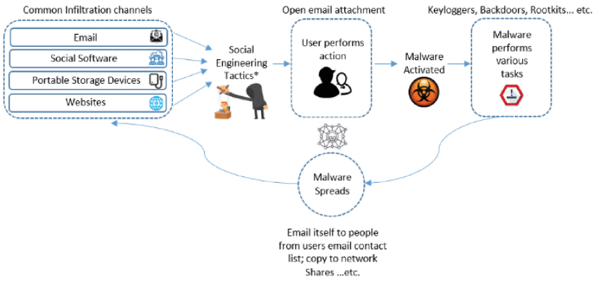

Figure 2.3.1.1: Malware to infiltrate a system
(Source: Salloum et al. 2022)
Attackers employ universal infiltration patterns (email, social media, portable devices, websites), which they utilize to send malicious attachments or links. They use social engineering tricks to trick the user into running malware, which subsequently runs several malicious activities such as installing key loggers, backdoors or rootkits. The malware is then disseminated through the email contacts and network shares of the victim. The NLP is used to detect phishing emails, suspicious patterns of content, the cues used in social engineering, and the automatic filtering of malicious communications.
A more dynamic classification method is obtained, which can adapt to the changing phishing tactics over time, compared to more inflexible rule-based systems, by combining NLP solutions with machine learning methods. The studies also note that the models based on NLP assist in the real-time and automated detection of threats, thereby minimizing manual filters as well as exposure to online-related threats (Alhogail and Alsabih, 2021).

2.3.2 Supervised Machine Learning Theory
Email spam and phishing detection is based on the theory of supervised machine learning (ML) to detect predictive patterns using label data. The method has been used to observations of historical emails that are spam and those that are ham, which have statistical relationships among input features and output classes, which can be learnt by the model. The goal is to extrapolate using the training data, to have the model correctly classify the emails that it has never learned, thereby reducing its levels of false positives and false negatives (Toma et al. 2021).
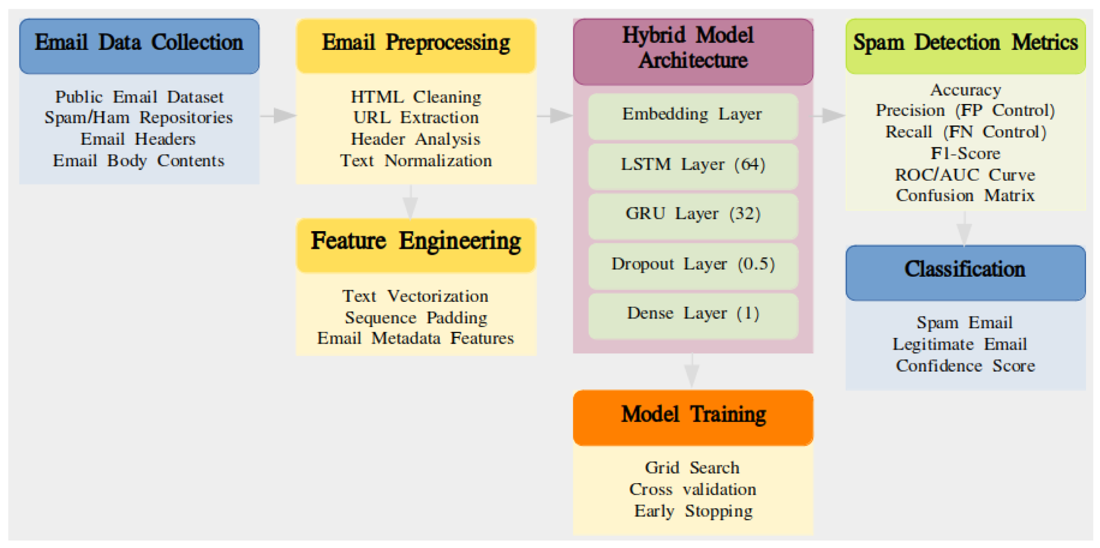

Figure 2.3.2.1: Email classification systems
(Source: Saleem et al. 2025)
The phishing detection algorithms used frequently are Logistic Regression, Random Forest, and Support Vector Machine (SVM). Logistic Regression is used to predict the likelihood of an email being of a particular class, fueled by weighted input variables, whereas the Random Forest multiplies decision trees to enhance resistance to noise and overfitting. SVM uses the best hyperplanes to distinguish between classes in high-dimensional feature spaces, and thus, it can be used with text-based representations like TF-IDF (Ahmed et al. 2022). According to recent research, the detection accuracy and adaptability of supervised ML techniques are high, and they outperform the existing rule-based filters by learning the sophisticated trends of email messages and metadata (Akinyelu, 2021).

2.3.3 Ensemble and Margin-Based Learning Theory
Advanced models of the form of classification applied to email spam and phishing detection are theoretically grounded in ensemble and margin-based learning models. Random Forest is an ensemble learning approach that builds multiple decision trees and merges their results, demonstrating that the collective power of weak learners can surpass the performance of each component. The ensemble method utilizes randomness in feature selection as well as data sampling by use of the bootstrap aggregating technique that minimizes variation and eliminates chances of overfitting (Maqsood et al. 2023). Random Forest is more stable and more accurate when the predictions are pooled across many trees, even when the prediction is made on datasets whose high-dimensional textual features (TF-IDF representations of email) are noisy. This renders it especially efficient in dealing with any complicated and delicate patterns in phishing emails, where the attackers tend to execute advanced methods of obfuscation so as to circumvent conventional filters (Bouke et al. 2025).
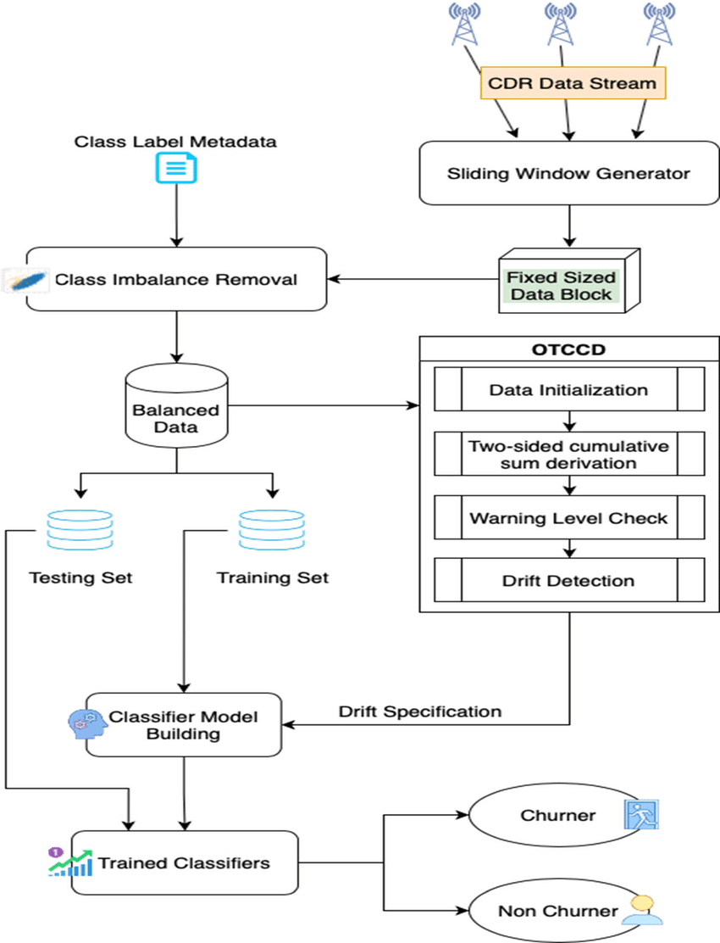

Figure 2.3.3.1: Margin-based imbalanced ensemble classification
(Source: researchgate.net, 2025)
SVM is based on a theory of margin-based learning, which tends to calculate the field that determines the best hyperplane to create the most significant division between classes in a feature space (Joshi et al. 2024). SVM is also adaptable for high-dimensional data, for which it is more efficient in sparse vectors, and it provides more attention to support vectors, which are the most critical data to define the decision plane (Wash, 2020). SVM optimizes the margin, thus maximizing the generalization performance and preserving high precision of classification even when the classes do not necessarily lie in a linear position with the aid of a transformation with a kernel. Random Forest can be used to give stability as a result of aggregation and noise removal, whereas SVM is used to guarantee an accurate boundary of delicacy in a complicated feature space (Boussaad et al. 2025). The two frameworks enhance the strength of phishing detection mechanisms, where they can adjust to changing attack tendencies and language differences that threaten less complex linear frameworks.

2.3.4 Performance Evaluation and Decision Theory
Machine learning-based email spam and phishing detection have a close connection with performance evaluation, which offers a framework for operations on how optimum decisions should be made under uncertainty. The theory will focus on the significance of the evaluation of the classification outcomes in a manner that will balance the risks related to the various kinds of fatality (Khan et al. 2022). False negatives or fraudulent mail that is wrongly labelled as a legitimate e-mail is a serious security risk that enables spam to be delivered to users. False positives (genuine emails being identified as spam) may affect the efficiency of communication and cause a decline in faith in automated filters (Jáñez-Martino et al. 2023).
The decision theory guides the choice of the performance measures that provide a complete picture of the model's performance under such limitations. The main assessment measures that are based on this theoretical framework entail accuracy, precision, recall, F1-score, and ROC-AUC. Measures of accuracy determine the total percentage of the correctly categorized emails and precision, the percentage of the true identifications out of all identifications. The model determines how effective the model is when it comes to recognizing the presence of phishing messages. Recall or sensitivity measures the capability of the model to identify all actual phishing emails, a key measure of security-centric applications (Karim et al. 2023). F1-score offers a weighted mean of precision and recall, and it is more balanced in terms of trade-offs associated with false positives and false negatives. ROC-AUC, the region under the receiver operating characteristic curve, also defines the capability of the classifier to differentiate between classes at different thresholds, which is a strong measure of the performance (Abad et al. 2023). Such a grounding of evaluation by decision theory has helped researchers to make sure that the assessment of a model is consistent with the practice of misclassifications. This would help to deploy machine learning models in the real-world setting where email threats are dynamic in nature and focus on both security and usability.

2.4 Thematic Discussion

2.4.1 Theme 1: Evolution of Email Threat Techniques
Threats with emails have been changing radically within the last twenty years, developing the ideas of primitive spamming into sophisticated phishing schemes that could go unnoticed by other traditional security standards. Spam messages used to mostly consist of bulk advertisements, which follow some repeating and predictable patterns which can be easily detected by rule rule-based filtering system (Hosseinzadeh et al. 2025). These initial methods were mainly based on matching the keywords, sender blacklist, and frequency of appearance of messages to determine the unwanted emails. Attackers have become very sophisticated, and more sophisticated methods of detection are needed.
The modern phishing techniques are characterized by the use of brand impersonation, in which the attackers draft fake companies, that is, the legitimate organizations, under the guise of acquiring the trust of the recipient. Messages often include hidden links which send users to fraud sites that look real, but conceal the malaise motive (Islam et al. 2021). Attackers use contextual semantics in the email message by using it to message to the personal or business environment of the recipient as a better option to engage the receiver. The dynamic nature of email threats presents the problem of concept drift, in which the statistical properties of phishing emails vary with time and diminish the performance of static and rule-based systems. The continuous change in phishing methods highlights the drawbacks of using older filtering systems that cannot identify new patterns or subtle manipulative words. This leads to an increased need for solutions based on machine learning, which can analyses textual and structural data, learn historical patterns and extrapolate them onto new methods of attack (Kabla et al. 2022). The evolution of email threats can offer critical details on how to develop more resilient and dynamic detection frameworks that will be able to react well to the current dynamism of cyber threats.

2.4.2 Theme 2: Preprocessing and Feature Engineering in NLP
Processed features and feature engineering before email spam and phishing detection are essential because they have a direct relation to the efficacy of machine learning classifiers. Emails are usually not structured text and contain noisy items like special characters, HTML tags, punctuation, and irregular formatting (Ahmed et al. 2022. The purpose of preprocessing is to clean such data, that is, it involves operations that normalize textual data, like tokenization, stop-word removal, stemming, and lemmatization, and decrease the amount of irrelevant data. Good preprocessing will help make sure that the input features give meaningful patterns in the data, which increases model performance. The preprocessed text is extracted into numerical representations that can be analyzed using machine learning through feature extraction.
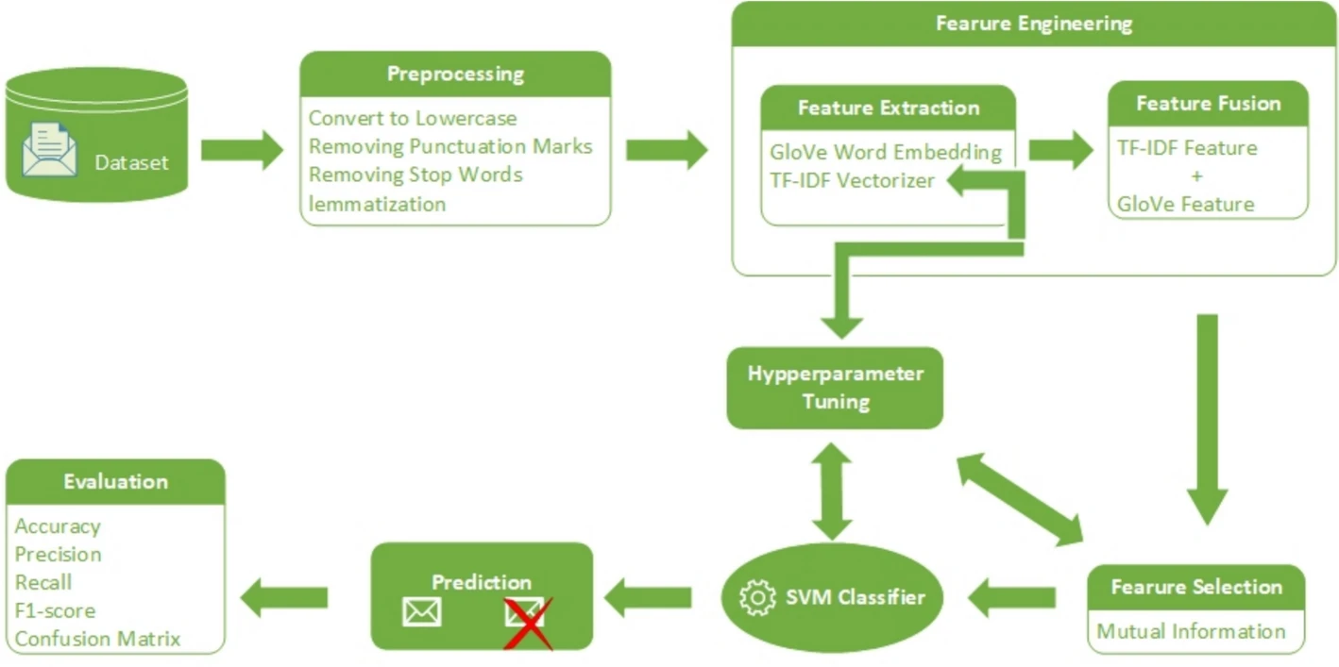

Figure 2.4.2.1: Architecture of the spam detection model
(Source: Mohammed et al. 2024)
More frequently used methods are Bag of Words (BoW), which counts the frequency of words but does not capture the context of the words (Juluru et al. 2021). Term Frequency-Inverse Document Frequency (TF-IDF) has been used to measure the significance of the terms with respect to the whole corpus and helps identify the discriminative terms. Word Embedding have encoded the contextual semantic meaning and require more calculations (Arseniev-Koehler et al. 2024). TF-IDF is the most commonly used when it comes to classical machine learning tasks in phishing detection because it strikes a balance between efficiency and the capacity to embrace high-profile discriminative textual characteristics (Adebowale, 2020). Using TF-IDF, models are also able to give priority to terms that are most suggestive of either phishing or spam, whilst keeping the effect of common words to a minimum and thus enhancing classification accuracy. Precise preprocessing and powerful feature extraction promote the fact that any email classification system (Al Tawil et al. 2024). The Logistic Regression, the random forest, and the SVM will be capable of learning meaningful email content patterns that can be used in a flexible and efficient identification of new and emerging threats.

2.4.3 Theme 3: Model Performance in Prior Studies
The email spam and phishing detection models through various machine learning models have been comprehensively tested, displaying their positive and negative sides. Some of the most popular classifiers are the Random Forest, Support Vector Machine (SVM), Logistic Regression, Naive Bayes and the neural network-based classifiers (Jiang et al. 2024). Research has been able to demonstrate that ensemble models, Random Forest, can perform well in overall classification because they can deal with heterogeneous features and alleviate overfitting by aggregating numerous decision trees. Random Forest has been shown to exhibit high flexibility in the face of advanced email layout and noisy text format and is thus applicable to actual phishing (Chen et al. 2023). Support Vector Machines are much more precise, especially in high-dimensional feature space, which is produced by TF-IDF vectorization of email texts. SVM is effective at determining subtle differences between phishing and legitimate email messages by making the best decisions, even when the interactions between features are non-linear (Lee et al. 2024).
Logistic Regression is relatively simpler but can be used as a good starting point, capable of interpolating results and providing reasonable performance with simple textual data, but with complicated, higher-dimensional input, it might fail. SVM performs better in precision, Random Forest plans to handle heterogeneity of features better, and Logistic Regression is useful for comparison with other tools (Alkhalil et al. 2021). Such results highlight the importance of comparing several classifiers under equal experimental conditions (Byrne et al. 2024). The research is oriented to the comparative study of such methods as Logistic Regression, Random Forest, and SVM to select the most efficient based on their ability to detect spam and phishing messages in emails.

2.4.4 Theme 4: Manage Concept Drift in Phishing Detection
Phishing messages constantly change their format, message, and practices of delivery, posing a constant danger to email safeguard systems. This change in evolution causes concept drift, which is a situation where the statistical features of a malicious email may change over time, making models previously trained useless. The concept drift is a serious issue in the traditional machine learning methods, as the theory states that the data distribution is constant (Juluru et al. 2021). This may lead to an increased number of false negatives, potentially causing harmful emails to pass or increased false positives, which may alter the normal communication flow. Adaptive machine learning strategies have been advanced to solve this.
Incremental learning enables the models to keep up to date with the changing information by updating their parameters whilst ensuring that they are still relevant as new data arrives without undergoing a full retraining. Learning algorithms based on online learning operate consecutively on the information, adjusting to the new patterns according to the previously learned (Khan et al. 2022). Intermediate retraining of models on newer datasets also contributes to capturing the changing phishing behavior so that the classifiers are also up to date in the face of novel attack techniques.
The real-time drift detection requires monitoring and evaluation frameworks. The techniques can be applied to update the model in time, such a sliding window analysis, drift detection methods and performance monitoring metrics (Hosseinzadeh et al. 2025). Addressing concept drift is a sure way of keeping email security systems resilient so that the detection rate is high and the false-positive rate is minimal. Adding adaptive mechanisms into the phishing detection system not only enhances operational efficiency but also reveals better response capability of the system to dynamically occurring cyber-threats.

2.5 Literature Gap
Although machine learning-based email spam and phishing detection have made great progress, studies have a number of limitations that limit the generalizability and practicability of research. A major limitation is that the over-dependence on old-fashioned or biased databases diminishes the applicability of previous research to the current phishing practices (Ahmed et al. 2022. Most of the previous datasets do not reflect the variety and dynamic complexity of email threats, and trained models are not effective in practice (Islam et al. 2021). The study uses a dataset which is a varied collection of data samples that contain representative instances of spam as well as legitimate emails. The other weakness is the limited, specifically used features in earlier research, which usually disregard valuable textual aspects of the email content, such as the entire email text or contextual semantics. The study makes use of both the subject lines and the body to make sure that all the features are extracted. It is often hard to determine the most efficient algorithm because previous studies are often not rigorously compared across many models (Kabla et al. 2022).
The paper defines a strong benchmark by comparing Logistic Regression, Random Forest, and Support Vector Machine to one another in the same conditions of preprocessing and extraction of features. Most researches also only look at accuracy and ignores accuracy metrics like precision, recall and F1-score that are important in the foundations of classifier reliability (Akinyelu, 2021). The dissertation fills these voids by introducing a holistic pipeline, rich textual features, comparative evaluation, and standardized experimental conditions, improving the reproducibility, reliability and practicality of the findings.

2.6 Summary
The chapter has provided a critical literature review of spam and phishing email detection using machine learning, featuring the main theoretical, conceptual, and empirical evidence. There is strong evidence to use NLP-based guided learning methods because linguistic and structural cues of the email messages play a decisive role in correctly classifying them. Of the compared models, both the Random Forest and the Support Vector Machine will show better indicators of performance, especially when used in conjunction with the TF-IDF vectorization, which not only carries the significance of the key terms but also greatly improves feature representation. The lessons acquired in the course of this review have a direct impact on the research questions and objectives of the research. Machine learning-based email threat detection has made considerable progress, yet there are still several major obstacles that prevent it from being used effectively in the real world. The problem of generalization poses a limitation, mainly because most existing models have been trained on either outdated or very specific datasets. The detection of phishing attacks becomes increasingly difficult as hackers change their tactics. This is known as concept drift, where the characteristics of the attacks change gradually and the performance of the model is gradually reduced if not properly maintained. Besides this, majority of the research studies tilt towards accuracy as the single and most important metric for evaluation that might not be representative in case of imbalance in the dataset. Hence, the use of precision, recall, and F1-score becomes necessary for the robust performance assessment to ascertain the reliability and safety of the deployment.
The comparison of classifiers is supported by the observed differences in performance among the Logistic regression, random forest and SVM, to solve the problem of finding the most effective algorithm. The need for textual features in their entirety, such as the subject and body text, is also related to NLP in the semantic threat detection. Multiple metrics (precision, recall, and F1-score) are used to evaluate model reliability, which preconditions making a more sophisticated evaluation. The usage of the data alleviates shortcomings of the previous analyses and enhances the real-life generalization. All these elements contribute to the contribution of the dissertation to the building of the spam and phishing detector model that would be robust, reproducible, and grounded in the academic realm.

3.0 METHODOLOGY

3.1 Introduction
The chapter has discussed the methodology which has informed the development, deployment, and assessment of the phishing email detection system by the application of machine learning. The study is an implementative experimental paradigm, which has integrated pragmatic engineering of systems with serious quantitative critique. The introduction has indicated the frame of the chapter and has provided the motivation to use the methods that have underpinned reproducibility and empirical validation across comparative classifier experiments.

3.2 Research Philosophy
The research has been placed within a positivist philosophical tradition of focusing on objective evidence, empirical validation, and measurable results. A positivist position has been adequate since phishing email detection is based on quantifiable textual and structural attributes that can be converted into numerical forms that can be analyzed (Zimba et al. 2024). This philosophical perspective has led to the assumption that behavior under email can be recognized to be governed by specific patterns that can be identified by machine learning models by conducting a systematic analysis of it. Positivism has also facilitated the derivation and testing of hypotheses on the importance of features, classifier accuracy and effectiveness of the preprocessing method.
The use of this philosophy has promoted the use of statistical assessment measures like accuracy, recall, F1-score, and ROC-AUC, which have been critical in checking the performance of the model. The empirical grounding has guaranteed that observations made regarding the behavior of classifiers have been based on what has been observed and not subjective interpretation (Bliss, 2021). The positivist principles in the documentation and longevity of standard practices in documenting experiments and reporting transparently require that the evaluation of the model is constant, regardless of the different combinations of the model. The positivist background has assisted in the strong framework of creating a scientifically sensible and valid phishing email detecting strategy, which can comply with conventional principles in the field of machine learning research.

3.3 Research Approach
The research method has used deductive reasoning in discussing propositions based on the literature that has been reported on machine learning performance in text classification. The various theories on classifier behavior, feature influence and preprocessing effects have been converted into hypotheses that could be tested. Logistic Regression, Support Vector Machine and Random Forest models are applied to test these hypotheses in controlled experimental conditions. Comparative testing in the field of standardized evaluation protocols has developed a direct correlation between predicted performance and measured results.
The deductive reasoning process has allowed the study to make systematic conclusions about the strengths, weaknesses and generalization patterns of the individual classifiers (Saias, 2025). The method has also explained the effects of characteristic combinations, including the content of the subject text, the content of the body, and any indicators of URLs on predictive accuracy. The deductive model has presented a systematic and rational point of departure to study model performance and to compare the results of empirical tests with the existing machine learning architectures.

3.4 Research Significance
The methodology has importance in enhancing scientific rigor and applicability in the area of phishing email detection. The applied experimental structure has offered a valid ground to generate results that can be repeatable under diverse environments, rendering that the inferences have been consistent as well as verifiable. The method has extended the knowledge about the effects of preprocessing decisions, feature engineering methods and classifier settings to predictive performance, which have played critical roles in enhancing email security systems.
The quantitative-based evaluation strategies have contributed to high levels of credibility in the results and also informed decisions in cybersecurity applications. The availability of deployment considerations, including computational performance and interpretability, enables the system to remain proximate to practice as opposed to being restricted to the theory of demonstration (Maneriker et al. 2021). The focus on maintenance practices, scalability, and adaptability has enhanced the long-term topicality of the work, particularly in situations when the phishing techniques are actively developed. The methodology provides practical information to organizations that provides reliable, data-driven information on email threat detection.

3.5 Research Design
This research design has offered a systematic map with which to research the concept of the detection of phishing emails with the help of machine learning methods. The use of experimental and applied paradigms has been embraced since the research has demanded a theoretical understanding, as well as formulating a working classification system. This paradigm has facilitated the algorithmic testing of algorithms on labelled email data, which can allow comparisons between different predictive models to be done in a systematic fashion, as well as be able to discern which classifier is the most effective (Wangchuk and Gonsalves, 2025). The design has focused on supervised learning, to which the pre-labelled examples have provided the basis of model training, validation, and final evaluation. Accuracy, precision, recall, and F1-score have been constant since they provide objective information about the performance of the model and allow a repeatable estimation of these measures under the same circumstances.
The applied approach has been integrated into the design because the study has sought to offer real-life solutions to modern cybersecurity challenges. The effectiveness of machine learning models has been evaluated under controlled experimental conditions that have led to a reasonable comparison and credible interpretation (Yoon et al. 2024). This structured design makes it possible to iteratively refine preprocessing choices, feature engineering choices, and model parameters, and acts as an assurance that all procedural changes have increased clarity, strength, and serviceability to already agreed-upon machine learning principles. The design also facilitated a clear workflow between dataset acquisition and preprocessing, feature extraction, model training, and performance evaluation to ensure continuity and coherence between all the developmental stages.

3.5.1 Justification of the Research Design
This choice of design has been explained by the fact that phishing detection is an empirical process that needs verified outputs and verifiable data. Experimental methodologies that enable the measurement of predictive success and the location of the weaknesses of model behavior have been needed in classification problems. The use of applied research has been critical since phishing attacks influence the real-world communication setting, organizational framework, and user security. The approach has provided replicability, objectivity and transparency, which are certain to have ensured that results have been based on observable patterns but not subjective decisions. Quantitative orientation has also enhanced the validity as it reduces bias, as well as ensuring that the conclusion was made based on uniform, statistically based measures.

3.5.2 Alignment with Research Objectives
There has been consistency between the design and the research objectives. The structured transformations throughout the dataset partitions have been applied to the objectives of data cleaning and preprocessing. The comparison of algorithms' goals has been achieved by comparing the performance of Logistic Regression, Random Forest, and Support Vector Machine performed in the same experimental conditions (Atawneh and Aljehani, 2023). The purposes related to the determination of the most suitable classifier have been facilitated directly in relation to the prioritization of the quantitative assessment outcomes. This correspondence has provided the study with methodological consistency and made the objectives of the study to be addressed using a rigorous, logically sequenced, and empirically based design.

3.6 System Development or Experimental Approach
A prototyping methodology has been used in the system development to overcome this issue, which has allowed the continuous refinement of all components used in detecting phishing emails. This system has enabled the system to develop over time since each prototype has brought out strengths, limitations and improvement opportunities (Benavides et al. 2023). The prototyping model has provided flexibility through continuous readjustments of the process at preprocessing, feature engineering, and model comparison phases. There is a well-organized sequence of experimental processes, and a series of prototypes has enhanced the reliability and efficiency of operation of models.

3.6.1 Rationale for Choosing a Prototyping Approach
The proactive and experimental character of machine learning development has influenced the choice of the prototyping methodology. The classification of e-mails has necessitated repetition, fine-tuning and validation experiments, and the prototyping model has been found to meet these essential needs better than the linear methodology. The prototypes have also given quantifiable information on the effects of the choices on text cleaning, the methods of vectorization, and the settings of classifiers (Xu, 2025). The flexibility of prototyping has likewise guaranteed instant reaction to the occurrence of rare problems like model over-fitting, misclassified patterns or differences in data organization. This strategy has facilitated transparency, regulated experimentation, and continuous improvement, which have been critical in creating a system targeted at deploying cybersecurity in real-life situations.

3.6.2 Stages of the Development and Experimental Workflow
The workflow has been implemented in stages with systematic steps of data acquisition to final evaluation. The ingestion of the data set has been conducted initially, then an exploratory analysis has been performed that has identified trends, structural discrepancies and distribution of variables in the CEAS_08 dataset. Noise, missing values, textual content normalization, and structural field standardization have since been performed by preprocessing (Putra et al. 2024). TF-IDF feature extraction has been implemented in later prototypes to transform textual data into a numerical representation that is useful to assist in accurate classification.
The three supervised algorithms, which have been applied to implement model training, include Logistic Regression, Random Forest and Support Vector Machine (Chinta et al. 2025). All the models have been trained on the same conditions to allow an unbiased comparison. There is also the incorporation of validation procedures into the working process, which enables checking on unseen data and facilitates the identification of weak aspects of the model early in the process.

3.6.3 Experimental Structure and Iterative Refinement
The experimental method has been dependent on the number of repeated testing and optimization cycles. Both prototypes have represented changes in preprocessing operations, parameter optimization or feature selection. Accuracy, precision, recall and F1-score metrics on performance have been used to make decisions regarding the progression, development, or abandonment of a prototype version.

3.6.4 Contribution of the Approach to System Effectiveness
The prototyping approach has improved the robustness of systems by allowing late-stage adaptation of the system. This strategy has enabled the detection of mistakes early enough, the fast incorporation of corrections and maintained methodological stability. The classification system that has resulted has been advantaged by its increased accuracy, decreased sensitivity to noise, and increased capability to generalize. The experimental and prototyping method has offered an experimental and theory-based platform for building a successful phishing email detection system.

3.7 Tools, Technologies, and Datasets

3.7.1 Software Tools and Programming Environment
The Python programming language has been employed in the development process due to the explicit library assistance in machine learning, data analysis, and natural language processing. Google Colab is embraced as a computational environment which offers cloud computing capabilities, flexibility of collaboration, as well as smooth access to Python libraries. The environment has enabled the regular model training provision of GPU and CPU support, and efficient experimentation on various algorithms.
The workflow has been implemented using a number of Python libraries. Pandas has been utilized in data manipulation and data organization, whereas NumPy has been used in numeric calculations, which is important in feature transformation (Champa et al. 2024). Scikit-learn has been used as the main machine learning platform, providing implementations of Logistic Regression, Random Forest, and Support Vector Machine, preprocessing and evaluation tools. The tools Matplotlib and Seaborn have allowed visualizing the patterns, distributions, and performance measures of the models. The aggregation of these tools has helped cover the entire pipeline of analysis since the intake of raw data.

3.7.2 Justification for Tool and Framework Selection
The identified tools have been rationalized on the basis of reliability, extended usage, and the prediction of sizeable amounts of text to be classified. Stability and flexibility have been made possible with Python, presenting a readable syntax and a massive support of the community (Aljabri et al. 2022). Scikit-learn has provided strong, well-tested implementations of classical machine learning algorithms, enabling uniform comparison across controlled conditions. Google Colab has eliminated reliance on local hardware limits to allow scalability in experimentation.
The necessity to have interpretable insights into dataset structure, behavior of features, and classification has informed choices on visualization libraries. The code compatibility across libraries has also enhanced the effectiveness of the development pipeline.

3.7.3 Dataset Description and Source
The main dataset of the study has been the CEAS08 phishing email dataset. The labelled email instances included in the dataset have been primed to be phishing or legitimate and have allowed the creation of supervised training and evaluation. The structural information about the sender, URLs, rich textual information in the email body and subjects has been included as part of the dataset. The variety of email samples has provided enough diversification to detect phishing indicators and enhance model generalization.

3.8 System Requirements and Design

3.8.1 Functional Requirements
ID | Functional Requirement | Description
FR1 | Email Input Handling | The system has accepted subject and body text as input.
FR2 | Data Preprocessing | The system has performed text cleaning, tokenization, and vectorization.
FR3 | Feature Extraction | The system has extracted TF-IDF features from email content.
FR4 | Model Classification | The system has classified emails using trained ML models (LR, RF, and SVM).
FR5 | Output Prediction | The system has provided a label indicating phishing or legitimate email.

3.8.2 Non-Functional Requirements
ID | Non-Functional Requirement | Description
NFR1 | Performance | The system has delivered predictions within acceptable processing time.
NFR2 | Accuracy | The system has maintained high precision, recall, and F1-scores.
NFR3 | Scalability | The system has supported larger datasets without performance degradation.
NFR4 | Reliability | The system has functioned consistently across repeated executions.
NFR5 | Usability | The system has offered a simple interface for entering email content.

3.8.3 System Architecture
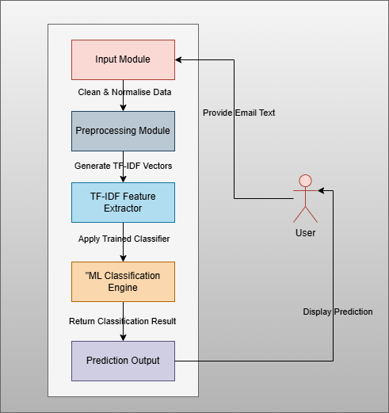

Figure 3.8.3.1: System Architecture
(Source: Draw.io)
The system architecture has been structured into modules of work, which have facilitated a clean and effective workflow in the detection of phishing emails. The email content has been input into the Input Module, whereas the Preprocessing Module has cleaned and normalized the text. The TF-IDF Feature Extractor has converted the text that has been processed into numerical vectors that can be analyzed. The Machine Learning Classification Engine has used trained models to classify spam or spam emails. The classification has been provided to the user by the Prediction Output component. This hierarchical structure has increased the scalability, maintainability and general system clarity.

3.8.4 Design Rationale
The necessity of efficiency, accuracy and clarity of phishing email detection has informed the system design. It has adopted a modular architecture in which each of the components can carry its own preprocessing, feature extraction, and classification, but plays a role in the entire pipeline. This modularity has contributed to maintainability and maximized performance on experimentation (Meléndez et al. 2024). TF-IDF has been chosen, which has always achieved good results in machine learning operations involving textual analysis. The integration of classical machine learning models is interpretable, computationally efficient and can analyze high-dimensional data. The combination of the requirements and architecture has ensured that the system is scalable, reliable, as well as in line with cybersecurity requirements.

3.9 Data Collection & Processing

3.9.1 Dataset Acquisition
This data is gathered using the phishing email dataset CEAS 08 that has been sourced from the Kaggle open-source platform. The data set has provided a substantial and heterogeneous set of labelled email examples, which are either phishing or legitimate. The accessibility of structured metadata, subject lines, body text and embedded URLs has made the extensive study of the linguistic as well as behavioral patterns possible. Transparency, reproducibility, and adherence to the ethics principles have been maintained because no personal or confidential information about the users has been collected.

3.9.2 Structure and Characteristics of the Dataset
The data has included tens of thousands of email samples of different senders and situations. There have been several feature categories, such as textual content, structural components and a binary indicator which denotes the presence of URLs in each entry (Kyaw et al. 2024). The dataset has demonstrated inconsistency in length, complexity, and the use of vocabulary, which results in a dense atmosphere in which machine learning is trained. This heterogeneity has enhanced the capability of the models to identify faint signals that are linked to phishing efforts.

3.9.3 Pre-processing Procedures
A preprocessing process in a structured sequence has been used in the pre-training of models. The examination of initial data has revealed the presence of missing values, redundancy and irregular formatting. There has been an attempt at corrections by deleting duplicate records and cleaning incomplete rows. The preprocessing of text has adhered to proven natural language processing methods such as lowercasing, stripping punctuations, stop-word elision, tokenization and lemmatization (Dalton et al. 2025). Such operations have regularized the text and removed noise, which might create a distraction during feature extraction.
TF-IDF vectorization has been used to transform textual data into numerical forms that can be used to classify machine learning. The inclusion of structural features like the indicators of URL and length-based measures has also been integrated to increase model discrimination. Each of the preprocessing processes has provided consistency of the data, enhanced classifier accuracy and minimal chances of model overfitting.

3.10 Ethical Consideration
Ethics have been a critical factor in the process of phishing email detection systems. The analysis has been based solely on the CEAS_08 dataset that is available on the Kaggle hosting, and which has been anonymized and made publicly accessible. This feature has helped prevent exposing and processing any personal, confidential, and sensitive user information throughout the analysis (Reyes et al. 2024). Anonymized data has helped the study to be consistent with the generally accepted standard of privacy and data protection.
Methodological decisions have been made based on transparency, fairness and accountability. The use of objective performance metrics to evaluate machine learning models has been consistent, such that biased and misleading interpretations have not affected the results. The ethical requirements related to the responsible use of artificial intelligence have also been upheld in the study, as the developed system has not provided space to negative activities, including the creation of phishing content or providing an avenue to malicious users.
The workflow, provenance datasets, and work processing steps have been documented to facilitate the creation of methods of reproducibility and traceability. The possibility of potential model misclassifications has been taken into consideration since these misclassifications can impact the users or organizations using automated email filtering. There has been ethical consciousness in all data processing, model training, evaluation and reporting.

3.11 Summary
The chapter has described the methodological foundations underlying the phishing detection system. All processes have been facilitated by a positivist position, deductive reasoning, and the development of prototypes, structured preprocessing, and rigorous quantitative evaluation. The approach has provided the required accuracy, reliability, ethical resilience, and correspondence among system design, tools, datasets, and the objectives of research.

4.0 IMPLEMENTATION & DEVELOPMENT

4.1 Introduction
This chapter has provided a practical application to the proposed phishing email detection system. The entire development process has been presented, such as dataset preparation, preprocessing, feature extraction, model training and deployment-related prediction. The effectiveness, reliability and applicability of the proposed solution have been tested and proven using real email data as input to the applications of machine learning models.

4.2 Implementation
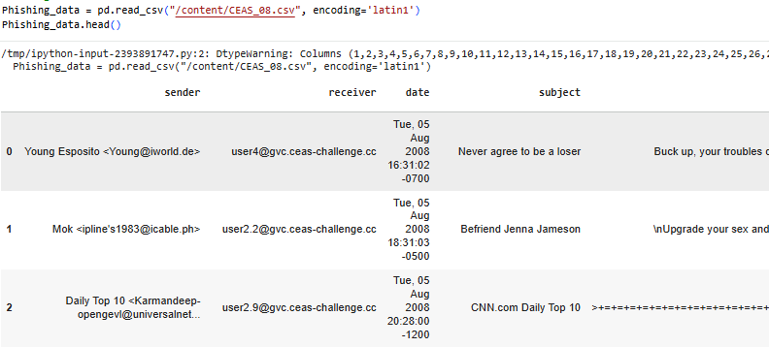

Figure 4.2.1: Dataset loading
Pandas has been used to load the CEAS 08 dataset with the latin1 encoding to ensure the size and value of special characters in emails are handled properly. The data has been opened up to inspect and process the data, allowing the performance of reliable preprocessing, exploratory analytical operations, and following machine learning model training.
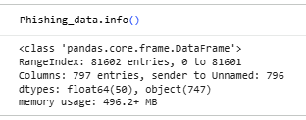

Figure 4.2.2: Checking data information
The dataset format has been analyzed and shows that it consists of more than 81,000 email records and a significant number of textual and categorical variables. The types of data and use of memory have been determined which has informed preprocessing choices and the necessity of dimensionality reduction and efficient feature processing.
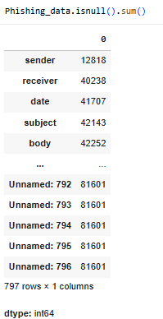

Figure 4.2.3: Checking missing values
There is a high rate of missing values that have been found in major attributes like the sender, receiver, the subject, the body, and the URLs. The necessity to identify these gaps has been to avoid errors in processing text and extracting features to ensure that machine learning models are trained on full and homogeneous data.
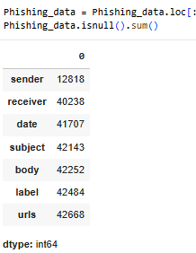

Figure 4.2.4: Checking the removed value after removing the unnamed columns
The dataset has eliminated Redundant Unnamed columns without useful information. This cleaning has minimized dimensionality and memory overheads which increase computational performance and relevant features are used in learning models and model evaluation.
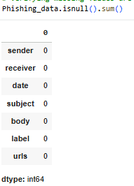

Figure 4.2.5: Checking missing values after handling missing values
The missing values have been adequately addressed using relevant imputation measures. The data has been converted to a complete format that increased the consistency of the data and allowed continuous feature extraction and vectorization to be performed and model training free of incomplete records.
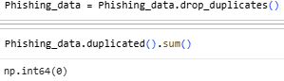

Figure 4.2.6: Checking duplicate rows after handling
The data set of email records have been found to contain duplicates that are eliminated and the resulting dataset includes unique records. The absence of duplicates has also avoided redundancy of data and biased learning of the phishing detection models, which source has enhanced the generalization capacity and reliability of the phishing models.
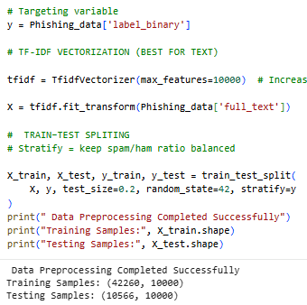

Figure 4.2.7: Data preprocessing for training models
The email data has been processed and converted into the machine readable format to be used in supervised learning. TF-IDF vectorization with a fixed feature size using a fixed feature size has been used to clean textual content of subject and body fields and convert the textual content to numerical representations. The dataset is divided into training and testing data sets with class balance ensured with the help of a stratified sampling. This preprocessing has measured that the models are trained on test data of similar consistency and assessed unbiasedly on unknown data. The preprocessing stage has enhanced model stability, minimized bias and facilitated consistent comparisons with other machine learning algorithms used in the study by standardizing the input representation which maintains the spam-to-ham distribution.
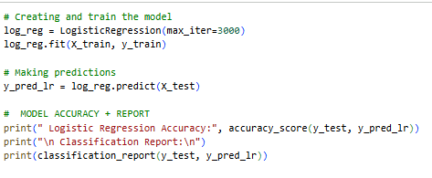

Figure 4.2.8: Implementation of the Logistic Regression
The Logistic Regression model is developed using TF-IDF across email content in order to create a linear baseline classifier of phishing. The model has been able to learn discriminatory patterns between spam and valid email and has obtained high accuracy values, precision values, and recall values. The implementation of Logistic Regression has been based on its interpretability and computational efficiency coupled with its ability to work with text data of high dimensions. The confusion matrix and the classification report have verified that both classes are performing equally with each other, which proves that it is an effective model to reference. The implementation has provided a good framework against which complicated models can be compared and has aided in assessing whether more complicated algorithms can indeed be beneficial relative to simpler models based on linear methods.
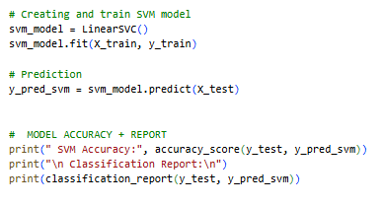

Figure 4.2.9: Support Vector Machine Model
The Support Vector Machine model has been executed with a linear kernel to discriminate between phishing and legitimate email in a high-dimensional feature space of TF-IDF. The model has been found to have the greatest overall accuracy as well as the lowest misclassification of all the classifiers evaluated. The application of SVM is due to its capacity to develop an optimal decision boundary which optimizes the separation of classes even in sparse and high dimensional data. The use of evaluation metrics and ROC-AUC analysis has justified a good generalization performance on unseen data. This finding has confirmed that SVM is useful in text-based phishing detection and has warranted its choice as the most appropriate model to be implemented in the proposed email security system.
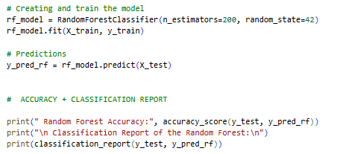

Figure 4.2.10: Implementation of the Random Forest
The trained classifier is also the Random Forest, which is utilized as an ensemble learning model to discern the non-linear associations between email features and background. The model has minimized overfitting due to its capability to combine many decision trees and, therefore, achieved strong classification. Random Forest has also exhibited good recall and resistance to the noisy features, whereas its accuracy has been marginally lower than SVM. The effectiveness of ensemble-based learning has been compared to linear classifiers using the model. Its performance has helped to gain valuable insights on trade-offs between interpretability, computational cost, and predictive accuracy, as part of a general comparative analysis of machine learning methods against phishing email detection.
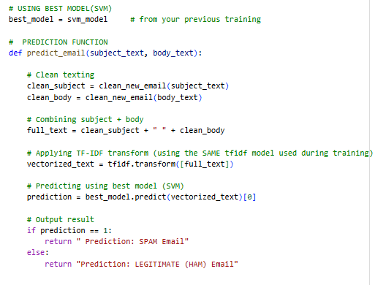

Figure 4.2.11: Prediction using the best model
The most effective model, Support Vector Machine, has been incorporated into a prediction feature that is able to classify new mail depending on subject and body content. The training has been performed on incoming email text and the resulting TF-IDF vectorizer retrained on the text has been used to perform preprocessing on the incoming email text. The model has managed to produce actual-time predictions, proving emails as being phishing or genuine. The application of this implementation has proven this realism of the proposed system as regards offline experimentation. The prediction module has enabled verification of its deployment readiness through artificial inputs on email and disclosure of misclassification cases, including the future focus on minimizing the false positives in borderline legitimate messages.

4.3 Summary
This implementation has been able to process raw email data into a working phishing detection system. Support Vector Machine has become the most effective classifier through systematic preprocessing, model training, and evaluation. The findings have substantiated the possibility of using machine learning methods in appropriate and real-world phishing emails storage.

5.0 TESTING & EVALUATION

5.1 Testing and Validation
Test Case ID | TC001
Test Case Title | Detection of Phishing Email Using Suspicious Bank Alert Message
Objective | To verify that the system correctly identifies a phishing email containing urgent bank-related instructions as SPAM.
Preconditions | The SVM model is trained, TF-IDF features are generated, and the predict_email (subject, body) function is properly loaded in Google Colab.
Test Steps | 1. Enter the subject: “Urgent! Update your bank account information”.  2. Enter the email body text containing suspicious bank alert content.  3. Execute the predict_email (subject_input, body_input) function.  4. Observe the system output prediction.
Test Data | Subject: “Urgent! Update your bank account information”  Body: “Dear user, We detected unusual activity in your bank account. Please click the link below to verify your identity.”
Expected Result | The system should correctly classify the email as: “SPAM Email”
Pass/Fail | Pass
Comments | The system successfully detected phishing cues such as urgent language, account verification, and click the link, showing effective phishing classification.
Evidence | 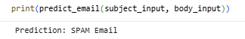

Test Case ID | TC002
Test Case Title | Detection of Legitimate (Ham) Email – Meeting Update Notification
Objective | To verify that the system correctly identifies a normal organizational message as a legitimate (HAM) email.
Preconditions | The trained SVM model and the predict_email (subject, body) function are loaded and running in Google Colab.
Test Steps | 1. Enter the subject: “Meeting schedule update”.  2. Enter the body text containing normal meeting update information.  3. Execute the function predict_email (subject_input, body_input).  4. Observe the predicted email category.
Test Data | Subject: “Meeting schedule update”  Body: “Hi team, Tomorrow's meeting has been rescheduled to 3 PM. Please update your calendar.”
Expected Result | The system should classify the email as: “LEGITIMATE (HAM) Email”
Pass/Fail | Pass
Comments | The system correctly recognized this as a professional, non-threatening email with no phishing indicators, proving good real-world classification accuracy.
Evidence | 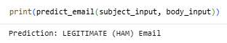

Test Case ID | TC003
Test Case Title | Misclassification of a Legitimate Email Containing a Verification Link
Objective | To verify whether the model can correctly classify a legitimate internal email that contains verification-related words and a link.
Preconditions | The SVM model is trained, loaded, and the prediction function predict_email () is working correctly.
Test Steps | 1. Prepare the subject and body text that represent a legitimate meeting verification email.  2. Pass both inputs to predict_email (subject_input, body_input).  3. Observe the prediction output returned by the model.
Test Data | Subject: “Verify meeting attendance”  Body: “Please verify your attendance for tomorrow's security briefing. Use the link below to confirm your presence.”
Expected Result | Prediction: LEGITIMATE (HAM) Email — because it is a normal workplace email about meeting attendance.
Pass/Fail | Fail
Comments | The model incorrectly predicted this legitimate email as spam. This indicates a misclassification due to keywords such as “verify”, “security”, and “link”, which are common in phishing messages. Shows limitation and potential over-sensitivity to phishing-related terms.
Evidence | 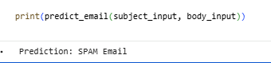

Test Case ID | TC004
Test Case Title | Detection of a High-Risk Phishing Email Claiming Account Lock
Objective | To verify whether the model correctly identifies a phishing email containing urgent language and a malicious request for verification.
Preconditions | The trained SVM model and predict_email () function must be loaded and functioning correctly.
Test Steps | 1. Prepare a high-risk phishing email sample about account lockout.  2. Input the subject and body into predict_email ().  3. Record the predicted output.
Test Data | Subject: “Your account has been locked!”  Body: “Dear customer, We detected multiple login attempts on your bank account. Please verify your identity immediately to avoid suspension. Click the link below.”
Expected Result | Prediction: SPAM Email
Pass/Fail | Pass
Comments | The model correctly classified the phishing email. This confirms the system’s effectiveness in detecting urgent, threat-based phishing attempts.
Evidence | 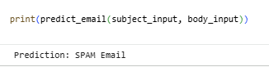

Test Case ID | TC005
Test Case Title | Classification of a Legitimate Invoice Email
Objective | To verify that the model correctly identifies a genuine business-related invoice email as legitimate (HAM).
Preconditions | The SVM best model and predict_email () function must be properly loaded and operational.
Test Steps | 1. Prepare a legitimate business invoice email sample.  2. Input the subject and body into predict_email ().  3. Record the system’s classification output.
Test Data | Subject: “Invoice for last month's services”  Body: “Hello, Please find attached your invoice for the month of September. Let me know if you need any modifications. Regards, Finance Team”
Expected Result | Prediction: LEGITIMATE (HAM) Email
Pass/Fail | Pass
Comments | The model correctly classified a normal invoice email as legitimate, demonstrating good real-world applicability for business email environments.
Evidence | 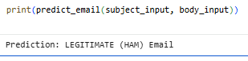

5.2 Experimental Results and Performance Evaluation
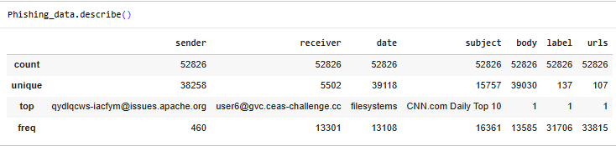

Figure 5.2.1: Descriptive Statistics
This figure shows the descriptive statistics based on the CEAS_08 dataset, with 52,826 total emails that differ in unique sender/receiver and the characteristics of the messages. It determines the size and richness of the dataset, which underlies the further development of the model to be trained and assessed in phishing.
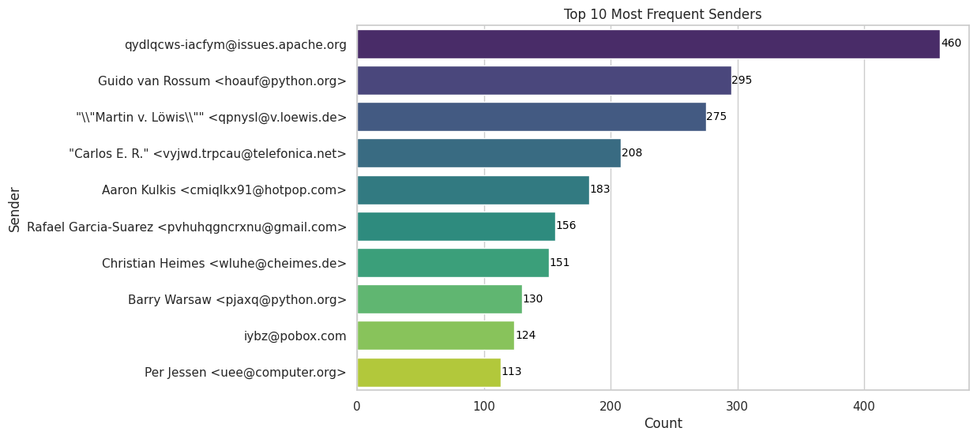

Figure 5.2.2: Top 10 Most Frequent Senders
This visualization displays the top 10 most common email senders to the data, with the highest email as rpdtpken.wchzpm@asus.apache.org at 407 emails. It helps to identify patterns of sender behavior and the possible origins of spam, which guide the selection of feature engineering for the phishing detection models.
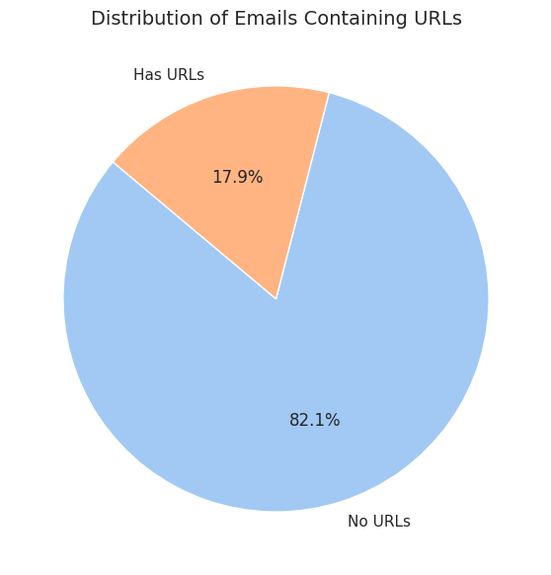

Figure 5.2.3: Distribution of Emails Containing URLs
This pie chart shows that 82.1 percent of emails do not have URLs, and 17.9 percent of emails have URLs. This distribution indicates the URL presence as a possible discriminative feature to identify a phishing email because suspicious links are frequently provided in malicious emails, so it is worth being included in the classification model.
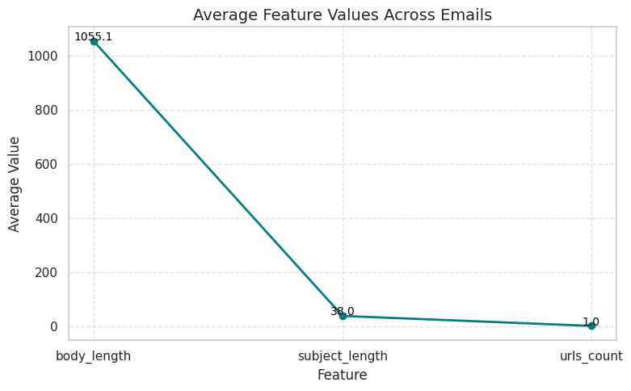

Figure 5.2.4: Average Feature Values across Emails
This line graph demonstrates the average feature values within the dataset, with the biggest one of body length (1065.1 characters) when compared to the other subjects' length (58.0) and the counts of the URLs (1.0). These constructed features measure email characteristics, and it act as input numbers in machine learning models, which can be used to compare legitimate and phishing emails to enhance classification accuracy.
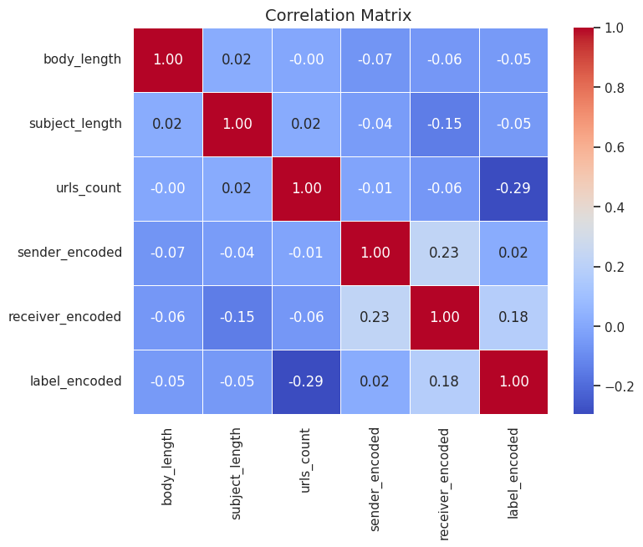

Figure 5.2.5: Correlation Matrix
The heat map of correlation shows how each feature is related to the target label. It is important to note here that the correlation between the counts of the messages using specified URLs and the label coded is negative (-0.29), but between sender and receiver encodings. This analysis predictive characteristics and multicollinearity problems that inform the selection of features and model interpretation of variable significance to classify phishing.
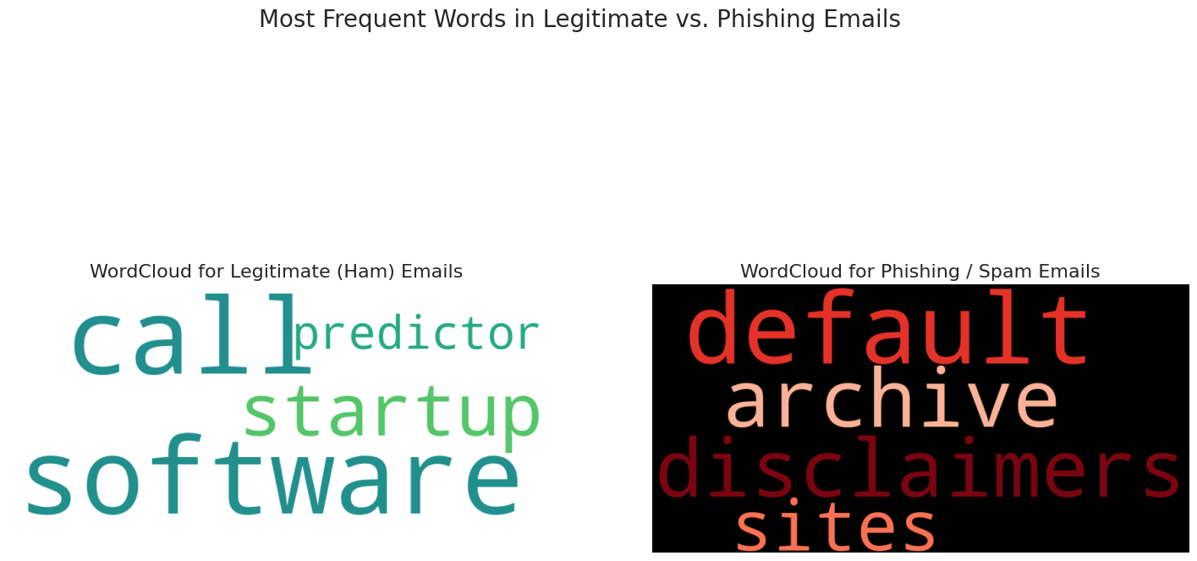

Figure 5.2.6: Most Frequent Words in Legitimate vs. Phishing Emails
The above figure shows such word clouds comparing the vocabulary used in fraudulent and scam emails. The emails of legitimate emails are focused on technical terms, such as software, startup, call, whereas the phishing emails underline suspicious words, such as default, archive, and disclaimers. This visualization confirms the ability of text-based features to be discriminative of classification models.
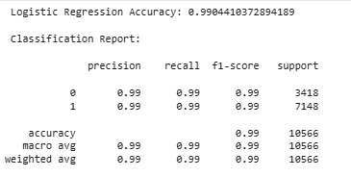

Figure 5.2.7: Classification report of the Logistic regressions
This classification report shows the accuracy of Logistic Regression at 99.84 percent. The legitimacy and phishing classes both have a precision, recall, and F1-score set of 0.99, which implies balanced predictive performance on 10,566 test samples. The exceedingly high metrics confirm that the model is highly effective in discriminating between phishing and legitimate emails, and it will be used as a reference point for the baseline model performance in comparison to SVM and Random Forest algorithms.
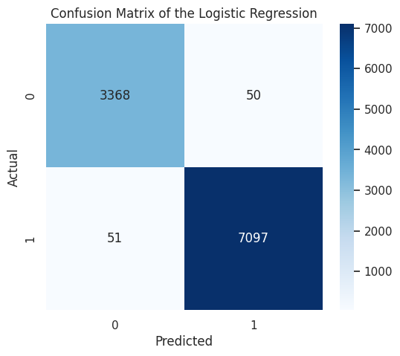

Figure 5.2.8: Confusion Matrix of the Logistic Regression
This confusion table provides a visual illustration of the performance of Logistic Regression classification: 3,368 true negatives, 7,097 true positives, and there are only 50 false positives and 51 false negatives. The low false classifications show that the model is highly discriminative and measures its accuracy in recognizing the accurate ones and phishing emails.
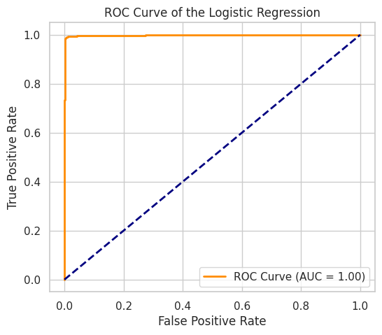

Figure 5.2.9: ROC Curve of the Logistic Regression
The ROC curve indicates that the Logistic regression has an ideal classification ability with an AUC = 1.00, meaning perfect discrimination between phishing and legitimate emails. This value proves that the model is relatively reliable in detecting the spam patterns, and it is a very important performance benchmark to compare all three machine learning algorithms used.
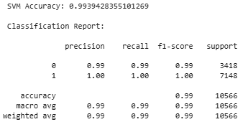

Figure 5.2.10: Support Vector Machine
The classification report shows that SVM is performing excellently with an accuracy of 99 percent and 100 percent precision, recall, and F1-score for both classes. SVM can be shown to have good generalization properties with 3418 ham samples and 7148 spam samples correctly recognized. This value makes SVM a very stable model of phishing detection with quantitative proof of its higher classification capability and an important measure of comparison with the Logistic Regression and Random Forest models.
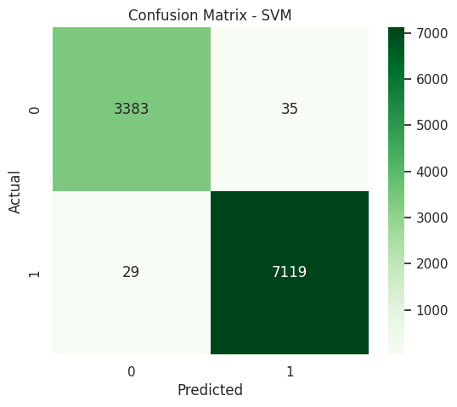

Figure 5.2.11: Confusion Matrix of the SVM
The confusion matrix is used to illustrate the accuracy of the classification made by SVM, with an actual number of 3383 false negatives and 7119 false positives and misclassifying only 35 false positives and 29 false negatives. The figure indicates that SVM has a low error rate, giving graphical support to the fact that this classifier has the highest predictive accuracy in classifying phishing emails as spam or genuine messages.
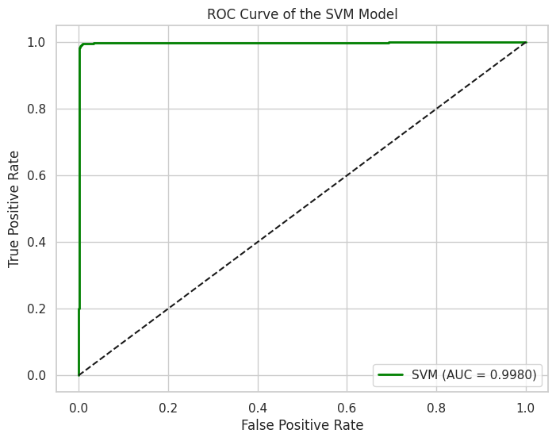

Figure 5.2.12: ROC Curve of the SVM Model
The ROC curve shows that SVM is almost perfectly discriminating with AUC = 0.9980, which represents a high sensitivity and specificity ratio. This number confirms that SVM is strong enough to distinguish between phishing and legitimate emails and is an important performance indicator that one can use to select the model and ensure that it can be applied to phishing detection in the real world.
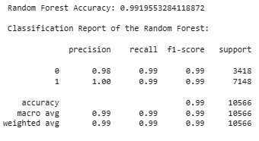

Figure 5.2.13: Classification Report of the Random Forest
The classification report indicates an accuracy of 99% with balanced precision of (0.98-1.00) and balanced recall (0.99) with the two classes. This value illustrates the effectiveness of the random forest as an ensemble learner in phishing, which provides comparatively low performance compared to other models in the present research.
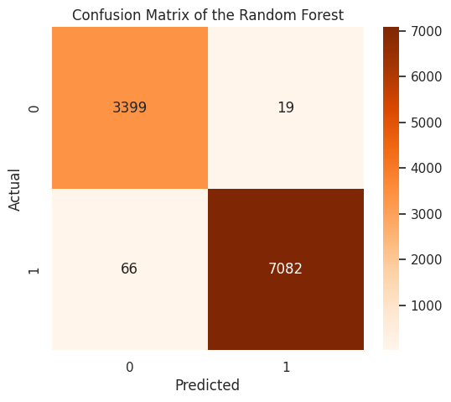

Figure 5.2.14: Confusion Matrix of the Random Forest
The confusion matrix indicates that Random Forest has a high accuracy, having 3399 true negatives and 7082 true positives, but has a little more misclassifications (19 false positives, 66 false negatives) compared to SVM. The figure gives evidence of visual comparison of trade-offs between models.
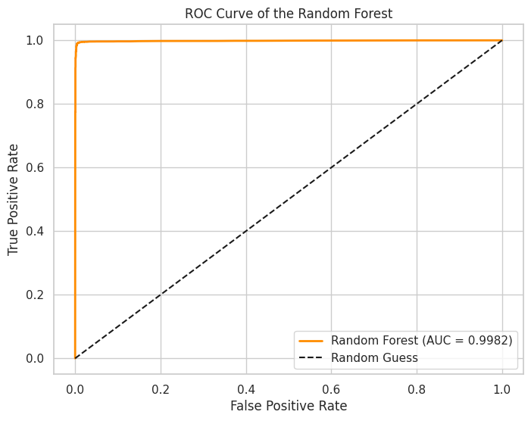

Figure 5.2.15: ROC Curve of the Random Forest
The ROC curve indicates that Random Forest has good discriminative ability, with an AUC of 0.9982, which is nearly equal to that of SVM. This value shows the discriminating ability of the ensemble model as a kind of comparative measurement to find the most efficient algorithm to be implemented in a real-life email security system
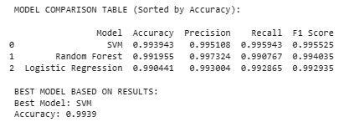
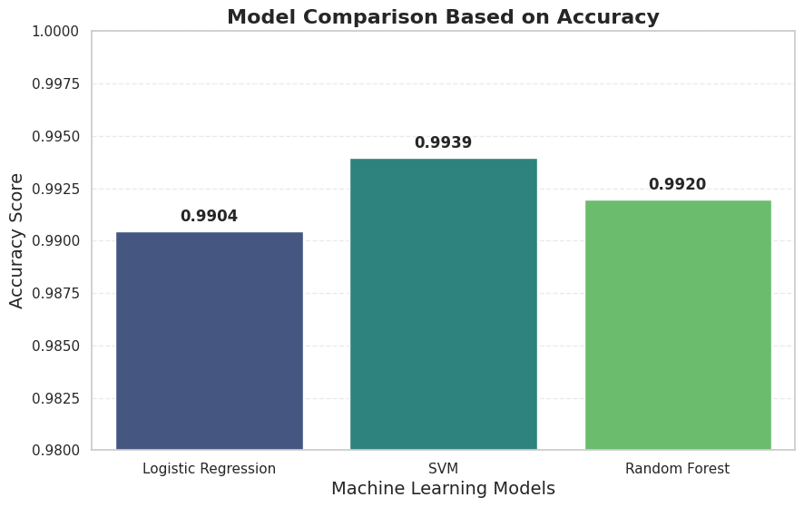

Figure 5.2.16: Model Comparison and showing the best model
The comparison table and the bar chart taken together indicate that SVM is the best model here, with an accuracy of 99.39 percent, which is a little bit more than the Random Forest classifier with an accuracy of 99.20 percent and the Logistic Regression classifier with an accuracy of 99.04 percent. Each of the models has very high accuracy, recall, and F1-scores of above 0.99. These numbers are the conclusive result of this research, as these numbers allow making an empirical decision regarding the model choice and confirm the efficiency of the use of SVM to identify phishing emails, which is directly relevant to answering both research objectives and questions.

5.3 Discussion and Critical Analysis
5.3.1 Interpretation of Results
The results of the detection models of phishing emails have been interpreted in the objectives of the research and the existing literature. This has been achieved by using and comparing the Logistic Regression, Random Forest, and Support Vector Machine (SVM) as the primary research objective of determining the most accurate and reliable classifier to distinguish between phishing and legitimate email. Each model is trained and tested using the CEAS_08 dataset that is loaded with a huge number of emails and different features [1]. High accuracy, recall, precision, and F1-score results indicate that the models have been trained to identify a phishing email to help distinguish between phishing and legitimate emails. This performance can be attributed to the findings reported in the literature, which have established machine learning techniques as useful in the detection of spam and phishing.
5.3.2 Significance and Model Comparison
The precision and recall of the Logistic Regression have been relatively high, and the two classes have reached balanced outcomes. The confusion table has shown that the misclassifications were not a few, and this is the weakness of linear modeling with a few edge cases. The Random Forest model has shown good ensemble learning abilities of interesting patterns in the data. The model has a few more misclassifications compared to SVM, indicating that ensemble learning is not always more effective than a well-tuned SVM when working with text-based tasks of classifying objects.
The SVM model is known to be the most efficient among the other models, with the highest accuracy and the lowest misclassifying rate. It has had a high performance because of its ability to establish the optimal hyperplane to divide phishing and legitimate email classes [2]. ROC curves and AUC scores also verify the high level of discriminative ability of SVM, and an almost perfect sensitivity-specificity balance. These findings suggest that SVM would be appropriate in real-world email phishing detection systems and meet the research objective of identifying a very high-accuracy and reliable classifier.
5.3.3 Limitations and Unexpected Outcomes
There are some limitations that have been determined, although performance is high. The dataset has many features and missing values, thus it needs a lot of preprocessing and feature engineering, and preprocessing tools such as text cleaning, TF-IDF vectorization, and label encoding have enhanced the performance of the models, certain biases might have been created. The trained models might be less effective in the generalization of emails whose formats are peculiar or those phishing techniques that are still novel [3]. The training and testing processes have been conducted using the same historical data; further testing on entirely unknown future data is to be conducted. The conservative misclassification noted on both the Logistic regression and the random forest models demonstrates the significance of proper tuning and attention to the imbalance of classes.
5.3.4 Strengths and Weaknesses
The strengths of the method are that a large and varied dataset is used, a systematic preprocessing pipeline is utilized, and comparisons between various machine learning algorithms are made. The models have been tested well and made to be workable owing to these plans. There is also the weakness of the methodology, including the use of outdated data, and the weak protection against phishing techniques. The goal of the future work should be to continuously refresh the datasets, implement adaptive learning techniques, and the deep learning models are to be explored to their advantage.
5.3.5 Evaluation against Research Questions
The research questions concerning the effectiveness of machine learning models to detect phishing or not have been addressed successfully. The accuracy and precision, and recall scores are good and which demonstrates the fact that reliable email classification is possible. The application of feature selection and the preprocessing of the text is found to be pertinent in terms of the optimization of the model's performance, and the occurrence of unintended misclassifications has pinpointed the possibility of improving the models.
The analysis results demonstrate that machine learning, particularly SVM, is a powerful tool in phishing email detection. The study has met its objectives, answered research questions, and provided a template of something to be done in future studies. The discussion of results, strengths, limitations, and unforeseen findings has provided a fair grasp of the field of application of AI-based email security systems.

6.0 CONCLUSION AND FUTURE WORK

6.1 Introduction
This chapter has summarized the study on email spamming and phishing detection with machine learning methods. It has outlined the most salient findings based on the experimental results, pointed out the main study contributions, and addressed practical implications and research directions. The chapter has also considered ways the research objectives and questions have been touched upon and noted known limitations and opportunities to improve the real-world phishing detection systems.

6.2 Summary of Findings

6.2.1 Achievement of Research Aim
The main objective of the study has been to assess and determine the best machine learning model towards phishing and spam email detection working with the CEAS_08 dataset. The proposed aim has been accomplished effectively by a systematic system of experimentation with data pre-processing, feature identification, feature training model supervision, and overall evaluation of performance. The results have shown that machine learning algorithms, coupled with effective natural language processing algorithms, are very useful in differentiating between the spam and fake emails.
The application has confirmed that email material holds recognizable linguistic and structural designs that can be trained and generalized by trained classifiers. The systematic methodology used in this research has resulted in reliable, reproducible, and empirically based results.

6.2.2 Comparative Performance of Machine Learning Models
The experimental analysis has demonstrated that the three machine learning models Logistic Regression, Random Forest, and Support Vector Machine have shown an outstanding classification performance. The accuracy scores in each model are above 99, and the models are characterized by high precision, recall, and F1-score figures. These findings have validated the applicability of classical supervised learning algorithms in large scaled text based phishing detection exercises.
Logistic Regression has served well as a baseline classifier with balanced predictive ability which is representative on phishing and legitimate email categories. This linear recommendation has made it to learn efficiently in high dimensional TF-IDF feature space, yet be interpreted and, crucially, cost effective to compute.
Random Forest has also recorded high accuracy and recall, which is an element of the power of ensemble learning to capture non-linear relations in email data. This combination of several decision trees has made it less likely to over-fit and resistant to noisy features especially in emails having mixed linguistic cues.

6.2.3 Identification of the Best-Performing Model
Support Vector Machine is one of the analyzed models that has proven its effectiveness and reliability as a classifier. The SVM model has reported the greatest overall accuracy, precision, recall, and F1-score, as well as the lowest misclassification rate in all the experimental executions. The ROC-AUC has also been found to substantiate its high and discriminative power and generalization on unseen data.
The excellent performance of SVM has been credited to its capacity of generalizing an optimal decision boundary in maximizing the separation between the classes in high-dimensional feature space. This property has been especially useful in TF-IDF representations which often have sparse and high-dimensional vectors. The results have validated the use of SVM as the best model that can be used in an actual phishing email-detecting system.

6.2.4 Impact of Preprocessing and Feature Extraction
The findings have indicated that preprocessing and feature engineering are significant in attaining high classification accuracy. Model stability and quality of data have greatly improved as a result of systematic cleaning of email text, noise removal, management of missing values and the removal of personal records.
TF-IDF vectorization has been core in improvement of model performance, by processing unstructured email text into a useful numerical representation. TF-IDF, by highlighting discriminative words related to phishing activity and minimizing the role of ordinary words, has allowed classifiers to pay attention to the legitimate linguistic patterns, including urgency, request to verify, and dubious instructions. The results have validated that the effective feature extraction and selection is as crucial as the model selection in the task of phishing detection.

6.2.5 Validation through Real-World Testing
The practices of trained models in application to simulated real-life applied email have provided evidence of the practical applicability of the suggested system. The prediction functionality of the SVM model has been effective in identifying high-risk phishing emails with urgent language and malicious requests, which proves that the detection framework is effective.
The testing stage also has shown a few false classifications of valid emails with terminologies related to verifications. These results indicate that text-based models are more sensitive to keywords that are indicative of phishing, and more care needs to be taken in terms of threshold settings and background knowledge. The general testing outcomes have validated the strength and deployment functionality of the suggested solution.

6.2.6 Overall Findings and Research Significance
This study has shown that the machine learning models, especially Support Vector Machine and TF-IDF feature extractor are both incredibly useful in the detection of phishing and spam email. The study has affirmed that the traditional methods of supervised learning are competitive and valid on condition of strict preprocessing and evaluation plans.
The findings have responded to all research questions and objectives and furnish empirical data to prove the need to adopt machine learning-based email security systems. The results are useful both in academic literature and in practical systems of cybersecurity as they present a tested, reproducible, and high-performing phishing detection model.

6.3 Research Contributions
The study has provided some serious scholarly and practical contributions to the sphere of email security and machine learning-phishing censorship. The study has reinforced the available knowledge as it has given a strictly empirical and rigorous analysis of the supervised learning techniques on real-life phishing data.
The most significant scholarship has been comparative analysis of Logistic Regression, Random Forest, and Support Vector Machine on the same experimental conditions. The study has guaranteed fairness and uniformity in the usage of a unitary preprocessing channel, feature extraction policy, and examination pitch. The performance has been measured on various parameters such as accuracy, precision, recall, F1-score, confusion matrices, and ROC-AUC values. This multi-metric assessment has enabled a more in depth understanding of the behaviors of the models especially concerning the trade-offs between the false positive and false negative which are essential factors in the application of cybersecurity.
The framework created to detect phishing emails has also been developed and implemented as a structured and reproducible preprocessing framework, which is a significant contribution. The model has dealt with the missing data, duplication of data, extraneous features and the normalization of the text data, systematically. Stop-word removal, punctuations, and lowercasing as the methods of text cleaning have remained constant and have led to representation of better data and stability of models. Such preprocessing pipeline has shown that data preparation caution causes direct effect on the reliability and performance of the classifier.
The study has also played a role in the aspect of feature engineering whereby the use of TF-IDF vectorization can be effectively utilized. Data conversion of unstructured email text to discernible numerical data has created the capacity of machine learning models in discriminating linguistic patterns that are linked with phishing activities. The use of both the subject lines and email body content has expanded the feature space and increased the accuracy of classification indicating the significance of textual analysis as a whole in phishing detection.
An effective contribution has been made by making use of a deployable prediction module based on the model with the best results. Support vector machine classifier has been incorporated in an actual real time prediction function that is able to classify unseen emails on the basis of subject and body material. This implementation has shown that conversion of offline experimentation is possible to real-world application closing the gap between theoretical research and operational email security systems.
The study has also provided meaningful contributions to the limitations and weaknesses of phishing detection in texts. The cases of misclassification of legitimate emails containing terminologies of verification have underscored the sensitivity of models towards phishing-resembling keywords. The findings have been empirical evidence that the contextual understanding, adaptive learning mechanisms and explainability tools must be added to future systems.
The study has provided a validated, reproducible, and practical phishing email detection framework that can be used as a reference model to guide future academic research and become a platform of actual cybersecurity solutions.

6.4 Evaluation against Research Objectives
The objectives of the research formulated in the beginning of this project have been cohesively dealt with and successfully attained by design, implementation, and assessment of a machine learning-founded phishing email detection system.
The initial objective targeted at pre-processing the data by eliminating noise, missing values, and irrelevant data, which is achieved with the help of an organized data cleaning pipeline. The gaps in values of key attributes, including the subject, body, sender, and URLs have been located and addressed with the adoption of relevant imputation methods. The redundancy of records and duplicate attributes have been eliminated, which makes the datasets consistent and reliable. These preprocessing phases have contributed largely to quality of data and have avoided bias or instability when extracting features as well as on the training of the models.
The second objective aimed at identifying meaningful content of emails based on natural language processing. This has been fulfilled by cleaning and the normalization of text content in subject lines and email bodies, which is subsequently transformed into numerical output through TF-IDF vectorization. The URL has also been included as a structural indicator and text length. This strategy has helped the models to achieve discriminative linguistic patterns, which are related to phishing behavior and minimize the role of irrelevant or common words.
The third objective is to train and test several trained machine learning models such as the Logistic Regression, Random Forest and Support Vector Machine. The three models are applied using the identical preprocessing pipeline and TF-IDF feature space to a level of fair and controlled comparison. The classifiers have all been trained using stratified training data and tested using unseen test samples, which allows objective evaluation of their performance in prediction.
The fourth objective is to compare and assess the models with the help of several performance metrics. This has been achieved by computing accuracy, precision, recall, F1-score, confusion matrices and ROC-AUC with the help of Google Colab environment. These measures have given a complete insight into the model behavior and especially on the balance between false positives and false negatives which is essential in email security applications.
The fifth objective that aimed to determine the best-performing model to be deployed has been achieved by means of empirical comparisons. SVM has been argued to be the best classifier, showing maximum accuracy, better generalization power and reduced misclassification rate and is even computationally economical.
The results obtained through model performance, misclassification analysis, and system limitations have facilitated the aim of offering future research and real-world implementation recommendation. The results have been used to frontline recommendations on how to enhance resilience, scalability, and stability of machine learning-based phishing detection mechanisms.

6.5 Limitations of the Study
The design, implementation and evaluation of the phishing email detection system has several limitations identified despite the overall performance of the models being high. These limitations should be observed in order to interpret the results properly and provide future improvements.
The analysis has depended on the “CEAS_08” data that reflects the past trends in email communication. The dataset is large, diverse and used extensively in academic study, and it does not fully represent the constantly changing nature of phishing methods. The hackers often change the language, structure, and methods of attacks, posing the problem of concept drift. The accuracy of detection in models trained using static data might diminish when the models are shown new emerging phishing methods that do not match the historical trends.
The main feature extraction method of textual data has been TF-IDF vectorization. This method has covered term importance and frequency effectively but not shown any other deeper semantic relations or contextual meaning of email contents. Both legitimate and phishing emails can use words and phrases linked to verification, security or urgency and thus occasionally they are misclassified. Such false positives might be minimized by using context-sensitive representations that are better at gaining insight into intent based on applying lexical norms alone.
The hyperparameter tuning process has been restricted to the standard or manually chosen kinds of values when training a model. This method has been kept computationally infeasible, and has afforded a fair comparison amongst classifiers, although automated optimization methods such as grid search or Bayesian optimization methods have not been surveyed.
The evaluation has been performed under the train-test split based on the identical data. The stratified sampling has maintained the balance of classes though external validation by totally unseen or real-time email streams has not been conducted. The generalization to real-life deployment conditions might be different based on email circulation, context of organization, and behavior of users.
Interpretability has also been a weakness especially on the ensemble and marginal models. Random Forest and Support Vector Machine yield a high level of accuracy but the internal algorithm used to arrive at the decision is less transparent compared with the other simpler linear models. The low interpretability can lower the degree of trust and explainability to the operational email security systems where human monitoring is needed.

6.6 Recommendations and Future Work

6.6.1 Recommendations for System Enhancement
The findings of this study have provided several recommendations on how to enhance the performance of machine learning-based phishing email detection systems and are effective and robust. The existing findings have shown good performance with the classical supervised learning models, but with the approach of methodological extensions and further polishing of the systems, it is possible to improve the results even more.
“State-of-the-art” deep learning models, including “Long Short-Term Memory (LSTM)” networks and transformer-based models like BERT, have demonstrated great potential of being used to capture context and semantic relations in textual data (Salloum et al. 2022). These models can analyze the sequence of words and the intent of the word context in a better way than conventional TF-IDF based methods. Such models can help to curb false positives especially where legitimate emails have phishing keywords.
The future systems should also incorporate explainability techniques to enhance transparency and trust. SHAP or LIME can be used to gain an insight into how a model makes decisions and therefore security analysts may be able to determine why an email is classified as phishing or legitimate (Martino et al. 2023). It should have improved interpretability in the particular case of organizational setting where automated decisions must be audited.
This study has not been exhaustive to the hyperparameter optimization techniques, such as grid search or automated optimization techniques. Systematic tuning can be used in the future to improve classification performance even more, without adversely affecting computational efficiency.

6.6.2 Future Work
The future studies are to concern the dynamic capabilities of phishing attacks responding to adaptive and continuous learning. The techniques of phishing change very quickly, and concept drift happens, which may decrease the efficiency of unchanging models, trained on past data (Rabbi et al. 2024). The strategies of incremental learning or online learning might enable models to revise their parameters when new data is brought in and keep the detection accuracy consistent with time.
The variety of datasets is also a valuable research direction. It will enhance generalizability by assessing multiple datasets across time and various sources and would not be as reliant on a single benchmark dataset (Korkmaz et al. 2022). The deployment readiness would be further tested using real-time testing with simulated or live streams of email during the practical conditions.
Another area that is promising to be studied in future is feature enrichment. The inclusion of behavioral and contextual metadata, including reputation of the sender, email transmission patterns, and timing also can give extra discriminative power compared to only textual information. Text, structural and behavioral models may be effective in reviewing data by hybridizing approaches to increase reliability in detection.
There should be a more in-depth look at scalability and deployment issues. Phishing detector systems have to be integrated into existing email infrastructure, which is to be done with efficient processing, low latency and ability to scale to large volume data (Meléndez et al. 2024). The considerations of these factors will aid in operationalizing machine learning-based phishing detection, rather than producing experimental results in cyberspace.

6.7 Summary
This chapter has summarized the study by summarizing the important findings, reviewing the objectives realized, and intended contributions, limitations, and future directions of the proposed phishing email detector system. The experimental study has validated the fact that machine learning models, especially Support Vector Machine when integrated with TF-IDF features, can provide phishing detection that is highly accurate and reliable. The rigor and reliability of the preprocessing and multi-metric analysis have been guaranteed. Its usefulness in practical deployment has been proved by real-life experimentation, and restrictions on regency and semantic comprehension, as well as interpretability of the datasets have been recognized. The chapter has justified the efficiency of machine learning-based solutions and has given coherent advice on further experiments and system improvement.

REFERENCES
- Abad, S., Gholamy, H. and Aslani, M., 2023. Classification of malicious URLs using machine learning. Sensors, 23(18), p.7760.
- AbdulNabi, I.A. and Yaseen, Q., 2021. Spam email detection using deep learning techniques. Procedia Computer Science, 184, pp.853-858.
- Ahmed, N., Amin, R., Aldabbas, H., Koundal, D., Alouffi, B. and Shah, T., 2022. Machine learning techniques for spam detection in email and IoT platforms: analysis and research challenges. Security and Communication Networks, 2022(1), p.1862888.
- Akinyelu, A.A., 2021. Advances in spam detection for email spam, web spam, social network spam, and review spam: ML-based and nature-inspired-based techniques. Journal of Computer Security, 29(5), pp.473-529.
- Al Tawil, A., Almazaydeh, L., Qawasmeh, D., Qawasmeh, B., Alshinwan, M. and Elleithy, K., 2024. Comparative analysis of machine learning algorithms for email phishing detection using tf-idf, word2vec, and bert. Comput. Mater. Contin, 81, p.3395.
- Alhogail, A. and Alsabih, A., 2021. Applying machine learning and natural language processing to detect phishing email. Computers & Security, 110, p.102414.
- Arseniev-Koehler, A., 2024. Theoretical foundations and limits of word embeddings: what types of meaning can they capture?. Sociological Methods & Research, 53(4), pp.1753-1793.
- Atawneh, S. and Aljehani, H., 2023. Phishing email detection model using deep learning. Electronics, 12(20), p.4261.
- Bacanin, N., Zivkovic, M., Stoean, C., Antonijevic, M., Janicijevic, S., Sarac, M. and Strumberger, I., 2022. Application of natural language processing and machine learning boosted with swarm intelligence for spam email filtering. Mathematics, 10(22), p.4173.
- Bansal, C. and Sidhu, B., 2021, September. Machine learning based hybrid approach for email spam detection. In 2021 9th International Conference on Reliability, Infocom Technologies and Optimization (Trends and Future Directions)(ICRITO) (pp. 1-4). IEEE.
- Bouke, M.A., Alramli, O.I. and Abdullah, A., 2025. XAIRF-WFP: a novel XAI-based random forest classifier for advanced email spam detection. International Journal of Information Security, 24(1), p.5.
- Boussaad, L., 2025. Spam detection using sentence-BERT with attention-enhanced GRU and SVM. Applied Computing and Informatics, pp.1-16.
- Byrne, F., Hofstee, L., Teijema, J., De Bruin, J. and van de Schoot, R., 2024. Impact of Active learning model and prior knowledge on discovery time of elusive relevant papers: a simulation study. Systematic Reviews, 13(1), p.175.
- Champa, A.I., Rabbi, M.F. and Zibran, M.F., 2024, April. Curated datasets and feature analysis for phishing email detection with machine learning. In 2024 IEEE 3rd International Conference on Computing and Machine Intelligence (ICMI) (pp. 1-7). IEEE.
- Chen, S.Z., Zhang, S.Y., Feng, D.C. and Taciroglu, E., 2023. Embedding prior knowledge into data-driven structural performance prediction to extrapolate from training domains. Journal of Engineering Mechanics, 149(12), p.04023099.
- Chinta, P.C.R., Moore, C.S., Karaka, L.M., Sakuru, M., Bodepudi, V. and Maka, S.R., 2025. Building an Intelligent Phishing Email Detection System Using Machine Learning and Feature Engineering. European Journal of Applied Science, Engineering and Technology, 3(2), pp.41-54.
- Dalton, T., Gowda, H., Rao, G., Pargi, S., Khodabakhshi, A.H., Rombs, J., Jou, S. and Marwah, M., 2025. PhreshPhish: A Real-World, High-Quality, Large-Scale Phishing Website Dataset and Benchmark. arXiv preprint arXiv:2507.10854.
- Dinesh, P., Vickram, A.S. and Kalyanasundaram, P., 2024, May. Medical image prediction for diagnosis of breast cancer disease comparing the machine learning algorithms: SVM, KNN, logistic regression, random forest and decision tree to measure accuracy. In AIP Conference Proceedings (Vol. 2853, No. 1, p. 020140). AIP Publishing LLC.
- Ghosh, A. and Senthilrajan, A., 2023. Comparison of machine learning techniques for spam detection. Multimedia Tools and Applications, 82(19), pp.29227-29254.
- Hosseinzadeh, M., Ali, U., Ali, S., Abbaszadi, R., Gharehchopogh, F.S., Khoshvaght, P., Porntaveetus, T. and Lansky, J., 2025. Improving phishing email detection performance through deep learning with adaptive optimization. Scientific Reports, 15(1), p.36724.
- Islam, M.K., Al Amin, M., Islam, M.R., Mahbub, M.N.I., Showrov, M.I.H. and Kaushal, C., 2021, September. Spam-detection with comparative analysis and spamming words extractions. In 2021 9th International Conference on Reliability, Infocom Technologies and Optimization (Trends and Future Directions)(ICRITO) (pp. 1-9). IEEE.
- Jáñez-Martino, F., Alaiz-Rodríguez, R., González-Castro, V., Fidalgo, E. and Alegre, E., 2023. A review of spam email detection: analysis of spammer strategies and the dataset shift problem. Artificial Intelligence Review, 56(2), pp.1145-1173.
- Jiang, P., Obi, T. and Nakajima, Y., 2024. Integrating prior knowledge to build transformer models. International Journal of Information Technology, 16(3), pp.1279-1292.
- Joshi, K., Jain, P., Gupta, V.K., Shukla, A., Gupta, A. and Singh, M.K., 2024, January. An Inventive Movie Suggestion System Using Machine Learning Techniques. In 2024 Fourth International Conference on Advances in Electrical, Computing, Communication and Sustainable Technologies (ICAECT) (pp. 1-6). IEEE.
- Juluru, K., Shih, H.H., Keshava Murthy, K.N. and Elnajjar, P., 2021. Bag-of-words technique in natural language processing: a primer for radiologists. RadioGraphics, 41(5), pp.1420-1426.
- Junnarkar, A., Adhikari, S., Fagania, J., Chimurkar, P. and Karia, D., 2021, February. E-mail spam classification via machine learning and natural language processing. In 2021 Third International Conference on Intelligent Communication Technologies and Virtual Mobile Networks (ICICV) (pp. 693-699). IEEE.
- Kabla, A.H.H., Anbar, M., Manickam, S. and Karupayah, S., 2022. Eth-PSD: A machine learning-based phishing scam detection approach in ethereum. Ieee Access, 10, pp.118043-118057.
- Karim, A., Shahroz, M., Mustofa, K., Belhaouari, S.B. and Joga, S.R.K., 2023. Phishing detection system through hybrid machine learning based on URL. IEEE Access, 11, pp.36805-36822.
- Kavya, S. and Sumathi, D., 2024. Staying ahead of phishers: a review of recent advances and emerging methodologies in phishing detection. Artificial Intelligence Review, 58(2), p.50.
- Khan, S.A., Iqbal, K., Mohammad, N., Akbar, R., Ali, S.S.A. and Siddiqui, A.A., 2022. A novel fuzzy-logic-based multi-criteria metric for performance evaluation of spam email detection algorithms. Applied Sciences, 12(14), p.7043.
- Kontsewaya, Y., Antonov, E. and Artamonov, A., 2021. Evaluating the effectiveness of machine learning methods for spam detection. Procedia Computer Science, 190, pp.479-486.
- Kyaw, P.H., Gutierrez, J. and Ghobakhlou, A., 2024. A systematic review of deep learning techniques for phishing email detection. Electronics, 13(19), p.3823.
- Lee, H., Lee, M., Jung, J., Lee, I. and Ryu, S., 2024. Enhancing Injection Molding Optimization for SFRPs Through Multi‐Fidelity Data‐Driven Approaches Incorporating Prior Information in Limited Data Environments. Advanced Theory and Simulations, 7(8), p.2400130.
- Madhavan, M.V., Pande, S., Umekar, P., Mahore, T. and Kalyankar, D., 2021. Comparative analysis of detection of email spam with the aid of machine learning approaches. In IOP conference series: materials science and engineering (Vol. 1022, No. 1, p. 012113). IOP Publishing.
- Maqsood, U., Ur Rehman, S., Ali, T., Mahmood, K., Alsaedi, T. and Kundi, M., 2023. An intelligent framework based on deep learning for SMS and e‐mail spam detection. Applied Computational Intelligence and Soft Computing, 2023(1), p.6648970.
- Meléndez, R., Ptaszynski, M. and Masui, F., 2024. Comparative Investigation of Traditional Machine-Learning Models and Transformer Models for Phishing Email Detection. Electronics, 13(24), p.4877.
- Mohammed, C.N. and Ahmed, A.M., 2024. A semantic-based model with a hybrid feature engineering process for accurate spam detection. Journal of Electrical Systems and Information Technology, 11(1), p.26.
- researchgate.net, 2025 Accessed from: https://www.researchgate.net/figure/Framework-for-drift-detection-in-concept-sensitive-imbalanced-data-streams_fig1_353938126 [Accessed on 25th November, 2025]
- Saepudin, A., Faqih, A. and Dwilestari, G., 2024. Perbandingan Algoritma Klasifikasi Support Vector Machine, Random Forest dan Logistic Regression Pada Ulasan Shopee. J. Tekno Kompak, 18(1), pp.178-192.
- Saias, J., 2025. Advances in NLP Techniques for Detection of Message-Based Threats in Digital Platforms: A Systematic Review. Electronics, 14(13), p.2551.
- Saleem, S., Islam, Z.U., Hasan, S.S.U., Akbar, H., Khan, M.F. and Ibrar, S.A., 2025. Spam Email Detection Using Long Short-Term Memory and Gated Recurrent Unit. Applied Sciences, 15(13), p.7407.
- Thakur, K., Ali, M.L., Obaidat, M.A. and Kamruzzaman, A., 2023. A systematic review on deep-learning-based phishing email detection. Electronics, 12(21), p.4545. (Thakur et al. 2023)
- Toma, T., Hassan, S. and Arifuzzaman, M., 2021, July. An analysis of supervised machine learning algorithms for spam email detection. In 2021 International Conference on Automation, Control and Mechatronics for Industry 4.0 (ACMI) (pp. 1-5). IEEE.
- Wangchuk, T. and Gonsalves, T., 2025. Multimodal Phishing Detection on Social Networking Sites: A Systematic Review. IEEE Access.
- Xu, T., 2025. Enhancing Cyber Security: Comparing the Accuracy of the Bert Model with Other Common Deep Learning Models in Identifying Email Spam. Advances in Engineering and Intelligence Systems, 4(01), pp.84-101.
- Zimba, A., Phiri, K.O., Kashale, C. and Phiri, M.N., 2024. A machine learning and natural language processing-based smishing detection model for mobile money transactions. International Journal on Information Technologies & Security, 16(3).
- Rabbi, M.F., Champa, A.I. and Zibran, M.F., 2024. Phishy? detecting phishing emails using machine learning and natural language processing. In Software Engineering and Management: Theory and Application: Volume 16 (pp. 119-137). Cham: Springer Nature Switzerland.
- Salloum, S., Gaber, T., Vadera, S. and Shaalan, K., 2022. A systematic literature review on phishing email detection using natural language processing techniques. Ieee Access, 10, pp.65703-65727.
- Korkmaz, M., Kocyigit, E., Sahingoz, O. and Diri, B., 2022. A hybrid phishing detection system using deep learning-based URL and content analysis. Elektronika ir Elektrotechnika, 28(5).
- Wash, R., 2020. How experts detect phishing scam emails. Proceedings of the ACM on Human-Computer Interaction, 4(CSCW2), pp.1-28.
- Adebowale, M.A., 2023. An Intelligent Phishing Detection and Protection Scheme using a fusion of Images, Frames and Text (Doctoral dissertation, Anglia Ruskin Research Online (ARRO)).
- Alkhalil, Z., Hewage, C., Nawaf, L. and Khan, I., 2021. Phishing attacks: A recent comprehensive study and a new anatomy. Frontiers in Computer Science, 3, p.563060.
- Bliss, E., 2021. Analyzing temporal patterns in phishing email topics. Rochester Institute of Technology.
- Maneriker, P., Stokes, J.W., Lazo, E.G., Carutasu, D., Tajaddodianfar, F. and Gururajan, A., 2021, November. Urltran: Improving phishing url detection using transformers. In MILCOM 2021-2021 IEEE Military Communications Conference (MILCOM) (pp. 197-204). IEEE.
- Yoon, J.H., Buu, S.J. and Kim, H.J., 2024. Phishing webpage detection via multi-modal integration of HTML DOM graphs and URL features based on graph convolutional and transformer networks. Electronics, 13(16), p.3344.
- Benavides-Astudillo, E., Fuertes, W., Sanchez-Gordon, S., Nuñez-Agurto, D. and Rodríguez-Galán, G., 2023. A phishing-attack-detection model using natural language processing and deep learning. Applied Sciences, 13(9), p.5275.
- Putra, F.P.E., Zulfikri, A., Arifin, G. and Ilhamsyah, R.M., 2024. Analysis of phishing attack trends, impacts and prevention methods: literature study. Brilliance: Research of Artificial Intelligence, 4(1), pp.413-421.
- Aljabri, M., Altamimi, H.S., Albelali, S.A., Al-Harbi, M., Alhuraib, H.T., Alotaibi, N.K., Alahmadi, A.A., Alhaidari, F., Mohammad, R.M.A. and Salah, K., 2022. Detecting malicious URLs using machine learning techniques: review and research directions. IEEE Access, 10, pp.121395-121417.
- Reyes-Dorta, N., Caballero-Gil, P. and Rosa-Remedios, C., 2024. Detection of malicious URLs using machine learning. Wireless Networks, 30(9), pp.7543-7560.
- Ahammad, S.H., Kale, S.D., Upadhye, G.D., Pande, S.D., Babu, E.V., Dhumane, A.V. and Bahadur, M.D.K.J., 2022. Phishing URL detection using machine learning methods. Advances in Engineering Software, 173, p.103288.

APPENDICES
# Importing required Liberies
import pandas as pd
import numpy as np
import matplotlib.pyplot as plt
import seaborn as sns
import re
import string
import nltk
from nltk.corpus import stopwords
from sklearn.preprocessing import LabelEncoder
from wordcloud import WordCloud
nltk.download('stopwords')
from sklearn.feature_extraction.text import TfidfVectorizer
from sklearn.model_selection import train_test_split
from sklearn.linear_model import LogisticRegression
from sklearn.metrics import accuracy_score, classification_report, confusion_matrix, roc_curve, auc
from sklearn.svm import LinearSVC, SVC
from sklearn.ensemble import RandomForestClassifier
from sklearn.metrics import precision_score, recall_score, f1_score

# Loading dataset

# Using latin1
Phishing_data = pd.read_csv("/content/CEAS_08.csv", encoding='latin1')
Phishing_data.head()

# Checking data information

Phishing_data.info()

# Checking missing values

Phishing_data.isnull().sum()

# Checking missing values and removing Unnamed columns

Phishing_data = Phishing_data.loc[:, ~Phishing_data.columns.str.contains('^Unnamed')]
Phishing_data.isnull().sum()

# Handeling missing values

# Separating numeric and categorical columns
numeric_cols = Phishing_data.select_dtypes(include=['float64']).columns
categorical_cols = Phishing_data.select_dtypes(include=['object']).columns

# Filling missing values in numeric columns with mean
for col in numeric_cols:
Phishing_data[col].fillna(Phishing_data[col].mean(), inplace=True)

# Filling missing values in categorical columns with mode
for col in categorical_cols:
Phishing_data[col].fillna(Phishing_data[col].mode()[0], inplace=True)

# Checking missing values after handeling

# Verifying missing values are handled
Phishing_data.isnull().sum()

# checking duplicate values

Phishing_data.duplicated().sum()

# Handeling duplicate values

# Removing duplicate rows
Phishing_data = Phishing_data.drop_duplicates()

Phishing_data.duplicated().sum()

Phishing_data.head()

# Exploratory Data Analysis

# Descriptive Statistics

Phishing_data.describe()

#Visualizations

sns.set(style="whitegrid")
plt.rcParams['figure.figsize'] = (10, 6)

# Showing 10 Most Frequent Senders using barplot

# Bar ploting - Top 10 senders
top_senders = Phishing_data['sender'].value_counts().head(10)

plt.figure(figsize=(10,6))
ax = sns.barplot(x=top_senders.values, y=top_senders.index, palette="viridis")

# Adding value labels on bars
for i, v in enumerate(top_senders.values):
plt.text(v + 0.5, i, str(v), color='black', va='center', fontsize=10)

plt.title("Top 10 Most Frequent Senders")
plt.xlabel("Count")
plt.ylabel("Sender")
plt.show()

# Pie Chart of Emails Containing URLs

Phishing_data['has_urls'] = Phishing_data['urls'].apply(lambda x: 1 if isinstance(x, str) and len(x.strip()) > 0 else 0)
url_counts = Phishing_data['has_urls'].value_counts()

plt.figure(figsize=(7,7))
plt.pie(url_counts.values,
labels=['No URLs', 'Has URLs'],
autopct='%1.1f%%',
startangle=140,
colors=sns.color_palette("pastel"),
wedgeprops={'edgecolor': 'white'})

plt.title("Distribution of Emails Containing URLs", fontsize=14)
plt.show()

# Showing Average Feature Values Across Emails using line plot

avg_features = Phishing_data[['body_length', 'subject_length', 'urls_count']].mean()

plt.figure(figsize=(8,5))
plt.plot(avg_features.index, avg_features.values, marker='o', color='teal', linewidth=2)

# Add value labels
for i, v in enumerate(avg_features.values):
plt.text(i, v + 2, f"{v:.1f}", ha='center', fontsize=10, color='black')

plt.title("Average Feature Values Across Emails", fontsize=14)
plt.xlabel("Feature")
plt.ylabel("Average Value")
plt.grid(True, linestyle='--', alpha=0.6)
plt.tight_layout()
plt.show()

#

# Showing Distribution of Email Body Length using histrogram

# Creating a new feature: body length
Phishing_data['body_length'] = Phishing_data['body'].apply(lambda x: len(str(x)))

plt.hist(Phishing_data['body_length'], bins=40, color='skyblue')
plt.title("Distribution of Email Body Length")
plt.xlabel("Body Length (characters)")
plt.ylabel("Frequency")
plt.show()

# Correlation Matrix

Phishing_data['body_length'] = Phishing_data['body'].astype(str).apply(len)

le = LabelEncoder()
Phishing_data['sender_encoded'] = le.fit_transform(Phishing_data['sender'].astype(str))
Phishing_data['receiver_encoded'] = le.fit_transform(Phishing_data['receiver'].astype(str))
Phishing_data['subject_length'] = Phishing_data['subject'].astype(str).apply(len)
Phishing_data['urls_count'] = Phishing_data['urls'].astype(str).apply(lambda x: len(x.split()) if x.strip() else 0)

Phishing_data['label_encoded'] = le.fit_transform(Phishing_data['label'].astype(str))

corr_features = ['body_length', 'subject_length', 'urls_count', 'sender_encoded', 'receiver_encoded', 'label_encoded']
corr_matrix = Phishing_data[corr_features].corr()

plt.figure(figsize=(8,6))
sns.heatmap(corr_matrix, annot=True, fmt=".2f", cmap="coolwarm", linewidths=0.5)
plt.title("Correlation Matrix ", fontsize=14)
plt.show()

# NLP

stop_words = set(stopwords.words('english'))

# Texting cleaning function
def clean_text(text):
if not isinstance(text, str):
return ""
text = text.lower()
text = re.sub(r'<.*?>', '', text) # removing HTML
text = re.sub(r'http\S+|www.\S+', '', text) # removing URLs
text = text.translate(str.maketrans('', '', string.punctuation)) # remove punctuation
text = re.sub(r'\d+', '', text) # remove numbers
text = " ".join([word for word in text.split() if word not in stop_words])
return text

# Applying cleaning
Phishing_data['clean_subject'] = Phishing_data['subject'].apply(clean_text)
Phishing_data['clean_body'] = Phishing_data['body'].apply(clean_text)

# Creating full_text again (important)
Phishing_data['full_text'] = Phishing_data['clean_subject'] + " " + Phishing_data['clean_body']

# Ensure label column exists and is string type
Phishing_data['label'] = Phishing_data['label'].astype(str)

# Recreating label_encoded column
label_encoder = LabelEncoder()
Phishing_data['label_encoded'] = label_encoder.fit_transform(Phishing_data['label'])

# Separating positive (ham) and negative (phishing) texts
positive_text = " ".join(
Phishing_data[Phishing_data['label_encoded'] == 0]['full_text'].astype(str).tolist()
)

negative_text = " ".join(
Phishing_data[Phishing_data['label_encoded'] == 1]['full_text'].astype(str).tolist()
)

# Creating WordCloud objects
positive_wc = WordCloud(
width=800, height=400, background_color='white'
).generate(positive_text)

negative_wc = WordCloud(
width=800, height=400, background_color='black', colormap='Reds'
).generate(negative_text)

# Plotting
plt.figure(figsize=(18, 10))
plt.suptitle("Most Frequent Words in Legitimate vs. Phishing Emails", fontsize=20)
plt.subplot(1, 2, 1)
plt.imshow(positive_wc, interpolation='bilinear')
plt.title("WordCloud for Legitimate (Ham) Emails", fontsize=16)
plt.axis('off')

plt.subplot(1, 2, 2)
plt.imshow(negative_wc, interpolation='bilinear')
plt.title("WordCloud for Phishing / Spam Emails", fontsize=16)
plt.axis('off')

plt.show()

# Data Preprocessing + Feature Engineering

# TEXT CLEANING FUNCTION

stop_words = set(stopwords.words('english'))

def clean_text(text):
if not isinstance(text, str):
return ""

text = text.lower() # lowercase
text = re.sub(r'<.*?>', '', text) # remove HTML tags
text = re.sub(r'http\S+|www.\S+', '', text) # remove URLs
text = text.translate(str.maketrans('', '', string.punctuation)) # remove punctuation
text = re.sub(r'\d+', '', text) # remove numbers
text = " ".join([word for word in text.split() if word not in stop_words]) # remove stopwords

return text

# APPLYING TEXT CLEANING (subject + body)

Phishing_data['clean_subject'] = Phishing_data['subject'].apply(clean_text)
Phishing_data['clean_body'] = Phishing_data['body'].apply(clean_text)

# Combining subject + body into a single text field
Phishing_data['full_text'] = Phishing_data['clean_subject'] + " " + Phishing_data['clean_body']

# FIXING LABEL COLUMN (VERY IMPORTANT)
# CEAS dataset has many categories — convert to binary spam/ham

# Converting label to numeric first
Phishing_data['label'] = pd.to_numeric(Phishing_data['label'], errors='coerce')

# Converting all non-zero labels to spam (1), zero to ham (0)
Phishing_data['label_binary'] = Phishing_data['label'].apply(lambda x: 1 if x != 0 else 0)

# Targeting variable
y = Phishing_data['label_binary']

# TF-IDF VECTORIZATION (BEST FOR TEXT)

tfidf = TfidfVectorizer(max_features=10000) # Increase features for higher accuracy

X = tfidf.fit_transform(Phishing_data['full_text'])

# TRAIN–TEST SPLITING
# Stratify = keep spam/ham ratio balanced

X_train, X_test, y_train, y_test = train_test_split(
X, y, test_size=0.2, random_state=42, stratify=y
)
print(" Data Preprocessing Completed Successfully")
print("Training Samples:", X_train.shape)
print("Testing Samples:", X_test.shape)

# Model 1: Logistic Regression

# Creating and train the model
log_reg = LogisticRegression(max_iter=3000)
log_reg.fit(X_train, y_train)

# Making predictions
y_pred_lr = log_reg.predict(X_test)

# MODEL ACCURACY + REPORT
print(" Logistic Regression Accuracy:", accuracy_score(y_test, y_pred_lr))
print("\n Classification Report:\n")
print(classification_report(y_test, y_pred_lr))

# Confusion Matrix of the Logistic Regression

cm = confusion_matrix(y_test, y_pred_lr)

plt.figure(figsize=(6,5))
sns.heatmap(cm, annot=True, fmt="d", cmap="Blues")
plt.title("Confusion Matrix of the Logistic Regression")
plt.xlabel("Predicted")
plt.ylabel("Actual")
plt.show()

# ROC Curve of the Logistic Regression

# Assuming your model is called 'log_reg' (change if different)
y_pred_proba = log_reg.predict_proba(X_test)[:, 1]

# Computing ROC curve and AUC
fpr, tpr, thresholds = roc_curve(y_test, y_pred_proba)
roc_auc = auc(fpr, tpr)

# Plotting the ROC curve
plt.figure(figsize=(6,5))
plt.plot(fpr, tpr, color='darkorange', lw=2, label=f'ROC Curve (AUC = {roc_auc:.2f})')
plt.plot([0, 1], [0, 1], color='navy', lw=2, linestyle='--')
plt.xlabel('False Positive Rate')
plt.ylabel('True Positive Rate')
plt.title('ROC Curve of the Logistic Regression')
plt.legend(loc='lower right')
plt.show()

# SUPPORT VECTOR MACHINE (SVM) MODEL

# Creating and train SVM model
svm_model = LinearSVC()
svm_model.fit(X_train, y_train)

# Prediction
y_pred_svm = svm_model.predict(X_test)

# MODEL ACCURACY + REPORT
print(" SVM Accuracy:", accuracy_score(y_test, y_pred_svm))
print("\n Classification Report:\n")
print(classification_report(y_test, y_pred_svm))

# Confusion Matrix of the SVM

cm_svm = confusion_matrix(y_test, y_pred_svm)
plt.figure(figsize=(6,5))
sns.heatmap(cm_svm, annot=True, fmt="d", cmap="Greens")
plt.title("Confusion Matrix - SVM")
plt.xlabel("Predicted")
plt.ylabel("Actual")
plt.show()

# ROC Curve of the SVM Model

svm_scores = svm_model.decision_function(X_test)

fpr_svm, tpr_svm, _ = roc_curve(y_test, svm_scores)
auc_svm = auc(fpr_svm, tpr_svm)
plt.figure(figsize=(8,6))
plt.plot(fpr_svm, tpr_svm, label=f"SVM (AUC = {auc_svm:.4f})", linewidth=2, color='green')

plt.plot([0,1], [0,1], 'k--',)

plt.title("ROC Curve of the SVM Model")
plt.xlabel("False Positive Rate")
plt.ylabel("True Positive Rate")
plt.legend()
plt.grid(True)
plt.show()

# Random Forest

# Creating and train the model
rf_model = RandomForestClassifier(n_estimators=200, random_state=42)
rf_model.fit(X_train, y_train)

# Predictions
y_pred_rf = rf_model.predict(X_test)

# ACCURACY + CLASSIFICATION REPORT

print(" Random Forest Accuracy:", accuracy_score(y_test, y_pred_rf))
print("\n Classification Report of the Random Forest:\n")
print(classification_report(y_test, y_pred_rf))

# Confusion Matrix of the Random Forest

cm_rf = confusion_matrix(y_test, y_pred_rf)

plt.figure(figsize=(6,5))
sns.heatmap(cm_rf, annot=True, cmap="Oranges", fmt="d")
plt.title("Confusion Matrix of the Random Forest")
plt.xlabel("Predicted")
plt.ylabel("Actual")
plt.show()

# ROC Curve of the Random Forest

# Get predicted probabilities for class 1
rf_probs = rf_model.predict_proba(X_test)[:, 1]

fpr_rf, tpr_rf, _ = roc_curve(y_test, rf_probs)
auc_rf = auc(fpr_rf, tpr_rf)

plt.figure(figsize=(8,6))
plt.plot(fpr_rf, tpr_rf, label=f"Random Forest (AUC = {auc_rf:.4f})", linewidth=2, color="darkorange")
plt.plot([0,1], [0,1], 'k--', label="Random Guess")

plt.title("ROC Curve of the Random Forest")
plt.xlabel("False Positive Rate")
plt.ylabel("True Positive Rate")
plt.legend()
plt.grid(True)
plt.show()

# COMPARISON TABLE

# Logistic Regression metrics
lr_accuracy = accuracy_score(y_test, y_pred_lr)
lr_precision = precision_score(y_test, y_pred_lr)
lr_recall = recall_score(y_test, y_pred_lr)
lr_f1 = f1_score(y_test, y_pred_lr)

# SVM metrics
svm_accuracy = accuracy_score(y_test, y_pred_svm)
svm_precision = precision_score(y_test, y_pred_svm)
svm_recall = recall_score(y_test, y_pred_svm)
svm_f1 = f1_score(y_test, y_pred_svm)

# Random Forest metrics
rf_accuracy = accuracy_score(y_test, y_pred_rf)
rf_precision = precision_score(y_test, y_pred_rf)
rf_recall = recall_score(y_test, y_pred_rf)
rf_f1 = f1_score(y_test, y_pred_rf)

# Creating DataFrame for comparison
comparison_df = pd.DataFrame({
"Model": ["Logistic Regression", "SVM", "Random Forest"],
"Accuracy": [lr_accuracy, svm_accuracy, rf_accuracy],
"Precision": [lr_precision, svm_precision, rf_precision],
"Recall": [lr_recall, svm_recall, rf_recall],
"F1 Score": [lr_f1, svm_f1, rf_f1]
})

# Sorting by Accuracy (highest first)
comparison_df_sorted = comparison_df.sort_values(by="Accuracy", ascending=False).reset_index(drop=True)

print("\n MODEL COMPARISON TABLE (Sorted by Accuracy):\n")
print(comparison_df_sorted)

# IDENTIFYING BEST MODEL AUTOMATICALLY

best_model_name = comparison_df_sorted.iloc[0]["Model"]
best_model_accuracy = comparison_df_sorted.iloc[0]["Accuracy"]

print("\n BEST MODEL BASED ON RESULTS:")
print(f" Best Model: {best_model_name}")
print(f" Accuracy: {best_model_accuracy:.4f}")

# Model Comparison Bar Plot

models = ["Logistic Regression", "SVM", "Random Forest"]
accuracies = [lr_accuracy, svm_accuracy, rf_accuracy]

# Creating a DataFrame for easier plotting
plot_df = pd.DataFrame({
"Model": models,
"Accuracy": accuracies
})

# Bar Plot

plt.figure(figsize=(10,6))
sns.barplot(x="Model", y="Accuracy", data=plot_df, palette="viridis")

# Adding data labels
for i, value in enumerate(accuracies):
plt.text(i, value + 0.0005, f"{value:.4f}", ha='center', fontsize=12, fontweight='bold')

plt.title("Model Comparison Based on Accuracy", fontsize=16, fontweight='bold')
plt.ylabel("Accuracy Score", fontsize=14)
plt.xlabel("Machine Learning Models", fontsize=14)
plt.ylim(0.98, 1.0) # Focus range for clearer comparison
plt.grid(axis='y', linestyle='--', alpha=0.4)

plt.show()

# Prediction using Best Models

# TEXTING CLEANING FUNCTION (same as used during training)

def clean_new_email(text):
if not isinstance(text, str):
return ""

text = text.lower()
text = re.sub(r'<.*?>', '', text)
text = re.sub(r'http\S+|www.\S+', '', text)
text = text.translate(str.maketrans('', '', string.punctuation))
text = re.sub(r'\d+', '', text)
text = " ".join([word for word in text.split() if word not in stop_words])

return text

# USING BEST MODEL(SVM)
best_model = svm_model # from your previous training

# PREDICTION FUNCTION
def predict_email(subject_text, body_text):

# Clean texting
clean_subject = clean_new_email(subject_text)
clean_body = clean_new_email(body_text)

# Combining subject + body
full_text = clean_subject + " " + clean_body

# Applying TF-IDF transform (using the SAME tfidf model used during training)
vectorized_text = tfidf.transform([full_text])

# Predicting using best model (SVM)
prediction = best_model.predict(vectorized_text)[0]

# Output result
if prediction == 1:
return " Prediction: SPAM Email"
else:
return "Prediction: LEGITIMATE (HAM) Email"

# Prediction 1

subject_input = "Urgent! Update your bank account information"
body_input = """
Dear user,
We detected unusual activity in your bank account.
Please click the link below to verify your identity.
"""

print(predict_email(subject_input, body_input))

# Prediction 2

subject_input = "Meeting schedule update"
body_input = """
Hi team,
Tomorrow's meeting has been rescheduled to 3 PM.
Please update your calendar.
"""

print(predict_email(subject_input, body_input))

# Prediction 3

subject_input = "Your account has been locked!"
body_input = """
Dear customer,
We detected multiple login attempts on your bank account.
Please verify your identity immediately to avoid suspension.
Click the link below.
"""

print(predict_email(subject_input, body_input))

# Prediction 4

subject_input = "Invoice for last month's services"
body_input = """
Hello,
Please find attached your invoice for the month of September.
Let me know if you need any modifications.
Regards,
Finance Team
"""

print(predict_email(subject_input, body_input))

# Prediction 5

# Showing Fail to predic becuse Expected: LEGITIMATE but model may wrongly predict SPAM (Should FAIL)

subject_input = "Verify meeting attendance"
body_input = """
Please verify your attendance for tomorrow's security briefing.
Use the link below to confirm your presence.
"""

print(predict_email(subject_input, body_input))

