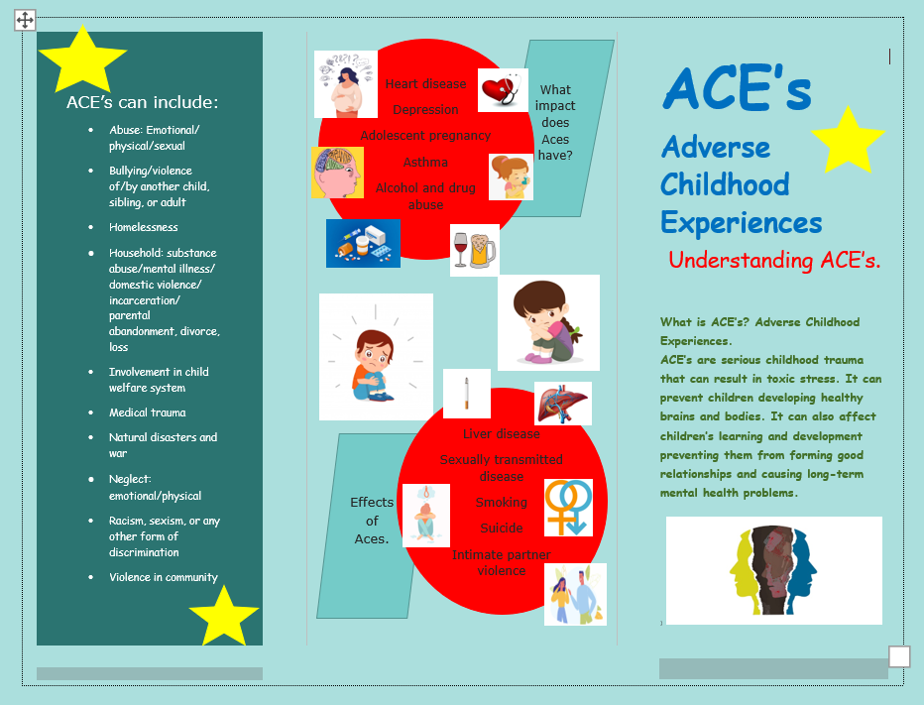

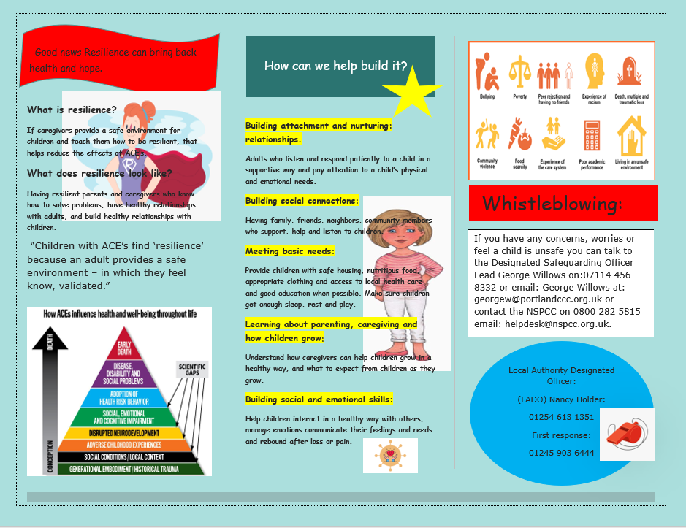
Rationale:
Adverse childhood experiences (ACE’s) are historically described as a series of ten traumatic events or circumstances that occur before the age of 18 and have been found in studies to increase the risk of adult mental health disorders and debilitating diseases. Five of the ACE definitions are known causes of child abuse and neglect, and are punishable by law, the other five are known forms of family dysfunctional that increase a child or young person exposure to trauma. (Asmussen, et al, 2020, p,6).
In this leaflet I am going to reflect and discuss the issues faced by negative implications which children and young people face due to being exposed to traumatic experiences throughout their childhood due to Adverse Childhood Experiences (ACE’s). This leaflet is aimed at educating people on ACE’s and help those affected by ACE’s. ACE’s are extreme childhood traumas that can lead to toxic stress. I have chosen this subject to highlight the effects of ACE’s on children and young people and the lasting affects in adulthood. Extended exposure to ACE’s can harm the brain and body of children and young person which may affect their overall health. Toxic stress can prevent a child from learning or playing with other children in a safe way and may cause long-term health problems. There is a growing concern throughout nations about damage caused from these ACE’s. There have been numerous studies undertaken and significant results show the negative long-lasting damage that can occur in adulthood as a result of the repercussions of childhood trauma. Public health Wales state that.
‘Children who experience stressful and poor- quality childhoods are more likely to experience poor mental health due to poor self-image and self-worth. They are most likely to adopt health-harming behaviours during adolescence which can lead to diseases such as cancer, heart disease and diabetes later in life’ (Adverse Childhood Experiences - Public Health Wales, 2021).
With the publication of the Childhood Experience Study (ACE) research findings in 1988, the relationships between childhood trauma and later adult well-being and behaviour were conclusively confirmed. ACE identified a connection between childhood experiences of abuse, neglect and family problems with related occurrence of chronic illness and mental health problems and health risks in adulthood. Changes in brain development and function tend to mediate this interaction. Harvard University and their Center on the Developing child reviewed current research on the genetics of human neurodevelopment and outlined a possible explanation for the ACE findings. Healthy, tolerant and toxic stress were invented by researchers there to identify, consolidate and communicate clearly the findings about the effect of differential stress responses, mild, moderate and traumatic events on the structure and development of the growing brain of the children (Sege and Harper Browne, 2017).
The child stimulates previous awareness and understanding during the early stages of development by processing new information. If a child is given enough opportunities to communicate with others, he or she can grow and learn social skills. Which brings me to Lev Vygotsky (1896-1934). Vygotsky placed a lot of importance on the role of the community and culture for the learning within the zone of proximal development in the learning process. He believed that knowledge and thought are constructed through social interaction with family, friends, teachers and peers. For Vygotsky, the environment in which children grow will influence how they think and what they think about (Mcleod, 2005). Bronfenbrenner also believes that the environment in which a child develops has a significant impact on their growth. He defines this as a two-way effect, in which the child’s attitude and behaviour influence how individuals in the child’s world deal with the child (Bates, 2019). However, Vygosky failed to consider those children whose home life is not at all perfect, those subject to poverty, neglect, abusive relationships and social interaction whereas a result causing truancy and behaviour problems with a school environment.
Welsh Governments main findings show leaders, teachers and support staff to have a better understanding of a child with ACE’s. They state that school best supports pupils with ACE’s and other vulnerable pupils because they know their pupils well and provide a safe and nurturing environment where pupils can feel happy (Knowing your pupils supporting your pupils with Adverse Childhood Experiences, 2020). Schools work hard to enhance the wellbeing of all its pupils. My educational setting fully recognises the contribution it makes to child protection. There are three main elements to their policy; prevention through teaching and pastoral support offered to students; procedures for identifying and reporting cases, or suspected case, of abuse. Because of our day-to-day contact with the children school staff are well placed to observe the outward signs of abuse; support to students who may have been abused (Penglais school 2020). There is well considered Universal provision for building resilience where there is structured specialised support and intervention for those who need it the most. Unfortunately, the recent pandemic and disruption to children’s education is likely to have significant long-term consequences with research stating that school closures may have a more negative outcome than positive. For some children, they will remember the recent pandemic and school closures as a positive getting to spend quality time with parents and playing board games. However, with schools being the major contributor to reporting ACE’s Public Health Wales along with Violence Protection Unit (VPU) have written an interim report and state that the measures put in place to protect children from ACE’s have been extremely difficult without that face-to-face contact. For many children and young people, the school closures mean the loss of the connectivity with a trusted adult and maybe the only support network in their life (Newbury, et al,2020 p, 10). A summary found whilst restrictions and two-meter distance has been essential for the health of the population, for some individuals there has been more exposure to harm within the home and reduced access to services for support (Newbury, et al, 2020 p, 2, 10). Schools will play a significant role in helping children recover from the pandemic. Once pupils return to school, there will be a substantial demand on teachers to recognise children who have experience trauma, control a surge in disclosures, promote pupils’ mental health and well-being and catch up on missed learning. Schools often work with third sector organisations who help support and provide interventions for children and young people.
Lord Laming produced new recommendations after serious failures within the system failed to protect children from significant harm. Lord Laming said, “Keeping children safe and promoting their well-being is a responsibility of us all, but more needs to be done”. Following the failure of various children, 108 sweeping recommendations and modifications were made to the child protection system. This is in response to the professionals who were made accountable for the care of those children for example Victoria Climbe who came to significant harm. The recommendations include the creation of a children and family board; a children’s commissioner; new local authorities management boards and the creation of a national children’s database (Lord Laming's report on child protection, 2009). Laming (2009) also wants to make sure children get the support as early as possible to prevent problems escalating and creating a risk of serious harm.
So, to conclude, through research and evidence provided we have learnt that childhood abuse has a lasting effect on children and young people, according to studies children’s growth can be affected and disrupted by ACE’s which can lead to cognitive, emotional and behavioural deficits. Children who have been exposed to ACE’s are less likely to do well in school and are more likely to engage in health-harming habits such as smoking, substance use and alcohol dependence while still in their teen years. Furthermore, exposure to ACE’s may have a variety of health consequences, including decreased mental well-being and an increased risk of chronic diseases (Newbury, et al, 2020 p,28). Universal screening is now taking place to help inform practitioners to increase public awareness of childhood adversities and help individuals to access the necessary support. Governments have increased their expenditure in these screenings over the last five years with the intention of avoiding or reducing ACEs at the population level. For example, the state of California recently pledged $95 million to implement ACE screening across primary care providers throughout the state. In the United Kingdom, the governments of Wales, Scotland and Northern Ireland are introducing informed care training to all frontline workforces. ACE’s informed care aims to help the stress associated with ACE-related trauma and increase children’s resilience (Asmussen, et al, 2020 p, 13).
Following Lord Laming proposals, there has been improvements in children’s services, legislation and policy, one of which was the green paper Every Child Matters (ECM). Existing plans are strengthened using four main themes of; support; early intervention; issues solved from previous failure and adult training (Laming, 2003).
We are yet to know what impact the pandemic has had on the children and young people. There is now a need to put these children in the centre of the recovery plans. More investment must be put in place to support more research into the effects of lockdown. Whilst some children have adapted well there are many children who have been trapped in home environments with risks of exposure to ACE’s (Newbury, et al, 2020, p, 30).
Finally, while this leaflet and rationale informs you about ACE’s and the research and reports of policies and recommendations that are in place early intervention can in the end provide a way to reverse the impact of childhood hardship, as well as rigorous safeguarding training to identify signs of violence in children and adults, allowing for early intervention before a traumatic experience causes life-long disruption. Preventing measures to improve resilience in the child are notable, as is focus on the parent or caretaker. Targeting the parent or caretaker to provide a safe, stable nurturing relationships may mitigate toxic stress response in children because as we know if the appropriate support is not provided for these individuals it can be passed on to future generations. Therefore, it is important that in order to address the ever-increasing population subjected to such negative incidents, support must be offered not only to the victims of ACE’s but also to those who encourage the violence.

References:
2021. [image] Available at: <http://clipart-library.com/hospital-heart-cliparts.html> [Accessed 22 February 2021].
2021. [image] Available at: <http://clipart-library.com/mother-cliparts.html> [Accessed 22 February 2021].
2021. [image] Available at: <http://www.tipstotricks.com/how-to-improve-liver-function-naturally-at-home-importance-of-liver-in-body/> [Accessed 22 February 2021].
2021. [image] Available at: <https://clipartstation.com/illness-clipart-11/> [Accessed 22 February 2021].
2021. [image] Available at: <https://tulsaworld.com/news/local/aces-research-panel-describes-how-workplaces-can-help-oklahomans-heal-from-trauma-permeating-the-state/article_b6c89f6a-06f4-54a3-8c09-bdb12eeeffc5.html> [Accessed 3 March 2021].
2021. [image] Available at: <https://www.dreamstime.com/illustration/sad-pregnant-woman.html> [Accessed 22 February 2021].
2021. [image] Available at: <https://www.google.co.uk/search?q=Child+with+ACES&tbm=isch&ved=2ahUKEwju8vT3xP3uAhVC4oUKHVX6D0oQ2-cCegQIABAA&oq=Child+with+ACES&gs_lcp=CgNpbWcQAzoECAAQ> [Accessed 22 February 2021].
2021. [image] Available at: <https://www.google.co.uk/search?q=clipart+resilience&safe=strict&source=lnms&tbm=isch&sa=X&ved=2ahUKEwjmkZuhwP3uAhVnQkEAHWdpDdAQ_AUoAXoECBAQAw&biw=1360&bi> [Accessed 22 February 2021].
2021. https://www.istockphoto.com/illustrations/child-asthma. [image].
2021. https://www.kissclipart.com/cartoon-wine-and-beer-glasses-clipart-wine-glass-b-nxkn9m/. [image].
2021. The hidden risk factor. [image] Available at: <https://hesonline.com/2019/01/14/adverse-childhood-experiences-ace-influence-wellbeing/> [Accessed 22 February 2021].
Asmussen, D., Fischer, D., Drayton, E. and McBride, T., 2020. Adverse childhood experiences: What we know, what we don't know, and what should happen next. [online] Early Intervention Foundation. Available at: <https://www.eif.org.uk/report/adverse-childhood-experiences-what-we-know-what-we-dont-know-and-what-should-happen-next-> [Accessed 26 March 2021].
Bates, B., 2019. Learning theories simplified. 2nd ed. London: Sage publ., p.194.
Bretherton, I., 1992. (PDF) The Origins of Attachment Theory: John Bowlby and Mary Ainsworth. [online] ResearchGate. Available at: <https://www.researchgate.net/publication/232490779_The_Origins_of_Attachment_Theory_John_Bowlby_and_Mary_Ainsworth> [Accessed 25 March 2021].
Dreamstime, 2021. [image] Available at: <https://www.dreamstime.com/illustration/sad.html> [Accessed 22 February 2021].
Familylaw.co.uk. 2009. Lord Laming's report on child protection. [online] Available at: <https://www.familylaw.co.uk/news_and_comment/lord-laming-s-report-on-child-protection> [Accessed 28 March 2021].
Gov.wales. 2020. Knowing your pupils supporting your pupils with Adverse Childhood Experiences. [online] Available at: <https://gov.wales/sites/default/files/publications/2020-01/knowing-your-children-supporting-pupils-with-adverse-childhood%20experiences.pdf> [Accessed 23 March 2021].
Hughes, M., 2020. Policies and Procedures | Ysgol Penglais School. [online] Penglais.org.uk. Available at: <https://penglais.org.uk/about-penglais/policies-and-procedures/> [Accessed 28 March 2021].
Keeping Children Safe. 2021. The child safeguarding standards. [online] Available at: <https://www.keepingchildrensafe.global/accountability/> [Accessed 25 March 2021].
Mcleod, S., 2005. Lev Vygostsky's socialcultural theory. [online] Simplypsychology.org. Available at: <https://www.simplypsychology.org/vygotsky.html> [Accessed 23 March 2021].
Newbury, A., Barton, E., Snowdon, L. and Hopkins, J., 2020. Understanding the Impact of COVID 19 on Violence and ACEs Experience by children and Young People in Wales. [online] Northwalessafeguardingboard.wales. Available at: <https://www.northwalessafeguardingboard.wales/wp-content/uploads/2020/12/Understanding-the-impact-of-COVID-19-on-Violence-and-ACEs.pdf> [Accessed 26 March 2021].
Phw.nhs.wales. 2021. Adverse Childhood Experiences - Public Health Wales. [online] Available at: <https://phw.nhs.wales/topics/adverse-childhood-experiences/> [Accessed 12 March 2021].
Sege, R. and Harper Browne, C., 2017. Responding to ACEs With HOPE: Health Outcomes From Positive Experiences. [online] https://www.academicpedsjnl.net/article/S1876-2859(17)30107-9/pdf. Available at: <https://www.academicpedsjnl.net/article/S1876-2859(17)30107-9/pdf> [Accessed 26 March 2021].
www.nhshighland.scot.nhs.uk/Publications/Documents/DPH-Annual-Report-2018_(web-version).pdf

