Early Intervention connections:
“What can we see today?”.
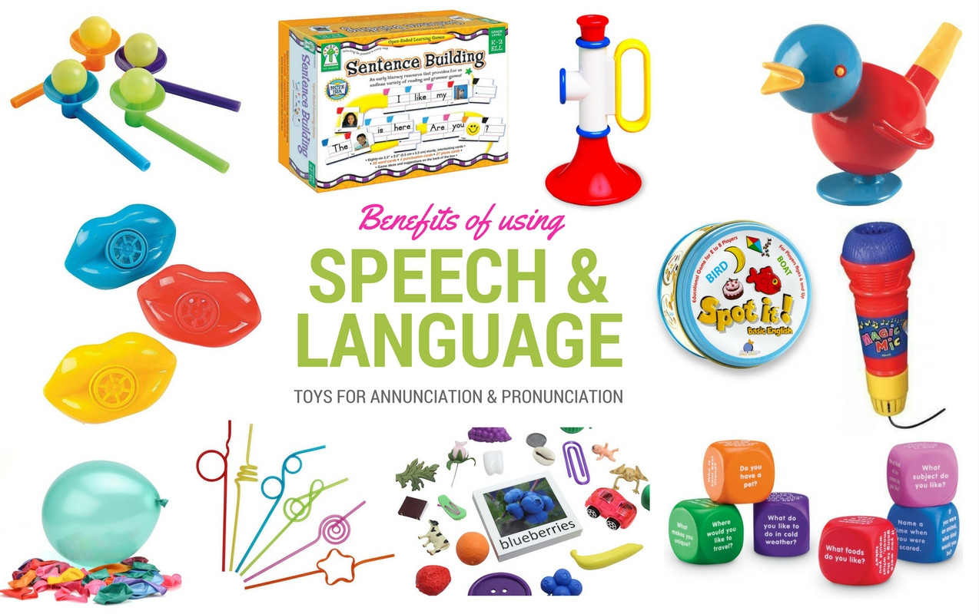
(Source: www.ilslearningcorner.com ,2018).

“What can we see today?”

Part 1 Introduction:
Language difficulties are greatly recognized within the early years sector with over one million children around the UK experiencing some form of delay with communication and language skills. This can be due to a many different reasons, some of which can be easily identified and dealt with, offering a good outcome for language development. However, some language difficulties are not easily corrected and some children will need the input of outside professionals for help and support in order to improve their skills. When handling language communication delays, it is crucial to observe the specific child carefully to look for indicators and clues to why they may be having problems (Kimberly,2016). This is why I chose this topic of speech and language to design a program called ‘what can we see today?’ which is designed to implement a speech and language information pack which is suitable to use from birth to 8 years, which is versatile so it can be used both at home and in setting and can be adapted to be used in and out doors, so it is inclusive for everyone and varying circumstances. As I feel that early intervention is key to reducing the number of children in the UK having speech and language delays and children that do have these delays addressed and cater for with the appropriate measures put in place. The purpose of this program is for people to be able to use every day experiences and real object and materials to encourage and implement speech and language through gestures, sounds, word formation, using techniques such as modelling, commenting and questioning. Once they achieve each stage of progress their outcomes would be reviewed and their next level of program would be set to continue their speech and language development learning journey. The reason for implementing this program is due to my passion in making a difference to children’s speech and language development from an early age to try and reduce anxieties, frustration and other emotional challenges, as speech and language difficulties in children seem to be ever increasing year on year which I find very concerning as an early years practitioner, also from my personal experience of my nephew struggling with speech and language delays from an early age where he was first given support from a speech and language therapist, then once he arrived at school age he had to attend a specific unit within a school setting out of his catchment area as their were no facilities available closer to his home, but as a result of him attending an intense speech and language program which was implemented both in setting and at home after two terms he was able to return to mainstream school with his peers and family members.
Why your idea is innovative?
The speech and language program that has been designed is innovative as it is easy to use and accessible and is designed to make a difference to children’s speech and language development. As Sinclair (2007, cited in Leadership in Early Childhood: The Pathway to Professionalism,2013) states that innovation is followed through via a leader who has a passion to make a difference to enhance the lives of the children within their settings. Which is the main purpose of the program ‘what can we see today?’ as we need to transform challenges into positive outcomes, change risks into rewards, values into action, vision into real life experiences and change barriers into innovation. However, a good leader is not a case of being a hero, but its how they behave in a way that supports the enrichment of empowerment, and well-being of others and the environment as a whole (Rodd,2013).
How to link to Early years?
Through this speech and language program’ what can we see today?’ oral language development in the early years and pre-school settings is vital to educational progress and provide the building blocks for the children’s overall development of language and literature skills. Furthermore, it has been proven that children who are part of intervention groups show positive outcome in all areas of communication. As early intervention for children with specific verbal language delays has proven to be successful and efficient in the support for the children (Fricke et al, 2012). Furthermore, the progression and use of speech, language and communication are at the heart of young children’s learning. As majority of teaching is delivered orally; and children need good communication skills to socialize with peers, to take part in group activities and to develop a good level of thinking skills. Children’s further progress and achievements is very much focused on their ability to communicate effectively. It is therefore vital that as educators we do everything possible to support children in becoming talented and confident communicators (ICan,2008).
Benefits of program?
Through planning this program as a professional I can liaise with parents from a very early age to identify barriers and also improve outcomes to facilitate adequate responses to progress development concerns, appropriate referrals, and appropriate interventions (Adelman et al, 2017). Furthermore, through children being part of a program like this from birth it has been proven that children gain better outcomes than peers not receiving this support. The reason for good outcomes is due to having joint input with parents, as it has been shown that through excellent parental involvement children complete the course quicker and maintain long-lasting outcomes (www.kidshealth.org ,2015).
How benefits link to early years development?
The main aim of this speech and language program is to improve communication. Through the early intervention of this program it is designed to improve skills which will enable a child to communicate more effectively, others benefit of this program also include progress in the ability to understand and express thoughts, ideas and emotions, also to enable children to problem solve in some independent surroundings. The ability for a child to express themselves is crucial. Early intervention programs such as this makes it possible for children to use and understand language, to communicate with others and express themselves to the greatest point possible (www.mychildwithoutlimits.org ,2018).
Discuss challenges & barriers of my idea?
Parents find it difficult to address the fact that their child has a specific issue or delay, which can have a significant impact on the child involved as parents sometimes delay interventions being put into action such as speech and language therapy, which in turn heightens the risk of opportunities being missed such as the crucial window of time from birth to three years of age when a child’s brain is develops and learning happens rapidly. Furthermore, other concerns of a practical nature must be considered, such a speech therapy is a drawn-out process for both parent and child. This can be difficult for families and adds to stress levels as they are already tirelessly trying to deal with the child’s therapy regime. In designing this program, it was important for myself to consider achievable outcomes with the advice of the therapists. These outcomes must be reviewed on a regular basis to assess progress (www.mychildwithoutlimits.org ,2018). Furthermore, other barriers which may affect the implementation of this program could be a lack of funding and time scales. Also, a recent communication trust is now stating that lack of training can also be a contributing factor, so they are suggesting that all staff in early years settings have basic speech and language training, part of this training should enable staff to implement strategies so they can work with parents on enhancing their knowledge and understanding of speech and language programs. The communication trust also suggest that early years settings should have a minimum of one staff member who is level three qualified in speech and language and a time scale through the local government for this to be in place should be set (Morton,2017).
Consider audience (stakeholders, children and staff)?
Margaret Donaldson (1992, cited in Cultivating Creativity: for babies, toddlers and young children,2011) enforces the importance of adults in children’s learning. Furthermore, she warns against forced approaches to learning, verbalizing the need for children to spend time with grown ups who ‘do not remain at a set point of view’(Bruce,2011). Which is why through this program ‘What can we see today?’ it has been designed as a easy to use working tool which can be used by professionals, staff and children alike to develop and enhance speech and language difficulties through hands on approaches while also at times following the child’s lead. It is also a manageable tool for stakeholders as it is low cost to implement (www.rcslt.org ,2018).
Why are you best person to carry this idea out?
Through working within the early years sector, I have received continuous training around speech, language and communication which has enabled myself to be able to identify and support children with these needs, using the skills gained to enhance their development through putting action plans into place and monitoring the progress of the individual child to best plan their future progress (Morton,2017).

Part 2.
The I Can report ‘The cost to Nation of children poor communication’ (2006, cited in The National Strategies Early Years: Inclusion development program Supporting children with Speech, language and communication needs: Guidance for practitioners,2008) states that is some areas more than 50% of children start school with transient language or communication delays. However, if children gain the correct support such as the ‘what can I see today?’ program they are likely to catch up to the correct level for their outcomes and their difficulties may not become a permanent delay. This in part lays in the responsibilities of early years workers to identify children’s needs and put in place appropriate measures as early as possible, to help children achieve their desired outcomes of ‘every child matters’ and progress to early learning goals. As the importance of early intervention and early language and communication development for children’s outcomes later on is now greatly documented (www.idponline.org.uk ,2008).
Implementing this program ‘what can we see today?’ from birth has good outcomes for children as children need good language skills as there are strong similarities between cognitive and language development. The strong link to cognitive progress means that focused activities which improve children’s vocabulary and allow them to explore different ways of using language will make it possible for children to develop complex ideas and thinking skills. Furthermore, if children are to be skilled communicators they need to be apart of programs like this to learn how to use language in varying ways (Tassoni and Tucker,2000). Furthermore, language skills are the development of communication skills which children develop through ‘what can we see today?’. These skills consist of receptive speech- which is the level of understanding a child has, expressive speech- are the words children can say and articulation- the way in which children verbalize the words (Meggit,2006). Furthermore, Bandura (1977, cited in Applications of Vygotsky’s learning theories in Early Years,2015) states that majority of human behavior is learned through observation through modelling: from observing the people around them, through children doing this they see behaviors being modelled then use memory recall to use it in action at a later date(www.ukessay.com). Which is the basis of this program to model language for children through play-based activities as children learn through play. Having high level planned experiences for children’s play is a crucial way for early years professionals to support children’s development that is both enjoyable and challenging. When children play there is overwhelming evidence that they learn at the highest level. Play can extend areas of learning such as developing language skills through encouraging verbal responses between peers or introducing new words that children use and role play into their game (www.earlyyearsmatters.co.uk ,2018).
As people we all need to communicate with each other, yet how we do this may vary depending on our personal development, and cultural backgrounds as through the foundation phase which is the curriculum for early years in wales we incorporate welsh language into our daily routines and curriculum, this is also implemented into the speech and language development programs such as ‘what can we see today?’(Welsh Government,2015). Which is why the implementation of speech and language programs and early interaction is crucial, as language properly starts to form in late infancy; and yet within a short space of three years the child will of developed systems of linguistic methods that they use to express their need, both physical and cognitive; and, in addition will form sentences with appropriate meaning, and their vocabulary will increase dramatically(McCarthy,1933). Furthermore, Vygotsky (1986, cited in Application of Vygotskys learning theories in Early Years,2015) states that social interaction is at the center of cognitive development and speech. It is through the need to communicate with one another that both speech and thinking develops and, according to Vygotsky, this lays the building blocks that eventually form personal brain functions. This leads to egocentric speech which in turn transforms into ‘inner speech’ (www.UKessay.com ,2015).
A recent survey of the children and young peoples workforce identifies a specific barrier which would affect children’s skills which is that there is a great lack of training given to early years staff on children’s speech, language and communication needs. The communication trust questionnaire of 1,200 of its members identify that more than half of the workforce have been given ‘little’ or no learning in their basic training about typical speech, language and communication development, of these 49 per cent work within the early years sector. This is evident in spite of speech, language and communication being made a mandatory part of the early years educational training criteria for practitioners in 2010(Morton,2017). Furthermore, Attenborough (2003, cited in The Excellence of play,2005) states there are many barriers to overcome in providing experiences for young children to develop language and literacy skills. The children themselves could be experiencing larger challenges both personally and socially. Furthermore, parents sometimes ‘lack the self-esteem and knowledge to put into to practice good parenting skills, such as attentive listening, singing songs, sharing books and playing rhyming games (Moyles,2005). However,there are also many challenges which can affect a child’s language development which must be considered these consist of hearing impairments, a lack of language understanding, in some cases an event can occur where a child regress and becomes a selective mute, also children with medical conditions can have an oral motor disorder, finally there is also the lack of pragmatic or social development(Kimberly, 2016).
Within early years inclusive communication is about best practice within the speech and language sector. Its also about keeping in mind the human right issue. Its implementation is set within a framework of international and national laws which support the rights of individual children and set out key responsibilities of early years providers and other professionals. The crucial legislation relates either directly to speech and language or to individual children’s rights to verbalize their needs and to take part effectively. Which is at this stage where we keep in mind the United Nations Rights of the Child (1992, cited in Key Legislation for inclusive communication,2018) which states that according to article 12 we must respect the opinions of the child furthermore, article 13 states that children should have the freedom of speech, which gives equal rights to all children and enables them to express themselves and make sense of information in the best way they know how. However, all UK Government policies and practices must encompass the Convention, which was corrected in the UK in 2009, which states that children with specific needs should receive the same support as their peers in having their rights respected and addressed, furthermore, countries must ensure that children with specific needs have the right to find out and gain information and to have their needs addressed, the same as everyone else. Countries must ensure that information is accessible to children with specific needs from the very start (www.rcslt.org 2018).
Prentice (2000, cited in Creativity in the early Years,2017) states that it can be challenging within the structure of early years education, with the requirement of the curriculum to meet goals that have to be maintained, to encourage creative thinking, in ways of not having the right environment to embrace the conditions needed to encourage creative thought and action. We need to further work on altering the narrow thinking of the way the setting needs to meet curriculum and attainment goals, and ’right’ answers, dominated thinking and learn to make way for new practices such as creative thinking and embrace it into the learning ethos (www.ukessay.com ,2017). Furthermore, Runco (1998, cited in The Standard Definition of creativity,2012) states that effectiveness may take the form of value. This label is very clear within the economic research on creativity; it explains how standard and valuable resources and ideas fair on the current market place, and furthermore on the cost and benefits of uniqueness (Runco and Jaegar,2012).
At present this program ‘what can we see today?’ is currently being piloted within a small number of early years settings within the local area, however, should the feedback show positive outcomes for speech and language development for children of all abilities, we would then aim to role it out to providers within the rest of wales and the UK to make it available as a national program. Currently funding options are being researched to make this a possible option (Welsh Government,2018).
This speech and language program ‘What can we see today?’ can be implemented from birth within the home and across settings, as the need to address early intervention speech and language is in high demand due to ever increasing numbers of children with speech and language delays. As evidence from early years professionals suggest that many children coming in new to early years settings, specifically those from less fortunate back grounds, may not have a wide range of verbal vocabulary skills needed to aid their speech, language and literacy learning. More than half of the new intake of children are being identified as having language difficulties, however girls were identified as having a higher level of language development than boys (Locke et al,2009). However, some suggest that the ability to learn language is an inherited skill. Furthermore, other are under the opinion that language is learnt following birth and is due to their natural surroundings, which is supported by F.B.Skinner (1957, cited in Theories of language development Chomsky and Skinner,2015) states that children develop language through the influence in their surroundings. Skinner supports this program ‘what can we see today?’ as it two is based on early intervention from birth the attention, input and pleasurable reactions babies gain from parent when they make a sound or utterance. Skinner suggests this way would eventually the child would learn to speak and use language. The child responds to smiles and approval of parents. Skinner also suggested that this is operative conditioning; the continuity of occasional response by reward (www.markedbyteachers.com ,2015).

Adelman, A., Keston, S.M. and Marshall,J.(2017) ‘Parents experiences navigating intervention systems for young children with mild language delays’, Journal of early intervention, volume 39, issue3. [online]. Available at: http://www.ezproxy.uwtsd.ac.uk [Accessed: 2nd July 2018].
Bowyers-Crane,C., Haley,A.J, Hulme.C. and Snowling,M. J. (2012) ‘Efficacy of language intervention in the Early Years’, volume54, issue3,pp.280-290. [online]. Available at: http://www.onlinelibrary.wiley.com [Accessed: 10th July 2018].
Bruce, T. (2011) Cultivating creativity: for babies, toddlers and young children. (2nd ed). Oxon: Hodder education.
Csikszentmihalyi, M. and Perennial, H. (1997) Flow and the Psychology of discovery and invention: Creativity. [online]. Available at: http://www.doc.uments.com [Accessed: 26th June 2018].
Early Years matters. (2018) ‘The importance of play’ http://www.earlyyearsmatters.co.uk [Accessed: 12th July 2018].
Hucker, K. and Tassoni, P. (2000) Planning Play and the Early Years. Oxford: Heinemann.
Ginsborg, J., Locke, A. and Peers, I. (2009)’Development and disadvantages: Implications for the early years and beyond’ pp.3-15. [online]. Available at: http://www.tandfonline.com [Accessed:30th June 2018].
Giving voice. (2018)’What is speech and language therapy’ http://www.rcslt.org [Accessed: 30th June 2018].
ICan. (2008) ‘The National Strategies Early Years: Inclusion development programme supporting children with speech, language and communication needs: guidance for practitioners’ http://www.idponline.org.uk [Accessed :1st July 2018].
Jaegar, G.J. and Runco, M.A.(2012) ‘The Standard Definition of creativity’, Journal creativity research, volume 24,issue1,pp.92-96. [online]. Available at: http://www.tandfonline.com [Accessed:29th June 2018].
Kimberly. (2016) ‘What are the main reasons a child may experience language delay’ http://www.earlyyearscareers.com [Accessed: 1st July 2018].
Learning corner. (2018) ‘Benefits of speech and language’ http://www.ilslearningcorner.com [Accessed: 5th July 2018].
McCarthy, D. (1933) ‘Language development’ http://www.psycnet.apa.org [Accessed: 5th July 2018].
Meggitt, C. (2006) Child Development. (2nd ed). Oxford: Heinemann.
Morton, K. (2017) Lack of SLC training for early years and school staff. London: MA Education. [online]. Available at: http://www.nurseryworld.co.uk [Accessed: 30th June 2018].
Moyles, J. (2015) The Excellence of Play.(2nd ed). Berkshire: Open University press.
My child without limits. (2018) ‘Outcomes benefits and drawbacks of speech therapy’ http://www.mychildwithoutlimits.org [Accessed: 12th July 2018].
No name. (2015)’speech-language therapy’ http://www.kidshealth.org [Accessed: 30th June 2018].
No name. (2015)’Application of Vygotskys Learning Theories in Early Years’ http://www.UKessay.com [Accessed: 30th June 2018].
No name. (2015)’ Theories of language development Chomsky and Skinner’ http://www.markedbyteachers.com [Accessed:29th June 2018].
Rodd, J. (2013) Leadership in Early Childhood: The Pathway to Professionalism. (4th ed). Berkshire: Open University Press.
Royal college of speech and language. (2018) ‘Inclusive communication key legislation’ http://www.rcslt.org [Accessed: 3rd July 2018].
Welsh Government. (2015) ‘Curriculum for Wales: Foundation Phase Framework’ http://www.learning.gov.wales [Accessed: 12th July 2018].
UK essays. (2017) ‘Creativity in the Early Years’ http://www.ukessay.com [Accessed: 29th June 2018].

