Major Project Brief

Title- Midnight Blush

Key words: floral, garden, foliage, Slovakia meets English Countryside, countryside, homely.

During my time in university I have always been drawn to drawing flowers, and creating floral designs. Design companies, such as Graham and Brown, Sanderson, and Laura Ashley, create very sophisticated interior designs, but they also stick to quite neutral tones, whereas I like bringing in brighter colours, inspired by design companies such as Timorous Beasties.

Over summer I spent a month in Slovakia for an internship, during my time there I stayed in a very remote rural village, surrounded by rich countryside, including loads of flowers and a huge range of wildlife. The contrast between the nature I experienced there and the beauty the countryside in Britain has to offer kick-started my initial idea of combining both components.

I want my interior collection to reflect a really homely, country house vibe. Therefore, I want my collection to be full of floral and foliage at the centre. I like the idea of have my designs built up of two layers, this concept all gives a lot of scope for a variety of different types of patterns from statement ones to basic repeats.

I will use a lot of the images and sketches I have form my time in Slovakia, but this is unlikely to be enough to go off of for the length of this project, therefore, I will go to places such as Plantasia (avoiding any plants too tropical), Singleton Park Botanical Gardens, and Margam Park. These are all places with a lot of plants, wildlife, or architecture which I can use to expand on the images and material I already have.

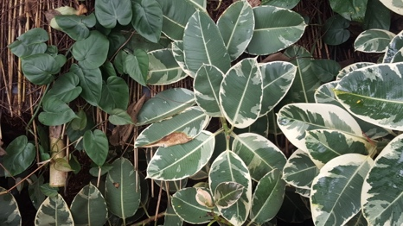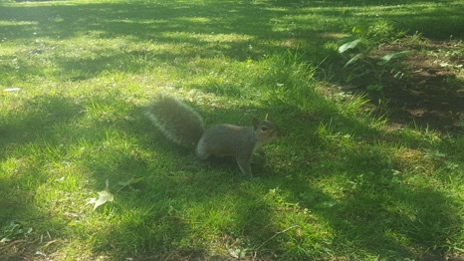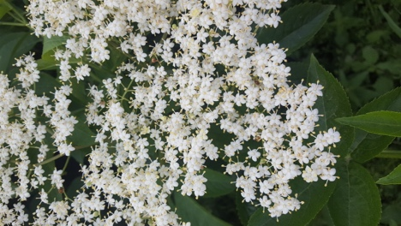

When it comes to the kinds of processes I want to use in this project I am quite open at the moment to using a range, before settling on the ones I will carry through into my final piece. I want to carry on experimenting with screen printing, during ACE I enjoyed the process of just using two colours to build up a design, and maybe bringing digital embroidery on top of it to create texture. During the Mission Gallery live brief I really enjoyed making lampshades, and as disappointed I couldn’t include digital embroidery into the design. Therefore, this is something I am interested in having more time to experimenting with this time.

I have chosen to design my collection for Iscoyd Park period property, which is situated in Shropshire. I read an article a few months back about how this period property mainly used to host weddings was given a makeover to bring a modern feel to contrast the period features. I really liked the small touches to furnishings they added, yet still ensuring it feels homely. A lot of the rooms also contain floral patterns, so I think the work I am planning on design will work well. Therefore, I have decided to target my collection towards this property.

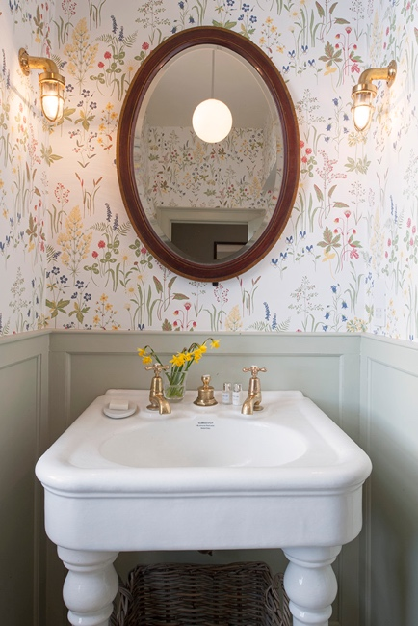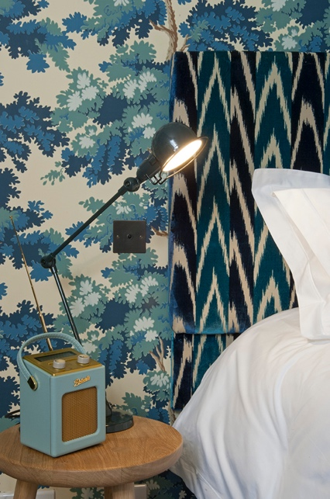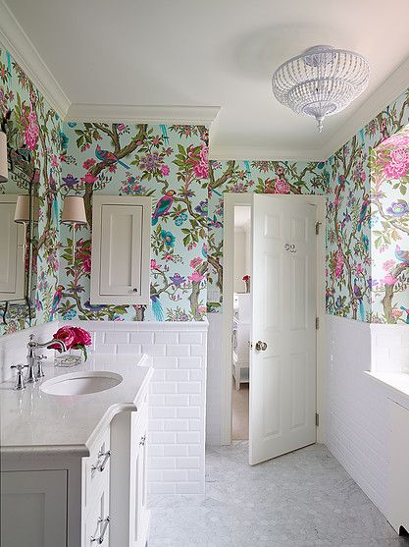

At the moment I am not 100% sure what I want to make for my final collection. I would love like to produce hand printed and digitally printed wallpaper samples and lengths. I really enjoy design lampshade, and have produced some for my final piece in second year and for the Mission Gallery live brief, and think this will also come into this project.

Week: | Tasks:
29th Jan | Tutorials with all lecturers to establish idea. Gather extensive research, secondary and primary. Start to draw from all images gathered.
5th Feb | Continue to draw from research, before the end of the week have a collection of strong drawings in and out of sketchbook. Work with coloured grounds, collage and paint. Decide on colours. Prepare a screen and start to produce some screen printed samples experimenting with a range of materials.
12th Feb | Use digital embroidery machine to work back on top of screen printed samples. Produce some sewn samples, play around with composition with materials. Source some acrylic from somewhere. Create some designs from drawings so far.
19th Feb | Laser cut acrylic. Go out and take pictures of laser pieces in floral places, play around with composition.
26th Feb | More screen printing experimentation, produce a new image for a new screen, play around with two colour printing. By this time I will have probably used a lot of the drawings I have at this point, so I will add to my sketchbook, so I don’t grow bored of the material I already have.
5th March | Spend this week creating a strong collection of designs, primarily on Photoshop. Produce them all in a variety of colour ways, and play around with different types of patterns. Statement, Co-ordinates, floral, and geometric, etc..
12th March | Reflect on what I have made so far, calculate what has worked well, what I could develop more and what things haven’t sparked much inspiration.
19th March | Develop all work to date, a few more material experiments, just expand on what I have already created.
26th March | Plan and get feedback on what I have planned for final pieces, and use rest of the week to prepare everything ready to start making it all during the Easter break when the other years are not in Uni. Work out costing.
2nd April | (Easter) Start marking (screen printing, digital printing, digital embroidery, laser cutting)
9th April | (Easter) Carry on making (screen printing, digital printing, digital embroidery, laser cutting)
16th April | (Easter) Carry on making (screen printing, digital printing, digital embroidery, laser cutting)
23rd April | Carry on making (screen printing, digital printing, digital embroidery, laser cutting)
30th April | Carry on making (screen printing, digital printing, digital embroidery, laser cutting)
7th May | Finish up everything
14th May | Set up show

