Poster competition reflection notes

The purpose of this reflective essay is to provide insight about the poster competition presentation. This is to draw a better understanding of the outcome of the presentation. The experience will be analysed along with all the positive and negative elements so that the experience itself will be improved for future similar experiences.
Two weeks ago, me, Dan Andronic, and three of my colleagues had a presentation on a poster to do. To comprehend exactly as to what happened, during that day, I’ve studied each and every one of my colleagues in their presentation.
Needless to say, is that not everyone has had a peak performance in presenting their parts of the slide and I think that we could’ve organized better with the allocated time and not only that, but we’ve could have structured the slide in the presentation much better.
We were asked to critically assess the core values of different companies.
The company that I choose to speak about, and its core values was Amazon. By applying the RED Critical Thinking Model (Recognize, assumptions, Evaluate Arguments, Draw conclusions) I’ve realized that Amazon’s core values are not to be trusted entirely due to the fact that, for instance, amazon’s core value “earn trust” has some major flaws in it. By treating the company’s employees and customers with respect, it helps to build trust. That is not the case with Amazon as in the past there were some major issues from this point of view, which some of them resulted with the fatalities of some workers in Amazon due to the lack of integrity and trust.
By applying Gibb’s reflective style theory on to the presentation of the poster, we can draw a better understanding as to how it helped me learn better the whole outcome of the presentation itself.
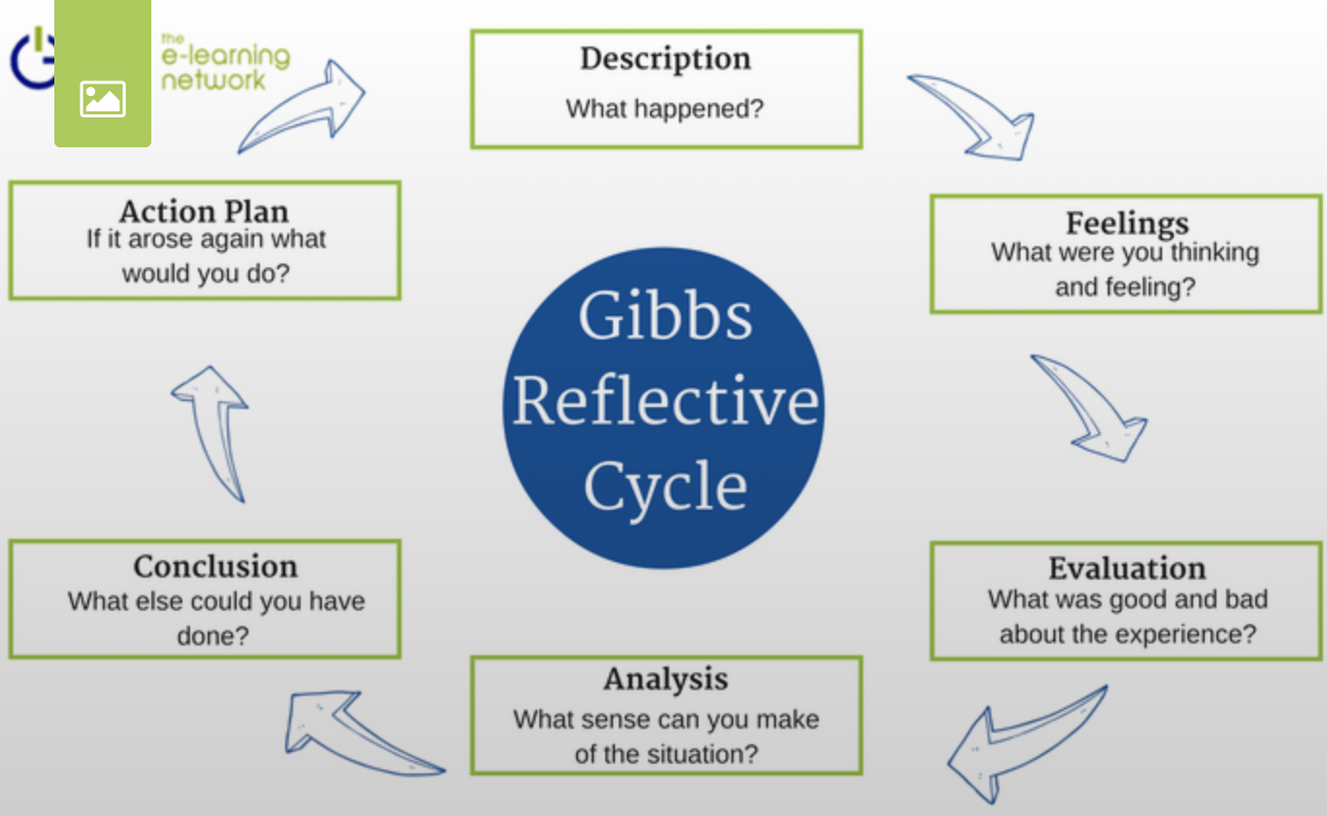
Starting off with the description from Gibb’s reflective cycle theory we’ve prepared for the presentation to our best knowledge. As stated in the beginning of these reflection notes, we had to critically asses the core values of a company of our own choosing. It all happened within our University classroom in front of the class. During our presentation of the poster the teacher was taking notes of how we were doing and other colleagues payed their attention to us and all together reacted really well with a round of applause after each of us finished our part. Not all of us have had peak performance about the whole poster presentation, but in the end, we managed to finish the presentation, some of us better than others.
The feelings that I have had during the presentation were some of nervousness and tension up until I started to speak on my part of the slide and thereafter, they were gone. There was also tension building up at this very point because I only wanted to do well in presenting my part of the slide. The colleagues in the classroom that were paying attention, I think that they were really curious about what we had to say and how it will all be concluded. After the presentation was all finished, I felt a sense of relief and a big weight lifted from my shoulders.
The evaluation has had some good and bad outcomes. The fact that most of us read from our speaker notes instead of actually presenting the poster and speaking about it did not bode well for the presentation. By reading the speaker notes word by word, some of us actually finished earlier than the allocated time given which I believe that it will have a negative impact on our markings. On the good side of things, some of us did not actually read the whole speaker notes and we managed to actually present our parts of the slide by speaking more about the poster than reading.
When it comes to the analysis part, the only overall sense that I have about the situation at hand is that of a good one. There haven’t been any major bad outcomes from this whole experience but actually a good one provided the fact that we got through it, overall in my own opinion, somewhere above average. Aside from that, there was also the experience that we’ve went through which will prove useful for future presentations.
Concluding what has happened in the presentation, I know for a fact that we’ve could’ve done more. We could have given more references about our critical assessments and we could have gone in more depth with some of the core values presented by the chosen companies thus having a better presentation than the one given with more based structure in the end.
By having an action plan for the future, it will further improve our presentation skills. As Confucius once said, “A man who does not think and plan long ahead will find trouble right at his door”. Therefore, in my own opinion, we could have planned this whole presentation much better by practicing at home more, meeting with my colleagues more frequently to discuss the importance of the key elements to be presented. The whole outcome of the presentation left me eager for the next one for I will look into the key elements more thoroughly, better organize my private time by setting up a time table and last but not least I will practice my speeches more at home to make sure I will fulfil the allocated time for the presentation.
To further improve this reflective essay writing I will align my core values with the ones of the company chosen by me which is Amazon.
My core values revolve around the words of simplicity, honour, justice, fairness, positiveness and common sense. Amazon’s core values are the following: customer obsession, invent and simplify, ownership, frugality, earn trust, insist on highest standards, deliver results. Honour, simplicity and fairness aligns directly with Amazon’s core values invent and simplify, earn trust, and ownership. Although the earn trust core value from Amazon does not actually live up to its name, it is still one of the greatest principles that I follow in life and therefore, for me to gain more trust in the company, Amazon needs to rethink this core value that they compiled in its list of core values. Suffice for me to say is that although Amazon has some flaws, I still think that this company can better itself in the future and would be a great working place for anyone that chooses to make a career in it.

References
Mindtools.com. (2009). Gibbs’ Reflective CycleHelping People Learn From Experience. [online] Available at: https://www.mindtools.com/pages/article/reflective-cycle.htm. [Accessed 06 Mar. 2020].
ELN.IO (2018). Graham Gibbs Reflective Cycle Model 1988. [online]
Available at: https://www.eln.io/blog/gibbs-reflective-cycle-model-1988. [Accessed 06 Mar. 2020].
Sainato, M. (2019). “Go back to work”: outcry over deaths on Amazon’s warehouse floor. [online] the Guardian.
Available at: https://www.theguardian.com/technology/2019/oct/17/amazon-warehouse-worker-deaths. [Accessed 06 Mar. 2020].
Oxbridge Essays. (2019). A complete guide to writing a reflective essay | Oxbridge Essays. [online] Available at: https://www.oxbridgeessays.com/blog/complete-guide-to-writing-a-reflective-essay [Accessed 06 Mar. 2020].
Unsw.edu.au. (2019). Examples of Reflective Writing | UNSW Current Students. [online]
Available at: https://student.unsw.edu.au/examples-reflective-writing [Accessed 06 Mar. 2020].
c) Copyright skillsyouneed.com 2011-2018 (2011). Critical Thinking | SkillsYouNeed. [online] Available at: https://www.skillsyouneed.com/learn/critical-thinking.html [Accessed 06 Mar. 2020].

