Student name: JAMIE LYON :2129405
Module BMPF7008 Module 3 Work based learning project.
Table of Contents
Project Proposal Form 3
1. Context: 3
2. Justification: 3
3. The Intended Impact: 4
4. The outlined intention 4
5. The Ethics and insider research 4
Personal Learning outcomes 5
References: 5
Introduction 7
Literature review 8
Group Singing 8
Early Research on Motivations in Community Choirs 9
Shifting Demographics and Motivations 9
Research in Ireland 10
Methodology 11
Ethics 12
Findings 13
Participant demographics: Who sings in the choir? 14
Age 14
Gender 14
Education & Experience 14
Choir demographics: In what choirs do they sing? 15
Location 15
Auditions and fees 17
Motivations 18
Why do they sing? 19
Community in the choir 23
Choir in the community 24
Opportunities to sing. 25
Benefits of community singing in County Wicklow 25
Summary of findings 29
Limitations and further research 31
Conclusion 31
References: 32
Appendix: 39
Appendix 1: Ethics form 39
Appendix 2: Survey 55
Appendix 3: Data Analysis 56

Project Proposal Form

  - Project Title: Wicklow Sings, an exploratory study into reasons why people engage in community singing in County Wicklow.

1. Context:

As the musical director of a large community choir and one of the Directors for the Wicklow Sings Festival, I have personally observed the thriving singing community in County Wicklow. This community was very apparent during the Wicklow Sings Festival, the most extensive choral event of its kind in the county (Buchanan, 2023). The festival which last took place in March 2023, showcased 13 amateur choirs from across the county, encompassing over 400 vocalists singing to a sold-out audience (WicklowNews.net, 2023). Despite this evident popularity for community singing in Co. Wicklow, coupled with the burgeoning body of research on the benefits of group singing (Williams et al., 2018; Fancourt et al., 2019; Camlin et al., 2020; Warran et al., 2022; Campbell et al., 2022; Więch et al., 2023), there remains minimal Irish-based studies specifically exploring the motivations behind participation. Given the lack of research on this vibrant community, the main aim of this project is to investigate the reasons that drive people to participate in community singing in County Wicklow.

2. Justification:

Irish based research by Hilitzer and Moss (2022) explored group singing for health and well-being, which led to the creation of the first national map of health and wellbeing singing groups in the Republic of Ireland. The study collected information from 185 singing groups across the country but only six groups responded from County Wicklow. Earlier research by Moss et al, (2018) explored the perceived health benefits of singing in a choir in an international mixed-methods study. While this study did have a high response rate from Ireland with 967 responses collected nationally, the report did not provide a breakdown of participants per county. Although this indicates that research on the perceived benefits of group singing in Ireland is continuing to grow, understanding the factors driving participation in community choirs in Wicklow have yet to be fully investigated. As the Wicklow Sings Festival is evidence of the popularity of community singing in Co. Wicklow, I believe further research is warranted to understand the reasons driving participation in community choirs in this county.

3. The Intended Impact:

Following a grounded theory approach, the intended impact of this research is to allow themes to emerge from the data, (Charmaz, 2014) providing a deeper understanding behind community choir participation in County Wicklow. The study aims to uncover key demographic information and initial insights driving participation specifically in County Wicklow. This preliminary investigation serves as a steppingstone for future research in this area, potentially contributing to local group singing recruitment strategies, improved engagement, and the promotion of overall community cohesion (Hendry et al., 2022). As a choir director, I believe these insights will be valuable not only to me but to the wider group singing community of County Wicklow.

4. The outlined intention

Beginning with a preliminary literature review, I will investigate studies which examine factors contributing to community choir participation, including available studies conducted in Ireland. By employing the structured yet flexible methodology of grounded theory (Charmaz, 2014), this study will explore emerging themes and patterns within the data, facilitating a comprehensive understanding of the factors that influence community choir participation. This study will utilize an anonymous mixed method survey primarily consisting of quantitative questions and optional qualitative summary questions. The survey will be electronically distributed to the Musical Directors of County Wicklow-based community choirs, who will further distribute it to their members. Additionally, the survey will be shared through Wicklow Sings and the Wicklow Arts Office social media platforms, ensuring a specific regional focus. A secondary literature review may be undertaken to support the findings.

5. The Ethics and insider research

As community choir director in County Wicklow and as one of the Directors of Wicklow Sings festival, I am highly aware of the unique insights I hold into the Wicklow singing community, while also recognising the potential for bias and conflicts of interest that can arise with insider research (Hewitt-Taylor, 2002). To mitigate these potential risks, I will employ rigorous and transparent methods during the collection and analysis of the survey data, with a strong focus on safeguarding privacy (Ma et al., 2019). The incorporation of triangulation between the literature review and the mixed methods survey will enhance the dependability and credibility of the results (Guion et al., 2011), and by engaging in ongoing self-reflection and practicing reflexivity, I will mitigate the risk of any power dynamics that may compromise the quality of data collected (Finlay, 2002). Ethical approval for this study was received from the University of Wales Trinity Saint David Ethics board as outlined in appendix 1.

Personal Learning outcomes:

- Enhanced knowledge of the choral landscape in County Wicklow
- Further understanding of participants motivation and experiences.
- Improved skills in mixed method research and data analysis.

References:

Buchanan, M. (2023) ‘Raise those voices as Wicklow’s largest singing festival returns for one night only’ The Independent, 10th February. Available at: https://www.independent.ie/regionals/wicklow/lifestyle/raise-those-voices-as-wicklows-largest-singing-festival-returns-for-one-night-only-42336844.html (Accessed 25th March 2023)

Camlin, H., Daffern,H. and Zeserson K. (2020) ‘Group singing as a resource for the development of a healthy public: a study of adult group singing,’ Humanities and Social Sciences Communications, 7(1), 1–15. https://doi.org/10.1057/s41599-020-00549-0

Campbell, Bodkin-Allen, S., and Swain, N. (2022) ‘Group singing improves both physical and psychological wellbeing in people with and without chronic health conditions: A narrative review’, Journal of Health Psychology, 27(8), 1897–1912. https://doi.org/10.1177/13591053211012778

Charmaz. (2014) Constructing grounded theory. (2nd ed.). SAGE.

Creswell, J., and Plano Clark, V. (2007) Designing and Conducting Mixed Methods Research. Thousand Oaks, CA: Sage

Denzin, N.K. (2009) The Research Act: A Theoretical Introduction to Sociological Methods. (1st ed.). Routledge. https://doi.org/10.4324/9781315134543

Fancourt, D., Warran, K., Finn, S., and Wiseman, T. (2019) ‘Psychosocial singing interventions for the mental health and well-being of family carers of patients with cancer: results from a longitudinal controlled study’ BMJ Open, 9(8), e026995–e026995. https://doi.org/10.1136/bmjopen-2018-026995

Finlay, (2002). Negotiating the swamp: the opportunity and challenge of reflexivity in research practice. Qualitative Research: QR, 2(2), 209–230. https://doi.org/10.1177/146879410200200205

Guion, L. Diehl,D and McDonald, D. (2011) ‘Triangulation: Establishing the Validity of Qualitative Studies’ EDIS, 8(3). Doi. /10.32473/edis-fy394-2011.

Helitzer, and Moss, H. (2022) ‘Group singing for health and wellbeing in the Republic of Ireland: the first national map’,Perspectives in Public Health, 142(2), 102–116. https://doi.org/10.1177/17579139221081400

Hendry, Lynam, D. S., and Lafarge, C. (2022) ‘Singing for Wellbeing: Formulating a Model for Community Group Singing Interventions’ Qualitative Health Research, 32(8-9), 1399–1414. https://doi.org/10.1177/10497323221104718

Hewitt-Taylor, J. (2002) ‘Inside knowledge: issues in insider research’, Nursing standard, 16(46), pp. 33–35. Available at: https://doi.org/10.7748/ns.16.46.33.s5.

Ma, Li, J., Ding, M., Yang, H. H., Shu, F., Quek, T. Q. S., and Poor, H. V. (2019) ‘On Safeguarding Privacy and Security in the Framework of Federated Learning’ https://doi.org/10.48550/arxiv.1909.06512

Moss, Lynch, J., and O’Donoghue, J. (2018) ‘Exploring the perceived health benefits of singing in a choir: an international cross-sectional mixed-methods study’ Perspectives in Public Health, 138(3), 160–168. https://doi.org/10.1177/1757913917739652

Warran, Smith, C., Ugron, H., Frøkjær Carstens, L., Zbranca, R., Ottow, M., Blaga, O. M., Lund Ladegaard, N., Davis, R. E., Fancourt, D., and Fietje, N. (2022) ‘Scalability of a singing-based intervention for postpartum depression in Denmark and Romania: protocol for a single-arm feasibility study’, BMJ Open, 12(12), e063420–e063420. https://doi.org/10.1136/bmjopen-2022-063420

WicklowNews.net. (2023) ‘400 voices come together for Wicklow Sings.’ [online] Available at: https://wicklownews.net/2023/03/400-voices-come-together-for-wicklow-sings/ [Accessed 22 June 2023].

Więch, Sałacińska, I., Walat, K., Kózka, M., and Bazaliński, D. (2023) ‘Can Singing in a Choir Be a Key Strategy for Lifelong Health? A Cross-sectional Study’ Journal of Voice, 37(1), 146.e11–146.e18. https://doi.org/10.1016/j.jvoice.2020.11.010

Williams, Dingle, G. A., and Clift, S. (2018) ‘A systematic review of mental health and wellbeing outcomes of group singing for adults with a mental health condition’ European Journal of Public Health, 28(6), 1035–1042. https://doi.org/10.1093/eurpub/cky115

Project report

Project Title: Wicklow Sings! An exploratory study into reasons why people engage in community singing in County Wicklow

Introduction

The Wicklow sings festival which last took place in March 2023, is the largest choral festival of its kind in County Wicklow (Buchanan, 2023). Unlike other choral festivals in Ireland, Wicklow Sings’ primary focus is on the non-competitive showcasing of amateur community choirs based within the county. The highly popular sold-out event hosted 13 community choirs based in County Wicklow boasting an upwards total of 400 singers (WicklowNews.net, 2023). As I am currently serving as the choral director for Unity Gospel Choir, one of the biggest participating choirs with over 70 active members, and as one of the Directors of the Wicklow Sings festival, it became very apparent that there is a strong interest for community singing across the county. This robust enthusiasm coupled with the growing body of research surrounding the potential benefits of group singing (Campbell et al., 2022; Camlin et al., 2020; Fancourt et al., 2019; Warran et al., 2022; Więch et al., 2023; Williams et al., 2018) led me to consider a suggestion made by Maury & Rickard (2020), regarding the need for studies to explore the role of individual attitudes towards participation in determining improvements in wellbeing. Due to the limited amount of research available on the vibrant singing community in Wicklow, this study seeks to initiate a preliminary investigation into the factors driving participation in community singing in County Wicklow. Inspired by the evident enthusiasm displayed at the 2023 Wicklow Sings festival (Shannon 2023; Buchanan 2023b) and considering the dearth of current research on this active community, the primary objective of this project is to explore the motivations behind community singing engagement.

As a choir director, and festival organiser, I believe these findings will not only be useful to me, but to the larger singing community of County Wicklow. The results of this study hold the potential enhance recruitment efforts in group singing, improve engagement and foster community cohesion (Hendry et al., 2022). As a result, the initial outcomes could assist in the future the development of programs or initiatives with the goal of expanding group singing participation within the county. Furthermore, this study could offer valuable insights for the future, enabling us to better understand how to promote and enhance the positive effects of choral participation. Specifically, by targeting and addressing individual attitudes towards group singing, we can possibly work towards maximising its benefits.

Learning outcomes for this module include:

- Enhanced knowledge of the choral landscape in County Wicklow.
- Further understanding of participants motivation and experiences.
- Improved skills in mix method research and data analysis.

Literature review

The aim of this literature review is to explore research examining the possible motivations that drive participation in amateur community choirs with a particular focus on studies conducted in Ireland. To ensure a comprehensive analysis, literature was sourced from academic databases, including PubMed, Google Scholar and Research gate. The inclusion criteria focused on relevance to the research topic, specifically, motivations driving group singing participation, while excluding non-English language publications. The literature review includes early research on motivations in community choirs, shifting demographics and motivations as well as current Irish based research. Although the available body of knowledge on this subject primarily consists of dated content, it remains valuable to understand the motivational landscape of group signing. The findings of this literature review contribute to the further understanding of choir participation and motivations in County Wicklow.

Group Singing

The Arts Council of Ireland’s most recent report on choirs was published in 2008. According to the report, choral music emerged as a prominent cultural sector in Ireland, with over 400 choirs performing on an annual basis. Furthermore, it goes on to indicate that if church choirs were included, it was estimated that potentially millions of Irish individuals are exposed to group singing on a regular basis (The Arts Council Ireland 2008). While this report recommends strategies to support the sector’s development, it fails to identify any motivational factors that might be driving such healthy participation. Nevertheless, studies have been conducted outside of Ireland investigating this very topic.

Early Research on Motivations in Community Choirs

Early research investigating involvement in community choirs such as Simmons (1962) and Buness (1979), aimed to explore the relationships between previous musical background and predicted participation, as well as the motivations driving engagement. Both studies found a demographic consisting primarily of educated women under the age of 40 with prior musical experience such as voice/choir or piano training. Simmons (1962 p.85) found the primary motivating factors driving participation “dealt specifically with musical matters” (p.85) with participants valuing the enjoyment of music participation and a desire to improve musical skill, secondary factors were classified as “meeting social needs” (p.85) including a desire to be with friends and meet new friends. However, Buness (1979) found that participants valued leadership qualities of the conductor over the social aspects. The studies also found that time commitment and scheduling conflict were the main reasons for declining or leaving a choir, while therapeutic motivations ranked the lowest.

Shifting Demographics and Motivations

A study by Tipps (1992) revealed the beginning of a new demographic trend, where the average age of community choir participant increases over 40 years old. Furthermore, Holmquist’s (1995) research suggested a shift in motivations, with participants now valuing a sense of community and social connections as primary factors in participation. We see this upward trend continue with Vincent (1997) reporting the majority demographic age now over 50, with primary motivations including factors such as a passion for singing, and appreciation of beauty in music. Bell (2000) found that although in line with previous studies where women participants still outnumber the men, 70% of participants are now in the 40 to 70 age categories with the largest group being in the 61 to 70 categories. Interestingly, during this period, not only do we see a continued shift in primary motivation away from musical mastery we see the impetus moving towards seeking the sense of community, enhancing social connections, and increasing personal fulfilment (Chorus America, 2003). It is during this time when the shift in motivations coincides with a surge in singing for health research (Bailey and Davison 2003; Banan and Montgomery 2008; Clift et al., 2002; Clift et al., 2009; Grape et al., 2002; Jeanotte 2003; Stacy et al., 2002). Whidden (2010) argues that participation in group singing is influenced by multiple cultural, economic, historical, familial, and educational factors, and Selfph and Bugos (2014) found that participants reasons for joining a community choir were most often related to their age. Younger participants were driven by a desire to enhance their musical skills, whereas the older participants were motivated by the pleasure found in creating music itself.
It could be argued that the upward shift in age and motivation to participate can be attributed to the declining availability of leisure time since the 1970s particularly due to increased paid work and childcare responsibilities for both men and women (Bangham and Gustaffson 2020). For older adults, joining a choir or community music group can be used to regain and maintain social networks replacing the social connections they once had in the workplace (Ernst and Emmons 1992) which can be crucial for successful aging (Carver et al., 2017).

Research in Ireland

Despite its popularity, there remains a shortage of research conducted in Ireland on the motivations driving group singing. However, Moss et al., (2017) undertook the first study exploring the beliefs of choral participants towards the benefits of singing for health and well-being. While the study did not specifically gather motivational data, it provided valuable insights into the choral landscape in Ireland with 967 respondents from Ireland. In this study we see the demographic profile aligning with Bell (2000) with the majority being female aged between 40 and 70, with prior singing experience. Moss et al., (2017) identified six themes shedding light on the perceived benefits of choir singing, these were, social connection, respiratory health, cognitive stimulation, mental health, enjoyment and transcendence, notably female participants reported substantially higher scores for physical emotional and social benefits compared to their male counterparts.
Building on this research, Helitzer and Moss (2022) in the first of its kind created a national map of group singing for health and well-being in the Republic of Ireland. The study aimed to map singing for health groups, identify their priorities and explore their perceptions of success, to enhance the potential of singing based social prescription interventions. While this research did not investigate initial motivating factors, it provided a comprehensive demographic breakdown and highlighted significant values among singing participants. Consistent with previous Irish research (Moss et al., 2017) the majority of group signing participants were female aged between 26-64, among the 131 groups surveyed, the top priorities for successful participation included singing for pleasure, socialisation, well-being, and social integration while performing in public concerts and achieving high artistic production ranked slightly lower. Notably although the demographic or priorities were not broken down on a per county basis, a total of six groups from County Wicklow were included in the study.

While group singing has had a significant cultural presence in Ireland (The Arts Council Ireland 2008), research detailing the motivations for participation specific to amateur community choirs is scarce. This study aims to fill these gaps by exploring the motivations driving participation in County Wicklow. The following methodology section will outline the data collections and analysis approach contributing to our understanding of motivations in the Irish context.

Methodology

To further understand why people engage in community singing in County Wicklow, I first recognise and acknowledge that experiences of participation can be shaped by social interactions and cultural contexts (Berger and Luckmann, 1966). The individual experience will play an active role in shaping their own understanding and motivations for singing (Bur, 1995), a view which aligns with Whidden (2012) who suggest participation in singing can be influenced by multiple external factors. Therefore, by viewing this study through the lens of a constructivist I can explore the subjective nature of reality (Forrest, 1986) and gain insight into the diverse motivations driving community singing.

Considering the limited existing knowledge in this area, a flexible methodological framework rooted in grounded theory was adopted to allow the emergence of an explanatory theory (Bryant and Chamez, 2007) and align with the inductive nature of data collection (Morse, 2001). Although this study could have benefited by placing an emphasis on qualitative research through focus groups or interviews, to gain a deeper understanding of “The meaning individuals or groups ascribe to a social or human problem” (Creswell, 2014 p.4). Due to the scale and scope of the target population, and the time-consuming nature of qualitative research (Silverio et al,. 2020), a mixed method survey using both quantitative and qualitative questions was implemented (appendix 2). The quantitative questions allowed for structured data that could be analysed using statistical techniques, (Goertson, 2017) while the qualitative questions enabled participants to express their opinions and provide additional insights, thereby enhancing the diversity and richness of the data (Albudaiwi, 2017).

Choosing a mixed method survey provided the opportunity to establish “an overall or negotiated account of the findings that brings together both components of the conversational debate “(Bryman, 2007, p.21) and therefore achieving a more robust research outcome that surpasses the individual strengths of each method in isolation (Malina et al., 2011). Additionally, the use of a survey over other types of data collection for this project offered advantages such as the potential to reach a large population for greater statistical power, gathering extensive information while utilising validated models (Jones et al., 2013). Further to this, the use of triangulation between the literature review and the mixed methods survey, will contribute to the reliability and validity of the findings (Guion et al., 2011). This approach will allow for a more nuanced exploration of the motivations driving participation and will enhance the credibility of the research findings (Glasser and Strauss, 1967).

The design of the survey was informed by the literature review which helped identify relevant themes and key areas of inquiry while drawing inspiration from the previous Irish based research conducted by Helitzer and Moss (2022). Comprising of 52 questions in total, the quantitative questions yielded structured data, amenable to statistical analysis, while the qualitative questions provided an opportunity for participants to express their viewpoints and offer nuanced insights (Almalki, 2016). This comprehensive survey-based approach was chosen to capture a range of aspects, such as participant demographics, frequency of participation, motivations, and perceived benefits associated with community singing. To ensure a diverse and representative sample, the survey link was made available to all participating choirs in the Wicklow Sings 2023 event, in addition to being promoted through the Wicklow Sings and County Wicklow Art Office social media channels. The anonymous survey provided a generous window for participation, running continuously from April 28th, 2023, to May 14th, 2023, using Microsoft forms. The quantitative and qualitative data was analysed and separated into categories to assist in the formulation of theories (Chung, 2019), by first investigating participant demographics, choir demographics and then viewing motivations through two broad categories, personal development and wellbeing and social connection and fulfilment.

Ethics

Ethical considerations in my research design focused on established ethical standards, such as informed consent, protection of participants privacy, as well as protecting participants against any stress, embarrassment, or risk of discomfort, potentially brought on by the proposed project (Trinity College Dublin, 2021). Given my role as a choir director in County Wicklow and the organiser of the Wicklow Sings Festival, particular attention was given to addressing the unique ethical dilemmas associated with insider research. These potential dilemmas stem from my pre-existing working relationships with participants (Poulton, 2021) and the potential challenges of maintaining objectivity and avoiding bias (Hewitt-Taylor, 2002). However, Unluer (2012) argues that research focusing on participants' individual experiences can mitigate these risks by incorporating various perspectives, including that of the researcher, thus fostering balance and objectivity. Notably it is important to acknowledge the potential disadvantages, such as the risk of bias in data collection and analysis (Saidin, 2016), therefore, to minimise the risks, I placed extra emphasis on collecting participant anonymous feedback with thoroughness and adhering to best practices when evaluating data (Dublin College University, 2017). Data was stored in Microsoft forms and then extracted for analysis to Microsoft excel and stored in Microsoft One drive while responses were anonymous, with no email address, IP addresses or personal identifying information recorded.

Finally, as an insider researcher, it is crucial to accurately depict the experiences of the participants, prioritising honesty, authenticity, and openness throughout the research process (Dwyer and Buckle, 2009). Recognising the value of my insider perspective, which stems from my in-depth knowledge and involvement, it is equally important to maintain a comprehensive understanding of alternative viewpoints (Costley et al., 2010). Striving to strike a balance between insider insights and openness to different perspectives, this research aims to uncover a clear understanding of the factors that drive participation in community singing in County Wicklow.

Findings

The online survey received responses from 222 participants. To ensure that the collected data would be relevant to the study's focus on motivations for participation in adult amateur community choirs in County Wicklow, respondents were asked to provide full consent, be aged 18 or above and be actively involved in a choir located within the county. Based on these criteria, it was necessary to exclude some participants from the current analysis. One participant was removed as their corresponding choir was in County Dublin rather than Wicklow, additionally, one participant was under the age of 18 and therefore did not meet the eligibility criteria for the study. Further to this, eight participants indicated that although they had previously participated in a choir, they were no longer participating in any community singing group. The information of these eight participants is registered in the demographic information, although the survey did not proceed to register their answers for the remaining questions. This decision was made to focus the analysis on individuals actively engaged in community singing in County Wicklow. The exclusion of these participants ensures the integrity and accuracy of the findings specifically pertaining to community singing participation in this specific county allowing for a more precise understanding of the motivations, experiences, and demographics of individuals currently involved in choir activities within Wicklow (Petino and Ferreria, 2018; Connoly, 2020; Hornberger, 2020). The findings of this study emerged through grounded theory and prompted a subsequent literature review to ensure a further understanding of the results. This review involved examining relevant studies related to the associated findings which were integrated into the subsequent sections of this paper. By combining the collected quantitative and qualitative data with the insights from the updated literature review, I will endeavour to provide a comprehensive analysis of the motivations for participation in adult amateur community choirs in County Wicklow.

Participant demographics: Who sings in the choir?

Age
Among the respondents, a significant proportion of 73% fell between the age range of 50 and 80 years old, with the majority falling between 61 and 70, this presented a slightly older age distribution than reported in the most recent Irish study by Helitzer and Moss (2022), where the most common age of participants fell between 24-64. When considering this inconsistency, it is plausible to assume the slight age variation identified in the study conducted by Helitzer and Moss (2022) may be attributed to the composition of their respondents with a large number primarily from County Dublin. Based on data from the central statistics office, County Dublin holds relatively younger population compared to County Wicklow. Moreover, recent statistics reveal a significant 27% rise in the population of individuals aged over 65 in Wicklow (CSO, 2023). Additionally, although the current recorded age group would suggest a higher retirement population, 49% indicated they are still in the workforce with the retirement population sitting in a close second at 44% respectively.

Gender
In line with previous studies (Simmons 1962; Buness 1979; Bell 2000), as well as the research conducted by Helitzer and Moss (2022), a noticeable gender imbalance was observed in the demographic breakdown. Specifically, the study included 183 women and 35 men, indicating a significantly higher representation of female to male participants. As an insider researcher I have direct knowledge of men being actively involved in various County Wicklow choirs, including two well-established male voice choirs in the region. Considering this perspective, the lower response rate among men in this survey and others may not imply a disinterest in singing, but rather stem from men's online behaviour favouring information gathering over information sharing (Jackson et al., 2001), thus suggesting a lack of enthusiasm for participating actively in online surveys. This finding suggests the necessity of targeted recruitment efforts to specifically attract more male participants and potentially considering alternative methods for data collection.

Education & Experience
Building on earlier research, which found attaining third level education was a common thread among participants, (Spell, 1989; Tipps, 1992; Vincent, 1997; Bell 2000) the current study shares consistent results with 49% of participants reporting the same. The study goes even further by revealing an additional 33% of participants attained graduate level education. These findings resonate with Eurostat's (2023) assertion that Ireland possesses the most educated workforce in the European Union although they do fall short of Bell (2000) who found 49% reached graduate level.
90% of participants reported prior music experience in either school choirs, church choirs or instrumental lessons, this follows previous research (Simmons, 1962; Buness, 1979; Tipps, 1992; Holmquist ,1995; Vincent 1997) linking prior experience to participation. Intriguingly, only 10% reported having no previous choral experience, suggesting that individuals with no prior experience in music tuition or group singing are less likely to be part of a community choir. The correlation between a lack of prior music experience and future participation in group singing activities strongly reinforces the findings of Demorest and Pfordresher (2017) which highlights the substantial positive impact of early musical education on an individual's musical self-concept, directly influencing their levels of future engagement in music-related activities.

Choir demographics: In what choirs do they sing?

Location
The survey successfully gathered responses from participants in several major towns across County Wicklow, Table 1 demonstrates the number of participants per area recorded, and Figure 1 denotes the geographical location of these areas in County Wicklow. Future studies will require redoubled effort to reach the Southwest sector of the county for which no responses were registered.

TABLE 1 - number of participants by area.

Town | Participants
Greystones | 87
Bray | 42
Avoca | 28
Wicklow Town | 23
Delgany | 14
Blessington | 10
Arklow | 4

FIGURE 1 - responses by geographical area (created in google my maps 2023)
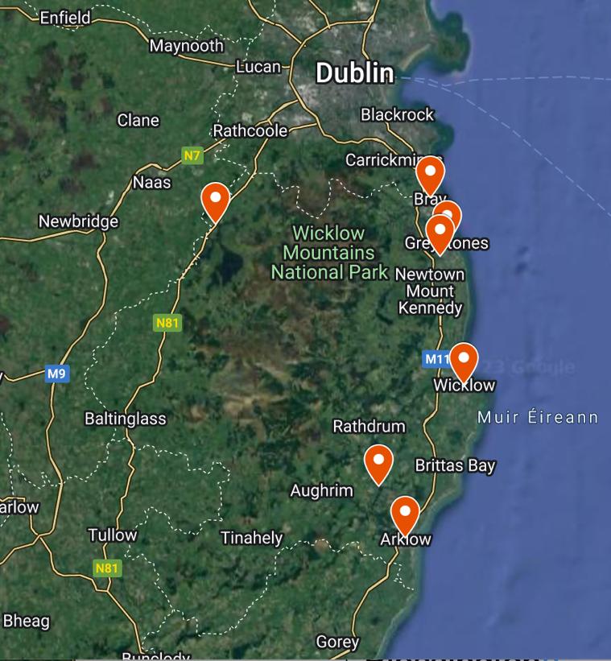

When examining the findings on the availability of different choirs in Wicklow, it becomes evident that only a small 28% of participants are undeterred by the choir’s rehearsal location. The remaining majority of participants considered the rehearsal location to be slightly to extremely important. This preference could be explained by the fact that, even though participants claimed that most rehearsal spaces are accessible by public transport, they tend to travel by car with the majority covering an average distance of 0 to 8 kilometres to participate. This indicates a strong preference by participants to join a local choir in their own town, rather than opting for one situated elsewhere, potentially indicating their inclination towards community-focused groups which can be vital to wellbeing (UK Health Security Agency, 2020).

Further analysis shows that a significant majority of 85%, report their choirs as being open to all members of the public with the remaining 15% indicating their choir as having a more targeted choral demographic ranging, from Alumni choirs, to gender specific voiced choirs, as well as more health focused groups such as cancer support choirs. The majority report weekly rehearsals, held in wheelchair accessible venues, that run under 2 hours often with a break for tea or opportunity to socialise.

Auditions and fees

In alignment with the previous findings of Helitzer and Moss (2022) participants indicated that auditions are not commonly required within their choirs, with only 20% of individuals having to audition. This supports a recent finding by Gunther (2022), who found community choirs have been moving away from the need for auditions over the past decade. Davis (2020) suggests that auditions can often be a barrier to participation, although of those that required an audition 91% stated it had had no impact on their motivation to join the choir. It is worth mentioning that there was a small percentage who were put off by the thought of an audition as indicated by participant 132 describing their choir’s policy, “Not having to audition! Would probably not have joined- the accessibility of this choir is unique” A second often sited deterrent to participation is fees (Davis, 2020) however, of the 62% who reported paying either annual, monthly, or weekly fees, the overwhelming majority indicated that these fees did not negatively affect their motivation to join the choir. Nevertheless, it is recommended, as suggested by Hilitzer and Moss (2022), to keep fees at a minimum to ensure accessibility.

The correlation between open accessibility, absence of auditions and the opportunity to socialise suggests that community choirs are striving to provide inclusive spaces, where individuals from diverse background and abilities can participate and connect thereby offering a sense of acceptance and community (Haslam et al,. 2015). This observation aligns with Clift's (2010) research, underscoring the significance of cultivating safe and non-judgmental environments within musical contexts, to provide a sense of wider community and social inclusion.

“It helped me find a place for my autistic son to belong and for us to have a shared interest” (Participant 34)

“Singing with others gives a sense of community and belonging”.
(Participant 128)

Based on this data analysis, we gain a comprehensive understanding of the contemporary community choir landscape in County Wicklow, characterised by its inclusive and accessible nature. These choirs are most often conveniently located near participants' residences, fostering strong local community engagement. Importantly, the majority of choirs do not require auditions, contributing to the inclusion of all voices. While some choirs may have associated fees, they also provide valuable opportunities for socialisation. Building on this analysis, we now shift our attention to exploring the motivations that drive individuals to actively participate in their local singing groups.

Motivations

Participants in the study were asked to rate the importance of various motivational factors on their decision to join a community choir. To facilitate the analysis of the data, the various motivational factors were mapped into two overarching categories: Personal development and well-being, and Social connection and fulfilment as seen in table 2. This categorisation allowed for a more organised and structured approach to analysing the participants' responses and understanding the main themes driving their decision to join a community choir.

TABLE 2- Category Mapping
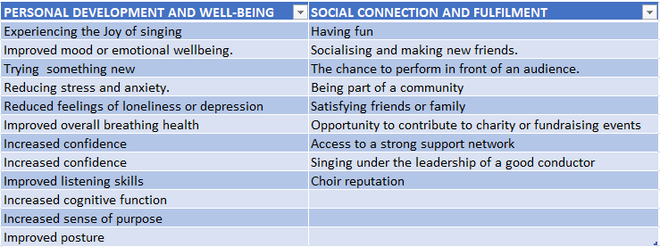

It is important to acknowledge that the study inadvertently displayed a bias towards personal development and well-being when examining motivational factors, potentially influencing the results. Despite this unintended bias, the overall findings still demonstrated a number of motivational factors within the social connection and fulfilment category. As a student researcher this oversight has taught me that future research must strive to establish an equitable representation of motivational factors by category during the creation of the survey to ensure a balanced and comprehensive understanding.

Why do they sing?

Aligning with previous research (Simmons,1962; Vincent ,1997; Selfph and Bugos, 2014;) 42% of participants indicate that their primary motivation for joining a community choir in County Wicklow was to experience the joy of singing. This finding is further supported in participant comments:

"The feeling you get after a choir session is pure joy" (Participant 38)

"The joy that singing brings" (Participant 98)

“The joy of singing together as a group” (Participant 136)

The joy of singing is accompanied closely by the second most significant motivational factor, which is the desire to have fun with 33% of participants indicating this as extremely important in their decision to join. Furthermore, ranking prominently is the motivation to sing under the guidance of a skilled conductor, indicated by 26.7% of respondents. Overall, the motivations behind participation tend to lean slightly towards emphasising factors that foster social connection and personal fulfilment. Shown below, figure 2 displays the importance of individual motivational factors as expressed by participants.
FIGURE2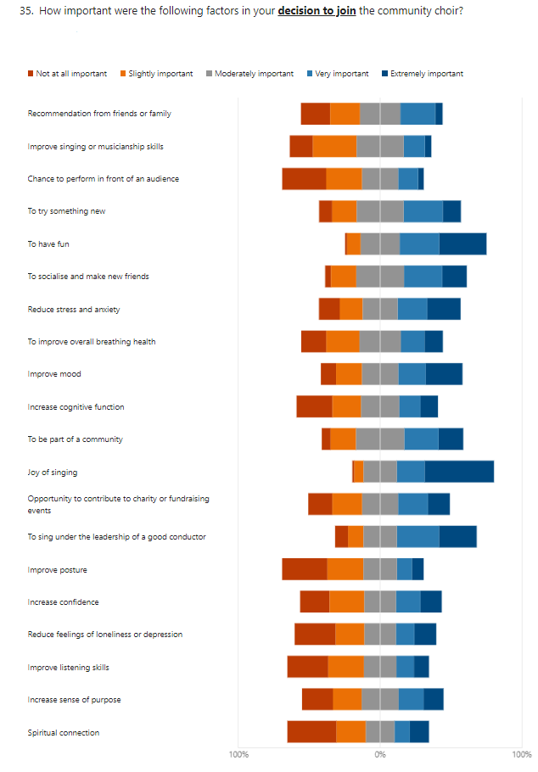

When asked to rate the importance of factors driving motivation to participate in their current choir over others in Wicklow, the overall majority reported being encouraged by friends and family, followed by the leadership and direction of the choir,(figure 3) again the overall category leaning towards Social development and fulfilment.

FIGURE 3
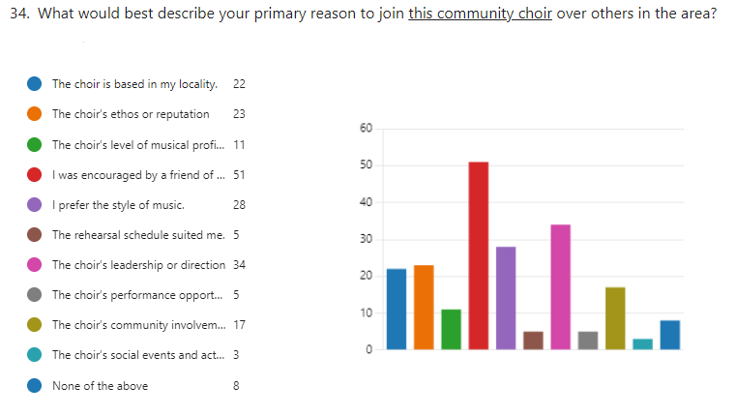

Upon further examination of the initial motivating factors by category and gender, an interesting finding emerges: While the top three factors for both men and women remain relatively consistent, namely the joy of singing, the desire to have fun, and the aspiration to sing under the guidance of a skilled conductor, there is a slight variation in their order of importance. For men, the primary factor is the joy of singing, followed by the opportunity to sing under the leadership of a good conductor, and then the desire to have fun. Conversely, women prioritise the joy of singing first, followed by the desire to have fun, and finally, singing under the guidance of a skilled conductor. Notably, when reviewing the further reported motivational factors, on the extreme end female participants display a stronger inclination towards factors associated with social connection and fulfilment, such as prioritising being part of the community well above their male counter parts. While men prioritise factors related to personal development and well-being by placing slightly more emphasis, on, experiencing spiritual connection, increasing a sense of purpose, and trying something new. Table 3 displays the motivational ranking by gender and category.

TABLE 3
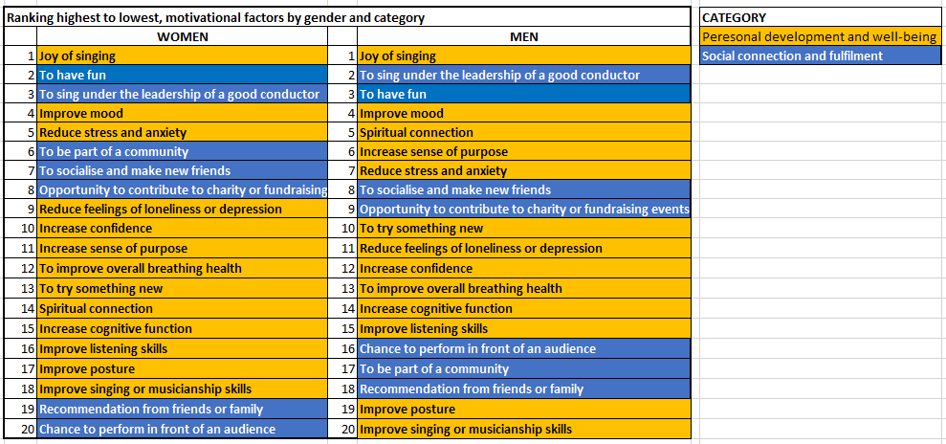

This very slight difference in motivations is supported by a substantial body of research (Fiori and Rauere 2021; Caver et al., 2017; Morgan et al,. 2018), including a recent study that suggests women often prioritise fulfilling their social needs, particularly through cultivating close interpersonal connections, which in turn contributes to successful ageing (Seko and Herano, 2021). Notably, women attribute higher value to these relationships, thereby establishing a stronger connection between social aspects and overall health (Seko and Herano, 2021), as depicted by the following female participants.

“Singing with friends lifts my spirits and gives great joy” (Participant 137)

“Meet new friends, experience a supportive network” (Participant 212)

However, there is a lack research on social connectedness specifically among males, leaving less understanding about their social networks and how they perceive and utilise support (Quinn et al., 2021). Many studies have suggested that males may be more vulnerable to experiencing low social support and having lower overall social connectedness compared to females (Cornwell, et al., 2008; McKenzie et al., 2018; Shields and Wheatley Price, 2005). This is demonstrated by Quinn et al,. (2021) who found males are typically less socially connected than females leaving more males who are lonely and less integrated in the community. Men who experienced increased social isolation tended to report lower levels of perceived social support and satisfaction with their relationships. Additionally, older age and a stronger adherence to masculine norms were independently associated with reduced levels of perceived social support and relationship satisfaction.
It is important to note that while these differences are observed in the current study, they are relatively minor and should not be considered as definitive generalisations for all participants. Rather, they hint at the possibility of distinct perspectives and priorities among individuals. Also, it is noteworthy that while men did not prioritise direct forms of social connection as highly as women, they did place importance on the positive effects of improved mood and a greater sense of purpose, which, although these fell into the personal development and wellbeing category, they are also considered outcomes of healthy social connections (Martino et al., 2015). As Quinn et al. (2021) indicates that older age is associated with a stronger adherence to masculine norms and lower perceived social support, this could imply, as reflected in the current study, that men may indeed value the benefits of social connection but may not always prioritise their origins. However, as this study was not specifically designed to explore gender differences in motivations, it highlights the importance of future attempts to incorporate a deliberate design to examine this aspect.

Community in the choir

“Singing with others gives a sense of community and belonging” (Participant 128)

When exploring the opportunity for choirs to create a sense of community and social connection, it becomes evident that a 127 participants (60%) believe that their choir promotes a strong sense of community, as indicated in figure 4.
FIGURE 4
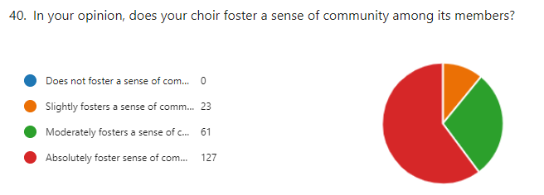

Among these participants, over half (57%) express feeling a deep connection and feel part of a closely-knit community, which they consider to be a highly important aspect of choir membership. These findings align with the research conducted by Pearce et al. (2015), who indicated that group singing has the capability to bond large groups of people, also highlighting that social interaction and a sense of belonging are important positive features of attending group singing sessions. This is consistent with the current study where an overwhelming majority (93%) of participants reported that their choir provides abundant opportunities to establish new acquaintances, form friendships, and even develop deep and meaningful connections. These findings reinforce the potential of choir participation as an effective tool for reducing loneliness and isolation, thereby enhancing the opportunity for successful aging (Seko and Herano, 2021). Moreover, this supports the notion that group singing contributes to cultivating a healthy public (Camlin et al., 2022).

"It gave me a chance to get out there and do something that didn't involve a partner. It was very effective in reducing stress and alleviating feelings of loneliness."
(Participant 106)

It is important to note that a significant percentage (48.7%) reported feeling only somewhat part of a close-knit community withing the choir, suggesting that their sense of connection may not be as strong or consistent as those who feel very much part of the community.

Choir in the community

An interesting factor motivating group singing in County Wicklow is not only the importance of the community within the choir, but also the role of the choir in the community. The current study revealed that 52% of respondents believe their community choir has a significant role to play within the community with 40% of participants expressing that being a member of the choir gives them a sense of contributing to the local community. The study further revealed that community choirs are actively engaged in charitable and fundraising events, with an impressive 88% of participants indicating that their choirs frequently or always take part in such initiatives. It is heartening to note that 56% of respondents observed tangible positive changes in the community resulting from the choir's activities.
These findings align with research conducted by Gridley et al. (2011), who suggest that community-based singing and similar group activities have the potential to cultivate social capital which can have profoundly positive impacts on the physical and psychological well-being of individuals, and communities as a whole.

“It gives you a sense of belonging, of achieving, and an opportunity to 'give back' through fundraising raising gigs” (Participant 233)

Opportunities to sing.

Events like the Wicklow Sings festival are reported to be major component of the choirs' activities in the county with over 74% of participants taking part in this year’s festival. Over half of these respondents indicate the value of these types of events for enhancing the overall sense of community within the choir and wider choral community. Additionally, respondents indicated that the festival also provides a valuable opportunity for choirs to observe and learn from other performances, improve their skills, and foster team morale. The survey results indicate that there is a strong desire among participants for programs aimed at promoting community choir participation in County Wicklow, with a significant 82% expressing this sentiment. Furthermore, an overwhelming 90% of participants support the idea of further funding opportunities specifically aimed at supporting community choirs in the county. These findings highlight the eagerness within the community to expand and strengthen the role of community choirs.

Benefits of community singing in County Wicklow.

The participants were given a set of multiple-choice questions to explore the benefits they experienced as members of a group singing community (figure 5). Over all, the majority of participants indicated that they experienced a varying degree of a sense of accomplishment, followed by stress reduction and improved general mood. Further investigation could delve into the underlying factors and reasons behind these emotional responses, offering an intriguing exploration into the relationship between these experiences and group singing participation.

FIGURE 5
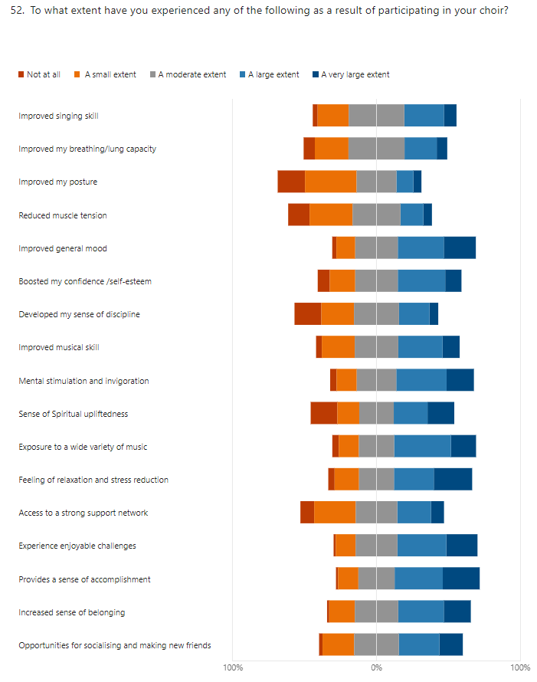
When given a chance to expand on these benefits participants included comments such as:

“I found joining a choir uplifting and can improve one mood and would recommend to all to try” (Participant 53)

“Enjoy creating a lovely sound. It is so satisfying to hear. It is also de-stressing. I practice in the car. A wonderful antidote to traffic jam stress - Sing fabulous choral music!”
(Participant 72)

“Anticipating choir helps get through a stressful week. Knowing I will meet friends and even when very tired before I go. Always invigorated and encouraged coming home.”
(Participant 116)

Participants were also given the chance to indicate if they had experienced any negative effects from choir and strikingly, 57.3 % of participants did in fact experience some degree of performance anxiety related to their participation in group singing. Figure 6 depicts the level of negative effects experienced by the participants.

FIGURE 6
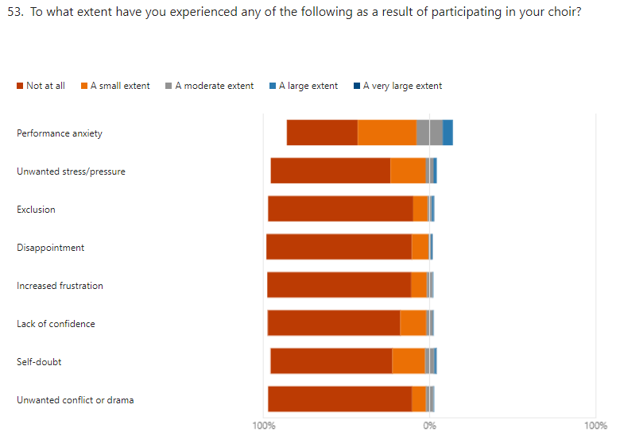

Inspired by Maury and Rickard (2020), who proposed that attitudes towards participation, including individual preferences and initial motivations, might be predictors of well-being outcomes, the participants were then asked to list their top three experienced benefits from their participation in choir (figure 7). Notably, and in line with the theory of Maury and Rickard (2020) the top perceived benefit matched the top three overall motivations, which were experiencing the joy of singing, having fun and the experience of singing under the leadership of a good conductor.

FIGURE 7
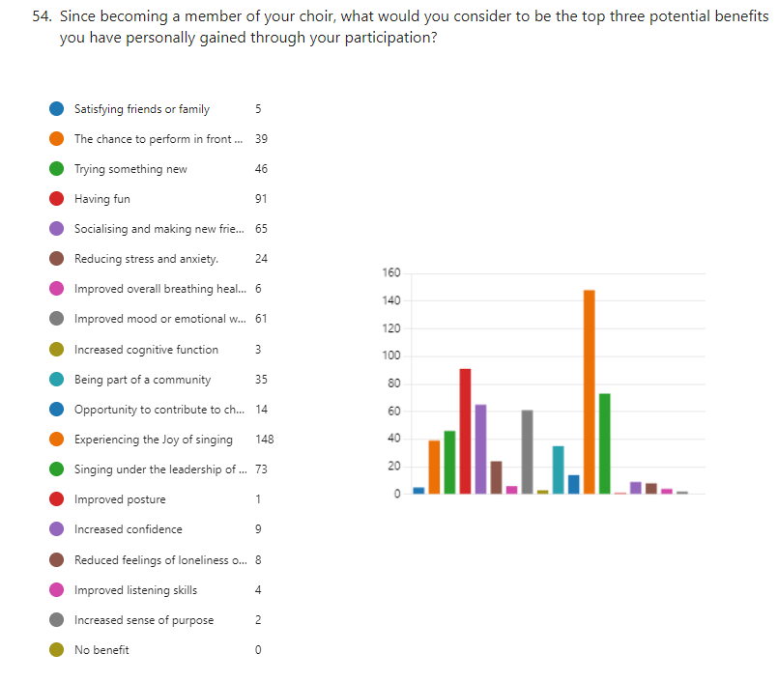

When the top three findings were further analysed by category and gender, we see a near repeat of the previously mentioned findings found driving participation in group singing. As per their top valued motivations, female participants experienced matching benefits of the Joy of singing, having fun and singing under the leadership of a good conductor. Suggesting support to the concept of understanding motivations to predict beneficial outcomes (Maury and Rickard, 2020). However, an intriguing variation was observed among men, as their top three reported benefits slightly differed from the initial motivations which were the joy of signing, singing under the leadership of a good conductor and having fun. The men highlighted the following as their top three experienced benefits: experiencing the joy of singing, socialising and making new friends, and singing under the leadership of a skilled conductor. Figure 8 displays the top three benefits separated by gender and category.

FIGURE 8
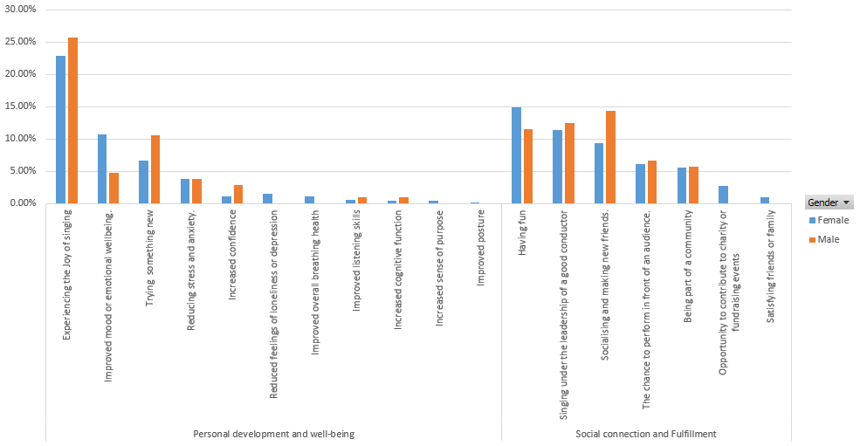

The findings relating to the top three experienced benefits differ slightly than the top three motivations for joining as male participants did not explicitly prioritise social connection as a motivating factor for joining community choirs instead, they placed slightly more value on factors within the category of personal development and well-being with outcomes such as a sense of purpose and increased confidence. However, as previously mentioned, it could be argued that these personal development outcomes are the beneficial results of experiencing positive social connections (Martino, 2017). This suggests that while they may prioritise factors relating to personal development and well-being, they in turn, highly value the social connections formed through participation community choirs.

Summary of findings

The demographic analysis revealed that the majority of participants were aged between 50 and 80, with a slight skew towards older individuals, reflecting the age composition of County Wicklow (CSO, 2022). However, there was a significant gender imbalance in participation, with more female participants than male.

The educational background of the participants indicated a highly educated workforce, with a significant proportion having attained third-level or graduate-level education. Moreover, the study highlighted the importance of prior music experience, suggesting that early musical education and childhood exposure to group singing play a crucial role in fostering a lifelong engagement with choirs (Demorest et al., 2017)

The study also provides insights into the location and characteristics of choirs in County Wicklow. Most participants attend choirs located within an 8 km radius indicating a strong preference for choirs based in their local community. The majority of choirs are open to all members of the public and offer weekly rehearsals in wheelchair accessible venues, fostering inclusive and accessible spaces for individuals from diverse backgrounds and abilities.

Auditions were found to be less prevalent among community choirs, indicating a shift away from this practice. However, for those choirs that still employed auditions, they did not act as a deterrent to participation. Furthermore, although a majority of participants reported paying fees, these fees did not negatively influence their motivation to join. To ensure accessibility, it is recommended to keep fees at a minimum (Moss et al,. 2015).

The study categorised the motivations reported by participants into two overarching categories: personal development and well-being, and social connection and fulfilment. The most common overall motivations included the joy of singing, having fun, Singing under the leadership of a good conductor, improving mood, followed by reducing stress, socialising and being part of a community. Female participants showed a minor inclination toward the categories of social connection and fulfilment factors, while male participants placed slightly greater importance on personal development and well-being factors.

A significant majority of respondents reported that their choir promoted a strong sense of community, with participants reporting feeling part of a closely-knit community. These findings support previous research on the bonding nature of group singing and its potential to reduce loneliness and enhance social interaction. (Pearce et al., 2015) Further to this the findings reveal that community choirs actively engage in charitable and fundraising events, leading to tangible positive changes in the wider community. This underscores the transformative power of choir activities and highlights their potential to make a beneficial impact beyond the boundaries of the choir itself (Camlin et al,. 2022)

Limitations and further research

Although this study has provided valuable insights, certain limitations should be acknowledged, the significant number of females over male participants suggests that future research should make efforts to attract more male participants and explore alternative data collection methods for a more comprehensive understanding of community singing engagement. The study also highlighted the need to reach out to the South Westerly regions of the county in future studies to encapsulate responses from all parts of Wicklow. Moreover, despite the unfortunate skewing of motivational categories, the slight gender differences observed driving participation suggests a possible avenue for further research. Investigating these differences in more detail can inform interventions that address the specific needs of men and women, leading to enhanced participation and engagement in community choirs. Finally, a line of research exploring the broader impacts of community choirs on local communities, such as social cohesion, community engagement, and cultural preservation, to gain a deeper understanding of their role beyond individual well-being could assist in informing community development and social prescription strategies.

This study adds to the existing body of knowledge on community choirs in Ireland (Moss et al,. 2015; Helitzer and Moss, 2020). Comparative studies between different areas could potentially uncover similarities or differences in demographic and individual motivations which could lead to a better understanding of motivations driving community singing engagement in Ireland.

Conclusion

The current research project has attempted to contributed to a deeper understanding of the contemporary community choir landscape in Co. Wicklow. Addressing its aims and objectives the study employed a grounded theory approach to explore the current reasons contributing to singing participation, examine health and wellness benefits, assess the sense of inclusion in the community, while additionally identifying factors that can affect group singing participation. Overall, I hope this study expands the knowledge of community choirs in County Wicklow and lays the foundation for future investigations, providing a steppingstone for continued exploration and advancement in this field.

References:

Albudaiwi, D. ed., (2017) 'Survey: Open-ended questions' ,The SAGE Encyclopedia of Communication Research Methods. Vol. 4. Thousand Oaks, CA: SAGE Publications, Inc. Available at: <https://doi.org/10.4135/9781483381411>

Almalki, S. (2016) 'Integrating Quantitative and Qualitative Data in Mixed Methods Research—Challenges and Benefits', Journal of Education and Learning, 5, pp.288-296.

Arts Council of Ireland. (2008) Raising your voice Towards a policy for The development of choral music in Ireland, Available at: https://www.artscouncil.ie/uploadedFiles/Main_Site/Content/Research_and_Publications/Music/Choral_Report_08_English.pdf (June 7 2023)

Bailey, B.A. and Davidson, J.W., (2003) 'Amateur group singing as a therapeutic instrument', Nordic journal of music therapy, 12(1), pp.18-32.

Bangham, G. and Gustafsson, M. (2020) The Time of Your Life, Trust for London, Resolution Foundation. Available at: https://www.resolutionfoundation.org/app/uploads/2020/07/The-time-of-your-life.pdf (Accessed: May 23, 2023).

Bannan, N. and Montgomery-Smith, C., (2008) 'Singing for the Brain: reflections on the human capacity for music arising from a pilot study of group singing with Alzheimer's patients'. Journal of the Royal Society for the Promotion of Health, 128(2), pp.73-78.

Bell, C. (2000) 'An examination of adult amateur community choirs and choral conductor rehearsal behavior, with implications for music education' Dissertation Abstracts International, 61(02),539A. (UMI No. 9959331)

Berger, P.L. and Luckmann, T. (1966) The Social Construction of Reality: A Treatise in the Sociology of Knowledge. Doubleday & Company, New York.

Bryant, A. and Charmaz, K. (2007) The SAGE handbook of grounded theory. Sage.

Bryman, A. (2007) 'Barriers to Integrating Quantitative and Qualitative Research' Journal of Mixed Methods Research, 1(1), 8–22. https://doi.org/10.1177/2345678906290531

Buchanan, M. (2023) 'Raise those voices as Wicklow’s largest singing festival returns for one night only' The Independent, Online,10th February. Available at: https://www.independent.ie/regionals/wicklow/lifestyle/raise-those-voices-as-wicklows-largest-singing-festival-returns-for-one-night-only-42336844.html (Accessed 25th March 2023)

Buchanan, M. (2023b) 'Sold-out Wicklow Sings returns with performances from 13 community choirs', Independent.ie, Online, Available at: https://www.independent.ie/regionals/wicklow/lifestyle/sold-out-wicklow-sings-returns-with-performances-from-13-community-choirs/42406306.html (Accessed June 25, 2023).

Buness, D. (1979) 'Factors contributing to participation and non-participation in selected community choruses in Montana’ Dissertation Abstracts International, 58(06), 2125A. (UMI No. 7922710

Burr, V. (1995) An introduction to social constructionism, Taylor & Frances/Routledge. https://doi.org/10.4324/9780203299968

Camlin,D., Daffern H. and Zeserson K. (2020) 'Group singing as a resource for the development of a healthy public: a study of adult group singing', Humanities and Social Sciences Communications, 7(1), 1–15. https://doi.org/10.1057/s41599-020-00549-0

Campbell, Bodkin-Allen, S., and Swain, N. (2022) 'Group singing improves both physical and psychological wellbeing in people with and without chronic health conditions: A narrative review' Journal of Health Psychology, 27(8), 1897–1912. https://doi.org/10.1177/13591053211012778

Carver L., Beamish R., Phillips SP. (2018) 'Successful Aging: Illness and Social Connections' Geriatrics (Basel). 2018 Jan 18;3(1):3. doi: 10.3390/geriatrics3010003.

Central Statistics Office Ireland. (2023) Census of Population 2022 - Summary Results - Wicklow. Retrieved from https://www.cso.ie/en/csolatestnews/pressreleases/2023pressreleases/pressstatementcensusofpopulation2022-summaryresultswicklow/ (Accessed May 1st, 2023)

Charmaz,K., (2014) Constructing grounded theory (2nd ed.). Sage

Chorus America. (2003) Chorus impact study Singing for a lifetime. Retrieved from http://www.chorusamerica.org/documents/2003chorstudy.pdf (Accessed May 23, 2023)

Chun Tie, Y., Birks, M., & Francis, K. (2019) 'Grounded theory research: A design framework for novice researchers', SAGE open medicine, 7, 2050312118822927. https://doi.org/10.1177/2050312118822927

Clift, S., Hancox, G., Morrison, I., Hess, B., Kreutz, G. and Stewart, D., (2009) 'What do singers say about the effects of choral singing on physical health?-Findings from a survey of choristers in Australia, England and Germany'. In ESCOM 2009: 7th Triennial Conference of European Society for the Cognitive Sciences of Music.

Connelly, LM., (2020) Inclusion and Exclusion Criteria. Medsurg Nursing, 29(2), 125–11

Cornwell, B., Laumann, E. O., & Schumm, L. P. (2008) 'The social connectedness of older adults: A national profile’, American Sociological Review, 73(2), 185–203. doi:10.1177/000312240807300201

Costley, C., Elliott, Geoffrey and Gibbs, P. (2010) Doing Work Based Research: Approaches to Enquiry for Insider-Researchers. Sage, London. ISBN 978-1-84860-678-4

Creswell, J. W. (2014) Research Design: Qualitative, Quantitative and Mixed Methods Approaches (4th ed.). Thousand Oaks, CA: Sage

Creswell, J., and Plano Clark, V. (2007) Designing and Conducting Mixed Methods Research. Thousand Oaks, CA: Sage

Davis, X. (2020) 'The barriers to joining a choral society' Making Music. Retrieved from https://www.makingmusic.org.uk/sites/makingmusic.org.uk/files/What%20are%20the%20barriers%20to%20joining%20a%20choral%20society_research.pdf (Accessed May 4th 2023)

Demorest, S. M., Kelley, J., and Pfordresher, P. Q. (2017) ' Singing Ability, Musical Self-Concept, and Future Music Participation', Journal of Research in Music Education, 64(4), 405–420. https://doi.org/10.1177/0022429416680096

Denzin, N.K. (2009) The Research Act: A Theoretical Introduction to Sociological Methods (1st ed.). Routledge. https://doi.org/10.4324/9781315134543

Dublin College University Research Ethics Committee guideline statement on insider research (2017) Available at: https://www.dcu.ie/sites/default/files/research_support/insiderresearch_v1_dec_2017.pdf (Accessed: January 12, 2023).

Dwyer, S.C. and Buckle, J.L. (2009) ‘The Space Between: On Being an Insider-Outsider in Qualitative Research’, International journal of qualitative methods, 8(1), pp. 54–63. Available at: https://doi.org/10.1177/160940690900800105.

Ernst, R. and Emmons, S., (1992) 'New Horizons for Senior adults' Music Educators Journal, 79(4), 30-34.

European Commission. (2020). Education and Training Monitor 2020: Ireland. Retrieved from https://op.europa.eu/webpub/eac/education-and-training-monitor-2020/countries/ireland.html (Accessed May 23rd, 2023)

Fancourt, D, Warran, K., Finn, S., and Wiseman, T. (2019) ‘Psychosocial singing interventions for the mental health and well-being of family carers of patients with cancer: results from a longitudinal controlled study' BMJ Open, 9(8), e026995–e026995. https://doi.org/10.1136/bmjopen-2018-026995

Finlay, (2002) 'Negotiating the swamp: the opportunity and challenge of reflexivity in research practice', Qualitative Research: QR, 2(2), 209–230. https://doi.org/10.1177/146879410200200205

Flori, L., and Rauer, A., (2021) 'The how, when, and where of women’s social relationships later in life', Journal of Women and Aging, 33:4, 345-346, DOI: 10.1080/08952841.2021.1946263

Forrest, B. (1986),' Apprentice-Participation: Methodology and the Study of Subjective Reality', Urban Life, 14(4), 431-453.

Glaser, B., and Strauss, A. L. (2017) The discovery of grounded theory: strategies for qualitative research. Routledge.

Goertzen, M.J. (2017) 'Applying Quantitative Methods to E-book Collections', Library Technology Reports, 53(4), 1+, available: https://link.gale.com/apps/doc/A508425359/AONE?u=anon~674cec6b&sid=googleScholar&xid=d4d46945 (accessed 16 Jun 2023)

Grape, Sandgren, M., Hansson, L.-O., Ericson, M., & Theorell, T. (2003). Does singing promote well-being? An empirical study of professional and amateur singers during a singing lesson. Integrative Physiological & Behavioral Science, 38(1), 65–74. https://doi.org/10.1007/bf02734261

Gridley, H., Astbury, J., Sharples, J., & Aguirre, C. (2011) Benefits of group singing for community mental health and wellbeing, Carlton, Australia: Victorian Health Promotion Foundation (VicHealth). https://www.vichealth.vic.gov.au/sites/default/files/Singing_survey_FINAL_with-cover.pdf

Guion, L., Diehl, D., and McDonald, D., (2011) 'Triangulation: Establishing the Validity of Qualitative Studies' EDIS. 2011. 3. 10.32473/edis-fy394-2011.

Gunther, K. (2022) 'Inclusion, auditions and American community choirs: A historical inquiry', International Journal of Community Music, 15(3), 405-424. DOI: https://doi.org/10.1386/ijcm_00071_1

Haslam, C., Cruwys, T., Haslam, S.A. and Jetten, J., (2015) Social connectedness and health, Encyclopaedia of geropsychology, 2015, pp.46-1.

Helitzer, and Moss, H. (2022) 'Group singing for health and wellbeing in the Republic of Ireland: the first national map', Perspectives in Public Health, 142(2), 102–116. https://doi.org/10.1177/17579139221081400

Hendry, Lynam, D. S., and Lafarge, C. (2022) 'Singing for Wellbeing: Formulating a Model for Community Group Singing Interventions', Qualitative Health Research, 32(8-9), 1399–1414. https://doi.org/10.1177/10497323221104718

Hewitt-Taylor, J. (2002) ‘Inside knowledge: issues in insider research’, Nursing standard, 16(46), pp. 33–35. Available at: https://doi.org/10.7748/ns.16.46.33.s5.

Holmquist, S.P. (1995) 'A study of community choir members school experiences', Available from ProQuest Dissertations and Theses database. UMI No. 9529054

Hornberger, B., & Rangu, S. (2020) 'Designing Inclusion and Exclusion Criteria' Retrieved from https://repository.upenn.edu/server/api/core/bitstreams/d1f1ce55-68b3-40b0-8ff3-161db91e7c5f/content (Accessed June 3rd, 2023,)

Irons, J. Y., Sheffield, D., Ballington, F., & Stewart, D. E. (2020) 'A systematic review on the effects of group singing on persistent pain in people with long-term health conditions', European Journal of Pain, 24(1), 71-90. doi: 10.1002/ejp.1485.

Jackson, L., Ervin, K., Gardner, P., and Schmitt, N. (2001) 'Gender and the Internet: Women Communicating and Men Searching' Sex Roles, 44, 363-379. https://doi.org/10.1023/A:1010937901821

Jeannotte, M.S., (2003) 'Singing alone? The contribution of cultural capital to social cohesion and sustainable communities' The International Journal of Cultural Policy, 9(1), pp.35-49.

Jones, T. L., Baxter, M. A., and Khanduja, V. (2013) ' A quick guide to survey research', Annals of The Royal College of Surgeons of England 95(1), 5-7. doi: 10.1308/003588413X13511609956372.

Ma, Li, J., Ding, M., Yang, H. H., Shu, F., Quek, T. Q. S., and Poor, H. V. (2020) 'On Safeguarding Privacy and Security in the Framework of Federated Learning' IEEE Network, 34(4), 242–248. https://doi.org/10.1109/MNET.001.1900506

Malina, Nørreklit, H. S., and Selto, F. H. (2011) ‘Lessons learned: advantages and disadvantages of mixed method research' Qualitative Research in Accounting and Management, 8(1), 59–71. https://doi.org/10.1108/11766091111124702

Martino, Pegg, J., & Frates, E. P. (2017) ‘The Connection Prescription: Using the Power of Social Interactions and the Deep Desire for Connectedness to Empower Health and Wellness’ American Journal of Lifestyle Medicine, 11(6), 466–475. https://doi.org/10.1177/1559827615608788

Maury, & Rickard, N. (2022) 'The benefits of participation in a choir and an exercise group on older adults’ wellbeing in a naturalistic setting', Musicae Scientiae, 26(1), 144–171. https://doi.org/10.1177/1029864920932633

McKenzie, S. K., Collings, S., Jenkin, G., and River, J. (2018) 'Masculinity, social connectedness, and mental health: Men’s diverse patterns of practice', American Journal of Men’s Health, 12(5), 1247–1261. doi:10.1177/1557988318772732

Morgan, Wiles, J., Park, H.-J., Moeke-Maxwell, T., Dewes, O., Black, S., Williams, L., and Gott, M. (2021) 'Social connectedness: what matters to older people?' Ageing and Society, 41(5), 1126–1144. https://doi.org/10.1017/S0144686X1900165X

Morse, J. M., Barrett, M., Mayan, M., Olson, K., & Spiers, J. (2002) 'Verification Strategies for Establishing Reliability and Validity in Qualitative Research', International Journal of Qualitative Methods, 1(2), 13–22. https://doi.org/10.1177/160940690200100202

Moss, Lynch, J., and O’Donoghue, J. (2018) ' Exploring the perceived health benefits of singing in a choir: an international cross-sectional mixed-methods study', Perspectives in Public Health, 138(3), 160–168. https://doi.org/10.1177/1757913917739652

OECD (Organisation for Economic Co-operation and Development). (2021) Rethinking Education: From Remote Learning to Hybrid Learning. OECD Publishing. Retrieved from https://www.oecd-ilibrary.org/sites/c18a4378-en/index.html?itemId=/content/component/c18a4378-en#section-d1e39678 (accessed May 6th, 2023)

Patino, M., and Ferreira, J., (2018) ‘Inclusion and exclusion criteria in research studies: definitions and why they matter’, Jornal brasileiro de pneumologia, 44(2), pp. 84–84. Available at: https://doi.org/10.1590/s1806-37562018000000088.

Pearce, E., Launay, J., & Dunbar, R. I. M. (2015) 'The ice-breaker effect: singing mediates fast social bonding', Royal Society Open Science, 2(10). https://doi.org/10.1098/rsos.150221

Poulton, P. (2021) Being a teacher-researcher: Reflections on an insider research project from a virtues-based approach to research ethics. Educational Action Research. https://doi.org/10.1080/09650792.2021.1962379

Quinn, B., Prattley, J., Rowland, B. (Eds.). (2021) Social connectedness among Australian males. Melbourne: Australian Institute of Family Studies.

Saidin, K. (2016) 'Insider Researchers: Challenges and Opportunities' Proceedings of The ICECRS. 1(1), picecrs.v1i1.563. https://doi.org/10.21070/picecrs.v1i1.563

Seko, K. and Hirano, M. (2021) ‘Predictors and Importance of Social Aspects in Ikigai among Older Women’, International journal of environmental research and public health, 18(16), p. 8718–. Available at: https://doi.org/10.3390/ijerph18168718.

Selph, C. and Bugos, J.A. (2014) 'Adult Perceptions of Participation in a Community Choir', Research Perspectives in Music Education, 16(2), 35-55.

Shannon (2023) Wicklow Sings Is a Record-Breaking Success. Sing in Wicklow, Available at: https://staging.singinwicklow.ie/latest/wicklow-sings-is-a-record-breaking-success/ (accessed June 20th, 2023)

Shields, M. A., and Wheatley Price, S. (2005) 'Exploring the economic and social determinants of psychological well-being and perceived social support in England' Journal of the Royal Statistical Society (Series A [Statistics in Society]), 168(3), 513–537.

Silverio, S., Hall, J., and Sandall, J. (2020) Time and qualitative research: Principles, pitfalls, and perils. In annual qualitative research symposium, University of Bath, Bath.

Simmons, D. W. (1962) 'The motivations and musical backgrounds pf participants and non-participants in selected community choruses', (Doctoral dissertation, University of Illinois, 1962). Dissertation Abstracts International, 23(11), 4380A.

Southcott, and Joseph, D. (2017) 'Changing the world one voice at a time: philanthropy and community choirs in Australia' Creative Industries Journal, 10(2), 155–167. https://doi.org/10.1080/17510694.2017.1324117

Spell, G. M. (1989) ' Motivational factors and selected sociodemographic characteristics of Georgia community chorus participants as measured by the Education Participation Scale, the Community Chorus Participation Scale, and the Personal Inventory Form' (Doctoral dissertation, University of Georgia). ProQuest Dissertations Publishing, 9018368.

Stacy, R., Brittain, K. and Kerr, S., (2002) ' Singing for health: An exploration of the issues', Health education, 102(4), pp.156-162.

Tipps, J. (1992) ‘Profile characteristics and musical backgrounds of community chorus participants in the southeastern United States' Available from ProQuest Dissertations and Theses database. UMI No. 9234255

Trinity College Dublin (2021) 'Policy On Good Research Practice' Trinity College Dublin https://www.tcd.ie/graduatestudies/assets/pdf/good-research-practice-policy.pdf (accessed: Jan 6 2023)

UK Health Security Agency. (2020) Can we build healthier, more resilient, and connected communities? [Blog post]. UKHSA Blog. Retrieved from https://ukhsa.blog.gov.uk/2020/01/14/can-we-build-healthier-more-resilient-and-connected-communities/ (Accessed May 20th, 2023)

Unluer, S. (2012) 'Being an Insider Researcher While Conducting Case Study Research.' The Qualitative Report, 17(29), 1-14. https://doi.org/10.46743/2160-3715/2012.1752

Vincent, Phyllis M. (1997) 'A study of community choruses in Kentucky and implications for music education' Available from ProQuest Dissertations and Theses database. (UMI No. 9735637

Warran, K. et al. (2022) ‘Scalability of a singing-based intervention for postpartum depression in Denmark and Romania: protocol for a single-arm feasibility study’, BMJ open, 12(12), pp. e063420–e063420. Available at: https://doi.org/10.1136/bmjopen-2022-063420.

Whidden, C. (2010) ' Understanding social-cultural influences affecting non-participation in singing'. Multi-disciplinary Research in the Arts: e-journal, 2(1), pp.1-15

WicklowNews.net. (2023) '400 voices come together for Wicklow Sings.' [online] Available at: https://wicklownews.net/2023/03/400-voices-come-together-for-wicklow-sings/ (accessed 22 June 2023)

Więch, Sałacińska, I., Walat, K., Kózka, M., and Bazaliński, D. (2023) ‘Can Singing in a Choir Be a Key Strategy for Lifelong Health? A Cross-sectional Study’ Journal of Voice, 37(1), 146.e11–146.e18. https://doi.org/10.1016/j.jvoice.2020.11.010

Williams, Dingle, G. A., and Clift, S. (2018) ‘A systematic review of mental health and wellbeing outcomes of group singing for adults with a mental health condition', European Journal of Public Health, 28(6), 1035–1042. https://doi.org/10.1093/eurpub/cky115

Appendix:

Appendix 1: Ethics form

APPLICATION FOR ETHICAL APPROVAL

In order for research to result in benefit and minimise risk of harm, it must be conducted ethically. A researcher may not be covered by the University’s insurance if ethical approval has not been obtained prior to commencement.

The University follows the OECD Frascati manual definition of research activity: “creative work undertaken on a systematic basis in order to increase the stock of knowledge, including knowledge of man, culture and society, and the use of this stock of knowledge to devise new applications”. As such this covers activities undertaken by members of staff, postgraduate research students, and both taught postgraduate and undergraduate students working on dissertations/projects.

The individual undertaking the research activity is known as the “principal researcher”.

Ethical approval is not required for routine audits, performance reviews, quality assurance studies, testing within normal educational requirements, and literary or artistic criticism.

Please read the notes for guidance before completing ALL sections of the form.

This form must be completed and approved prior to undertaking any research activity. Please see Checklist for details of process for different categories of application.

Delete the Guidance Notes at the end of the form BEFORE submitting your application

SECTION A: About You (Principal Researcher)
1 | Full Name: |  | Jamie Lyon
2 | Tick all boxes which apply: |  | Member of staff: | ☐ | Honorary research fellow: | ☐
3 | Undergraduate Student | ☐ | Taught Postgraduate Student | ☒ | Postgraduate Research Student | ☐

4 | Institute/Academic Discipline/Centre: | WAPPAR
5 | Campus: | Carmarthen
6 | E-mail address: | Mrs.Jamielyon@gmail.com
7 | Contact Telephone Number: | +353 0851125421
 | For students:
8 | Student Number:
9 | Programme of Study: | MA in Professional Practice
10 | Director of Studies/Supervisor: | Nick Samuel

SECTION B: Approval for Research Activity
1 | Has the research activity received approval in principle?  (Please check the Guidance Notes as to the appropriate approval process for different levels of research by different categories of individual) |  | YES | ☒ | NO | ☐
 |  |  |  |  | Date
2 | If Yes, please indicate source of approval (and date where known): Approval in principle must be obtained from the relevant source prior to seeking ethical approval | Research Degrees Committee |  | ☐
3 |  | Institute Research Committee |  | ☐
4 |  | Other (write in)  WAPPAR Ethics Board Representative |  | ☒

SECTION C: Internal and External Ethical Guidance Materials
 | Please list the core ethical guidance documents that have been referred to during the completion of this form (including any discipline-specific codes of research ethics, and also any specific ethical guidance relating to the proposed methodology). Please tick to confirm that your research proposal adheres to these codes and guidelines.
1 | UWTSD Research Ethics & Integrity Code of Practice | ☒
2 | UWTSD Research Data Management Policy | ☒
3 |  | ☐

SECTION D: External Collaborative Research Activity
1 | Does the research activity involve collaborators outside of the University? |  | YES | ☐ | NO | ☒
2 | If Yes, please provide the name of the external organisation and name and contact details for the main contact person and confirmation this person has consented to their personal data being shared.as part of this collaboration.
3 | Institution
4 | Contact person name
5 | Contact person e-mail address
6 | Has this individual consented to sharing their details on this form? |  | YES | ☐ | NO |  |  | ☐
7 | Are you in receipt of a KESS scholarship? |  | YES | ☐ | NO |  |  | ☐
8 | Is your research externally funded |  | YES | ☐ | NO |  |  | ☐
9 | Are you specifically employed to undertake this research in either a paid or voluntary capacity? | Voluntary | YES | ☐ | NO |  | ☐
10 |  | Employed | YES | ☐ | NO |  | ☐
11 | Is the research being undertaken within an existing UWTSD Athrofa Professional Learning Partnership (APLP) | If YES then the permission question below does not need to be answered. | YES | ☐ | NO |  |  | ☐
12 | Permission to undertake the research has been provided by the partner organisation | (If YES attach copy)  If NO the application cannot continue | YES | ☐ | NO |  |  | ☐

Where research activity is carried out in collaboration with an external organisation
13 | Does this organisation have its own ethics approval system? | YES | ☐ | NO | ☐
14 | If Yes, please attach a copy of any final approval (or interim approval) from the organisation

SECTION E: Details of Research Activity
1 | Indicative title: | Wicklow Sings, an exploratory study into reasons why people engage in community singing in Co. Wicklow
2 | Proposed start date: | March 20 2023 | Proposed end date: | July 13th 2023
3 | Introduction to the Research (maximum 300 words)  Ensure that you write for a Non-Specialist Audience when outlining your response to the three points below:  - Purpose of Research Activity  - Proposed Research Question  - Aims of Research Activity  - Objectives of Research Activity  Demonstrate, briefly, how Existing Research has informed the proposed activity and explain  - What the research activity will add to the body of knowledge  - How it addresses an area of importance.
4 | Purpose of Research Activity  The purpose of this research activity is to gain a deeper understanding of why people in County Wicklow sing in choirs.
5 | Research Question  Wicklow Sings! An exploratory study into reasons why people engage in community singing in Co. Wicklow
6 | Aims of Research Activity  The aim of this research is to gain a deeper understanding of the reasons behind participation in choirs in Co. Wicklow.
7 | Objectives of Research Activity  The Objectives of this research are:  - To discover the current reasons contributing to singing participation in Co. Wicklow  - To allow themes to emerge from the data collection in order to follow a grounded theory approach to research  - To discover if singing in Co. Wicklow contributes to any perceived health or wellness benefits  - To discover if singing in Co. Wicklow may contribute to an overall sense of inclusion in the community.  - To examine what aspects of group singing in Co. Wicklow can potentially influence or prevent future group singing participation.
8 | Proposed methods (maximum 600 words)  Provide a brief summary of all the methods that may be used in the research activity, making it clear what specific techniques may be used. If methods other than those listed in this section are deemed appropriate later, additional ethical approval for those methods will be needed.
9 | Currently little is known of the reasons behind participation in choirs in Co. Wicklow. Therefore, following the structured yet flexible methodology of grounded theory I will use both quantitative and qualitative methods to construct theory from the data  My proposed methods for this study are as follows:  - Literature review.  Beginning with a preliminary literature review, I will study any current research examining contributing factors behind community choir participation with a specific focus on Irish based research. A secondary literature review may be undertaken to support the findings of the research.  - Mixed Method Survey:  An anonymous mixed method survey distributed electronically to community choirs based in County Wicklow. The survey would ask for choir name and location, but participants would remain individually anonymous. This survey will consist mainly of qualitative questions with an option for a qualitative summary question. The survey will include a consent to participate further option to facilitate the selection of participants willing to move to the next stage of research.  - Semi structured interviews:  The potential to lead a semi structured interview of a member or members of a participating community choirs, based on returns from the survey.  - Focus group:  Potential to lead focus groups based on the returns of the survey. The focus group could be in person or held over zoom to facilitate access Transcripts from the focus group will be audio recorded in order to capture all the discussion.  It is my belief that the triangulation of these methods will provide a robust view of the study allowing for an increased validity in the findings.
10 | Location of research activity  Identify all locations where research activity will take place.
11 | Research will be conducted via electronic survey distributed in Co. Wicklow. Interviews or focus groups will be conducted in the designated rehearsal venue for the choir or choir member being interviewed in Co. Wicklow. Interviews and focus groups may also be conducted over zoom to remove the participants need for travel.  (this box should expand as you type)
12 | Research activity outside of the UK  If research activity will take place overseas, you are responsible for ensuring that local ethical considerations are complied with and that the relevant permissions are sought. Specify any local guidelines (e.g. from local professional associations/learned societies/universities) that exist and whether these involve any ethical stipulations beyond those usual in the UK (provide details of any licenses or permissions required). Also specify whether there are any specific ethical issues raised by the local context in which the research activity is taking place, for example, particular cultural and/or legal sensitivities or vulnerabilities of participants.
13 | N/A  (this box should expand as you type)
14 | Use of documentation not in the public domain: Are any documents NOT publicly available? | NO | ☒
14 |  | YES | ☐
15 | If Yes, please provide details here of how you will gain access to specific documentation that is not in the public domain and that this is in accordance with prevailing data protection law of the country in question and England and Wales.  (this box should expand as you type)
SECTION F: Scope of Research Activity
1 | Will the research activity include: | YES | NO
2 | Use of a questionnaire or similar research instrument? | ☒ | ☐
3 | Use of interviews? | ☒ | ☐
4 | Use of diaries? | ☐ | ☒
5 | Participant observation with their knowledge? | ☐ | ☒
6 | Participant observation without their knowledge? | ☐ | ☒
7 | Use of video or audio recording? | ☒ | ☐
8 | Access to personal or confidential information without the participants’ specific consent? | ☐ | ☒
9 | Administration of any questions, test stimuli, presentation that may be experienced as physically, mentally or emotionally harmful / offensive? | ☐ | ☒
10 | Performance of any acts which may cause embarrassment or affect self-esteem? | ☐ | ☒
11 | Investigation of participants involved in illegal activities? | ☐ | ☒
12 | Use of procedures that involve deception? | ☐ | ☒
13 | Administration of any substance, agent or placebo? | ☐ | ☒
14 | Working with live vertebrate animals? | ☐ | ☒
15 | Other primary data collection methods, please explain in this box  For example, ‘focus groups’. Please indicate the type of data collection method(s) in this box and tick the accompany box. | ☒ | ☐
16 | Details of any other primary data collection method:  Focus groups  (this box should expand as you type) | ☒ | ☐
If NO to every question, then the research activity is (ethically) low risk and may be exempt from some of the following sections (please refer to Guidance Notes).

If YES to any question, then no research activity should be undertaken until full ethical approval has been obtained.

SECTION G: Intended Participants
1 | Who are the intended participants: | YES | NO
2 | Students or staff at the University? | ☐ | ☒
3 | Adults (over the age of 18 and competent to give consent)? | ☒ | ☐
4 | Vulnerable adults? | ☐ | ☒
5 | Children and Young People under the age of 18? (Consent from Parent, Carer or Guardian will be required) | ☐ | ☒
6 | Prisoners? | ☐ | ☒
7 | Young offenders? | ☐ | ☒
8 | Those who could be considered to have a particularly dependent relationship with the investigator or a gatekeeper? | ☐ | ☒
9 | People engaged in illegal activities? | ☐ | ☒
10 | Others (please identify specifically any group who may be unable to give consent) please indicate here and tick the appropriate box. | ☐ | ☒
11 | Other – please indicate here:  .  (this box should expand as you type) | ☐ | ☒

12 | Participant numbers and source  Provide an estimate of the expected number of participants. How will you identify participants and how will they be recruited?
13 | How many participants are expected? | Although the response rate to the mainly quantitative electronic survey will vary based on choir size, I would estimate at minimum 200 responses. Interviews or focus groups will be determined from the returns of the survey and will not consist of more than 10 people.  (this box should expand as you type)
14 | Who will the participants be? | The participants will be members of active choirs in County Wicklow who will voluntarily respond to the electronic survey.  (this box should expand as you type)
15 | How will you identify the participants? | The participants will be current members of community choirs based in County Wicklow.

16 | Information for participants: | YES | NO | N/A
17 | Will you describe the main research procedures to participants in advance, so that they are informed about what to expect? | ☒ | ☐ | ☐
18 | Will you tell participants that their participation is voluntary? | ☒ | ☐ | ☐
19 | Will you obtain written consent for participation? | ☒ | ☐ | ☐
20 | Will you explain to participants that refusal to participate in the research will not affect their treatment or education (if relevant)? | ☒ | ☐ | ☐
21 | If the research is observational, will you ask participants for their consent to being observed? | ☒ | ☐ | ☐
22 | Will you tell participants that they may withdraw from the research at any time and for any reason? | ☒ | ☐ | ☐
23 | With questionnaires, will you give participants the option of omitting questions they do not want to answer? | ☒ | ☐ | ☐
24 | Will you tell participants that their data will be treated with full confidentiality and that, if published, it will not be identifiable as theirs? | ☒ | ☐ | ☐
25 | Will you debrief participants at the end of their participation, in a way appropriate to the type of research undertaken? | ☒ | ☐ | ☐
26 | If NO to any of above questions, please give an explanation
27 | (this box should expand as you type)

28 | Information for participants: | YES | NO | N/A
29 | Will participants be paid? | ☐ | ☒ | ☐
30 | Is specialist electrical or other equipment to be used with participants? | ☐ | ☒ | ☐
31 | Are there any financial or other interests to the investigator or University arising from this study? | ☐ | ☒ | ☐
32 | Will the research activity involve deliberately misleading participants in any way, or the partial or full concealment of the specific study aims? | ☐ | ☒ | ☐
33 | If YES to any question, please provide full details
34 | (this box should expand as you type)

SECTION H: Anticipated Risks
1 | Outline any anticipated risks that may adversely affect any of the participants, the researchers and/or the University, and the steps that will be taken to address them.  If you have completed a full risk assessment (for example as required by a laboratory, or external research collaborator) you may append that to this form.
2 | Full risk assessment completed and appended? |  | Yes | ☐
2 |  |  | No | ☒
3 | Risks to participants  For example: emotional distress, financial disclosure, physical harm, transfer of personal data, sensitive organisational information
4 | Risk to Participant:  1 As focus groups and interviews will be recorded,(audio only) this may result in potential disclosure of personal information.  2 Further risk to participants may include potentially emotional conversation if participants should choose to express emotional reasons tied to singing. | How will you mitigate the Risk to Participant  1 I will mitigate the risk to the participant by giving each participant a code instead of using personal identifiers such as name. Further to this I will ensure that all data is secured on my own personal password protected computer to which I alone have access.  2 I will mitigate this risk, by providing a safe comfortable environment that participants feel welcome to share and all conversation will remain strictly anonymous through the use of participant code.  ( this box should expand as you type)
5 | If research activity may include sensitive, embarrassing or upsetting topics (e.g. sexual activity, drug use) or issues likely to disclose information requiring further action (e.g. criminal activity), give details of the procedures to deal with these issues, including any support/advice (e.g. helpline numbers) to be offered to participants. Note that where applicable, consent procedures should make it clear that if something potentially or actually illegal is discovered in the course of a project, it may need to be disclosed to the proper authorities
N/A

(this box should expand as you type)
6 | Risks to investigator  For example: personal safety, physical harm, emotional distress, risk of accusation of harm/impropriety, conflict of interest
 | Risk to Investigator:  1.As I am also a director of a choir in Wicklow there is the risk that I may be mentioned in one of the qualitative questions, or that I may find some of the answers to the overall benefit of choirs less positive than I had anticipated, resulting in my own emotional disappointment.  2. With electronic surveys, there is a risk that the response rate will be much lower than expected  (this box should expand as you type) | How will you mitigate the Risk to Investigator:  1.To mitigate this risk I will begin by ensuring the anonymity of the electronic survey, and designing questions, so that they do not encourage the use of names in the qualitative comments.  2. As I run a large-scale choral festival I have direct contacts to the currently known choir directors in the county, I will ensure the links to the survey are sent to each choir with plenty of time to complete before the deadline.  (this box should expand as you type)
7 | University/institutional risks  For example: adverse publicity, financial loss, data protection
 | Risk to University:  The risks to the University will mainly surround data protection  (this box should expand as you type) | How will you mitigate the Risk to University:  This risk will be mitigated by ensuring all data is coded securing anonymity. The information will be kept on my own personal password protected computer and accessed only by me.  (this box should expand as you type)

8 | Disclosure and Barring Service
9 | If the research activity involves children or vulnerable adults, a Disclosure and Barring Service (DBS) certificate must be obtained before any contact with such participants. | YES | NO | N/A
10 | Does your research require you to hold a current DBS Certificate? | ☐ | ☒ | ☐

SECTION I: Feedback, Consent and Confidentiality
1 | Feedback  What de-briefing and feedback will be provided to participants, how will this be done and when?
I will provide all participants with my contact details and provide a copy of the final report if requested.

(this box should expand as you type)
2 | Informed consent  Describe the arrangements to inform potential participants, before providing consent, of what is involved in participating. Describe the arrangements for participants to provide full consent before data collection begins. If gaining consent in this way is inappropriate, explain how consent will be obtained and recorded in accordance with prevailing data protection legislation.
I will inform potential participants of what is involved in participating in the research, prior to the first question of the electronic survey, which will require participants to give their consent, if no consent is given the survey cannot be completed and no data will be collected.

(this box should expand as you type)
3 | Confidentiality / Anonymity  Set out how anonymity of participants and confidentiality will be ensured in any outputs. If anonymity is not being offered, explain why this is the case.
No names will be collected as part of the survey. Choir names or locations will not be included in the final report unless explicit permission is obtained.
(this box should expand as you type)

SECTION J: Data Protection and Storage
In completing this section refer to the University’s Research Data Management Policy and the extensive resources on the University’s Research Data Management web pages (http://uwtsd.ac.uk/library/research-data-management/).
1 | Does the research activity involve personal data (as defined by the General Data Protection Regulation 2016 “GDPR” and the Data Protection Act 2018 “DPA”)? | YES | NO
 | “Personal data” means any information relating to an identified or identifiable natural person (‘data subject’). An identifiable natural person is one who can be identified, directly or indirectly, in particular by reference to an identifier such as a name, an identification number, location data, an online identifier or to one or more factors specific to the physical, physiological, genetic, mental, economic, cultural or social identity of that natural person. | ☒ | ☐
2 | If YES, provide a description of the data and explain why this data needs to be collected:
Audio data will be collected in case of focus group or focus group before it is transcribed and coded.

(this box should expand as you type)
3 | Does it involve special category data (as defined by the GDPR)? | YES | NO
 | “Special category data” means sensitive personal data consisting of information as to the data subjects’ –  (a) racial or ethnic origin,  (b) political opinions,  (c ) religious beliefs or other beliefs of a similar nature,  (d) membership of a trade union (within the meaning of the Trade Union and Labour Relations (Consolidation) Act 1992),  (e) physical or mental health or condition,  (f) sexual life,  (g) genetics,  (h) biometric data (as used for ID purposes), | ☐ | ☒
4 | If YES, provide a description of the special category data and explain why this data needs to be collected:
 | (this box should expand as you type)

5 | Will the research activity involve storing personal data and/or special category data on one of the following: | YES | NO
6 | Manual files (i.e. in paper form)? | ☐ | ☒
7 | University computers? | ☐ | ☒
8 | Private company computers? | ☐ | ☒
9 | Home or other personal computers? | ☐ | ☒
10 | Laptop computers/ CDs/ Portable disk-drives/ memory sticks? | ☒ | ☐
11 | “Cloud” storage or websites? | ☒ | ☐
12 | Other – specify: | ☐ | ☐
13 | For all stored data, explain the measures in place to ensure the security of the data collected, data confidentiality, including details of password protection, encryption, anonymisation and pseudonymisation:
All data will be kept in password protected cloud storage on my personal Office 365 system which will not be shared. Audio/visual data will be transcribed and would be shown to participants to
check accuracy of reporting. Any USB sticks used to store or transfer data will be password protected. All participants will be given a unique identifier to ensure confidentiality and this list will be kept securely in the password protected folder.

(this box should expand as you type)
14 | All Data Storage
15 | Will the research activity involve any of the following activities: | YES | NO
16 | Electronic transfer of data in any form? | ☒ | ☐
17 | Sharing of data with others at the University? | ☐ | ☒
18 | Sharing of data with other organisations? | ☐ | ☒
19 | Export of data outside the European Union or importing of data from outside the UK? | ☐ | ☒
20 | Use of personal addresses, postcodes, faxes, emails or telephone numbers? | ☐ | ☒
21 | Publication of data that might allow identification of individuals? | ☐ | ☒
22 | Use of data management system? | ☐ | ☒
23 | Data archiving? | ☐ | ☒
24 | If YES to any question, please provide full details, explaining how this will be conducted in accordance with the GDPR and DPA (and/or any international equivalent):
All data will be encrypted and kept in password protected cloud storage on my own personal Office 365 system which will not be shared. Any USB sticks used to store or transfer data will be password protected. All data transfers will be encrypted, and password protected. All participants will be given a unique identifier to ensure confidentiality and this list will be kept securely in the password protected folder. The data will be stored until the completion of the project and then deleted. In accordance with the DPA2018, participants will have the right to ask to see what data is held relating to them, and this data will be deleted immediately if the participant requests this, in which case the data will not be used in the project.

(this box should expand as you type)
25 | List all who will have access to the data generated by the research activity:
Only myself as the principal researcher

(this box should expand as you type)
26 | List who will have control of, and act as custodian(s) for, data generated by the research activity:
Only myself as the principal researcher.

(this box should expand as you type)
27 | Give details of data storage arrangements, including security measures in place to protect the data, where data will be stored, how long for, and in what form. Will data be archived – if so how and if not why not.
All data will be encrypted and kept in password protected cloud storage on my personal Office 365 system which will not be shared. Any USB sticks used to store or transfer data will be password protected and will be reformatted at the end of the project in order to destroy the data. The data will be stored until the completion of the project and then deleted.

(this box should expand as you type)
28 | Please indicate if your data will be stored in the UWTSD Research Data Repository (see https://researchdata.uwtsd.ac.uk/ ). If so please explain. (Most relevant to academic staff)
 | N/A
29 | Confirm that you have read the UWTSD guidance on data management (see https://www.uwtsd.ac.uk/library/research-data-management/) | YES | ☒
29 |  | NO | ☐
30 | Confirm that you are aware that you need to keep all data until after your research has completed or the end of your funding | YES | ☒
30 |  | NO | ☐

SECTION K: Declaration
31 | The information which I have provided is correct and complete to the best of my knowledge. I have attempted to identify any risks and issues related to the research activity and acknowledge my obligations and the rights of the participants.  In submitting this application I hereby confirm that I undertake to ensure that the above named research activity will meet the University’s Research Ethics and Integrity Code of Practice which is published on the website: https://www.uwtsd.ac.uk/research/research-ethics/
 | Signature of applicant: | Jamie Lyon | Date:  6th Feb 2023

For STUDENT Submissions:
32 | Director of Studies/Supervisor: | Louise Emanuel | 15.3.23
33 | Signature: | Louise Emanuel | 15.3.23

For STAFF Submissions:
34 | Academic Director/ Assistant Dean: |  | Date:
35 | Signature: |  | Date:

Checklist: Please complete the checklist below to ensure that you have completed the form according to the guidelines and attached any required documentation:
☒ | I have read the guidance notes supplied before completing the form.
☒ | I have completed ALL RELEVANT sections of the form in full.
☒ | I confirm that the research activity has received approval in principle
☐ | I have attached a copy of final/interim approval from external organisation (where appropriate)
☐ | I have attached a full risk assessment (and have NOT completed Section H of this form) (where appropriate) ONLY TICK IF YOU HAVE ATTACHED A FULL RISK ASSESSMENT
☒ | I understand that it is my responsibility to ensure that the above-named research activity will meet the University’s Research Ethics and Integrity Code of Practice.
☒ | I understand that before commencing data collection all documents aimed at respondents (including information sheets, consent forms, questionnaires, interview schedules etc.) must be confirmed by the DoS/Supervisor, module tutor or Academic Director.
☒ | I have deleted the guidance notes before submitting the PG2 for consideration

RESEARCH STUDENTS AND STAFF ONLY
All communications relating to this application during its processing must be in writing and emailed to pgresearch@uwtsd.ac.uk , with the title ‘Ethical Approval’ followed by your name.
You will be informed of the outcome of your claim by email; therefore it is important that you check your University and personal email accounts regularly.
STUDENTS ON UNDERGRADUATE OR TAUGHT MASTERS PROGRAMMES should submit this form (and receive the outcome) via systems explained to you by the supervisor/module leader.

This form is available electronically from the Academic Office web pages: https://www.uwtsd.ac.uk/academic-office/appendices-and-forms/

Application Process

All staff research projects and all research students must submit the Ethical Approval Form to the University Research Ethics Committee via the Academic Office (pgresearch@uwtsd.ac.uk). Staff research directly in relation to personal study for taught undergraduate or Masters programmes should be submitted via the Institute procedures explained below.

Taught masters and taught undergraduate research Ethical Approval Forms are considered within Institutes. Institutes will provide details of the specific processes for this. Where the Ethical issues within any single ethical application are of particular concern the Institute will refer these to the University Research Ethics Committee. Any student activity that involves the collection of primary data needs to undergo Ethical approval, this includes assignment work as well as dissertations.

Notes for guidance in completion of this form

Section A: About You
Please complete all relevant sections

Section B: Approval for research activity
Research proposals must be approved in principle before applying for Ethical Approval. The proposal approval only becomes final when the ethical approval is received.

The process for proposal approval varies according the individual and programme of study:
- Research students, by application on form PG1 to the Research Degrees Committee
- Taught students by review of research proposal within Institutes (Institutes provide specific details of these processes)
- Staff, by agreement by the Academic Director/Assistant Dean

Section C: External Ethical Guidance materials
Many discipline areas are required to operate with the discipline specific codes of research ethics (for example health, psychology, education etc.), any such codes must be listed and you must tick to confirm that you have consulted with these.

Section D: External Collaborative Research Activity
Provide details of the external collaborative partners, where appropriate you might want to submit a copy of the external collaboration agreement with the Ethical Approval Form. If the partner requires the research to be subject to its own internal Ethical approval process then please provide details of that process and a copy of any final (or interim) approvals received from the organisation.

Section E: Details of Research Activity
Remember that the individuals reviewing this Ethical Approval Form may not have seen your research proposal, and also may not be experts in the specific area of your research. The information provided should therefore be jargon free and clearly stated.

Indicative Title: please use the same title as used on the research proposal.

Purpose: the Ethical approval process will want to ensure that the methods you propose are adequate and appropriate to address the research aims and objectives. Excessive additional data collection can be seen as unethical.

Proposed Methods: the Ethical approval process seeks to ensure that you understand the methods that are intended, and that the implementation of those methods will be appropriate and without unnecessary impact on respondents. This section must explain how the methods described will lead to the collection of necessary and sufficient data, but not excessive data. Please be specific.

Location: this needs to mention geographical location and also local situation (for example, within Local Authority Offices in Cardiff, using a private room but close to other individuals). If you are collecting data within an organisational setting then you need to explain the permissions that you have obtained to do this.

Research Activity outside of the UK: please complete this section in detail, and note any guidance you have received. Also describe your own familiarity (or not) with the location that you will be utilising.

Section F: Scope of Research Activity
Please tick ALL of the research activities that might be undertaken. If any additional types of activity are intended then please add an extra box and describe these.

If you have answered no to all questions in F then sections G and I do not need to be completed. . Signatures are still required in section K.

Section G: Intended Participants
Please tick all categories that might apply.

Numbers & Source: if you are using a series of different methods or research activities please list numbers for each stage/phase. Be clear about how you will find respondents. Will you use intermediaries, and if so how? How will you ensure compliance with your sampling strategy?

Information for participants: all participants should be appropriately informed about the research, what is expected of them and what will happen to the information that they provide. The Ethical review process does not ask to see this documentation, but requires this to be reviewed and approved by the Director of Studies in the case of research students, the supervisor/module tutor in relation to students on taught programmes and the Academic Director/Assistant Dean in relation to staff research.

Section H: Anticipate Risks
All research carries some level of risk. The answers you provide to questions in this section will be reviewed to ensure that you have an appropriate understanding of the type of risks involved and how you can mitigate against these risks. If you have completed a full risk assessment, as required for example for laboratory work, field work, clinical tests, diving operations, or by a collaborative partner, you may append that to this form. In that case, please tick the box indicating this has been provided. You will not then be required to complete Section H.

Risk to participants Think very carefully about how your actions/questions/discussions might affect the people you are involving as participants. You might identify the risk as small but it would still be a risk. Many types of question have the potential to make respondents less content with their life / job; you need to recognise and try to ameliorate any such effects
If these are business owners, time with you may reduce profit.
In some locations physical risk is very real to both participants and yourself, please consider this.

Risk to you, the researcher Think about where you will meet people, if there are any dangers involved in the location. If you are meeting people as individuals think about using a public place. In general do not visit people in their own homes or remote locations. If you are talking to individuals about certain issues think about how their responses might affect you emotionally. What about the risk of collecting insufficient data?

Risk to the University When undertaking your research, you are acting as a member of the University (student or staff). Professionalism is important, so it is important to be well organised and well prepared. Punctuality, clarity etc. are all part of this. What will you do to ensure this? You must ensure you do not harm the good name of the University in any way and do nothing to undermine the reputation of the research it conducts and sponsors. Upholding high standards of conduct and integrity are vital in this regard. You must also conduct the research in such a way to minimise the potential for claims of negligence made against the University, its researchers and any collaborating individual or organisation. In this respect you should always comply with ethical, legal and professional frameworks, obligations and standards as required by statutory and regulatory authorities, as well as the university’s Research Integrity and Ethics Code of Practice. Research misconduct in this respect can take many forms, including:
- fabrication: making up results or other outputs (eg, artefacts) and presenting them as if they were real
- falsification: manipulating research processes or changing or omitting data without good cause
- plagiarism: using other people’s material without giving proper credit
- failure to meet ethical, legal and professional obligations: for example failure to declare competing interests; misrepresentation of involvement or authorship; misrepresentation of interests; breach of confidentiality; lack of informed consent; misuse of personal data; and abuse of research subjects or material
- improper dealing with allegations of misconduct: failing to address possible infringements such as attempts to cover up misconduct and reprisals against whistle-blowers

Adverse Outcomes. Think carefully about the possibilities, and cover here

Section I: Feedback, Consent and Confidentiality

Feedback to participants: outline your approach. Will interview transcripts be shared with respondents to check accuracy? Will summaries of questionnaire analysis be made available to respondents in some way? Will an overview report be provided? How and when?

Informed consent: Draft letter / e-mail / or heading (or footer) section of questionnaire must be approved by DoS/supervisor (if research student), supervisor/module tutor if taught student, or Academic Director / Assistant Dean if a member of staff.
Confidentiality/Anonymity. Explain clearly how you will ensure confidentiality and anonymity.

Section J: Data Protection and Storage
Before completing this section it is necessary to read the University’s Research Data Management information. The questions that follow are designed to ensure compliance with the Data Protection Act as well as established research protocols.

Many research activities will involve electronic transfer of data and use of data management systems in the summarisation and analysis of data. You will need to explain these in relation to compliance with the Data Protection Act.

Think carefully about who will have access to your data, this will include supervisors and examiners. Also that a thesis will be made available via the University library and the British Library system. If you are seeking an access bar for a period of time after completion then mention it here. If you will provide a copy of your findings, or intend to give a presentation, to a facilitating/ supporting/accessing organisation then explain that in this section. But also think about the general principle of data sharing, as explained in the Research Data Management information.

In terms of storage of data please ensure security, and also mitigate against loss of data.

Section K: Declaration
Ensure the appropriate countersignatures have been provided
Look carefully at the checklist and ensure that you comply with and tick all that are relevant to your research.

Appendix 2: Survey

Appendix 3: Data Analysis

