White wines

De Grendel Sauvignon Blanc  Delicious vibrant Sauvignon Blanc from South Africa | 27.00
Audrey Wilkinson Chardonnay  Hunter Valley Chardonnay at its best | 30.00
Lustau Moscatel de Alejandría  Deliciously sweet with natural balancing freshness | 20.00

Hotel Trinity

Starters

Deep Fried Breaded Camembert
Served with mixed leaves and a delicious sweet chilli dip

Stuffed Portobello Mushroom
Filled with smoked bacon, leeks and mature cheddar served on creamed leeks,perfectly served with a glass of our De Grendel

Soup of the Day
Served with golden crusty bread and butter

8.50

6.50

7.00



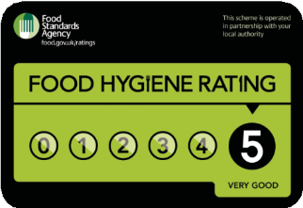
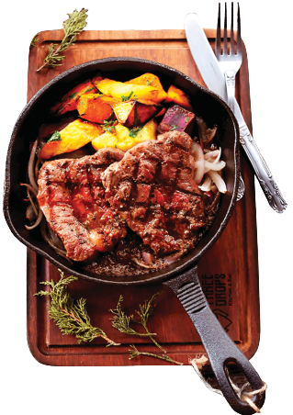
Pan-fried Frogs Legs 7.50
.p.ro.v.e.n.ç.al.e.-s.t.yl.e.............................................

Main Course

Baeckeoffe 20.00
Beef, pork and Welsh lamb, slow-cooked in white wine stock with layers of potato, onions, leek and garlic, perfectly accompanied with our Offrenda by Norton red wine

Slow-roasted belly of pork 18.00
with French-style mash and onion gravy

Half a large roast Guinea Fowl 25.00
served with our famous Cognac and green peppercorn sauce, triple-cooked chips

Welsh fillet of beef (250g/8oz approx) 28.00
.se.r.v.e.d.w.i.th..o.u.r .am..a.zi.n.g.C.o.g.n.a.c.a.n.d.g.r.e.e.n.p.e.p.p.e.rc.o.rn..s.au.c.e............

Desserts

Selection of Ice Creams 6.50
Served with chocolate sauce, raspberry coulis or just plain

Golden Salted Caramel Tart 7.00
with a layer of salted caramel and dark chocolate filling, sprinkled with a gold dusting

Chocolate dipped strawberries 8.00
.in..a.c.h.o.ic.e.o.f.d.e.li.ci.o.u.s .m.e.lt.e.d.c.h.o.c.o.la.te............................

Soft Drinks

Coca Cola 330ml bottle | 3.50
Diet Coke 330ml bottle | 3.50
Fresh Squeezed Orange Juice 450ml | 6.50
Still Water 500ml bottle | 3.00
.S.p.a..rk..li.n.g..W..a.t.e.r..5.0..0.m..l.b..o.t.tl.e......................3...5.0..

Red Wines

Offrenda by Norton 30.00
A blend of Malbec, Cabernet Sauvignon & Merlot 750ml

Le Riche Cabernet Sauvignon 35.00
A wine that will develop over time

“Food allergies and intolerances - please speak to our staff about the ingredients
......^{in}...^{y}.º..^{u}.^{r}..^{m}...^{e}.ª..^{l}.^{w}..^{h}..^{e}.^{n}...^{m}..ª..^{k}.^{i}.^{n}.^{g}...^{y}.º..^{u}.^{r}..º..^{r}.^{d}..^{e}.^{r}.”......
Opening hours
Monday to Friday from 13:00pm - 21:30pm Saturday and Sunday from 14:00pm - 23:00pm
You can contact us directly to place your order or use one of our delivery partners apps

...........................................................
Contact details:
Trawler Rd, Maritime Quarte r, Swansea SA1 1LB
Telephone number:
01792 439220

Delivery fee depends on the distance from our restaurant to your home address.
Minimum charge is 2.50 for 2 miles’ radius

Gilligan’s Restaurant. Available at: http://www.gilligansrestaurant.com/ (Accessed: 21 February 2022).
Pant-Y-Gwydr Restaurant. Available at: https://www.pantygwydr.com/ (Accessed: 21February 2022).
Waitrose & Partners Cellar. Available at: https://www.waitrosecellar.com/ (Accessed: 21 February 2022).
Kaspa’s Desserts. Available at: https://kaspas.co.uk/?utm_source=Google&utm_medium=Yext (Accessed: 21 February 2022).

