

Adults from the Black, Asian and Minority Ethnic communities’ perception of policing, experience with Stop Search and the effects caused by unconscious bias and/or racism.

Name of student: Rebecca Hatter
Student ID number: 2016382
Degree title: Professional Police Practice BSc (Hons)

Acknowledgements
I would like to that my Director of Studies, Jane Thomas, and Dissertation Supervisor, Rhiannon Sandy, for their support and guidance throughout the process of this dissertation.
I would also like to thank Sunil from Show Racism the Red Card for inspiring me into choosing my topic and to the members of the Black, Asian and Minority Ethnic communities’ that participated in the survey.
I would like to thank my husband, Michael, for his unwavering support and sacrifice throughout the entirety my degree and I can now offer my gratitude for helping me even though I did not appear grateful at the time, Per Ardua Ad Astra.
Lastly, my children, Myles and Emily, this has been for you my darlings, never underestimate the power of your dreams and aspirations.

Declaration
This work has not previously been accepted in substance for any degree and is not being concurrently submitted in candidature for any degree.
Signed: R. Hatter
Date: 07/10/2023

Statement 1
This dissertation is being submitted in partial fulfilment of the requirements for the degree of BSc.
Signed: R. Hatter
Date: 07/10/2023

Statement 2
This dissertation is the result of my own independent work/ investigation, except where otherwise stated.
Other sources are acknowledged by footnotes giving explicit references. A bibliography is appended.
Signed: R. Hatter
Date: 07/10/2023

Statement 3
I hereby give consent for my dissertation, if accepted, to be available for photocopying and for interlibrary loan, and for the title and summary to be made available to outside organisations.
Signed: R. Hatter
Date: 07/10/2023

Statement 4
I hereby give consent for my dissertation, if accepted, to be available on the university’s IT system to those who have consent to use the system.
Signed: R. Hatter
Date: 07/10/2023

Abstract
The objective of this study was to examine the perceptions of policing, experiences with Stop Search, and the potential impacts of unconscious prejudice and/or racism on adults from Black, Asian, and Minority Ethnic (BAME) populations. Previous studies indicate that several reasons have contributed to the erosion of trust in the police, with a particular focus on the manifestation of racial bias. Notably, a substantial discrepancy persists between those from BAME communities and those who do not belong to these groups in the context of Stop and Search procedures.
To undertake a comprehensive investigation of these matters, a thorough and meticulous evaluation of pertinent and extant scholarly material pertaining to the subject matter of how individuals from BAME groups perceive the police, their encounters with Stop Search, and the ramifications stemming from unconscious bias and/or racism was initially conducted. Subsequently, a primary research endeavour was undertaken in the form of an online survey to procure both qualitative and quantitative data. This data was subsequently compared with the secondary data to identify any congruent or disparate findings.
Based on the insights derived from this research, recommendations were suggested regarding how the police can enhance relationships with individuals from BAME communities, foster trust, and eradicate racism and unconscious bias.
Table of contents
- Chapter One: Introduction
  - Introduction
  - Aims and Objectives
    - Aim
    - Objectives
  - Research structure
- Chapter Two: Literature Review
  - Introduction
  - Perception of Policing
  - Unconscious Bias and Policing
  - Section 1 of the Police and Criminal evidence Act 1984
    - Statistics of Stop Search under Section 1 of the Police and Criminal Evidence Act (PACE) 1984 ending March 2022
    - Background and Current Issues and Media Reports
  - Impact and Reform
- Chapter Three: Methodology
  - Introduction
  - Research Strategy
  - Data Collection
  - Data Analysis
  - Ethical Considerations
- Chapter Four: Analysis of Results
  - Demographics
  - Survey Results
    - Experiences of BAME Individuals with the Police
    - The Perspectives of BAME Individuals Regarding the Police
    - The Assessment of Favourable Encounters with the Police
    - Evaluations of Adverse Encounters with the Police
    - Involvement Context of Police Encounters
    - Involvement in Stop and Search procedure
    - Fair Treatment During a Stop Search Procedure
    - Explanation of Detainment
    - Information Received During the Stop Search
    - Justification of Stop Search
    - Stop Search Resulting in Arrest
    - Nature of Arrest
    - Result of Arrest
    - Level of Force Used During Stop Search
    - Ethnicity Involvement During Stop Search
    - Perspective of Race Being a Targeting Factor During Stop Search
    - Change in Perception of the Police
    - Perception of Policing
    - Trust in the Police
    - Belief That There are soe Good Officers
    - Perspective on the Potential Presence of Racial Bias Within Policing
- Chapter Five: Conclusion and Recommendations
  - The Achievement of the Objectives
  - Main Findings
  - Recommendations
  - Limitations
  - Conclusion
- Chapter Six: Bibliography
- Chapter Severn: Appendices
  - Appendix One: Application for Ethical Approval
  - Appendix Two: Research Proposal
  - Appendix Three: Survey
  - Appendix Four: Demographic Survey Results
  - Appendix Five: General Survey Results
  - Written Responses on Perception
  - Written Responses on Racism in Policing
  - Appendix Six: General survey Results (Excel)

1. Chapter One: Introduction
  - Introduction
This first chapter aims to provide a clear rational for the study research. By addressing the foundational elements, it will set the stage for a thorough exploration of the research topic.
1.2 Aims and Objectives
1.2.1 Aims
The aim of this study is to explore the perceptions of adults from Black, Asian, and Minority Ethnic (BAME) communities regarding policing, examine their personal experiences with stop and search encounters and analyse the potential effects of unconscious bias and/or racism within these interactions. Based on findings, recommendations may be provided aimed at improving the relationship between adults and law enforcement agencies, promoting fairness, trust, and equality in policing practices.
1.2.2 Objectives
Objective 1:
What are the key determinants of being a member of the BAME community in the UK, particularly in disadvantaged communities.
Objective 2:
To what extent Adverse Childhood Experiences has on prospects of members of the BAME community, particularly from a criminal aspect and/or unconscious bias.
Objective 3:
Within policing, what are the statistic around stop searches within the UK and considerations to unconscious bias surrounding them.
Objective 4:
How many arrests end up with No Further Action, is there a disproportionately between White communities and BAME communities, why is that?

1.3 Research Structure
To accomplish the stated purpose of this study, the dissertation will comprise five chapters:
The fundamental aim of Chapter One is to offer a logical justification for conducting the research investigation. By providing a clear explanation of the essential elements, it has built the structure for a thorough examination of the research topic. Furthermore, it has elucidated the significance of the investigation and presented an overview of the primary aims.
Chapter Two is the literature review which has identified and synthesised the key studies, theories and findings that are relevant to the adults from the BAME communities’ perception of policing, experience with Stop Search and the effects caused by unconscious bias and/or racism. It has served the purpose of critically evaluating the existing literature, highlighting gaps in knowledge, which has provided a framework for the research and allowed a research question to be identified.
Chapter Three provides a comprehensive overview of the approach employed in the dissertation. This section provides a comprehensive overview of the research design, methodology, and procedures employed in the study. It elucidates the reasoning behind the selection of the research design and methodologies. Additionally, the research report encompasses a comprehensive portrayal of the sample population, as well as a detailed account of the methodologies employed for data collecting and analysis.
Chapter Four will provide a comprehensive examination of the data that has been obtained using the methodologies outlined in Chapter Three. This chapter presents a succinct overview of the findings and the statistical analysis undertaken.
Chapter Five presents a comprehensive analysis of the research findings and establishes their connection to the literature discussed in Chapter Two. The research presents the targets and objectives, as well as recommendations for improvement.

2. Chapter Two: Literature Review
2.1 Introduction
Policing is a cornerstone of society, tasked with the noble duty of maintaining law and order (Hartley, 2021). However, the perception and experiences of policing are not uniform, particularly among adults from BAME communities (Sharp and Atherton, 2007). The intersection of race, policing and unconscious bias is a complex and contentious issue that has garnered attention in recent years (Drakulich, 2020).
This literature review will delve into the multifaced dimensions of how adults from BAME backgrounds perceive policing, their experiences with stop search procedures, and the profound effects of unconscious bias and/or racism within these interactions. By examining existing scholarship, this review aims to shed light on the intricate relationship between law enforcement and marginalised communities, offering insight into potential pathways for reform and improved community-police relations.

2.2 Perception of Policing
The police play a vital role in society, but their effectiveness hinges on the public’s perception of their action and conduct (Hurst-Wagner and Oswald, 2012). Building trust and positive relationships within communities is crucial for maintaining law and order while upholding democratic values (Torres, 2017). Bradford, Jackson, and Stanko (2009) highlights the importance of public confidence in policing. Jackson and Bradford (2009) state positive public perception fosters trust and cooperation, making it easier for the police to perform their duties. Malone Gonzalez, Simon, and Rogers (2022) discusses the ample evidence to support the existence of racial bias and discrimination within policing. Spencer, Charbonneau, and Glaser (2016) explain that based on numerous incidents it is clear that members of BAME communities are treated disproportionately from white people which in turn has a detrimental effect on policing perception and alludes to tension within BAME communities and beyond.
Adults from BAME communities frequently hold negative perceptions of policing due to historical, high-profile cases of police brutality and systematic bias (Sharp and Atherton, 2007). Barrett, Fletcher, and Patel, (2014) further infers that members of BAME communities can often view the police as untrustworthy and bias during police encounters. Long and Joseph-Salisbury (2019) states members from the BAME community feel they are viewed through the lens of racial stereotyping and highlights this extends to encounters with the police resulting in more severe consequences. Furthermore, Long and Joseph-Salisbury (2019) state that, whilst issues have been acknowledged, encounters involving the police and members of the BAME community have drawn little notice and has lacked substantial reform. Pica, et al. (2020) states policing has faced unprecedented levels of scrutiny, driven by heightened media attention focused on instances of police conduct involving racial discrimination which led to the rise of Black Lives Matter (BLM) movement.
This suggests that addressing the root of the causes of negative perceptions, such as unconscious bias and discriminatory practices, is essential for fostering improved relations between BAME communities and the police, ultimately leading to more equitable and just policing practices. It could further be suggested that the heightened media attention on racial discrimination has ignited conversations, protests and calls for reform to have a profound impact on how policing is conducted, perceived, and reformed worldwide. Furthermore, the impact of the media, technology, activism, and public demand for accountability has ushered in an era of transformation and reform within the field of policing. However, Zhu and Dukes (2015) explain through selective reporting, the media can influence public perception and shape societal attitudes and actions. This could suggest the media could effectively stoke the flames of racism in policing by perpetuating stereotypes and racialised fear. Furthermore, Zhu and Dukes (2015) adds that the media also serves as a powerful platform of raising awareness and informing the public of real issues. This could suggest that acknowledging the medias influence on issues of racism in policing is crucial for fostering informed discussions, challenging biased narratives, and promoting transparency and accountability within policing.

2.3 Unconscious Bias and Policing
Unconscious bias refers to the attitudes, beliefs, stereotypes, and prejudices that individuals hold at a subconscious level, often without their awareness or intention (Storm, et al. 2023). Furthermore, Suveren (2022) explains unconscious biases are typically formed based on societal and cultural influences and can affect how people perceive and interact with others, often leading to discriminatory or unfair treatment.
Spencer, Charbonneau, and Glaser (2016) explain unconscious bias in policing refers to the implicit biases that police officers may hold unconsciously, which can influence their judgments and actions during law enforcement activities. Noon (2018) states that these biases are not necessarily intentional or overt forms of discrimination but are subtle and often automatic associations or stereotypes that can affect decision making. Furthermore, Noon (2018) explains combatting unconscious bias is an ongoing challenge as biases can be deeply engrained and difficult to eradicate completely. Williamson and Foley (2018) indicate that recognising and addressing unconscious bias is an important step in promoting fair treatment, reduce disparities and foster positive relationships regardless of background. This could suggest from a policing aspect, to recognise and address unconscious bias could improve relationships with members of BAME communities and reduce disparities in policing.
Brown (2019) states the historical presence of racism and its associated negative consequences have been ingrained within the history and established practises of policing. Additionally, Brown (2019) infers race and class have consistently occupied a pivotal position, influencing the role of law enforcement agencies and officers in our society.
The Independent Office for Police Conduct (2021) informs that in 2020, several officers from the Metropolitan Police Service were issued final written warnings due to their engagement in gross misconduct. This misconduct involved the sharing of text messages that contained offensive content, including derogatory allusions towards those with disabilities, as well as jokes pertaining to sensitive topics such as rape, paedophilia, racism, and homophobia (Independent Office for Police Conduct, 2021).
This suggests that despite the recognition of unconscious bias and/or racism being recognised through the ages, racial discrimination and/or unconscious bias continued to shape perceptions of police officers and impact on interactions between members of the BAME community and the police.

2.4 Section 1 of the Police and Criminal evidence Act 1984
Section 1 of the Police and Criminal evidence Act (PACE) 1984 serves as an introductory provision that outlines the fundamental objectives of the Act, which are to regulate police powers and procedures whilst safeguarding the rights of individuals during criminal investigations (Bowling and Phillips, 2007). Furthermore, Brown (2007) explains the Act establishes the legal framework that governs police conduct and ensures that police duties are carried out within the bounds of the law and with respect with civil liberties. HM Government (2023) state section 1 of PACE 1984 allows a constable to have the power to detain any person or vehicle, within a public place, to search that person or vehicle should the constable have reason to believe that the person would be in possession of any prohibited item(s). College of Policing (2017) state that an officer does not need to arrest a person to carry out a stop and search under section 1 of PACE 1984 but the individual will be detained, and that reasonable force can be used to compete the search.
The utilisation of stop and search procedures can significantly contribute to the identification, deterrence of criminal activities and enhances overall efficiency (College of Policing, 2017). Murray, et al. (2021) argues that the practise of stop-and-search has been the subject of controversy which has attributed to the increased levels of violence in the United Kingdom. Furthermore, Murray, et al. (2021) adds that police fairness when using stop and search powers holds significant relevance to the ongoing discussions which in turn, undermines faith in the police which could consequently lead to a rise in criminal behaviour. Bradford and Tiratelli (2019) argue that a decrease in the utilisation of stop and search is often considered as a contributing factor to the increase in violent crime. However, Murray, et al. (2020) discusses the escalating rates of recorded violence, particularly knife crime, in London and other English cities have sparked public apprehension and that police commanders have recognised a correlation between the rise in stop search numbers and the decline in incidents of violence including knife crime. Waddington, Stenson and Don (2004) suggest that the balance between members of BAME communities and non-members is disproportionate when considering police stop and search encounters.
2.4.1 Statistics of Stop Search under Section 1 of the Police and Criminal Evidence Act (PACE) 1984 ending March 2022
The Home Office (2022a) reported that in 2021, across England and Wales, 697,405 stop and searches were carried out by the police. According to the Home Office (2022a) data, it can be determined that among the 697,405 individuals subjected to searches under section 1 of the Police and Criminal Evidence Act (PACE) in 1984, 52% belonged to the white ethnic group. Individuals with a black or black British origin accounted for 14% of the searches, while those identifying as Asian or Asian British constituted 11%. Additionally, individuals identifying as having a mixed ethnicity included 3% of the searches. According to the available census data and statistical analysis, it has been determined that the likelihood of a black individual being subjected to a stop search is five times higher compared to their white counterparts (Home Office, 2022a).
The Home Office (2022b) states in 2022, across England and Wales, 526,024 stop and searches were carried out by the police which, due to Covid-19 restrictions, saw a decline of 179,888, or a reduction of 25%, in comparison to the preceding year. The Home Office (2022b) informs that according to ethnicity, those from a black or black British heritage were subjected to searches at a significantly higher rate of 6.2 times compared to individuals from a white ethnic group. Moreover, the rate of searches conducted on individuals who identify as Asian or Asian British, was 2.1 times higher than that of those from a white ethnic group and individuals identifying as having a mixed ethnicity were subjected to searches at a rate that was 2.3 times higher than individuals from a white ethnic group (Home Office, 2022b). The Home Office (2022b) add that out of the total number of 526,024 searches conducted, 66,772 (13%) of searches resulted in arrest.
Upon analysing the statistical data for the years 2021 and 2022, it becomes evident that there continues to exist a significant disparity between individuals belonging to BAME populations and those who do not. This observation implies that race continues to exert a substantial influence on the individuals who are subjected to stop and search procedures. Furthermore, one could posit that the data presented provides compelling evidence of the presence of racial profiling, whereby individuals are singled out for scrutiny primarily due to their colour or ethnicity, rather than being subject to reasonable suspicion of engaging in criminal behaviour. National statistics do not provide information on the exact proportion of stop and search incidents in locations where crime rates are high and the BAME community is present, which suggests that the proportion may be greater in such places. However, the government figures suggest that there is a potential inference to be made regarding the disproportionate nature of stop and search practises, indicating that individuals from the BAME group are still more prone to being subjected to such searches.

2.4.2 Background and Current Issues and Media Reports
Jackson (2015) explains during the month of April in the year 1981, a series of riotous events unfolded in the neighbourhood of Brixton, located in South London; these disturbances were primarily instigated by Black teenagers and spanned across a duration of two days. The consequences of this unrest were manifold, including a significant number of injuries and extensive damage to properties inside an area that was already grappling with economic challenges (Jackson, 2015). In the aftermath of the incident, numerous politicians, among them the recently appointed Prime Minister Margaret Thatcher, characterised the 'disorder' as a manifestation of indiscriminate disregard for the law (Purbrick and Schofield, 2009). However, the utilisation of section 4 of the 1824 Vagrancy Act, often known as "sus law", was widely perceived as the catalyst for the outbreak of the riot (Jackson, 2016). Maggs (2019) describes “sus law” as an Act which granted police officers the discretionary authority to apprehend those whom they deemed to be loitering with the intention of committing an arrestable offence; this was replaced with the Police and Criminal Evidence Act (PACE) 1984 which introduced stop search as we know it.
The media reports on incidents such as the Metropolitan Police issued an apology and provided a monetary compensation of £6,000 to the family of 13-year-old child of mixed-race background, who of was handcuffed and subjected to an unlawful stop search in 2018. (White, 2022). Moreover, despite the receipt of nearly 5,000 complaints, a mere six Metropolitan Police officers have faced disciplinary action for the improper utilisation of stop and search procedures since 2014 (BBC, 2021).
Doward (2020) informs that after Police Sergeant Matiu Ratana was fatally shot by Louis De Zoysa in September 2020, the police called for an immediate reassessment of the stop and search procedures employed during the apprehension of individuals suspected of criminal activity. De Zoysa had been arrested after police officers observed peculiar behaviour and conducted a stop search; De Zoysa was found to be in possession seven bullets and cannabis (BBC, 2023). Officers did not find the firearm hidden under his arm and despite being handcuffed to the rear, De Yoysa was able to discharge it as Police Sergeant Matui Ratana was in the process of conducting a search with a metal detector in the custody suite (BBC, 2023). Robinson (2023) informs that Cleveland police arrested a teenager after officers located a knife and drugs during a routine stop and search. The mother of a child who was stabbed to death by another child has expressed her belief that the stop and search measures, originally intended for adults, should also be extended to encompass minor (Haseldine, 2023).
When analysing the background of stop search up until recent times, it could be suggested that perception is varied and different for each person depending on which side of the fence you sit on. Whilst there is clear evidence to suggests that police have abused stop search powers, there is also clear evidence of positive results. When considering the devastating effects of gun and knife crime, a review would be beneficial to ensure that racial profiling has no place in modern policing.

2.5 Impact and Reform
Joseph–Salisbury, Connelly, and Wangari-Jones (2021) state that it is widely acknowledged that seeing racism as a systemic and deeply ingrained issue highlights the insufficiency of incremental improvements. Furthermore, infer the insufficiency in question has been brought to attention through numerous modifications made to the system over the course of several decades, although these adjustments have had minimal impact on the dominance of “White supremacist policing” (Joseph–Salisbury, Connelly, and Wangari-Jones, 2021). Lauve‐Moon and Park (2023) acknowledges that members of the BAME community are more likely to be killed by the police than white ethnic groups. Williams and Etkins (2021) explain racism and unconscious bias can fuel stress, anxiety, and low self-esteem. Hoggard and Lutchman (2023) agree adding that racism and unconscious bias in policing leads to a distrust in the police and have a detrimental effect on communities.
It could be suggested that to address these issues, it is crucial for the police to implement reforms that promote transparency, accountability, and equitable policing practices. Furthermore, community engagement, unbiased training and data driven policies could be essential in reducing the impact of police racism and unjust stop search practices. Ultimately, building trust and fostering a more just and inclusive society should be the primary goals in addressing these critical issues.

3. Chapter Three: Methodology
3.1 Introduction
The objective of this research is to investigate the perspectives of individuals belonging to BAME communities in relation to law enforcement. It seeks to examine their personal encounters with stop and search incidents and analyse the potential impacts of unconscious bias and/or racism within these interactions. Based on the results of the study, it is possible to offer suggestions that are intended to enhance the rapport between adults and law enforcement organisations, with the goal of fostering equitable, trustworthy, and unbiased policing methods.

3.2 Research Strategy
A survey was chosen as the research method to support the predetermined aims and objectives. Biggam (2011) explains a survey is a research method used to gather information and data from a group of individuals, known as respondents or participants. A survey will include structured questions are set and provided to respondents who can provide their responses in their own time either verbally, in writing or through digital means which allows the collection of data in the chosen research topic (Biggam, 2011). A survey method was chosen as it would allow the respondent to complete the survey at their own leisure which would be beneficial to the authors commitments of a full-time job which includes shift work, a young family and renovating a house to adapt to the needs of a dependent grandparent.
The survey was disseminated on 1st September 2023, and was available for completion until 1st October 2023, with the objective of acquiring 100 responses. The survey inquiries were centred on the perspectives of policing, encounters with Stop Search, and the repercussions of unconscious prejudice and/or institutional racism as perceived by adults from Black, Asian, and Minority Ethnic communities. The survey was constructed to include a combination of closed-ended multiple choice questions and open-ended questions, allowing respondents to express their views and insights using their own words.

3.3 Data Collection
The data was obtained through the utilisation of an electronic survey instrument developed by Microsoft Forms. Microsoft Forms offers users the ability to generate surveys to broadcast to target audiences and access real time results to utilise the integrated analytics feature to assess the collected replies which can be exported to Excel for further analysis (Eckstein and Schultz, 2018). The rationale for choosing this data collection approach stems from its efficiency in eliciting respondents' thoughts and attitudes, ensuring their anonymity, facilitating study replication, and accommodating both quantitative and qualitative inquiries (Denny and Weckesser, 2022; Shirley, 2020). The sampling technique used in this research is known as random sampling. Random sampling is a fundamental method used in surveys and research to select a subset of individuals from a larger population in a way that every member of that population has an equal chance of being included in the sample (Bickman and Rog, 2009).
To ascertain potential revisions, the survey was distributed to a pilot audience consisting of three individuals, with the objective of assessing the feasibility of the survey and ensuring the clarity of its phrasing (Bloor and Wood, 2006). The result of the piolet survey was the following amendment:
Amendment One:
Ethnic groups were not broken down. It was suggested that each ethnic group have different experiences. As a result, question 2 was added and the respondent was asked to describe their ethic group.
After the modification was implemented, the Microsoft Forms survey was disseminated to the intended recipients using various social media platforms and the charitable organisation known as Show Racism the Red Card.
Amendment Two:
Ages of the respondents were not broken down into ranges, there for the survey was then aimed at adults and not young adults.

3.4 Data Analysis
Data analysis is a methodical process that involves the careful inspection, refinement, transformation, and interpretation of data to extract valuable information, detect recurring patterns, recognise emerging trends, and acquire useful insights (Fielding, Lee, and Blank, 2017). The process entails the utilisation of many statistical, mathematical, and computational methodologies to derive meaning from data, which may be presented in numerical, textual, or other formats (Hai-Jew, 2019). The utilisation of data analysis is imperative in various domains such as business, science, research, and other pertinent sectors, as it plays a crucial role in facilitating informed decision-making and problem-solving (Wyse, et al., 2017). Therefore, this suggests that to form the basis of argumentative fact is derived from a myriad of information gathering exercises followed by analysis to understand, interpret and presented unbiased preposition.
In order to analyse the results from a Microsoft Form Survey the data was transposed to a Microsoft Excel Spreadsheet. All submissions were anonymous with submissions from participants under 18 omitted manually. The data set was analysed by interpreting the answers to each question proportional to the total returns for each question. This data was then calculated as a percentage to enable a balanced and clear view of the results to form a viewpoint.

3.5 Ethical Considerations
Ethical considerations in research are essential principles and guidelines that researchers must adhere to in order to ensure the ethical conduct of their studies (Adams, Khan and Raeside, 2007). Ethical considerations are not only a matter of compliance but also reflect a commitment to conducting research that is ethical, responsible, and respectful to the rights and wellbeing of all participants and stakeholders (Saunders, Lewis, and Thornhill, 2019). Researchers should be well versed in ethical guidelines relevant to their field and seek guidance from ethic review boards when necessary (Tang, 2020).

4. Chapter Four: Analysis of the Results
4.1 Demographics
A total of 66 individuals participated in the online survey, of which 31 persons comprised 47% of the sample. Among the participants, a total of 28 individuals described themselves as members of the BAME communities, accounting for 42% of the sample. Additionally, 3 respondents, equivalent to 5% of the population, themselves as having a mixed ethnic background. Within the cohort of participants under consideration, it was determined that a total of 30 individuals, constituting 97% of the sample, were classified as being above the age of 18.
Out of the total respondents, 2 individuals, accounting for 7% of the total, self-identified as Arab/Arab/British/Welsh, 3 individuals, representing 10% of the total, self-identified as Asian/Asian/British/Welsh/Bangladeshi/Pakistani/Indian, 4 individuals, representing 13%, self-identified as Black/Black/British/Welsh/African/Caribbean, and 2 individuals, representing 7%, self-identified as belonging to any other Mixed Race/Multiple ethnic background. The ethnic background of 19 individuals, comprising 63% of the sample, remains undisclosed.
Individuals belonging to the BAME population, who had reached the age of 18 or above, were extended an invitation to proceed with the survey.

4.2 Survey Results
The comprehensive findings of the survey will be presented in Appendix Three.

4.2.1 Experiences of BAME Individuals with the Police
Among the entire sample of respondents who proceeded with the survey, a total of 31 individuals provided their responses to the question. Out of these respondents, 28 individuals, accounting for 90% of the total, reported having had interactions with the police. Conversely, 2 individuals, representing 6% of the sample, reported not having had any interactions with the police. Additionally, 1 respondent, constituting 3% of the sample, provided a response categorised as "other."

4.2.2 The Perspectives of BAME Individuals Regarding the Police
Out of the total sample size of 31 participants, a majority of the 28 respondents responded to the question and provided their evaluation regarding their positive perception of the police. Three individuals, constituting 11% of the sample, expressed a slightly positive opinion. Conversely, eleven individuals, comprising 39% of the sample, assessed their opinion as fairly positive. Additionally, six individuals, accounting for 21% of the sample, reported a very favourable attitude. Finally, two individuals, representing 7% of the sample, indicated an extremely positive opinion. Out of the total sample size of six participants, almost 21% said that their opinion was non-applicable.

4.2.3 The Assessment of Favourable Encounters with the Police
Among the total sample size of 31 participants, a majority of the 28 respondents responded to the question and provided their evaluation regarding their positive perception of the police. 3 individuals, constituting 11% of the sample, expressed a slightly positive opinion. Conversely, 11 individuals, comprising 39% of the sample, assessed their opinion as fairly positive. Additionally, 6 individuals, accounting for 21% of the sample, reported a very favourable attitude. Finally, 2 individuals, representing 7% of the sample, indicated an extremely positive opinion. Out of the total sample size of 6 participants, almost 21% said that their opinion was non-applicable.

4.2.4 Evaluations of Adverse Encounters with the Police
Based on the data collected from a sample size of 31 respondents, it was found that a majority of 28 individuals expressed their negative opinion regarding their interaction with the police by providing a grading. Among the sample of 28 respondents, 1 individual, representing approximately 4% of the total respondents, expressed a slightly negative opinion. In addition, a total of 4 individuals, constituting approximately 14% of the sample, expressed a moderately negative viewpoint. Furthermore, 3 individuals, accounting for approximately 10% of the sample, conveyed a highly negative perspective. Similarly, another 3 individuals, also representing approximately 10% of the sample, characterised their opinion as extremely negative. Among the total of those who responded, a total of 17 individuals, accounting for approximately 61% of the total, indicated that their opinion was non-applicable.

4.2.5 Involvement Context of Police Encounters
When asked about the context of the respondent’s involvement with the police, 32 individuals responded. Amongst the total, 8 people, who made up 25 %, stated that they had been a victim during their encounter, 6 people, who made up 19% stated that they had been a witness whereas 13 people which made up 41% stated that they had been a suspect. 5 people, who made up 13% stated that their interaction where none of the suggested and 1 person making up 3% stated that their interaction was non-applicable.

4.2.6 Involvement in Stop and Search Procedure
Among the pool of respondents, a subset of 28 individuals provided their responses regarding whether they had experienced a Stop Search conducted under section 1 of the Police and Criminal Evidence Act 1984. Based on the data collected from the 28 respondents, it can be observed that a significant majority, specifically 68% (19 individuals), reported experiencing instances of being Stopped and Searched by the police. In addition, it is worth noting that a total of 8 individuals, representing approximately 32% of the sample, reported that they had not been involved in a Stop Search.

4.2.7 Fair Treatment During a Stop Search Procedure
Out of the 19 people who stated that they had been subject of a Stop Search Procedure, 11 individuals which accounts for 58% stated that they believed they had been treated fairly during the Stop Search. However, 8 people, making up for 42%, believed that they had not been treated fairly during their Stop and Search.

4.2.8 Explanation of Detainment
According to the data collected, it was found that a total of 19 individuals, constituting 100% of the respondents, reported receiving an explanation for the rationale behind their Stop Search encounters.

4.2.9 Information Received During the Stop Search
Based on the available data, it can be observed that out of the total 19 respondents, a significant majority of 15 individuals, accounting for approximately 79% of the sample, reported being adequately informed about the specific items or objectives targeted by the officer during the search process. A total of four individuals, constituting approximately 21% of the sample, reported that they were not adequately informed.

4.2.10 Justification of Stop Search
Based on the data provided, it can be observed that a total of 19 individuals participated in answering the question. Among these respondents, 13 individuals, accounting for approximately 68% of the total, expressed the belief that the reasons provided for the search were justified. On the other hand, 6 individuals, constituting around 32% of the respondents, indicated that they did not consider the reasons given to be sufficient to justify the procedure.

4.2.11 Stop Search Resulting in Arrest
Based on the 19 people who answered the question, 5 people, making up 26% stated that they were arrested as a result of their Stop Search, whereas 14 people, making up 74% stated that they were not arrested.

4.2.12 Nature of Arrest
The data from the responses to the multiple-choice question reveals that there was a total of 6 answers. Out of these, 2 arrests were made in connection with drugs, 2 arrests were made in connection with weapons, and 2 arrests were made in connection with going equipped to commit offences. Additionally, each of these three offences accounted for an equal proportion of 33% based on the total number of responses.
The data indicates there are three primary reasons for the arrests made from the sample responses:
- 33% of the responses reported arrests in connection with drugs.
- Another 33% of the responses in connection with weapons.
- The remaining 33% of the responses mentioned arrests in connection with going equipped to commit offences.

4.2.13 Result of Arrest
In the given multiple-choice question, there were 6 responses analysed. Among these responses, it was found that the majority, specifically 5 individuals, reported that their arrest did not lead to any subsequent action. This group constituted 83% of the total responses. On the other hand, none of the respondents mentioned being cautioned or given conditional or unconditional bail. However, 1 individual, representing 17% of the responses, reported being released under investigation. Additionally, 2 people, accounting for 33% of the responses, stated that they were charged following their arrest.
The data provided the majority of respondents reported the following:
- The majority of respondents, specifically 83%, reported that their arrests did not lead to any subsequent action.
- None of the respondents mentioned being cautioned or given conditional or unconditional bail.
- 17% of the respondents reported being released under investigation.
- 33% of respondents stated that they were charged following their arrest.

4.2.14 Level of Force Used During Stop Search
In response to an inquiry regarding the utilisation of force during a Stop Search, it is noteworthy that 22 individuals provided their input. This is intriguing considering that in a prior question, only 19 individuals acknowledged having experienced a Stop Search. Out of the total sample size of 22 respondents, it was found that 8 individuals, representing approximately 36% of the participants, reported that no force was utilised in the given context. According to the data provided, a total of 5 individuals, accounting for 23% of the sample size (4 people), reported being handcuffed without resisting. On the other hand, 4 individuals, representing 18% of the sample (4 people), claimed to have been handcuffed but also resisted. Additionally, 3 individuals, equivalent to 14% of the sample, reported experiencing hands-on restraining by officers. Lastly, 2 individuals stated that they were subjected to the use of incapacitating spray, specifically PAVA. Based on the available information, there were no individuals who claimed to have experienced being tasered or having a taser withdrawn against them.

4.2.15 Ethnicity Involvement During Stop Search
Among the 19 respondents, a total of 5 individuals, representing approximately 26% of the sample, reported that their race was a contributing factor in their experience of being stopped and searched. On the other hand, a larger proportion of 9 individuals, accounting for approximately 47% of the sample, stated that their race did not play a role in their encounter with stop and search procedures. In addition, it is worth noting that five individuals expressed the possibility that their race may have influenced the decision to subject them to a Stop and Search procedure.

4.2.16 Perspective of Race Being a Targeting Factor During Stop Search
Out of the 21 individuals surveyed, a total of 6 respondents, representing approximately 29% of the sample, reported feeling targeted by the police due to their race. Conversely, 9 participants, accounting for approximately 43% of the sample, indicated that they did not perceive any racial targeting by the police. Out of the total sample size of five individuals, it is noteworthy that 24% of them expressed a belief that they might have been singled out or victimised based on their racial background. This indicates a significant proportion of respondents who perceive a potential correlation between their race and being targeted. Additionally, it is worth mentioning that one person, constituting 5% of the sample, provided a response categorised as "other," which suggests the existence of alternative factors or reasons that may have contributed to their perceived targeting.

4.2.17 Change in Perception of the Police
Among the 28 individuals who participated in the survey, a mere 4% (equivalent to one person) reported a negative shift in their perception of the police. Interestingly, none of the respondents indicated any improvement in their perception. According to the data provided, a total of seven individuals, representing approximately 25% of the sample, reported that their perception had remained unchanged. Out of the total respondents, 5 individuals, representing 18% of the sample, indicated that the question was not applicable to them. On the other hand, 15 individuals, accounting for 54% of the sample, provided responses categorised as "other."

4.2.18 Perception of Policing
The general answers from respondents can be found in Appendix 7.6.
4.2.19 Trust in the Police
In response to the question regarding the trustworthiness of the police, a total of 28 individuals provided their feedback. Among these respondents, 12 individuals, constituting approximately 43% of the total, expressed their agreement with the notion that the police are trustworthy. On the other hand, 9 individuals, accounting for approximately 32% of the total, indicated their lack of trust in the police. According to the data provided, a total of 7 individuals, which represents 25% of the sample, responded with the answer "maybe."

4.2.20 Belief That There are Some Good Officers
When asked if the respondents believed there were some good police officers, 19 individuals making up 70% stated there was whereas 3 making up 11% stated there was now. 5 people making up 19% stated maybe.

4.2.21 Perspective on the Potential Presence of Racial Bias Within Policing
The general answers from respondents can be found in Appendix 7.7.

5. Chapter Five: Conclusion and Recommendations
To gain a deeper understanding, it could be beneficial to explore factors that influence these perceptions beyond the survey sample. Further research and analysis, including investigating the non-applicable responses, could provide a more comprehensive understanding of the topic.
The data reflects on the experiences and perceptions of the respondents within this sample. These experiences may not be representative of the broader population and individual perceptions ca be influenced by various factors, including personal attitude and past experiences.

5.1 The Achievement of the Objectives
The main objective of this study was to gain insight into the perspectives of adults from BAME groups regarding policing, their encounters with Stop Search, and the potential impacts resulting from unconscious prejudice and/or racism. Subsequently, suggestions were provided with the aim of enhancing the rapport between the police and communities of BAME backgrounds.

Objective 1:
What are the key determinants of being a member of the Black, Asian and Minority Ethnic community in the UK, particularly in disadvantaged communities.
Objective 2:
To what extent Adverse Childhood Experiences has on prospects of members of the Black, Asian and Minority Ethnic community, particularly from a criminal aspect and/or unconscious bias.
Objective 3:
Within policing, what are the statistic around stop searches within the UK and considerations to unconscious bias surrounding them.
Objective 4:
How many arrests end up with No Further Action, is there a disproportionately between White communities and Black, Asian, and Minority Ethnic communities, why is that?

The objectives were achieved through two main methods: conducting a comprehensive literature review to assess the available research and identify areas where information is lacking and creating an online survey using Microsoft Forms. Subsequently, measurable data was gathered for the purpose of analysis. The data that was evaluated was afterwards compared to the conclusions obtained from the literature review to identify any patterns, similarities, and inconsistencies.

5.2 Main Findings
Overall, the survey results suggest that of the 66 respondents, 31 identified as being a member of the BAME community; 28 out of the 31 respondents have had some form of interaction with the police, this suggests that a significant majority, approximately 90%, have encountered the police in some way. This information alone indicates that police interactions within BAME communities are common within this sample. Many respondents provided evaluations of their positive perception of the police. However, it is noted that 6 out of 31 respondents said their opinion was non-applicable. Understanding why these individuals found the question non-applicable could be valuable for interpreting the data. It could be suggested that it may be through lack of experience the police or other factors. Furthermore, the data offers insights into members of BAME communities’ positive perceptions of police encounters. The perceptions are categorised from “slightly positive” to “extremely positive” which add depth to the analysis by showing there are varying degrees of positive opinions within the sample. Data collected suggests the response rate is relatively high and is generally favourable. The data categorises respondents’ opinions into various degrees of negativity, ranging from “slightly negative” to “extremely negative”. This granularity provides a detailed perspective on the depth of the opinions within the sample. These finding suggest that a notable portion of the respondents have had a negative experience with the police. However, these percentages are relative to the respondents in the sample and may not be indicative of the broader public sentiment. Moreover, e data suggests that a notable portion of respondents have had experiences as suspects, which may raise questions about the nature of these interactions and the factors contributing to these procedures.
This data indicates that a significant portion of the subset of respondents has experienced Stop Search encounters. The high response rate within this subset adds to the reliability of the results. It is important to consider potential biases in the sample. Within this group, the majority had a positive perception on how they were treated during their Stop Search Procedure; however, it is notable that 42% did not feel the same. These findings highlight a diversity of experiences and perceptions within the group of individuals who underwent a Stop and Seach procedure. It is essential to note that this is a 100% response rate within this subgroup, indicating that all respondents received an explanation for the rationale behind their Stop Seach procedure. This suggests consistency with police practice; however, it is worth nothing that the sample size is relatively small and may not reflect so well on the police should the sample size be greater. The data shows that a significant majority of respondents, approximately 79%, reported being adequately informed by officers about the specific objectives of the search process. This is a positive indication of transparency in policing practices; however, 21% of the respondents reported that they were not. Among those who were searched, approximately 68% expressed the belief that the reasons provided for the search were justified, however, 32% did not feel the same suggesting that a minority within the group had reservations about the justifications provided for the search. Approximately 26% of the sample reported that they were arrested as a result of their Stop Seach procedure while the majority, approximately 74% stated that they were not suggesting that Stop Search encounters can have varied outcomes. Outcomes like arrests during Stop and Search encounters underscore the importance of transparency and accountability in policing. Ensuring that these procedures are conducted lawfully and with clear justifications is crucial to maintaining public trust.
The data indicates there are three primary reasons for the arrests made from the sample responses:
- 33% of the responses reported arrests in connection with drugs.
- Another 33% of the responses in connection with weapons.
- The remaining 33% of the responses mentioned arrests in connection with going equipped to commit offences.
Furthermore, the data reveals an equal distribution of arrets amongst the categories, with each accounting for 33% of the total responses. This suggests that, based on the limited sample, there was no dominant reason for arrests amounts the respondents.
The data provided the respondents reported the following:
- The majority of respondents, specifically 83%, reported that their arrests did not lead to any subsequent action.
- None of the respondents mentioned being cautioned or given conditional or unconditional bail.
- 17% of the respondents reported being released under investigation.
- 33% of respondents stated that they were charged following their arrest.
Within this small sample, there was a diversity of outcomes following arrests, including no subsequent action and cautions. However, the small sample size restricts the generalizability of these findings, and further research may be needed to understand the factors influencing arrest outcomes in a broader context.
It is intriguing that 22 individuals provided responses about the use of force during a Stop Search, while only 19 individuals acknowledged having experienced a Stop Search. This discrepancy might be due to various reasons such as individuals reporting hypothetical scenarios or recalling past experiences incorrectly. The data suggests that the majority of respondents, approximately 59%, did not resist their Stop Search and were compliant if they were handcuffed or not. However, it is worth noting that approximately 41% of respondents reported they received a higher level of force when resisting such as: restraints, handcuffs with resistance and incapacitating spray (PAVA). The statement implies that when an individual resists, there is a higher probability of needing an increased level of force to carry out the Stop Search procedure. While some individuals perceived race as a contributing factor, others did not, and some expressed uncertainty. This complexity underscores the need for ongoing discussions and efforts to address racial bias in policing and ensure equitable treatment for all individuals.
Although a larger proportion, approximately 43%, indicated that they did not perceive racial bias from the police, approximately 29% believed that it did and approximately 24% expressed uncertainty or alternative factors. The data highlights the complex nature of bias in policing. The presence of alternative factors and differing perceptions suggests that the issue of bias is multifaceted. Moreover, a variety of responses indicated a shift in perception of the police. while a minority reported in a negative shift, the absence of positive shifts and the prevalence of “other” responses highlight the complicated nature of public perception of policing. The date suggests there is a diverse array of perceptions pertaining to the trustworthiness of the police within the sample population. Furthermore, it shows that a considerable proportion of individuals expressed trust in the subject under discussion. However, it is worth noting that a minority of respondents did not exhibit the same level of trust, indicating a lack of confidence. Additionally, there were some individuals who expressed uncertainty, suggesting a lack of clarity or conviction in their opinions. The data reveals a range of perceptions regarding the trustworthiness of the police within this sample. While a significant portion expressed trust, a notable minority lacked trust, and some individuals were uncertain. Moreover, it becomes evident that there exists a diverse range of beliefs among the individuals included in this sample when it comes to the existence of good police officers. The results of the survey indicate that a significant portion of the participants hold a belief in the existence of something, while a smaller proportion no longer maintain this belief. Additionally, there is a group of individuals who remain uncertain about the matter.
The open-ended questions provided an opportunity for participants to express their subjective perspectives and draw their own conclusions regarding the potential presence of racial bias within policing. The data indicates the presence of both casual and thoughtful reactions, with regards to both negative and positive aspects.
The perception of policing was uniformly distributed across the participants.
“Very helpful and down to earth.”
“The police are nothing but racists who abuse power.”
“They were gentle whilst finding my weapon...😏”
“I used to think that the police were racist from the top to the bottom. However, at that time I will honestly admit I was a regular offender. I blamed the police for my situation. I have since turned my life around and I know that I was not targeted because of my race, it was because I was committing crimes regularly. I am now work with young people trying to guide them away from crime.”
“Sometimes they are good, sometimes they are bad.”
“While there are many well meaning officers trying to do a good job the are still blind to some types of racism and unacceptable behaviour. Training and budget cuts have an impact on this.”

Regarding the perspective of the respondents on the existence of racism within policing, a significant proportion of participants expressed a lack of belief in the occurrence of racial bias among the police. Nevertheless, a significant proportion of individuals held the perception that the police exhibited racial bias.
“Not really but if You Wanna Be A Big Cop In A Small Town, Flip Off Up The Model Village”
“Not to my knowledge.”
“System of government categorized by extreme dictatorship”
“No, don’t get me wrong, there are bad eggs in all professions just the same as there are bad people in all races/genders etc. Don’t get me wrong, there are plenty of people who are just in the wrong place at the wrong time but when you match a description that a victim or witness has given, then it’s reasonable to be stopped by the police.”
“No, I have always been treated with respect.”
“Not as much these days but that’s probably because the old school coppers are going/gone.”

The absence of supporting evidence or contextual information makes it challenging to conduct a comprehensive and well-informed critical analysis of the seemingly casual feedback. However, data which suggests the presence of thoughtful reactions, with regards to both perception and racism in policing appear to show no dominant answer.

5.3 Recommendations
The present study proposes a set of recommendations aimed at enhancing the perception of policing among members of BAME communities, with the goal of fostering positive community-police interactions. These recommendations are formulated based on a comprehensive analysis of the existing literature and the insights gained from a survey done as part of this research.

- Further research:
To gain a deeper understanding the factors identified in the finding, further research could explore the reason behind members of BAME communities’ perceptions and experiences in addition to the impact racist and/or unconscious bias has and identify further potential strategies to address bias policing.

- Training and Education:
It is imperative that law enforcement personnel undergo comprehensive training to address issues of racism, unconscious bias, and the adverse consequences associated with biased policing. This can contribute to improved community relations, increased trust, and fairer treatment for all individuals regardless of background or identity. Possible training and teaching approaches encompass the following components: cultural competency training, implicit bias training, de-escalation techniques, community policing training, scenario-based training, as well as legal and ethical training.

- Transparent Policing
The police should be transparent and offer openness and honesty between themselves and the communities they have been entrusted to serve. This includes the dissemination of information pertaining to police practises, policies, and procedures, with the active participation in substantive discussions with people of the community.

- Diversity and Inclusion
There is a need for enhanced representation of the police force to align with the diverse communities they have been entrusted with serving. Enhancing diversity and inclusion within policing can be accomplished by implementing recruitment and promotion polices.

- Accountability
The Police must be held accountable for their actions to increase and maintain public trust. Accountability could be increased by the following: internal affairs unit, civilian oversight, access to body worn cameras, whistleblower protection, independent investigations, legal accountability, and disciplinary action.

- Community Engagement
It is imperative for the police and members of the community to engage in a collaborative effort aimed at identifying issues, collectively devising remedies, and establishing channels through which community members may offer feedback, report instances of misconduct, and express concerns. This approach is crucial in ensuring that the perspectives and voices of community members are duly acknowledged and considered.

5.4 Limitations
While the study was meticulously planned to minimise potential difficulties, it is important to acknowledge several methodological limitations. The limitations are as follows:
- The sample population of a small rural community in South Wales, which lacks diversity, would be constrained when utilising social media sites. The survey was distributed to a charitable organisation with the intention of engaging participants from a wider geographical range.

- The survey's target demographic may lack the means to utilise social media platforms, access the supporting charity, or connect to the internet.

- Owing to the inherent nature of the inquiries, participants might have perceived the act of divulging information as excessively personal and confidential, hence potentially restricting their level of contribution.

- The perspectives on racism within the police force may be influenced by pre-existing beliefs, potentially leading to inherent bias.

- Due to the limited size of the data set, it was not possible to obtain a comprehensive understanding, hence compromising the assurance of participants providing constructive and truthful responses.

5.5 Conclusion
This study has investigated the perceptions of policing among individuals belonging to BAME populations, their encounters with Stop Search, and the potential impacts resulting from unconscious prejudice and/or racism. The research has successfully achieved its objectives, encompassing an analysis of both positive and negative perspectives as well as constructive viewpoints expressed by the participants of the survey.
The findings of this study indicate the significance of transparency and accountability in policing which is highlighted by outcomes such as arrests that occur during Stop and Search encounters. The importance of conducting these procedures in a lawful manner and providing clear justifications cannot be overstated, as it is essential for upholding public trust. However, it is important to consider the context in which these search procedures occurred. Factors such as location, nature of the search, and clarity of the manner of communication by police officers could influence an individual's perception. The complex nature of trust in policing underscores the need for ongoing efforts to build and maintain positive relationships between BAME communities and the police.
Word count from Chapter 1 to Chapter 5 - 8790

6. Chapter Six: Bibliography
Adams, J., Khan, H.T.A. and Raeside, R. (Robert) (2007) ‘Research methods for business and social science students’. Second edition. New Delhi, India: Sage Publications.
Barrett, G.A., Fletcher, S.M. and Patel, T.G. (2014) ‘Black minority ethnic communities and levels of satisfaction with policing: Findings from a study in the north of England’, Criminology & criminal justice, 14(2), pp. 196–215. Available at: https://doi.org/10.1177/1748895813483760.
BBC (2021) ‘Stop and search: Six met pcs disciplined after almost 5,000 complaints’, BBC News. Available at: https://www.bbc.co.uk/news/uk-england-london-55877838 (Accessed: 22 September 2023).
BBC (2023) ‘Matiu Ratana: Man guilty of murdering met police sergeant’, BBC News. Available at: https://www.bbc.co.uk/news/uk-england-london-65975164 (Accessed: 22 September 2023).
Bickman, L. and Rog, D.J. (2009) ‘The SAGE handbook of applied social research methods’. 2nd ed. Los Angeles ;: SAGE.
Biggam, J. (2011) ‘Succeeding with your master’s dissertation: a step-by-step handbook’. 2nd ed. Maidenhead: Open Univ. P.
Bloor, M. and Wood, F. (2006) ‘Keywords in Qualitative Methods: A Vocabulary of Research Concepts’. Thousand Oaks: SAGE Publications Inc.
Bowling, B. and Phillips, C. (2007) ‘Disproportionate and Discriminatory: Reviewing the Evidence on Police Stop and Search’, Modern law review, 70(6), pp. 936–961. Available at: https://doi.org/10.1111/j.1468-2230.2007.00671.x.
Bradford, B., Jackson, J. and Stanko, E.A. (2009) ‘Contact and confidence: revisiting the impact of public encounters with the police’, Policing & society, 19(1), pp. 20–46. Available at: https://doi.org/10.1080/10439460802457594.
Bradford, B. and Tiratelli, M. (2019) ‘Does stop and search reduce crime?’, Centre for Crime and justice studies. Available at: https://www.crimeandjustice.org.uk/sites/crimeandjustice.org.uk/files/Does%20stop%20and%20search%20reduce%20crime.pdf (Accessed: 21 September 2023).
Brown, R.A. (2019) ‘Policing in American History’, Du Bois review, 16(1), pp. 189–195. Available at: https://doi.org/10.1017/S1742058X19000171.
College of Policing (2017) ‘Stop and search’, College of Policing. Available at: https://www.college.police.uk/app/stop-and-search/stop-and-search (Accessed: 20 September
Denny, E. and Weckesser, A. (2022) ‘How to do qualitative research?: Qualitative research methods’, BJOG : an international journal of obstetrics and gynaecology, 129(7), pp. 1166–1167. Available at: https://doi.org/10.1111/1471-0528.17150.2023).
Doward, J. (2020) ‘Police call for urgent review of stop and search protocols after officer’s death in Croydon’, The Guardian. Available at: https://www.theguardian.com/uk-news/2020/sep/26/police-call-for-urgent-review-of-stop-and-search-protocols-for-arrests (Accessed: 22 September 2023).
Drakulich, K. et al. (2020) ‘Race and policing in the 2016 presidential election: Black lives matter, the police, and dog whistle politics’, Criminology (Beverly Hills), 58(2), pp. 370–402. Available at: https://doi.org/10.1111/1745-9125.12239.
Eckstein, J. and Schultz, B.R. (2018) ‘Introductory relational database design for business, with Microsoft Access’. Hoboken, New Jersey: Wiley.
Fielding, N., Lee, R.M. and Blank, G. (eds) (2017) ‘The SAGE handbook of online research methods’. Second edition. Los Angeles;: SAGE.
Hai-Jew, S. (2019) ‘Qualitative and quantitative methods in online survey design and data analytics’. Edited by S. Hai-Jew. Hershey, PA: IGI Global. Available at: https://doi.org/10.4018/978-1-5225-8563-3.
HM Government (2023) ‘Police and Criminal Evidence Act 1984’, Legislation.gov.uk. Available at: https://www.legislation.gov.uk/ukpga/1984/60/section/1 (Accessed: 20 September 2023).
Home Office (2022a) ‘Stop and search’, GOV.UK Ethnicity facts and figures. Available at: https://www.ethnicity-facts-figures.service.gov.uk/crime-justice-and-the-law/policing/stop-and-search/6.0 (Accessed: 21 September 2023).
Haseldine, K. (2023) ‘Stop and search orders should cover over-12s, murdered girl’s mum says’, BBC News. Available at: https://www.bbc.co.uk/news/uk-england-merseyside-65312926?at_medium=RSS&amp;at_campaign=KARANGA (Accessed: 22 September 2023).
Hartley, M. (ed.) (2021) ‘Blackstone’s police operational handbook 2022 : law’. Fifteenth edition. Oxford: Oxford University Press.
Hoggard, L.S. and Lutchman, M.T. (2023) ‘Police‐perpetrated racism and health in African American and Black communities’, Social and personality psychology compass [Preprint]. Available at: https://doi.org/10.1111/spc3.12868.
Home Office (2022b) ‘Police powers and procedures: Stop and search and arrests, England and Wales, year ending 31 March 2022’, GOV.UK. Available at: https://www.gov.uk/government/statistics/police-powers-and-procedures-stop-and-search-and-arrests-england-and-wales-year-ending-31-march-2022/police-powers-and-procedures-stop-and-search-and-arrests-england-and-wales-year-ending-31-march-2022 (Accessed: 21 September 2023).
Hurst-Wagner, M. and Oswald, M.E. (2012) ‘Impact of deception detection errors on public’s trust in the police’, Legal and criminological psychology. Received 18 August 2010; revised version received 8 December 2010, 17(2), pp. 294–306. Available at: https://doi.org/10.1111/j.2044-8333.2010.02008.x.
Independent Office for Police Conduct (2021), ‘Background to our work on race discrimination’, Independent Office for Police Conduct (IOPC). Available at: https://www.policeconduct.gov.uk/news/update-iopc-race-discrimination-work (Accessed: 20 September 2023).
Jackson, N.M. (2015) ‘“A nigger in the new England”: “Sus”, the Brixton riot, and citizenship’, African and black diaspora, 8(2), pp. 158–170. Available at: https://doi.org/10.1080/17528631.2015.1027330.
Jackson, N.M. (2016) ‘IMPERIAL SUSPECT: Policing Colonies within “Post”-Imperial England’, Callaloo, 39(1), pp. 203–215. Available at: https://doi.org/10.1353/cal.2016.0003.
Jackson, J. and Bradford, B. (2009) ‘Crime, policing and social order: on the expressive nature of public confidence in policing’, The British journal of sociology. Date accepted: May 2009, 60(3), pp. 493–521. Available at: https://doi.org/10.1111/j.1468-4446.2009.01253.x
Joseph–Salisbury, R., Connelly, L. and Wangari-Jones, P. (2021) ‘“The UK is not innocent”: Black Lives Matter, policing and abolition in the UK’, Equality, Diversity and Inclusion: An International Journal, 40(1), pp. 21–28. Available at: https://doi.org/10.1108/EDI-06-2020-0170.
Lauve‐Moon, T.A. and Park, J.Z. (2023) ‘Racism in the Hands of an Angry God: How Image of God Impacts Cultural Racism in Relation to Police Treatment of African Americans’, Journal for the scientific study of religion, 62(3), pp. 605–623. Available at: https://doi.org/10.1111/jssr.12863.
Long, L. and Joseph-Salisbury, R. (2019) ‘Black mixed-race men’s perceptions and experiences of the police’, Ethnic and racial studies, 42(2), pp. 198–215. Available at: https://doi.org/10.1080/01419870.2017.1417618.
Maggs, J. (2019) ‘Fighting sus! then and now’, Institute of Race Relations. Available at: https://irr.org.uk/article/fighting-sus-then-and-now/ (Accessed: 22 September 2023).
Malone Gonzalez, S., Simon, S.J. and Rogers, K.K. (2022) ‘The diversity officer: Police officers’ and black women civilians’ epistemologies of race and racism in policing’, Law & society review, 56(3), pp. 477–499. Available at: https://doi.org/10.1111/lasr.12623.
Murray, K. et al. (2020) ‘Procedural justice, compliance with the law and police stop-and-search: a study of young people in England and Scotland’, Policing and Society, 31(3), pp. 263–282. Available at: https://doi.org/10.1080/10439463.2020.1711756.
Murray, K. et al. (2021) ‘Procedural justice, compliance with the law and police stop-and-search: a study of young people in England and Scotland’, Policing & society, 31(3), pp. 263–282. Available at: https://doi.org/10.1080/10439463.2020.1711756.
Noon, M. (2018) ‘Pointless Diversity Training: Unconscious Bias, New Racism and Agency’, Work, employment and society, 32(1), pp. 198–209. Available at: https://doi.org/10.1177/0950017017719841.
Purbrick, L. and Schofield, J. (2009) ‘Brixton: Landscape of a Riot’, Landscapes (Bollington, England), 10(1), pp. 1–20. Available at: https://doi.org/10.1179/lan.2009.10.1.1.
Robinson, M. (2023) ‘16-year-old arrested after police find drugs and knife in stop and Search, The Northern Echo’. Available at: https://www.thenorthernecho.co.uk/news/23515968.stockton-teen-arrested-stop-search-finds-knife-drugs/ (Accessed: 22 September 2023).
Saunders, M.N.K., Lewis, P. and Thornhill, A. (2019) ‘Research methods for business students’. Eighth edition. Harlow, England: Pearson.
Sharp, D. and Atherton, S. (2007) ‘TO SERVE AND PROTECT? The Experiences of Policing in the Community of Young People from Black and Other Ethnic Minority Groups’, British journal of criminology, 47(5), pp. 746–763. Available at: https://doi.org/10.1093/bjc/azm024.
Shirley, M.M. (2020) ‘How should economists analyze institutions? Comments on David Skarbek, “Qualitative research methods for institutional analysis”’, Journal of institutional economics, 16(4), pp. 429–431. Available at: https://doi.org/10.1017/S1744137420000053.
Spencer, K.B., Charbonneau, A.K. and Glaser, J. (2016) ‘Implicit Bias and Policing’, Social and personality psychology compass. Spencer, K. B., Charbonneau, A. K., and Glaser, J. (2016) Implicit Bias and Policing. Social and Personality Psychology Compass, 10: 50-63. doi: 10.1111/spc3.12210., 10(1), pp. 50–63. Available at: https://doi.org/10.1111/spc3.12210.
Storm, K.I.L. et al. (2023) ‘Unconscious bias in the HRM literature: Towards a critical-reflexive approach’, Human resource management review, 33(3), p. 100969–. Available at: https://doi.org/10.1016/j.hrmr.2023.100969.
Suveren, Y. (2022) ‘Unconscious Bias: Definition and Significance’, Psikiyatride güncel yaklaşimlar, 14(3), pp. 414–426. Available at: https://doi.org/10.18863/pgy.1026607.
Tang, H. (Herman) (2020) ‘Engineering research: design, methods, and publication’. Hoboken: Wiley.
Torres, J.A. (2017) ‘Predicting perceived police effectiveness in public housing: police contact, police trust, and police responsiveness’, Policing & society, 27(4), pp. 439–459. Available at: https://doi.org/10.1080/10439463.2015.1077837.
Waddington, P.A.J., Stenson, K. and Don, D. (2004) ‘IN PROPORTION: Race, and Police Stop and Search’, British journal of criminology, 44(6), pp. 889–914. Available at: https://doi.org/10.1093/bjc/azh042.
White, N. (2022) ‘Met police forced to pay £6k after unlawful search and handcuffing of mixed-race boy’, The Independent. Available at: https://www.independent.co.uk/news/uk/home-news/met-police-unlawful-search-boy-b2200251.html (Accessed: 22 September 2023).
Williams, D.R. and Etkins, O.S. (2021) ‘Racism and mental health’, World psychiatry, 20(2), pp. 194–195. Available at: https://doi.org/10.1002/wps.20845.
Williamson, S. and Foley, M. (2018) ‘Unconscious bias training: The “Silver Bullet” for gender equity?’, Australian journal of public administration, 77(3), pp. 355–359. Available at: https://doi.org/10.1111/1467-8500.12313.
Wyse, D. et al. (2017) ‘The BERA/SAGE handbook of educational research’. First edition. London: SAGE Publications Ltd.

7. Chapter Severn: Appendices
7.1 Application for Ethical Approval

APPLICATION FOR ETHICAL APPROVAL

In order for research to result in benefit and minimise risk of harm, it must be conducted ethically. A researcher may not be covered by the University’s insurance if ethical approval has not been obtained prior to commencement.

The University follows the OECD Frascati manual definition of research activity: “creative work undertaken on a systematic basis in order to increase the stock of knowledge, including knowledge of man, culture and society, and the use of this stock of knowledge to devise new applications”. As such this covers activities undertaken by members of staff, postgraduate research students, and both taught postgraduate and undergraduate students working on dissertations/projects.

The individual undertaking the research activity is known as the “principal researcher”.

Ethical approval is not required for routine audits, performance reviews, quality assurance studies, testing within normal educational requirements, and literary or artistic criticism.

Please read the notes for guidance before completing ALL sections of the form.

This form must be completed and approved prior to undertaking any research activity. Please see Checklist for details of process for different categories of application.

Delete the Guidance Notes at the end of the form BEFORE submitting your application

SECTION A: About You (Principal Researcher)
Full Name: |  | Rebecca Hatter
Tick all boxes which apply: |  | Member of staff: | ☐ | Honorary research fellow: | ☐
Undergraduate Student | ☒ | Taught Postgraduate Student | ☐ | Postgraduate Research Student | ☐

Institute/Academic Discipline/Centre: | IMH
Campus: | Swansea Campus
E-mail address: | 2016382@student.uwtsd.ac.uk
Contact Telephone Number: | N/A
For students:
Student Number: | 2016382
Programme of Study: | BSc (Hons) Bachelor of Science
Director of Studies/Supervisor: | Jane Thomas

SECTION B: Approval for Research Activity
Has the research activity received approval in principle?  (please check the Guidance Notes as to the appropriate approval process for different levels of research by different categories of individual) |  | YES | ☒ | NO | ☐
 |  |  |  | Date
If Yes, please indicate source of approval (and date where known): Approval in principle must be obtained from the relevant source prior to seeking ethical approval | Research Degrees Committee |  | ☐
 | Institute Research Committee |  | ☐
 | Other (write in) |  | ☒ | Jane Thomas

SECTION C: Internal and External Ethical Guidance Materials
Please list the core ethical guidance documents that have been referred to during the completion of this form (including any discipline-specific codes of research ethics, and also any specific ethical guidance relating to the proposed methodology). Please tick to confirm that your research proposal adheres to these codes and guidelines.
UWTSD Research Ethics & Integrity Code of Practice | ☒
UWTSD Research Data Management Policy | ☒
 | ☐

SECTION D: External Collaborative Research Activity
Does the research activity involve collaborators outside of the University? |  | YES | ☐ | NO | ☒
If Yes, please provide the name of the external organisation and name and contact details for the main contact person and confirmation this person has consented to their personal data being shared.as part of this collaboration.
Institution | N/A
Contact person name | N/A
Contact person e-mail address | N/A
Has this individual consented to sharing their details on this form? |  | YES | ☐ | NO |  |  | ☒
Are you in receipt of a KESS scholarship? |  | YES | ☐ | NO |  |  | ☒
Is your research externally funded |  | YES | ☐ | NO |  |  | ☒
Are you specifically employed to undertake this research in either a paid or voluntary capacity? | Voluntary | YES | ☐ | NO |  | ☒
 | Employed | YES | ☐ | NO |  | ☒
Is the research being undertaken within an existing UWTSD Athrofa Professional Learning Partnership (APLP) | If YES then the permission question below does not need to be answered. | YES | ☐ | NO |  |  | ☒
Permission to undertake the research has been provided by the partner organisation | (If YES attach copy)  If NO the application cannot continue | YES | ☐ | NO |  |  | ☒

Where research activity is carried out in collaboration with an external organisation
Does this organisation have its own ethics approval system? | YES | ☐ | NO | ☒
If Yes, please attach a copy of any final approval (or interim approval) from the organisation

N/A

SECTION E: Details of Research Activity
Indicative title: | A Police Officers View Regarding Positive Action When Attending Incidents Involving Domestic Abuse.
Proposed start date: | 26/09/2023 | Proposed end date: | 03/07/2023
Introduction to the Research (maximum 300 words)
Ensure that you write for a Non-Specialist Audience when outlining your response to the three points below:
- Purpose of Research Activity
- Proposed Research Question
- Aims of Research Activity
- Objectives of Research Activity
Demonstrate, briefly, how Existing Research has informed the proposed activity and explain
- What the research activity will add to the body of knowledge
- How it addresses an area of importance.
Purpose of Research Activity

This research addresses the case of racism and the disadvantages members of the Black, Asian and Minority Ethnic community experience within policing, including use of force in relation to ethnicity. It will also cover the detrimental effect of Adverse Childhood experiences (ACEs) has and the likelihood of being involved in in criminal activity or due to unconscious bias, be assumed to be involved in criminal activity.

Research Question

Q1: What are the key determinants of being a member of the Black, Asian and Minority Ethnic community in the UK; particularly in disadvantaged communities.

Q2: To what extent Adverse Childhood Experiences has on prospects of members of the Black, Asian and Minority Ethnic community, particularly from a criminal aspect and/or unconscious bias

Q3: Within policing, what are the statistics around stop searches within the UK and considerations to unconscious bias surrounding them.

Q4: How many arrests end up with No Further Action, is there a disproportionately between white communities and Black, Asian and Minority Ethnic communities, why is that?
Aims of Research Activity

The research aims to gain an understanding of the disadvantage’s members of the Black, Asian and Minority Ethnic community, specifically young people, may face through Adverse Childhood Experiences, Stop Search and unconscious bias, consideration for the impact on relations, recruitment, trust and mental health. Furthermore, the research aims to identify areas of disproportionality between white communities and Black, Asian and Minority Ethnic communities.
Objectives of Research Activity

1. To explore the perception of policing within the Black, Asian & Minority Ethnic communities
2. To identify the effects of racism and/or unconscious bias within policing
3. To evaluate the impact and detrimental effects of racism and unconscious bias in policing
4. To identify disproportionalities between white communities and Black, Asian and Minority Ethnic communities

Proposed methods (maximum 600 words)
Provide a brief summary of all the methods that may be used in the research activity, making it clear what specific techniques may be used. If methods other than those listed in this section are deemed appropriate later, additional ethical approval for those methods will be needed.
In this research the method(s) selected as most appropriate will be an online survey issued to serving and non-serving police officers. Data will be analysed from completed questionnaires. In addition to surveys, liaise with charities which tackle racism from all aspects including policing.

Location of research activity
Identify all locations where research activity will take place.
Research will be conducted with officers serving with Gwent Police.

Research activity outside of the UK
If research activity will take place overseas, you are responsible for ensuring that local ethical considerations are complied with and that the relevant permissions are sought. Specify any local guidelines (e.g. from local professional associations/learned societies/universities) that exist and whether these involve any ethical stipulations beyond those usual in the UK (provide details of any licenses or permissions required). Also specify whether there are any specific ethical issues raised by the local context in which the research activity is taking place, for example, particular cultural and/or legal sensitivities or vulnerabilities of participants.
N/A

Use of documentation not in the public domain: Are any documents NOT publicly available? | NO | ☒
 | YES | ☐
If Yes, please provide details here of how you will gain access to specific documentation that is not in the public domain and that this is in accordance with prevailing data protection law of the country in question and England and Wales.

N/A

SECTION F: Scope of Research Activity
Will the research activity include: | YES | NO
Use of a questionnaire or similar research instrument? | ☒ | ☐
Use of interviews? | ☐ | ☒
Use of diaries? | ☐ | ☒
Participant observation with their knowledge? | ☐ | ☒
Participant observation without their knowledge? | ☐ | ☒
Use of video or audio recording? | ☐ | ☒
Access to personal or confidential information without the participants’ specific consent? | ☐ | ☒
Administration of any questions, test stimuli, presentation that may be experienced as physically, mentally or emotionally harmful / offensive? | ☐ | ☒
Performance of any acts which may cause embarrassment or affect self-esteem? | ☐ | ☒
Investigation of participants involved in illegal activities? | ☐ | ☒
Use of procedures that involve deception? | ☐ | ☒
Administration of any substance, agent or placebo? | ☐ | ☒
Working with live vertebrate animals? | ☐ | ☒
Other primary data collection methods, please explain in this box  For example, ‘focus groups’. Please indicate the type of data collection method(s) in this box and tick the accompany box. | ☐ | ☒
Details of any other primary data collection method:  N/A | ☐ | ☒
If NO to every question, then the research activity is (ethically) low risk and may be exempt from some of the following sections (please refer to Guidance Notes).

If YES to any question, then no research activity should be undertaken until full ethical approval has been obtained.

SECTION G: Intended Participants
Who are the intended participants: | YES | NO
Students or staff at the University? | ☒ | ☐
Adults (over the age of 18 and competent to give consent)? | ☒ | ☐
Vulnerable adults? | ☐ | ☒
Children and Young People under the age of 18? (Consent from Parent, Carer or Guardian will be required) | ☐ | ☒
Prisoners? | ☐ | ☒
Young offenders? | ☐ | ☒
Those who could be considered to have a particularly dependent relationship with the investigator or a gatekeeper? | ☐ | ☒
People engaged in illegal activities? | ☐ | ☒
Others (please identify specifically any group who may be unable to give consent) please indicate here and tick the appropriate box. | ☐ | ☒
Other – please indicate here:  N/A | ☐ | ☒

Participant numbers and source
Provide an estimate of the expected number of participants. How will you identify participants and how will they be recruited?
How many participants are expected? | Up to 100 participants will be invited to participate in the research.
Who will the participants be? | Self-administrated questionnaire survey will be conducted to collect empirical data from officers serving within Gwent Police.
How will you identify the participants? | The participants will be officers who are currently serving on response policing within Gwent Police.

Information for participants: | YES | NO | N/A
Will you describe the main research procedures to participants in advance, so that they are informed about what to expect? | ☒ | ☐ | ☐
Will you tell participants that their participation is voluntary? | ☒ | ☐ | ☐
Will you obtain written consent for participation? | ☐ | ☐ | ☒
Will you explain to participants that refusal to participate in the research will not affect their treatment or education (if relevant)? | ☐ | ☐ | ☒
If the research is observational, will you ask participants for their consent to being observed? | ☐ | ☐ | ☒
Will you tell participants that they may withdraw from the research at any time and for any reason? | ☐ | ☐ | ☒
With questionnaires, will you give participants the option of omitting questions they do not want to answer? | ☐ | ☐ | ☒
Will you tell participants that their data will be treated with full confidentiality and that, if published, it will not be identifiable as theirs? | ☐ | ☐ | ☒
Will you debrief participants at the end of their participation, in a way appropriate to the type of research undertaken? | ☐ | ☐ | ☒
If NO to any of above questions, please give an explanation
N/A

Information for participants: | YES | NO | N/A
Will participants be paid? | ☐ | ☒ | ☐
Is specialist electrical or other equipment to be used with participants? | ☐ | ☒ | ☐
Are there any financial or other interests to the investigator or University arising from this study? | ☐ | ☒ | ☐
Will the research activity involve deliberately misleading participants in any way, or the partial or full concealment of the specific study aims? | ☐ | ☒ | ☐
If YES to any question, please provide full details
N/A

SECTION H: Anticipated Risks

Outline any anticipated risks that may adversely affect any of the participants, the researchers and/or the University, and the steps that will be taken to address them.

If you have completed a full risk assessment (for example as required by a laboratory, or external research collaborator) you may append that to this form.
Full risk assessment completed and appended? |  | Yes | ☐
 |  | No | ☒
Risks to participants
For example: emotional distress, financial disclosure, physical harm, transfer of personal data, sensitive organisational information
Risk to Participant:  There will be no risk to the participant. | How will you mitigate the Risk to Participant  N/A
If research activity may include sensitive, embarrassing or upsetting topics (e.g. sexual activity, drug use) or issues likely to disclose information requiring further action (e.g. criminal activity), give details of the procedures to deal with these issues, including any support/advice (e.g. helpline numbers) to be offered to participants. Note that where applicable, consent procedures should make it clear that if something potentially or actually illegal is discovered in the course of a project, it may need to be disclosed to the proper authorities
N/A

Risks to investigator
For example: personal safety, physical harm, emotional distress, risk of accusation of harm/impropriety, conflict of interest
Risk to Investigator:  There will be no risk to the investigator. | How will you mitigate the Risk to Investigator:  N/A
University/institutional risks
For example: adverse publicity, financial loss, data protection
Risk to University:  There will be no risk to the university. | How will you mitigate the Risk to University:  N/A

Disclosure and Barring Service
If the research activity involves children or vulnerable adults, a Disclosure and Barring Service (DBS) certificate must be obtained before any contact with such participants. | YES | NO | N/A
Does your research require you to hold a current DBS Certificate? | ☐ | ☒ | ☐

SECTION I: Feedback, Consent and Confidentiality
Feedback
What de-briefing and feedback will be provided to participants, how will this be done and when?
Charities that have participated thus far have requested a copy of the dissertation.

(this box should expand as you type)
Informed consent
Describe the arrangements to inform potential participants, before providing consent, of what is involved in participating. Describe the arrangements for participants to provide full consent before data collection begins. If gaining consent in this way is inappropriate, explain how consent will be obtained and recorded in accordance with prevailing data protection legislation.
I will ensure that both the consent process and the consent form must be approved by the Ethic committee.

I will inform any potential participants receive ample information which will allow them to make an advised decision regarding participation of the research. Furthermore, consent will be required from participants before the online questionnaire.

I will ensure the participant understands all the important elements of the consent form at the time the consent form is written signed, and, all during the research study. For those online questionnaires, before the questions start, potential participants will be presented (either verbally or in writing) with the same information required in a written consent document.

Confidentiality / Anonymity
Set out how anonymity of participants and confidentiality will be ensured in any outputs. If anonymity is not being offered, explain why this is the case.
Confidentiality and anonymity will be guaranteed by the researcher.

I will employ several methods to keep my subjects' identity confidential and anonymous. Personal records will be kept secure by using password protected files, encryption when sending information over the internet. Information will not be recorded in a way that links subject responses with identifying information. I will remove the contributor's name as the basic step to protect a participant's identity. I will only report aggregate findings, not individual-level data, to the public.

SECTION J: Data Protection and Storage
In completing this section refer to the University’s Research Data Management Policy and the extensive resources on the University’s Research Data Management web pages (http://uwtsd.ac.uk/library/research-data-management/).
Does the research activity involve personal data (as defined by the General Data Protection Regulation 2016 “GDPR” and the Data Protection Act 2018 “DPA”)? | YES | NO
“Personal data” means any information relating to an identified or identifiable natural person (‘data subject’). An identifiable natural person is one who can be identified, directly or indirectly, in particular by reference to an identifier such as a name, an identification number, location data, an online identifier or to one or more factors specific to the physical, physiological, genetic, mental, economic, cultural or social identity of that natural person. | ☐ | x
If YES, provide a description of the data and explain why this data needs to be collected:
(this box should expand as you type)
Does it involve special category data (as defined by the GDPR)? | YES | NO
“Special category data” means sensitive personal data consisting of information as to the data subjects’ –  (a) racial or ethnic origin,  (b) political opinions,  (c ) religious beliefs or other beliefs of a similar nature,  (d) membership of a trade union (within the meaning of the Trade Union and Labour Relations (Consolidation) Act 1992),  (e) physical or mental health or condition,  (f) sexual life,  (g) genetics,  (h) biometric data (as used for ID purposes), | ☐ | x
If YES, provide a description of the special category data and explain why this data needs to be collected:
(this box should expand as you type)
Will the research activity involve storing personal data and/or special category data on one of the following: | YES | NO
Manual files (i.e. in paper form)? | ☐ | ☒
University computers? | ☐ | ☒
Private company computers? | ☐ | ☒
Home or other personal computers? | ☐ | ☒
Laptop computers/ CDs/ Portable disk-drives/ memory sticks? | ☐ | ☒
“Cloud” storage or websites? | ☐ | ☒
Other – specify: | ☐ | ☒
For all stored data, explain the measures in place to ensure the security of the data collected, data confidentiality, including details of password protection, encryption, anonymisation and pseudonymisation:
(this box should expand as you type)
All Data Storage
Will the research activity involve any of the following activities: | YES | NO
Electronic transfer of data in any form? | ☐ | ☒
Sharing of data with others at the University? | ☐ | ☒
Sharing of data with other organisations? | ☐ | ☒
Export of data outside the European Union or importing of data from outside the UK? | ☐ | ☒
Use of personal addresses, postcodes, faxes, emails or telephone numbers? | ☐ | ☒
Publication of data that might allow identification of individuals? | ☐ | ☒
Use of data management system? | ☐ | ☒
Data archiving? | ☐ | ☒
If YES to any question, please provide full details, explaining how this will be conducted in accordance with the GDPR and DPA (and/or any international equivalent):
N/A

List all who will have access to the data generated by the research activity:
The investigator will have access to the data generated by the research activity.

List who will have control of, and act as custodian(s) for, data generated by the research activity:
The investigator will have control of, and act as custodian for, data generated by the research activity.

Give details of data storage arrangements, including security measures in place to protect the data, where data will be stored, how long for, and in what form. Will data be archived – if so how and if not why not.
N/A

(this box should expand as you type)
Please indicate if your data will be stored in the UWTSD Research Data Repository (see https://researchdata.uwtsd.ac.uk/ ). If so please explain. (Most relevant to academic staff)
N/A

(this box should expand as you type)
Confirm that you have read the UWTSD guidance on data management (see https://www.uwtsd.ac.uk/library/research-data-management/) | YES | x
 | NO | x
Confirm that you are aware that you need to keep all data until after your research has completed or the end of your funding | YES | x
 | NO | x

SECTION K: Declaration
The information which I have provided is correct and complete to the best of my knowledge. I have attempted to identify any risks and issues related to the research activity and acknowledge my obligations and the rights of the participants.

In submitting this application I hereby confirm that I undertake to ensure that the above named research activity will meet the University’s Research Ethics and Integrity Code of Practice which is published on the website: https://www.uwtsd.ac.uk/research/research-ethics/
Signature of applicant: | R.Hatter | Date:  19/06/23

For STUDENT Submissions:
Director of Studies/Supervisor: |  | Date:
Signature: |  | Date:

For STAFF Submissions:
Academic Director/ Assistant Dean: |  | Date:
Signature: |  | Date:

Checklist: Please complete the checklist below to ensure that you have completed the form according to the guidelines and attached any required documentation:
x | I have read the guidance notes supplied before completing the form.
x | I have completed ALL RELEVANT sections of the form in full.
 | I confirm that the research activity has received approval in principle
☐ | I have attached a copy of final/interim approval from external organisation (where appropriate)
☐ | I have attached a full risk assessment (and have NOT completed Section H of this form) (where appropriate) ONLY TICK IF YOU HAVE ATTACHED A FULL RISK ASSESSMENT
x | I understand that it is my responsibility to ensure that the above named research activity will meet the University’s Research Ethics and Integrity Code of Practice.
x | I understand that before commencing data collection all documents aimed at respondents (including information sheets, consent forms, questionnaires, interview schedules etc.) must be confirmed by the DoS/Supervisor, module tutor or Academic Director.
x | I have deleted the guidance notes before submitting the PG2 for consideration

RESEARCH STUDENTS AND STAFF ONLY
All communications relating to this application during its processing must be in writing and emailed to pgresearch@uwtsd.ac.uk , with the title ‘Ethical Approval’ followed by your name.
You will be informed of the outcome of your claim by email; therefore it is important that you check your University and personal email accounts regularly.

STUDENTS ON UNDERGRADUATE OR TAUGHT MASTERS PROGRAMMES should submit this form (and receive the outcome) via systems explained to you by the supervisor/module leader.

This form is available electronically from the Academic Office web pages: https://www.uwtsd.ac.uk/academic-office/appendices-and-forms/

Application Process

All staff research projects and all research students must submit the Ethical Approval Form to the University Research Ethics Committee via the Academic Office (pgresearch@uwtsd.ac.uk). Staff research directly in relation to personal study for taught undergraduate or Masters programmes should be submitted via the Institute procedures explained below.

Taught masters and taught undergraduate research Ethical Approval Forms are considered within Institutes. Institutes will provide details of the specific processes for this. Where the Ethical issues within any single ethical application are of particular concern the Institute will refer these to the University Research Ethics Committee. Any student activity that involves the collection of primary data needs to undergo Ethical approval, this includes assignment work as well as dissertations.

Notes for guidance in completion of this form

Section A: About You
Please complete all relevant sections

Section B: Approval for research activity
Research proposals must be approved in principle before applying for Ethical Approval. The proposal approval only becomes final when the ethical approval is received.

The process for proposal approval varies according the individual and programme of study:
- Research students, by application on form PG1 to the Research Degrees Committee
- Taught students by review of research proposal within Institutes (Institutes provide specific details of these processes)
- Staff, by agreement by the Academic Director/Assistant Dean

Section C: External Ethical Guidance materials
Many discipline areas are required to operate with the discipline specific codes of research ethics (for example health, psychology, education etc.), any such codes must be listed and you must tick to confirm that you have consulted with these.

Section D: External Collaborative Research Activity
Provide details of the external collaborative partners, where appropriate you might want to submit a copy of the external collaboration agreement with the Ethical Approval Form. If the partner requires the research to be subject to its own internal Ethical approval process then please provide details of that process and a copy of any final (or interim) approvals received from the organisation.

Section E: Details of Research Activity
Remember that the individuals reviewing this Ethical Approval Form may not have seen your research proposal, and also may not be experts in the specific area of your research. The information provided should therefore be jargon free and clearly stated.
Indicative Title: please use the same title as used on the research proposal.
Purpose: the Ethical approval process will want to ensure that the methods you propose are adequate and appropriate to address the research aims and objectives. Excessive additional data collection can be seen as unethical.
Proposed Methods: the Ethical approval process seeks to ensure that you understand the methods that are intended, and that the implementation of those methods will be appropriate and without unnecessary impact on respondents. This section must explain how the methods described will lead to the collection of necessary and sufficient data, but not excessive data. Please be specific.
Location: this needs to mention geographical location and also local situation (for example, within Local Authority Offices in Cardiff, using a private room but close to other individuals). If you are collecting data within an organisational setting then you need to explain the permissions that you have obtained to do this.
Research Activity outside of the UK: please complete this section in detail, and note any guidance you have received. Also describe your own familiarity (or not) with the location that you will be utilising.

Section F: Scope of Research Activity
Please tick ALL of the research activities that might be undertaken. If any additional types of activity are intended then please add an extra box and describe these.
If you have answered no to all questions in F then sections G and J do not need to be completed. Section H should be considered, and may be completed. Signatures are still required in section K.

Section G: Intended Participants
Please tick all categories that might apply.
Numbers & Source: if you are using a series of different methods or research activities please list numbers for each stage/phase. Be clear about how you will find respondents. Will you use intermediaries, and if so how? How will you ensure compliance with your sampling strategy?
Information for participants: all participants should be appropriately informed about the research, what is expected of them and what will happen to the information that they provide. The Ethical review process does not ask to see this documentation, but requires this to be reviewed and approved by the Director of Studies in the case of research students, the supervisor/module tutor in relation to students on taught programmes and the Academic Director/Assistant Dean in relation to staff research.

Section H: Anticipate Risks
All research carries some level of risk. The answers you provide to questions in this section will be reviewed to ensure that you have an appropriate understanding of the type of risks involved and how you can mitigate against these risks. If you have completed a full risk assessment, as required for example for laboratory work, field work, clinical tests, diving operations, or by a collaborative partner, you may append that to this form. In that case, please tick the box indicating this has been provided. You will not then be required to complete Section H.
Risk to participants Think very carefully about how your actions/questions/discussions might affect the people you are involving as participants. You might identify the risk as small but it would still be a risk. Many types of question have the potential to make respondents less content with their life / job; you need to recognise and try to ameliorate any such effects
If these are business owners, time with you may reduce profit.
In some locations physical risk is very real to both participants and yourself, please consider this.
Risk to you, the researcher Think about where you will meet people, if there are any dangers involved in the location. If you are meeting people as individuals think about using a public place. In general do not visit people in their own homes or remote locations. If you are talking to individuals about certain issues think about how their responses might affect you emotionally. What about the risk of collecting insufficient data?
Risk to the University When undertaking your research, you are acting as a member of the University (student or staff). Professionalism is important, so it is important to be well organised and well prepared. Punctuality, clarity etc. are all part of this. What will you do to ensure this? You must ensure you do not harm the good name of the University in any way and do nothing to undermine the reputation of the research it conducts and sponsors. Upholding high standards of conduct and integrity are vital in this regard. You must also conduct the research in such a way to minimise the potential for claims of negligence made against the University, its researchers and any collaborating individual or organisation. In this respect you should always comply with ethical, legal and professional frameworks, obligations and standards as required by statutory and regulatory authorities, as well as the university’s Research Integrity and Ethics Code of Practice. Research misconduct in this respect can take many forms, including:
- fabrication: making up results or other outputs (eg, artefacts) and presenting them as if they were real
- falsification: manipulating research processes or changing or omitting data without good cause
- plagiarism: using other people’s material without giving proper credit
- failure to meet ethical, legal and professional obligations: for example failure to declare competing interests; misrepresentation of involvement or authorship; misrepresentation of interests; breach of confidentiality; lack of informed consent; misuse of personal data; and abuse of research subjects or material
- improper dealing with allegations of misconduct: failing to address possible infringements such as attempts to cover up misconduct and reprisals against whistle-blowers

Adverse Outcomes. Think carefully about the possibilities, and cover here

Section I: Feedback, Consent and Confidentiality
Feedback to participants: outline your approach. Will interview transcripts be shared with respondents to check accuracy? Will summaries of questionnaire analysis be made available to respondents in some way? Will an overview report be provided? How and when?
Informed consent: Draft letter / e-mail / or heading (or footer) section of questionnaire must be approved by DoS/supervisor (if research student), supervisor/module tutor if taught student, or Academic Director / Assistant Dean if a member of staff.
Confidentiality/Anonymity. Explain clearly how you will ensure confidentiality and anonymity.

Section J: Data Protection and Storage
Before completing this section it is necessary to read the University’s Research Data Management information. The questions that follow are designed to ensure compliance with the Data Protection Act as well as established research protocols.

Many research activities will involve electronic transfer of data and use of data management systems in the summarisation and analysis of data. You will need to explain these in relation to compliance with the Data Protection Act.
Think carefully about who will have access to your data, this will include supervisors and examiners. Also that a thesis will be made available via the University library and the British Library system. If you are seeking an access bar for a period of time after completion then mention it here. If you will provide a copy of your findings, or intend to give a presentation, to a facilitating/ supporting/accessing organisation then explain that in this section. But also think about the general principle of data sharing, as explained in the Research Data Management information.
In terms of storage of data please ensure security, and also mitigate against loss of data.

Section K: Declaration
Ensure the appropriate countersignatures have been provided
Look carefully at the checklist and ensure that you comply with and tick all that are releva

7.2 Appendix Two: Research Proposal

UNDERGRADUATE DISSERTATION
RESEARCH PROPOSAL FORM

Please complete the following research proposal and submit it to Turnitin.

Which project option are you taking? Please tick:

8,000 word project: X
OR
4,000 word project and presentation:

NAME: Rebecca Hatter | STUDENT ID No.: 2016382
DRAFT RESEARCH TITLE QUESTION:

Young adults from the Black, Asian and Minority Ethnic communities’ perception of policing, experience with Stop Search and the effects caused by unconscious bias and/or institutional racism.

INTRODUCTION:
The aim of this study is to gain an understanding of the perception of young adults from the Black, Asian and Minority Ethnic communities regarding policing, experience with Stop Search and the effects caused by unconscious bias and/or institutional racism.

In order to understand and ascertain the personal experiences with my target audience, I have liaised with charity 'Show Racism the Red Card'. Based in the UK, Show Racism the Red Card (SRtRC) is a leading anti-racism educational charity established in 1996 who support people from Black, Asian and Minority Ethnic and encourages everybody to tackle racism (Show Racism the Red Card, 2023). Furthermore, SRtRD main objective is to deliver education around racism to young people and adults and challenges “misconceptions, stereotypes and negative attitudes in society” (Show Racism the Red Card, 2023).

SUMMARY OF RESEARCH OBJECTIVES:

Q1: What are the key determinants of being a member of the Black, Asian and Minority Ethnic community in the UK; particularly in disadvantaged communities.

Q2: To what extent Adverse Childhood Experiences has on prospects of members of the Black, Asian and Minority Ethnic community, particularly from a criminal aspect and/or unconscious bias

Q3: Within policing, what are the statistics around stop searches within the UK and considerations to unconscious bias surrounding them.

Q4: How many arrests end up with No Further Action, is there a disproportionately between White communities and Black, Asian and Minority Ethnic communities, why is that?

LITERATURE REVIEW:

Borooah (2011) states in the United Kingdom, there is a disproportion in Stop Search between members of the Black, Asian and Minority Ethnic communities, and White people. Black Lives Matters (2023) add there is unfair racial profiling, disproportionate stop and searches, harsher sentences, and unfairly high rate of black boys and men in jail. Furthermore, Black Lives Matter (2023) inform that Systematic discrimination has always been a source of pain, trauma, and huge amounts of stress all over the world. Criminal Justice Alliance (2020) believe if an individual feels targets by stop and search, they are more likely to be at risk of committing assault or public order offences. It could be suggested that to highlight the disproportion and question as to why there is a disproportion of Stop Search, it could help gain and understanding from the point of view of young members of BAME groups.

Stop and Search powers came into effect as far back as the eighteen hundreds via the Vagrancy Act 1824 (Smith, 2019). This included the ‘sus law’ which required an officer to suspect a person before arresting them for an offence (Gloucestershire County Council, 2023) which was highlighted as an aggravating factor during the Brixton riots in 1981 (Dabydeen, Gilmore, and Jones, 2007). Borooah (2011) agrees, linking the ‘sus law’ to the Brixton riots, in addition to Bristol, Liverpool and Leeds. Jackson (2015) explains the Brixton Riots were a two-day riot caused injuries and damage to property in an area that was already deprived. Furthermore, Jackson (2015) infers that activists at the time claimed the riots were caused by institutional racism within society.

The Stephen Lawrence Inquiry was critical of police handling when the 18-year-old black male was murdered in a racially motivated attack in 1993 (Macpherson, 1999). After the Stephen Lawrence Inquiry came out in 1999, the idea of institutional racism became a powerful rallying point for police change in the UK (Souhami, 2014).

Williams (2021) stated that following the murder of George Floyd in the USA in 2020, protests worldwide highlighted police interactions are still having a damaging effect on those from Black, Asian, and Minority Ethnic (BAME) groups. It could be suggested that despite clear recognition of racism and years of heavy criticism, institutionalised racism still exists within modern policing and that members of the BAME communities are still suffering.

SUMMARY OF RESEARCH –SURVEY METHOD:
On this basis and to avoid any bias, it is planned to use a combination of numerical data and academic study information from all open literature sources. Owing to this, most of the study may end up being quantitative. Qualitative research methods will be used in the suggested dissertation, and response officers in South Wales, UK, will be asked to fill out questionnaires and surveys as proof.

SUMMARY OF SAMPLING FRAMEWORK:

Cleave (2021) explains an anonymous survey prevents the respondent from being identified or contacted via personal details. Cleave (2021) adds by conducting an anonymous survey, it will allow individuals to speak openly whilst providing honest feedback.

As SRtRC works with my target audience of young people aged 18-21 years old from the Black, Asian and Minority Ethnic community, I plan to utilise their contacts to send out a survey of questions which will cover the objectives of my dissertation. As a result of the survey, my aim is to gain knowledge of my objectives whist respecting anonymity to make recommendations on how the police can make changes to reassure members of the Black, Asian and Minority Ethnic communities and wider public that racism is not a factor in modern policing.

ETHICAL ISSUES:

There will be no significant ethical issues associated with this study as all information volunteered by respondents of the survey will be anonymous with the option to opt out should they wish. No personal information will be required to participate meaning participants will not be identifiable.

TIME SCALE:

The timescale to this study will be based on submission dates provided by the university.The submission dates are set in order to allow the Principal Researcher sufficient time for modifications in the study. To ensure the study is meeting standards expected communication with dissertation supervisor will be frequent.

REFERENCE LIST:

Black Lives Matter (2023) ‘Official statement’, BLACKLIVESMATTER.UK. Available at: https://www.blacklivesmatter.uk/official-statement (Accessed: 20 July 2023).

Borooah, V.K. (2011) ‘Racial Disparity in Police Stop and Searches in England and Wales’, Journal of quantitative criminology, 27(4), pp. 453–473. Available at: https://doi.org/10.1007/s10940-011-9131-0.

Cleave, P. (2021) ‘The benefits of anonymous surveys’, SmartSurvey. Available at: https://www.smartsurvey.co.uk/blog/the-benefits-of-anonymous-surveys (Accessed: 18 August 2023).

Criminal Justice Alliance (2020) ‘Serious violence reduction orders home office consultation response’, Criminal Justice Alliance. Available at: https://www.criminaljusticealliance.org/wp-content/uploads/CJA-SVRO-consultation-response-FINAL.pdf (Accessed: 20 July 2023).

Dabydeen, D., Gilmore, J. and Jones, C. (2007) ‘Sus Law’ The Oxford Companion to Black British History. 1st edn. Oxford University Press.

Gloucestershire County Council (2023) ‘Race relations acts 1965 – 2000’, Gloucestershire County Council. Available at: https://www.gloucestershire.gov.uk/your-community/black-history-month/black-history-month-2020/race-relations-acts-1965-2000/sus-laws/ (Accessed: 20 July 2023).

Jackson, N.M. (2015) ‘A nigger in the new England’: “Sus”, the Brixton riot, and citizenship’, African and black diaspora, 8(2), pp. 158–170. Available at: https://doi.org/10.1080/17528631.2015.1027330.
Macpherson, W. (1999) ‘Independent report’, The Stephen Lawrence Inquiry, GOV.UK. Available at: https://www.gov.uk/government/publications/the-stephen-lawrence-inquiry (Accessed: 20 July 2023).
Show Racism the Red Card (2023) ‘Our story’, Show Racism the Red Card. Available at: https://www.theredcard.org/our-story/ (Accessed: 11 August 2023).

Smith, C. (2019) ‘Stop and search’, West Midlands Police and Crime Commissioner. Available at: https://www.westmidlands.pcc.gov.uk/wpcontent/uploads/2019/06/stop_and_search_7214.pdf?x29833 (Accessed: 20 July 2023).

Souhami, A. (2014) ‘Institutional racism and police reform: an empirical critique’, Policing & society, 24(1), pp. 1–21. Available at: https://doi.org/10.1080/10439463.2012.703198.

Williams, W. (2021) ‘Disproportionate use of police powers - criminal justice inspectorates’, HMICFRS. Available at: https://www.justiceinspectorates.gov.uk/hmicfrs/wp-content/uploads/disproportionate-use-of-police-powers-spotlight-on-stop-search-and-use-of-force.pdf (Accessed: 19 July 2023).

7.3 Appendix Three: Survey
https://forms.office.com/Pages/AnalysisPage.aspx?AnalyzerToken=zPOlRVvFdOy9ZFCz6OGdmvFXsFx6iK25&id=DQSIkWdsW0yxEjajBLZtrQAAAAAAAAAAAAMAAGZuQ0xUM1U5REROUFJVT09SUkhJOFg3TDlQNU9GNi4u
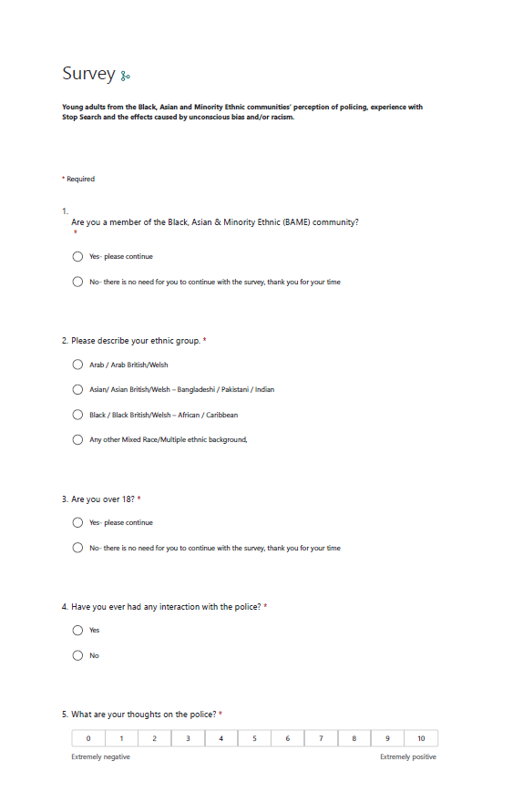
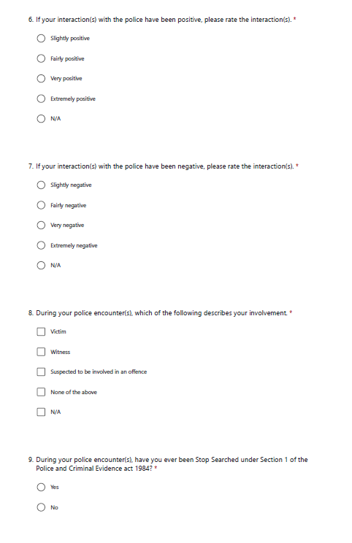
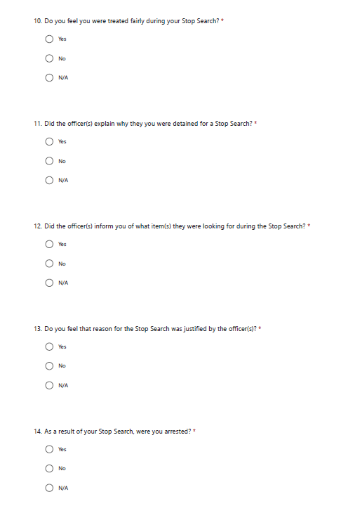
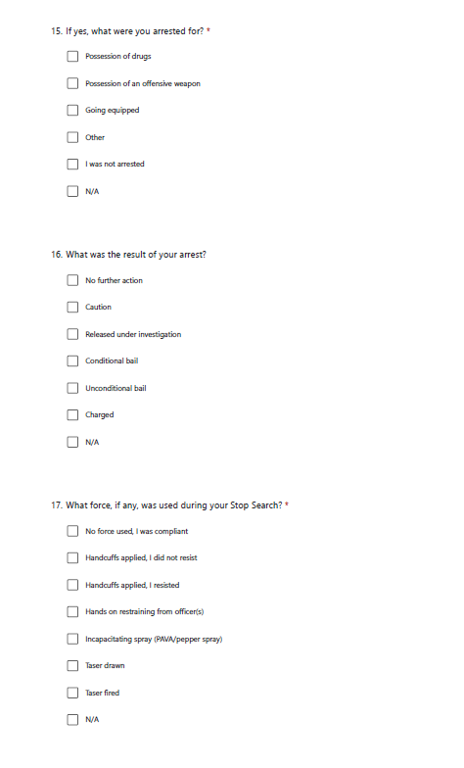

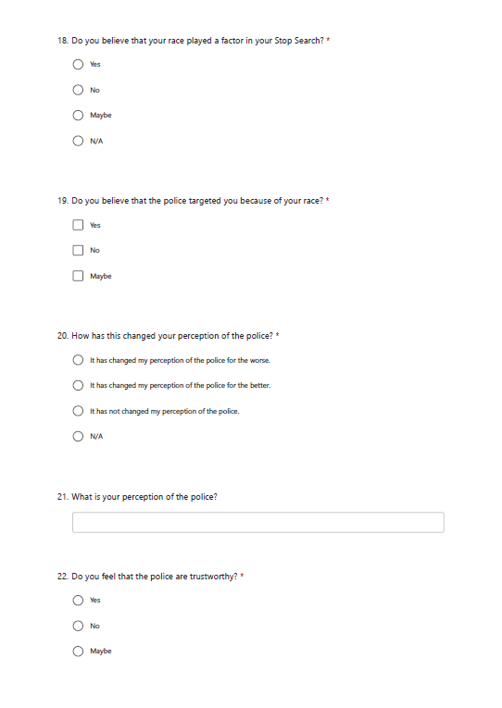
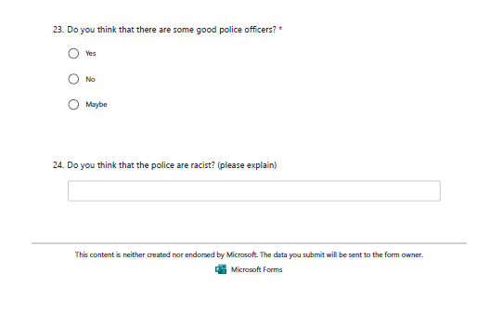

7.4 Appendix Four: Demographic Survey Results
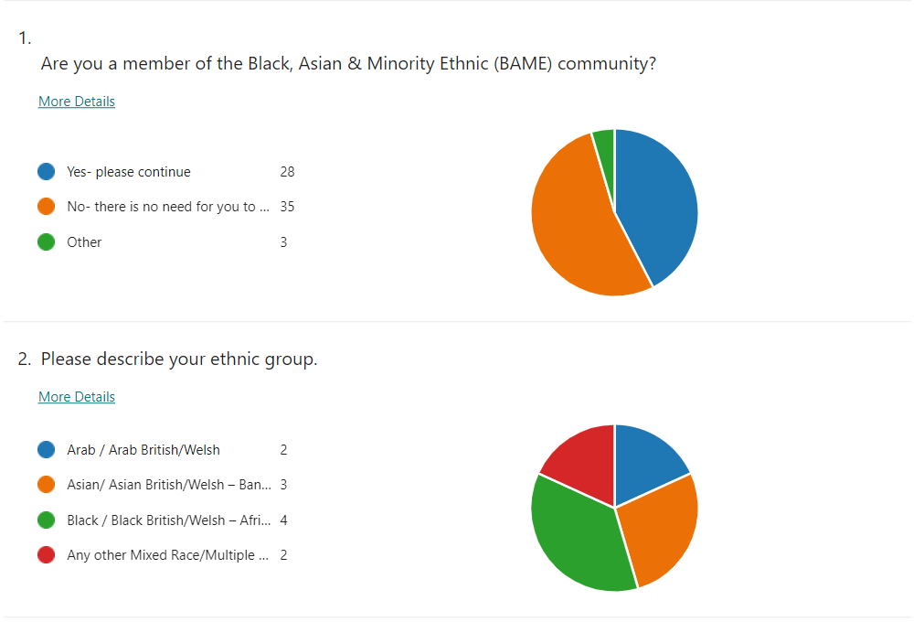

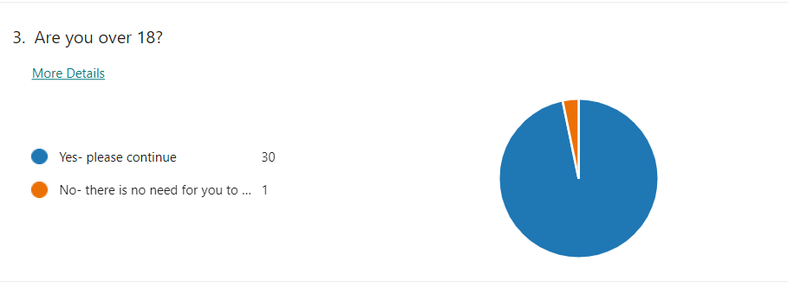
7.5 Appendix Five: General survey Results

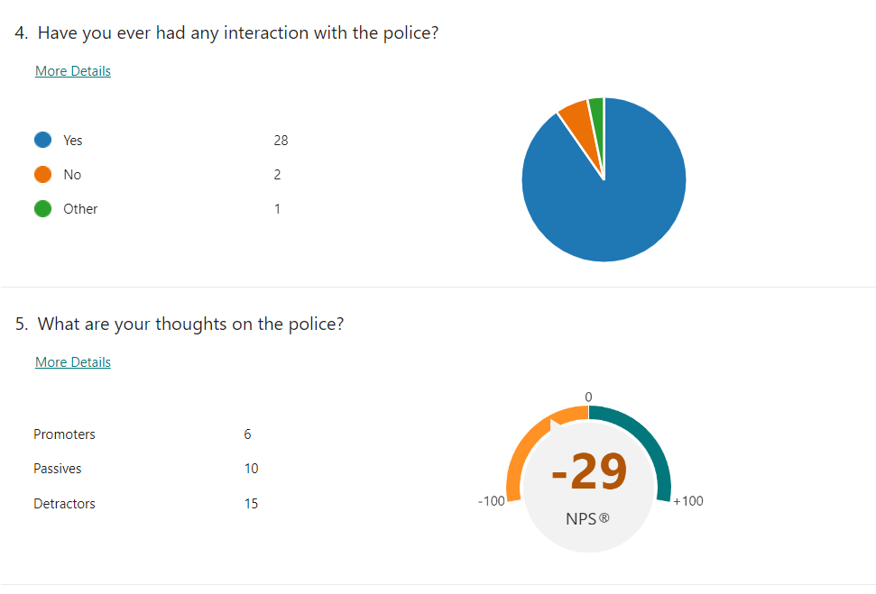
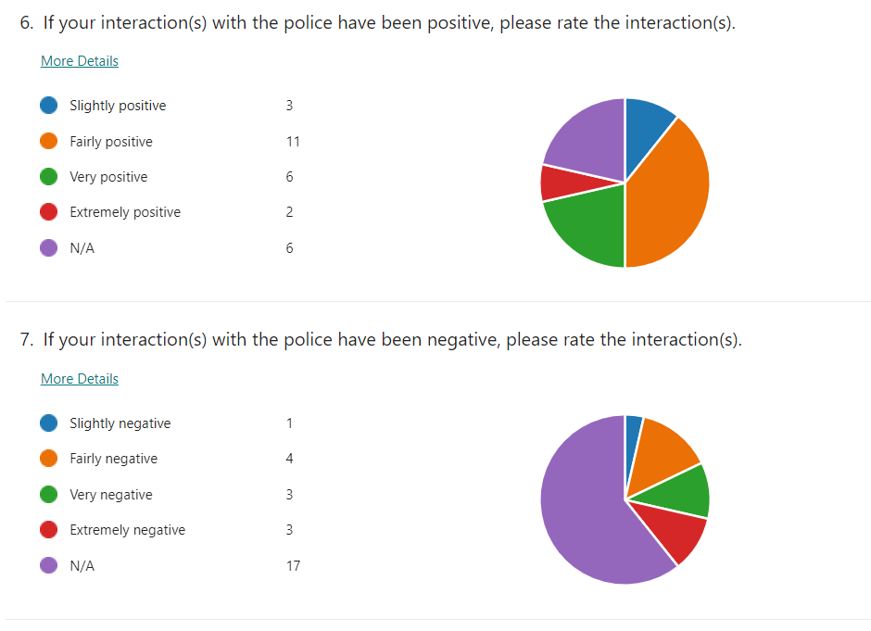
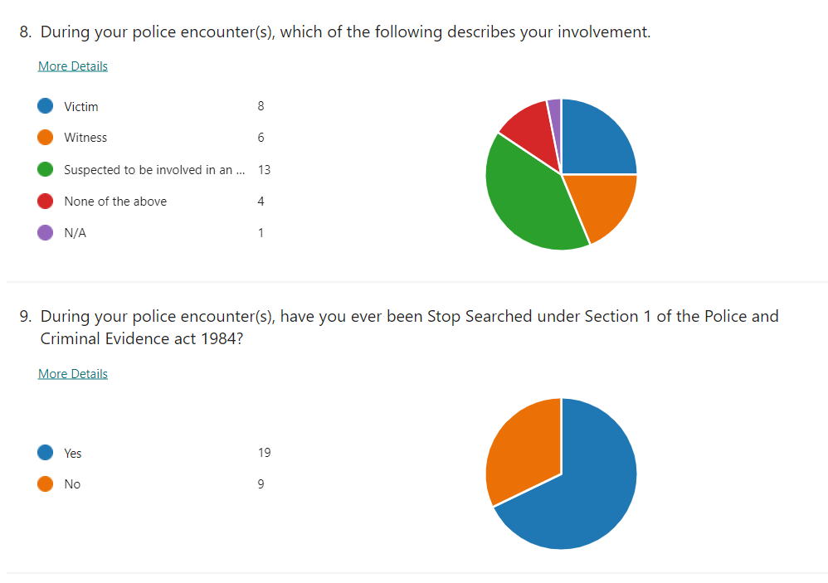
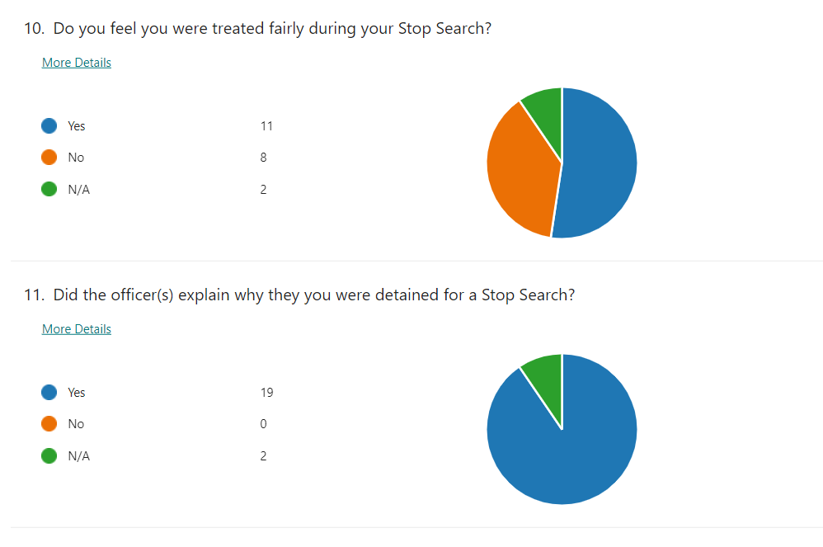
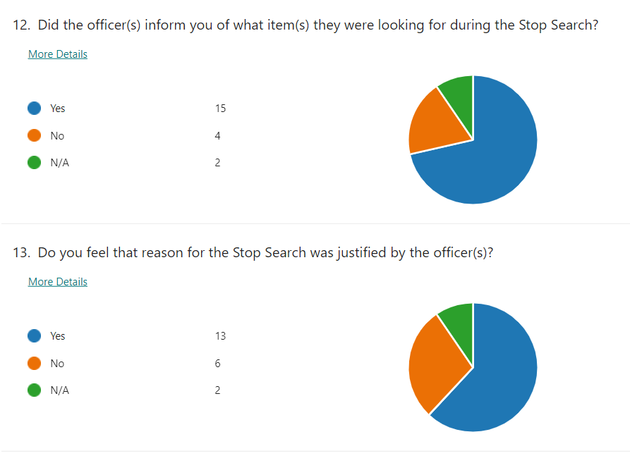
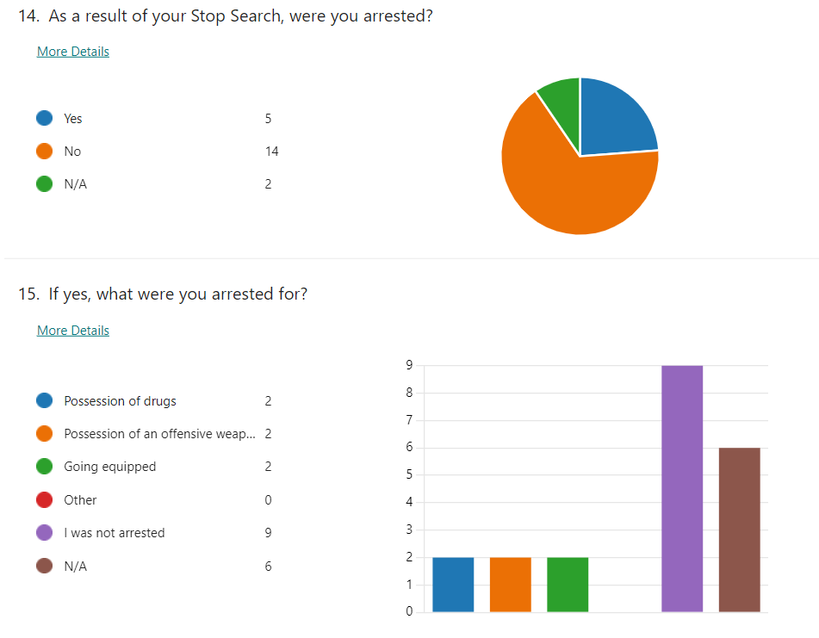
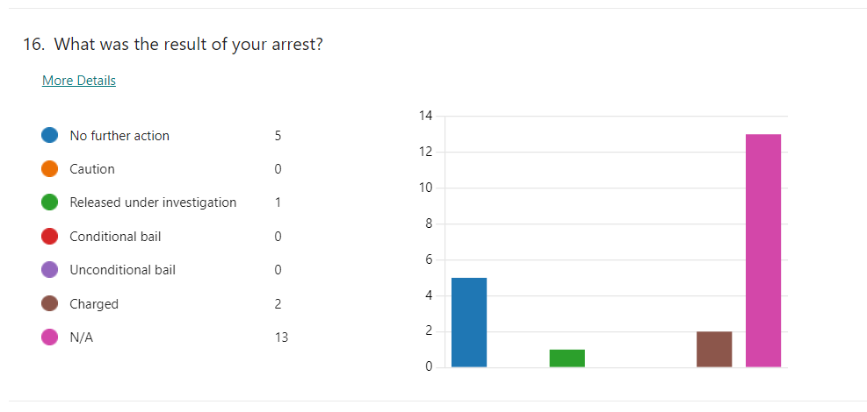
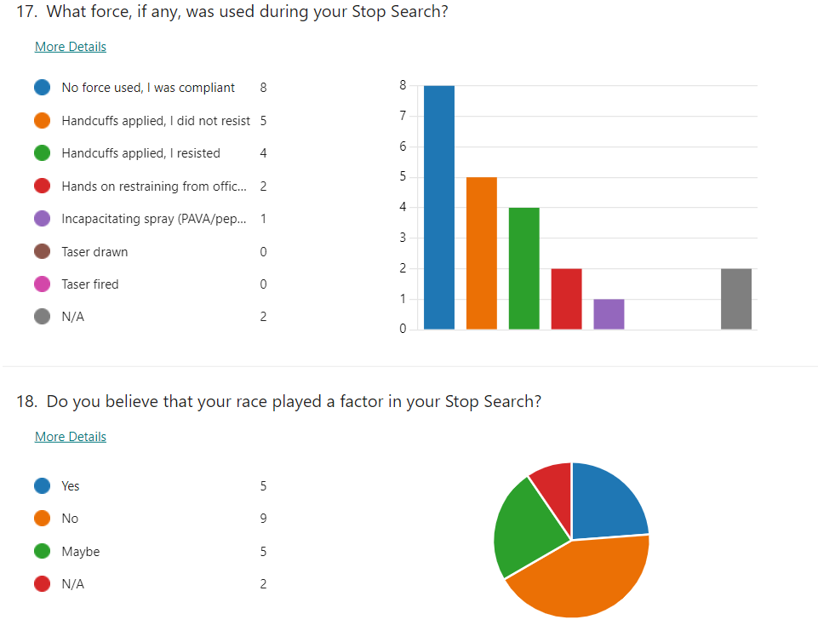
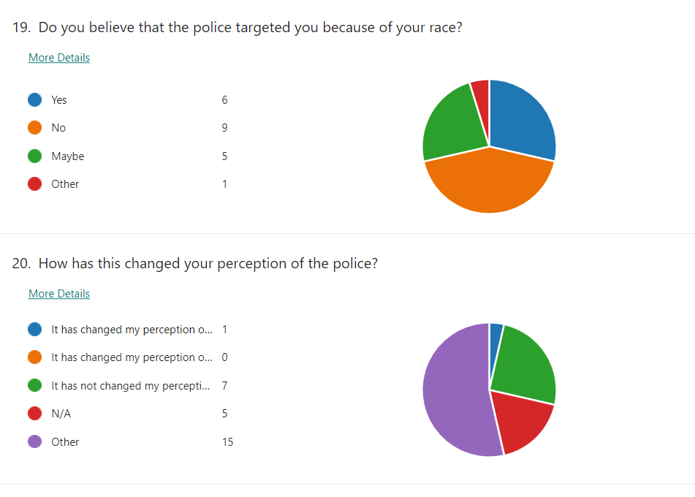
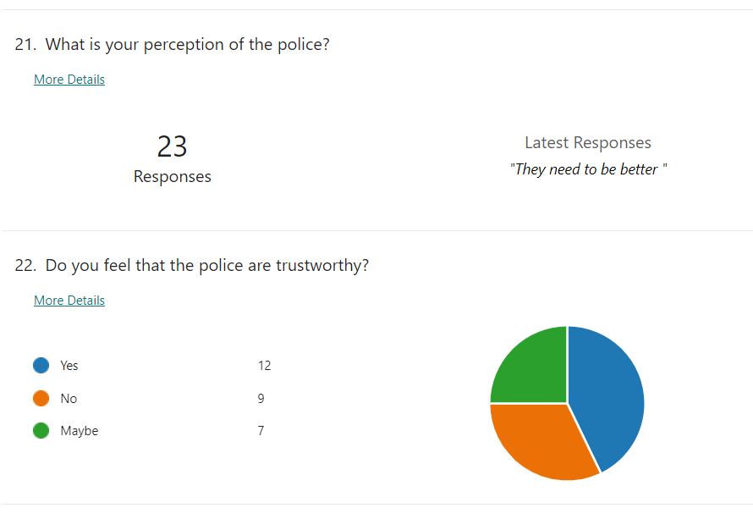
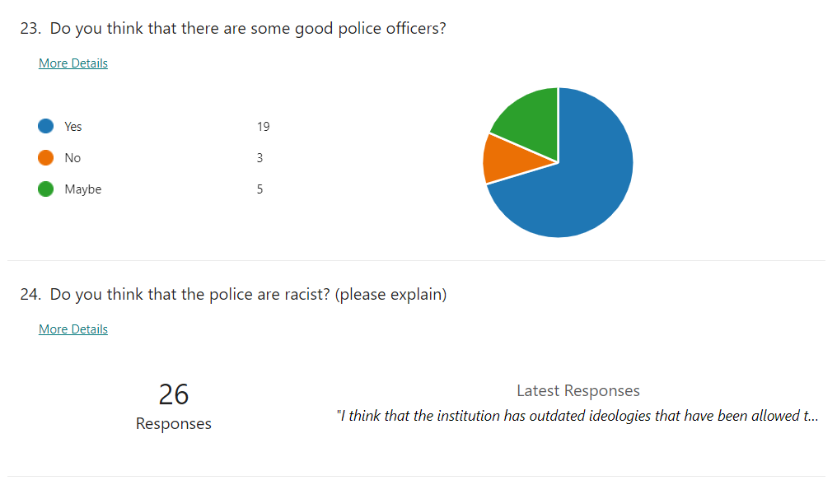
7.6 Written Responses on Perception
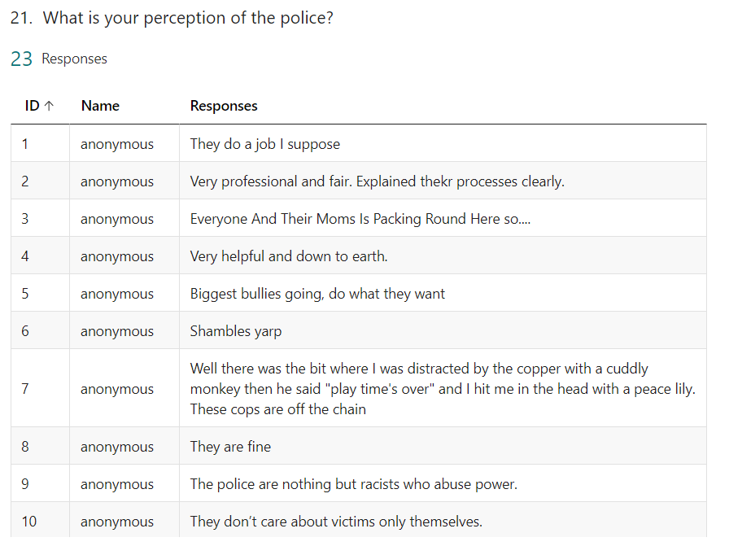
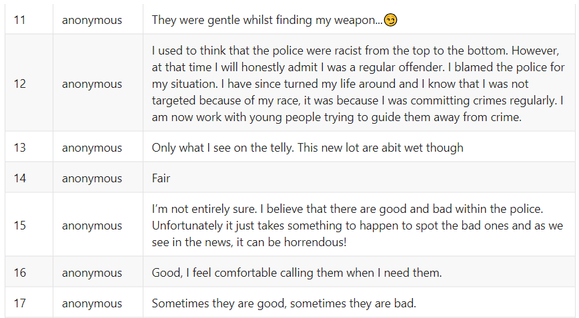
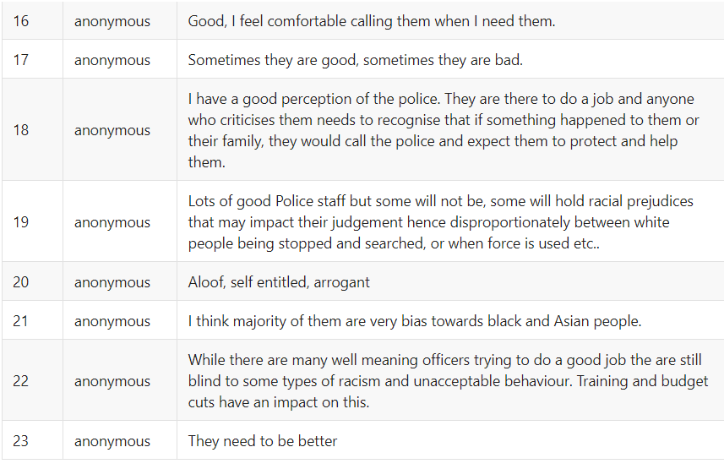
7.7 Written Responses on Racism in Policing
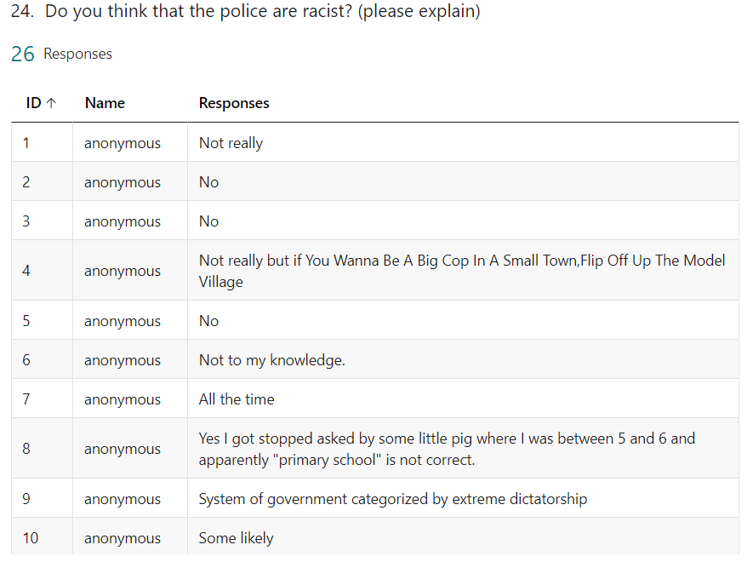
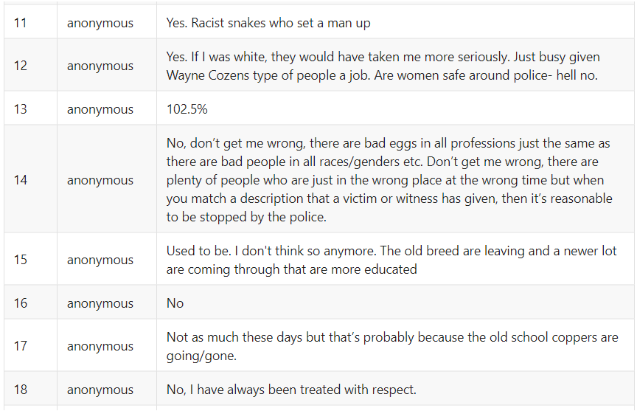
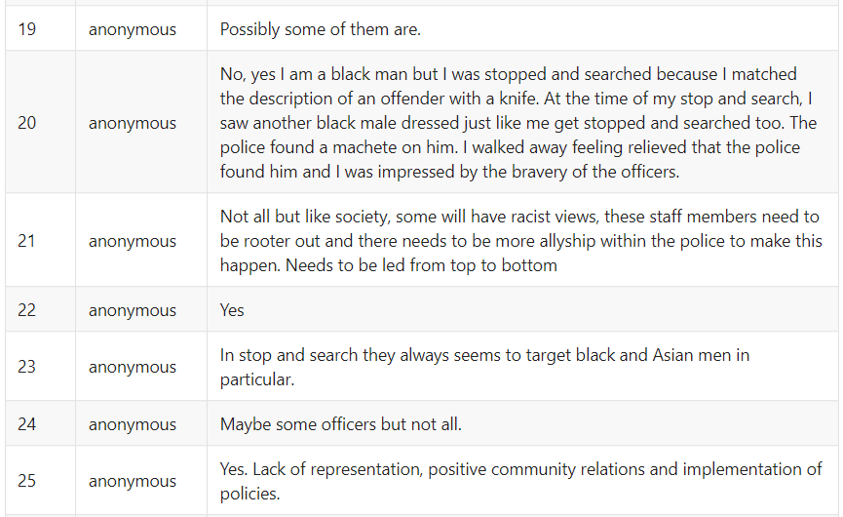
  - Appendix Six: General survey Results (Excel)

