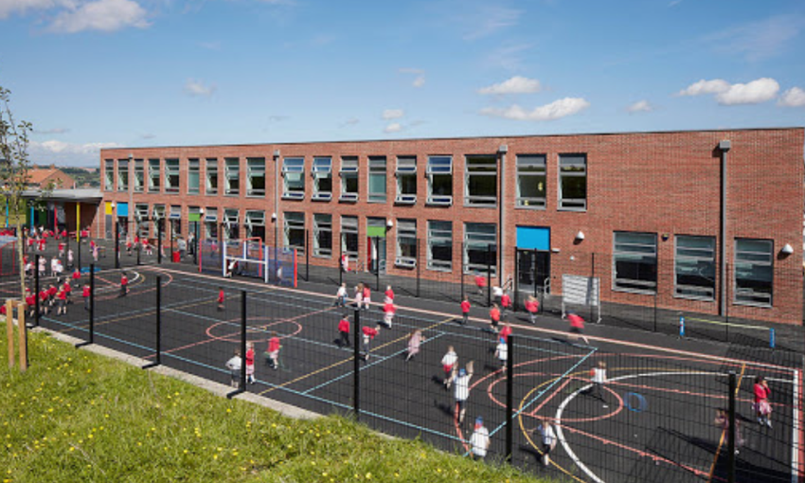

THANK YOU FOR READING THIS BOOKLET WE HOPE THAT YOU HAVE GAINED INFORMATION BY READING THIS.

YSGOL BRO TEIFWR

CROESO WELCOME

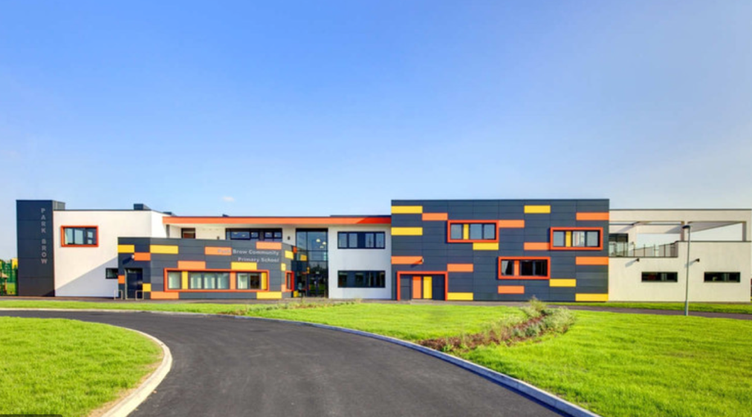

Parental Responsibilities

Every parent has the legal rights and responsibilities, Parents have to ensure that their child is supported financially, whether they have parental responsibility or not, every parent has the responsibility to:
- Provide a safe home for the child
- Protect and maintain the child
Also, parents are responsible for:
- Disciplining the child
- Choosing and providing for the child’s education
- Agreeing to the child’s medical treatment
- Naming the child and agreeing to any change of name
- Looking after the child’s property (www.gov.uk).

What are Children’s rights?

- Non-discrimination- this means that all children have the same right to develop their potential in all situations and at all times. For example, every child should have equal access to education, the child’s gender, race, ethnicity, nationality, religion, disability, parentage, sexual orientation or other status does not matter.
Why do children need rights?
- The best interests of the child- must be “a primary consideration” in all actions and decisions concerning a child and must be used to resolve conflicts between different issues.
- The right to survival and development- underscores the vital importance of ensuring access to basic services and to equality of opportunity for children to achieve their full development. For example, a child with a disability should have effective access to education and health care to achieve their full potential
- The views of the child- mean that the voice of the child must be heard and respected in all matters concerning his/her rights. For example, those in power should consult with children before making decisions that will affect them, in order to have their views too (Childrensrights.ie. (2015)).

After much debate in 1989, the UN Convention on the Rights of the child was ratified with only one country outstanding to sign. It has become broadly accepted that children should have their own set of rights
Children need their own rights as:
- They are separate and unique to adults
- They need special protections as they may be venerable and developing maturity
- They have special developmental needs and evolving capacities
- They can be less articulate than adults
- They are less likely to be taken seriously, and they have less power (Crae.org.uk. (2017)).

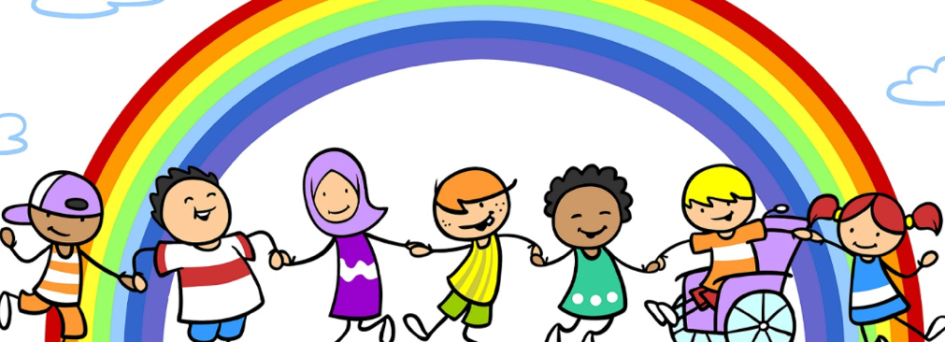(policyhubscotland.co.uk)
Educational Rights

Articles 28 and 29 focus on a child’s right to an education and on the quality and content of education. Article 28 states that “State Parties recognise the right of children to education” and “should take all appropriate measures to ensure that school discipline is administered in a manner consistent with the child’s human dignity.” Also, Article 29 focuses on the aims of education and argues that government has said that “the education of the child shall be directed to:
- the development of the child’s personality, talents, mental and physical abilities to their best and fullest potential
- development of respect for human rights and fundamental freedoms and the principles enshrined in the charter of the United Nations (www.unicef.org.uk).
Children’s Rights

Article 2
1. States Parties shall respect and ensure the rights set forth in the present Convention to each child within their jurisdiction without discrimination of any kind, irrespective of the child’s or his or her parent’s or legal guardian’s race, colour, sex, language, religion, political or other opinion, national, ethnic or social origin, property, disability, birth or other status.
2. States Parties shall take all appropriate measures to ensure that the child is protected against all forms of discrimination or punishment on the basis of the status, activities, expressed opinions, or beliefs of the child’s parents, legal guardians, or family members (unicef.org.uk).
Article 12
1. States Parties shall assure to the child who is capable of forming his or her own views the right to express those views freely in all matters affecting the child, the views of the child being given due weight in accordance with the age and maturity of the child.
2. For this purpose, the child shall in particular be provided the opportunity to be heard in any judicial and administrative proceedings affecting the child, either directly, or through a representative or an appropriate body, in a manner consistent with the procedural rules of national law (unicef.org.uk).

ARTICLE 29
Education should help develop every child’s personality, talents and mental and physical abilities to the full. It should develop children’s respect for their own rights and those of others, for their parents, for their own culture and the cultures of others, and for the natural environment (Savethechildren.org.uk).
Article 23:
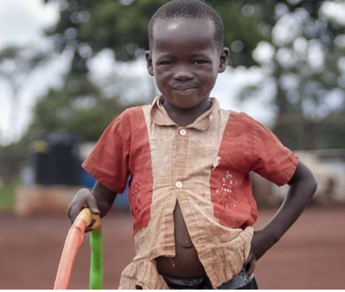
States that child with any kind of disability has the right to live a full and decent life with dignity and, as far as possible, independence and to play an active part in the community. Governments must do all they can to provide support to disabled children and their families.

(www.savethechildren.org.uk/)
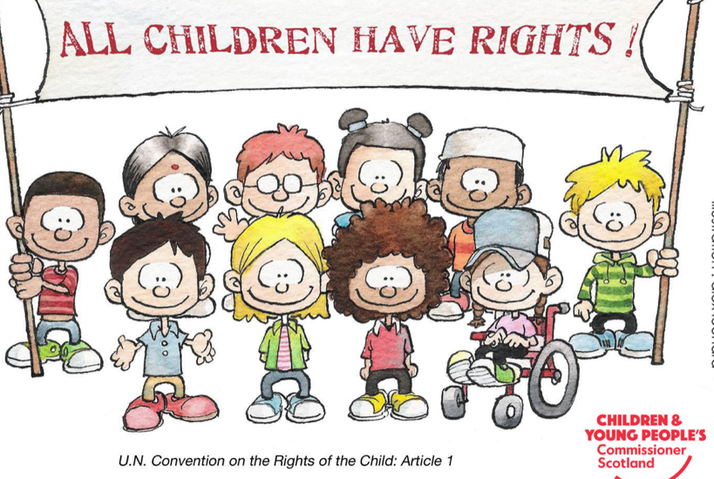

(www.cypcs.org.uk)

Article 2
This article states that every party must respect and ensure that the rights that are set forth in the present Convention to each child within their jurisdiction without any kind of discrimination, irrespective of the child’s nor their parents or legal guardian’s race, colour, sex, language, religion, political or any other opinion, national, ethnic or social origin, property, disability, birth or any other kind of status.
This article can relate to the Equality Act 2010. The Equality Act 2010 provides the basic framework of protection against direct and indirect discrimination, harassment and victimisation in services and public functions, premi, work, education, associations and transport (www.gov.uk).
Article 2 (www.unicef.org.uk) related to disability, stating that each and every child needs to be protected against disability discrimination. There are many different types of disabilities in
schools, there are many different form of disabilities,
these can include, autism, wheelchair bound, hearing/speech impediment etc.

According to (www.bbc.co.uk 2014 assessed 27 Feb 20) ‘The study found 12% of seven-year-olds with special needs felt bullied all the time, compared with 6% of non-disabled peers’. Comparing these percentages together, it shows double the children are being bullied as they have some sort of disability.
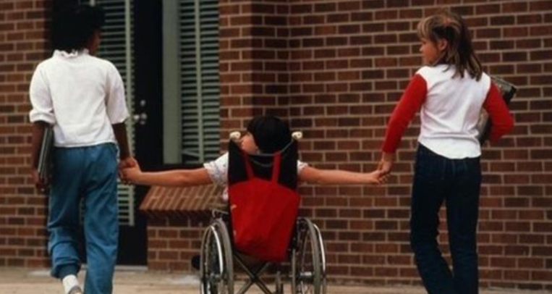

(www.bbc.co.uk)

Article 12
This article states that the child who is capable of expressing their own opinion and views has the right to express those views freely in all matters affecting the child. In accordance to the Article, the child shall in particular be provided the opportunity to be heard in any distinguished and administrative proceedings affecting the child, either directly or through any representative or an appropriate body, in a manner that is with the procedural rules of national law (unicef.org.uk).
The opinion of the child or a young person should be considered everywhere. This is not only in schools; this is also included in the household and anywhere they go. This right is. Important, no matter the age of the child/young person. However, the weight of their opinion changes as they grow up and become more mature (www.cypcs.org.uk).
The UNCRC is an international human right treaty that sets out every child that is entailed to. It was altered 30 years ago in 1989 and has been ratified by every country in the world besides USA. United Kingdom ratified the UNCRC in 1991, however it has still not been incorporated into domestic law, this means that many of the protections contained within it are not accessible to children and young people within the UK (www.cypcs.org.uk) There is also a wider group of rights (or articles) that address the right of children to participate and which influence our understanding of participation, including a child’s right to seek and receive information, to express their own views and to associate with others (www.unicef.org.uk).
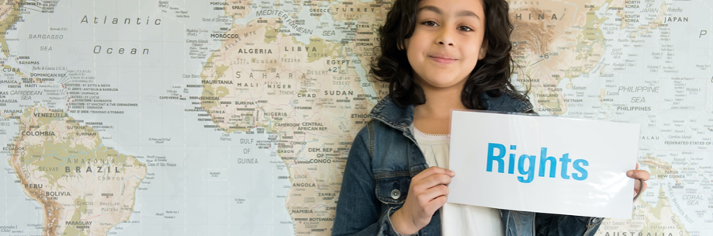
Article 12 applies to everyone, care needs to be taken to ensure it can be exercised by everyone on a day to day basis, for example, different materials needs to be in place for children and young people with a disability if they need the help to participate. Special consideration needs to be given to children and young people in difficult or venerable situations, such as the children in care or if they are a refugee. Most importantly, boys and girls’ opinions should be equal, no gender are important than the other.
This article is concerned with ensuring children and young people are able to free their opinions and express them however they want. It states that their feelings and opinions will not be dismissed or regarded as invalid because of their age (www.cypcs.org.uk).
The Children and Young People’s Commissioner in Scotland is Bruce Adamson. Adamson and his team, their work is to protect the rights of children.
According to Adamson (www.cypcs.org.uk/) ‘Following decades of campaigning by civil society and children’s commissioners, the First Minister has committed to incorporation of the United Nations Convention on the Rights of the Child (UNCRC) into Scots law before the end of the current Parliamentary session in 2021’.

(www.unicef.org.uk)

Article 29
Article 29 states that every child has the right to an education. Which education develops personality, respect for other people’s rights. Article 29 says that a child or young person’s education should help their mind, body and personality to ensure they can be the best they can.
It also helps build respect for other people and the environment around them. However, Article 29 helps them to show respect towards:
- rights of others and their rights
- their freedom and freedom of others
- their parents
- the identity, language and values of countries including their own.
Article 29 also states that children and young people have the right to be educated in a place other than a school, for example a private school or by a family member. The government should not make it so the only places they can study are provided by the State (www.cypcs.org.uk).
Article 29 also links in with Article 14. The Article states that children have the right to their own thoughts and beliefs and to choose any religion with their parents’ guidance. Article 14 of UNCRC says that children and young people are free to be any religion or no religion at all. Parents can help their children on deciding what religion they would like to be included in however, parents cannot force a child/young person to adopt a religion nor a parent cannot force a child/young person to stop following their chosen religion (www.cypcs.org.uk).

Article 23
This article is about children and young people with different disabilities. Schools are not only supporting disabled children and young people in the present, but they are helping to empower them and their families for the future. The Convention is for everyone under the age of eighteen, but of course human rights are for life.
Every child and young person have the right to be happy but most importantly, to feel safe, when a child or young person has a disability, people should ensure that it does not get in the way of this. Staff, parents/guardians should ensure that they stick to the rules no matter the disability. Children and young people should be cared for in a way that takes any disability they have into account, and that teachers should ensure that it is taught in school to ensure that everyone understands their disability.
It is vital that no one treats the child/young person any differently because of their disability. They need to ensure that it does not stop the child/young person from doing certain activities that they enjoy, and to ensure that it does not take their rights away.
Children and young people with a disability should be able to:
- join in with their friends in activities
- feel included within the school
- have special care, if they are need of it
- able to choose what they do and have a right to express their opinion in class (www.cypcs.org.uk/)

Ysgol Bro Teifwr is delighted to share this information with parents/guardians. As a school, each and every staff member work together to ensure each child has equal opportunities amongst others.
This school is pleased to be following these rights, not only as it is law, but on the hand that the school is delighted to and are happy to ensure every child are happy coming to school to learn, but importantly, have fun.
Ysgol Bro Teifwr pride themselves very highly on the fact that children have fun whilst being in school, as the school believes that every child learn more through play.
If you have any questions, please do not hesitate to come in and speak to Mr Heitman (headmaster).
Thank you

Mae Ysgol bro Teifwr yn hapus i rannu’r gwybodaeth gyda rhieni a gwarcheidwaid. Ni gyd fel staff yn gweithio gydai’n gilydd to wneud yn siwr bod plant yn gael. cyfle cyfartal.
Mae Ysgol Bro Teifwr yn fwy na hapus i dilyn hawliau plant, dim, dim ond hawl yw hwn, ond da ni yn mwy na hapus i wneud yn siwr bod phob plenty yn hpaus dod i’r ysgol i dysgu, ond yn bwysicaf, i gael hwyl.

Mae Ysgol Bro Teifwr yn ymfalchïo'n fawr yn y ffaith bod plant yn cael hwyl wrth fod yn yr ysgol, gan fod yr ysgol yn credu bod pob plentyn yn dysgu mwy trwy chwarae.

Os gennych. unrhyw cwestiynnau, plis dewch mewn, neu cysylltwch da Mr Heitman (Pennaeth)
Diolch

References

Childrensrights.ie. (2015). What are Children's Rights? | Children's Rights Alliance. [online] Available at: https://childrensrights.ie/childrens-rights-ireland/childrens-rights-ireland [Accessed 13 Feb. 2020].
Crae.org.uk. (2017). [online] Available at: http://www.crae.org.uk/media/123572/Barriers-and-solutions-to-using-childrens-rights-in-policy-E.pdf [Accessed 17 Feb. 2020].
Downloads.unicef.org.uk. (2020). [online] Available at: https://downloads.unicef.org.uk/wp-content/uploads/2010/05/UNCRC_united_nations_convention_on_the_rights_of_the_child.pdf?_ga=2.82177430.1204514837.1582630402-130268758.1581957942 [Accessed 25 Feb. 2020].
Savethechildren.org.uk. (2020). [online] Available at: https://www.savethechildren.org.uk/content/dam/gb/reports/humanitarian/uncrc19-summary2.pdf [Accessed 26 Feb. 2020].
Scotland, C. (2020). Your rights in pictures. [online] CYPCS. Available at: https://www.cypcs.org.uk/rights/picture/children [Accessed 26 Feb. 2020].
Policy Hub Scotland. (2020). Children's Rights - Policy Hub Scotland. [online] Available at: https://policyhubscotland.co.uk/in-house/childrens-rights/ [Accessed 26 Feb. 2020].
BBC News. (2014). Young disabled 'are bullying victims'. [online] Available at: https://www.bbc.co.uk/news/education-27902500 [Accessed 27 Feb. 2020].
GOV.UK. (2015). Equality Act 2010: guidance. [online] Available at: https://www.gov.uk/guidance/equality-act-2010-guidance#equality-act-provisions-commencement-dates [Accessed 27 Feb. 2020].
Scotland, C., 2020. Article 12. [online] CYPCS. Available at: <https://www.cypcs.org.uk/rights/uncrcarticles/article-12> [Accessed 13 March 2020].
Scotland, C., 2020. Incorporation Of The UNCRC. [online] CYPCS. Available at: <https://www.cypcs.org.uk/policy/incorporation-of-the-un-convention-on-the-rights-of-the-child-> [Accessed 17 March 2020].
Rights Respecting Schools Award. 2020. The Right To Participation For Rights Respecting Schools - Unicef UK. [online] Available at: <https://www.unicef.org.uk/rights-respecting-schools/the-right-to-participation/> [Accessed 17 March 2020].
GOV.UK. 2020. Parental Rights And Responsibilities. [online] Available at: <https://www.gov.uk/parental-rights-responsibilities> [Accessed 19 March 2020].
Rights Respecting Schools Award. 2020. The Right To Education - Unicef UK. [online] Available at: <https://www.unicef.org.uk/rights-respecting-schools/the-right-to-education/> [Accessed 19 March 2020].
Scotland, C., 2020. Article 29. [online] CYPCS. Available at: <https://www.cypcs.org.uk/rights/uncrcarticles/article-29> [Accessed 19 March 2020].
Scotland, C., 2020. Article 14. [online] CYPCS. Available at: <https://www.cypcs.org.uk/rights/uncrcarticles/article-14> [Accessed 19 March 2020].
Scotland, C., 2020. Article 23. [online] CYPCS. Available at: <https://www.cypcs.org.uk/rights/uncrcarticles/article-23> [Accessed 19 March 2020].

