Module: Marketing Management
Module code: LCMB7024

Assessment Component 1- Essay

Student ID: 2429424
Student Name: Kaniz Fathama Chowdhury
Word Count: 2900
Lecturer: Haoran Liu

Table of Contents
Introduction 3
Advantages of being a pioneer 4
Example of pioneer 4
Advantages of being a follower 6
Example of followers 6
Product life cycle 8
Apple's Product Life Cycle Management 9
Samsung's Product Life Cycle Management 12
Comparison with Other Companies 14
Conclusion 15
References 16

Introduction
A company must decide whether to enter a new market as a pioneer or a follower. This choice influences its success and determines its competitive position and market strategy. Market entry strategy is important for business growth (Chen, 2023). A pioneer is the first company to enter a market. It introduces a new product or service. This company sets trends and builds early customer trust (Dreiling and Bican, 2022). A follower enters later. It learns from the pioneer’s mistakes. This company can improve products and reduce costs (Xu et al., 2021). Both strategies have benefits and risks. Pioneers gain a strong brand image. They also create customer loyalty (Dreiling and Bican, 2022). However, they face high costs and risks. Followers avoid these costs. They can also improve existing products (Xu et al., 2021). Yet, they may struggle to gain market share. The Product Life Cycle (PLC) model explains how products change over time. It has four stages: introduction, growth, maturity, and decline (Udokporo, 2021). Companies use different strategies at each stage. Pioneers focus on innovation and promotion, while followers focus on cost and quality improvement. This essay will discuss both strategies. It will compare their advantages with examples. It will also explain how companies use PLC strategies. The aim is to show how these strategies help companies grow (Chen, 2023). Understanding market entry is important. It helps companies succeed. The right strategy depends on many factors. These include costs, competition, and market conditions (Xu et al., 2021). A company must choose wisely. This choice affects its future.

Advantages of being a pioneer
A pioneer is the first company in the market. It creates new products or services. This is called a first-mover advantage (Chavez and Chen, 2022). A pioneer can shape customer needs and industry trends. This helps it grow faster than later competitors (Cirik and Makadok, 2023). Historically the advantages of being a pioneer have been promoted to a much greater extent than the risks (Lieberman, Montgomery, 1998). A pioneer builds strong brand recognition. It has become the leader in its industry. Customers trust well-known brands (Cirik and Makadok, 2023). People prefer to buy from brands they know. The speed of entering a new market always has an important competitive impact. Perhaps an enterprise intends to develop a new product, novel technology to generate new products or a commercial sector wishes to introduce new services. Regardless of which sector environmental change certainly provides better opportunities for first movers. However, industry must initially process organizational skills and resources to capitalize on such opportunities (Kerin et al, 1992). Pioneering and first-move advantage can be achieved in several ways: 1) by making new products, 2) by using a new process, or 3) by entering a new market (Heiens et al, 2003).

Example of pioneer
Apple is an example Apple was the first to launch the iPhone. It introduced the touchscreen smartphone (Chavez and Chen, 2022). Before that, phones had buttons. Apple changed how people used phones. Apple set the trend in the industry. Other companies copied its ideas (Cirik and Makadok, 2023). It became a leader in the smartphone market. People trusted Apple’s brand. They believed its products were high quality. Apple spent a lot on research. It made new technology before others (Chavez and Chen, 2022). It created the App Store. Users could download apps for the first time. This made iPhones more useful. Apple kept improving. It released a new iPhone every year (Yang et al., 2025). Each model had better cameras and batteries. Customers stayed loyal to Apple. They did not want to switch brands. Switching to another brand was hard. This is called switching cost (Yang et al., 2025). Apple users were used to iOS. They did not want to learn a new system. This kept them buying iPhones. Apple controlled pricing. It set high prices for its phones (Gauttier et al., 2024). Even with high prices, people still bought them. Owning an iPhone became a status symbol. Apple also controlled sales. It sold phones directly through its stores (Gauttier et al., 2024). This gave Apple more control over profits. It did not depend on other retailers. Apple made big decisions in the market. It removed the headphone jack in 2016. Many customers complained, but other brands followed (Cirik and Makadok, 2023). Apple led industry in design changes. Apple’s strategy made it very successful. The iPhone became one of the best-selling products in history. Its brand loyalty remained strong. Customers waited for new iPhones every year.

Advantages of being a follower
A follower enters the market after a pioneer. This is called a late-mover advantage. It means the company can avoid early risks (Xie et al., 2021). A follower learns from the pioneer’s mistakes. This helps it grow faster. A pioneer spends a lot on research. It develops new products from scratch. This is costly and risky (Deqiang et al., 2023). A follower does not need to do this. It can study the pioneer’s product. Then, it can improve it at a lower cost. Moreover, pioneers disadvantages and challenges become followers advantage such as The main first-mover disadvantages (Lieberman, Montgomery, 1988) are: 1) free–rider benefits to followers, 2) market and technological uncertainties, 3) unforeseen changes in technology or customer needs, and 4) incumbent inertia, which results in the gradual updating of existing technology, rather than the adoption of new and improved technologies.

Example of followers
Samsung entered the smartphone market later. It studied Apple’s success (Xie et al., 2021). It saw what worked and what did not. Then, it improved where Apple was weak. Samsung made more phone models. It sold both expensive and cheap phones (Deqiang et al., 2023). This helped it reach more customers. People who could not afford iPhones bought Samsung phones. Samsung learned from Apple’s design. It made similar phones but added better features (Park, 2022). In 2011, it launched big-screen phones. Apple did not have big screens then. Many customers wanted larger displays. Samsung also improved cameras. Apple had good cameras, but Samsung added extra lenses (Park, 2022). It focused on making better pictures. Many people preferred Samsung for photography. Price was another advantage. Apple set high prices. Samsung made cheaper models (Xie et al., 2021). People who wanted good phones at lower prices chose Samsung. Samsung also worked on software. Apple had iOS, but Samsung used Android (Deqiang et al., 2023). It added special features that iPhones did not have. This made Samsung phones different. Samsung watched Apple’s mistakes. When Apple removed the headphone jack, Samsung kept it (Xie et al., 2021). Many people did not like Apple’s choice. Samsung used this as an advantage. Marketing helped Samsung grow. It made ads comparing itself to Apple (Park, 2022). It showed why its phones were better. Many customers switched from Apple to Samsung. Samsung also worked on new technology. It made foldable phones before Apple (Xie et al., 2021). It kept testing new ideas. This helped it stay ahead in some areas. Apple had loyal users. But Samsung gave them reasons to switch (Deqiang et al., 2023). Some people moved from iPhones to Samsung. This helped Samsung grow fast.

The chances of long-term success vary between first movers and those that follow later. Both face risks and challenges. Some pioneers fail. Multiple followers experience business difficulties (Peng et al., 2021). The company determines what customers pay and how products reach markets (Dreiling and Bican, 2022). However, pioneers must keep innovating. When market leaders pause for improvement, their followers stand a chance to take over their market position. A follower pays less expenses during start-up. It improves existing products. The strategy helps businesses escape many potential threats (Sheth and Parvatiyar, 2021). To succeed in the market a follower needs to battle their competitors. Followers need to create more customer value than leading pioneers in the market.

A pioneer needs to invest heavily in research work. Its main goal is to generate interest from customers in its product. Their business ends when customers do not show interest (Dreiling and Bican, 2022). The followers try to compete in a well-established marketplace. Since strong competitor brands exist the company must fight for market share. The company faces hard challenges when it enters the marketplace (Peng et al., 2021). A pioneer requires substantial money to try new business ventures that could fail. People who follow market trends will face financial dangers when they join the market. When market patterns adjust the company can end up failing according to Ngamvichaikit (2024). BlackBerry launched the first smartphones for the market. It led the market for years. However, it failed to adapt.

Product life cycle
Products transform through various stages in business life based on the Product Life Cycle model. It demonstrates how products begin their existence before transitioning through development and peak stages until their market decline (Iveson et al., 2022). The steps of a product require unique marketing strategies.
Introduction Stage: A new product enters the market. Sales are low, and costs are high. Companies spend money on promotion. Customers may not know the product yet (Vendrell-Herrero et al., 2022).

Growth Stage: Sales start to rise. More customers buy the product. Companies focus on increasing market share. They improve product features. Competition starts to grow (Krishen et al., 2021).

Maturity Stage: Sales reach their peak. The market becomes saturated. Companies reduce prices to stay competitive. They try to keep customer loyalty. Profits may start to decline (Iveson et al., 2022).

Decline Stage: Sales drop. Customers lose interest in the product. Companies decide whether to improve, replace, or stop the product (Vendrell-Herrero et al., 2022).
Pioneers focus on creating demand in the introduction stage. They spend more on research and promotion. Followers enter later. They improve the product and set lower prices (Krishen et al., 2021). Pioneers must defend their market share in maturity. Followers focus on taking customers from pioneers. Each strategy depends on market conditions.

Apple's Product Life Cycle Management
Introduction Stage: Apple introduces innovative products. For example, the first iPhone launched in 2007. This was a new concept combining phones, music players, and internet devices. Apple invested heavily in marketing to educate consumers. Sales were initially modest but showed promise (Vendrell-Herrero et al., 2022).
Growth Stage: Sales of the iPhone increased rapidly. Apple released new models with improved features. The App Store launched, expanding functionality (Morales-González et al., 2022). Competitors entered the market, but Apple's brand remained strong. Revenue and market share grew significantly.​

Table 1: Apple's Annual iPhone Sales (in millions)
Year | iPhone Sales
2007 | 1.39
2008 | 11.63
2009 | 20.73
2010 | 39.99
2011 | 72.29
2012 | 125.05
2013 | 150.26
2014 | 169.22
2015 | 231.22
2016 | 211.88
Source: Apple Inc. Annual Reports

Looking at the figures Apple showed a very strong performance based on time. It ensures that as a pioneer they managed to keep customer trust and loyalty for several years. The figure also demonstrates their good control over risk and expenses for long period of time therefore achieved huge revenue.

Figure: Apple’s iPhone sales over time
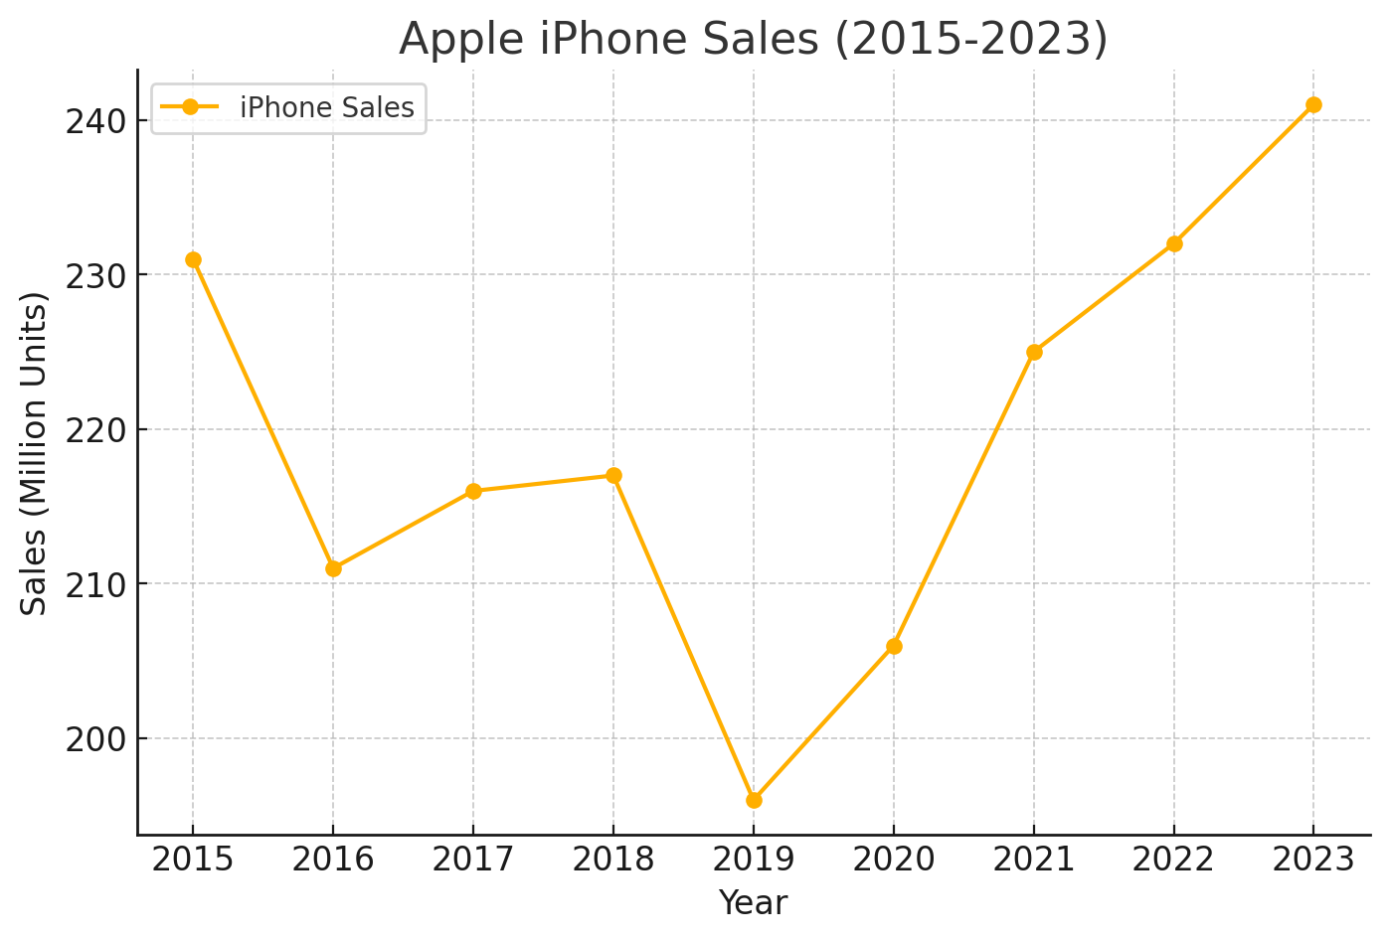
Source: (Apple Inc., 2025)
The chart shows that Apple’s iPhone sales have remained strong. The company continues to grow as a pioneer.

Maturity Stage: The smartphone market became saturated. Apple faced intense competition (Vendrell-Herrero et al., 2022). To maintain interest, Apple introduced features like Face ID and improved cameras. Pricing strategies varied, offering premium and budget models. Despite challenges, customer loyalty remained high.

Figure: Apple’s produce life cycle
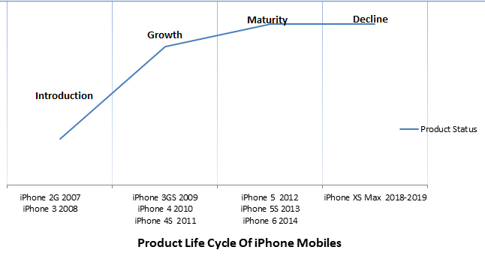
Source: (Apple inc., 2019)

The above graph shows Apple managed to hold maturity stage well. Since 2012 they remain steady and never decline to sale or in performance. Moreover, they introduced several new models in the iPhone industry. Almost every new version each year let them connect with consumers.

Decline Stage: While the iPhone remains popular, growth may slow. Apple focuses on services like Apple Music and Apple TV+. This diversification offsets slowing down hardware sales. Continuous innovation aims to prolong the product's life cycle (Morales-González et al., 2022).

Samsung's Product Life Cycle Management
Introduction Stage: Samsung enters markets after pioneers. It studies existing products and identifies improvement areas (Gómez et al., 2022). For instance, after Apple's iPhone launch, Samsung introduced the Galaxy series. These phones offered features like larger screens and stylus support (Joao et al., 2021).
Growth Stage: Samsung's smartphones gained popularity quickly. The company released diverse models catering to various market segments. Aggressive marketing and competitive pricing boosted sales (Morales-González et al., 2022). Samsung's adaptability allowed it to capture a significant market share​ (Yilin, n.d.).

Table 2: Samsung's Annual Smartphone Sales (in millions)
Year | Smartphone Sales
2010 | 6
2011 | 94
2012 | 213
2013 | 319
2014 | 405
2015 | 322
2016 | 309
2017 | 319
2018 | 295
2019 | 296
Source: Samsung Electronics Annual Reports

Even though Samsung provides a variety of products to their customers, perhaps looking into only smartphone sales the performance is outstanding. Samsung has sold a substantial number of smartphones over the years. It shows very strong stability on the market.

Figure: Samsung’s smartphone sales
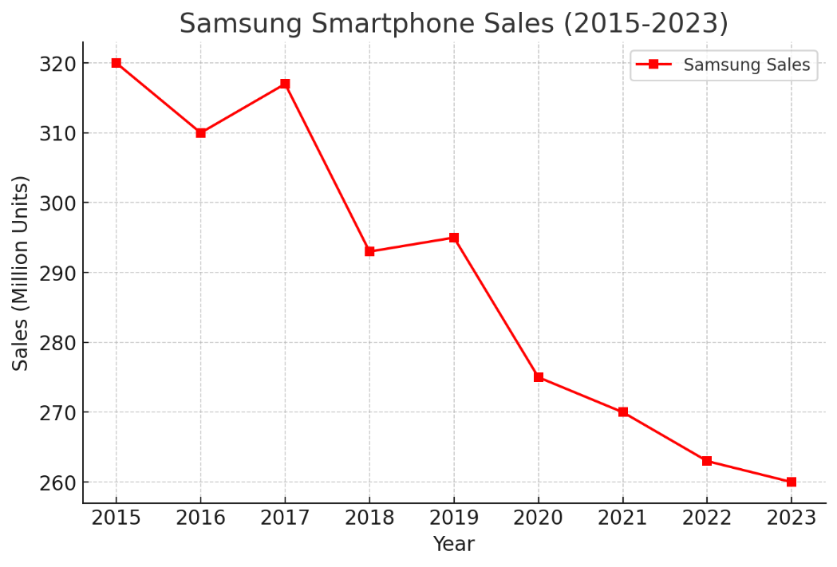
Source: (Samsung, 2024)
The chart shows that Samsung sells more phones than Apple. It reaches more customers because it offers more models at different prices.

​
Maturity Stage: Facing a saturated market, Samsung diversified its product line. It offered both high-end and budget-friendly models. Innovations like foldable screens set it apart (Yilin, n.d.). Samsung also invested in ecosystem development, integrating devices seamlessly.​ Let’s look into Samsung’s SWOT analysis to determine their strong position in maturity stage.

Figure: Samsung SWOT analysis
Strength | Weakness
Diversified business operations.  Robust market position and brand image of Samsung Electronics.  Samsung Electronics' focus on R&D | Patent infringement litigations with Apple
Opportunities | Threat
Strategic alliances  Growing global life insurance market  Positive outlook for smartphone market | Currency risk  Environmental regulations  Intense competition
Source: Datamonitor Plc
As an enterprise global business Samsung deals with various currency exposure therefore face risk of foreign currency exchange. Due to its subsidiaries operation Samsung faces high intense competition. Subject to various environmental laws of global warming and energy policy Samsung exposes substantial amount of environmental cost and liabilities. Moreover, Samsung sign off an agreement with the world largest manufacturers of hard disk drives company called “Seagate technology” in April 2011(Datamonitor, 2011). These agreements lead Samsung create a strong strategic alliance with growing global market.
However, Apple filed a lawsuit against Samsung Electronics, which alleged
that several of Samsung Electronics devices were infringed on Apple’s intellectual property. Later Samsung introduced new features in their devices (Datamonitor, 2011). Samsung set up new strategy of pricing to get customer loyalty and successfully achieved so. By increasing television market with approximately 22% market share, and global large LCD panel market with approximately 26% market share. Besides, it holds 20% share in the global laser printer market, 40% in global four-door refrigerator market, 21% in global mobile phone industry, 9% (Datamonitor, 2011) Samsung continued to perform positive impact on market for long time.

Decline Stage: Samsung combats decline by exploring new technologies. It invests in areas like 5G and artificial intelligence. Sustainability initiatives appeal to environmentally conscious consumers (Gómez et al., 2022). These strategies aim to rejuvenate product lines and maintain relevance.​

Comparison with Other Companies
BlackBerry: Once a leader in smartphones, BlackBerry struggled to innovate. It failed to adapt to touchscreen trends. This led to a rapid decline in market share. The company eventually exited the smartphone market (Joao et al., 2021).
Nokia: Nokia dominated early mobile phone markets. However, it was slow to adopt smartphones. Competitors like Apple and Samsung surpassed it. Nokia's market share plummeted, leading to the sale of its mobile division (Vendrell-Herrero et al., 2022).

Conclusion
This essay explored both market pioneering companies and those that follow. Both have strengths and weaknesses. The market approach needs to balance various elements. Companies need to develop thorough strategies in advance of their selection. Pioneers enter the market first. These businesses introduce the first products and establish market standards. Their powerful brand marketing helps them create a committed customer base. They establish rules for selling costs and selling locations. Pioneers need to spend heavily and take significant dangers. They should dedicate their resources to developing products and advertise their brands. By failing these market players lose every investment they made. Followers enter later. They learn from pioneers’ mistakes. They allocate much fewer resources to experimental activities. They make product enhancements and offer lower prices to buyers. This helps them attract customers. However, followers face strong competition. They need to put in considerable effort to capture market position. Market conditions affect success. The pioneer approach shows success in starting brand-new markets. A company can pioneer once there is no commercial product present in the market. Through innovation, it develops market needs and forms how people want to buy products. Tesla used this strategy to enter the electric car market. Companies employ follower business strategies when running against market competition. A company can study pioneers. Our company can deliver improved merchandise at cheaper rates. Actual business results came from this approach when Samsung worked with mobile phones. The company added better iPhone functions and attracted more buyers to their business model. Companies need to pioneer the market when they have exclusive innovation. The company needs sufficient resources to handle problem-solving actions. The organisation needs to train their customer base in this strategy. An organisation should stick to following when market conditions remain unclear. The company can observe early leading companies to improve its results. The organisation needs to develop enhanced features which will create customer interest. Artificial intelligence is changing marketing. Companies use AI systems to identify what their customers require and need. The method helps both leading firms and companies that join later minimise their potential hazards.

References
Apple Inc. (2023) 2023 Annual Report and Form 10-K. Available at: https://annualreports.com/Company/apple-inc (Accessed: 20 March 2025).
Apple Inc. (2025) Apple reports first quarter results. Available at: https://apple.com/newsroom/2025/01/apple-reports-first-quarter-results/ (Accessed: 20 March 2025).
Chavez, D. E., & Chen, H. (2022). First-mover advantages and innovation success: A contingency approach. Journal of Business & Industrial Marketing, 37(6), 1169-1181.
Chen, Y. (2023). Research on Market Entry and Environment. Academic Journal of Business & Management, 5(9), 9-13.
Cirik, K., & Makadok, R. (2023). First-mover advantages versus first-mover benefits: What’s the difference and why does it matter?. Academy of Management Review, 48(3), 409-431.
DATAMONITOR: Samsung Group’ (2011) Samsung Group SWOT Analysis, pp. 1–10.Available at:
https://research-ebsco-com.ezproxy.uwtsd.ac.uk/linkprocessor/plink?id=6f697d58-9def-3a75-93e8-b43f2d94f784 (Accessed: 27 March 2025).
Deqiang, S., Zhijun, C., & Rafique, M. Z. (2023). Late-mover advantages, innovation capability, and leapfrogging upgrading of low-carbon technology: evidence from Chinese enterprise groups. Environmental Science and Pollution Research, 30(42), 96515-96530.
Dreiling, A., & Bican, P. M. (2022). Pioneer or follower: Which strategy to choose?. In The Routledge companion to technology management (pp. 100-115). Routledge.
Gauttier, S., Simouri, W., & Milliat, A. (2024). When to enter the metaverse: business leaders offer perspectives. Journal of Business Strategy, 45(1), 2-9.
Gómez, J., Perez-Aradros, B., & Salazar, I. (2022). How to beat early movers: The role of competitive strategy and industry dynamism on followers’ performance in the telecommunications industry. Long Range Planning, 55(5), 102244.
Iveson, A., Hultman, M., & Davvetas, V. (2022). The product life cycle revisited: an integrative review and research agenda. European Journal of Marketing, 56(2), 467-499.
Joao, B., Castelo, R., Bezerra, D., Piscopo, M., Prates, L., & Serralvo, F. (2021). Global Strategy in LCD Market for Late Movers: A Brazilian Case.
Kaličanin, Đ. (2008) ‘A Question of Strategy: To Be a Pioneer or a Follower?’, Economic Annals / Ekonomski Anali, 53(177), pp. 89–102. doi:10.2298/EKA0877089K.
Krishen, A. S., Dwivedi, Y. K., Bindu, N., & Kumar, K. S. (2021). A broad overview of interactive digital marketing: A bibliometric network analysis. Journal of Business Research, 131, 183-195.
Morales-González, M. G., Ayup-González, J., & Huerta-Zavala, P. A. (2022).
b43f2d94f784 (Accessed: 27 March 2025).
Sustainability marketing strategies of companies in Mexico. Cuadernos de Administración (Universidad del Valle), 38(72).
Ngamvichaikit, A. (2024). Technology Driven Marketing Research in a Digital World: Implications for the Role and Scope of Marketing Research. International Journal of Trade, Economics and Finance, 15(2), 69-76.
Park, C. (2022). Different determinants affecting first mover advantage and late mover advantage in a smartphone market: a comparative analysis of Apple iPhone and Samsung Galaxy. Technology Analysis & Strategic Management, 34(3), 274-289.
Peng, H., Zhou, C., Sadowski, B. M., & Sun, T. (2021). Does an Imitation Strategy Promote Long-Term Firm Growth in a Dynamic Environment? A Meta-Analysis. Frontiers in Psychology, 12, 774071.
Salamzadeh, A., Hadizadeh, M., Rastgoo, N., Rahman, M. M., & Radfard, S. (2022). Sustainability-oriented innovation foresight in international new technology based firms. Sustainability, 14(20), 13501.
Samsung (2024) Audited Financial Statements. Available at: https://www.samsung.com/global/ir/financial-information/audited-financial-statements/ (Accessed: 20 March 2025).
Samsung Securities (n.d.) Annual Report. Available at: https://samsungsecurities.com/eng/invest/annual_report.do?tabCode=1 (Accessed: 20 March 2025).
Sheth, J. N., & Parvatiyar, A. (2021). Sustainable marketing: Market-driving, not market-driven. Journal of macromarketing, 41(1), 150-165.
Udokporo, C. K. (2021). Understanding the stages of the product life cycle. In Product Life Cycle-Opportunities for Digital and Sustainable Transformation. IntechOpen.
Vendrell-Herrero, F., Gomes, E., Opazo-Basaez, M., & Bustinza, O. F. (2022). Knowledge acquisition throughout the lifecycle: product and industry learning frameworks. Journal of Knowledge Management, 26(6), 1633-1647.
Vendrell-Herrero, F., Gomes, E., Opazo-Basaez, M., & Bustinza, O. F. (2022). Knowledge acquisition throughout the lifecycle: product and industry learning frameworks. Journal of Knowledge Management, 26(6), 1633-1647.
Xie, F. T., Donthu, N., & Johnston, W. J. (2021). Beyond first or late mover advantages: timed mover advantage. Journal of Business & Industrial Marketing, 36(7), 1163-1175.
Xu, K., Hitt, M. A., Brock, D., Pisano, V., & Huang, L. S. (2021). Country institutional environments and international strategy: A review and analysis of the research. Journal of International Management, 27(1), 100811.
Yang, Y., Chuang, Y. T., Wu, C. H., & Chen, Y. J. (2025). Is Switching Cost Always a First-Mover Advantage for the Technology Leader?. Available at SSRN 5143033.
Yilin, W. Embracing the wave of digital transformation: a case study of the Tech Pioneer Company Information Systems project.

