
APPENDIX GA36a

LEVEL 4 ASSESSMENT SPECIFICATION

Student name: |  | Student ID number:
Programme: | Cert HE STEM & Foundation Year Engineering Streams
Module: | Academic Writing
Module code: | M4X01498 | Contribution to Overall Module Assessment (%): | 50%
Lecturer: | Dr A Marotin | Internal Verifier: | DR G Owen
Assignment Title: | MATLAB | Word count (or equivalent): | MATLAB code
Submission deadline: | 06/05/2019 | Return date of provisional marks & written feedback: | 10/06/2019
Submission method: | All written assessments, where practical and possible, must be submitted via Turnitin unless otherwise instructed by the Lecturer. (Please DO NOT put this assessment specification into Turnitin or it will match many similarities with other students’ submissions.)  Alternative submission method (if applicable):  Late submission of the assessment will result in a late penalty mark. Penalties for late submission: Up to one week late, maximum mark of 40%. Over one week late, 0%. Only the Extenuating Circumstances Panel may approve a change to submission dates.
Academic honesty / referencing: | Academic honesty is required. In the main body of your submission you must give credit to authors on whose research and ideas your work is based. Append to your submission a reference list that indicates the books, articles, etc. that you have used, cited or quoted in order to complete this assessment.

Module Learning Outcomes
(from module syllabus)
Demonstrate knowledge and understanding of specific engineering concepts and how their theoretical characteristics are used in discipline specific engineering applications

TASK DESCRIPTION

In this assignment, you will be required to write a script in Matlab to generate two different figures comprising drawings made of circles as described below.

BACKGROUND INFORMATION
First, some fundamental mathematical definitions regarding the equation of a circle must be recalled.
The equation of a circle of radius r and centre C(a, b) can be written as,

$${\left(x-a\right)}^{2}+{\left(y-b\right)}^{2}=r$$

This equation can be expressed in a parametric form as,

$$\left\{\begin{matrix}x=a+r\cos{θ} \\ y=b+\sin{θ}\end{matrix}\right.$$
for all angular values of parameter θ.

What does 'parametric' mean?
In the above equations, the angle θ (theta) is called a 'parameter'. This is an independent variable that appears in a system of equations that can take on any value (unless limited explicitly) but has the same value everywhere it appears. A parameter values are not plotted on an axis.

Algorithm for drawing circles:
Parametric equations provide a convenient way to represent curves and surfaces. This form of defining a circle is very useful in computer algorithms. In fact, all the circles drawn by your Matlab script will be plotted using this equation’s form.

TASK 1:
The first figure your Matlab script should generate is a donut of centre C(2, 3), external radius of 2 and width of 1.3. The inside of the donut’s ring should comprise multiple circles as shown in Figure 1. The number of inscribed circles within the donut’s ring should be a user input and should be evenly distributed.

The figure should be titled ‘Donut with inscribed circles’ and x and y axis should be labelled as shown in Figure 1.

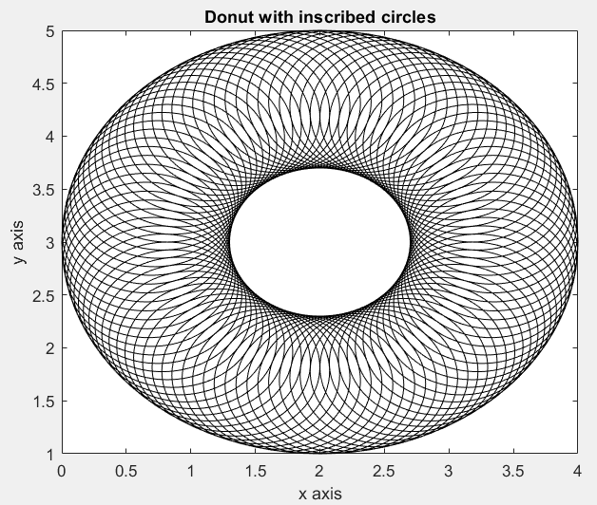
- 15 inscribed circles user input example. b) 100 inscribed circles user input example.
Figure 1: First figure of your Matlab script must produce.
TASK 2:
The second figure your Matlab script should generate is a donut of centre C(0, 0), external radius of 6 and width of 2. The donut’s hole should include inscribed circles of random colour. The number of inscribed circles should be a user input and should be evenly distributed as shown in Figure 2.

The number of circles within the donut’s ring should as many as the number of circles within the donut’s hole. The donut’s contour should be plotted in dash-dotted lines of colour black and width 3. The inscribed circles within the donut’s hole should be solid lines of random colours and width 1. The circles inscribed within the donut ring should be orange solid lines of width 1.
The figure should be titled ‘Donut hole filled with circles of random colours’ and x and y axis should be labelled in red as shown in Figure 2.

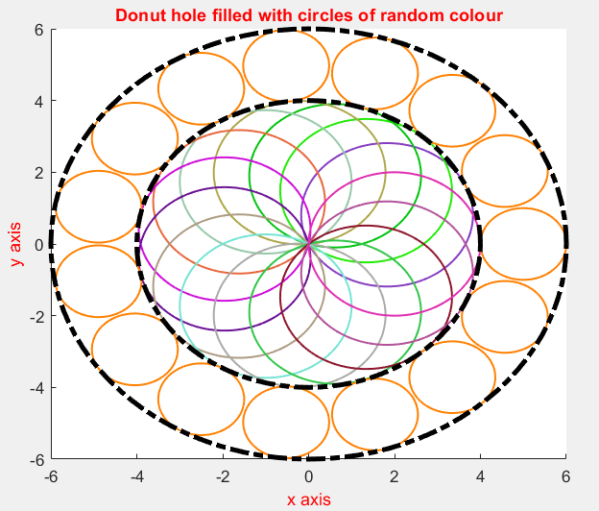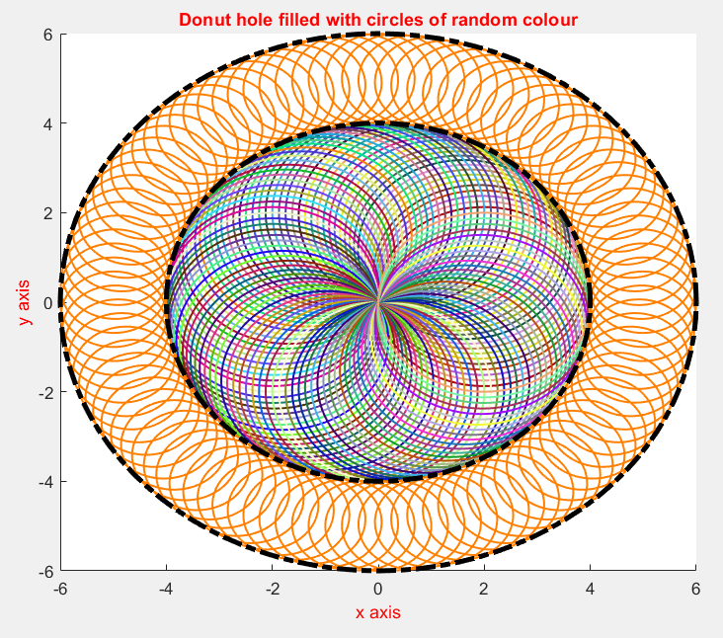
- 15 inscribed circles user input example. b) 100 inscribed circles user input example.
Figure 2: Second figure your Matlab script must generate.

SCRIPTS SUBMISSION

Your script must be name as follow:
FamilyName_FirstName_StudentNumber
And should be emailed to arnaud.marotin@uwtsd.ac.uk.

marking criteria and Student FEEDBACK
for this specific assignment

This section details the assessment criteria. The extent to which these are demonstrated by you determines your mark. The marks available for each criterion are shown. Lecturers will use the space provided to comment on the achievement of the task(s), including those areas in which you have performed well and areas that would benefit from development/improvement.

Programs that compile and run will be graded as follows:
55% Program Correctness,
15% Programming Style,
15% Software Design,
15% Documentation.

 | Comments | Grade
Program Correctness: 55%
This refers to:
- whether and how well the program meets the requirements specified in the assignment,
- how well the program addresses the problem specified in the assignment, and
- whether and how logically correct the solution is. It is possible that your code may yield incorrect results with logically correct solution to the problem specified in the assignment. It is also possible that your code may yield correct results with logically incorrect solution to the problem specified in the assignment.

Programming Style: 15%
This refers whether:
- the overall software organization is clear and sensible,
- the program file naming convention.

A solution that gives correct results may be poorly designed. Software clarity or simplicity, consistency, modularity, extensibility, and maintainability are a few important principles of good software design.

Software Design: 15%
This refers to:
- good and clear indentations,
- good use of variable names,
- proper declaration of global constants,

The consistency of your programming style throughout your code is extremely important. It allows readers of your code to understand your code much more easily.

Documentation: 15%
This refers to all the good practices regarding the code documentation. The code should contain clear descriptions of what the code does and how it achieves what it wants to do. This can be accomplished by adding comment to the script using the percent symbol %.

Total

GENERIC ASSESSMENT CRITERIA
Level 4
In accordance with the Framework for Higher Education Qualifications, at the end of Level 4 students will be expected to have demonstrated knowledge of the basic underlying concepts and principles of a subject, and an ability to evaluate and interpret these within the context of that area of study. They should be able to present, evaluate and interpret qualitative and quantitative data in order to develop lines of argument and make sound judgements in accordance with basic theories and concepts of their subject(s) of study. They will have learned how to evaluate different approaches to solving problems, and will be able to communicate the results of their study/work accurately and reliably, and with structured and coherent arguments. They will be able to undertake further training and develop new skills within a structured and managed environment and will have the qualities and transferable skills necessary for employment requiring the exercise of some personal responsibility.
Level 4 | FAIL | MARGINAL FAIL | SATISFACTORY  (3rd / Pass) | GOOD  (2.2 / Pass) | VERY GOOD  (2.1 / Merit) | EXCELLENT  (1st / Distinction) | EXCEPTIONAL  (1st / Distinction)
Category | 0-29% | 30-39% | 40-49% | 50-59% | 60-69% | 70-84% | 85-100%
Engagement with literature (including reading, referencing,  academic conventions and  academic honesty) | Little or no evidence of reading and/or reliance on inappropriate sources.  Views and findings mostly unsupported and non-authoritative.  Referencing conventions used incoherently or largely absent. | Poor engagement with essential reading. No evidence of wider reading. Reliance on inappropriate sources, and/or indiscriminate use of sources. Heavily reliant on information gained through class contact. Inconsistent and weak use of referencing. | Engagement with a limited range of mostly relevant and credible sources but with some reliance on information gained through class contact. Some omissions and minor errors.  Referencing conventions evident though not always applied accurately or consistently. | Engagement with an appropriate range of literature, including sources retrieved independently. Some over-reliance on texts rather than other sources. Referencing may show minor inaccuracies or inconsistencies. | Engagement with a wide range of literature, including sources retrieved independently.  Selection of relevant and credible sources. Generally sound referencing, with no/very few inaccuracies or inconsistencies. | Engagement with an extensive range of relevant and credible literature. Consistently accurate application of referencing. | Exceptional engagement with an extensive range of relevant and credible literature. High-level referencing skills consistently applied.
Knowledge and understanding (Knowledge of the basic underlying concepts and principles of a subject.) | Major gaps in knowledge and understanding of the basic underlying concepts and principles of the subject matter. Inclusion of irrelevant material. Substantial inaccuracies. | Gaps in knowledge of the basic underlying concepts and principles, with flawed or superficial understanding. Some significant inaccuracies and/or irrelevant material. | Limited knowledge and understanding of the basic underlying concepts and principles within the subject area. Some elements may be missing. | Knowledge of the basic underlying concepts and principles is accurate with a good understanding of the field of study but lacks depth and/or breadth. | Competent knowledge of the basic underlying concepts and principles. Exhibits very good understanding. | Excellent knowledge and understanding of the basic underlying concepts and principles of the subject. | Exceptional, detailed knowledge and understanding of the basic underlying concepts and principles
Cognitive and intellectual skills  (Evaluate underlying concepts and principles of a subject and interpret qualitative and quantitative data in order to develop lines of argument and make sound judgements.) | Wholly or almost wholly descriptive work. Little or no evaluation of the underlying concepts and principles.  Failure to develop arguments, leading to illogical or invalid judgements. Minimal or no use of  evidence to back up views. | Largely descriptive work, with superficial evaluation of the underlying concepts and principles. Weak interpretation of data, flawed development of arguments and judgements. Information accepted uncritically, uses generalised statements made with scant evidence and unsubstantiated opinions. Ideas sometimes illogical and contradictory. | Limited attempt at evaluation of the underlying concepts and principles, tending towards description.  Can interpret qualitative and quantitative data but with some errors. Some evidence to support emerging arguments and judgements but these may be underdeveloped or with a little inconsistency / mis-interpretation. | Good evaluation of the underlying concepts and principles. Can interpret qualitative and quantitative data, with minor errors.  An emerging ability to use evidence to support the argument.  Mostly valid arguments and logical judgements. | Sound evaluation of the underlying concepts and principles. Can interpret qualitative and quantitative data accurately. Ability to devise arguments using evidence to make mostly appropriate and valid judgements. | Excellent evaluation of the underlying concepts and principles. Can interpret qualitative and quantitative data accurately and with some insight. Excellent ability to devise arguments using evidence and make appropriate and valid judgements. | Exceptional evaluation of the underlying concepts and principles based evidence. Outstanding interpretation of qualitative and quantitative data.  Exceptional ability to devise arguments using evidence and make wholly appropriate and valid judgements.
Practical skills  (Different approaches to solving problems in particular contexts.) | Limited or no use of taught, basic methods, materials, tools and/or techniques.  Little or no appreciation of the context of the application.  Very weak evidence of different approaches to problem-solving in particular contexts. | Rudimentary application of taught, basic methods, materials, tools and/or techniques but without consideration and competence. Flawed appreciation of the context of the application.  Weak evidence of different approaches to problem-solving in particular contexts. | An adequate awareness and mostly appropriate application of basic methods, materials, tools and/or techniques.  Basic appreciation of the context of the application.  Can identify problems in particular contexts and propose basic alternative approaches or solutions though there may be errors. | A good and appropriate application of basic methods, materials, tools and/or techniques.  Clear appreciation of the context of the application.  Good evidence of different approaches to problem-solving in particular contexts and proposes mostly appropriate solutions. | A very good application of a range of basic methods, materials, tools and/or techniques.  Very good consideration of the context of the application. Very good evidence of different approaches to problem-solving in particular contexts and proposes appropriate solutions. | An advanced application of a range of taught, basic methods, materials, tools and/or techniques.  The context of the application is well considered, and insightful.  Excellent evidence of different approaches to problem-solving in particular contexts and proposes appropriate solutions. | Exceptional levels of application and deployment skills in particular practical contexts. Outstanding identification of problems in particular contexts and formulation of wholly appropriate, thoughtful solutions / different approaches.
Transferable skills for life and professional practice  (Communicate the results of their study/work accurately and reliably, and with structured and coherent arguments; the qualities needed for employment requiring the exercise of some personal responsibility within a structured and managed environment.) | Work is poorly structured, disorganised, inaccurate and/or confusingly expressed. Very weak use of language and/or very inappropriate style. Failure to work effectively individual or as part of a group. Little or no evidence of the skills for employment requiring the exercise of some personal responsibility. | Work is poorly presented in a disjointed manner. It is loosely, and at times incoherently, structured, with information and ideas often poorly expressed. Weak use of language and/or inappropriate style. Flawed approach to individual or group work, meeting only partial obligations to others. Limited evidence of the skills for employment requiring the exercise of some personal responsibility. | Mostly ordered presentation and structure in which relevant ideas / concepts are reasonably expressed. Work may lack coherence and/or accuracy in places. Can work as part of a group, meeting most obligations to others but perhaps with limited involvement in group activities.  Demonstrates the basic skills for employment requiring the exercise of some personal responsibility, with some areas of minor weakness. | Mostly coherent, organised and accurate work, in a suitable structure and is for the most part clearly expressed. Can work effectively independently and/or as part of a team, with clear contribution to group activities.  Demonstrates the skills for employment requiring the exercise of some personal responsibility, with some areas of strength and some of minor weakness. | Work is accurate, coherent, fluent, well-structured and organised.  Can work effectively independently and/or as part of a team, with very good contribution to group activities. Demonstrates very good skills for employment requiring the exercise of some personal responsibility, with just occasional minor weakness. | Work is coherent, very fluent and is presented professionally. Can work effectively independently and/or as part of a team, with an excellent contribution to group activities. Demonstrates excellent skills for employment requiring the exercise of some personal responsibility with an appetite for further development. | Work is accurate, exceptionally coherent, very fluent and presented well. Can work effectively independently and/or as part of a team, with an exceptional contribution to group activities. Demonstrates exceptional skills for employment requiring the exercise of some personal responsibility with an appetite for further development.

THIS DOCUMENT IS ALSO AVAILABLE IN WELSH

