

LOCATION: Swansea | LLEOLIAD: abertawe
LEVEL 6 | LEFEL 6
EXAMINATION PERIOD | CYFNOD ARHOLIADAU
jUNE 2019 | MEHEFIN 2019

MODULE CODE: m6x00414
ADVANCED PROCESSES AND MATERIALS

TIME: 2 HOURS
answer all questions
bn
Equipment or materials required – calculator
Adnoddau neu ddefnyddiau sydd eu hangen - cyfrifiannell

EQUATIONS

$μ_{E}=\frac{v_{d}}{E}$, $σ=n\left|e\right|μ_{e}$, $n=\frac{σ-p\left|e\right|μ_{e}}{\left|e\right|μ_{e}}$, $E=hf=\frac{hc}{λ}$

$e=1.6×{10}^{-19}C$, $h=6.63×{10}^{-34}Js$, $c=3×{10}^{8}ms^{-1}$
ANSWER ALL QUESTIONS

- Show that the resistance of the wire with diameter D is 8 times the resistance of the wire with twice the diameter.

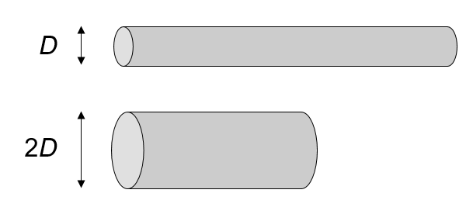

- Describe how the formation of bands occurs as isolated atoms are brought together to form a crystal structure. [8]

- With respect to the Fermi energy level, how does the size of the band gap vary according to N type or P type donor impurities [8]



