
Managers in the middle: culpable components of “big picture” synergy
SBUS6108 – Dissertation paper
 | Word count: 11140 | BA Business Management

Declaration

In submitting this dissertation paper, I confirm that:

- This work has not previously been accepted in substance for any degree and is not being concurrently submitted in candidature for any other degree.
- This dissertation is being submitted in partial fulfilment of the requirements for the degree of BA Business Management.
- This dissertation is the work of my own independent work investigation, except where otherwise stated.
Other sources are acknowledged by footnotes giving explicit references.
A bibliography is appended.
- I hereby give consent for my dissertation, if accepted, to be deposited in the school dissertation library.

Name:

Date of submission: ………………………..

Signature: …………………………………

Acknowledgments
I would like to take this opportunity to thank a few people. I hope it doesn’t present itself like an awards speech, but if it does I sincerely apologise…
To the staff at Carmarthen Business School I would like to say that you have motivated me, and continue to do so. Your drive and passion for your chosen fields is nothing short of inspiring.
A very special thank you to my dissertation supervisor Glenn Behenna, who has been a constant source of encouragement and advice, and nothing more than a phone call away at any time. Also, a huge thank you to Louise Emanuel, who, throughout the three years of the course has bent over backwards to make the course be all it could be. While there have been issues, she has constantly gone above and beyond to satisfy our needs.
I would also like to thank my fellow students for being a sounding board, and a constant source of entertainment that has gotten me through this process.
Finally, I would like to thank my son, Riley. Your strength and sacrifice has got me to where I am now, you inspire me to be more than I am, and to see who I could be. I hope I make you proud xxx
Table of Contents
Declaration 1
Acknowledgments 1
1. Introduction 1
1.1 Purpose, assumptions and research question(s) 1
1.2 Overview of study 1
2. Literature Review 1
2.1 Introduction 1
2.2 Chaos Theory 1
2.3 Organisational Culture 1
2.4 Cognitive Psychology 1
2.5 Middle Management 1
3. Methodology 1
3.1 Introduction 1
3.2 Research context 1
3.3 Research approach 1
3.4 Research methods and design 1
3.5 Ethical considerations 1
3.6 Limitations of study 1
4. Analysis of findings 1
4.1 Quantitative 1
4.1.1 Study demographic 1
4.1.2 Job function 1
4.1.3 Organisation sizes 1
4.1.4 Gender outlook 1
4.1.5 Organisational Position 1
4.1.6 Organisational transparency 1
4.1.7 Perceived transparency by industry sector 1
4.1.8 Management style 1
4.1.9 Middle manager key highlights 1
4.1.10 Health industry focused 1
4.1.11 Strategic awareness within senior roles 1
4.1.12 Results of quantitative findings 1
4.2 Qualitative 1
4.2.1 Defining the importance of culture 1
4.2.2 Power distance 1
4.2.3 Communication 1
4.2.4 Leadership development 1
4.2.5 A sense of belonging 1
4.2.6 Results of qualitative findings 1
5. Conclusion 1
5.1 Methods to diminish the impacts of climactic and environmental chaos 1
6. Appendices 1
6.1 Informed consent form 1
6.2 Questionnaire 1
6.3 Interpreted interview text 1
6.4 Correlation table 1
6.5 Average scores by gender 1
6.6 Average scores by Industry sector 1
6.7 Average scores by job function 1
6.8 Average scores by position 1
7 Reference list 1

Introduction
In this economically uncertain time, the role of culture and trust in the organisational environment has become paramount in driving innovation and strategy. At the forefront of connectedness or organisational climate is middle management and their interrelated and interdependent constraints of ownership and their role of facilitation toward the attainment of organisational goals.
Over recent times we have seen the decline of industries and economies, with many countries particularly in the EU struggling financially. We see reports outlining the disconnect between managers and their workforce, politicians and their constituents... What is driving the phenomena? While this study will focus on the organisational paradigm, the construct and guiding principles can translate across borders, and provide a framework for further, more personalised exploration.

1.1 Purpose, assumptions and research question(s)
The research paper itself is intended to form the basis of an individual phenomenological exploration by the reader during and post interaction. As such, does not formulate or speculate toward specific answers, instead preferring to facilitate participants to perform their own research to their own specific requirements.
With the recent release of the middle manager’s lifeline from the Charted Management Institute (CMI), a series of assumptions has been made:
- Trust in UK organisations is at the lowest point in a long time.
- There is a lack of transparency.
- Middle managers act as a vital link in the health and culture of an organisation
- Feedback is not often asked of middle managers.
- Middle managers do not feel confident conveying organisational strategy
These assumptions and pre-reading, form the basis of the exploratory statements and the direction for the study; while the focus will remain on that of middle management, the wider environment will also become integral:
- How culpable are middle managers for the level of disengagement in UK organisations?
- What factors influence organisational synergy?
- Do we understand the “bigger picture” of organisational culture?
- Are UK organisations healthy environments?
While the statements will not be categorically addressed within the study, the exploratory nature and reader involvement will open avenues for further self-discovery and realisation of the statements.

1.2 Overview of study
The literature review will introduce the components of the paper, much like a jigsaw puzzle; each piece will offer a little, but not its fit within the big picture, instead forming the starting points for individual visualisations based on experiential phenomena. Only when the final piece of the puzzle, the linchpin, is introduced will we uncover how the pieces come together. Hopefully inspiring the reader to offer their own insight or new ways in which organisational or personal engagement can be maximised and utilised.
The components of the literary review encompass chaos theory: an obvious inclusion based on the tumultuous and uncertain times we as a society find ourselves, and as a means to understand and capitalise on the uncertainties that are prevalent. The study will then progress to defining and exploring the theories behind organisational culture and cognitive psychology.
Following the secondary research of the literary review, the primary research encompassing a mixed-methods approach will be documented. The quantitative component will take the form of a questionnaire that will be targeted toward management positions through the use of social media. The questionnaire will also act as a pilot for data and question direction whilst also act as the search platform for interview participants.
The interview participants will be asked a series of questions of an open nature, with the aim of creating a dialogue that could be probed for a deeper understanding. The combination of both quantitative and qualitative data will be analysed against the literature review in the broader context of organisational

Literature Review

2.1 Introduction
“Middle managers do a whole lot of nothing!” and “Firing middle managers is good for business” (Young, 2016). Just two statements out of plethora declaring the worthlessness of middle management. In fact, if we look at Wikipedia (2017), which while not a wholly reliable source, can give a general consensus of public perception, states that “this position is often seen as unnecessary and holds back organisations from achieving its full potential.” Hardly glowing recommendations for the necessity of middle managers in talent management and strategic programs. However, recent studies are highlighting the role that middle managers play within their organisations: contradictory positions to the common held beliefs on middle management.
The purpose of this review is to profile a holistic vision of middle management in the modern organisational construct. The rate of change in which we find ourselves has put the onus on the driving forward of emergent strategy based on empirical reasoning, and the psychological construct of organisational culture plays a pivotal role in achieving these aims. This research paper will be structured around a cognitive psychological approach to a chaos theory framework.

2.2 Chaos Theory
According to Greek mythology, in the beginning there was only chaos; the origin of everything (Greekmythology.com, 2017; Miller and Swinney, 1992). Miller and Swinney (1992) stated that “Chaos is not total randomness, but implies an implicate, “hidden”, or occult order within the nature of reality.” This “non-linear” chaos or “constrained randomness” is connected with fractal geometry, which in turn is the basis for human anatomy (Miller and Swinney, 1992), and indeed the brain is also a chaotic system (Holland, 2010). As such, chaos theory can provide us with a model for constructing cognitive maps (Miller and Swinney, 1992).
Tolman (1948, also Cited in McLeod, 2013 and Eden, 1992) proposed the idea of cognitive maps as a method in which individuals can acquire and store relative attributes of environmental phenomena. These cognitive, or mental maps form the basis of Kolb’s experiential learning theory and as such, we can use these maps to interpret circumstantial occurrences. To understand how chaos theory can utilise cognitive maps we need to comprehend the basic principles of chaos theory: Henri Poincaré (1982) hypothesised that small differences in initial conditions produce great ones in the final result; this has been expanded upon further by the likes of Lorenz (1963) and Murphy (1996). The former being known as the “father of chaos theory” after he accidently uncovered the validity and accuracy of Poincaré’s hypothesis. We have all heard of the butterfly effect? An analogy created by Lorenz to explain the concept of chaos theory in layman’s terms; Well, an alternate can also be a tsunami, starting as small ripples at sea, but gathering pace and size the further it gets from the epicentre. As the wave hits the shoreline it leads to a sudden change in the make-up of the wave. Each of these structural, directional or characteristic changes are known as a bifurcation. Each chaotic act having its attractors, a starting point or organising principal that it would return to; in our analogy, the tsunami would return to being the sea. On an individual level, personality may act as an attractor, explaining why personality traits for a single behavioural incident have low predictability, but patterns reflecting a personality style can be established and thus a link to organisational culture can be established (Murphy, 1996).
“Our brains respond differently because they are not only different from person to person, but from moment to moment.” (Holland, 2010)
To further contextualise the relevance of chaos theory in an organisational system, we can look at stakeholder engagement. Organisations interact with competitors, suppliers, customers, staff, government, and so on: the decisions made have taken in to account possible actions of others (Levy, 1994). While we can informally assign a game theory model to organisational culture over this general construct as cited by Camerer (1991), the emergent and non-linear interactions over the short term and “micro-level” are more in keeping with chance and opportunity, and thus the prevailing need for chaos theory rhetoric becomes invaluable (Levy, 1994 and Murphy, 1996). In truth, reality is boiling with change, disorder and process (Holland, 2010; Miller and Swinney, 1992).
This reality and the burgeoning uncertainty of macro-environments has highlighted the negative connotations of chaos: disunity, crisis and loss of control (Murphy, 1996), surely not a sign for growth and security. But what we have discussed previously is that by embracing the chaos we can indeed formulate circumstantial predictors and thus avoidance strategies or perhaps new innovative methods can be obtained; and so, chaotic activity is conducive to creativity (Miller and Swinney, 1992). Only by letting go of the rigid, apprehension and welcoming chaos do we allow true flexibility and adaptability (Holland, 2010).
By allowing people and groups within an organization some autonomy, businesses encourage the organization to organize itself, enacting multiple iterations of its own functioning until the various pieces of the organization can work together most effectively. An organization that encourages this type of management has been termed a fractal organization, one that trusts in natural organizational phenomena to order itself.
To better understand how chaos theory can impact individuals and organisations alike, let’s think about the “butterfly effect” a little more, but extremely simplistic: we carry out the same action time and time again, each time the results vary slightly, after say 20 iterations of the same act, the result could be completely different from the first. Now imagine long range forecasts based upon historical data; suddenly becomes irrelevant, doesn’t it? This also follows trend through individuals and groups alike: Learning takes place when a new stimulus leads to the emergence of a random, chaotic state in the brain that provides the substrate for a new nerve cell (Freeman, [no date]). it is clear that the brain’s ability to generate new information internally is critical to our creative processes. It is likely that chaos is essential to that ability (Ives, [no date]).

2.3 Organisational Culture
What is organisational culture? Well, that’s a more complicated question to answer than you first think: Mats Alvesson (2002) wrote that “How people in a company think, feel, value, and act is guided by ideas, meanings, and belief of a cultural (socially shared) nature.” Denning said, “Organisational culture comprises of interlocking sets of goals, roles, processes, values, communication practices, attitudes, and assumptions.” (Brown, 2016) Scouring through LinkedIn we come across many others:
“Culture is how organisations ‘do things’.”
“Organizational culture defines a jointly shared description of an organization from within.”
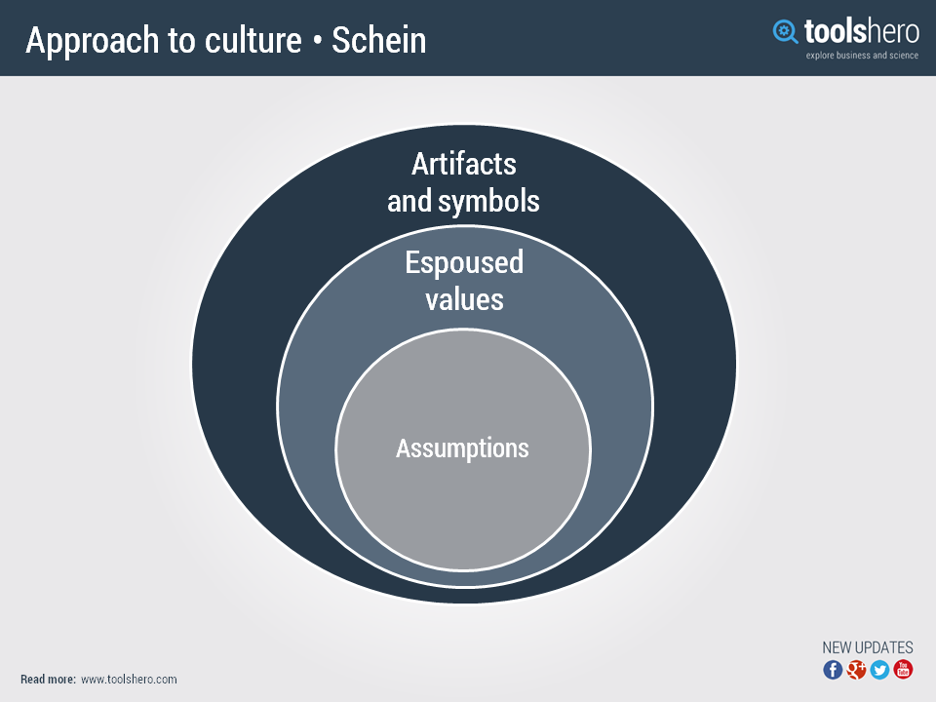
So, with a structure that is yet to be clearly defined, comprehension is also an open-ended book, with different models and frameworks…
Figure 1 (toolshero.com, 2014)
- Artifacts and Symbols | Artifacts and symbols: Branding, architecture etc.
- Espoused values | Code of conduct, mission statement, how the organisation is presented toward its public.
- Assumptions | Deeply embedded in the organisation, unconscious behaviours.
.. Edgar Schein (1980) developed the organisational culture model that is often the basis of cultural discussion. The model splits culture in to layers, and is referred to as an “onion” model as per image [figure.1]. The three levels expressed in the following manner:

Schein’s model represents the ‘high-brow’ principals of what constitutes a culture, and provides a starting point for further analysis. But as Denning’s definition highlights, we generally have a ‘business-centric’ nature of cultural study. Geert Hofstede (2017a) created a specific ‘8D’ model of organisational culture, which emphasises this ‘business-centric’ approach and thus the combination of Schein’s model and Hofstede’s 8D provides an overview of the organisational culture. Evidence of this can be seen in the prevalence of management thinking, such as those highlighted in Peter Drucker’s writings:

“Any business enterprise must build a true team and weld individual efforts into a common effort. Each member of the enterprise offers something different, but they must contribute towards a common goal.” (Drucker, 2006)

The inclusion of Hofstede’s 6D (2017b) model however, which is normally associated with national culture, brings a new perspective of, and insights toward what cultural understanding can offer. As an evolution of his original four dimensions of culture, transitioning from the essentialist to non-essentialist paradigm (Ganesh, 2015), Hofstede’s 6D’s in the microcosm of organisational culture can be an antecedent determinant to the cognitive viability of the workplace culture. Within the micro-environment of the corporate world, garnering a deep-rooted understanding of, and the implementation toward a socio-cultural equilibrium with the organisational culture context is congruent to the holistic approach with heterogeneous traits suggested for the future viability of organisations.
Akin to organisational culture is organisational climate, the differentiator being the perspective from which it is being viewed and the hierarchical position of influence: corporate v employee and global v local. According to Mullins (2007), organisational climate relates to the general atmosphere and morale. Climate will influence the attitudes of employees and how they impact upon each other. How well the organisational culture is ingrained in the employees will impart upon the temperate nature of the climate.
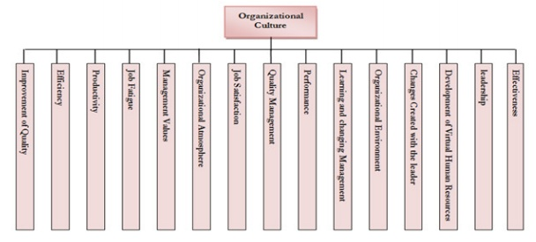
A lot has been said on the structure and formation of organisational culture. The historical president has been that of a top-down system, a system that still influences the cognitive or mental maps of today’s leaders, with the individuals below being driven by self-interest and self-preservation (Quinn, 2015). However recent researchers have stated an alternative hypothesis: Dictated from the bottom guided from the top (Murriner, 2016; Drury, 2015); or as Lisewski (2004) phrases it: top-down strategy meets bottom-up culture. A notion that suggests perhaps that organisational culture and climate are in fact a blended manipulation of circumstance and intention, in a constant state of flux, controlled by the flow of internal communication and environmental pressures.
(Danaeefard et al, 2012)
figure.2
Lewis and Seibold (1998) suggest that organisational, and change management is a “communication-related phenomenon” with communication being a substance that flows upward, downward and laterally within an organisation (Doolin, 2003). As such, communication is both the tangible and intangible glue that builds and bonds culture within an organisation. Just like a glue, communications can become brittle, weakened over time, without due care and management. The impact that communications can have on an organisation are detrimental to the attainment of strategy and successes of both individuals and the organisation as a whole. Misinformation or communication more often than leads to individuals “filling in the blanks” or reading between the lines to establish a complete picture, often with negative connotations and building of barriers

2.4 Cognitive Psychology
Through both chaos and culture a unified force is bonding: the mental processes involved in the completion of day to day tasks. Cognitive psychology teaches us to see the human mind as a complex computer system (Rutgers, 2017), but a recent study by world leading researchers has moved beyond that: people process in innumerable ways dependant on the situation or circumstance (Kingston university, 2016). Cognitive psychology is the study of mental mind as an information processor (McLeod, 2015), with some theorists suggesting that cognitive psychology is a precursor for Emotional intelligence (EI) (Niedenthal, Krauth-Gruber and Ric, 2006). It is also noted how culture can influence cognition, emotion and motivation (Markus and Kitayama, 1991). Lazarus (1982) argues that thought is a necessity of emotion and thus falls within the realms of cognition. Lazarus’ perspective of emotion follows Schachter and Singer’s (1962) theory, in which a stimulus leads to a physiological response which is then cognitively interpreted and labelled, resulting in an emotion (Cherry, 2016). The involvement of cognitive psychology within organisational systems presents us with opportunities: cognition is the process of acquiring knowledge through thought, experiences, the subtlety of the senses and guiding physical action (Psychology today, 2017). Leading behavioural theorists in today’s environment take a lot of influence from Lev Vygotsky’s (1978) cognitive development theory, in which he suggests that community plays a central role in the process of “making meaning” (Vygotsky, 1978; Wertsch, 1991), and that learning is a necessary and universal aspect of the process of developing culturally organized, specifically human psychological function (Vygotsky, 1978). While it is important to note that Vygotsky’s theories are aimed at child development, the core principals and understandings are holding true across countless aspects of human knowledge and behavioural development.
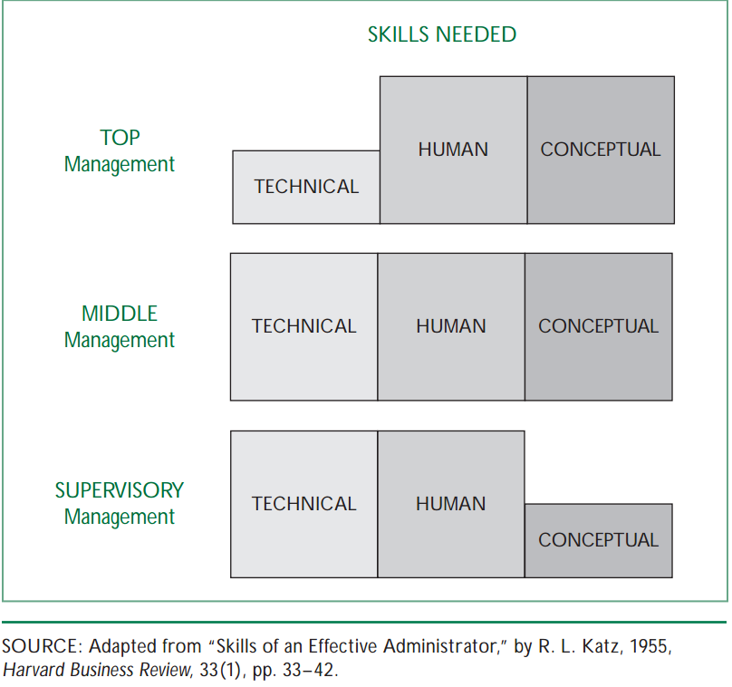
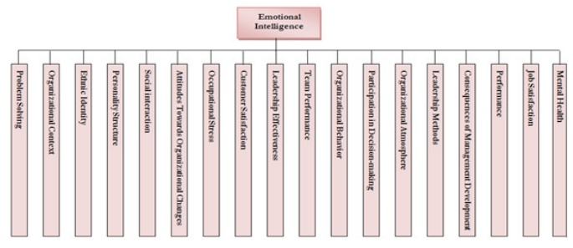
While most literature acknowledges the importance of culture in influencing organisations, subtleties of cognitive processes and how they influence leadership is largely ignored (Steers, Sanchez-Runde and Nardon, 2012). The concept of cognition having influence however, is inherent across numerous leadership models. Mumford et al (2000) cites cognitive abilities as key drivers to leadership outcomes. Katz (1955) three-skills approach [Figure.3] encapsulates the spectrum of cognition, with middle management being cited as in requirement of full and equal measures. With the evolution and furthering of knowledge through research we also see the deepening of leadership understanding, and the levels of which cognitive psychology influences and facilitates personal, professional, and organisational development. With the evolutionary progress of EI and mental toughness we can see how much impact cognition actually has on organisational success. EI is the ability of people to understand their emotions and those of others (Mayer and Salovey, 1997), recent studies have found that organisations with a perceived high level of EI have improved performance, particularly across areas of innovation (Smollan and Sayers, 2009). According to Salovay and Mayer (1990); Nikolić, Hadžić and Nedeljković (2014) people management skills are essential for effective management and leadership, with EI the most critical component. “Hence, having middle managers with high emotional intelligence is a necessity for attaining sustainable results.” Having the EI to understand and manage cognitive processes in oneself and the chaos around us is paramount for operative success. The Cynefin framework created by David Snowden perhaps goes some way to bridging the gap between the social frameworks of culture and the intelligence based frameworks of cognitive psychology in a way that can be encompassed in an ever changing, chaotic working environment; how managers can interpret the complexities of multiple tasks while maintaining and developing the social construct within their respective remit. After all decision making is heavily influenced by the world around us (Kingston university, 2016).
Figure.3 (Katz, 1955)
Figure.4
(Danaeefard et al, 2012)
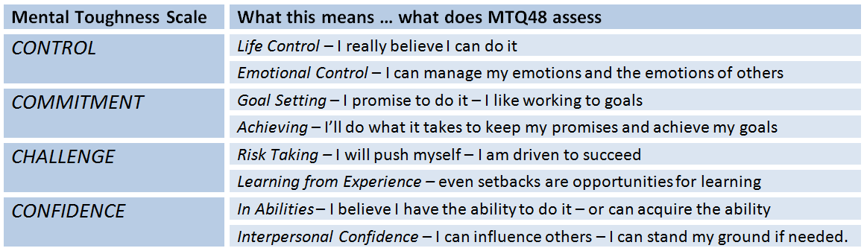
The concepts of cognitive psychology and EI also encompass the realms of mental toughness (MT), which, according to Dewhurst et al (2012) is underpinned by cognitive inhibition, or the ability to “tune out” stimuli that are irrelevant to the task or current emotional state. Originally designed to predict athlete’s performance under stress, MT is now entering the field of business management and leadership development, testing the resilience, concentration and self-belief of individuals through an assessment known as the MTQ-48 (Delaney et al, 2015) and conceptualised by Clough et al (2002) in the 4C’s. [fig.5] provides a link to MT links to cognition and EI.
Figure.5 (AQRinternational, 2017)

2.5 Middle Management
So, thus far we have established the heart, mind and soul for the operational levels of an organisation, aka chaos, cognition and culture; but by whom, and how, are these phenomena managed?
The role of the middle manager has, in recent history been one of a task driver in the path-goal theory mould, with levels of subordinates beneath, and reports to a higher level of management or executive above. The middle manager would structure their leadership style to the motivational needs of the subordinates in their charge, to reach the desired outcome. With the theory having very little research carried out between the relationship of task and subordinate’s individual characteristics, it may be time to examine the level of support for the theory (Evans, 1996).
As the title suggests, middle managers are the intermediaries, responsible for the implementation of corporate strategy at an operational level whilst maintaining the culture throughout but particularly from the bottom up. The middle manager’s lifeline survey (2016) suggests that middle managers act as vital pivots within organisations and leaders must recognise this pivotal role played by middle managers and support them in the uncertain times in which we find ourselves (Francke, 2016 also cited in HRGrapevine.com, 2016; Businessdesk.com, 2017; top-b.com, 2016). This latest study conducted by the Chartered Management Institute emphasises the importance middle managers play in the context of strategic goal attainment. However, the report also highlights the lack of trust from the middle toward the top with only 36% of middle managers fully trusting their senior leaders with almost eighty percent of middle managers believing their staff lack trust in their CEO (Scott, 2016). According to Pont (2006), middle managers usually perform a coordination task, since they mediate, negotiate and interpret the organisational connections with the operational and client facing levels of the business. In practice, the company’s strategic direction is basically implemented by the middle manager and as such, middle managers often become the face of an organisation, especially in times of negativity.
Since the 1980’s, the influence of the organisational middle has been heavily researched, with the role of middle manager being cited as being of key strategic importance (Burgelman, 1983a, 1983b; Dopson and Stewart, 1990, 1993; Dutton and Ashford, 1993; Dutton et al., 1997, 2001; Floyd and Lane, 2000; Floyd and Wooldridge, 1992, 1994, 1997, 2000; Frohman and Johnson, 1993; Huy, 2001, 2002: Nonaka, 1988, 1991, 1994; Nonaka and Takeuchi 1995; Smith, 1997; Wooldridge and Floyd, 1990). With the breadth and depth of research in the subject matter, supporting the importance of the middle manager, and again a wide range of literature attempting to answer the question as to ‘what is happening to middle management?’ (Thomas and Linstead, 2002) it is difficult to comprehend that we are no closer to finding a conclusive answer. In fact, the perception of middle management has if anything, declined further, Young (2016), Scott (2016), Korpela (2014), Williams (2012), Gratton (2011), Dopson and Stewart (1990), and Leavitt and Whisler (1958) all stating the increasing obsolescence of middle managers.
“Firing middle managers is good for business; at the very least, they would literally be more productive cleaning the restrooms.” (Young, 2016).
Combined with the increasing negativity, middle managers also have to balance increased workloads with fewer resources (Brüggemann and Santos, 2016; Harvard business school, 2013). The resulting pressures placing middle managers at high risk of mental illness (Prins et al, 2015; Lebowitz, 2015; Williams et al, 2015 also cited in Hensel, 2015; Columbia University, 2015; Cha, 2015).
So why is such a pivotal role associated with so much uncertainty and disconnect? Burgoyne and Livian (2005) suggest that middle managers have been particularly effected by the degree and complexity of organisational change. So, with levels of resentment and uncertainty increasing, the corrosion of trust is particularly concerning and a profound managerial challenge (Francke, 2016). The concern is only exacerbated when you consider the disillusionment of senior leaders, who believe levels of trust are at much higher levels (Middle-manager lifeline, 2016). This would suggest that middle managers are disengaged due to disconnect with those further up the hierarchy...?
“There is a clear trust illusion in our organisations: the further away from the top you go, the more of an issue trust becomes.” (Terry, 2016)
Perhaps the disconnect can be attributed to the mental toughness and emotional intelligence scores at the respective levels: Middle managers stand out with the highest emotional intelligence (EQ) scores in the workplace but things change drastically as you move beyond middle management. For the titles of director and above, scores descend faster than a snowboarder on a black diamond. CEOs, on average, have the lowest EQ scores in the workplace (Bradberry, 2015).
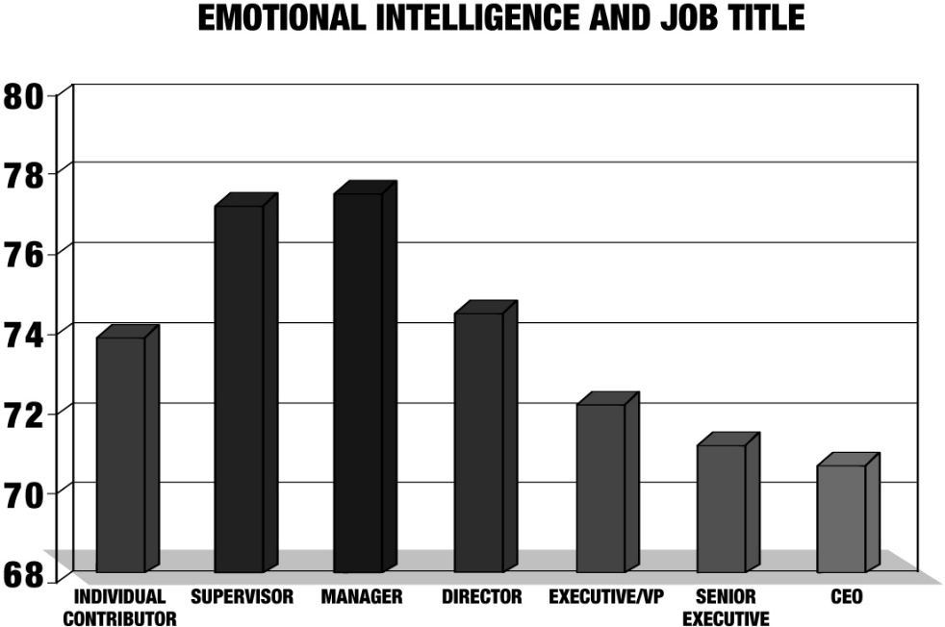
Figure.6 (Bradberry, 2015)
So, with middle managers in pivotal roles, and in ownership of favourable EI scores one could assume that the essence of an organisation, or its very being is best represented, or managed by the middle manager role(s).

Methodology

3.1 Introduction
In this section of the study we will explain the process of conducting primary research and the structure of the overall direction. We will briefly explain the different methods of capturing data and the theories to be used in the acquisition, assembly and analysis of data.

3.2 Research context
The main aim of the research is not to find answers: the scope and scale of the issues focused on are too large to be sufficiently covered in such a small paper. So, with that, the intention of both the secondary and primary research is to act as an exploration of factors that impact upon the role middle management and that could potentially be the root cause of the fundamental failings. Throughout the research and subsequent writing, the objective has been to create an arena and framework for self-discovery; somewhat of a birthing place for hypotheses. What we will aim to establish are the following parameters:
- To provide an overview of the many definitions of culture to reach a personal consensus.
- To establish and recognise the psychological influencers on organisational climate.
- Formulate connections between the psychological/ emotional and culture through chaotic theory.
- Provide insight in to the issues that Middle management encounter.
- Investigate “real world” perceptions of how systems influence outcomes.

3.3 Research approach
There are countless research approaches that can be employed, but the overriding issue on the selection of research methods is in the who/what/why of the research subject and objectives sought. Research approaches commonly fall in to two main categories of evaluation: can questions be answered with a yes/no, or follow an analytical construct? Or is there a phenomenon being observed that can be given meaning? These categories form the basis of quantitative and qualitative research methods and are either used individually, or together in a ‘mixed-methods’ approach. The manner in which the methods are used, and the construct of the theoretical rationale toward the research aims forms the overall methodology.
The construction of a theory through the analysis of data brings the methods in to the realm of grounded theory. Grounded Theory is simply the discovery of emerging patterns in data (Glaser, 2015; Engward, 2013). The analytical construct of grounded theory avoids prior assumption, relying solely on the theory being ‘grounded’ in the data sets (Engward, 2013; Charmaz, 2014); there is no area for interpretative evaluation. Grounded theory constructs a system in which data is collected and analysed simultaneously, using a continuous comparison method at each iteration (Charmaz, 2014) to provide us with an explanatory framework in which we can understand the phenomenon under investigation (mheducation.co.uk, 2017).
As we have established, the breadth and depth of the subject has pre-determined that definitive answers are unlikely to be discovered and analysis of the data cannot be considered or constructed, nor what potential insights the data can yield, until the acquisition has been completed. In fact, the scope, and overwhelming uncertainty of the subject suggests that the approach should be to engage and drive further dialogue beyond the realms of this specific paper. With this prior knowledge, it has shaped the research methodology and desired interactions with the viewer, pushing the approach beyond that of an analytical or traditional grounded theory.
To further confound the complexities of the study, conformity to a single methodology could not be established within the scope of the research. While the determinants coincide with a phenomenological approach, or the establishment of ‘meaning’ or sentiment of circumstance, the exploratory nature expected with reader interaction has placed the research beyond the confines of a single, or well defined, established approach.
Combining a phenomenological approach with exploratory framework allows us to gain familiarity of the lived experiences of the participants and interpret their individual perceptions to develop a more feasible hypothesis. Phenomenology father Edmund Husserl theorised that people take, for example, the social surrounding, houses, values and social life, including one’s friends and the court of appeal, for granted, and people do not normally reflect upon this (Aspers, 2004). This notion has guided, and become an integral undertone to the research: business-centric cultural models for example...
Bogdan and Taylor (1975) suggested ethnographic strategies for exploring, and exploiting the study to its fullest, citing the need to identify keywords while observing interactions; “concentrate on open and closing statements”, and taking detailed notes (Moustakas, 1994). Moustakas’ (1994, cited in Moerer-Urdahl and Creswell, 2004) transcendental phenomenology prescribes that the researcher set aside prejudgements and to try and view the phenomena with a fresh pair of eyes, this is known as the “epoche”, a Greek word meaning to refrain from judgement (Moerer-Urdahl and Creswell, 2004).
While phenomenological research and epoche emphasises that the researcher set aside prejudgements, bias and pre-conceived ideas, there is no denying that the epoche cannot eliminate everything, does not deny or doubt everything, but desires that truth and reality of grounded knowledge be cast aside (Moustakas, 1994). Imagine closing your eyes over a blank canvas and having another direct the brush strokes that formulates a new picture: you start with nothing, yet with each instruction you learn a little bit more, you start to create a picture in your mind, but it’s only at the end when you open your eyes that you see the picture as they saw it.
With the mixed methodology theories that are a part of this study we can assign a somewhat different approach to that of the epoche, yet the grounding remains the same: cast aside what you know and start afresh but this time you are assigned the role of facilitator to prescribe the tools in which the participant can convey their story in a dialogic construct.

3.4 Research methods and design

3.4.1 Quantitative questionnaire
The pre-planning of primary research was intended to meet the masses. Meaning that a questionnaire was to be utilised to construct a general, yet targeted overview of the subject matter. The prevalence of social media platforms (SMP’s) for interactions was a clear route to be considered for the engagement. With the nature of the subject and the desired respondents, the SMP of choice needed to be of professional calibre groups and individuals. LinkedIn provided the perfect arena with the abundance of professionals across all fields. The questionnaire initially was to be targeted across the mass market of international LinkedIn social groups, however after two weeks of the questionnaire going ‘live’, responses were non-existent. The focus had to become narrowed and more targeted, so the decision was made that the questionnaire would become a pilot, driven by the exploration and pursuit of willing interviewees. A further factor that I wished to address is the nature of questionnaires lacking in any personal connections, or the opportunity to build a relationship. I chose the option to include a brief video of myself presenting an insight in what drove the subject matter and how I wished to progress. The feedback from the video was indeed favourable.
Narrowing the field for questionnaire interaction, South Wales groups for management professionals were specifically targeted. These groups were targeted due to being local, and more importantly of the same time zone. This meant that engagement on posts were almost instant, affording the opportunity for rapport to be built and increasing the likelihood of participants being willing to be interviewed.
The questionnaire consists of twenty-nine questions split in to four sections:
- General
- Culture
- Doing your job
- Performance management
The structure of the questionnaire primarily followed a quantitative approach with the added interjector of sentiment to add extra depth and feeling to what is ultimately a cold process, with the quantitative data being recorded against a Likert scale. Likert scales measures attitudes and behaviours from one extreme to the other, this study’s scale ranges from strongly disagree to strongly agree. A full copy of the questionnaire can be viewed in the appendices.
The final question asks the respondents if they would be interested in partaking in an interview.
The respondents to the questionnaire numbered 40 and ranged from junior managers through to business owners and C-suite executives, thus guaranteeing pertinent responses from each. Out of the respondents, twenty-five percent were willing to be interviewed, and out of these, five were selected for interview. One of which was to act as a pilot to test how the questions were perceived and the flow of conversation, allowing for alterations for the bulk of the interviews.

3.4.1.1 Analysis of quantitative data
Analysis of questionnaire data will be conducted in Microsoft excel and SPSS analytics software. Microsoft excel will be used to perform pivot tables and basic mathematical equations to be used as the scoring system in the Likert scale. SPSS will perform more complex correlations and chi square tests to determine levels of significance across factors. A more comprehensive analysis will be displayed in the appendices.

3.4.2 Qualitative interviews
The purpose of interviews in phenomenology research is to gain research perspective on a lived experience, familiar to those participants taking part in the research. These perspectives are best obtained via a semi-structured interview of the participant’s, lived experiences (Knorr, et al., 2011). The interviews were to follow a semi-structured approach as the semi-structured interview (SSI) is used for gathering qualitative information in specific situations from small samples (Laforest, 2009) and allows the interviewer to intervene in the respondent’s speech in order to direct him or her to the desired topics (Iconaru, 2012) or to entice deeper meaning out of the responses. SSI’s are the most common form of qualitative research methods in a mixed-method approach and can form the basis of quantitative data as the text derived from the interviews can be assigned numerical value, or can work alongside independent quantitative data from the likes of a questionnaire as per this study (McIntosh & Morse, 2015). While the interview questions were independent of the quantitative questionnaire, the initial data gathered formed the basis and framework in which the interviews would be structured.
The initial pilot interview consisted of just three questions, the aim was to formulate a broad base in which participants can have a scope to explore their own emotional responses to the questions through a vast dialogue. The decision to run a pilot interview was made as a method of assessing the feasibility of the study and to develop an overall research question and plan (van Teijlingen & Hundley, 2001).
It must be pointed out that pilot studies do have their downfalls or limitations. These include the possibility of formulating false assumptions, generating bias, or leading the main participants to conform to the predetermined samples. Pilot studies and feasibility studies are often described as the same thing, but in fact the definitions are significantly different: Feasibility is undertaken to see if it ‘Can be done’ whereas a pilot is a small version of the main study (O’Cathain, et al., 2015) and as such, the example for this study falls within the parameters of a pilot.
While the selection group for the overall study is small, the process remains the same and the single pilot interview the test bed for the validation of the main interview parameters. For the study, the pilot proved invaluable as the initial three questions were met with a level of ambiguity that confused and confounded the participant that rendered the interview redundant. The Updated interview consisted of five core questions and a series of prompts to guide and continue the dialogue in an overall direction yet not adding any bias to the outcome. The core questions are as listed below: -
- What role do you think culture plays in the success of organisations?
- Are all employees appraised of corporate strategies and their role?
- Are managers in possession of the right capabilities/traits to lead?
- Why do you think engagement has decreased in recent years, especially within middle management?
- 60% of respondents rated management styles as Authoritarian or bureaucratic, is this conducive to a strong forward thinking culture?

3.4.2.1 Qualitative analysis
Interviews by their very nature are providers of qualitative data and sentiment. It is that sentiment which provides the richness of the data, allowing the interviewer to comprehend and embrace the lived experiences of the participants. The information provided through interviews is often vast and complex so is in need of interpreting and filtering for fit with the research criteria. Key statements from each interview were coded and categorised in to relevant themes that fit with the overall construct of the study. This process is time consuming but also provides the opportunity to fully understand the meaning and value behind the statements.

3.5 Ethical considerations
With any study undertaken, it is imperative that the impact upon participants is limited, and their rights are not contravened in any way. With qualitative research relating to lived experience this becomes a greater concern as airing personal thought can have a detrimental impact on the individuals and their respective organisations.
Therefore, both the quantitative and qualitative research were to be devoid of any personal or traceable information. For the quantitative research only an age range and work industry were required. For the qualitative research and the flow of dialogue, one cannot predict what information would be shared inadvertently, therefore it was made clear from the outset, through the use of informed consent forms (see appendices 6.1) that each participant has the right to withdraw at any time, and that any information that contained names, businesses or finite detail would be removed or given pseudonyms.

3.6 Limitations of study
The limitations of the study are quite broad. The complexity and exploratory nature of the research question itself has resulted in numerous potential spin-off papers, each of which have barely been touched upon based on the severe restrictions of word count. This has also impacted upon the ability to fully digest and incorporate the qualitative data. The analysis of which revealed a multitude of specific themes, there were compressed in to seven more generalised themes. Out of these themes, only four could be brought across to the study.
Further limitations include the small sample size, while 40 managers participated in the questionnaire, only five interviews were conducted, with one being discounted as a pilot/ trial. Given more time and a greater word count, the possibility was presented to interview at least ten individuals.
The complexity of the research question and the exploratory nature of the study can present itself as somewhat vague in its approach and findings, not revealing a single point of interest or focus. While the intention of the paper is to act as its own phenomena, to open new avenues for readers to explore for themselves, to be picked apart and to encourage further questions and critique of the subject matter, this in itself can be construed as somewhat of a “cop-out”

Analysis of findings
5 | Positive
3 | Neutral
1 | Negative

Quantitative
The questionnaire follows a positivistic Likert scale, or a graduated series of optimism in a traffic light colour schema numbered as per the diagram to the left of this page. The analysis will follow through across all the sections of the questionnaire and aim to attribute relationships and correlations across all aspects. The traffic light system will create a clearly visible and understandable system for the positivity felt toward a specific subject.

Gender | Age range | Percentage | Overall
Male | 18-24 | 11.4% | 66%
 | 25-34 | 14.29% | 66%
 | 35-44 | 31.43% | 66%
 | 45-60 | 5.71% | 66%
 | 60+ | 2.86% | 66%
Female | 18-24  25-34 | 5.74%  8.57% | 34%
 | 35-44 | 20% | 34%
The gender split for the quantitative study is split to an almost 2:1 ratio with males in the clear majority. The statistics also show that the clear majority of participants are in the category of 35-44 with just over fifty percent (51.43%) falling in to this age range.

4.1.1 Study demographic

Internal – Female
External – Male

4.1.2 Job function
Industry sectors
Administration | Construction | Finance | Health | HR | Manufacturing | Marketing | R&D
14.3% | 14.3% | 20% | 5.7% | 17.1% | 20% | 5.7% | 2.9%

4.1.3 Organisation sizes
Org size
1-50 | 32%
51-100 | 3.1%
101-200 | 9.3%
201-500 | 12.5%
500+ | 43.15%
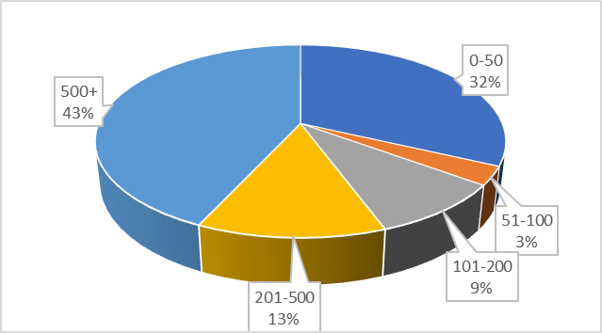
There is a broad range of industry sectors encompassed within the data set that also fits across organisation sizes and private, public and voluntary sectors. However, the organisations included are dominated by SME’s of less than fifty personnel, and the large 500+ bracket, many of whom fall in to the MNE category. The broad range of enterprises will provide a more rounded coverage to the data set.

4.1.4 Gender outlook
Gender | Optimism
Male | 3.16
Female | 3.31
To start the analysis, we will look at gender outlook, and gauge the overall positivity and relationships that are inherent within the study group. Shukla and Rai (2015), Haselhun et al (2015) identified that females recorded slightly higher values when compared to their male counterparts when looking at organisational trust. Koellinger et al (2007, 2011) however, argued that genders have different perceptions of environments and that women show lower levels of optimism. The quantitative element of this study has identified that females are slightly more optimistic when compared to males, with both recording scores slightly above neutral (3.00) overall. Yet there are more profound differences when targeting specific areas.
Statements | Male | Female
The organisation is transparent | 2.78 | 3.42
I have a high degree of autonomy | 3.74 | 3.17
I am provided ample resources to complete tasks | 2.52 | 3.25
Goals and objectives are clearly defined | 2.78 | 3.25
I have plenty of opportunities to challenge or provide feedback on the organisations approach | 2.91 | 3.67
However, there does not seem to be any correlation within the findings; beyond that of perhaps what the cynic may see: The historical machismo that is management prevails; discrimination and sexism remains abundant. Women are evaluated more poorly in situations that involve complex problem solving; in these situations, people are sceptical, offer stricter scrutiny and more consistent observations (Thomas-Hunt and Phillips, 2004; Neumark, Bank and Von Nort, 1995). A counter to this argument could be that the more nurturing and inclusive nature, of relationship building within females breaks down the barriers or perceived threats to the position of authority that is often inherent in the competitive nature of the male psyche.

4.1.5 Organisational Position

Position | Score
C-Suite | 4.17
Junior manager | 2.50
Middle manager | 3.33
Senior manager | 2.79
Shifting the focus to positions within organisations, we can identify distinct areas of difference between hierarchical levels. The level of organisational transparency is perceived much higher at executive levels with a score of 4.17 compared to an average of 2.87 across management levels. This contrast in scores represents the perception of trust as identified by the middle-manager lifeline (2016) and that middle managers are disengaged due to disconnect with those further up the hierarchy. Here however, we can see that the average level of transparency is viewed negatively across all other levels of management.

4.1.6 Organisational transparency

Pearson's correlation
Transparency v’s | sig.
Opinion trusted | 0.0001
Routes of progression | 0.008
Scope of role | 0.0003
Internal communications | 0.006
Resources available | 0.029
Overall the impact of organisational transparency is duly notable, with significance scores of .002 within Chi-square test and ranges .0001 – 0.028 across the following Pearson correlation analyses.
 | Transparency
Chi-Square | 17.333ª
Df | 4
Asymp. Sig. | .002

Using the “Transparency v’s opinion trusted” statements as an example we will explore the significance factor through regression analysis.

SUMMARY OUTPUT
Regression Statistics
Multiple R | 0.606728_{a}
R Square | 0.368118
Adjusted R Square | 0.34897
Standard Error | 1.15395
Observations | 35
There is a significant positive relationship between the level of transparency and perceived and trust, R (33_{b}) = 0.61_{a}, p < .0001_{c}
ANOVA
 | df | SS | MS | F | Significance F
Regression | 1 | 25.6 | 25.6 | 19.22497 | 0.00011159
Residual | 33_{b} | 43.94286 | 1.331602
Total | 34 | 69.54286

 | Coefficients | Standard Error | t Stat | P-value
Intercept | 0.914285714 | 0.581081882 | 1.57342 | 0.125161
The organisation is transparent & trust | 0.8 | 0.182455593 | 4.384629 | 0.000112_{c}

4.1.7 Perceived transparency by industry sector

4.1.8 Management style

4.1.9 Middle manager key highlights
Middle managers score significantly lower on awareness of progression routes with 2.67 (average 3.68), meaning they often feel trapped within their roles. Middle managers also scored lower on receiving feedback 2.83 (average 3.26), again this can result with middle managers being unaware of how they are progressing and why they have certain objectives, thus disrupting internal communications. Across the seventeen points, middle managers scored highest in the following statements:
Statements | Middle management | Average
Average of I have a favourable work life balance | 3.50 | 2.85
Average of as well as my technical abilities I am provided opportunities to develop people management skills | 3.83 | 3.62

4.1.10 Health industry focused

Shifting focus toward individual job function, primarily within the field of health services and the public sector, we can begin to grasp an insight in to the potential issues faced:
Overall the health services culture is perceived in a slight negative manner with the lowest score of any industry/ function tested (2.69), slightly lower than the public-sector average (2.88) and the Private sector at (3.22). But the key components of resources and communications are showing significantly low scores. This, while not a thorough
Statement | Average
Autonomy | 2.67
Opportunities to develop people management skills | 3.33
Mentorships | 2.67
Continuous feedback | 3.00
Performance expectations are too high | 3.67
I can approach my superiors at any time | 3.00
Communications with my superiors is always two-way | 2.67
I have a favourable work life balance | 2.33
Clear routes and opportunities for progression | 2.67
Scope of my role is clearly defined | 3.33
My ability and opinion is trusted | 2.67
The organisation is transparent | 2.33
I am provided ample resources to complete tasks | 1.33
Goals and objectives clearly defined | 3.00
Internal communications are strong | 2.00
Regular cross-departmental discussions/meetings | 2.33
investigation by any stretch of the imagination, shows a synopsis of cultural abnormalities within the organisation and identifies areas for further, more in-depth analysis.

4.1.11 Strategic awareness within senior roles

Statements | C-suite | Senior manager
Provided ample resources | 2.83 | 2.8
I can approach superiors at any time | 2.83 | 2.8
Goals & objectives clearly defined | 2.83 | 2.8
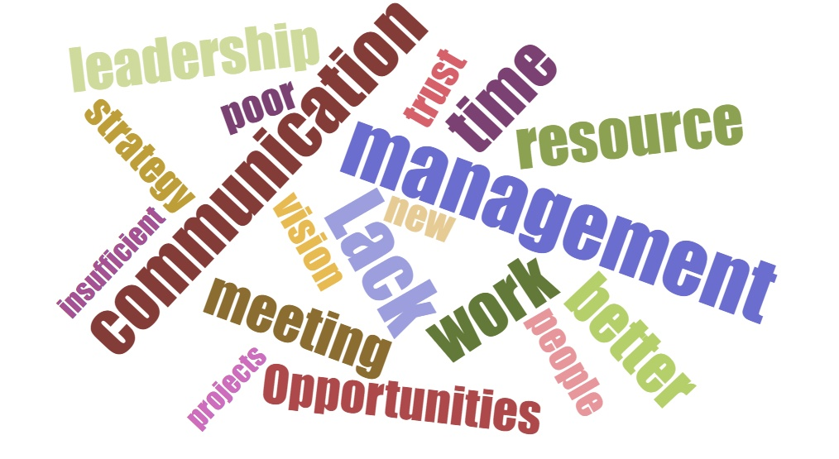
Aside from middle managers, a major influence of organisational culture comes from the top, and the strategic direction in which the organisation is headed. The questionnaire provided a new insight, in that C-suite executives and senior managers scored either neutral or negative across three strategic areas. The lack of positivity at these senior levels will undoubtedly have a knock-on effect at an operational level, as can be seen within the common words brought up through additional comments within the questionnaire: Lack of communication and resources being the common complaint followed by lack of trust.

4.1.12 Results of quantitative findings
The quantitative study has uncovered many areas that need further investigation, questions that have not been explored thoroughly enough, or at all in other studies. We see discrepancies across genders, industry function, business sectors, organisation size and age ranges. One can also assume that this is consistent across nations, to at least a certain degree.

4.2 Qualitative
The semi-structured interviews formed a formal dialogue with the intention of exploring the emotional connection of the participants with the subject matter. Throughout the interviews common threads of conversation were realised, and have been interpreted into themes. These themes will be assessed against secondary research in the literary review, and where themes cannot be cross-checked, further secondary reading will be carried out. The statements will be recorded and structured as literal interpretations in an academic report format to guide the reader through the emotive thought process of the interviewees.
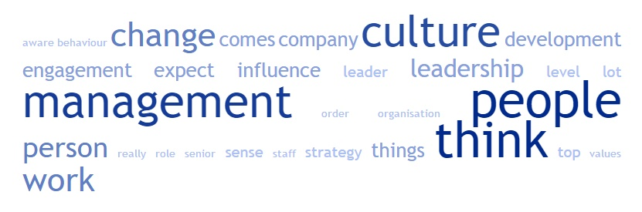
Out of the interviews carried out, the most prevalent words have been identified in the word cloud below.
Out of the common threads determined by the word cloud, and the secondary research, culture is the dominant factor, and as such, forming a definition hypothesis of culture leads the themes.

Defining the importance of culture
It is well established that organisational culture is a vital component of organisational success, and integral to the way an organisation operates. Alvesson (2002) wrote “How people in a company think, feel, value, and act is guided by ideas, meanings, and belief of a cultural (socially shared) nature.” which remains accurate. Yet the fluid, organic nature of culture as a living, breathing entity that cannot be contained or constrained is not fully embraced or utilised.
“I would suggest culture can’t be managed, I think it is an organism that can develop over time and change, so I don’t think necessarily it can be managed. (3)”
Culture is a facilitator of innovation and it is said that innovation is enhanced by organic structures (Ahmed, 1998), but as emphasised by Lisewski (2004), Murriner (2016) and Drury (2015), culture is influenced by top level strategy, influenced by environmental circumstance and intention. Which returns us to the principal of top-down strategy meeting bottom-up culture.
“You set a strategy and formulate a strategy. In a sense, you can influence culture by value statements, the values and statements of leaders but I don’t think you can manage a culture (4)”
While empowerment, responsibility and accountability drives engagement, positive culture and indeed innovation, the economic strain that organisations and individuals alike find themselves in, drives a culture of cuts and self-preservation, with the levels of management expected to achieve ever increasing results with less resources.
“If people have more accountability, more responsibility, more empowerment, we tended to have less problems, so that really does say something (3)”
“More for less, you feel that they want more than a pound of flesh out of you (1)”
The necessity to include the values of the macro-environment is becoming more and more apparent, often driven by the ever-increased demands of the talent pool and socio-economic sphere. Failure to meet these expectations will drive disengagement and talent drain.
“I think, when/if those expectations are not met, that’s maybe what’s driving people to become disengaged (3)”
The over-arching consensus is the vital importance culture plays in the success of an organisation, with the inclusion and empowerment of individuals sustaining, and driving the organisation forward.

Power distance
Power distance is a value that differentiates individuals, groups, organizations, and nations based on the degree to which inequalities are accepted either as unavoidable or as functional. Understanding power distance is especially important in organizational research because power is fundamental to all relationships, is inherent in hierarchical organizations, and affects many organizational processes and outcomes (Daniels and Gregarus, 2014).
The masculine traits identified by early academics as the drivers of strong leadership are still the over-arching preference of leadership today, despite research proving the benefits of the contrary (Saseanu, Toma and Marinescu, 2014).
“In … there is hardly any female representation (3%), but where there are females in senior roles, they have very masculine behaviours, so have they done that to succeed? (3)”
This adoption of, and continued prevalence of masculine traits emphasises the point that the challenges female leaders face in overcoming both sexual bias and stereotypes regardless of style, is an ongoing uphill battle (Rhee and Sigler, 2015). These masculine traits combined with strong hierarchical systems instils a perceived power distance within the workforce that creates a culture of fear and risk of reprisal.
“Basically, this person had given them a flip around the back of the head and said something, I was like oh god... They were like, I know they’re a manager and I’m not sure I should say anything... (2)”
This power distance still exists across all levels of organisation to an extent. Hierarchies and budgets are stretched to breaking point and the pressures of achieving strategic objectives falls upon middle managers to provide the pivotal role of juggling strategy and culture (middle manager lifeline, 2016)

Communication
One of the principal constructs of culture is communication. Luhmann’s (1987) seminal work on organisational communications as part of a system theory approach, postulated that organisational communications are inseparable from those of the macro-level structure of modern society (Bognár, 2013). Therefore, the understanding and management of the greater macro-environment and its internal impacts is of vital importance in the growth and preservation of a positive, inclusive culture.
“Comes back to the culture, as a community; especially in … because that town is so heavily reliant on the survival… not just for the people that work there, but the whole community that you know there was a sense of, we got to turn this around, we have got to engage (3)”
While it may be the responsibility of the middle manager to engage with the stakeholders on the micro-level, it is the obligation of senior executives to invite participatory involvement from the macro-environment. It is perhaps at this point where an increase in transparency and communication flow/frequency is required to instil a level of cultural agility across the workforce.
“Meeting more with managers & senior managers so people have got a snapshot view of the changes as and when they are happening (4)”
Increased transparency and communication comes with many obvious benefits, improved internal systems, efficiencies, innovation... yet this communication phenomena as identified by Lewis and Seibold (1998) is not given the level of attention or importance it craves. This has become more prevalent in the current economic climate where organisations and individuals alike find themselves in a reactionary, self-preservation mind-set, which often results in closed communication and stagnated or diminished growth.

Leadership development
While we have established that the middle managers occupy pivotal positions in organisations, the obstacles they face are numerous, ongoing, and detrimental to both personal and organisational growth. The role communication from leader’s plays is paramount to the engagement and success of the organisation.
Middle managers need to have a level of awareness of the level of influence they impart on the behaviours of others. Communication as a leader is more than just the words you say, you are constantly being analysed and critiqued and the way you behave imprints on those around you (Lewis and Seibold, 1998).
“People up there have such influence that the people down here change the way they speak… that shows me the drive that the person is having and the influence they are having on the culture (1)”
With the level of attention being presented on the likes of Mental Toughness and Emotional Intelligence, the over-arching direction for management and leadership development requirement is in the realms of organisational and macro behavioural awareness.
The failures across management levels is often attributed to trust issues, born from inconsistent communications, lack of transparency and empathetic ability (middle manager lifeline, 2016) which results in over eighty percent of middle managers believing staff do not trust senior managers (Scott, 2016). This level of disconnect from the senior levels, and their relatively low EI and cognitive awareness forming barriers to transparency and trust (Bradberry, 2015).
“Put them through development programmes that focus more on behaviour and changing behaviours, making them more self-aware making them understand the importance of building relationships with people (3)”
“Senior directors think they communicate well (2)”
The issues above put even greater emphasis on those in the middle to be the conduit that sparks life in to the organisation, but in order to do this, the ability and attributes of managers needs to be assessed prior to role attainment, and under continuous professional development throughout their tenure. The role of mentorships across levels of management aims to provide an independent perspective that can allow managers to view culture and climate from a new angle.
“That’s where the executive coach comes in to play, he kind of makes you more aware (2)”
This can include a deeper understanding of the importance of individuals and job functions throughout the hierarchy:
“I think companies underestimate the part senior/top management play in the development of culture (1)”
And the commitment needed from all levels to build a strong culture of trust and integrity through authentic and inclusive leadership.
“Unless you’ve got leadership buy-in then you won’t be able to change the culture (4)”
Bureaucratic leadership remains in abundance in today’s organisational society, while many believe this is due to the economic climate and continuous change in which we find ourselves, and a means of mitigating the chaos and complexity. However bureaucratic management diminishes the trust and integrity which are fundamental elements of a strong culture and leadership, instead breeding toxicity and micro-management.
“You treat people right and they will walk over hot coals for you, that’s culture isn’t it (2)”
The role of a strong leadership model is in the understanding the beauty that is YOU and what you can bring to the table, this builds a strong culture of trust and togetherness. This can be obtained through a leadership consisting of strong EI, which is often lacking in top management (Bradberry, 2015).

A sense of belonging
The feeling of belonging that a strong inclusive culture can instil gives a sense of achievement and responsibility, which in turn drives growth. However, growth can bring about change and uncertainty that has to be anticipated, balanced and accounted for.
“When you grow, you bring about change, and that is not comfortable for everyone (2)”
This holistic approach, with the inclusion of macro-level impacts can drive a strong inclusive culture that can lessen the disjoint to the equilibrium, caused by uncertainty and power struggles within teams and structures as organisations shift and grow. While growth undoubtedly causes uncertainty and elements of chaos, certainty and stagnation often has a more detrimental impact: Stability and consistency contributes to levels of disengagement as people know when and what to expect, so ramp up effort at personally beneficial points.
“You know what to expect and when to expect it, so you jump through these certain hoops at certain times (4)”
This is brought more to the fore by the hectic work and personal lives that people have nowadays, where people are in the mind-set to achieve what is required and nothing more, as personal circumstance should take priority. Combine this with the higher expectations that are now demanded, increased uncertainty and complexity and you get levels of disengagement.
To counter this, management must garner an understanding of job roles and expectations, and their fit within the organisation. Understand the workforce YOU have, establish the use of “best practice” and the concepts of others as a starting point for a framework that fits with your organisation, the workforce, and their individual wants and needs.
“I think the key for organisations is to actually understand what it is that the workforce requires in order to get them to engage, rather than just emulating what others are doing, or best practice even (3)”
The challenge to implementing a holistic approach to leadership and management, are obvious: Masculine traits are still to the fore, with many female leaders having broken through the glass ceiling, adopting such traits in which to fit in to their role. The pressures placed on individuals in these senior positions, and the bureaucratic tendencies from above, alienates the managers from below and causes barriers to those above, creating a power distance, or “them & us” culture which diminishes respect and trust.

Results of qualitative findings
The data presented from the interview process has followed the path of that within the literature review. There is no clear or concise reasoning for levels of disengagement at any levels. However, the phenomenon has outlined a multitude of contributory factors that individually or combined can have detrimental effects on the internal culture of an organisation.
We see a broad spectrum of chaos and complexity combined with the cognitive processing required to balance an ever-tougher work place with a faster pace, and more complex environment for personal lives. This has given a broad scope of potential causes, effects and solutions to work place disengagement.
Using the qualitative data, we can begin to formulate positive actions to counter the chaos, with authenticity and integrity through strong communication becoming essential elements to building a strong inclusive culture.

Conclusion
This study started life as an exploratory search for the phenomenon behind the disengagement of middle managers, however both the quantitative and qualitative primary research revealed that middle managers are one of the most engaged and engaging levels of organisational hierarchy. This perhaps revealing that the phenomenon is much more complex than just a singular point of focus.
Our introduction to the realm of chaos theory has shown us that our existence and the world in which we live is chaotic, and it is through this chaos that we evolve, innovate and grow. Our very behaviours and learning capabilities are born of chaotic acts, and it is this chaos element that makes identifying personality traits for single incidents so difficult to predict.
To simplify chaos theory to an absolute basic form, imagine going to the supermarket for a grocery shop. The same shop, and the same list you use each week: You park in a different spot, it’s raining, you get a trolley that has a dodgy wheel… Whilst shopping you notice a different brand of eggs are on offer, you start talking to a fellow shopper... Each of these things represent a chaotic act that has reshaped and expanded your mental processing capabilities yet the rationale and the outcome have remained the same. Take those eggs for example, buy purchasing those reduced eggs instead, you have impacted on that brand, your usual brand, the customer who would normally have bought those eggs; the list goes on... The same principal and experiential learning is a part of day to day running of an organisation and it is through an understanding of chaos theory that we can best learn to deal with the complexities of organisations.
Chaos and therefore complexity comes with uncertainty, the antitheses of what organisations desire. With uncertainty comes risk, in business, risk means a financial constraint or contraction, that often falls on the managers to control the fallout.
The cognitive ability required to learn and interpret the complexities of the internal, micro and macro environments, particularly those of the behavioural and cultural traits at an internal level is significant. Thus, the evolution of cognitive processing to that of Emotional Intelligence has fast become the buzzword requirements for managers to possess or strive for.
Emotional Intelligence (EI) is the ability to understand personal emotions, and those of others, and through the process of EI we can influence emotion and motivation. Whilst middle managers are shown to be in possession of high levels of EI, those positioned above in the hierarchy are shown to possess significantly lower levels. This fact brings us to one of the key points of this research, and the realisation that historically masculine traits and attitudes are still prevalent in today’s managerial hierarchy.
The quantitative research carried out for this paper showed that there are four times the amount of men in C-suite positions compared to women, this is somewhat higher than the global statistics, and for those women who have scaled the ranks, the adoption of masculine traits has been noted. For those women in middle or senior management roles there appears to be a much higher level of involvement from superiors compared to their male counterparts. This begs the question:
Are female managers, in turn micro-managed by their superiors?
Or…
Perhaps it is their nurturing traits for relationship building that sees them obtain the interaction and resources that their male counterparts complain most vehemently about.
Or…
Are male managers viewed as competition by their male dominated peers and thus isolated and excluded from discussions?
The analysis goes on to show that middle managers are of high optimism compared to other roles, only coming second to c-suite executives; although the score is only slightly above neutral. However, the analysis does show that middle managers are slightly pessimistic toward the scope of growth and development within the role which corroborates the secondary research.
A major development in the quantitative study is the strategic direction given by senior management, with both c-suite and senior managers negative toward organisational goals, resource availability and opportunity to approach those more senior. This lack of direction and clarity is undoubtedly going to filter down the ranks with middle managers being the deliverer of an incomplete picture. Which will ultimately cause uncertainty and disengagement from them, and those under them.
Whilst the quantitative analysis does show some criteria that could relate to middle management disengagement, namely the visibility of progression routes, feedback from top level managers and being provided a clear direction (Which senior managers also lack); the overall picture paints a chaotic scene of disarray throughout organisational cultures [Further analysis of the quantitative data can be seen in the appendices].
With a general picture of disarray and turmoil spread across all facets and levels of hierarchy and industry, the focus of the study shifted toward the climate and environment that has led to this chaos, and what can be done to mitigate the impacts.

Methods to diminish the impacts of climactic and environmental chaos
The common denominator for possible root causes of disengagement and disconnect is that of communication. According to both the quantitative and the qualitative research carried out, the lack of, or poor quality communication is having a detrimental effect on organisational culture. Whilst we see reactionary and bureaucratic management coming to the fore, the communication style that comes along with it incorporates policies, procedures, restrictions to try and minimise the impact caused by chaos and uncertainty. This style of management is conducive to a culture of toxicity and exacerbating the uncertainty toward stakeholders.
The general consensus from both the secondary and primary research is that of cultural integrity, empowerment and cognitive acuity being essential components for an organisation that is agile in nature, and understands that risk and uncertainty is an inevitability. This shift needs to come from a strategic directive from the senior levels with complete buy-in and commitment. Assigning any of these elements as a token bolt on is likely to have the opposite effect.
The recruitment and development of management hierarchy needs to be associated with more than task based ability, with cognitive and relationship building elements proven to drive strategic longevity and sustained cultural engagement. However, to achieve this will require a social mind set shift; we may be seeing the beginnings, but we still tend to revert to masculine traits for positions of authority or in times of crisis.
Historically, “the great man” theories of leadership came about through times of great uncertainty and chaos, instilling the notion of “with great power comes great responsibility”, and in these historic times, it was most definitely a man’s world. Male leaders have been the norm, the stable consistency of organisations going back generations, the ones deemed most capable and strong enough to yield power. Perhaps it is time to flip this notion on its head, instilling the culture of “with great responsibility comes, power” as the empowering norm across organisations.
The societal predisposition here in the UK is that of historical precedent with an Anglo-Saxon pragmatic approach to the question “How?” and not “Why?” These characteristics also tend to mean that we are more individualistic and aggressive in our approach, which while a general stereotypical overview, highlights the pitfalls we encounter in the pursuit of collaboration and organisational cultural agility.
Through the development of systems and levels of cognitive acuity requirements across hierarchical structures that will serve to broaden the depth and value of communication and thus yields the potential to drive empowerment. This empowerment and deeper communication will create a level of mutual respect within the organisation which in turn will drive a thirst to confront the uncertainties, a desire to innovate, Beit to protect and preserve or to push the boundaries of creativity.

Appendices

6.1 Informed consent form
Participant Name __________________________________
Participation Agreement to be interviewed:
I agree to participate in the research concerning “Manager in the middle: Cause and effect of middle management disconnect”. I understand that the purpose of this study is to examine my experiences of “interactions with middle management and my understanding of the issues middle management face”. I understand that this will involve participation in a short 30-45-minute interview, either in person or via Skype.
I understand that this interview will be recorded and transcribed for use in Christian Felices’ undergraduate dissertation at the University of Wales Trinity Saint David only.
I understand that my name or any reference to my identity will be kept anonymous in this study, and for any subsequent publications I will be asked again for my consent. I understand that use storage of the recordings relating to this interview will not be used for any other purpose and will be subsequently destroyed after the use intended here.
I understand that I may withdraw from the study at any point with all records of my contribution removed without reason.
Interviewee Signature

Interviewer Signature

A copy of this agreement should be retained by both interviewer and interviewee.

6.2 Questionnaire
Gender *
Age range *
Industry sector *

Job function *
Administration
Construction
Finance
Health Services
Human Resource
Marketing
Manufacturing
Research & Development
Position held *
Size of organisation *

CULTURE *
The organisation is transparent
Strongly Disagree
Disagree
Neutral
Agree
Strongly Agree
There is a balanced mix of management and leadership
Strongly Disagree
Disagree
Neutral
Agree
Strongly Agree
I have plenty of opportunities to challenge or provide feedback on the organisations approach
Strongly Disagree
Disagree
Neutral
Agree
Strongly Agree
I have a high degree of autonomy
Strongly Disagree
Disagree
Neutral
Agree
Strongly Agree
There are regular cross-departmental discussions/meetings
Strongly Disagree
Disagree
Neutral
Agree
Strongly Agree
Internal communications between departments is strong
Strongly Disagree
Disagree
Neutral
Agree
Strongly Agree
I have a favourable work/ life balance
Strongly Disagree
Disagree
Neutral
Agree
Strongly Agree
My ability and opinion is trusted
Strongly Disagree
Disagree
Neutral
Agree
Strongly Agree
How would you describe your organisations management style?
Please tick up to three options
Reactive
Authoritarian
Trusting
Empowering
Accessible
Proactive
Bureaucratic
What do you think the most common internal complaint would be?
Using keywords separated by commas, please list what you think the most common internal complaints are
DOING YOUR JOB *
Scope of my role is clearly defined
Strongly Disagree
Disagree
Neutral
Agree
Strongly Agree
I am provided ample resources to complete tasks
Strongly Disagree
Disagree
Neutral
Agree
Strongly Agree
There are clear routes and opportunities for progression
Strongly Disagree
Disagree
Neutral
Agree
Strongly Agree
Goals and objectives are clearly defined
Strongly Disagree
Disagree
Neutral
Agree
Strongly Agree
As well as my technical abilities, I am provided opportunities to develop people management skills
Strongly Disagree
Disagree
Neutral
Agree
Strongly Agree
Mentorships are an integral part of internal coaching
Strongly Disagree
Disagree
Neutral
Agree
Strongly Agree
What would greatly enhance your work experiences? *
Using keywords separated by commas, please list what you think would improve your productivity
PERFORMANCE MANAGEMENT *
Communications with my superiors is always two-way
Strongly Disagree
Disagree
Neutral
Agree
Strongly Agree
I can approach my superiors at any time
Strongly Disagree
Disagree
Neutral
Agree
Strongly Agree
Performance expectations are too high, given the resources provided
Strongly Disagree
Disagree
Neutral
Agree
Strongly Agree
Feedback is continuous
Strongly Disagree
Disagree
Neutral
Agree
Strongly Agree
How would you assess your relationship with your organisation?
Using keywords separated by commas, please describe your relationship with your employer and colleagues
Would you be willing to be interviewed? *
Yes
No
Email
If yes, please provide your name and email address below
Further comments
If you do not wish to be interviewed but would like to add further comments, please use the space below

6.3 Interpreted interview text
Theme | Original text | Interpreted text
Communication | - Meeting more with managers & senior managers so people have got a snapshot view of the changes as and when they are happening. (4)  - Some people are guilty of right, okay, this is the person that this person is because it says so here.. (2)  - You could walk through the shop floor and they wouldn’t know if you were a new employee, a visitor, a contractor.. They wouldn’t know, but they were at a stage where they wouldn’t ask either.. But now since we have been putting that information out there, if a new person comes in, they would think to themselves that must be so and so.. (2)  - You would think common sense would say these people know every little component that goes in there, how to put it together, they know what it is used for, they do all of that. It goes out the door, any issues and it comes back, they know what the issues are, they fix the issues, it goes back out. But they not a part of the process. (2) | - Increasing transparency and communication flows  - By the book and not embracing macro-influence.  - See 1.  - Improving internal systems and efficiencies.
Leadership & Development | - In Tata there is hardly any female representation (3%), but where there are females in senior roles, they are very masculine behaviours, so have they done that in order to succeed? (3)  - It is surprising how quickly the traits of the top managers are seen lower down (1)  - Do management and put them through development programmes that focus more on behaviour and changing behaviours, making them more self-aware making them understand the importance of building relationships with people (3)  - Executive coach coming in to play, he kind of makes you more aware (2)  - If people up there have such influence that the people down here change the way they speak, more often than not it’s a subconscious thing, but if they change the way are talking then that shows me the drive that the person is having and the influence they are having on influencing the culture (1)  - Comes back to the culture, as a community; especially in Port Talbot because that town is so heavily reliant on the survival of the steelworks, not just for the people that work there, but the whole community that you know there was a sense of, we got to turn this around, we have got to engage, we have to make things work (3)  - I think companies underestimate the part senior/top management play in the development of culture (1)  - You treat people right and they will walk over hot coals for you, that’s culture isn’t it (2)  - I do not know if our top management have enough power to make decisions (1)  - There were areas in PT where there was that type of management and the culture was toxic, there was a lot of bad performance, a lot of disciplinary cases coming out of those areas where that type of culture was prevalent (3)  - Senior directors think the communicate well (2)  - But if top management doesn’t realise the impact they are having on the culture to their staff there is a danger of that culture happening, or lack of culture (1)  - I think people who are sometimes very good at managing are often not particularly good leaders (3)  - Unless you’ve got leadership buy-in then you won’t be able to change the culture (4)  - Culture is critical and I believe it has to be top-down (1)  - Managers that lack leadership qualities do turn in to these micro managing lunatics (3)  - Executive coaching and i3 has made a big difference to the management team I think, so we will try and cascade it down in a diluted form (2)  - If I look at the different leadership theories and I think about what resonates with me and I think it is about authenticity, it is about believing in the person, trusting in them, it’s about them role-modelling and doing the right thing (3)  - Developing their emotional intelligence I would say is the key thing in terms of leadership development (3)  - I think even though we know about authentic leadership and EI, those masculine traits are still valued (3)  - I3, not sure exactly what it stands for but it’s kind of like your preferences, how you go about your business, your learning styles, that kind of thing (2)  - The values and ethics of the leader and the business will certainly have a big influence on the culture (3)  - Good at selling, good at interacting with customers, good at persuading people to buy, but they are crap at managing (3) | - Masculinity still the over-arching preference of leadership despite research proving the benefits of the contrary.  - Imprinting  - Mental toughness and behavioural awareness.  - The role of mentorships to provide independent and 3rd eye POV.  - Awareness of the level of influence you impart on the behaviours of others.  - Understanding of the greater macro-culture and its internal impacts.  - Under-estimation of the importance of individuals and job functions throughout the hierarchy.  - Trust and integrity brings a strong bond of togetherness.  - Power distance of hierarchical levels and the ability to formulate decision and strategy.  - Bureaucratic management and the toxicity of the culture it creates.  - The levels of disconnect from the top and their low level EI scores.  - See 11  - Understanding the differences between management and leadership  - Change, culture and trust need commitment from the top.  - See 14.  - Poor leadership results in micro management.  - See 3 & 4  - Trust and integrity is the fundamental elements of a strong leadership  - See 3 & 4  - See 1  - Understanding the beauty that is YOU and what you can bring to the table.  - See 18  - As is
Defining culture | - I would suggest culture can’t be managed, I think it is an organism that can develop over time and change, so I don’t think necessarily it can be managed. (3)  - I used to have people call me up and say “oh I started today and there’s no paperwork”. I’d be like I don’t know who you are.. The MD would just offer a job, say start on Monday and not relay on to anybody else. So what must the rest of the team felt? This random person just comes in and claims to work there. (2)  - Not really wanting to do people management stuff (2)  - So I think, when/if those expectations are not met, that’s maybe what’s driving people to become disengaged (3)  - So you set a strategy and formulate a strategy. In a sense you can influence culture by value statements, the values and statements of leaders but I don’t think you can manage a culture (4)  - If people have more accountability, more responsibility, more empowerment, we tended to have less problems, so that really does say something (3)  - I think it’s very much financially driven, in our company its financials that drives the culture (1)  - More for less, you feel that they want more than a pound of flesh out of you (1)  - I worked for a company where they would sit everybody down quite often and would tell you how much was in the bank, what was due to go out of the bank.. (2) | - The fluid organic nature of culture cannot be contained or constrained  - Entrepreneurial leadership without inclusion drives a culture of uncertainty and negativity.  - Fear of, or not predisposed to the responsibility of people management.  - Failure to meet predetermined expectations will drive disengagement and talent drain.  - Top level strategy influences organisational culture + see 1.  - Empowerment, responsibility & accountability drives engagement and positive culture.  - The economic strain that organisations and individuals alike find themselves drives a culture of cuts and self-preservation.  - Greater results with less resources  - Utter transparency
Dominance/ Power distance | - Basically this person had given them a flip around the back of the head and said something, I was like oh god.. They were like, I know they’re a manager and I’m not sure I should say anything.. (2) | - The perceived Power Distance of the hierarchical management systems instils a level of fear and risk of reprisal in subordinates
HR Analytics | - I think it is easy to measure things like good retention, staff engagement, increased performance, those types of things.. (3)  - We have no way of capturing that date or no way of showing that we know they’re capable of that so there will definitely be people who are disengaged for that reason (2)  - I think you can’t separate the two (L&M) in an organisation (3)  - We had fantastic sales people, top performers, they were great. Next thing you know they are promoted to a sales floor controller or a store manager and they just fail miserably. (3)  - I would say people are still even after all this time we recognise this thing called the Peter Principal, in terms of people being promoted beyond their level of capability because they are doing a good job (3)  - We have left some people kind of struggle just because it was a natural thing and we didn’t know how to deal with it (2)  - Effective line managers who ran the appraisal system well attached KPI’s to objectives would literally be able to open a dashboard to see if they achieved the strategies or not (3)  - We absolutely had a way of tracking the achievement of each of the strategies and it was called degrees of Hardness (DoH), and DoH1 was “is there a plan?”, and it went right the way up to implementation and DoH5 was “have we got the ROI expected from the strategy?” So it was extremely well managed (3) | - Basic measurements within HR analytics  - Inability to measure and capitalise on capabilities of individuals can cause disillusionment and disengagement  - Leadership and management are insurmountable linked  - Top performers do not make great managers or leaders, the traits needed are completely different  - As is  - Inability to deal with circumstance leads to disengagement  - Setting benchmarks to measure against aids in performance management and offers 360 feedback potential  - As above but at a strategic level
Holistic Approach | - So as a leader, I wouldn’t expect somebody to do something that I wasn’t willing to do myself. And I don’t think a good leader should compromise on ethics, so I don’t think that they excuse themselves from doing the wrong thing just because it may line the pockets of the organisation (3)  - Aim to establish what their role content is, what they believe their role is versus what they’re actually doing on a daily basis, versus what their manager thinks their role is and what they think they do on a daily basis (2)  - I think the younger generations even more; their expectations of what the workplace can provide are massive, health care, free gym membership, flexible working, the latest tech.. (3)  - Holistic approach is beneficial, but it is a bit of a headache for people because there are time issues, it does take time, it’s a bit more consultative in style so you have to take time you have to test the temperature of your staff all the time and be aware of it all the time, Mind sets have to change, so there’s more effort (2)  - I think the key for organisations is to actually understand what it is that the workforce require in order to get them to engage, rather than just emulating what others are doing, or best practice even, thinking we can do all of these things, we can do staff surveys and fruit Fridays or whatever they’re called, but not really understand what the workforce want and need (3)  - What you’ve got to accept as well or you should be aware of is the person taking the orders from you one day could be the one giving the orders on another day, so you can only treat everyone with that level of respect as an individual (2)  - Will it change? You would like to think that.. Now there are more women in leadership that some of those traits would be diminishing a little bit but what’s happening... Do you know Marissa Myer? CEO of Yahoo, Extremely successful, extremely intelligent woman who’s made it.. Very successful at google but she is emulating masculine behaviour, she is perceived as quite a bully, not a particularly nice person so lacking in EI, so I don’t know, I don’t know if it’ll change (3)  - But we are still people and outside of work we are all exactly the same (2) | - Authenticity, trust & integrity.  - Clarity and understanding of job roles and expectations, and their fit within the organisation  - Levels of expectations struggling to be met in the economic climate, driving disengagement  - Encompassing a holistic approach takes time, effort and money. The change process instils levels of uncertainty and possible disengagement  - Understand the workforce YOU have. Use “best practice” and the concepts of others as a starting point to establish the framework for your workforce and their individual wants and needs  - Establishing a power distance creates a “them & us” culture which diminishes respect and trust.  - Masculine traits are still to the fore, with many female leaders having broken through the glass ceiling having to adopt such traits in which to fit in to their role.  - At the end of the day, we are all human beings and deserving of being treated as equals.
A sense of belonging | - When you grow you bring about change, and that is not comfortable for everyone (2)  - Sometimes you do lose engagement because you do just need to get things done and be off again (2)  - They’ve worked for the company as its grown, so they want to do what’s right as well, which is quite unique (2)  - I do think the level of uncertainty that people face and the level of expectations that people have of what work should be.  - Public sector engagement has decreased because of all the change they have to go through, the constant downsizing, cutting of budgets. It must be really difficult to maintain engagement when you are working in an environment like that (2)  - Life is so busy you know, and I think sometimes like work is something you just plug in to your massive time table and kind of like WORK, then this, then this.. And sometimes you can just lose sight.. (2)  - Before I left Tata, the things that were going on there in terms of the uncertainty, not knowing whether people were going to have a job or even I the company was going to exist in 12mths time. You would have thought that engagement levels would have seriously decreased, but actually they didn’t because it gave people something to fight for (3)  - Looking to grow and quite aggressively, there is going to be a lot of change, it will be uncomfortable for a lot of people, we will have to take on a lot of new people who will jostle to find their place, which will disjoint the current teams (2)  - A sense of belonging to the bigger organisation (2)  - You know what to expect and when to expect it, so you jump through these certain hoops at certain times (4)  - The overall culture of the company you would get a view of an open participation and ethical leadership. But if you were to go in to the steelworks and in to each work area, that culture wouldn’t be reflected, it would be more influenced by the local management of the local area and not the culture of the over-arching company (3) | - Growth and change bring about uncertainty  - Hectic work and personal lives sometimes drives a loss of engagement as other circumstances have to take priority at that time  - Feeling a part of something gives a sense of achievement and responsibility. Inclusion drives growth  - The combination of high expectation countered by uncertainty drives disengagement  - Public sector services are vulnerable to high levels of bureaucratic involvement, downsizing and budgetary constraints. Which results in low morale and engagement  - As is  - Inclusion of macro-impact can drive a strong inclusive culture  - Rapid growth and recruitment will disjoint the current equilibrium causing levels of uncertainty and power struggles within teams and structure  - As is  - Stability and consistency contributes to levels of disengagement as people know when and what to expect, so ramp up effort at personally beneficial points  - Understanding that top level values and culture are adapted to local levels and may differ.

Correlation table

6.5 Average scores by gender

6.6 Average scores by Industry sector

6.7 Average scores by job function

6.8 Average scores by position

6.9 Transparency by position: Regression

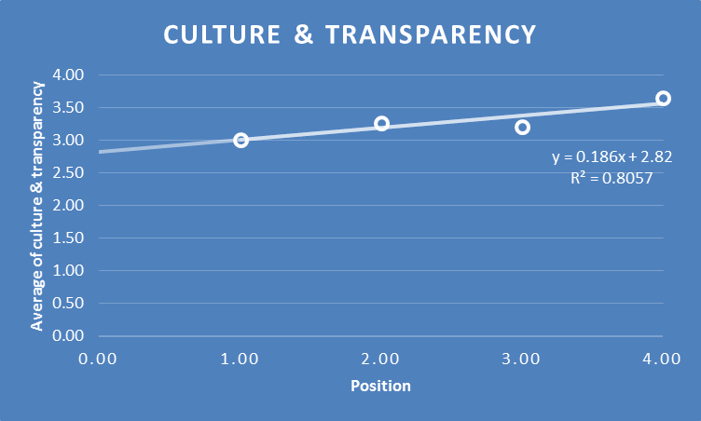

1.00 | Junior management
2.00 | Middle management
3.00 | Senior management
4.00 | C-suite

Results indicate with a high degree of certainty (R² = 0.8057) that the position that individuals are seated within the hierarchy influences the perceived level of organisational transparency.

Reference list

- Ahmed, P., (1998) Culture and climate for innovation, European Journal of Innovation Management,1(1), pp. 30-43.
- AQRinternational, (2017) MTQ48 assessment, Available at: http://aqrinternational.co.uk/product/mtq48-assessment, [Accessed: 7th April 2017]
- Aspers, P., (2004) Empirical phenomenology: An approach for qualitative research, London School of Economics and Political science Methodology Institute, 9 Available at: http://www.crpspc.qc.ca/Guide_entretien_versionWEB_eng.pdf [Accessed 30 March 2017].
- Bogdan, R. and Taylor, S. J., (1975) Introduction to Qualitative Research Method: A Phenomenological Approach to the Social Sciences, New York: John Wiley & Sons
- Bognár, B., (2013) Fluid and Stable Structures in the Organisational Communication of the Modern Society. KOME: International Journal of Pure Communication Inquiry, 1(2), pp. 23-32.
- Bradberry, T., (2015) Why your boss lacks emotional intelligence, Available at: http://www.talentsmart.com/articles/Why-Your-Boss-Lacks-Emotional-Intelligence-(EQ)-1932040793-p-1.html [Accessed: 4th March 2017]
- Brown, N., (2016) Is organisational culture shock pushing your employees away?, Available at: http://www.skyword.com/contentstandard/creativity/is-organizational-culture-shock-pushing-your-employees-away/ [Accessed: 21st December 2016]
- Brüggemanne, C., and Santos F., (2016) When stress at work becomes a problem: Coping approaches told by middle managers, Master’s Thesis, available at: http://www.diva-portal.org/smash/get/diva2:932644/FULLTEXT01.pdf, [Accessed: 3rd March 2017]
- Burgelman, R. A. (1983a). ‘A model of the interaction of strategic behaviour, corporate context, and the concept of strategy’. Academy of Management Review, 8, 1, 61–70.
- Burgelman, R. A. (1983b). ‘A process model of internal corporate venturing in a diversified major firm’. Administrative Science Quarterly, 28, 223–44
- Burgoyne, J., and Livian, Y-F., (2005) Middle managers in Europe, Routledge advances in management and business studies, Routledge, pp. 169-171
- Camerer, C.F., (1991) ‘Does strategy research need game theory?’, Strategic management journal, 12, Winter special issue, pp. 137-153
- Cha, A. E., (2015) ‘The perilous plight of middle managers: Exploitation, domination and depression’, available at: https://www.washingtonpost.com/news/to-your-health/wp/2015/08/20/why-middle-managers-are-more-likely-to-be-depressed/?utm_term=.c9bd9bcfdd8a, [Accessed: 3rd March 2017]
- Charmaz, K., (2014) Constructing grounded theory: Introducing qualitative methods series, SAGE
- Cherry, K., (2016) ‘Theories of emotion: Some the main theories to explain human emotion’, Available at: https://www.verywell.com/theories-of-emotion-2795717 [Accessed: 7th February 2017]
- Columbia University (2015) ‘Anxious? Depressed? Blame it on your middle-management position’, Available at: https://www.mailman.columbia.edu/public-health-now/news/anxious-depressed-blame-it-your-middle-management-position, [Accessed: 3rd March 2017]
- Danaeefard et al, (2012) How emotional intelligence and organizational culture contribute to shaping learning organization in public service organizations, African journal of business management, 6(5), pp. 1921-1931
- Daniels, M.A., Gregarus, G.J., (2014) Exploring the nature of power distance, Journal of Management, 40(5), pp. 1202-1229
- Delaney, P.F., Goldman, J.A., King, J.S., Nelson-Grey, R.O., (2015) Mental toughness, reinforcement sensitivity theory, and the five-factor model: Personality and directed forgetting, Personality and individual differences, Vol 83, pp. 180-184
- Dewhurst, S.A., Anderson, R.J., Cotter, G, Crust, L., Clough, P.J., (2012) Identifying the cognitive basis of mental toughness: Evidence from the directed forgetting paradigm, Personality and Individual Differences, 53(5), pp. 587-590
- Doolin, B., (2003) Narratives of change, discourse, technology and organization, Organization, 10, pp. 751-770
- Dopson, S. and Stewart, R., (1990) ‘What is happening to middle management?’. British Journal of Management, 1, 3, 3–16
- Dopson, S. and Stewart, R., (1993) ‘Information technology, organisational restructuring and the future of middle management’. New Technology, Work and Employment, 8, 1, 10–20.
- Dopson, S. and Stewart, R., (1990) ‘What is Happening to Middle Management?’, British Journal of Management, vol. 1, pp. 3-16
- Drucker, P., (2006) ‘The practice of management’, Reissue edition, Harper Business
- Drury, A., (2015) Top-down or bottom-up: Why company culture must meet in the middle, Available at: http://bostinno.streetwise.co/channels/top-down-or-bottom-up-why-company-culture-must-meet-in-the-middle/ [Accessed: 7th February 2017]
- Dutton, J. E. and Ashford, S. J. (1993). ‘Selling issues to top management’. Academy of Management Review, 18, 3, 397–428.
- Dutton, J. E., Ashford, S. J., O’Neil, R. and Lawrence, K. (2001). ‘Moves that matter: issue selling and organizational change’. Academy of Management Journal, 44, 4, 716–36.
- Dutton, J. E., Ashford, S. J., Wierba, E. E., O’Neil, R. and Hayes, E. (1997). ‘Reading the wind: how middle managers assess the context for issue selling to top managers’. Strategic Management Journal, 15, 407–25.
- Eden, C., (1992) ‘On the nature of cognitive maps’, Journal of management studies, 29 (3), pp. 261-265
- Engward, H., (2013) Understanding grounded theory, Nursing standard (through 2013), 28 (7), pp. 37
- Evans, M., (1996) R.J. House’s “A path-goal theory of leader effectiveness”, The Leadership quarterly, 7(3), pp. 305-309
- Floyd, S. W. and Lane, P. J. (2000). ‘Strategizing throughout the organization: management role conflict in strategic renewal’. Academy of Management Review, 25, 1, 154–77.
- Floyd, S. W. and Wooldridge, B. (1992). ‘Middle management involvement in strategy and its association with strategic type: a research note’. Strategic Management Journal, 13, 153–67.
- Floyd, S. W. and Wooldridge, B. (1994). ‘Dinosaurs or dynamos? Recognising middle management’s strategic role’. Academy of Management Executive, 8, 4, 47–57.
- Floyd, S. W. and Wooldridge, B. (1997). ‘Middle management’s strategic influence and organisational performance’. Journal of Management Studies, 34, 3, 465–85.
- Floyd, S. W. and Wooldridge, B. (2000). Building Strategy from the Middle: Reconceptualising Strategy Process. Thousand Oaks, CA: Sage.
- Francke, A., (2016) Ann Francke on Brexit: We need a strong and inclusive leadership, Available at: http://www.managers.org.uk/insights/news/2016/june/ann-francke-on-brexit-we-need-strong-and-inclusive-leadership, [Accessed: December 16th 2016]
- Francke, A., (2016) Middle manager lifeline report, Top banana, pp. 3
- Freeman, W.J., ([no date]) Chaos in the CNS: Theory and Practice, Unpublished, prepared for Dahlem Workshop on Flexibility and Constraint in Behavioural Systems.
- Frohman, A. and Johnson, L. (1993). The Middle Management Challenge: Moving from Crisis to Empowerment. New York: McGraw-Hill.
- Ganesh, N., (2015) ‘A non-essentialist model of culture: Implications of identity, agency and structure within multinational/ multicultural organizations’, International journal of cross-cultural management, 15 (1), pp. 101-124
- Glaser, B., G., (2015) Choosing Classic Grounded Theory: A Grounded Theory Reader of Expert Advice, Sociology press
- Gratton, L., (2011) Column: the end of the middle manager, Harvard business Review
- Greekmythology.com, (2017) ‘Chaos’, Available at: http://www.greekmythology.com/Other_Gods/Chaos/chaos.html [Accessed: December 30th 2016]
- Harvard business school (2013) Danger in the middle: why midlevel managers aren’t ready to lead, London
- Haselhun, M., Kennedy, J., Kray, L., Van Zant, A., Schweitzer, M., (2015) Gender differences in trust dynamics: Women trust more than men following a trust violation, Journal of Experimental Social Psychology, 56, pp.104-109
- Hensel, A., (2015) ‘The psychological strain of being a middle manager’, Available at: http://www.inc.com/anna-hensel/why-middle-managers-have-higher-rates-of-depression.html, [Accessed: 3rd March 2017]
- Hofstede, G., (2017a) Organisational culture, Available at: https://geert-hofstede.com/organisational-culture.html, [Accessed: January 27th 2017]
- Hofstede, G., (2017b) National culture, Available at: https://geert-hofstede.com/national-culture.html, [Accessed: January 27th 2017]
- Holland, N., (2010) How you are who you are – In chaos theory, Available at: https://www.psychologytoday.com/blog/is-your-brain-culture/201008/how-you-are-who-you-are-in-chaos-theory, [Accessed: December 19th 2016]
- HRGrapevine.com (2016) Why do middle managers distrust their bosses? Available at: https://www.hrgrapevine.com/content/article/2016-09-22-middle-managers-dont-trust-those-above, [Accessed: 3rd March 2017]
- Huy, Q. N. (2001). ‘In praise of middle managers’. Harvard Business Review, 80, 8, 72–9
- Huy, Q. N. (2002). ‘Emotional balancing of organizational continuity and radical change: the contribution of middle managers’. Administrative Science Quarterly, 47, 1, 31–69.
- Iconaru, C., 2012. Perceived risk when buying online: Evidence from a semi-structured interview. Studia Universitatis Vasile Goldis Arad, Seria Stiinte Economice, 22(2), pp. 63-73.
- Ives, C., ([no date]) Human beings as chaotic systems, Available at: http://www.fractal.org/Life-Science-Technology/Publications/Human-beings-as-fractal-systems.pdf, [Accessed: 14th April 2017]
- Katz, R. L., (1955) ‘Skills of an effective administrator’, Harvard business review, 33 (1), pp. 33-42
- Kingston university (2016), ‘Thinking with our hands can help us find new ways of solving problems, research from Kingston university psychology experts reveal’, Available at: http://www.kingston.ac.uk/news/article/1769/22-dec-2016-thinking-with-our-hands-can-help-find-new-ways-of-solving-problems-research-from-kingston/ [Accessed: January 15th 2017]
- Knorr, R., Bronack, S., Switzer, D. & Medford, L., 2011. Methodology of a Novel Virtual Phenomenology Interview Technique. Journal of virtual worlds research, 3(3), pp. 4-23.
- Koellinger, P., Minniti, M., Schade, C., (2007) Seeing the world with different eyes: gender differences in perceptions and propensity to start a business, Tingergen Institute, 35(3)
- Koellinger, P., Minniti, M., Schade, C., (2011) Gender differences in entrepreneurial propensity, Oxford bulletin of Economics and statistics, 75(2)
- Korpela, N., (2014) The middle manager role – A case study of expectations, norms, behaviours and conflicts within the role, Department of entrepreneurship, Management and Organisation, Harken school of economics, Helsinki
- Laforest, J., 2009. Guide to organizing semi-structed interview with key informant. [Online]
- Leavitt, H. J., and Whistler, T.L., (1958) ‘Management in the 1980’s’, Harvard Business Review, November, pp. 41-48
- Lebowitz, S., (2015) Scientists say middle managers are more likely to be anxious and depressed, Available at: http://uk.businessinsider.com/why-its-hard-to-be-a-middle-manager-2015-8?r=US&IR=T [Accessed: 4th March 2017]
- Levy, D., (1994) Chaos theory and strategy: theory, application, and managerial implication, Strategic management journal, 15, pp. 167-178
- Lewis, L. K., and Seibold, D., (1998) Reconceptualising organisational change implementation as a communication problem: a review of literature and research agenda, in Roloff, M.E. and Paulson, G. (Eds) Communication Yearbook, Vol. 21, Sage, California, pp. 93-151
- Lisewski, B., (2004) Implementing a learning technology strategy: top-down strategy meets bottom-up culture, Research in learning technology, 12 (2)
- Lorenz, E. N., (1993) Deterministic non-periodic flow, journal of the atmospheric sciences, 20, pp. 130-141
- Luhmann, N., (1987) Soziale Systeme: Grundriß einer allgemeinen Theorie, suhrkamp taschenbuch wissenschaft
- Markus, H. R.; Kitayama, S., (1991) ‘Culture and the self: implications for cognition, emotion, and motivation, Psychological review, 98 (2), pp. 224-253
- McIntosh, M. & Morse, J., 2015. Situating and Constructing Diversity in Semi-Structured Interviews. Global Qualitative Nursing Research, 2(2), pp. 1-12.
- McIntosh, M., & Morse, J. (2015). Situating and Constructing Diversity in Semi-Structured Interviews. Global Qualitative Nursing Research, 2, Global Qualitative Nursing Research, 2015, Vol.2.
- McLeod, S., (2013) ‘Tolman – Latent learning’, Available at: http://www.simplypsychology.org/tolman.html [Accessed: January 27^{th,} 2017]
- McLeod, S., (2015) ‘Cognitive psychology’, Available at: http://www.simplypsychology.org/cognitive.html [Accessed: 7th February 2017]
- Mheducation.co.uk (2017) ‘Grounded theory methodology’, Available at http://www.mheducation.co.uk/openup/chapters/9780335244492.pdf [Accessed: 18th February 2017]
- Miller, I., Swinney, G., (1992) Human dimensions of chaos theory: consciousness, physiology, perception and psychology
- Moerer-Urdahl, T., and Creswell, J., W., (2004) Using transcendental phenomenology to explore the “ripple-effect” in a leadership mentoring programme, International journal of qualitative methods, 3(2), pp. 19-35
- Moustakas, C., (1994) Phenomenological research methods, SAGE, London
- Mullins, L. J., (2008) Management and organisational behaviour, Prentice Hall.
- Mumford et al (2000) ‘Leadership skills for a changing world: Solving complex social problems’, Leadership quarterly, 11 (1), 23
- Murphy, P., (1996) Chaos theory as a model for managing issues and crises, Public relations review, 22 (2), pp. 95-113
- Murriner. D., (2016) Is culture created top-down or bottom-top?, Available at: https://www.cloverleaf.me/go/is-culture-created-top-down-or-bottom-up/ [Accessed: 7th February 2017]
- Neumark, D; Bank, R., Von Nort, K., (1995) Sex discrimination in restaurant hiring: An audit study, National bureau of economic research, 5024
- Niedenthal, P. M., Krauth-Gurber, S., and Ric, F., (2006) ‘Psychology of emotion: interpersonal, experiential and cognitive approaches, New York, Psychology Press.
- Nikolić, M., Hadžić, O., and Nedeljković, M., (2014) The relationship between GLOBE organisational culture values and the emotional intelligence of employees in Serbian organisations, Primenjena Psihologija, 7(2) pp. 137-156
- Nonaka, I. (1988). ‘Towards middle up/down management: accelerating information creation’. Sloan Management Review, 29, 9–18.
- Nonaka, I. (1991).’The knowledge-creating company’. Harvard Business Review, November–December, 96–104.
- Nonaka, I. (1994). ‘A dynamic theory of organizational knowledge creation’. Organization Science, 5, 14–37.
- Nonaka, I. and Takeuchi, H. (1995). The Knowledge Creating Company. Oxford: Oxford University Press.
- O’Cathain, A. et al., 2015. Maximising the impact of qualitative research in feasibility studies for randomised controlled trials: guidance for researchers. Pilot and feasibility studies, 1(32), pp. 1-13.
- Poincaré, H., (1982) ‘Foundations of science’, reprint of pre-1920’s book, University press of America.
- Prins, S., Bates, L., Keyes, K., and Muntaner, C., (2015) Anxious? Depressed? You may be suffering from capitalism: Contradictory class locations and the prevalence of depression and anxiety in the USA, Sociology of health & illness, 37(8), pp. 1352-1372
- Psychology today, (2017) ‘Cognition’, Available at: https://www.psychologytoday.com/basics/cognition [Accessed: 7th February 2017]
- Quinn, R. (2015). The positive organization breaking free from conventional cultures, constraints, and beliefs (1st ed.). Oakland: Berrett-Koehler.
- Rhee, K.S. and Sigler, T.H., (2015) Untangling the relationship between gender and leadership. Gender in Management, 30(2), pp. 109-134.
- Rutgers.edu (2017), Rutgers school of arts and sciences: Department of psychology, http://psych.rutgers.edu/menu-iv/co
- Salovey, P., and Mayer, J., (1990) Emotional intelligence, Imagination, Cognition and Personality, 9, pp. 185-211
- SASEANU, A., TOMA, S. and MARINESCU, P., (2014) Feminine leadership and organisational culture. Manager, (19), pp. 144-150.
- Schachter, S., Singer, J., (1962) Cognitive, social, and physiological determinants of emotional state, Psychological review, 69(5), pp. 379-399
- Schein, E., (1980) Organisational culture and leadership, Wiley, San Francisco
- Scott, M., (2016) Why middle managers no longer trust their bosses (and what that means for UK plc), Available at: http://www.managers.org.uk/insights/news/2016/september/why-middle-managers-no-longer-trust-their-bosses-and-what-that-means-for-uk-plc [Accessed: December 16th 2016]
- Scott, M., (2016) Why middle managers no longer trust their bosses (and what that means for UK plc), Available at: http://www.managers.org.uk/insights/news/2016/september/why-middle-managers-no-longer-trust-their-bosses-and-what-that-means-for-uk-plc [Accessed: 13th January 2017]
- Shukla, A. and Rai, H., (2015) Linking Perceived Organizational Support to Organizational Trust and Commitment: Moderating Role of Psychological Capital, Global Business Review, 16(6), pp. 981-996
- Smith, V. (1997). Managing in the Corporate Interest: Control and Resistance in an American Bank. Berkeley, CA: University of California Press.
- Smollan, R.K. and Sayers, J.G., (2009) Organisational culture, organisational change and emotions: a qualitative study, Journal of change management, 9(4), pp. 435-457
- Steers, R.M., Sanchez-Runde, C. and Nardon, L., (2012) Culture, cognition, and managerial leadership. Asia Pacific Business Review, 18(3), pp. 425.
- Terry, N., (2016) UK growth held back as bosses lose trust of middle management, Available at: http://www.managers.org.uk/about-us/media-centre/cmi-press-releases/uk-growth-held-back-as-bosses-lose-trust-of-middle-management [Accessed: 4th Marth 2017]
- Thebusinessdesk.com (2017) Business Bytes: Why we don't trust our managers - and how you can fix it, Available at: http://www.thebusinessdesk.com/mobile/eastmidlands/why-we-dont-trust-our-managers/ [Accessed: 3rd March 2017]
- Thomas-Hunt, M., C., Phillips, K., W., (2004) When what you know is not enough: expertise and gender dynamics in task groups, Personality and Social Psychology Bulletin, 30(12), pp. 1585–1598
- Tolman, E., (1948) ‘Cognitive maps in rats and men’, Psychological review, 55 (4), pp. 189
- Top-b.com (2016) New CMI report highlights massive disconnect between leaders & middle managers, Available at: http://top-b.com/news/new-cmi-report-middle-manager-lifeline/ [Accessed: 3rd March 2017]
- van Teijlingen, E. & Hundley, V., 2001. The importance of pilot studies. [Online] Available at: http://sru.soc.surrey.ac.uk/SRU35.html [Accessed 30 March 2017].
- Vygotsky, L., (1978) Mind in society: the development of higher psychological processes, Cambridge, Harvard University Press.
- Wertsch, J. V., (1991) Voices of the mind: A sociocultural approach to mediated action. Cambridge: Harvard University Press.
- Williams D, (2012) The end of middle managers and why they’ll never be missed, Available at: https://www.forbes.com/sites/davidkwilliams/2012/07/10/the-end-of-middle-managers-and-why-theyll-never-be-missed/#66ff5712774a [Accessed: 4th March 2017]
- Williams, G., Rees-Jones, I., Allen, D., Elliott, E., Hughes, D., and Latimer, J., (2015) Sociology of health and illness, WILEY online, Available at: http://onlinelibrary.wiley.com/journal/10.1111/(ISSN)1467-9566, [Accessed: 3rd March 2017]
- Wooldridge, B. and Floyd, S. W. (1990). ‘The strategy process, middle management involvement, and organizational performance’. Strategic Management Journal, 11, 231–41.
- Young, A., (2016) Just as you suspected all along: Firing middle managers is good for business, Salon.com, Available at: http://www.salon.com/2016/09/28/just-as-you-suspected-all-along-firing-middle-managers-is-good-for-business/ [Accessed: December 17th 2016]
- Young, A., (2016) Just as you suspected all along: Firing middle managers is good for business, Available at: http://www.salon.com/2016/09/28/just-as-you-suspected-all-along-firing-middle-managers-is-good-for-business/, [Accessed: 3rd March 2017]

