University of Wales

Trinity Saint David


Student name: Rumen Pavlov
Student number:1902012
Programme: MBA General Management
Module: Marketing Management
Module code: LCMB7001
Assignment: 1-75%
Lecture: Tushara B.

CONTENUT:

Introduction
Background of Marriott Hotels.
Communication diagram
Channel module
IMC
New strategies
Definition of Brand
Keller’s brand
Customer Journey
Touch points pre purchase post
Diagram of customer journey plus touch point how they work
Strengths and weakness points
Total Engagement model related to the Marriott
Recommendation new points to increase the business
Conclusion

Introduction:
This report will have a look at marketing used by the Marriott Hotels group.
The brand was founded by W.J.Marriott, looking at the communicational diagram in
the business, the specific model and new strategies to improve the business,
definition of brand, the connection between the customer journey and marketing, the
weaknesses and strengths, the new recommendation to improve the business and
conclusion.
Background of Marriot Hotel:
The famous Marriott brand hotel which all the world knows today is been founded in
Washington D.C USA on 5th of March 1927 by J. William Marriott and his wife Alice
Marriott. By Marriott history (2023).
1927-1956
“It all began with an A&W root beer stand. Founder J. Willard Marriott and his wife,
Alice, got their young business off the ground by quenching people’s thirst during
Washington D.C.’s hot, muggy summers. Good food and good service at a fair price
became a guiding principle for Hot Shoppes restaurants--and for Marriott
International as it grew”-By Marriott history (2023).
1957-1985
“Marriott made a historic shift into the hotel business in 1957. The world’s first motor
hotel opened in Arlington, Virginia, under the management of J. Willard Marriott’s
son, Bill. Over the next 25 years, Marriott became a diverse global enterprise, and
Bill Marriott became a visionary CEO whose leadership transformed the hospitality
industry”. ”-By Marriott history (2023).
1986-2011
“One company, many brands--that's the innovative model that Marriott began
building in the late 1980s. From pioneering the extended-stay business to launching
distinctive brands geared toward the business traveller to increasing its presence
overseas, Marriott International broke new ground in its quest to become the number
1 hospitality company in the world”. ”-By Marriott history (2023).
Today Marriott hotel are having 120,000 employees in all of them hotels.
Started from a small restaurant today is one of the most famous hotels.
Communicational diagram:

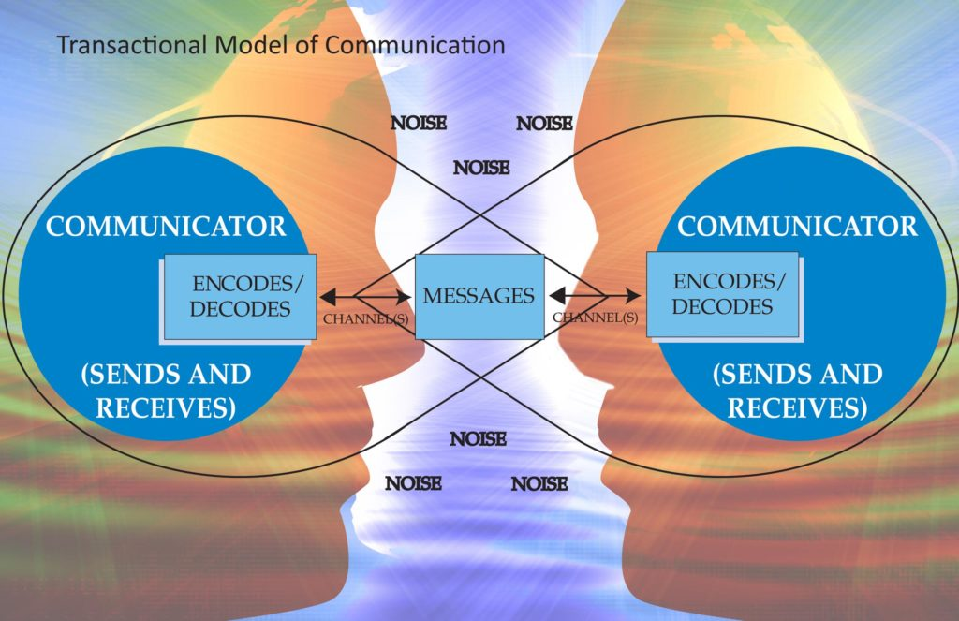

During the communicational process is imperative the message to be clear and
short, in this case the receiver will decode the message easily and will sends the
message back. Is also important to calculate the noise next to them.
“The communicational process by Indeed Editorial Team (2020) “Communication is
an important skill in the workplace. In order to effectively communicate with others,
it's important to understand the different components involved in the communication
process”
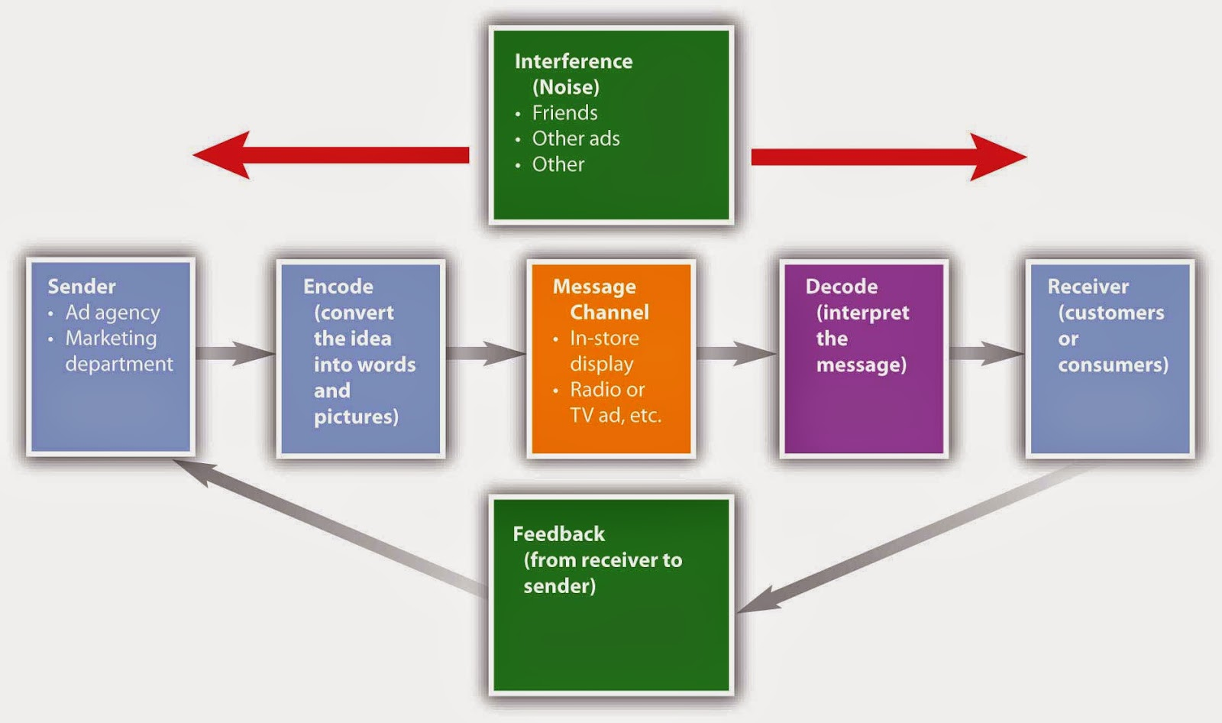
By communicating in a verbal or nonverbal way, the verbal is any type of words, the
nonverbal is the colour, body language.
The sender needs to know very well the communicational process in specific in the
marketing industry and know how to communicate, to deliver the message to
customers.
The Advertising process is consisting in communicating with the customer, selling
them a product tangible and a non-tangible when a service is. Advertising by using
colours, buildings and movies can influence the buyer to buy the specific product,
which can be tangible and a non-tangible when a service is.
The advertising process can be done by media, by promotion the difference between
promotion and advertising.
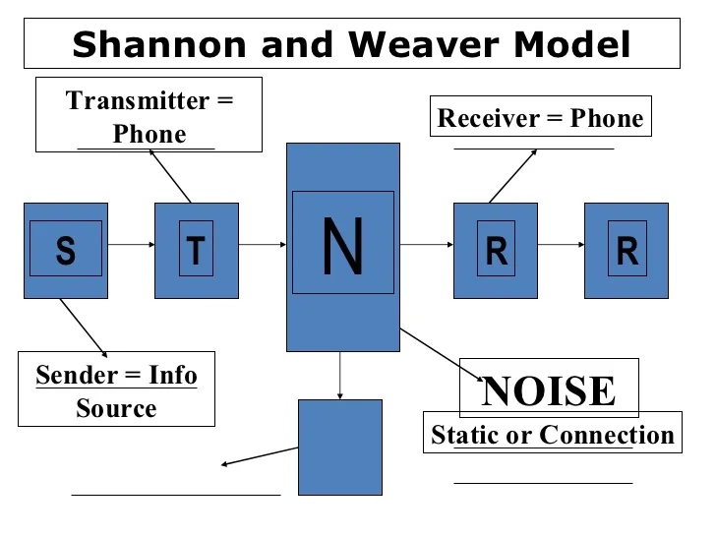
By Chara Adav (2023)-” The difference between advertising and promotion is that
advertising is an expensive campaign but promotion, on the other hand, is
comparatively cheaper. Advertising is a long-term investment for the brands. It also
consumes a longer time to show the effect. But sales promotion is a strategy for a
short period and gives instant results”. The best model of explaining the
communication is the model of Shannon also Keller’s model.
The first model of communication is Shannon-Weaver is model for more influential
communicational model, which is been explained firstly in 1948.
Shannon and Weaver Model of Communication
“In 1948, Shannon was an American mathematician, electronic engineer and
Weaver was an American scientist both of them join together to write an article in
“Bell System Technical Journal” called “A Mathematical Theory of Communication”
and also called as “Shannon-Weaver model of communication”. By businesstoppia in
communication (2018)“This model is specially designed to develop the effective
communication between sender and receiver. Also, they find factors which affecting
the communication process called “Noise”. At first the model was developed to
improve the technical communication. Later it’s widely applied in the field of
Communication.” By businesstoppia in communication (2018)“The model deals with
various concepts like Information source, transmitter, Noise, channel, message,
receiver, channel, information destination, encode and decode.”
By businesstoppia in communication (2018)

In 1948 the above discover the theory of communications with Warren Weaver.
Shannon was an American mathematician, whereas weaver was a scientist.
The mathematical theory later came to be known as Shannon Weaver model of
communication is mother of all models.
Contacts in Charmin, behaviour model set or information source sender is the
person who makes the message chooses the channel and sends the message.
Encoder or the transmitter encoder is the sender who uses machine, which converts
message into signals or binary data. It might also there a quick refer to the machine
Channel is the meeting this present message?
Also known as seriously. Decoder is the machine used to convert signals or binary
data into message or there is river. Who translates the message from signals.
Receiver or destination. Receiver is the first one who gets the message or the place
where the message must reach the receiver provides feedback.
According to the message, Noise is the physical disturbance, light environment and
people which do not let the message get to the receiver as.
How does the model work? The centre and holds the message.
And telegram. And your converts, the message. The message is sent in code to a
meet you. The receiver after the code, the message before understanding it and
interpreting it. Their receptor machine can also act as a decoder in some the
channels and have noise and the receiver might not have the capacity to decode,
which might cause problems.
Process. Here for instance, we might be descender mouth might be included which
includes purple language. Yeah, might be the channel. Another decision sphere
might be their receptor. This might be the decoder and the receiver. The following
situation is some examples of Sarah had sent a voice message to Dave, going him
to do his chores.
In this situation. As the sender, who encoded the message. Voice recorder is the
channel in which the message is sent to. And Dave was the receiver who will be
Example of noises that could be present in the channel. Could be that Sarah had
recorded in a noisy environment and Dave cannot hear her words.
Levels of communication problems. There is three levels of problems of
communication. According to Shannon Mirror, they are one technical problem.
How channel causes a problem 2. Semantic problem is the meaning of message
sent and receive. The 3rd different 3 effectiveness problem. How effectively does the
message cause reaction advantages of the mother concept of noise helps in making
the communication effective. So, removing the noise or problem with this model
takes communication. As a two-way process, It makes the model applicable in
general communication. Communication is taken, as quantifiable in channel Hoover
model. With the system of channel, either model. Can be applied for more
interpersonal, communications than root, communication, and less communication.
Crazy about Prince capacitive part in the communication process, a sender place to
primary role. That sends messages. Feedback is taken as less important in
comparison to the messages sent by sending. By businesstoppia in communication (2018)

Integrated marketing communication
Whether it's personal selling field solution. Advertise. Concerts intended to get our

message across to our audience, but a consumers or Whoever we're targeting.

We're trying to get a message across. One thing that. It all is. Our message is going

out, all these different ways, but The same. And that's the key.

In marketing communication. Definition. Here's coordinated. Use promotional tools.

Create consistent messaging to a range of target audience. The keyword in, all of

that is Because if our messaging changes from place to place, or from channel to

channel or That's, Me. Equals clear. And that's what we want to shoot.

If it then consistent, like I said it's going to be confusing gonna cause conflict in the

mind of the listener or the audience. And, Not good. Because Will turn away or take.

Choose another option. So, if we can, And co-ordinate all of our different

communications. That can be really powerful way to strengthen our image.

And that's important for us as marketers because we want people to have a good

firm understanding of who we are and what we're all about. That's the key to

integrated marketing communications.

Within marketing, one of our highest level goals is customer satisfaction. If we're
doing things right, we should be satisfying our customers but how do we know? Well,
there's something called a net promoter score. That can help us understand how well
we're actually satisfying our customers. So what is a net?
Promoter's score. This is a measure of customer satisfaction or loyalty as based on
how likely a customer is to recommend our company to a friend or colleague.
Thinking about this simply if our customer is very satisfied. They're going to be very
likely to recommend our product or service to somebody else.
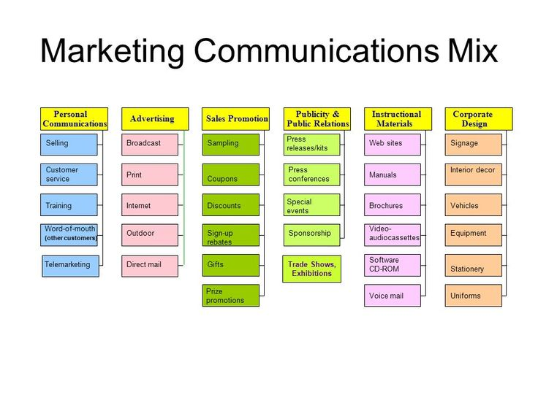
If they're not satisfied, they're going to be very unlikely in most cases.
The recommended. The more satisfied our customer is the higher.
The integrated Marketing Communication(IMC)

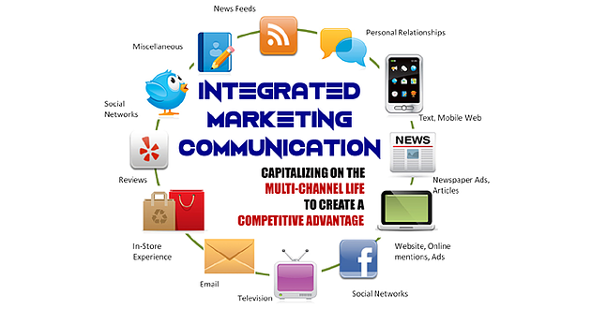
The integrated Marketing Communication(IMC) is this process using all media and
any type of communication to can achieve them goals in increasing them sels of
them intangible product like service. By Asana(2023)

By the online dictionary (2023) strategies mean: planning, organizing evaluate the steps to do for a better incomes, sells

Brand
By Brian McCarthy (2017) . “A brand is a word or a visual representation, which
gives a product a unique identity” By Brian McCarthy (2017) Today, a brand is a
word or a symbol which gives a product a unique identity. That is the simple
explanation of what a brand is. What it's more complicated than that, because a
brand is also a promise. To consistently deliver certain promises.
About promise, about the experiences. So, creating a brand identity means using

brand elements brand elements we as the fundamental building blocks of a brand's

identity of a brand visual representation. This can be just the name. It can be a logo.

It can include both. It usually includes a well specified font and setup colours.

In detail about some of the words that marketers use when they talk about brand.

The brand name is obvious and let's use the example of a service business. At

cultural level let have a look at the famous Oxford University in the UK, the brand

name here, of course, is expert University.

Their logo is a circle. With university of Oxford around the perimeter and inside a

book in three, crowns. There might be a banner with this brand mark on it is more

than just the logo and more than just the name.

take a closer look at this brand mark. At example the logo of Oxford university.
(See more in the appendix).

Marriott oversees 30 brands in more than 131 countries, boasting 7,000+ properties

worldwide. Marriott recently combined Marriott Rewards, the Ritz-Carlton Rewards,

and SPG into Marriott Bonvoy, the largest loyalty program in the world with 140

million members. Here’s what you need to know about this portfolio of

brands. By Hotel Tech Report, 12 October 2022

Brand equity:
By Adam Hayes, (2022) “Brand equity refers to a value premium that a company
generates from a product with a recognizable name when compared to a generic
equivalent. Companies can create brand equity for their products by making them
memorable, easily recognizable, and superior in quality and reliability.
Mass marketing campaigns also help to create brand equity.”- By Adam Hayes, (2022)
The brand equity is looking for the value of the company, if the company add the
same value to the rules of management, of working
When a company has positive brand equity, customers willingly pay a high price for
its products, even though they could get the same thing from a competitor for less.
Customers, in effect, pay a price premium to do business with a firm they know and admire.
Because the company with brand equity does not incur a higher expense
than its competitors to produce the product and bring it to market, the difference in price goes to their margin.
The firm's brand equity enables it to make a bigger profit on each sale.
The key helping the bran to do that are the fact the brand is referring the value of
company, is making this company easy recognizable, is having direct effect on
customers.
Keller’s Brand Equity:
What is Keller front equity model? Will Kevin Keller is an international leader in the
field of management, and we developed one of the most recognised plan equity
problems available today.
And that is for the customer thing around equity level. Now this model isn't who has a
establish grow and evaluate brand equities, and forgive brand, builders a framework.
Away. And That is the brand equity model works. Well, tellers’ idea was simple that
in order.
A valuable brand. The marketplace that your audience value. So, every single point, Single
interaction that audience has a brand, the entire brand experience should work towards that
perception. So, using the steps of the model are brands will grow into equity.
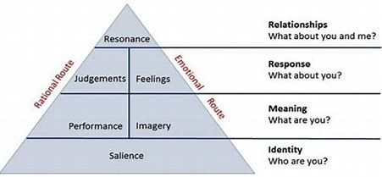
Emotions. Connection. So, let's jump into the steps of the Brown Equity model. So, this is
the brand equity models in full, or the Apparently Now it has four levels, all focused

on achieving on equity. So, let's roam through each level. -By Keller brand model.

Level 1 on the pyramid is the salience
Level one is, I get the so who are you? So this is all about brand recognition. Awareness.
And generating more developing that run your audience means for the aware of brand using
to be able to recognise it when it call it.
So just slogan your tagline your logo, your name, the broader identity, all of these elements,
can contribute towards establishing that brand awareness and helping to establish that
recognition in the marketplace.
Level 2 is the performance and the imagery
Level two is the meaning. What are you? So this is all about communicating, what value you
offer in? Wherefore you're different, why? why audience should care about that brand, why
they should turn more to your brand instead of your competitors? can use performance and
imagery within this level. So, performance is about demonstrating how your brand fit, the
need of your audience. And the image is about how the brand alliance with your customer
through social and psychological level.
Level 3 is the feelings, judgment
What do they believe? And what is your brand believe? And what is your brand stand for .
Level three is response. So how is your brand proceed? How does the customer respond to the specific brand messaging? And what response does brand vote? Specifically, what is the audience, think? And feel about your brand and the two building blocks for this level are judgement and feelings.
So judgements, are the conclusions that audience? Comes to in the role that your brand plays what can play in their life and the feelings are, what they feel. What emotions have you evoked from your audience through your imagery through your messaging and associations?
Level 4 is the resonance, the relationship between the bran and the customer.
And this level is all about resonance. Have you resonated with the who your audience on.
Emotional level on a level. Do they self-identify with your brand because if your audienceself-identifies, Your brand. Who they are, then they Connections. So set out to build a brand, this is the level that any company should pay. The framework to perse evaluate
where you are with your brand and then to grow your brand equity loyalty and ultimately your market share.
Now, you can remember the first step of the brand equity model is to establish that recognition on awareness.- By Keller, K.L. (2001) ‘Building Customer-Based Brand Equity: Creating Brand Resonance Requires Carefully Sequenced Brand Building Efforts,’ Marketing Science Institue, 1-107, July/August 2001
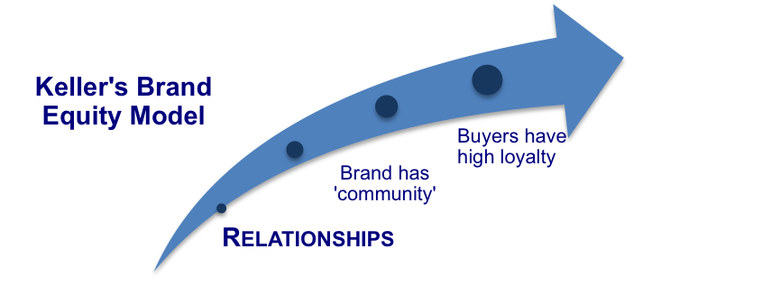

Advantages and disadvantages of Keller brand equity model.
Advantages is that the noise of this model is making it famous and effective attracting the attention of customers
How effectively does the message cause reaction advantages of the mother concept
of noise helps in making the communication effective. So, removing the noise or
problem with this model takes communication.
Disadvantages:

The noise is affecting the communication and the message can be delivered in the wrong meaning us been misunderstood.
Noise is the physical disturbance, light environment and people which does not let the message get to the receiver as
Customer journey:
Is giving information about all the points of the business and is easy to track the steps in terms of developing and how to improve the business.
In the picture bellow is represented how suppose to be the journey by T.Balendran(2022)
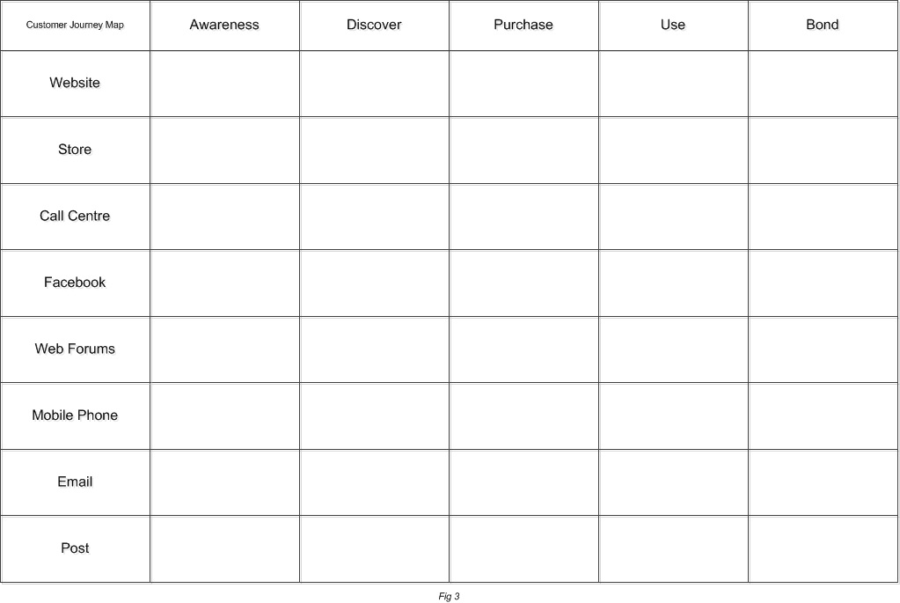

Marriott customer journey:

The orange indicator is showing how Marriott brand is using internet for booking. 7
From (green line) Mobile phone to email and purchase is showing the brand are using the phone, email to sell them service. The email to send them new promotions and offers.
The Blue line showing they are using the phone, even if the cost if been increase.
The red/brown line is showing that they are using phone, email, post to receive complain and have a customer service for the complains.
By Ben Goodey(2022) “Customer touchpoints are essential to understanding your customer's journey.
66% of companies now compete primarily on customer experience. This makes sense
given that 86% of buyers will pay more for a great experience.
Great customer experiences require a lot of attention to detail at every stage of
interaction with the customer. So in this guide, we will not only go through the basics
and why touch points are so important, we'll also walk you through how you can do
a customer feedback analysis that breaks into a touchpoint analysis”.
Therefore, the push promotions would be sampling, personal selling volume,
discounts of point, of purchase and package promotions. If you've identified them
correctly.
The total engagement of Marriott
In hospitality industry and other too, the people are first, the pursue must be
excellence, the integrity need to serve the world, for this reason the staff and the
customer are treated in the best way, as the staff is of front desk is been train in
diversity culture welcome. Which help to give the best impression during the
welcoming into guest. By Marriott (2022)
Below its represented the total engagement model:

Typical customer touch points for most businesses include an elements like: website, call centre, post email, customer service, sales and support service which Marriott brand is having all the points.

Strategies of Marriott:
The bonvoy Marriott is a program”travel programme” club card, which is making the customer to earn towards by travelling, this card is started to work with first staying in one of Marriott hotels in the words.
To join and receive this club card all of this and the membership is not having any cost as is free. The customer can enroll even from home visiting Marriott site going on loyalty. The customer can transfer these points wherever prefer.
New strategies:
To change the focus of the targeting as Marriott brand is a luxury, is not for the common customer. If Marriott reduces the price will have more customers, which will increase them incomes. Also they should sell the Bonvoy membership in fly planes, like that the guest will have more information about it. The minus also is this membership a lot of people doesn’t know about it as luxury brand is blocking the common person to know about it. Price is high price. The plus of this brand is that the image is working for them, also the service is at good level, the staff is receiving the best training by them supervisors and managers. You might combine in a package promotion, a room, a show dinner family package of four with the water park to encourage more personal stays at the hotel. Endorsements. Help generate consumer loyalty as well.
Conclusion:
The Marketing is a complex of knowledge and rules which any company need to

know, as of the marketing impact on the guest depend all the business of the

company.

Marriot marketing is elementary, applying on service and luxury, on businesspeople.

The selling is depending of a lot of things like moment, colours, place, is not only to
pretend doing marketing, is a lot of research, of demanding more higher is the

demanding more higher will be the price. Low demanding low price, but for the

essential needs of any person is impossible to minimise the use, even when is

celebrity manipulation. And that's important for us as marketers because we want

people to have a good firm understanding of who we are and what we're all about.

That's the key to integrated marketing communications.

Within marketing, one of our highest-level goals is customer satisfaction. If we're
doing things right, we should be satisfying our customers but how do we know? Well,
there's something called a net promoter score. That can help us understand how well
we're satisfying customers.

References:

- Marriott history: Marriott History | History of the Marriott Family, ,( access on 7th of January 2023)
- Communication-Definitions of Communication (communicationtheory.org), ,( access on 7th of January 2023)

- Bonvoy: https://www.marriott.com/loyalty.mi,( access on 7th of January 2023)
- Enroll as a Member: https://www.marriott.com/loyalty.mi,( access on 7th of January 2023).
- Definition of Brand-Brand Definition & Meaning - Merriam-Webster, ,( access on 7th of January 2023).
- Keller’s brand Keller’s Brand Equity - Search (bing.com) ,( access on 7th of January 2023). Keller, K.L. (2003) 'Strategic Brand Management,' New Jersey: Prentice Hall.
- [2] Keller, K.L. (2001) ‘Building Customer-Based Brand Equity: Creating Brand Resonance Requires Carefully Sequenced Brand Building Efforts,’ Marketing Science Institue, 1-107, July/August 2001.

- Customer Journey : https://en.ryte.com/wiki/Customer_Journey. ,( access on 7th of January 2023), https://transformation.ai/customer-journey-definition, ,( access on 7th of January 2023),
- Touch points pre purchase post- Customer Touchpoints | Definitions, strategies, & expert interviews [2021] (sentisum.com). ,(access on 7th of January 2023),

- Total Engagement model related to the Marriott.- https://graduateway.com/total-quality-management-of-marriot-international. ,(access on 7th of January 2023),

- Brand Definition & Meaning - Merriam-Webster, ,(access on 7th of January 2023),

- Equity brand-Equity Brand - Definition and More from the Free Merriam-Webster Dictionary ,(access on 7th of January 2023),
- Integrated marketing communications (IMC)- What Is IMC? Integrated Marketing Communications Explained (ahrefs.com) ,(access on 7th of January 2023),

