Research and Case Scenario in Data Security and Compliance
Rose Plumley
2218443
Data Security and Compliance
ACCA5034
Carlene Campbell

Table of Contents
- Task 1 – Research in Data Security and Compliance………………………………………………………………3
  - Abstract………………………………………………………………………………………………………………………….3
  - Introduction……………………………………………………………………………………………………………………3
  - Implementing Information Security…………………………………………………………………………………3
  - Security Technologies……………………………………………………………………………………………………..5
- Task 2 – Case Scenario – CyStresSolution………………………………………………………………………………8
  - Organisation structure…………………………………………………………………………………………………….8
  - Policies and Procedures………………………………………………………………………………………………….8
  - Compliance (Laws and Ethics)…………………………………………………………………………………………8
  - Governance and Strategic Planning for Security………………………………………………………………8
  - Risk Management…………………………………………………………………………………………………………..8
  - Contingencies Planning…………………………………………………………………………………………………..9
  - Protection Mechanisms………………………………………………………………………………………………….9
- Conclusion…………………………………………………………………………………………………………………………….9
- References…………………………………………………………………………………………………………………………..10

Research and Case Study in Data Security and Compliance

Task 1 – Research in Data Security and Compliance
Rose A Plumley
Student University of Wales Trinity St David, Swansea, Wales
2218443@student.uwtsd.ac.uk

  - Abstract
THIS IS TO BE WRITTEN LAST.
  - Introduction
All organisations, from the largest international bodies to the smallest Small-Office-Home-Offices, need to implement some form of information security. This will usually be informed by pre-existing frameworks, provided by trusted professional organisational bodies such as the Association for Computing Machinery (ACM) [1] or the International Council of Electronic Commerce Consultants (EC-Council) [2]; But regardless of past precedents, organisations must stay informed of the most modern threats and attack vectors to their businesses. To this end, whether outsourced or not, an organisation must do research into areas of data security and compliance.
  - Implementing Information Security
If understanding information security (IS) through the lens of the updated McCumber INFOSEC cube model, then it is defined by the balance between information characteristics (confidentiality, integrity, availability), information states (transmission, storage, processing), and security countermeasures (technology, policy and practice, training and education) [3]. For an organisation’s information to be secure, their assets must be protected in their characteristics, regardless of state, via application of relevant countermeasures [4]. Importantly, there is no perfect solution to IS. An organisation must consider their individual needs on a case-by-case basis; For instance, a private hospital must ensure maximal confidentiality, integrity and availability of records and services, ensuring the protection and safe operation of systems, data, information and assets [5]. However, IS is a balance between protection and availability – should an organisation be too protected, access to relevant data as needed may prove cumbersome, interfering with normal organisational and business functionality. To aid with this IS auditing process, professional bodies offer models by which an organisation may self-assess their needs. For example, the National Institute of Standards and Technology (NIST) offers their cybersecurity framework, which allows an organisation to create a profile to measure their implementation’s success, based on the following 7-stage process [6]:
- Determine objectives, requirements, and scope
- Identify assets and risk
- Create a current profile
- Conduct a risk assessment
- Create a target profile
- Perform a gap analysis
- Implement the action plan
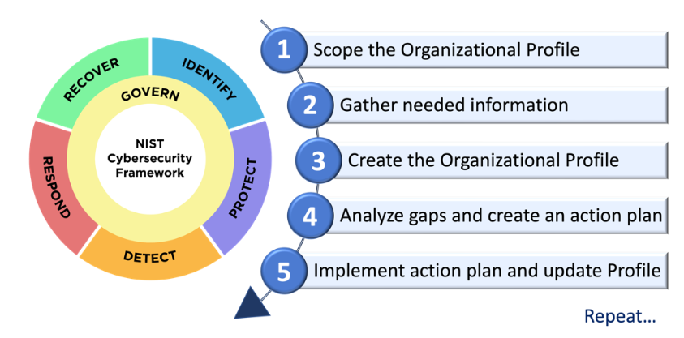[7]
However, this is more useful for a pre-existing IS framework. For those organisations which do not yet have an IS implementation, they may consider various approaches, but a popular option is the top-down approach to IS – a common implementation initiated by upper management, usually through a legal team, which [8]:
- Issues policy, procedures and processes
- Dictates goals and expected outcomes
- Determines accountability for each required outcome
With the most successful types of top-down approach also including a formal development strategy, known as a systems development life cycle (SDLC). SDLCs also have varying models, such as the waterfall method and the prototyping model, but typically include five phases: Initiation, development/acquisition, implementation/assessment, operations/maintenance, and disposal [9].
An organisation may also consider alternative IS blueprints, frameworks and models. One of the more widely used models for instance is the ISO 27000 Series, which offers a globally recognised framework for IS management, including guidelines and voluntary directions [10]. Frameworks such as this are especially useful for the sake of certification and accreditation. In the UK for example, a business may need to implement an ISO 27000 series to receive Internet Security Management System certification [11].
Regardless of frameworks, models or blueprints used, an organisation should always form their IS implementation with reference to current laws and regulations. For example, when initiating a new IS implementation via top-down approach, a legal team may reference UK GDPR guidelines; building on the earlier privatised healthcare example, they may wish to dictate policy and responsibility in accordance with UK GDPR Chapter 4, section 1, article 25, which covers data protection by design and default. For reference, this states that “the controller shall, both at the time of the determination of the means for processing and at the time of the processing itself, implement appropriate technical and organisational measures, such as pseudonymisation, which are designed to implement data-protection principles, such as data minimisation, in an effective manner and to integrate the necessary safeguards into the processing in order to meet the requirements of this Regulation and protect the rights of data subjects” [12].
Once an organisation has performed initial research and self-assessments according to their business needs and governing regulations where applicable, they may begin executing an implementation following a project plan. Proper implementation requires a great deal of communication and coordination, including considerations for changes to procedures, people, hardware, software, and data [13]. These changes themselves should be assessed from multiple perspectives, such as the financial considerations, time and scheduling needs/conflicts, priorities, staffing, training, and so on. To this end, a project plan could be created and understood through tools such as the work breakdown structure (WBS), which splits the entire project into a hierarchical tree of all the tasks needed to complete the project; The top of the tree is the most abstract, labelled as the project itself, with further branch layers progressing in detail, complexity and specificity [14].
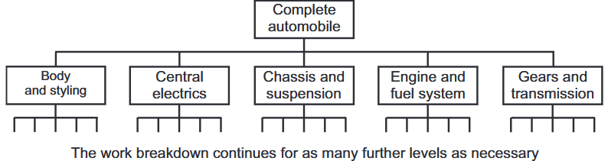[14]
Above is an example of a WBS based on the construction of a vehicle. The top of the tree encompasses the project, while following branches specify activities and deliverables needed. These subdivisions and tasks should be assigned by a project manager in accordance with necessary people or skills. Also note, while implementation should be split and assigned towards those responsible for project completion, much of the project plan or policies therein should reach the people of the organisation – a recurring event during a project is to “come into contact with people who do not know that (new) policy exists never mind know what to do with the implications of it” [15].
During project plan implementation, a project manager (usually a Chief Information Security Officer, or equivalent authority) will supervise and aid in plan execution. To do so, the CISO may perform gap analysis, which allows for the assessment of the current state of the project plan against the desired state, comparing measured results against expected results [16]. The resulting “gap” between current and desired states helps inform an organisation how well they are implementing the plan, with corrective action/reassessment being performed if either project plan estimates are flawed (for example, in the scenario where required effort hours are underestimated), or where performance has lagged. In short, the CISO creates a remediation plan. Below is an example of the gap analysis process:
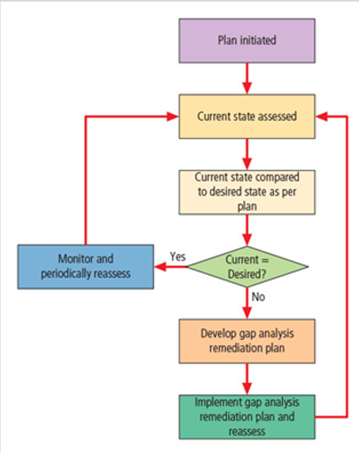[17]
Other methods of project management exist for IS implementation, as well as project planning and execution (such as using the “Bull’s-Eye” model for prioritisation in programs of complex change), but regardless of chosen model or method, a CISO must communicate with their team to supervise implementation, execute the plan, perform analysis, and wrap-up the project. To this end, the author suggests a multidisciplinary approach informed by multiple different models and thorough research and planning.
  - Security Technologies
Mentioned above under section 3 was the NIST cybersecurity framework, whose second stage involved the identification of assets and risks. In an IS context, these assets are usually stored as electronic data, with risks to said assets usually culminating in their loss, theft, unauthorised distribution, tampering, and so on. In many cases, the best way to prevent data loss would be to manage access control. Microsoft defines this as that which “determines who is allowed to access certain data, apps, and resources – and in what circumstances. In the same way that keys and pre-approved guest lists protect physical spaces, access control policies protect digital spaces” [18]. Approaches to this, whether discretionary (implemented at the discretion or option of the data user) or nondiscretionary (implemented by a central authority), rely on four fundamental functions of access control systems: identification, authentication, authorisation, and accountability [19].
To begin with, identification represents that a user is verified, insofar as they have a unique label – an ID. The system can link the user with this identifier, mapped as a unique link between the two. For example, an unverified user – a “supplicant” – may need to enter a username to enter a secure domain. Sometimes the user supplies this themselves, though some organisations may prefer to apply ID to the supplicant. An organisation may use composite identifiers, including department codes, random numbers, or special characters; others may instead generate random IDs for supplicants to protect assets from potential attackers. Some IS systems do not need overly complex IDs however – a single piece of information, such as a user’s initials and last name, may suffice. IS is ultimately a balance between control and access – if a system is too complex, the organisation risks accidental obstruction of their own business activities.
The next fundamental function, authentication, covers the validation of a supplicant’s unique ID. If a system must validate a supplicant’s ID, this often takes the form of a password – think of an employee accessing an organisation’s workstation. They may input their unique username, as well as a password into the system, to access relevant data, software, assets, and so on. However, authentication is not limited to this. As an abstraction, authentication can come in the form of something a supplicant knows, has, or is. The earlier password example fills the “knows” aspect. As for “has,” this factor may rely on a tool the user can provide as and when necessary. For example, a user may be supplied with an ID card, or an RFID key fob, or even something more advanced, such as a synchronous (or asynchronous) token generator. Finally, for “is,” this factor relies on individual characteristics – often under the umbrella of biometrics. This includes fingerprints, retinal scans, iris scans, palm prints, facial scans and topography, voice patterns, and so on.
Of note, an organisation should limit their authentication in accordance with the necessary strength of protection. For example, financial businesses may want to make use of multiple authentication mechanisms, while an online software-as-a-service business model may only necessitate a username-password combination.
Once a user has been identified and authenticated, they may be granted access to the system. However, some users may require more or less access than others. To this end, users have different authorisation access levels, or permissions, broadly speaking. Authorisation can be handled in different ways, with popular methods including:
- Authorisation for each authenticated user (where users are authenticated and verified on a case-by-case basis)
- Authorisation for members of a group (where authentication is matched to a list of group memberships, with access granted according to the group’s access rights and permissions – this is the most common method)
- Authorisation across multiple systems
With access control credentials assigned by an authenticator.
Finally, accountability (or alternatively, auditability), ensures that all actions a user performs, authorised or not, can be traced back and attributed to that user. This is often implemented in an IS system in the form of logs, which can later be audited as and when needed.
However, access to an organisation’s hardware and software has multiple attack vectors. For example, effective hackers may not even need access to a username-password matched pair. Some need only connect to the system. An organisation must consider incoming connections, as well as outgoing ones. To this end, a common security technology implementation is a firewall. Firewalls are a combination of hardware and software that filters or prevents specific information from moving between outside untrusted networks, and inside trusted ones. These appear in the form of separate computer systems, software services running on existing routers/switches, or even as separate networks containing supporting devices. Firewalls themselves can be split into different categories, such as packet filtering firewalls, application layer firewalls, MAC layer firewalls, and hybrids of the above. Many businesses opt for the creation of a screened subnet demilitarised zone, whereby layers of firewalls separate outside network connections from an organisation’s servers, which are further separated from their internal connections. In this way, members of the internal, trusted network can access servers through proxy, and outside networks have controlled access to the servers.
DIAGRAM OF A SCREENED SUBNET?
Eggs!
IF I HAVE TIME: EVERYTHING ABOVE IN MORE CONCISE, RESEARCHED DETAIL. MENTION REMOTE CONNECTIONS, VPNs, INTRUSION DETECTION/PREVENTION SYSTEMS. CUTTING PHYSICAL SECURITY SECTION FOR TIME.
However, one must consider that having the best security technologies alone does not make an organisation secure. A renowned hacker, Kevin Mitnick, notes that “People are the weakest link. You can have the best technology; firewalls, intrusion-detection systems, biometric devices … and somebody can call an unsuspecting employee. That’s all she wrote, baby. They got everything” [20]. In short, technologies are not the only attack vector towards data and assets that an organisation must consider; many different threats to IS exist that are not solely bound to cyberspace, such as compromises to intellectual property, espionage or trespass, forces of nature, human error, and so on.

- Task 2 – Case Scenario – CyStresSolution
“CyStresSolution (CSS) is a fast-growing threat intelligence and consultancy company that uses online presence to sell it services. It assists businesses to proactively combat real and immediate threats from cyber-attacks. CSS also use their consultancy services to provide the right tools and frameworks solutions to their customers state of compliance, business continuity, data recovery and risk management which includes their cloud storages and services. CSS is setting up a new information security unit.”
Based on the above scenario, below is one possible approach to meeting the needs of this new IS unit.
  - Organisation structure
Eggs!
  - Policies and Procedures
Eggs!
  - Compliance (Laws and Ethics)
Assuming CSS is operating within the European union, the organisation may wish to subscribe to the ISO 27000 model(s) for IS. This would qualify the business for ISMS accreditation, however, as the business is mainly online, it may be prudent to know that some international countries refused to adopt the ISO standard, citing a lack of measurement precision associated with a technical standard, as well as an overall rushed and incomplete state in comparison to other standards. Thus, as alternatives, CSS may consider security models from NIST, such as NIST SP 800-18 Rev. 1 (“Guide for Developing Security Plans for Federal Information Systems). Other alternatives exist as well, such as the Computer Emergency Response Team Coordination Center’s (CERT/CC) frameworks, or lists of best practices from the International Association of Professional Security Consultants (IAPSC). The best frameworks and methods for the sake of compliance depend on locational factors of CSS’s main office (for the sake of local law compliance), but an informed decision must be made depending on business needs and priorities.
  - Governance and Strategic Planning for Security
According to the Information Technology Governance Institute (ITGI), governance includes all the methods, responsibilities and accountabilities provided by higher management to provide strategic direction, establishment of objectives, and a measurement of progress towards those objectives. Additionally, governing covers the verification that risk management practices are appropriate, and the validation that assets are not misused.
In the case of CSS, they must provide fast and reliable online services, meaning XYZ
  - Risk Management
To begin risk management, CSS must first make a combined risk identification and assessment, categorising and prioritising assets, threats and vulnerabilities, including assessment of the extent to which the organisation’s information assets are exposed to risk. The scenario above mentions a strong online presence, including consultancy services (presumably close to, if not in immediate real-time as and when other businesses require), provision of tools, provision of frameworks for compliance, continuity, data recovery and risk management.
Ultimately, CSS as a business functions around online consultancy, meaning XYZ
  - Contingencies Planning
Needs:
- Incident Response Planning
- Disaster Recovery Planning
- Business Continuity/Resumption Planning
Contingency planning business impact analysis Incident response + disaster recovery + business continuity (DR and BC closely linked)
The goal of contingency policy and planning is to recover business criticality – meaning, recovery efforts should focus on restoring functions that are critical to the business. In the case of CSS, this would involve restoring financial data, ensuring details are properly saved/restored/copied as needed, while also ensuring data has not been lost or tampered with. If necessary, information may also need to be re-encrypted. After this, systems should be checked – servers, workstations, hardware and software. Depending on attack or accident severity, systems may need to be patched and upgraded, with the potential addition of more monitoring systems and redundancies. Following on, the internal network should be assessed – firewall status and proxy servers, and the like. Finally, external network connections should be restored, with potential new routes incorporated (relies on outsourced assistance). This follows the “Spheres of Security” model.
Contingencies are not solely reliant on reaction to incidents – these must be either predicted, or backups and redundancies must be incorporated beforehand. A common method for this server-side is to use a RAID setup – a Redundant Array of Independent Discs (or Drives) for the sake of data backup for online usage. This involves the mirroring or striping of a storage drive, or set of drives, occasionally incorporating a parity drive. RAID setups include RAID 0 (striping), RAID 1 (mirroring), RAID 10 (combination of striping and mirroring), and Raid 5 (striping with parity) – the latter of which is the most commonly implemented method, offering a balance between safety and redundancy. RAID 5 is particularly useful as well due to the parity drive, which allows for lost or corrupted data to be rebuilt.
  - Protection Mechanisms
Depends on business needs, but as CSS is mainly an online consultancy service, this means most protection mechanisms rely on good access control (with associated technologies). This means integrating firewalls, considering VPN access, implementing an intrusion detection/prevention system, potentially adding honeypots/nets, and so on. The online service will also deal with financial data, so some measure of cryptography should be researched and implemented.
- Conclusion
Eggs!

4. References
[1] “Association for Computing Machinery,” ACM, 2000. [Online]. Available: https://www.acm.org/. [Accessed: 03-Dec-2024].
[2] “Cybersecurity exchange,” EC Council Cybersecurity Exchange, 14-Mar-2022. [Online]. Available: https://www.eccouncil.org/cybersecurity-exchange/. [Accessed: 03-Dec-2024].
[3] W. V. Maconachy, C. D. Schou, D. Ragsdale and D. Welch, "A Model for Information Assurance: An Integrated Approach", Proceedings of the 2001 IEEE Workshop on Information Assurance and Security, 5–6 June 2001.
[4] M. E. Whitman, Principles of information security, Seventh edition. Boston: Cengage, 2021. ch. 1, pp. 10-11.
[5] M. E. Whitman, Principles of information security, Seventh edition. Boston: Cengage, 2021. ch. 2, pp. 47.
[6] A. Calder, “IMPLEMENTING THE FRAMEWORK,” in NIST Cybersecurity Framework: A pocket guide, Ely, England: IT Governance Publishing, 2018, pp. 55–62.
[7] National Institute of Standards and Technology, “The NIST Cybersecurity Framework (CSF) 2.0,” National Institute of Standards and Technology, Gaithersburg, MD, 2024.
[8] G. L. Stewart, K. A. Manges, M. M. Ward, “Empowering Sustained Patient Safety – The Benefits of Combining Top-down and Bottom-up Approaches”, Journal of Nursing Care Quality, vol. 30, no. 3, pp. 240-246, July 2015.
[9] “NIST Special Publication 800-64 Revision 2, Security Considerations in the System Development Life Cycle,” Nist.gov. [Online]. Available: https://nvlpubs.nist.gov/nistpubs/legacy/sp/nistspecialpublication800-64r2.pdf. [Accessed: 09-Dec-2024].
[10] A. Calder and S. Watkins, IT governance an international guide to data security and ISO27001/ISO27002, 5th ed. London; Kogan Page, 2012, ch. 3, pp. 35-38.
[11] “ISO 27001 certification: What you need to know,” Itgovernance.co.uk. [Online]. Available: https://www.itgovernance.co.uk/iso27001-certification. [Accessed: 08-Dec-2024].
[12] “Regulation (EU) 2016/679 of the European Parliament and of the Council of 27 April 2016 on the protection of natural persons with regard to the processing of personal data and on the free movement of such data (United Kingdom General Data Protection Regulation)”, ch.4, 27 April 2016. [Online]. Available: https://www.legislation.gov.uk/eur/2016/679/chapter/IV/section/1#. [Accessed 09-Dec-2024]
[13] M. E. Whitman, Principles of information security, Seventh edition. Boston: Cengage, 2021. ch. 10, pp. 507.
[14] D. Lock, Project Management, 10th ed. Burlington, Vt: Gower, 2013. ch. 12, pp. 176.

[15] J. D. Nosworthy, “Implementing Information Security In The 21st Century — Do You Have the Balancing Factors?,” Computers & security, vol. 19, no. 4, pp. 337–347, 2000, doi: 10.1016/S0167-4048(00)04021-9.
[16] S. Andalib, “Performing a Gap Analysis Method and Examples,” Linkedin.com, 03-Apr-2024. [Online]. Available: https://www.linkedin.com/pulse/performing-gap-analysis-method-examples-saida-andalib-nxawc. [Accessed: 11-Dec-2024].
[17] M. E. Whitman, Principles of information security, Seventh edition. Boston: Cengage, 2021. ch. 10, pp. 516.
[18] “What is access control?,” Microsoft.com. [Online]. Available: https://www.microsoft.com/en-gb/security/business/security-101/what-is-access-control. [Accessed: 11-Dec-2024].
[19] M. E. Whitman, Principles of information security, Seventh edition. Boston: Cengage, 2021. ch. 6, pp. 302.
[20] Abreu, Kevin Mitnick bares all; The notorious former hacker reveals some tricks of the trade at a computer-security conference.(Industry Trend or Event). Network World, Inc, 2000.
[21]
[22]
[23]
[24]
[25]
[26]
[27]
[28]
[29]
[30]

