Menu Planning for Young Adults

Introduction

Young adulthood (18-25 years) is a critical life stage where dietary habits are often developed and carried into adulthood. During this period, individuals typically gain independence and begin making their own food choices. However, this age group is often associated with irregular eating patterns, increased consumption of convenience foods, and lower adherence to dietary recommendations (Public Health England, 2016). These behaviours can negatively impact nutritional status and increase the risk of long-term health conditions.

The nutritional requirements of young adults are important for supporting energy levels, cognitive function, and overall health. According to UK Dietary Reference Values (DRVs), average energy requirements are approximately 2000 kcal per day for females and 2500 kcal per day for males, although these vary depending on physical activity levels (Department of Health, 1991). Macronutrient distribution should follow current UK guidelines, with carbohydrates contributing around 50% of total energy intake, fat no more than 35%, and protein intake around 0.75 g per kilogram of body weight (SACN, 2015).

In addition to macronutrients, several micronutrients are particularly important during young adulthood. Calcium is essential for achieving peak bone mass, with a recommended intake of 700 mg per day (National Health Service, no date). Iron is also a key nutrient, especially for females due to menstrual losses, with recommendations of 14.8 mg per day for women and 8.7 mg for men (Department of Health, 1991). Vitamin D is required for bone health and immune function, with a recommended intake of 10 µg per day, although deficiency is common in the UK (NHS, no date). Fibre intake is often below recommended levels, with guidance suggesting 30 g per day to support digestive health (SACN, 2015).

Nutrient | Recommended Intake | Importance
Energy | 2000-2500 kcal | Supports daily function
Protein | 0.75 g/kg BW | Growth and repair
Fat | <35% energy | Hormone function
Carbohydrates | 50% energy | Main energy source
Calcium | 700 mg/day | Bone health
Iron | 8.7-14.8 mg/day | Oxygen transport
Vitamin D | 10 µg/day | Immune and bone health
Fibre | 30 g/day | Digestive health

Understanding these requirements is essential when planning a nutritionally balanced menu for young adults, as poor dietary habits at this stage can have long-term health implications.

Importance of a Nutritionally Balanced Diet

A nutritionally balanced diet is essential for maintaining health and preventing disease, particularly in young adults where lifestyle habits are still developing. The UK Eatwell Guide provides evidence-based recommendations for achieving a balanced diet by promoting the consumption of fruits and vegetables, whole grains, lean proteins, and healthy fats, while limiting foods high in sugar, salt, and saturated fat (Public Health England, 2016).

Failure to follow a balanced diet can have both short-term and long-term health consequences. In the short term, poor dietary intake may lead to fatigue, reduced concentration, and decreased academic or work performance. In the long term, it increases the risk of non-communicable diseases such as obesity, cardiovascular disease, and type 2 diabetes (NHS, no date). Young adults who consume high levels of processed foods and sugary drinks are particularly at risk of excess calorie intake and poor nutrient quality.

The Eatwell Guide emphasises that meals should be based on starchy carbohydrates, preferably wholegrain varieties, which provide fibre and sustained energy. Fruit and vegetable intake should account for at least five portions per day, contributing essential vitamins, minerals, and antioxidants. Protein sources such as beans, pulses, fish, eggs, and lean meats are important for tissue repair and overall health. Dairy or fortified alternatives provide calcium, which is particularly important during early adulthood for bone development.

Additionally, fat intake should focus on unsaturated fats, such as those found in olive oil, nuts, and seeds, while limiting saturated fats to reduce cardiovascular risk. Free sugars should not exceed 5% of total energy intake, as excessive consumption is linked to obesity and dental issues (SACN, 2015).

Overall, following the Eatwell Guide supports adequate nutrient intake and helps reduce the risk of chronic diseases later in life. For young adults, developing healthy eating habits at this stage is particularly important, as these behaviours are likely to continue into adulthood.

Key Factors in Menu Planning

When planning a menu for young adults, several factors must be considered to ensure the diet is both nutritionally adequate and practical.

One key factor is cost. Young adults, particularly students, often have limited budgets, which can influence food choices. Affordable meal options such as beans, lentils, frozen vegetables, and whole grains can help meet nutritional requirements without excessive cost.

Food preferences and lifestyle are also important. Young adults often have busy schedules, which may lead to reliance on convenience foods. Therefore, menus should include quick and easy meal options that still meet nutritional guidelines. Cultural preferences and dietary choices, such as vegetarian or vegan diets, must also be considered.

Variety is essential to ensure a wide range of nutrients is consumed and to prevent dietary monotony. Including different food groups across meals helps improve both nutritional quality and adherence to the diet.

Food safety is another important consideration. Proper storage, handling, and preparation of food are essential to prevent foodborne illness. This includes ensuring food is cooked thoroughly and stored at appropriate temperatures (Food Standards Agency, 2020).

Sustainability is increasingly recognised as a key factor in menu planning. Choosing locally sourced, seasonal foods and reducing food waste can help minimise environmental impact. The Eatwell Guide also promotes sustainable food choices, such as increasing plant-based foods.

Finally, nutritional balance must remain the priority. Meals should align with DRVs and include appropriate portions of macronutrients and micronutrients. Using nutritional analysis software such as Nutritics allows for accurate assessment of dietary intake and ensures that menus meet recommended guidelines.

7-Day Meal Plan
The following 7-day meal plan was developed to provide a balanced and realistic diet for young adults, aligned with UK dietary guidelines. Each day includes a variety of foods to support energy needs, macronutrient balance, and overall health, while also reflecting typical eating habits.

Day 1
- Breakfast: Porridge made with semi-skimmed milk, banana, and almond butter, with coffee
- Lunch: Chicken salad sandwich (wholemeal bread) with lentil chips
- Dinner: Spaghetti bolognese (lean mince, pasta, tomato sauce) with side salad and olive oil
- Snacks: Yoghurt with berries and honey, mixed nuts, apple, kiwi, and a cereal/protein bar
Day 2
- Breakfast: Greek yoghurt with granola, mixed berries, and honey, with coffee
- Lunch: Tuna pasta salad with sweetcorn, salad, and mayonnaise
- Dinner: Chicken stir-fry with wholemeal noodles, vegetables, soy sauce, and olive oil
- Snacks: Banana, yoghurt, almond butter, orange, and a cereal/protein bar

Day 3
- Breakfast: Porridge with milk, banana, and honey
- Lunch: Chicken wrap with salad and mayonnaise, with a small snack portion of crisps
- Dinner: Salmon with roasted potatoes and vegetables cooked in olive oil
- Snacks: Yoghurt, mixed nuts, fruit, and a small chocolate snack

Day 4
- Breakfast: Wholemeal toast with peanut butter and banana, with coffee
- Lunch: Pasta salad with chicken, vegetables, and dressing
- Dinner: Beef stir-fry with rice and vegetables
- Snacks: Yoghurt with berries, fruit, and a cereal bar

Day 5
- Breakfast: Greek yoghurt with granola and berries
- Lunch: Cheese sandwich (wholemeal bread) with crisps
- Dinner: Chicken curry with rice and vegetables
- Snacks: Banana, nuts, yoghurt, and a snack bar

Day 6
- Breakfast: Porridge with milk, berries, and honey
- Lunch: Tuna sandwich with salad and mayonnaise
- Dinner: Roast chicken with potatoes, vegetables, and olive oil
- Snacks: Fruit, yoghurt, nuts, and a biscuit or snack bar

Day 7
- Breakfast: Breakfast cereal with milk and banana, with coffee
- Lunch: Vegetable soup with bread and butter
- Dinner: Salmon with rice and green vegetables
- Snacks: Fruit, yoghurt, nuts, and a small chocolate snack
Two days from the 7-day meal plan were analysed using Nutritics dietary analysis software (Nutritics, 2026) to assess nutritional intake, with full results presented in the appendix.

Each day incorporates:
• Wholegrain carbohydrates (e.g. oats, brown rice, wholemeal bread)
• Lean protein sources (e.g. chicken, fish, beans, eggs)
• Healthy fats (e.g. olive oil, nuts)
• At least five portions of fruit and vegetables

The menu was analysed using Nutritics, and average daily values were calculated to assess whether nutritional requirements were met. Overall, the menu aimed to meet energy requirements and achieve recommended intakes for protein, fibre, and key micronutrients such as calcium and iron.

The detailed nutritional analysis for each day is provided in the appendix, as required.

Justification of Menu Choices

The menu was designed to reflect the nutritional needs and lifestyle of young adults while remaining practical and affordable. Meals were selected to align with the Eatwell Guide, ensuring a balance of carbohydrates, proteins, and fats, alongside adequate micronutrient intake.

Wholegrain carbohydrates were included to increase fibre intake and support sustained energy levels. Lean protein sources such as chicken, fish, and plant-based options were used to support muscle maintenance and overall health. Dairy and fortified alternatives were included to ensure adequate calcium intake, while iron-rich foods such as red meat and legumes were incorporated to reduce the risk of deficiency.

Convenience and cost were also considered, with simple recipes and accessible ingredients included to improve adherence. Snacks such as fruit, yoghurt, and nuts were used to maintain energy levels throughout the day.

Overall, the menu provides a balanced, practical, and nutritionally adequate diet that supports the health and wellbeing of young adults. This approach was chosen as it reflects my understanding of typical student eating habits.

Conclusion

In conclusion, the 7-day meal plan was designed to meet the nutritional requirements of young adults while remaining realistic and practical. The plan followed current UK dietary guidelines and included a balance of macronutrients alongside key micronutrients such as calcium, iron, and fibre. The use of Nutritics analysis demonstrated that the selected days were generally in line with recommended energy and nutrient intakes.

Although minor adjustments could be made to further improve macronutrient balance, the plan reflects a healthy and achievable approach to eating for this age group. This highlights the importance of developing sustainable dietary habits during young adulthood to support long-term health.

Reference List

Department of Health (1991) Dietary Reference Values for Food Energy and Nutrients for the United Kingdom. London: HMSO.

Food Standards Agency (2020) Food safety and hygiene. Available at: https://www.food.gov.uk

National Health Service (no date) Vitamins and minerals. Available at: https://www.nhs.uk (Accessed: 15 April 2026).

Nutritics (2026) Nutritics dietary analysis software. Available at: https://www.nutritics.com (Accessed: 13 April 2026).

Public Health England (2016) The Eatwell Guide. Available at: https://www.gov.uk/government/publications/the-eatwell-guide (Accessed: 15 April 2026).

Scientific Advisory Committee on Nutrition (SACN) (2015) Carbohydrates and health. London: TSO.

Appendix 1: Nutritics Analysis (Day 1)
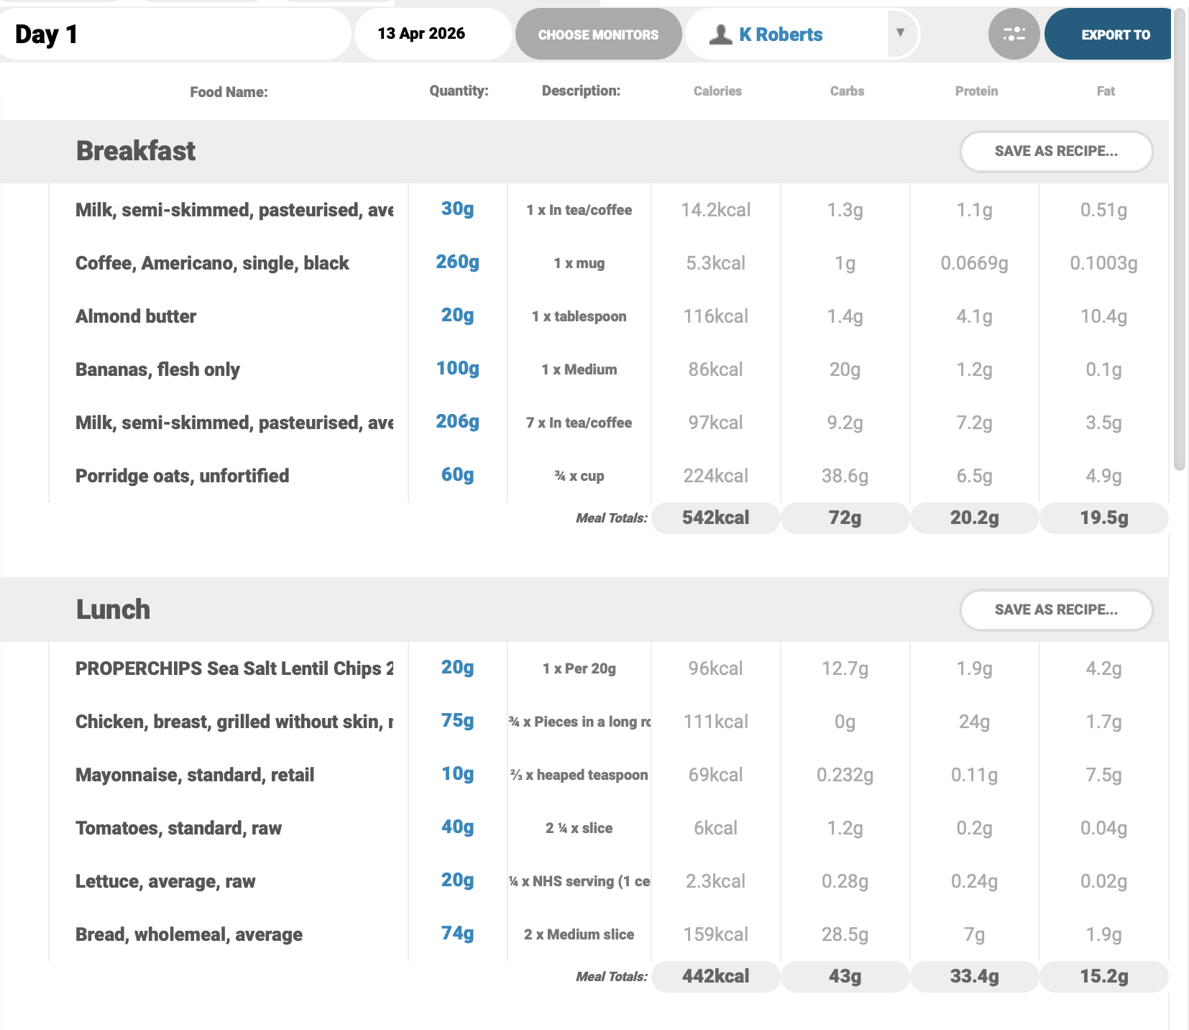
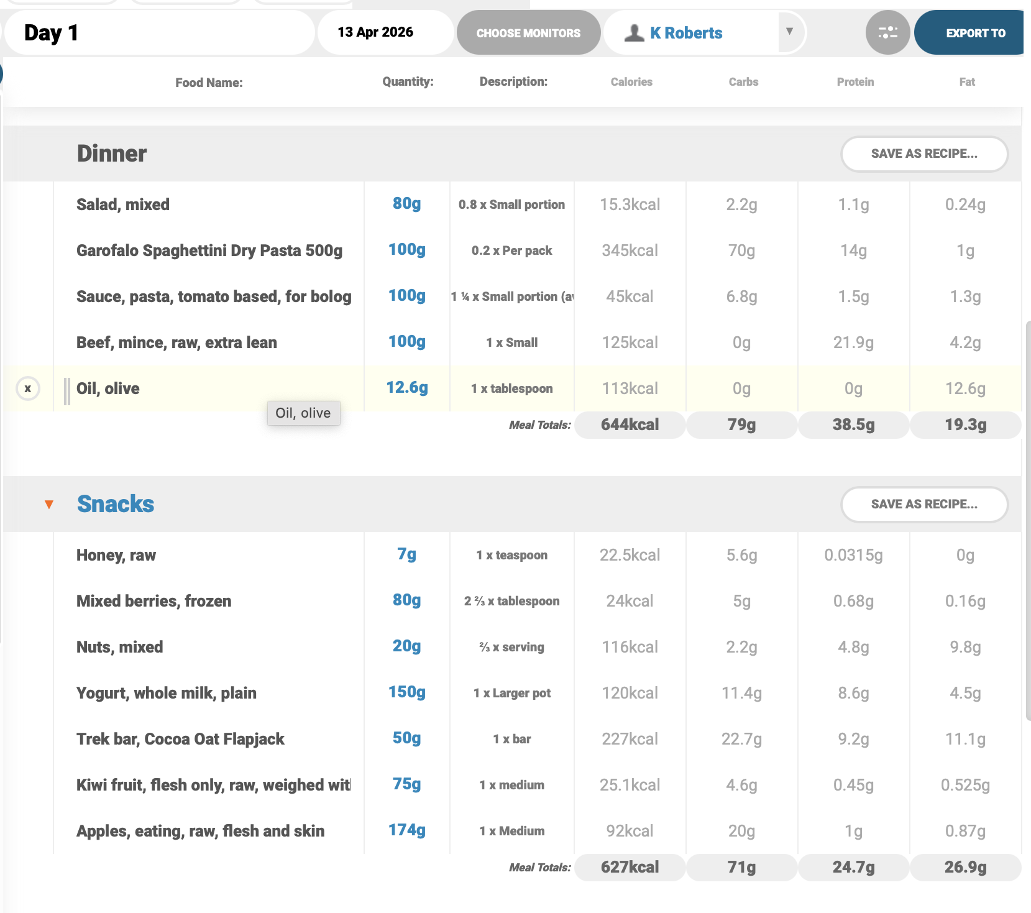
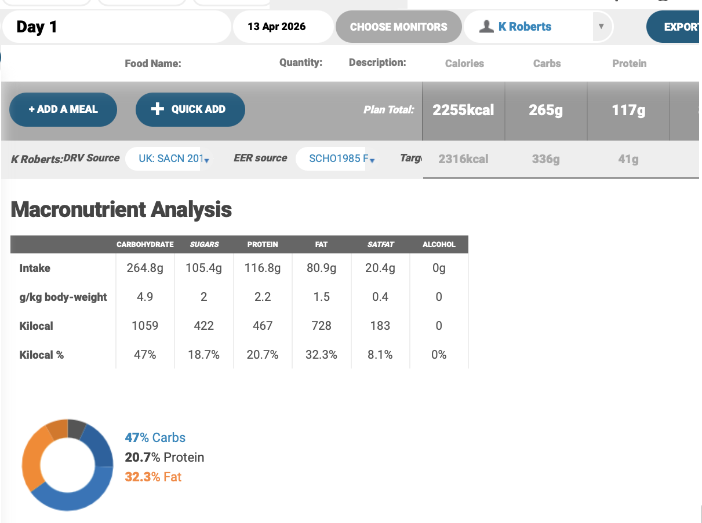
Appendix 1: Nutritics Analysis (Day 2)


