Well-being
Well-being can be viewed as a concept, and can differ with each person, however, according to Cambridge Dictionary (no date) well-being is the state of feeling heathy and happy. However, On the other hand Well-being People (2023) views well-being as a concept that individuals can feel a good well being is completely different to the next person. They have explained that although happiness is an integral aspect of well-being, things such as a sense of purpose or achieving personal goals can be part of a good well-being. This would also be different for children. Children would describe a good well-being as something different again, due to the way they view the world and the influences they have around them. This is clear in the article office for national statistics (2020) explains that children describe well-being as feeling loved, having positive relationships, being able to express themselves and to have good friends. Clearly these are the aspects of well being us as practitioners need to be supporting.
For a child to thrive and to feel a sense of well-being, practitioners need to encourage and fulfil these key indicators of well-being viewed by children to ensure they develop and have positive outcomes (NSPCC Learning 2021). Furthermore, practitioners need to establish a safe and comfortable environment for children to express themselves, as well as talk about how they are feeling. This is the ensure we are able to give all children the correct and adequate support the need to gain a positive wellbeing, for children to know they are able to speak out about their thoughts and feeling can create a sense of belonging, and that alone is a start to supporting a child’s wellbeing (NSPCC learning 2021). This would be beneficial for the child’s emotional wellbeing.
There are subcategories to well-being, as it is such a broad experience, we can break it down into several types. Which include, emotional wellbeing, psychological well-being, social well being and many more (Colorado state University no date).
According to National library of medicine (2023) psychological well-being is referred to when a child experiences feeling such as happiness and feeling sense of worth, face struggles and difficulties. however, being able to regulate how they feel and finding a resilience by finding clarity in the way they feel therefore growing from the experience they face. Furthermore, physiological well being can encourage a child to develop their problem-solving skills through real life experiences. Neuraseharm (No Date), agrees that psychological well-being can assist children with their physical, emotional, and mental well-being, which will aid them with daily and regular routines.

To encourage children to develop and helping them strive for the best outcome for the specific child we need to ensure that the child’s specific needs are met. This is clearly proved with Mallow’s hierarchy of needs, this theory highlights the importance of a child’s well-being, as it focuses on five levels of needs which go from the most basic need to the more advanced level of needs (Stevens No Date). These levels are physiological needs, safety needs, love and belonging, esteem and self actualisation.

Health, well-being, and lifestyles
Introduction
Within this poster I will be exploring and considering three key factors, which are, health, well being and lifestyles in the the early years and why they are important concepts to acknowledge. Furthermore, I will use theories and legislation to identify the connection with the early years and the three key factors. I will also discuss how the role of the practitioner can promote positive health, wellbeing, and lifestyles in the early years to support and improve their holistic development. This poster will demonstrate how health, wellbeing, and lifestyles all link and how each factor should be considered just as important as each other.

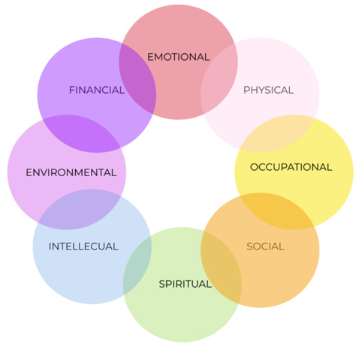

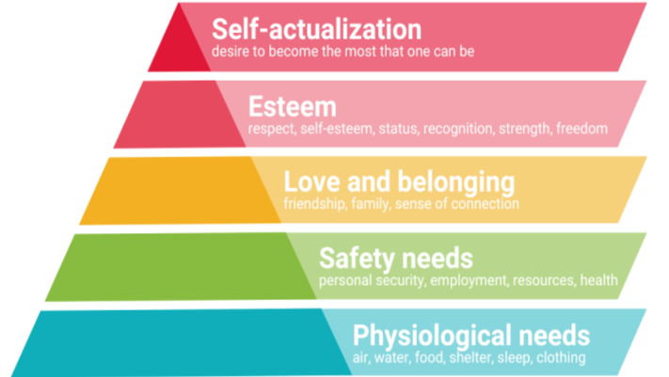

Health
National library of medicine (2006) defines health as being in a position of genuine physical, mental, and social wellbeing. Also, health professionals' base health off the lack of or the existence of disease and illness. Children need good role models in their like to demonstrate what a healthy lifestyle is which will then influence the child the mimic and lead a healthy life (national library of medicine 2006). Furthermore, for a child to thrive and to be at the healthiest state possible many factors contribute to enable this, such as, the environment the child is in, family income, gender, race, and ethnicity (Marmot, 2010).

Child care.gov (no date) suggests that keeping up to date with a child’s health can prevent and identify illnesses and developmental setbacks such as, disabilities, mental health issues and milestone delays. According to National library of medicine (2007) children’s development in the early years creates the premise for health in their later adult years. However, National library of medicine (2007) explains that poverty is a big hindering factor to the poor health and lack of development within children. This would include complications such as asthma, diabetes, obesity, mental health problems and a lack of ability to learn (National library of medicine 2007).

Moving on I will discuss how attachment plays a big part of contributing to a child’s health. This is evident in Bowlbys attachment theory as secure attachments can help the child foster emotional regulation, resilience, and reasoning, lessoning the chances of mental health struggles such as anxiety and depression (NSPCC learning 2021). It encourages the child to develop healthy relationships, good behaviours leading to enhancing their physical and social wellbeing. NSPCC learning 2021 explains that this is because healthy behaviours lead to positive life choices which are more than likely to benefit the child holistically due to being exposed to a positive environment growing up.

Lifestyles
A lifestyle is the way a person lives or chooses to live things like societal, cultural, or religious outlooks on life can determine how a person's lifestyle can be (Cambridge dictionary no date). Prime health (no date) emphasises that a healthy lifestyle can not only benefit children in the future, but it can also create healthy habits and routines to reinforce structure and an understanding of balanced and productive life choices. Constructing a positive lifestyle for children consists of a variety of healthy foods, a clear routine, a satisfactory role model, sufficient amount of sleep, physical activity, and good mental and physical health (Prime health no date).
Teach early years (no date) explains that it is important for children to have a healthy lifestyle as it can tech the chute how to be independent, and to look after their personal hygiene as well as their health. Teach early years (no date) states the Montessori also believes that the independence of a child can encourage them to feel good about themselves and it is an imperative part of their holistic development as it gives the child’s a keen sense of self efficacy in day-to-day life.
Giving a child guidance yet allowing them to take control of their life is great child centred approach allowing themselves to learn in real life situations and pushes the child to gain new opportunities to develop life skills (teach early years no date). For example, this could be, brushing their hair, tidying up after themselves, dressing themselves and brushing their teeth.
Research has shown that Children with an imbalanced lifestyle can develop behavioural problems, obesity, the child could have an effect on education and can lead to cognitive and social delays (national library of medicine 2020). This can be because of poverty, as households on a low income can struggle to afford nutritious foods and therefore lead to a bad diet and unhealthy lifestyle choices.
Parents/ Carers need to ensure the environment that children are living in, is positively influencing the child to help them make good choices now and in the future.

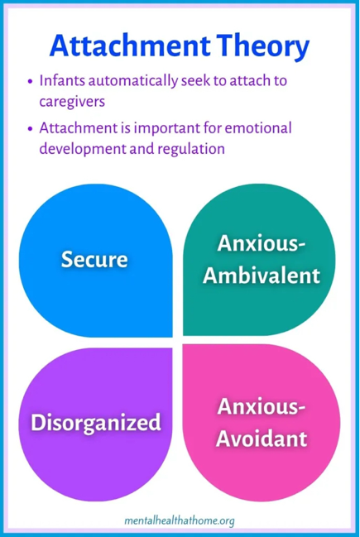

Conclusion
From all the information and evidence that has been used in, we can tell Well-being, Health and lifestyle are all factors that contributing with each other. Throughout this poster practitioners, multi-agency and parents and carers play a role in ensure healthy lifestyle, good well-being, healthy relationships, and healthy experiences should be met to ensure children individual need and holistic development are met. The UNCRC promotes and encourages these factors. The theories in this poster empowers the importance of attachment during a child’s life and the importance of an enabling adult. It is also important that children are not discriminated by these needs due to their culture, race, religion, disability, illnesses, or background. Lastly, well-being, health and lifestyle are still changing by what is going on in the world such as poverty. Practitioner should adjust to these factors and should understand policy and procedures that they should use in practice to support this.

Early year practice
The Welsh Government (2014) states that there is a program that is used in all school’s which promotes healthy eating, healthy drinking, and healthy lifestyle. All schools in Wales have a system which is put into place that all children receive milk, this support children bone development and overall holistic development. All schools in Wales also provide breakfast for children at the start of every school day and they believe this helps concentration which means all children are ready to learn (Welsh Government 2014).
All schools in Wales should be aware of the whole school approach, which means they emphasise the importance of a healthy diet which is also used in the new curriculum for Wales (Welsh Government Association, No Date).
The New Curriculum for Wales has 4 purposes, one of these purposes is that practitioners should ensure that in their care children’s feel that they are able to become healthy and secure individuals, (Welsh Government, 2024). Another factor is, practitioners should also guide parents/carers on how they can ensure their child’s individual needs are met, this means supporting a child’s learning and development.
Being an Enabling adult for children is one of the many factors for a child to become a healthy and confident individual (Welsh Government, 2023).
As a practitioner during transition or a lifestyle change’s, practitioners should ensure that the environment is a safe, inclusive and all children to express their feeling’s.
The UNCRC (No Date), explains that every child child’s views should be respected and be taken into consideration.
Solomon (2019) believes that during multi-agency’s working, children’s views should be considered in every decision and that the voices of child’s and parents/carers.
To emphasis on this, the UNCRC (No Date) states that the government should provided information for parents/carers which will support them and guide them in the correct direction for the child’s individual needs
Payler (2013), believe in order for a positive collaboration working multi-agency should share information, ideas, and work. The UNCRC (No Date), state that in any decision that is made for the child should be top priority when multi-agency, parents/carers and practitioners make any decision may affect the child’s well-being, health, or holistic development

Reference list
Ayres, N. (2022). The Importance of Living a Healthy Lifestyle | Prime Health. [online] Prime-health.co.uk. Available at: https://www.prime-health.co.uk/blog/importance-of-living-a-healthy-lifestyle/.
Cambridge Dictionary (2019). LIFESTYLE | meaning in the Cambridge English Dictionary. [online] Cambridge.org. Available at: https://dictionary.cambridge.org/dictionary/english/lifestyle.
Cambridge Dictionary (2024). WELL-BEING | Meaning in the Cambridge English Dictionary. [online] Cambridge.org. Available at: https://dictionary.cambridge.org/dictionary/english/well-being.
childcare.gov. (n.d.). Supporting Children’s Physical Health | Childcare.gov. [online] Available at: https://childcare.gov/consumer-education/supporting-childrens-physical-health.
Colorado State University Pueblo (2024). 8 Dimensions of Well-Being | Health Education & Prevention | CSU-Pueblo. [online] www.csupueblo.edu. Available at: https://www.csupueblo.edu/health-education-and-prevention/8-dimension-of-well-being.html.
Gupta, R.P.-S., de Wit, M.L. and McKeown, D. (2007). The impact of poverty on the current and future health status of children. Paediatrics & Child Health, [online] 12(8), pp.667–672. doi:https://doi.org/10.1093/pch/12.8.667.
Jordan, A. and Rees, E. (2020). Children’s views on well-being and what makes a happy life, UK: 2020 - Office for National Statistics. [online] www.ons.gov.uk. Available at: https://www.ons.gov.uk/peoplepopulationandcommunity/wellbeing/articles/childrensviewsonwellbeingandwhatmakesahappylifeuk2020/2020-10-02.
Media (2000), M. (n.d.). Why you need to teach healthy habits to early years children | Enabling Environments. [online] Teach Early Years. Available at: https://www.teachearlyyears.com/enabling-environments/view/why-you-need-to-teach-healthy-habits-to-early-years-children.
NHS (2021). Advice for parents of healthy-weight children. [online] nhs.uk. Available at: https://www.nhs.uk/live-well/healthy-weight/childrens-weight/healthy-weight-children-advice-for-parents/.
NSPCC (2021). Attachment and Child Development. [online] NSPCC Learning. Available at: https://learning.nspcc.org.uk/child-health-development/attachment-early-years.
Wang, L., Jansen, W., van Grieken, A., Vlasblom, E., Boere-Boonekamp, M.M., L’Hoir, M.P. and Raat, H. (2020). Identifying patterns of lifestyle behaviours among children of 3 years old. European Journal of Public Health, [online] 30(6), pp.1115–1121. doi:https://doi.org/10.1093/eurpub/ckaa109.

UNCRC (No Date) Summary of the un-Convention on the Rights of the Child. Available at: https://www.unicef.org.uk/wp-content/uploads/2019/10/UNCRC_summary-1_1.pdf (Accessed: 12 January 2025).

Neuraxpharm (No Date) Psychological wellbeing in children. Available at: Psychological wellbeing in children - Neuraxpharm (Accessed 3 January).

Stevens, G. (No Date) Maslow’s Hierarchy of Needs: Strengths, Weaknesses & Examples.Available at: Maslow's Hierarchy of Needs: Strengths, Weaknesses & Examples(Accessed 5 January).

Welsh Government (2014) Healthy eating in maintained schools. Available at: healthy-eating-in-maintained-schools-statutory-guidance-for-local-authorities-and-governing-bodies.pdf (Accessed: 10 January 2024).

Welsh Government (No Date) A new curriculum in Wales. Available at:a-new-curriculum-in-wales-a-guide-for-children-young-people-and-families.pdf(Accessed: 10 January 2025).

