UNIVERSITY OF WALES TRINITY SAINT DAVID
LONDON CAMPUS
Assignment 2
Learning in the Digital Era
Video Link: LDE

Please be sure to give unrestricted access to your video presentation so that your work can be marked by the examiner.
Module Name: Learning in the Digital Era
Module Code: ACCA 4025

Student Name: Halo Mahdy Hady
Student ID: 2544815
Group: 2

Lecturer’s Name: Suneth Fernando

Table of Contents
Introduction 2
Main Body 2
Conclusion 9
References 9

Introduction
This report presents my self-evaluation, Professional Development Plan, and a summary of an assigned topic from Unit 4. It reflects on my strength and weaknesses, and learning experiences as a computing student at UWTSD, University of Greenwich. The purpose of this report is to show how I can use self-awareness and agile learning to achieve my career goal of working in AI and Cybersecurity.

Slide 1 COVER PAGE
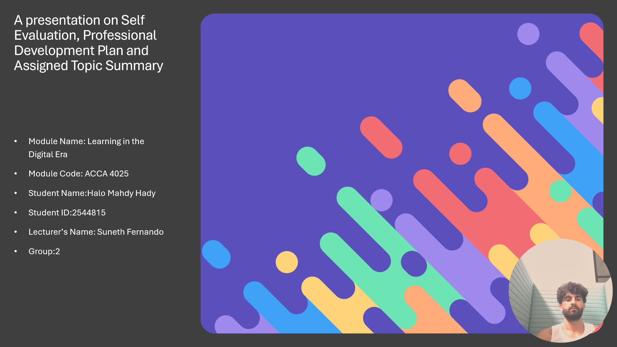

This is the cover page for my presentation titled “Self Evaluation, Professional development plan and Assigned Topic Summary”. The presentation is for the module “Learning in the Digital Era“ and it was completed by me.
SLIDE 2 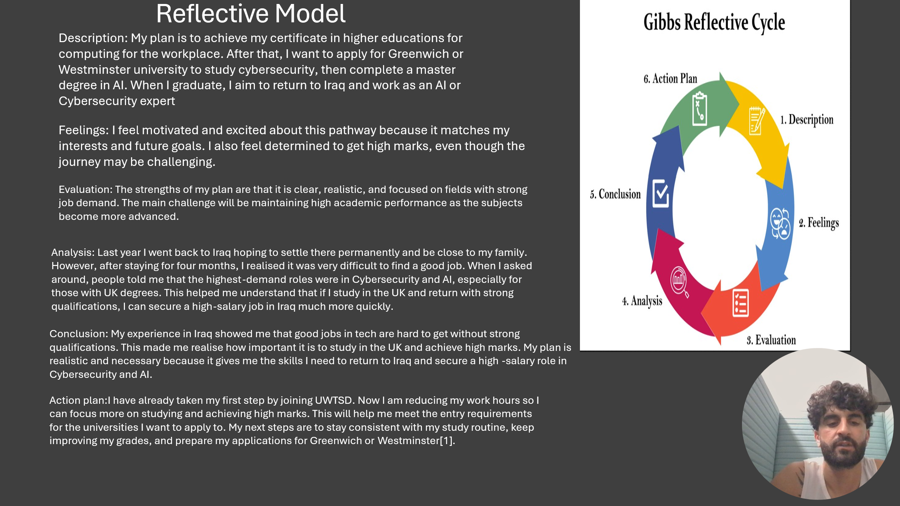
I used Gibbs’ Reflective Cycle to analyse my plan to study computing , AI, Cybersecurity. It helped me to break down my experience into 6 stages: what happened, how I felt, what went well, what I learned, what I concluded, and what I will do next.

Slide 3
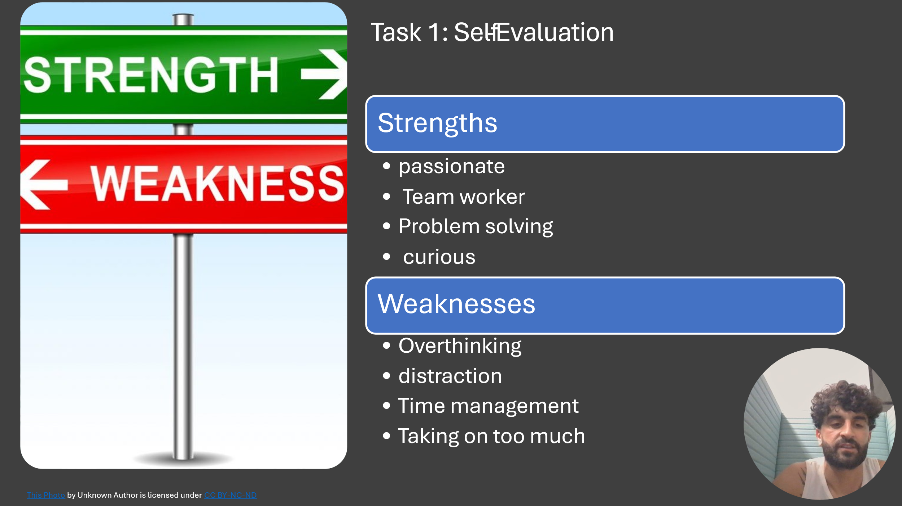
On this slide I identified my key strengths and weaknesses. My strengths are that I am passionate, a good team worker, good at problem solving, and curious to learn new things. My main weaknesses are overthinking, distraction, poor time management, and taking on too much work, but I am working to improve them through my PDP.

Slide 4
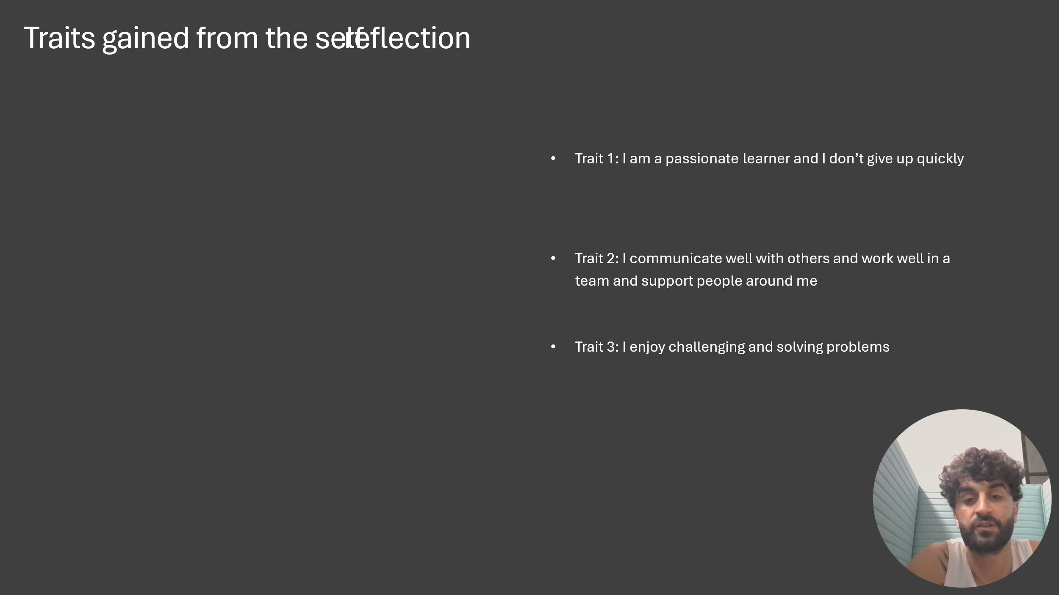
Through self-reflection I identified three important traits I have gained. First, I am a passionate learner and I do not give up easily. Second, I communicate well and work well in a team. Third, I enjoy challenging and solving problems, which is very important for my future career in AI and Cybersecurity.

Slide 5
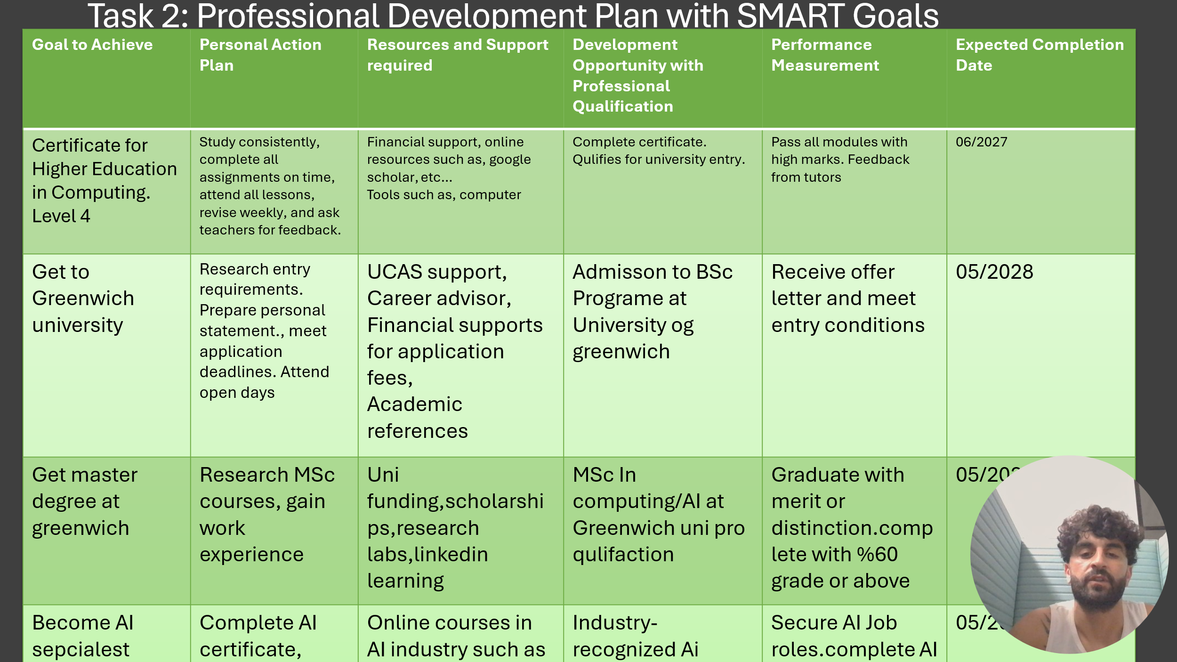
This is my Professional Development Plan with SMART Goals to achieve my career in AI and Cybersecurity. The plan shows 4 key goals: completing my Certificate in Computing, getting into Greenwich University, doing a Masters, and becoming an AI Specialist. For each goal I have listed the action plan, resources I need, and expected completion dates to help me stay focused and track my progress.

Slide 6 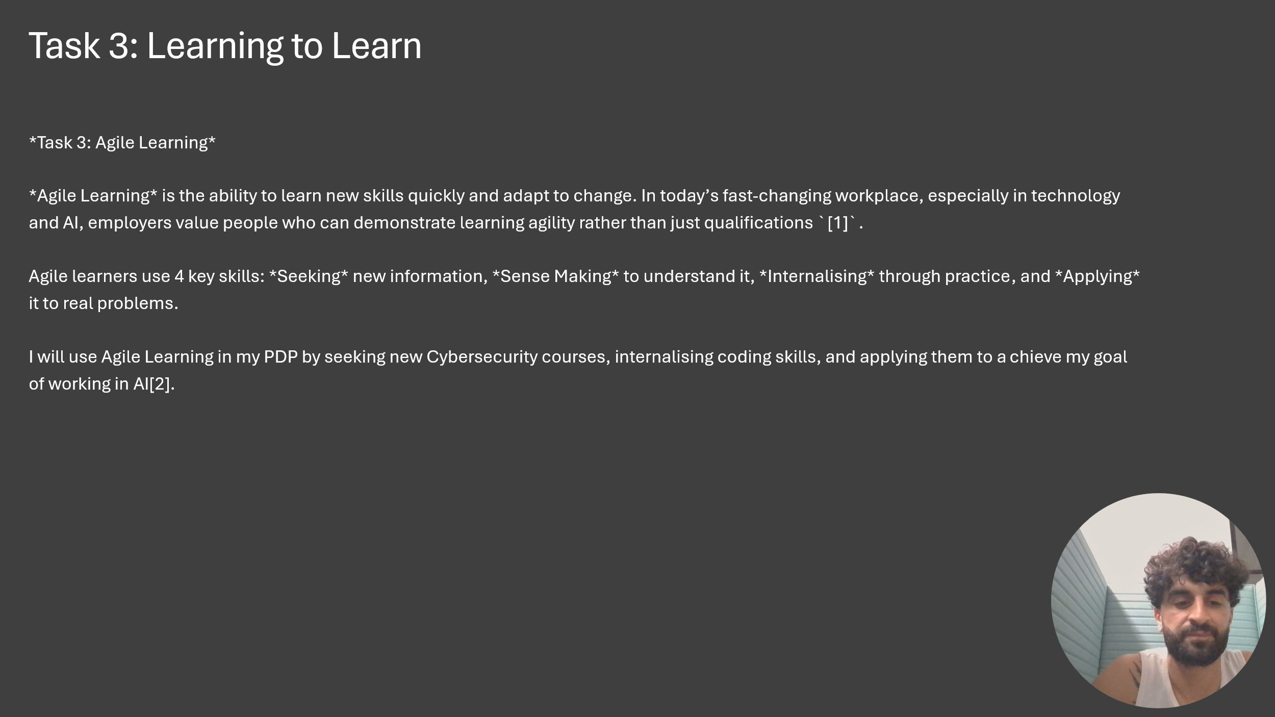

For Task 3 I chose Agile Learning. Agile Learning is the ability to learn new skills quickly and adapt to change, which is very important in technology and AI. In my PDP I will use Agile Learning by seeking new Cybersecurity courses, internalising coding skills, and applying them to reach my goal of working in AI.

Slide 7
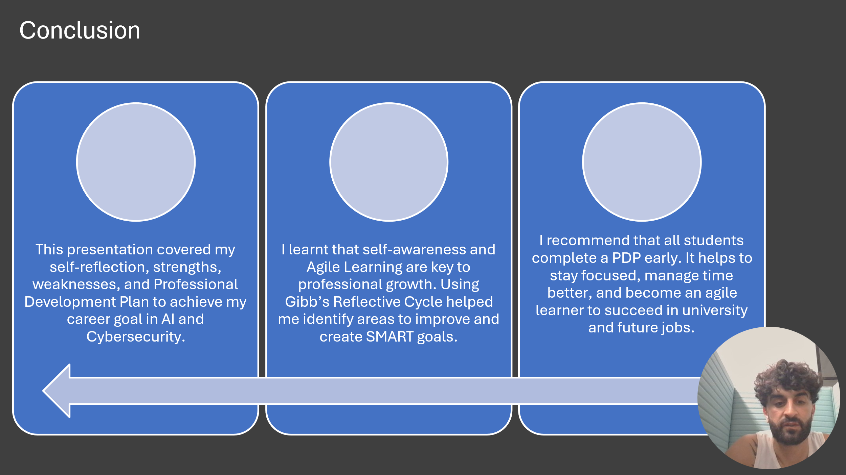

To conclude, this presentation covered my self-reflection, strengths, weaknesses, and Professional Development Plan to achieve my career goal in AI and Cybersecurity. I learnt that self-awareness and Agile Learning are key to professional growth, and using Gibbs’ Reflective Cycle helped me identify areas to improve and create SMART goals. I recommend that all students complete a PDP early to stay focused and become agile learners for university and future jobs.
Slide 8
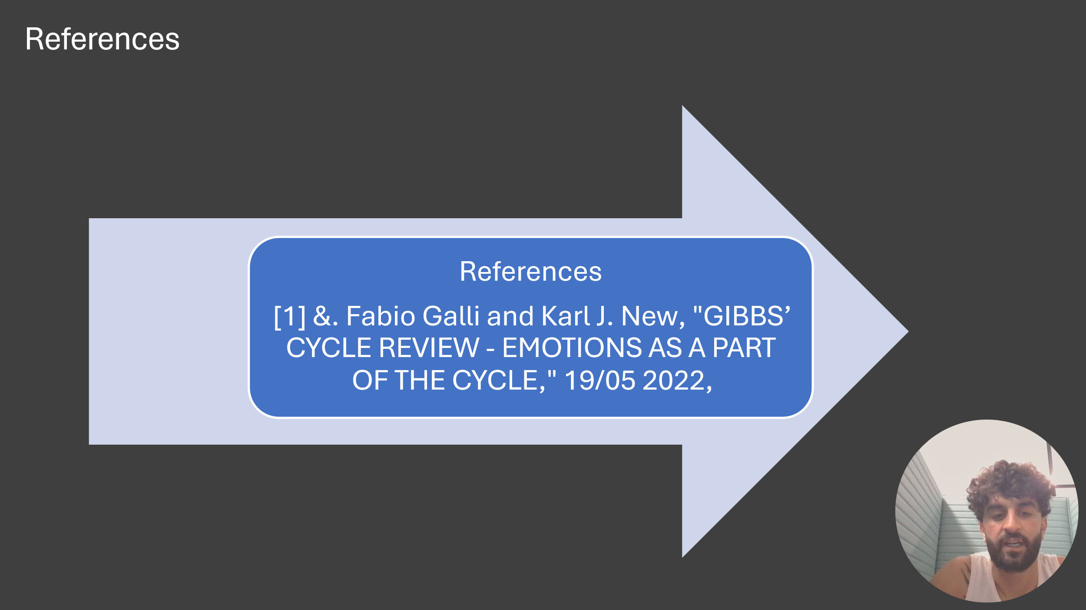

Finally, this slide lists the references I used in my presentation. The main source is the Gibbs’ Cycle Review article by Fabio Galli and Karl J. New, which helped me with my reflection.

Slide 9
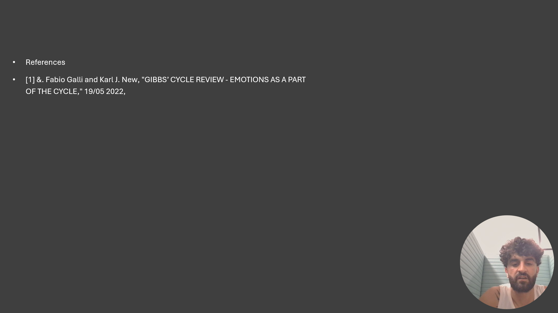
Conclusion
This presentation covered my self-reflection, strengths, weaknesses, and Professional Development Plan to achieve my career goal in AI and Cybersecurity.
I learnt that self-awareness and Agile Learning are key to professional growth. Using Gibb’s Reflective Cycle helped me identify areas to improve and create SMART goals.
I recommend that all students complete a PDP early. It helps to stay focused, manage time better, and become an agile learner to succeed in university and future jobs.

References

References
[1] &. Fabio Galli and Karl J. New, "GIBBS’ CYCLE REVIEW - EMOTIONS AS A PART
OF THE CYCLE," 19/05 2022,
References
[2] "Becoming a Lifelong Learner," no. 2026,

