T-test
Data analysis and visualisation

Teodora Todeva
Student ID: 2022546
Cloud computing
Level 4



Contents
The meaning of T-test 2
What is T-test? 2
Null and alternative hypothesis 2
What is hypothesis? 2
How can we develop null and alternative hypothesis? 3
Hypothesis testing with significance level 3
Two-Sample Assuming Unequal Variances t-test 5
Outliers 5
What are outliers? 5
Sorting the data for outliers. 5
Factors which might affect the testing of the hypothesis 6

The meaning of T-test

What is T-test?
This is a very common statistical test which has been used to find if there is any difference between the means of two samples/groups. However, this type of test is used for and as hypothesis testing tool which is letting the testing of assumption to be applicable to a population.
The T-test is concentrated mostly at the t-distribution values, t-statistic and therefore the degrees of freedom to see the statistical significance. To conduct a test with three or more means, one must use an analysis of variance.
Essentially t-test allows us to contrast the average values between the data sets so we could find out if they came from identical population. Within the examples is we would require a simple of the students form class A and class B, however we won’t look for them to be with exact same mean and standard division.
Mathematically this t-test is taking specimen from both data sets and is demonstrating the problem statement and presumes null hypothesis that both means are equal. Based on relevant formulas, particular values are calculated and compared in opposition to the standard values, and the assumed null hypothesis is accepted or rejected accordingly. [1]

Null and alternative hypothesis

What is hypothesis?
Hypothesis occur to be testable statement bases on researcher’s predictions could be in the end result of the study. Typically, this require proposing relationships which can be possible between two variables:
- Independent variable (what the researchers are changing)
- Dependent variable (what the researchers are measuring)
In some researches it is stated that there is existing convention where the hypothesis can be written in two forms which are null hypothesis and alternative hypothesis. However, those are also called experimental hypothesis when the method of investigation is an experiment. [2]
Null hypothesis declares population parameter (for instance mean, standard deviation etc.) is equal to a hypothesis value. This hypothesis is usually based on previous analyses or specialized knowledge. The symbol of null hypothesis is H_{0.}
Alternative hypothesis declare population parameter actually is smaller, greater or different than the hypothesized value displayed in null hypothesis. This hypothesis aims to prove true or supposed to be true. The symbol for alternative hypothesis is H_{1.} [3]

How can we develop null and alternative hypothesis?
If we would like to use those hypotheses for a study we have to point out the key variables. The independent value is under the control and manipulation of the researcher until the dependent value is outcome which is measured.
Another thing which has to be done is to operationalize the variables however they deal with how will be defined and measured specific variable for the study.
Decision has to be made according to the prediction. If evidence is available within the literature for the support of a specific effect on the independent and dependent variables can be done directional hypothesis. If there is not enough information within the literature for the effect of the dependant variable on the dependent variable can be done non-directional hypothesis.
When it comes to writing a hypothesis, good hypothesis is the concise, clear and comprehensible one. [2]

Hypothesis testing with significance level
- p=0.10
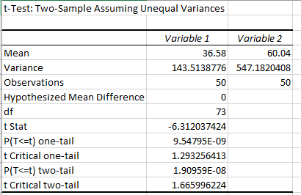
This testing has been made on significance level of 0.10. As is shown in the picture above we can see that T Stat is -6.312037424 and T Critical is 1.665996224. Looking at the numbers like that we can see that T Stat is < than T Critical which means that we have to reject the null hypothesis. However, since the minus sign can be ignored while we compare the two T values our number will become 6.312037424 which automatically show us that now T Stat is > than T Critical so in this case we are not rejecting the null hypothesis. When our p-two tail value 1.909 is bigger than null value cannot be rejected and when this p two tail value 1.909 is bigger than the alpha then the null hypothesis. [4]

- p=0.01
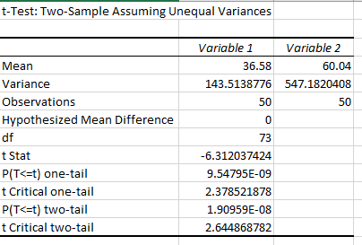
This testing has been made on significance level of 0.01. We are using same technique in here as well.
As is shown in the picture above we can see that T Stat is -6.312037424 and T Critical is 2.644868782. Looking at the numbers like that we can see that T Stat is < than T Critical which means that we have to reject the null hypothesis. However, since the minus sign can be ignored while we compare the two T values our number will become 6.312037424 which automatically show us that now T Stat is > than T Critical so in this case we are not rejecting the null hypothesis. So null hypothesis is performed here. When our p-two tail value 1.909 is bigger than null value cannot be rejected and when this p two tail value 1.909 is bigger than the alpha then the null hypothesis. [4]

- p=0.02
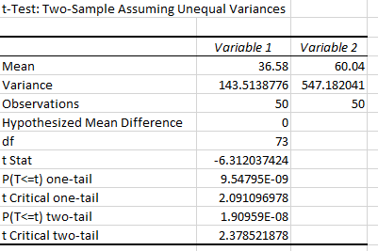
This testing has been made on significance level of 0.02. And here again we are using same technique for the testing.
As is shown in the picture above we can see that T Stat is -6.312037424 and T Critical is 2.378521878. Looking at the numbers like that we can see that T Stat is < than T Critical which means that we have to reject the null hypothesis. However, since the minus sign can be ignored while we compare the two T values our number will become 6.312037424 which automatically show us that now T Stat is > than T Critical so in this case we are not rejecting the null hypothesis. When our p-two tail value 1.909 is bigger than null value cannot be rejected and when this p two tail value 1.909 is bigger than the alpha then the null hypothesis [4]

Two-Sample Assuming Unequal Variances t-test
Out hypothesis here is done on the Two-Sample Assuming Unequal Variances on the two populations white patients and BAME patients which are independent. Here this type of test is appropriate as there is age difference, and we also need to find the truthfulness of the data according to the infections during COVID-19. This is a statistical test where we can compare the means of two groups. In this test we are also comparing two different groups/populations and aim to see the differences between them and truthfulness of all the data.
The technique here which we used is the
Null Hypotheses which are showing us that is no difference between the categories of characteristics.
Alternative Hypotheses which show us that there is no match in those characteristics between the populations. If somewhere in our sample there are available evidence where we can reject the null hypotheses then we will accept the alternative one. [5]

Outliers

What are outliers?
Those are data point which are lower or higher than the other ones which makes them different. The impact of those data points on statistics is that they are values which are unusual in the dataset. Those values can be problematic and can make the analyses and cause the tests to be with miss significant findings. They can also affect the results at the end. Before making statistical analyses we should identify the outliers.

Sorting the data for outliers.
We can sort our data sheet be looking if we have some outliers. Those can be usually some values higher or lower than the data for which we are performing the test. In our case we have the values between 20 and 100 years. In our table we also have a few values which are lower than the value from which we need to perform our calculations.
Another thing which we can make is a graphic which graph can be boxplot, histogram or fitted line pot which will easily show us the outlier values.
We can use Z-scores so we can find the unusual values. This Z-score is the standard deviation numbers which are above or below the mean. For the calculation of this Z-score we need to make measurement then we have to subtract the mean and after that we have to divide it by the standard deviation. Then it will be shown the high and low values and the outlier can be identified. [6]

Factors which might affect the testing of the hypothesis
- The size of the sample (n).
The size of the sample depends on how many participants we will include for our study. We represent this number with n. There are two factors which might interfere with our statistics, and they are the power of our study and the precision of the estimates. We can have sampling errors which might be unavoidable because of the sample size. However, if we increase our size it might no longer impact error in the sampling.
If the size of the sample is going to be larger than the power of this test also will be greater. The data trend and values are not known for the smaller samples. When the size of the sample is increasing this might lead to the hypothesis to become more sensitive. In other words, it is more likely the null hypothesis to be rejected which in fact can be false. When changing significance levels, the region of acceptance become smaller and exactly this leads to rejecting the null hypothesis. Sometimes it could be difficult to work with large size of samples in other hand the larger size of samples is more accurate. [7]

- Level of significance (α).
The significance level in the hypothesis testing is controlling the probability when is has some preassigned values which may lead to the Type I error which error is that might happen rejecting of null hypothesis when it true.
Between the significance level and the power there is a trade-off. If the power of significance is going to be low if the significance value is lower. Acceptance region will be bigger when the values are lower which means that rejecting the null hypotheses will be less likely. If the lower values are going to be false then hypotheses also will be false it will be harder null hypotheses the be rejected for those values of significance which are lower. [8]

- True value parameter.
If we have difference between true value parameter and a specific value in null hypothesis then the hypotheses testing will have more power. Null values and true values are comparing. As much greater the difference between true value parameter and specified value in null hypothesis is then the power will be greater of the test. As well the effect sizes the greater they are then the greater will be to power of this test. We can assume the null hypothesis is false and we can be offered to have alternative view on the true value parameter once we calculate the power of the test. The difference between the specified value and the true value is the effect size in the null hypothesis. [8]

References

[1] | A. HAYES, “Investopedia,” T-test, 22 03 2020. [Online]. Available: https://www.investopedia.com/terms/t/t-test.asp. [Accessed 13 08 2021].
[2] | S. McLeod, “Simply Psychology - Research methods,” Hypothesis, 10 08 2018. [Online]. Available: https://www.simplypsychology.org/what-is-a-hypotheses.html. [Accessed 13 08 2021].
[3] | Minitab 18, “Minitab 18,” Null and alternative hypotheses, 01 01 2021. [Online]. Available: https://support.minitab.com/. [Accessed 13 08 2021].
[4] | A. Hayes, “Investopedia,” T-test, 20 03 2020. [Online]. Available: https://www.investopedia.com/terms/t/t-test.asp. [Accessed 01 09 2021].
[5] | R. Bevans, “scribbr,” t-test, 31 01 2020. [Online]. Available: https://www.scribbr.com/statistics/t-test/. [Accessed 01 09 2021].
[6] | R. E. Shiffler, “The American Statistician,” Maximum Z Scores and Outlier, vol. 42, no. 1, pp. 79-80, 1988.
[7] | Institute of work and health, “Institute of work and health,” Sample size and power, 08 01 2008. [Online]. Available: https://www.iwh.on.ca/what-researchers-mean-by/sample-size-and-power. [Accessed 02 09 2021].
[8] | Star Trek, “Star Trek,” power of hypothesis test, 01 01 2021. [Online]. Available: https://stattrek.com/hypothesis-test/power-of-test.aspx. [Accessed 02 09 2021].

