Kristina Harris
SCVS volunteering services
Neath Port Talbot hospital – Ward F

Contents

Reflective commentary…………………………………………. Page 2
additional evidence pieces……………………………………. Page 7
Reference list……………………………………………………… Page 17
Appendices………………………………………………………... Page 18

Component Two: Portfolio of Evidence from voluntary/work-based experience
Reflective Commentary on Volunteering Experience at Ward F

This reflective commentary explores my ongoing experience volunteering on Ward F at Neath Port Talbot Hospital. I will use Gibbs' Reflective Cycle to guide my reflection and consider what I have learned, the challenges I have faced, and how this experience has supported my personal and professional development. Although this forms part of my university work, I intend to continue volunteering as I find the role meaningful and rewarding.
Description
During my time on Ward F, I have supported patients experiencing mental health difficulties through activities such as drawing, creative writing, crystal art, and general conversation. I have also spent time listening to patients play music and discussing their lyrics, encouraging them to use music as a way to express their emotions. These interactions helped me to build trust and develop positive relationships with patients.
One experience that stood out involved working closely with a patient who used songwriting to express their feelings. Over time, we built a strong connection, and I supported them in developing this as a coping strategy. I also signposted them to appropriate volunteering opportunities for the future, as they expressed interest in giving back to the community. They told me that I had inspired them and that what I was doing made a difference to them.
Sadly, this patient later took their own life. When I was informed, I was given the option to go home, but I chose to stay so I could continue supporting other patients. Although I felt upset, I remained professional and focused on being present. I later attended the funeral and supported patients by creating a memorial canvas together.
Feelings
At the beginning of my placement, I felt both excited and nervous as it was a new environment. As I became more familiar with the ward, I gained confidence and felt more comfortable in my role.
I often felt happy and fulfilled when patients engaged in activities or opened up in conversations. Knowing that I could make a positive difference, even in small ways, was very rewarding. However, the loss of the patient brought feelings of sadness and shock.
Choosing to stay on the ward during that time was challenging, but it showed me that I could manage my emotions in a professional way. I allowed myself to feel the emotion while still supporting others, which I believe I handled well. There were also moments where patients became frustrated or upset, sometimes directing this towards me. While this could be difficult, I learned not to take it personally and instead respond with patience and understanding.
Evaluation
Overall, my experience has been very positive and has helped me to develop both personally and professionally. I have built strong relationships with patients and contributed to a supportive environment on the ward.
The creative activities were particularly effective, as they allowed patients to express themselves in different ways. This is supported by research suggesting that creative approaches can improve emotional wellbeing (Stuckey and Nobel, 2010). I also developed my understanding of the importance of signposting. By guiding patients towards appropriate support and opportunities, I was able to extend my impact beyond the ward. This refers to guidance from the National Institute for Health and Care Excellence, which emphasises the importance of supporting individuals in accessing appropriate care and services.
However, there were challenges. Dealing with emotional situations and difficult behaviour was not always easy. The experience of losing a patient showed me that while I can support others, I also need to consider my own wellbeing.
Analysis
This experience has taught me a lot that I did not know before. I now understand that mental health recovery is not straightforward and that progress can be different for each person. I have also learned how important empathy and active listening are when building trust with patients. This links to Rogers (1957), who highlights the importance of understanding and acceptance in supportive relationships.
I have developed several transferable skills, including communication, teamwork, adaptability, and emotional resilience. Supporting patients required me to remain calm and flexible, especially in challenging situations. I also showed initiative when helping to create the memorial canvas, which gave patients a way to express their emotions during a difficult time.
One of the biggest challenges was managing my own emotions, particularly after the patient’s death. While I feel I handled the situation well by remaining professional, it also showed me the importance of self-awareness. According to Kinman et al. (2020), emotional resilience is important in caring roles, and this is something I will continue to develop.
Conclusion
In conclusion, my volunteering experience has been both rewarding and challenging. I have gained new skills, increased my confidence, and developed a deeper understanding of mental health and patient care.
I have learned that small actions, such as listening or spending time with someone, can have a meaningful impact. I also recognise the importance of being empathetic, patient, and professional, even in difficult situations.
Action Plan
As I plan to continue volunteering, I want to keep building on what I have learned. I will continue to reflect on my experiences to improve my skills and confidence.
In the future, I will make sure to seek support when dealing with emotionally difficult situations, rather than trying to manage everything on my own. I also want to continue developing my communication skills, particularly when responding to challenging behaviour.
Overall, this experience has been very valuable and will continue to shape my personal and professional development as I move forward.

Portfolio of evidence – Patient feedback:
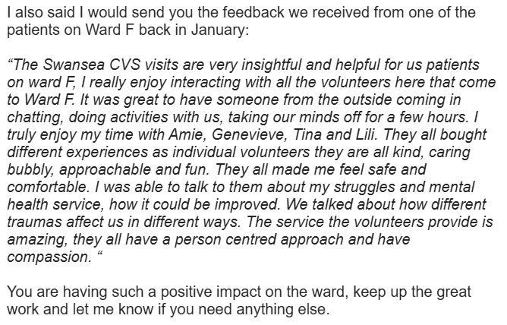
The patient feedback I received highlights the positive impact I had during my placement, particularly in relation to my communication and interpersonal skills. Through activities such as music discussions and creative sessions, I was able to build trusting relationships and create a space where patients felt comfortable expressing themselves. One patient shared that I had inspired them and made a meaningful difference, which reinforced the value of active listening and empathy. This feedback demonstrates my ability to engage effectively with patients and supports my development in helping skills, confidence, and emotional awareness.
Portfolio of evidence – Safeguarding certificate

Certificate of Attendance

This is to certify that
Kristina Harris

attended a full-day-equivalent course on

West Glamorgan Safeguarding Board Group B Safeguarding Training

16/04/2025

This course allows participants to:
- Describe how to work in ways that safeguard people from abuse, harm and neglect.
- Explain factors, situations and actions that could lead or contribute to abuse, harm or neglect.
- Consider legislation, national policies, codes of conduct and professional practice in relation to safeguarding.
- Know how to recognise and report different types of abuse, neglect and harm.

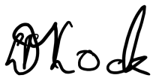
__________________________ 16/04/25
Danielle Lock Date
Volunteer Services Manager
The safeguarding training I completed provided me with a clear understanding of my responsibilities when working with vulnerable individuals. It helped me recognise the importance of maintaining professional boundaries, ensuring confidentiality, and responding appropriately to any concerns. I was able to apply this knowledge in practice, particularly in emotionally challenging situations, where it was important to remain calm, professional, and focused on the wellbeing of patients. This training supported my confidence in handling sensitive situations and reinforced the importance of acting in a safe and responsible manner at all times.

Portfolio of evidence - Volunteer Supervision Record Sheet

Name | Kristina Harris
Scheme | MHWB
Date | 27/3/26

Pre supervision checklist
 | Date | Renew
Safeguarding training (every 3 years) |  | n/a
References (every 3 years) |  | n/a
DBS (every 3 years) |  | n/a
Social Services check (Every 3 years) |  | n/a
ID card (annually) |  | n/a
Car declaration form (annually) |  | n/a
MOT (annually) |  | n/a
Car insurance certificate (annually) |  | n/a
Driving licence (annually) |  | n/a

Volunteer contact details up to date? | All up to date
If not, add new details here:
Diary sheets – happy with them, need copies printed? | 
Expenses – happy to claim, need paper copies?

Details of current role:
Length of time in the role: | Nearly 4 months
How often do you meet/phone/ Zoom, and for how long? | Twice weekly
How would you describe the group/individual you work with? | Ward F – supporting inpatients on the ward.
Are you comfortable with the activities you are carrying out and conversations you are having? | Yes
What have you been doing? | Games – e.g. Connect 4  Signposting – e.g. to volunteering  121 with patients who need the time to talk about feelings, quieter activities.  Adapting to patients needs, taking into consideration everyone need and interests.
Is there anything specific you are trying to achieve? | Gain experience, support people on the ward.
Describe any progress you have made or positive changes made. | Building the trust of quieter patients who struggle to engage in activities.
Are there any barriers/difficulties/challenges in achieving aims or volunteering generally? | Working out what to say in difficult conversations or responding to difficult questions. PG to send over Papyrus suicide prevention conversation starters and let Kristina know when next ASIST training takes place.
Do you have any concerns about the person/group you are volunteering with? | Loves being on the ward.
Do you feel the risk assessment is still up to date or are changes needed? | Ys

Volunteer development:
Feedback from individual/ward/group | Will provide patient feedback from patients separately – see email.  We have received very positive feedback from Rupert and Tom (Ward Staff) and from patients. Tom said that Tina had been able to engage patients who were struggling to enjoy activities and to bring happiness and fun to the ward.
How do you feel about this feedback?
Are you still enjoying volunteering and is it still meeting your needs? | Yes – loves it.
Is there anything more we can do to support you? | No
Do you have any training or development needs? | Talked about ASIST training/Behaviour change – PG to send details of next course
Is there anything else you would like to discuss?

Volunteer signed |  | Date
VDO signed |  | Date

The supervision I received during my placement played an important role in supporting my development and confidence. Through informal discussions and guidance from staff, I was able to reflect on my experiences, particularly when dealing with challenging situations. This included managing emotional responses and maintaining professionalism, especially following difficult events on the ward. Supervision provided me with reassurance and practical advice, helping me to improve my approach and build resilience. It also highlighted the importance of seeking support when needed and learning from experienced professionals.

Reference list:
Gibbs, G. (1988). Learning by doing: A guide to teaching and learning methods. Further Education Unit.
Kinman, G., Teoh, K., & Harriss, A. (2020). Supporting the well-being of healthcare workers during and after COVID-19. Occupational Medicine, 70(5), 294–296.
National Institute for Health and Care Excellence. (2011). Service user experience in adult mental health.
Rogers, C. R. (1957). The necessary and sufficient conditions of therapeutic personality change. Journal of Consulting Psychology, 21(2), 95–103.
Stuckey, H. L., & Nobel, J. (2010). The connection between art, healing, and public health. American Journal of Public Health, 100(2), 254–263.

Appendices:
Appendix A – Confirmation email
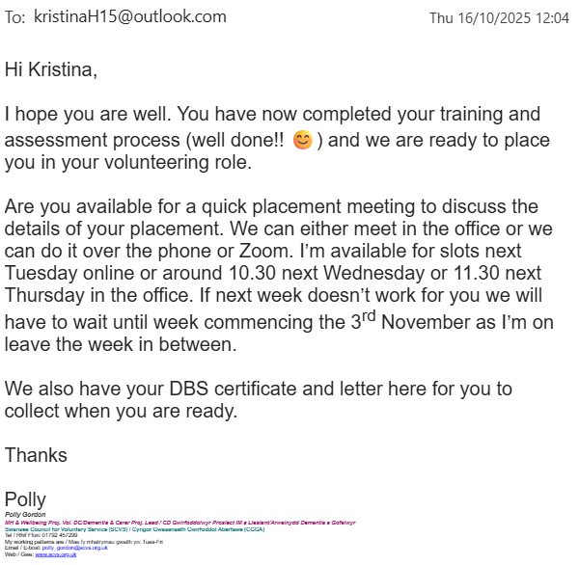

Appendix B –


Placement Information Form
Name of student: | Kristina Harris
Proposed placement setting and address: | Ward F Neath Port Talbot hospital
Proposed dates of placement: | 8/12/2025
Name and position of contact: | Polly Gordon
Contact email address: | Polly_gordon@scvs.org.uk
Contact telephone number: | 01792544000
Is a DBS required for you to attend this placement? | - Yes  If Yes, have you applied for this?  - Yes applied on ___08/12/2025_____________
Explain how your role in this organisation/on this placement meets the criteria for the assessment for the module  (e.g., what duties/tasks will you be undertaking that are relevant for the module assessment) | The overall aim of the role is to provide befriending/support to in-patients directly on the wards. I will listen and chat with people, not only about mental health, but also about hobbies, interests and general well-being. I will also play a crucial part in signposting to other charity organisations in Swansea, Neath and Port Talbot.

ALL information must be provided. Incomplete forms will be returned to the student.
Please return this form to Stacey Coleman (stacey.coleman@uwtsd.ac.uk) by no later than 12pm on Monday 1st July.

