

A Proposal for 'NEXT Plates' – A Personalized Nutrition Meal Service

Student Name: Fabiha Rahman
Student ID: 2506578
Module Name: Marketing Management

Module Code: LCMB7024

Lecturer’s Name: Dr. Laila Maazouz

Word Count: 2430 Words

Term 1
Submission Date: 20 December 2025

Abstract

A new brand development strategy is proposed for NEXT, a UK-based clothing and accessories company, to enter the personalized nutrition market. The existing company’s logistical and brand strengths are leveraged to launch a new brand, NEXT Plates, within a new product category. A comprehensive segmentation, targeting, differentiation, and positioning (STDP) analysis is presented, identifying the health-conscious consumer as the primary target. The marketing mix (4Ps) is designed to support a value-based positioning of scientific personalization. The strategy is critically examined, highlighting its alignment with consumer trends toward health and convenience. The development process highlights the importance of evidence-based innovation and strategic brand architecture.

Contents
Introduction 3
1.0 STDP Analysis for a New Brand Concept 3
1.1 Company Introduction & New Brand Concept 3
1.2 Market Appeal & Consumer Trends 5
1.3 Segmentation & Targeting 5
1.4 Differentiation & Positioning 6
2.0 Marketing Mix (4Ps Framework) 7
2.1. Product 7
2.2. Price 8
2.3. Place (Distribution) 8
2.4. Promotion 9
3.0 Poster for the Product Development 10
4.0 Reflection 11
Conclusion 12
References 13

Introduction

A new brand concept for the existing company, NEXT, has been developed and proposed within this research portfolio. The proposed venture, named NEXT Plates, is a direct-to-consumer subscription service that delivers personalized, nutritionally optimized ready meals. The concept is strategically positioned at the intersection of two dominant consumer trends: health-conscious convenience and the growing demand for individualized nutrition. This paper is structured to present a comprehensive marketing strategy, beginning with a segmentation, targeting, differentiation, and positioning (STDP) analysis, followed by a detailed marketing mix. The development process and key strategic insights are subsequently reflected upon, with recent academic and industry literature being utilized to substantiate the proposal throughout (Voruganti, 2023).

1.0 STDP Analysis for a New Brand Concept

Company Introduction & New Brand Concept

NEXT is recognized as a leading UK retailer with a strong heritage in clothing, homeware, and a growing online platform (NEXT Total Platform). It is widely recognized for its robust logistics, data-driven operations, and trusted brand name, positioning it well for expansion into high-growth consumer sectors. This proposal introduces NEXT Plates, a new-to-company brand positioned in the lucrative health and wellness food-tech market.
The proposed "NEXT Plates" falls into the New Brands quadrant (lower-right), representing both a new brand name and a new product category for the parent company NEXT; analyzed on a chart below:

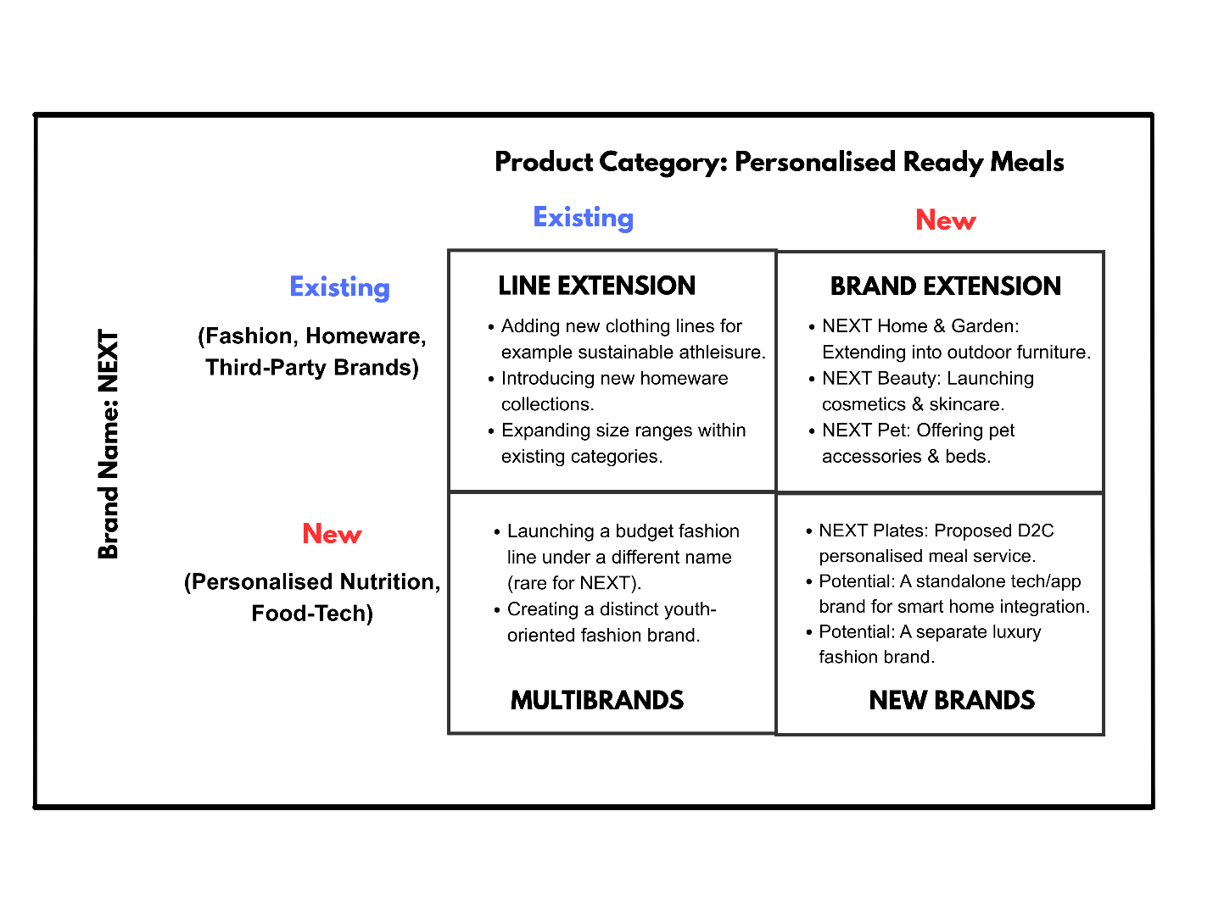
Figure 1 Brand Development Strategies
(Kotler et. al, 2024)

NEXT Plates is analyzed as a direct-to-consumer (D2C) subscription service through which chef-crafted, nutritionist-approved ready meals could be delivered. The unique selling proposition is rooted in personalized nutrition, whereby meals are tailored to individual customer profiles through the use of lifestyle questionnaires and optional at-home biomarker test kits, such as those designed for vitamin level or gut microbiome insights. A shift is thereby made beyond the generic “healthy” meal category into the domain of science-backed, individualized wellness, with NEXT’s operational excellence in fulfillment and customer data management being leveraged.
This approach is classified as a “New Brand” strategy (see Figure 1), as both a new brand name and a new product category, personalized food-tech, are introduced for the parent company. By this means, risk to the core NEXT brand is mitigated, while a distinct market segment is captured.

Market Appeal & Consumer Trends

Two converging global trends are directly addressed by the new brand. First, the demand for personalized health is observed, as the one-size-fits-all approach to nutrition is increasingly being rendered obsolete. Solutions tailored to the unique biology of the individual are sought by consumers, a shift supported by research in nutrigenomics and digital health, which underscores that personalized dietary interventions can improve compliance and outcomes (Martín et al., 2017).
Second, the unstoppable rise of health-conscious convenience is noted. Wellness is prioritized by modern consumers, particularly millennials and Gen Z, yet they are often time-poor. This has created a surge in demand for services in which nutrition is merged with convenience (Barton et al., 2020). The intersection of these trends is occupied by NEXT Plates, where a credible, science-aligned solution that fits seamlessly into hectic lifestyles is offered.

Segmentation & Targeting

The relevant market can be segmented along demographic, psychographic, and behavioral lines:
The Proactive Bio-Hackers (Primary Target) are defined as urban professionals aged 28–45 with high disposable income. This group is characterized by tech-savviness, a data-oriented mindset, and a deep commitment to optimizing physical and cognitive performance. Wellness influencers are followed, fitness trackers are utilized, and health-tech innovations are adopted early by this segment.
The Time-Poor Health Seekers (Secondary Target), typically aged 35–55, consist of busy parents or professionals. Significant time constraints are faced by these individuals, despite a high level of health consciousness. Convenient access to nutritious and trustworthy food for themselves and their families is prioritized, without quality being compromised.
The Medically-Motivated (Niche Target) comprises individuals with specific dietary goals—such as the management of pre-diabetes, gut health issues, or sustainable weight management—for whom structured, evidence-based food solutions are sought.
Primarily, “The Proactive Bio-Hackers” are targeted by NEXT Plates. This segment is valued for its appreciation of innovation, possession of the financial means to subscribe to a premium service, and role as influential early adopters whose endorsement can be leveraged to drive wider market penetration.

Differentiation & Positioning

It is acknowledged that the prepared meal industry is crowded with competitors such as Professional Chef (positioned as ethical and healthy) and All-plants (positioned as plant-based), alongside mass-market retailers that offer “healthy” ranges. Differentiation is therefore regarded as critical.
Differentiation:
- Personalization Science: Customization, such as the ability to omit an ingredient, is offered by competitors, whereas true personalization based on biomarkers is not. A key differentiator is represented by the integration of simple diagnostic tools by NEXT Plates.
- Brand Credibility & Logistics: Flawless subscription management and delivery are ensured by leveraging NEXT’s established reputation for reliability and its state-of-the-art logistics network, representing a significant operational advantage over start-up rivals.
- Holistic Ecosystem: A sticky, ecosystem-based relationship that extends beyond transactional food delivery is created through the complementing of meals with a digital dashboard, which is designed to track nutritional intake against personal goals.
Positioning Statement:
For health-conscious, data-driven individuals seeking optimal wellness, a unique position is occupied by NEXT Plates, which is characterized as the only meal service in which chef-crafted convenience is combined with scientifically personalized nutrition. Unlike generic healthy meals, insights derived from the user’s unique biology are utilized to deliver food that is optimized for individual efficacy (Martin, 2023).
Consequently, NEXT Plates is positioned as the most advanced, intelligent, and effective solution in the market. This positioning justifies a premium pricing strategy and facilitates the construction of a competitive moat through the deployment of proprietary personalization algorithms (Kotler et al., 2024).

2.0 Marketing Mix (4Ps Framework)

The 4Ps marketing mix framework is expanded to encompass the hybrid nature of NEXT Plates, a product-based subscription service enhanced by a significant digital service component.

2.1. Product

At the core, the offering is defined as a weekly subscription of freshly prepared, chilled meals. However, the augmented product is where the primary value is delivered:
- Core Product: Gourmet, nutritionally-balanced meals are provided, such as Harissa Spiced Chickpea & Sweet Potato, which can be adapted with personalized vegetable adjustments.
- Personalization Engine: Subscription initiation is signified by the completion of a detailed health and lifestyle questionnaire. For premium subscribers, a "NEXT Biomarker Kit" is included to facilitate advanced, personalized meal programming.
- Digital Platform: Each meal is linked via a QR code to a personal digital dashboard. This platform is designed to display detailed macro and micronutrient breakdowns, illustrate alignment with individual health objectives, for example, indicating "This meal supports your energy focus,” and enable progress tracking over time (Cavero-Redondo et al., 2020).
- Packaging: Packaging is constructed to be fully recyclable and insulated, and is integrated with RFID (Radio Frequency Identification) technology to ensure precise freshness monitoring, thereby reinforcing the brand's premium and technologically advanced positioning.
- Branding: A clean, minimalist design featuring the NEXT Plates logo is utilized. Colour-coded labels are used to indicate primary health benefits, for example: green for "Gut Health," blue for "Cognitive Focus", a strategy which aligns with the brand's commitment to transparency, scientific rigor, and user-friendly communication (Olavarrieta, 2020).

2.2. Price

A value-based pricing strategy is adopted, which is based on the perceived value of personalized health outcomes rather than merely the cost of food. A customized subscription model is proposed:
- NEXT Plates Core (£8.50/meal): Access to the menu is provided with basic personalization. A minimum of six meals per week is required.
- NEXT Plates+ (£11.50/meal): An initial biomarker kit is included, along with advanced algorithm-based personalization and monthly video check-ins with a nutritionist.
Psychological pricing is employed through the use of .50 endings, which maintains a premium brand perception while being perceived as less aggressive than .99 price points.
This pricing structure is aligned with the STDP framework, as advanced personalization is made accessible to the primary target segment for example, “Bio-Hackers,” who are willing to pay for science-backed optimization, while an entry-level tier is offered to the secondary target segment (Trihatmoko et al., 2019).

2.3. Place (Distribution)

A direct, digital-native distribution model is essential for data collection, customer relationship management, and margin control (Hubner et al., 2016).
Primary Channel: A dedicated e-commerce website is utilized and optimized for subscription sign-up and profile management.
Strategic Physical Evidence: Although a Direct-to-Consumer model is adopted, the physical assets of NEXT are leveraged for credibility. Limited-time “NEXT Plates Experience Pods” could be utilized in select large NEXT stores, where taste, tests and biomarker kit demonstrations are offered. Tangible “physical evidence” of the brand’s quality and scientific approach is thereby provided (Zeithaml et al., 2017).
Logistics: NEXT’s existing, sophisticated nationwide distribution and cold-chain logistics network is utilized, ensuring next-day delivery reliability, which represents a significant competitive advantage in freshness guarantee.

2.4. Promotion

A digital-first, educational, and trust-building promotional strategy is adopted.
Content marketing serves as the cornerstone, whereby high-value content is produced, including blogs on nutrigenomics, podcasts featuring nutrition scientists, and whitepapers on microbiome health. This content is designed to attract the target audience through search engine optimization (SEO) and establish NEXT Plates as a thought leader (Pulizzi, 2015).
Strategic partnerships are formed with corporate wellness programs, which target professionals, as well as with fitness influencers and athletes who embody the “bio-hacker” ethos. Through these partnerships, credibility is enhanced and direct access to niche communities is gained (Grunig, 2023).
Performance marketing is executed through targeted social media advertising on platforms such as Instagram and LinkedIn, along with search ads focused on keywords including “personalized nutrition,” “DNA diet,” and “healthy ready meals UK.”
A public relations campaign is launched, centered on proprietary research into “The UK’s Personalized Nutrition Gap.” Coverage is secured in publications such as The Guardian’s wellness section and Wired.
This promotional mix is aligned to avoid generic food advertising. Communication is directed towards the intelligence and aspirations of the target audience, with an emphasis placed on the science and results rather than solely on the food. Differentiation is reinforced, and premium positioning is supported through the cultivation of an aura of authority and innovation (Campbell et al., 2020).

3.0 Poster for the Product Development

The proposed "NEXT Plates" falls into the New Brands quadrant (lower-right), representing both a new brand name and a new product category for the parent company NEXT:

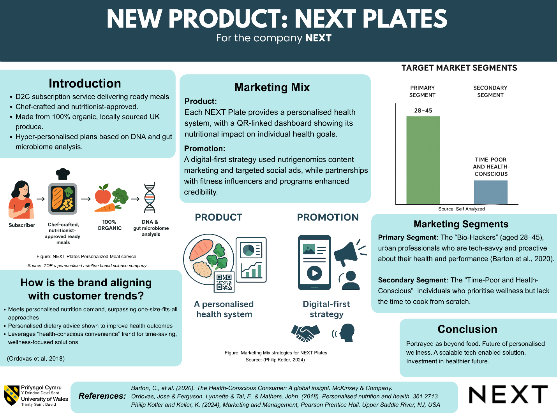

Figure 2: Marketing Strategy Pitch for New product development NEXT Plates
Source: Self Analyzed

4.0 Reflection

The development of the NEXT Plates brand concept and its marketing strategy was a profoundly insightful exercise in translating a consumer trend into a viable, differentiated business proposition. The initial challenge was identified in moving beyond a generic “healthy meal” idea. The critical importance of evidence-based innovation in the construction of a persuasive brand narrative, especially for a discerning target audience, was underscored. (Martín, 2017).
The crafting of the STDP analysis necessitated rigorous critical thinking. The definition of the "Proactive Bio-Hacker" segment was analyzed by moving beyond demographic data to an in-depth examination of psychographics and personal values. The most significant lesson was discovered to be the power of strategic reduction in targeting; by focusing heavily on this major niche, the brand's posture was refined and made more convincing as premium, scientific, and optimizing. Similarly, the process of articulating differentiation revealed that true competitive advantage is often located not in an isolated feature, but in a synergistic system. In this instance, the integration of biomarker personalization, the parent company’s logistics network, and a dedicated data dashboard.
The preparation and delivery of the marketing strategy pitch served to hone skills in strategic synthesis and persuasive communication. It was learned that a strong, relatable problem like one-size-fits-all nutrition should be led with, followed by a concise presentation of the solution (Ordovas, 2018). The necessity of appealing simultaneously to investors through the highlighting of scalability and market trends and to customers through the emphasis of benefits and user experience was identified as a valuable lesson in audience-tailored messaging.
Upon critical reflection, it is proposed that future projects be enhanced through the incorporation of more robust financial modelling and risk analysis earlier in the process. Although the strategy is conceptually sound, a deeper investigation into customer acquisition costs for the digital marketing plan and the unit economics of the biomarker kits would strengthen the practical viability of the pitch. Furthermore, the conduction of primary research, such as surveys with the target segment to validate willingness-to-pay for personalization, would provide even stronger evidence than reliance solely on secondary trends data.

Conclusion

In conclusion, the process transformed an understanding of brand development from a creative exercise into a disciplined strategic discipline. It was highlighted that a powerful brand is built at the intersection of deep consumer insight, credible differentiation, and flawless tactical execution. A structured framework and a more critical, evidence-driven approach for developing market-ready strategies in the future have been acquired through this experience.

References

Barton, C., et al. (2020). The Health-Conscious Consumer: A global insight. McKinsey & Company.
Campbell, Colin & Farrell, Justine. (2020). More than meets the eye: The functional components underlying influencer marketing. Business Horizons. 63.
Cavero-Redondo, Ivan and Martinez Vizcaino, (2020). Effect of Behavioral Weight Management Interventions Using Lifestyle mHealth Self-Monitoring on Weight Loss: A Systematic Review and Meta-Analysis. 1977.12.
de Toro Martín, Juan & Arsenault, Benoit & Després, Jean-Pierre & Vohl, Marie-Claude. (2017). Precision Nutrition: A Review of Personalized Nutritional Approaches for the Prevention and Management of Metabolic Syndrome. Nutrients. 2017. 913. 10.3390
Grunig, J. E. (2023). Public Relations, Social Inclusion, and Social Exclusion. Journalism & Communication Monographs, 25(2), 90-108.
Hübner, Alexander & Wollenburg, Johannes & Holzapfel, Andreas. (2016). Retail logistics in the transition from multi-channel to omni-channel. International Journal of Physical Distribution & Logistics Management. 46. 562-583.
Ordovas, J. M., Ferguson, L. R., Tai, E. S., & Mathers, J. C. (2018). Personalised nutrition and health. BMJ, *361*, k2173.
Olavarrieta, Sergio and Friedmann, Roberto (2020). Logo Selection and Modification Guidelines: an empirical international validation in Chile. Estudios de Administración. 1.14.
Philip Kotler and Keller, K. (2024), Marketing and Management, Pearson Prentice Hall, Upper Saddle River, NJ, USA
Pulizzi, J. (2015). Content Inc.: How Entrepreneurs Use Content to Build Massive Audiences and Create Radically Successful Businesses. McGraw Hill LLC.
Trihatmoko, R. and Purnamasari, Dian (2019). New Product Pricing Strategy and Product Performance Assessment in Fast Moving Consumer Goods.417-423.VII.
Voruganti V. Saroja, (2023). Precision Nutrition: Recent Advances in Obesity. Physiology.38.42-50
Zeithaml, V.A. and Bitner, M.J., (2017). Services Marketing: Integrating Customer Focus Across the Firm.

