Research methodology by Thomas Skelton
Student number: 19922409

Introduction
Within this research chapter, I will be questioning police officers to find out about their experiences and opinions when attending mental health calls. I will complete this by implementing both a quantitative and qualitative questionnaire to gather the data and to further explore my objectives and gaps within my research. My research question is:
“An investigation into if police have an adverse effect on dealing with people with poor mental health when responding to mental health concern calls”.
Research objectives:
I have divided my research question into smaller research questions to gain a deeper understanding of the wider question and these are:
- To review the training that police officers receive and if it is appropriate when dealing with people at mental health relates calls.

- To review the Police role when attending mental health calls in accordance with the role of a constable as defined by the College of Policing.

- To review if other services can collaborate to ensure a better outcome.

- To evaluate if police attendance has an adverse effect on dealing with persons with mental health when attending mental health-related calls.

Limitations and problems with my research:
In this dissertation as set by my ethics form, the questionnaire and interviews will be in accordance with current Data Protection laws. I will not be interviewing or sending questionnaires to service users and I will only be taking data from current serving Police Officers. I will make the participant aware of how the data will be used, and give the participant the option to opt out, remain anonymous and withdraw at any time. The survey will be confidential and I will attempt to keep my questions succinct to prevent the participant from losing interest and avoid asking leading questions.
I want to establish if there are any secondary opinions such as if the police have biased opinions of dealing with people with mental health problems and review the satisfaction level of the current training that they have received. I will also ask about their knowledge of local mental health agencies and charities and how often they refer or signpost people in need of support.
The Questionnaire
I have used the website Allcounted.com to create my Questionnaire. At this stage I will not be reviewing the themes but just gathering raw data, I am going to attempt to gain the largest possible sample size to create a larger reflection an opinion and reflection of the general population of Police officers. The website and link to my questionnaire can be found at:
https://www.allcounted.com/s?did=s14bru9otbuzp&lang=en_GB&fbclid=IwAR0EHoFleqPV5vaT8136OXefA5Hc5tQGY_oE0gcHwVMHrbFhe20i9OP1vYU

During this questionnaire I have included both Quantitative and Qualitative style questions. I have included questions true to being quantitative research by obtaining simpler style questions which can represented by numbers. I have included questions as part of my Qualitative research by asking questions which are required to be answered by words. I have also allowed the use of the comment section for each question so if the participant would like to add additional comments.

The Questionnaire

Question one:
How long have you been a serving police officer with South Wales Police?
Question two:
On a scale of one being the lowest to five being the highest, how much mental health training have you received from South Wales Police throughout your career?
1 2 3 4 5
Question three:
When was the last time you received mental health training from South Wales Police or an external provider? (please indicate which).
Question four:
On a scale of one being lowest to five being highest, how would you rate the quality of training supplied by South Wales Police in terms of dealing with the members of the public with mental health problems?
1 2 3 4 5
Question five:
Which statements below do you agree with in relation to your own knowledge and training when dealing with persons with mental health: Please pick one.
I am well equipped and feel confident in dealing with mental health calls from the level of training I have received. I have a full understanding of mental health legislation including my powers.
I have some knowledge and understanding of mental health issues and I have learned how to deal with mental health calls by following my colleague’s lead. I understand my role to safeguard and have some knowledge of the legislation surrounding it.
I do not understand why the police attend mental health calls. I believe police powers should only be used in extreme circumstances. I have a basic understanding of mental health legislation.
I have a very limited or no understanding of mental health. I have received next to no training regarding it and don’t know my powers in terms of mental health.

Question six:
Which of the following statements do you agree with as a Police Constable? (Please tick all that apply).
I believe that the Police in collaboration with the ambulance and mental health services provide the best outcome for service users with mental health problems.
I believe Police are the primary service for dealing with persons with mental health problems.
I believe Police should only attend mental health calls in extreme circumstances.
I believe Police should not attend mental health calls and ambulances should attend these calls solely.
I believe Police should only attend mental health calls to mitigate threats and use powers such as section 17 of the Policing and Criminal Evidence act to assist ambulance.
Question seven:
On a scale of one being the lowest to five being constant, how often do you deal with the same persons with mental health (repeat callers)?
1 2 3 4 5
Question eight:
Do you believe that the Police have often an adverse effect on dealing with people with mental health problems when attending mental health-related calls?
Yes No
Question nine:
What services do you think are most equipped to best deal with people who are in need of mental health support?
Question ten:
On a scale of one to five (one being the lowest), how good is your knowledge of local mental health support services?
1 2 3 4 5

The results:
The below participants / responses equalled a total of 24 random anonymous Police officers from South Wales Police, it is unknown from what station, unit or anything apart from their length of service. This questionnaire was put into the Western sector overtime group. This does not say for certain they are from the western area of the Service.
Question one:
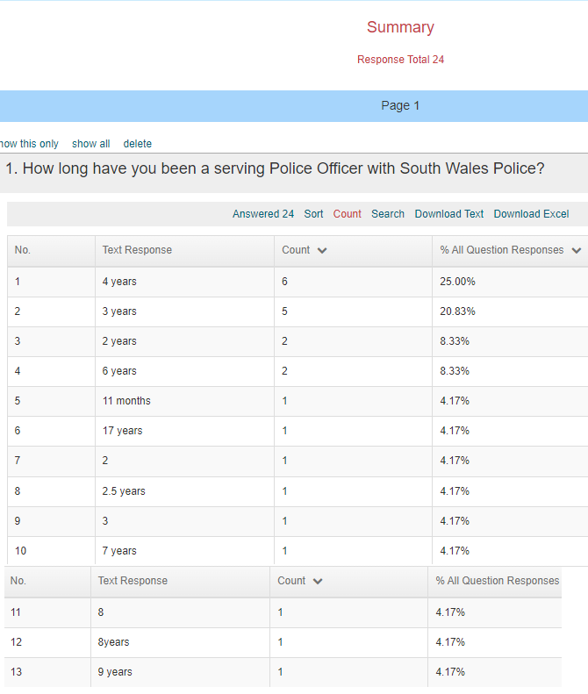

Question two:
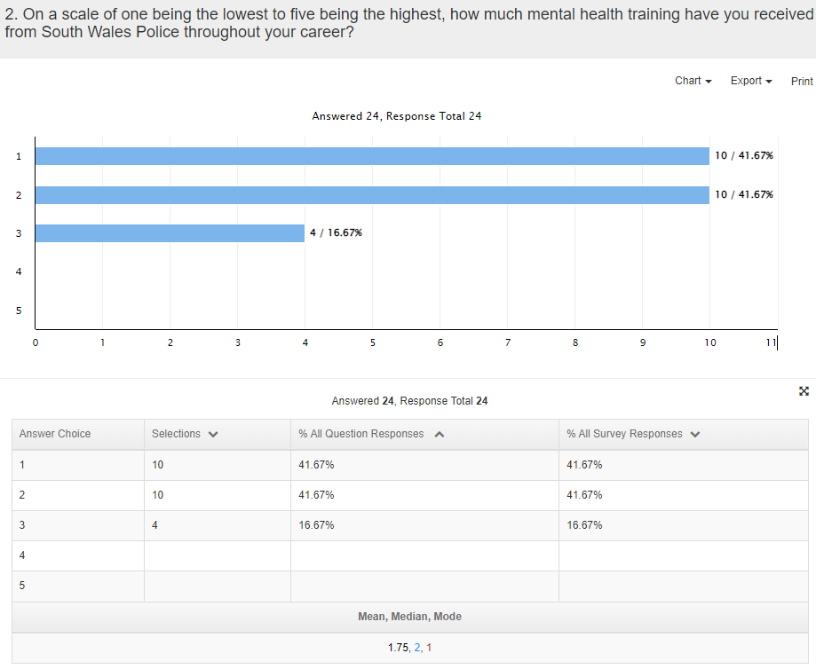

Question three:
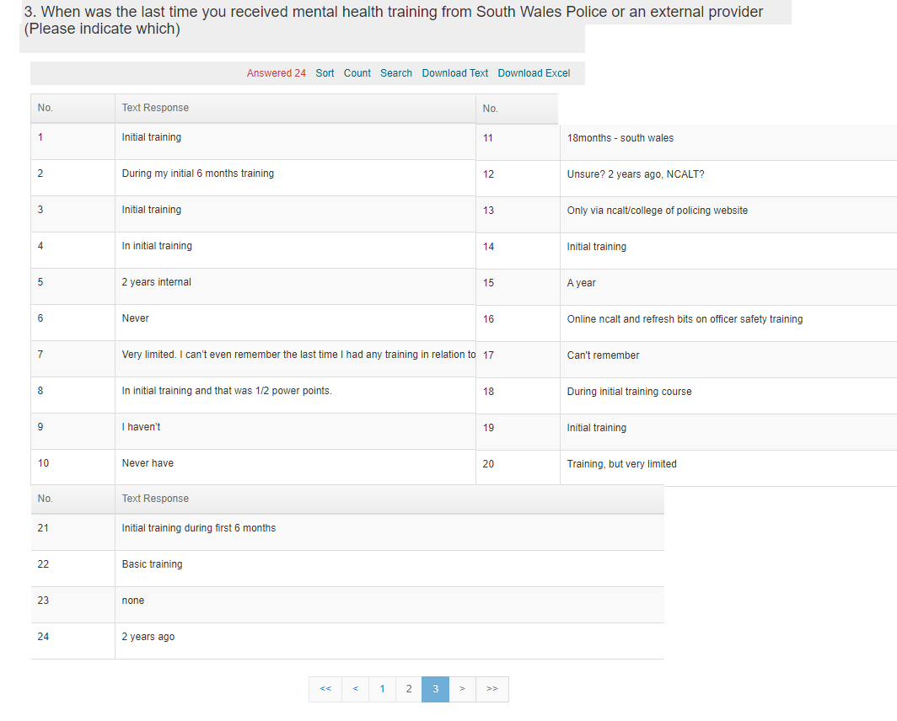

Question four:
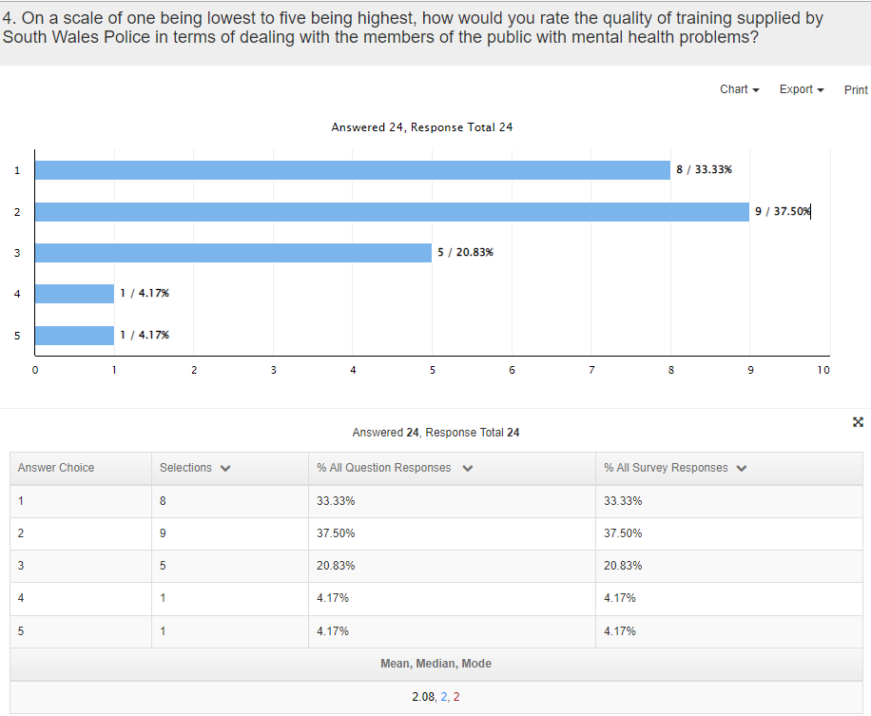

Question five
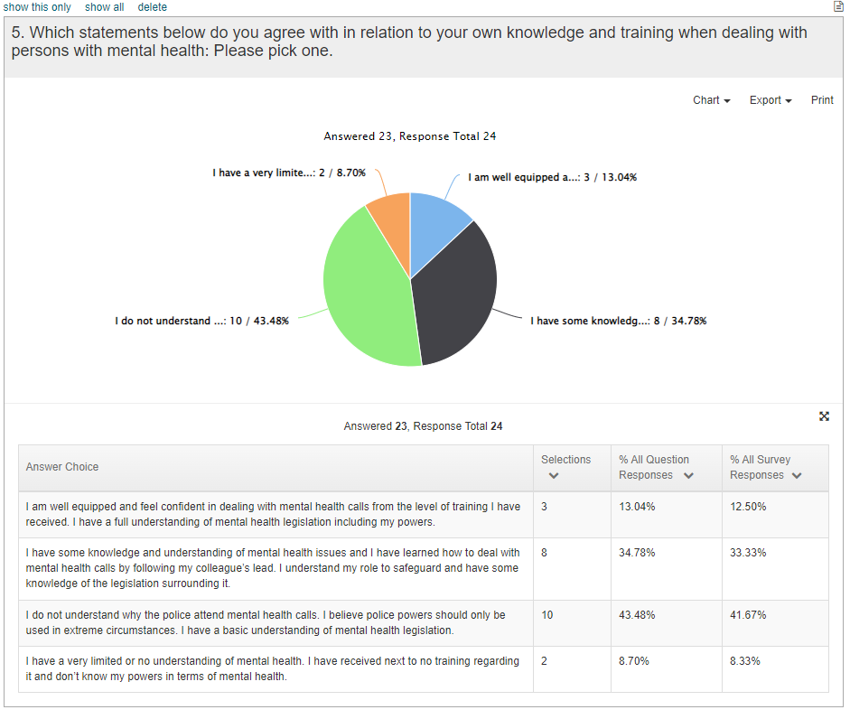

Question six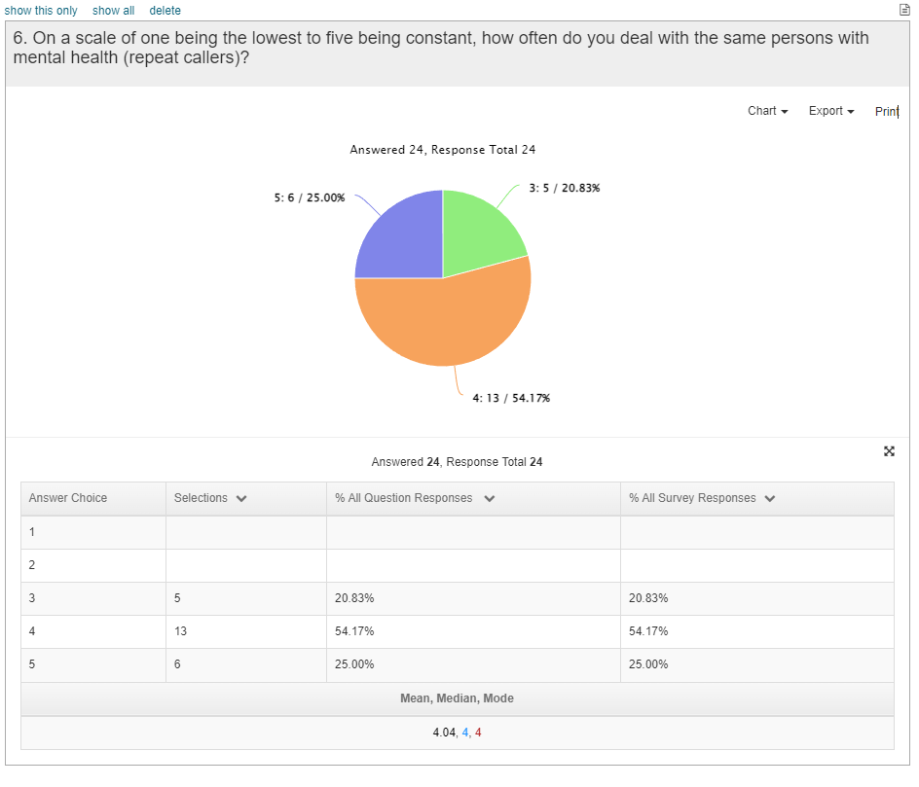

Question seven
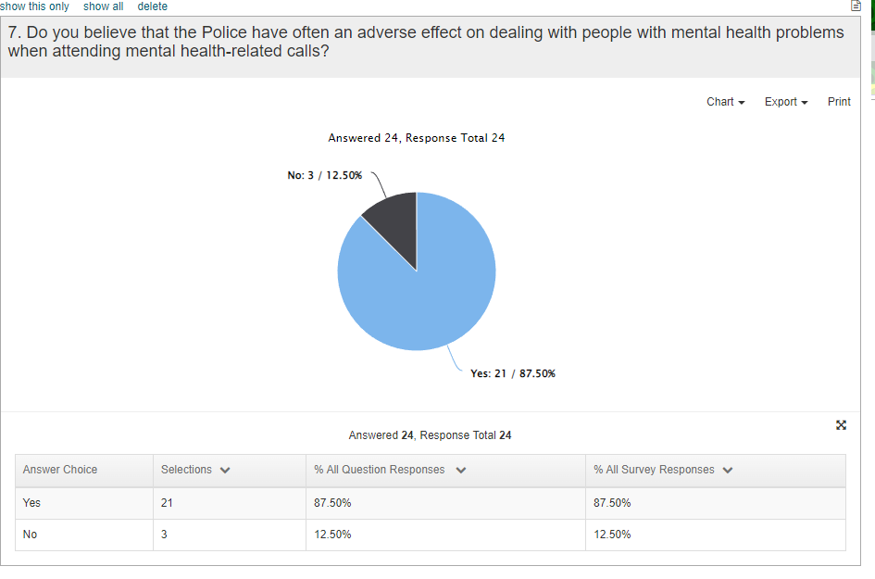
Question 8 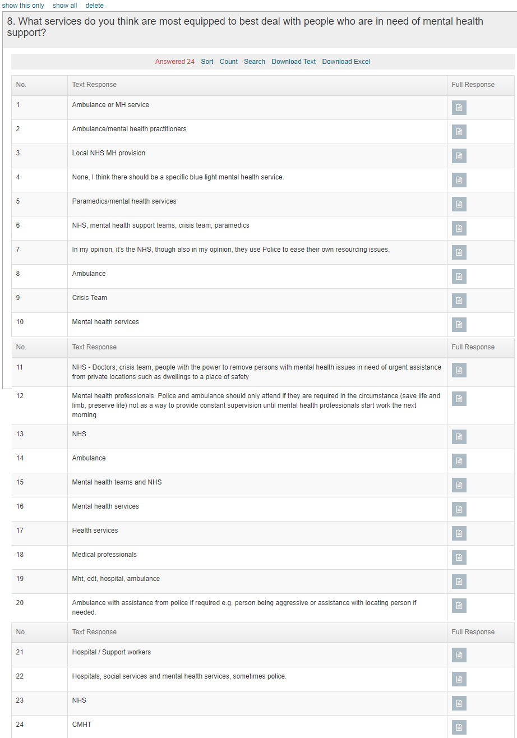

Question 9
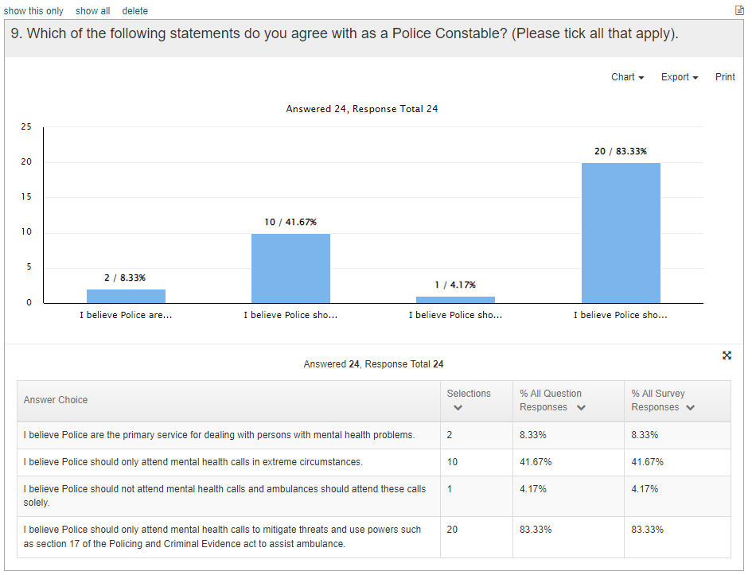

Question 10


